Earth and Environmental Science Module 2: Evidence for plate tectonics

Contents
Overview 3
Information for teachers 4
Introduction 4
Outcomes 4
Learning intentions and success criteria 5
Teaching and learning activities 6
Current evidence that supports the theory of plate tectonics: tic-tac-toe 6
Activity 1: Evidence for plate tectonics – written text comprehension activity 8
Activity 2: how do we know plate tectonics is real? 10
Sample answer 11
Activity 3: gathering information – evidence 12
Sample answer 13
Activity 4: exploring Sir Arthur Holmes and convection currents 17
Activity 5: modelling the evidence 18
Sample answers 19
Activity 6: continental drift or plate tectonics? 21
Activity 7: evaluating the evidence 25
Activity 8: place mat analysis 31
Activity 9: open option 32
Student resources 33
Tic-tac-toe activity grid 33
Activity 1: evidence for plate tectonics – written text comprehension activity 33
Activity 2: how do we know plate tectonics is real? 33
Activity 3: gathering information – evidence 33
Activity 4: exploring Sir Arthur Holmes and convection currents 33
Activity 5: modelling the evidence 33
Activity 6: continental drift or plate tectonics? 34
Activity 7: evaluating the evidence 34
Activity 8: place mat analysis 34
Activity 9: open option 34
Current evidence that supports the theory of plate tectonics: tic-tac-toe activity grid 34
Activity 1: evidence for plate tectonics – written text comprehension activity 36
Activity 2: How do we know plate tectonics is real? 41
Activity 3: gathering information – evidence 43
Activity 4: exploring Sir Arthur Holmes and convection currents 45
Activity 5: modelling the evidence 46
Activity 6: continental drift or plate tectonics? 51
Activity 7: evaluating the evidence 52
Activity 8: placemat analysis 54
Activity 9: open option 56
Support and alignment 57
References 59
Further reading 60
Appendix: compare and contrast chart 62

Overview
Stage and Learning Area: Earth and Environmental Science Stage 6
Description: this resource has been designed to address the module 2 inquiry question: What is the current evidence for the theory of plate tectonics, and how did the theory develop?
This learning sequence builds an understanding of the evidence and contributions of various theories, models and research to our understanding of the theory of plate tectonics.
Duration: while timing will vary based on the mode of delivery, differentiation strategies employed and class or school context, this series of activities should take approximately two 60-minute lessons.

Information for teachers
Students should have an awareness of the evidence supporting the theory of plate tectonics and the research supporting it before completing this activity. This activity is designed to support and develop student understanding by applying knowledge. Although it does cover much of the foundational knowledge of this course component, it is not comprehensive and should be supported with prior explicit teaching. Teachers should also identify opportunities for explicit teaching with small groups or individuals as students complete selected activities.

Introduction
This resource consists of a tic-tac-toe activity. A range of 9 activities is presented in a matrix reflecting Bloom’s Taxonomy and Sternberg’s intelligence preferences. Students will choose 3 activities from the matrix to complete. It is suggested that one activity be selected from each row and column. However, this is up to the teacher's discretion and may be adjusted to suit student abilities.
This learning sequence is designed to build skills gradually throughout the task. Teachers may wish to modify the task or focus on specific sections based on their class context, student ability and current mastery of content.

Outcomes
A student:
- describes the evidence for the theory of plate tectonics and the energy and geological changes that occur at plate boundaries EES11-9
- analyses and evaluates primary and secondary data and information EES11/12-5
Earth and Environmental Science Stage 6 Syllabus © NSW Education Standards Authority (NESA) for and on behalf of the Crown in right of the State of New South Wales, 2017.

Learning intentions and success criteria
Students: analyse evidence, including data and models, that supports the theory of plate tectonics and evaluate the contributions of the following theories, models and research to our understanding of the movement of plates.
Students can/will:
- describe the evidence supporting the theory of plate tectonics
- outline the contributions of Wegener, Hess, Holmes, Vine and Matthews and the Glomar Challenger to the development of the theory of plate tectonics
- evaluate the contributions of the scientists and technology who contributed to the theory of plate tectonics.
Differentiation consideration: Learning intentions should not be differentiated. All students need access to the same core content, big ideas and concepts. Differentiation should be evident in the success criteria, or the activities/support needed to achieve the success criteria (Wiliam and Leahy 2015). Teachers may co-construct the success criteria with students or adjust them to suit their class context, for example, using the strategies and resources for curriculum planning on the Planning, programming and assessing 7-12 webpage.

Teaching and learning activities

Current evidence that supports the theory of plate tectonics: tic-tac-toe
Note: students must choose 3 activities to complete from the grid below. Students are encouraged to select a variety of ways to connect with, and demonstrate understanding of the content.
Table 1 – tic-tac-toe table showing choice of activities
Activity 1:  Comprehension activity from written text | Activity 2:  Video analysis and fishbone diagram summary | Activity 3:  Conduct research and fill in table
Activity 4:  Exploring Holmes and convection currents | Activity 5:  Modelling evidence:  Jigsaw of continents, physical matching of fossils, age of seafloor rocks and magnetic reversals | Activity 6:  Compare and contrast similarities between continental drift and the theory of plate tectonics
Activity 7:  Evaluate the evidence and written report | Activity 8:  Place mat analysis | Activity 9:  Open option activity
Differentiation: this activity is differentiated using Bloom’s taxonomy. Further adjustments may be made to the activities to accommodate individual learning requirements.
The task can be further differentiated by altering the requirements for selected tasks. For example, students can be extended by requiring 2 activities from the bottom row.
It is suggested that students create a glossary of new terms. This could be carried out as a whole class activity to support students with their learning or as individuals on an as needs basis.
Most activities may be differentiated to allow students to use their preferred mode of communication.
Provide targeted support for individuals further as required. This could include explicit teaching of analysing and interpreting primary and secondary data as well as summarising data.

Activity 1: evidence for plate tectonics – written text comprehension activity
Teacher notes: in this activity, students will skim and scan a text before using it to complete recall questions. The focus is on obtaining information from written text.
Differentiation: explore more information, tips and activities on the skim and scan technique.

Sample answers
- Skim and scan:
- Read all the headings and sub-headings in this text.
- Highlight the following terms or people: Wegener, Jigsaw fit, fossil, seafloor, age of sea rocks, magnetic reversals, Holmes, Hess, Vine, Matthews, Glomar.
- Use a different colour to highlight the key terms for each idea.
- Draw a line to link each piece of evidence to the person or technology responsible for it.
- Comprehension questions:
- Who was the scientist responsible for the theory of continental drift?
Alfred Wegener
- The commonly provided example of continents that fit together is Africa and South America. Provide another example that supports the jigsaw fit of continents as evidence of plate tectonics.
Australia and Antartica (from the map) or the Mid-Atlantic Ridge fits the South America – Africa coastlines
- Identify one animal and one plant fossil that supports evidence of plate tectonics.
Animal – cynogathus
Plant – glossopteris
- The freshwater fossil Mesosaurus has been found in South America and southern Africa. Explain why it provides evidence that the continents were once joined.
The Mesosaurus is a fossil from a freshwater species. It could not have migrated across the saltwater ocean to exist on both continents.
- Describe where the newest crust is on the seafloor.
The newest crust on the ocean floor is located nearest the mid-ocean ridges.
- How does this support the theory of plate tectonics?
The molten material rising from the mantle pushes the oceanic plates apart, creating new crust. This results in the movement of the crust.
- Identify where the magnetic reversals have been found in the Earth’s crust.
Magnetic reversals are found in the crust on either side of and parallel to the mid-ocean ridges.
- Explain why this is significant.
The magnetic reversals, age of the seafloor rocks, and the movement of oceanic plates can be tracked.
- Outline the importance of the Glomar Challenger.
The Glomar Challenger provided physical evidence consisting of core rock samples. These samples showed the seafloor rocks were younger than continental rocks and confirmed the theory of magnetic reversals. Both these pieces of evidence consolidated the importance of mid-ocean ridges and seafloor spreading.
- Create a table linking scientists to their findings.
Table 2 – linking scientists and evidence (sample answers)
Evidence | Scientist or Technology
Jigsaw fit of continents | Wegener
Fossil evidence | Wegener
Seafloor profile | Hess
Age of the seafloor | Glomar Challenger
Magnetic reversals | Vine and Matthews

Activity 2: how do we know plate tectonics is real?
Students will watch 2 videos and create a fishbone summary. This activity contains all the information required by students for this inquiry question in an easy to access form. The key skill being developed is summarising in a visual form.
Differentiation: students may need to be taught how to use a fishbone scaffold for notetaking.
Students may watch the videos multiple times at their own pace to ensure they understand the key points. Ensure that closed captions are on to support student understanding.

Sample answer
Figure 1 – fishbone diagram – evidence for the theory of plate tectonics with sample answers
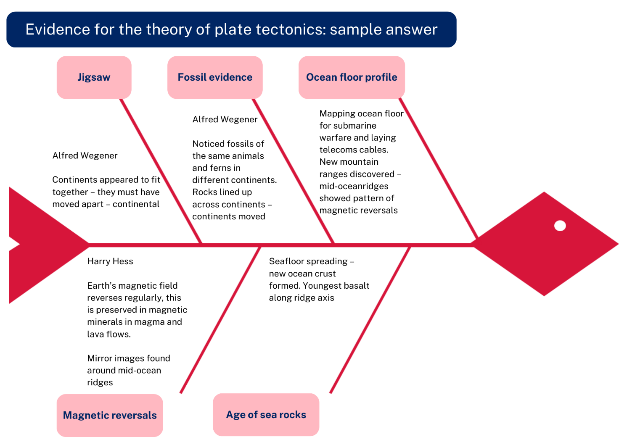

Activity 3: gathering information – evidence
Students will conduct a search of the internet and/or textbooks to fill in a table of information outlining the evidence supporting plate tectonics.
Differentiation: students should use more than one source and cross reference information used. All sources should be referenced.
Students experiencing difficulty could be provided sources and/or sentence starters.

Sample answer
Table 3 – evidence supporting the theory of plate tectonics (sample answers)
Evidence | Scientist or Technology | How the evidence supports the theory of plate tectonics | Image or diagram | Reference or source
Jigsaw fit of continents | Alfred Wegener | The coastlines of Africa and South America are similar and seem to fit together like a jigsaw. The rock types also match up across the continents. | 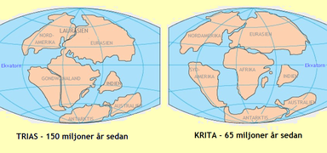  ‘Map showing continental drift’ by Caspiax is in the Public Domain. | Plate tectonics - Development of tectonic theory | Britannica
Fossil evidence | Antonio Snider-Pellegrini | Fossils of Mesosaurous have been found in South America and Africa. Fossils of the glossopteris fern have been found across South America, Africa, India, Antartica and Australia. | 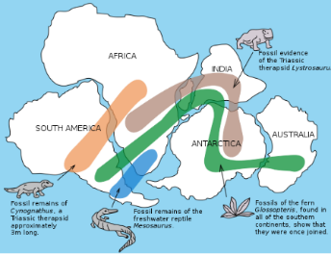  ‘Obra derivade de Snider-Pellegrini Wegener fossil map’ by Osvaldocangaspadilla is in the Public Domain. | Plate tectonics - Development of tectonic theory | Britannica
Seafloor profile | Harry Hess | Bathymetry, the study of the seafloor, shows mid-ocean ridges, deep sea trenches and hotspot volcanoes. New crust is created at mid-oceanridges as the plates spread apart, it is subducted in deep sea trenches. This results in movement of the oceanic plates. | 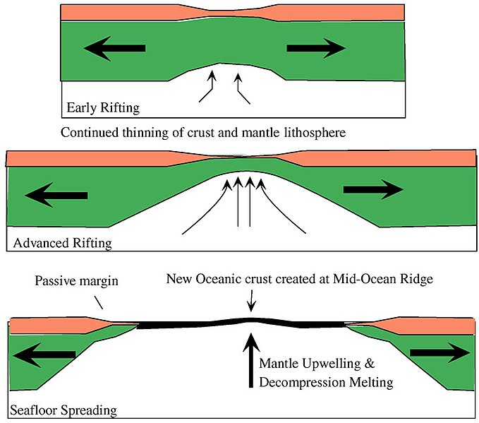  ‘Rifting to Spreading Transition’ by Joshua Doubek by CC BY-SA 3.0. | Seafloor Spreading
Magnetic reversals | Vine and Matthews | Patterns of magnetic reversals were observed parallel to mid-ocean ridges. New stripes were created as new rock formed corresponding to changes in the Earth’s magnetic polarity. This supported the theory that new rock is formed at mid-ocean ridges due to seafloor spreading. | 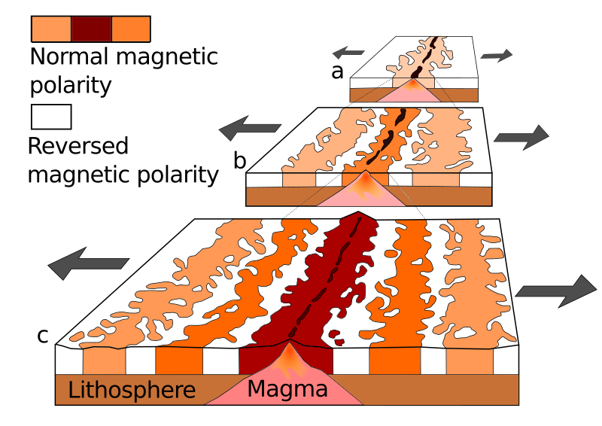  ‘Oceanic.Stripe.Magnetic.Anomalies.Scheme’ by Chmee2 is in the Public Domain. | NOAA Ocean Explorer: Education - Multimedia Discovery Missions | Lesson 2 - Mid-Ocean Ridges | Seafloor Spreading Activity
Age of sea rocks | Glomar Challenger | The Glomar Challenger investigated over 600 sites, taking core samples and analysing them for age and magnetic orientation. The core samples confirmed that the age of the seafloor rocks increased as the distance from mid-ocean ridges increased, that seafloor renewal was taking place and magnetic reversals were as predicted. | 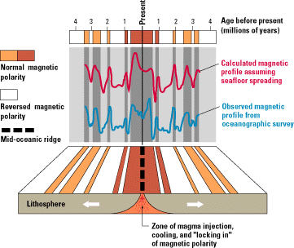  ‘East Pacific Rise seafloor magnetic profile - observed vs calculated’ by W. Jacquelyne Kious and Robert I. Tilling is in the Public Domain. | Ocean Drilling Program: Glomar Challenger drillship

Activity 4: exploring Sir Arthur Holmes and convection currents
In this activity, students will be introduced to Sir Arthur Holmes work with convection currents as the mechanism for continental drift. They will then design, create and justify a model demonstrating the mechanism.
Differentiation: some students may require revision of convection currents.
The development of a model may be conducted in groups to support student learning. Scaffolding model development may be required by some students.
A method may be presented to students in need of further assistance with the use of cloze passages or jumbled instructions.

Sample answers
- Conduct an internet search to find a diagram that demonstrates convection currents in the mantle.
Figure 2 – oceanic spreading
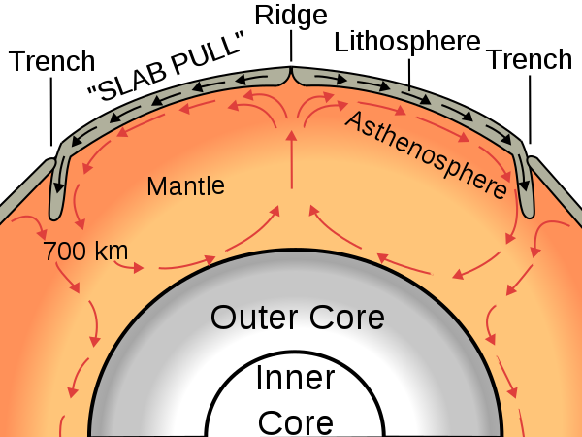
‘Oceanic spreading’ by Surachit is licensed under CC BY-SA 3.0.
- Design and construct a model that will demonstrate the effect of convection currents in the mantle. You may need to use your prior knowledge of convection currents or conduct research to help with this. Remember, the aim is for you to design the model, not find and copy a model so any research that you conduct is background information to support your understanding.
This could take a range of forms, the simplest being convection currents in a beaker of water. Dots of paper created by a hole punch could be placed on top of the water. As the convection currents move the surface of the water, the paper will also move.
- Justify the components of your model.
Each component of the model should be fully justified.
For example.
- Dots of paper floating on the water represent tectonic plates. They move and spread apart or collide as the water below them moves modelling the movement of tectonic plates.
- Water represents the mantle. It is effective as it allows convection currents to form quickly and flow freely. It has the ability to carry the paper dots.
- A Bunsen burner heating one side of the beaker represents uneven heating of the mantle as per a hot spot.
- Outline any limitations of the model.
- Water has a lower viscosity than the mantle so convection currents will flow more quickly than they will in the mantle.
- Paper will absorb water and may sink.
- The paper is light and will move more quickly than tectonic plates will move.

Activity 5: modelling the evidence
The students will undertake 2 exercises in modelling evidence supporting plate tectonics.
- Model the jigsaw fit of continents. A Plate Tectonic Puzzle [PDF 631KB] is a worksheet that may be used for this activity. Print the worksheet for the students to complete.
- Model the magnetic reversals and age of sea rocks at a mid-oceanridge. Blackline masters are included in the activity for printing.
Differentiation: if students require more guidance, provide targeted support and use class discussions to consolidate learning.
A scaffold may be provided to support justifications of strengths and limitations of the models.
Students with physical disabilities may need supports with cutting and pasting activities.

Sample answers

Jigsaw fit
- Complete a jigsaw activity to investigate the similarity in continental boundaries. See your teacher for a print copy of the activity to cut and paste.
- Outline the strengths and weaknesses of this model. Justify your answer.
Strengths:
- A paper model allows students to physically manipulate the pieces. This can aid understanding and visualisation of the evidence.
- It is quick and simple to complete.
Limitations:
- The paper model has limited detail.
- The paper model is incomplete, it does not show the continental shelf that lies below the ocean.
- It does not show the processes that underlie the movement of the plates.
Although there are limitations to using a paper model of the jisgsaw fit contintents, it is a simiple way to visualise the evidence.

Magnetic reversals and age of sea rocks
Model the magnetic reversals and age of sea rocks at a mid-ocean ridge.
- Take the 2 pages that represent the model of a mid-ocean ridge.
- Page 1: seafloor. Cut the 3 lines marked on the page.
- Page 2: new seafloor with magnetic reversals. Colour each normal polarity arrow (up) red. Colour each reversal arrow (down) blue.
- Cut the bands of new seafloor out.
- Hold the strips so that the sides with the magnetic reversal arrows are together.
- Insert one end of the strips up through the middle slit of the seafloor and separate them so that the first magnetic strip is visible. Note the direction.
- Continue pushing the strips through the paper. As the new seabed reaches the slits at the ends of the page, slide them down through the slit. This represents a subduction zone.
- Tape the magnetic reversals down.
- Explain how this model represents the age of seafloor rocks and magnetic reversals?
This model demonstrates that new crust is formed at the mid-ocean ridge. As new seafloor is created, the older is pushed further away from the mid-ocean ridge showing how the age of seafloor rocks changes along the seafloor. Magnetic reversals are shown in the colours and arrows. The model demonstrates that the magnetic strips are parallel to the mid-ocean ridge and change periodically.
- Discuss the benefits and limitations of this model in representing the age of sea rocks and magnetic reversals.
Strengths:
- Simple visualisation of the age of the seafloor and magnetic reversals.
- Shows the loss of seafloor at subduction zones as well as creation of rock.
Limitations:
- Implies that the magnetic reversals are regular when they are not.
- It is two-dimensional only so does not show the profile of the seafloor.

Activity 6: continental drift or plate tectonics?
Continental drift and plate tectonics are 2 terms that are sometimes used interchangeably. Students will conduct research to add detail and specific examples of similarities and differences between the 2 ideas. They will then create a graphic to demonstrate understanding. For example, this could take the form of a Venn Diagram, table or Appendix A – compare and contrast chart.
This task is focused on starting with simple information from the website provided, then gathering more details to deepen understanding. Encourage students to go beyond their current level of understanding and use multiple sources of information.
Differention: if students require more guidance, provide targeted support and use class discussions to consolidate learning.
Some students may require guidance on the selection and use of graphic organisers.

Sample answers
- Use the information on this Continental Drift versus Plate Tectonics webpage as a starting point to conduct more in depth research. Compare and contrast the 2 ideas.
- Create a list of similarities and differences from the article.
Table 4 – similarities and differences between the theories of continental drift and plate tectonics (sample answers)
Similarities | Differences
Movement of continents | Qualitative evidence supported Continental drift
Multiple pieces of evidence supported the theories | Wegener did not have a mechanism for the movement of continents
N/A | Technology development provided quantitative evidence before the theory of plate tectonics was proposed
N/A | Strips of rock with alternate magnetic poles is explained in the theory of plate tectonics
- Conduct your own research to add detail and specific examples of similarities and differences between the 2 ideas.
- Create a graphic to demonstrate your understanding. For example, this could take the form of a Venn diagram, table or compare and contrast chart.
Figure 3 – compare and contrast chart
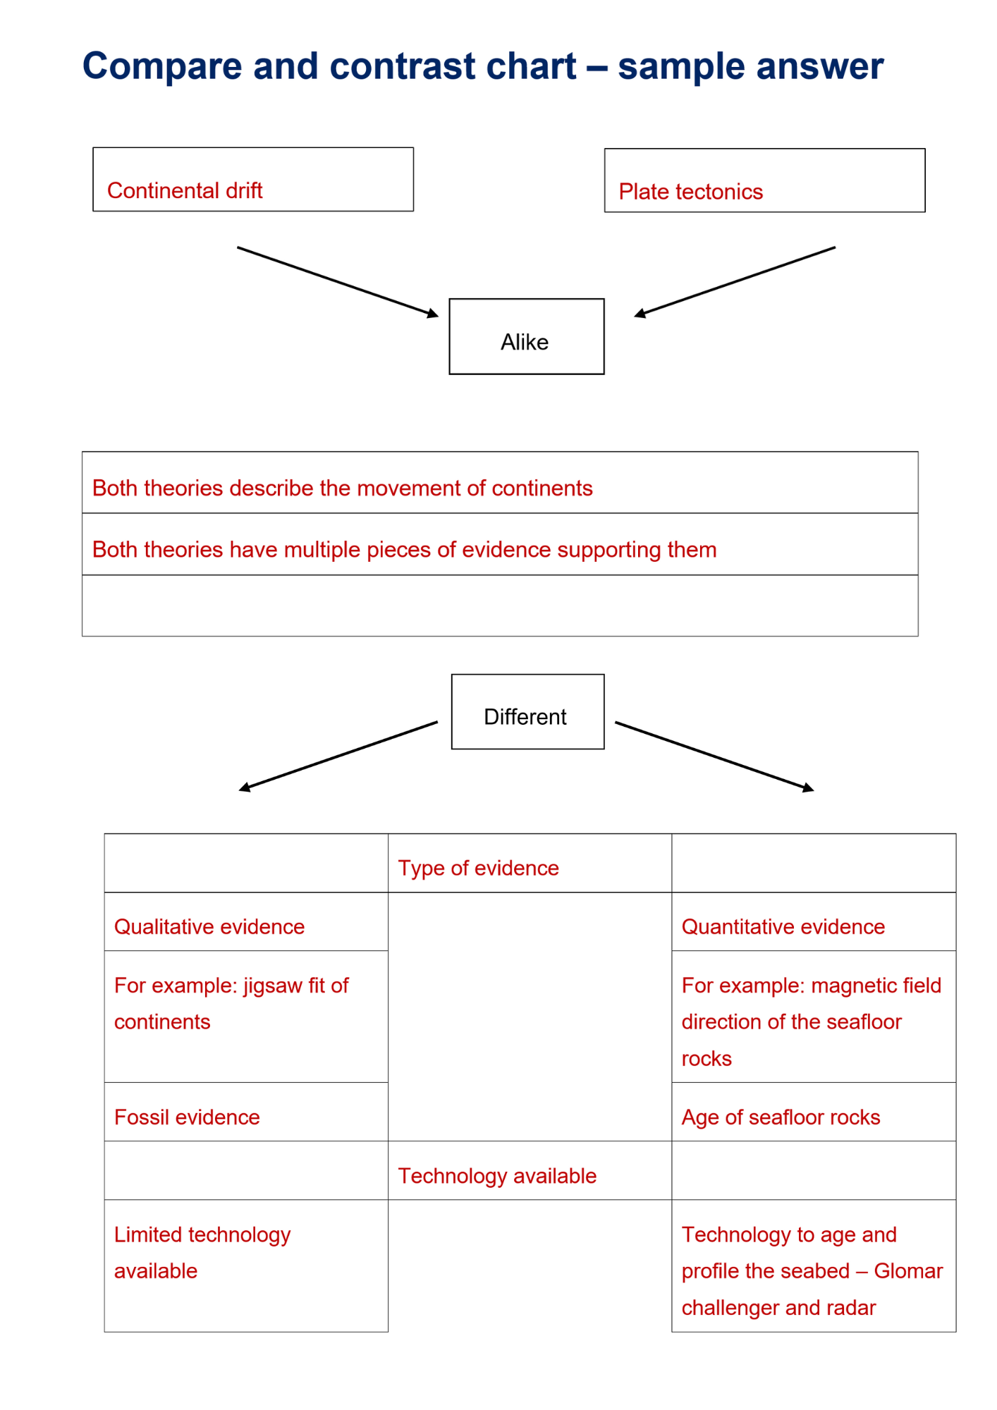
Figure 4 – compare and contrast chart (part 2)
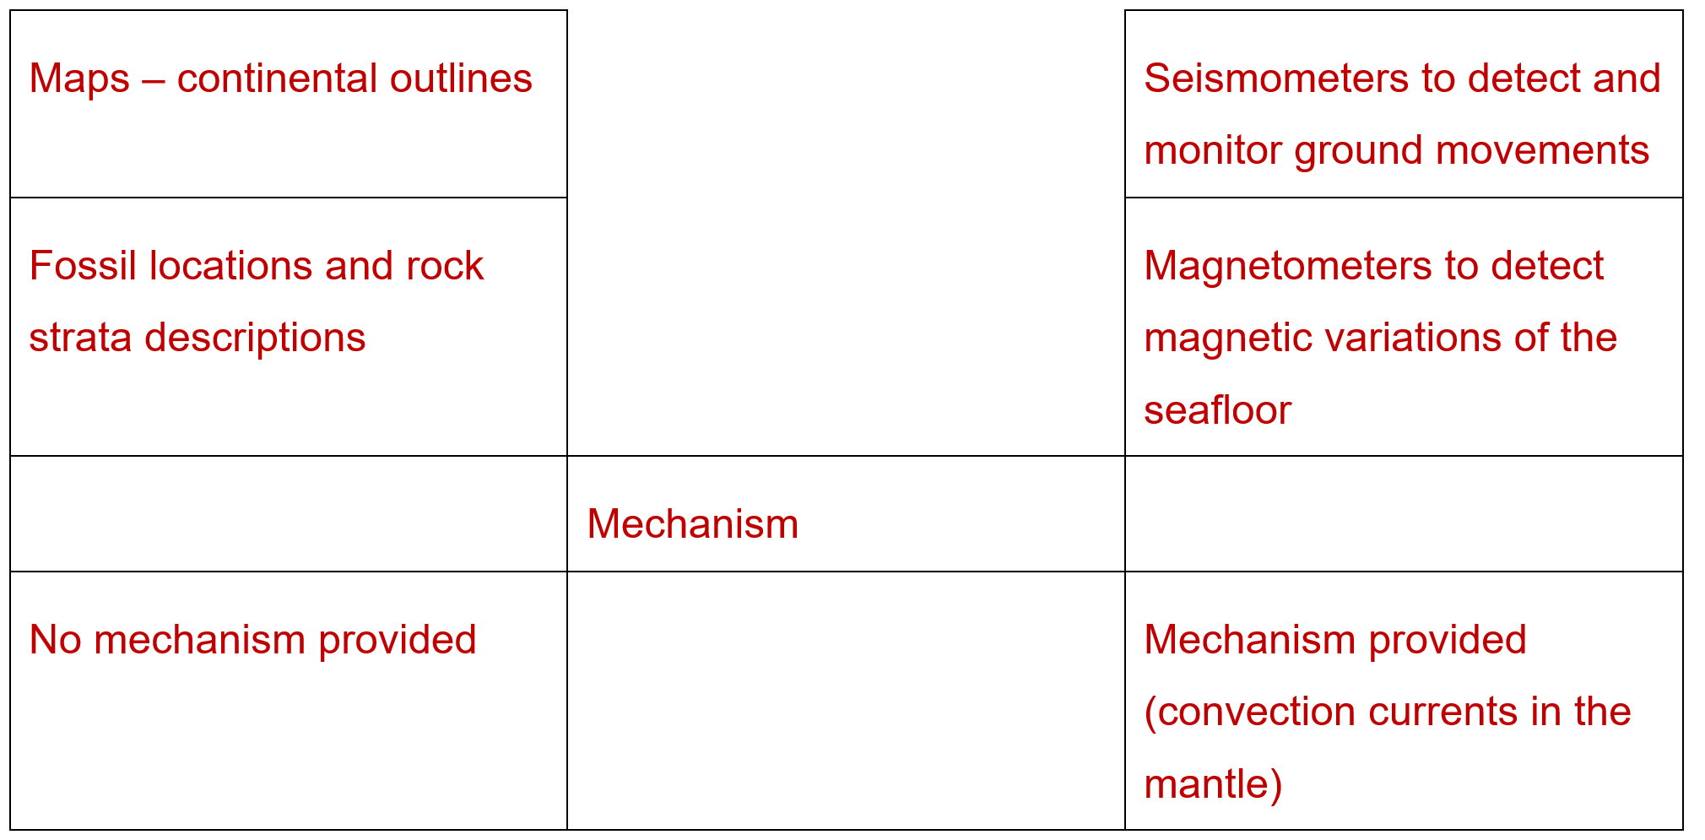
Activity 7: evaluating the evidence
In this activity, students will gather and evaluate the evidence provided to support plate tectonics. They will then use this data to write a formal report.
Differentiation: it is important that students understand the terms impact and evaluate. These may need to be explicitly taught to students before they complete this task.
Note: the focus of this task is on formal report writing. Some students may require a scaffold for this part of the activity. Explicit instruction on writing a formal report should have been conducted prior to this learning activity. Individual or small group support may be required. This could take the form of advice on vocabulary, sentence structure or text structure or the provision of sentence and paragraph starters.
Provide targeted support for students as required.
- Use a variety of sources to conduct a secondary source survey of the evidence supporting the theory of plate tectonics. Keep a reference list of all resources that you use.
- Complete the table below.
Table 5 – impact of the evidence contributed to the theory of plate tectonics (sample answers)
Scientist(s) | Date | Contribution to the theory of plate tectonics | Impact of their evidence
Wegener | 1912 | He proposed the theory of continental drift which suggested that the Earth’s continents were once joined together in a supercontinent called Pangaea then gradually drifted apart over time. | It challenged the view that the continents were fixed in place and could not move.  The theory of continental drift was the precursor to the theory of plate tectonics.
Holmes | Late 1920s | Holmes proposed that heat flow from the Earth's interior drives the movement of the Earth's crust, which in turn leads to the formation and movement of the Earth's tectonic plates.  Holmes suggested that the Earth's mantle is convecting, with hot material rising and cooler material sinking. This process creates a kind of conveyor belt system that drags the Earth's tectonic plates along with it. The plates move away from spreading ridges, where new crust is being created, and are eventually subducted, or pulled back into the mantle, at subduction zones. | Holmes' ideas about mantle convection helped to provide a physical explanation for how the Earth's tectonic plates move and interact with each other.  He inspired further research and development of the theory of plate tectonics, leading to a greater understanding of how the Earth's surface has changed over time.
Hess | Early 1960s | Hess was the first to propose the concept of seafloor spreading in the early 1960s, which suggested that new oceanic crust is formed at mid-ocean ridges and then spreads outward in opposite directions, eventually being subducted back into the mantle at subduction zones. He incorporated Holmes’ idea of convection currents in the mantle with the profile of the seafloor to arrive at his conclusion. | This idea helped to explain the age and distribution of the Earth's ocean basins, as well as the magnetic stripes that are found on the seafloor.  His proposals provided a unifying framework for a wide range of geological phenomena, including the distribution of earthquakes and volcanic activity, the formation of mountain ranges, and the evolution of the Earth's climate over time. His ideas revolutionized the field of geology and helped to establish plate tectonics as one of the most important and influential scientific theories of the 20th century.
Vine and Matthews | 1963 | Their work on mapping the magnetic properties of rocks allowed them to determine the relative positions of continents over time and make connections between changes to the Earth’s magnetic field over time and the magnetic reversals observed rocks in the seafloor. | Their work provided: confirmation of seafloor spreading, the development of a magnetic reversal timescale, connection between plate tectonics and the Earth’s magnetic field.
Glomar challenger | 1968 | Scientists could study the ocean floor in detail leading to confirmation of seafloor spreading through determining patterns in the age of rocks. Mapping the seafloor profile and the discovery of new geological features – trenches, vents. | Mapping showed the centres for seafloor spreading. The age of rocks in the sea bed also supported seafloor spreading which in turn provided physical evidence supporting plate tectonics.

- Present your findings in a formal report.
The theory of plate tectonics is a widely accepted scientific model that explains the movement of the Earth's crustal plates. The theory proposes that the Earth's crust is made up of several large plates that move relative to each other over time. This report will evaluate the evidence supporting the theory of plate tectonics, including the findings of Wegener, Holmes, Hess, Vine and Matthews and the Glomar Challenger.
Wegener’s proposal of the theory of continental drift suggested that the Earth’s continents were once joined together in a supercontinent called Pangaea then gradually drifted apart over time. Although the theory was rejected at the time due to a lack of a mechanism, it challenged the view that the continents were fixed in place and could not move. It became the precursor to the theory of plate tectonics.
Holmes proposed that heat flow from the Earth's interior drives the movement of the Earth's crust, which in turn leads to the formation and movement of the Earth's tectonic plates. He suggested that the Earth's mantle is convecting, with hot material rising and cooler material sinking. This process creates a kind of conveyor belt system that drags the Earth's tectonic plates along with it. The plates move away from spreading ridges, where new crust is being created, and are eventually subducted, or pulled back into the mantle, at subduction zones. Holmes' ideas about mantle convection helped to provide a physical explanation for how the Earth's tectonic plates move and interact with each other. He inspired further research and development of the theory of plate tectonics, leading to a greater understanding of how the Earth's surface has changed over time.
Hess was the first to propose the concept of seafloor spreading in the early 1960s, which suggested that new oceanic crust is formed at mid-ocean ridges and then spreads outward in opposite directions, eventually being subducted back into the mantle at subduction zones. He incorporated Holmes’ idea of convection currents in the mantle with the profile of the seafloor to arrive at his conclusion. This idea helped to explain the age and distribution of the Earth's ocean basins, as well as the magnetic stripes that are found on the seafloor. His proposals provided a unifying framework for a wide range of geological phenomena, including the distribution of earthquakes and volcanic activity, the formation of mountain ranges, and the evolution of the Earth's climate over time.
The work of Vine and Matthews on mapping the magnetic properties of rocks allowed them to determine the relative positions of continents over time. It also allowed for connections between changes to the Earth’s magnetic field and the magnetic reversals observed rocks in the seafloor to be made. Their work provided confirmation of seafloor spreading, the development of a magnetic reversal timescale and connection between plate tectonics and the Earth’s magnetic field thus providing physical evidence to support the theory of plate tectonics.
The Glomar Challenger provided scientists the opportunity to study the ocean floor in detail. This led to the confirmation of seafloor spreading through determining patterns in the age of rocks. Mapping the seafloor profile and the discovery of new geological features such as trenches, mounts and vents. The research from the Glomar Challenger provided important physical evidence in support of the theory of plate tectonics.
The evidence supporting the theory of plate tectonics is overwhelming. Each piece of evidence has built upon previous knowledge and evidence to produce the theory that is currently accepted.

Activity 8: place mat analysis
Placemats are a method of summarising a lot of information into a one page. They can include: short summaries of information, images, diagrams, links between ideas, evaluations and analyses.
Students will create a placemat analysis of the evidence supporting plate tectonics and the scientists responsible for the evidence. In order to do this you will need to analyse the information to find the most important facts and summarise them into a small space.
This activity will elicit a range of responses. Students should be encouraged to use their critical thinking and creativity in completing this activity.

Activity 9: open option
Students have the option to deep dive into an area in which they need to development their understanding further. Information can be presented using their preferred mode of learning.
If students choose this option, they should discuss their ideas with their teacher. It is intended to be a high order thinking activity so should delve deeply into content and be evaluative or analytical in nature.
Differentiation: students may require teacher guidance on the depth of understanding required and the development of a high-quality question. Although this task is intended as an extension activity, it could also be used for students experiencing difficulty with a concept to further consolidate their understanding.

Student resources

Tic-tac-toe activity grid
The activity choice boardcontains an outline of activities that can be selected for completion.
Activity 1:  Comprehension activity from written text | Activity 2:  Video analysis and fishbone diagram summary | Activity 3:  Conduct research and fill in table
Activity 4:  Exploring Holmes and convection currents | Activity 5:  Modelling evidence:  Jigsaw of continents, physical matching of fossils, age of seafloor rocks and magnetic reversals | Activity 6:  Compare and contrast similarities between continental drift and the theory of plate tectonics
Activity 7:  Evaluate the evidence and written report | Activity 8:  Place mat analysis | Activity 9:  Open option activity

Resource 1: evidence for plate tectonics – written text comprehension activity
The text below summarises the key evidence supporting the Theory of Plate Tectonics. Remember that diagrams are included in a text for a reason. You should look at them carefully as you read and note important information.

Evidence supporting the theory of plate tectonics
The theory of plate tectonics is a widely accepted scientific model that explains the movement of the Earth's lithosphere, the outermost layer of the planet. According to this theory, the lithosphere is divided into several large, rigid plates that move slowly over the Earth's surface, interacting with each other at their boundaries. Although the theory was first proposed by Alfred Wegener in the early 20th century, it was not until the 1960s and 1970s that substantial evidence was found to support it. In this report, we will examine the various lines of evidence that support the theory of plate tectonics.
Jigsaw puzzle fit: one of the most compelling pieces of evidence supporting the theory of plate tectonics is the jigsaw puzzle fit of the continents. Alfred Wegener first noticed this phenomenon in the early 1900s. He observed that the coastlines of Africa and South America fit together like pieces of a puzzle. The Mid-Atlantic Ridge also follows the same shape.The fit of these coastlines suggests that the continents were once joined together in a single landmass, which scientists have named Pangaea. This led him to propose the theory of continental drift, which later evolved into the theory of plate tectonics.
Figure 5 – map showing continental drift
‘Maps showing the continental drift during Triassic and Cretaceous periods’ by Caspiax is in the Public Domain.
Fossil evidence: Another key piece of evidence supporting the theory of plate tectonics is the presence of identical fossils on opposite sides of the ocean. For example, identical plant and animal fossils have been found on the eastern coast of South America and the western coast of Africa. These fossils suggest that the 2 continents were once connected and that the landmass separating them today was once part of a larger continent. This evidence was also noted by Wegener in his original proposal of continental drift.
Figure 6 – Snider-Pellegrini Wegener fossil map
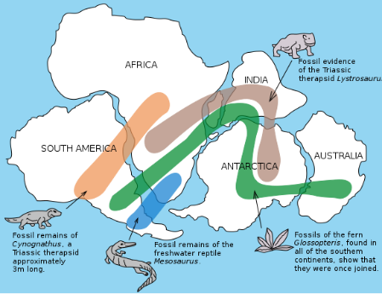
‘Obra derivade de Snider-Pellegrini Wegener fossil map’ by Osvaldocangaspadilla is in the Public Domain.
Ocean floor profile: The topography of the ocean floor also provides evidence supporting the theory of plate tectonics. In the 1950s and 1960s, scientists used sonar to map the ocean floor and discovered a system of mid-ocean ridges. These ridges are long chains of underwater mountains that run through the center of the world's oceans. The ridges are created by the upwelling of molten material from the Earth's mantle, which spreads out and pushes the oceanic plates apart, creating new crust. This discovery was made by Harry Hess in the 1960s and was an essential part of his proposal of seafloor spreading.
Figure 7 – Earth seafloor crust age 1996
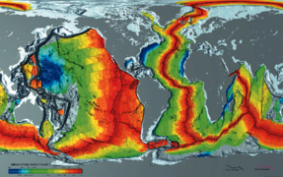
‘Earth seafloor crust age 1996’ by Sapernaud is in the Public Domain.
Figure 8 – key for the image 'Earth seafloor crust age'
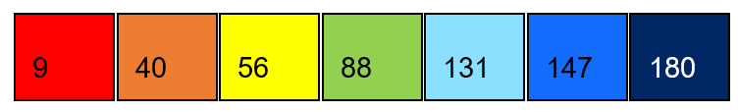
Millions of years before present.
Age of sea rocks: another important line of evidence supporting the theory of plate tectonics is the age of the seafloor. Scientists have found that the rocks on the ocean floor are much younger than the rocks on the continents. This suggests that the ocean floor is continually being created and destroyed, as the plates move and interact with each other. This evidence was also noted by Wegener, who observed that the oceanic crust is much thinner and younger than the continental crust.
Magnetic reversals: scientists have also found evidence of magnetic reversals in the rocks of the ocean floor. As the Earth's magnetic field changes polarity over time, it leaves a record in the rocks on the ocean floor, parallel to mid-oceanridges. By studying these magnetic reversals, scientists have been able to track the movements of the oceanic plates over millions of years. This discovery was made by Fred Vine and Drummond Matthews in the 1960s.
Figure 9 – oceanic stripe magnetic anomalies
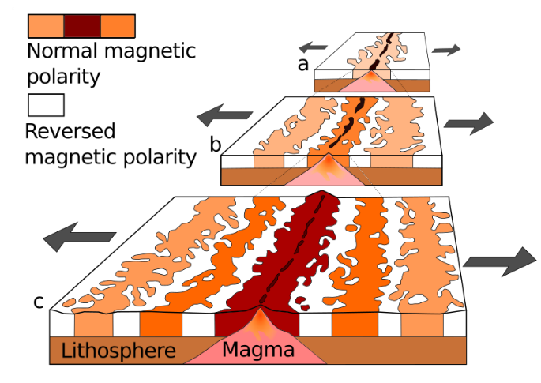
‘Oceanic.Stripe.Magnetic.Anomalies.Scheme’ by Chmee2 is in the Public Domain.
Glomar Challenger: the Glomar Challenger was a research vessel that was used in the 1960s and 1970s to gather data on the ocean floor. The vessel drilled into the ocean floor and collected core samples that provided evidence supporting the theory of plate tectonics. The core samples revealed the age of the ocean floor and showed that it was much younger than the continents, supporting the idea of seafloor spreading. The samples also showed that the magnetic orientation of the rocks changed with depth, supporting the theory of magnetic reversals. The Glomar Challenger provided a wealth of data that confirmed the ideas of Hess, Vine, and Matthews, and helped to solidify the theory of plate tectonics.

Questions
- Skim and scan:
- Read all the headings and sub-headings in this text.
- Highlight the following terms or people: Wegener, Jigsaw fit, fossil, seafloor, age of sea rocks, magnetic reversals, Holmes, Hess, Vine, Matthews, Glomar.
- Use a different colour to highlight the key terms for each idea.
- Draw a line to link each piece of evidence to the person or technology responsible for it.
- Comprehension questions:
- Who was the scientist responsible for the theory of continental drift?
- The commonly provided example of continents that fit together is Africa and South America. Provide another example that supports the jigsaw fit of continents as evidence of plate tectonics.
- Identify one animal and one plant fossil that supports evidence of plate tectonics.
- The freshwater fossil Mesosaurus has been found in South America and southern Africa. Explain why it provides evidence that the continents were once joined.
- Describe where the newest crust is on the seafloor.
- How does this support the theory of plate tectonics?
- Identify where the magnetic reversals have been found in the Earth’s crust.
- Explain why this is significant.
- Outline the importance of the Glomar Challenger.
- Create a table linking scientists to their findings.

Resource 2: how do we know plate tectonics is real?
- Watch the following Youtube videos.
- How Do We Know Plate Tectonics Is Real? (4:22).
- Earth.Parts #1 - Discovery of plate tectonics, seafloor spreading & subduction (11:15).
- Complete the Fishbone activity with brief summary notes.
- Ensure that you link the evidence, the scientist responsible and how the evidence supports plate tectonics.
- Take note of any missing pieces of information or areas of which you are unsure so that you can make sure that you address them in another activity.
- Create a timeline showing all major contributions to our understanding of the theory of plate tectonics.
Note: a Fishbone diagram is used to for very short summaries only so you need to look for the most important information to include.

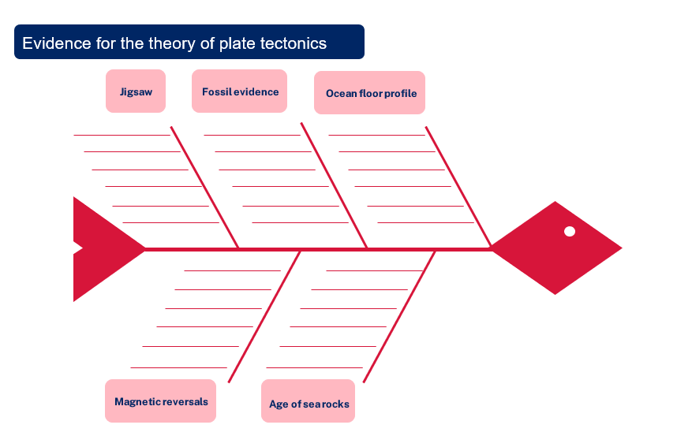

Resource 3: gathering information – evidence
Conduct a search of the internet and/or your textbooks to fill in the table below. Make sure that you have 2 sources of information for each point to cross reference the information you find and increase its reliability.
Table 6 – evidence supporting plate tectonics
Evidence | Scientist or Technology | How the evidence supports the theory of plate tectonics | Image or diagram | Reference or source
Jigsaw fit of continents
Fossil evidence
Profile of the ocean floor
Magnetic reversals
Age of sea rocks

Resource 4: exploring Sir Arthur Holmes and convection currents
In 1919, Sir Arthur Holmes suggested the mechanism for continental drift was convection currents. Holmes showed that the Earth’s internal temperature was maintained by the heat generated from radioactive decay. He proposed that this heat could build up and produce convection cells in the mantle. Hot material in the mantle would rise, as it cooled it would sink.
Upward convection from a hotspot could lift or rupture the crust causing continental uplift. The lateral (sideways) movement of the convection current in the mantle could pull the crust apart causing continents to break up. Or, it could push them together causing mountain ranges to form.
- Conduct an internet search to find a diagram that demonstrates convection currents in the mantle.
- Design and construct a model that will demonstrate the effect of convection currents in the mantle. You may need to use your prior knowledge of convection currents or conduct research to help with this. Remember, the aim is for you to design the model, not find and copy a model so any research that you conduct is background information to support your understanding.
- Justify the components of your model.
- Outline any limitations of the model.

Resource 5: modelling the evidence

Jigsaw fit
- Complete a jigsaw activity to investigate the similarity in continental boundaries. See your teacher for a print copy of the activity to cut and paste.
- Outline the strengths and weaknesses of this model. Justify your answer.

Magnetic reversals and age of sea rocks
Model the magnetic reversals and age of sea rocks at a mid-ocean ridge.
- Take the 2 pages that represent the model of a mid-ocean ridge.
- Page 1: seafloor. Cut the 3 lines marked on the page
- Page 2: New seafloor with magnetic reversals. Colour each normal polarity arrow (up) red. Colour each reversal arrow (down) blue.
- Cut the bands of the new seafloor out.
- Hold the strips so that the sides with the magnetic reversal arrows are together.
- Insert one end of the strips up through the middle slit of the seafloor and separate them so that the first magnetic strip is visible. Note the direction.
- Continue pushing the strips through the paper. As the new seabed reaches the slits at the ends of the page, slide them down through the slit. This represents a subduction zone.
- Tape the magnetic reversals down.
- Explain how this model represents the age of seafloor rocks and magnetic reversals.
- Discuss the benefits and limitations of this model in representing the age of sea rocks and magnetic reversals.
Figure 10 – step 1, page 2 – magnetic reversals
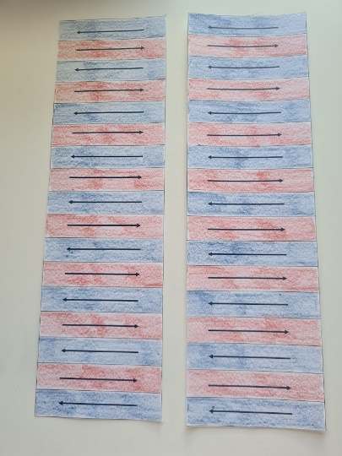
Figure 11 – step 3
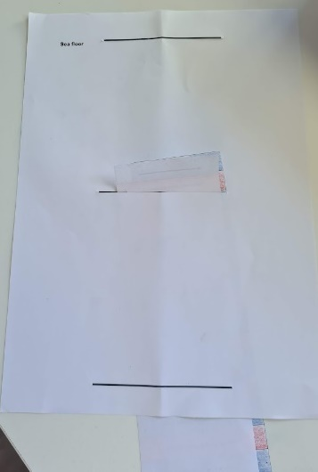
Figure 12 – step 4
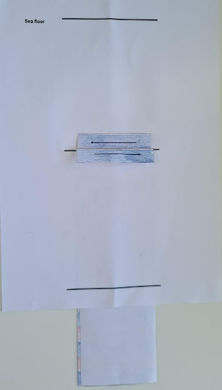
Figure 13 – step 5
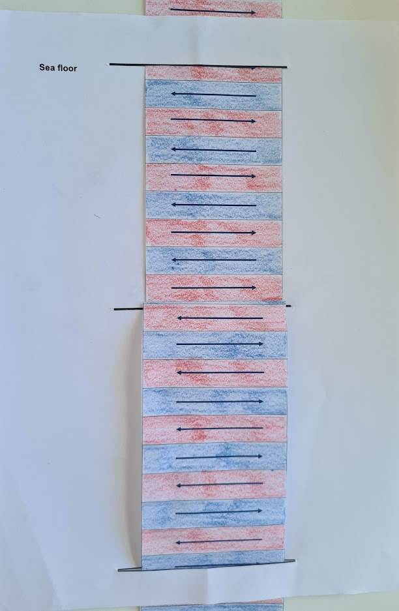
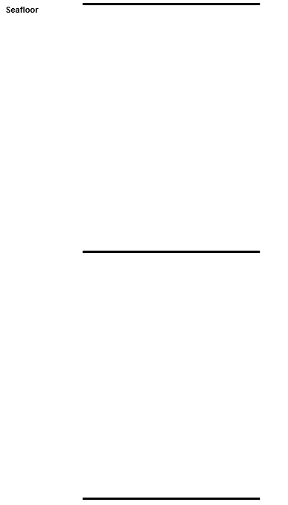
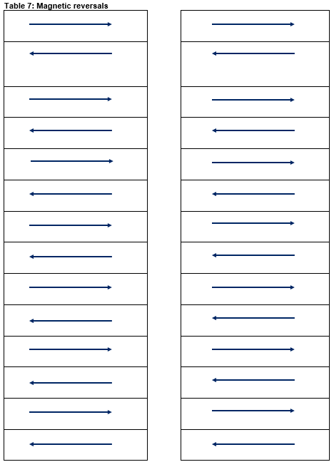

Resource 6: continental drift or plate tectonics?
Continental drift and plate tectonics are 2 terms that are sometimes used interchangeably.
- Use the information on this Continental Drift versus Plate Tectonics website as a starting point to conduct more in depth research. Compare and contrast the 2 ideas.
- Create a list of similarities and differences from the article.
- Conduct your own research to add detail and specific examples of similarities and differences between the 2 ideas.
- Create a graphic to demonstrate your understanding. For example, this could take the form of a Venn Diagram, table or compare and contrast chart.
Venn diagram
Compare and contrast chart

Resource 7: evaluating the evidence
Wegener’s theory of continental drift was dismissed because there was no identified mechanism for the movement of the continents. Conversely, the theory of plate tectonics was quite quickly accepted with little explanation for the movement of the plates. In this task you will evaluate the evidence for each of the major contributions to our understanding of the theory of plate tectonics. Remember for evidence to have an impact, it must have changed our understanding in some way.
- Use a variety of sources to conduct a secondary source survey of the evidence supporting the theory of plate tectonics. Keep a reference list of all resources that you use.
- Complete the table below.
- Present your findings in a formal report.
References:
List your references below.
Table 7 – impact of the evidence contributed to the theory of plate tectonics
Scientist(s) | Date | Contribution to the theory of plate tectonics | Impact of their evidence
Wegener
Holmes
Hess
Vine and Matthews
Glomar challenger

Resource 8: placemat analysis
Placemats are a method of summarising a lot of information into a one page. They can include: short summaries of information, images, diagrams, links between ideas, evaluations and analyses.
Create a placemat analysis of the evidence supporting plate tectonics and the scientists responsible for the evidence. In order to do this you will need to analyse the information to find the most important facts and summarise them into a small space.
Steps:
- Gather your information – all the evidence, the scientists and their research.
- Try to break the information down into one or 2 sentences or phrases.
- Think about how you can represent the information as diagrams or pictures.
- Plan a layout for your placemat.
- Start creating. The idea is that this is should be engaging to look at, chunk ideas with colour and lettering style. Have some fun, but make your decisions relevant to the topic.
Figure 14 – example one of a placemat summary
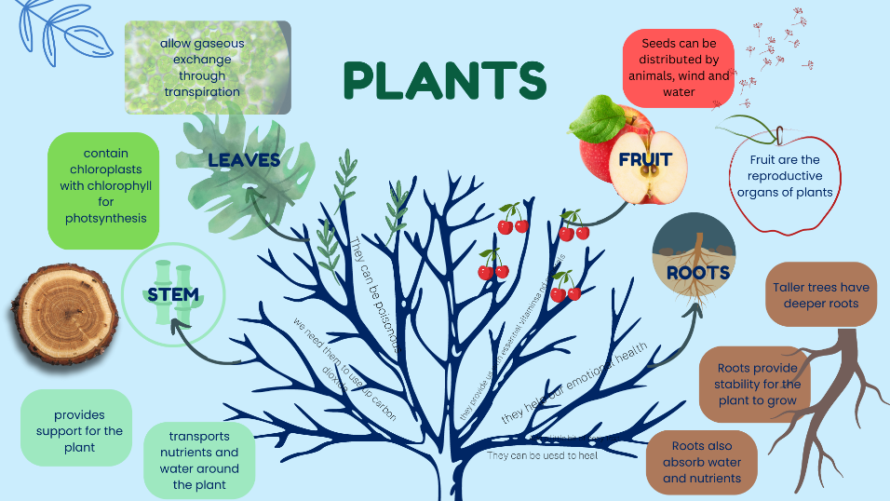
Figure 15 – example 2 of a placemat summary
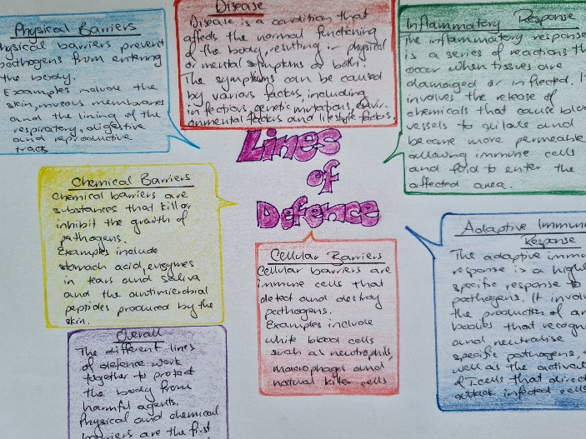

Resource 9: open option
In this activity you will be able to choose your topic of study and the method that you use to demonstrate your understanding.
- Look through the list of topics and scientists that you need to be able to discuss.
- Choose one of these topics that you wish to know more about or that you feel you don’t understand as well as the others.
- Develop a question to answer about the topic. You may need to work with your teacher to do this.
- Some question starters include:
- Evaluate the impact of…
- Analyse the evidence…
- Determine the value of…
- What data was used…
- Conduct research to answer the question.
- Select an appropriate method to demonstrate your understanding. This could be a written report, a graphic organiser, vodcast, podcast. This is your chance to shine.

Appendix A – Venn diagram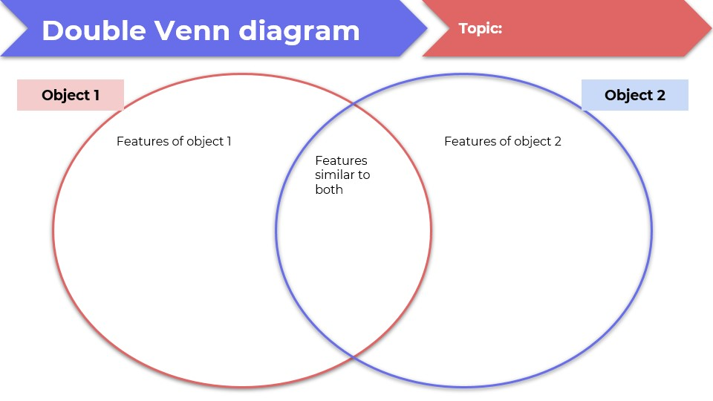

Compare and contrast chart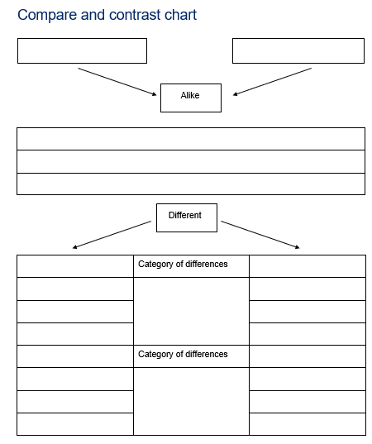

Support and alignment
Resource evaluation and support: all curriculum resources are prepared through a rigorous process. Resources are periodically reviewed as part of our ongoing evaluation plan to ensure currency, relevance and effectiveness. For additional support or advice, or to provide feedback, contact the Science Curriculum team by emailing Science7-12@det.nsw.edu.au.
Differentiation: further advice to support Aboriginal and Torres Strait Islander students, EALD students, students with a disability and/or additional needs and High Potential and gifted students can be found on the Curriculum webpage.
Assessment: further advice to support formative assessment is available on the Planning, programming and assessing 7-12 webpage.
Professional learning: relevant professional learning is available on the Science statewide staffroom. Stage 6 Literacy in context provides further advice to teachers to improve student writing.
Related resources: further resources to support Stage 6 Earth and Environmental Science can be found on the Planning, programming and assessing science 11–12 page.
Consulted with: Curriculum and Reform, Inclusive Education, Multicultural Education, Aboriginal Outcomes and Partnerships and subject matter experts.
Alignment to system priorities and/or needs: School Excellence Policy.
Alignment to Australian Professional Teaching Standards: this resource supports teachers to address Australian Professional Teaching Standards 2.1.2, 2.5.2, 3.2.2, 3.3.2.
Author: Science 7-12 Curriculum Team
Resource: Classroom resource
Creation date: 15 March 2023

References
This [document / resource] contains NSW Curriculum and syllabus content. The NSW Curriculum is developed by the NSW Education Standards Authority. This content is prepared by NESA for and on behalf of the Crown in right of the State of New South Wales. The material is protected by Crown copyright.
Please refer to the NESA Copyright Disclaimer for more information https://educationstandards.nsw.edu.au/wps/portal/nesa/mini-footer/copyright.
NESA holds the only official and up-to-date versions of the NSW Curriculum and syllabus documents. Please visit the NSW Education Standards Authority (NESA) website https://educationstandards.nsw.edu.au/ and the NSW Curriculum website https://curriculum.nsw.edu.au/home.
Earth and Environmental Science Syllabus © NSW Education Standards Authority (NESA) for and on behalf of the Crown in right of the State of New South Wales, 2017.
Australian Earth Science Education (n.d.) Earth & Enviro Science (NSW), Australian Earth Science Education website, accessed 13 June 2025.
Paleontological Research Institution (2021) Evidence for the Movement of Continents, Earth@Home website, accessed 13 June 2025.
National Geographic Society (2023) Seafloor Spreading, National Geographic Education website, accessed 13 June 2025.
NESA (NSW Education Standards Authority) (2022) ‘Proficient teacher: standard descriptors’, The Standards, NESA website, accessed 13 June 2025.
CESE (Centre for Education Statistics and Evaluation) (2020a) ‘What works best: 2020 update’, NSW Department of Education, accessed 13 June 2025.
CESE (Centre for Education Statistics and Evaluation) (2020b) ‘What works best in practice’, NSW Department of Education, accessed 13 June 2025.
Vendatu.com (2023) Continental Drift Theory, Vendatu website, accessed 13 June 2025.
Earth. Parts (9 December 2016) ‘Earth.Parts #1 - Discovery of plate tectonics, seafloor spreading & subduction’ [video], Earth.Parts, YouTube, accessed 13 June 2025.
Hanson J (8 March 2017) ‘How Do We Know Plate Tectonics Is Real?’ [video], Be Smart, YouTube, accessed 13 June 2025.
Ritter ME (n.d.) 15.1: Plate Tectonics and Continental Drift, LibreTexts Geosciences website, accessed 13 June 2025.

Further reading
State of New South Wales (Department of Education) (2022) Literacy and numeracy, NSW Department of Education, accessed 13 June 2025.
State of New South Wales (Department of Education) (2022) Literacy and numeracy priorities, NSW Department of Education, accessed 13 June 2025.
State of New South Wales (Department of Education) (2022) Strategies for differentiation, NSW Department of Education, accessed 13 June 2025.
© State of New South Wales (Department of Education), 2023
The copyright material published in this resource is subject to the Copyright Act 1968 (Cth) and is owned by the NSW Department of Education or, where indicated, by a party other than the NSW Department of Education (third-party material).
Copyright material available in this resource and owned by the NSW Department of Education is licensed under a Creative Commons Attribution 4.0 International (CC BY 4.0) licence.

This licence allows you to share and adapt the material for any purpose, even commercially.
Attribution should be given to © State of New South Wales (Department of Education), 2023.
Material in this resource not available under a Creative Commons licence:
- the NSW Department of Education logo, other logos and trademark-protected material
- material owned by a third party that has been reproduced with permission. You will need to obtain permission from the third party to reuse its material.
Links to third-party material and websites
Please note that the provided (reading/viewing material/list/links/texts) are a suggestion only and implies no endorsement, by the New South Wales Department of Education, of any author, publisher, or book title. School principals and teachers are best placed to assess the suitability of resources that would complement the curriculum and reflect the needs and interests of their students.
If you use the links provided in this document to access a third-party's website, you acknowledge that the terms of use, including licence terms set out on the third-party's website apply to the use which may be made of the materials on that third-party website or where permitted by the Copyright Act 1968 (Cth). The department accepts no responsibility for content on third-party websites.

