Chemistry Stage 6 – Module 7
Chemistry IUPAC nomenclature guide
Contents
Outcomes 3
Chemical nomenclature 5
Nomenclature of inorganic compounds 6
Element names and symbols 7
Sequence of the name 8
Sequence of the formula 10
Names of coordination complexes 11
Sequence of the formula 12
Organic nomenclature 13
Drawing structures 14
Text styles 14
Atom labels 14
Intramolecular bonds 16
Intermolecular bonds 18
Naming structures 19
Identification of the parent structure 19
Identification of functional groups 23
Alkenes 23
Alkynes 24
Alcohols (primary, secondary and tertiary) 25
Aldehydes 25
Ketones 26
Carboxylic acids 27
Amines 27
Amides 28
Halogenated organic compounds 29
Side chains 29
Numbering of the parent structure 31
Constructing the name 32
Appendix A – further reading 35
Appendix B – types of nomenclature 37
Support and alignment 38
References 39
Further reading 40

Note: this resource is a reference material for teachers to support the teaching of chemical nomenclature in Chemistry Stage 6. It is not relevant for the resource to explicitly reference suggestions or modifications to meet the needs of all students.

Outcomes
This teaching resource addresses the following outcomes:
- explores the properties and trends in the physical, structural and chemical aspects of matter CH11-8
Inquiry question: How do the properties of substances help us to classify and separate them?
- investigate the nomenclature of inorganic substances using International Union of Pure and Applied Chemistry (IUPAC) naming conventions
- analyses the structure of, and predicts reactions involving, carbon compounds CH12-14
Inquiry question: Why are atoms of elements different from one another?
- investigate the basic structure of stable and unstable isotopes by examining:
- representation of the symbol, atomic number and mass number (nucleon number)
Inquiry question: How do we systematically name organic chemical compounds?
- investigate the nomenclature of organic chemicals, up to C8, using IUPAC conventions, including simple methyl and ethyl branched chains, including:
- alkanes
- alkenes
- alkynes
- alcohols (primary, secondary and tertiary)
- aldehydes and ketones
- carboxylic acids
- amines and amides
- halogenated organic compounds
Chemistry Stage 6 Syllabus © NSW Education Standards Authority (NESA) for and on behalf of the Crown in right of the State of New South Wales, 2017.

Chemical nomenclature
The primary aim of chemical nomenclature is to provide a methodology for assigning descriptors (names and formulae) to chemical species so that they can be identified without ambiguity, thereby facilitating communication (Connelly et al. 2005:3).
IUPAC concerns itself principally with compositional, substitutive, and additive nomenclatures (Leigh 2011:35).
- Compositional nomenclature is based on stoichiometry. It is not restricted to binary (two-element) compounds, but the nomenclature is often binary in structure (Leigh 2011:35).
- Substitutive nomenclature is the principal nomenclature used in organic chemistry (Leigh 2011:36).
- Additive nomenclature was developed originally to name coordination compounds, although, when appropriate, it is now also used in other circumstances. It is sometimes called coordination nomenclature (Leigh 2011:36).

Nomenclature of inorganic compounds
The type of nomenclature generally used for inorganic compounds is compositional (or stoichiometric). It only provides information on the composition of an ion, molecule or compound. It does not provide any information about the structure of that species.
As a general rule of thumb, if you use it or produce it, name it and use the formula. Any compounds experienced practically or in diagrams throughout the course must be introduced to students.

Element names and symbols
Element atomic symbols consist of one, 2 or 3 roman letters, which are often, but not always, related to their name in English (Leigh 2011:36). An atomic symbol can carry up to 4 modifiers to convey further information. For the hypothetical atom with the symbol X:
Figure 1 – hypothetical atom with the symbol X
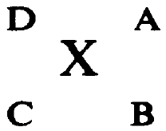
Figure 1 shows the 4 positions around the element X – A, B, C and D. In each position, the following information can be conveyed:
- A – charge number. This is indicated as positive or negative integers, for example, 2+ or 2− indicating X is an ion (it is incorrect to write charges as +2, −2, ++ or −−). For single charges, the 1 may be omitted. In the absence of a value, it is assumed to be zero (Leigh 2011:7).
- B – number of atoms of this symbol bound together in a single chemical entity or species. For an empirical formula, this number represents the relative proportions of this atom. Where this value is 1, it may be omitted (Leigh 2011:8).
- C – atomic number. This position is commonly left blank as the atomic symbol implies the atomic number (Leigh 2011:8).
- D – mass number. This is the precise number of nucleons (protons and neutrons in the nucleus) for the isotope to which this symbol refers (Leigh 2011:8).
Note: C and D are used when writing nuclear notations and equations, whereas A and B are used when writing formulae for radicals, inorganic and coordination compounds.

Sequence of the name
Inorganic compounds are generally named using compositional nomenclature. For homoatomic entities, where only one element is present, the name is formed by combining the element name with the appropriate multiplicative prefix. Ions are named by adding charge numbers in parentheses, for example, (1⁺), (3⁺), (2⁻), and for (most) homoatomic anion names, the element name is modified by adding ‘-ide’.
For binary compounds (containing atoms of 2 elements), or heteropolyatomic entities (containing atoms of 3 or more elements), the name is derived by combining the names of the electropositive constituent(s) with the electronegative constituent(s), suitably modified by any necessary multiplicative prefixes (mono-, di-, tri-, tetra-) and separated by a space. The multiplicative prefixes may not be necessary if the oxidation states are explicit or are clearly understood. The name of the electropositive constituent is simply the unmodified name followed by roman numerals in parentheses where needed to indicate the oxidation state. Monoatomic electronegative constituents are named using the suffix ‘-ide’ added to the first syllable, and polyatomic anion names are retained in full (Leigh 2011:40–43). Use the sequence in the figure below to determine relative electronegativities for nomenclature purposes. The sequence starts at the top right (most electronegative) and finishes at the bottom left (least electronegative or most electropositive) (Leigh 2011:16).
Figure 2 – the element sequence is used to determine relative electronegativities for nomenclature purposes
This image has been adapted from Red Book: Nomenclature of Inorganic Chemistry, IUPAC Recommendations 2005 [PDF 4.1 MB] by IUPAC.
If there is more than one electropositive and/or electronegative constituent, the names are separated by a space and cited in alphabetical order (ignoring any multiplicative prefixes). For example, hydrogen is always cited last among the electropositive constituents, and where associated with an anion, ‘hydrogen’ is not separated by a space from the following anion name (Leigh 2011:40–43).
Table 1 – examples of systematic names of inorganic compounds
Formula | Correct | Incorrect
S₈ | octasulfur | sulfur
NaCl | sodium chloride | sodium chlorine
AlK(SO₄)₂ | aluminium potassium sulfate | potassium aluminium sulfate
NaHCO₃ | sodium hydrogencarbonate | sodium hydrogen carbonate
FeCl₂ | iron(II) chloride | iron chloride, ironchlorine
PCl₅ | phosphorous pentachloride | Phosphorus pentchlorine

Sequence of the formula
The atoms belonging to polyatomic groups are retained as a group (Leigh 2011:16). For all other constituents, electropositive constituents are cited first, followed by the electronegative constituents. Within each group, the symbols are cited in alphabetical order (ignoring any multiplicative prefixes) by the symbol letter(s). Like the compound's name, hydrogen in the formula is always cited last among the electropositive constituents (Leigh 2011:40–43). This may create a sequence in the formula which differs from the name in some compounds due to the difference in alphabetical order of the names compared to the symbols of elements or polyatomic ions, for example:
Table 2 – examples of formulae of inorganic compounds
Name | Correct | Incorrect
ammonium sodium hydrogenphosphate | NaNH₄HPO₄ | NH₄NaHPO₄
potassium sodium tartrate | KNaC₄H₄O₆ | NaKC₄H₄O₆

Names of coordination complexes
A coordination compound is a compound that contains a central atom and surrounding ligands. The central atom is the atom or ion around which the rest of the coordination entity or complex is built and is often a metal ion.
A ligand is an atom, molecule or ion bonded to a central atom by a covalent bond. The groups that surround the central atom or structure must be identified in the name. They are listed as prefixes to the central atom's name and appropriate multipliers. These prefixes are usually derived simply from the ligand names. Names of anionic coordination entities are furthermore given the ending ‘-ate’ (Leigh 2011:87–89).
The following general rules are used when naming coordination compounds:
- ligand names are listed before the name(s) of the central atom(s)
- no spaces are left between parts of the name that refer to the same coordination entity
- multiplicative prefixes such as mono-, di-, tri- and so on are generally used with the names of simple ligands
- ligand names are listed in alphabetical order (multiplicative prefixes indicating the number of ligands are not considered in determining that order).
Table 3 – examples of systematic names of coordination complexes
Coordination compound | Name | Cation | Anion | Ligand
[Co(NH₃)₆]Cl₃ | hexaamminecobalt (III) chloride | [Co(NH₃)₆]³⁺ | Cl⁻ | NH₃
[Cu(NH₃)₄]SO₄ | tetraamminecopper (II) sulfate | Cu(NH₃)₄]²⁺ | SO₄²⁻ | NH₃

Sequence of the formula
Formulae comprise element symbols for central atoms and simple ligands, but more complicated abbreviations often represent polyatomic ligands (Leigh 2011:97). Formulae of the simple coordination complexes are constructed by identifying the central atom(s) and ligands.
The central atom is listed first. The formally anionic ligands appear next, listed in alphabetical order of the first symbols of their individual formulae. The neutral ligands follow, also in alphabetical order. The formula for the entire coordination entity, whether charged or not, is enclosed in square brackets. The charge on an ion is indicated in the usual way by the use of a right superscript. In the formula of a salt containing coordination entities, cation always precedes anion, no charges are indicated and there is no space between the formulae for cation and anion (Leigh 2011:55).
Note: constructing names and formulae for the complicated coordination complexes is beyond the scope of this guide. This is related to Module 8.
Table 4 – examples of systematic names of coordination complexes
Name | Central atom | Ligand | Formula | Structure
diamminesilver(+) | silver | ammonia | [Ag(NH₃)₂]⁺ | 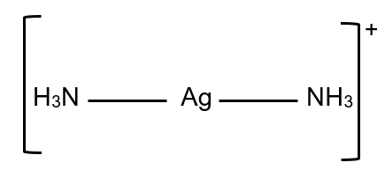
hexaaquairon(II) sulfate | iron | ammonia | [Fe(H₂O)₆SO₄ | 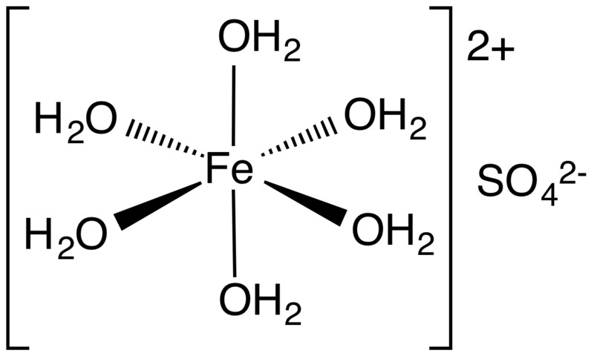
‘structure of hexaaquo iron(II) sulfate for normal folk’ by Smokefoot is licensed under CC BY-SA 4.0.

Organic nomenclature
The existence of a preferred IUPAC name (PIN) does not prevent the use of other names. Any name other than a PIN, as long as it is unambiguous and follows the principles of the IUPAC recommendations, is acceptable as a general IUPAC name (Favre and Powell 2014:1).
For nomenclature purposes, a structure containing at least one carbon atom and no elements from groups 1 to 12 that can be named using the principles of organic nomenclature is considered an organic compound (Favre and Powell 2014:1).
As a general rule of thumb, if you use it or produce it, name it and draw it. Any structures experienced practically or in diagrams throughout the course, such as cyclohexane or cyclohexene (halogen addition to alkenes), glucose (fermentation), esters (esterification) or ethenylbenzene (styrene for polystyrene), need to be introduced to students despite some of these not being included in the syllabus content descriptor.

Drawing structures
Many tools are specifically designed for chemical structure depiction (such as MolView or ChemSketch), which typically account for the majority of the drawing requirements automatically. However, while students are learning to draw organic structures by hand, a stencil may prove helpful, such as hexagonal graph paper [PDF 16.0 KB] in landscape orientation.
Although drawing chemical structures is not strictly a nomenclature matter, it conveys the structure of a chemical compound just as effectively as an IUPAC systematic name. It is necessary to use certain widely accepted conventions when drawing a chemical structure (Leigh 2013).

Text styles
Any roman font is acceptable, but plainer fonts are preferred. Bold and/or coloured text can be used to draw emphasis to a portion of a diagram using the colour scheme for molecular modelling, for example, propanone:
Table 5 – structure of propanone
Preferred | Acceptable | Not acceptable
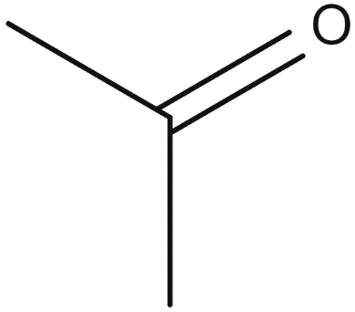 | 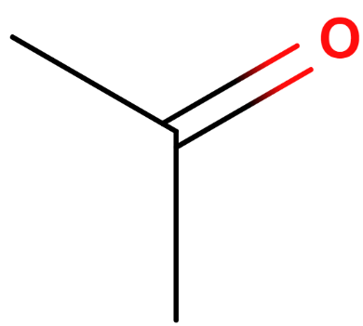 | 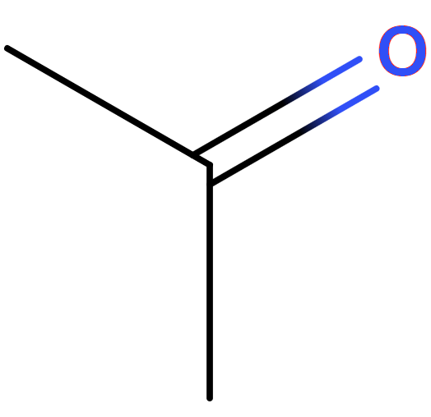

Atom labels
Hydrogen atoms usually are unlabelled on organic structures, except where they are bonded to non-carbon atoms. It is acceptable to depict hydrogen atoms at the end of explicit bonds or in a contracted form (Brecher 2008:299–300), for example, ethanol:
Table 6 – structure of ethanol
Acceptable | Acceptable | Not acceptable

Explicit depiction of hydrogen atoms may also be necessary in situations where the bond to the hydrogen is of particular interest, for example, when depicting intermolecular forces (Brecher 2008:300), such as in ethanal:
Table 7 – structure of ethanal
Acceptable | Acceptable
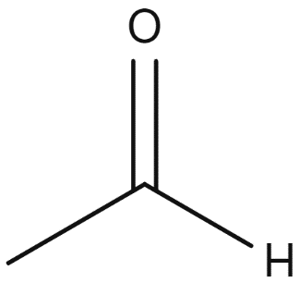 | 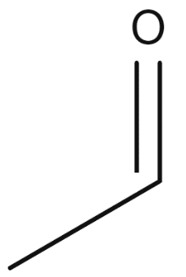
Carbon atoms are traditionally left unlabelled. The presence of the carbon atom is implied by the ‘bend’ in the bonds. However, any carbon atom with 2 identical collinear bonds is explicitly labelled to remove the possibility of the 2 bonds being misinterpreted as one long bond (Brecher 2008:300), for example:
Table 8 – structure of penta-2,3-diene
Preferred | Not acceptable
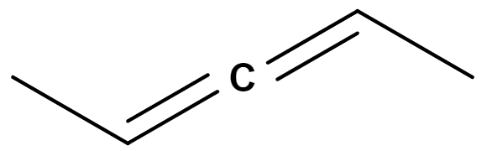 | 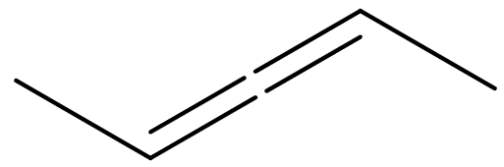
It is acceptable (but not preferred) to add a CH₃ label for terminal carbon atoms. However, when ethane, ethene, ethyne and related molecules are drawn with only one explicit bond, both terminal carbon atoms must be labelled to prevent the molecule from being interpreted as a stray line or set of lines (Brecher 2008:302):
Table 9 – structure of ethane
Preferred | Not acceptable
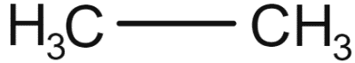 | 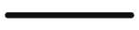
When the atom label contains several characters, the atom involved in the bond is placed at the end of the bond line with the rest of the label extending to the right (Brecher 2008:305), for example, propan-2-amine:
Table 10 – structure of propan-2-amine
Acceptable | Not acceptable
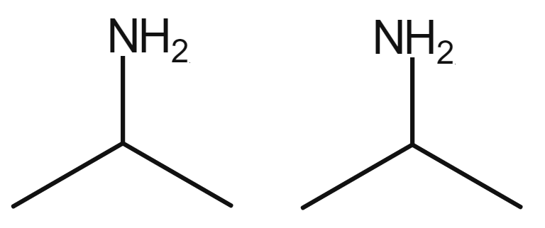
If an atom label with more than one element symbol has bonds to its right but does not have any bonds to its left, the atom label is reversed (Brecher 2008:305), for example, butanoic acid:
Table 11 – structure of butanoic acid
Acceptable | Not acceptable
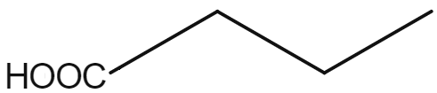 | 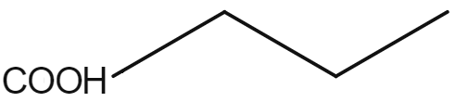

Intramolecular bonds
There are 2 main styles for depicting structures, the ‘zigzag’ form and the ‘linear’ form. Since it is possible to use the linear form only for relatively simple structures, the chain form is generally more useful. The linear form, however, remains acceptable for any structure to which it is suited (Brecher 2008:324). When using the linear form, there is no ‘bend’ in the chain of bonds. All atoms, including carbon and hydrogen atoms, are explicitly labelled (Brecher 2008:403), for example, when butane is drawn as a linear structure:
Table 12 – butane drawn as a linear structure
Preferred | Acceptable | Not acceptable
 | 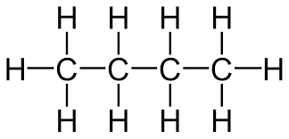
Within a given structure, most bonds are drawn using a single consistent length. The length used for bonds is long enough so that the bond is clearly visible between 2 atoms or atom labels (Brecher 2008:289), for example, butane:
Table 13 – structure of butane
Preferred | Not acceptable | Not acceptable
 | 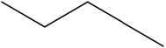 | 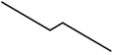
Structures that are known to be ionic are to be depicted as such. They are drawn with atoms bearing explicit positive and negative charges and include a space (rather than a bond) between those atoms (Brecher 2008:382), for example, sodium acetate:
Table 14 – structure of sodium ethanoate
Preferred | Not acceptable | Not acceptable
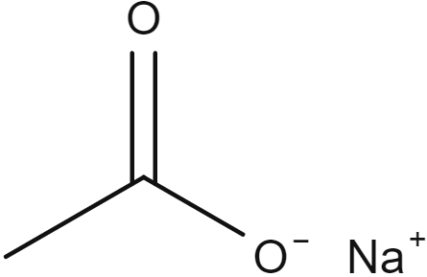 | 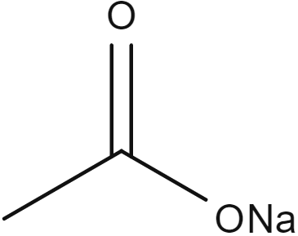 | 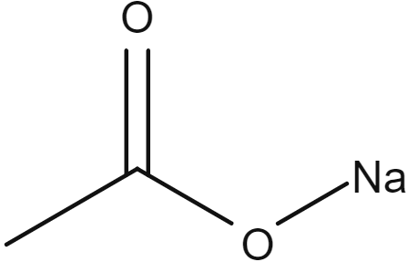

Intermolecular bonds
It is often useful to depict an association between atoms that is significantly weaker than a normal covalent or ionic bond. Intermolecular bonds are represented with dotted lines with a minimum of 3 dots and long enough to be clearly visible between 2 atom labels (Brecher 2008:295), for example, ethanol and water:
Table 15 – structure of a hydrogen bond
Preferred | Not acceptable
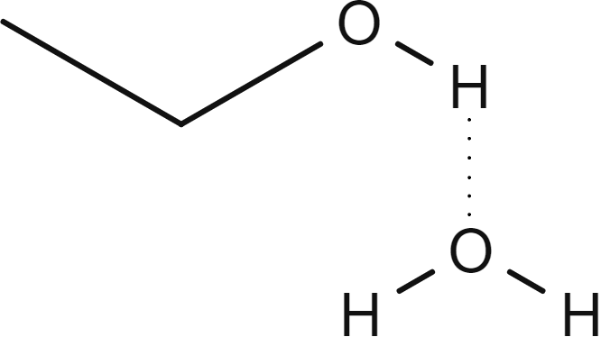 | 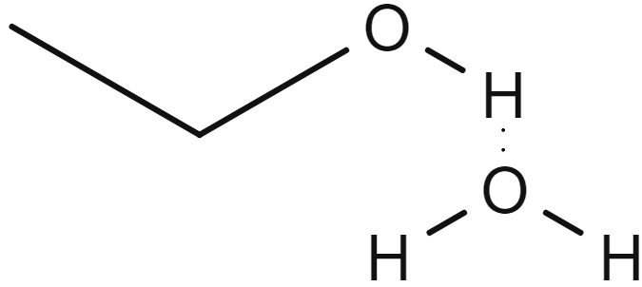

Naming structures
Many tools are designed explicitly for naming chemical structures (such as MolView or ChemSketch), which typically account for the majority of the naming requirements automatically. However, when using the name provided, it is important to refer to the systematic name, as in some cases, they will report a trivial or retained name for a given structure.
The structural names are written lowercase to ensure they are not considered proper nouns. The first letter of a name is only capitalised if it is the beginning of a sentence. Commas are used to separate locants (numbering of the parent chain where groups are attached) and hyphens are used to separate locants from words (Favre and Powell 2014:104–106). The systematic name for a structure is a combination of the parent structure modified by the name of the principal functional group (if present) and any associated prefix or suffix groups and their associated locant numbers (Leigh 2011:51, 182), in a general form:
locant-prefixparent structure-locant-suffix
The process of constructing the name includes several steps:
- Select and name the parent structure.
- Identify the principal functional group and append a suffix to the parent structure name.
- Identify and name each side chain.
- Number the parent chain carbons to give the lowest locants.
- Construct the name as locant-prefix + parent structure + − locant-suffix

Identification of the parent structure
Select and name the parent structure.
When a choice exists of a parent structure on which a name must be based, the following selection criteria are applied in this order until one choice remains (Leigh 2011:58):
- The chain containing the principal functional group, cited as a suffix, to the parent structure name (do not include alkenes or alkynes), for example:
Table 16 – structure of 2-methylbutan-1-ol
Structure | Correct | Incorrect
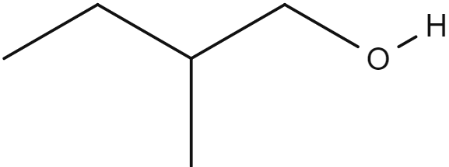 | 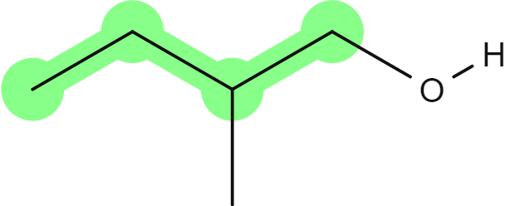 | 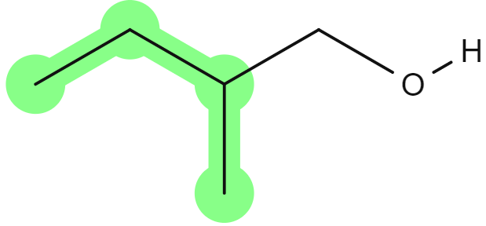
- The chain with the maximum number of carbons, for example:
Table 17 – structure of 2-methylbutan-1-ol
Structure | Correct | Incorrect
 |  | 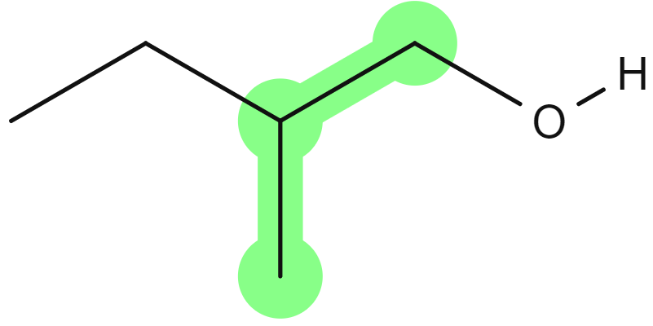
Note: according to the recent update, in acyclic parent structures, the order of seniority between unsaturation and length of chain given in earlier recommendations is reversed. Thus, the first criterion to be considered in choosing a preferred parent acyclic chain is the length of the chain; unsaturation is now the second criterion (Moss 2022).
For example:
Figure 3 – structure of 3-methylideneoctane
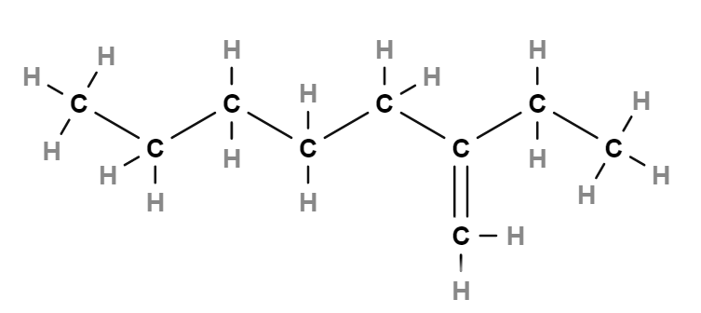
Although 3-methylideneoctane is the PIN, the alternative name of 2-ethylhept-1-ene could be acceptable as it does not confuse the structure identity, and the Chemistry Stage 6 Syllabus only requires students to cover methyl and ethyl side chains.
Table 18 – structure of 3-methylideneoctane
Structure | Correct | Could be acceptable
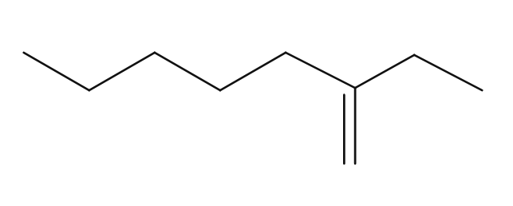 | 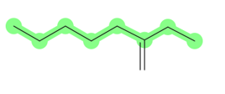 | 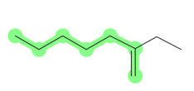
- The chain with the maximum number of unsaturated bonds, for example:
Table 19 – structure of 3-ethylhex-2-ene
Structure | Correct | Incorrect
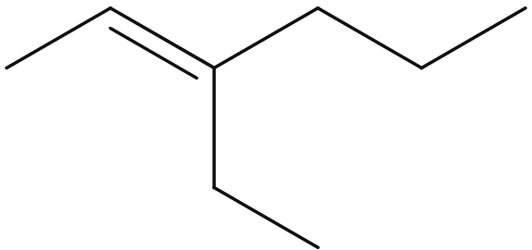 | 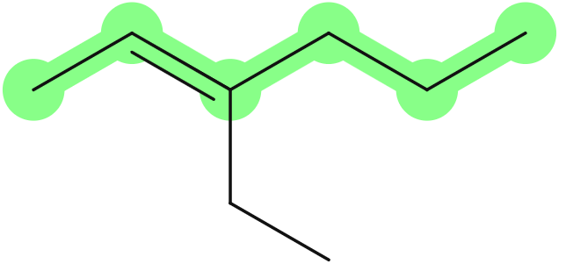 | 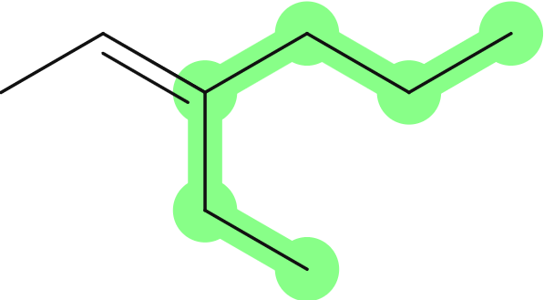
- The chain which has the greatest number of groups included as a prefix to the parent structure, for example:
Table 20 – structure of 3-ethyl-2-methyl hexane
Structure | Correct | Incorrect
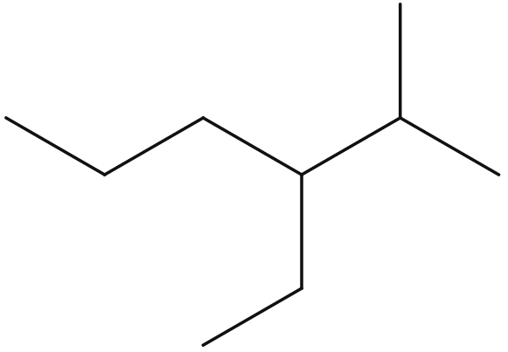 | 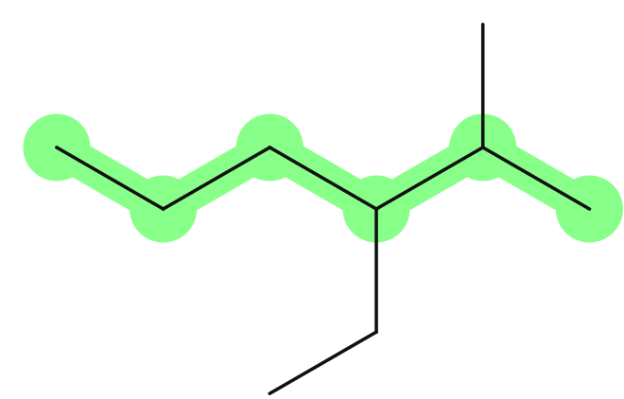  (Two prefix groups) | 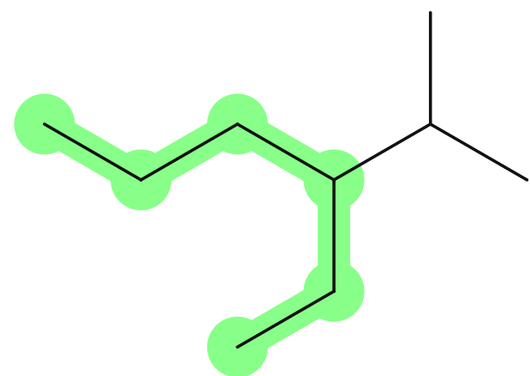  (One prefix group)

Figure 4 – flowchart showing steps for selection of parent structure
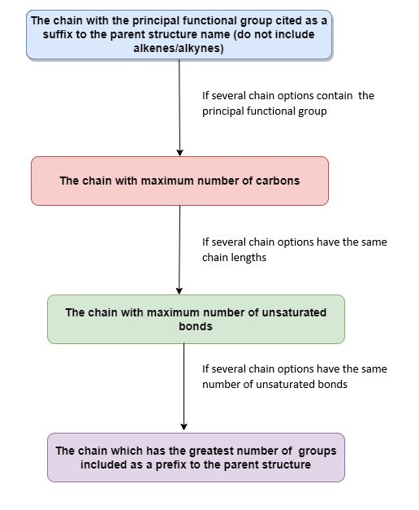
For organic chemistry, names are developed using substitutive nomenclature where a parent alkane must be the starting point of a name. Next, hydrogen atoms from the parent alkane are substituted with other groups, which are named using either prefixes or suffixes (Leigh 2011:51). Finally, the length of the chain is given a prefix to indicate the number of continuously connected carbons:
Table 21 – prefixes for parent hydrocarbons
Carbon chain length | Prefix | Memory strategy | Parent alkane
1 | meth- | 4 letters | Methane
2 | eth- | 3 letters | Ethane
3 | prop- | 4 letters (propeller) | Propane
4 | but- | 3 letters (buttocks) | Butane
5 | pent- | 4 letters (pentagon) | Pentane
6 | hex- | 3 letters (hexagon) | Hexane
7 | hept- | 4 letters (heptagon) | Heptane
8 | oct- | 3 letters (octagon/octopus) | Octane

Identification of functional groups
Identify the principal functional group and append a suffix to the parent structure name.
Functional groups are substitutive groups on a parent structure with a prefix or suffix added to the name and suitably modified using any necessary multiplicative prefixes (mono-, di-, tri-, tetra-).

Alkenes
Alkenes are named with the suffix ‘-ene’, replacing the ‘-ane’ at the end of the parent structure name. The inclusion of an appropriate locant to indicate the position of the functional group is also included in the name where appropriate, excepting ethane as the parent structure where a locant is not required (propane or higher must have a locant):
Table 22 – alkene functional group
Functional group | Name | Structure
Alkene | prop-1-ene  (parent is propane) | 
Alkene | 2-methylprop-1-ene  (parent is propane) | 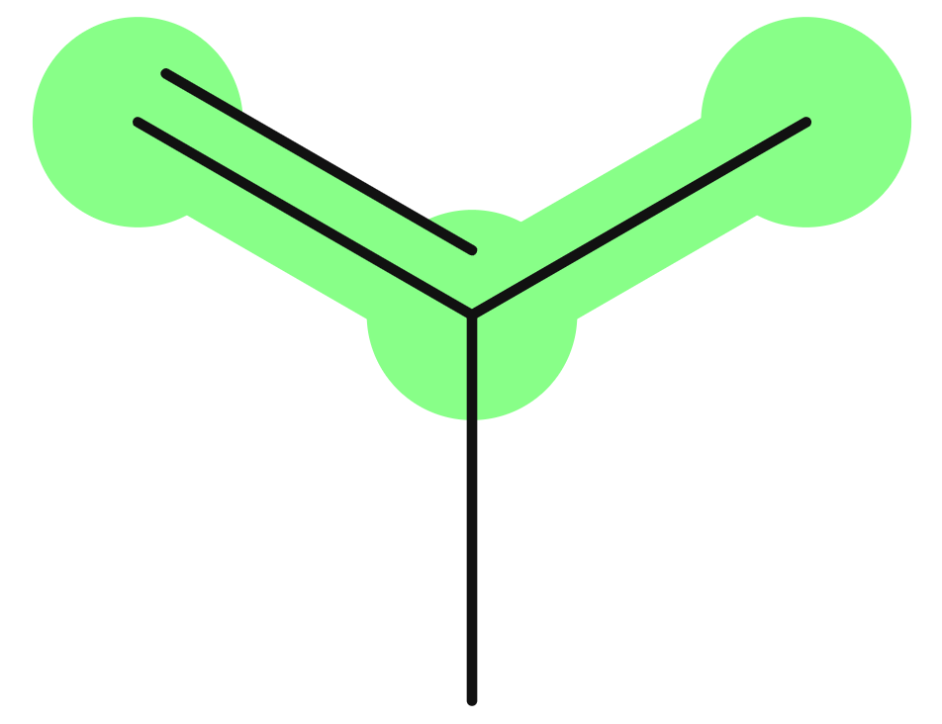

Alkynes
Alkynes are named with the suffix ‘-yne’, replacing the ‘-ane’ at the end of the parent structure name. The inclusion of an appropriate locant to indicate the position of the functional group is also included in the name where appropriate, excepting ethane as the parent structure where a locant is not required (propane or higher must have a locant):
Table 23 – alkyne functional group
Functional group | Name | Structure
Alkyne | prop-1-yne  (parent is propane) | 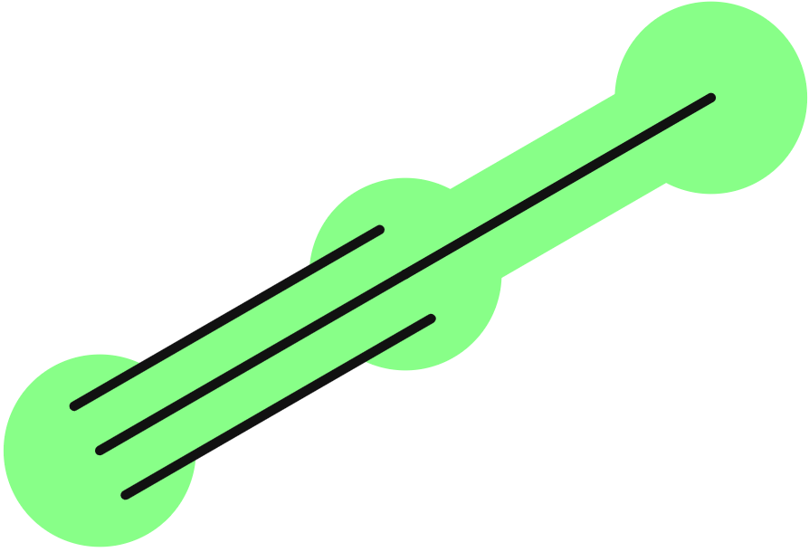
Alkyne | 3-methylbut-1-yne  (parent is butane) | 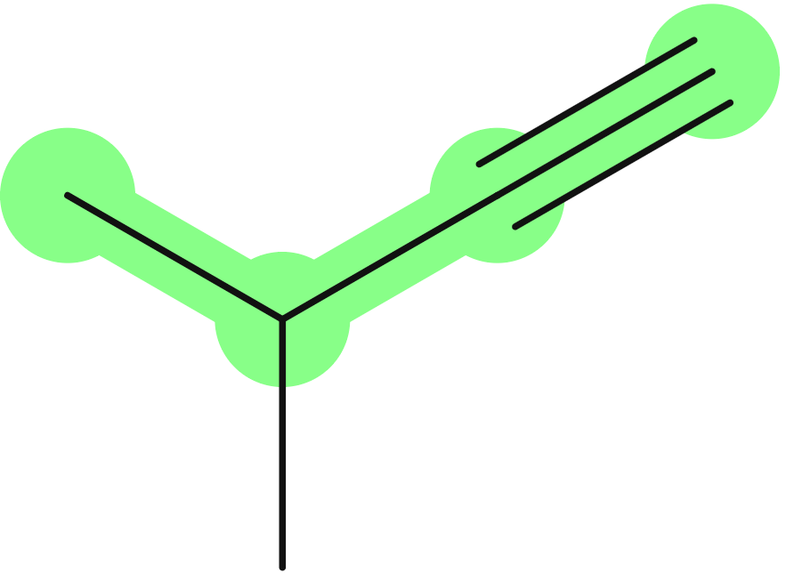

Alcohols (primary, secondary and tertiary)
Alcohols are named with the suffix ‘-ol’ replacing the ‘-e’ at the end of the parent structure name. The inclusion of an appropriate locant to indicate the position of the functional group is also included in the name where appropriate:
Table 24 – alcohols (primary, secondary and tertiary) functional groups
Functional group | Name | Structure
Primary alcohol | 2-methylpropan-1-ol  (parent is propane) | 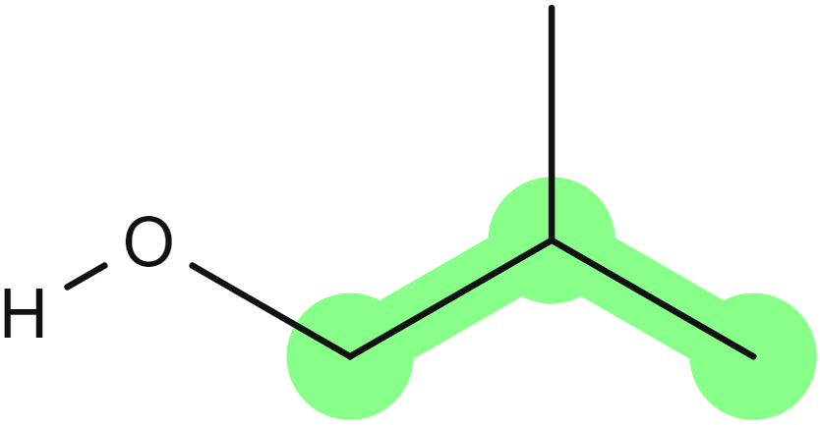
Secondary alcohol | 3-methylbutan-2-ol  (parent is butane) | 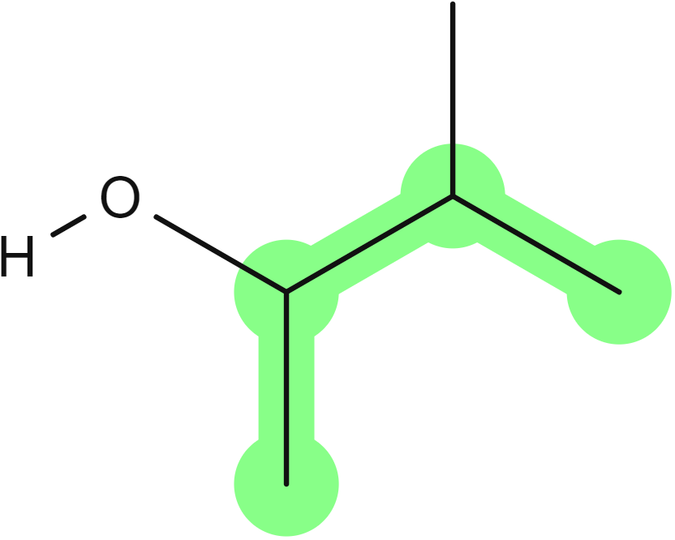
Tertiary alcohol | 2-methylpropan-2-ol  (parent is propane) | 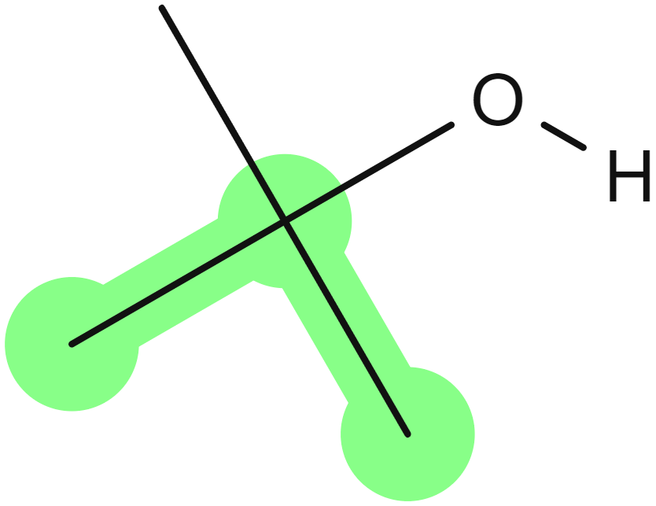

Aldehydes
Aldehydes are named with the suffix ‘-al’ replacing the ‘-e’ at the end of the parent structure name. A locant is not required as this functional group is only ever present on a terminal carbon:
Table 25 – aldeyhyde functional group
Functional group | Name | Structure
Aldehyde | propanal  (parent is propane) | 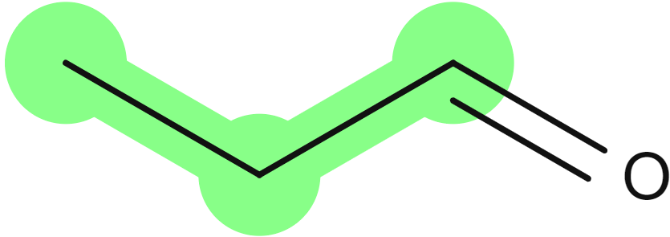
Aldehyde | 2,3-dimethylpentanal  (parent is pentane) | 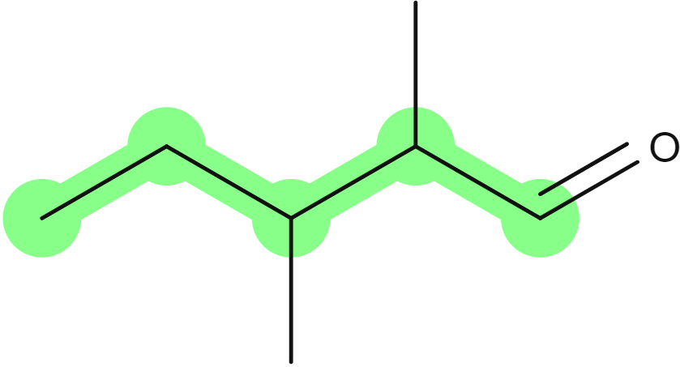

Ketones
Ketones are named with the suffix ‘-one’ replacing the ‘-e’ at the end of the parent structure name. The inclusion of an appropriate locant to indicate the position of the functional group is also included in the name where appropriate. Ketones are only possible on non-terminal carbons, so they have a minimum of 3 carbons. For 3 carbons, a locant is not required:
Table 26 – ketone functional group
Functional group | Name | Structure
Ketone | propan-2-one  (parent is propane) | 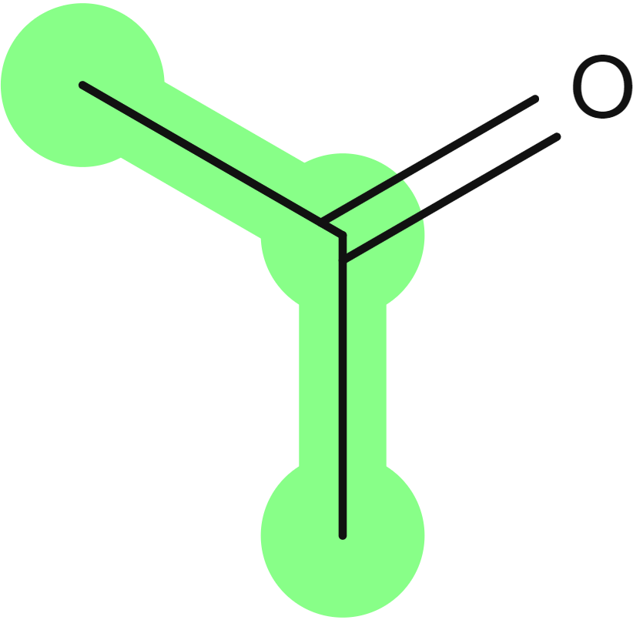
Ketone | 3-methylpentan-2-one  (parent is pentane) | 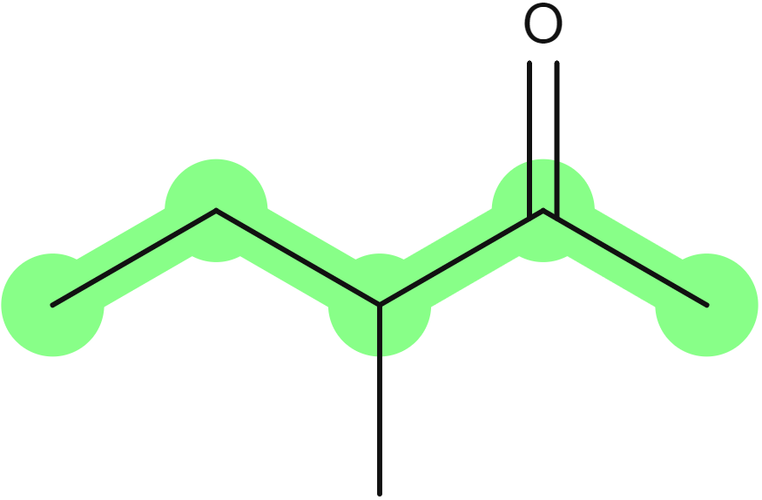

Carboxylic acids
Carboxylic acids are named with the suffix ‘-oic acid’ replacing the ‘-e’ at the end of the parent structure name. A locant number is not required as this functional group is only ever present on a terminal carbon:
Table 27 – carboxylic acids functional group
Functional group | Name | Structure
Carboxylic acid | propanoic acid  (parent is propane) | 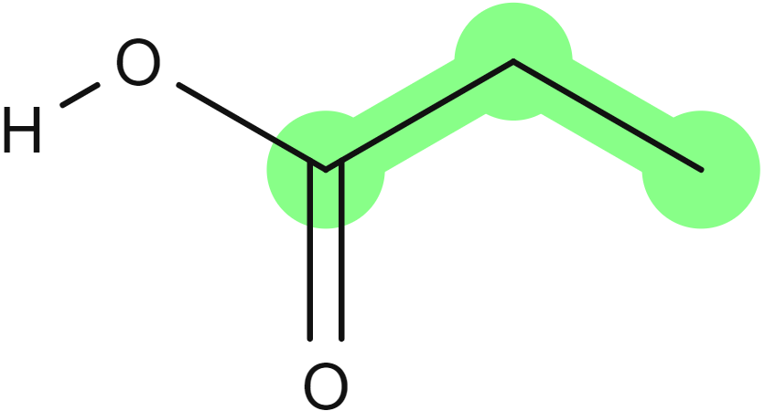
Carboxylic acid | 2-ethyl-3-methylbutanoic acid  (parent is butane) | 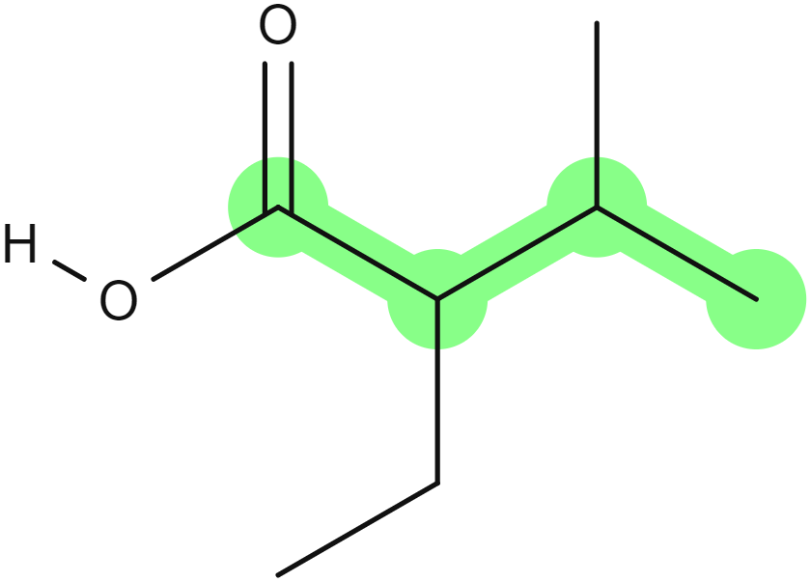

Amines
Amines are named with the suffix ‘-amine’ replacing the ‘-e’ at the end of the parent structure name. The inclusion of an appropriate locant to indicate the position of the functional group is also included in the name where appropriate:
Table 28 – amine functional group
Functional group | Name | Structure
Amine | propan-1-amine  (parent is propane) | 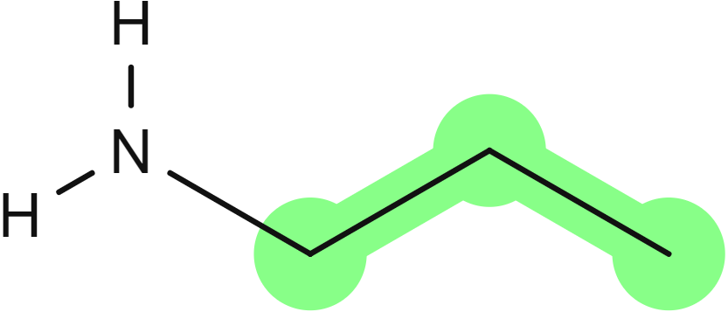
Amine | 3,4-dimethylpentan-2-amine  (parent is pentane) | 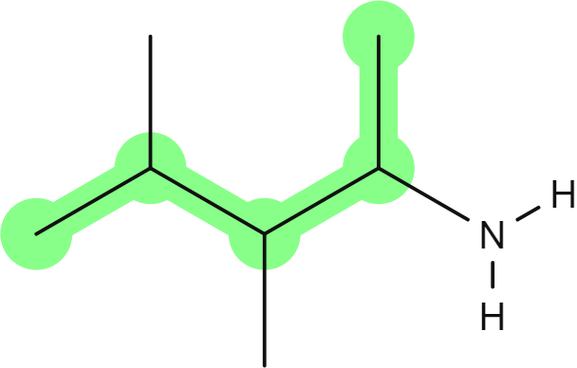

Amides
Amides are named with the suffix ‘-amide’ replacing the ‘-e’ at the end of the parent structure name. A locant is not required as this functional group is only ever present on a terminal carbon:
Table 29 – amide functional group
Functional group | Name | Structure
Amide | propanamide  (parent is propane) | 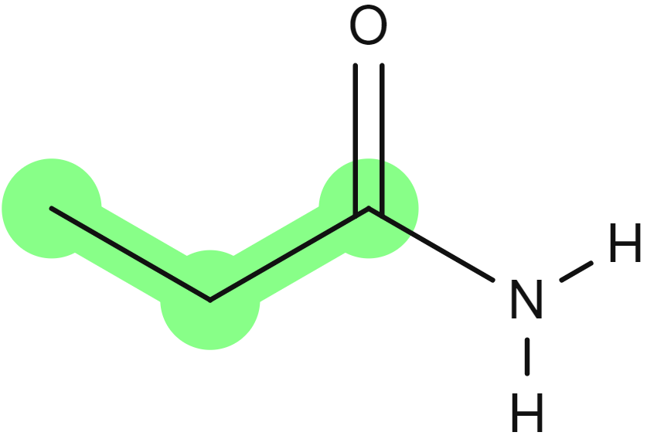
Amide | 2,3-dimethylbutanamide  (parent is butane) | 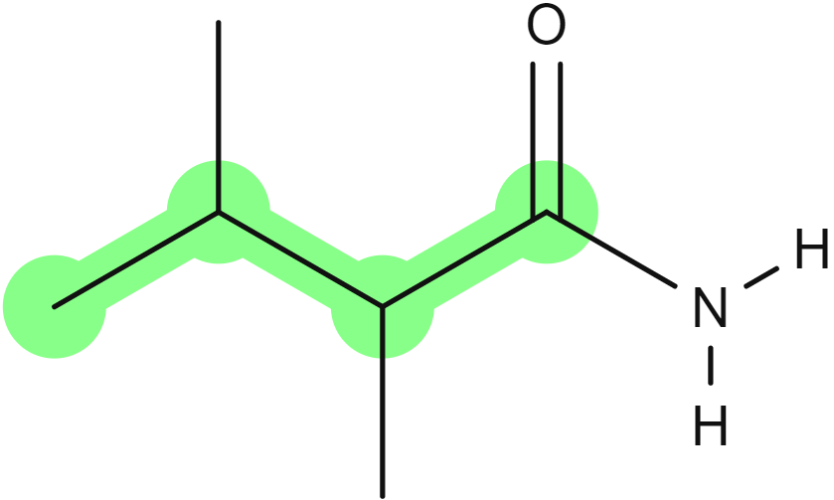

Halogenated organic compounds
Halogenated organic compounds are named with a prefix representing each halogen present – ‘fluoro-’, ‘chloro-’, ‘bromo-’, ‘iodo-’. The complete parent structure name is retained. The inclusion of an appropriate locant to indicate the position of the halogens is also included in the name where appropriate:
Table 30 – halogenated organic compounds functional group
Functional group | Name | Structure
Halogenated organic compound | 1-chloropropane  (parent is propane) | 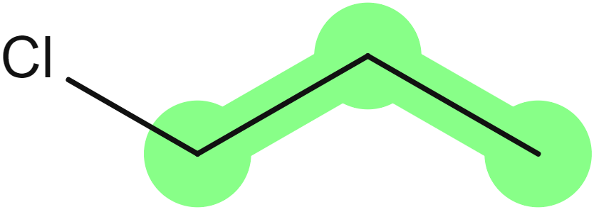
Halogenated organic compound | 2-bromo-1-chloropropane  (parent is propane) | 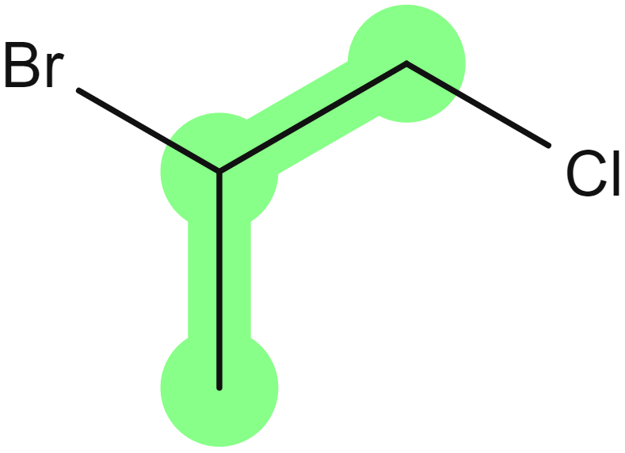

Side chains
Identify and name each side chain.
It is important to note that in this content descriptor, there is a plural. This is because multiple side chains could be present, resulting in the need for additional locants and the inclusion of multiplicative prefixes (di-, tri- and tetra-) in the name. Therefore, these chains are named as substituted prefix groups based on the regular naming principles for the length of the side chain (Leigh 2011:54, 70):
Table 31 – various side chains
Structure | Name | Structure
Methyl side chain | 3-methylpentane  (parent is pentane) | 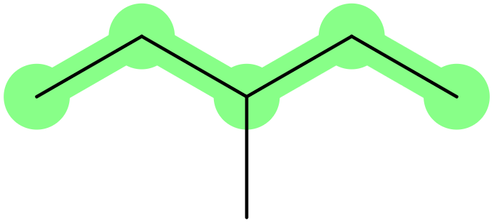
Dimethyl side chain | 2,3-dimethylpentanal  (parent is pentane)
Ethyl side chain | 3-ethylpentane  (parent is pentane) | 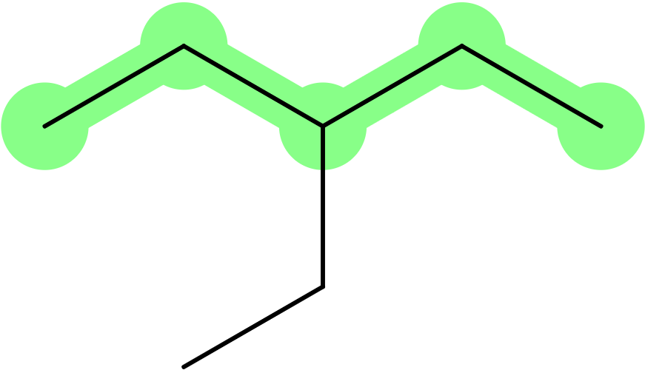
Diethyl side chain | 3,5-diethylheptan-2-one  (parent is heptane) | 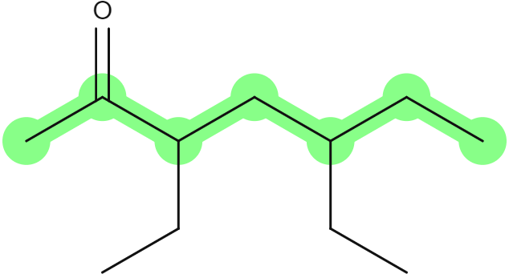
Ethyl methyl side chain | 2-ethyl-3-methylbutanoic acid  (parent is butane)

Numbering of the parent structure
Number the parent chain carbons to give the lowest locants.
The longest chain is numbered in a continuous line to give the lowest locants to the principal functional group, which is the substituted group selected as the suffix to the parent structure name (Favre and Powell 2014:60–69). Where there are multiple substituted groups (such as methyl or ethyl side chains and halogens considered equal) without a principal functional group, numbering of the parent structure for:
- The lowest set of locants determines the asymmetrical placement of substituted groups. Placing all locants in increasing numerical order, the sets are compared to find the first point of difference and the locant set with the lowest number at the first point of difference is selected (Favre and Powell 2014:34).
- The symmetrical placement of substituted groups is determined by giving the lowest locant to the substituent, which comes first when placed alphabetically with the name of all prefixes considered to begin with the first letter of its complete name, excluding any multiplicative prefixes.
Table 32 – parent chain carbons
Structure | Name
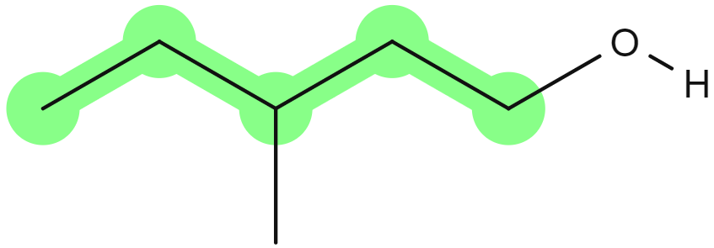 | 3-methylpentan-1-ol  not  3-methylpentan-5-ol  (lowest locant to the principal functional group)
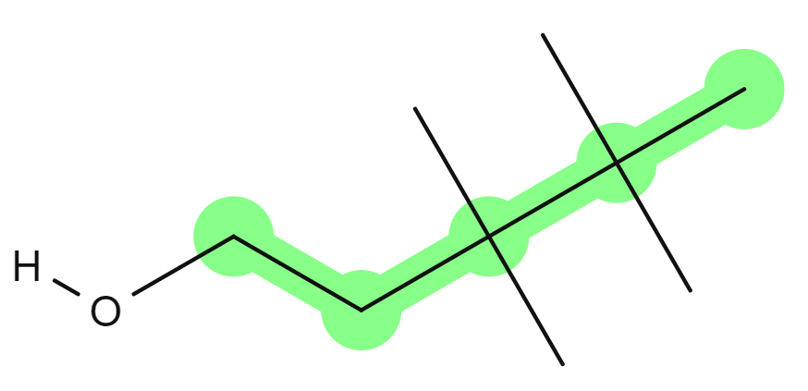 | 3,3,4,4-tetramethylpentan-1-ol  not  2,2,3,3-tetramethylpentan-5-ol  (lowest locant to the principal functional group despite a lower locant set available)
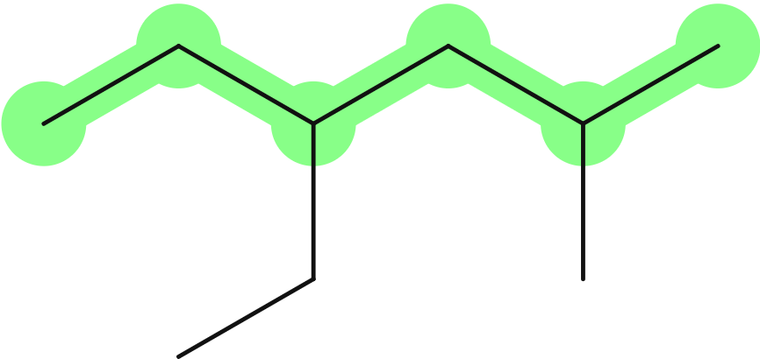 | 4-ethyl-2-methylhexane  not  3-ethyl-5-methylhexane  (asymmetry, lowest locant set – 2,4 vs 3,5 despite ethyl before methyl alphabetically)
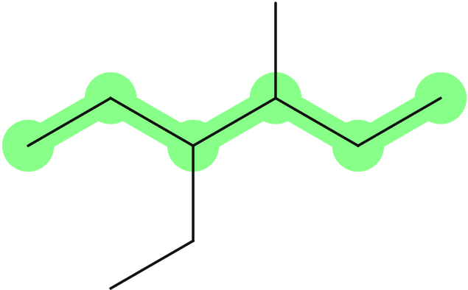 | 3-ethyl-4-methylhexane  not  4-ethyl-3-methylhexane  (symmetry, ethyl before methyl alphabetically)
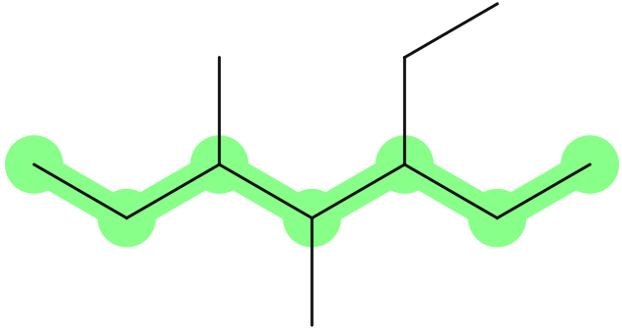 | 3-ethyl-4,5-dimethylheptane  not  5-ethyl-3,4-dimethylheptane  (symmetry, ethyl before methyl alphabetically ignoring the di prefix)

Constructing the name
Construct the name as locant-prefix + parent structure + − locant-suffix
Locants are placed immediately before that part of the name to which they relate. For example, ‘2-hexene’ is no longer correct and ‘hex-2-ene’ is the preferred name. Locants are essential for defining the intended structure where alternative possibilities exist (Favre and Powell 2014:29).
- Halogens and alkyl side chain prefixes have the equal-lowest priority and are written first in the name, with each group appearing in alphabetical order, excluding any multiplicative prefixes:
bromo > chloro > ethyl > fluoro > iodo > methyl
- Any other prefix groups are written next, starting with their appropriate locants.
- Parent structure name, including any appropriate modification to support the principal functional group name.
- Starting with the appropriate locants, the name concludes with the suffix of the principal functional group.
Table 33 – constructing names using locants
Structure | Name
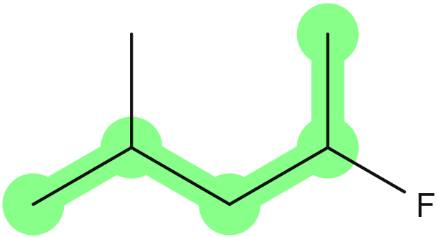 | - Pentane parent structure  - Fluoro and methyl prefixes  - Symmetrical locant set – 2,4  - Fluoro > methyl  2-fluoro-4-methylpentane
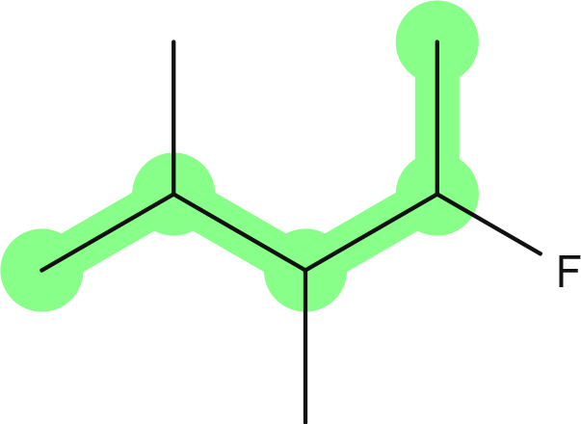 | - Pentane parent structure  - Fluoro and methyl prefixes  - Symmetrical locant set - 2,3,4  - Fluoro > methyl  2-fluoro-3,4-dimethylpentane
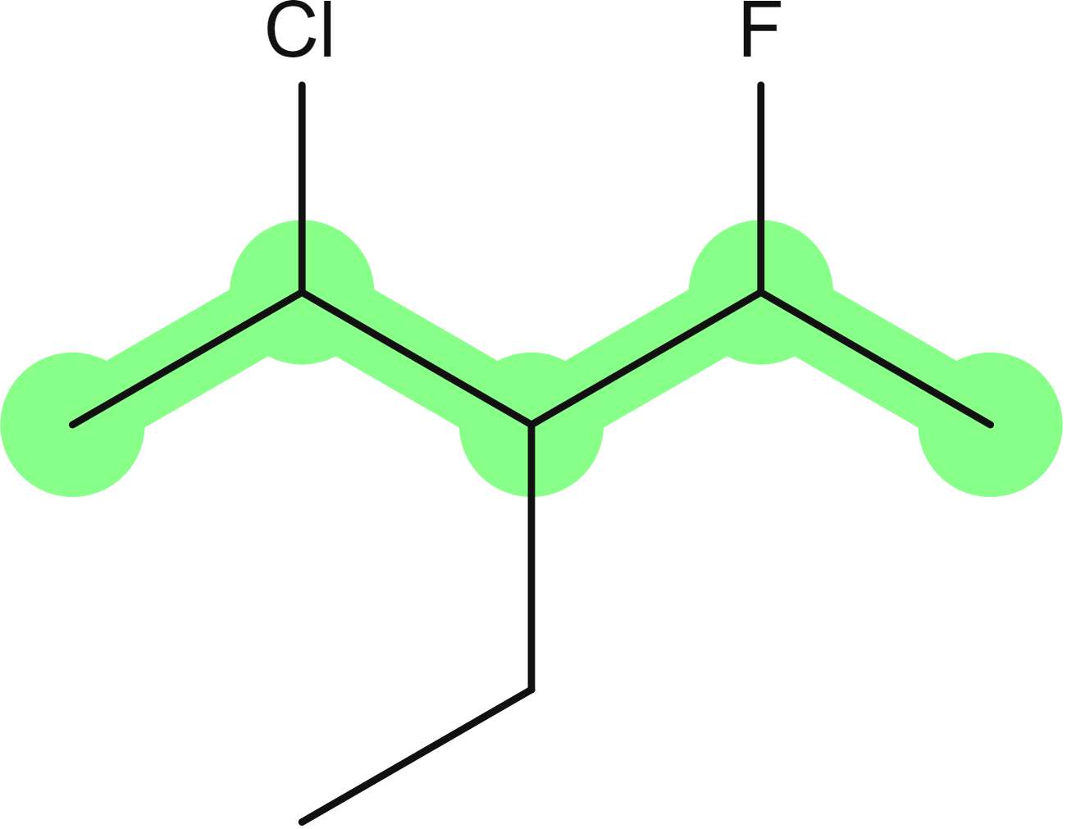 | - Pentane parent structure  - Chloro, fluoro and ethyl prefixes  - Symmetrical locant set - 2,3,4  - Chloro > ethyl > fluoro  2-chloro-3-ethyl-4-fluoropentane
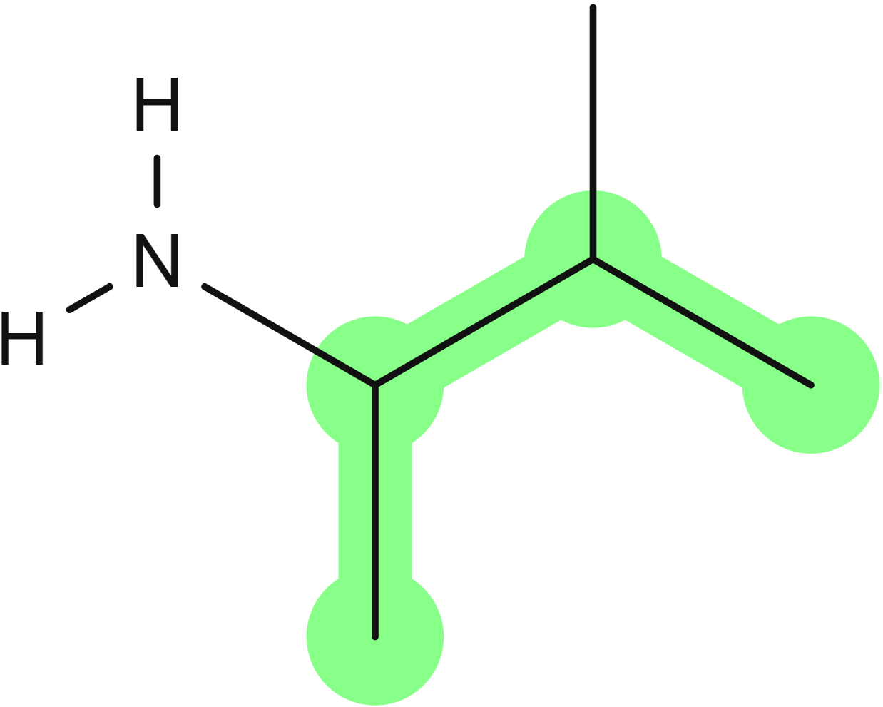 | - Butane parent structure  - Amine principal functional group  - methyl prefix  - Amine, given the lowest locant  3-methylbutan-2-amine
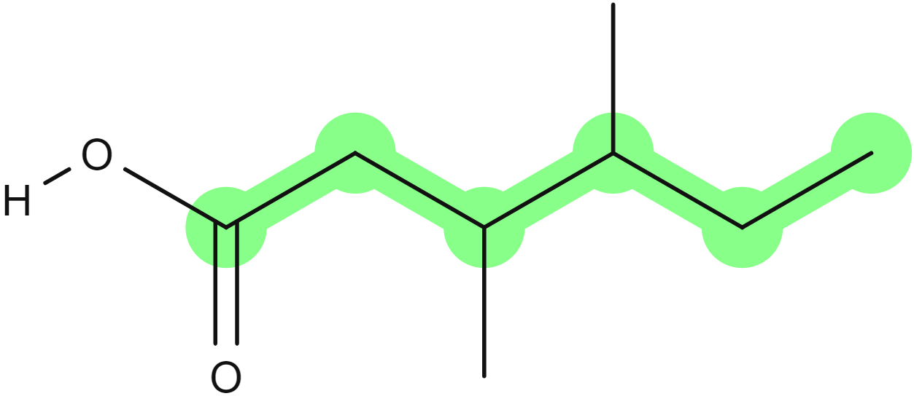 | - Hexane parent structure  - Carboxylic acid principal functional group  - Dimethyl prefix  3,4-dimethylhexanoic acid

Appendix A – further reading
This document is derived from several sources from the International Union of Pure and Applied Chemists (IUPAC). The main source for this document is Jeff Leigh’s Principles of Chemical Nomenclature: A Guide to IUPAC Recommendations. This guide is directed towards teachers and students of chemistry in schools and universities. This book is an introduction to all other colour books (Red, Blue and Purple) and is only available in hardcopy. However, most of the relevant content is still similar to the content presented in the 1998 edition, freely available online [PDF 1750 KB].
The most recent publications by IUPAC are available online:
- Brief guide to the nomenclature of inorganic chemistry (Pure and Applied Chemistry, July 2015) is available as a PDF [PDF 996 KB]
- Brief guide to the nomenclature of organic chemistry (Pure and Applied Chemistry, Feb 2020) is available as a PDF [PDF 2.8 MB]
- A concise guide to polymer nomenclature for authors of papers and reports in polymer science and technology (Pure and Applied Chemistry, 6 Mar 2020) is available as a PDF [PDF 2.6 MB] and a short summary [PDF 676 KB] (although this was published in 2012)
- Graphical representation standards for chemical structure diagrams (Pure and Applied Chemistry, Feb 2008) is available as a PDF [PDF 2.6 MB].
For a much more comprehensive review of nomenclature, IUPAC has published many of the current ‘colour books’ on their website, the most relevant being:
- Red Book : Nomenclature of Inorganic Chemistry [PDF 4.1 MB]
- Blue Book: Nomenclature of Organic Chemistry (only Chapter 1 is available online with a free login from the Royal Society of Chemistry)
- Purple Book: Compendium of Polymer Terminology and Nomenclature [PDF 2.5 MB].
Other online journals containing the most recent IUPAC publications include:
- Pure and Applied Chemistry is the official monthly journal of IUPAC, with responsibility for publishing works arising from those international scientific events and projects that are sponsored and undertaken by IUPAC
- Chemistry International (CI) is the newsmagazine of IUPAC. News about IUPAC, its chemists, its publications, its recommendations, its conferences and the work of its commissions and committees is published bimonthly in CI. As of 2014, Chemistry International is published by De Gruyter.

Appendix B – types of nomenclature
Special nomenclature specialists recognise 2 categories of nomenclature – systematic names and trivial names. ‘Trivial’, in the context of chemical nomenclature, is not a dismissive term; trivial names are arbitrary and not derived by systematic methods. Trivial names include the names of the elements and laboratory names. Trivial nomenclature contrasts with systematic nomenclature, an assembly of naming rules, though these rules may be arbitrary (Leigh 2011:35).
In contrast to such systematic names, traditional (retained) names are widely used in industry and academic circles. Examples are acetic acid, benzene and pyridine. Therefore, when they meet the requirements of utility and when they fit into the general pattern of systematic nomenclature, these traditional names are retained (Favre and Powell 2014:1).
There may be more than one way to name a compound or species and no one way may be superior to all the others. In the past, different systems have been developed to suit the needs of individual groups of chemists. Names also vary in complexity, depending on how much information needs to be conveyed (Leigh 2011:35). Therefore, IUPAC often allows several different methods for naming a given compound. The user may adopt whichever is most appropriate (Leigh 2011:11).
Rather than recommend only a single 'unique name' for each structure, IUPAC has developed rules for assigning a preferred IUPAC name (PIN) while allowing alternative names to preserve the diversity and adaptability of the nomenclature to daily activities in chemistry and in science in general. The existence of a PIN does not prevent the use of other names. Any name other than a PIN, as long as it is unambiguous and follows the principles of the IUPAC recommendations, is acceptable as a general IUPAC name (Favre and Powell 2014:1). Retained names are traditional or common, well-established names that may be either preferred IUPAC names, such as acetic acid and styrene or alternative names are allowed in general nomenclature (Favre and Powell 2014:4,9).
See also Chemistry International Nomenclature notes articles:
- Vol. 34, No. 5, Sep–Oct 2012: Systematic and Trivial Nomenclature
- Vol. 34, No. 4, July-Aug 2012: Non-IUPAC Nomenclature Systems
- Vol. 34, No. 3, May-Jun 2012: On the Various Nomenclature Systems
- Vol. 34, No. 2, Mar-Apr 2012: What is IUPAC Nomenclature?

Support and alignment
Resource evaluation and support: all curriculum resources are prepared through a rigorous process. Resources are periodically reviewed as part of our ongoing evaluation plan to ensure currency, relevance and effectiveness. For additional support or advice, or to provide feedback, contact the Science Curriculum team by emailing Science7-12@det.nsw.edu.au.
Differentiation: further advice to support Aboriginal and Torres Strait Islander students, EALD students, students with a disability and/or additional needs and High Potential and gifted students can be found on the Planning, programming and assessing 7–12 webpage.
Assessment: further advice to support formative assessment is available on the Planning, programming and assessing 7–12 webpage.
Professional learning: relevant professional learning is available on the Science statewide staffroom and HSC Professional Learning. Stage 6 Literacy in context provides further advice to teachers to improve student writing.
Related resources: further resources to support Chemistry Stage 6 can be found on the Science Curriculum page.
Consulted with: Multicultural Education and subject matter experts.
Alignment to system priorities and/or needs: School Excellence Policy, School Success Model.
Alignment to the School Excellence Framework: this resource supports the School Excellence Framework elements of curriculum (curriculum provision) and effective classroom practice (lesson planning, explicit teaching).
Alignment to Australian Professional Teaching Standards: this resource supports teachers to address Australian Professional Teaching Standards 2.5.2, 3.2.2, 3.3.2
Author: Science 7-12 Curriculum Team
Resource: Teacher resource
Creation date: 10 February 2023

References
This resource contains NSW Curriculum and syllabus content. The NSW Curriculum is developed by the NSW Education Standards Authority. This content is prepared by NESA for and on behalf of the Crown in right of the State of New South Wales. The material is protected by Crown copyright.
Please refer to the NESA Copyright Disclaimer for more information https://educationstandards.nsw.edu.au/wps/portal/nesa/mini-footer/copyright.
NESA holds the only official and up-to-date versions of the NSW Curriculum and syllabus documents. Please visit the NSW Education Standards Authority (NESA) website https://educationstandards.nsw.edu.au/ and the NSW Curriculum website https://curriculum.nsw.edu.au/home.
Chemistry Stage 6 Syllabus © NSW Education Standards Authority (NESA) for and on behalf of the Crown in right of the State of New South Wales, 2017.
CESE (Centre for Education Statistics and Evaluation) (2020a) What works best in practice, NSW Department of Education10 February 2023.
CESE (Centre for Education Statistics and Evaluation) (2020b) What works best: 2020 update, NSW Department of Education, accessed 10 February 2023.
NESA (NSW Education Standards Authority) (2022) ‘Proficient teacher: Standard descriptors’, The Standards, NESA website, accessed 10 February 2023.
State of New South Wales (Department of Education) (2017) ‘Controversial Issues in Schools – Procedures’, Policy library, NSW Department of Education, accessed 21 March 2023.
Wiliam D and Leahy S (2015) Embedding formative assessment: practical techniques for K-12 classrooms, Learning Sciences International, US.
Brecher J (2008) 'Graphical representation standards for chemical structure diagrams (IUPAC Recommendations 2008)', Pure and Applied Chemistry, 80(2):277–410.
Favre HA and Powell WH (2014) 'General Principles, Rules, and Conventions', in Nomenclature of Organic Chemistry: IUPAC Recommendations and Preferred Names 2013, The Royal Society of Chemistry, London.
Leigh GJ (2011) Principles of Chemical Nomenclature: A Guide to IUPAC Recommendations, Royal Society of Chemistry, Cambridge, UK.
Leigh GJ (2013) Drawing Chemical Structures, accessed 17 July 2020.

Further reading
State of New South Wales (Department of Education) (2022) ‘Literacy and numeracy’, Curriculum, NSW Department of Education website, accessed 24 February 2023.
State of New South Wales (Department of Education) (2022) ‘Literacy and numeracy priorities’, Literacy and numeracy, NSW Department of Education website, accessed 24 February 2023.

© State of New South Wales (Department of Education), 2023
The copyright material published in this resource is subject to the Copyright Act 1968 (Cth) and is owned by the NSW Department of Education or, where indicated, by a party other than the NSW Department of Education (third-party material).
Copyright material available in this resource and owned by the NSW Department of Education is licensed under a Creative Commons Attribution 4.0 International (CC BY 4.0) license.

This license allows you to share and adapt the material for any purpose, even commercially.
Attribution should be given to © State of New South Wales (Department of Education), 2023.
Material in this resource not available under a Creative Commons license:
- the NSW Department of Education logo, other logos and trademark-protected material
- material owned by a third party that has been reproduced with permission. You will need to obtain permission from the third party to reuse its material.
Links to third-party material and websites
Please note that the provided (reading/viewing material/list/links/texts) are a suggestion only and implies no endorsement, by the New South Wales Department of Education, of any author, publisher, or book title. School principals and teachers are best placed to assess the suitability of resources that would complement the curriculum and reflect the needs and interests of their students.
If you use the links provided in this document to access a third-party's website, you acknowledge that the terms of use, including licence terms set out on the third-party's website apply to the use which may be made of the materials on that third-party website or where permitted by the Copyright Act 1968 (Cth). The department accepts no responsibility for content on third-party websites.

