Science Stage 5
The periodic table
Creation date: 3 July 2023
Contents
Overview 3
Information for teachers 4
Introduction 4
Outcomes 4
Learning intentions and success criteria 5
Teaching and learning activities 6
Review prior knowledge 6
Activity 1 – the Periodic Table song 6
Activity 2 – getting to know the periodic table and its elements 7
Part A – looking for patterns 7
Activity 3 – modelling trends in the periodic table 10
Part A – modelling the Bohr atom 10
Part B – tableau (optional activity) 14
Activity 4 – a very different periodic table 14
Introduction 14
Reading the text (explicit information) – skimming and scanning 14
Activity 5 – examining a trend in the periodic table (PEOE) 20
Setting the scene 20
Practical activity 20
Teacher preparation 20
Method 21
Risk assessment 24
Activity 6 – scavenger hunt 26
Activity 7 – periodic table battleships (optional activity) 26
Student resources 30
Prior knowledge – Quick writes 30
Activity 1 – word bank 32
Activity 2 – getting to know the periodic table and its elements 33
Part A – looking for patterns – inquiry cube labels 33
Activity 3 – models of the atom 34
Modelling the Bohr atom 37
Activity 4 – a very different periodic table 38
Activity 5 – examining a trend in the periodic table – Predict-Explain-Observe-Explain (PEOE) extension 40
Activity 5 – examining a trend in the periodic table – Predict-Explain-Observe-Explain (PEOE) 42
Equipment 43
Method 43
Activity 6 – scavenger hunt 45
Support and alignment 46
References 47
Further reading 48

Overview
Stage and Learning Area: Science Stage 5
Description: this resource has been designed to address SC5-16CW the atomic structure and properties of elements are used to organise them in the Periodic Table.
This learning sequence builds an understanding of:
- the organisation of elements in the periodic table using their atomic number and
- the properties of elements in relation to their position in the periodic table.
A range of strategies are used to develop literacy and working scientifically skills.
Duration: while timing will vary based on the mode of delivery, differentiation strategies employed and class or school context, this series of activities should take approximately five x 50-minute lessons.

Information for teachers
The students should understand the atom, it’s structure and the symbols used for elements before they begin this lesson.

Introduction
This learning sequence is designed to build skills gradually throughout the task. Teachers may wish to modify the task or focus on specific sections based on their class context, student ability and current mastery of content.
This content also links with other sections of the Years 7–10 Science course, including:
- CW1 scientific understanding changes and is refined over time through a process of review by the scientific community.

Outcomes
- SC5-16CW explains how models, theories and laws about matter have been refined as new scientific evidence becomes available
- SC6-6WS undertakes first-hand investigations to collect valid and reliable data and information, individually and collaboratively
- SC5-7WS processes, analyses and evaluates data from first-hand investigations and secondary sources to develop evidence-based arguments and conclusions
- SC5-8WS applies scientific understanding and critical thinking skills to suggest possible solutions to identified problems
- SC5-9WS presents science ideas and evidence for a particular purpose and to a specific audience, using appropriate scientific language, conventions and representations.
Science Years 7–10 Syllabus © NSW Education Standards Authority (NESA) for and on behalf of the Crown in right of the State of New South Wales, 2018.

Learning intentions and success criteria
The learning intentions and success criteria below are a guide and may be adapted to meet your students’ needs.
Students describe the organisation of elements in the periodic table and relate the properties of some common elements to their position in the periodic table.
Students can:
- identify simple and complex patterns
- identify simple patterns in the periodic table
- model trends within the periodic table
- explain that the model of the periodic table is not static
- use the periodic table to identify elements and their properties.
Differentiation consideration: learning intentions should not be differentiated. All students need access to the same core content, big ideas and concepts. Differentiation should be evident in the success criteria, or the activities/support needed to achieve the success criteria (Wiliam and Leahy 2015). Teachers may co-construct the success criteria with students or adjust them to suit their class context, for example, using the strategies and resources for curriculum planning on the Planning, programming and assessing 7–12 webpage.

Teaching and learning activities

Review prior knowledge
The students recall prior knowledge of atomic structure using the Quick writes activity in the student resources section of this document. A copy is also included in The periodic table supporting PowerPoint that can be used instead of printed worksheets.
Differentiation: Quick writes are used to encourage students to develop their writing skills using regular, short opportunities. Dot points are an acceptable form of expressing their knowledge in this case. The activity can be differentiated by changing the amount of detail required by students in their responses. It can be further differentiated by allowing students to discuss their answers with a partner before they write an individual response. Students requiring support in expressing themselves through writing may be given options for the representation of their knowledge.

Activity 1 – the Periodic Table song
Introduce key vocabulary terms to the students by listening to SLOW "The NEW Periodic Table Song (in Order)".(4:20) or The Periodic Table Song (2018 Update!) (3:04). The students listen to the song as it is played through once. Replay the song while the students create a word bank of new or unfamiliar terms. They should also include terms that are used in a new way, for example, shells. The students should not include the names of elements in their word list. Discuss the terms that are identified with the class. The students will continue to develop the word bank through the learning sequence so it is not necessary that they have all the meanings in this lesson.
Differentiation: the slower version of the song is more accessible for most students. Ensure that closed captions are turned on to increase accessibility and encourage vocabulary development for all students.

Activity 2 – getting to know the periodic table and its elements

Part A – looking for patterns
The modern periodic table was developed by looking for patterns and trends in the elements. In this activity, the students practise looking for patterns before creating their own periodic table model.
Inquiry cube
This activity is adapted from Making Models: Wooden Blocks – Perimeter Institute. This is a free download after you sign into the Perimeter Institute.
The activity uses small cubes with labels attached to 5 faces of the cube with one face left blank.
- Divide the class into groups of 4.
- Place the inquiry cube in the middle of the table, blank face down, with one face towards each student. Do not let them see the bottom face of the block.
- Each student records observations about the vertical face closest to them without touching the cube.
- The students share observations with their opposite partner and discuss any patterns.
- Combine observations with the adjacent pair. Discuss the patterns that emerge.
- The group build a detailed model that describes how the labels are assigned (these models can be discussed as a class).
- Using observations of the top face and their model, predict the hidden face (share predictions with the class).
- Conduct a class discussion on looking for patterns, making inferences and gaps in patterns. Lead this into a discussion on the periodic table and its development based on patterns.
Differentiation consideration: inquiry cubes can be created with differing levels of complexity. Simple cubes will have one pattern to discover and use to make predictions. To better reflect the complexities of the periodic table cubes with 2 or 3 patterns to match could be used. To extend students further, cubes could be created with 4 or 5 patterns to match and make predictions. The cube label template included in Making Models: Wooden Blocks – Perimeter Institute could be modified by adding shapes or colours. Consider the needs of your students and adjust the template for this activity as required.
Another way to use the cubes is to allow the students to manipulate the cube and make observations on all sides as a group.
Possible patterns that may be identified (examples only, other patterns may be identified)
Sample response:
- Words on opposite sides have the same starting letters.
- The top right hand corner numbers add to seven.
- The bottom left-hand number on opposite sides is the same
- The bottom left-hand number is equal to the number of shared starting letters in the names.

Part B – patterns in the periodic table
Begin this section of the lesson by providing a periodic table to the students and asking them to look for patterns. This could be conducted as a Think-Pair-Share activity. Encourage the students to find as many trends as they can. These could include:
- atomic number
- atomic mass
- location of gases
- atomic radius
- the location of common metals
- patterns in naming and symbols.
Ask the students to look for places where the patterns are broken, for example, the mass order is reversed for tellurium and iodine.
Extension: ask the students to predict the reason for different patterns and breaks in the pattern. Emphasise that they are not expected to know the answers, so it is ok to not know the answer.
Discuss the importance of the patterns in the periodic table (to quickly predict the properties of an element).
Watch the video The Periodic Table: Crash Course Chemistry #4 (11:21) (you may choose to stop the video at 8:33 minutes and watch the rest of the video in Activity 4. The students should add any new and unfamiliar terms to their word bank.
Anchor chart
Create an anchor chart of the periodic table with the students for them to reference later.
- Label the groups 1–18.
- Label the periods 1–7.
- Colour the metals red.
- Colour the non-metals green.
- Hatch over the metalloids.
The periodic table – classification of elements (8:56) or refer to slide 5 in The periodic table supporting PowerPoint may be used to facilitate this activity. Give the students time to discuss annotations on their periodic table, create a key for their annotations and discuss terminology.
Extension:
- Label the alkali metals
- Label the alkali earth metals
- Label the halogens
- Label the noble gases
Differentiation: the section in the video from 0:38 to 0:59 can be skipped for lower ability classes.
Game: the mystery puzzle may be used as a fun activity to consolidate understanding of patterns in the periodic table. The game refers to electron configuration for some elements, however, if the students focus on patterns, they should be able to complete the activity without an understanding of electron shells.

Activity 3 – modelling trends in the periodic table

Part A – modelling the Bohr atom
In this activity students create physical models of the Bohr atom to identify trends in the periodic table.
Provide the students with the Models of the atom table to complete. It may be necessary to remind students how to find the atomic number and mass number on the periodic table. You may also need to remind students how to calculate the number of protons, electrons and neutrons from this information. (The number of neutrons = mass number – atomic number.)
Teacher note: this activity could be conducted as a jigsaw activity. Divide the class into groups of 4. Each student will fill out the information for 2 columns. They will share the information with the rest of the group. The group will then discuss what is going on in each of the columns.
See Table 1 below for an example of suggested responses.
Provide the students with 3 different coloured chocolates or coloured counters. They will need up to 22 of each colour. The students use the counters to create models of 4 elements showing the position and number of protons, neutrons and electrons. The elements that are created should come from a range of groups and periods.
The students describe the trends that they observe:
- increasing proton number
- increasing number of electrons
- number of protons is often the same as the number of neutrons
- the number of electrons in the outer shell is the same as the group number
- the number of shells with electrons in it is the same as the period number.
Differentiation: model the completion of the table and construction of the Bohr model for one or 2 elements.
The number of elements that the students construct may be modified to suit the needs of the class and individual students.
This activity could be conducted in small groups or as a whole class discussion to support student learning.
It may not be necessary for students to complete the table or create a model for all 12 elements for them to observe patterns and trends.
Extension: students could be extended by asking them to explain the trends that they observe.
Table 1 – atomic structure suggested responses
Atomic number | Element | Mass number | Period | Number of shells | Group | Electrons in outer shell | Protons (equals the atomic number) | Neutrons (= mass number − atomic number)
1 | Hydrogen | 1 | 1 | 1 | I | 1 | 1 | 0
2 | Helium | 4 | 1 | 1 | VIII | 2 | 2 | 2
3 | Lithium | 7 | 2 | 2 | I | 1 | 3 | 4
4 | Beryllium | 9 | 2 | 2 | II | 2 | 4 | 5
5 | Boron | 11 | 2 | 2 | III | 3 | 5 | 6
6 | Carbon | 12 | 2 | 2 | IV | 4 | 6 | 6
7 | Nitrogen | 14 | 2 | 2 | V | 5 | 7 | 7
8 | Oxygen | 16 | 2 | 2 | VI | 6 | 8 | 8
9 | Fluorine | 19 | 2 | 2 | VII | 7 | 9 | 10
10 | Neon | 20 | 2 | 2 | VIII | 8 | 10 | 10
11 | Sodium | 23 | 3 | 3 | I | 1 | 11 | 12
12 | Magnesium | 24 | 3 | 3 | II | 2 | 12 | 12
13 | Aluminium | 27 | 3 | 3 | III | 3 | 13 | 14
14 | Silicon | 28 | 3 | 3 | IV | 4 | 14 | 14
15 | Phosphorous | 31 | 3 | 3 | V | 5 | 15 | 16
16 | Sulfur | 32 | 3 | 3 | VI | 6 | 16 | 16
17 | Chlorine | 35 | 3 | 3 | VII | 7 | 17 | 18
18 | Argon | 40 | 3 | 3 | VIII | 8 | 18 | 22
19 | Potassium | 37 | 4 | 4 | I | 1 | 19 | 18
20 | Calcium | 40 | 4 | 4 | II | 2 | 20 | 20

Part B – tableau (optional activity)
Ask the students to work in small groups to create a tableau demonstrating one of the trends that has been identified. The rest of the class watch the tableau and guess the trend. For example, students may model increasing size down a group by standing in a line to represent a group. Each person makes their body take up more space as they go down the group.

Activity 4 – a very different periodic table
This activity develops the students’ ability to locate and extract explicit and implicit information from a text while exploring the variety of models of the periodic table and that are still evolving. This activity uses the Cosmos article A very different periodic table.
The document: Locating explicit and implicit information has additional information on supporting student comprehension skills.

Introduction
Discuss the terms explicit and implicit. Explain the difference between the 2 terms and the need to be able to determine both types of information when reading texts.
- Explicit: clear, no space for interpretation.
- Implicit: implied or strongly suggested.

Reading the text (explicit information) – skimming and scanning
Skimming: the students skim the text to identify the main idea of the article. This can be done by looking at headings, subheadings, pictures and captions and the first and last paragraph of the text.

Suggested answers to question 1
- Use skimming techniques to answer the following questions:
- Is the text imaginative, persuasive or informative? How do you know?
The text is informative because it contains factual information about the periodic table, its different forms and its creators.
- What is the text about?
The text is about the evolution of different models of the periodic table.
- What is the first paragraph about?
The first paragraph is about the significance of the periodic table and Mendeleev’s contribution.
- What does the image ‘Theodor Benfey’s spira table (1964)’ show?
It shows a model of the periodic table that has the elements spiralling outwards. The spokes of the wheel are like groups in the modern periodic table. Each line represents a group of elements.
- What does the image ‘The Underground Map of the Elements’ show?
This image shows how the elements in the periodic table could be organised in groups like a map of railway lines.
- What is the last section, ‘Settling on a design’ about?
This section of the article informs us that the format of the periodic table is still changing and evolving and that there are many different forms that it takes.
Differentiation: this and the following activities could be carried out as a ‘Think aloud’ activity, either for the whole class or small groups. The teacher skims the text and verbalises their thinking and highlights key information on the board as they read.
The students could carry out this activity in small groups to support their understanding and confidence.
The use of home languages should be encouraged to discuss and consolidate understanding of new terms.
Scanning: the students scan the text to identify key dates, names and models of the periodic table.

Suggested answers to question 2
- Scan the text to answer the questions below.
- When did Mendeleev develop his model of the periodic table?
1869
- Who was the first person to arrange the elements in a table?
Dalton
- Who was the first scientist to sort elements based on their properties?
Newlands
- When did Werner add the noble gases to the periodic table?
1905
Who created the model of the periodic table that is the basis of the modern periodic table?
Werner
Reading the text (implicit information)
The students now read the text looking for implications in the text. This information can be used to answer higher order questions. The process for extracting implicit information can be modelled using the ‘Think aloud’ strategy.
The students now complete questions 3–8.

Suggested responses to question 3
- Describe how the way that Mendeleev approached the model of the periodic table was different to that of other scientists.
Mendeleev organised the elements according to chemical and physical properties. He also added gaps for elements that he predicted as missing.
- Explain why Mendeleev’s model of the periodic table was important.
Mendeleev’s model of the periodic table was important because it contained predictions of elements that were as yet unknown and their predicted properties. This meant that scientists could look for these elements.
- Create a Venn diagram to identify similarities and differences between Baumhauer’s spiral model and the modern periodic table.
Sample response on next page and on slide 6 of The periodic table supporting PowerPoint.

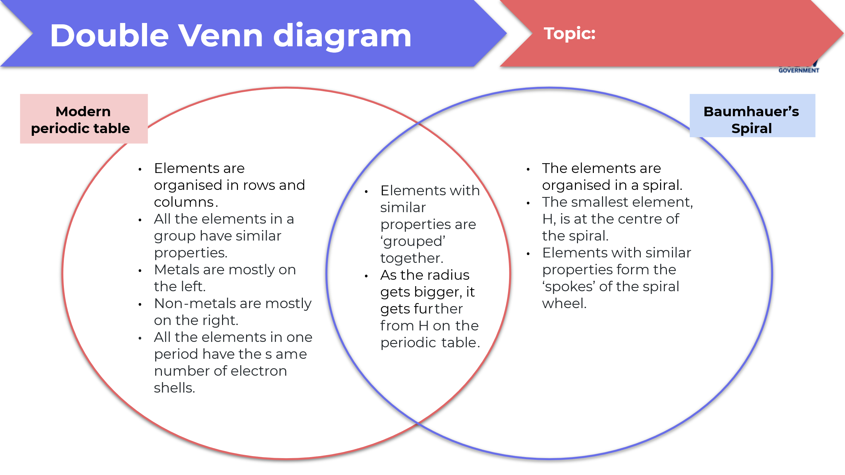

- Select one of the alternative models of the periodic table, for example: The Underground Map of the Elements, the 3D ‘Mendeleev flower’. Evaluate how effective the model is to find the elements and predict their properties. The following databases may be used to discover other models of the periodic table.
The underground map of the elements
This model of the periodic table is an engaging model. The colours and train lines show elements that have similar properties. The lines could be extended as new elements are discovered, for example, the lanthanides.
The model demonstrates the overlap of some properties, such as no stable isotopes and the actinides. However, there are limitations as this line ends and should not.
The obvious limitation to the model is that there is no pattern showing increase in atomic number, electron configuration or reactivity. This means that the model has limited use as a tool for predicting chemical reactivity or elemental behaviour.
- Evaluate the statement: ‘The modern periodic table is based on evidence and will not change.’
This statement is not an accurate statement. Although it could be predicted that the overall structure may not change significantly, our knowledge and understanding of elements and their properties is constantly developing. It is expected that there may be small changes to the structure of the periodic table as new discoveries are made.
The following websites contain models of the periodic table that may be used to further extend the students’ understanding of the range of models that have been developed.
- Leach's database
- 3D models of the periodic table

Activity 5 – examining a trend in the periodic table (PEOE)

Setting the scene
The students will identify and investigate a trend in chemical reactivity of the alkali earth metals using the Predict-Explain-Observe-Explain (PEOE) model.
Introduce the activity by watching Alkali Metals Reacting with Water (3:16). Discuss the trends that are observed in the video. The students will then use the information from this discussion to complete the ‘Predict’ and ‘Explain’ sections of the PEOE activity.

Practical activity
The students will now conduct a short experiment to investigate the reactivity of group II elements. The data they collect will provide them with information to complete the ‘Observe’ and ‘Explain’ sections of the activity.
The goal is to go through the process of making predictions and providing reasons for their predictions before they do the practical component. Class discussions can be used to support their final explanations and correct misunderstandings after they have attempted the activity.
Differentiation: ensure that closed captions are turned on before watching the video. The video may be watched more than once to reinforce understanding.
Discussion of observations and predictions may be carried out in small groups or as a whole class. Encourage the use of home languages in small group discussions.
Students may be provided with opportunities to represent their ideas in a manner that they are most comfortable with because report writing is not the focus of this activity.
Two scaffolds are provided for students to complete this activity. A standard scaffold and an extension scaffold. These may be modified to provide further scaffolding as required by your class.

Teacher preparation
The following equipment will need to be made available to each group.
- Magnesium
- Calcium
- Strontium turnings
- 50 mL graduated cylinder
- 5 × 100 mL beakers
- Mass balance
- 3 × 50 mL beakers
- Timer
- Hydrochloric acid (1 M)
- Universal indicator solution (dropper bottle)
- De-ionized water
- Tweezers

Method
- Measure 20 mL of hydrochloric acid into each of the three 50 mL beakers.
- Add 3 drops of universal indicator to all 3 beakers. Swirl the solution to mix.
- Place two 1 cm pieces of magnesium into the second 100mL beaker.
- Place 2 similar sized pieces of calcium into the first 100 mL beaker.
- Place 2 similar sized pieces of strontium into the last 100 mL beaker.
- One person should be ready to time this next step.
- Each of the 3 volunteers should get ready to pour the hydrochloric acid solution into each of the beakers at the same time.
- The timing person should record the time it takes each metal to disappear.
- If one element takes longer than 5 minutes, stop the time and write down 5+.
- You should now know which element reacts the fastest, faster, and slowest.
- Discuss this data with your small group and complete the rest of the PEOE table.
This experiment may be conducted as a teacher demonstration if preferred.

Suggested response
Table 2 – Predict-Explain-Observe-Explain (PEOE)
Description of focus
Reactivity of group II elements.
Predict (what do you expect to see? Give reasons to support your predictions.)
In the demonstration, the elements further down the group will react more quickly than the elements higher in the group.
Explain (why do you think this will happen?)
The reactivity of metals will increase down the group due to increase in atomic size.
Observe (what do you see?)
The strontium will react the most quickly, with the most bubbles. Magnesium took the longest to react. (The common misconception is that the metal is dissolving in the acid, it is reacting.)
Explain (Add to or change your previous explanation. Why does this trend occur?)
The reactivity of the elements will increase down a group in the group I demonstration. Therefore, we expect the reactivity of elements in group II to increase as well. Strontium will be the most reactive and magnesium the least reactive.
(Extension: The electrons participating in the reaction are in the valence shell. As you go down a group, the valence shell is further from the nucleus and the electrons are held less strongly and can therefore be more easily transferred.)
If strontium turnings are not available, this experiment could be modified to use calcium and magnesium. The reactivity of magnesium and granulated calcium in water could be investigated and then compared to the reactivity of magnesium and granulated calcium in hydrochloric acid.

Risk assessment
A thorough risk assessment should be conducted before conducting the experiment. We suggest that you inspect the SDS for the chemicals before proceeding with this experiment. All safety measures must be implemented when conducting this experiment.
Table 3 – sample risk assessment
Items/Chemicals | Hazard | Control Measures
Beakers, measuring cylinders | Breakage of beaker. Cuts from chipped glassware. | Use standard handling procedures. Inspect and discard broken glassware. Sweep up broken glass with a dustpan and brush; do not use fingers to clean up broken glass. Wear enclosed leather shoes.
Hydrochloric acid | Splashing chemicals in eyes or on skin. | Wear safety glasses throughout the experiment. Wear enclosed leather footwear. Wash splashes off the skin with cool water.
Magnesium | Produces flammable gases on contact with water which may ignite spontaneously. | Wear safety glasses throughout the experiment. Keep in a container away from water until use.  Do not place excess in the garbage or down the drain.
Calcium | In water releases flammable gases. | Wear safety glasses throughout the experiment. Keep in a container away from water until use.  Handle in a well-ventilated area.  Provide students with a few grains of strontium only.
Strontium | Produces flammable gases on contact with water which may ignite spontaneously.  May cause skin irritation. | Wear safety glasses throughout the experiment. Keep in a container away from water until use.  Handle in a well-ventilated area.  Provide students with a few grains of strontium only.
Spills, bags, chairs | Slips, trips and falls. | Bags are to remain away from the work area. Spills are to be cleaned immediately. No running in the lab.

Activity 6 – scavenger hunt
In this activity the students conduct a scavenger hunt to find as many elements as they can. The students could include a photograph of the item containing the element as evidence that they found it. Alternatively, they can add a detailed location to the table. Edit the table as required to suit your class needs.
A copy of The Periodic Table of the Elements, in Pictures and Words [PDF 1 KB] could be printed to support students in identifying where elements can be found.
Teacher notes: this activity could be conducted within the classroom with items placed strategically to be found by the students or the students could be given boundaries to search around the school. This activity could be extended as a homework task with the students being challenged to find as many elements as possible.
Clear time frames and boundaries should be provided to facilitate classroom management.
Differentiation: this activity provides opportunities for students to express themselves in the form that they are most comfortable with. This could include drawing the item instead of describing it in words.

Activity 7 – periodic table battleships (optional activity)
In this activity the students play battleships using the periodic table as their grid. Period and group numbers become the code for ship locations.
Equipment (per pair)
- 4 laminated copies of the periodic table
- 2 whiteboard markers
- 2 large paper clips or dog clips
- 2 folders
How to play
- Attach a copy of the periodic table to each side of the folders (on the inside).
- Open the folders and clip one side of each folder together so that the open folders will stand up facing each student. They should be able to see their 2 periodic tables in front of them, one is vertical and one is flat.
Figure 1 – periodic table battleships setup
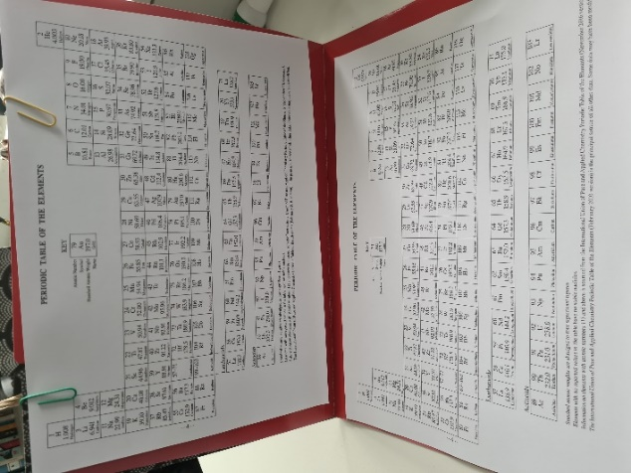
- Mark the battleships on the flat periodic table by circling elements.
- 1 × 5 element ship
- 2 × 4 element ships
- 2 × 3 element ships
- 3 × 2 element ships
- 4 × 1 element ships
Figure 2 – periodic table battleships – the battleships
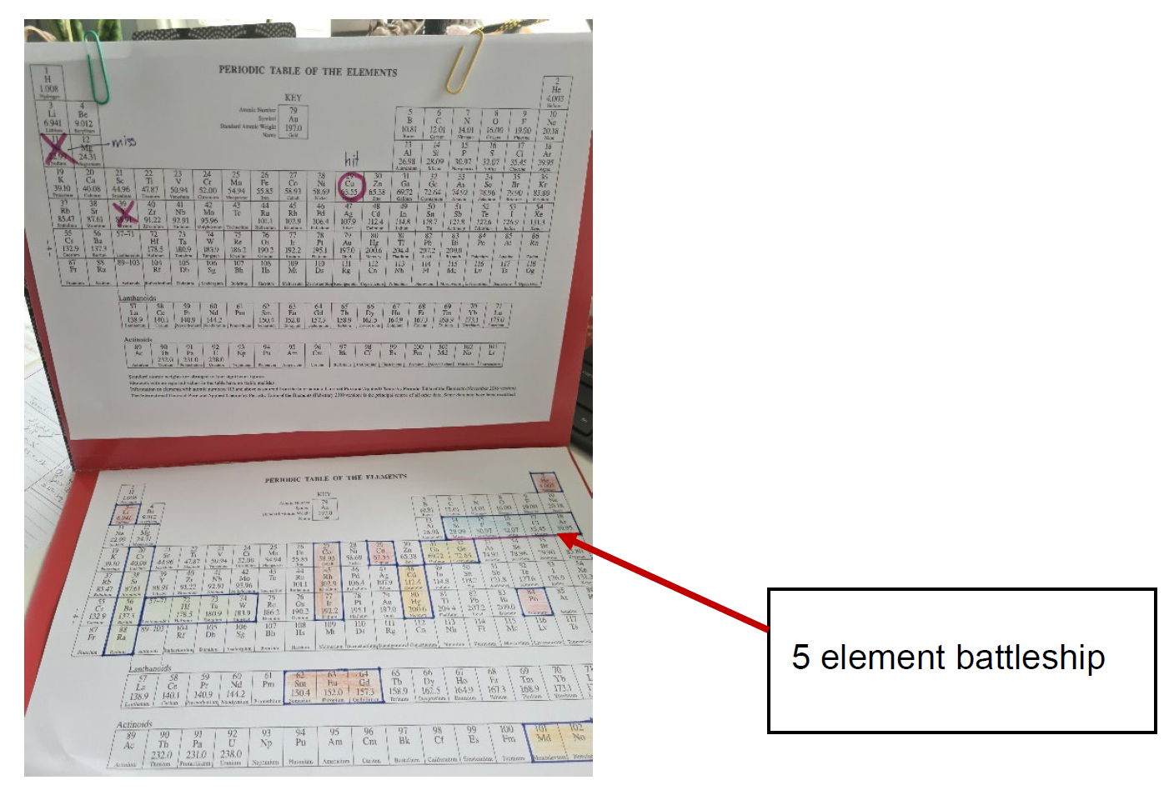
- Play a round of scissors-paper-rock (or other suitable game) to determine who starts play.
- The first player identifies coordinates using the group and period numbers, for example, group 2 – period 3.
- Use the vertical periodic table to track your hits. Mark the selected element with an ‘X’ if it is a miss and circle the element if it is a hit.
- Play continues until all ships have been sunk.
Figure 3 – periodic table battleships – hit and miss
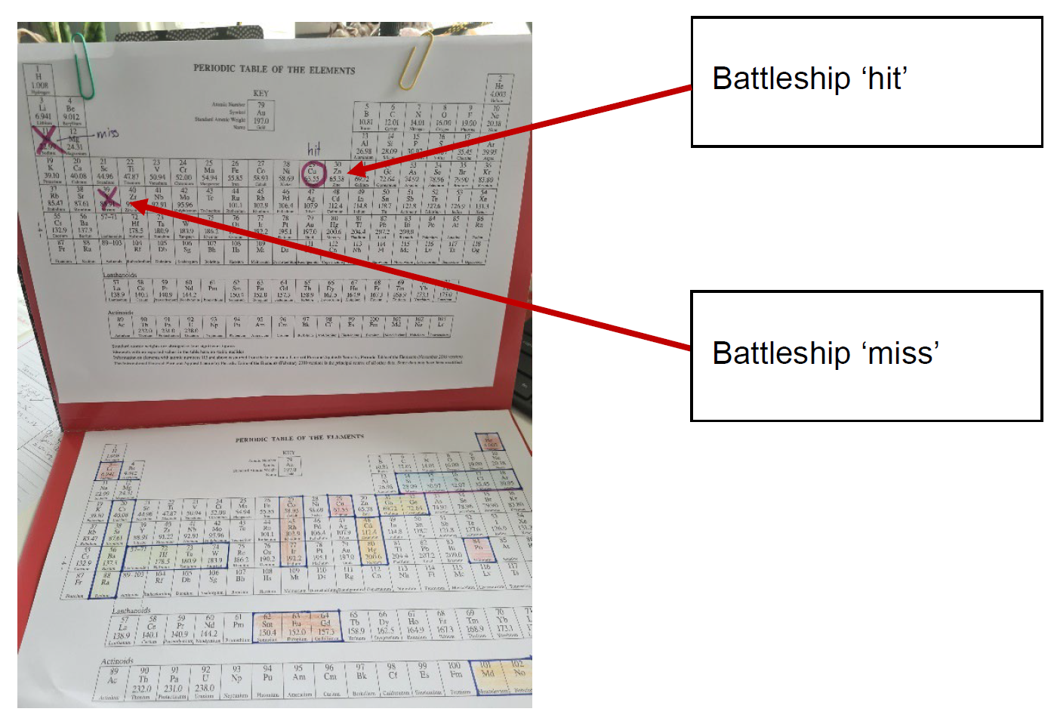
Differentiation: element names or symbols could be used instead of coordinates with a time limit for finding the element.
If students are not familiar with scissors-paper-rock, dice could be rolled to select the first player.

Student resources

Prior knowledge – Quick writes
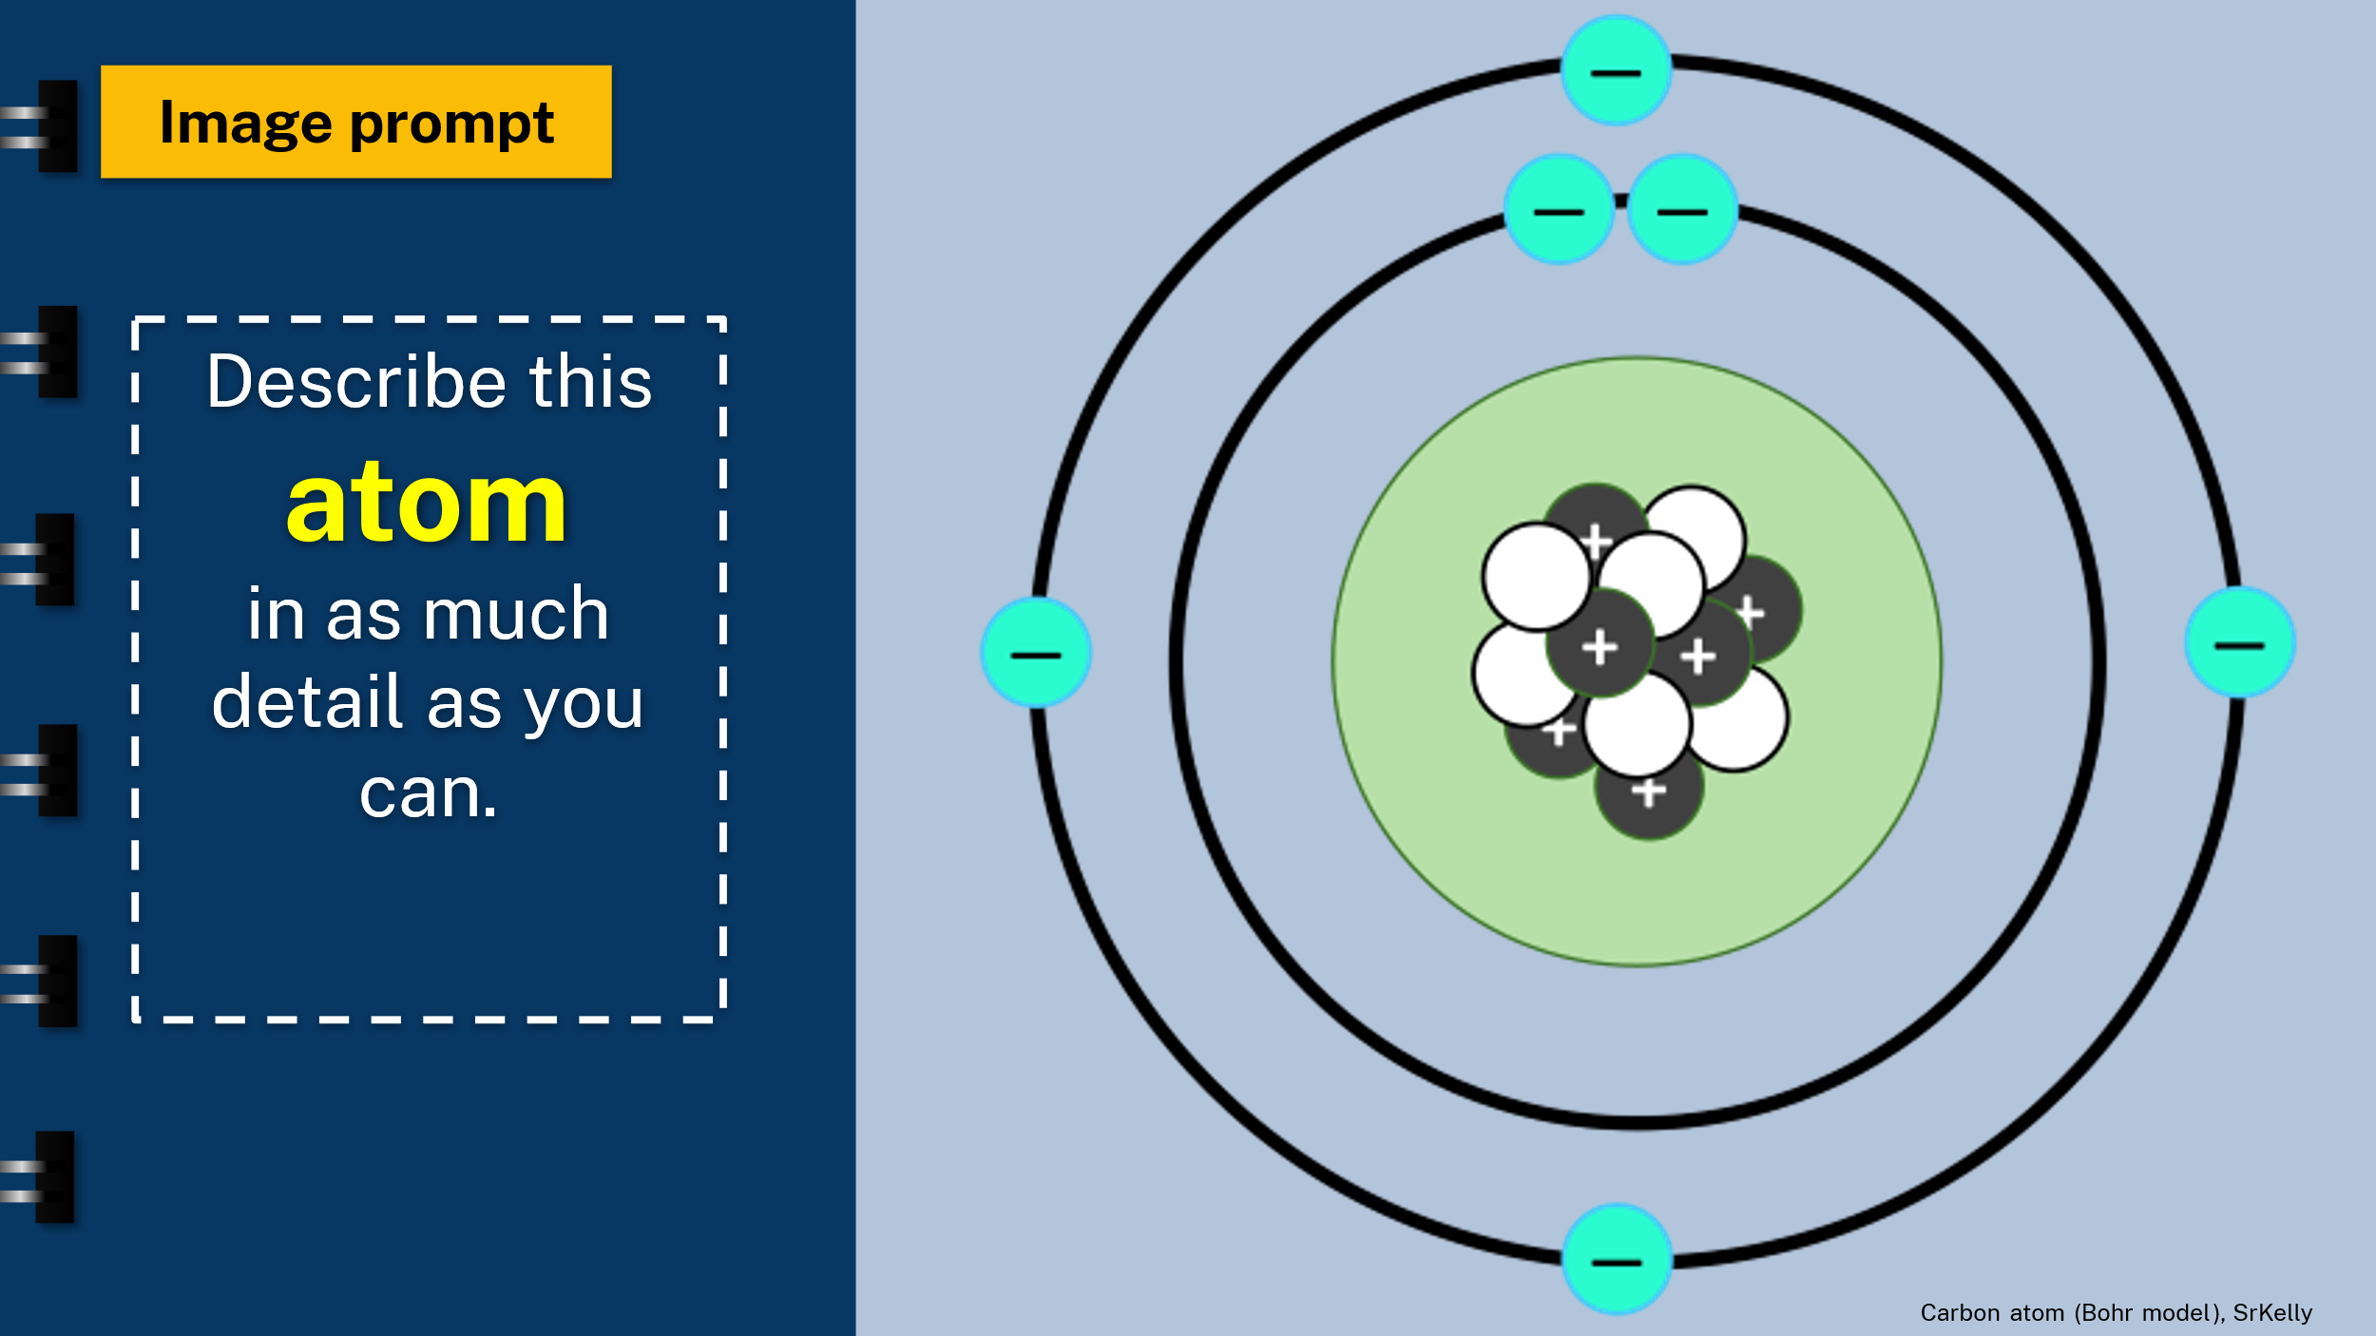
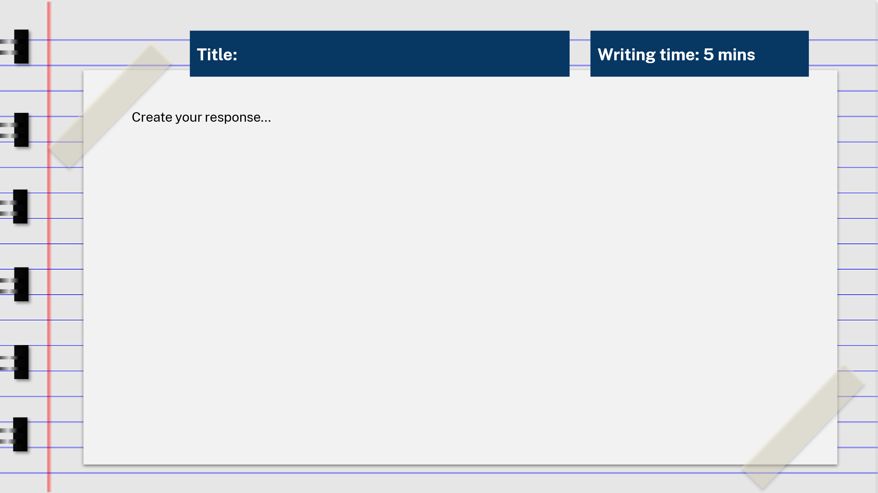

Activity 1 – word bank
In the table below, write down unfamiliar terms as you listen to the SLOW "The NEW Periodic Table Song (in Order)" (4:20) (do not include the names of elements in your word bank).
Term | Meaning

Activity 2 – getting to know the periodic table and its elements

Part A – looking for patterns – inquiry cube labels
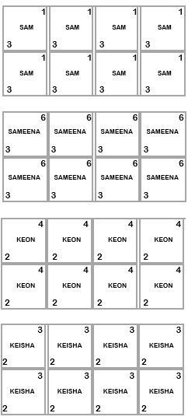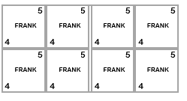

Activity 3 – models of the atom
Use your periodic table to complete the Atomic structure table below.
Atomic number | Element | Mass number | Period | Number of shells | Group | Electrons in outer shell | Protons (equals the atomic number) | Neutrons (= mass number - atomic number)
1
2
3
4
5
6
7
8
9
10
11
12
13
14
15
16
17
18
19
20

Modelling the Bohr atom
Use the template to create models of atom. Use different coloured counters to represent atoms, protons and electrons.
- Identify each atom.
- Count the correct number of protons, electrons and neutrons needed for the atom.
- Place them in the correct place on the template.
- Ask your teacher to check your work.
Figure 4 – Bohr model of the atom scaffold

Activity 4 – a very different periodic table
Read the Cosmos article A very different periodic table.
In questions 1 and 2 you will be looking for explicit information. Questions 3–6 use implicit information gained by reading the text.
- Use skimming techniques to answer the following questions:
- Is the text imaginative, persuasive or informative? How do you know?
- What is the text about?
- What is the first paragraph about?
- What does the image ‘Theodor Benfey’s spira table (1964)’ show?
- What does the image ‘The Underground Map of the Elements’ show?
- What is the last section, ‘Settling on a design’ about?
- Scan the text to answer the questions below.
- When did Mendeleev develop his model of the periodic table?
- Who was the first person to arrange the elements in a table?
- Who was the first scientist to sort elements based on their properties?
- When did Werner add the noble gases to the periodic table?
- Who created the model of the periodic table that is the basis of the modern periodic table?
- Describe how the way that Mendeleev approached the model of the periodic table was different to that of other scientists.
- Explain why Mendeleev’s model of the periodic table was important.
- Create a Venn diagram to identify similarities and differences between Baumhauer’s spiral model and the modern periodic table.
- Select one of the alternative models of the periodic table, for example: The Underground Map of the Elements, the 3D ‘Mendeleev flower’.
- Evaluate how effective the model is to find the elements and predict their properties. The following databases may be used to discover other models of the periodic table.
- Evaluate the statement: ‘The modern periodic table is based on evidence and will not change.’

Activity 5 – examining a trend in the periodic table – Predict-Explain-Observe-Explain (PEOE) extension
You have watched the video Alkali Metals Reacting with Water (3:16) demonstrating a trend in how group I elements react with water. Your task is to:
- Predict: the reactivity trend of elements in group II of the periodic table (the alkali earth metals).
- Explain: why you think that this will happen.
- Observe: design and carry out an experiment to investigate and observe the reactivity of group II elements.
- Explain: explain the trend that you observe.
Use the table below to Predict-Explain-Observe-Explain.
Description of focus
Reactivity of group II elements.
Predict (what do you expect to see? Give reasons to support your predictions.)
Explain (why do you think this will happen?)
Observe (what do you see?)
Explain (Add to or change your previous explanation. Why does this trend occur?)
Develop a valid and logical method to check your prediction. Include a complete risk assessment. Have your method, risk assessment and data collection process checked by your teacher before you conduct the experiment.
The following equipment is available to you.
- Magnesium
- Calcium
- Strontium turnings
- 50 mL graduated cylinder
- 5 × 100 mL beakers
- Mass balance
- 3 × 50 mL beakers
- Timer
- Hydrochloric acid (1 M)
- Universal indicator solution
- De-ionized water
- Tweezers
Carry out your experiment and complete the PEOE table.

Activity 5 – examining a trend in the periodic table – Predict-Explain-Observe-Explain (PEOE)
You have watched a video demonstrating a trend in how group I elements react with water. Your task now is to predict, explain and observe the trend in reactivity of elements in group II of the periodic table (the alkali earth metals).
- Complete the ‘Predict’ and ‘Explain’ sections of the table below based on your observations from Alkali Metals Reacting with Water (3:16) and your class discussion.
- Carry out the experimental method provided. Discuss your observations with your small group and complete the rest of the table.
Use the table below to Predict-Explain-Observe-Explain.
Description of focus
Reactivity of group II elements.
Predict (what do you expect to see? Give reasons to support your predictions.)
Explain (why do you think this will happen?)
Observe (what do you see?)
Explain (Add to or change your previous explanation. Why does this trend occur?)

Equipment
- Magnesium
- Calcium
- Strontium turnings
- 50 mL graduated cylinder
- 5 × 100mL beakers
- Mass balance
- 3 × 50 mL beakers
- Timer
- Hydrochloric acid (1 M)
- Universal indicator solution
- De-ionized water
- Tweezers

Method
- Measure 20 mL of hydrochloric acid into each of the three 50 mL beakers.
- Add 3 drops of universal indicator to all 3 beakers. Swirl the solution to mix.
- Place two 1 cm pieces of magnesium into the second 100 mL beaker.
- Place 2 similar sized pieces of calcium into the first 100 mL beaker.
- Place 2 similar sized pieces of strontium into the last 100 mL beaker.
- One person should be ready to time this next step.
- Each of the 3 volunteers should get ready to pour the hydrochloric acid solution into each of the beakers at the same time.
- The timing person should record the time it takes each metal to disappear.
- If one element takes longer than 5 minutes, stop the time and write down 5+.
- You should now know which element reacts the fastest, faster, and slowest.
- Discuss this data with your small group and complete the rest of the PEOE table.

Activity 6 – scavenger hunt
How many of the elements can you find in the everyday things that you use?
You have 15 minutes to locate as many elements as you can. Fill out the table below. You may wish to include a photograph of the item.
Element | Item | Location | Photograph

References
This resource contains NSW Curriculum and syllabus content. The NSW Curriculum is developed by the NSW Education Standards Authority. This content is prepared by NESA for and on behalf of the Crown in right of the State of New South Wales. The material is protected by Crown copyright.
Please refer to the NESA Copyright Disclaimer for more information https://educationstandards.nsw.edu.au/wps/portal/nesa/mini-footer/copyright.
NESA holds the only official and up-to-date versions of the NSW Curriculum and syllabus documents. Please visit the NSW Education Standards Authority (NESA) website https://educationstandards.nsw.edu.au/ and the NSW Curriculum website https://curriculum.nsw.edu.au/home.
Science Years 7–10 Syllabus © NSW Education Standards Authority (NESA) for and on behalf of the Crown in right of the State of New South Wales, 2018.
AsapSCIENCE (7 February 2013) 'The Periodic Table Song (2018 Update!) | SCIENCE SONGS' [video], AsapSCIENCE, YouTube, accessed 16 May 2023.
CESE (Centre for Education Statistics and Evaluation) (2020) What works best: 2020 update, NSW Department of Education, accessed 9 June 23.
CESE (Centre for Education Statistics and Evaluation) (2020) What works best in practice, NSW Department of Education, accessed 9 June 23.
CrashCourse (5 March 2013) 'The Periodic Table: Crash Course Chemistry #4' [video], CrashCourse, YouTube, accessed 9 June 23.
Dave-Family (3 September 2013) 'Mix - SLOW "The NEW Periodic Table Song (In Order)" (AsapSCIENCE 2013)' [video], AsapSCIENCE, YouTube, accessed 16 May 2023.
Enevoldsen K (2005–2016) The Periodic Table of the Elements, in Pictures and Words [PDF 1 MB], elements.wlonk.com, accessed 29 June 23.
Fish D (2019) Making Models: Wooden Blocks, The Perimeter Institute website, accessed 30 May 23.
Khan Academy (31 October 2016) 'The periodic table - classification of elements | Chemistry | Khan Academy' [video], Khan Academy Organic Chemistry, YouTube, accessed 9 June 23.
Leach M R (1999–2023) 3D versions of the periodic table, The Chemogenesis Web Book, accessed 3 July 23.
Lorch M (7 January 2019) ‘A very different periodic table’, Cosmos, accessed 26 June 23.
Milam S (22 October 2015) 'Alkali Metals Reacting with Water' [video], Scott Milam, YouTube, accessed 26 June 23.
NESA (New South Wales Education Standards Authority) (2019) HSC Chemistry formulae sheet [PDF 879 KB], accessed 26 October 2023.
NESA (NSW Education Standards Authority) (2022) ‘Proficient teacher: Standard descriptors’, The Standards, NESA website, accessed 9 June 23.
PBS Learning Media (n.d.) Periodic Table of the Elements [website], accessed 9 June 23.
State of New South Wales (Department of Education) (26 June 2023) Year 9 Locating explicit and implicit information, NSW Department of Education, accessed 30 June 23.
The teacher toolkit (n.d.) Tableau, the teacher toolkit website, accessed 13 June 23.
Wiliam D and Leahy S (2015) Embedding formative assessment: practical techniques for K-12 classrooms, Learning Sciences International, US.

Further reading
State of New South Wales (Department of Education) (2022) Literacy and numeracy, NSW Department of Education, accessed 24 February 23.
State of New South Wales (Department of Education) (2022) Literacy and numeracy priorities, NSW Department of Education, accessed 24 February 23.
© State of New South Wales (Department of Education), 2023
The copyright material published in this resource is subject to the Copyright Act 1968 (Cth) and is owned by the NSW Department of Education or, where indicated, by a party other than the NSW Department of Education (third-party material).
Copyright material available in this resource and owned by the NSW Department of Education is licensed under a Creative Commons Attribution 4.0 International (CC BY 4.0) license.

This license allows you to share and adapt the material for any purpose, even commercially.
Attribution should be given to © State of New South Wales (Department of Education), 2023.
Material in this resource not available under a Creative Commons license:
- the NSW Department of Education logo, other logos and trademark-protected material
- material owned by a third party that has been reproduced with permission. You will need to obtain permission from the third party to reuse its material.
Links to third-party material and websites
Please note that the provided (reading/viewing material/list/links/texts) are a suggestion only and implies no endorsement, by the New South Wales Department of Education, of any author, publisher, or book title. School principals and teachers are best placed to assess the suitability of resources that would complement the curriculum and reflect the needs and interests of their students.
If you use the links provided in this document to access a third-party's website, you acknowledge that the terms of use, including licence terms set out on the third-party's website apply to the use which may be made of the materials on that third-party website or where permitted by the Copyright Act 1968 (Cth). The department accepts no responsibility for content on third-party websites.

