La ropa – game cards

For the teacher
These activities occur at different points in the learning sequence.

Activity 1
Students form pairs or groups of 3. Provide each group with one copy of the ‘Activity 1 – clothing and colours’ table.
Using the ‘Activity 1 – clothing and colours’ table as a stimulus, students create 6 to 8 sentences, describing items of clothing in Spanish. Ask students to write a mixture of correct and incorrect sentences. For example, they may write the wrong colour, or not agree the adjective with the noun.
Students then take turns to read their sentences to the other student(s) in their group. The other student(s) must decide if the sentence is correcto or incorrecto.
If the student decides the statement is incorrecto, they must correct the error orally. For example, a student reads Es un mono negro. The correction may be No es un mono negro, es un mono violeta or No es un mono negro, es una corbata negra.

Activity 2
Students form groups of 3 or 4. Provide each group with one set of the ‘Activity 2 cards – What is it and where do you wear it?’ cards. You will need to cut these up in advance or ask the students to do it for you.
Students place the pile of cards face down on the desk.
When directed, Student A draws the top card and asks the student to their right (Student B) ¿Qué es esto?
Student B responds by identifying the item on the card with the appropriate details (for example, un vestido largo, una camiseta a rayas and so on).
Student A then asks ¿Dónde llevas esto?
Student B must reply with an appropriate event or place, for example, A la fiesta de cumpleaños or A la playa.
Student B then takes the next card from the pile and repeats the interaction with Student C, based on the new card.
Repeat the process until all the cards in the pile have been correctly identified. If students are in even groups, they can race other groups to finish the round first.

Activity 3
Students play a game similar to ‘Go Fish’, in groups of 3 or 4. The aim of the game is for students to be the first to complete an outfit.
On the board, write ‘You need to build an outfit, including:
- something to wear on your top (T-shirt, shirt or blouse)
- something to wear on your bottom (skirt, jeans, shorts or pants)
- something warm (jumper or jacket)
- socks or tights
- shoes (heels, boots, sandals, thongs or runners).’
Provide each group with one set of the ‘Activity 2 cards – What is it and where do you wear it?’ cards (from the previous activity). Each student is dealt 5 cards. The remaining cards are placed face down in a pile at the centre of the desk. One player begins (as determined by a roll of the dice or other means). Based on what they already have in their hand and what they need, the first student (Student A) asks the player to their left (Student B) if they have a particular card, being specific about what they need. For example, if they need a top, they ask Necesito una camiseta (I need a T-shirt). If Student B:
- doesn’t have the requested card, Student A casts off a card and draws another one from the draw pile
- does have the requested card, student A takes the card and Student B draws a replacement card from the draw pile.
Student B, then asks the student to their left (Student C) and so on.
During the game, students will interact using sentences such as:
- Necesito (I need), for example, Necesito una camiseta.
- No lo tengo (I don’t have it) or aquí está (here it is)
- ¡Gané! (I won!)
Students win the game by being the first to complete their outfit, their 5 cards face up on the desk in front of them.
If you have students who need additional support, provide them with one of the cards below, to use during play.
You need to build an outfit, including:  - something to wear on your top  Necesito una camiseta (I need a T-shirt)  Necesito una camisa (I need a shirt)  Necesito una blusa (I need a blouse)  - something to wear on your bottom  Necesito unos shorts (I need shorts)  Necesito unos pantalones (I need pants)  Necesito unos vaqueros (I need jeans)  Necesito una falda (I need a skirt)  - something warm  Necesito una chaqueta (I need a jacket)  Necesito un suéter (I need a jumper)  - socks or tights  Necesito unos calcetines (I need socks)  Necesito unas mallas (I need tights)  - shoes  Necesito unas botas (I need boots)  Necesito unas zapatillas (I need runners)  Necesito unas chancletas (I need thongs)  Necesito unas sandalias (I need sandals)  Necesito unos tacones (I need heels). | You need to build an outfit, including:  - something to wear on your top  Necesito una camiseta (I need a T-shirt)  Necesito una camisa (I need a shirt)  Necesito una blusa (I need a blouse)  - something to wear on your bottom  Necesito unos shorts (I need shorts)  Necesito unos pantalones (I need pants)  Necesito unos vaqueros (I need jeans)  Necesito una falda (I need a skirt)  - something warm  Necesito una chaqueta (I need a jacket)  Necesito un suéter (I need a jumper)  - socks or tights  Necesito unos calcetines (I need socks)  Necesito unas mallas (I need tights)  - shoes  Necesito unas botas (I need boots)  Necesito unas zapatillas (I need runners)  Necesito unas chancletas (I need thongs)  Necesito unas sandalias (I need sandals)  Necesito unos tacones (I need heels).
Once a student has won, all students then write 5 sentences, providing a detailed description of the 5 cards they have at the end of play. For example, Tengo una camiseta amarilla, un suéter marrón, una falda a rayas blancas y negras, unas mallas verdes y violeta y zapatillas amarillas. Students then write the outfit they would prefer, using clothing items, colours and designs of their own choosing, for example Prefiero una camiseta blanca, una chaqueta negra, unos vaqueros, unos calcetines negros y zapatillas blancas y negras.

Activity 1 table – clothing and colours
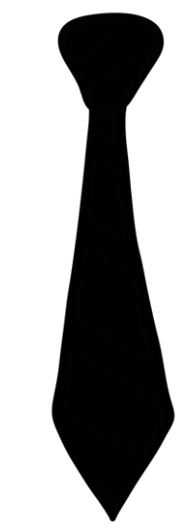 | 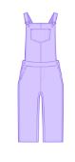 | 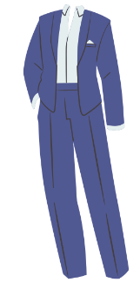 | 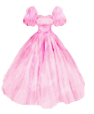
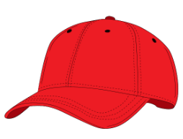 | 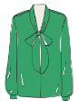 | 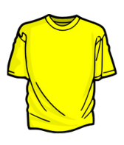 | 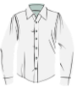
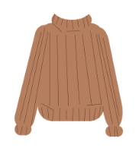 | 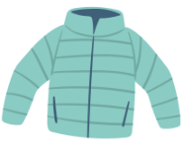 | 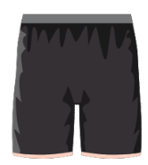 | 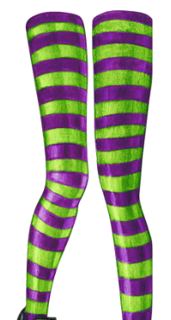
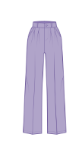 | 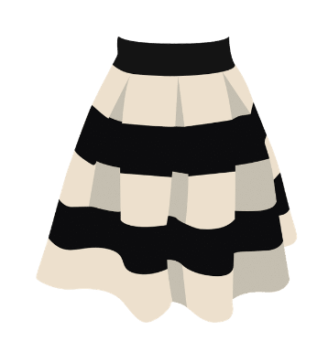 | 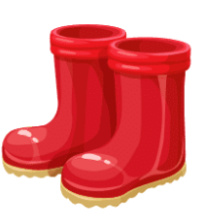 | 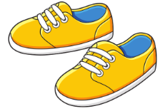
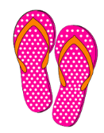 | 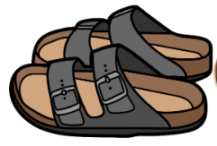 | 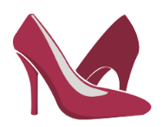 | 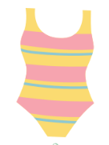

Activity 2 cards – What is it and where do you wear it?
 |  | 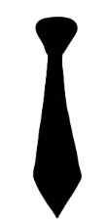 | 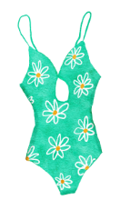
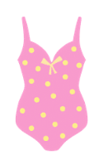 |  |  | 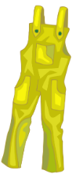
 | 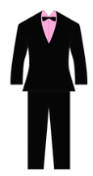 | 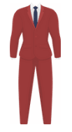 | 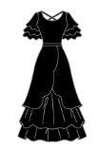
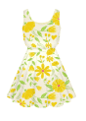 | 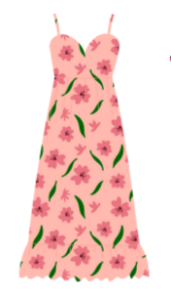 |  | 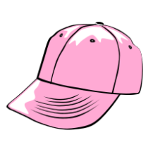
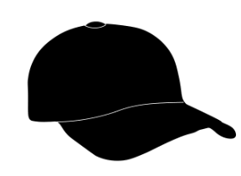 | 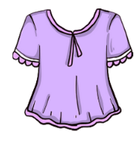 | 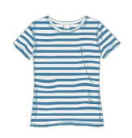
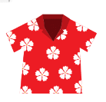 | 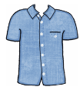 | 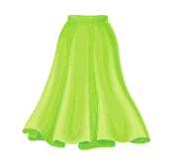
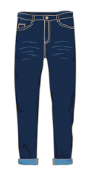 | 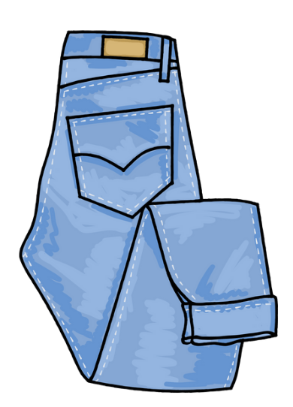 | 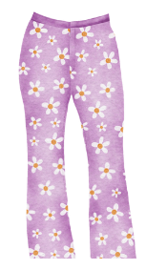
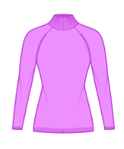 | 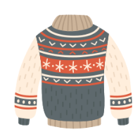 | 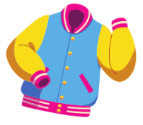 | 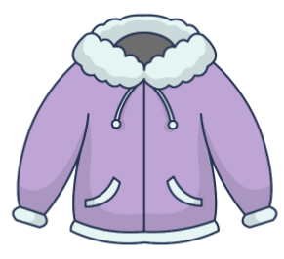
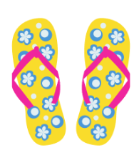 | 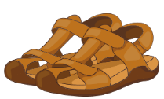 | 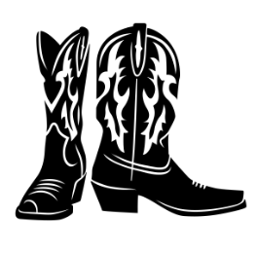 | 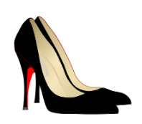
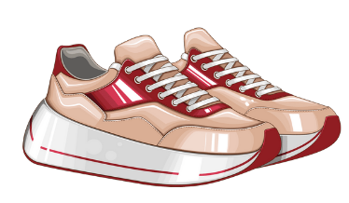 |  | 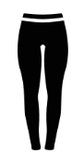 | 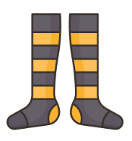
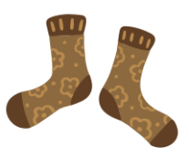 | 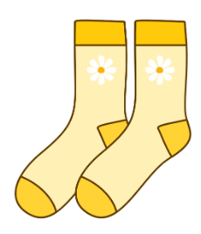 | 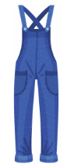

© State of New South Wales (Department of Education), 2023
The copyright material published in this resource is subject to the Copyright Act 1968 (Cth) and is owned by the NSW Department of Education or, where indicated, by a party other than the NSW Department of Education (third-party material).
Copyright material available in this resource and owned by the NSW Department of Education is licensed under a Creative Commons Attribution 4.0 International (CC BY 4.0) license.

This license allows you to share and adapt the material for any purpose, even commercially.
Attribution should be given to © State of New South Wales (Department of Education), 2023.
Material in this resource not available under a Creative Commons license:
- the NSW Department of Education logo, other logos and trademark-protected material
- material owned by a third party that has been reproduced with permission. You will need to obtain permission from the third party to reuse its material.
Links to third-party material and websites
Please note that the provided (reading/viewing material/list/links/texts) are a suggestion only and implies no endorsement, by the New South Wales Department of Education, of any author, publisher, or book title. School principals and teachers are best placed to assess the suitability of resources that would complement the curriculum and reflect the needs and interests of their students.
If you use the links provided in this document to access a third-party's website, you acknowledge that the terms of use, including licence terms set out on the third-party's website apply to the use which may be made of the materials on that third-party website or where permitted by the Copyright Act 1968 (Cth). The department accepts no responsibility for content on third-party websites.

