El Día de los Muertos – reading comprehension

Activity 1 – text
El Día de los Muertos es una celebración que recuerda a los muertos. Se celebra el primero y el dos de noviembre. Tradicionalmente el primero es para los niños difuntos* y el dos para los adultos. La celebración es una mezcla de catolicismo de los colonizadores españoles y varias culturas indígenas de las Américas.
Hoy en día las familias mexicanas visitan el cementerio y adornan las tumbas de sus familiares fallecidos con flores especiales (caléndulas) y con cosas representativas de los difuntos tales como sus comidas y bebidas favoritas.

Una caléndula
En las casas muchas familias tienen altares con fotos de sus difuntos, sus comidas favoritas, flores, velas y comidas típicas de la celebración como pan de muerto, un pan dulce con la imagen de una calaca de azúcar.
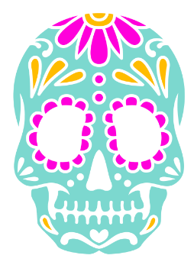
Una calaca de azúcar (pan de muerto)
El símbolo del Día de los Muertos es un esqueleto vestido como una dama aristócrata. Es una figura creada por José Guadalupe Posada, un artista mexicano, en 1913. Originalmente era para reírse* de las damas aristócratas en México y ahora durante el primero y dos de noviembre las calles mexicanas se llenan* con Catrinas que caminan.
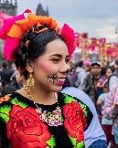
Una mujer vestida en ‘Catrina’
* difuntos – deceased; * reírse – to make fun of; * se llenan – are filled

Questions
- When is the Día de los Muertos celebrated?
- Which 2 cultures influence the tradition of the Día de los Muertos?
- What are some of the ways Mexican families celebrate the Día de los Muertos with their deceased loved ones?
- What items are commonly found on the altars created in households during the Día de los Muertos?
- How popular do you think the concept of the ‘Catrina’ is and how can you tell?

Activity 2 – invitación
Look carefully at the invitation to the event below and answer the questions that follow in English:
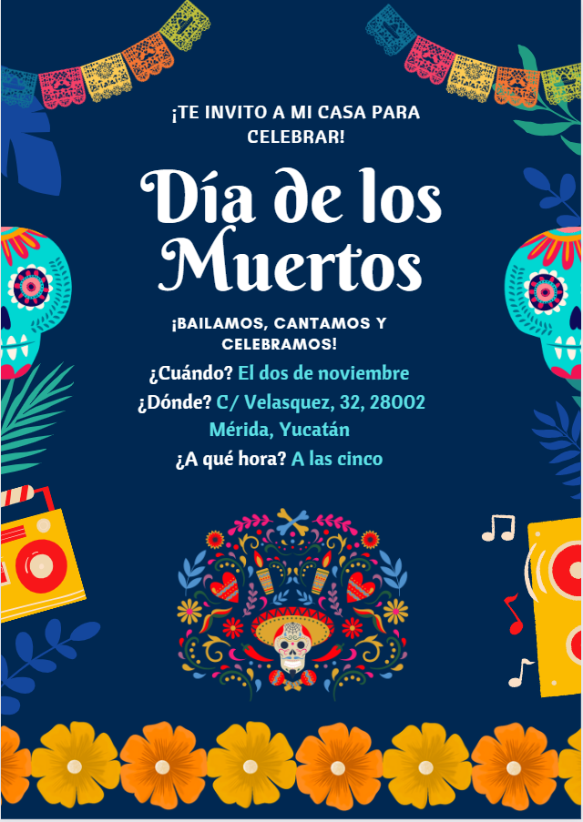
- What event is this flyer an invitation to?
- In English, summarise the information included in the invitation.

For the teacher
This text includes vocabulary which is likely unfamiliar to your students.
Introduce the reading activity by reviewing the strategies for understanding texts – find a couple of sample sentences with unfamiliar words and model the strategies for students. The strategy you choose should best meet the needs of the students.
For example, you may ask students to:
- underline words they know and circle unfamiliar words
- code texts using ‘*’ for familiar words or structures, ‘+’ for new information, ‘!’ for ’wow’ (something they find interesting) and ‘?’ for ‘I don’t understand’
- colour code the text to identify prepositions, nouns, adjectives and verbs.
Alternatively, lead students through the following steps:
- Do I know these words?
- Do they look like English words (cognates)?
- Can I extrapolate or guess the meaning from the context?
- Help me, I need a dictionary!
Another approach is to read for context clues using the reading strategies in the table below.
Step | Action
1. Read and question | Read the text carefully.  Frequently ask yourself ‘Does this make sense?’.
2. Slow advance | Notice when you don’t know the meaning of a word and slow down.  Read that sentence at least once more, looking for clues.
3. Stop and rewind | If necessary, go back and re-read the preceding sentence, looking for clues that will help you figure out what the word or phrase might mean.
4. Read and question | When you think you have figured out what the word or phrase means, substitute your guess for the word or phrase.  If it makes sense, keep reading.  If it does not make sense, stop and rewind, and try again or check the meaning in a dictionary.
Students could also use their own strategies.
Allow students time to access the text and questions independently or, if preferred, in pairs. Provide vocabulary hints for students who need additional support.

Questions
- When is the Día de los Muertos celebrated? 1 and 2 November.
- Which 2 cultures influence the tradition of the Día de los Muertos? The Catholic Spanish colonisers and Indigenous cultures of the Americas.
- What are some of the ways Mexican families celebrate the Día de los Muertos with their deceased loved ones? Families visit the cemetery and decorate their loved ones’ tombs with marigolds and things like their favourite foods and drinks
- What items are commonly found on the altars created in households during the Día de los Muertos? Photos of their loved ones, favourite foods, flowers, candles and sugar skulls.
- How popular do you think the concept of the ‘Catrina’ is and how can you tell? It is a very popular concept because the text says the streets are full of ‘Catrinas’.

Activity 2 – invitación
- What event is this flyer an invitation to? A party to celebrate the Día de los Muertos (Day of the Dead).
- In English, summarise the information included in the invitation. A statement to invite someone, information about what is going to happen (dancing, singing and celebrating), details about when (2 November), where and what time (5 o’clock).

© State of New South Wales (Department of Education), 2023
The copyright material published in this resource is subject to the Copyright Act 1968 (Cth) and is owned by the NSW Department of Education or, where indicated, by a party other than the NSW Department of Education (third-party material).
Copyright material available in this resource and owned by the NSW Department of Education is licensed under a Creative Commons Attribution 4.0 International (CC BY 4.0) license.

This licence allows you to share and adapt the material for any purpose, even commercially. Attribution should be given to © State of New South Wales (Department of Education), 2023.
Material in this resource not available under a Creative Commons licence:
- the NSW Department of Education logo, other logos and trademark-protected material
- material owned by a third party that has been reproduced with permission. You will need to obtain permission from the third party to reuse its material.
Links to third-party material and websites
Please note that the provided (reading/viewing material/list/links/texts) are a suggestion only and implies no endorsement, by the New South Wales Department of Education, of any author, publisher, or book title. School principals and teachers are best placed to assess the suitability of resources that would complement the curriculum and reflect the needs and interests of their students.
If you use the links provided in this document to access a third-party's website, you acknowledge that the terms of use, including licence terms set out on the third-party's website apply to the use which may be made of the materials on that third-party website or where permitted by the Copyright Act 1968 (Cth). The department accepts no responsibility for content on third-party websites.

