Japanese seasons and calendar

Japanese seasons
Above each kanji, write a sentence in Japanese which includes the months of the season. The first season has been done for you.
春は三月と四月と五月です。  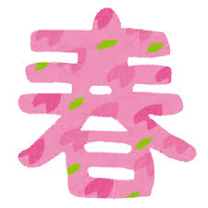 | 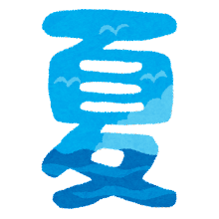
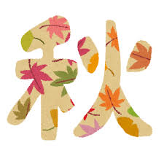 | 
Images by Takashi Mifune are licensed under Irasutoya’s terms of use.

Japanese calendar
In the table below, you can see one Japanese festival or seasonal event for each month of the year. The first example has been done for you.
- Underneath each month, write the season in kanji: 春, 冬, 秋 or 夏.
- Read the festival or seasonal event vocabulary and write the meaning in English next to the Japanese.
- Look at the festival picture for each month and write a sentence in Japanese, following the example 四月はおはなみです.
- In small groups, research each festival or seasonal event and add a brief description in English to the calendar. The description should include 3 to 4 sentences about the event.
- Identify 3 to 4 events in Australian life, look up their Japanese term and add these to the relevant months, using the same structure.
Month and season | Japanese festival or seasonal event | Australian festival or seasonal event
一月  冬  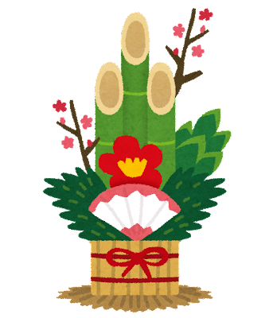 | お正月 （おしょうがつ）Japanese new year  一月はおしょうがつです。  お正月 celebrates the new calendar year. People send new year cards to family and friends, called ねんがじょう. People eat food such as mochi and buckwheat noodles. Relatives give money to children and Buddhist temples ring bells at midnight 108 times.
二月  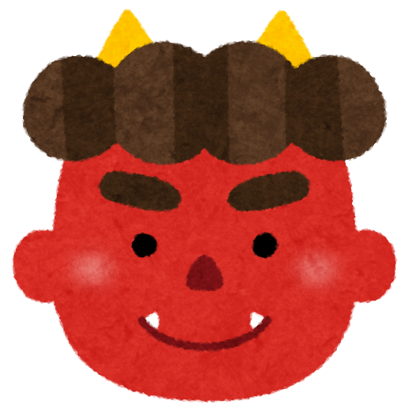 | せつぶん
三月  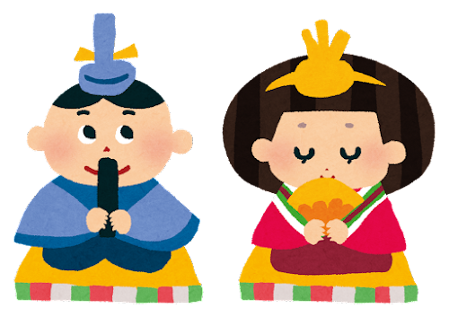 | ひなまつり
四月  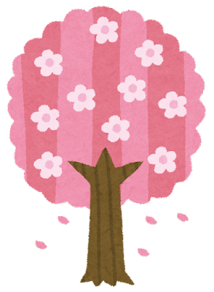 | お花見 （おはなみ）
五月  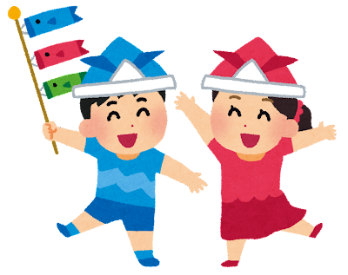 | こどもの日
六月  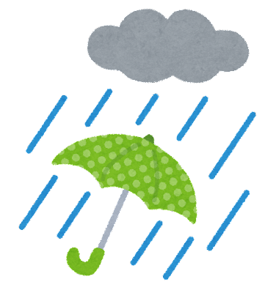 | つゆ
七月  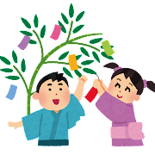 | 七夕 （たなばた）
八月  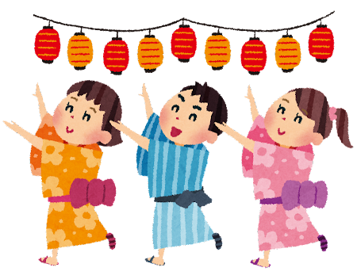 | おぼん
九月  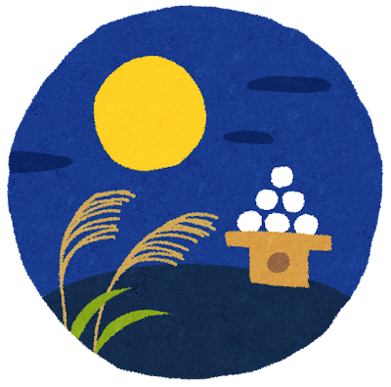 | お月見 (おつきみ)
十月  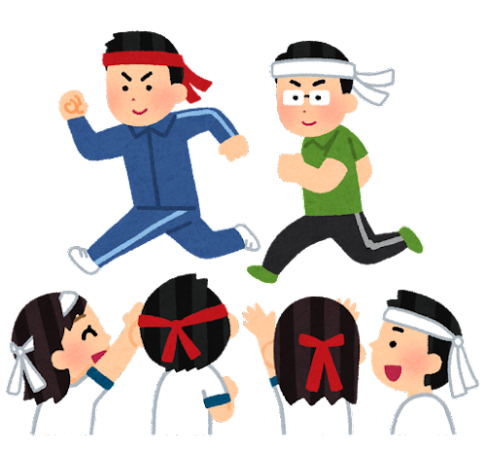 | スポーツの日
十一月  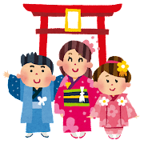 | 七五三 （しちごさん）
十二月  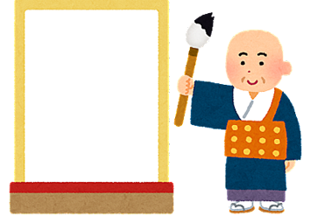 | おおみそか
Images by Takashi Mifune are licensed under Irasutoya’s terms of use.

For the teacher
Remove this section before sharing this resource with students.

Japanese seasons
春は三月と四月と五月です。 | 夏は六月と七月と八月です。
秋は九月と十月と十一月です | 冬は十二月と一月と二月です
Images by Takashi Mifune are licensed under Irasutoya’s terms of use.

Japanese calendar
Month and season | Japanese festival or seasonal event | Australian festival or seasonal event
一月  冬 | お正月 （おしょうがつ） Japanese new year  一月はおしょうがつです。  お正月 celebrates the new calendar year. People send new year cards to family and friends, calledねんがじょう. People eat food such as もちand buckwheat noodles. Relatives give money to children and Buddhist temples ring bells at midnight 108 times. | Student responses will vary.
二月  冬 | せつぶん Bean throwing festival  二月はせつぶんです。  せつぶん is a traditional Japanese festival celebrated on 3 February. On せつぶんpeople do rituals to ward off evil spirits and bring in good fortune for the upcoming year. One of the main rituals is まめまき (bean throwing), where roasted soybeans are thrown by a person wearing a demon mask, while chanting おにはそと! ふくはうち! which means ‘Demons out! Good fortune in!’ It is also common for people to eat the same number of beans as their age to ensure good health and fortune for the year. | Student responses will vary.
三月  春 | ひなまつり Girls’ festival  三月はひなまつりです。  ひなまつり is a traditional Japanese festival celebrated on 3 March dedicated to the well-being and happiness of girls. Families with daughters display a set of ornamental dolls, known as ひなにんぎょう, which represent the Emperor, Empress, and other court attendants in traditional Heian period attire. The dolls are usually arranged on a tiered platform covered with a red cloth. The festival also involves customs such as eating special foods like ちらしづしand ひしもち. ひなまつりis an occasion for families to pray for the health, happiness, and prosperity of their daughters. | Student responses will vary.
四月  春 | お花見 （おはなみ） Flower viewing festival  四月はおはなみです。  お花見 is the Japanese tradition of enjoying the beauty of さくらcherry blossoms in spring. People gather under blooming cherry trees in parks and gardens to appreciate the flowers, often with picnics, music, and festive activities. お花見is a time for socialising and celebrating the fleeting beauty of nature, as the cherry blossoms only last for a short period. It is a cherished cultural event in Japan, symbolising renewal and the transient nature of life. | Student responses will vary.
五月  春 | こども日 （こどものひ） Children’s Day  五月はこどもの日です。  こども日 is celebrated on 5 May. It is a day to celebrate the happiness, health and growth of children. Traditionally, families display こいのぼり(colourful, carp-shaped kites), which symbolise strength and perseverance, and set up samurai dolls and helmets, representing courage and success. Special foods like かしわもち (rice cakes wrapped in oak leaves) and ちまき (sweet rice dumplings wrapped in bamboo leaves) are enjoyed. | Student responses will vary.
六月  夏 | つゆ Rainy season  六月はつゆです。  つゆ occurs in Japan from early June to mid-July and is an important season that marks the transition from spring to summer. During つゆthere is heavy rainfall and high humidity. つゆ is needed for agriculture, providing water for rice paddies and other crops. However, it can also lead to flooding and landslides. | Student responses will vary.
七月  夏 | 七夕 （たなばた） Tanabata festival  七月はたなばたです。  七夕 is a Japanese celebration held on 7 July. It commemorates the meeting of 2 deities, おりひめand ひこぼし who are star-crossed lovers separated by the Milky Way and allowed to reunite only once a year. During Tanabata, people write their wishes on たんざく (colourful strips of paper) and hang them on bamboo branches, often decorating them with other ornaments. Festivals and parades also mark the occasion, celebrating the spirit of hope and the beauty of dreams. | Student responses will vary.
八月 | おぼん Obon festival  八月はおぼんはです。  おぼん is a Japanese Buddhist festival held in mid-August to honour the spirits of deceased ancestors. It is believed that during おぼん, the spirits return to visit their living relatives. Families gather to clean and decorate graves, offer food and incense, and participate in ぼんおどり, a traditional dance to welcome the spirits. Lanterns are lit and floated down rivers or set outside homes to guide the spirits back to their resting places. おぼん is a time for family reunions, remembrance, and paying respects to those who have passed away. | Student responses will vary.
九月 | お月見 (おつきみ) Moon viewing festival  九月はお月見です。  お月見 is a traditional Japanese celebration of the autumn moon. During お月見 people gather to admire the beauty of the moon, often setting up outdoor displays with offerings such as 月見だんご (rice dumplings) and seasonal fruits. The celebration is a time to appreciate the changing seasons and crop harvests, reflecting on the beauty and transience of nature. | Student responses will vary.
十月 | スポーツの日 （スポーツのひ） Sports day  九月はスポーツの日です。  スポーツの日 is a national holiday in Japan celebrated on the second Monday of October. Originally established in 1966 to commemorate the opening of the 1964 Tokyo Olympics, this day promotes physical activity, sportsmanship, and a healthy lifestyle. Schools and communities organise various athletic events and activities, such as track and field competitions, team sports, and traditional games. The holiday encourages people of all ages to engage in sports and outdoor activities, fostering a sense of unity and community spirit through physical fitness and recreation. | Student responses may vary.
十一月 | 七五三 （しちごさん） Shichi-go-san festival  十一月は七五三です。  七五三 is a traditional Japanese festival held on 15 November to celebrate the growth and well-being of children aged 3, 5, and 7. During this festival, families dress their children in beautiful kimonos and visit shrines to pray for their health and prosperity. The ages 3, 5, and 7 are considered significant milestones in a child's development in Japanese culture. Children also receive ちとせあめ (thousand-year candy) which symbolises healthy growth and longevity. | Student responses may vary.
十二月 | おおみそか Japanese new year’s eve  十二月はおおみそかです。  おおみそか is celebrated on 31 December. It marks the end of the old year and the beginning of the new one. On this day, families often clean their homes to remove the old year's misfortunes and prepare for the new year's blessings. Traditions include eating としこしそば (buckwheat noodles) to symbolise crossing over from one year to the next and visiting temples or shrines for the first prayer of the new year, known as はつもうで. Many people also watch the year-end TV program こうはくうたがっせん, which features performances by popular artists. | Student responses may vary.
Images by Takashi Mifune are licensed under Irasutoya’s terms of use.

© State of New South Wales (Department of Education), 2024
The copyright material published in this resource is subject to the Copyright Act 1968 (Cth) and is owned by the NSW Department of Education or, where indicated, by a party other than the NSW Department of Education (third-party material).
Copyright material available in this resource and owned by the NSW Department of Education is licensed under a Creative Commons Attribution 4.0 International (CC BY 4.0) license.

This license allows you to share and adapt the material for any purpose, even commercially.
Attribution should be given to © State of New South Wales (Department of Education), 2024.
Material in this resource not available under a Creative Commons license:
- the NSW Department of Education logo, other logos and trademark-protected material
- material owned by a third party that has been reproduced with permission. You will need to obtain permission from the third party to reuse its material.
Links to third-party material and websites
Please note that the provided (reading/viewing material/list/links/texts) are a suggestion only and implies no endorsement, by the New South Wales Department of Education, of any author, publisher, or book title. School principals and teachers are best placed to assess the suitability of resources that would complement the curriculum and reflect the needs and interests of their students.
If you use the links provided in this document to access a third-party's website, you acknowledge that the terms of use, including licence terms set out on the third-party's website apply to the use which may be made of the materials on that third-party website or where permitted by the Copyright Act 1968 (Cth). The department accepts no responsibility for content on third-party websites.

