Geography 11–12
Earth’s natural systems resource booklet
Contents
Overview 4
Week 1 – overview of the uniqueness and diversity of the Earth 5
Activity 1 – inspirational landscapes 5
Activity 2 – biodiversity introduction 5
Activity 3 – exploring biodiversity with spatial technologies 6
Activity 4 – wildlife migrations 7
Activity 5 – people’s connections to the natural world 8
Activity 6 – variations with people’s connections to the natural world 9
Activity 7 – how worldview influences our choices 10
Activity 8 – intrinsic and extrinsic value 11
Activity 9 – the global commons introduction 12
Activity 10 – the tragedy of the commons 13
Activity 11 – the importance of the global commons 13
Week 2 – characteristics of Earth’s natural systems and factors affecting their functioning 15
Activity 12 – latitude and longitude 15
Activity 13 – latitude and longitude diagram 15
Activity 14 – latitude and longitude capacity matrix 16
Activity 15 – how altitude and latitude impact temperature 18
Activity 16 – scatter graphs 20
Activity 17 – the impact of altitude on plants 22
Activity 18 – analysing rainfall maps 22
Activity 19 – continentality and oceanity 23
Activity 20 – climate graphs 24
Activity 21 – interpreting climate graphs capacity matrix 28
Activity 22 – Indigenous seasonal calendars 29
Week 3 – atmospheric systems 30
Activity 23 – atmospheric systems key terms 30
Activity 24 – layers of the atmosphere 31
Activity 25 – Earth’s energy budget 32
Activity 26 – global atmospheric circulation 1 33
Activity 27 – global atmospheric circulation 2 34
Activity 28 – weather maps (synoptic charts) 35
Activity 29 – atmosphere–ocean circulations 36
Week 4 – hydrological systems 38
Activity 30 – precipitation pattern and cycles 1 38
Activity 31 – precipitation pattern and cycles 2 39
Activity 32 – precipitation patterns in South-East Asia 39
Activity 33 – climate data 40
Activity 34 – water storages and flows 41
Activity 35 – water storage in Australia and worldwide 41
Activity 36 – water stores and flows 42
Activity 37 – flood hydrographs 43
Activity 38 – water storage case study 43
Activity 39 – factors influencing river catchments 44
Activity 40 – catchment story 45
Week 5 – geomorphic systems 46
Activity 41 – process at tectonic boundaries 46
Activity 42 – plate tectonics 47
Activity 43 – history of the Earth 48
Activity 44 – evolution of the Australian continent 48
Activity 45 – Australia’s intra-plate seismic activity 49
Activity 46 – mapping Earth’s active volcanoes 49
Activity 47 – how volcanic eruptions shape Earth 50
Activity 48 – key terms for soil formation 50
Activity 49 – What is soil? 51
Activity 50 – soil identification 52
Activity 51 – river processes 53
Week 6 – ecological systems 55
Activity 52 – key terms for energy flows 55
Activity 53 – energy flows 56
Activity 54 – key terms for nutrient cycles 1 56
Activity 55 – the carbon cycle 57
Activity 56 – nutrient cycles 58
Activity 57 – key terms for nutrient cycles 2 58
Activity 58 – biological productivity 59
Activity 59 – key terms for nutrient cycles 3 59
Activity 60 – deconstructing a short answer exam question 60
Week 7 – natural systems and land cover change 61
Activity 61 – exploring land cover with spatial technologies 61
Activity 62 – creating a land use map with Google My Maps 61
Activity 63 – key terms for climatic and glacial cycles 62
Activity 64 – natural causes of climate change 62
Activity 65 – glacial and interglacial periods 64
Activity 66 – key terms for invasion and ecological succession 64
References 66

Overview
This student resource pack supports the learning sequences in Earth’s natural systems learning program. It should be considered in conjunction with the sample program for resource context and teaching guidance. Ways this student resource pack can be used include:
- using the resources as worksheets, samples and models, tailoring them to address contextual needs and specific learning objectives
- reviewing the resources during faculty meetings or planning days, jointly planning opportunities for team teaching, mentoring, lesson observation and sharing of student samples
- employing the examples of resources and/or activities as a blueprint for designing student-specific tasks that cater to individual learning styles and needs
- leveraging the strategies, texts, assessment practices, pedagogical practices and/or syllabus planning as an opportunity to backward map, ensuring a cohesive and comprehensive learning experience in geography 11–12.

Week 1 – overview of the uniqueness and diversity of the Earth

Activity 1 – inspirational landscapes
An inspirational landscape is a place in the natural world that evokes a strong response in people — such as awe, wonder, calm, curiosity or spiritual connection. These landscapes may be visually striking, emotionally moving, culturally significant or symbolically powerful. While not everyone finds the same places inspiring, inspirational landscapes matter because they help people connect to nature in ways that go beyond usefulness or economic value. In geography, understanding these connections helps us explore how people value, protect and interact with environments differently.
Access UNESCO World Heritage List and select an inspirational landscape image.
- Identify the key features of the landscape that make it inspirational.

Activity 2 – biodiversity introduction
Fill the blanks in the text below using these terms:
- biodiversity
- biodiversity hotspot
- ecosystem diversity
- genetic diversity
- species diversity
- species rarity.
Biodiversity refers to the full range of life on Earth, from the tiniest bacteria to the largest mammals, and includes 3 key levels: ______________ (the number of different species in a region), ______________ (the variety of genes within a species, which helps populations adapt to changing environments), and ______________ (the variety of ecosystems, such as rainforests, coral reefs and deserts, that support different communities of life). Each level helps maintain ecological balance and resilience.
Some regions are particularly rich in biodiversity. A ______________ is a place that has an exceptionally high number of unique species (known as endemism). This term has also been used to describe areas that have high levels of biodiversity and are being threatened by human activity. These areas often have high species richness (a large number of different species) and may contain many rare species that are found in few other places (______________). The concept of a hotspot helps scientists and governments focus conservation efforts where they’re needed most.
Biodiversity is important because it helps keep ecosystems healthy, stable and resilient. Each species plays a role – like pollinating plants, cleaning air and water, or helping break down waste – which supports life on Earth, including human life. High ______________ means ecosystems can better adapt to change, recover from disasters and continue providing food, medicine and other resources we rely on. Without biodiversity, ecosystems become weaker and more vulnerable to collapse.

Activity 3 – exploring biodiversity with spatial technologies
Follow the steps below to view a world map showing terrestrial (land-based) biodiversity using National Geographic MapMaker 4.0.
- Go to National Geographic MapMaker 4.0. A world map should appear with a default basemap.
- Select Add layer from the bottom toolbar and search for Terrestrial Biodiversity. Select the plus button on the left to add this layer to your map. Close the Add layer menu.
- Select Map layers from the bottom toolbar to manage which layers are visible.
- A layer called Terrestrial Biodiversity should now appear to the right of the main map. Hover over the icons under the words Terrestrial Biodiversity to see options (including ‘Zoom to’, ‘Show legend’, ‘Adjust transparency’, ‘Swipe’, ‘Table’, ‘Description’ and ‘Remove’).
- Select Legend from the bottom toolbar to reveal the legend for the Terrestrial Biodiversity layer. Use the Legend to see how areas are ranked for species richness and species rarity.
This map layer is a type of choropleth map, which means it uses colour to show values. If you zoom in you will see the map is made up of thousands of small squares, each about 777 km². Each square has its own value for both richness and rarity. Species richness is the number of different species found in a particular place. Species rarity describes how likely they are to be found in other areas. Note that the map is not showing how many individual organisms are present. Use the map to complete the following questions.
- What overall spatial patterns do you notice with both richness and rareness?
- What does the dominance of light blue over Northern Europe, Russia and Canada suggest?
- What does the orange around the edges of Antarctica suggest? What about the white in central Antarctica?
- Zoom to the Galapagos Islands. All parts of the Galapagos Islands are high in rarity but relatively low in richness. What are some possible reasons for this?

Activity 4 – wildlife migrations
Read the first paragraph of Nature’s Most Impressive Animal Migrations.
- Define the term ‘migration’.
- Identify the 3 main reasons why animals migrate.
Watch each of the following video clips and complete the table.
Table 1 – wildlife migration
Video | Location(s) | Animal(s) | Description of the migration | Reasons for the migration
Planet Earth - Pole to Pole (2:30) | Kalahari Desert, Southern Africa
David Attenborough’s Great Barrier Reef: Episode 1 – Builders (from 8:51–11:00) | Raine Island
The Arctic Tern Holds the Record for the Longest Migration (2:19) | Arctic Ocean, Antarctica
Note: an ABC iView login is required to access David Attenborough’s Great Barrier Reef.

Activity 5 – people’s connections to the natural world
People who live in close proximity to nature are likely to resonate with many of the examples on this list and may find it difficult to live without some of them. For example, many people who grow up near the beach find it hard to consider ever living away from the coast. Consider the following list of ways that someone might connect with nature. Highlight any of the examples that you are likely to encounter regularly.
- The sound of cicadas on a hot summer afternoon.
- The haze of bushfire smoke over a summer sunset.
- The sight of dark black clouds rolling in as a storm approaches.
- The sounds and sights of a thunderstorm on a summer night.
- The sounds of kookaburras, magpies and other birds.
- The smell of the land after rain.
- The sound of wind on a cold winter night.
- The smell of the ocean.
- The sound and feeling of crunching bark under your feet.
- The colours of autumn leaves.
- The sight of NSW Christmas Bush flowering in December.
- The sight of Jacarandas flowering in Spring.
- The sight of a perfectly clear blue sky on a sunny day in January.
- The feeling of warm sand between your toes at the beach in summer.
- The smells, sights and sounds of a bushwalk.
- The sight of sunrise on a morning run.
- The sight of a colourful sunset as you are driving home.
- Spotting kangaroos bouncing across open plains at dusk.
- The shock of cold water when you first enter the ocean for a swim or surf.
- The sound of waves crashing from a nearby beach.
- The sight of a clear night sky lit up by stars.
- The sight of a full moon rising at sunset.
During the COVID-19 lockdowns, many people reported feeling more connected to nature. Research by Li et al. (2023) found that proximity to natural environments played a protective role in mental health. Individuals with access to green and blue spaces reported better mental health outcomes than those with limited or no access.
- How did your proximity to nature impact your mental health during the COVID-19 pandemic?

Activity 6 – variations with people’s connections to the natural world
Read the article below and answer the questions that follow.
A worldview is a person’s overall way of seeing and understanding the world, based on their experiences, culture, values and beliefs. It shapes how they interpret events, make decisions and connect with people and places, including the natural world. People’s worldviews change as they grow older and often begin to see more meaning in everyday experiences with nature – not just as moments in time, but as memories linked to people, places and feelings. Some of these experiences may feel ordinary now for younger people, but they can take on new value as priorities and perspectives change. If you have a worldview that places high value on connecting with nature, it’s likely that you will make decisions in life that will allow you to connect with nature daily or weekly. It might influence where you choose to live, work, visit, and how you choose to get from one place to another.
NESA defines the overview effect as ‘a shift in awareness reported by some astronauts who have viewed the Earth from space, including the wonder of the Earth, the thinness of its atmosphere, and the absence of national boundaries’ (2022). Photos like ‘Earthrise’, taken by the crew of Apollo 8 in 1968, are widely recognised as advancing the global environmental movement.
For Aboriginal and Torres Strait Islander peoples, connection to Country is far deeper than a moment of awe or appreciation – it is a spiritual, cultural and lived relationship that stretches back tens of thousands of years. Country is not just the land or nature; it includes the skies, waters, animals, plants and stories of ancestors. Every sound, smell and sight in the landscape holds meaning, memory and identity. The land is alive with knowledge, and caring for Country is not optional – it is a responsibility passed from generation to generation. While many Australians might connect to nature through individual moments, Aboriginal peoples’ worldview sees Country as family, as teacher and as life itself.
Other factors that may impact people’s connections to the natural world include cultural background, age, economic circumstances, urban or rural living, level of education and awareness, personal experiences, religious or spiritual beliefs, media exposure, health and mobility, and experiences of environmental degradation.
Answer the following questions.
- What is a worldview, and how can it influence someone’s connection to nature?
- Why is connection to Country important for Aboriginal and Torres Strait Islander peoples?

Activity 7 – how worldview influences our choices
Leila is 22 and moving out of home for the first time. She’s choosing between 2 very different places to live.
Table 2 – two choices for a place to live
Option 1 | Option 2
A large, modern 3-bedroom apartment in town. It’s close to restaurants, cinemas and shops, and has lots of modern features. It’s about 20 minutes from the beach by car. | A small, beachside studio apartment. It’s older and much smaller with fewer conveniences, but it has an ocean view and direct access to the beach.
Conduct a Think–Pair–Share and discuss the following prompt:
- Outline how Leila’s decision could be influenced by her worldview.

Activity 8 – intrinsic and extrinsic value
All of the Earth’s environments have universal value, which can be understood through 2 slightly different concepts: intrinsic value and extrinsic value. Intrinsic value means that environments have worth simply because they exist – regardless of any benefit to humans. For example, a remote rainforest still has value even if no one ever visits it or uses it in any way. Extrinsic value, on the other hand, is based on the benefits environments provide to people. This includes utility value (such as providing food, water or raw materials), as well as aesthetic, cultural, ecological, recreational and spiritual value.
- Complete the table below. For the ‘Value’ column, indicate if the example has intrinsic value, extrinsic value or both. Give a reason for each answer.
Table 3 – intrinsic and extrinsic value
Example | Value | Reason
The Great Barrier Reef | Both | It has intrinsic value as a natural wonder and extrinsic value through ecological, tourism and economic benefits.
A wilderness forest no one can access
The Galapagos Islands
A coral atoll that’s uninhabited
A remote mountain range near a small town
Use examples from the table to help answer these exam-style questions.
- Identify one environment that has both intrinsic and extrinsic value. Justify your choice with reference to its characteristics.
- Explain why some environments are protected even if they do not provide any direct benefit to humans.

Activity 9 – the global commons introduction
A slightly different but equally important concept is the global commons. Global commons refer to all natural systems or resources beyond national jurisdiction. That is, they are shared by all and require collective stewardship. Included in this are the atmosphere, Antarctica, the high seas and outer space. These environments lie outside national borders and are essential to all life on the planet, meaning their protection is a shared global responsibility. Refer to this Geography Revision article for more on the global commons.
The Amazon Rainforest is an interesting non-example. While the Amazon Rainforest spans multiple countries in South America, including Brazil, Peru and Colombia, and is therefore beyond the national jurisdiction of any one of these countries, it is also not a global resource that requires global management. Instead, it is a regional resource that demands bilateral and multilateral cooperation between the countries that share it. The Amazon does, however, have significant ecological importance and provides shared global benefits. These include carbon storage, climate regulation and biodiversity. The widespread recognition of the Amazon’s global significance was evident in the strong international reaction to the 2019 wildfires and ongoing deforestation.
The tragedy of the commons is a concept that explains what happens when shared natural resources (like oceans, forests or the atmosphere) are used by individuals acting in their own self-interest. Because no one owns these resources, people tend to overuse or exploit them, thinking their individual impact is small. But when everyone does this, the resource can become damaged, depleted or even destroyed. This shows the need for cooperation, management or rules to protect common resources for the future.
Use the following question as a prompt for a Think-Pair-Share discussion:
- How are school playgrounds similar to the global commons? Who uses them, and who is responsible for looking after them?

Activity 10 – the tragedy of the commons
Access What is the tragedy of the commons? (4:57). Before watching, reflect on these questions:
- If you and a group of people all share a limited resource, like a pond with fish, how would you decide what’s fair to take?
- What might happen if everyone in a community uses a shared resource based only on what’s best for themselves?
- Can you think of a time when too many people used or relied on the same thing – and it ended up ruined or gone? What caused that to happen?

Activity 11 – the importance of the global commons
Complete the table below, identifying if each example is considered part of the global commons.
Table 4 – examples and non-examples of the global commons
Example | Global commons? | Reason
The Amazon Rainforest
Antarctica
The atmosphere
Blue Mountains World Heritage Area
Mount Everest
The high seas (open ocean beyond EEZs)
Use examples from the table to help answer these exam-style questions.
- How do global commons differ from other types of resources in terms of ownership and management?
- Why are global commons important for the overall health of the Earth and its inhabitants?
- What role do you think humans have as stewards protecting the intrinsic value of the Earth?
- What are some of the consequences of the ‘tragedy of the commons’?
- Should the Arctic be considered part of the global commons? Justify your answer.

Week 2 – characteristics of Earth’s natural systems and factors affecting their functioning

Activity 12 – latitude and longitude
Access Longitude and latitude explained (2:33), Differential heating and Annual Migration of Tropical Rain Belt to answer the following questions:
- What are latitude and longitude and how do they help us determine a location on Earth?
- How does the Earth’s tilt affect the distribution of latitudes and their exposure to sunlight?
- How do the latitude and longitude lines intersect to form a coordinate system?
- How does differential heating contribute to climate variations across different latitudes?
- In what ways does Earth’s rotation influence the distribution of heat from the equator to the poles?
- How does the tropical rain belt affect global weather patterns?
- What are the characteristics of the tropical rain belt’s climate?

Activity 13 – latitude and longitude diagram
The diagram should follow these steps:
- Begin with a blank piece of paper or use a drawing tool or software like Adobe Illustrator, Inkscape or Microsoft PowerPoint.
- raw a large circle to represent the Earth. You can use the circle or ellipse tool in your chosen software or a compass if you’re drawing by hand.
- Divide the circle into 2 equal parts, to represent the northern and southern hemispheres, by drawing a horizontal line across the middle. This line represents the equator at zero degrees (0°) latitude.
- Label the top point of the circle as the ‘North Pole (90°N)’ and the bottom point as the ‘South Pole (90°S)’. These points represent the poles at 90 degrees north and south.
- To show the difference in concentration of the Earth’s rays at the equator and at higher altitudes, draw a series of parallel lines at an angle from left to right, representing sunlight coming from the sun.
- To represent the curvature of the Earth, make the parallel lines slightly curved. This will demonstrate that the sunlight strikes the Earth’s surface at different angles, depending on the latitude.
- At the equator, the sunlight should be perpendicular (90 degrees) to the surface. At higher latitudes, the sunlight will strike the surface at more oblique angles. You can use arrows to show the angle at which sunlight hits the Earth’s surface at various latitudes.
- Label the area near the equator as ‘High concentration of Earth’s rays’ or ‘Direct sunlight’ and label the area near the poles as ‘Low concentration of Earth’s rays’ or ‘Indirect sunlight’.
- If you want to add more detail, you can use colours to represent the intensity of sunlight. For example, use a warm colour, like red or orange, at the equator to indicate high solar radiation, and cooler colours, like blue or purple, near the poles to represent lower solar radiation.
- Submit and save or export your diagram in the desired format, and review it to ensure all the elements are accurately represented.

Activity 14 – latitude and longitude capacity matrix
Note: teachers could use this capacity matrix as a diagnostic tool to identify students’ prior knowledge and common gaps related to latitude and longitude. Each element can be used to design checks for understanding during instruction or to anticipate likely misconceptions. The matrix also supports targeted reteaching by breaking complex spatial skills into clear, teachable components.
Latitude and longitude are more complex than is sometimes recognised. There are many elements of information needed to be able to complete the types of tasks in the geography 11–12 course. The list below attempts to break the knowledge down into a list of smaller elements. Review the capacity matrix below for latitude and longitude. For each element, indicate if you do or don’t understand.
Table 5 – latitude and longitude capacity matrix
I can … | Yes | No
I can explain that latitude and longitude form a coordinate system used to locate places on Earth.
I can describe what latitude means and how it measures distance north or south of the equator.
I can describe what longitude means and how it measures distance east or west of the Prime Meridian.
I can write coordinates in the correct order: latitude, then longitude.
I can identify and use directional notation such as N, S, E and W.
I can recognise and convert between decimal degrees and degrees-minutes-seconds (DMS).
I can identify major reference lines like the Equator, Prime Meridian, Tropics and International Date Line.
I can determine which hemisphere a place is in based on its latitude and longitude.
I can use a map or atlas to find the location of a place using its latitude and longitude.
I can estimate coordinates between marked intervals on a map.
I can accurately plot a location on a map using given coordinates.
I can explain the difference between latitude/longitude and grid or area references on topographic maps.
I can use coordinates to describe spatial relationships such as direction and distance between places.
I can explain how latitude and longitude are used in Global Positioning Systems (GPS) and Geographic Information Systems (GIS).
I can apply latitude and longitude knowledge in real-world contexts, such as navigation or fieldwork.

Activity 15 – how altitude and latitude impact temperature
Latitude is the distance north or south of the equator, measured in degrees, and it plays a key role in temperature: places closer to the equator (low latitude) are generally hotter, while places closer to the poles (high latitude) are colder. Altitude refers to height above sea level, usually measured in metres, and also influences temperature. Typically, for every 1,000 metres of altitude gained, the temperature decreases by around 6.5°C. Together, latitude and altitude help explain why some places are hot while others are cool, even if they are near each other on the map.
Complete the table below. Use a spatial technologies tool such as National Geographic MapMaker 4.0, or an atlas to find the altitude and latitude data. Use an internet search to find the climate data. In this instance, for ‘range’ we are looking for the difference between average annual minimum temperature and average annual maximum temperature.
Table 6 – the impact of altitude and latitude on temperature
Place | Altitude | Latitude | Average minimum | Average maximum | Average range
Singapore, Singapore | 15 m | 1°N | 24°C | 31°C | 7°C
Nairobi, Kenya
Quito, Ecuador
Oslo, Norway
Denver, USA
Thimphu, Bhutan
Reykjavik, Iceland
Murmansk, Russia
Vostok Station, Antarctica | 3,488 m | 78.5°S | -27°C | -66°C | 39°C
Use the blank world map below or Google My Maps to plot these places.
Figure 1 – blank world map (Wikimedia Commons, 2020)
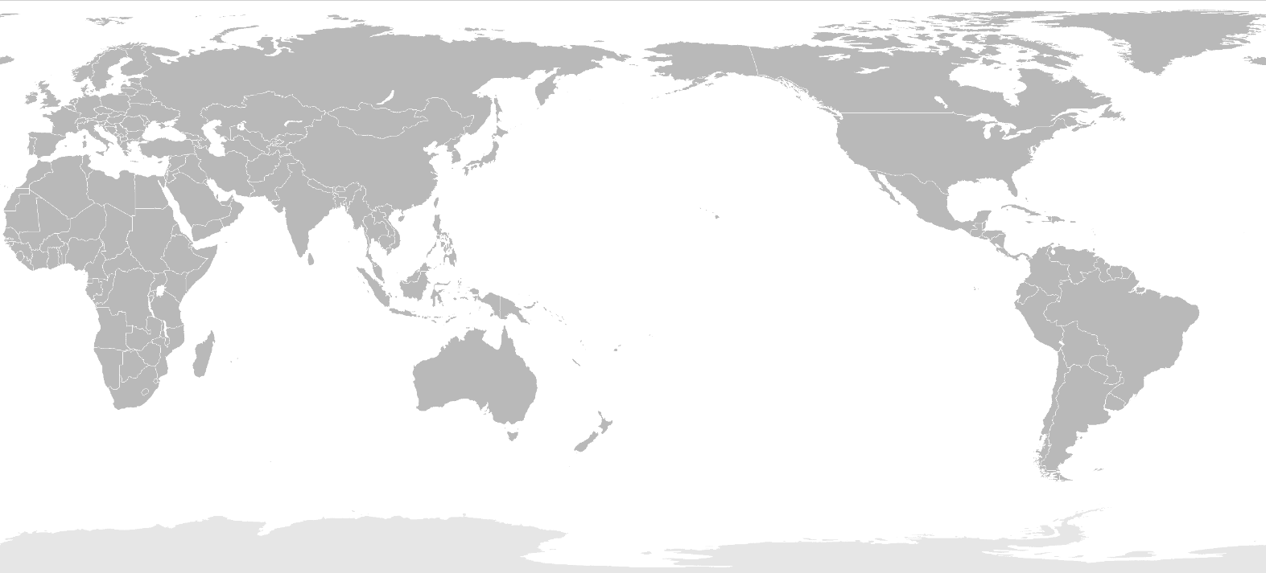
‘Pacific-centric-map’ by Spr895 is available in the public domain.
After completing the table and map, discuss the following question as a Think-Pair-Share activity.
- How does the impact of latitude and altitude account for the variation in temperature among the specified cities?

Activity 16 – scatter graphs
Complete the table below. Use a spatial technologies tool such as National Geographic MapMaker 4.0, or an atlas to find the altitude and latitude data. Access The Weather Channel for climate data.
Table 7 – Ecuador cities summary
Location | Altitude | Latitude | Highest daily temperature
Cotopaxi
Quito
Latacunga
Ibarra
Esmeraldas
Guayaquil
A scatter graph, also known as a scatter plot or scatter diagram, is a type of data visualisation that displays the relationship between 2 numerical variables. Each data point on the graph represents a pair of values, one from each variable, plotted on a Cartesian coordinate system. Scatter graphs are widely used in geography including in statistics, data analysis and scientific research, to explore relationships, trends and potential causality between variables. The main characteristics and features of a scatter graph include:
- Axes: scatter graphs have 2 axes, the horizontal (x-axis) and the vertical (y-axis). Each axis represents one of the 2 variables being compared.
- Data points: data points are plotted as individual points or markers on the graph, with their positions determined by the values of the 2 variables. Each data point represents an observation from the dataset.
- Distribution: scatter graphs can reveal the distribution of the data points, providing insight into the concentration, spread or outliers within the data.
- Trend: a scatter graph can help identify trends or patterns in the data, such as positive or negative correlations, or the lack of a relationship between the 2 variables.
- Correlation: the degree to which the 2 variables are related can be visually assessed in a scatter graph. A positive correlation indicates that as one variable increases, the other tends to increase as well; a negative correlation means that as one variable increases, the other tends to decrease. No correlation suggests that there is no observable relationship between the 2 variables.
- Line of best fit: a line of best fit, or regression line, can be added to the scatter graph to quantify the relationship between the 2 variables. This line may be linear or nonlinear, depending on the nature of the relationship.
Create a scatter graph illustrating data presented in Table 7.
The following instructions will support this learning activity:
- Label the x-axis in meters from 0 to 7,000 m and the y-axis in Celsius from -15°C to 35°C.
- Plot the data for altitude and temperature.
- Add a linear trend line (line of best fit) through the data in the scatter plot. A trend line will not cross every point but rather there should be approximately the same number of points below the line as above it.
- Look at the trend line. Estimate the approximate change in temperature for every increase of 1,000 m in elevation.
Answer the following questions and integrate data from the table.
- How can a scatter graph help identify trends or patterns in a dataset?
- When is it appropriate to use a scatter graph instead of other types of data visualisations?
- How do you determine if there is a positive, negative or no correlation between 2 variables in a scatter graph? (Correlation is used to describe the relationship between 2 variables).
- Can a scatter graph be used to establish causation between 2 variables? Why or why not? (Causation means a change in one variable directly leads to a change in another variable).
- Based on the table and graph, predict the temperature for the following elevations:
- 0 m
- 1,000 m
- 2,000 m
- 3,000 m
- 4,000 m.
- How does temperature vary with elevation in the city according to the table and graph?
- How does the temperature change with a 1,000 m increase in elevation in the city according to the table and graph?
- What are the factors that influence temperature variation with elevation in the city?
- Discuss the following prompt: ‘How does altitude influence the characteristics of Earth’s natural systems and their functioning?’

Activity 17 – the impact of altitude on plants
Malbec is a variety of grape vine. When grown in different places, the grapes can develop in different ways depending on factors like altitude and climate. With reference to the 3 locations below, research how altitude impacts the growth of the malbec grape vine.
- Bordeaux, France
- Orange, Australia
- Mendoza, Argentina

Activity 18 – analysing rainfall maps
Use the BOM’s Recent and historical rainfall maps to complete the following:
- Describe the pattern of rainfall.
- What conclusions can you draw regarding the correlation between proximity to the coast and the amount of rainfall? Use continentality and oceanity to further examine and improve your response.
- Describe any correlation between latitude and rainfall on the map.
- How might the rainfall pattern impact the diversity of flora and fauna? For example, in a tropical rainforest the high annual rainfall contributes to an incredibly diverse ecosystem.

Activity 19 – continentality and oceanity
Complete a Frayer diagram for both continentality and oceanity.
Figure 2 – Frayer diagram
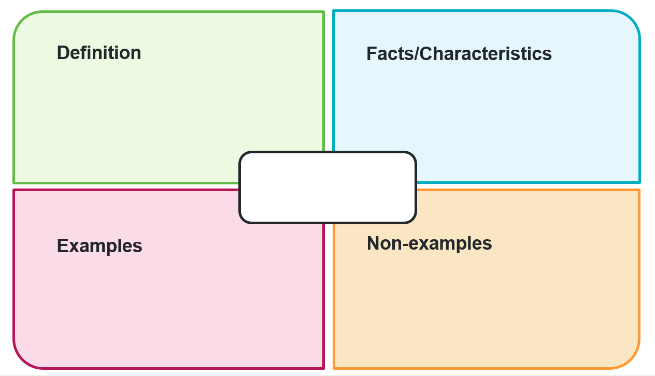
Figure 3 – Frayer diagram
Answer the following questions.
- What causes coastal regions to have smaller temperature fluctuations compared to inland areas?
- What factors contribute to increased precipitation in coastal areas compared to locations further inland?
- In what ways do continentality and oceanity influence a region’s climate?

Activity 20 – climate graphs
A climate graph is a visual way of showing the average temperature and rainfall for a location over the course of a year. It combines a line graph (for temperature) and a bar graph (for rainfall) in a single diagram. Each graph helps geographers describe the climate characteristics of a place and make comparisons between different locations. Climate graphs are useful tools for understanding how climate influences ecosystems, human activity and patterns of land use.
Access Seasons (5:38) and record the seasons in the northern and southern hemispheres in the table below.
Table 8 – seasons
Months | Southern Hemisphere | Northern Hemisphere
Dec – Feb
Mar – May
June – Aug
Sept – Nov
Figure 4 – climate graph of Kathmandu airport, Nepal
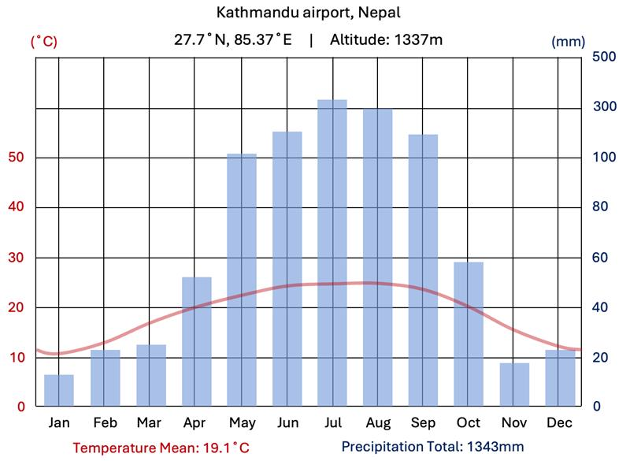
Figure 5 – climate graph of Kuwait airport, Kuwait
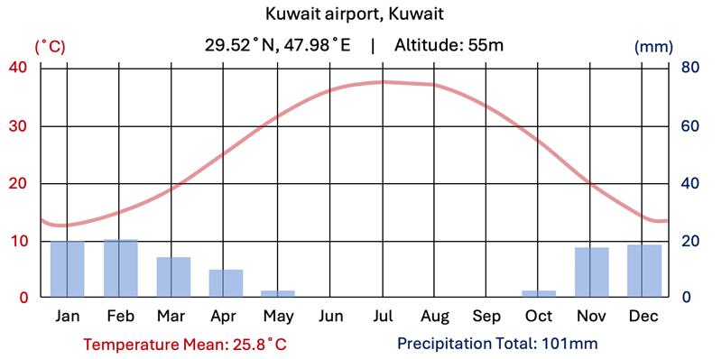
Figure 6 – climate graph of Sydney airport, Australia
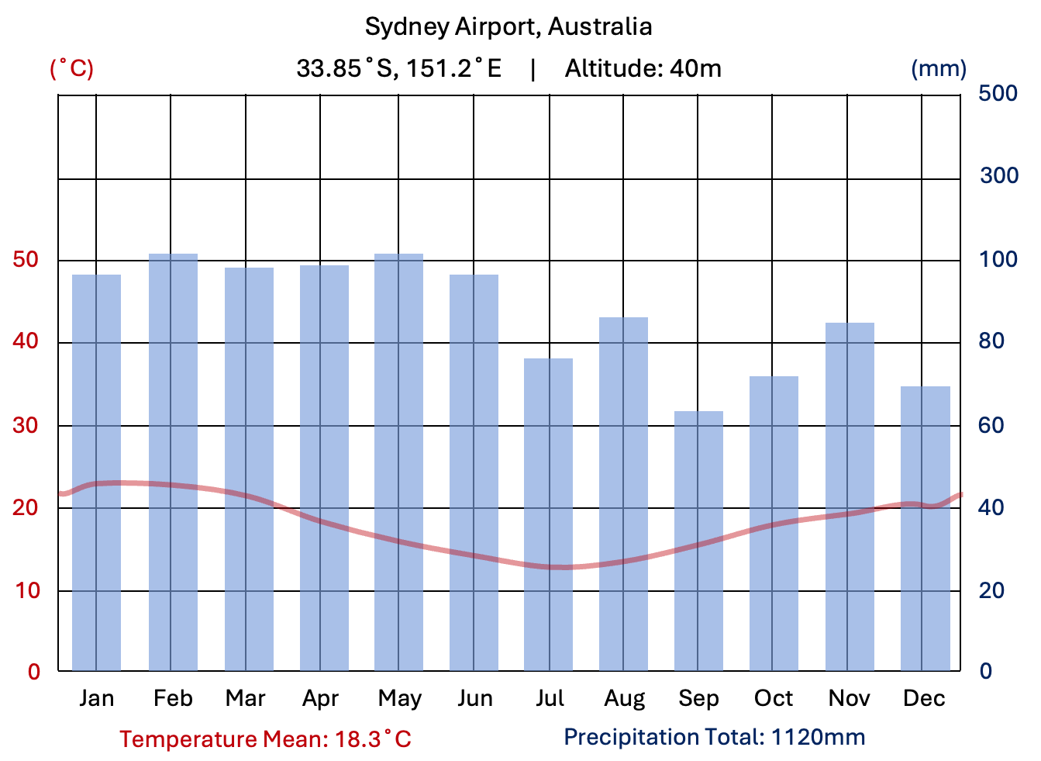
Figure 7 – climate graph of Darwin airport, Australia
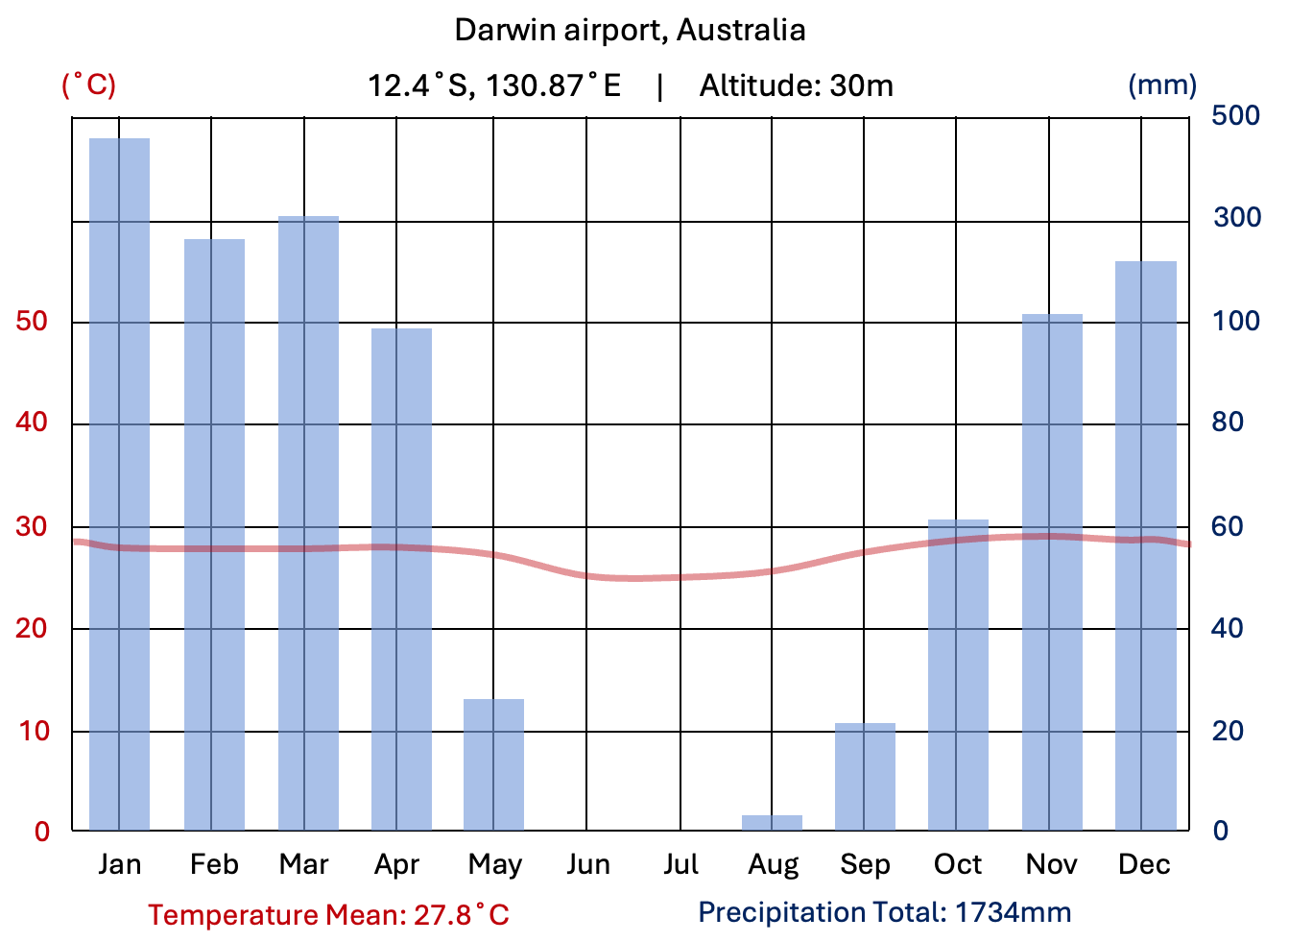
Use the climate graphs above to complete the table below.
Table 9 – climate graphs
 | Kathmandu | Kuwait | Sydney | Darwin
Latitude
Altitude
Distance from sea
Hottest month
Wettest season
Describe the main geographic features that influence climate
Note: teachers may wish to change the examples to suit locations more suitable to school context.

Activity 21 – interpreting climate graphs capacity matrix
Table 10 – interpreting climate graphs capacity matrix
I can … | Yes | No
I understand what a climate graph is and why geographers use them.
I can read and interpret temperature and rainfall data from a climate graph.
I can identify the hottest, coldest, wettest and driest months and seasons using the graph.
I can calculate seasonal and diurnal temperature ranges, total annual rainfall and total average annual rainfall.
I can describe seasonal climate patterns such as rainfall distribution and temperature trends.
I can infer the hemisphere of a location based on the pattern of temperature.
I can hypothesise the possible location of a place, such as hemisphere, latitude, altitude, proximity to the coast on patterns in the graph.
I can compare climate data between 2 or more locations.
I can interpret graphs with multiple temperature lines or unfamiliar formats (such as dual axes, circular graphs).

Activity 22 – Indigenous seasonal calendars
Access Indigenous seasonal calendars, Indigenous weather knowledge and About the Indigenous seasonal calendars. Answer the following questions:
- How do the Indigenous seasonal calendars differ from the Western 4-season calendar in understanding and managing Country in Australia?
- What role does seasonal understanding play in the activities and management of Country for Aboriginal and Torres Strait Islander peoples?
- How has the Commonwealth Scientific and Industrial Research Organisation (CSIRO) contributed to the development and application of the Indigenous seasonal calendars?
- In what ways have the co-produced seasonal calendars been effective in representing Indigenous understanding of and connection to Country?

Week 3 – atmospheric systems

Activity 23 – atmospheric systems key terms
Use sources such as BBC Bitesize, BOM Glossary and National Geographic to complete the table below of key terms relating to atmospheric systems.
Table 11 – atmospheric systems key terms
Term | Definition
Differential heating
Global atmospheric circulation
Albedo (reflectivity)
Hadley cell
Ferrel cell
Polar cell
Coriolis effect
Jet streams
Prevailing winds
Thermal gradient
Insolation
Troposphere
Tropopause
Low-pressure system
High-pressure system
Polar front
Subtropical ridge

Activity 24 – layers of the atmosphere
The table below summarises the features of the layers of the atmosphere that are most relevant to the geographers.
Table 12 – layers of the atmosphere
Layer | Upper limit | Key features
Troposphere | 6 km (poles) to 18–20 km (equator) | - Temperature decreases with height.  - Almost all weather occurs here. This includes clouds, storms, hail and lightning.  - Hot air balloons, drones and most aviation operate here.  - Most greenhouse gasses found here.  - Mount Everest (8,849 m) is well within the troposphere.  - The boundary between the troposphere and stratosphere is called the tropopause.  - Plumes from small to moderate volcanic eruptions.
Stratosphere | 50 km | - Contains the ozone layer which is important for absorbing ultraviolet (UV) radiation.  - The tops of some cumulonimbus thunder clouds can occur in the lowest parts of the stratosphere.  - Weather balloons and some aircraft at lower levels.  - Plumes from large volcanic eruptions.
Outer layers | Various heights | - Meteors.  - Auroras (northern/southern lights).  - Satellites and International space station in orbit.  - Very thin, no weather.
Create a diagram that shows the main features of the 3 layers in the table.
Figure 8 – layers of the atmosphere


Activity 25 – Earth’s energy budget
Access Earth’s Energy Budget and interpret the heat map (thematic map) of outgoing energy. Discuss the following questions.
- What does the colour coding on the heat map represent?
- Are there any factors, such as geographical location or time of day, that might affect the balance of absorbed sunlight and radiated heat in different areas of the map?
- How does heat impact climate in a particular geographical location?
- What is Earth’s energy budget and how is it related to the temperature stability?
- How much of the solar energy that reaches Earth is reflected back to space, and what are the primary factors responsible for this reflection?
- What happens to the solar energy that is absorbed by the atmosphere, and what are the main atmospheric components that absorb this energy?
- How does the Earth’s surface absorb and distribute incoming solar radiation?
- How does the temperature of the Earth’s surface and atmosphere relate to the amount of heat radiated by each? A resource to further support this response is Surface Energy Budget.
- What is radiative cooling, and how does it help prevent runaway heating on Earth?

Activity 26 – global atmospheric circulation 1
Access What is global circulation ꞁ Part One ꞁ Differential heating (2:50) to answer the following questions:
- Outline the reasons given for differential heating based on latitude
- curvature of the Earth
- atmospheric thickness
- Earth’s tilt.
- What role does the albedo effect play in differential heating?

Activity 27 – global atmospheric circulation 2
Access What is global circulation? | Part Two | The three cells (3:35), Prevailing Winds and the summary notes below to create an annotated diagram or a flow chart that shows the main features of global atmospheric circulation.
The heat equator, receives the most intense insolation (incoming solar radiation), making it the warmest part of the Earth. It is a region of calm, sometimes referred to as the doldrums, where rising air leads to low pressure (the Intertropical Convergence Zone or ITCZ). The heat equator shifts with the seasons. It is aligned with the equator on both March and September equinoxes, the Tropic of Cancer on the June solstice and Tropic of Capricorn on the December solstice.
Air is coldest at 90˚N and 90˚S where insolation is lowest. This cold dense air at the poles sinks, creating areas of high pressure at the surface. The cold air has nowhere to go but away from the poles towards the equator.
If the Earth didn’t rotate, the air that originated from the equator would travel towards the poles before descending as high pressure, creating one ‘cell’ or conveyor belt of wind between the equator and the poles.
At 30˚N and 30˚S, the Coriolis effect is stronger than it is at the equator, so much so that the air that originated from the equator falls here and forms a band of high-pressure cells. This loop or conveyor belt of air is known as the Hadley cell.
The sinking air from the Hadley cell around 30°N and 30°S is significant as it leads to high-pressure systems and dry conditions.
Surface air masses that came from the poles rise at 60° latitude due to thermal contrast. Cold polar air undercuts warmer air, forcing the lighter air to rise. This uplift results in a band of low pressure at 60˚N and 60˚S. Air rises and then returns to the poles where it completes a loop known as the Polar cell.
Between the Hadley and Polar cells is the Ferrel cell, an indirect circulation cell found between 30° and 60° latitude, driven by the motion of the Hadley and Polar cells around it. Unlike the other 2, it is not powered by temperature differences but by the transfer of momentum and energy in mid-latitude weather systems.
The boundary of the Polar and Ferrel cells is known as the polar front. The boundary of the Hadley and Ferrel cells is sometimes referred to as a subtropical ridge. The exact locations of these cell boundaries are dynamic, influenced by the distribution of land and ocean.
Because the heat equator shifts with the seasons, the boundaries between the atmospheric circulation cells also move. For example, in June, the boundary between the Ferrel and Polar cells in the Southern Hemisphere shifts northward to between 40°S and 50°S, making cold fronts and low-pressure systems common south of Australia during winter. This boundary is known as the polar front.
The Coriolis effect is also the reason why air pressure systems rotate clockwise or anticlockwise.
The global atmospheric circulation system gives us prevailing winds such as the trade winds, westerlies and polar easterlies. The north-east and south-east trade winds, for example, result from air moving from the high-pressure zones around 30° latitude towards the low-pressure zone near the equator. As this air moves towards the equator, the Coriolis effect causes it to deflect westward, producing north-easterly winds in the Northern Hemisphere and south-easterly winds in the Southern Hemisphere.
This explains why there are almost always surface winds blowing from the Americas towards South-East Asia along the equator. These trade winds drive a major westward-flowing ocean current across the Pacific Ocean, known as the South Equatorial Current. This current plays a key role in feeding the East Australian Current, a warm-water current that contributes significantly to rainfall along Australia’s eastern seaboard.
The global atmospheric circulation system is responsible for redistributing heat from the equator towards the poles, bringing cold air towards the equator, and driving all weather patterns on Earth.

Activity 28 – weather maps (synoptic charts)
Access The art of the chart: how to read a weather map and view the embedded film clip (0:06). Complete the following questions:
- What are the main features of a weather map (synoptic chart)?
- How do isobars (isoline) indicate the flow of air around weather systems?
- What are high- and low-pressure systems, and what do their numbers indicate?
- What are fronts and how do they appear on a weather map?
- How can you use isobars on a weather map to interpret wind strength and direction?
- Discuss low-pressure systems and the frequency and impact of east coast lows and cyclones.

Activity 29 – atmosphere–ocean circulations
- Use Bureau of Meteorology – Australian Climate Influences to collect definitions for the following terms.
Table 13 – key terms for atmosphere–ocean circulations
Term | Definition
ENSO (El Niño–Southern Oscillation)
El Niño
La Niña
Trade winds
Thermocline
Upwelling
Southern oscillation
Southern Oscillation Index (SOI)
Indian Ocean Dipole (IOD)
Indian Ocean Dipole (IOD) – negative phase
Indian Ocean Dipole (IOD) – positive phase

Week 4 – hydrological systems

Activity 30 – precipitation pattern and cycles 1
- Access average annual rainfall of Australia (1991 to 2020) and the choropleth map of Sydney below. Complete a Think-Pair-Share class discussion considering: ‘What patterns can you see in these maps’?
Figure 9 – choropleth map showing average annual precipitation for Sydney and surrounds
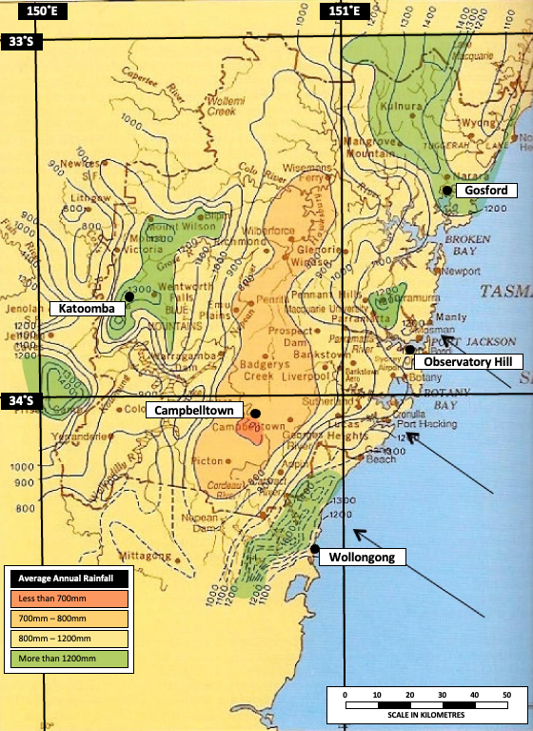

Activity 31 – precipitation pattern and cycles 2
Use National Weather Service and Britannica to complete a table of key terms relating to atmospheric systems.
Table 14 – key terms for precipitation patterns and cycles
Term | Definition
Precipitation
Rainfall intensity
Rainfall variability
Orographic rainfall
Convectional rainfall
Frontal rainfall
Condensation
Condensation nuclei
Climatic zone
Rain shadow effect
Monsoon

Activity 32 – precipitation patterns in South-East Asia
Use Asia Pacific Regional Reference Map: Annual Precipitation and Regional Climate Maps: Asia to research the precipitation patterns for a selected location in Asia.
- Describe the spatial patterns in precipitation across South-East Asia.
- Outline 3 factors influencing the spatial patterns of precipitation across South-East Asia. These may include latitude, altitude, topography, distance from water bodies, ocean currents, air pressure, prevailing winds.
Note: in addition to the core factors listed, other influences on rainfall include convection and frontal systems (linked to uplift), ENSO events (which shift rainfall patterns globally), vegetation cover (which affects local humidity), and sea surface temperatures. These can be introduced where relevant to deepen student understanding or in extension activities.

Activity 33 – climate data
Use the State of the Climate 2024 report (pages 8 to 9) rainfall information, graphs, choropleth maps and data, to answer the following questions:
- What is the trend in rainfall in the south-west of Australia since 1970?
- Which months have seen the largest decrease in rainfall in the south-west of Australia since 1970?
- What is the trend in rainfall in the south-east of Australia since the late 1990s?
- How has rainfall in northern Australia changed since the 1970s?
- What are some drivers that influence Australian rainfall?
- Despite natural variability, what long-term trend is evident in Australia’s rainfall records?
- How many years out of the past 22 have had below-average rainfall in southern Australia between April and October?
- What factors are responsible for the decrease in rainfall in southern Australia?
- What is the significance of rainfall in the cooler months for southern Australia?
Using State of the Climate 2024 report – heavy rainfall information and data, answer the following questions:
- What was the main observation regarding heavy rainfall events in Australia?
- What is the relationship between short-duration extreme rainfall events and flash flooding?
- What weather systems typically cause heavy rainfall events in Australia?
- What has happened to the number of low-pressure systems in southern Australia in recent decades and what are the implications?
- How does the relationship between atmospheric moisture and global temperature increases affect the likelihood and intensity of heavy rainfall events in Australia?

Activity 34 – water storages and flows
The hydrological cycle is the continuous movement of water between the atmosphere, land and oceans through processes such as evaporation, condensation, precipitation, infiltration and runoff. At a global scale, it operates as a closed system, meaning no water is added to or lost from the Earth – the total volume of water remains constant, continually cycling through different forms and locations. However, when we examine the water cycle at a local scale, such as within a catchment area, it functions as an open system. In an open system, water enters and leaves through inputs (like precipitation) and outputs (such as evaporation or river discharge). The difference between these inputs and outputs determines the water balance, which influences how much water is stored in different parts of the system, including in rivers, soil and groundwater.
Create an annotated diagram of the hydrological cycle using separate colours to distinguish between flows and stores.
- Label flows such as evaporation, transpiration, evapotranspiration, condensation, precipitation, infiltration, percolation, surface runoff and groundwater flow.
- Label each process clearly and use arrows to show the direction of water movement.
- Label water stores such as the atmosphere, oceans, lakes, glaciers, groundwater and dams.

Activity 35 – water storage in Australia and worldwide
Use the Water in Australia 2019–20 report and Energy Education to identify the percentage of water stored in Australia and worldwide. Complete the following table.
Table 15 – water storage
Water resources | Australia | Worldwide
Freshwater systems
Oceans
Groundwater
Icecaps and glaciers
Lakes
Swamps
Rivers

Activity 36 – water stores and flows
Access Water Cycle – Stores and Flows (7:11) and pause at 4:45 to complete the table below, by identifying the inputs, processes, outputs and stores likely to be occurring in a fjord.
Table 16 – water cycle, stores and flows
Inputs | Processes | Outputs | Stores
Resume Water Cycle – Stores and Flows (7:11) and identify inputs, processes, outputs and stores. As a class, discuss and complete the following questions:
- What are the main inputs and outputs of the water cycle?
- How does precipitation contribute to the water cycle?
- What is evaporation and how does it fit into the water cycle?
- What role do plants play in the water cycle?
- What is the difference between a closed and open system?

Activity 37 – flood hydrographs
Access Queensland Government Wetland Info – River Flows (hydrograph) and discuss the following questions as a class:
- What is a hydrograph and how is it used to describe river flows over time?
- How is baseflow separated from direct runoff or quick flow in a hydrograph?
- What is lag time and how is it related to the catchment’s flashiness?
- How does flooding occur and what are its effects on the river system?
- What is bank storage/recharge and how does it occur during high flow or flood?
- What is flood recession and why is it important for fish species and riverbanks?
- How does the flow velocity in the river channel change from the riverbed to the river surface?

Activity 38 – water storage case study
Provide each group with ONE case study of a water storage project. For example:
- Snowy Hydro 2.0: this is a proposed expansion of the existing Snowy Mountains Hydroelectric Scheme in New South Wales. The project aims to increase the capacity of the hydroelectric system by building a network of tunnels and dams to store and release water to generate electricity.
- Murray-Darling Basin Plan: this is a government initiative aimed at managing the water resources of the Murray-Darling Basin, which spans across New South Wales, Victoria, South Australia, Queensland and the Australian Capital Territory. The plan involves reducing water consumption by irrigators, increasing environmental flows, and improving water efficiency.
- Tasmanian Hydroelectric Scheme: this is a network of hydroelectric power stations located across Tasmania. The scheme uses the island’s abundant rainfall and rugged terrain to generate electricity by storing and releasing water from dams and reservoirs.
- Brisbane’s water grid: this is a network of dams, pipelines and treatment plants that supply water to the city of Brisbane and surrounding regions. The water grid includes several dams, including the Wivenhoe, Somerset and North Pine dams, which store water for drinking, irrigation and industrial use.
Each group must complete a report on their assigned case study that includes:
- the benefits and drawbacks of the project
- impacts on the environment
- measures taken to mitigate these impacts.
Groups should use a combination of geographical tools to support their report findings, including:
- maps (for example, topographic, land use and hydrological maps, cadastral/zoning maps)
- aerial photography (for example, satellite, historical)
- statistical analysis (for example, total water storage and flow)
- Geographic Information Systems (GIS).

Activity 39 – factors influencing river catchments
Access the Queensland Government Wetland Info – Hydrology webpage and complete the following activities.
- Outline the main differences between (hydrological) regions and catchments.
- With reference to the catchment diagram and the region and catchment pages, explain how characteristics such as geology and topography, soils, landcover, human modifications and climatic factors influence hydrology.

Activity 40 – catchment story
In groups, research and present a catchment story. A catchment story will outline how one NSW catchment has formed, including its key physical and human features. Inspiration for the catchment story may be sourced from Queensland Government Wetland Info – Catchment stories.
For example, Warragamba Dam is the main water storage for Sydney’s drinking water supply. The proposed dam raising project aims to increase the dam’s capacity by 14 metres to provide additional water storage for the city.
In researching the catchment, the following aspects should be considered:
- geological and geographical overview of the catchment
- natural features of the catchment – topography and geology
- natural features of the catchment – rainfall
- natural features of the catchment – vegetation
- significant modification to natural features of the catchment – dams, weirs
- any relevant sub catchment details and interactions.
Once completed, groups swap and review catchment stories.
Groups design an infographic on the factors that impact catchment functioning at different locations across NSW. The infographic should visually display the information mentioned above in a clear and concise manner. The infographic should be visually appealing, easy to understand and should provide a clear understanding of the factors that impact catchment functioning.

Week 5 – geomorphic systems

Activity 41 – process at tectonic boundaries
Use sources such as National Geographic and Geoscience Australia – Classroom resources to define the key terms in the table below.
Table 17 – key terms for atmosphere–ocean circulations
Term | Definition
Tectonic plate
Plate tectonics
Convection currents
Convergent boundary
Divergent boundary
Transform boundary
Subduction
Rifting
Continental drift
Geological time scale
Gondwana
Intraplate earthquake
Ring of Fire
Topography
Seismic activity

Activity 42 – plate tectonics
Use Plate Tectonic Types and Plate Boundaries to complete the table below.
Table 18 – plate tectonics
Plate boundary | Type of movement | Examples | Landforms created
Transform
Convergent
Divergent
Table 19 – questions about tectonic plates
Questions about tectonic plates
What are tectonic plates and how are they formed?
What evidence supports the theory of plate tectonics? What is seafloor spreading and how does it support the theory of plate tectonics?
How do tectonic plates move and what causes these movements?

Activity 43 – history of the Earth
Access and discuss the History of the Earth poster and answer the following questions.
- What does the History of the Earth poster depict?
- What is the geological time scale?
- How has the Earth’s surface changed over time according to the poster?
- What are some of the key events in Earth’s history that are highlighted in the poster?
- How have the oceans, continents and boundaries changed over time?

Activity 44 – evolution of the Australian continent
Access GIS’s Australia – Evolution of a Continent and play the slideshow (0:21) revealing Australia’s land mass changes through time. Complete the following questions:
- How has the Australian continent changed over time?
- How have the movements of tectonic plates influenced the geography of Australia?
- What were the major events that occurred in Australia?
- How did the breakup of the supercontinent Gondwana affect the geography of Australia?
- How did the rise and fall of sea levels influence the geography of Australia?
- What is the relationship between plate tectonics and the formation of Australia’s Great Dividing Range?

Activity 45 – Australia’s intra-plate seismic activity
Find maps online that show seismic activity and/or intra-plate fault lines within Australia and access the GIS map of Historical earthquakes of Australia. Answer the following questions.
- What is the history of seismic activity in Australia? Which regions of Australia are most prone to earthquakes, and why?
- How does the location of Australia’s tectonic plate affect its susceptibility to earthquakes?
- What is the ‘Ring of Fire’ and where is it located?
- How does the topography and the ‘Ring of Fire’ contribute to seismic activity in Australia, and the Pacific and Indian Oceans?
- Can earthquakes occur in regions outside of tectonic plate boundaries? If so, how?
- Where would you expect the most earthquakes to occur in Australia? Why?

Activity 46 – mapping Earth’s active volcanoes
Follow the steps below to create a map of the world’s active volcanoes.
- Use an internet search to find a list of all active volcanoes in the world. The list needs to have latitude and longitude coordinates such as this list from Oregon State University.
- Carefully copy and paste the data into a spreadsheet. You may have to tidy it up a bit.
- Import this spreadsheet into a new Google My Map.
- When asked how you want to position place marks, choose Latitude and Longitude.
- When asked how to title your markers, choose ‘Volcano Name’.
- Change the style of marker by selecting ‘Uniform Style’. Change it from ‘Uniform Style’ to ‘Volcano Type’.
- You should now see a map of all Volcanoes in the World, sorted by type.
Use the completed map to complete these questions:
- Analyse the overall global spatial patterns of volcanoes.
- On which plate boundaries are shield, cinder and composite (stratovolcanoes) mostly located?

Activity 47 – how volcanic eruptions shape Earth
Access How Volcanic Eruptions Shape Earth (3:44) to complete a Think-Pair-Share based on the following questions:
- Where are volcanoes found?
- How are volcanoes formed?
- What happens when magma reaches the surface of the Earth?
- How does lava turn into igneous rock?
- What are the different types of volcanic mountains and what are their characteristics?
- What are craters and calderas and how are they formed?

Activity 48 – key terms for soil formation
Use sources such as Soil Science Australia and Soil Science Society of America to define the key terms in the table below.
Table 20 – key terms for soil formation
Term | Definition
Soil
Parent rock
Regolith
Leaching
Humus
Minerals
Organic matter
Soil horizons
Topsoil
Subsoil
Soil texture
Soil fertility
Soil profile
Pedogenesis

Activity 49 – What is soil?
Use Queensland Government – What is soil? to complete the following activities.
Create your own labelled diagram of soil profiles showing O, A, B and C horizons.
- What is a soil profile and what are the main layers of soil profiles? Relate your response to the image.
- How does the accumulation of material through the action of water, wind and gravity contribute to soil formation?
- How do physical, chemical and biological weathering affect soil formation?
- What are the 5 main interacting factors affecting soil formation?
- What is the influence of parent materials on soil properties?
- How do organisms influence soil formation?
- What is the role of climate in soil formation?
- How does the topography of a slope affect soil formation?
- What are the main horizons of soils and how do they differ in terms of texture, fertility and biological activity?
- Why is soil considered a valuable resource and why is it important to manage it carefully?
- How would the factors of time, parent material, climate, topography and organism influence a soil profile?

Activity 50 – soil identification
Materials required: soil sample(s), grain card, magnifying glass or microscope, ruler or calliper, tray or container for sorting soil particles.
Complete a sediment analysis exercise to identify and characterise the size and shape of soil materials in a given sample area(s) using a grain card.
Use the following procedure.
- Collect soil sample(s) from the field or a designated area.
- Place the soil sample(s) in a tray or container and remove any visible rocks or debris.
- Divide the soil sample(s) into different fractions based on their grain size using the grain size cards as a reference. For example, separate the soil into sand, silt and clay fractions.
- Use grain size cards, a magnifying glass and/or microscope to examine the size and shape of the soil particles in each fraction. Measure the diameter of individual particles using a ruler or calliper.
- Classify the soil particles based on their shape using a sphericity chart. Sphericity refers to the degree of roundness of a particle, with perfectly spherical particles having a sphericity value of 1.0 and irregular particles having a lower value.
- Record the size and shape characteristics of each fraction in a table or spreadsheet and calculate the percentage of each fraction in the overall soil sample.
Post sediment analysis exercise:
- Compare the grain size distribution of the soil sample(s) to typical soil types, such as sand, loam or clay.
- Discuss the potential implications of the soil grain size distribution for soil properties, such as water retention, nutrient availability and compaction.
- Compare the sphericity values of the soil particles to typical values for different sedimentary environments, such as river or beach sediments.

Activity 51 – river processes
The Earth’s surface is constantly being shaped by natural processes that work together in sequence. Weathering breaks down rocks in place, while erosion involves the removal of that material by moving agents like water or wind. Once the material is loosened, it is transported to new locations, and finally, deposition occurs when the energy drops and the material is laid down. Together, these processes help explain how landforms like rivers, valleys, beaches and dunes are created and changed over time.
Topography has a major influence on how rivers behave. In the upper reaches, where the land is steep, rivers flow quickly, causing high levels of erosion and transporting larger sediments. As the slope becomes more gentle in the middle reaches, the river slows down and continues to carry smaller materials. By the time it reaches the lower, flatter areas, the river has little energy left, so it deposits much of its load, forming features like floodplains and deltas.
Table 21 – river processes
River stage | Topography | Water speed | River width | Common processes
Upper reaches | Steep topography | Rapid velocity | Narrow, V-shaped channel | Weathering and erosion; the river transports most stones and sediments.
Middle reaches | Gentle topography | Medium velocity | Wider, U-shaped channel | Less weathering and erosion; continued transportation of some sediments.
Lower reaches | Flat topography | Gentle velocity | Widest, meandering channel | Little weathering and erosion. Deposition occurs because the river can no longer transport sediments (except for fine suspended particles).
Complete the following activities.
- Outline the difference between weathering and erosion.
- Outline the difference between erosion and transportation.
- Outline the roles played by hydraulic action, abrasion, attrition and solution in rivers.
- Explain the difference between transportation processes such as traction, saltation, suspension and solution.
- Explain how rivers create erosional and depositional landforms such as waterfalls or meanders.
- Imagine you dropped a leaf near the watershed of your local river catchment area. Follow the journey it would take. How would the river’s slope and speed change as it travels downstream? Where would the leaf end up?

Week 6 – ecological systems

Activity 52 – key terms for energy flows
Use sources such as Khan Academy and BBC Bitesize to define the key terms in the table below.
Table 22 – key terms for energy flows
Term | Definition
Energy flow
Photosynthesis
Biological productivity
Trophic levels
Autotroph
Heterotroph
Producers
Primary consumers
Secondary consumers
Tertiary consumers
Food chains
Food webs
Trophic cascade
Niche
Apex predators
Keystone species

Activity 53 – energy flows
Use sources such as Khan Academy and BBC Bitesize to answer the following questions:
- Identify and describe each of the trophic levels in the flow of energy.
- Explain why energy is lost at each trophic level.
- Explain why energy flows are unidirectional and non-cyclical.
- Using the research and notes on energy flows, create a food chain representing the energy flow between organisms in an ecosystem. This food chain should identify the different trophic levels and places where energy is lost from the flow.
- How does energy flow through ecological systems?
- How do the number of trophic levels in a food chain affect the amount of energy available to higher-level consumers?
- How do food webs differ from food chains?

Activity 54 – key terms for nutrient cycles 1
Use sources such as Khan Academy and BBC Bitesize to define the key terms in the table below.
Table 23 – key terms for nutrient cycles
Term | Definition
Nutrient cycle
Decomposers
Leaching
Bioaccumulation

Activity 55 – the carbon cycle
Access NASA Earth Observatory’s – The Carbon Cycle and discuss the following focus questions:
- What role does the carbon cycle play in sustaining all life on Earth?
- How does the slow carbon cycle differ from the fast carbon cycle?
- What role does the Earth’s orbit play in influencing the carbon cycle?
- How does chemical weathering relate to the slow carbon cycle?
- How do fast and slow carbon cycles maintain a steady concentration of carbon in the atmosphere, land, plants and ocean?
- How has the carbon cycle changed in response to climate change in Earth’s past?
- How have variations in Earth’s orbit affected the carbon cycle and led to ice ages and warm periods?
- How has the correlation between carbon dioxide levels and temperature been demonstrated over the past 800,000 years, using Antarctic ice-core data?
- How does deforestation affect the carbon cycle, and why do crops or pasture store less carbon than forests?
- How have carbon dioxide and methane concentrations in the atmosphere changed since the beginning of the Industrial Revolution, and what are the implications of these changes? Include data in your response.

Activity 56 – nutrient cycles
Access Living World – Nutrient Cycles (4:08) for background information on the nutrient cycle. Answer the following questions:
- What are the 3 stores of nutrients within an ecosystem?
- What is biomass, and how does it relate to the movement of nutrients within an ecosystem?
- How does the decomposition of dead material, such as leaves and animal scat, contribute to the movement of nutrients within an ecosystem?
- How can deforestation impact the nutrient content of the biomass within an ecosystem?
- How can rainfall impact the movement of nutrients within an ecosystem, particularly litter and soil stores?
- What is leaching, and how can it impact the nutrient content of the soil within an ecosystem?
- What is weathering, and how can it add nutrients to the soil within an ecosystem?
- What are some other ways in which nutrients can be added to or lost from the 3 stores within an ecosystem?

Activity 57 – key terms for nutrient cycles 2
Access sources such as Khan Academy and BBC Bitesize to define the terms in the table below.
Table 24 – key terms for nutrient cycles
Term | Definition
Biological productivity
Net primary productivity
Photosynthesis
Heterotroph
Autotroph

Activity 58 – biological productivity
In small groups, review the following definition of biological productivity.
Primary biological productivity refers to the amount of living plant or organic material (biomass) produced by plants (autotrophs) during the process of photosynthesis. This is measured in units of energy like kilojoules or in units of weight like tonnes. Secondary primary productivity refers to the generation of biomass by heterotrophs (consumers of plants like bacteria, fungi and animals). Biological productivity varies across the world and across time.
Collaboratively create a visual representation of this definition, for example in a mind map.
As a class, complete the following:
- Brainstorm factors that may affect the biological productivity of terrestrial and ocean biomes.
- Discuss the contrast between the biological productivity of a region or ecosystem with the concept of biodiversity.

Activity 59 – key terms for nutrient cycles 3
Access sources such as Khan Academy and BBC Bitesize to define the terms in the table below.
Table 25 – key terms for nutrient cycles
Term | Definition
Ecosystem
Terrestrial ecosystem
Marine ecosystem
Biome
Habitat
Biotic
Abiotic

Activity 60 – deconstructing a short answer exam question
Access Question 17(b) from the 2005 HSC Geography Exam (page 11), along with the marking notes guidelines.
Discuss as a class the features of strong short-answer responses such as the direct use of key terms from the question, clear cause-and-effect explanations, specific references to the diagram or case study, and avoiding unnecessary introductions or repetition.
Read the sample response below and identify 3 ways it could be improved. Discuss as a class.
There are many ways that ecosystems can be affected by human activity, such as over-fishing. Over-fishing of the secondary consumer means there are fewer fish in the ecosystem. This affects the balance of organisms in the food chain, including zooplankton and phytoplankton. These changes can have an impact on the ecosystem and reduce biodiversity.
Write your own response to this question.

Week 7 – natural systems and land cover change

Activity 61 – exploring land cover with spatial technologies
Access ESRI Sentinel-2 Land Cover Explorer. Adjust the level of zoom to see the percentages of water, trees, crops, built area and rangeland for each of the following:
- your suburb and local area
- your nearest regional centre or city
- Sydney CBD
- New South Wales
- Australia
- the world.
Use the percentages of one place to create a sector graph.
Compare your sector graph with the world map graph from Land Use – How is humanity using the Earth’s land? And how can we decrease our land use so that more land is left for wildlife?. In pairs, complete the following questions.
- How does the distribution of land use categories in the sector graphs compare to their visual representation on the world map graph?
- What is the total land area occupied by agricultural land, and how does it break down between arable and permanent crops versus pastures?
- What percentage of the world’s land is covered by urban areas, and how does this compare to other land use types?

Activity 62 – creating a land use map with Google My Maps
Use Google My Maps to construct a basic land use map for your school site or suburb. Use the polygon tool to create shapes that illustrate land cover. Use a logical colour scheme. For example, dark green for dense and/or tall vegetation. Light green for sparse vegetation. Blue for water. Include the following spatial data on the map:
- Earth’s physical/natural features (for example, forested areas, wetlands, water bodies)
- anthropogenic elements that are derived from human activity and influence the environment (for example, plantations, crops and built environments).

Activity 63 – key terms for climatic and glacial cycles
Use sources such as Energy Education’s Glacial and interglacial periods and The Global Last Glacial Maximum to define the following terms.
Table 26 – key terms for climatic and glacial cycles
Term | Definition
Ice age
Glacial period
Interglacial period
Last Glacial Maximum (LGM)
Milankovitch cycle

Activity 64 – natural causes of climate change
Complete the table below to include an example of a how the factor impacted Earth’s climate.
Table 27 – natural causes of climate change
Natural cause | Description | Example
Earth’s orbital changes | Long-term changes in Earth’s orbit, tilt and wobble affect how much solar energy reaches the planet. | Milankovitch cycles triggering the Last Glacial Maximum (~21,000 years ago).
Plate tectonics | Movement of Earth’s plates reshapes continents, mountains and ocean basins, altering long-term climate.
Ocean gateways opening and closing | Tectonic shifts that block or open ocean passages can redirect ocean currents and shift global climate.
Variations in solar radiation | Fluctuations in solar energy output, such as sunspot cycles, impact Earth’s climate.
Asteroid and meteor impacts | Large space objects colliding with Earth can eject dust and gases, blocking sunlight and causing cooling.
Major volcanic eruptions | Volcanic ash and gases can block sunlight and lower global temperatures temporarily. | A cooling of up to 0.5°C which lasted 18 to 36 months is attributed to the 1991 Mt. Pinatubo eruption (Boretti 2024).
Major ice melting events | Rapid release of glacial meltwater can disrupt ocean currents and cause abrupt climate shifts.
Natural greenhouse gas emissions | Gases like methane and CO₂ released from permafrost, wetlands and oceans can contribute to warming.
Albedo changes | Changes in ice cover or vegetation alter how much sunlight is reflected, affecting Earth’s energy balance.
Ocean oscillations | Short-term natural cycles in ocean-atmosphere systems redistribute heat and alter weather patterns.

Activity 65 – glacial and interglacial periods
Use Figure 2 from the article Energy Education’s Glacial and interglacial periods and Introduction to Climate Science to answer the following questions:
- Approximately how long ago was the LGM?
- How much colder were global average surface air temperatures during the LGM?
- How much lower was atmospheric CO₂ during the LGM compared to the pre-industrial late Holocene?
- What are glacial and interglacial periods, and how do they differ from each other?
- What causes the Earth to go through these cycles of glacial and interglacial periods?
- What evidence do we have of past glacial and interglacial periods, and how do we study them?
- How do glacial and interglacial periods affect the Earth’s climate and ecosystems?
- Are we currently in an interglacial period, and if so, how long do these periods typically last?
- How have human activities influenced the Earth’s climate and the occurrence of glacial and interglacial periods?

Activity 66 – key terms for invasion and ecological succession
Use sources such as Khan Academy and BBC Bitesize to define the following terms.
Table 28 – key terms for invasion and ecological succession
Term | Definition
Ecological succession
Pioneer species
Primary succession
Secondary succession
Climax community
Invasion

References
This resource contains NSW Curriculum and syllabus content. The NSW Curriculum is developed by the NSW Education Standards Authority. This content is prepared by NESA for and on behalf of the Crown in right of the State of New South Wales. The material is protected by Crown copyright.
Please refer to the NESA Copyright Disclaimer for more information https://educationstandards.nsw.edu.au/wps/portal/nesa/mini-footer/copyright.
NESA holds the only official and up-to-date versions of the NSW Curriculum and syllabus documents. Please visit the NSW Education Standards Authority (NESA) website https://educationstandards.nsw.edu.au and the NSW Curriculum website https://curriculum.nsw.edu.au.
Geography 11–12 Syllabus © NSW Education Standards Authority (NESA) for and on behalf of the Crown in right of the State of New South Wales, 2022.
Boretti A (2024) ‘Reassessing the cooling that followed the 1991 volcanic eruption of Mt. Pinatubo’, Journal of Atmospheric and Solar-Terrestrial Physics, 256:106187, doi: https://doi.org/10.1016/j.jastp.2024.106187, accessed 12 September 2025.
Li A, Mansour A and Bentley R (September 2023) ‘Green and blue spaces, COVID-19 lockdowns, and mental health: An Australian population-based longitudinal analysis’, Health & Place, 83:103103, doi:10.1016/j.healthplace.2023.103103, accessed 12 September 2025.

© State of New South Wales (Department of Education), 2025
The copyright material published in this resource is subject to the Copyright Act 1968 (Cth) and is owned by the NSW Department of Education or, where indicated, by a party other than the NSW Department of Education (third-party material).
Copyright material available in this resource and owned by the NSW Department of Education is licensed under a Creative Commons Attribution 4.0 International (CC BY 4.0) license.

This license allows you to share and adapt the material for any purpose, even commercially.
Attribution should be given to © State of New South Wales (Department of Education), 2025.
Material in this resource not available under a Creative Commons license:
- the NSW Department of Education logo, other logos and trademark-protected material
- material owned by a third party that has been reproduced with permission. You will need to obtain permission from the third party to reuse its material.
Links to third-party material and websites
Please note that the provided (reading/viewing material/list/links/texts) are a suggestion only and implies no endorsement, by the New South Wales Department of Education, of any author, publisher, or book title. School principals and teachers are best placed to assess the suitability of resources that would complement the curriculum and reflect the needs and interests of their students.
If you use the links provided in this document to access a third-party's website, you acknowledge that the terms of use, including licence terms set out on the third-party's website apply to the use which may be made of the materials on that third-party website or where permitted by the Copyright Act 1968 (Cth). The department accepts no responsibility for content on third-party websites.

