 | 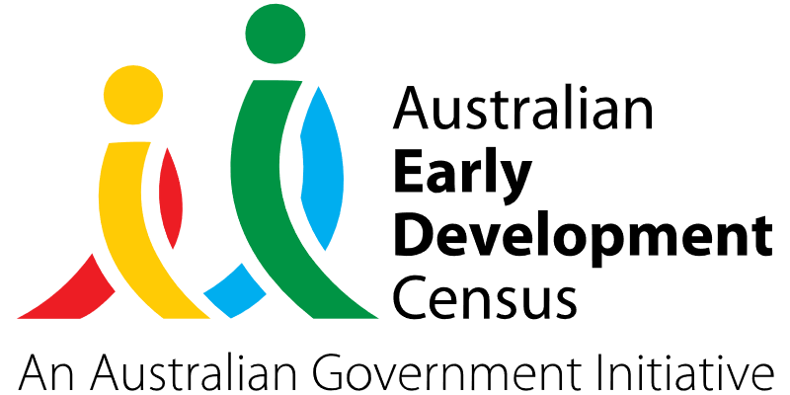

Small Talk

Milton Therapy and Learning Centre

About the community
Developmentally ‘at risk’ in 2021 | Communication skills and general knowledge | Social competence | Language and cognitive skills
Milton | 35.0% | 30.0% | 20.0%
Mollymook Beach | 26.9% | 7.7% | 11.5%
Ulladulla | 18.2% | 13.6% | 15.2%
NSW | 8.4% | 9.4% | 6.2%
Milton is a village located in the Shoalhaven region on the NSW South Coast. Milton is 220 km south of Sydney and is near the seaside towns of Mollymook and Ulladulla.
Milton Therapy and Learning Centre is a family-centred multidisciplinary practice providing a range of services to Milton, Ulladulla and surrounding areas. Owned and operated by speech pathologist, Kate Kinch, Milton Therapy and Learning Centre offers speech pathology, occupational therapy, music therapy and early intervention services.



What did the data show?
The Australian Early Development Census (AEDC) is a national measure of early childhood development that is collected at the time children commence their first year of full-time school. The AEDC collects data relating to 5 key areas of early childhood development, referred to as domains. The domains are: physical health and wellbeing; social competence; emotional maturity; language and cognitive skills (school-based); communication skills and general knowledge.
According to the 2021 AEDC data, the areas of Milton, Mollymook and Ulladulla all had high percentages of developmentally at-risk children in the domains of communication skills and general knowledge; social competence; and language and cognitive skills (school-based) in comparison with other New South Wales regions:

Bringing about change
The ‘Small Talk' program was established to provide support to families with preschool aged children as well as early childhood educators who may be concerned about a child's speech, language and overall communication skills.
The program involved connecting with early childhood education (ECE) service providers in the Milton and Ulladulla area to provide education, screening and recommendations. Drop-in clinics were set up to give families access to a speech pathologist in their community who could perform speech and language screening sessions and deliver education programs for educators and families.
Providing a community wide education program (including small talk education sessions for ECE educators, and parent and carer education sessions) was intended to help families and educators increase their knowledge of speech and language development, as well as how and when to intervene.

Partnerships
The ‘Small Talk' program was a collaborative approach with the following ECE service providers and local playgroups:
- Milton and Mollymook Early Foundations
- Naturally Curious Early Education and Care Centre
- Myrtle Street Early Learning Centre
- Milton Early Learning and Care
- Milton Ulladulla Preschool
- Green Street Preschool
- Ulladulla Children's Centre
- Northside Early Learning Centre
- Tabourie Childcare Centre.
Milton Therapy and Learning Centre also has strong links with local general practitioners, nurses and other allied health professionals in the community. The centre works closely with Lifestart, the early intervention National Disability Insurance Scheme (NDIS) planners in the area, to support families in accessing services.

Achievements
The ‘Small Talk' program has led to increased engagement and collaboration between ECE service providers and families to support developmental at-risk domains in the Milton community. More children who are developmentally at-risk or vulnerable have been able to access initial appointments with a speech pathologist in the community, which is expected to be reflected in improvements in their language and communication skills over time.
Under the ‘Small Talk' program, 30-minute speech and language screening sessions were completed for 24 children and a short summary report was provided to their families following the session. These reports supported several families to partner with Lifestart and access NDIS funding. All parent and carers found these screening sessions and the provision of practical information about what to do, who to contact and what the next steps should be regarding their child’s speech, language or communication concerns very useful.
Two preliminary education sessions (with 15 attendees) and one follow-up small talk education session (with 10 attendees) were held for ECE educators. Educators attending the sessions responded in a survey that they had increased confidence after the sessions regarding identifying whether a child was reaching age-appropriate developmental milestones, identifying speech and language errors, bringing up speech and language concerns with parents and carers and referring people to the right services.
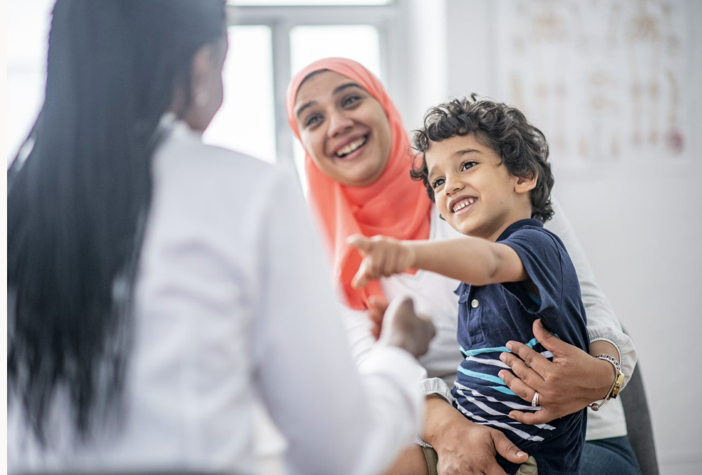
A parent and carer information session was also facilitated by Milton Therapy and Learning Centre, which had 12 attendees. Positive feedback was received from parents and carers attending the sessions who felt they had increased knowledge and confidence in identifying whether a child was reaching age-appropriate developmental milestones and knowing the right health services to contact if they had speech or language concerns about their child.

Looking ahead
Milton Therapy and Learning Centre has continued offering speech and language screening sessions to families to meet the ongoing needs of the community, with parents paying a small supplemental fee for the service.
They hope to expand their ‘Small Talk' program by partnering with more local service providers in the future to continue to foster and achieve better outcomes for children and families in the Milton local area.
For more information, contact the AEDC NSW Project Team:
Phone: 1300 083 698
Email: aedc@det.nsw.edu.au

