Enterprise Computing Stage 6 (Year 12) – teacher support resource
Data science

Teacher support resource
Teacher note: this resource has been designed to facilitate the ready conversion into a student booklet by removing the answers within the response windows. Teacher notes can be deleted before distributing to students.
Student name:
Class:
Teacher:

Contents
Teacher support resource 1
Unit overview 4
Assessment task overview 5
Submission details 7
Steps to success 8
Glossary 11
NESA glossary keywords 15
The design and production process 16
Collecting, storing, and analysing data 17
Explore nominal, ordinal interval and ratio levels of measurement applied to data 22
Investigate data sampling, including manual and computerised methods of active and passive data collection 23
Assess the relevance, accuracy, validity and reliability of primary and secondary data 25
Exploring the data 30
Investigate how informatics supports the development of a deeper understanding of data 37
Interpret and present data using graphs, infographics, dashboards, reports, network diagrams and maps 40
Investigate structured and unstructured datasets 42
Explore the use of likes, emoticons and memes as forms of alternative data as sources of feedback 43
Examine the impact of errors, uncertainty and limitations in data 45
Explain how blockchain technology is used to manage and verify data 50
Examine software features that affect the privacy and security of data 56
Explore the use of big data and data warehousing, considering volume, variety, and velocity 59
Explore the risks and benefits of data mining 61
Analyse the impact of data scale 62
Evaluate the effectiveness of different methods for data storage 66
Data quality 71
Investigate the ethical use of data for social or enterprise research purposes 71
Explore social, ethical and legal issues associated with using data 73
Investigate the legal issues surrounding data collection and handling 77
Investigate the influence of curated and communicated data on social behaviour 80
Processing and presenting data 83
Summarise data using a spreadsheet 83
Collate information using spreadsheet analysis features, including charts, statistical analysis and what-if modelling 87
Filter, group and sort data in a spreadsheet to process and display information 93
Apply spreadsheet analysis features to develop a data dashboard 100
Develop a flat-file database 106
Apply computational thinking to design a relational database with appropriate user views 107
Sort and search data, including using structured query language (SQL) 117
Explore how machine learning and statistical modelling are used in data analytics to analyse big data, and as a prediction tool 128
References 132


Unit overview
In this unit students will develop a fundamental understanding of the area of Data science. The lessons and sequences in this teacher resource are designed to allow students to develop the knowledge and skills to use datasets and relational databases.
Weeks 1 to 4 see students understand collecting, storing and analysing data. Students assess the quality of data while analysing the types of data required to support the production of meaningful information. They develop their skills in analysing, processing and presenting data using software tools that are commonly used in enterprises.
Students investigate social and ethical issues associated with collecting, securing, using and visualising data. They also explore patterns that may emerge as a result of processing and analysing data.
Weeks 5 to 10 see students learn about Data science through practical activities to support the development of skills.
The learning experiences, projects and tasks may highlight opportunities for students to incorporate data science into their Enterprise Computing project.

Assessment task overview
Type of task: develop a data science product with documentation.
Outcomes being assessed:
A student:
- explains the function of data and information within enterprise computing systems EC-12-02
- explains how data is used in enterprise computing systems EC-12-04
- applies tools and resources to analyse complex datasets EC-12-05
Enterprise Computing 11–12 Syllabus © NSW Education Standards Authority (NESA) for and on behalf of the Crown in right of the State of New South Wales, 2022.
Suggested weighting: 20%
Students will analyse a large dataset and develop a spreadsheet, relational database and data dashboard to ascertain specific historic and current data that provides information.
We live in an age where information plays an important role in our daily and business lives. Large datasets are easily accessible to help us develop and inform our decision-making processes.
Choose a dataset to create a spreadsheet, relational database and a data dashboard that contains current and historic data.
Examples of datasets to consider include:
- weather data for a location over the last 25 or more years
- ocean temperatures from 1950 to present
- Spotify playlists from 2012 to present
- mobile phone prices and usage in Australia 2000 to present
- population density and other census data for a state from 1970 to present.
Alternately, teachers may want to download a pool of datasets and assign them to students to process.
Once you have collected your data, analyse the information using a variety of data analysis tools such as:
- filtering data using pivot tables, creating charts, or applying conditional formatting
- using the ‘analyse data’ tool in Excel to analyse trends, patterns and create summaries
- using the Analysis ToolPak in Excel to perform complex data analysis
- using a ‘What-if’ analysis to explore various results.
Once you have completed your analysis, create your spreadsheet following the ‘Steps to Success’ model.
You will then create a relational database and data dashboard that best displays your findings. Your database should include:
- a data dictionary
- linked tables via key fields
- the ability to search and sort data using structured query language (SQL)
- the use of forms and reports.

Submission details
Students submit their documentation digitally, including a link to their system of information delivery for this project.
Students should present a summary of their analysis in one of the following formats:
- Preparing a word-processed report with relevant screenshots and analysis.
- Creating a presentation slide deck.
- Creating a video presentation of your findings.
Students should structure their analysis using the ‘Steps to Success’ model.
The potentially large file size of their digital solution may make this the most practical way to submit their work. This provides an essential learning opportunity to discuss cloud-based data storage.
The submitted project and accompanying digital documentation should contain the facility for teachers and ‘clients’ to review and make comments.
Students should be provided the opportunity to showcase their work in a class presentation that includes a question and answer segment.
Opportunities should also be explored for students to peer assess their classmate’s work. This will enable a forum for the exchange of ideas that may help inform future tasks and projects.
This project may be used to inform the design and development of the student’s Enterprise project during the Year 12 course.

Steps to success
Table 1 – assessment preparation schedule
Steps | What I need to do
Identifying and defining  Identify a valid dataset. | Identify, download and acknowledge a valid data source to create a spreadsheet, relational database and data dashboard.  Seek your teacher’s approval to use the dataset.
Researching and planning  Investigate your dataset. | For your dataset:  Investigate the origin of your dataset.  - What is the source?  - Is it reliable? How do you know?  Explain how these data sources are valid and relevant.  Investigate other reliable data sources that could correlate your data.  Explain how the data collected can be stored safely and securely and evaluate how safely and securely you stored the data in your information system.  Develop a data base schema.
Producing and implementing  Analyse data to tell a relevant and compelling story. | Use a variety of tools to analyse your dataset. This could include spreadsheets, databases, or an analysis tool like Gapminder.  Analyse the data. What does story tell? Use both qualitative and quantitative data analysis.  Explain the most significant results from your dataset.  Evaluate limits or uncertainties in your dataset. This could include sample size, data quality, timeliness or bias.  Analyse historical trends in your dataset.
Develop a spreadsheet | The spreadsheet should include the following features to demonstrate that you can:  - enter text, numeric values and formulas  - copy cells using both absolute and relative referencing  - fill down and across  - use built-in and user determined formulas, including:  - Arithmetic: SUM, MAXIMUM, MINIMUM, COUNT, ABSOLUTE VALUE, SQUARE ROOT, INTEGER, PART  - Statistical: MEAN, STANDARD DEVIATION  - Logical: IF (determines a value based on a condition being TRUE or FALSE)  - relational operators: LESS THAN OR EQUAL TO, EQUAL TO, NOT EQUAL TO, GREATER THAN and GREATER THAN OR EQUAL TO  - Other: LOOKUP(s)  - print all or parts of a spreadsheet  - import data from a variety of sources  - export spreadsheet data in a variety of formats  - manipulate rows and columns of a spreadsheet and apply a variety of formats  - record, run and edit macro routines to automate processing  - sort selected areas of the spreadsheet  - configure page layouts and manipulate page breaks  - work with data across multiple sheets  - apply conditional formatting to display information  - use filters and pivot tables to display information.
Develop a database | The database should include features to demonstrate that you can:  - create a relational database  - use relational operators, including:  - CONTAINS, DOES NOT CONTAIN  - EQUALS, NOT EQUAL TO  - GREATER THAN, GREATER THAN OR EQUAL TO  - LESS THAN, LESS THAN OR EQUAL TO  - use logical operators, including:  - AND, OR and NOT  - sort data using multiple fields to specify the sequence  - design forms and reports  - implement and display a schema  - import and export data  - apply security to the database.
Testing and evaluating  Review and improve | - Evaluate the effectiveness of your spreadsheet, database and data dashboard.  - Self and peer assess the success of the product.

Glossary
Many of the following words will gather more meaning for you as you work through this booklet.
Each time you see a new word in bold throughout this workbook you can add its definition in the table below in case you need to refer to them later.
Word | Definition
Active data collection | Active data basically involves anything that you would directly ask users for. For instance, participants may be asked to provide their name or email address. Feedback forms and consumer satisfaction surveys are also examples of active data.
Blockchain technology | A growing list of records, known as blocks, which are linked using cryptography. It can be used to record transactions between 2 parties efficiently and in a verifiable and permanent way.
Cloud storage | Distributing computing over a network where storage of files, processing of data and/or access to software occurs automatically on interconnected server computers to which the user’s device is connected. The term refers to accessing files, software and services over the internet.
Computational thinking | A process in which a problem is analysed and solved so that a human, machine or computer can effectively implement the solution. It involves using strategies to organise data logically, break down problems into parts, interpret patterns and design, and implement algorithms to solve problems.
Data warehousing | The practice of collecting data from a wide range of sources within a company into a single database that may be used to guide management decisions.
Emoticons | :-) An acronym for emotion icon. Emoticons are a representation of a facial expression such as a smile or frown, formed by various combinations of keyboard characters or small images and used to convey the writer's feelings or intended tone.
Graphs | A diagram showing the relation between variable quantities, typically of 2 variables, each measured along one of a pair of axes at right angles.
Indigenous Cultural and Intellectual Property (ICIP) | Includes, but is not limited to, objects, sites, cultural knowledge, cultural expression, and the arts, that have been transmitted or continue to be transmitted through generations as belonging to a particular Indigenous group or Indigenous people as a whole or their territory.
Informatics | The science of processing data for storage and retrieval.
Interval levels of measurement | An interval scale is one where there is order and the difference between 2 values is meaningful. Examples of interval variables include temperature in Celsius, pH or a score.
Machine learning | The use and development of computer systems that are able to learn and adapt without following explicit instructions, by using algorithms and statistical models to analyse and draw inferences from patterns in data.
Memes | An image, video, piece of text, that is typically humorous in nature, that is copied and spread rapidly by internet users, often with slight variations.
Passive data collection | A methodology which often takes place without the participants being aware and, as the name suggests, without them having to actively do anything towards the research.
Pivot table | A pivot table is a table of grouped values that aggregates the individual items of a more extensive table within one or more discrete categories.
Qualitative data | Qualitative data is defined as the data that approximates and characterises. Qualitative data can be observed and recorded. This data type is non-numerical in nature. This type of data is collected through methods of observations, one-to-one interviews, conducting focus groups, and similar methods.
Quantitative data | Quantitative data is any quantifiable information that can be used for mathematical calculation or statistical analysis. This form of data helps in making real-life decisions based on mathematical derivations.
Ratio levels of measurement | For analysis, data are classified into 4 levels of measurement—nominal, ordinal, interval and ratio.  These are the 4 fundamental levels of measurement scales used to capture, classify and analyse collected data.
Relational database | A database structured to recognise relations between stored items of information.
Structured Query Language (SQL) | Specialist programming language used to manage data and access data in relational database management systems.
Statistical modelling | A statistical model is a mathematical model that embodies a set of statistical assumptions concerning the generation of sample data. A statistical model represents, often in considerably idealised form, the data-generating process.
Structured datasets | Structured data is when data is in a standardised format, has a well-defined structure, complies to a data model, follows a persistent order, and is easily accessed by humans and programs. This data type is generally stored in a database.
Unstructured datasets | Unstructured simply means datasets (typical large collections of files) that aren't stored in a structured database format. Unstructured data has an internal structure, but it's not predefined through data models. It might be human generated, or machine generated in a textual or a non-textual format.
Variety | The diversity of source data, that does not fall into neat relational structures. For example, text from social networks, image data or a raw feed directly from a sensor source.
Velocity | The increasing rate at which data flows into an organisation, increased with smartphones, the internet and streaming.
Volume | The size of datasets that an organisation has collected to be analysed and processed.
What-if modelling | What-if analysis modelling helps an organisation best determine its next move in the market, not based on a hunch but cold, historical facts.
Teacher note: for students with an EAL/D background, the glossary can be provided complete so that they have additional time to understand the key terms with bilingual dictionaries. The glossary can be provided to students in their preferred communication mode.

NESA glossary keywords
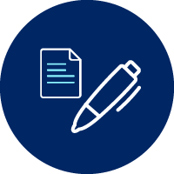
NESA keywords can be used in the syllabus and in the Higher School Certificate examination. Familiarisation with these keywords can assist in understanding how to write and respond to questions.
Key term | Definition
Analyse | Identify components and the relationship between them; draw out and relate implications
Apply | Use, utilise, employ in a particular situation
Assess | Make a judgement of value, quality, outcomes, results or size
Define | State meaning and identify essential qualities
Examine | Inquire into
Explain | Relate cause and effect; make the relationships between things evident; provide why and/or how
Evaluate | Make a judgement based on criteria; determine the value of
Identify | Recognise and name
Investigate | Plan, inquire into and draw conclusions about
Interpret | Draw meaning from
Outline | Sketch in general terms; indicate the main features of
Summarise | Express, concisely, the relevant details
NESA: A Glossary of Key Words
Teacher note: collate, develop, determine, explore and filter are used in this topic and are not listed.

The design and production process
Throughout your study of Enterprise Computing, you will learn about design processes and how to apply them. You will explore different types of design processes and learn how to apply them in your design project.
The design and production process:
- involves a sequence of organised steps which provide a solution to design needs and opportunities
- may take a few seconds or minutes, such as when you select what clothes to wear, or may take years as in the case with the design of a motor vehicle
- may involve one person or may involve many people
- may be simple or complex, depending on the task
- involves questioning (or evaluating) throughout the iterative process.
Figure 1 – flowchart of a design and production process
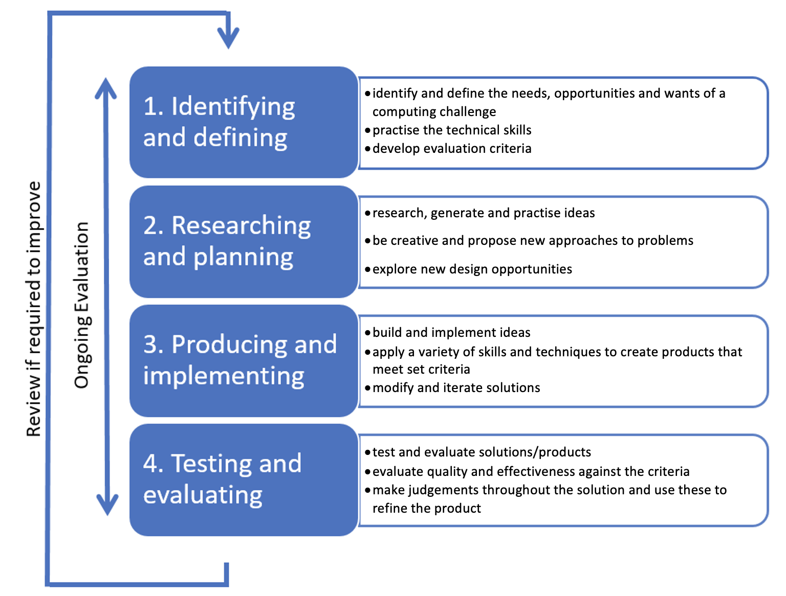


Collecting, storing, and analysing data
As a class watch A Day in the life of a Data Analyst (13:33).
This video gives an overview to the role of a data analyst and the role of analysing data in enterprise business.

As a class watch Data Analysis Roles – How do you differentiate between them all (2:34).
Discuss how data science, data analysis and data engineer roles overlap and converge under Data science.
Teacher note: a good resource to use for levelling prior learning and checking for understanding is to have students complete Grok Academy – Data Analytics. Additionally teachers and/or students would benefit from the 3-hour course created by the Institute of Applied Technology - Introduction to Data Analytics.
Quantitative data is numerical data that can be measured and compared using mathematical methods. Examples include age, height, weight or salary.
Qualitative data is descriptive data that cannot be measured using mathematical methods. Examples include opinions, emotions or perceptions.
How do the 2 methods of data collection differ?
Quantitative data is used to draw conclusions and make predictions based on numerical analysis, while qualitative data is used to understand experiences and perspectives.

As a class watch Qualitative vs Quantitative vs Mixed Methods Research (1:40–7:00).

Quantitative data
Quantitative data is often represented using numerical data types such as integers, decimals or floating-point numbers.
In a survey, a person's age might be represented as an integer, for example 28, while their religion might be represented as a string, for example Catholic. A product's price might be represented as a decimal, for example 9.9, while its brand might be represented as a nominal data type, for example ‘Nike’.
Quantitative data answers key questions such as:
- How many?
- How much?
- How often?
Activity 1: examples of quantitative data

Identify examples of quantitative data. Students complete a Think, Pair, Share activity to encourage conversation.
Sample answers:
- Scores on tests and exams, for example 85, 67, 90 and so on.
- Shoe size.
- The temperature in a room.
- Height in centimetres.
- Weight in kilograms.
- Age in years.
- Sales in dollars.
- Temperature in Celsius.
- Test scores (percentage or out of 100).
- Income in dollars.
- Population size.
- Number of customers served.
- Inventory levels in units.

Qualitative data
Qualitative data can’t be expressed as a number and can’t be measured. Qualitative data consists of words, pictures and symbols. This type of data is also called categorical data because the information can be sorted by category, not by number.
Qualitative data is often represented using categorical data types such as strings, characters, or nominal or ordinal data and can be represented by a wide variety of charts such as line, bar graph, pie charts or scatter plots.
Qualitative data can answer questions such as:
- How has this happened?
- Why has this happened?
Activity 2: examples of qualitative data
Identify examples of qualitative data. Students complete a Think, Pair, Share activity to encourage conversation.
Sample answers:
- Colours for example the colour of the sea.
- Your favourite holiday destination such as Hawaii, New Zealand and so on.
- Names such as John or Zahria.
- Open-ended questions
- Customer satisfaction levels (for example ‘very satisfied’, ‘somewhat satisfied’)
- Employee job satisfaction (for example ‘happy’, ‘unhappy’)
- Brand perception (for example ‘luxury’, ‘budget’)
- Product reviews (for example ‘excellent’, ‘fair’)
- Religious beliefs (for example ‘Catholic’, ‘Muslim’)
- Education level (for example ‘bachelor's degree’, ‘high school diploma’)
- Marital status (for example ‘married’, ‘single’)
- Gender (for example ‘male’, ‘female’).
Activity 3: define quantitative and qualitative data.
Define the term quantitative data and outline what is it used for?
Sample answer:
Quantitative data refers to information that can be measured and expressed numerically. This type of data is used to quantify the characteristics of a population, phenomenon or process. It is commonly collected through methods such as surveys, experiments and statistical analysis. Quantitative data is used for various purposes, including making comparisons, identifying patterns and trends, testing hypotheses, and making informed decisions based on statistical evidence. In the field of education, quantitative data is often used to assess student performance, evaluate the effectiveness of educational programs, and inform policy decisions.
Define the term qualitative data and outline what is it used for?
Sample answer:
Qualitative data is information that is more about descriptions and meanings rather than numbers. It helps us understand people's experiences, thoughts and feelings. This type of data is collected through methods like interviews and observations. In education, qualitative data is used to learn about what students and teachers think and feel, and to get a better understanding of how things work in schools. It's like getting the ‘story’ behind the numbers.
Identify data types used to represent quantitative data.
Sample answer:
- Counting numbers
These are like how many students are in a class, and they can be whole numbers or decimals.
- Numbers with equal differences
This is like temperatures on a thermometer, where the difference between 10 and 20 degrees is the same as the difference between 20 and 30 degrees.
- Numbers with a true zero
This is like measuring height or weight, where zero means there is none of something.
Identify data types used to represent qualitative data.

Sample answers:
- Descriptive data
This type of data includes descriptions, observations and non-numeric information that captures the qualities of a subject.
- Categorical data
This represents data that can be grouped into categories or labels, such as types of fruit or favourite colours.
- Narrative data
This involves telling a story or providing detailed accounts of experiences, perspectives and opinions.
Explain the difference between qualitative and quantitative data.
Sample answer:
Quantitative data is often represented using numerical data types and is expressed as numbers. Qualitative data cannot be represented in numerical form and is about meanings and descriptions rather than numbers. It helps represents people’s thoughts, feelings and experiences.

Explore nominal, ordinal interval and ratio levels of measurement applied to data
As a class watch Nominal, Ordinal, Interval & Ratio Data (10:55).
Activity 4: explore nominal, ordinal, interval and ratio levels of measurement applied to data.
In the space below, provide your own description of nominal, ordinal, interval and ratio levels of measurement applied to data.
Level of measurement | Description when applied to data
Nominal | Sample answer:  Nominal data describes qualitative characteristics with no numerical value, order or rank. For example, gender, ethnicity, brands or personal preference. Nominal data is used in surveys to collect sample demographic information.
Ordinal | Sample answer:  Ordinal data is categorial in nature, but it has an inherent rank or order. For example, income levels, levels of agreement (agree, disagree, neutral), and levels of satisfaction.
Interval | Sample answer:  Interval data is quantitative data that is measured by numbers. Interval data has an order with equal measure points. For example, a credit score, which is a number between 2 values, such as 200–900. You can measure the distance between points, but the values do not have a meaningful zero point.
Ratio | Sample answer:  Ratio data is naturally numerical, ordered data with an absolute zero. For example, weight, height, length or time. Ratio data can measure distances between data points (add and subtract) and divide and multiply.

Investigate data sampling, including manual and computerised methods of active and passive data collection
Data sampling is the process of selecting a subset of data from a larger population for analysis. This is done because it is often too time-consuming and resource-intensive to collect data from the entire population.
The choice of data collection method will depend on the research question, resources available, and the characteristics of the population being studied.
These broad definitions of data sampling focus upon comparisons between computerised and manual approaches which are the 2 main types of data collection methods.

Manual methods of data collection
Active data collection: this involves actively engaging with participants or customers to collect data. Examples include surveys, interviews and focus groups.
Passive data collection: this involves collecting data without actively engaging with participants or customers. Examples include observation and collecting existing data (for example public records).

Computerised methods of data collection
Active data collection: this involves using technology to actively collect data from participants or customers. Examples include online surveys and mobile apps.
Passive data collection: this involves collecting data automatically through technology, without actively engaging with participants or customers. Examples include web analytics and tracking devices (for example GPS).

Activity 5: categorising methods of data collection
Consider the following scenarios and categorise each into one of the quadrants in the table below. Student surveys on:
- jersey design
- election votes
- Census data
- social media likes.
Manual methods of collecting data include personal interviews, paper-based data collection (for example a questionnaire or a survey) or telephone interviews.
For each of the manual methods of data collection, there is a corresponding computer assisted method of data collection, such as computer assisted interviews, self-interviews via web and email forms and computer-assisted telephone interviews.
Methods of data collection | Manual | Computer-assisted
Active | Sample answer:  Election votes | Sample answer:  Jersey design
Passive | Sample answer:  Census data | Sample answer:  Social media likes
Activity 6: the advantages of using computerised methods of data collection
Identify the advantages of using computerised methods of data collection.
Sample answer:
Efficiency: computerised methods can significantly increase the speed of data collection compared to manual methods. With automated data entry and processing, tasks that would otherwise take hours or days can be completed in a fraction of the time.
Accuracy: computerised methods reduce the likelihood of human error in data entry and processing. Automated validation checks can help identify and correct errors in real time, leading to more accurate data.
Integration: computerised data collection methods can be integrated with other systems and databases, streamlining data management and analysis processes. This integration reduces the need for manual data entry and enables more efficient data sharing and collaboration.
Real-time monitoring: computerised methods allow for real-time monitoring of data collection progress and results. Researchers and practitioners can track data collection activities as they happen, identify any issues or trends early on, and make timely adjustments as needed.
Cost-effectiveness: while there may be upfront costs associated with setting up computerised data collection systems, they often result in long-term cost savings. Automated processes reduce the need for manual labour, paper and other resources, ultimately lowering the overall cost of data collection.
Data security: computerised methods offer enhanced data security features, such as encryption, access controls, and audit trails. This helps protect sensitive information and ensures compliance with data privacy regulations.

Assess the relevance, accuracy, validity and reliability of primary and secondary data
Primary data is collected by the researcher themselves, while secondary data is obtained from existing sources. The quality of data is important to ensure that the results of a study are trustworthy and can be used to make decisions.
The relevance, accuracy, validity and reliability of both primary and secondary data must be assessed.
Relevance is the extent to which the data is directly related to the research question being studied. For example, if a study is looking at the effect of a new product on customer satisfaction, relevant data would be information about customer experiences with the product.
Accuracy is the degree to which the data reflects the true values of the variables being measured. For example, if a study is looking at the height of participants, the data should accurately reflect the actual height of each participant.
Validity is the degree to which the data accurately measures what it is supposed to measure. For example, a survey questionnaire about customer satisfaction should accurately measure customer satisfaction and not something else, such as their level of agreement with the company.
Reliability is the consistency of the data over time and across different sources. For example, if a study is measuring customer satisfaction, the results should be reliable if the same survey questionnaire is used over time or across different customer groups.
In general, primary data is often considered to be more accurate and relevant, but also more time-consuming and resource-intensive to collect.
Primary data can come from the following sources:
- diaries, correspondence
- original documents
- biographies, autobiographies, manuscripts
- government documents, statistical data, and research reports.

Primary data
Advantages of primary data | Disadvantages of primary data
- Relevance  Data collected specifically for the research question is more likely to be directly relevant and tailored to the specific needs of the study.  - Accuracy  Data collected directly from the source is less likely to be subject to errors or biases introduced through interpretation or secondary sources.  - Control  Researchers have more control over the data collection process and can ensure that data is collected in a standardised and consistent manner.  - Customisation  Primary data can be tailored to the specific needs of the research question, allowing for the collection of unique and specific information. | - Cost  Collecting primary data can be more time-consuming and expensive than collecting secondary data.  - Burden  Participants or customers may not be willing to participate or may not provide complete or accurate information.  - Time-consuming  Data collection, processing and analysis can take a significant amount of time, delaying the completion of the study.  - Expertise  Specialised skills and knowledge may be required to collect, process, and analyse primary data, requiring additional resources or expertise.

Secondary data
Secondary data is often easier to access, but may be less relevant and accurate, and the reliability of the data may be questionable. Both primary and secondary data have their advantages and disadvantages, and the choice of data will depend on the research question and available resources.
Secondary data can come from the following sources:
- journal articles
- textbooks
- dictionaries and encyclopedia
- websites.
Advantages of secondary data | Disadvantages of secondary data
- Cost  Collecting secondary data is often less expensive and time-consuming than collecting primary data.  - Accessibility  Secondary data is often readily available and easy to access, either through publicly available sources or through data providers.  - Speed  Using secondary data can speed up the research process, allowing for faster completion of the study.  - Historical context  Secondary data can provide valuable historical context and background information for the research question. | - Relevance  Secondary data may not be directly relevant to the research question and may require significant manipulation or interpretation to make it useful.  - Accuracy  Secondary data may not be up-to-date, accurate or complete, and may be subject to biases introduced through the original data collection process.  - Reliability  The reliability of secondary data may be questionable, and the data may not have been collected using standardised or consistent methods.  - Bias  Secondary data may be subject to biases or limitations introduced by the original data collector or source.

Activity 7: assessing primary and secondary datasets
To complete this activity, you need to look at the following datasets and assess the accuracy, validity and reliability of both pieces of data.
- The Australia 2021 Census – All persons QuickStats – Australian Bureau of Statistics
- Demographics of Australia – Wikipedia
- Identify which dataset is the primary data and which is the secondary data.
- Now that you have decided which is primary data and which is secondary data, complete the table below. Assess the relevance, accuracy, validity and reliability of each of these pieces of data.
 | Primary data (ABS data) | Secondary data (Wikipedia site)
Relevance | Sample answer:  This data is from a government website and is the most up-to-date census data. It is relevant because it is collected directly from Australian households and provides a snapshot of Australian demographics at a point in time. | Sample answer:  This data is collated from a variety of sources, some from government sites, journal articles and organisations. All of which are relevant to the study of demographics in Australia.
Accuracy | Sample answer:  This data is accurate, as it comes directly from the Australian Bureau of Statistics from primary data collected from the population of Australia on paper or online. | Sample answer:  While the reference list cites official sites such as the ABS, it is open to editing as Wikipedia is a user-generated source of information. This creates a possibility that the data used is not accurate.
Validity | Sample answer:  This research is valid as it is an official (government) source of independent information. | Sample answer:  There are reference lists, but users can update and change the content which can make the data invalid.
Reliability | Sample answer:  This research is reliable as it comes from official channels and is independently collected. | Sample answer:  Wikipedia is not always a reliable source of secondary data as users of the site can change and update the information.

Activity 8: NSW public schools master dataset
The purpose of this activity is to allow students to start learning the skills of data science using a common dataset. The NSW public schools master dataset as an example of open data, we can see commonly defined data on every school. This activity also commences practical learning about Processing and presenting data.

The definitions for each data field are presented in the data dictionary to make interpretation easier and the dataset is available in several formats to suit your use.
For this activity use the CSV or comma separated values version of this document as it will easily open in Google Sheets or Microsoft Excel for analysis.
- Visit the Master dataset: NSW government school locations and student enrolment numbers.
- Download the CSV file.
- Check the meaning of each field using the data dictionary which you can download.
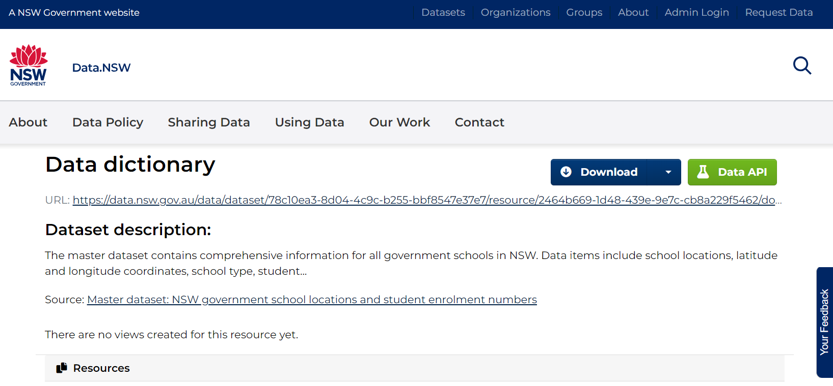

Exploring the data
Use the following tools in the spreadsheet application to select and explore this data.
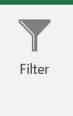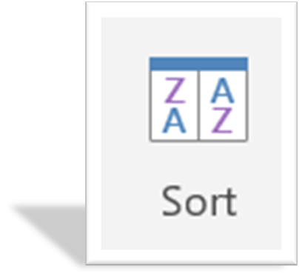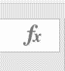
Remember that any typing or selections can be easily undone with Ctrl Z (is your friend).

Filters, sort, formulas and functions
Filters, sort, formulas and functions are some of the basic methods of data analysis which are possible in spreadsheet programs.
Data can be filtered or sorted, and various formulas and functions can be applied.
Data can be visualised in tables and graphs (charts in Excel) using the PivotChart functions.
Data visualisation will be the focus later in the course.

Filters
Filtering is the most immediately powerful tool that makes this basic analysis much easier. By clicking on “1” to highlight the top row, you can turn on data filters using these headings. In Excel using the data tab and clicking on the funnel icon, in Google Sheets this is similar, data is a drop-down menu and click on “create a filter”.

Sort
For each column you can sort the dataset rows based on the values in either ascending or descending order.
Specific values can be filtered out of the display which hides rows that do not match the filter criteria. These options are available in the drop-down arrow next to each column heading.
Sorting and filtering co-exist so filtered data can be sorted, and sorted data can be filtered.

Formulas and functions
A wide range of formulas are possible in spreadsheet applications, although nearly all the formulas you will use are common to all applications. Some are unique to only one application, so cross-compatibility is not always possible.
The main mathematical functions you can use are statistical aggregations like SUM, AVERAGE, STDEV (standard deviation), MODE, MEDIAN, MAX and MIN (to calculate range).
To use a formula, start a new sheet to avoid problems with filters and sorting of data affecting the cells used in the calculations.
In a blank cell you can use the formula wizard or directly type the formula starting with the equals sign.
The formula will have a range of input data you select from the dataset using the cell reference letter/number combination – A1 being the uppermost left cell in the spreadsheet.
The wizard will guide you through the formula, or tooltip messages will provide guidance if you directly type the formula into the cell.
Once completed you can submit the formula by finishing the wizard or pressing enter.
The formula will continually update based on the cells referenced.
Filters and sorting do not affect the formula’s result as the sorted or filtered data still retains its original cell reference value used in the formula.
Additional useful links and guides:
- Mr Excel on YouTube
- Excel help and learning on Microsoft
- Excel Easy
- Excel Functions
- ExcelTip
- ExcelJet

The NSW public schools master dataset
Practise some of these skills using the current dataset.
Consider which fields in the data and what data is available in this dataset to analyse and produce the information as an answer to the following questions.
For each question provide a suggestion as to who may use this information and what data-driven decisions they may make.

Filtering and sorting
Where in the Sydney area was the first teacher? What was the date?
Sample answer:
Using the date of the first teacher on duty field it is a tie between Botany Public School, Largs Public School, and Mulbring Public School on 1/1/1849. There are issues with this dataset in terms of the date format giving the sorting an incorrect order. Data cleansing is a normal process that precedes any form of analysis to fix up these small issues that can distort conclusions. The AgeID field is also not the age of the school (see the data dictionary).
The way Microsoft stores dates is a fascinating study in itself and teachers are encouraged to complete the data types exercises in the Appendix as extension exercises with students.
Which NSW school is the newest as shown in this dataset?
Sample answer:
Using the same data sorted in the opposite direction was at the time of writing - Jordan Springs Public School with the first teacher on duty starting 20/7/2020.
Students should be encouraged to visit the websites of these schools and confirm, using images of the schools, these dates.
In which principal networks are most fully selective schools in NSW?
Sample answer:
You need a filter on fully selective schools, not including partially selective, and sorting by principal network to count which has more, a tie on 3 apiece.
Which school had the most enrolments last year?
Sample answer:
A sort based on latest FTE enrolment high to low (descending order).
Which school is furthest west?
Sample answer:
A sort on longitude (measure of east/west, latitude measures north/south).
Which school has the highest percentage of EAL/D students?
Sample answer:
A sort on LBOTE (see data dictionary) for EAL/D students which is the new term that has not yet made it into this dataset.

Formulas
What is the average number of students enrolled in NSW schools?
Sample answer:
371.27 students
Teachers should discuss what .27 of a student may look like!
What is the range of ICSEA values across NSW schools?
Sample answer:
657. Using both MAX and MIN formulas on the ICSEA column and then calculating the difference between these values with SUM.
What is the range of student enrolments across all NSW schools?
Sample answer:
Need max/min/sum calculation based on enrolments (FTE).
What is the average ICSEA values for all schools with secondary students?
Sample answer:
This calculation needs an average calculation on a filtered dataset (highlight the filtered column and look at the bottom bar in Excel); need to be careful as some schools do not have this data so highlighting the column is best rather than the actual cells which can stop early on a blank value.
Which Federal electorate contains the most schools?
Sample answer:
Select all the federal electorates and copy into a new list. Remove duplicates and use the COUNTIF formula for counting the number of schools if the federal electorate matched the criteria.
Teacher note: these answers were determined based on the NSW public schools master dataset at the time. The same methods and tools should be used on the current dataset and may result in different answers. This is an opportunity to discuss currency and reliability of data.

Useful data on my school
Look at your own school in this dataset. What information is held in this dataset that is useful to you or others?
How could the data be used?
Answer:

How does my school compare in size to other schools?
Answer:

What data fields do I need to answer these questions?
Answer:

What data operations do I need to perform?
Answer:

What else could we learn by integrating other sources of data?
Answer:

Activity 9: exploring data from your school
For 5 minutes each, students extract (using sorting/filtering/formulas) relevant information about their school.
Students explore and qualitatively or quantitatively analyse their own school's data in comparison to the dataset.
Reflect on the information gained in this process.
Assess the relevance, accuracy, validity and reliability of the master dataset.
Activity 10: Atlas of Living Australia
Explore the Atlas of Living Australia. What types of analysis is possible with your school individually, or in comparison to other schools in the same principal network, operational directorate or local government area (LGA)?
Take some time now to explore these ideas. Undertake some data analysis techniques we have explored and share with the class any insights you were able to determine from the analysis of this dataset.
Activity 11: treasure hunt design
Students design and develop their own data treasure hunt using fun, beginner-friendly datasets. Students complete a Think, Pair, Share activity to decide what type of dataset they will use.
Step 1:
- Visit either FiveThirtyEight or Kaggle.
- Find a dataset which has interest for your team.
- Download the .csv dataset.
Step 2:
- Understand and investigate the dataset.
- What are the fields?
- What type of data is in the dataset?
- qualitative
- quantitative.
Step 3:
- What questions could be asked of this data?
- Most? Least? Average? How wide is the gap?
- What is interesting about this data?
Step 4:
- How can the data be searched and sorted to reveal answers to these questions?
Include filters, sorting and formulas
Step 5:
- Pose the questions to the class and see which students can answer the questions the quickest.
Step 6:
- The fastest student demonstrates their methods to the other students in the class.

Investigate how informatics supports the development of a deeper understanding of data
Informatics play a critical role in the development of a deeper understanding of data, providing researchers with the tools and techniques they need to collect, organise, analyse and interpret data in new and innovative ways.
As a class watch this video outlining Informatics (2:22).
Activity 12: informatics in medicine
How can data-driven approaches in medicine improve patient outcomes, and what are some potential risks associated with relying heavily on data?
Sample answer:
Data-driven approaches in medicine can significantly improve patient outcomes by enabling personalised treatment plans, predicting disease outbreaks, and identifying risk factors through data analytics. These methods allow for more accurate diagnoses and tailored therapies. However, the reliance on data also presents risks, such as data breaches, inaccuracies due to flawed data, and potential biases in datasets that can lead to inequitable healthcare practices. Ensuring the accuracy and security of data is crucial to mitigate these risks.
Discuss the ethical implications of using big data in healthcare. How can privacy concerns be balanced with the benefits of personalised medicine?
Sample answer:
The ethical implications of using big data in healthcare include issues of patient consent, data privacy, and potential misuse of sensitive information. Balancing privacy concerns with the benefits of personalised medicine involves implementing robust data protection measures, ensuring transparency in data usage, and obtaining explicit patient consent for data collection and use. Healthcare providers must also adhere to strict ethical guidelines and regulations, such as de-identifying patient data to protect privacy while still allowing for beneficial medical research and personalised care advancements.
Are informatics and data visualisation the same?
Sample answer:
No, informatics and data visualisation are not the same.
Informatics refers to the study of how information is processed, stored, and communicated. It covers a wide range of topics, including data management, data analysis and data interpretation.
Data visualisation, on the other hand, is a specific aspect of informatics that involves the creation of visual representations of data. The goal of data visualisation is to help people understand and make sense of data by making it more accessible, understandable and meaningful.
In other words, informatics is a broader field that encompasses data visualisation, as well as other topics related to information processing and management. Data visualisation is a specific tool or technique within the field of informatics that is used to help people understand and make sense of data.
Informatics is the study of the processing and management of information, and it plays a crucial role in the development of a deeper understanding of data. Informatics provides a range of tools and techniques that support the collection, organisation, analysis and interpretation of data.
Some of the key ways in which informatics supports the development of a deeper understanding of data include:
Key way | Informatics supports the development of a deeper understanding of data
Data collection | Informatics provides a range of tools and techniques for collecting data, including electronic data capture, data mining and web scraping among others. These tools allow researchers to collect large and complex datasets efficiently and effectively.
Data organisation | Informatics provides tools for organising and storing data, including databases, data warehouses and data management systems. These tools allow researchers to manage large and complex datasets efficiently and effectively.
Data analysis | Informatics provides a range of tools and techniques for analysing data, including statistical software, machine learning algorithms and data visualisation tools. These tools allow researchers to analyse and interpret data in new and innovative ways, revealing patterns and relationships that might not have been evident otherwise.
Data interoperability | Informatics provides tools and standards for ensuring that data can be shared and reused across different systems and platforms. This interoperability allows researchers to build on existing data and knowledge, leading to a deeper understanding of data.
Data visualisation | Informatics provides tools for visualising data, including data dashboards, data visualisation software and interactive data maps. These tools allow researchers to explore and understand data in new and innovative ways, revealing patterns and relationships that might not have been evident otherwise.
Activity 13: scenario – informatics in healthcare
Students watch the following video on informatics in healthcare (2:46).
Investigate the development and impact of informatics in healthcare and make notes in the space below:
Sample answer:
- Health informatics acts as the interface between health and technology and is about health data and how that data can be used to improve health.
- The data is stored in databases and kept on record for health providers and patients.
- The stored data is used to help make informed decisions and run advanced analytics.
- AI is used to predict patients’ possible outcomes and improve patient health.
- Life cycle of data is 4 stages:
- Created – a patient’s symptoms, diagnosis and treatments and personal information are entered into the database.
- Stored – data is stored in a record.
- Analysed – the data from a patient’s record is analysed using advanced analytics, machine learning and AI to find patterns and make predictions.
- Dispersed – the data and results are dispersed to health care providers so that the patient can be treated accordingly.
- This type of data means that a patient’s risk for developing certain diseases can be assessed and predicted based on their medical history.
- Other data such as return to hospital after discharge and reactions to medication are also available.
- Health informatics improves outcomes in hospitals and medical facilities and allows patients to use this information in their home. ‘Prescribing apps’, such as fitness data and blood sugar tracking, allow people to better understand their own health and habits. These apps also help physicians. For example, a person with Type 2 diabetes uses a blood sugar sensor and app to track changes in their blood sugar 24 hours a day. This information can be shared with their doctor and medication, diet and exercise can be tailored to suit the patient’s needs.

Interpret and present data using graphs, infographics, dashboards, reports, network diagrams and maps
Interpreting and presenting data using graphs, infographics, dashboards, reports, network diagrams and maps is an important aspect of informatics and data visualisation. Each of these tools can be used to effectively communicate different types of data and insights.
Graphs are a powerful tool for visualising quantitative data and can help to highlight trends, patterns and relationships in the data. Popular types of graphs include bar graphs, line graphs, scatter plots and histograms.
Infographics are visual representations of information and data that use images, charts and other graphic elements to convey information. Infographics are useful for presenting complex information concisely.
Dashboards are interactive visual representations of data that allow users to view and analyse data from multiple sources quickly and easily. Dashboards can be used to monitor real-time data, track performance and make informed decisions.
Reports are written documents that present data and analysis in a structured format. Reports can be used to summarise findings, present results and make recommendations.
Network diagrams are visual representations of networks, such as computer networks, social networks or organisational networks. Network diagrams can be used to understand the relationships and connections between different elements in a network.
Maps are visual representations of geographic data and can be used to visualise location-based data, such as demographic information or environmental data. Maps can also be used to understand spatial relationships and patterns in the data.

Activity 14: data visualisation challenge
Students work in small groups to complete the following steps and examine how to visualise data.
Step 1: pick a research topic, for example:
- most streamed songs on Spotify
- top-ranked anime
- sales data
- bike sharing.
Step 2: students find a dataset on their chosen topic using kaggle.com.
Step 3: students interpret the data and select at least 3 different visual tools to present the information.
Step 4: each group showcase their visual presentations to the class, explaining their rationale for employing specific visual tools and how these effectively communicate the data.

Investigate structured and unstructured datasets
Structured data is easier to analyse and process than unstructured data, but unstructured data is often richer and more informative than structured data.
When working with data, it is often necessary to combine structured and unstructured data to gain a complete understanding of the data and to derive insights and findings.
Structured data is data that is organised into a specific format, such as a table or a spreadsheet. Structured data is typically easy to process and analyse using computer programs and algorithms. Examples of structured data include numerical data, categorical data, and dates and times.
Unstructured data is data that does not have a specific format or structure, such as text, images or audio files. Unstructured data is more difficult to process and analyse than structured data and requires specialised tools and techniques. Examples of unstructured data include emails, social media posts and customer feedback.
As a class watch structured vs unstructured data (1:36).

Activity 15: investigating structured and unstructured datasets
Investigate what structured datasets your school would currently use and make notes in the space below:
Sample answer:
At school structured datasets commonly used may include student enrolment data, test scores, attendance records, school performance indicators and survey data. These datasets are often used for research, policy analysis, program evaluation and decision-making purposes within educational institutions. It's important to ensure that any data collected and used complies with relevant privacy and data protection regulations.
Investigate what unstructured datasets your school currently uses and make notes in the space below:
Sample answer:
In school unstructured datasets may include textual data from sources such as student essays, teacher comments, academic papers, open-ended survey responses, social media posts and educational resources. Unstructured data often requires natural language processing and text mining techniques to extract meaningful insights and patterns. It's important to handle unstructured data ethically and in compliance with privacy regulations, especially when dealing with personally identifiable information.

Explore the use of likes, emoticons and memes as forms of alternative data as sources of feedback
Likes, emoticons and memes are increasingly being used as forms of alternative data for collecting feedback and insights about people, products and events.
Likes are a simple way for users to indicate their approval or support of a particular item, such as a post or a page. The number of likes that an item receives can be used to understand its popularity and to gauge the public's response to it.
Emoticons are pictorial representations of emotions and are often used in digital communication to express feelings and emotions. The use of emoticons can provide valuable insights into the emotional responses of users and can be used to understand their opinions and attitudes towards a particular item.
Memes are images, videos or pieces of text that are spread virally online and often used to make humorous or satirical comments about current events or popular culture. The popularity and spread of memes can be used as a measure of public interest and can provide valuable insights into public opinion and attitudes.
While these forms of alternative data can provide valuable feedback and insights, it is important to remember that they are not always representative of the general population or of a particular target audience. Furthermore, it is important to be cautious when interpreting this type of data, as it may be subject to biases, such as selection bias or response bias.
Activity 16: emoticons as feedback
Investigate which software use likes, emoticons and memes as forms of feedback?
Sample answer:
Likes, emoticons and memes as forms of feedback are commonly used on social media platforms and communication tools.
Some of the software that use these forms of feedback include:
- Facebook which allows users to like and react to posts, pages and comments using emoticons
- Twitter which allows users to like tweets and to use emoticons in tweets and direct messages
- Instagram which allows users to like posts and to use emoticons in comments
- Snapchat which allows users to use emoticons and to create and share memes
- WhatsApp which allows users to use emoticons in messages and share memes.
What do likes, emoticons and memes communicate as feedback?
Sample answer:
Likes show that someone agrees or enjoys what's posted.
Emoticons express feelings like happiness (😊), sadness (😢), or surprise (😲).
Memes can say ‘this is funny’ or ‘I feel the same way’ without using words.
How do these forms of feedback differ from traditional written or verbal feedback?
Sample answer:
These are quicker and use images instead of long sentences.
They can be less personal because they don't use your own words.
They're more about immediate reactions than detailed thoughts.
In what contexts are likes, emoticons and memes commonly used as feedback?
Sample answer:
Likes are common on social media posts and photos.
Emoticons are used in text messages and online chats to show emotions.
Memes are shared in social media comments or group chats to make people laugh or think.

Examine the impact of errors, uncertainty and limitations in data
Errors, uncertainty and limitations in data can have a significant impact on the accuracy and reliability of data-driven decisions and insights.
Errors refer to mistakes made in data collection, entry or processing. They can range from minor typos to more significant inaccuracies that affect the validity of the data.
Uncertainty refers to the lack of precision or ambiguity in the data. It can arise from the measurement process, the nature of the data or the methods used to analyse the data.
Limitations refer to the inherent constraints of the data, such as sample size, coverage or representativeness. They can also result from the methods used to collect or analyse the data, such as limitations in the scope or reliability of the data sources.

Data sources
Data sources refer to the origin or sources from which data is collected and analysed. Examples of data sources include surveys, transactions, social media, government reports, customer feedback and sensor data. The quality and accuracy of the data collected depends on the data source. The following are issues that can occur with data sources.
Data collection methods
The accuracy and validity of the data are influenced by the methods used to collect the data. For example, self-reported data may be subject to bias, while data collected through observation may be subject to observer error.
Sample size
The sample size of a dataset can impact the level of uncertainty and limitations in the data. Small sample sizes may not be representative of the population and can result in high levels of uncertainty.
Data quality
The quality of the data depends on the accuracy and completeness of the data sources. Poor data quality can result in errors, uncertainty and limitations in the data.
Data timeliness
The timeliness of the data sources is also an important factor. Outdated data may not reflect current trends and can impact the validity of the data.

Raw data versus processed data
Raw data
Raw data is data that has not been processed or analysed in any way. It is often more susceptible to errors and limitations, as it may contain errors in data collection or entry.
Raw data may not be well-suited for analysis, as it may not be in a format that is easily analysed.
Processed data
Processed data is data that has been cleaned, transformed or otherwise manipulated to make it easier to analyse.
Processing data can help to reduce the impact of errors, uncertainty and limitations in data by identifying and correcting errors, transforming the data into a format that is more suitable for analysis, and providing more meaningful insights into the data.
Processing data can also introduce new sources of uncertainty, errors and limitations, particularly if the processing methods are not appropriate or if the data is manipulated in a way that is not representative of the original data.
Activity 17: understanding raw data and processed data

Raw data is just the original data, while processed data has been cleaned or changed to make it easier to understand and analyse.
As a class discuss how there may be mistakes in raw data and how processing data can help fix those mistakes.
Raw data can look like a messy list of numbers, while processed data looks like an organised report. Discuss how using raw data for analysis can be hard but processing it can make it easier to find useful information.
Group discussion
Split into small groups and students can discuss some raw data they have worked with or will work with for their assessment task. Ask them to talk about any mistakes or problems in the raw data and how they could fix them to make the data easier to understand.
Reflection
Come back together as a whole group and share what each group learned about processing raw data. Discuss how important it is to clean up data for better analysis and to think about how changes to the data can affect the results.

Data bias
Data bias refers to systematic errors in a dataset that can arise from issues such as selective sampling, underrepresentation of certain groups, or measurement errors. Data bias can affect the validity of conclusions drawn from a dataset and may also perpetuate or amplify existing inequalities or unfairness in a system. It is important to identify and mitigate potential sources of bias in data collection, analysis and interpretation.
As a class watch Sampling Methods and Bias with Surveys (11:45).

Sampling bias
Sampling bias refers to the presence of systematic errors in a sample of data, which can result from issues with the sample selection process, such as self-selection or oversampling of certain groups. Sampling bias can result in an unrepresentative sample that does not accurately reflect the population being studied, leading to inaccurate insights and conclusions.
Selection bias
Selection bias refers to the influence that the process of selecting data has on the results of a study. This can occur when data is selected based on certain criteria, such as being more likely to support a particular hypothesis, leading to inaccurate insights and conclusions.
Confirmation bias
Confirmation bias refers to the tendency to selectively seek out, interpret or remember information that confirms one's preconceived beliefs, while disregarding information that contradicts those beliefs. This can lead to inaccurate insights and conclusions, as well as reinforce existing biases in the data.
Data quality bias
Data quality bias refers to systematic errors or inaccuracies in data that arise from issues with data collection, processing or storage. These can include issues with data collection methodologies, such as using self-reported data, as well as issues with data processing, such as using automated methods that are prone to error.
The impact of these factors can be far-reaching and can affect the validity, reliability and accuracy of the data and the insights that are derived from it. They can also impact the confidence that stakeholders have in the data and the decisions that are based on it.
It is important to be aware of the limitations, errors and uncertainty in data and to take appropriate measures to minimise their impact. This may include using multiple data sources, conducting thorough data quality checks, and using appropriate statistical methods to account for uncertainty and limitations in the data.
Activity 18: quiz
Define data bias in your own words.
Sample answer:
Data bias refers to systematic errors or inaccuracies in a dataset that can lead to unfairness, inequalities or misleading conclusions. It can result from issues such as selective sampling, underrepresentation of certain groups, or preconceived beliefs influencing data interpretation.
What are some potential sources of data bias in a dataset?
Sample answer:
Potential sources of data bias include sampling bias, selection bias, confirmation bias and data quality bias. These can arise from issues with sample selection, data collection methodologies, data processing and the interpretation of data.
Explain the difference between sampling bias and selection bias.
Sample answer:
Sampling bias refers to systematic errors in a sample of data, often due to issues with the sample selection process, while selection bias refers to the influence of the data selection process on study results, potentially leading to inaccurate insights and conclusions.
How can confirmation bias impact the interpretation of data?
Sample answer:
Confirmation bias can impact the interpretation of data by leading individuals to selectively seek out, interpret or remember information that confirms their preconceived beliefs, potentially disregarding contradictory information and leading to biased conclusions.
Why is it important to be aware of data quality bias in data analysis?
Sample answer:
It is important to be aware of data quality bias because systematic errors or inaccuracies in data collection, processing or storage can impact the validity, reliability and accuracy of the data, potentially leading to misleading insights and decisions.
Describe a real-life example of how data bias could impact the validity of conclusions drawn from a dataset.
Sample answer:
A real-life example of data bias impacting conclusions could be a study on social media usage that only collects data from one age group, leading to biased conclusions about social media habits that may not represent the broader population.
What measures can be taken to mitigate the impact of data bias in data collection and analysis?
Sample answer:
Measures to mitigate data bias can include using diverse data sources, ensuring representative sampling, conducting thorough data quality checks, and employing statistical methods to account for uncertainty and limitations in the data.
Imagine you are conducting a survey on a social media platform. What are some potential sources of bias in the data collected from this survey?
Sample answer:
Potential sources of bias in a social media survey could include self-selection bias (only certain individuals participate), response bias (participants may not provide truthful responses), and underrepresentation of individuals not active on social media.
How can the presence of data bias affect the confidence that stakeholders have in the data and the decisions based on it?
Sample answer:
The presence of data bias can erode stakeholders' confidence in the data and the decisions based on it, as biased data can lead to inaccurate insights and decisions, potentially impacting outcomes and trust in the data.
Discuss the importance of using multiple data sources and conducting thorough data quality checks in minimising the impact of data bias.
Sample answer:
Using multiple data sources and thorough data quality checks is important to minimise data bias as it can provide a more comprehensive and balanced view, help identify and correct errors, and increase the reliability and validity of the data and subsequent insights.

Explain how blockchain technology is used to manage and verify data
Blockchain technology is a distributed ledger that can be used to manage and verify data in a secure, transparent and decentralised manner. Instead of having a central server or service, blockchains work in a peer-to-peer model, with nodes talking directly to each other across a decentralised network.
Figure 2 – the distributed ledger
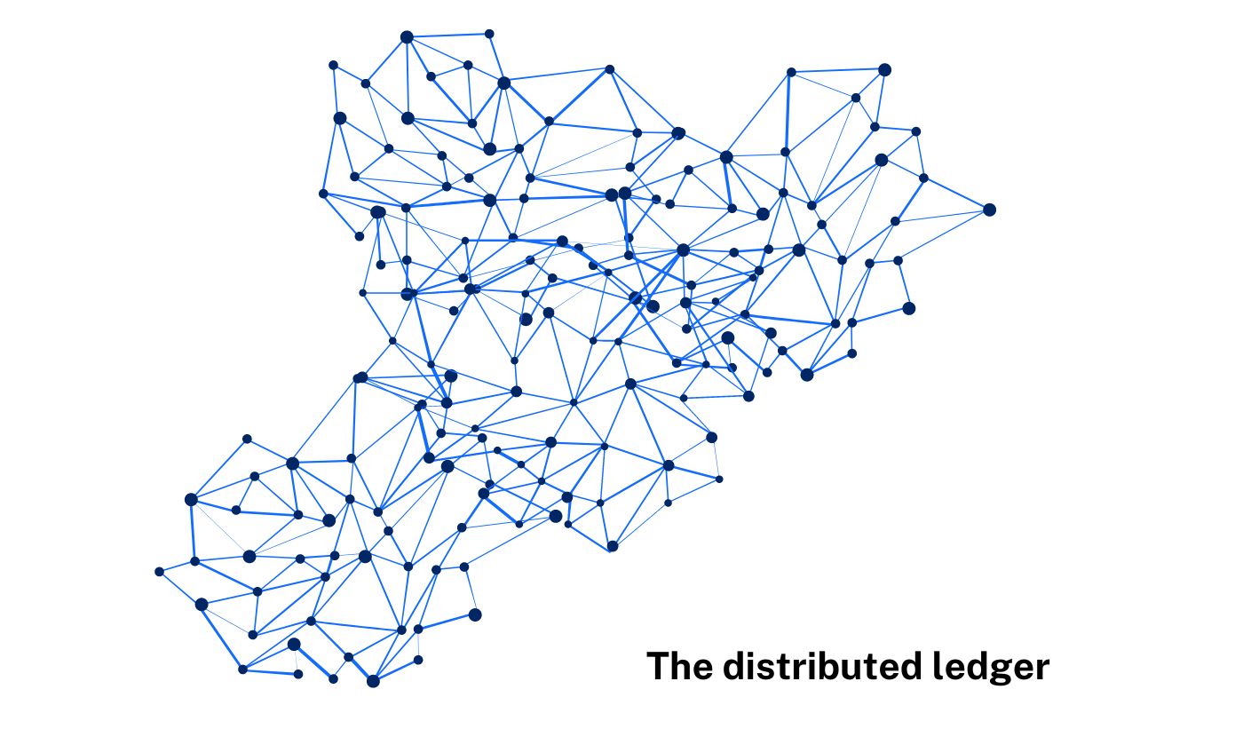
As a class watch the video on blockchain (7:02) to understand how blockchain technology works.

Data management
The blockchain is a secure, decentralised database that can store and manage data. Each block in the chain contains a set of transactions, which are verified and added to the chain through consensus among network participants. This makes it nearly impossible to alter or tamper with data stored in the blockchain, providing a secure and tamper-proof record of transactions. Each block of data in the chain contains the hash of the previous block, meaning the previous block cannot be modified without invalidating the subsequent blocks.
Figure 3 – blocks in blockchain
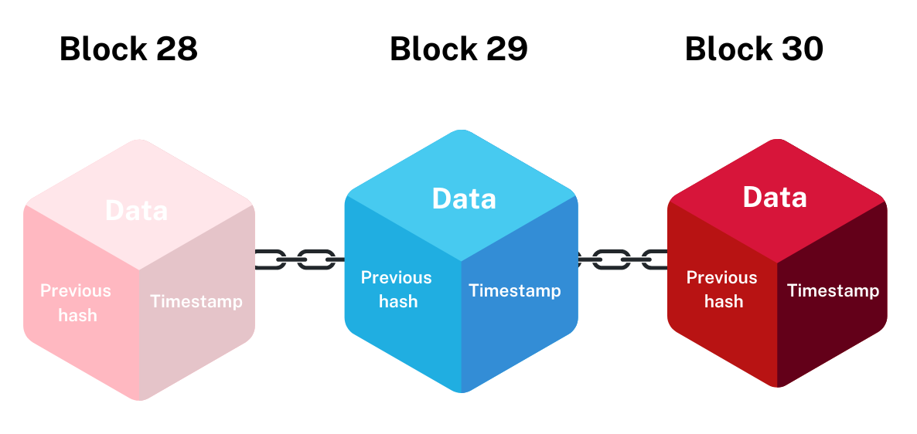
Data verification
Blockchain technology uses cryptographic algorithms to ensure that data is accurate and secure. Transactions are verified and confirmed by multiple participants in the network, which makes it difficult to falsify or alter data. This creates a verifiable and transparent record of transactions that can be used to track and verify data.
Data sharing
Blockchain technology enables the secure sharing of data between participants in the network. This can include the sharing of data between organisations, as well as between individuals. The decentralised nature of the blockchain ensures that data is accessible to all network participants, while also providing security and privacy.
Smart contracts
Blockchain technology also supports the creation of smart contracts, which are self-executing agreements that automatically enforce the terms of a contract. This can be used to automate the verification and management of data, making it possible to build decentralised applications that manage and verify data securely.
Blockchain technology provides a secure, decentralised and transparent way to manage and verify data. This makes it a promising technology for a variety of use cases, including supply chain management, financial services and identity management.

Online voting
Online voting in blockchain technology refers to the use of blockchain technology to conduct electronic voting securely and transparently. The blockchain is used to create a secure and transparent record of voting transactions, making it possible to conduct voting in a transparent, secure and tamper-proof manner.
Security
Blockchain technology provides a secure and tamper-proof record of voting transactions. Each vote is recorded as a transaction in the blockchain, which is verified and confirmed by multiple participants in the network, making it difficult to alter or falsify voting results.
Transparency
Blockchain technology provides a transparent record of voting transactions, making it possible to easily track and verify voting results. The use of cryptographic algorithms and consensus mechanisms in the blockchain ensure the accuracy and integrity of voting data.
Anonymity
Blockchain technology can also support anonymous voting, making it possible for individuals to cast their votes in a confidential and secure manner. This is accomplished using cryptographic techniques that protect the privacy of voters.
Decentralisation
Online voting in blockchain technology is decentralised, meaning that voting data is stored across multiple nodes in the network, rather than in a centralised database. This reduces the risk of data breaches, making it more secure and reliable.
Online voting in blockchain technology provides a secure, transparent and tamper-proof way to conduct electronic voting. This has the potential to revolutionise the way we conduct elections and could provide a more secure, transparent and accessible way to participate in democratic processes.

Online identities
Online identities in blockchain technology refer to digital identities that are stored and managed on a blockchain network. These identities are created and stored as digital assets in the blockchain and can be used to authenticate individuals, organisations and devices in various online transactions and interactions.
Online identities in blockchain technology provide a secure, portable and verifiable way to store and manage digital identities. They offer a range of benefits over traditional online identities, including greater security, privacy and control, and have the potential to revolutionise the way we interact and transact online.
Decentralisation
Unlike traditional online identities, which are managed by centralised organisations, online identities in blockchain technology are decentralised. This means that they are not controlled by a single entity but are instead stored and managed on a blockchain network.
Security
Online identities in blockchain technology are secured using cryptographic techniques, such as encryption and digital signatures. This makes it difficult for unauthorised individuals to access or alter a person's online identity information.
Portability
Online identities in blockchain technology are portable, meaning that individuals can use their digital identity across different platforms and services. This makes it possible to store, share and manage personal information and credentials in a secure and convenient manner.
Control
Online identities in blockchain technology give individuals more control over their personal information. They can choose who has access to their information, as well as what information is shared. This provides a level of privacy and security that is not possible with traditional online identities.
Verifiability
Online identities in blockchain technology are verifiable, meaning that their authenticity can be easily and quickly verified. This makes it possible to confirm the identity of individuals and organisations in various online transactions and interactions.

Tracking items of value
In blockchain technology, items of value, such as digital assets, can be tracked using unique identifiers called ‘tokens’. Tokens are created and stored on a blockchain network and represent a specific asset or unit of value. They are used to verify ownership, track transfers and transactions, and ensure the authenticity of the assets they represent.
Blockchain technology provides a secure and transparent way to track items of value. Tokens, public ledgers, smart contracts and the transparency of the blockchain make it possible to track assets, transactions and transfers in a decentralised and secure manner.
Unique identifiers
Tokens have unique identifiers, such as serial numbers or hash values, that distinguish them from other tokens and assets on the blockchain. This makes it possible to track specific assets and transactions on the blockchain.
Public ledgers
Blockchains are public ledgers, meaning that transactions and transfers are recorded and stored in a decentralised and transparent manner. This makes it possible to track the history and status of assets on the blockchain.
Smart contracts
Blockchain technology also allows for the creation of smart contracts, which are self-executing contracts with the terms of the agreement between buyer and seller being directly written into lines of code. This enables the automated tracking of assets and transactions, without the need for intermediaries.
Transparency
Blockchains are transparent, meaning that anyone with access to the network can view the history and status of assets and transactions. This makes it possible to track items of value in a secure and transparent manner.

Recordkeeping
Recordkeeping in blockchain technology refers to the process of maintaining and storing information or transactions in a secure, decentralised and tamper-proof manner.
In a blockchain network, transactions are verified and recorded as blocks, which are linked together to form a chain of blocks, hence the name blockchain. Each block contains a unique record of all transactions that have taken place on the network, and these blocks are stored in multiple nodes, providing a secure and decentralised ledger of all transactions.
The use of cryptography and consensus algorithms ensures that the records stored in a blockchain are secure, transparent and tamper-proof, making it possible to maintain an accurate and trustworthy record of all transactions and information stored on the network.
Recordkeeping in blockchain technology can be used for a wide range of purposes, including financial transactions, supply chain management, and record keeping in various industries, including healthcare, voting and real estate. By providing a secure and transparent way to maintain records, blockchain technology is transforming the way records are kept and stored, providing greater efficiency, security and reliability.

Activity 19: research exploring blockchain technology in voting systems.
Explore the Vote Australia website on blockchain voting.
This research task aims to investigate the application of blockchain technology in voting systems, including its potential benefits, security measures, challenges, and impact on accessibility and participation in elections.
Your task is to conduct comprehensive research on the use of blockchain technology in voting systems, with a focus on its implications for security, transparency and accessibility. Additionally, you will explore the potential benefits and challenges associated with implementing blockchain in voting, as well as real-world examples or pilot projects that have leveraged this technology.
Task guidelines:
Step 1: define blockchain technology and its fundamental characteristics.
Step 2: explain how blockchain applies to the concept of voting and its potential impact on traditional voting systems.
Step 3: research and summarise the potential benefits of implementing blockchain in voting systems. Identify and describe key advantages such as enhanced security, transparency and integrity in the voting process.
Step 4: investigate the challenges or concerns mentioned on the webpage regarding the adoption of blockchain for voting.
Step 5: describe how blockchain technology ensures security and transparency in the context of voting.
Step 6: explore how blockchain technology addresses issues such as voter fraud and tampering with election results. Discuss the security mechanisms and cryptographic protocols employed in blockchain-based voting to mitigate fraud and ensure the integrity of election outcomes.
Step 7: compare traditional voting systems with blockchain-based voting systems based on the information provided. Highlight the distinguishing features, advantages and potential drawbacks of each approach in facilitating fair and reliable elections.
Step 8: based on the information provided, outline the necessary steps or considerations for governments or organisations interested in adopting blockchain for voting purposes. Discuss key factors such as regulatory frameworks, technological infrastructure and education in the successful implementation of blockchain-based voting systems.

Examine software features that affect the privacy and security of data

Autofill
To protect privacy and security, it is important to be cautious when using autofill, to disable autofill on public devices and shared browsers, and to regularly review and delete saved information. Additionally, using a password manager that provides encryption and two-factor authentication can help to protect sensitive information stored in autofill.
Autofill can affect the privacy and security of data in several ways:
Data leakage: autofill saves sensitive information, such as passwords and credit card numbers, which can be easily accessible to unauthorised parties if the device is lost or stolen.
Phishing attacks: autofill can be exploited by phishing attacks to access sensitive information, such as usernames and passwords, by tricking users into entering them on a fake website.
Unwanted sharing: autofill can also result in unwanted sharing of sensitive information, such as personal or financial information, if the autofill feature is enabled on public devices or shared browsers.
Privacy concerns: autofill saves a record of all the information entered, which can raise privacy concerns, especially if the data is collected and stored by third-party providers.

Public or private connections
Public connections are public Wi-Fi networks, such as those found in airports, coffee shops and hotels. These are generally unsecured, meaning that data transmitted over these networks can be intercepted and viewed by unauthorised parties.
Private connections, such as home networks or workplace networks, are typically more secure, but still carry some risks. For example, private networks can be hacked or infected with malware, allowing attackers to access and steal sensitive data.
Public or private connections can affect the privacy and security of data in several ways:
Encryption: used to protect data transmitted over both public and private connections. It is important to use encryption, such as Virtual Private Network (VPN) software, to encrypt data before it is transmitted, making it more difficult for unauthorised parties to access and steal sensitive data.
Firewalls: security systems that protect networks from unauthorised access. Using a firewall in combination with encryption can help to protect data transmitted over both public and private connections.
Awareness: it is essential to know the risks associated with both public and private connections, and taking the necessary steps to protect sensitive data can help to minimise the impact of data breaches and other security incidents.

Checkbox
Checkboxes in software and online forms can affect the privacy and security of data in several ways:
Data collection: checkboxes can be used to collect personal information and consent from users. For example, a checkbox asking for consent to collect personal data or to receive marketing emails. If users do not understand the implications of checking a box, they may inadvertently agree to share their personal data, which can put their privacy and security at risk.
Data sharing: checkboxes can also be used to control how data is shared with third parties. For example, a checkbox asking whether to share data with affiliates or other partners. Users may unknowingly agree to share their data with third parties, increasing the risk of data breaches and other privacy violations.
Data management: checkboxes can also be used to manage the security and privacy of data, for example, by controlling the level of access that different users have to sensitive data.
Awareness: it is important to be aware of the implications of checking or unchecking checkboxes in software and online forms, and to fully understand the consequences of sharing personal data or granting access to sensitive information. By taking the time to understand the implications of checkboxes and to make informed decisions, users can help to protect their privacy and security of data.

Terms of Agreement (TOA)
The terms of agreement helps the user to make informed decisions about data privacy and security. Users can help to protect their data and reduce the risks associated with data breaches and other privacy violations.
Terms of agreement can significantly affect the privacy and security of data in several ways:
Data collection: Terms of agreement often include details about what data is collected and how it is used. This information can help users understand what personal data is being collected and what risks they are taking by agreeing to the terms.
Data sharing: Terms of agreement can also include details about how data is shared with third parties, including partners, affiliates and advertisers. If users are not aware of these arrangements, they may be inadvertently agreeing to share their data with third parties, which can increase the risk of data breaches and other privacy violations.
Data management: Terms of agreement can also set out rules and regulations around data management, including data retention and deletion policies. By understanding these policies, users can help to protect their data privacy and security.
Awareness: it is important to be aware of the terms of agreement before accepting them. This includes reading and fully understanding the terms and taking the time to consider the implications of sharing personal data or granting access to sensitive information.
Negotiating: in some cases, users may have the ability to negotiate terms of agreement, including data privacy and security terms. This could involve seeking alternative agreements, such as data privacy policies or service-level agreements, that better protect their privacy and security of data.
Activity 20: reflect on privacy and security of data.

In the space below, explain from your experience what software features you use to increase your privacy and security of data.
Answer:

Explore the use of big data and data warehousing, considering volume, variety, and velocity
As a class watch Big data is better data (15:42).
Big data refers to large and complex datasets that can't be processed and analysed by traditional data processing systems.
Data warehousing is a process of centralising and storing large amounts of data in a single repository for easy access and analysis.
Volume refers to the sheer size of the data, which can be in petabytes or even exabytes.
Variety refers to the different types of data such as structured, semi-structured, and unstructured data.
Velocity refers to the speed at which the data is generated and the need to process it in real time.
Big data and data warehousing are used to store, process and analyse massive amounts of data to gain insights, improve decision-making and optimise business processes. They enable enterprises to handle and make sense of the growing volume, variety and velocity of data.

Software tools used in industry
Big data and data warehousing typically use a combination of software tools to examine volume, variety and velocity. Some of the most common software tools include:
- Hadoop is an open-source big data platform used for distributed processing of large datasets.
- Spark is an in-memory data processing framework that can handle big data processing tasks.
- NoSQL databases are used to store and manage unstructured data such as Cassandra, MongoDB and CouchDB.
- Data lakes are centralised repositories that store structured and unstructured data in its raw form.
- Data visualisation tools are used to present big data in an easily understandable format, such as Tableau and PowerBI.
- ETL (Extract, Transform, Load) tools are used to extract, clean and transform data from various sources into the data warehouse, such as Talend and Informatica.
- Data warehousing platforms are used to store and manage large amounts of structured data, such as Amazon Redshift and Google BigQuery.

Explore the risks and benefits of data mining
Data mining involves extracting and analysing large amounts of data to uncover patterns, trends, relationships and insights that are not immediately apparent.
As a class watch the video about data mining (6:52) by IBM Cloud.
Benefits of data mining | Risks of data mining
Improved decision making  Data mining helps organisations make better decisions by providing insights into consumer behaviour, market trends and other important business metrics. | Privacy violations  Data mining can access sensitive information about individuals and organisations, potentially violating their privacy rights.
Increased efficiency  Data mining can automate manual processes, freeing up time and resources for more important tasks. | Bias in results  The algorithms used in data mining can perpetuate existing biases in the data, leading to unfair outcomes.
Fraud detection  Data mining can identify patterns and anomalies in large amounts of data, making it easier to detect and prevent fraud | Data security  Storing and analysing large amounts of data can pose a risk to data security, potentially exposing sensitive information to unauthorised individuals.
Customer insights  Data mining can help organisations understand their customers better, allowing them to tailor their products and services to meet their needs. | Misinterpretation of results  The insights generated from data mining are only as accurate as the data that is used to create them. If the data is flawed, the results of the analysis will be unreliable.
Predictive modelling  Data mining can be used to build predictive models that can forecast future trends, reducing the risk of business disruptions, and helping organisations make more informed decisions | Legal implications  Data mining may result in the discovery of information that is protected by laws, regulations or contracts, leading to legal and ethical concerns.

Analyse the impact of data scale
The impact of data scale refers to the ways in which the size and complexity of a dataset can affect the analysis, interpretation and utilisation of data.
Advantages of large data scale | Disadvantages of large data scale
Improved accuracy  With more data points, the results of a study can be more accurate and representative of the population. | Computational challenges  Handling and processing large datasets can be computationally intensive and time-consuming.
Greater detail  Larger datasets can reveal patterns and relationships that might be missed in smaller datasets. | Data quality issues  Data quality is critical for accurate analysis, but in large datasets it is more challenging to maintain data quality and accuracy.
Increased efficiency  Advanced algorithms and hardware can quickly process and analyse large datasets. | Privacy concerns  Large datasets often contain sensitive information that must be protected, raising privacy and security concerns.

Volume of raw data
The volume of raw data can greatly impact data scale as it refers to the amount of data that is generated, collected and stored.
Advantages of large volume raw data | Disadvantages of large volume raw data
- More comprehensive insights: with more data points, the results of a study can be more comprehensive and representative of the population.  - Increased granularity: with larger datasets, it is possible to delve deeper into the data and uncover new insights and relationships.  - Better predictions: with more data, machine learning algorithms can make more accurate predictions. | - Storage and processing costs: storing and processing large amounts of data can be expensive and time-consuming.  - Data quality issues: ensuring the quality of large datasets can be difficult and time-consuming.  - Privacy concerns: large datasets can contain sensitive information, which must be protected and secured.
The volume of raw data has a significant impact on data scale and requires careful consideration when analysing and utilising the data.

Storage
The volume of data being stored can impact data scale as it directly affects the amount of storage required and the speed at which data can be retrieved and processed.
If the storage capacity is limited, it can cause data overflow or slow performance.
If the storage is ample, it can facilitate larger datasets and faster processing speeds, improving the overall data scale.
The type of storage used, such as physical hard drives or cloud storage, can also impact the efficiency and scalability of data storage.

Real-time and continuous streaming
Real-time and continuous data streaming can have a significant impact on data scale as it requires the processing and storage of a large volume of data in real time, which can be a significant challenge.
For example, in real-time streaming, data is generated and processed in real time, and it must be processed, analysed and stored quickly to keep up with the stream. This requires high-performance computing resources, high-bandwidth networks, and scalable storage systems to manage the volume and velocity of the data.
If the data scale is not managed effectively, it can lead to data overflow, slow performance, or even data loss.
Efficient management of data scale can allow for more accurate and timely analysis, and improved decision-making based on real-time data.

Opportunities for machine learning (ML)
The opportunities for machine learning (ML) can have a significant impact on data scale, as ML algorithms require large amounts of data to be trained and tested effectively. With more data, ML models can be improved, becoming more accurate and efficient in predicting outcomes.
The volume and variety of data can also pose challenges in terms of processing and storage, requiring significant computing power and resources. This can increase the cost and complexity of data management and analysis, requiring organisations to carefully consider their data management strategies to effectively balance the benefits and risks of data scale.

Changes in human behaviour
Changes in human behaviour can greatly impact data scale, as they can drive fluctuations in the volume, variety and velocity of data being generated and collected. For example, the increasing use of mobile devices and the Internet of Things (IoT) has led to a massive increase in the amount of data being generated and collected, requiring organisations to adapt their data management strategies to effectively handle and make sense of this information.
Shifts in social media usage, online shopping behaviour and other digital interactions can significantly impact the variety and velocity of data being generated, creating new opportunities and challenges for organisations looking to effectively analyse and use this information.
Overall, changes in human behaviour play a critical role in shaping the scale of data and the challenges and opportunities it presents.

Ethical implications, including digital footprints
As the volume and scope of data increases, ethical implications surrounding data privacy, surveillance, informed consent and the use of personal information become more significant.
The creation and accumulation of large-scale datasets, often referred to as ‘digital footprints’, has led to growing concerns over the collection, storage and use of sensitive personal information.
With increasing data scale, it is important to have measures in place to ensure that the privacy and rights of individuals are protected, and to ensure that data is used for legitimate purposes and not for harmful or unethical activities.
Machine Learning and other advanced technologies rely heavily on vast amounts of data. The potential for discrimination, bias and other unethical consequences must be closely monitored and addressed.
Activity 21: smart agriculture and data management scenario
As a class read Artificial intelligence (AI), machine learning and deep learning: what can they do for agriculture? Discuss as a class how technology has impacted agriculture.
Students work in small groups to discuss the questions posed by the scenario. Answers are shared together as a class. Students can make notes of answers to questions.
Scenario
In the near future, a farm called GreenHarvest has adopted an advanced Agritech system to optimise crop production. The farm uses a variety of sensors and drones to collect data on soil moisture, weather conditions, crop health and other factors. This data is collected in real time and is used to drive machine learning algorithms that help make decisions on irrigation, fertilisation and pest control.
Impact of data scale and volume of raw data
- How does the volume of raw data collected from sensors and drones affect the farm’s ability to make informed decisions?
- Discuss the potential challenges and benefits of handling large volumes of data.
Storage solutions
- What are the possible storage solutions for managing the large volumes of data collected on the farm?
- Compare cloud storage with local storage.
Real-time and continuous streaming
- How does real-time and continuous streaming of data influence decision-making processes on the farm?
- What are the potential advantages and limitations of having access to continuous data streams?
Opportunities for Machine Learning (ML)
- In what ways can ML algorithms be applied to the data collected from GreenHarvest?
- Discuss examples of how ML can improve crop yields, reduce resource usage and enhance overall farm efficiency.
Changes in human behaviour
- How might the implementation of advanced Agritech systems change the behaviour of farm workers and management?
- Consider both positive and negative changes.
Ethical implications and digital footprints
- What ethical concerns arise from the collection and use of data in Agritech?
- Discuss issues related to digital footprints, data privacy and the potential for misuse of data.
- How should these concerns be addressed to ensure ethical practices?

Evaluate the effectiveness of different methods for data storage
Choosing the right storage method depends on the organisation's specific requirements, including data volume, access needs, budget and security considerations.
The effectiveness of each data storage method varies based on specific needs and use cases:
- local storage: best for on-premises data needs with limited remote access and tight control over security
- cloud storage: ideal for flexible, scalable and accessible storage solutions with remote access requirements
- portable storage media: suitable for temporary storage and physical data transfer
- data warehouses: essential for large-scale data integration and analytics, providing robust solutions for business intelligence.

Local storage
Advantages | Disadvantages
- Speed: fast access and retrieval times since data is stored locally.  - Control: full control over data security and management.  - Cost: one-time cost for hardware, no recurring subscription fees. | - Scalability: limited by hardware capacity; expanding storage can be expensive.  - Accessibility: limited to physical location; difficult to access remotely.  - Security: vulnerable to physical damage (fire, theft, hardware failure) and requires robust security measures.
Local storage effectiveness:
- suitable for small to medium-sized businesses with limited remote access needs
- best for sensitive data that requires tight control.

Cloud storage
Advantages | Disadvantages
- Scalability: easily scalable; can increase or decrease storage capacity as needed.  - Accessibility: accessible from anywhere with an internet connection.  - Cost: pay-as-you-go model; no need for significant upfront investment. | - Security: depends on the service provider’s security measures; potential vulnerability to cyber-attacks.  - Speed: dependent on internet speed; can be slower than local storage.  - Cost: recurring costs can accumulate over time.
Cloud storage effectiveness:
- ideal for businesses with distributed teams and a need for remote access
- suitable for applications requiring high availability and disaster recovery.

Portable storage media
Examples: USB drives, external hard drives, CDs/DVDs
Advantages | Disadvantages
- Portability: easy to transport and share data physically.  - Cost: low initial cost for purchase.  - Control: complete control over data. | - Durability: prone to physical damage, loss, or theft.  - Capacity: limited storage capacity compared to other methods.  - Security: data can be easily accessed if not encrypted.
Portable storage media effectiveness:
- best for temporary storage and transferring data between systems
- suitable for small backups and offline data sharing.

Data warehouses
Advantages | Disadvantages
- Integration: consolidates data from multiple sources for comprehensive analysis.  - Performance: optimised for querying and analytics; high-speed data retrieval.  - Scalability: can handle large volumes of data and complex queries. | - Cost: expensive to set up and maintain.  - Complexity: requires specialised knowledge to manage and operate.  - Latency: not suitable for real-time data processing.
Data warehouses effectiveness:
- essential for large organisations with significant data analytics needs
- suitable for historical data analysis, business intelligence and reporting.
Activity 22: data storage scenario
Create a concept map showing the various data storage solutions.
As a class read the following scenario about EduTech Solutions with the view to making a recommendation for what data storage solution would best meet their needs.
Scenario
A company called EduTech Solutions is an education technology provider that develops and manages an online learning platform for schools and universities. The company has experienced rapid growth and now serves thousands of educational institutions globally. They are facing several challenges with their current data storage solution and need to decide on the best method for storing and managing their increasing volume of data.
Current challenges
EduTech Solutions is having scalability issues as the current local storage solution is reaching its capacity limits. Adding more local storage is costly and time-consuming, leading to frequent disruptions.
EduTech Solutions has remote access needs as the development and support teams are distributed across different countries. Accessing data remotely is slow and often unreliable, causing delays in updates and support.
EduTech Solutions has data security and compliance concerns. Educational data is sensitive and requires stringent security measures. The company must comply with various international data protection regulations.
EduTech Solutions needs disaster recovery and the company lacks a robust disaster recovery plan. Any data loss or system failure could severely impact service availability and customer trust.
Requirements:
- Scalable storage that can grow with the company’s needs.
- Reliable and fast remote access for global teams.
- High security and compliance with international regulations.
- Effective disaster recovery solutions.
Describe the data storage method would you recommend to EduTech Solutions and outline the benefits?
Sample answer:
Given the challenges and requirements of EduTech Solutions, cloud computing stands out as the most effective data storage method. It addresses the scalability issues, provides reliable remote access, ensures high-level security and compliance, and offers strong disaster recovery options. By migrating to a cloud storage solution, EduTech Solutions can support its growing user base, streamline operations and enhance the security and reliability of its services.
Cloud storage benefits
- Scalability
- Cloud storage solutions, such as AWS, Google Cloud or Azure, offer virtually unlimited storage capacity.
- The company can easily scale storage up or down based on demand, avoiding the high costs and delays of upgrading local hardware.
- Accessibility
- Cloud storage allows team members to access data from anywhere with an internet connection.
- This ensures seamless collaboration and faster response times for support and development.
- Security and compliance
- Leading cloud providers offer advanced security features, including encryption, multi-factor authentication and regular security audits.
- Cloud storage services comply with international standards and regulations, helping EduTech Solutions meet its legal obligations.
- Disaster recovery
- Cloud storage providers offer robust disaster recovery solutions with automated backups and geographic redundancy.
- This ensures that data is protected against localised failures and can be quickly restored in case of an incident.

Data quality

Investigate the ethical use of data for social or enterprise research purposes
The ethical use of data for social or enterprise research purposes involves several key considerations, including:
- Privacy: the collection, storage and use of personal data must respect individuals' privacy and comply with data protection laws.
- Consent: participants should be informed about the purpose of the research, the data that will be collected, how it will be used and give their informed consent to participate.
- Data security: collected data must be stored securely and protected against unauthorised access, loss or theft.
- Transparency: researchers should be transparent about their methods, results and any potential biases in their research.
- Responsibility: researchers must take responsibility for the consequences of their research and ensure that the data is used in a responsible and ethical manner.
- Data accuracy: researchers must take steps to ensure that the data collected is accurate and reliable and take steps to minimise any potential harm to participants.
- Confidentiality: researchers must maintain the confidentiality of participants and their data, unless otherwise agreed or required by law.
By following these principles, social and enterprise researchers can help ensure that the use of data for research purposes is ethical, responsible and in line with the rights and expectations of individuals.
Activity 23: SmartCity Data Analytics Project scenario
As a class discuss the scenario, including the background and ethical issues of privacy and consent. Pose questions and examine possible answers.
Background
A city government, in collaboration with a tech company UrbanInsights, is undertaking a ‘SmartCity Data Analytics Project’ to improve urban planning, traffic management and public services. The project involves collecting and analysing large amounts of data from various sources, including public transportation systems, CCTV cameras, social media and citizens' smartphones. The aim is to make the city more efficient, sustainable and liveable. However, the project raises several ethical issues related to data usage.
UrbanInsights collects data from multiple sources, such as:
- public transportation usage (for example bus, train and light rail card swipes)
- traffic patterns from CCTV cameras and road sensors
- social media posts tagged with the city’s name
- GPS data from citizens' smartphones to analyse movement patterns.
Ethical issue – privacy and consent
- Many citizens are unaware that their data is being collected and used for the project.
- There are no clear guidelines on obtaining informed consent from the citizens.
- Concerns arise about the extent of data collection and the potential for misuse.
Small group discussion questions:
- What are the ethical implications of collecting data without explicit consent?
- How can the project ensure transparency and obtain informed consent from citizens?
- What measures can be taken to protect citizens' privacy and ensure data security?

Explore social, ethical and legal issues associated with using data

Bias
Bias in data can lead to unfair outcomes and discrimination. It arises from the way data is collected, processed and interpreted. Addressing bias involves ensuring diverse and representative datasets and being aware of potential prejudices in data algorithms and analysis.

Accuracy of the collected data
Accuracy is crucial for reliable data analysis and decision-making. Inaccurate data can lead to incorrect conclusions and decisions. Ensuring data accuracy involves regular validation, cleaning and cross-referencing with reliable sources.

Metadata
Metadata provides information about other data, such as how, when and by whom it was collected. Proper metadata management ensures transparency, improves data quality and facilitates better data governance and usage.

Copyright and acknowledgement of source data
Respecting copyright and properly acknowledging sources is vital to avoid legal issues and give credit to original data providers. This involves citing data sources accurately and adhering to licensing agreements.

Intellectual property and respect for ownership, including Indigenous Cultural and Intellectual Property (ICIP)
Intellectual property laws protect the rights of data creators. For Indigenous communities, ICIP recognises their right to control their cultural heritage, including data related to their traditions and knowledge. Respecting ICIP involves obtaining consent and acknowledging ownership.

Permissions, rights and privacy of individuals, including cultural responsibility
Data collection must comply with privacy laws, such as the Privacy Act 1988, which includes obtaining informed consent from individuals. Cultural responsibility involves respecting the values and privacy of all communities, particularly Indigenous groups.

Security
Data security is essential to protect sensitive information from unauthorised access, breaches and cyberattacks. Implementing robust security measures and regular audits ensures data integrity and confidentiality.
Key points for understanding:
- Bias: ensure diverse, representative datasets to avoid discrimination.
- Accuracy: validate and clean data regularly for reliable outcomes.
- Metadata: use metadata to enhance transparency and data quality.
- Copyright: properly cite sources and adhere to licensing agreements.
- Intellectual Property: respect ICIP and obtain necessary consents.
- Permissions and privacy: comply with privacy laws and respect cultural values.
- Security: implement strong security measures to protect data.
Activity 24: HealthTrack Solutions scenario
A company called HealthTrack Solutions, is developing a new health and fitness tracking app aimed at helping users monitor their physical activity, diet and overall wellbeing. The app uses data analytics to provide personalised recommendations and insights based on user data. As part of the development process, the company faces several social, ethical and legal issues related to data usage.
Social issue – bias in data
Scenario
- HealthTrack Solutions aims to develop an algorithm that provides personalised fitness recommendations based on user data such as age, gender, weight and activity level.
- The company uses a dataset from a previous health study that predominantly includes data from young, urban male participants.
- As a result, the algorithm tends to recommend fitness routines that are more suited to young men, potentially neglecting the needs and preferences of older adults, women and those living in rural areas.
Small group discussion questions:

- How can bias in the dataset impact the recommendations provided by the app?
- What steps can the company take to ensure their algorithm is fair and inclusive for all users?
- What are the potential consequences of biased recommendations for users?
Ethical issue: copyright infringement
Scenario:
- To provide rich content, HealthTrack Solutions plans to integrate fitness videos, diet plans and articles from various online sources.
- The development team starts using copyright material without obtaining proper licences or giving credit to the original creators, believing that it will be easier to ask for forgiveness than permission.
Small group discussion questions:

- What are the ethical implications of using copyright material without permission?
- How can the company ensure that it respects intellectual property rights while providing valuable content to users?
- What are the potential legal and reputational risks of copyright infringement for HealthTrack Solutions?
Legal issue – metadata and privacy
Scenario:
- The app collects various types of metadata, including user location, time stamps of activities and device information.
- While this metadata helps improve the app's functionality and user experience, the company does not clearly inform users about the extent of data collection and how it will be used.
- A privacy advocate raises concerns about the potential misuse of metadata, including the risk of tracking users' movements and profiling them without their explicit consent.
Small group discussion questions:

- What are the privacy concerns associated with collecting and using metadata?
- How should HealthTrack Solutions address user consent and transparency regarding data collection?
- What legal regulations must the company comply with to protect user privacy, and how can they ensure adherence?

Exploring the issues
Bias in data:
- Impact: biased data can lead to unfair or inaccurate recommendations, potentially harming users' health and fitness progress.
- Mitigation: diversify the dataset, regularly audit the algorithm for fairness, and involve diverse user groups in testing.
- Consequences: users who receive inappropriate recommendations may lose trust in the app and experience negative health outcomes.
Copyright infringement:
- Implications: using copyright material without permission is unethical and illegal.
- Respecting IP: obtain licences, give credit to original creators, and create original content when possible.
- Risks: legal actions, financial penalties, and damage to the company's reputation.
Metadata and privacy:
- Concerns: metadata can reveal sensitive information, leading to potential misuse or breaches of privacy.
- Transparency: clearly inform users about data collection practices and obtain explicit consent.
- Compliance: adhere to regulations, implement strong data protection measures and regularly review privacy policies.

Investigate the legal issues surrounding data collection and handling

Legislation
In Australia, data collection and handling are primarily governed by the Privacy Act 1988. This Act regulates how personal information is collected, used, stored and disclosed. It includes principles such as:
Australian Privacy Principles (APPs)
There are 13 Australian Privacy Principles and they govern standards, rights and obligations around:
- the collection, use and disclosure of personal information
- an organisation or agency’s governance and accountability
- integrity and correction of personal information
- the rights of individuals to access their personal information.
Notifiable Data Breaches (NDB) scheme
This scheme requires entities to notify individuals and the Office of the Australian Information Commissioner (OAIC) about data breaches likely to result in serious harm.
Activity 25: Australian Privacy Principles
Read about the 13 Australian Privacy Principles and complete the purpose in the following table.
Principle | Title | Purpose
APP 1 | Open and transparent management of personal information
APP 2 | Anonymity and pseudonymity
APP 3 | Collection of solicited personal information
APP 4 | Dealing with unsolicited personal information
APP 5 | Notification of the collection of personal information
APP 6 | Use or disclosure of personal information
APP 7 | Direct marketing
APP 8 | Cross-border disclosure of personal information
APP 9 | Adoption, use or disclosure of government related identifiers
APP 10 | Quality of personal information
APP 11 | Security of personal information
APP 12 | Access to personal information
APP 13 | Correction of personal information

Authorities responsible for data protection
The Office of the Australian Information Commissioner (OAIC) is the key authority responsible for overseeing data protection laws. The OAIC enforces the Privacy Act, investigates complaints, and provides guidelines and resources to ensure compliance with data protection laws.

Data sovereignty of Aboriginal and Torres Strait Islander Peoples
Data sovereignty for Aboriginal and Torres Strait Islander Peoples emphasises the right to control the collection, ownership and application of their data. Key considerations include:
- Informed Consent
Ensuring data collection is conducted with the community's informed consent.
- Cultural Respect
Handling data in ways that respect cultural protocols and values.
- Control and Ownership
Empowering Indigenous communities to manage and decide how their data is used and accessed.
Activity 26: summary
In the space below summarise the legal issues surrounding data collection and handling.
Sample answer:
Legislation: understand the Privacy Act 1988, APPs, and NDB scheme.
Authorities: recognise OAIC's role in enforcing data protection.
Data sovereignty: understand the importance of data sovereignty for Aboriginal and Torres Strait Islander Peoples, focusing on informed consent, cultural respect and community control.

Investigate the influence of curated and communicated data on social behaviour

Data literacy
Develop skills to interpret and analyse data.
Data literacy involves the ability to read, understand, create and communicate data as information. It’s essential for analysing how curated and communicated data can shape social behaviours. Understanding data sources, statistical methods and data visualisation techniques is crucial for interpreting data accurately.
An important step in data literacy is developing skills to read charts, graphs and datasets and understanding statistical concepts to draw accurate conclusions.

Timeframes
Study data across different periods for comprehensive insights.
The influence of data on social behaviour can vary significantly over different timeframes. Short-term data might reflect immediate reactions, while long-term data can indicate more stable trends. Recognising these differences helps in understanding the transient versus lasting impacts of data on behaviour.
Timeframes refer to the periods over which data is collected and analysed. Recognising how data trends change over short and long timeframes helps in making more informed predictions about social behaviour.

Signals impacting on behaviour
Identify key indicators that influence behaviour.
Signals are pieces of information or data points that can influence social behaviour. For instance, trending topics on social media, news reports and public opinion polls serve as signals. Understanding these signals requires analysing their sources, credibility and the context in which they appear.

Data swamps
Learn data management to avoid disorganised data.
A data swamp is a disorganised data repository, where the stored data is difficult to retrieve or analyse. This can lead to misleading conclusions if not properly managed. Avoiding data swamps involves implementing good data governance practices, ensuring data quality and maintaining clear documentation.
Avoiding data swamps involves learning appropriate data management practices and ensuring data is clean, relevant and well-documented.

Educating users
Promote ethical and effective data communication.
Educating users about data involves teaching them to critically evaluate data sources, understand the context of data and communicate findings effectively. This includes raising awareness about the ethical use of data, privacy concerns, and the potential impacts of data on social behaviour. Effective education ensures that users can leverage data responsibly to make informed decisions. This includes ethical considerations, such as privacy and data protection, ensuring data is used responsibly to influence social behaviour positively.
Activity 27: reflect on the influence of curated and communicated data on social behaviour.
Think, Pair, Share about your experience working with a dataset in previous activities or for Assessment task 1.
Use the following questions as stimulus for thinking.
- How can analysing data over both short-term and long-term periods provide a more comprehensive understanding of social behaviour trends?
- What types of signals (for example social media trends, news reports) most significantly influence social behaviour, and why?
- What are the key practices for maintaining clean, well-documented data to avoid creating a data swamp, and why are they important?
- Why is it important to teach ethical considerations, such as privacy and data protection, when educating users about data literacy and communication?

Processing and presenting data
Spreadsheets and databases provide us with powerful tools to collate, organise, process and present data.

Summarise data using a spreadsheet
Activity 28: summarise data using the CSIRO spreadsheet.
Spreadsheets use rows and columns to organise data and can be searched, sorted, calculated and summarised to present meaningful information. To investigate the power of spreadsheets, you will be utilising a dataset from the CSIRO website.
- Click on the link above to access the resources.
- Download the Novice DataZIP file.
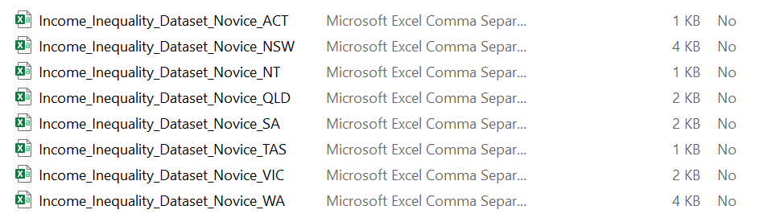You should have access to a dataset for each state.
- Open the NSW file, as shown in the image above.
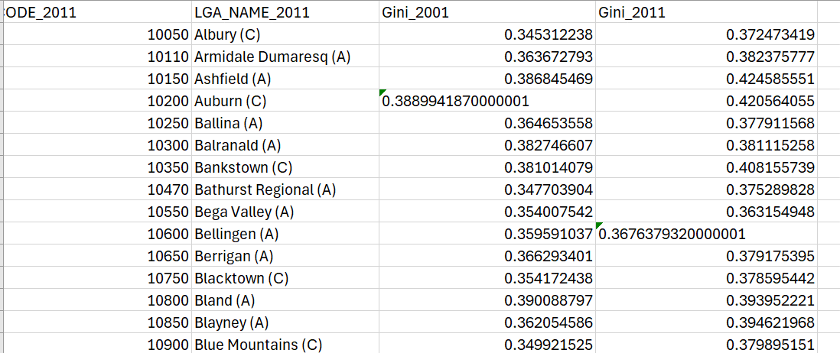
The CSIRO has provided the following information to understand the dataset.
This dataset is a measure of income inequality around Australia. In data science terms it’s a relatively small dataset, with only one value for each local government area (LGA), and a code for the area the number relates to. Despite the small size, it is a very rich set of information with a lot of potential to fit into different subject areas.
The dataset was calculated from Census data by CSIRO scientists. It contains the Gini coefficient (GC) for every LGA in Australia, calculated for 2001 and 2011. The GC is a measure of income inequality which measures how incomes are balanced across a community. A perfectly equal society where everyone has the same income would have a GC of 0, and a completely unequal society where one person earns all the income and everyone else earns nothing would have a GC of 1. So, a GC of 0.8 shows that most of the income is going to a very small proportion of society - meaning some people have very high incomes, and some have very low – whereas a GC of 0.2 shows that income is being equally shared among everyone and that everyone is earning roughly the same amount. In practice, GC values of 0 or 1 do not happen, because the real world is not that neat.
It’s not a perfect measure of equality since it doesn’t give you much detail, much in the same way as taking an average. Very different datasets may lead to the same GC, just as 100 can be the average of both the following sets: 50, 100, 150, 99, 100 and 110. It is also important to remember that this measures inequality, not poverty levels. So, if everyone in a given area has a very low income, the GC value will indicate that incomes are very equal. The dataset has state level information and LGA level – meaning you can compare, say, Victoria with Queensland, but you can also look at the distribution around Victoria, or across Melbourne, or any other slice of Australia that is interesting and relevant to students.
Source: Income Inequality in Australian Regions – Educational Datasets Teachers Guide –Year 7-10
We will start by summarising some of the data in the dataset.
- Click in cell G9. Enter the following headings. You will need to write the formulas in the relevant cells under Gini_2001 and so on.
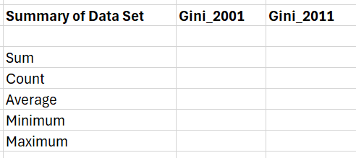
- To work out the sum of the 2001 Gini use the following:
=sum(C2:C154)

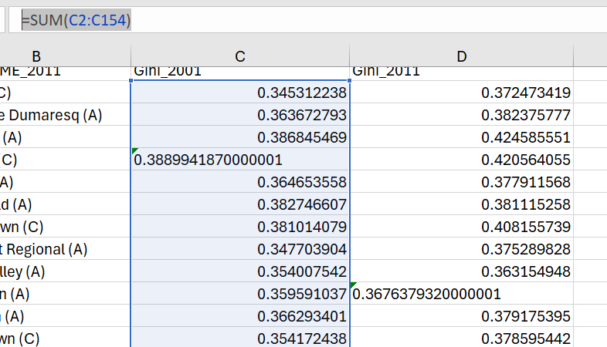
- To quickly find out the sum of the 2011 Gini you can click and drag the formula across into the 2011 column.
- Use the following formulas to obtain the rest of the data.
=COUNT(C2:C154)
=AVERAGE(C2:C154)
=MIN(C2:C154)
=MAX(C2:C154)
- Your summary should look something like the following:
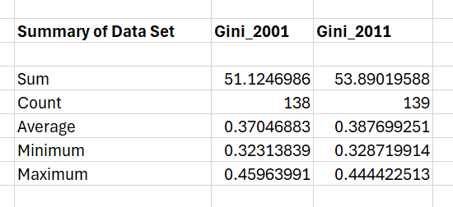
Note: If you are having trouble obtaining the correct result ensure you are using the correct cell references. Make sure the column letter and the row number match correctly with your dataset.

Collate information using spreadsheet analysis features, including charts, statistical analysis and what-if modelling
Activity 29: collate information using the CSIRO spreadsheet.
Continue to use the dataset on Income Inequality in Australian Regions from the CSIRO website.

Charts
- Choose one LGA, for example area where you live, and experiment with the different charts available. Are some more/less useful with this data than others? Hint: a quick way to do this is to highlight the relevant data and use the quick analysis tool. We have used the data for the Albury LGA in the examples below.
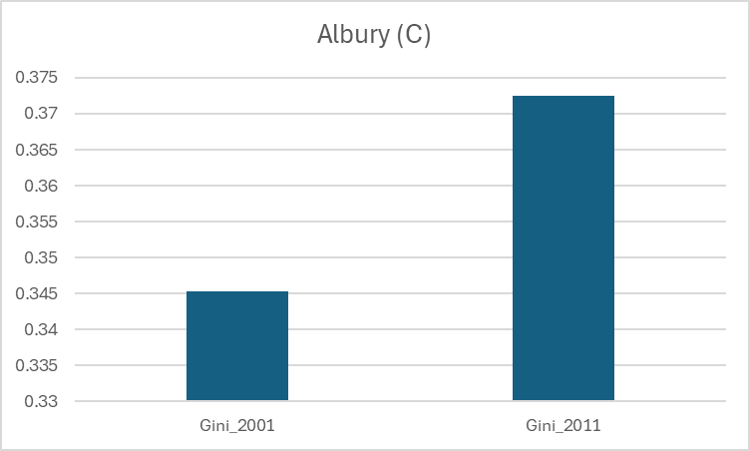
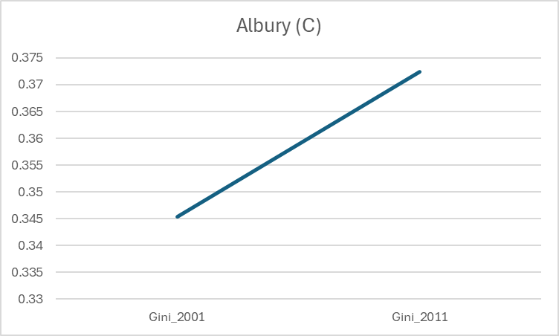
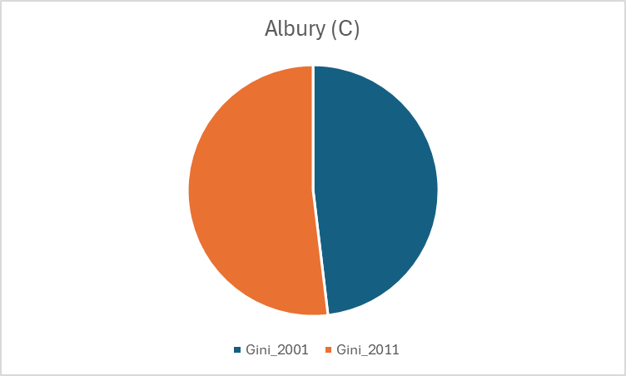
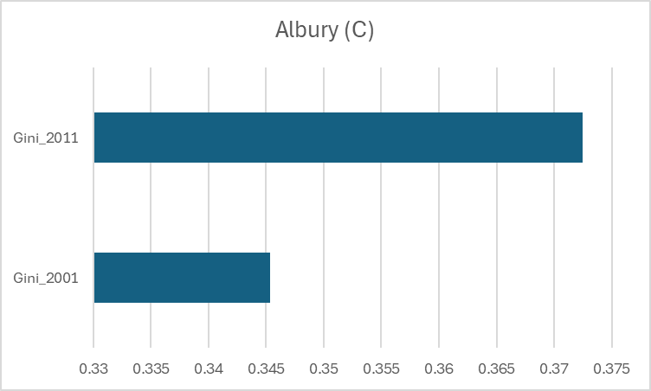

Statistical analysis
Excel has a data function built in to help you quickly analyse your data. You can see this icon below. You will find this tool in the ‘Home’ ribbon in Excel. Experiment with this tool to provide some analysis of your dataset.
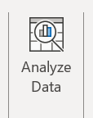
Examples of ways to analyse data
Insert a pivot table to sort, visualise, organise, filter, sort and drill down into data.
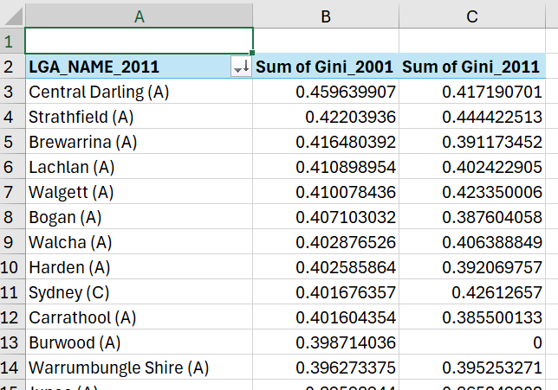
Use scatter charts to detect patterns and trends, compare multiple datasets.
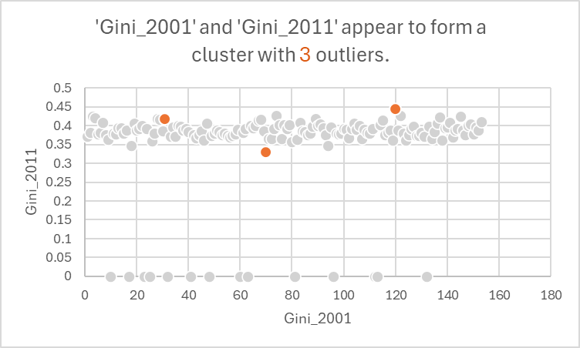
Use a histogram to understand distribution, identify skewed data, spot outliers and compare data.
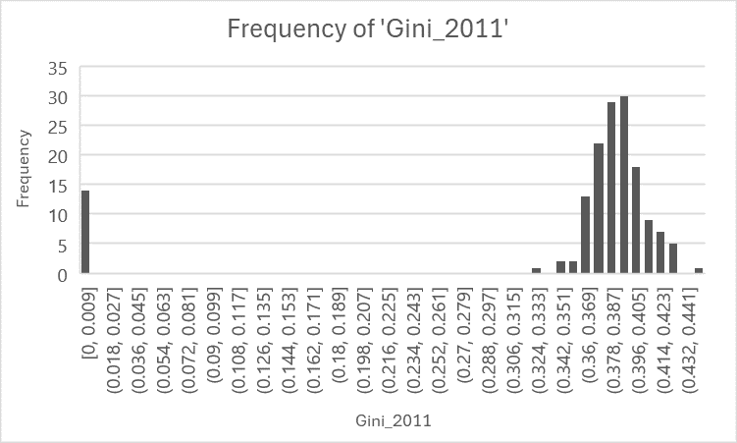
Use a line graph to display data points over a continuous period, showing trends and changes in data.
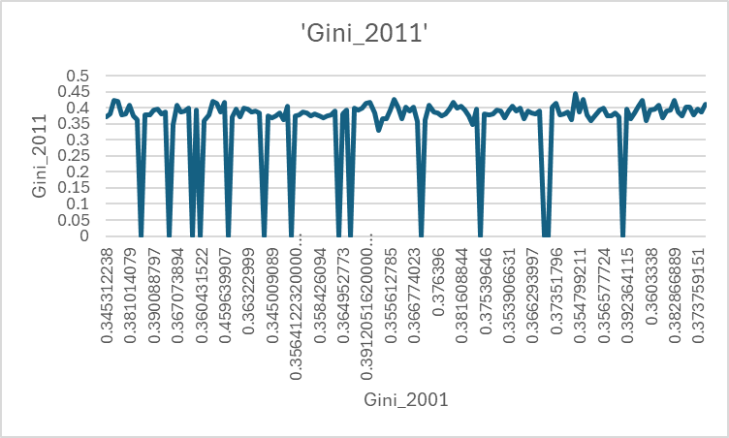

What-if modelling
What-if modelling is used to predict and analyse different outcomes in a spreadsheet by changing input values and observing how the changes affect the results. To create a simple what-if model, we are going to use the what-if analysis tool, which can be found in the ‘Data’ ribbon in Excel.

- Looking at the summary of the dataset you created earlier, click on the cell where you put your maximum formula.
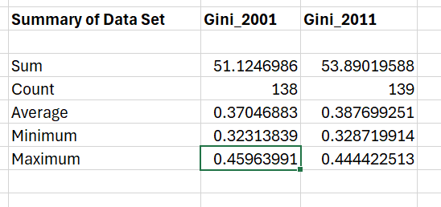
- Next, open the data ribbon then click on the What-If Analysis tool and select Goal Seek. We are going to ask what value is required in a particular cell to increase the value to a new maximum.
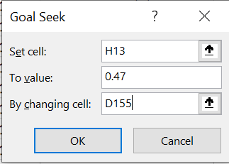
- Watch Excel: What-if Analysis (3:27) for a slightly more advanced example.
In the space below discuss what you have learnt to develop a more sophisticated what-if analysis for your spreadsheet?

Filter, group and sort data in a spreadsheet to process and display information
Activity 30: filter, group and sort data in a spreadsheet.

- Filter
We can use the filter tool to display certain information. To do this first select the data in the Gini_2011 column.
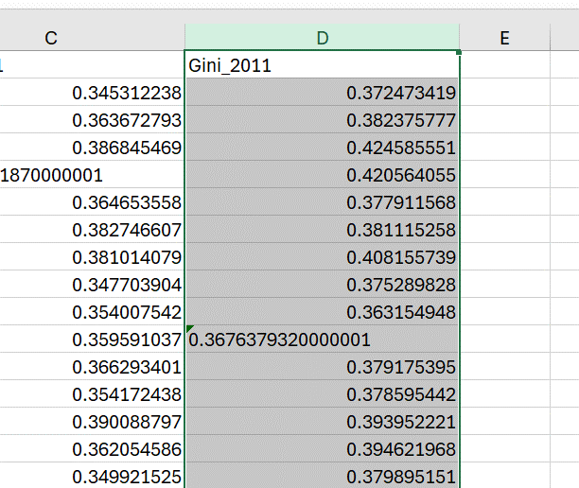
With this data selected on the data toolbar click filter.
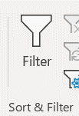
Click on the drop-down menu.
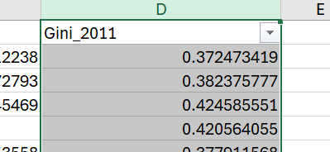
Experiment with the different filters available for example Top 10, which is under number filters.
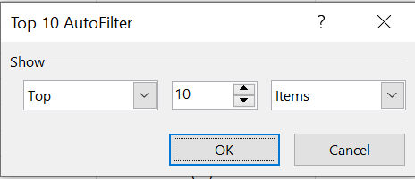
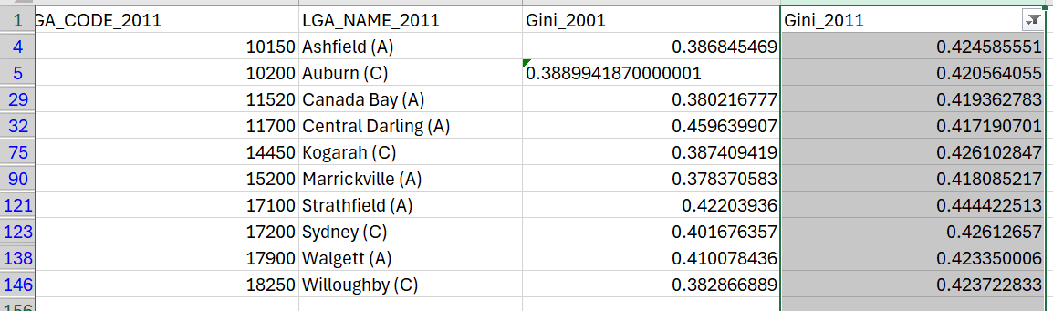
- Group and sort data
To group data, go to the Data tab and select group.
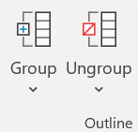
Experiment with the grouping of columns to see if you can make a group of the summarised table we created earlier.
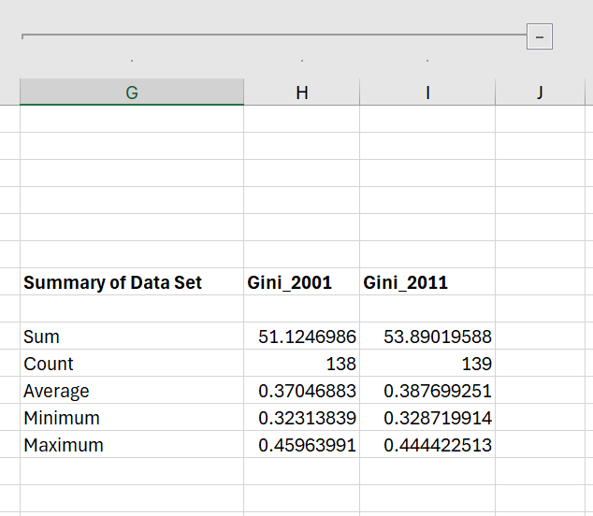
If you need more help watch How to Group Rows in Excel (3:46).
- Sorting
To sort data we can select Sort from the Data menu.
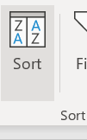
Select the entire workbook. Click on Sort and select column D. Sort values Smallest to Largest. You may need to ensure that your data is consistent and the same data type.
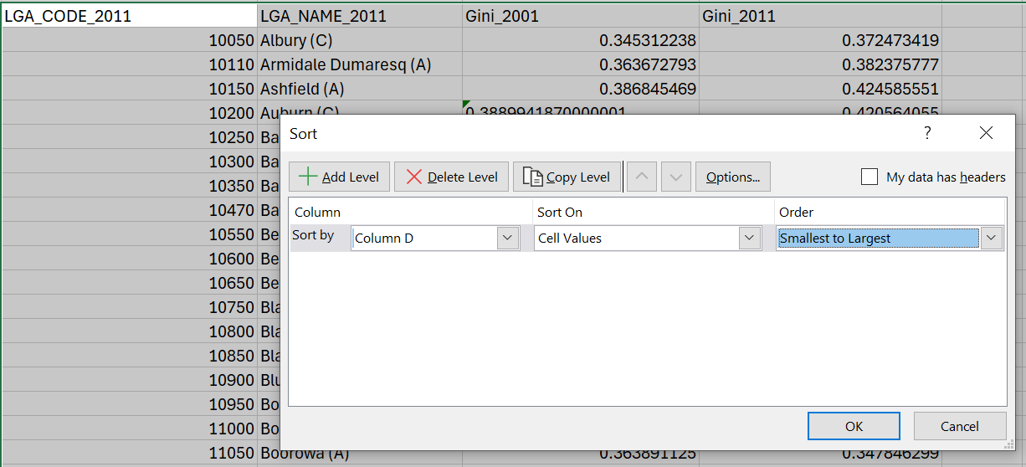
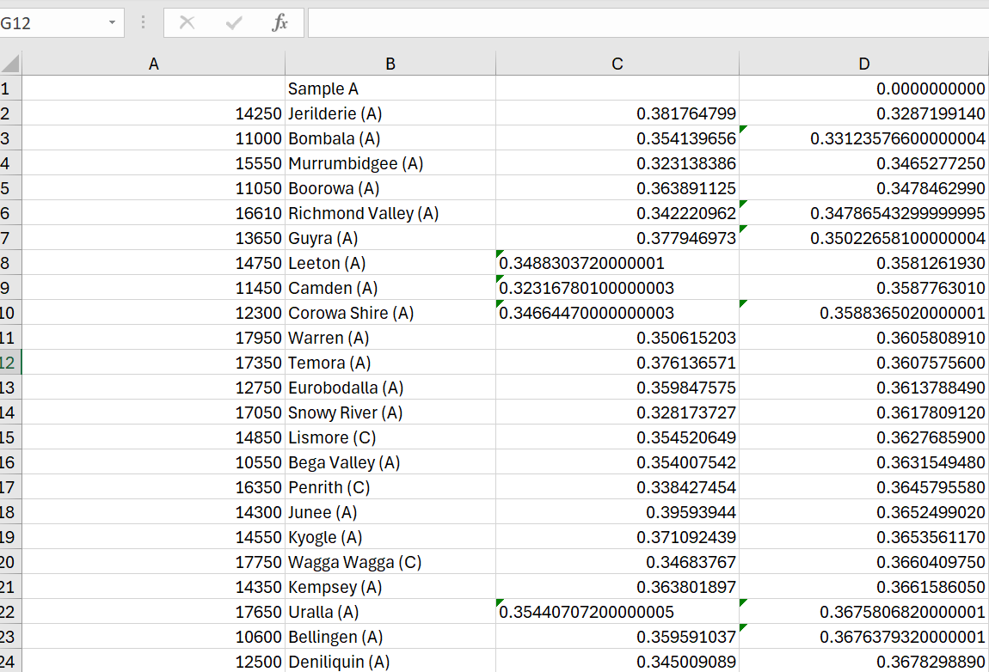

Linking multiple sheets to extract data and create summaries
For this exercise we are going to calculate the average Gini coefficient for each state and territory for 2011. What does this tell us about income inequality in each state? We did this earlier for NSW. Apply the same formula for the other states.

Applying conditional formatting
- Select the Gini_2011 column. Then select conditional formatting and experiment with the different options. The example below uses colour scales.
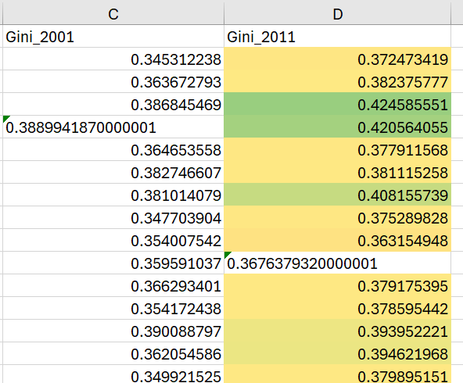

Making data comparisons
- To experiment with graphs, we will use the NSW public schools master dataset. Download the master dataset.
- To make data comparisons in Excel we are going to compare 2 columns in the NSW public schools master dataset. Open the master dataset and find the adjacent columns with the following headings:
- Electorate_from_2023
- Electorate _2015_2022
- We are going to investigate which electorates (if any) have changed their name from 2015 to 2023.
- To do this select (highlight) for the 2 columns mentioned above (Electorate_from_2023 and Electorate _2015_2022.
- Go to the Home tab and click on Find & Select. Choose Go To Special and select Row Differences. Click OK and observe the highlighted cells.
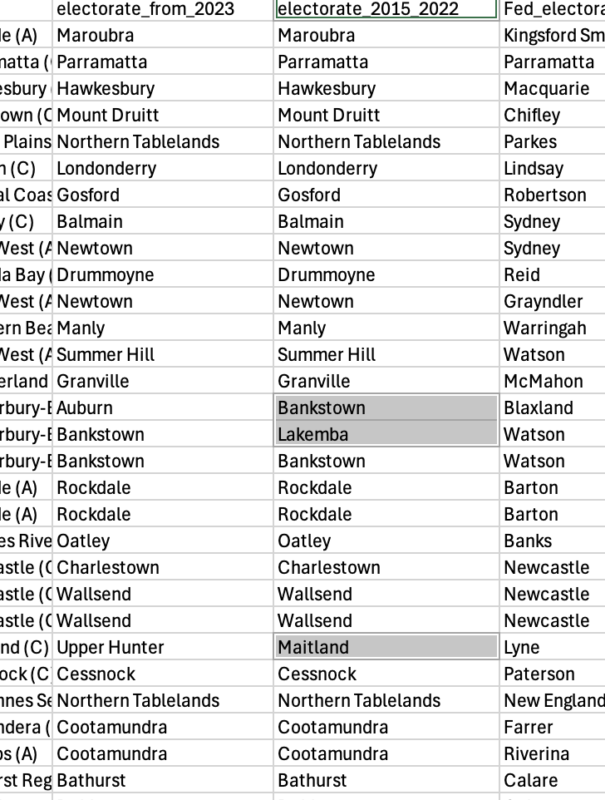
- You should notice for example the electorate of Bankstown in 2015–2022 is named Auburn under the electorate_from_2023 column heading.
- What other changes have you noticed/
- Experiment with the other options available to you, for example blanks and last cell. Are there other ways to make data comparisons?

Designing forms and reports
Microsoft Excel has the ability to create forms which can help with data entry.
Watch Creating Easy Data Entry Forms in Excel (9:51) which clearly outlines the steps to take in order to insert a form into your spreadsheet.
Note: Excel has a limit of 32 columns that it can work with for a form so you may need to delete some data. Your form may look something like what is displayed below.
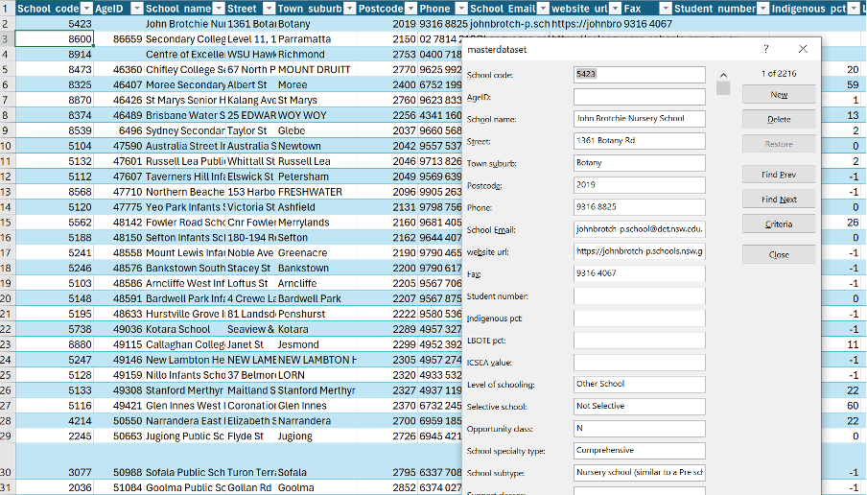

Apply spreadsheet analysis features to develop a data dashboard
The following steps outline how you could use spreadsheet analysis features to develop a data dashboard. We have used some of these ideas and features previously.
Activity 31: apply spreadsheet analysis features.

Step 1: use Excel functions and formulas
Utilise Excel functions and formulas to analyse your data. Common functions include SUM, AVERAGE, COUNT, IF, VLOOKUP and INDEX-MATCH.
Step 2: create PivotTables
PivotTables are powerful tools for summarising and analysing large datasets.
To create a PivotTable:
- Select your data range.
- Go to Insert > PivotTable.
- Choose where you want the PivotTable report to be placed.
- Drag and drop fields into the PivotTable Field List to organise your data.
Step 3: use Data Analysis Toolpak
- Enable the Data Analysis Toolpak if it’s not already enabled.
- Go to File > Options > Add-ins > Manage: Excel Add-ins > Go > Check Analysis Toolpak > OK.
- Use the tools provided for advanced data analysis like regression, correlation and histograms.
Step 4: create charts and graphs
Use Excel's charting tools to create visual representations of your data.
- Select your data range and choose the type of chart that best represents your data from the Insert tab (for example bar chart, line chart, pie chart and so on).
Step 5: utilise Sparklines
Sparklines are small charts that fit within a cell.
- Insert Sparklines by selecting the data range and going to Insert > Sparklines.
Activity 32: building the dashboard
Step 1: create a dashboard layout
Plan the layout of your dashboard on a new worksheet. Decide where to place each chart, table and visual element.
Leave space for titles, labels and other annotations.
Step 2: link data to visualisations
Ensure all charts and tables are dynamically linked to your data so that they update automatically as the data changes.
Use dynamic named ranges or tables for your data source to ensure the dashboard remains updated.
Step 3: add interactive elements
Use features like slicers and drop-down lists to add interactivity to your dashboard.
To add slicers:
- Select your PivotTable or table.
- Go to Insert > Slicer.
- Choose the fields for the slicers and place them on the dashboard.
Step 4: format for clarity and aesthetics
Apply consistent formatting to make the dashboard visually appealing and easy to read.
Use colours, fonts and styles to highlight important information.
Step 5: protect and share the dashboard
Protect the worksheet to prevent accidental changes.
- Go to Review > Protect Sheet.
Share the dashboard with stakeholders by saving it as an Excel file, PDF, or publishing it to the web.
Example
Here’s a simplified example to illustrate the steps:
Data collection:
- Import sales data into Excel.
Data organisation:
- Arrange the data with columns like Date, Product, Sales, Region.
Data analysis:
- Create a PivotTable to summarise sales by region and product.
Data visualisation:
- Insert a bar chart to display total sales by product.
- Insert a line chart to show sales trends over time.
Dashboard layout:
- Place the charts and PivotTables on a new sheet.
- Add slicers for regions and products.
Interactive elements:
- Use slicers to filter the data dynamically.
Formatting:
- Apply consistent colours and styles to charts and tables.

Activity 33: graphs
- To experiment with graphs, we will use the NSW public schools master dataset.
- Download the master dataset.
- Open your PivotTable created earlier.
- Experiment with the different charts and graphs available to you.
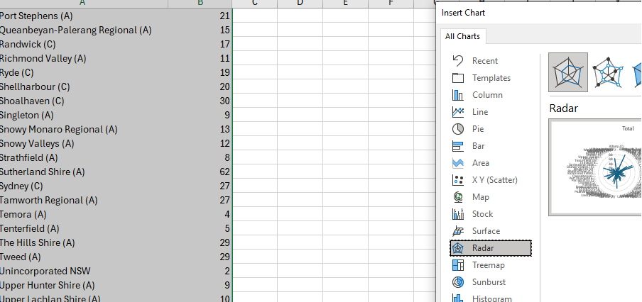

Pivot tables and slicers
Activity 34: pivot table
You may have used a pivot table previously when you looked at the NSW public schools master dataset. As a reminder do the following:
- Download the master dataset.
- The question being asked is: Which Federal electorate contains the most schools?
- To do this highlight the LGA column.
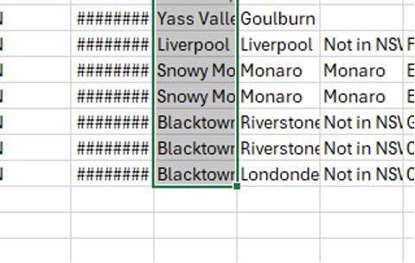
- Click on the quick analysis tool.
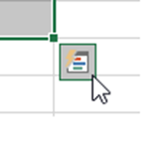
- Select table and pivot table.
- You will be provided with an overall count of the LGAs
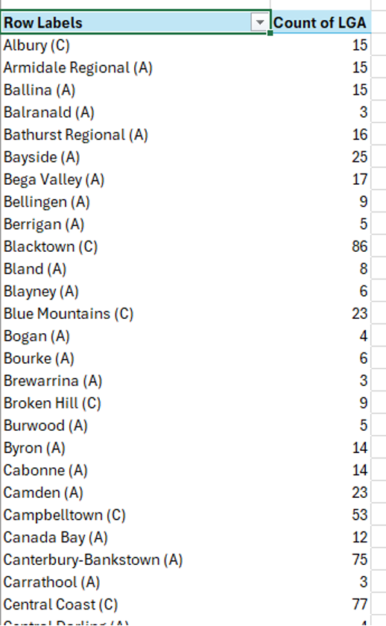

Activity 35: slicers
Slicers allow for further targeted analysis from a table.
- To use a slicer, click anywhere in the pivot table you created above.
- Select Insert, Slicer.
- Select the fields you want to display.
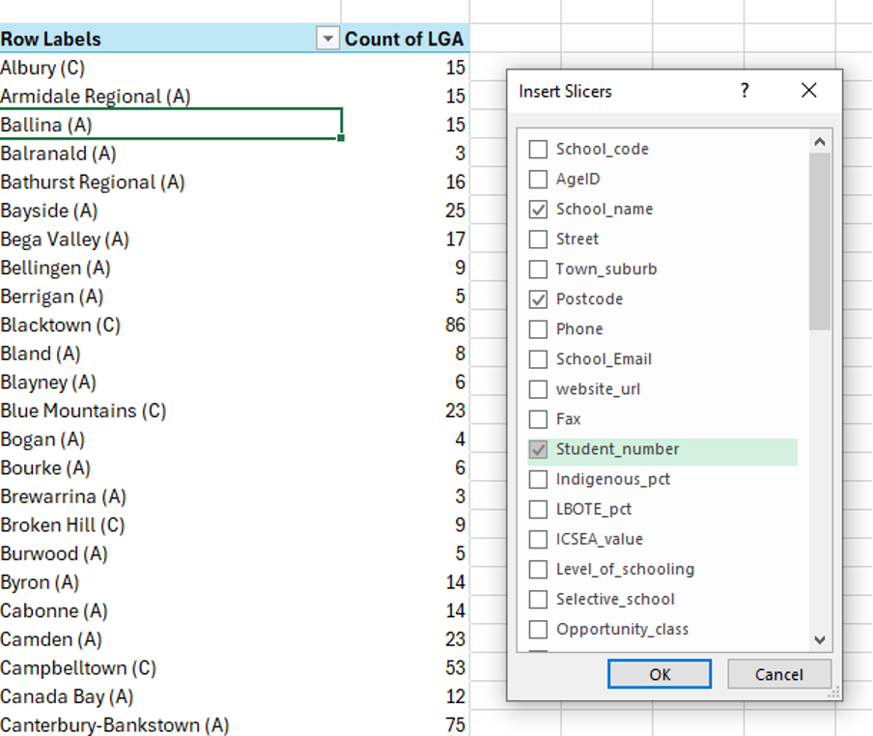
- Move the slicers to where you want them to be
- Select a slicer button and the filter will be automatically applied.
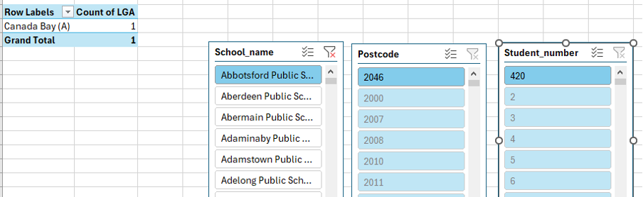
- Hold Ctrl to select more than one item.
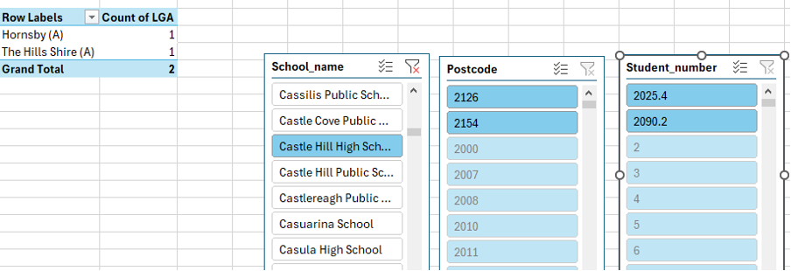

Develop a flat-file database
As part of your assessment you will create a flat-file database from the dataset you source.
To develop a flat-file database, follow these steps:
- Identify the purpose and requirements of the database. What kind of data will be stored and what information will be retrieved from the database?
- Determine the structure of the database. What are the fields and data types that will be included in the database?
- Create a table structure. Design a table layout that aligns with the database's purpose and requirements. Each column in the table represents a field and each row represents a record.
- Input data into the database. Input the data into the database in a consistent and organised manner, making sure that each record has the same fields.
- Verify data accuracy. Verify that all data is accurate and complete to ensure the reliability of the database.
- Save the database. Save the database in a suitable format, such as CSV or TXT, that allows for easy import into other programs or applications.
- Test the database. Test the database to ensure that it functions as intended and that the data can be retrieved and processed as required.

Apply computational thinking to design a relational database with appropriate user views
To develop the skills required to design a relational database we are going to use the schema provided in the Enterprise Computing 11–12 Course Specifications.
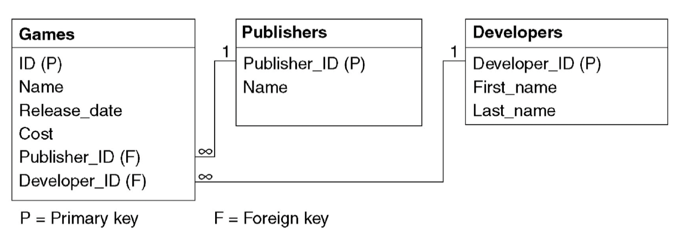

Develop a data dictionary
Activity 36: develop a data dictionary.
Develop a data dictionary based on the previous schema. The Games entity has been done for you. Continue the data dictionary for the Publishers and Developers.
Games Data Dictionary
Field name | Data type | Data format | Field size | Description | Example
ID | Text | XXXNNNN | 7 | Unique ID for the game | ABC9876
Name | Text | XXX...XXX | 25 | Name of the game | Return of the Blokus
Release_date | Date | DD/MM/YYYY | 10 | Date of game release | 19/05/2024
Cost | Currency | $#####.## | 9 | Cost of Game | $99.99
Publisher_ID | Text | XXXNNNN | 7 | Unique ID of the Publisher | DEF5432
Developer_ID | Text | XXXNNNN | 7 | Unique ID of the Developer | GHI1987
Publishers Data Dictionary
Field name | Data type | Data format | Field size | Description | Example
Developers Data Dictionary
Field name | Data type | Data format | Field size | Description | Example

Linking tables via key fields
Activity 37: develop a database.
To create the database, we are going to use Microsoft Access.
- Open Microsoft Access
- Click on Blank database
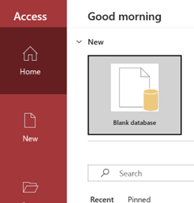
- Save the database as Games Database and click Create.
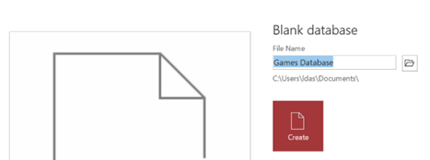
- In the top left corner click on View and select Design View.

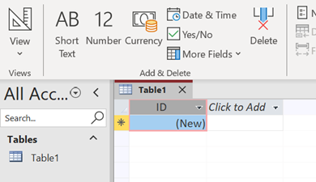
- Save the table as Games.
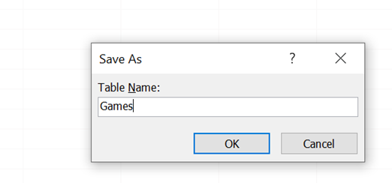
- Enter the information into the table as shown below.
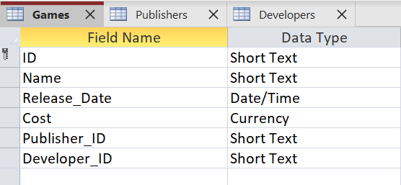
- Save your database file
- Create a new table. Change the view to Design View as we have done before.
- Repeat the previous steps to create, populate and save a Publishers table and a Developers table. Ensure you have set the correct primary keys as shown in the schema.
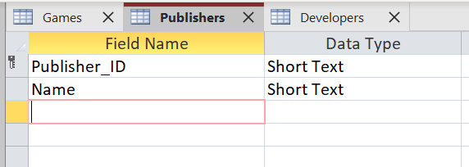
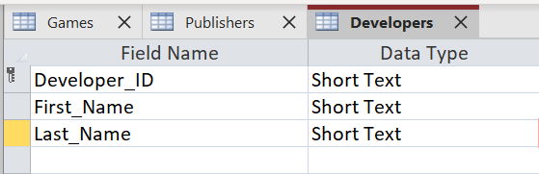
- Save and close all the tables.

Relationships
We now need to create relationships. Click on database tools and then relationships.
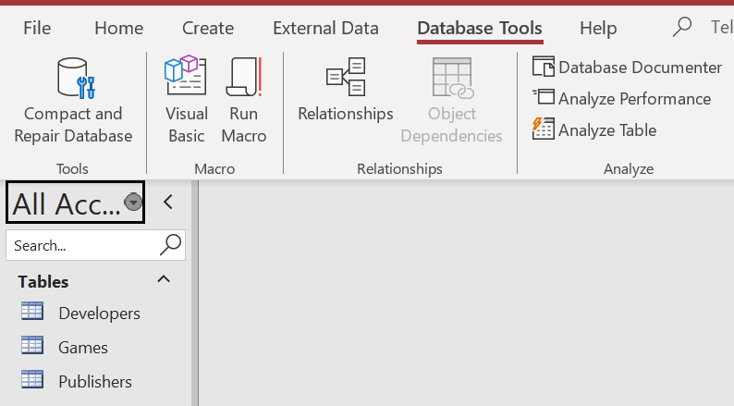

- Click on Add Tables.
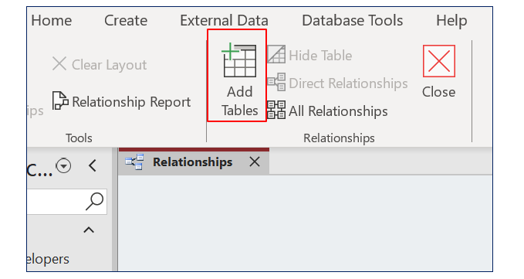
- Drag the tables onto the Relationships screen.
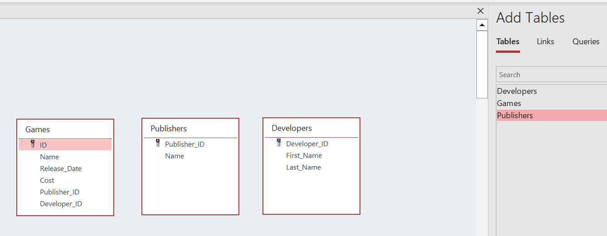

- Create relationships by clicking and dragging from the primary key.
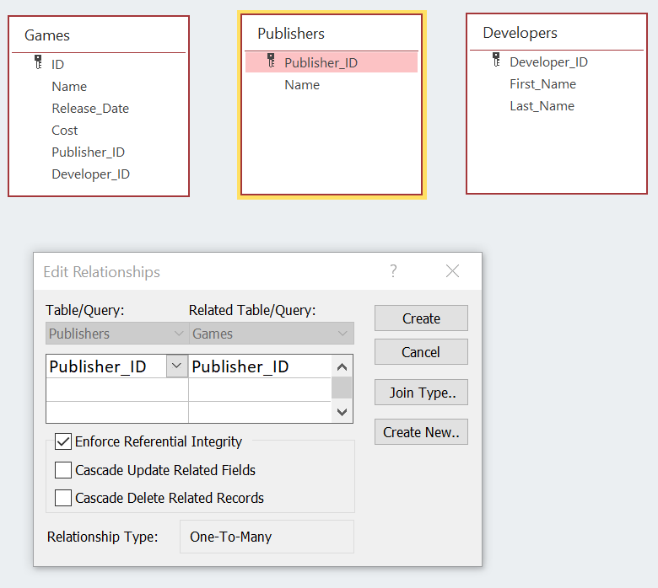

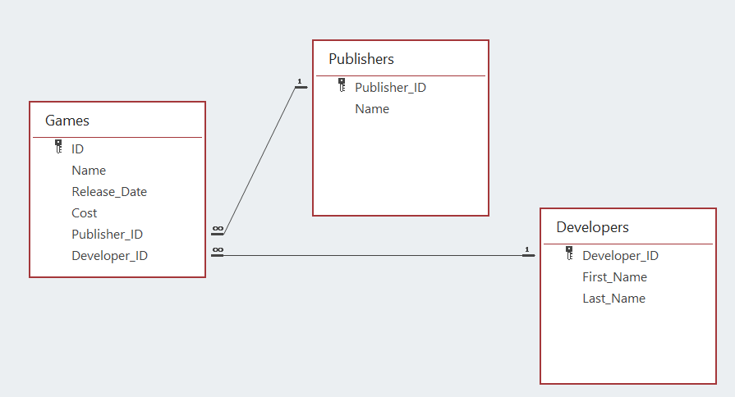
- Save your database.

Creating and using forms
Now we have the entities, attributes and relationships created we can design forms to enter and edit data.
- Click on the Developers table. Then select create Form.
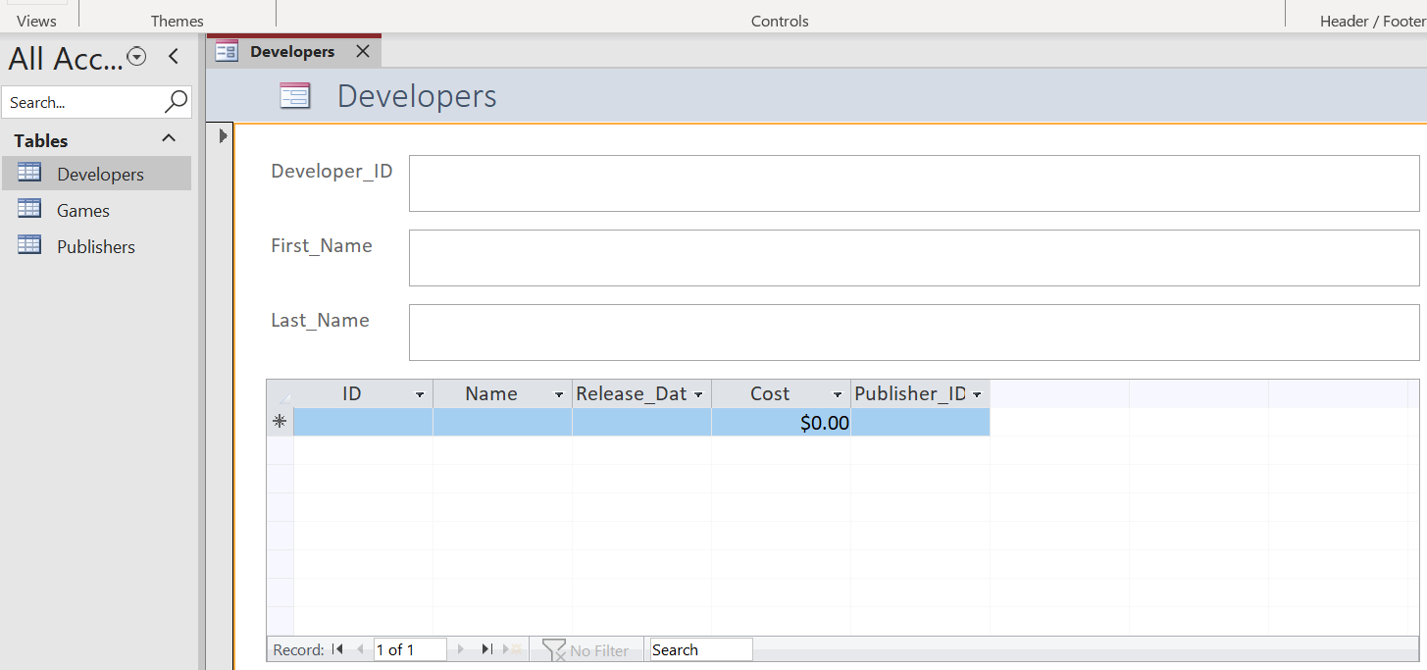
- Save the form and repeat the steps for Games and Publishers.
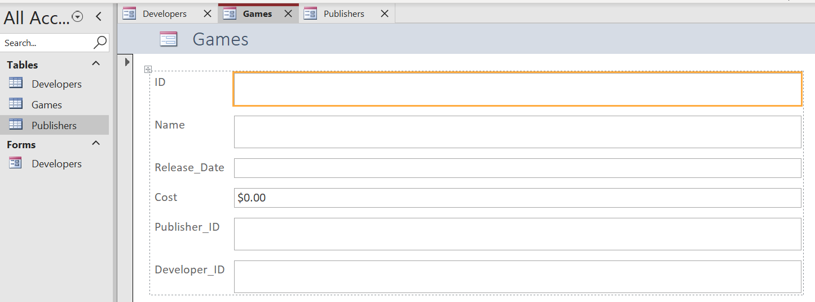
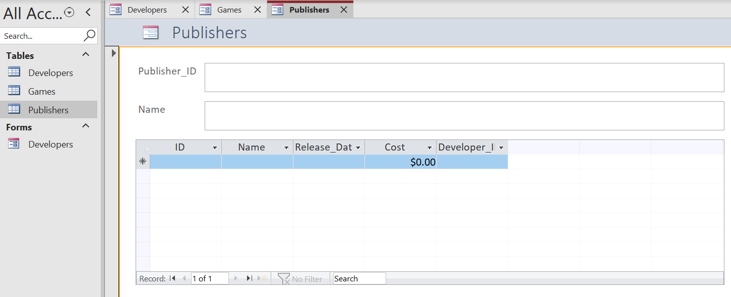
- Save your database.
- Do some research on real-life developers, games and publishers.
- Populate your forms with the information you found. At this stage, 3 records for each table will be enough. Be sure to start with publishers, then developers and finally games.
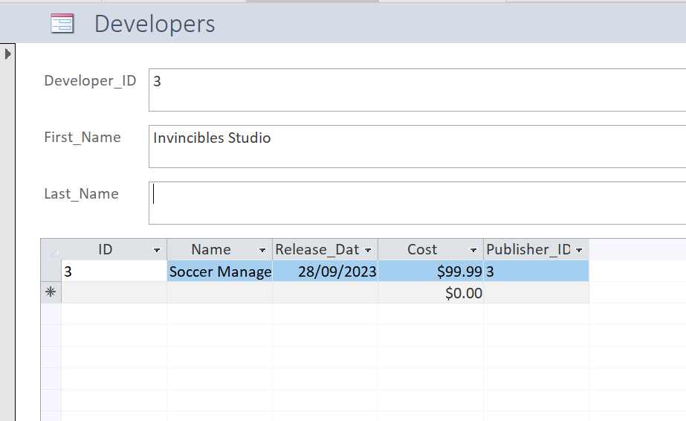
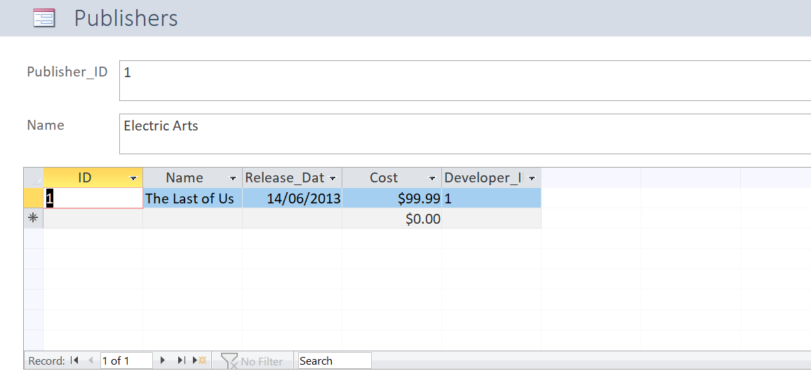
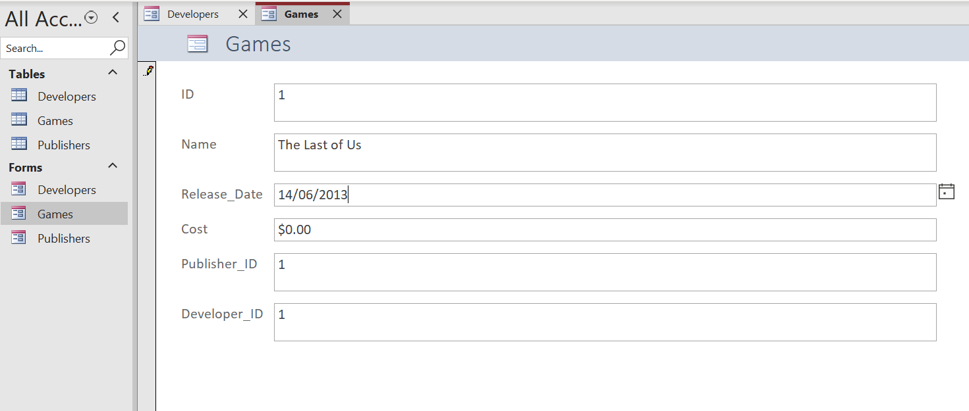
- Save your database.
- You will find that Access does not like the use of ‘Name’ as a field name so you will notice in screenshots that have been added in further instructions, we have changed “Name” to ‘Name_Game’ and ‘Name_Publisher’.
- Edit your Games and Publishers Entity and change ‘Name’ to ‘Name_Game’. Likewise change ‘Name’ in the Publishers entity to ‘Name_Publisher’.

Sort and search data, including using structured query language (SQL)
The following information regarding SQL is from the Enterprise Computing 11–12 Course Specifications.
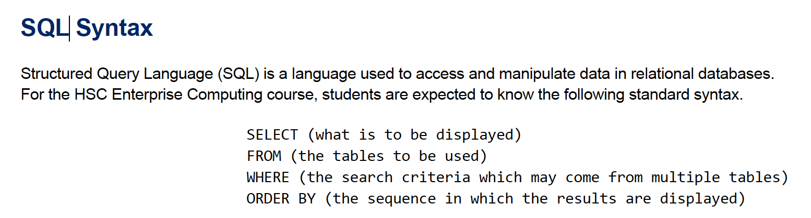
Activity 38: develop a query using SQL.
Implement the following query in Microsoft Access.
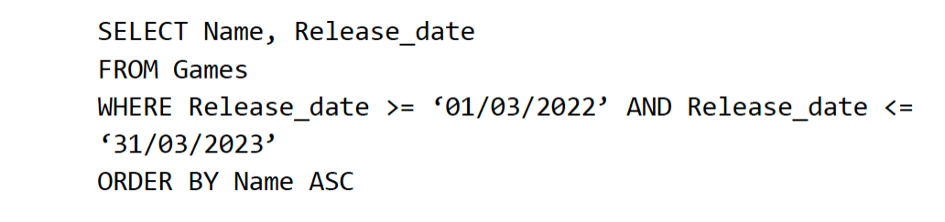
- To do this click on Create, Query Design. Change the view to Design View.
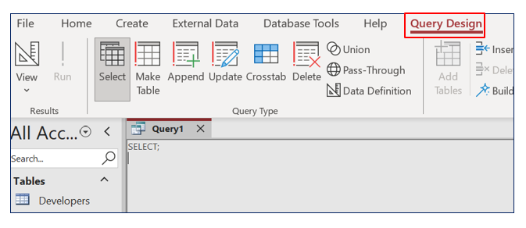
- Start by writing a very simple SQL query.
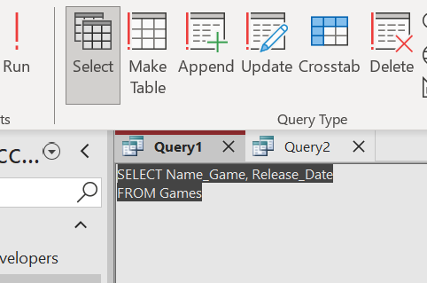
- Click Run and ensure it displays correctly.
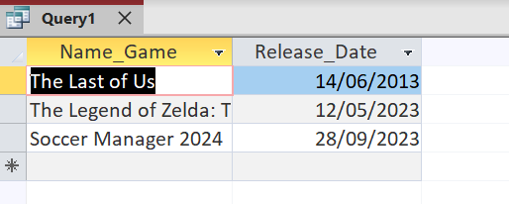
- Add to your SQL as shown below.
SELECT Name_Game, Release_Date
FROM Games
WHERE (((Games.Release_Date)>=#3/1/2022# And (Games.Release_Date)<=#5/19/2024#))
ORDER BY Name_Game ASC
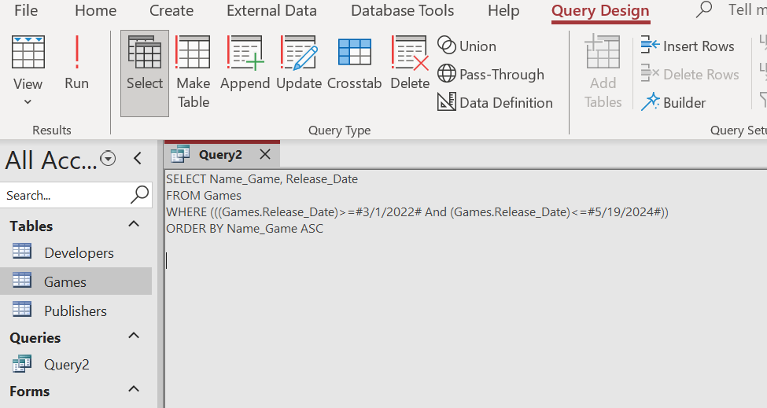
- Ensure you get the correct output from your SQL query.
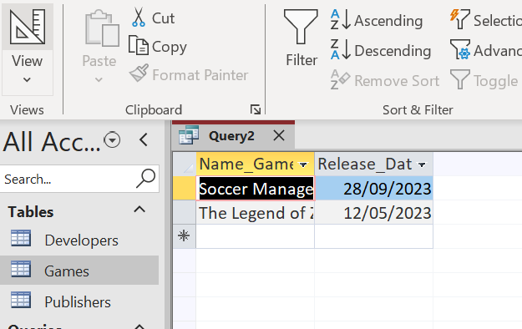
- Experiment with changing the parameters for your SQL statement.
- Save your database.

Using reports
Activity 39: use Microsoft Access to create simple reports.
- To do this, click on the table you want to create the table for. Then click on the Create Menu and report.
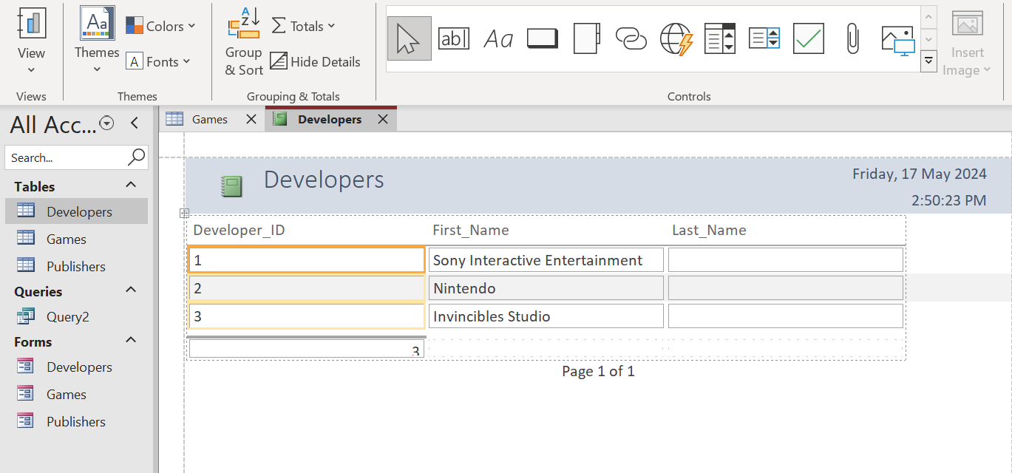
- Experiment with creating reports for the different entities.
Activity 40: create and use a Switchboard.
A Switchboard can be created to provide a user-friendly method for end users to access and use the database.
- To create the Switchboard you first need to add the Switchboard Manager to the Ribbon.
- Click on Access Options in the File menu. Click on Customise Ribbon. Select All Commands from the Choose commands drop down box. Add the Switchboard Manager to a new custom group as shown below.
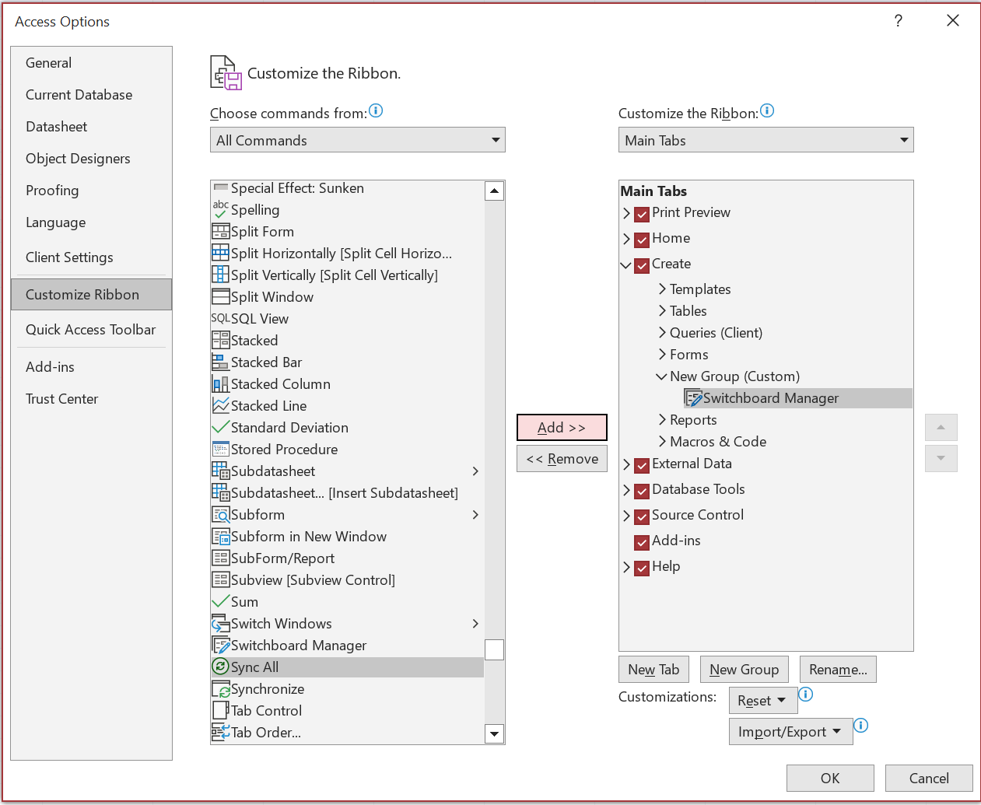
The Switchboard Manager will now appear in the Create menu.
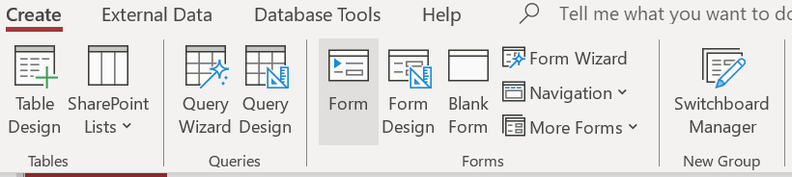
- Click on Switchboard Manager and select Yes to the message shown below.
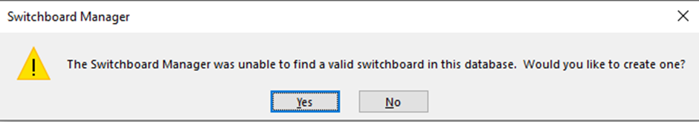

- Add the Following Switchboard pages.
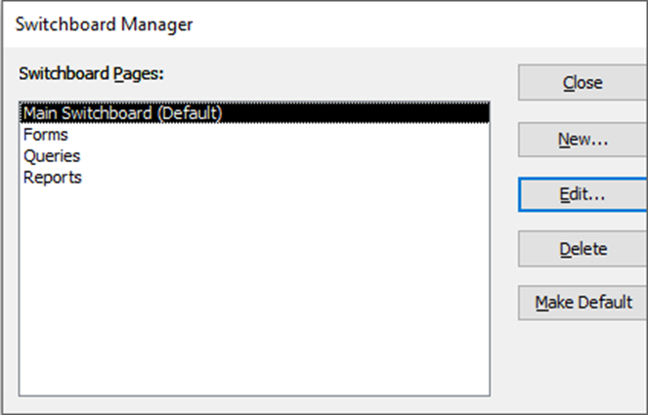
- Click Edit to edit the main Switchboard. Then click New and add an Enter and Exit button to the main Switchboard with the commands shown below.
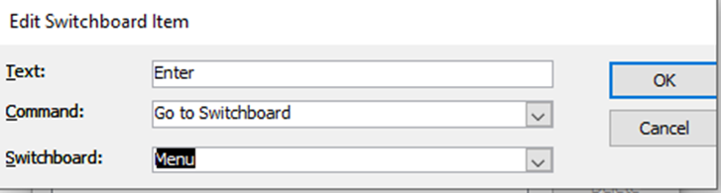
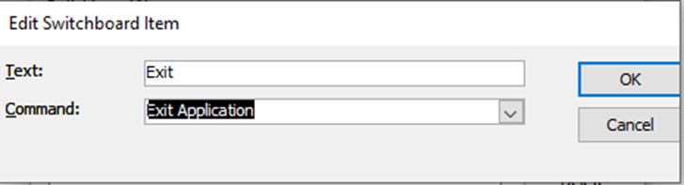
- We now need to edit the menu Switchboard.
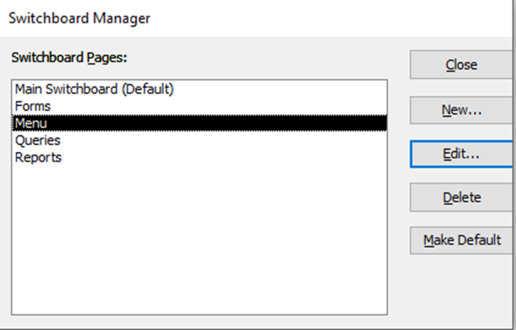
- Edit the menu Switchboard and add a button for Forms, Queries, and Reports. Be sure the Command is set to ‘Go to Switchboard’ and the selected Switchboard is the correct one.
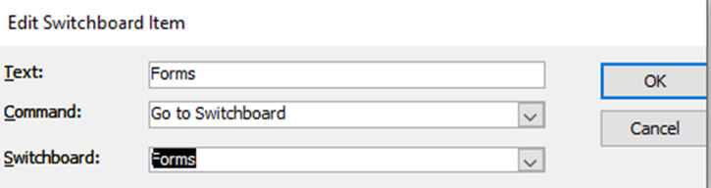
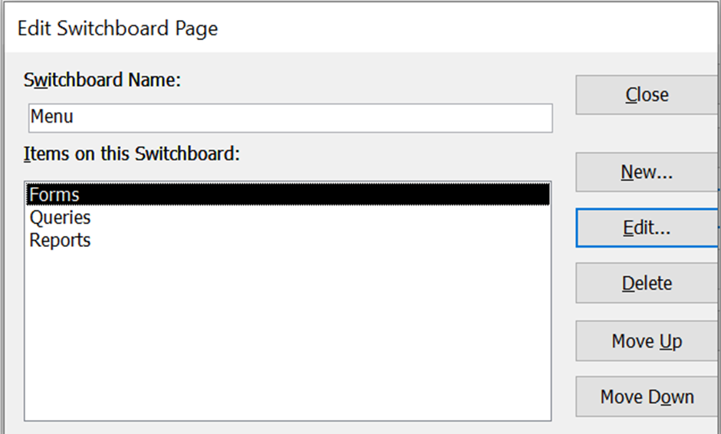
- Take some time now to test your Switchboard and ensure it is working as expected.
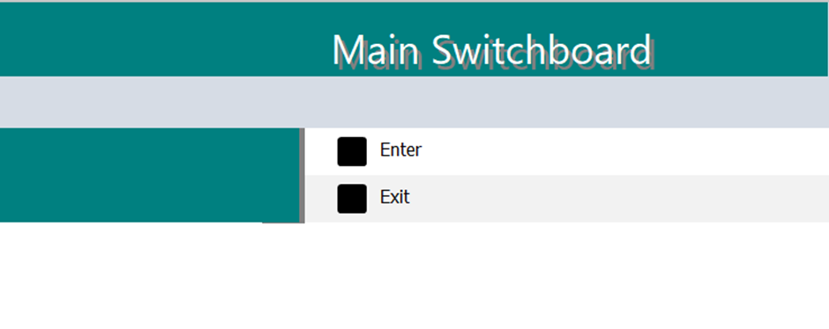



- Edit the Forms Switchboard and add a button to edit the 3 forms in edit mode.
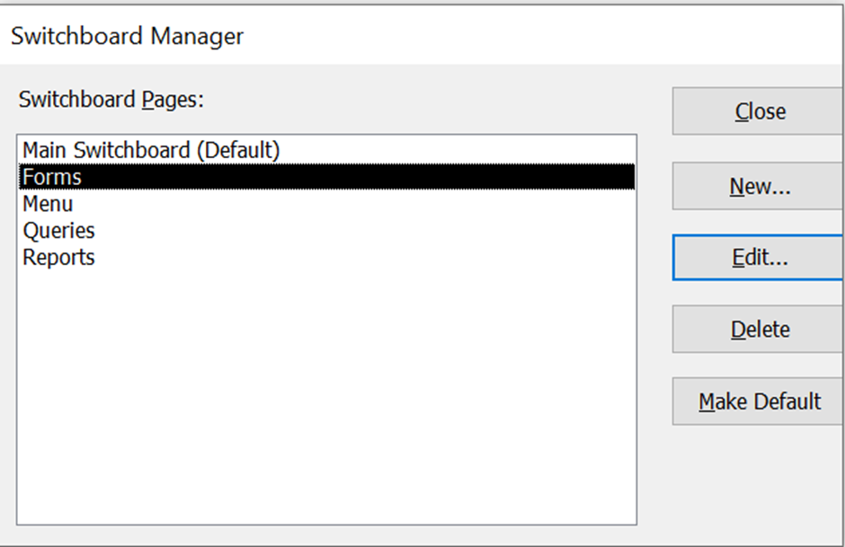
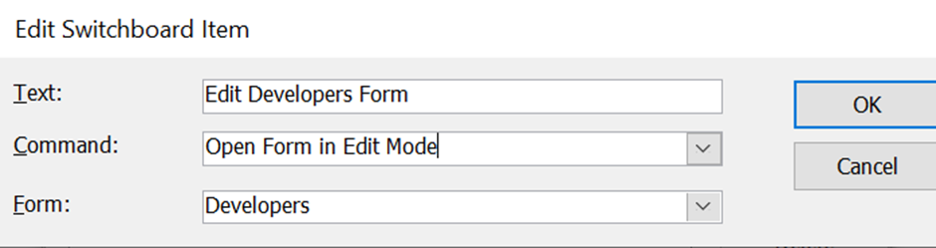
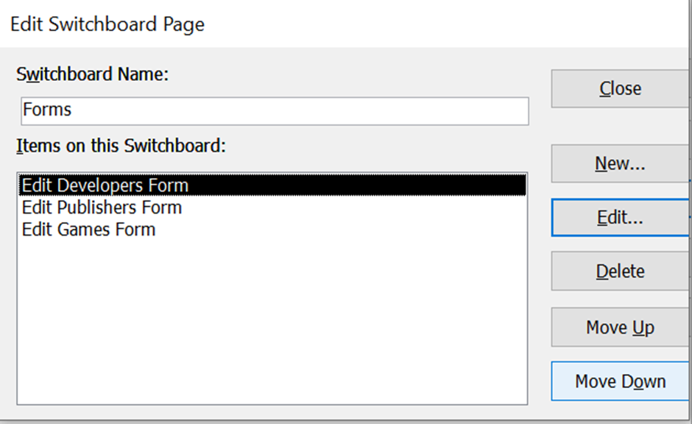
- Again, test your Switchboard and ensure you can edit your forms from the Switchboard.
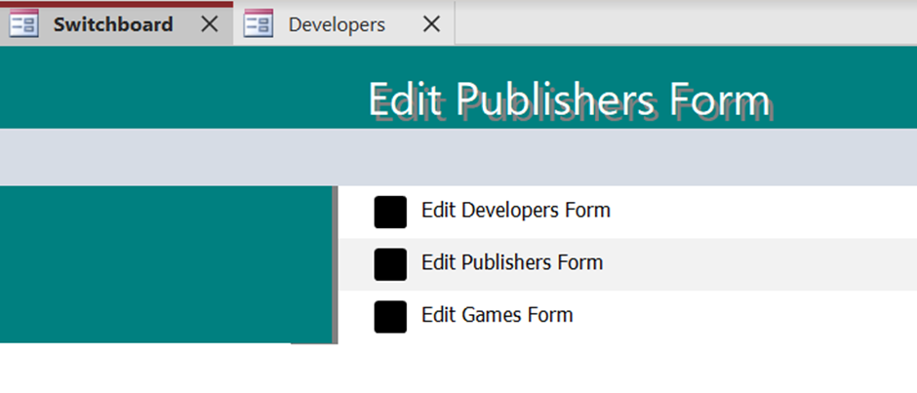
Finish off the navigation for the Switchboard by populating the Queries and Reports menu. To add a query to your Switchboard you will first need to create a macro.
A macro is where you can record a series of steps and record that as a single action. Create a new macro and have the macro perform the action of opening a query. Once the macro is completed you can then add the macro to the Switchboard that performs the task of opening the query.
Can you further enhance the navigation of your Switchboard by adding a back button? This is an important user navigation feature and is essential if your users are going to be able to interact with your database effectively.
If you feel adventurous you can change the background colour of your Switchboard by opening the Switchboard in Edit mode. Be sure to back up your database if you are contemplating this step.
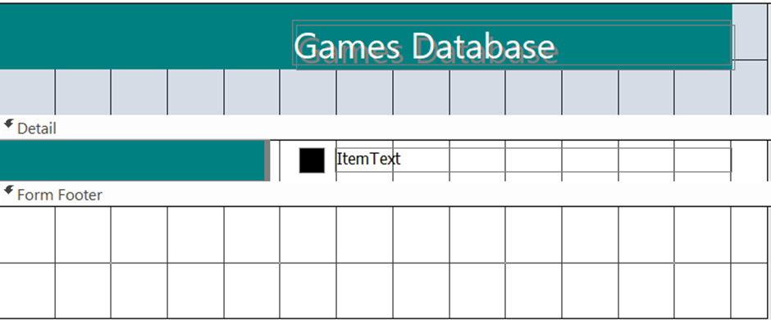
Activity 41: Data Hack High
Using the Data Hack High PowerPoint resource published with the Teacher Support Resource, students are able to work in small groups and choose a challenge to compete. The challenges have been created using various industry datasets and students are guided to analyse and deduce a data story from the variety of datasets.
Teacher note: the Data Hack High challenges guide students in the thinking required for Assessment task 1. The datasets could be utilised in Assessment task 1 if students are unable to ideate, research or source their own dataset of interest. The datasets are saved in the files section of the TAS Statewide Staffroom.

Explore how machine learning and statistical modelling are used in data analytics to analyse big data, and as a prediction tool
Machine learning (ML) and statistical modelling are used in data analytics to analyse big data and make predictions based on the data.
Machine learning uses algorithms to identify patterns and relationships in large datasets, while statistical modelling uses mathematical and statistical techniques to build models that can make predictions. These techniques can be used together to analyse and make predictions about large datasets, such as customer behaviour, market trends and sales data.
The models generated by these techniques can help organisations to identify trends, make data-driven decisions and improve decision-making processes.
However, it is important to consider the limitations and biases that may exist in the data, as well as the potential for errors in the predictions made by these techniques.
Activity 42: predicting customer behaviour scenario
Students in small groups work through this scenario to gain a comprehensive understanding of how ML and statistical modelling are used in data analytics to analyse big data and make predictions, along with the practical and ethical considerations involved in this process.
An e-commerce company, ShopSmart, wants to improve its customer experience and increase sales by leveraging big data analytics. They have collected vast amounts of data from their website, including customer purchase histories, browsing patterns, product reviews and social media interactions. ShopSmart decides to use ML and statistical modelling to analyse this data and develop predictive models for customer behaviour.
Scenario:
1. Data collection
ShopSmart gathers data from various sources:
- Purchase histories (items bought, transaction dates, payment methods)
- Website interactions (pages visited, time spent on each page, clicks)
- Customer reviews and ratings
- Social media interactions (likes, shares, comments).
2. Machine Learning and statistical modelling:
The company employs different ML algorithms and statistical models to:
- predict which products a customer is likely to purchase next
- identify patterns in customer reviews to gauge product satisfaction
- analyse browsing behaviour to personalise recommendations
- forecast sales trends based on historical data.
Questions: understanding ML and statistical modelling
- What are the key differences between ML and traditional statistical modelling?
- Explore how ML algorithms learn from data compared to how statistical models infer relationships.
- How can supervised and unsupervised learning be applied in this scenario?
- Identify which tasks in the scenario could benefit from supervised learning (for example predicting purchases) and which could use unsupervised learning (for example customer segmentation).
- What types of ML algorithms would be suitable for predicting customer purchases and why?
- Consider algorithms like decision trees, random forests, or neural networks for their ability to handle large datasets and complex patterns.
Application in data analytics
- How can ShopSmart ensure the quality and relevance of the data used for modelling?
- Discuss the importance of data cleaning, handling missing values, and ensuring data is up-to-date and relevant.
- What role do feature selection and engineering play in improving the performance of predictive models?
- Explore how transforming raw data into meaningful features can enhance model accuracy.
- How can ShopSmart validate and test the performance of their predictive models?
- Consider techniques like cross-validation, train-test splits, and performance metrics (for example accuracy, precision, recall).
Ethical considerations
- What ethical issues might arise from using ML to analyse customer data?
- Discuss privacy concerns, data security and the potential for biased algorithms.
- How can ShopSmart address potential biases in their predictive models?
- Explore methods for detecting and mitigating bias, such as fairness-aware ML techniques.
Predictive analytics and business impact
- How can predictive analytics improve customer experience on the ShopSmart platform?
- Consider personalised recommendations, targeted marketing and dynamic pricing strategies.
- What are the potential risks and challenges of relying on predictive models for business decisions?
- Discuss overfitting, model drift, and the need for continuous monitoring and updating of models.
- How can ShopSmart use predictive analytics to forecast sales trends and inventory needs?
- Explore time series analysis and demand forecasting techniques.
Future directions
- How might advancements in ML and artificial intelligence (AI) further enhance the capabilities of ShopSmart's data analytics?
- Consider the impact of emerging technologies like deep learning, reinforcement learning, and AI-driven automation.

References
This resource contains NSW Curriculum and syllabus content. The NSW Curriculum is developed by the NSW Education Standards Authority. This content is prepared by NESA for and on behalf of the Crown in right of the State of New South Wales. The material is protected by Crown copyright.
Please refer to the NESA Copyright Disclaimer for more information https://educationstandards.nsw.edu.au/wps/portal/nesa/mini-footer/copyright.
NESA holds the only official and up-to-date versions of the NSW Curriculum and syllabus documents. Please visit the NSW Education Standards Authority (NESA) website https://educationstandards.nsw.edu.au and the NSW Curriculum website https://curriculum.nsw.edu.au.
Enterprise Computing 11–12 Syllabus © NSW Education Standards Authority (NESA) for and on behalf of the Crown in right of the State of New South Wales, 2022.
Enterprise Computing 11–12 Course Specifications © NSW Education Standards Authority (NESA) for and on behalf of the Crown in right of the State of New South Wales, 2022.
Atlas of Living Australia (n.d.) Atlas of Living Australia [website], accessed 31 July 2024.
Australian Bureau of Statistics (2024) Australia 2021 Census – All persons QuickStats, ABS website, accessed 31 July 2024.
CareerFoundry (14 March 2022) 'Data Analysis Roles – How Do You Differentiate Between Them All?' [video], CareerFoundry, YouTube, accessed 31 July 2024.
CareerFoundry (19 May 2022) 'A day in the Life of a Data Analyst (2023)' [video], CareerFoundry, YouTube, accessed 31 July 2024.
CrashCourse (29 March 2018) Sampling Methods and Bias with Surveys: Crash Course Statistics #10 [video], CrashCourse, YouTube, accessed 31 July 2024.
CSIRO (n.d.) CSIRO, [website], accessed 31 July 2024.
CSIRO (15 January 2021) Income Inequality in Australian Regions [website], accessed 31 July 2024.
Cukier, K (June 2014) Big data is better data [video], TED, accessed 31 July 2024.
Data.NSW (2024) Master dataset: NSW government school locations and student enrolment numbers, NSW Government website, accessed 31 July 2024.
Excel Easy (2024) Excel Easy [website], accessed 31 July 2024.
Excel Tutorials by EasyClick Academy (15 December 2022) How to Group Rows in Excel (Automated and Manual Way) [video], Excel Tutorials by EasyClick Academy, YouTube, accessed 31 July 2024.
ExcelFunctions.net (2023) Excel Functions [website], accessed 31 July 2024.
ExcelJet (2024) ExcelJet [website], accessed 31 July 2024.
ExcelTip (n.d.) ExcelTip [website], accessed 31 July 2024.
FiveThirtyEight (n.d.) FiveThirtyEight [website], accessed 31 July 2024.
George Mason University College of Public Health (18 May 2019) What is Health Informatics? [video], George Mason University College of Public Health, YouTube, accessed 31 July 2024.
Grad Coach (27 September 2021) Qualitative vs Quantitative vs Mixed Methods Research: How To Choose Research Methodology [video], Grad Coach, YouTube, accessed 31 July 2024.
Grad Coach (27 September 2022) Nominal, Ordinal, Interval & Ratio Data: Simple Explanation With Examples [video], Grad Coach, YouTube, accessed 31 July 2024.
Grok Academy (2024) Data Analytics, Grok Learning website, accessed 31 July 2024.
IBM Technology (13 April 2022) What is Data Mining? [video], IBM Technology, YouTube, accessed 31 July 2024.
Kaggle (n.d.) Kaggle [website], accessed 31 July 2024.
LearnFree (9 February 2016) Excel: What-if Analysis [video], LearnFree, YouTube, accessed 31 July 2024.
Microsoft Support (n.d.) Excel help and learning, Microsoft website, accessed 31 July 2024.
MrExcel.com (n.d.) Mr Excel on YouTube [channel], YouTube, accessed 31 July 2024.
NESA (NSW Education Standards Authority) (2021) ‘Glossary of key words’, Student guide, NESA website, accessed 31 July 2024.
OIAC Office of the Australian Information Commissioner (n.d.) Australian Privacy Principles quick reference, [website], accessed 31 July 2024.
OIAC Office of the Australian Information Commissioner (n.d.) OIAC, [website], accessed 31 July 2024.
Presto Learn (11 June 2020) Structured vs Unstructured Data [video], Presto Learn, YouTube, accessed 31 July 2024.
Simplilearn (28 February 2019) Blockchain In 7 Minutes | What Is Blockchain | Blockchain Explained | How Blockchain Works [video], Simplilearn, YouTube, accessed 31 July 2024.
TAFE NSW (2024) Introduction to Data Analytics, TAFE NSW website, accessed 31 July 2024.
Technology for Teachers and Students (28 January 2020) Creating Easy Data Entry Forms in Excel [video], Technology for Teachers and Students, YouTube, accessed 31 July 2024.
UL Lafayette Online (28 June 2022) What is informatics? [video], UL Lafayette Online, YouTube, accessed 31 July 2024.
Vote Australia (n.d.) Vote Australia [website], accessed 31 July 2024.
Wikipedia (2024) Demographics of Australia, Wikipedia website, accessed 31 July 2024.

© State of New South Wales (Department of Education), 2024
The copyright material published in this resource is subject to the Copyright Act 1968 (Cth) and is owned by the NSW Department of Education or, where indicated, by a party other than the NSW Department of Education (third-party material).
Copyright material available in this resource and owned by the NSW Department of Education is licensed under a Creative Commons Attribution 4.0 International (CC BY 4.0) license.

This license allows you to share and adapt the material for any purpose, even commercially.
Attribution should be given to © State of New South Wales (Department of Education), 2024.
Material in this resource not available under a Creative Commons license:
- the NSW Department of Education logo, other logos and trademark-protected material
- material owned by a third party that has been reproduced with permission. You will need to obtain permission from the third party to reuse its material.
Links to third-party material and websites
Please note that the provided (reading/viewing material/list/links/texts) are a suggestion only and implies no endorsement, by the New South Wales Department of Education, of any author, publisher, or book title. School principals and teachers are best placed to assess the suitability of resources that would complement the curriculum and reflect the needs and interests of their students.
If you use the links provided in this document to access a third-party's website, you acknowledge that the terms of use, including licence terms set out on the third-party's website apply to the use which may be made of the materials on that third-party website or where permitted by the Copyright Act 1968 (Cth). The department accepts no responsibility for content on third-party websites.

