Engineering Technology 7–10 – Structures– teacher resource
Bridging the gap (20-week unit)
Contents
Unit overview 4
Glossary 5
Introduction 8
Engineers work 9
What is engineering? 9
Types of engineering 10
Real-world examples of civil engineering 11
Discussion and reflection 12
Engineering structures 13
Forces 17
What is a force? 17
Types of forces 18
How is a force measured? 19
Let’s talk about gravity 21
Engineering example – post and beam construction 21
Mass versus weight – What’s the difference? 22
Why it matters in engineering 23
Gravity is a constant 26
Paper tower sprint 26
Engineering materials 29
Engineering materials – definitions and examples 30
Metals 30
Polymers 31
Ceramics 31
Elastomers 32
Natural materials 32
Composites 33
Engineering properties of materials 34
Mechanical properties 34
Physical properties 35
Manufacturing and environmental properties 35
How materials are used in structures 39
Engineering scenario 39
Real-world examples 40
Materials testing 41
Aboriginal engineered structures 43
Built for purpose 43
What do engineers do? 43
Structure comparison 44
Whole-class reflection 44
Think like an engineer 44
Sustainability in structural materials 45
Materials analysis 45
Beams, a closer look 49
Understanding loads and forces in beam design 49
Common loading of beams 51
Stress 52
Tension and compression at the same time 53
Introducing the I-beam 55
What is an I-beam? 55
I-beam weakness 57
Introducing trusses 58
Why are triangles a strong shape? 60
Types of trusses 63
Warren truss 63
Howe truss 63
Pratt truss 64
Introduction to engineering drawing 66
AS 1100 Standards 66
Why use orthogonal drawings? 67
Orthogonal drawing rules and standards (AS 1100) 68
Why do we need to have more than one view? 68
Orthogonal projection introductory exercises 70
‘Bridging the gap’ assessment task 74
Considerations when delivering the assessment task 77
Testing reference images 78
References 82

Unit overview
This resource supports schools’ implementation of the Structure focus area of the new Engineering Technology 7–10 Syllabus. It can be adopted as is or adapted to meet the needs of individual school contexts.
The ‘Bridging the gap unit’ is an engaging and comprehensive 20-week program designed for Engineering Technology 7–10 students. This unit offers a blend of theoretical knowledge, practical experiences and evaluative practices.
The learning matters because understanding structures and the engineering that supports them builds practical problem-solving skills. It prepares students to think critically about the built environment and make informed decisions as future engineers, tradespeople, citizens or consumers. Through active experimentation and teamwork, students gain confidence with tools, terminology and techniques that underpin design and construction. This foundational knowledge is vital in a world where infrastructure, sustainability and innovation intersect. Students will explore the engineering principles behind truss bridge design. They will investigate types of forces, load distribution and structural efficiency. Using accessible materials such as balsa wood or spaghetti, students will design, construct and test their own bridges. Emphasis will be placed on mechanical analysis, material selection, testing and evaluation, safe working practices and technical communication through sketches, drawings and engineering reports.
Note: this resource has been designed to facilitate the ready conversion into a student booklet by removing the answers within the response windows. Teacher notes (in blue) can be deleted before distributing to students. The resource is intended for you to adapt to suit to your school and your resources. Alternative ideas are included for the project design brief. The resource can be introduced and delivered earlier in the term or used as an assessment.
School leaders and teachers should refer to Equipment Safety in Schools and Chemical Safety in Schools, for current information on safety and safe working practices.

Glossary
Note: provide the table with the definition column blank for students to complete the activity throughout the term.
Each time you see a new word throughout the workbook, you can add its definition in the table below for later reference.
Table 1 – glossary
Word | Definition
arch | A curved, symmetrical structure spanning an opening and typically supporting the weight of a bridge, roof or wall above it.
beam | A horizontal structural element that supports loads from above.
cantilever | A beam that is fixed at one end and extends outward, like a diving board.
composite material | A composite material is made from 2 or more different materials that are combined to make something stronger, lighter or more durable than the individual parts.
compressive strength | A material’s ability to resist being squashed or compressed.
compression | Compression force (or compressive force) occurs when a physical force presses inward on an object, causing it to become compacted.
dead load | The weight of the structure itself, including materials and permanent fixtures.
deflection | The amount a structure bends or moves under load.
efficiency | How well a structure supports a load compared to its own weight or material use.
engineer | A person who designs, builds or maintains engines, machines or structures.
equilibrium | A state where all forces on a structure are balanced.
failure | When a structure breaks or can no longer support its load.
force | A push or pull acting on an object, measured in newtons (N).
foundation | The lowest part of a structure that transfers loads to the ground.
joint | A connection point where structural elements meet.
load | A force or weight placed on a structure. Loads can be permanent (dead) or temporary (live).
live load | The weight of things that move on or in a structure, such as people, vehicles or furniture.
mass | The quantity of matter that a body contains, as measured by its acceleration under a given force.
material properties | Characteristics of a material, such as strength, flexibility and hardness.
newton | The SI unit of force. It is equal to the force that would give a mass of one kilogram an acceleration of one metre per second squared (m/s²).
prototype | A working model used to test ideas before final construction.
shear | A force that causes parts of a material to slide past one another.
stability | The ability of a structure to remain upright and resist collapse.
stress | Stress is the material’s internal reaction to an externally applied force.
structure | An object or system that supports a load and resists forces, such as a bridge, tower or building.
sustainability | Designing with environmental, social and economic impacts in mind for long-term use.
SI units | A system of physical units (SI units) based on the metre, kilogram, second, ampere, kelvin, candela, and mole, together with a set of prefixes to indicate multiplication or division by a power of 10.
suspension | A suspension bridge is a type of bridge in which the deck is hung below suspension cables on vertical suspenders.
tension | A pulling force that stretches a material.
tensile strength | A material's ability to resist being pulled apart.
testing | A process of applying loads or stress to see how a structure performs.
torsion | A twisting force applied to a structure or component.
truss | A framework of triangles used to provide strength and distribute forces in a structure.
vector | A quantity having direction as well as magnitude, especially in determining the position of one point in space relative to another.
weight | The force exerted on the mass of a body by a gravitational field.

Introduction
This unit introduces students to fundamental engineering concepts through a series of engaging, hands-on practical challenges. Using real-world problems and simulated engineering tasks, students will explore the relationships between forces, materials and structural efficiency. As they develop an understanding of tension, compression, load paths and material properties, students will apply this knowledge to design and construct their own truss bridge model. The unit culminates in a collaborative design and testing project that mirrors authentic engineering processes.

Engineers work

What is engineering?
- In your own words, what is engineering?
Sample answer:
Engineering is using science, maths and creativity to design solutions to real-life problems.
Watch the video: Engineering. Making Life Happen. (0:30).
- After watching the video, list 3 things that engineers do in their work:
Sample answer:
- Solve problems using design and technology
- Work in teams to build things like machines or structures
- Use testing and calculations to improve ideas
- Why is problem-solving important for engineers?
Sample answer:
Because engineers often face challenges in design and construction, they need to find safe, cost-effective and efficient solutions.

Types of engineering
Match each type of engineer with what they design or build.
Table 2 – types of engineering
Type of engineer | What they work on
Civil engineer | Test and maintain aircraft
Mechanical engineer | Electronic circuits, robotics
Electrical engineer | Engines, machines, mechanical systems
Aeronautical engineer | Roads, bridges, tunnels
Sample answer
Type of engineer | What they work on
Civil engineer | Roads, bridges, tunnels
Mechanical engineer | Engines, machines, mechanical systems
Electrical engineer | Electronic circuits, robotics
Aeronautical engineer | Test and maintain aircraft

Real-world examples of civil engineering
Civil engineers help plan and build infrastructure. For each of the following projects, suggest how they may impact our society.
Table 3 – impact of civil engineering
Project | Impact
Highway expansion | - Reduces traffic congestion and travel time  - Boosts economic activity by improving freight movement  - May disrupt local ecosystems or communities during construction
Desalination plant | - Provides clean drinking water in drought-prone areas  - Supports population growth and agriculture  - High energy use and environmental concerns around brine disposal
Flood levee system | - Protects homes and businesses from flood damage  - Increases land value and safety in flood-prone zones  - May alter natural water flow and affect wildlife habitats
Bicycle lane networks | - Promotes healthy lifestyles and reduces car use  - Lowers emissions and traffic congestion  - Requires careful integration with existing roads
Bridge rehabilitation/maintenance projects | - Extends lifespan of critical transport links  - Improves safety and reduces maintenance costs  - May disrupt traffic during upgrades
Green roofs on public buildings | - Improves insulation and reduces energy costs  - Enhances biodiversity and urban aesthetics  - May have higher initial costs and structural requirements

Discussion and reflection
- What is one structure you see every day that a civil engineer helped design? Describe it.
Sample answer:
The local road or bridge – a civil engineer planned its structure, materials and drainage.
- Would you like to work as an engineer? Why or why not?
Sample answer:
Yes, because I enjoy solving problems and building things. I’d like to design structures that help people.

Engineering structures
Activity: identify examples of structural columns and beams in your classroom.
Look around your classroom or school. What parts of the building do you think are holding it up?
Figure 1 – components of post and beam structure
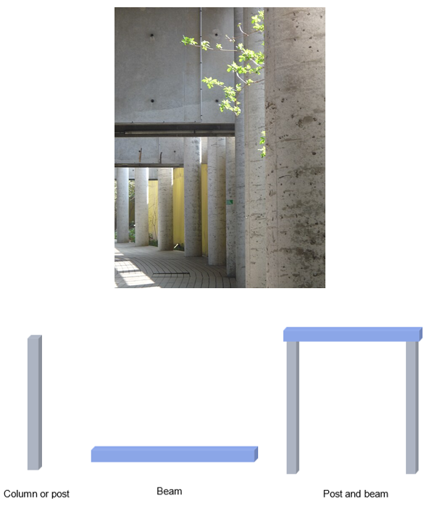
‘Concrete pillars at the Université Paris - Dauphine building in Paris’ by Arria Belli is licensed under CC BY-SA 3.0.

Other basic structures that are more difficult to locate are arches and trusses. These simple engineered concepts have been used in a wide range of man-made structures.
Figure 2 – truss examples
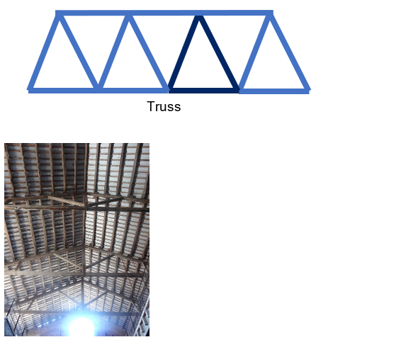
‘Old Wine Cellar and Olive Oil Mill, in Igualada, designed in 1919-1921 by the architect Cèsar Martinell, and built in 1921-1922’ by Jordiferrer is licensed under CC BY-SA 4.0.
Figure 3 – arch examples
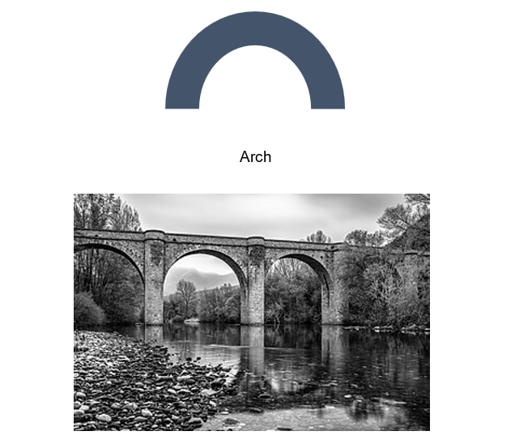
‘Monochrome photo of the Ceps bridge above the Orb River in the commune Roquebrun (Hérault, France)’ by Christian Ferrer is licensed under CC BY 4.0.

Activity: provide a real-world example of the structure and provide an image where it is commonly used.
Table 4 – structure types
Structure type | Real-world examples | Diagram or image
Beam | A pedestrian walkway over a highway.
Column | A tower or post holding up a roof.
Arch | An old stone bridge or cathedral doorway.
Truss | A typical gable roof of a house.

Forces

What is a force?
Activity: students name situations where objects get pulled, squashed or twisted.
Table 5 – examples of forces
Forces | Situations
Pulled | - Towing a car  - Cables in a crane when lifting objects  - Tug of war rope  - Guitar strings
Squashed | - Foundations in a house or building  - Sole of your shoe when standing  - Legs of a table  - Squeezing toothpaste from a tube
Twisted | - Turning a screwdriver  - Steering column in a car  - Skateboard deck when turning  - Drill bits
Teacher demonstration: a rubber band (tension), sponge (compression) and ruler twist (torsion) can be used to demonstrate forces.

Types of forces
Using the diagrams provided, complete the sentences detailing the differences between tensile (tension), compressive (compression) and torsional (torsion) forces.
Figure 4 – tensile force

Tensile forces are forces that
Figure 5 – compressive force

Compressive forces are forces that
Figure 6 – torsional force

Torsional forces are forces that

How is a force measured?
In the world around us, forces are constantly at play as we have already discovered. A force is simply a push, pull or twist that can cause an object to move, stop, change direction or change shape. To understand how much force is acting on an object, scientists use a simple but powerful formula:
$$Force = mass ×acceleration$$
or
$$F = ma$$
This equation comes from Newton’s Second Law of Motion and it tells us how force is related to motion. Let’s break it down:
- F stands for force, measured in newtons (N)
- m stands for mass, measured in kilograms (kg)
- a stands for acceleration, measured in metres per second squared (m/s²).
The amount of force acting depends on how heavy the object is and how quickly it is speeding up or slowing down.
Example
An object with a mass of 2 kg accelerates at 3 m/s². The force is:
$$F = 2 × 3 = 6 N$$
That means a force of 6 newtons is needed to make a 2 kg object accelerate at the rate of 3 m/s2.
- What is the force needed to accelerate a 4 kg object 3 m/s²?
$$F = 4 × 3 __$$
$$__ = 12 N$$
That means a force of __ is needed to make an __ object accelerate at the rate of __.
- What is the force needed to accelerate a 6 kg object at 1.5 m/s²?
$$F = __ × __$$
$$F = __$$
That means a force of __.
Independent practice
- A 10 kg object accelerates at 2 m/s². What is the force?
- A 2.5 kg object accelerates at 5 m/s². What is the force?
- A 7 kg object accelerates at 3 m/s². What is the force?
- A 4 kg object accelerates at 0.5 m/s². What is the force?

Let’s talk about gravity
Gravity is the invisible force that pulls everything toward the Earth. It is why apples fall from trees, why people and objects stay on the ground and why buildings need strong foundations. In engineering, gravity is one of the most important forces to consider, especially when designing structures that must safely support weight.
To understand how gravity affects structures, we must use the formula:
$$F = ma$$
When we talk about gravity, the acceleration is always approximately 9.8 m/s². That’s how fast objects accelerate toward Earth when dropped.
If a beam weighs 50 kg, the force of gravity acting on it is:
$$F = 50 × 9.8 = 490 N$$
That means the beam is exerting 490 newtons of downward force on whatever is supporting it.
Note: to simplify our calculations, instead of using 9.8m/s² we can use 10m/s².
Example
If a beam weighs 50 kg, the force of gravity acting on it is:
$$F = 50 × 10 = 500 N$$

Engineering example – post and beam construction
In a simple structure the beam spans across the top and holds weight (like a roof). The posts stand vertically and support the beam.
Figure 7 – post and beam
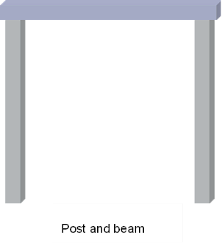
Gravity pulls the beam downward. Engineers must calculate the force the beam exerts so they can choose materials strong enough for the posts and beam to resist that force.
For example, a timber beam weighs 60 kg. What force does it exert due to gravity?
$$F= __$$
$$a = 10 m/s2$$
$$m = 60 kg$$
$$Answer: F = 60 × 10 = 600 N$$
That means each post must help support 600 newtons of downward force.

Mass versus weight – What’s the difference?
Although we often use the words ‘mass’ and ‘weight’ interchangeably in everyday life, they mean very different things in science and engineering.
Mass:
- Mass is the amount of matter in an object.
- It is measured in kilograms (kg).
- It does not change depending on location, whether you are on Earth, the Moon or Mars, your mass stays the same.
- It is a scalar quantity, meaning it has size but no direction.
Weight:
- Weight is the force of gravity acting on that mass.
- It is measured in newtons (N).
- It depends on gravity and changes depending on where you are. For example, you weigh less on the Moon than on Earth.
- It is a vector quantity, meaning it has both size and direction (always pulling downward).
For an example, a steel beam has a mass of 100 kg. Its weight on Earth is:
$$F = 100 × 10 = 1000 N$$
That means the beam exerts 1000 newtons of downward force due to gravity.

Why it matters in engineering
In engineering design and construction, engineers need to know:
- the mass of materials to transport and assemble them
- the weight to calculate how much force the structure must support.
Understanding the difference ensures buildings are safe, stable and built to last.

Activity: consider 2 identical bricks – one on Earth and one on the Moon
Figure 8 – mass versus weight
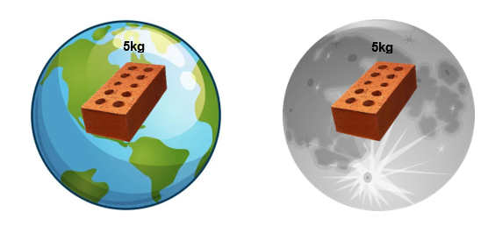
Both bricks have a mass of 5 kg.
On Earth, the weight is:
$$5 ×10 = 50 N$$
On the moon, the weight is:
$$5 ×1.6 = 8 N$$
Why does the same brick weigh less on the Moon even though its mass hasn’t changed?
Activity: let’s consider our simple post and beam frame.
If the beam has a mass of 100 kg, how much force does each post need to support if there are 2 of them?
Figure 9 – post and beam frame worked example with 100 kg beam
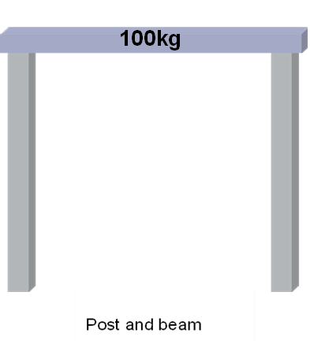
$$100 × 10 = 1000N$$
Divide by the number of posts.
Answer: 500 N in each post.
Figure 10 – post and beam frame worked example with 750 kg beam
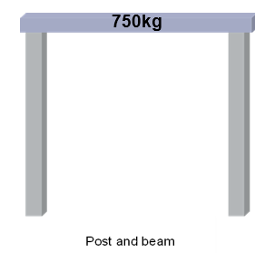
$$750 x 10 = 7500N$$
Divide by the number of posts.
Answer: 3750 N in each post.
Activity: fill in the blanks
Mass is measured in __________ and does not change based on location.
Weight is the __________ of gravity acting on mass.
The formula to calculate weight force is __________.
A 10 kg object exerts __________ newtons on Earth.
In a post-and-beam structure, the posts must resist the __________ caused by the beam’s weight.

Gravity is a constant
If you drop a bowling ball and a feather from the same height and at the same time, which one would hit the ground first?
Watch the video: Brian Cox visits the world's biggest vacuum | Human Universe – BBC (4:41). What caused the bowling ball and feather to hit the ground at different times?

Paper tower sprint
The teacher divides the class into groups of 3 to 4
Challenge overview
Design and build the tallest free-standing tower possible using only 10 sheets of A4 paper and 300 mm of masking tape. The structure must remain upright for at least 10 seconds to be considered successful.
Figure 11 – paper tower example
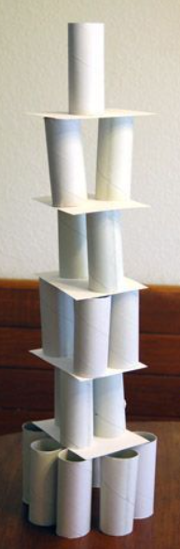
Rules and materials
Materials provided for each group:
- 10 sheets of A4 paper (80 gsm)
- 300 mm masking tape (pre-cut)
- scissors (shared)
- one ruler (shared).
Rules
- No additional materials are allowed.
- Tape can be cut into smaller pieces.
- The structure must be free-standing with no external supports.
- Height is measured from the base to the highest point.
- The build time is 20 minutes.
Reflection questions
- Which design techniques helped improve the height and stability of your tower?
- How did your team plan and use your materials and time?
- If you had a second attempt, what would you do differently?

Engineering materials
Engineering materials are all around us, from the steel in skyscrapers to the rubber in tyres and the polymers in water bottles. There are hundreds of different materials used in engineering, construction, manufacturing and technology.
Because there are so many types of materials, engineers and designers need a way to make sense of them. To do this, we classify materials into categories based on their properties and where they come from. This helps us choose the right material for the right job.
In this unit, we will explore the major groups of engineering materials: metals, polymers, ceramics, elastomers, natural materials and composites and learn how their unique characteristics affect how we use them in the real world.
Initially we can classify materials into 2 broad categories, metals and non-metals.
Activity: use the table below to identify 5 items you use when getting ready for school today, then classify whether they are primarily made from metals or non-metals.
Table 6 – metals versus non-metals
Item | Metal | Non-metal
Toothbrush |  | 
Toaster
Keys
Clothes
Footpath

Engineering materials can be further classified using the below diagram.
Figure 12 – one way of classifying materials
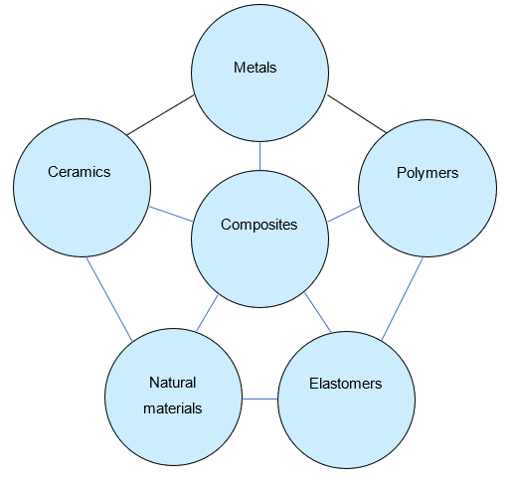

Engineering materials – definitions and examples

Metals
Definition: metals are hard, shiny materials that conduct heat and electricity well. They are usually strong and can be shaped or welded.
Common properties
- Strong
- Malleable and ductile, meaning they can be stretched and shaped
- Conductive
- Often recyclable
Examples
- Steel is used in buildings and bridges.
- Aluminium is used in aircraft and cans.
- Copper is used in wires and plumbing.

Polymers
Definition: polymers are materials made from long chains of molecules and include most plastics. They are usually lightweight and resistant to corrosion.
Common properties
- Lightweight
- Flexible or rigid
- Can be moulded into shapes
- Some are recyclable
Examples
- Polyethylene is used in plastic bags and bottles.
- PVC is used in pipes and window frames.
- Acrylic is used in signs and display cases.

Ceramics
Definition: ceramics are hard, brittle materials made by heating natural substances. They can withstand high temperatures and are often used as insulators.
Common properties
- Very hard
- Brittle and breaks easily
- Heat resistant
- Electrical insulators
Examples
- Porcelain is used in sinks and toilets.
- Glass is used in windows and bottles.
- Bricks are used in construction.

Elastomers
Definition: elastomers are stretchy materials that return to their original shape after being stretched or squashed.
Common properties
- Flexible
- Elastic, meaning they can stretch and return
- Water resistant
Examples
- Rubber is used in tyres and seals.
- Silicone is used in kitchenware and medical products.
- Foam rubber is used in cushions and sports gear.

Natural materials
Definition: natural materials come directly from plants, animals or the earth. They are often biodegradable and used in traditional construction.
Common properties
- Naturally occurring
- Renewable (with exceptions)
- Biodegradable
Examples:
- Wood is used in building and furniture.
- Cotton is used in textiles.
- Leather is used in clothing and tools.

Composites
Definition: composites are made by combining 2 or more different materials to create something stronger or more useful than the parts alone.
Common properties
- Strong and lightweight
- Designed for specific purposes
- Can be more expensive to produce
Examples
- Fibreglass is plastic reinforced with glass fibres and used in boats and car panels.
- Carbon fibre is made of carbon threads in resin and used in bikes, aircraft and sports equipment.
- Reinforced concrete is concrete with steel bars and used in buildings and bridges.

Engineering properties of materials
Engineers choose materials based on their properties. These properties affect how the material performs in real-world situations like bridges, buildings, tools or machines.

Mechanical properties
The below table explains how a material’s property responds to forces.
Table 7 – mechanical properties
Property | Description | Example
Strength | Ability to withstand a force without breaking. | Steel is strong in tension and compression.
Hardness | Resistance to scratching, denting or cutting. | Ceramic tiles are very hard.
Toughness | Ability to absorb energy without breaking. | Bike helmets are made from tough plastics.
Brittleness | Breaks or cracks easily without much change in shape. | Glass and ceramics are brittle.
Ductility | Can be stretched into a wire without breaking. | Copper is highly ductile.
Malleability | Can be hammered or rolled into thin sheets. | Aluminium foil is malleable.
Elasticity | Can return to its original shape after being stretched. | Rubber bands are elastic.

Physical properties
Table 8 – physical properties
Property | Description | Example
Density | Mass per unit volume, how heavy it feels for its size. | Lead is denser than aluminium.
Melting point | The temperature at which a solid turns into a liquid. | Metals have high melting points.
Thermal conductivity | Ability to transfer heat. | Copper pans heat up quickly.
Electrical conductivity | Ability to carry electric current. | Metals like copper are good conductors.

Manufacturing and environmental properties
Table 9 – manufacturing and environmental properties
Property | Description | Example
Workability | How easy it is to cut, shape, join or finish. | Timber is easy to saw and sand.
Sustainability | Whether the material can be recycled or sourced responsibly. | Bamboo is a sustainable material.
Disposability | How easy and safe it is to dispose of. | Bioplastics break down in compost.
Availability | How easy it is to obtain or purchase. | Steel is widely available.
Cost | How expensive it is to buy and work with. | Titanium is expensive.
Safety | How safe it is to use. For example, non-toxic or low fire risk. | Food-grade plastics are safe.
Note: a number of these properties are interrelated. For example, if the availability of the material is very low, it is often expensive to buy and work with.
Activity: match the property
Match each property with its correct description.
Table 10 – matching activity
Property |  | Description
Ductility |  | - Can return to its original shape after being stretched
Hardness |  | - Can be stretched into a wire without breaking
Elasticity |  | - Can be hammered into sheets
Brittleness |  | - Breaks easily without bending
Malleability |  | - Resists scratching or denting

Answers:
- Ductility – 2
- Hardness – 5
- Elasticity – 1
- Brittleness – 4
- Malleability – 3
Activity: property hunt
Find an item in your classroom, school or home that matches each property. Fill in the table below with what you found.
Table 11 – property hunt
Property | Item found | Justification | Image
Conductivity
Strength
Brittleness
Toughness
Elasticity
Activity: key words
Fill in the blanks using the missing keywords from the box below.
Word bank:
brittle | tough | malleable | conductor | sustainable
dense | elastic | ceramic | corrosion | ductile
- Metals like copper are _______, which means they can be drawn into thin wires.
- Rubber bands are _________, because they stretch and return to their original shape.
- Glass is a ________ material, meaning it can break easily if dropped.
- Stainless steel is resistant to ________, so it does not rust easily.
- Clay, bricks and porcelain are all types of ________ materials.
- Aluminium is less _______ than steel, making it lighter to use.
- Wood and bamboo are considered ______ materials because they are renewable.
- A ______ material allows electricity or heat to pass through it.
- A hammer is made from a ______ material so it can absorb impact.
- Gold is very _______, which means it can be flattened into thin sheets.

How materials are used in structures

Engineering scenario
You are designing and engineering a new pedestrian bridge for a public park. The bridge must be:
- strong and durable
- weather resistant
- safe to walk on in all weather.
Choose 3 different materials to use in your design and explain why.
Table 12 – design materials
Part of the bridge | Material selected | Why it is a good choice
Walkway surface
Handrails
Supporting beams
Extension (optional): create a labelled sketch of your structure showing where each material will be used.

Real-world examples
Select one existing structure (for example, bridge, stadium, tower) and research the types of materials used in its construction. Paste an image of the structure and record your findings below.
Table 13 – research
Image of structure
Name of structure
Location
Main materials used
Why were these materials selected?

Materials testing
Ask: How do engineers find out what a material can do?
Conduct a brief class brainstorm using the following questions:
- What might we want to know about a material before building with it?
- How would we find out it is suitable?
Engineers perform materials testing to measure properties like strength, flexibility, brittleness and toughness amongst many other materials properties.
Common material tests include:
- tensile tests: pulling to see how much stretch or break force
- compression tests: squashing to see resistance
- hardness tests: scratching or indentation
- impact tests: striking to test toughness.
Watch the video Understanding The Different Mechanical Properties Of Engineering Materials (10:08) to visually introduce testing concepts. Pause after each type of test and discuss observations.
Use the below questions during or after the video to promote engagement:
- What types of materials are tested in the video?
- What happens to each material as more force is applied?
- What is meant by ‘tensile strength’?
- Why do some materials snap while others stretch or deform first?
- What surprised you most about the results?

Activity: How do we find out about a material’s properties?
- Divide the class into groups of 4 or 5.
- Give each group samples of wood, metal, plastic, rubber, ceramic tile and a piece of foam.
- Assign each group a material property to test, or let them choose one, such as hardness, brittleness, flexibility, workability or toughness.
- Have each group research and design a suitable method to test their assigned material property.
- Ask each group to demonstrate their testing process to the class.
- Collate the results from all groups and produce a report showing the rank order for each material.
Reflection activity: Based on what you tested, which material would you recommend for building a chair, a phone case or a sports shoe and why?

Aboriginal engineered structures

Built for purpose

What do engineers do?
Revisit what engineers do (for example, solve problems using materials, forces and design).
- Students access the website: Deadly Story – Engineering.
- In pairs or small groups, read and explore the information on the website.
- Focus on the following sections:
- stone houses and aquaculture (Budj Bim – Gunditjmara Country)
- shelters and materials
- tools and environmental engineering.
- Use the website to find 3 examples of Aboriginal structures. For each structure, fill out the following:
- structure name
- location/region
- materials used
- purpose/use
- properties that made the materials suitable.
- Record your findings in the guided table below, referencing the structures built by Aboriginal communities.
Table 14 – Aboriginal structures
Structure | Region | Purpose | Materials used | Material properties
Stone hut | Gunditjmara | For permanent village living, protection from cold. | basalt rocks | heavy, strong, insulative
Willam | Wurundjeri | Seasonal shelter, fast to build, kept people dry. | bark, sticks, fire pit | lightweight, water resistant
Mia-mia | Wiradjuri | Built for cold seasons, semi-permanent. | tree branches, bark, leaves | weatherproof, fits family

Structure comparison
Write a short paragraph comparing 2 structures from different regions.

Whole-class reflection
Discuss the following questions as a class:
- What makes these designs smart and sustainable?
- Why is understanding Indigenous engineering important today?
- Can you think of modern designs inspired by these ideas?

Think like an engineer
Design a shelter for a hot, dry place using only natural materials. Explain which materials you would choose and why.

Sustainability in structural materials
For the lesson introduction, prompt students with the following questions:
- What makes a material environmentally friendly?
- Have you seen examples of sustainable construction in your area?
- Why does sustainability matter in civil engineering?
Present the key factors that affect sustainability in materials in the table below.
Table 15 – sustainability factors
Sustainability factor | Sustainability considerations
Resource extraction | How is it mined, harvested or sourced?
Energy use (embodied energy) | How much energy is used to produce or process the material?
Durability and lifespan | How long does it last before needing replacement?
Recyclability | Can it be reused or recycled after use?
Waste and pollution | Does it create pollution during production or disposal?
Transport impact | How far does it travel? What are the fuel/transport costs?

Materials analysis
Students work in groups to research and discuss 4 key material types used in structures:
- metals including metal alloys
- polymers
- timber
- concrete.
Complete Table 16 as a class.
Note: suggested answers have been provided.
Table 16 – material types used in structures
Material | Sustainability/ advantages | Environmental impact | Options for more sustainable practices
Metals, including metal alloys | Long-lasting, recyclable | High energy to extract/refine (for example, steel, aluminium) | Use recycled metal, green steel, local sourcing
Timber | Renewable, low embodied energy, absorbs carbon | Deforestation risk, habitat loss | Use sustainably harvested timber (FSC), local species
Concrete | Durable, fire resistant, readily available | High CO₂ emissions from cement production | Use alternative fillers such as fly ash, green cement, recycled aggregate, local sourcing
Polymers | Lightweight, cheap, can be moulded easily | Made from petroleum, generally not biodegradable | Use bio-based or recycled plastics, avoid single-use items

Using the plain English descriptions scale found in ‘Figure 3: plain English descriptions’ on page 13 of the Engineers Australia Implementing Sustainability: Principles and Practice report, suggest a category for each material.
Table 17 – plain English description scale
Material | Description
Metals, including metal alloys | Moderately sustainable
Timber | Sustainable
Concrete | Very unsustainable
Polymers | Very unsustainable
Question: Imagine you are engineering a small footbridge over a creek. Which main material would you choose to construct the bridge?
Students write a short response or diagram justifying their decision based on the following considerations:
- environmental impact
- local material availability
- durability and longevity
- community use and visual impact.
Sample answer:
I would choose timber as the main material for my footbridge because it is a renewable resource that can be harvested in a way that protects the environment.
If sourced from sustainably managed forests, timber has a lower environmental impact than concrete or steel, especially in terms of the energy used to produce it. Timber also has the benefit of storing carbon, which helps reduce greenhouse gas emissions over time. It is lightweight, easy to work with, and can be replaced or repaired more easily than some other materials.
Using timber supports local industries and communities, especially if the wood is sourced from nearby areas, which reduces transport pollution. If the timber is certified (like FSC), and the structure is designed to be durable and weather resistant, I think it's a smart and sustainable choice for a small bridge.
Optional class debate/discussion topic:
Would you rather use a high environmental impact material that lasts 100 years, or a sustainable one that needs replacing every 25 years?

Beams, a closer look
Ever since the first tree fell across a stream, people have found ways to bridge the gap between 2 places. That fallen tree, simple as it may seem, is one of the earliest examples of a beam. It spans across 2 supports and carries a load. Just like the bridges, buildings and walkways we use every day.

Understanding loads and forces in beam design
Activity: students read the following passage and answer the corresponding questions.
For engineers, choosing the right material for a beam isn’t just about picking something strong. It’s about understanding the forces acting on the beam and the type of load it needs to support.
A beam in a bridge might need to hold up the weight of cars and trucks. A beam in a roof might only need to support tiles and occasional rainwater. Each situation is different and so is the best material for the job.
To make a smart choice, engineers must first identify:
- what type of load is being applied (point load, evenly distributed, dynamic)
- where the supports are located and how far apart they are
- what kind of forces will occur in the beam (bending, shear, tension, compression)
- what material properties are needed – strength, stiffness, flexibility, resistance to corrosion.
Only by understanding the forces at play can engineers select a material that will be safe, efficient and long-lasting in the real world.
Questions
- Why can’t engineers just choose the strongest material every time they design a beam?
Sample answer:
Because the strongest material might be too heavy, too expensive, or not flexible enough for the job. Engineers need to match the material to the specific forces and conditions the beam will face.
- List 2 different situations mentioned in the text where beams are used.
Sample answer:
- A bridge supporting cars and trucks.
- A roof holding tiles and rainwater.
- What are 3 types of forces that can act on a beam?
Sample answers:
- Bending
- Tension
- Compression
- Shear
- What is a ‘point load’ compared to a ‘distributed load’?
Sample answer:
A point load is a force applied in one specific spot on the beam, while a distributed load is spread out evenly across the whole length of the beam.
- In your own words, explain why understanding forces helps engineers choose the best material.
Sample answer:
Different forces affect materials in different ways. If engineers understand what kind of force the beam will face, they can choose a material that will handle it without breaking or wearing out.

Common loading of beams
The table below displays common loading scenarios to consider. The forces are indicated by the red arrows. The reaction forces are blue. For each example, sketch the direction the beam will flex or distort.
Table 18 – common loading scenarios

Practical activity: an optional class demonstration using a 2.4 m length of 90 × 35 radiata pine timber (or similar) supported by 2 bricks. Measure the distance from the ground to the middle of the beam. Then load the beam and remeasure the distance. Reorientate the beam from ‘flat’ to ‘on edge’ and compare the measurements with the same loading. Students can record the data and use it to draw their own conclusions.

Stress
Definition: stress is the material’s internal reaction to an externally applied force.
For example, stress is the internal force within the beam material resisting the load.
Stress is calculated by dividing the external force (or load) by the area it is applied to.
$$stress =\frac{Load}{Area}$$
The basic units used in stress calculations are:
- stress – pascal (Pa)
- load – newton (N)
- area – square metre (m²)
- 1 Pa = 1 N/m²
Teacher demonstration: show 2 objects: one wide (for example, a book) and one narrow (for example, a pencil) and push them into a sponge or soft surface.
Ask: Which one leaves a deeper mark?
This leads to the concept that the same force over a smaller area equals more stress.
Activity: students think-pair-share real-world examples that help illustrate the concept that the same force applied over a smaller area creates more stress.
Sample answers:
- A person wearing stiletto heels walking on timber floorboards is more likely to dent or damage the floor compared to if that same person was wearing work boots, because the force is concentrated on a much smaller area.
- Cutting a tomato with a sharp knife easily slices through, but using a spoon (same hand force, larger area) squashes the tomato – the knife applies more stress to a smaller surface.
- A person walking in snow with regular boots sinks in, but with snowshoes they stay on the surface – the same weight is spread over a larger area, reducing stress on the snow.
- A nail with a sharp point enters wood easily when hit with a hammer because the point concentrates force, while a blunt-ended rod (same force, wider tip) would just bounce off.
- A motorbike with narrow tyres can sink into soft ground more than a tractor with wide tyres, even if the tractor is heavier, because its weight is spread across a larger contact area.
If a material is subjected to external compressive forces, then compressive stress will be created in the material. Similarity if a material is subjected to tensile, torsional or shear forces then the corresponding stress will be created in the material.

Tension and compression at the same time
As was witnessed earlier, when a beam that is supported at both ends is loaded up, the beam will tend to sag down in the middle.
Figure 14 – load applied to middle of a beam
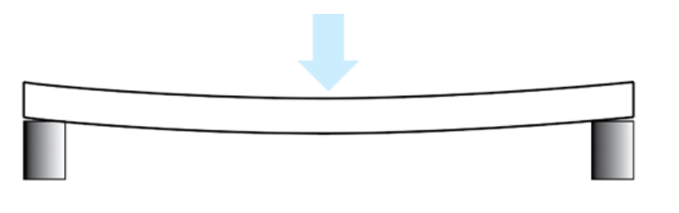
When material bends, it experiences both tension and compression simultaneously.
For example, when the load is applied on a beam, its bottom part experiences tension and its top part experiences compression.
While a layer called the neutral axis runs along the middle of the beam, surprisingly, it experiences zero stresses during bending.
Figure 15 – compression and tension forces in a beam
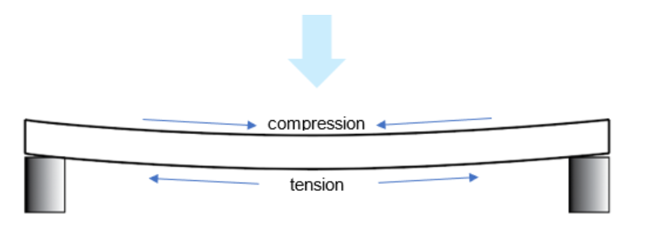
If we built a structure with a material that can’t handle tension and compressive forces, then the structure may collapse, therefore all structures must be designed with materials that can handle the range forces acting upon them.
Tension and compression forces exist within all the structures. An engineer must design a structure able to withstand these forces without failing.

Introducing the I-beam
Activity: read the section ‘What is an I-beam?’ below and answer the questions.

What is an I-beam?
When engineers need to design something like a bridge, skyscraper, or even an open plan house they often use a special type of beam called an I-beam. It is named after its shape – a long, straight piece of metal that looks like a capital letter ‘I’ when viewed from the end.
The top and bottom parts of the I (called the flanges) resist compression and tension, the 2 main forces acting on a beam when it bends. The vertical middle section (called the web) holds the flanges together and helps resist shear forces.
Figure 16 – profile of an I-beam
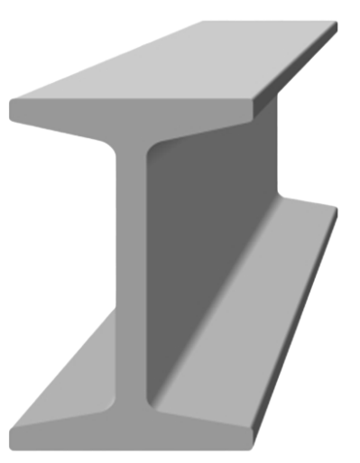
The I-beam gives maximum strength with minimum weight (a good strength to weight ratio). Instead of using a solid block of steel, the I-beam removes material from the centre (where it contributes the least to strength) and keeps it in the areas that matter most – the top and bottom.
Because of this, I-beams:
- use less material (which saves cost and weight)
- can span long distances without bending too much
- are easy to work with and widely available.
- Why is it called an I-beam?
Sample answer:
Because it resembles the shape of the capital letter I.
- What are the names of the 2 main parts of an I-beam?
Sample answer:
1. ______________ (top and bottom)
2. ______________ (middle)
- What types of forces do the flanges resist?
Sample answer:
The top flange resists compressive forces while to bottom flange resists tensile forces in the normal loading of the beam.
- What is the main advantage of using an I-beam instead of a solid steel beam?
Sample answer:
The main advantage of an I-beam is its excellent strength-to-weight ratio. This is achieved through its shape that places the most material in the top and bottom flanges to resist bending and in the web to resist shear forces. This results in superior load-bearing capacity with minimal material use, which lowers costs and makes it suitable for long-span applications.
- Why is the centre (web) thinner than the top and bottom?
Sample answer:
Most of the stress is located at the top and bottom of the beam. Therefore, more material is required in these locations rather than the middle.
Figure 17 – labelling an I-beam
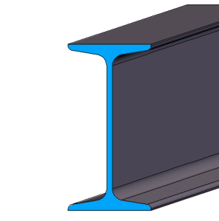
- Label the following parts of the I-beam.
- Top flange.
- Web.
- Bottom flange.

I-beam weakness
Watch the first part of the video The Critical Weakness of the I-Beam (6:13) to see the limitations of I-beams and some of the methods engineers have developed to work with these limitations.

Introducing trusses
A truss, that familiar triangle-filled structure, is just a smarter, more efficient kind of beam. It spreads forces like tension and compression in ways that allow engineers to build lighter, stronger and longer-spanning structures.
Watch the video Understanding and Analysing Trusses (17:40) and answer the questions below.
- Why do engineers use trusses in structures?
Sample answer:
Because trusses allow large spans using smaller, lighter materials. They distribute loads efficiently and are structurally efficient.
- What shape is the key to a strong truss structure? Why?
Sample answer:
Triangles, because they are geometrically stable and cannot change shape without changing the length of a side.
- What happens to a square structure under load compared to a triangle?
Sample answer:
A square will deform into a rhombus without diagonal bracing. A triangle maintains its shape and resists load without bending.
- How does changing the truss design affect the amount of force in each member?
Sample answer:
Changing the angle or position of members can spread the load differently. Some designs reduce the maximum force in each member, making the structure more efficient.
Reflection questions
- Why do you think bridges and roofs often use trusses instead of solid beams?
Sample answer:
Because trusses are lighter, use less material, and can cover long distances while still being strong.
- In your own words, explain how a truss reduces bending in a beam.
Sample answer:
It breaks the beam into smaller elements that carry only tension or compression, so there’s less bending force in the structure overall.

Why are triangles a strong shape?
When engineers design things like bridges or towers, they need to make sure the structure can hold up under weight. This means it shouldn’t collapse or bend when a force is applied – like cars driving over a bridge or wind pushing on a roof.
One shape that helps structures stay strong is the triangle. But why are triangles used so often in construction?
Figure 18 – forces within a triangle frame
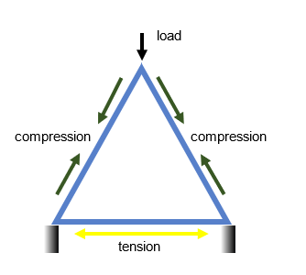
Let’s look at what happens when a force is applied to a triangle.
When a load (force) pushes down on one corner of a triangle, the force travels along the sides. The 2 angled sides of the triangle are pushed in – this is called ‘compression’. The bottom side is pulled outwards – this is called ‘tension’.
Triangles are special because they don’t change shape easily under force. This makes them a smart and stable choice for engineers when building safe, strong structures like trusses and bridges.
Activity: comparing force application on square versus triangle frames
Students will investigate and compare the structural stability and force response of square and triangular frames when external forces are applied, to understand stress distribution and shape stability in engineering design.
Materials
- Thin wooden sticks or straws (all cut to equal lengths, for example, 15 cm)
- Small connectors (thumb tacks or pins)
- Weights (small masses or bags of sand) or a force gauge
- Clamps or fixed supports (optional)
- Ruler or protractor
- Paper and pen for notes and sketches
Instructions
Students prepare 2 frames:
- Square frame: Connect four sticks to form a square.
- Triangle frame: Connect three sticks to form an equilateral triangle.
Ensure all joints are secured but allow some movement as a pinned joint.
Initial observation
Have students observe and sketch both frames. Discuss expectations about which shape might be more stable and why.
Apply forces
- Place each frame on a flat surface.
- Apply a gentle horizontal force at one corner of the square frame and observe deformation. Does it easily change shape?
- Apply a gentle shear force (two forces applied in opposite directions) at the top and bottom of the square frame.
- Repeat both processes for the triangle frame.
- Observe how each frame reacts. Note any deformation.
- Record the observations for each frame under load.
Group discussion
- Why did the square frame deform more easily?
- Why is the triangle more stable under the same forces?
- How does this relate to stress distribution within the shapes?
Discuss real-world applications where triangles provide structural stability (for example, bridges, roof trusses).
Optional
Add diagonal bracing inside the square frame to form 2 triangles and repeat the tests. Observe if or how this improves stability.
Assessment questions
- Why does a square frame deform more easily under force compared to a triangle?
Sample answer:
The square can deform into a parallelogram shape without changing side lengths, making it less rigid.
- What is the significance of internal forces such as tension and compression in maintaining the stability of a triangle frame?
Sample answer:
Triangles transfer tension and compression efficiently; all sides support each other, making it stable.
- How does adding diagonal bracing to a square frame affect its stability? Explain why this is effective.
Sample answer:
Diagonal bracing creates triangles within the square, increasing rigidity and reducing deformation.

Types of trusses
There are an infinite number of truss shapes, but some have become more common because they are efficient, reliable and relatively easy to build.
Prompting question: What are some places you’ve seen trusses used? (Bridges, roofs, cranes, towers)

Warren truss
- Consists of equilateral or isosceles triangles
- Load is distributed evenly
- Members alternate between tension and compression
- Efficient for uniform loads
Figure 19 – Warren truss


Howe truss
- Diagonals face inwards from the top
- Vertical members = tension
- Diagonal members = compression
- Strong under heavy vertical loads (often used in railroad bridges)
Figure 20 – Howe truss
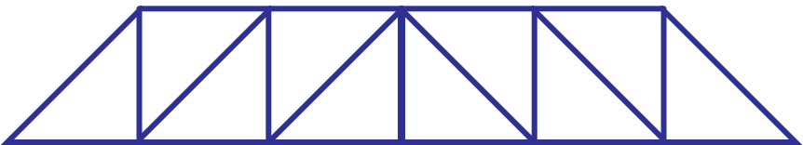

Pratt truss
- Diagonals face outwards from the top
- Vertical members = compression
- Diagonal members = tension
- Efficient for longer spans and variable loads
Figure 21 – Pratt truss

Activity: truss comparison table
Table 19 – truss comparison
Truss type | Key features | Suitable for | Main forces | Examples
Warren | Even triangles, alternating members in tension and compression | Uniform loads | Tension and compression alternating throughout the truss | Roofs, short bridges
Howe | Diagonals inward, verticals in tension | Heavy downward loads | Compression in diagonals | Railway bridges
Pratt | Diagonals outward, verticals in compression | Long spans, changing loads | Tension in diagonals | Pedestrian bridges, towers
Activity: students sketch each truss and use colour coding (for example, red for compression, blue for tension).
- Which truss would you choose for a railway bridge and why?
- Which truss might work best for a lightweight roof frame?
- Why is understanding tension and compression important in choosing a truss design?

Introduction to engineering drawing
Engineering drawing is the universal language of engineers. Before a bridge, machine or product is manufactured, it must first be drawn and communicated to the construction team. A well-prepared drawing allows ideas to be shared, tested and constructed accurately. Unlike freehand sketches, technical drawings follow strict standards so that engineers and builders anywhere in the world can understand the same design. These drawings show more than just the shape of an object, but also its dimensions, materials and how it fits with other parts. In this way, drawings ‘bridge the gap’ between an idea and the finished product, ensuring that a design can be built safely, efficiently and exactly as intended.

AS 1100 Standards
For engineering drawings to be understood anywhere in the world, they must follow a common set of rules. Without standards, every engineer or company might draw things differently, leading to mistakes, delays, or unsafe products. In Australia, we use the AS 1100 drawing standards, which ensure that all technical drawings follow the same conventions for line types, dimensioning, scales and projections. These standards align with international conventions, meaning that a drawing prepared here can be interpreted correctly in any country. This universal ‘language of drawing’ allows engineers, manufacturers and builders across the globe to collaborate and produce accurate, reliable designs.
Activity: think-pair-share ‘Why do we need standards in engineering drawings?’
Task: students discuss with a partner, ‘What problems might happen if every country or engineer used their own style of drawing?’
Sample answer:
If everyone used different drawing rules, construction workers and builders could misinterpret dimensions and make mistakes. For example, a part might be cut to the wrong size or assembled the wrong way. This could make the product unsafe or mean that time and money is wasted fixing the mistake.
Why is it so important for bridge designs to be universally accessible?
Sample answer:
Because bridges are very large projects involving teams of engineers, builders and suppliers from different places and different backgrounds. Everyone needs to understand and interpret the drawings and the same way to avoid mistakes in construction.
Orthogonal projection
Orthogonal (or orthographic) drawing is a method of showing a 3D object in 2D views.
It is the industry standard for communicating exact shapes, sizes and details.
In Australia, third-angle projection is the system used as per Australian Standards (AS 1100).
Figure 22 – symbol for third angle projection
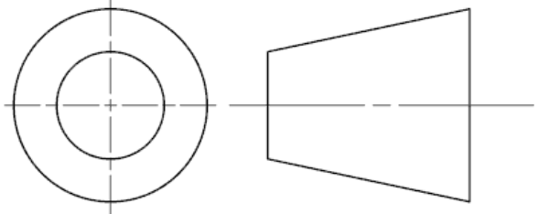

Why use orthogonal drawings?
Pictorial drawings (such as isometric drawings) show what an object looks like, but they are often not precise enough for manufacture.
Orthogonal drawings provide accurate measurements and clear details needed to build a product.
A minimum of 2 views (front and top) are required, but usually 3 views are required (front, top and side).
Each view is aligned or projected from each other. Normally the top and side views are projected from the front view.
View details:
- front view: main shape and detail
- top view: shows width and depth
- side view: shows height and depth.

Orthogonal drawing rules and standards (AS 1100)
- Third-angle projection symbol must be shown.
- Views are aligned horizontally and vertically.
- Hidden detail is shown with dashed lines.
- Centre lines mark symmetry and holes.
- Dimensioning shows real-world size, not the scaled drawing size.
- Line types must follow standard (thick outlines, thin construction, dashed for hidden).
Example (bridge application)
A truss bridge drawn pictorially in 3D shows its general shape.
Orthogonal drawings break it down into front, top and side views, with each member shown in true length and can be dimensioned.
This allows accurate cutting of materials and assembly.

Why do we need to have more than one view?
Figure 23 – red flag attached to extended pipe

Activity: referring to the image, ask students:
- From behind the vehicle, how do we know how long the pipe sticks out?
- Why is there a flag on the end of the pipe?
Prompt for class discussion:
From one view (rear view), the pipe only looks like 2 small circles – you can’t tell the true length. You need a side view to see how far it extends from the back of the vehicle.
Note: the flag allows the drivers behind to more accurately gauge the distance from the flag, and therefore the end of the long load. It is a legal requirement over certain lengths.
- Identify 2 other examples of objects or situations where more than one view is required.
Sample answers:
- Front door key: from the end it looks like a flat metal strip, from the side you see the unique detail of the grooves and teeth of the key that identifies it as the key to use for the front door.
- Balcony overhang on a building: directly from the front of the building it is difficult to see how big the area is on each balcony. From the side of the building, you can see more clearly how far the balcony extends from the building, therefor better able to calculate the approximate area.
Note: the use of simple objects such as timber shapes can be presented to the class to help illustrate that if we were asked to manufacture a replica of the object, then looking at it from only one view would not be adequate. You would need to view the object from at least 2 viewpoints to gather the required information/dimensions.

Orthogonal projection introductory exercises
The following CAD drawings can be used as a series of introductory manual orthogonal drawing exercises.
The timing required for this section will vary on the class and the level of experience and understanding of manual drawing techniques.
Manual drawing equipment is required for these activities, including:
- drawing boards and T squares
- set squares
- 0.5 mechanical pens (preferred) or sharp 2B pencils
- method of attaching drawing sheet to the board such as tape or drawing board clips (preferred)
Points to consider for each sheet when delivering and demonstrating the introductory exercises are:
- title block and page border
- setting out, providing a start point to ensure the object views fit appropriately on the page and are spaced evenly
- projecting the top and side views from the front view
- labelling each view
- (optional) dimensioning standards.

Figure 24 – exercise 1
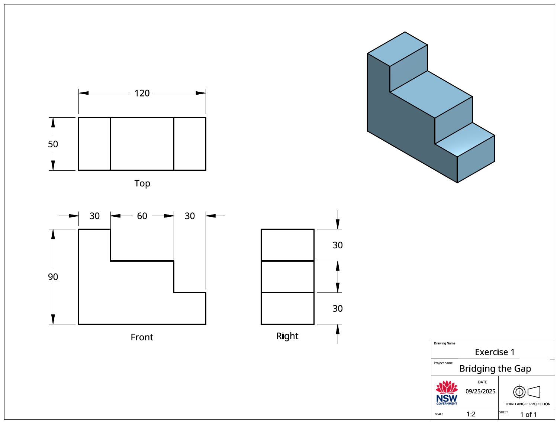
Figure 25 – exercise 2
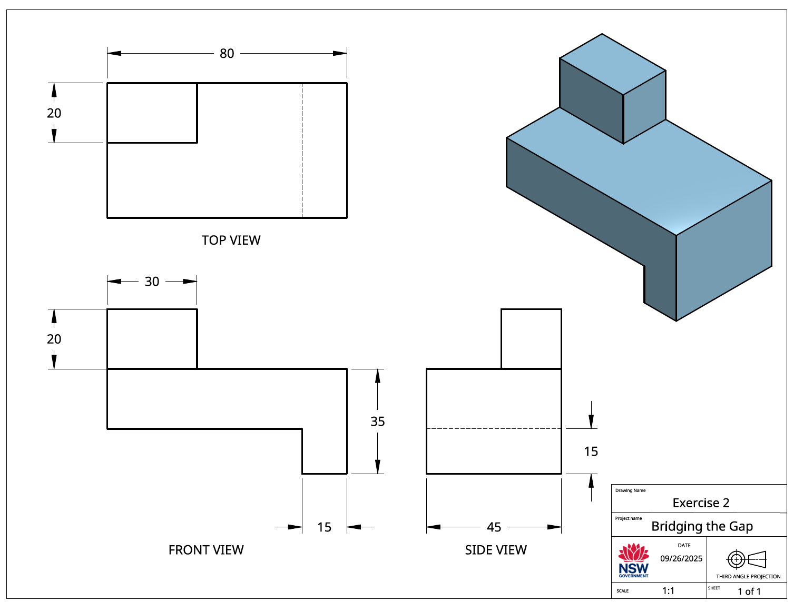
Figure 26 – exercise 3
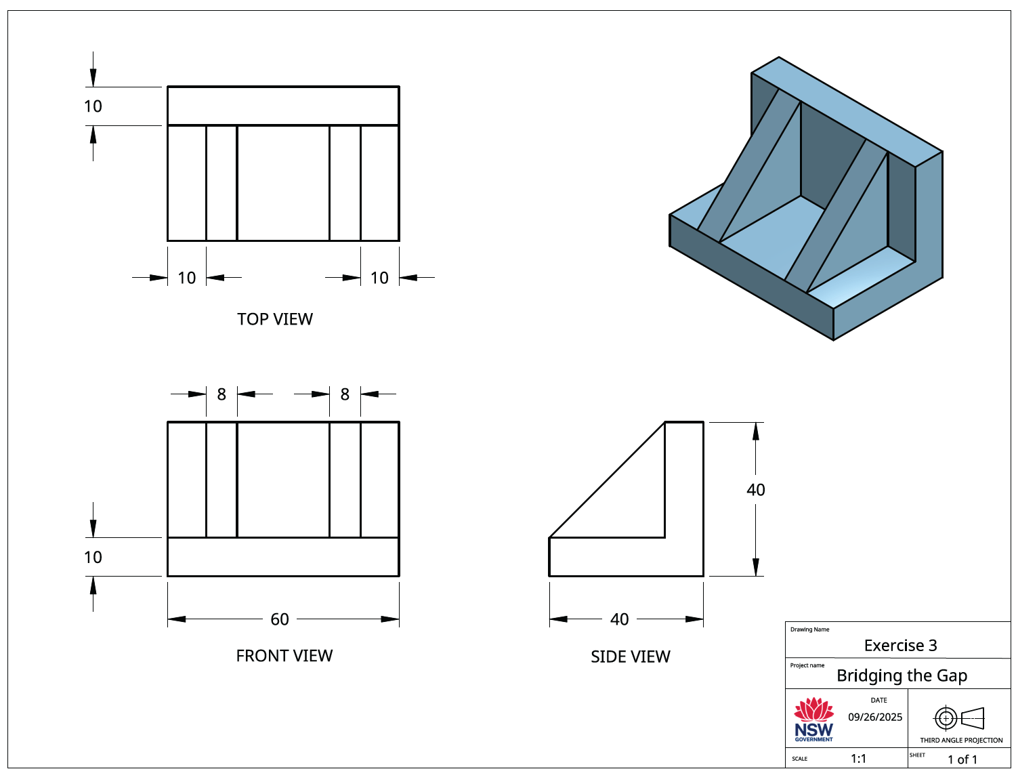
Figure 27 – exercise 4
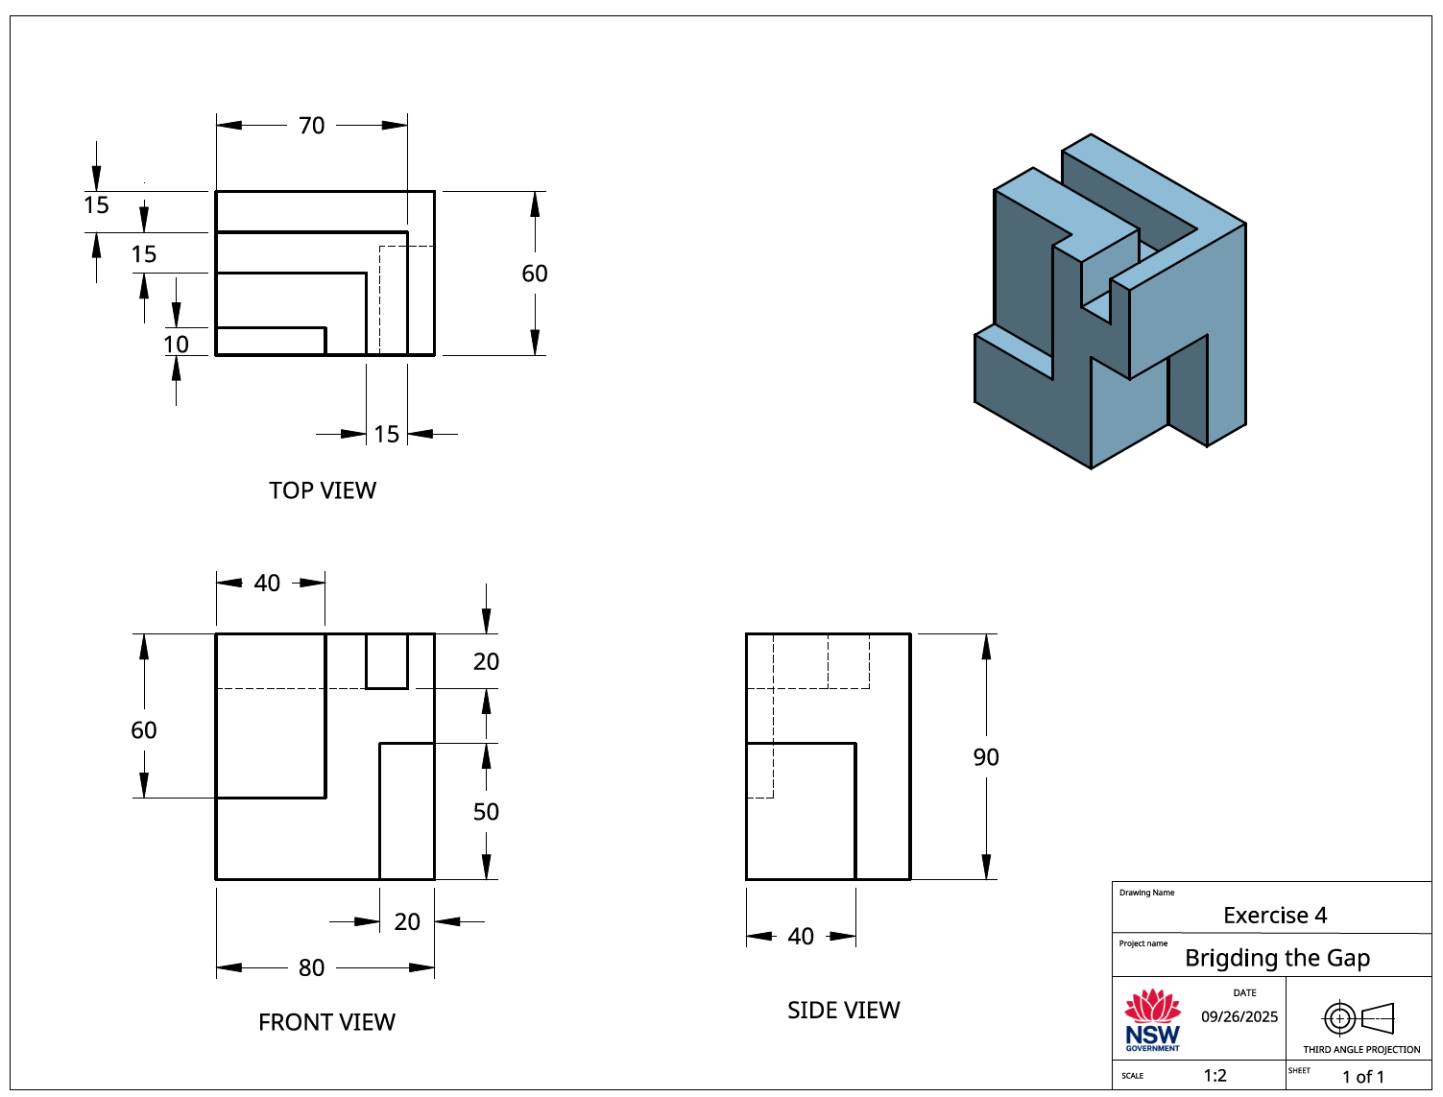
Figure 28 – exercise 5
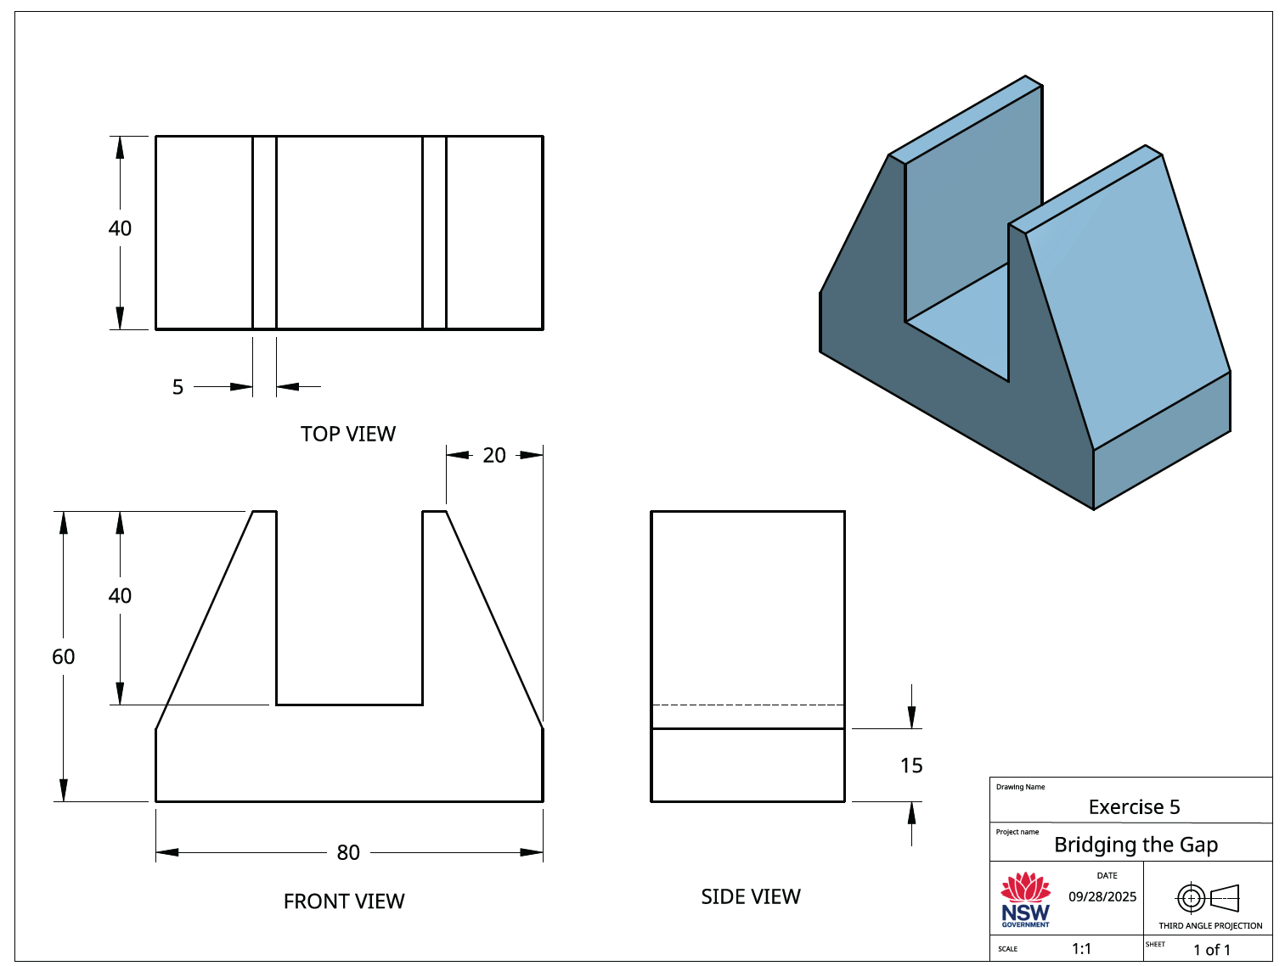

‘Bridging the gap’ assessment task
Students design, construct and test a model truss bridge using 3 mm × 3 mm balsa wood and a standardised roadway section.
Figure 29 – model truss bridge design specifications
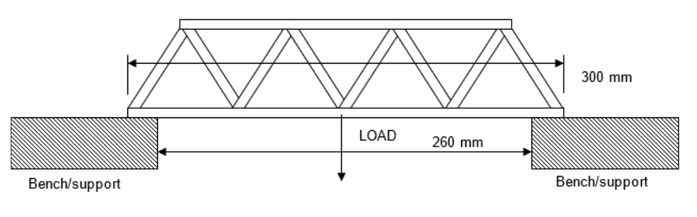
Dimensions
- Total length: 300 mm
- Span: 260 mm
- Roadway: 40 mm × 1.5 mm
- Truss balsa: 3 × 3 mm (cross section)
Materials
- 2 pieces of 3 × 3 mm square 915 mm lengths of balsa wood
- 1 piece of 300 mm × 40 mm × 1.5 mm balsa wood (roadway)
- Suitable balsa wood adhesive
This assessment task is designed to be delivered over 10 weeks. The following table provides a suggested breakdown of components and timing.
Table 20 – assessment preparation schedule
Steps | Student actions and timeline
Task introduction and research | Week 11  - Review assessment outline  - Research different truss bridge designs (for example, Warren, Pratt, Howe)  - Record key features and advantages
Design development | Week 12  - Reference the truss research to guide your designs  - Produce 3 design proposals (with sketches with annotations)  - Consider efficient use of materials and strength-to-weight ratio
Design justification and final drawing | Week 13  - Select the preferred design  - Write a one-page justification comparing proposals  - Produce an A3 orthogonal drawing of the final design
Construction | Week 15  - Cut and assemble the bridge from 3 mm × 3 mm balsa wood  - Ensure the bridge matches the drawing  - Apply safe work practices
Testing | Week 17  - Record the mass of completed bridge  - Participate in load testing  - Record the maximum load and calculate the strength-to-weight ratio
Evaluation and report submission | Weeks 19–20  - Analyse bridge failure points  - Suggest improvements to design for efficiency  - Compile testing data and final evaluation into a short engineering report

Considerations when delivering the assessment task
The focus for this activity is on the strength to weight ratio, not the ultimate strength of the truss design. A predetermined maximum load (for example, 20 kgs) allows for more effective planning and implementation of the testing procedures.
It is recommended that the standardised roadway be implemented as this will ensure the students truss design is the focus of the test results. The standard roadway also provides a more consistent testing procedure. Building this component step by step together as a class allows the opportunity for teacher demonstration of safe working procedures and correct cutting and gluing procedures. Extreme care is required when using sharp edge blades such as craft knives or box cutters.
Fastening the truss side members to the outside of the roadway, instead of the top of it will maximise the potential load carrying capabilities of the truss.
Once the students complete their A3 orthogonal drawing of the bridge design, it is recommended that an A3 copy is made and given back the students so they can use it a template during the construction phase of their bridge.
Using a set of digital kitchen scales is an effective method of weighing each bridge prior to testing.
Details of a suggested testing apparatus is provided in the sample assessment task.
Loading the bridge using water allows for a more even or gradual increase of the load. A large water bucket is required as a reservoir for students to scoop and pour into the container.
Using a large funnel or similar students can load their own bridges by pouring the water into the suspended container. A standard 22 L water jerrycan works well for this purpose (see image below). The construction of a cradle or holder for the water container is suggested. This is to minimise the chances of the container tipping during testing or from sudden bridge failure.
Weighing the container with water can be achieved by standard bathroom scales or more accurately with a fisherman scale (see image below).
If possible, it is recommended that a camera is set up to record each bridge test. This allows the student to replay, pause or slow down the moment of failure. This can assist in their analysis and evaluation as part of the submitted engineering report.

Testing reference images
Table 21 – testing reference images
Item | Image
3 × 3 mm balsawood section. Usually available in 1 m lengths. | 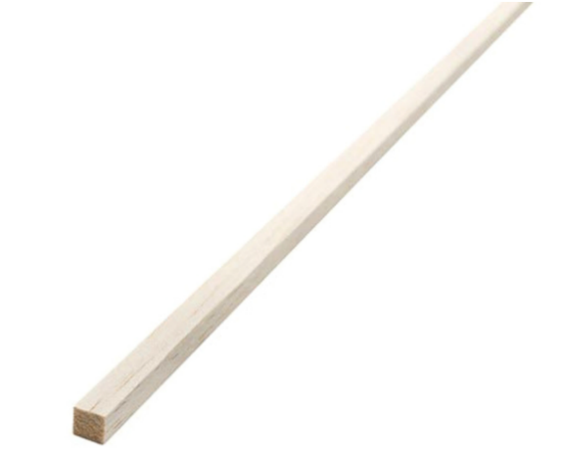
1.5 mm balsa wood 100 mm wide sheet. Normally available in 915 mm lengths.  Note: this will need to be cut to 40 mm widths. A balsa stripper is recommended for this (see below). | 
Balsa wood stripper. Used to slice the 1.5 mm sheet into 40 mm wide sections. | 
Art knife | 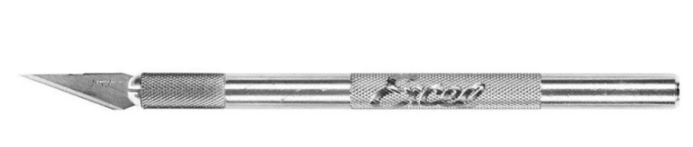
Adhesives: fast setting is desirable, however standard PVA works well. |   or  
Standard roadway | 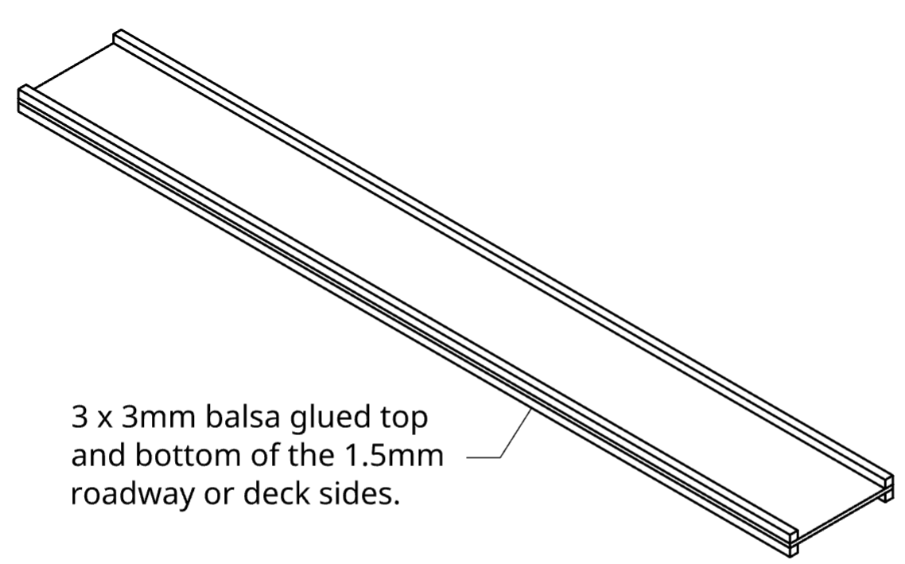
Sample completed bridge | 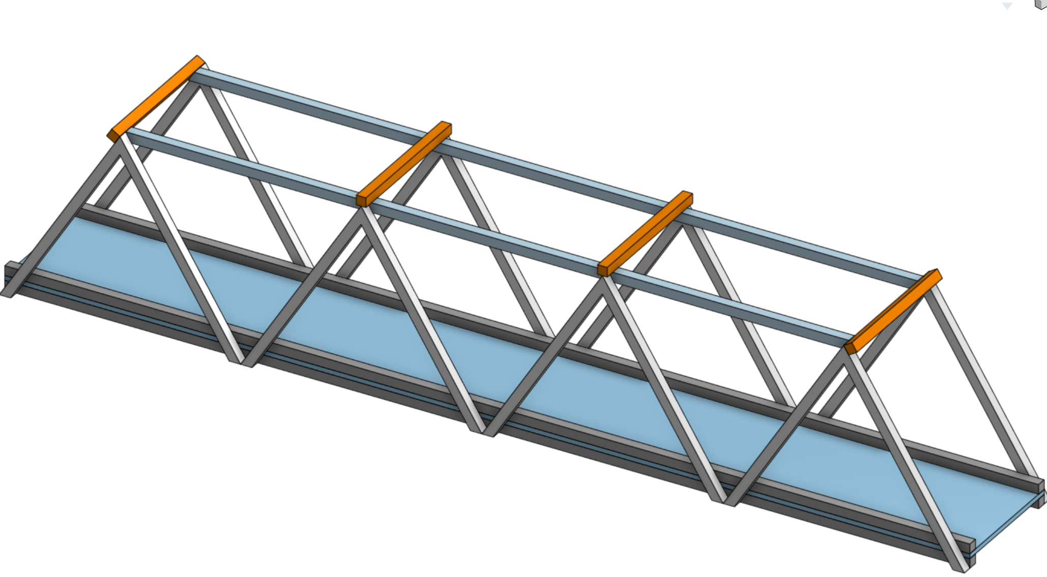
Suggested testing apparatus | 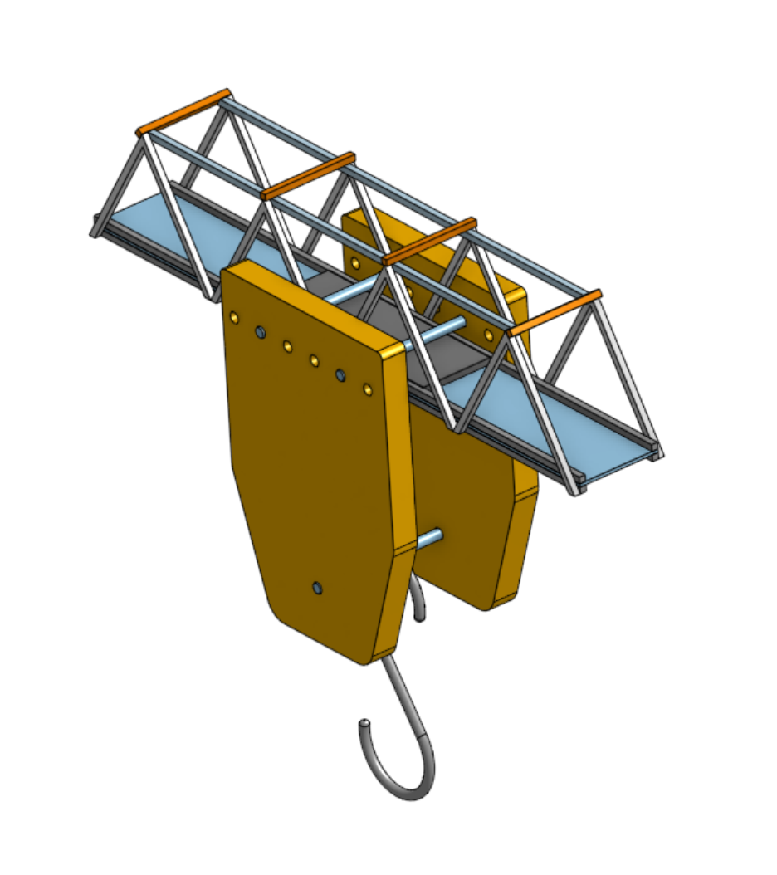
Suitable water container | 
Funnel | 
Fisherman scales | 

References
This resource contains NSW Curriculum and syllabus content. The NSW Curriculum is developed by the NSW Education Standards Authority (NESA). This content is prepared by NESA for and on behalf of the Crown in right of the State of New South Wales. The material is protected by Crown copyright.
Please refer to the NESA Copyright Disclaimer for more information https://www.nsw.gov.au/education-and-training/nesa/copyright.
NESA holds the only official and up-to-date versions of the NSW Curriculum and syllabus documents. Please visit NESA https://www.nsw.gov.au/education-and-training/nesa and NSW Curriculum https://curriculum.nsw.edu.au.
Engineering Technology 7–10 Syllabus © NSW Education Standards Authority (NESA) for and on behalf of the Crown in right of the State of New South Wales, 2024.
BBC (25 October 2026) ‘Brian Cox visits the world's biggest vacuum | Human Universe – BBC’ [video], BBC, YouTube, accessed 1 April 2026.
Deadly Story (n.d.) ‘Engineering’, Life & Lore, Deadly Story website, accessed 1 April 2026.
Engineers Australia (25 July 2025) ‘Engineering. Making Life Happen.’ [video], Engineers Australia, YouTube, accessed 1 April 2026.
——(2026) Champion the people and projects redefining engineering, Engineers Australia website, accessed 1 April 2026.
James Sword Engineering (17 August 2026) ‘Understanding The Different Mechanical Properties Of Engineering Materials.’ [video], James Sword Engineering, YouTube, accessed 1 April 2026.

© State of New South Wales (Department of Education), 2026
The copyright material published in this resource is subject to the Copyright Act 1968 (Cth) and is owned by the NSW Department of Education or, where indicated, by a party other than the NSW Department of Education (third-party material).
Copyright material available in this resource and owned by the NSW Department of Education is licensed under a Creative Commons Attribution 4.0 International (CC BY 4.0) license.

This license allows you to share and adapt the material for any purpose, even commercially.
Attribution should be given to © State of New South Wales (Department of Education), 2026.
Material in this resource not available under a Creative Commons license:
- the NSW Department of Education logo, other logos and trademark-protected material
- material owned by a third party that has been reproduced with permission. You will need to obtain permission from the third party to reuse its material.
Links to third-party material and websites
Please note that the provided (reading/viewing material/list/links/texts) are a suggestion only and implies no endorsement, by the New South Wales Department of Education, of any author, publisher, or book title. School principals and teachers are best placed to assess the suitability of resources that would complement the curriculum and reflect the needs and interests of their students.
If you use the links provided in this document to access a third-party's website, you acknowledge that the terms of use, including licence terms set out on the third-party's website apply to the use which may be made of the materials on that third-party website or where permitted by the Copyright Act 1968 (Cth). The department accepts no responsibility for content on third-party websites.

