Engineering Technology 7–10 – Structures – sample assessment task notification
Bridging the gap
Contents
Task description 3
Task description 4
Design phase 4
Construction phase 5
Testing and evaluation phase 5
Submission details 6
Steps to success 7
What is the teacher looking for? 9
Marking guidelines 10
Student-facing rubric 14
Teacher support material 16
Suggested testing procedures 17
Suggested loading procedure 18
Student support material 20
Sample drawing 20
Sample student engineering report format 21
Bridging the gap cover page 21
Research 21
Design development 21
Design justification and final drawing 21
Construction 22
Testing 22
Analysis and evaluation 23
Sustainability of engineered structures 23
Student checklist 24
Support and alignment 25
Evidence base 26

Task description
Type of task: a model bridge will be designed, constructed and tested to ascertain the relative success of the design. The assessment will be completed both in class and at home. It requires components to be handed in at different times.
Outcomes being assessed
A student:
- applies risk management and safe work practices in engineering contexts EGT5-SAF-01
- communicates ideas, concepts and solutions for engineering practice EGT5-COM-01
- investigates and evaluates engineering systems and solution EGT5-EVL-01
- develops and applies technical graphics in engineering contexts EGT5-GRP-01
- applies mechanical analysis and practical testing to investigate engineering concepts
EGT5-MEA-01
- selects and applies materials for engineering projects EGT5-USE-01
Engineering Technology 7–10 Syllabus © NSW Education Standards Authority (NESA) for and on behalf of the Crown in right of the State of New South Wales, 2024.
Suggested weighting: 25%
Students will design, construct, test and evaluate a truss bridge structure.

Task description
Students design, construct, and test a model truss bridge using 3 mm × 3 mm balsa wood and a standardised roadway section.
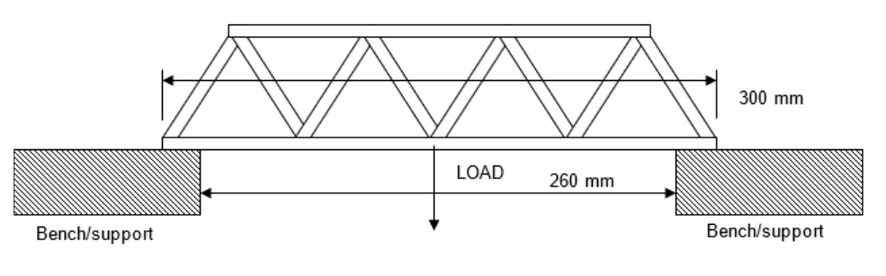
Dimensions
- Total length: 300 mm
- Span: 260 mm
- Roadway: 40 mm × 1.5 mm
- Truss balsa: 3 mm × 3 mm (cross section)
Materials
- 2 pieces of 3 mm × 3 mm square 915 mm lengths of Balsa wood
- 1 piece of 300 × 40 × 1.5mm balsa wood (roadway)
- Suitable balsa wood adhesive

Design phase
- Each student develops 3 different truss bridge design proposals. Note: the emphasis is on efficient use of materials and achieving a high strength-to-weight ratio rather than maximum strength.
- The bridge design must allow a small matchbox® car (or similar) to pass across the bridge.
- Students justify their final design selection using engineering principles and comparisons with the other proposals.
- Students produce an A3 orthogonal drawing of the selected design following AS 1100 standards with overall and critical dimensions and annotations.
- The drawing should be 1:1 scale to allow it to be printed as a construction template.

Construction phase
- Students build the bridge model according to the final drawing.
- Bridges must span 300 mm with a minimum width of 40 mm.
- All bridges must be constructed only from 3 mm × 3 mm balsa wood and PVA glue.
- Use the provided standard roadway section to maintain design and testing consistency. Refer to the images for guidance.
- The bridge should be constructed like a model aircraft, by cutting, pinning and glueing while overlaying the drawing.

Testing and evaluation phase
- Measure and record the mass of each bridge before testing.
- Test each bridge by suspending a 20 L container beneath the structure and gradually filling it with water until it breaks (see suggested testing procedures).
- Record the maximum load supported.
- The strength-to-weight ratio is calculated by multiplying the load carried (L) in kilograms by 1000, then dividing by the bridge mass (m) in grams.
$$Ratio =\frac{\left(L\right)kgs ×1000}{\left(m\right)g}$$
- Analyse failure points and propose improvements to reduce weight without compromising load-carrying ability.

Submission details
Table 1 – bridge design project requirements
Project component | Requirements
Design sketches | - Three design proposals presented as A4 page sketches with annotations.
Final design | - Final A3 orthogonal drawing to AS 1100 standards, including a title block.  - Justification for the selection of the final design.
Constructed bridge model | - Bridge model submitted prior to testing.
Engineering report | - Justification (up to one page) comparing and evaluating the 3 design proposals.  - Details of the construction procedures undertaken in building the bridge.  - Testing data and truss evaluation documented.

Steps to success
Table 2 – assessment preparation schedule
Steps | Student actions and timeline
Task introduction and research | Week 11  - Review assessment outline  - Research different truss bridge designs (for example, Warren, Pratt, Howe)  - Record key features and advantages
Design development | Week 12  - Reference the truss research to guide your designs  - Produce 3 design proposals (with sketches and annotations)  - Consider efficient use of materials and strength-to-weight ratio
Design justification and final drawing | Week 13  - Select the preferred design  - Write a one page justification comparing proposals  - Produce an A3 orthogonal drawing of the final design.
Construction | Week 15  - Cut and assemble the bridge from 3 mm × 3 mm balsa wood  - Ensure the bridge matches the drawing  - Apply safe work practices
Testing | Week 17  - Record the mass of completed bridge  - Participate in load testing  - Record the maximum load and calculate the strength-to-weight ratio
Evaluation and report submission | Week 19–20  - Analyse bridge failure points  - Suggest improvements to design for efficiency  - Compile testing data and final evaluation into a short engineering report

What is the teacher looking for?
- Safe use of tools, equipment and materials when designing, constructing and testing your bridge.
- Clear communication of your ideas through labelled sketches, orthogonal drawings and correct use of engineering terms.
- Evidence that you have investigated and compared different truss bridge designs to decide on the most efficient option.
- A well-justified final design choice that explains why it is the best use of materials.
- Accurate construction of your bridge that matches your final drawing.
- Correct measurement and recording of the mass of your bridge and the maximum load it carries.
- Accurate calculation of the strength-to-weight ratio.
- An evaluation that explains, using engineering terminology, how your bridge performed, where it failed, and how it could be improved.
- Consideration of how efficient use of materials relates to sustainability in engineering design.

Marking guidelines
Table 3 – assessment marking guidelines
Grade | Marking guideline descriptors
A | The student:  - consistently demonstrates safe and responsible use of tools, equipment and materials throughout all stages of the task  - produces 3 highly detailed truss designs with clear, accurate sketches and annotations and uses precise engineering terminology and conventions consistently  - provides a detailed and logical justification for the final design, making clear, well-supported comparisons between proposals and explaining efficiency of material use  - produces an accurate, highly detailed orthogonal drawing to AS 1100 standards, including all required dimensions, title block and neat presentation  - constructs a bridge with a high degree of accuracy to match the final drawing and ensures excellent quality of joints and assembly while meeting all specifications  - accurately measures and records bridge mass and maximum load and correctly calculates strength-to-weight ratio with no errors  - provides a highly detailed evaluation of bridge performance, clearly identifying failure points and suggesting well-justified improvements for efficiency and sustainability  - presents a clear understanding of the importance of sustainable design in engineering.
B | The student:  - frequently demonstrates safe and responsible use of tools, equipment and materials  - produces 3 well-developed truss designs with clear sketches and annotations and uses engineering terminology and conventions appropriately  - provides a thoughtful justification for the final design, with clear comparisons between proposals and some reference to material characteristics  - produces a mostly accurate orthogonal drawing to AS 1100 standards, with most dimensions and required features included  - constructs a bridge that closely matches the final drawing with good quality of joints and assembly and meets most specifications  - accurately measures and records bridge mass and load with minor errors and correctly calculates strength-to-weight ratio  - provides a detailed evaluation of bridge performance, identifying failure points and suggesting realistic improvements  - presents some understanding of the importance of sustainable design in engineering.
C | The student:  - usually demonstrates safe use of tools, equipment and materials  - produces three truss designs with adequate sketches and annotations and uses some correct terminology  - provides a general justification for the final design with some comparisons between proposals  - produces a drawing with some required features and dimensions, presented with some accuracy  - constructs a bridge that mostly matches the final drawing with reasonable quality of joints and assembly and meets some specifications  - measures and records mass and load with some accuracy and attempts calculation of strength-to-weight ratio with minor errors  - provides a general evaluation of bridge performance, identifying some failure points and suggests general improvements  - presents characteristics of sustainable considerations when designing engineered structures.
D | The student:  - sometimes demonstrates safe use of tools, equipment and materials  - produces one or two basic sketches with limited annotations and uses some general engineering terms  - provides a limited justification for the final design with minimal comparison of proposals  - produces a drawing with limited features or dimensions and contains inaccuracies  - constructs a bridge that shows limited similarity to the final drawing with poor quality of joints and assembly and meets few specifications  - provides limited measurements and attempts calculation but with major errors  - provides a limited evaluation with little detail on performance, failure points or improvements  - presents some consideration of the importance of sustainable designs.
E | The student:  - rarely demonstrates safe use of tools, equipment and materials  - produces very limited or incomplete sketches with minimal communication of ideas  - provides little or no justification of design choice  - produces a very incomplete or unclear drawing with little relevance to the final design  - constructs a bridge that does not match the final drawing or specifications with very poor quality of construction  - provides little or no measurement or calculation  - provides little or no evaluation of performance  - presents little or no reference to the importance of sustainable design.

Student-facing rubric
Table 4 – rubric for assessment
Criteria | Limited | Basic | Sound | High | Outstanding
Safe work practices | Rarely follows safety instructions when using tools and materials. | Sometimes follows safety instructions but often needs reminders. | Usually follows safety instructions and uses tools safely. | Consistently follows safety instructions with care and responsibility. | Always demonstrates excellent safety awareness and sets a positive example for others.
Design and communication | Produces few or unclear sketches with little explanation. | Produces some sketches with limited detail and explanation. | Produces 3 clear sketches with some annotations. | Produces 3 detailed sketches with clear annotations and correct use of terms. | Produces 3 highly detailed designs with high quality sketches, clear annotations and precise engineering language.
Bridge construction | Bridge is incomplete or poorly made and does not meet specifications. | Bridge is roughly made with several errors and only partly meets specifications. | Bridge is complete, reasonably accurate and meets most specifications. | Bridge is well made, accurate relative to the drawing and meets all specifications. | Bridge is constructed with excellent accuracy and quality, closely matching the drawing and exceeding specifications.
Testing and evaluation | Provides little or no testing data or reflection. | Provides some testing data but with errors and limited reflection. | Provides testing data and a basic evaluation of bridge performance. | Provides accurate testing data and a clear evaluation, including some suggestions for improvement. | Provides very accurate testing data and a detailed evaluation, clearly identifying failure points and suggesting realistic improvements for efficiency and sustainability.
Sustainable design | Presents little or no reference to the importance of sustainable design. | Presents some consideration to the importance of sustainable design. | Presents characteristics of sustainable considerations when designing engineered structures. | Presents some understanding of the importance of sustainable design in engineering with examples. | Presents a clear understanding of the importance of sustainable design in engineering with specific examples.

Teacher support material
It is suggested that a consistent roadway or deck be used to construct the bridges. This ensures that the truss design is part of the structure being tested. It is also suggested that students attach their truss designs to the outside of the roadway.
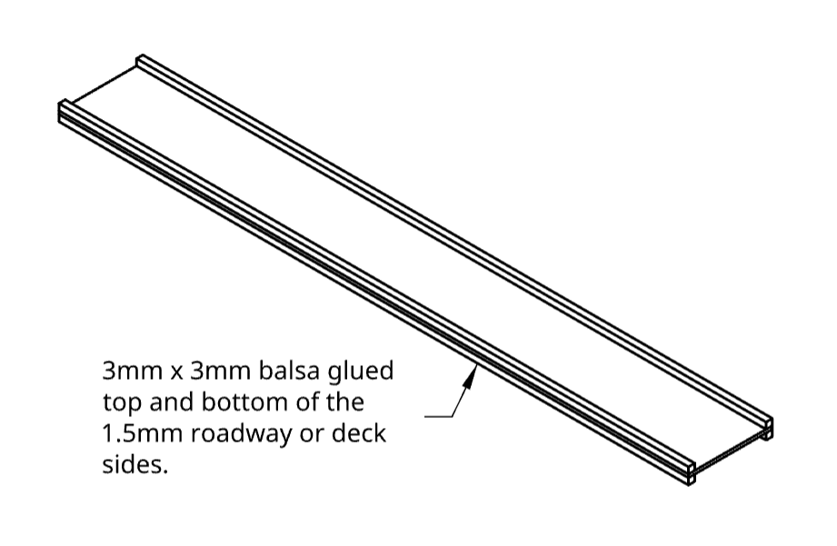

Suggested testing procedures
There are many ways to load the students’ bridges. This is only a suggested method of testing the bridges.
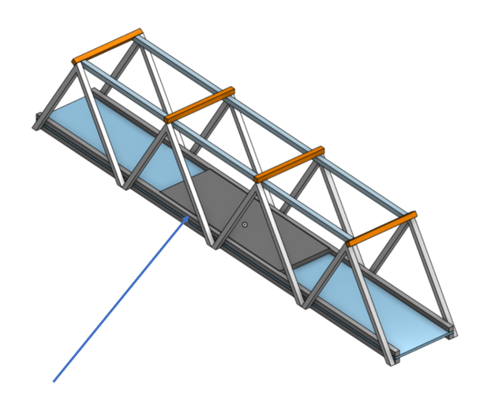
Place a 100 mm × 35 mm × 3 mm piece of timber (plywood) on the roadway. This ensures that the load is distributed across a consistent area for all bridges. The 3 mm thickness also allows the load to be spread across both sides of the roadway as well as the 1.5 mm deck.

Suggested loading procedure
To apply consistent and even loading for each bridge, a suggested method is shown in the diagram below. Each end of the bridge will need to be supported by a desk or other solid surface. A span of 260 mm ensures 20 mm of support of both ends.
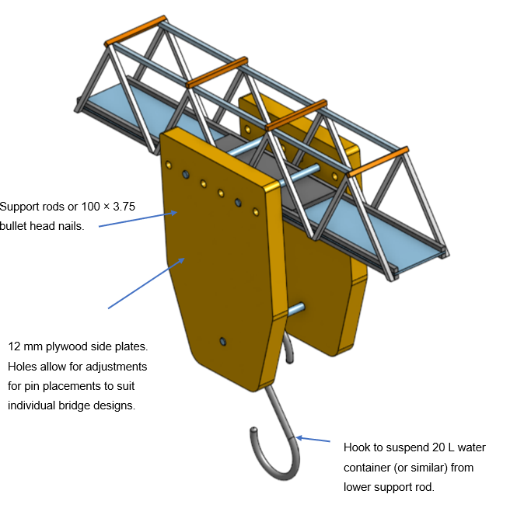
Suspended from the hook would be a suitable container that can be filled with water. Using a funnel, students can fill the container steadily increasing the load on their bridge design.
Once the predetermined weight is supported, the container can be unhooked.
Alternatively, if the bridge fails, the container of water can be weighed to determine the maximum strength-to-weight ratio for the bridge design.

Student support material

Sample drawing
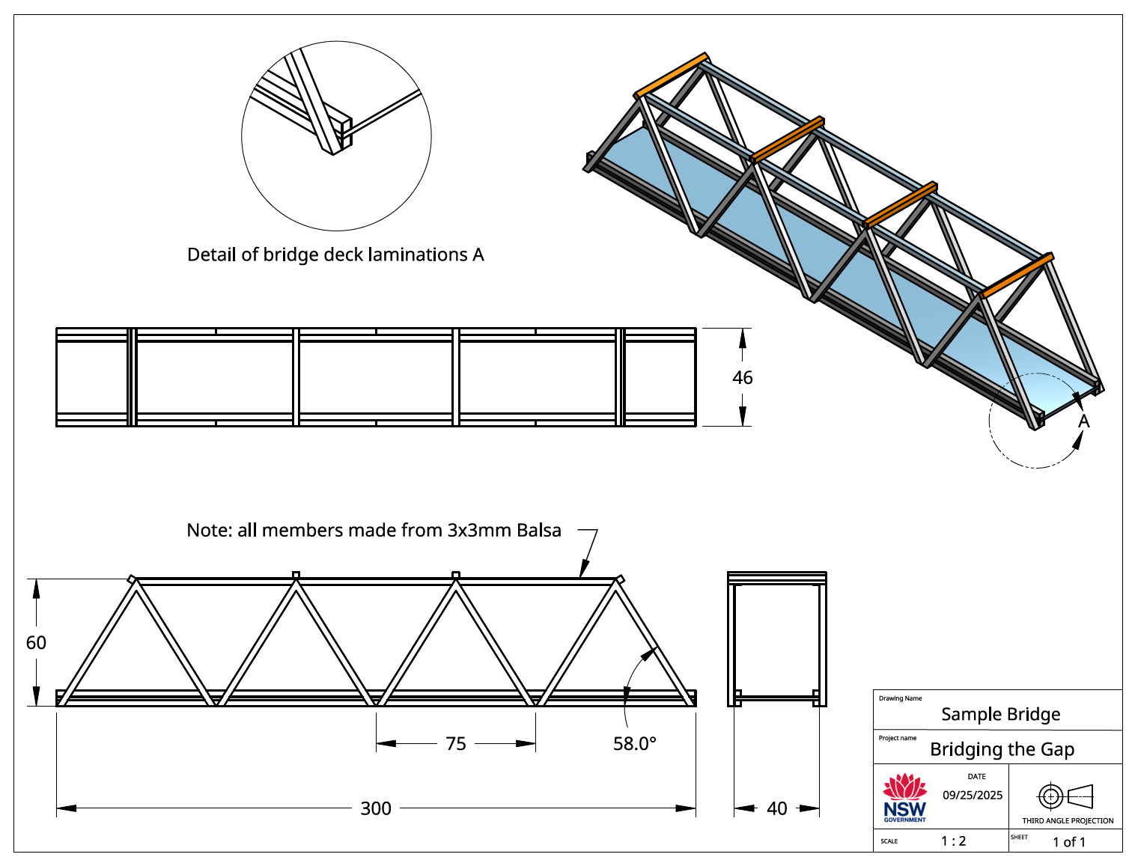

Sample student engineering report format

Bridging the gap cover page
Include:
- report title
- your full name
- date
- class and teacher's name.

Research
- Identify and describe 3 truss designs (for example, Warren, Pratt, Howe).
- For each design, explain
- advantages
- disadvantages
- a real-world example of its use.

Design development
- Present your 3 proposed truss designs (one design per A4 page).
- Include annotations and labels to explain structural features (for example, tension members, compression members, joints).
- Use correct engineering terminology.

Design justification and final drawing
- Select the design you believe is most suitable for the challenge.
- Provide a written justification
- Why is this design more efficient than your other 2 options?
- How does it use materials effectively?
- How can it be made satisfactorily?
- Include your final A3 orthogonal drawing to AS 1100 standard with title block and basic dimensions.

Construction
Detail the construction procedures undertaken in building the bridge. Include:
- materials used
- adhesives
- basic assembly and construction procedures
- quality control checks (for example, alignment, joint fit and symmetry)
- include labelled photos (if possible) to show key stages of construction.

Testing
Record:
- mass of the bridge in grams
- maximum load supported in kilograms
- strength-to-weight ratio calculation
- strength-to-weight ratio.
$$Ratio =\frac{\left(L\right)kgs ×1000}{\left(m\right)g}$$
Present the results in a table format.

Analysis and evaluation
Include details of how the bridge performed.
Points to consider:
- Did it support the predetermined maximum load?
- Identify failure points if any and suggest improvements.
- How could the design be improved?
- How could the strength-to-weight ratio be improved?

Sustainability of engineered structures
Write a brief statement outlining the importance of sustainable designs in engineering.
Consider:
- efficient use of materials
- environmental impacts
- longevity of structures.

Student checklist
- A clear cover page with all required details.
- Research section with 3 truss designs described and examples provided.
- Three design proposals, clearly labelled with annotations.
- A justification of your final design with an orthogonal drawing included.
- A construction section explaining materials, methods and quality control.
- A testing section with bridge weight, load and strength-to-weight ratio correctly calculated.
- An analysis and evaluation that identifies performance, failure points and improvements.
- A short statement on the sustainability of engineered structures.
- Correct use of engineering terminology throughout.
- Work is neat, well organised and free of spelling and grammar errors.

Support and alignment
Resource evaluation and support: all curriculum resources are prepared through a rigorous process. Resources are periodically reviewed as part of our ongoing evaluation plan to ensure currency, relevance and effectiveness. For additional support or advice, or to provide feedback, contact the TAS Curriculum team by emailing TAS@det.nsw.edu.au.
Differentiation: further advice to support Aboriginal and/or Torres Strait Islander students, students learning English as an additional language or dialect (EAL/D), students with a disability and/or additional needs and high potential and gifted students can be found on the Planning programming and assessing 7–12 webpage. This includes the Inclusion and differentiation advice 7–10 webpage.
Assessment: further advice to support formative assessment is available on the Planning programming and assessing 7–12 webpage. This includes the Classroom assessment advice 7–10. For summative assessment tasks, the Assessment task advice 7–10 webpage is available.
Explicit teaching: further advice to support explicit teaching is available on the Explicit teaching webpage. This includes the CESE Explicit teaching – Driving learning and engagement webpage.
Consulted with: Curriculum and Reform, Inclusive Education, Aboriginal Education Committee, Explicit Teaching and subject matter experts.
Alignment to system priorities and/or needs: School Excellence Policy, Our Plan for NSW Public Education.
Alignment to the School Excellence Framework: this resource supports the School Excellence Framework elements of curriculum (curriculum provision) and effective classroom practice (lesson planning, explicit teaching).
Alignment to Australian Professional Standards for Teachers: this resource supports teachers to address Proficient Teacher Standard Descriptors 3.2.2, 3.3.2.
Creation date: 25 February 2026.

Evidence base
This resource contains NSW Curriculum and syllabus content. The NSW Curriculum is developed by the NSW Education Standards Authority (NESA). This content is prepared by NESA for and on behalf of the Crown in right of the State of New South Wales. The material is protected by Crown copyright.
Please refer to the NESA Copyright Disclaimer for more information https://www.nsw.gov.au/education-and-training/nesa/copyright.
NESA holds the only official and up-to-date versions of the NSW Curriculum and syllabus documents. Please visit NESA https://www.nsw.gov.au/education-and-training/nesa and NSW Curriculum https://curriculum.nsw.edu.au.
Engineering Technology 7–10 Syllabus © NSW Education Standards Authority (NESA) for and on behalf of the Crown in right of the State of New South Wales, 2024.
Brookhart S (2018) ‘Appropriate Criteria: Key to Effective Rubrics’, Frontiers in Education, 3(22):1–12, doi:10.3389/feduc.2018.00022, accessed 14 May 2025.
CESE (Centre for Education Statistics and Evaluation) (2020) What works best: 2020 update, NSW Department of Education website, accessed 8 August 2025.
——(2020) What works best in practice, NSW Department of Education website, accessed 8 August 2025.

© State of New South Wales (Department of Education), 2026
The copyright material published in this resource is subject to the Copyright Act 1968 (Cth) and is owned by the NSW Department of Education or, where indicated, by a party other than the NSW Department of Education (third-party material).
Copyright material available in this resource and owned by the NSW Department of Education is licensed under a Creative Commons Attribution 4.0 International (CC BY 4.0) license.

This license allows you to share and adapt the material for any purpose, even commercially.
Attribution should be given to © State of New South Wales (Department of Education), 2026.
Material in this resource not available under a Creative Commons license:
- the NSW Department of Education logo, other logos and trademark-protected material
- material owned by a third party that has been reproduced with permission. You will need to obtain permission from the third party to reuse its material.
Links to third-party material and websites
Please note that the provided (reading/viewing material/list/links/texts) are a suggestion only and implies no endorsement, by the New South Wales Department of Education, of any author, publisher, or book title. School principals and teachers are best placed to assess the suitability of resources that would complement the curriculum and reflect the needs and interests of their students.
If you use the links provided in this document to access a third-party's website, you acknowledge that the terms of use, including licence terms set out on the third-party's website apply to the use which may be made of the materials on that third-party website or where permitted by the Copyright Act 1968 (Cth). The department accepts no responsibility for content on third-party websites.

