Design Innovation Technology 7–10 – sample assessment schedule

Contents
About this resource 2
Purpose of resource 2
Target audience 2
When and how to use 2
Design Innovation Technology 7–10 Syllabus (2025) – assessment schedule 3
Year A 3
Reporting outcomes 4
Year B 6
Reporting outcomes 7
Additional information 9
Further implementation support 9
The teaching and learning cycle 9
Formative assessment and evidence of learning 10
Differentiation and adjustments 11
Support and alignment 12
Evidence base 13

About this resource

Purpose of resource
This resource has been designed to support teachers by providing a range of tasks based on syllabus content that adhere to the school-based assessment standards.

Target audience
This resource can be used by school leaders to support teachers with effective syllabus implementation.

When and how to use
This resource has been designed to support teachers by providing a range of tasks based on syllabus content and can be modified to suit individual school contexts and procedures as required.

Design Innovation Technology 7–10 Syllabus (2025) – assessment schedule

Year A
Table 1 – Design Innovation Technology 7–10 assessment schedule (Year A)
No. | Task | Outcomes | Date | Weighting (%)
1 | Sustainable material innovator  Bioplastics experimental design report | DIT5-COM-01, DIT5-DEP-01, DIT5-MAT-01, DIT5-EVL-01 | Term 1, Week 10 | 30
2 | Inclusive by design  Needs analysis and CAD modelling | DIT5-COM-01, DIT5-DEP-01, DIT5-USR-01 | Term 2, Week 10 | 20
3 | Inclusive by design  Project and portfolio | DIT5-COM-01, DIT5-DEP-01, DIT5-USE-01, DIT5-EVL-01 | Term 3, Week 5 | 30
4 | Disruptive lighting design  Design investigation | DIT5-WOR-01, DIT5-USR-01, DIT5-IVT-01 | Term 4, Week 4 | 20

Reporting outcomes

Semester 1
- DIT5-COM-01 communicates ideas, concepts, processes and solutions for design and production
- DIT5-DEP-01 applies technical and practical skills for design and production
- DIT5-MAT-01 selects and justifies the use of materials based on their properties and suitability for purpose
- DIT5-USR-01 assesses the needs of end users to support innovative design solutions
- DIT5-EVL-01 develops and evaluates innovative design solutions using quality principles and design processes

Semester 2
- DIT5-COM-01 communicates ideas, concepts, processes and solutions for design and production
- DIT5-DEP-01 applies technical and practical skills for design and production
- DIT5-USE-01 selects and justifies the use of materials, tools, equipment and processes to make products
- DIT5-WOR-01 evaluates the responsibilities of designers and factors affecting their work
- DIT5-USR-01 assesses the needs of end users to support innovative design solutions
- DIT5-EVL-01 develops and evaluates innovative design solutions using quality principles and design processes
- DIT5-IVT-01 explains the influence of current and emerging technologies on the practice of designers
Outcomes and other elements of syllabus references in this document are from the Design Innovation Technology 7–10 Syllabus © NSW Education Standards Authority (NESA) for and on behalf of the Crown in right of the State of New South Wales, 2025.

Year B
Table 2 – Design Innovation Technology 7–10 assessment schedule (Year B)
No. | Task | Outcomes | Date | Weighting (%)
1 | Smart futures: designing with IoT  Virtual simulation and testing | DIT5-COM-01, DIT5-DEP-01, DIT5-IVT-01 | Term 1, Week 7 | 20
2 | Smart futures: designing with IoT  Project and portfolio | DIT5-COM-01, DIT5-DEP-01, DIT5-EVL-01 | Term 2, Week 3 | 30
3 | Personal design project  Project proposal and project management | DIT5-COM-01, DIT5-USR-01, DIT5-EVL-01 | Term 3, Week 8 | 20
4 | Personal design project  Project development and realisation | DIT5-COM-01, DIT5-DEP-01, DIT5-MAT-01, DIT5-USE-01 | Term 4, Week 4 | 30

Reporting outcomes

Semester 1
- DIT5-COM-01 communicates ideas, concepts, processes and solutions for design and production
- DIT5-DEP-01 applies technical and practical skills for design and production
- DIT5-EVL-01 develops and evaluates innovative design solutions using quality principles and design processes
- DIT5-IVT-01 explains the influence of current and emerging technologies on the practice of designers

Semester 2
- DIT5-COM-01 communicates ideas, concepts, processes and solutions for design and production
- DIT5-DEP-01 applies technical and practical skills for design and production
- DIT5-MAT-01 selects and justifies the use of materials based on their properties and suitability for purpose
- DIT5-USE-01 selects and justifies the use of materials, tools, equipment and processes to make products
- DIT5-USR-01 assesses the needs of end users to support innovative design solutions
- DIT5-EVL-01 develops and evaluates innovative design solutions using quality principles and design processes
Outcomes and other elements of syllabus references in this document are from the Design Innovation Technology 7–10 Syllabus © NSW Education Standards Authority (NESA) for and on behalf of the Crown in right of the State of New South Wales, 2025.

Additional information
For additional support or advice, contact the TAS (Technological and Applied Studies) curriculum team by emailing TAS@det.nsw.edu.au.

Further implementation support
Curriculum design and implementation is a dynamic and contextually specific process. The department is committed to supporting teachers to meet the needs of all students. The advice below on assessment and planning for the needs of every student may be useful when considering the material presented in this sample program of learning.
When establishing an assessment schedule, consider how student achievement will be evidenced and determined. NESA advice on Determining Stage 5 grades can be used as part of this planning process.

The teaching and learning cycle
Planning learning experiences in a program of learning is complex. Explicit and targeted lesson sequences that activate prior knowledge provide opportunity for students to experience high rates of success and master difficult concepts with guidance and support. It is important to note that this cycle is recursive, and a range of iterations will be present throughout a program.
Figure 1 – teaching and learning cycle
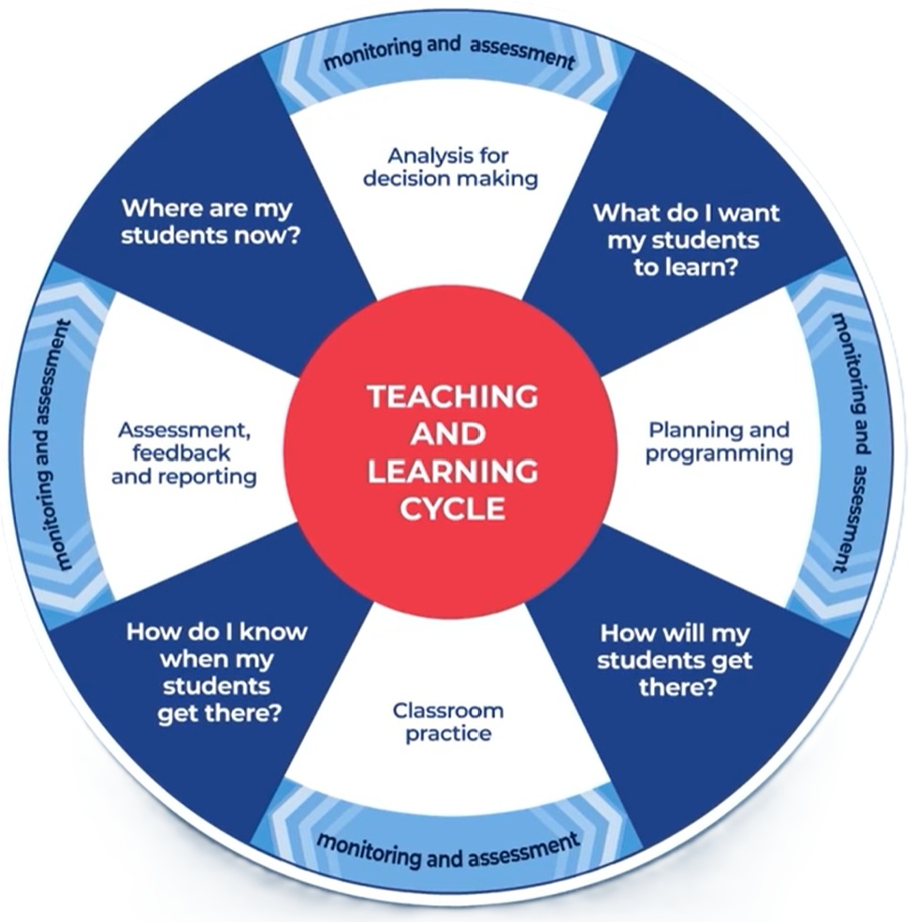

Formative assessment and evidence of learning
The primary role of assessment is to establish where individuals are in their learning so that teaching can be differentiated and further learning progress can be monitored over time.
CESE What works best 2025
Wiliam (2013:15) suggests ‘The term formative should apply not to the assessment but to the function that the evidence generated by the assessment actually serves.’ This concept further supports the practice of gathering ongoing evidence of learning and adjusting teaching to support learning. Ongoing formative assessment can be considered ‘checkpoints’ within a learning sequence or unit. Strategies to elicit evidence of learning allow teachers to determine the next steps in learning and assists them in evaluating the impact of teaching and learning activities. Strategies that can be used to elicit evidence include all student response systems, exit tickets, mini whiteboards (actual or digital), hinge questions, Kahoot, Socrative, or quick quizzes, ensuring individual student progress can be monitored and the lesson sequence adjusted based on formative data collected.
Tracking ongoing evidence of learning through formative assessment provides opportunity for teachers to understand if students have mastered their learning and moved it into long-term memory, or if they have developed misconceptions.

Differentiation and adjustments
All students need to be challenged and engaged to develop their potential fully. A culture of high expectations needs to be supported by strategies that both challenge and support student learning needs, such as through appropriate curriculum differentiation.
CESE What works best 2025
Differentiated learning should be enabled throughout the assessment process. For more information on differentiation, go to Differentiating learning and Differentiation. Additionally, refer to Collaborative curriculum planning when determining the most appropriate adjustments for students with a disability.

Support and alignment
Resource evaluation and support: all curriculum resources are prepared through a rigorous process. Resources are periodically reviewed as part of our ongoing evaluation plan to ensure currency, relevance and effectiveness. For additional support or advice, or to provide feedback, contact the TAS curriculum team by emailing TAS@det.nsw.edu.au.
Differentiation: further advice to support Aboriginal and/or Torres Strait Islander students, students learning English as an additional language or dialect (EAL/D), students with a disability and/or additional needs and high potential and gifted students can be found on the Planning, programming and assessing 7–12 webpage. This includes the Inclusion and differentiation advice 7–10 webpage.
Assessment: further advice to support formative assessment is available on the Planning, programming and assessing 7–12 webpage.
Explicit teaching: further advice to support explicit teaching is available on the Explicit teaching webpage. This includes the CESE Explicit teaching – Driving learning and engagement webpage.
Consulted with: Curriculum and Reform and subject matter experts.
Alignment to system priorities and/or needs: School Excellence Policy.
Alignment to the School Excellence Framework: this resource supports the School Excellence Framework elements of curriculum (curriculum provision) and effective classroom practice (lesson planning, explicit teaching).
Alignment to Australian Professional Standards for Teachers: this resource supports teachers to address Proficient Teacher Standard Descriptors 1.2.2, 2.2.2, 2.3.2.
Creation date: 12 March 2026.

Evidence base
This resource contains NSW Curriculum and syllabus content. The NSW Curriculum is developed by the NSW Education Standards Authority (NESA). This content is prepared by NESA for and on behalf of the Crown in right of the State of New South Wales. The material is protected by Crown copyright.
Please refer to the NESA Copyright Disclaimer for more information https://www.nsw.gov.au/education-and-training/nesa/copyright.
NESA holds the only official and up-to-date versions of the NSW Curriculum and syllabus documents. Please visit NESA https://www.nsw.gov.au/education-and-training/nesa and NSW Curriculum https://curriculum.nsw.edu.au.
Design Innovation Technology 7–10 Syllabus © NSW Education Standards Authority (NESA) for and on behalf of the Crown in right of the State of New South Wales, 2025.
CESE (Centre for Education Statistics and Evaluation) (2025) What works best 2025: evidence guide for excellent schools, NSW Department of Education, accessed 12 March 2026.
Rosenshine B (2012) ‘Principles of Instruction: Research-Based Strategies That All Teachers Should Know’, American Educator, 36(1):12–19, accessed 12 March 2026.
Wiliam D (2013) ‘Assessment: The bridge between teaching and learning’, Voices from the Middle, 21(2):15–20, accessed 27 January 2026.

© State of New South Wales (Department of Education), 2026
The copyright material published in this resource is subject to the Copyright Act 1968 (Cth) and is owned by the NSW Department of Education or, where indicated, by a party other than the NSW Department of Education (third-party material).
Copyright material available in this resource and owned by the NSW Department of Education is licensed under a Creative Commons Attribution 4.0 International (CC BY 4.0) license.

This license allows you to share and adapt the material for any purpose, even commercially.
Attribution should be given to © State of New South Wales (Department of Education), 2026.
Material in this resource not available under a Creative Commons license:
- the NSW Department of Education logo, other logos and trademark-protected material
- material owned by a third party that has been reproduced with permission. You will need to obtain permission from the third party to reuse its material.
Links to third-party material and websites
Please note that the provided (reading/viewing material/list/links/texts) are a suggestion only and implies no endorsement, by the New South Wales Department of Education, of any author, publisher, or book title. School principals and teachers are best placed to assess the suitability of resources that would complement the curriculum and reflect the needs and interests of their students.
If you use the links provided in this document to access a third-party's website, you acknowledge that the terms of use, including licence terms set out on the third-party's website apply to the use which may be made of the materials on that third-party website or where permitted by the Copyright Act 1968 (Cth). The department accepts no responsibility for content on third-party websites.

