Enterprise Computing Stage 6 (Year 12) – teacher support resource
Intelligent systems

Teacher support resource
Teacher note: this resource has been designed to facilitate the ready conversion into a student booklet by removing the answers within the response windows. Teacher notes can be deleted before distributing to students.
Student name:
Class:
Teacher:

Contents
Teacher support resource 1
Unit overview 5
Assessment advice 6
Glossary 7
NESA glossary keywords 12
The design and production process 13
Intelligent systems 14
Systems and their applications 14
Investigate applications of decision support systems 20
Describe categories of decision-making within decision support systems 25
Investigate common applications of expert systems 45
Describe key features of an expert system 49
Research factors that have allowed expert systems to advance from rule-based systems to integrate probability 57
Describe how people’s changing needs have shaped the proliferation of expert systems 64
Describe the operation of simplistic and complex intelligent agents used by search engines, including predictive search strings and the use of voice assistants to initiate interaction 70
Compare techniques used by different inference engines 71
Investigate the hardware used in an intelligent system 73
Explore how computational thinking can be integrated into the design and development of an intelligent system 80
Communicate the logical processes performed by an intelligent system by using flowcharts, data flow diagrams and infographics 96
Investigate the disruptive effects of intelligent systems 101
Investigate social and ethical issues to be considered when developing, implementing and using intelligent systems 106
Investigate current and emerging technologies associated with intelligent systems, including AI 109
Explain how intelligent systems combine innovative techniques and technologies to meet the needs of enterprise 110
Data and intelligent systems 115
Investigate the infrastructure requirements for an intelligent network in an enterprise with devices linked through an Internet of Things (IoT) 115
Explore collection, type, storage, processing, application and transmission of relevant and surplus data in an intelligent IoT network 121
Investigate the application of simulation, data modelling and the automation of systems in a range of enterprises 124
Explain the role of intelligent systems in surveillance 127
Explain how AI supports efficiency in an IoT network 130
Creating intelligent systems 133
Develop a set of rules and facts that could be used within an expert system to draw conclusions 133
Apply certainty factors to construct a decision tree for a proposed expert system 139
Verify the sources of data used in a decision support system 142
Use a flowchart to develop a knowledge base of IF-THEN rules to be used by an expert system 147
Design and model an automated smart system using a range of inputs and outputs 148
Implement automated processing using software 151
Assess the output produced by a decision support system, including graphing to detail the success of decisions and comparing the proposed versus the actual outputs 152
Explain how expert systems contribute to the efficiency of intelligent systems 154
Appendix 161
Intelligent systems project ideas 161
Using spreadsheets to investigate decision support systems 164
Create a medical diagnosis expert system 170
Certainty factors 170
Expert systems case study – Bureau of Meteorology 176
References 186

Unit overview
The lessons and sequences in this teacher resource are designed to allow students to learn about the design and evolution of intelligent systems and investigate how they support people and real-world enterprises. Students develop the knowledge, understanding and skills used to support expert systems and explore the data, patterns and processing power of intelligent systems.
In Weeks 1 to 3, students are introduced to intelligent systems and their applications. They investigate decision support systems and categorise decision-making within these systems. Students investigate common applications of expert systems and describe their key features. They research factors that have led to advances from rule-based systems to integrate probability. Students describe how people’s changing needs have shaped the proliferation of expert systems as they complete Activities 1 to 30.
In Weeks 4 to 6, students compare techniques used by different inference engines. They investigate the hardware used in an intelligent system and explore how computational thinking can be integrated into the development of an intelligent system. Students communicate the logical processes performed by an intelligent system by using flowcharts, data flow diagrams and infographics. They investigate the disruptive effects of intelligent systems and complete Activities 31 to 60.
Weeks 7 to 10 see students investigating current and emerging technologies associated with intelligent systems. They explain how intelligent systems meet the needs of enterprise, and investigate the infrastructure requirements for an intelligent network with devices linked through an Internet of Things (IoT). Students explore collection, type, storage, processing, application and transmission of data in an intelligent IoT network. They investigate simulation, data modelling and the automation of systems in a range of enterprises. Students explain the role of intelligent systems in surveillance and how AI supports efficiency in an IoT network. Student groups create intelligent systems. They develop a set of rules and facts to draw conclusions and apply certainty factors to construct a decision tree for a proposed expert system. Students verify the sources of data used in a decision support system. They use a flowchart to develop a knowledge base of IF-THEN rules to be used by an expert system. Student groups design and model an automated smart system using a range of inputs and outputs and implement automated processing using software. They assess the output produced by a decision support system, including graphing, to detail the success of decisions, and compare the proposed versus the actual outputs and explain how expert systems contribute to the efficiency of intelligent systems. Students complete activities 61 to 94.

Assessment advice
Teacher note:
Curriculum Secondary Learners have not included a specific assessment task for this focus area within the published sample assessment schedule.
Teachers wishing to formally assess student knowledge of the concepts within this focus area may do so via the trial examination and/or seek to integrate this focus area with the Enterprise project:
An intelligent system that uses expert systems and artificial intelligence (AI) to provide decision support or automation for a specific purpose, such as diagnosis, scheduling, gaming or surveillance. This system will use expert systems to store and apply knowledge from human experts in a specific domain or problem. It will also use AI techniques to learn from data and perform tasks that normally require human intelligence or judgement. To develop this system, you will need flowcharts to show logic or rules of the system or process, data flow diagrams to show data movement or transformation in the system or process, infographics to show information or results of the system or process, decision trees to show choices or outcomes of the system or process, structured query language (SQL) to work with databases or queries in the system or process.
Teachers may also seek opportunities to extend upon the Year 11 Networking systems and social computing project to explore the use of intelligent systems in IoT networks.
A network of interconnected devices that uses the Internet of Things (IoT) and machine learning (ML) to monitor and optimise the energy consumption and environmental impact of a smart home or a smart building. This type of system will use sensors and actuators to collect and control data from different devices and appliances, such as lights, heaters or cameras. It will also use ML algorithms to analyse the data and find ways to improve the efficiency and sustainability of the home or building. To develop this system, you will need biometrics to identify people who live or work in the home or building, haptics to give feedback to the users or devices, touch and gesture to control the devices or settings, virtual and augmented reality (VR/AR) to create immersive experiences for the users or devices, voice and sound to communicate with the users or devices, microcontrollers to program the devices or appliances, sensors to measure things like temperature, humidity or motion, actuators and motors to move things like switches, valves or fans.

Glossary
Teacher note: many of the following words gather meaning as students work through this booklet. Each time students see an unfamiliar word throughout this workbook they add its definition in the table below for future reference. An alternate and engaging group activity is for teachers to cut up and separate the words from the definitions and have students match the correct definition to the right word.
Word | Definition
Abstraction | Abstraction is a way of simplifying complex data and programs by focusing on their main ideas while hiding the details of how they work. It helps programmers concentrate on important concepts without getting overwhelmed by all the specifics. In the end, algorithms need to be broken down into simple steps that a computer can understand and follow.
Algorithm | A step-by-step procedure required to solve a problem. Algorithms may be presented in many ways, for example written instructions, flow charts or using a computer programming language.
Artificial intelligence (AI) | Intelligence demonstrated by machines. Sometimes called machine intelligence.
Automation | The use of technology to perform tasks without human intervention, often seen in manufacturing processes and enterprise systems.
Automation of enterprise processes | The use of intelligent systems to automate business operations, reducing the need for human intervention.
Autonomous vehicles | Vehicles that can drive themselves without human intervention, using a combination of sensors, cameras and AI.
Biometrics | A term that describes the source of data being human or biological. It refers to technologies that measure and analyse human body characteristics, such as fingerprints, eye retinas and facial recognition, for identification and access control.
Certainty factors | A measure used in expert systems to express the confidence in the truth of a given piece of information.
Data availability | The ease of access to vast amounts of data, which supports the development of more advanced intelligent systems.
Data flow diagrams (DFD) | Graphical representations of data processes within a system, showing how data moves from one process to another.
Decision support system (DSS) | A computer-based system that helps people make decisions by analysing data and presenting it in a way that is easy to understand.
Decision tree | A tool used in decision support systems that uses a tree-like model of decisions and their possible consequences.
Decomposition | The process of breaking down a complex problem or system into smaller, manageable parts.
Digital assistants | AI-powered software that performs tasks for users, for example, Apple’s Siri or Amazon’s Alexa.
Digital distraction | The reduction in attention span due to constant exposure to digital devices and media.
Enterprise computing | Refers to business-oriented information technology that is critical to a company’s operations. Enterprise computing encompasses types of information technology tools that businesses use for resource management, efficient production operations, relationship management and back-office support.
Enterprise system | The combination of digital systems, people and processes that collect, manage and analyse data.
Expert systems | A type of intelligent system designed to mimic human expertise in specific areas, using a knowledge base and inference engine.
Flowcharts | Diagrams that represent the logical sequence of steps in a process, often used in designing intelligent systems.
Forward chaining | A technique used by inference engines that applies reasoning to the knowledge base to get the information to make a decision. In forward chaining, the inference engine evaluates existing data to develop new data to make a decision.
Haptics | Refers to the sense of touch. Often used to describe a method of output from a device that can be measured by feel or touch.
Heuristic knowledge | Techniques used in problem-solving that rely on practical methods or ‘rules of thumb’ rather than guaranteed optimal solutions.
High-risk applications | The use of intelligent systems in situations where failure could result in significant harm, such as in medical or safety-critical systems.
Inference engine | The component of an expert system that applies logical rules to the knowledge base to deduce new information or make decisions.
Intelligent agents | Software entities that perform tasks on behalf of a user, such as predictive search strings or voice assistants.
Intelligent system | A collective term for enterprise-based information systems that have the capacity to gather and/or analyse data and communicate with other systems, learn and produce targeted output to respond to the world around them.
Internet of Me (IoMe) | The internet of me (IoMe) loosely refers to technology which connects our minds and bodies with the online world. It transforms our biological and cognitive life into streams of data which can be monitored, shared and shaped.
Internet of Things (IoT) | Internet of Things (IoT) encompasses smart devices and smart objects that send and receive information using the internet and communication infrastructure.
Industry 4.0 | The current trend of automation and data exchange in manufacturing technologies, including cyber-physical systems, IoT and cloud computing.
Knowledge base | The part of an expert system that contains the facts, rules and data that the system uses to make decisions.
Microcontroller | A small computer built for the purpose of dealing with specific tasks, such as managing the engine in a car, displaying information in a microwave control panel or receiving information from a television remote control. Microcontrollers process data inputted by users (for example, via keypad) or sensors (for example, light).
Multitasking | The ability to handle more than one task simultaneously.
Neural networks | A type of AI that mimics the human brain’s interconnected neuron structure, allowing systems to learn from data.
Pattern recognition | The ability of intelligent systems to recognise patterns and regularities in data.
Processing power | The ability of a computer to process data quickly, crucial for the advancement of intelligent systems.
Sniffing | The act of intercepting data as it is transmitted over a network, often used maliciously to steal information.
Streaming services | Platforms that use intelligent systems to recommend content, such as Netflix or Spotify.
Structured decision-making | Automated decision-making processes based on a set of predefined, finite instructions.
Surveillance | The monitoring of behaviour and activities, typically for security purposes. Examples include CCTV and biometric scanning.
Trolling | The act of making deliberately offensive or provocative online posts to upset someone.
Truth maintenance | A technique used by inference engines to keep track of the truth status of information in an evolving knowledge base.
Unstructured decision-making | A type of decision-making process where judgement is required due to the lack of clear guidelines or rules.
User interface (UI) | The part of an intelligent system that allows users to interact with the system. The means by which users interact with computer hardware or software. In software, this usually comprises fields for text and number entry, mouse pointers, buttons and other graphical elements. In hardware, switches, dials and light-emitting diodes (LEDs) provide information about the interactions between a user and a machine.
Virtual reality and augmented reality (VR/AR) | Technologies that create immersive environments or overlay digital information onto the real world.
Webometrics | The study of the quantitative aspects of the construction and use of information resources, structures and technologies on the web.
Teacher note: for students learning English as an additional language or dialect (EAL/D), the glossary can be provided complete so that they have additional time to understand the key terms with bilingual dictionaries. The glossary can be provided to students in their preferred communication mode.

NESA glossary keywords
NESA keywords can be used in the syllabus and in the Higher School Certificate examination. Familiarisation with these keywords can assist in understanding how to write and respond to questions.
Key term | Definition
*Apply | Use, utilise, employ in a particular situation.
*Assess | Make a judgement of value, quality, outcomes, results, or size.
Communicate | Convey information or ideas effectively to others through spoken, written, or visual means.
*Compare | Show how things are similar or different.
*Describe | Provide characteristics and features.
Design | Plan and create a solution or product, taking into consideration functionality, aesthetics, and user needs.
Develop | Generate, evolve, or enhance a concept, idea or product through a process of growth or improvement.
*Explain | Relate cause and effect; make the relationships between things evident; provide why and/or how.
Explore | Investigate or examine a subject or concept in depth to gain a better understanding or uncover new information.
Implement | Put a plan or decision into effect; execute a strategy or process.
*Investigate | Plan, inquire into and draw conclusions about.
Research | Systematically investigate a topic to establish facts and reach new conclusions, often involving the collection and analysis of data.
Use | Employ something for a particular purpose or apply it in a specified way.
Verify | Confirm the accuracy or truth of something through evidence or analysis.
*Words marked with an asterisk can be found in NESA’s Glossary of key words.

The design and production process
Throughout the development of your Intelligent systems project you will learn about design processes and how to apply them. You will explore different types of design processes and learn how to apply them in your design project.
The design and production process:
- involves a sequence of organised steps which provide a solution to design needs and opportunities
- may take a few seconds or minutes, such as when you select what clothes to wear, or may take years as in the case with the design of a motor vehicle
- may involve one person or may involve many people
- may be simple or complex, depending on the task
- involves questioning (or evaluating) throughout the iterative process.
Figure 1 – flowchart of design and production process
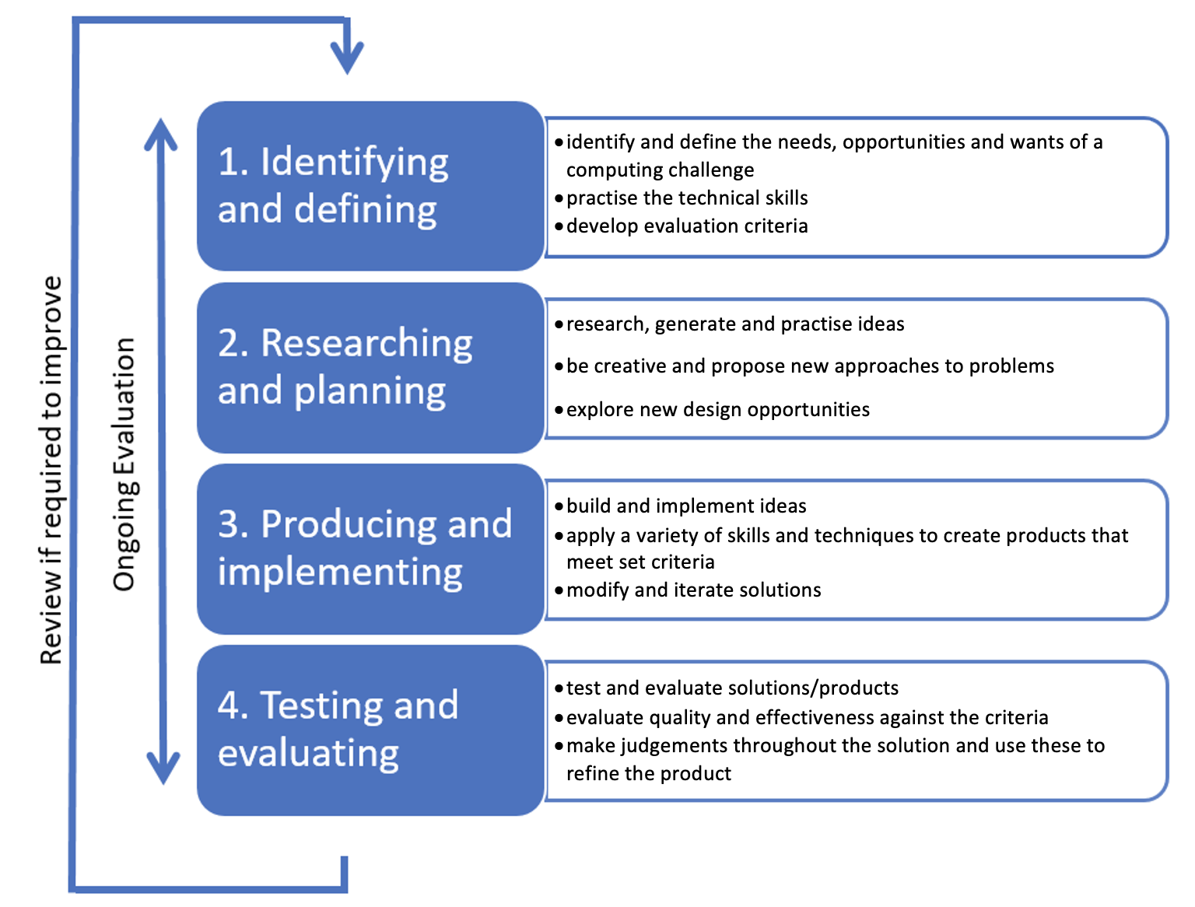

Intelligent systems

Systems and their applications
Teacher note: building on prior knowledge, students recall their understanding of what the word ‘systems’ means before applying this understanding to the phrase ‘intelligent systems’.
Activity 1: Think, Pair, Share
- Provide examples of different types of systems that you have heard of or studied. Answer in the space provided.
Sample responses:
Biological system, computer system, transportation system, solar system, belief system, school system, weather system, legal system.
Students collate these responses and highlight common themes to develop a definition of systems.
- What is a system? Answer in the space provided.
Sample response:
A system is a group of parts that are connected and work together to do something.
These parts can be things you can touch, like machines, or ideas, like rules.
Systems can be found everywhere, such as in nature (like the human body), in technology (like a computer), or in society (like a school).
They work in an organised way and can change when needed.
Students look for connections in their different types of systems
- How do systems interact with each other? Answer in the space provided.
Sample response:
One system can provide input to another system, which then processes that input to produce an output. A weather system can provide data (input) that a transportation system uses to adjust flight schedules (output). Systems can influence each other through feedback. For example, in an ecosystem, the population of predators and prey affects each other's populations. If there are more predators, the prey population may decrease, which then affects the predator population. Some systems rely on others to function properly. For example, a manufacturing system depends on a supply system for materials to create products.
Systems can share information with each other, allowing them to coordinate actions or responses. For example, in smart home technology, different devices communicate to manage energy use effectively. Systems can also interact through their environments. Changes in one system, like climate change, can impact other systems, such as agriculture or water supply systems.
- What are examples of intelligent systems? Answer in the space provided.
Sample responses:
AI, robotics, smart home devices.
Activity 2: group activity
Students create a table that compares traditional systems with intelligent systems.
Feature | Intelligent systems | Traditional systems
Autonomy | operate independently without human intervention | require direct human control or input to function
Learning ability | can learn from experience and improve over time | follow pre-defined rules and do not change unless manually adjusted
Complex problem solving | analyse complex data and solve problems effectively | handle simpler tasks with limited problem-solving capabilities
Interactivity | understand natural language and recognise patterns for interaction | have limited user interfaces requiring specific commands
Integration of data | integrate and process large amounts of data from various sources | often operate in isolation with a narrower focus
Adaptability | adapt to changing environments and user needs effectively | struggle to function outside their original design parameters
Teacher note: system thinking skills are essential for understanding our complex world.
Students can better understand complex systems by recognizing interconnectedness, patterns, and emergent behaviours.
System thinking skills are essential for effective problem-solving and decision-making.
These skills can be developed in students by activities that require them to see the bigger picture instead of focusing on isolated parts.
Students should be encouraged to look at the whole system and how its components interact. They identify interconnectedness and recognise that everything is linked and that changes in one part of the system can affect other parts.
Students can identify recurring patterns of behaviour within a system to understand its dynamics and the complex behaviours and outcomes that may arise from the interactions of simple components.
Systems thinking skills help students understand how actions within a system can create both positive and negative feedback loops, which can amplify or dampen effects.
They can help students recognise that systems are constantly evolving and adapting, rather than being static and assist students to decipher the way things influence each other in a system.

Activity 3: complete the table
Reflect on the decisions you make or will make, based on the different timeframes shown in the table.
Timeframe | Choices that you make
Daily | Sample answers:  - What to eat  - What to wear  - When to sleep
Weekly | Sample answers:  - When to go shopping  - Items to purchase  - Social activities
Annually | Sample answers:  - Gifts for special occasions  - Celebrations  - Medical, dental or eye care appointments
Lifetime | Sample answers:  - Career decisions  - Marital status  - Purchasing a home  - Choosing further study
What do you notice about these decisions as you go up the scale of longer time frames?
Sample answer:
The decisions get harder and harder to make.
There are higher stakes to the decisions, and you want to make good decisions.
It can be hard to imagine what will impact your decision-making process into the future.
These decisions are personal but now imagine that you are running an enterprise like a business, club or sporting association.
Activity 4: Think, Pair, Share
Students choose a business, workplace, club or sports association with which they are familiar and list some of the decisions they would need to make. This could also be their Enterprise project.
Student responses will vary upon the chosen context though should fit within one or more of the following categories:
- managing
- financial resources
- inventory
- human skills
- production resources
- information technology (IT)
- natural resources.
- production operations including
- how to deliver products or services in the most cost-effective manner without compromising on quality.
- back-office support
- providing administrative and managerial support for front office staff
- handling tasks related to business operations
- performing data entry, payroll management, and human resources functions
- ensuring the smooth running of the company without direct client interaction.
Teacher note: there are many kinds of decisions that are important to an enterprise being successful, and as such there are many systems that help support the decision-making process. The enterprise system students use will include the combination of digital systems, people and processes that collect, manage and analyse data. Ideally it would be a student Enterprise project.

Activity 5: teacher issues the syllabus focus area to students
As a class, students watch Intelligent systems (26:14) and mark off the syllabus content points with a highlighter as they are discussed.
Activity 6: students reflect upon their chosen enterprise business, club or association from the activity above. They identify where an aspect from the video (and syllabus content) could assist their enterprise to become an intelligent system.
Student responses will vary dependent upon the chosen context.
Responses should reference the digital systems, people and processes that collect, manage and analyse data within their chosen enterprise system. They should highlight opportunities within their enterprise to adopt intelligent systems that:
- gather and/or analyse data and communicate with other systems
- learn and produce targeted output to respond to the world around them.
Teacher note: the complexity of the concepts and abstracted nature of the language used in this focus area can be daunting to students unfamiliar or inexperienced with systems thinking. Connecting the learning from this focus area to what they already know is an essential strategy in educational research on cognitive load theory. Students are able to make connections between the information systems within their workplace or school, and this syllabus focus area will well prepare them for success in the course and beyond.

Investigate applications of decision support systems
One key type of intelligent system is the decision support system (DSS).
Activity 7: teacher writes ‘Decision Support System’ on the board.
Students approximate a definition of DSS based on the words in the title alone.
Sample answer:
A tool that helps people make choices.
It gives people useful information and helps them look at different options so they can make better decisions.
Teacher reads the formal definition of DSS (below), and students update their first response with any missing key concepts.
What is a decision support system (DSS)? A decision support system (DSS) is an interactive computer-based system that helps individuals and organisations make decisions by analysing large sets of data. A DSS combines data, sophisticated analytical models and user-friendly software to support decision-making processes, especially in complex and uncertain environments. DSS provide powerful tools that assist in making informed decisions across various fields, from healthcare to transportation.
Students complete the following table.
Component | Description
Database management system (DBMS) | Stores and manages the data that the DSS uses for analysis.
Model-based management system (MBMS) | Includes the mathematical and analytical models used to process the data.
User interface (UI) | The front end of the system that allows users to interact with the DSS, input data and view results.

Activity 8: jigsaw
Students are put into 3 teams: A, B and C.
Each team forms subgroups, 1 to 6, and is allocated one of the applications of DSS below (for example, healthcare, business or agriculture).
Each subgroup investigates a real-world example of how a DSS is used in that field. Consider how the system collects data, what kind of decisions it supports and the benefits it provides.
They prepare a short report or presentation that explains the application, including any challenges or limitations of the DSS in that context.
Application | Description | Activity
- Healthcare – Clinical Decision Support Systems (CDSS) | CDSS is a type of DSS specifically designed for the healthcare sector. It helps doctors and medical professionals make clinical decisions by analysing patient data, medical history and current research.  A CDSS can suggest possible diagnoses based on a patient’s symptoms and medical history, recommend treatment plans, or flag potential drug interactions. This leads to more accurate diagnoses and personalised patient care. | As a group, watch What is a Clinical Decision Support System? (2:11).
- Business and finance – financial planning and forecasting | Businesses use DSS to make financial decisions such as budgeting, investment planning and financial forecasting. These systems analyse historical financial data, market trends and economic indicators to provide insights and predictions.  A company might use a DSS to forecast sales for the next quarter, considering factors like past sales data, current market conditions and economic trends. The DSS helps decision-makers allocate resources and plan for potential challenges. | As a group watch :  What Are Decision Support Systems?(3:49)
- Supply chain management – inventory management | In supply chain management, a DSS can optimise inventory levels, manage orders and streamline logistics. These systems analyse data from suppliers, warehouses and sales to ensure that the right products are available at the right time and place.  A retail company might use a DSS to decide how much stock to order for each product. The system can predict future demand based on sales trends, seasonal patterns and promotional activities, helping the company avoid overstocking or stockouts. | As a group, watch Mastering Sales Forecasts with Consumer Trends, Seasonal Variations, and Competitor Insights (3:22).
- Agriculture – precision farming | In agriculture, DSS assists farmers in making decisions about crop management, such as when to plant, irrigate, or harvest crops. These systems use data from weather forecasts, soil conditions and crop models to optimise farming practices.  A DSS might analyse soil moisture levels, weather predictions and crop growth stages to recommend the best time to irrigate a field. This helps farmers conserve water, reduce costs and increase crop yields. | As a group, watch Artificial intelligence comes to farming in India (3:01).
- Transportation – traffic management systems | DSS are used in transportation to manage and optimise traffic flow, plan routes and reduce congestion. These systems analyse real-time traffic data, accident reports and weather conditions to make recommendations for drivers or traffic controllers.  A city’s traffic management centre might use a DSS to monitor traffic patterns and adjust traffic signals in real-time to reduce congestion and improve traffic flow. The system can also suggest alternative routes to drivers to avoid traffic jams. | As a group, watch Decision Support Systems (DSS) for ICM (9:19).
- Environmental management – disaster response planning | DSS play a crucial role in environmental management, especially in planning responses to natural disasters such as floods, hurricanes, or earthquakes. These systems analyse data on weather patterns, topography and infrastructure to develop emergency response strategies.  In the event of an approaching hurricane, a DSS might help government officials decide which areas to evacuate, where to set up shelters and how to allocate emergency resources. The system can model different scenarios to predict the potential impact of the hurricane and recommend the most effective response actions. | As a group, watch Flood Integrated Decision Support System (FIDSS) (3:26) and Decision Support System for Nuclear Emergencies Affecting Food and Agriculture (3:41)

Each subgroup reforms into their initial teams (A, B or C) and as a team, presents their responses to the reflection questions to the class.
- How do DSS improve decision-making in complex environments?
Sample answer:
Decision support systems (DSS) help people make better decisions in complicated situations by handling a lot of data. They look for patterns in the data and give useful information to guide choices. DSS makes it easier for decision-makers by showing data clearly, which helps them decide faster and more accurately. They also allow users to explore different scenarios and predict outcomes, making it easier to see what might happen before making a final choice. This is especially helpful in fast-changing environments where many things are happening at once.
- What are the potential risks or downsides of relying on DSS for critical decisions?
Sample answer:
One risk of depending too much on decision support systems (DSS) is that users might ignore important details or context that the system doesn’t consider. DSS can also be affected by biases in the data, which can result in bad recommendations. If the system isn’t kept up to date, it might give outdated or wrong information. Lastly, users might not have the skills to understand the results from the DSS correctly, which can lead to poor decisions.
- How might advances in AI and machine learning further enhance the capabilities of DSS in the future?
Sample answer:
Improvements in AI and machine learning will make decision support systems (DSS) much better by allowing them to make more accurate predictions, learn from their experiences, and process data in real time. AI can help DSS learn from past decisions and get better at giving advice. Machine learning can find patterns and relationships in data that might not be easy for people to see. Plus, AI-powered DSS can work with unstructured data, like text and images, making them more flexible and useful for many different tasks.

Describe categories of decision-making within decision support systems
Activity 9: complete the cloze passage on decision support systems by using the following words:
business, categories, choose, data, decisions, enhancing, models, processes, semi-structured, structured, tools, unstructured
Decision support systems (DSS) assist in making ___________ by processing _____ and presenting it in a way that helps users _______ the best course of action.
DSS handles different types of decision-making ___________, categorised as _____________, semi-structured and _______________.
Understanding the different _____________ of decision-making within DSS helps in selecting the right approach for various __________ situations.
Whether a decision is unstructured, ___________________, or structured, DSS plays a crucial role in ___________ the decision-making process by providing valuable data, _______ and ______.
Solution:
Decision support systems (DSS) assist in making decisions by processing data and presenting it in a way that helps users choose the best course of action. DSS handles different types of decision-making processes, categorised as structured, semi-structured and unstructured.
Understanding the different categories of decision-making within DSS helps in selecting the right approach for various business situations. Whether a decision is unstructured, semi-structured, or structured, DSS plays a crucial role in enhancing the decision-making process by providing valuable data, models and tools.
Activity 10: as a class, watch Types of decisions (2:41) to watch how a decision can be unstructured, semi-structured, or structured.
Students complete the table on the following page.

Decision category | Definition | Examples | Support tools
Structured decisions | Decisions that can be automated due to well-defined standard operating procedures. | Record keeping, payroll, simple inventory | Information technologies are major support tools.
Semi structured decisions | Decisions that have some structure but are not fully defined by standard procedures; they benefit from information systems. | Budget preparation, sales forecasting, capital acquisition (buying equipment, buildings or technology) | Analytical models, information retrieval, information systems technology.
Unstructured decisions | One-time decisions with no standard procedures; they rely heavily on the decision maker’s intuition. | Research and development, hiring/firing, introducing a new product | Limited support from information technology.
Teacher note: semi structured and unstructured decisions can be difficult due to multiple criteria and conflicting objectives (for example, balancing employee raises with cost reduction).

An infinite set of instructions where judgement may be required (unstructured)
Unstructured decision-making involves situations where there are no predefined rules or guidelines to follow, and judgment or intuition plays a significant role. These decisions are often complex and require a deep understanding of the context.
Activity 11: teacher-led discussion
Characteristics of unstructured decision-making:
- No clear procedure or algorithm.
- High uncertainty and complexity.
- Requires human judgment, creativity and intuition.
Students describe familiar unstructured decision-making situations where they are required to use judgement.
Situation | Description
Choosing a career path | Deciding on a career after high school, considering interests, skills, values, and job market trends.
Selecting electives | Weighing passions, career implications, and academic strengths when choosing elective subjects.
Relationships | Making judgement calls about trust, conflict resolution, and social dynamics without clear answers.
Academic pressure | Managing time and prioritising tasks during exams or multiple commitments requires intuition and strategy.
Social issues | Deciding whether to intervene in bullying or social injustices involves complex ethical considerations.
Sports and hobby choice | Weighing interests against time commitments and stress in deciding to join clubs or sports teams.
Planning for after high school | Navigating choices about further education, workforce entry, or taking a gap year with future implications.
Personal finances | Budgeting allowance or part-time earnings requires understanding personal priorities and savings goals.
Parental expectations | Balancing personal desires with parental expectations regarding education, career or lifestyle.
Identity and values | Making decisions about beliefs, values, and identity during self-discovery without clear right or wrong.

Decision support systems in unstructured decision-making
A DSS can assist by providing relevant data and analysis tools but is not used to make final decisions. A DSS supports decision-makers by offering insights, possible scenarios and visualisations.
Activity 12: teacher-led discussion: Students describe how decision support systems could be used to offer insights and make better judgements.
Situation | With decision support systems
Choosing a career path | A DSS could provide information on various careers, including required skills, job outlook, and potential salaries, helping students make informed choices based on their interests and market trends.
Selecting electives | The system could offer a database of elective courses, including student reviews, course prerequisites, and potential career paths, assisting students in selecting subjects aligned with their goals.
Relationships | A DSS could include resources and tools for conflict resolution and communication strategies, helping students evaluate their social situations and make informed decisions about relationships.
Academic pressure | The DSS could provide time management tools, study schedules, and stress management resources, empowering students to make strategic decisions about prioritising tasks effectively.
Social issues | A DSS could provide information on reporting mechanisms, support resources, and intervention strategies, guiding students in making decisions about how to approach these sensitive issues.
Sports and hobby choice | The DSS could include databases of clubs and activities, allowing students to compare options based on time commitment, benefits, and peer experiences, aiding their decision-making process.
Planning for after high school | A DSS could offer pathways for further education, job opportunities, or gap year options, along with pros and cons for each path, helping students evaluate their next steps effectively.
Personal finances | The DSS could include budgeting tools, financial literacy resources, and calculators to assist students in making informed decisions about saving, spending and investing their money.
Parental expectations | The system could provide resources on communication strategies and frameworks for discussing choices with parents, helping students navigate their personal desires and parental expectations.
Identity and values | A DSS could offer self-assessment tools, personality quizzes, and resources for exploring values, aiding students in understanding themselves better and making informed decisions about their identity.
Students consider how in each of these situations, a DSS can serve as a valuable resource, providing relevant information, tools, and support that empower them to make more informed decisions based on their unique contexts and needs.

Activity 13: Think, Pair, Share
Students imagine developing a startup company based on their Enterprise computing project.
They complete the table with a description of the unstructured decision-making.
Characteristic | Description
No clear procedure or algorithm | Sample response:  We have a unique business idea with no established guidelines or step-by-step processes to follow. We will have to research various business models, funding options, and market strategies.
High uncertainty and complexity | Sample response:  We are uncertain about market demand, competition, and potential challenges. We can analyse multiple scenarios and outcomes but don’t have clear indicators of success.
Requires human judgement, creativity, and intuition | Sample response:  Our success hinges on the ability to innovate and differentiate our product or service. We rely on creativity for design and intuition for decisions about marketing strategies, branding, and partnerships. We need to assess risks and make judgement calls about investments and team dynamics.

Activity 14: teacher-led discussion on how DSS could assist with decision-making for their startup.
DSS assistance | Description
Data analysis and visualisation | Helps analyse market trends, customer preferences, and competitive landscapes through data analysis tools and visualisations.
Scenario simulation | Provides simulation tools to model different business scenarios and predict potential outcomes based on various variables.
Financial modelling | Assists in creating financial models to project revenues, costs, and funding needs, aiding in budgeting and cash flow forecasting.
Collaboration tools | Facilitates collaboration among team members through platforms for sharing ideas, documents, and feedback.
Customer relationship management (CRM) | Supports managing interactions with potential customers, tracking leads, and analysing feedback to refine offerings.
Risk assessment | Provides tools for identifying potential risks and assessing their impact, enabling informed decisions to mitigate risks.
Resource management | Assists in optimising resource allocation, managing human resources, materials, or finances for efficient operations.

Use of a specified set of finite instructions (semi-structured)
Activity 15: teacher-led discussion
Semi-structured decision-making involves a mix of structured and unstructured elements. While some parts of the decision-making process follow clear rules, others require judgment and interpretation. The characteristics of semi-structured decision-making include:
- some rules and procedures exist, but not all aspects are clear-cut.
- a combination of analytical and judgment-based decision-making.
In semi-structured decisions, DSS can provide models and frameworks to guide the decision-making process, offering data-driven insights while allowing for human judgment in areas where rules are not well-defined.
Students apply the characteristics of semi-structured decision-making to their start up scenario.
- What rules and procedures exist, but not all aspects are clear-cut?
Sample response:
We have access to basic business frameworks and templates, but specifics like market entry and pricing strategies remain uncertain.
- How can you combine analytical and judgement-based decision-making?
Sample response:
We could use analytical tools for market and financial analysis while applying judgement and creativity to interpret data and make strategic decisions.

Automated decisions (structured)
Activity 16: teacher-led discussion
Structured decision-making involves decisions that are routine and follow a well-defined set of instructions or rules. These decisions are often repetitive and can be easily automated. An example of structured decision-making is processing a loan application based on credit score, income and other criteria. The process follows a clear set of rules, and the decision can be made automatically. The characteristics of structured decision-making include: clearly, predefined rules and procedures; minimal need for human judgment; and a high potential for automation. In structured decision-making, DSS can automate the entire process, making decisions quickly and efficiently based on the set rules. This reduces the need for human intervention and speeds up operations.
Students apply the characteristics of structured decision-making to their start up scenario.
- What clear, predefined rules and procedures could be followed?
Sample response:
We can follow established guidelines for creating a business plan, including marketing strategy and financial projections. We can use predefined processes for registering the startup, applying for permits, and seeking funding through grants or loans. This structured approach gives us a roadmap for the startup's initial phases.
- Where is there minimal need for human judgement?
Sample response:
Many of the decisions in the early stages can be based on objective criteria and established metrics. For example, to determine pricing, we can use industry benchmarks to set prices based on the cost of production and desired profit margins to reduce the need for our subjective judgement.
- Describe areas in your startup with a high potential for automation.
Sample response:
We could use tools and software to automate parts of the startup process. Financial management software can track expenses, generate invoices, and prepare financial statements without manual intervention. Marketing automation tools can manage social media posts, email campaigns, and customer relationship management, allowing us to streamline operations and focus on higher-level strategic decisions.
Activity 17: a decision-making scenario using a DSS
Scenario: you are a manager at a retail company that needs to decide how much inventory to order for the upcoming holiday season. You have access to a decision support system (DSS) that analyses historical sales data, current market trends and supplier information.
Identify the type of decision to determine whether the decision is structured, semi-structured, or unstructured.
Justify your choice based on the scenario.
Sample answer:
This scenario involves semi-structured decision-making. The decision to order inventory for the holiday season involves both structured elements (for example, historical sales data and supplier lead times) and unstructured elements (for example, predicting market trends and customer preferences). While the DSS can provide data-driven insights, human judgment is needed to interpret and adjust the recommendations based on unique circumstances like upcoming promotions or external market conditions.
Describe the DSS's role and explain how the DSS would assist in making this decision.
- What data would it analyse?
- What recommendations might it provide?
Sample answer:
The DSS will analyse historical sales data from previous holiday seasons, current market trends and supplier lead times. It will likely provide recommendations on the optimal inventory levels based on predictive analytics. For instance, the DSS might suggest ordering 20% more of a product based on increased demand forecasts, or it might flag items that are overstocked and recommend reducing orders.
Decision-making process
Outline the steps you would take to use the DSS in making the final inventory decision. Include both the data-driven elements and any human judgment required.
Sample answer:
- Step 1: input historical sales data, market trends and supplier information into the DSS.
- Step 2: analyse the DSS recommendations on inventory levels for each product.
- Step 3: apply human judgment to adjust recommendations, considering factors like promotional plans or changes in consumer behaviour that the DSS might not fully account for.
- Step 4: make the final decision on how much inventory to order, balancing DSS insights with personal expertise.
Evaluation
Reflect on the benefits and limitations of using a DSS for this decision. How does it improve the decision-making process? What challenges might arise?
Sample answer:
The DSS improves the decision-making process by providing data-driven insights, reducing the risk of under- or over-stocking. It helps identify trends that might not be immediately obvious. However, the DSS might not fully account for sudden changes in market conditions or unique factors like a new competitor entering the market. Therefore, combining DSS recommendations with human intuition is essential for making the most informed decision.
Short report
Write a short report (300 to 500 words) explaining your analysis and decision-making process, including the role of the DSS and your final decision. Be sure to include how the DSS supports or complements human judgment in this scenario.
Sample answer:
In this scenario, the decision-making process is semi-structured.
The DSS provides valuable data by analysing historical sales trends, current market conditions and supplier information. It offers recommendations on optimal inventory levels, such as ordering more stock of high-demand items and reducing orders for overstocked products. However, human judgment is necessary to interpret these recommendations in the context of external factors like promotions or market shifts.
The DSS enhances the decision-making process by offering data-driven insights, but it must be combined with human expertise to ensure accurate decisions.
The final decision balances these insights, ensuring that inventory levels are optimised for the holiday season while minimising the risks associated with unpredictable factors.

Spreadsheets
Activity 18: using spreadsheets to investigate decision support systems
Students refer to page 20 of the Enterprise Computing Course Specifications: Spreadsheet software. They cross-reference this list with those in the following activities.
Create a spreadsheet as follows:
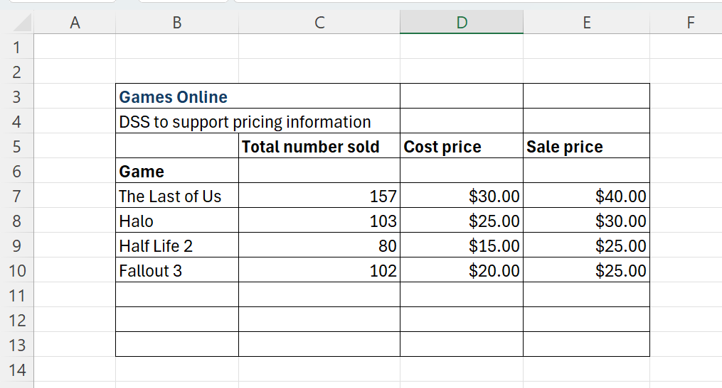
Total number sold, cost price and sale price are the input variables that Games Online use to determine Total Sales and Total Cost.
- How do Games Online calculate the Total Sales?
- Add a column called ‘Total Sales’ and apply the formula to multiply the Total number sold by the Sale price.
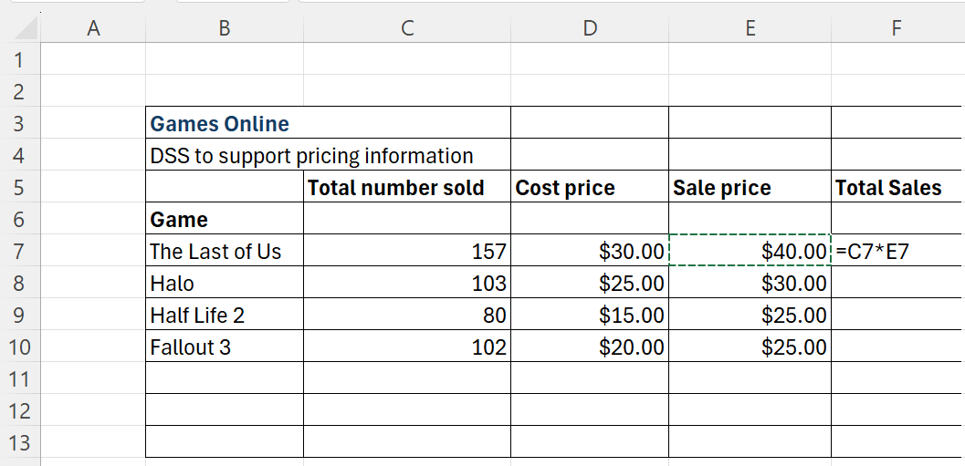
- How do Games Online calculate the Total Cost?
- Add a column called Total Cost and apply the formula to multiply the Total number sold by the Cost price.
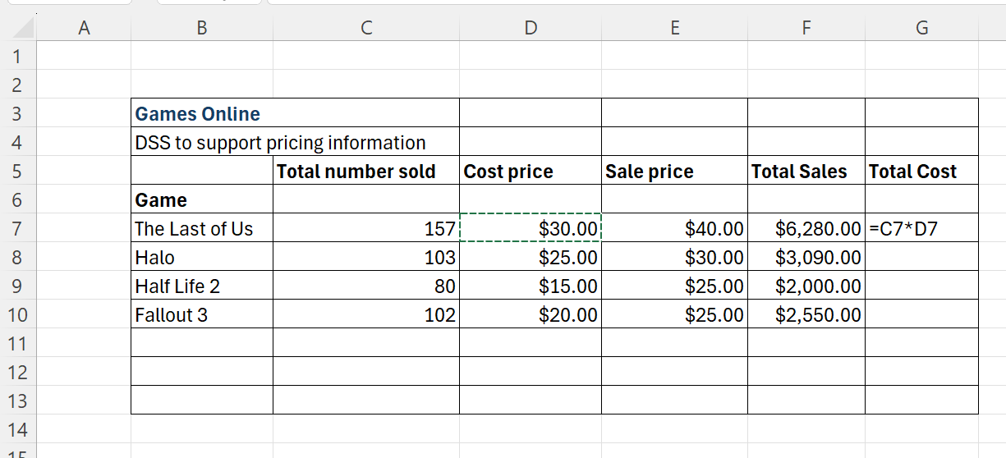
- How do Games Online calculate their profit?
- Add a column called Profit and apply the formula to subtract the Total Cost sold from the Total Sales
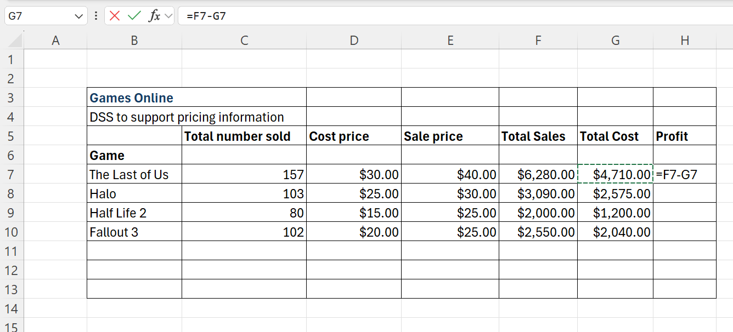
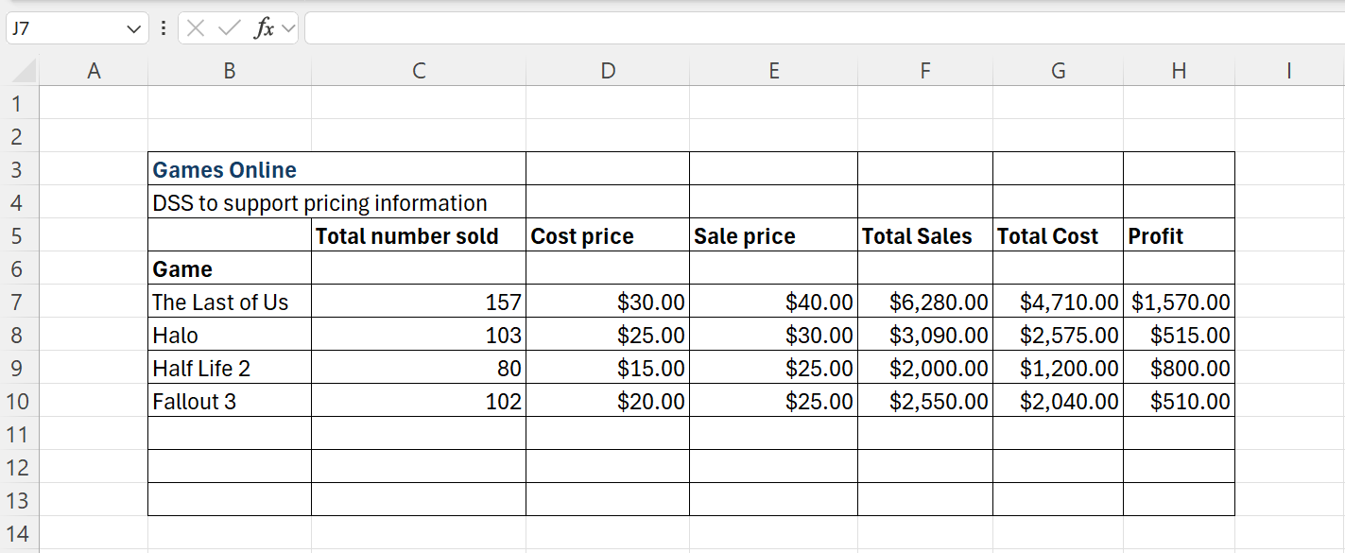

- Describe the formulas used to create this spreadsheet.
Sample answer:
- Total Sales (Column F):
Formula: =C7*E7
Total Sales=Total number sold × Sale price
For example, for ‘The Last of Us’, the formula would calculate:
157 * $40.00 = $6,280.00.
- Total Cost (Column G):
Formula: =C7*D7
Total Cost = Total number sold × Cost price
For example, for ‘The Last of Us’, the formula calculates:
157 * $30.00 = $4,710.00.
- Profit (Column H):
Formula: =F7−G7
Profit= Total Sales−Total Cost.
For example, for ‘The Last of Us’, the formula calculates:
$6,280.00 − $4,710.00 = $1,570.00.
- Describe the use of the fill down process and its use.
Sample answer:
The fill down process allows the formulas entered in one row to be quickly applied to the rows below without manually re-entering them. In this spreadsheet:
The formulas for Total Sales, Total Cost and Profit are entered for the first game (The Last of Us) and then dragged down to apply the same logic to the other rows (Halo, Half-Life 2, Fallout 3).
This ensures consistency, reduces errors and saves time when working with large datasets.

- Games Online is aiming to make a profit of $2,000 for the Last of Us Game. What is the minimum number of units that need to be sold to achieve this?
Sample answer:
To find the minimum number of units:
Profit per unit = Sale Price − Cost Price = $40.00 − $30.00 = $10.00.
Minimum units required:
=2000/10 = 200 units.
So, ‘The Last of Us’ needs to sell 200 units to achieve a profit of $2,000.
- Games Online has decided to make a flat rate increase in terms of its Sale Price. It needs to make a change so the difference between the cost price and sales price is an increase of 20%. Describe the changes that would need to be made to the decision support system to accommodate this.
Sample answer:
To increase the sale price by 20% over the cost price:
Update the Sale Price (Column E) with the formula:
=D7*1.2.
Apply the formula using the fill down process to update all rows.
For example, if the cost price of ‘The Last of Us’ is $30.00, the new sale price would be:
$30.00 * 1.2 = $36.00.
Implement these changes in your spreadsheet. Add a formula for the total profit. Games Online would like to make a total profit of $5,000.
- How many units of the game ‘Halo’ would need to be sold to achieve this?
Sample answer:
To find the number of units:
Profit per unit for Halo: Sale Price − Cost Price = $30.00 − $25.00 = $5.00.
Minimum units required:
=5000/5 = 1,000 units.
So, Games Online needs to sell 1,000 units of ‘Halo’ to achieve a profit of $5,000.
To help analyse the data, automate the spreadsheet using conditional formatting to display all profit cell values over $600 in blue, and all profit cell values below $550 in pink.
Complete the questions on spreadsheets from the HSC Enterprise Computing familiarisation exam on the spreadsheet that shows the sales data for a business.
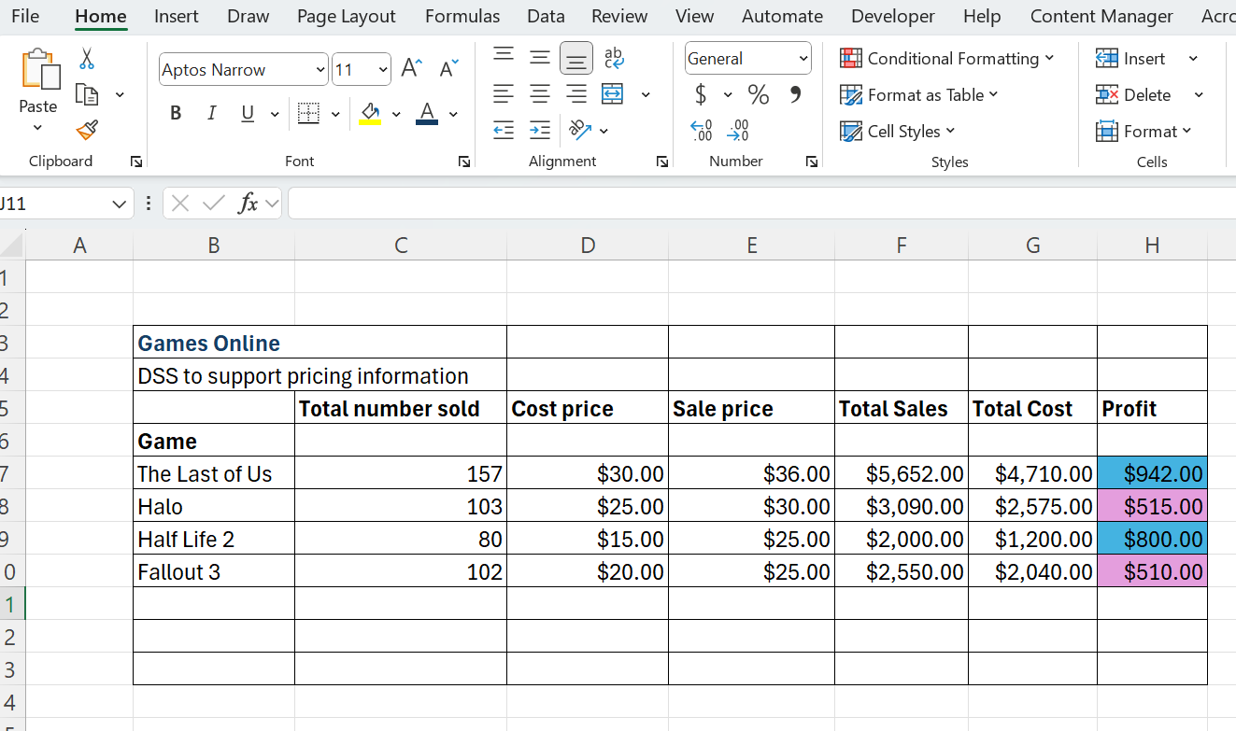

- Would you consider this to be a decision support system? Justify your response.
Sample answer:
Yes, this spreadsheet can be considered a decision support system because:
- It helps analyse data and simulate scenarios, such as determining the number of units needed to achieve specific profit goals.
- It uses formulas and calculations to provide actionable insights, enabling informed decision-making.
- Users can adjust variables like cost price, sale price, or profit targets to explore outcomes and make strategic choices.
- Which one of the following best describes the decision-making in this spreadsheet:
- An infinite set of instructions where judgement may be required (unstructured).
- The use of a specified set of finite instructions (semi-structured).
- Automated decision (structured).
Justify your response.
Sample answer:
The decision-making process in this spreadsheet is semi-structured because:
- The spreadsheet uses clear formulas and instructions (structured elements).
- Human judgment is required to interpret the data, adjust variables and decide on actions (unstructured elements).
This combination of structured calculations and the need for user input makes it semi-structured.

Digital examination Excel practice activity
Activity 19: students watch and replicate the steps in IF Function in Excel Tutorial (6:13).
Activity 20: students watch and replicate the steps in VLOOKUP in Excel | Step-by-Step Tutorial for Beginners (5:42).
Digital examination practice question activity
Activity 21: this activity is based on a 5 mark question from the HSC Enterprise Computing Familiarisation examination. Students should be encouraged to produce a solution within 9 minutes which is approximately a mark every 2 minutes during the digital examination.
Students respond to the following scenario by designing a spreadsheet for a business, that shows all relevant labels and formula:
A business wants to use a spreadsheet to create a decision support system that will streamline its staff hiring process.
The business’s hiring decisions are based on 3 scores achieved by each job applicant. A higher score indicates a more suitable applicant.
The travelling score: if an applicant can travel to work within a specified time they score 10 points. If not, they score 0 points. The specified time should be given as data in the spreadsheet, so that it can be changed according to future circumstances.
The experience score: applicants score points depending on the number of years they have worked. The table shows how points are allocated based on the number of years worked.
Number of years worked | Points
0 | 0
1–4 | 10
5–9 | 20
10 or more | 30
The interview score: each job applicant is interviewed and given a score out of 100.
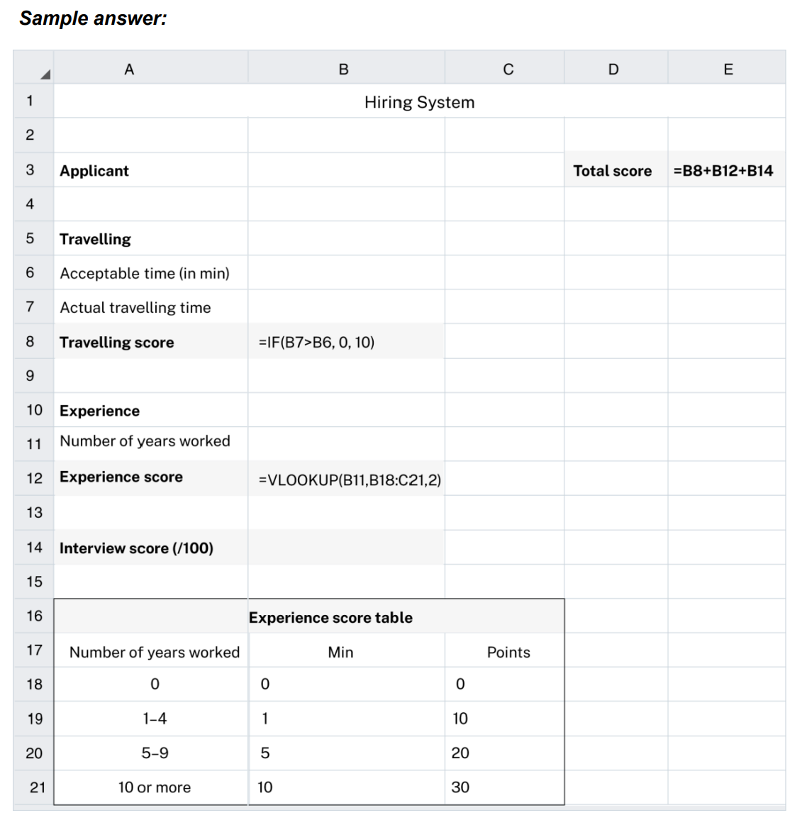

Investigate common applications of expert systems
Activity 22: students watch and actively take notes on Expert Systems – Lesson 1 (11:00).
Activity 23: use the following words to complete the cloze passage:
accuracy, complex, critical, decision-making, diagnosing, expert knowledge, logistics, mimic, optimising, productivity, specialised tools.
Expert systems are systems that ______ the ___________________ ability of a human _______.
They are widely used in various fields for tasks that require ______________ knowledge.
Expert systems are vital ______ across various industries, enhancing efficiency, __________ and decision-making.
From _____________ medical conditions to _____________ industrial processes and ___________, expert systems contribute to solving _________ problems that require specialised ___________.
These applications demonstrate the power of expert systems in improving both _______________ and outcomes in __________ tasks.
Solution:
Expert systems are systems that mimic the decision-making ability of a human expert.
They are widely used in various fields for tasks that require specialised knowledge.
Expert systems are vital tools across various industries, enhancing efficiency, accuracy and decision-making.
From diagnosing medical conditions to optimising industrial processes and logistics, expert systems contribute to solving complex problems that require specialised knowledge.
These applications demonstrate the power of expert systems in improving both productivity and outcomes in critical tasks.

Activity 24: Jigsaw activity where students are numbered 1–4
Teacher note: these groups could be randomly selected, based on student interest OR best align with the students Enterprise Computing project.
- Students numbered 1 form a team responsible for investigating expert systems for diagnosis.
- Students numbered 2 form a team responsible for investigating expert systems for monitoring.
- Students numbered 3 form a team responsible for investigating expert systems for process control.
- Students numbered 4 form a team responsible for investigating expert systems for scheduling and planning.
Each team investigates their application of expert system and creates a presentation of its features to class
These common applications are seen in various industries and teams may choose to allocate members to each industry.
Presentations are collated as class notes.
Sample responses are provided below.

Diagnosis
Sample response:
Expert systems are extensively used in medical diagnosis.
They help doctors and medical professionals identify diseases and conditions by analysing patient data, symptoms and medical history.
For example, systems like MYCIN were designed to diagnose bacterial infections and recommend treatment options.
These systems improve diagnostic accuracy and speed, especially in complex cases.
In addition to medical use, expert systems are also used in diagnosing technical issues in machines, engines and other equipment.
For instance, in automotive industries, expert systems can diagnose engine problems based on data from sensors and user inputs.

Monitoring
Sample response:
Expert systems are crucial in monitoring systems that require continuous oversight, such as industrial processes, network security, or environmental conditions.
These systems can detect anomalies, assess risk levels and send alerts or recommendations for corrective actions.
In network security, expert systems monitor data traffic for unusual activities that might indicate a cyberattack. They can detect threats, such as malware or unauthorised access and initiate defensive measures in real time.
In environmental monitoring, expert systems track changes in air or water quality, alerting authorities to potential hazards or compliance issues. These systems help in preventing disasters and ensuring safety.

Process control
Sample response:
Expert systems play a significant role in process control within manufacturing industries.
They regulate and adjust machinery and equipment based on real-time data to ensure optimal performance and quality control.
For example, in a chemical plant, an expert system might adjust temperatures, pressures and chemical mixtures to maintain product quality and safety.
In the energy sector, expert systems are used to control the output of power plants.
They manage the balance between energy supply and demand, adjusting generator outputs to ensure efficiency and stability in the grid.

Scheduling and planning
Sample response:
In industries like manufacturing, expert systems help plan and schedule production processes. They optimise the use of resources, minimise downtime and ensure that products are manufactured on time.
For instance, an expert system might analyse production data and suggest the best times to start or stop production lines to meet deadlines efficiently.
Expert systems are also used in logistics and supply chain management to plan and optimise the movement of goods. They help in determining the best routes for delivery, the most efficient use of transportation resources and the timing of shipments.
In project management, expert systems assist in planning tasks, allocating resources and scheduling deadlines. They ensure that projects stay on track and within budget by analysing project data and forecasting potential delays or cost overruns.

Describe key features of an expert system
Activity 25: students watch Expert Systems – Lesson 1 (11.00) and Expert Systems – Lesson 2 (10:41).
Teacher note: consider allocating the watching of these videos as homework as a flipped classroom approach.
Students answer the following questions:
- What is an expert system?
Sample answer:
Expert systems are computer systems designed to emulate the decision-making abilities of human experts, solving specific problems in a particular domain using a knowledge base and inference engine.
- What are some examples of expert systems?
Sample answer:
Examples of expert systems include weather apps, medical diagnostic tools and recommendation systems (like Netflix or Spotify).
- What are the 3 main components of expert systems?
Sample answer:
- Knowledge base
- Inference engine, including forward chaining and backward chaining
- User interface (UI)

- Create a diagram of the key components of an expert system.
Sample answer:
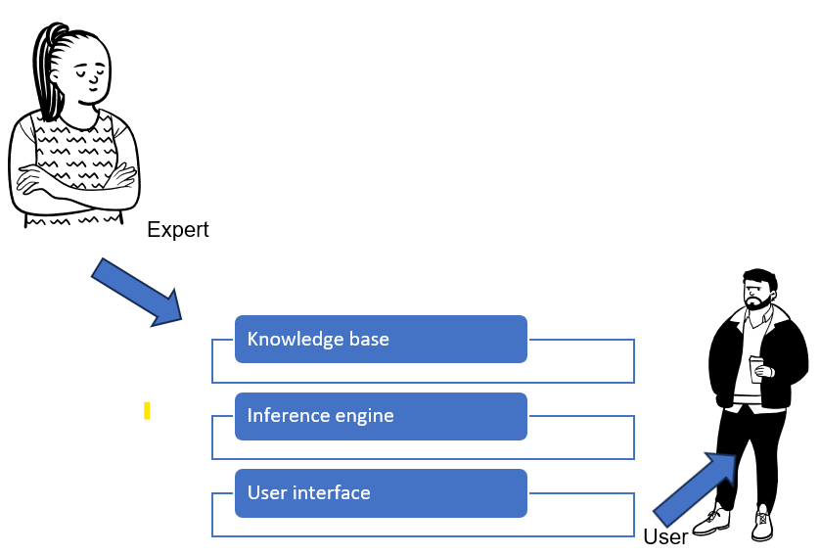
- For each of the components of an expert system provide a definition, an example and a description of the components role in the expert system.
Homework activity: students watch Expert Systems (36:55) and note the tools to build expert systems including: CLIPS, Jess, Prolog, Mycroft and DREAM.

Teacher note: as a class examine the Intelligent Systems PowerPoint and examine what are expert systems.

Knowledge base
Definition: the knowledge base is a collection of facts, rules and data that the expert system uses to make decisions. It contains all the information needed to solve specific problems within a particular domain, such as medical conditions, legal regulations or technical troubleshooting.
Example: in a medical expert system, the knowledge base would include information on symptoms, diseases, treatments and diagnostic protocols.
Role in the expert system: the knowledge base is the foundation of the expert system. The quality and accuracy of the knowledge base determine how well the system can replicate expert-level decision-making. It is continually updated to reflect new information and changes in the field.

Inference engine, including forward chaining and backward chaining
Definition: the inference engine is the reasoning component of the expert system. It processes the information in the knowledge base to draw conclusions or make decisions. The inference engine uses logical rules to apply the knowledge base to specific problems.
Two types of inference:
- Forward chaining
The system begins with known facts and applies rules to derive new conclusions. This is useful for diagnostic problems where you start with symptoms and work toward a diagnosis.
- Backward chaining
The system starts with a goal or hypothesis and works backward to determine what conditions must be met to achieve that goal. This is often used in problem-solving scenarios.
Example: in a troubleshooting system for machinery, the inference engine might use forward chaining to identify the possible cause of a malfunction, or backward chaining to figure out what maintenance steps are needed to prevent future issues.
Role in the expert system: the inference engine acts as the decision-making brain of the expert system. It processes inputs and determines the best course of action or conclusion based on the knowledge base.

User interface (UI)
Definition: the user interface (UI) is the part of the expert system that allows users to interact with the system. It is designed to be user-friendly, enabling users to input data, ask questions and receive recommendations or solutions from the system.
Example: in a legal expert system, the UI might allow a lawyer to input details about a case and receive advice or legal precedents in an easy-to-understand format.
Role in the expert system: the UI is critical for making the expert system accessible to users who may not be experts themselves. A well-designed UI ensures that users can effectively interact with the system, understand its recommendations and apply them to real-world situations.

Activity 26: students summarise the key features of their expert system.
Key feature | Description in medical diagnosis
Knowledge base | Contains domain-specific knowledge, including facts about diseases, symptoms, treatment protocols, and medical guidelines used to identify possible conditions.
Inference engine | Processes the knowledge base to deduce information or make decisions. Includes:  - Forward chaining: starts with known facts (for example, symptoms) and applies rules to infer possible diagnoses  - Backward chaining: begins with a hypothesis (for example, a specific disease) and works backward to determine if symptoms support this hypothesis.
User interface (UI) | Facilitates interaction between healthcare providers and the expert system. It allows for easy input of patient data and access to diagnostic recommendations. The UI should be intuitive and informative, showing reasoning and relevant rules.

Key feature | Description in environmental monitoring.
Knowledge base | Contains domain-specific information about environmental factors, such as air quality, temperature, humidity, pollutants, and relevant regulations or guidelines. This database helps the system identify and assess environmental conditions based on the input data.
Inference engine | Processes the knowledge base to analyse environmental data and draw conclusions. Includes:  - Forward chaining: starts with current environmental data (for example, temperature readings, pollutant levels) and applies rules to infer potential environmental issues (for example, air quality warnings)  - Backward chaining: begins with a specific environmental hypothesis (for example, predicting the likelihood of a smog event) and works backward to check if current conditions (such as humidity and temperature) support this prediction.
User interface (UI) | Facilitates interaction between users (for example, environmental scientists, policymakers) and the expert system. The UI allows users to input environmental data, view real-time monitoring results, and access recommendations for action. It should be user-friendly and provide clear visual representations of data, alerts, and reasoning behind the system's conclusions.

Key feature | Description in process control
Knowledge base | Contains detailed information about manufacturing processes, equipment specifications, quality standards, and best practices. This knowledge allows the system to identify optimal conditions and detect deviations in the manufacturing process.
Inference engine | Analyses data from the manufacturing process and applies logical rules to ensure optimal operation. Includes:  - Forward chaining: starts with current process data (for example, temperature, pressure, production speed) and applies rules to infer necessary adjustments or identify potential issues (for example, overheating)  - Backward chaining: begins with a desired outcome (for example, a specific product quality) and works backward to determine if the current process conditions meet the criteria for achieving that outcome.
User interface (UI) | Facilitates interaction between operators and the expert system. The UI allows users to input real-time process data, monitor system performance, and receive recommendations for adjustments or interventions. It should be intuitive, providing clear visualisations of process metrics, alerts, and the rationale behind the system's advice.

Key feature | Description in scheduling and planning for logistics
Knowledge base | Contains comprehensive information about logistics operations, including inventory levels, transportation options, delivery schedules, demand forecasts, and supplier data. This knowledge helps the system make informed decisions regarding scheduling and resource allocation.
Inference engine | Processes the knowledge base to optimise logistics planning and scheduling. Includes:  - Forward chaining: starts with known data (for example, current inventory levels, order requests) and applies rules to infer necessary actions (for example, scheduling shipments or restocking items).  - Backward chaining: begins with a desired outcome (for example, meeting a specific delivery deadline) and works backward to determine what actions and resources are needed to achieve that outcome (for example, arranging transportation).
User interface (UI) | Facilitates interaction between logistics planners and the expert system. The UI allows users to input relevant data, monitor logistics operations in real-time, and access recommendations for scheduling and planning. It should be user-friendly, providing clear visualisations of schedules, alerts for potential issues, and the reasoning behind the system's recommendations.

Research factors that have allowed expert systems to advance from rule-based systems to integrate probability
Activity 27: teacher-led discussion
Expert systems have evolved significantly, moving from rigid rule-based systems to more flexible systems that incorporate probability.
This evolution is due to several key factors:
- processing power
- data availability and access
- hardware costs
- neural networks
- webometrics.
The transition from rule-based expert systems to those that integrate probability has been driven by advancements in processing power, data availability, hardware affordability, neural networks and webometrics. These factors have enabled expert systems to handle uncertainty and provide more accurate, reliable and dynamic decision-making support across various industries.
Students complete the table on the following page.

Factor | Description | Impact on expert systems
Processing power | Advancements in processing power have enabled computers to perform complex calculations much faster. Modern processors can handle large datasets and run sophisticated algorithms, allowing expert systems to evaluate probabilities based on statistical models. | With increased processing power, expert systems can analyse vast amounts of data and simulate different scenarios in real-time, improving decision-making accuracy and considering uncertainty for more nuanced recommendations.
Data availability and access | The availability of large datasets, thanks to advancements in data storage and the internet, has transformed expert systems. Access to real-time data from various sources enables these systems to learn from patterns and trends, enhancing their predictive capabilities. | Expert systems can integrate real-time data and historical information to calculate probabilities, making recommendations more dynamic and context sensitive. This shift is crucial for fields like finance, healthcare, and logistics.
Hardware costs | The cost of hardware, including powerful processors and storage devices, has significantly decreased over time. This reduction has made advanced computing accessible to more organisations, enabling them to implement expert systems that incorporate probability and complex algorithms. | Lower hardware costs have democratised access to expert systems, allowing more industries to benefit from advanced decision-making tools. Companies can now afford to deploy powerful systems that consider probabilities and uncertainties in their operations.
Neural networks | Neural networks mimic the way the human brain processes information. They learn from data, recognise patterns, and make predictions. They have advanced expert systems by enabling the processing of complex, non-linear relationships within data. | By integrating neural networks, expert systems can move beyond simple rule-based logic and incorporate machine learning techniques, handling probabilistic reasoning and enhancing overall performance in uncertain situations.
Webometrics | Webometrics involves measuring and analysing web-based data, including how information is connected and accessed online. This field has contributed to the growth of expert systems by providing insights into online behaviour, trends and data flows. | Expert systems utilising webometrics can analyse vast amounts of web data to understand trends, predict outcomes, and provide accurate recommendations, making them more relevant and effective in industries like marketing, research and e-commerce.
Activity 28: students reconvene into teams to apply the concepts from the above table to their expert system. Assign each student a number from 1 to 4.
- All students allocated a 1 research expert systems for diagnosis
- All students allocated a 2 research expert systems for monitoring
- All students allocated a 3 research expert systems for process control
- All students allocated a 4 research expert systems for scheduling and planning
Teams research how processing power, data availability and access, hardware costs, neural networks and webometrics have allowed expert systems to advance from rule-based systems to integrate probability.
Teams present this information for classmates to complete the following tables.
These presentations and completed table form part of the class study notes.

Factor | How medical diagnosis has advanced from rule-based systems to those that integrate probability
Processing power | Increased processing power enables expert systems to handle complex calculations and large datasets efficiently, facilitating the use of sophisticated algorithms and probabilistic models.
Data availability and access | Proliferation of electronic health records and medical research databases has improved access to diverse datasets, allowing expert systems to learn from a wide range of patient cases for better accuracy.
Hardware costs | Reduction in hardware costs makes advanced computing resources more accessible, enabling healthcare institutions to invest in powerful servers capable of running complex diagnostic algorithms.
Neural networks | Neural networks, as a subset of machine learning, can learn from examples and identify intricate patterns in data, allowing expert systems to integrate probabilistic models for diagnosis.
Webometrics | Involves the analysis of online medical literature and guidelines, allowing expert systems to stay updated with the latest research, enhancing their ability to make probabilistic assessments based on current evidence.

Factor | How environmental monitoring has advanced from rule-based systems to those that integrate probability
Processing power | Enhanced processing power enables environmental monitoring systems to analyse large volumes of data from various sources (for example, sensors, satellite imagery) quickly and efficiently, facilitating the use of complex algorithms and probabilistic models.
Data availability and access | The availability of extensive environmental datasets, including real-time sensor data, historical climate data, and pollution statistics, allows expert systems to learn from diverse sources, improving their accuracy in making probabilistic assessments about environmental conditions.
Hardware costs | Decreased hardware costs have made advanced computing resources more accessible, enabling organisations to invest in powerful systems that can handle complex calculations and support the implementation of probabilistic models in environmental monitoring.
Neural networks | The application of neural networks allows expert systems to identify complex patterns and relationships in environmental data. These models can learn from examples and are capable of making probabilistic predictions about future environmental conditions or potential risks.
Webometrics | Webometrics facilitates the analysis of online environmental data, research findings, and policy documents, providing expert systems with up-to-date information and trends. This access enhances the systems' ability to make informed probabilistic assessments based on the latest evidence and research.

Factor | How process control in manufacturing has advanced from rule-based systems to those that integrate probability
Processing power | Increased processing power allows process control systems in manufacturing to perform complex calculations and real-time data analysis efficiently, enabling the use of advanced algorithms and probabilistic models for optimising operations and decision-making.
Data availability and access | The proliferation of data from various sources, such as sensors, IoT devices, and production systems, provides expert systems with extensive datasets. This availability allows the systems to learn from historical data and improve their accuracy in predicting manufacturing process outcomes.
Hardware costs | The reduction in hardware costs has made advanced computing technology more accessible to manufacturing industries. This affordability enables organisations to invest in powerful systems that can support complex probabilistic models for effective process control.
Neural networks | The integration of neural networks enables expert systems in manufacturing to learn from data and identify intricate patterns in process behaviour. These models can make probabilistic predictions about process performance, allowing for more adaptive and responsive control strategies.
Webometrics | Webometrics allows for the analysis of online resources, research, and industry trends in manufacturing, providing expert systems with current information that can influence process control decisions. This ongoing access to the latest findings helps in making informed probabilistic assessments.

Factor | How scheduling and planning in logistics and supply chain management has advanced from rule-based systems to those that integrate probability
Processing power | Enhanced processing power allows scheduling and planning systems in logistics and supply chain management to perform complex calculations and analyse large datasets in real-time. This capability enables the use of advanced algorithms and probabilistic models to optimise scheduling and resource allocation.
Data availability and access | The availability of extensive datasets, including real-time tracking information, demand forecasts, inventory levels, and transportation data, provides expert systems with the information needed to make informed decisions. This access allows the systems to learn from historical data and improve accuracy in predicting logistical outcomes.
Hardware costs | The reduction in hardware costs has made powerful computing resources more accessible to logistics and supply chain organisations. This affordability enables the investment in systems capable of running complex probabilistic models for effective scheduling and planning.
Neural networks | The application of neural networks in scheduling and planning enables expert systems to identify complex patterns in logistical data. These models can learn from past experiences and make probabilistic predictions about demand, delays, and optimal resource allocation, enhancing decision-making processes.
Webometrics | Webometrics facilitates the analysis of online resources, research, and industry trends relevant to logistics and supply chain management. This ongoing access to current information supports expert systems in making informed probabilistic assessments, improving responsiveness to changing conditions and market dynamics.

Describe how people’s changing needs have shaped the proliferation of expert systems
Activity 29: note taking
Students take turns to read out the following text while classmates take notes and summarise into key points and diagrams.
People's changing needs have significantly influenced the development and proliferation of expert systems. As industries have become more complex, the need for sophisticated decision-making tools has grown. Expert systems simulate human expertise to aid in making decisions in fields like healthcare, finance, and engineering, where the stakes are high, and information is vast. Organisations strive for greater efficiency and productivity.
Expert systems can automate routine tasks and provide quick access to expert knowledge, reducing the time required for decision-making and allowing human experts to focus on more complex problems. There is often a shortage of human experts in critical areas.
Expert systems can bridge this gap by making specialised knowledge more accessible to non-experts, enabling more individuals to make informed decisions without needing direct access to a human expert. With the rise of big data and analytics, there is a demand for personalised services. Expert systems can analyse individual user data to provide tailored recommendations, enhancing user experiences in areas like healthcare (personalised treatment plans) and marketing (targeted advertising).
The fast pace of technological change has created a need for continuous learning and adaptation. Expert systems can be designed to incorporate new information quickly, allowing organisations to keep up with evolving knowledge and practices. Organisations are always looking for ways to cut costs. By implementing expert systems, they can reduce reliance on human experts for every decision, thus lowering operational costs while maintaining high levels of accuracy and reliability.
As businesses operate on a global scale, there is a need for systems that can work across various regions and languages. Expert systems can standardise knowledge and processes, making it easier for organisations to operate internationally. The proliferation of expert systems is a direct response to the need for efficiency, accessibility, and adaptability in an increasingly complex and fast-paced world.

The changing needs of people and industries have significantly shaped the proliferation of expert systems. As the IoT, IoMe and Industry 4.0 continue to expand, expert systems are increasingly integrated into everyday life and industrial processes, providing more intelligent, personalised and efficient solutions to meet the demands of the modern world.

IoT, IoMe, Industry 4.0
Activity 30: teachers cut up the table and issue the terms and definitions for students to match correctly.
Terms | Definitions
Internet of Things (IoT) | Objects connected to the internet that collect and exchange data, such as smart thermostats (Google Nest), wearable devices (Fitbit), and connected home systems.
Internet of Me (IoMe) | Technologies tailored to individual users, providing personalised experiences based on data collection from personal devices (for example, smart assistants like Alexa, Google Home, or personalised shopping experiences).
Industry 4.0 | The fourth industrial revolution, where smart factories and manufacturing processes are integrated with IoT, AI, robotics, and big data to create more efficient, autonomous, and responsive systems.
Activity 31: group research activity
Students form small groups (2–3 students per group).
Each group researches and presents to the class one of the following topics:
- Group 1: How have people’s changing needs (for example, convenience, safety, health) influenced the development of Internet of Things (IoT) devices?
- Group 2: How is the Internet of Me (IoMe) changing our everyday lives and our need for personalised technology (for example, smart home systems, personalised health devices, personal assistants, avatars)?
- Group 3: How has Industry 4.0 transformed manufacturing, logistics and business practices and how do businesses respond to increased consumer demands for faster, smarter and more sustainable products?
Each group will research real-world examples related to their assigned topic and explore how societal needs (for example, convenience, health, efficiency) have driven the growth of these technologies.
Each group member is allocated a question (A, B or C) to research.
- What problem or need did this technology address?
- How has this expert system or technology evolved over time?
- What impact has it had on people's lives, industries, or economies?
Suggested research sources
- Websites like TechCrunch, Wired or Industry Week
- Videos on IoT, Industry 4.0, or IoMe
- Features and news articles provide case studies on companies that use these technologies.
Teacher note: detailed worksheets of each of these concepts can be found in the Appendix of this document.
Sample answers:
IoT devices and changing needs
- Problem addressed: the need for convenience, safety and better health monitoring.
- Evolution over time: early IoT devices were limited to basic automation; now, they use AI to learn user behaviour.
- Impact: smart homes enhance convenience and safety, while wearables promote healthier lifestyles.
- Real-world example: Ring Doorbell integrates security cameras with mobile notifications, ensuring safer homes.
Internet of Me and personalised technology
- Problem addressed: growing demand for personalised and adaptive technologies.
- Evolution over time: initially focused on basic customisation (for example, playlists); now, it incorporates AI for dynamic personalisation (for example, personalised healthcare insights).
- Impact: IoMe technologies improve user experiences and streamline daily tasks.
- Real-world example: Google Nest integrates with Google Assistant to automate home functions based on user routines.
Industry 4.0 and business transformation
- Problem addressed: consumer demands for faster, smarter and sustainable products.
- Evolution over time: shift from traditional assembly lines to fully automated, data-driven production systems.
- Impact: increased efficiency, reduced costs and minimised environmental impact.
- Real-world example: Tesla's Gigafactories use AI and robotics to optimise electric vehicle production.
Activity 32: teacher-led discussion and questions
- How do these technologies overlap or support each other? (For example, how might IoT and Industry 4.0 work together?)
Sample answer:
IoT supports Industry 4.0 by providing real-time data from sensors in smart factories.
IoMe integrates IoT data to create personalised user experiences, like tailored health insights from wearables.
- What future trends do you foresee in expert systems, IoT, IoMe, or Industry 4.0?
Sample answer:
In the field of expert systems, I foresee an increasing use of artificial intelligence and deep learning, which will lead to more accurate predictions and improved decision-making capabilities. In IoT, greater interoperability among devices, as well as significant improvements in data security to protect user information. With IoMe, advanced artificial intelligence will enable even more personalised services. Industry 4.0, may provide wider adoption of green technologies, along with a focus on AI-driven sustainability practices, which will make for more environmentally friendly manufacturing processes.
- How might these technologies shape the way people live, work, or interact with the world in the next 10 years?
Sample answers:
We may see more personalised and connected homes that not only reduce energy use but also improve safety for residents.
In the workplace, I anticipate the emergence of smarter factories and the implementation of AI-driven business decisions, which will enhance productivity and operational efficiency. For interaction, a seamless integration of devices, services, and environments will create a more adaptive and efficient world that enhances how people connect with their surroundings.

Describe the operation of simplistic and complex intelligent agents used by search engines, including predictive search strings and the use of voice assistants to initiate interaction
Activity 33: teacher demonstrates the operation of predictive search strings and students make suggestions as to how this works.
Example: as the teacher types ‘How to bake …’ in a search engine, it might suggest ‘How to bake a cake’ or ‘How to bake bread’ based on common searches.
Describe this operation.
Sample answer:
This is a straightforward, rule-based system that enhances the user experience by predicting the most likely searches. These agents use algorithms that analyse large datasets of search history and patterns. They rely on statistical methods to offer the most relevant suggestions, but they do not deeply understand the content or context of the search.
Teacher demonstrates the operation of voice assistants (for example, Siri, Google Assistant), and students make suggestions as to how this works.
Example: teacher asks, ‘What's the weather like today?’ or ‘Find Italian restaurants near me’, and the voice assistant will provide a spoken response, along with additional information displayed on your device.
Describe this operation.
Sample answer:
Voice assistants convert spoken language into text, interpret the meaning using natural language processing (NLP); a subfield of AI that focuses on enabling computers to understand, interpret, and generate human language. It then searches the web or accesses other apps to provide a relevant answer. These agents can handle complex queries and even follow-up questions, making them highly interactive and adaptive. They learn from user interactions, becoming more accurate over time.

Compare techniques used by different inference engines
Inference engines are a core component of expert systems, responsible for drawing conclusions based on data and rules. Different techniques are used by inference engines to make decisions, and each has its own strengths and applications.
Activity 34: jigsaw activity
Students form teams of 4 students and are numbered off 1–4.
- Students numbered 1 join the truth maintenance group.
- Students numbered 2 join the hypothetical reasoning group.
- Students numbered 3 join the heuristic knowledge and fuzzy logic group.
- Students numbered 4 join the ontology classification group.
Each group provides a definition of the concept, a use case and a description of its strengths.
Students reconvene into their teams and share their findings by creating a table. A sample response can be found on the next page.

Concept | Definition | Use case | Strength
Truth maintenance systems (TMS) | TMS track which beliefs or facts are true in a dynamic environment. They ensure that when new information is added or existing information is revised, the system consistently updates all related facts. | In an expert system for network security, TMS ensures that if a new security protocol is implemented, all related rules and actions are updated accordingly. | It provides consistency and reliability in decision-making, ensuring that the system’s knowledge remains accurate and up to date.
Hypothetical reasoning | Involves exploring ‘what-if’ scenarios. The system tests different hypotheses or assumptions to determine possible outcomes or solutions. | In medical diagnosis, hypothetical reasoning allows the system to suggest different diagnoses based on varying symptoms and test results, helping doctors explore alternative possibilities. | It enhances decision-making by allowing the system to consider multiple possibilities and their implications, improving the chances of finding the best solution.
Heuristic knowledge and fuzzy logic | Heuristic knowledge involves using practical rules or ‘rules of thumb’ based on experience, while fuzzy logic deals with reasoning that is approximate rather than precise, handling uncertainty and imprecision. | In autonomous vehicles, heuristic rules and fuzzy logic help the system make decisions in unpredictable environments, such as interpreting the behaviour of other drivers. | These techniques allow expert systems to handle uncertainty and make decisions in complex, real-world situations where exact answers may not be available.
Ontology classification | Involves organising knowledge into categories or concepts, defining relationships between them. This helps the system understand and reason about the data in a structured way. | In e-commerce, ontology classification helps the system recommend products by understanding the relationships between different categories and user preferences. | It improves the system’s ability to understand and reason about complex domains, enabling more accurate and relevant decision-making.

Investigate the hardware used in an intelligent system
Intelligent systems rely on various hardware components to interact with the physical world, process data and make decisions. These components enable systems to sense, interpret and respond to their environment.
Activity 35: students collect images of each of these technologies and provide a description on how they work. This research is presented in a slide deck and used as class notes.

Biometrics
Students research images and paste them here.
Describe biometrics in the space below.
Sample answer:
Biometric hardware refers to devices that measure and analyse human physical or behavioural characteristics for identification and security purposes.
Examples:
- Fingerprint scanners used in smartphones and security systems.
- Facial recognition cameras used in access control systems.
- Biometrics enhance security by ensuring that access to systems or data is granted only to authorised individuals.

Haptics
Students research images and paste them here.
Describe haptics in the space below.
Sample answer:
Haptic technology involves hardware that provides tactile feedback to users through touch or vibration.
Examples include: game controllers provide vibrations in response to in-game events, and wearable devices that use haptics to give notifications or guide users.
Haptics enhance user experience by providing physical sensations that correspond to digital interactions.

Touch and gesture
Students research images and paste them here.
Describe touch and gesture in the space below.
Sample answer:
Touch and gesture hardware allows users to interact with systems through touchscreens or motion-based gestures.
Examples include: touchscreens used in smartphones, tablets and kiosks as well as gesture sensors used in gaming consoles like the Xbox Kinect.
These devices provide intuitive and direct ways for users to control intelligent systems.

Virtual and augmented reality (VR/AR)
Students research images and paste them here.
Describe VR and AR in the space below.
Sample answer:
VR and AR hardware create immersive digital environments or overlay digital information onto the real world.
Examples include: VR headsets fully immerse users in a virtual environment and AR glasses overlay digital information onto the physical world.
These technologies are used in gaming, training simulations and real-world applications like architecture and design.

Voice and sound
Students research images and paste them here.
Describe voice and sound hardware in the space below.
Sample answer:
Voice and sound hardware enable intelligent systems to process audio inputs and produce sound outputs.
Examples include: microphones capture voice commands for voice assistants like Alexa or Siri and speakers provide audio feedback or play music.
Voice recognition and sound generation allow for natural and hands-free interaction with intelligent systems.

Microcontrollers
Students research images and paste them here.
Describe microcontrollers in the space below.
Sample answer:
Microcontrollers are small, programmable chips that control the functions of electronic devices.
Examples include: Arduino boards used in DIY electronics projects and embedded controllers found in appliances, cars and industrial machinery.
Microcontrollers act as the brains of simple intelligent systems, processing inputs and controlling outputs.

Sensors, actuators and motors
Students research images and paste them here.
Describe sensors, actuators and motors in the space below.
Sample answer:
Sensors detect physical changes in the environment, actuators perform physical actions, and motors drive movement.
Examples include: temperature sensors monitor environmental conditions in smart thermostats; motors power robotic arms in manufacturing and actuators control mechanical systems, like opening a valve. These components allow intelligent systems to interact with the physical world by sensing conditions and performing actions in response.
Project alignment
Describe how your Enterprise Computing project could be made into or benefit from an intelligent system.
Student response.
What hardware could be used?
Student response.

Explore how computational thinking can be integrated into the design and development of an intelligent system
Computational thinking is a problem-solving approach that helps us break down complex tasks, identify patterns and create step-by-step solutions.
Activity 36: students apply computational thinking to a series of Bebras questions.
Extension activity: consider enrolling students in the Bebras challenge.

Decomposition
Activity 37: teacher-led discussion
Decomposition involves breaking a complex problem into smaller, manageable parts.
In intelligent systems, an example would be designing an autonomous car involves decomposing the system into tasks like object detection, route planning and speed control.
Decomposition is important as smaller tasks are easier to analyse and solve, leading to more efficient development.
Example: break down the problem of designing a smart home system into smaller tasks. Consider areas like security, lighting and energy management.
- What are the main functions of a smart home system?
Sample answer:
Security, lighting control, energy management, climate control, home entertainment, communication and networking.

- Describe the processes required for each of these functions.
Security
- Surveillance system
- install cameras (indoor/outdoor)
- set up motion detection
- configure remote access and notifications
- Alarm system
- choose alarm types (door/window sensors, glass break detectors)
- install alarms and sensors
- set up monitoring services
- Access control
- install smart locks
- develop a user access system
- set up remote locking/unlocking
Lighting control
- Smart lighting
- install smart bulbs/fixtures
- configure lighting schedules and scenes
- integrate with voice assistants
- Automation
- set up motion sensors for automatic lighting
- create routines based on time of day
- Remote control
- develop a mobile app for lighting control
- integrate with home assistant devices
Energy management
- Smart thermostats
- choose and install smart thermostats
- set up learning capabilities and schedules
- monitor energy usage through an app
- Smart plugs and outlets
- install smart plugs for appliances
- implement energy monitoring features
- Integration with energy providers
- explore demand response programs
- set up alerts for peak usage times
Climate control
- HVAC automation
- integrate HVAC systems with smart thermostats
- set up zoning controls for different areas
- Air quality monitoring
- install air quality sensors
- develop alerts for poor air quality
Home entertainment
- Audio/video control
- set up smart TVs and speakers
- integrate with streaming services
- Multi-room audio systems
- install speakers throughout the home
- configure app control for music playback
Communication and networking
- Home network setup
- ensure robust Wi-Fi coverage
- set up a secure network for devices
- Integration of devices
- ensure compatibility among devices and develop a centralised app for control
- Assign a priority level to each task. Which task should be developed first?
High priority:
- security (surveillance system, alarm system, access control)
- home network setup (to support all devices)
Medium priority:
- energy management (Smart Thermostats, Smart Plugs)
- climate control (HVAC automation)
- lighting control (Smart Lighting, automation)
Low priority:
- home entertainment (audio/video control, multi-room audio systems)
- communication and networking (integration of devices)
Students should be encouraged to debate this prioritisation.

Pattern recognition
Activity 38: teacher-led discussion
Pattern recognition involves identifying recurring patterns or trends in data or processes.
In intelligent systems, an example would be a facial recognition system that identifies patterns in facial features, like the distance between eyes or the shape of a nose.
Pattern recognition is important as it helps the system learn and make predictions more effectively.
Example: spot the patterns
Using the Bureau of Meteorology website, analyse a dataset of daily temperatures over a month from the suburb where you live to identify patterns.
- Are there noticeable trends or patterns in temperature changes?
Daily temperature fluctuations: students will observe variations in temperature from day to day, which can highlight the natural fluctuations that occur due to weather systems, cloud cover, and other environmental factors.
Weekly patterns: there might be noticeable trends across weeks, such as warmer temperatures during the weekends or cooler temperatures at the beginning or end of the week, depending on local weather patterns.
Seasonal trends: if the dataset covers a month that falls within a specific season (for example, summer, winter), students may observe trends consistent with that season, such as generally higher temperatures in summer months or lower temperatures in winter.
Extremes: students may identify days with extreme temperatures, both highs and lows, and analyse what weather conditions might have contributed to these extremes.
Overall trends: they may observe whether the overall trend for the month is increasing (warmer temperatures) or decreasing (cooler temperatures) and relate this to broader climatic conditions or local weather events.
Humidity and precipitation influence: if humidity or precipitation data is available, students may see how these factors correlate with temperature changes, such as cooler temperatures following rain.
Anomalies: students might find unusual temperature readings that deviate significantly from the expected pattern, prompting discussion about events like heatwaves or cold snaps.
Time of day variations: if the dataset includes time-specific data (for example, hourly temperatures), students could analyse how temperatures change throughout the day, observing patterns such as cooler mornings and warmer afternoons.
- How could an intelligent weather prediction system use these patterns?
By analysing historical temperature data and the identified patterns, the system can train machine learning models to predict future temperatures based on past trends. This could include recognising seasonal variations, daily fluctuations, and anomalies.
The system can fine-tune its algorithms to improve the accuracy of forecasts by incorporating patterns such as weekly trends and the effects of humidity and precipitation on temperature changes.
By understanding typical temperature patterns, the system can identify anomalies or extreme weather events more effectively. This would enhance its ability to issue alerts for unusual weather conditions, such as heatwaves or cold snaps.
The system could analyse local patterns to provide personalised forecasts and alerts based on user preferences or needs, such as warnings for high temperatures during summer or frost alerts in winter.
By continuously updating its models with new data, the system can analyse long-term trends in temperature changes and provide insights into climate change impacts specific to a region.
The system could combine temperature patterns with data from other sources, such as satellite imagery and atmospheric pressure readings, to enhance prediction capabilities and provide more comprehensive weather forecasts.
As new data becomes available, the system can adapt its predictions based on observed changes in patterns, allowing for continuous improvement in forecasting accuracy.
By communicating observed patterns and predictions effectively, the system can engage users better, helping them understand weather trends and make informed decisions based on predicted conditions.

- Can you think of other examples where pattern recognition is essential in intelligent systems?
Create a table of your examples
Example | Description
Image and facial recognition | Identifies and classifies objects, faces, or features in images. Used in security and social media.
Natural language processing | Understands and generates human language, enabling chatbots and virtual assistants to interpret queries.
Speech recognition | Converts spoken language into text for voice-activated assistants, transcription services and accessibility tools.
Anomaly detection | Identifies unusual patterns in finance and cybersecurity to detect fraud or security breaches.
Medical diagnosis | Analyses patterns in medical imaging to identify diseases or abnormalities in X-rays, MRIs, or CT scans.
Recommendation systems | Provides personalised recommendations based on user behaviour and preferences in e-commerce and streaming platforms.
Autonomous vehicles | Interprets data from sensors and cameras to identify obstacles and navigate safely in self-driving cars.
Financial market analysis | Analyses stock market trends and price movements to inform investment decisions based on historical patterns.
Predictive maintenance | Monitors equipment performance data to identify patterns, allowing for predictive maintenance and reduced downtime.
Sports analytics | Analyses player performance and game strategies to improve tactics and training in sports.

Abstraction
Activity 39: teacher-led discussion
Abstraction involves focusing on the important details while ignoring irrelevant information.
In intelligent systems an example would be in designing a navigation app, abstraction focuses on roads, traffic and directions, ignoring irrelevant details like building colours or sidewalk patterns.
Abstraction is important as it simplifies complex problems by reducing unnecessary complexity.
Example: imagine you are designing an intelligent shopping assistant app. Identify the most critical features and filter out unnecessary ones.
- What features are essential for the shopping assistant to function?
Sample answers:
- A secure login and registration process to protect user data
- A powerful search function with filtering options to help users easily find products
- A shopping cart with functionality to add, remove, and manage items, along with a clear overview of total costs
- Secure payment options with a reliable payment gateway for safe and easy transactions
- Real-time updates to track orders and delivery times
- Basic AI-driven suggestions based on user preferences and browsing history
- Access to reviews and ratings to assist users in making informed decisions
- A simple wish list feature to save products for later consideration

- What details can you ignore to simplify the design process?
Sample answers:
- Augmented reality (AR) functionalities look good, though are not essential for a basic shopping experience.
- In-depth analysis of user behaviour can be postponed until after the core app is established.
- Start with a limited number of payment methods instead of integrating many from the beginning.
- Skip comprehensive support options (like live chat) initially, focusing on basic FAQs or email support.
- Social media links can be useful for sharing, though could be added later.
- Product information should focus on essential product details and images rather than extensive specifications.
- It does not need store locator features if the app primarily focuses on online shopping.

Activity 40: complete the cloze passage using the word bank provided:
collaboration, abstraction, adaptability, code, complexity, components, core, data, debugging, detail, encapsulation, entire, essential, faster, flexibility, grow, important, independently, infrastructure, interface, learning, manageable, modifications, modules, non-essential, parallel, prioritise, quality, redundancy, reliable, reusability, scalability, separate, simplify, simultaneously, update.
Abstraction is a powerful concept in computing that helps __________ complex systems. Imagine trying to build a car. Instead of focusing on every tiny _______, like how the engine works or how the brakes are designed, ______________ allows you to look at the car as a whole. It hides these intricate details and shows you only the ___________ features, like the steering wheel, pedals, and dashboard. This makes it easier for developers and users to focus on what's ___________ without getting overwhelmed by the _____________ beneath the surface.
By removing ________________ details, teams can concentrate on developing and refining the _____ functionalities of the system. This streamlined focus can lead to _______ development cycles and ultimately improve the _________ of the product. For instance, when designing a software application, developers can _____________ features that directly enhance user experience rather than getting sidetracked by less critical aspects. Another significant advantage of abstraction is ______________. It allows developers to create generalised _____________ or modules that can be used across different parts of the system or even in future projects. This means that instead of rewriting code, they can reuse existing _________, which saves time and reduces _____________, ensuring consistency throughout the application.
Maintenance becomes more _____________ with abstraction as well. Systems designed with abstraction in mind are typically easier to _______. Since changes can often be made to abstracted components without impacting the _______ system, developers can implement updates and ________________ more efficiently. Abstraction often goes hand-in-hand with ________________, which is like bundling related _____ and functions together. This approach restricts access to certain details, promoting a clear ___________ that minimises errors and unintended interactions. For example, if a developer needs to use a function, they can do so without needing to understand all the underlying _____, which simplifies the process. Additionally, abstraction enhances ______________. As systems _____, high-level components can be expanded or modified without requiring extensive changes to the underlying code. This ______________ makes it easier for systems to adapt to new requirements or technologies. ________________ among teams is also improved through abstraction. Different developers can work on __________ components without needing to understand every detail of one another’s work. This encourages __________ development, allowing teams to progress __________________ and efficiently.
Testing and ___________ become simpler with abstracted components as well. Since these components can be tested ________________, it’s easier to identify and fix issues. This modular approach not only simplifies testing but also contributes to building more robust and __________ systems. For new developers or users, an abstracted system presents a faster __________ curve. They can interact with simplified interfaces and grasp the system’s functionality without needing to understand all the complex details right away. Lastly, abstraction provides flexibility and _______________. It allows systems to adjust to changes in requirements or technologies with greater ease. High-level designs can be modified without needing to rework the entire underlying __________________, making it easier for developers to keep up with evolving needs.

Solution:
Abstraction is a powerful concept in computing that helps simplify complex systems. Imagine trying to build a car. Instead of focusing on every tiny detail, like how the engine works or how the brakes are designed, abstraction allows you to look at the car as a whole. It hides these intricate details and shows you only the essential features, like the steering wheel, pedals and dashboard. This makes it easier for developers and users to focus on what's important without getting overwhelmed by the complexity beneath the surface.
By removing non-essential details, teams can concentrate on developing and refining the core functionalities of the system. This streamlined focus can lead to faster development cycles and ultimately improve the quality of the product. For instance, when designing a software application, developers can prioritise features that directly enhance user experience rather than getting sidetracked by less critical aspects. Another significant advantage of abstraction is reusability. It allows developers to create generalised components or modules that can be used across different parts of the system or even in future projects. This means that instead of rewriting code, they can reuse existing modules, which saves time and reduces redundancy, ensuring consistency throughout the application.
Maintenance becomes more manageable with abstraction as well. Systems designed with abstraction in mind are typically easier to update. Since changes can often be made to abstracted components without impacting the entire system, developers can implement updates and modifications more efficiently.
Abstraction often goes hand-in-hand with encapsulation, which is like bundling related data and functions together. This approach restricts access to certain details, promoting a clear interface that minimises errors and unintended interactions. For example, if a developer needs to use a function, they can do so without needing to understand all the underlying code, which simplifies the process.
Additionally, abstraction enhances scalability. As systems grow, high-level components can be expanded or modified without requiring extensive changes to the underlying code. This flexibility makes it easier for systems to adapt to new requirements or technologies. Collaboration among teams is also improved through abstraction. Different developers can work on separate components without needing to understand every detail of one another’s work. This encourages parallel development, allowing teams to progress simultaneously and efficiently. Testing and debugging become simpler with abstracted components as well. Since these components can be tested independently, it’s easier to identify and fix issues. This modular approach not only simplifies testing but also contributes to building more robust and reliable systems.
For new developers or users, an abstracted system presents a faster learning curve. They can interact with simplified interfaces and grasp the system’s functionality without needing to understand all the complex details right away. Lastly, abstraction provides flexibility and adaptability. It allows systems to adjust to changes in requirements or technologies with greater ease. High-level designs can be modified without needing to rework the entire underlying infrastructure, making it easier for developers to keep up with evolving needs.

Algorithms
Activity 41: teacher-led discussion
Algorithms are step-by-step instructions for solving a problem or performing a task.
In intelligent systems, an example would be a recommendation system for an online store uses an algorithm to suggest products based on user preferences.
Algorithms are important as they power the decision-making process in intelligent systems.
Example: write a simple algorithm for a robot vacuum to clean your room.
- Define the robot's start position.
Sample answer:
- Initialise start position.
- Set the robot's starting coordinates, for example, (0,0) in the bottom-left corner of the room.
- Ensure the robot is facing a specific direction, for example, upwards (north).
- Outline steps for moving around the room, avoiding obstacles and cleaning efficiently.
Begin cleaning loop:
Move forward:
- Move in the current direction.
- If an obstacle is detected, move to Step 2.
- If the boundary of the room is reached, move to Step 3.
Avoid obstacles:
- Detect obstacle using sensors.
- Stop, then turn 90 degrees clockwise.
- Move forward and continue cleaning.
Boundary handling:
- Upon reaching a boundary, stop and turn 90 degrees clockwise.
- Move forward to begin cleaning the next row.
Check for completion:
- If the entire room is clean, return to the starting position.
- If not, repeat the cleaning loop.
- Test your algorithm with a diagram or a flowchart.
Figure 2 – sample algorithm for robot vacuum. Students may consider a nested pre-test loop
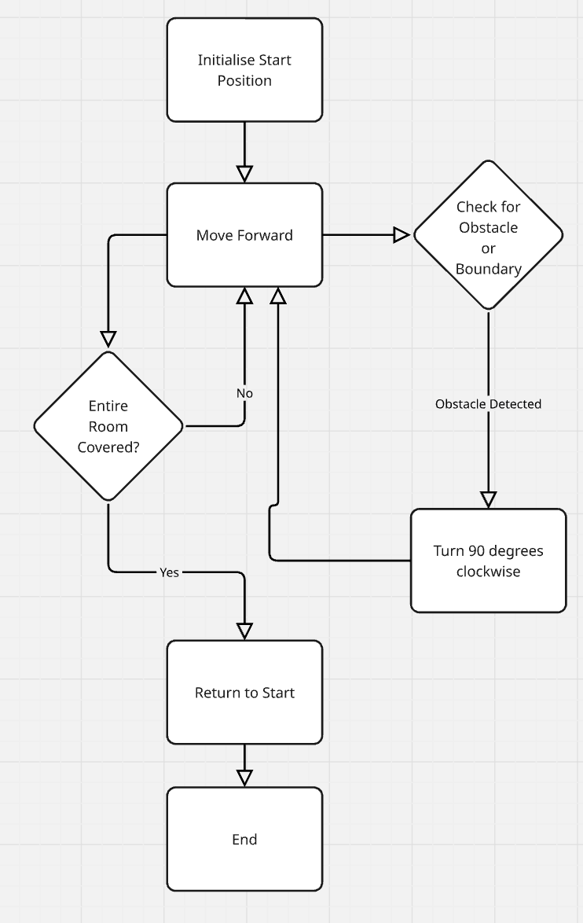
Challenge: improve your algorithm to include a ‘return to charging station’ function.
Suggested response:
Start
Initialise Start Position and Charging Station
Move Forward
Check for Obstacle or Boundary
If Obstacle Detected -> Turn 90 degrees clockwise -> Move Forward
If Boundary Detected -> Turn 90 degrees clockwise -> Move Forward
Check Battery Level:
If Battery Low or Room Clean -> Go to "Return to Charging Station"
If Battery Sufficient -> Continue Cleaning
Return to Charging Station:
Navigate to charging station while avoiding obstacles.
Reach charging station and dock.
End
Extension activity: students can use Trinket to write the code for the algorithm

Communicate the logical processes performed by an intelligent system by using flowcharts, data flow diagrams and infographics
Intelligent systems, such as AI-driven chatbots, self-driving cars, and smart home assistants, use a series of logical processes to make decisions. Understanding and visualising these processes helps developers design, test, and improve intelligent systems.
To communicate these processes effectively, we use:
- Flowcharts – they show step-by-step logic in a process.
- Data flow diagrams (DFDs) – they show how data moves through a system.
- Infographics – they simplify complex processes for easy understanding.
Flowcharts
Flowcharts are diagrams that represent logic and are read from top to bottom and left to right. Arrows indicate the direction of flow.
They are a diagrammatical way to represent logic and use the 4 symbols shown below:
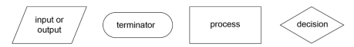
Activity 42: examine examples of flowcharts in the Higher School Certificate Course Specifications – Enterprise Computing (PDF 2.3 MB).

Activity 43: the following example of a flowchart represents the logic to determine the application of a delivery charge to perishable and non-perishable items. Label each shape with the name of the symbol.
Figure 3 – perishable item algorithm
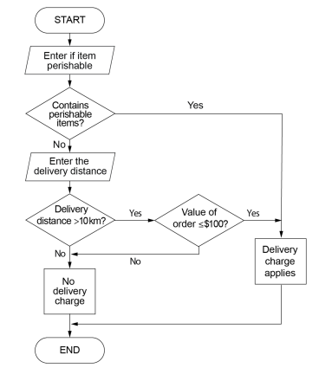

Activity 44: in the space below create a flowchart to represent a system which includes a knowledge base of IF-THEN rules to be used by an expert system.
An example could illustrate the decision-making process of a smart home thermostat. The system senses the room temperature and decides whether to turn the heater on or off.
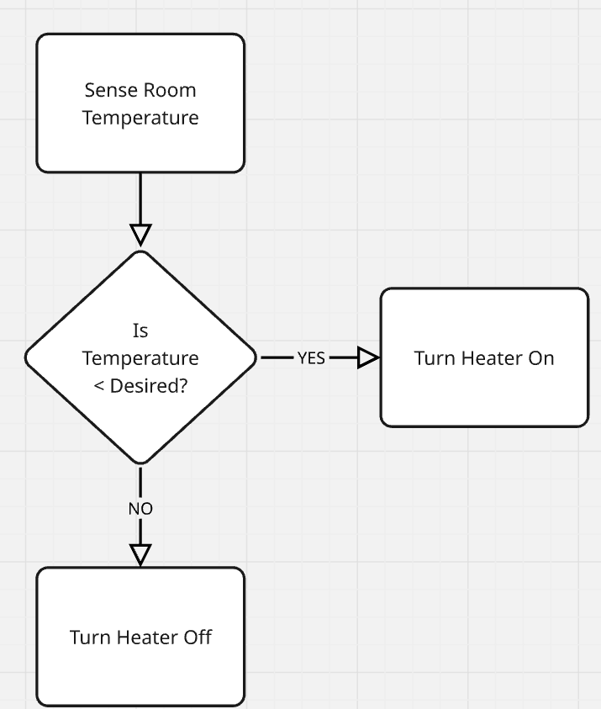

Data flow diagrams (DFDs)
A data flow diagram (DFD) shows how data moves through an intelligent system. It consists of:
- external entities that are the sources or sinks of the data (for example, users, sensors)
- These are things so are named with nouns
- processes (for example, calculations, logic)
- These change the data in some way and as actions are named with verbs.
- data stores (for example, databases)
- data flows (arrows showing data movement).
The table below shows the symbols used in a data flow diagram,
Symbol name | Symbol | Description
Processes | 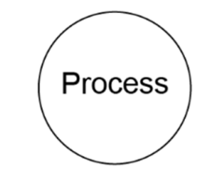 | These circles show how data is processed within the system.  A circle represents a process. A process uses input(s) to generate output(s).
Data stores | 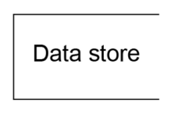 | Depicted as open-ended rectangles, they indicate where data is stored.  A data store can be an electronic file or non-computer storage.
External entity | 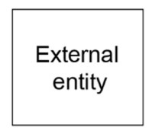 | Illustrated by squares, these are sources or destinations of data outside the system.  An external entity can be any person, organisation or element that provides data to the system or receives data from the system.
Data flow |  | A labelled, curved arrow represents the flow of data between processes, data stores and external entities.
Examine examples of Level 0 and Level 1 DFDs in the Enterprise Computing HSC Course Specifications (PDF 2.3 MB).
Activity 45: AI chatbot
Create a Level 0 DFD (a high-level view) of an AI chatbot responding to user queries.
This Level 0 DFD should show how an AI chatbot processes a user's query. The flow of data moves between the user, chatbot, natural language processing (NLP), and a database to generate a response.
AI Chat data flow diagram
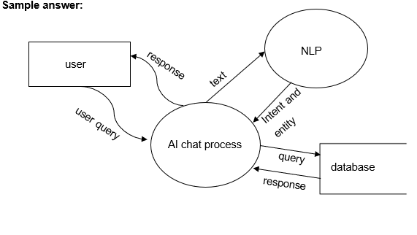

Investigate the disruptive effects of intelligent systems
Activity 46: teacher-led discussion
Intelligent systems, such as artificial intelligence (AI), machine learning and automation are transforming industries, workplaces and daily life. While they bring many benefits, their rapid adoption can also disrupt traditional processes, jobs and lifestyles. Understanding these disruptive effects allows us to navigate and adapt to the changes more effectively.

Multitasking versus digital distraction
- Describe multitasking.
Sample answer:
Multitasking involves handling multiple tasks at the same time, such as switching between writing an email and attending a virtual meeting. A student-friendly example of multitasking could be: You're doing your homework while listening to music and chatting with your friend on your phone. You're trying to solve a maths problem, but you also want to keep up with the song lyrics and respond to your friend's messages at the same time.
- Describe digital distraction.
Sample answer:
Digital distraction occurs when notifications, apps, or online content interrupt focus, reducing productivity. A student-friendly example of digital distraction is when you're trying to study for a test, but your phone keeps buzzing with notifications from social media. Every time you check your phone to see what's happening, it pulls your attention away from your studying, making it harder to remember what you’re learning.
Intelligent systems, like productivity apps and AI assistants, aim to help users multitask efficiently but can also increase digital distractions if not managed well. Research shows that frequent interruptions can lead to decreased attention span and lower work quality.

Activity 47: digital distraction
Keep a log for one hour of how often you are interrupted by notifications or tempted to check your phone while completing a task.
- What strategies could you implement to reduce digital distractions while using intelligent systems?
Sample answer:
Turn off non-essential notifications, use focus modes on devices and schedule specific times to check emails or social media.
- What is the difference between multitasking and digital distraction? How can intelligent systems contribute to both?
Sample answer:
Multitasking involves working on multiple tasks, while digital distraction is interruptions caused by technology. Intelligent systems can help manage tasks but also increase interruptions through notifications.

Working differently to complete the same task
Activity 48: teacher-led discussion
Intelligent systems change how tasks are performed. For example, instead of manually searching for information, users can rely on AI-powered search engines or virtual assistants like Siri or Alexa.
These systems can make tasks faster and more accurate but may require new skills, such as learning to give clear voice commands or interpret AI-generated results.
An example may include planning a trip. Traditionally, you might research flights, hotels and activities separately. An intelligent system like travel AI can automate these steps, offering a tailored itinerary.

Activity 49: compare how you would plan a study schedule manually versus using an AI scheduling assistant.
What are the advantages and disadvantages of using an intelligent system for this task?
Sample answer:
Advantages: saves time, provides reminders, optimises schedule based on priorities.
Disadvantages: limited flexibility if inputs are unclear, reliance on technology.

Automation of enterprise and manufacturing processes
Activity 50: teacher-led discussion
Automation uses intelligent systems to perform repetitive tasks, reducing human effort and error.
In manufacturing, robots assemble products. In enterprises, software automates data entry or customer service.
While automation improves efficiency and lowers costs, it can displace workers performing those tasks. For example, automated warehouses use AI-powered robots to pick, pack and ship products faster than humans.
Activity 51: examples of tasks that automation has replaced
- What are 3 examples of tasks that automation has replaced in manufacturing and enterprise and what are the implications?
Sample answer:
- Manufacturing assembly line workers. Faster production but reduced job opportunities.
- Customer service agents. Chatbots handle basic queries, but human agents are still needed for complex issues.
- Data entry clerks. Automation reduces errors but requires workers to upskill for more advanced tasks.
- How has automation changed traditional manufacturing processes? Give an example.
Sample answer:
Automation has replaced manual tasks with robots, increasing efficiency and reducing errors. For example, car assembly lines use robotic arms for precision tasks.

Impact of artificial intelligence (AI) on employment
Activity 52: teacher-led discussion
AI can create new jobs while eliminating others. For example, self-driving technology may reduce the need for truck drivers but increase demand for AI engineers and vehicle technicians.
Roles requiring creativity, emotional intelligence and complex decision-making are less likely to be replaced by AI.
Workers need to reskill and adapt to remain competitive in the AI-driven job market.
- What is the impact on employment?
Discuss how AI might impact jobs in 2 industries of your choice. Suggest ways workers in those industries can adapt.
Sample answer:
- In healthcare, AI assists with diagnostics, reducing demand for some administrative roles but creating opportunities in AI maintenance and patient interaction roles. Workers can adapt by learning AI-related skills.
- In retail, automated checkout systems reduce cashier roles but increase jobs in technology support and inventory management. Workers can adapt by upskilling in customer service or technology.
- How can workers adapt to the impact of AI on employment?
Sample answer:
Workers can adapt by reskilling in areas like technology, creativity or emotional intelligence and by learning to work alongside AI systems.
- What is the difference between multitasking and digital distraction? How can intelligent systems contribute to both?
Sample answer:
Multitasking involves working on multiple tasks, while digital distraction is interruptions caused by technology. Intelligent systems can help manage tasks but also increase interruptions through notifications.

Investigate social and ethical issues to be considered when developing, implementing and using intelligent systems
Activity 53: teacher-led discussion
Intelligent systems are increasingly integrated into various aspects of society, from healthcare and finance to education and entertainment. While these systems offer numerous benefits, they also raise significant social and ethical concerns that developers, implementers and users must carefully consider.
Defining social and ethical issues in intelligent systems
Social issues refer to challenges that impact individuals, communities, or society as a whole when intelligent systems are developed, implemented, and used. These issues often relate to fairness, access, human rights and societal wellbeing.
Ethical issues are concerns about what is morally right or wrong when designing and using intelligent systems. Ethical issues focus on values like fairness, transparency, accountability, and the responsible use of technology.
Understanding both types of issues helps ensure intelligent systems are fair, responsible, and beneficial to society while minimising harm and unintended consequences.

Social versus ethical issues in intelligent systems
Activity 54: students are provided the issue and choose whether it is a social or ethical issue. They provide a justification.
Issue | Social or ethical | Justification
Job displacement due to AI automation | Social | Affects employment rates, leading to economic and social inequality.
Bias in AI algorithms | Ethical | Involves fairness and moral responsibility in system design to prevent discrimination.
Digital divide (unequal access to AI and technology) | Social | Impacts economic and educational opportunities, creating gaps between different social groups.
Privacy violations (data misuse and surveillance) | Ethical | Concerns the moral responsibility of protecting personal data and preventing misuse.
AI in law enforcement (for example facial recognition) | Social | Impacts public trust, civil rights, and social justice.
Transparency of AI decisions | Ethical | AI decisions should be explainable and accountable to avoid unfair or harmful outcomes.
AI in healthcare (access to AI-driven medical care) | Social | Raises concerns about who benefits from AI-based medical advances and who is left out.
AI weaponisation (use of AI in military applications) | Ethical | Raises moral concerns about autonomous weapons making life-and-death decisions.

Activity 55: as a class, watch What is AI Ethics? (6:09) and Ethics of AI: Challenges and governance (6:41).
Teacher note: students actively engage in these videos by taking notes. They should be reminded that the HSC digital examination includes responding to stimulus material and this is a skill that requires practice.
Discuss the realm of issues that intelligent systems may include.
Students play and discuss the Moral Machine.
Extension activity: ethical considerations
In small groups, students read The ethical considerations of Artificial Intelligence and choose one of the following issues to further investigate and discuss, then share their findings with the class.
- Bias and discrimination
- Transparency and accountability
- Creativity and ownership
- Social manipulation and misinformation
- Privacy, security and surveillance
- Job displacement
- Autonomous weapons

Investigate current and emerging technologies associated with intelligent systems, including AI
Activity 56: students research and share current and emerging technologies associated with intelligent systems, including AI.
As a conversation starter for this research, students watch AI Emergency service 911 calls: the limitations of AI (7:10).
How reliable is artificial intelligence in critical, high-stakes situations?
As a class, watch Could this tech save lives? (5:29) and discuss the possible solutions.
Students read the How can we understand AI? article and discuss as a class the meaning of the article.
Homework activity: students watch OpenAI’s Sam Altman Talks ChatGPT, AI Agents and Superintelligence – Live at TED2025 (47:29) and take notes.
Students watch 10 Key Breakthrough Technologies of 2025 (53:53) and take notes.
Teacher note: these video activities could be offered as a flipped classroom. Students watch at home and discuss in the classroom the following day.
Extension activity: students widen their reading by researching emerging technologies in MIT Technology Review and discuss as a class.

Explain how intelligent systems combine innovative techniques and technologies to meet the needs of enterprise
Activity 57: complete the cloze passage using the word bank provided below.
Enterprises use ______________ systems to improve _____________, __________ tasks, and make better ___________. These systems use a combination of _____________ techniques and technologies to solve _________ problems and __________ business processes. By integrating _____________ intelligence (AI), _________ learning, ___ data, automation, and ______ computing, enterprises can _________ vast amounts of _____, improve __________ experiences, and increase _______________.
analyse, artificial, automate, big, cloud, complex, customer, data, decisions, efficiency, innovative, intelligent, machine, optimize, productivity.
Solution:
Enterprises use intelligent systems to improve efficiency, automate tasks, and make better decisions. These systems use a combination of innovative techniques and technologies to solve complex problems and optimize business processes.
By integrating artificial intelligence (AI), machine learning, big data, automation, and cloud computing, enterprises can analyse vast amounts of data, improve customer experiences, and increase productivity.
Activity 58: students watch What is AnyLogic Simulation Software? (1:39) and complete the table on the following page.
Teachers may distribute the table as a matching exercise.

Technology | Description | Enterprise use case
Artificial intelligence (AI) | Enables machines to simulate human intelligence and decision-making. | AI-powered chatbots provide 24/7 customer support.
Machine learning (ML) | Systems learn from data and improve performance over time without human intervention. | Banks use ML to detect fraudulent transactions.
Big data analytics | Processes large volumes of structured and unstructured data to find patterns and insights. | Retailers analyse customer purchase trends to optimize stock levels.
Automation and robotics | Uses software or robots to perform repetitive tasks without human intervention. | Factories use robotic arms to assemble products faster and more accurately.
Cloud computing | Provides access to computing resources (storage, processing) over the internet. | Companies store and access data securely without needing expensive physical servers.
Internet of Things (IoT) | Connects physical devices (sensors, cameras, machines) to the internet for data exchange. | Smart warehouses use IoT sensors to track inventory in real time.
Natural language processing (NLP) | Allows computers to understand and process human language. | Virtual assistants like Siri and Alexa understand and respond to voice commands.

How do enterprises benefit from intelligent systems?
Activity 59: teacher-led discussion
Intelligent systems reduce manual work by automating repetitive tasks. For example, a logistics company uses AI-powered scheduling systems to optimize delivery routes, reducing delays and fuel costs.
AI-powered systems analyse vast amounts of data to provide real-time insights. For example, a hospital uses machine learning to predict patient admission rates and allocate staff accordingly.
Intelligent chatbots and virtual assistants provide instant customer support. For example, online stores use AI to recommend products based on customer preferences.
AI can identify suspicious activities and detect fraud in banking and cybersecurity. For example, a bank uses machine learning algorithms to spot unusual transaction patterns and prevent fraud.
Cloud computing allows enterprises to scale their IT infrastructure without large upfront costs. For example, a startup can store all its data on cloud servers and only pay for what it uses instead of buying expensive hardware.
Activity 60: teacher-led discussion
Consider the following scenario and answer the questions on how intelligent systems help businesses:
A large supermarket chain wants to improve its operations using intelligent systems. The company faces the following challenges:
- High energy costs due to inefficient store lighting and refrigeration.
- Long checkout lines, causing customer frustration.
- Inventory shortages leading to lost sales.
- Food waste due to expired products.
The supermarket has hired an IT consultant (you!) to recommend intelligent technologies that will solve these problems.
Answer the following questions:
- Which intelligent technologies could help reduce energy costs?
Sample answer:
Energy cost reduction
The supermarket can install IoT sensors that automatically adjust lighting and refrigeration based on store occupancy and temperature needs.
- What automation solutions could speed up the checkout process?
Sample answer:
Faster checkout
- Self-checkout kiosks powered by AI can speed up transactions.
- Computer vision AI can scan items automatically without the need for barcodes.
- How can big data analytics help manage inventory better?
Sample answer:
Better inventory management
Big data analytics can track sales patterns and predict demand, ensuring the supermarket stocks the right products at the right time.
- What IoT technology can reduce food waste in the supermarket?
Sample answer:
Reducing food waste
IoT-connected smart shelves and RFID tags can track expiration dates and notify employees when products need to be sold or discounted before they expire.
- How can artificial intelligence improve the overall customer experience?
Sample answer:
AI for customer experience
- AI-powered chatbots on the supermarket’s website or app can answer customer questions.
- Personalised product recommendations based on previous purchases enhance the shopping experience.

Data and intelligent systems

Investigate the infrastructure requirements for an intelligent network in an enterprise with devices linked through an Internet of Things (IoT)
Teacher note: ensure students are aware that many of the concepts covered in this focus area were introduced in the Year 11 Networking systems and social computing focus area including Internet of Things and machine learning.
Activity 61: teacher-led discussion
An intelligent network in an enterprise context refers to a sophisticated system that integrates various devices and technologies to enhance operational efficiency, data management, and decision-making. When incorporating the Internet of Things (IoT), this network connects numerous devices (such as sensors, machines, and servers), facilitating seamless communication and automation.
As a class watch the following videos and take notes:
- IoT In 2 Minutes | What Is IoT | Introduction To IoT | IoT Explained (1:51)
- The internet of things (9:34)
- (Jordan makes a prediction on the impact of IoT by 2025.Was he correct?)
- The Internet of Everything | Tom Moran (13.02)
Students discuss what the infrastructure requirements would be for an intelligent network in an enterprise.
Teacher note: consider delivering this as a homework or flipped classroom activity where students watch the video in their own time and report back during the classroom lesson.

Networks with servers, local and cloud storage, and end-point devices
Activity 62: students revise the key concepts and content from Year 11 on Networking systems and social computing. They brainstorm the infrastructure components needed to establish an effective intelligent IoT network. Using the following keywords they describe the components needed for these intelligent networks.
Servers, storage solutions, end-point devices, communication links, network infrastructure.
Sample response:
First up are servers.
There are 2 main types: on-premises servers and cloud servers. On-premises servers are physical machines located right within the business’s facilities. They give companies direct control over their data and applications, which is crucial for tasks that need quick responses and strong security. On the other hand, cloud servers are hosted by third-party providers and can be accessed over the internet. These servers are great for businesses that experience changing workloads because they offer scalable resources without requiring hefty upfront hardware investments.
Next, we have storage solutions.
There’s local storage, which involves on-site hardware like hard drives and storage area networks (SANs). While local storage allows for fast data access, it can be a hassle to maintain and isn’t very scalable. In contrast, cloud storage allows businesses to store their data on remote servers managed by service providers. This option is flexible, cost-effective, and perfect for companies that expect growth or have varying storage needs.
Then there are the end-point devices.
These include all sorts of Internet of Things (IoT) devices, such as sensors, actuators, and user interfaces that gather and send data. It’s crucial that these devices can communicate securely and effectively with the rest of the network. Communication links are also vital. We have wired connections, which use Ethernet cables to ensure stable and speedy data transfer, making them suitable for stationary devices and critical systems.
On the flip side, wireless connections—like Wi-Fi, Bluetooth, and cellular networks (including 5G)—offer the flexibility and scalability needed for mobile and remote devices. Lastly, a solid network infrastructure ties everything together. This includes routers, switches, gateways, and firewalls, all of which help manage data traffic, ensure security, and maintain reliable connections between devices and servers.
As a class, read Cloud storage vs. on-premises servers: 9 things to keep in mind.
Activity 63: students investigate Minecraft Cloudcraft.
Extension activity: students investigate drawing network architecture using Cloudcraft – Draw AWS diagrams.

Communication links that enable the efficient control and flow of data
Activity 64: teacher-led discussion. Students take notes.
The choice of communication links impacts the network's performance and reliability:
- Wi-Fi: offers wireless connectivity within a limited range, suitable for indoor environments and devices requiring moderate bandwidth.
- Bluetooth: ideal for short-range communication between devices with low data requirements.
- 5G cellular networks: provide high-speed, low-latency connections over wide areas, beneficial for mobile devices and remote monitoring.
- Ethernet: delivers high-speed and secure wired connections, essential for critical systems and devices demanding consistent performance.
Activity 65: students are provided the following scenario to design an Intelligent IoT network for a smart office and complete the task on the next page.
A company plans to transform its traditional office into a smart office by integrating IoT devices to enhance productivity and energy efficiency.
The objectives include:
- automating lighting and climate control that adjusts based on occupancy and time of day
- implementing smart security systems that utilise connected cameras and access controls
- enhancing employee collaboration through connected devices and seamless data sharing.

Task
As an IT consultant, outline the infrastructure requirements for this intelligent IoT network.
Guiding questions
- What types of servers and storage solutions are appropriate for the smart office?
Sample answer:
Servers and storage solutions appropriate for a smart office include:
- on-premises servers for security systems requiring immediate response and cloud servers for scalable data storage and collaboration tools
- cloud storage solutions to handle data from IoT devices, allowing for easy scalability and remote access.
- Which end-point devices are necessary to achieve the company's objectives?
Sample answer:
End-point devices include:
- smart thermostats and lighting systems that automate environmental controls based on occupancy
- connected security cameras and smart locks for enhanced security and controlled access
- collaboration tools such as smart whiteboards and connected conferencing systems to facilitate teamwork.
- What communication links will ensure efficient data flow between devices?
Sample answer:
Communication links to ensure efficient data flow between devices include:
- Wi-Fi networks that ensure robust and secure Wi-Fi coverage throughout the office for general device connectivity.
- Ethernet connections for devices requiring stable and high-speed connections, such as security systems and servers.
- Bluetooth that is used for short-range communications, like connecting peripherals and personal devices.
- How will you address data security and privacy concerns in the network design?
Sample answer:
Data security and privacy concerns that can be addressed through:
- using network segmentation to isolate IoT devices on a separate network to prevent unauthorised access to sensitive data
- using encryption protocols to implement end-to-end encryption for data transmitted between devices
- applying regular updates and patches to maintain up-to-date firmware and software to protect against vulnerabilities.

Explore collection, type, storage, processing, application and transmission of relevant and surplus data in an intelligent IoT network
Teachers may choose to revisit and extend the project from Year 11 Networking systems and social computing on the Ultimate Home network and modify the following activities accordingly. Hands-on experience with IoT devices and their applications provides an understanding of the lifecycle of data from collection to application.
Students gain skills in programming, hardware integration, and data visualisation. They gain insight into real-world applications of intelligent networks in agriculture and environmental monitoring.
A suggested list of other possible projects and platforms is available in the Appendix of this document and includes: smart home automation system, weather station, smart waste management system, health monitoring system, smart traffic management system, indoor air quality monitor, smart plant watering system, IoT-enabled security system, smart energy monitoring system, IoT-based smart mirror.
This project will provide the basis for the ‘Creating intelligent systems’ content later in the syllabus

The Smart Garden Project
Activity 66: a practical group activity to explore the collection, type, storage, processing, application, and transmission of data in an IoT network is a Smart Garden Project.
Students analyse, or if time permits, create a simulated smart garden using IoT devices to collect and manage data related to plant growth and environmental conditions.
Hardware components needed
- Microcontroller (for example, Micro:bit, Arduino or Raspberry Pi). These links are to tutorials.
- Sensors (for example, soil moisture sensor, temperature sensor, light sensor)
- Actuators (for example, water pump for irrigation)
- Wi-Fi module (for example, ESP8266) for data transmission
- LED lights for notifications
Software components needed
- Programming environment (for example, Scratch, Arduino IDE, Python)
- Data storage solution (for example, cloud storage like Google Firebase or a local database)
- Data visualisation tool (for example, Google Sheets, Tableau, or a simple web interface)

Students form small teams. They research the types of data that can be collected in a garden (for example, soil moisture, temperature, light levels).
Teams plan which microcontroller, sensors and actuators will be used and how they will interact.
This could be done based on experience and/or resources. Resources such as Micro:bit, Arduino or Raspberry Pi are examples of microcontroller platforms that could be included.
Teams assemble the microcontroller with the sensors and actuators and connect the Wi-Fi module to enable internet connectivity for data transmission.
They write a simple program to collect data from the sensors at regular intervals. They define the types of data to be collected (for example, moisture level, temperature, light intensity). Students set up a cloud storage solution or a local database to store the collected data. They structure the data for easy retrieval and processing.
Students create algorithms to analyse the collected data (for example, determine when to water the plants based on soil moisture levels). They program the actuators to respond to the data (for example, activate the water pump when the soil moisture level is low).
Students use the Wi-Fi module to transmit data to the cloud or local server. They implement a simple notification system (for example, an LED that lights up when water is needed).
Students use a data visualisation tool to display the collected data in real-time. They create graphs or dashboards to track the garden's conditions and plant health.
Teams present their projects, discussing the challenges they faced and the solutions they implemented. They reflect on the importance of data collection, storage, processing and transmission in an IoT network.

Investigate the application of simulation, data modelling and the automation of systems in a range of enterprises

Education and training, Business analytics, High-risk applications
Activity 67: teacher-led discussion
The application of simulation, data modelling, and automation of systems across various enterprises provides significant benefits in enhancing decision-making, improving efficiency, and ensuring safety, particularly in high-risk environments. These technologies enable organisations to better understand complex systems, predict outcomes, and respond effectively to challenges, leading to improved performance and reduced risks in a wide range of applications. As technology continues to evolve, the potential for these applications will expand, driving further innovation and efficiency across industries.
Students investigate simulation software: for example: NetLogo and AnyLogic.
Each student is issued with a topic for investigation and provides a single slide of text and images on their topic. These are collated into a single deck and class notes.
1.1. Simulation in healthcare
Sample answer:
Simulation is used for training medical professionals in surgical procedures and patient management, providing a safe environment to develop skills without risking patient safety.
1.2. Simulation in aerospace
Sample answer:
Flight simulators are essential for pilot training, allowing pilots to experience realistic scenarios, including emergencies, enhancing their preparedness for real-world situations.
1.3. Simulation in nuclear power
Sample answer:
Simulations model reactor behaviour under various scenarios, aiding in the development of safety protocols and emergency response plans.
1.4 Simulation in disaster response
Sample answer:
Emergency responders use simulation to prepare for natural disasters, improving planning and resource allocation during actual crises.
2.1 Data modelling in predictive maintenance
Sample answer:
Data modelling is employed in manufacturing and aerospace to predict equipment failures by analysing historical performance data, allowing for timely maintenance and reducing risks.
2.2 Data modelling in risk assessment
Sample answer:
High-stakes industries use data modelling to identify and evaluate potential risks, improving safety and decision-making.
2.3 Data modelling for predicting patient outcomes
Sample answer:
In healthcare, data models help predict treatment outcomes, guiding healthcare providers in making informed decisions.
2.4 Data modelling in operational efficiency
Sample answer:
Data modelling optimises processes in various sectors, including logistics in emergency response, ensuring effective resource allocation during crises.
3.1 Automation for robotic surgery
Sample answer:
Automation in surgical systems enhances precision and reduces human error, leading to improved patient outcomes.

3.2 Automation in aviation
Sample answer:
Automated autopilot systems in aircraft reduce pilot workload and enhance safety during critical flight phases.
3.3 Automation for nuclear monitoring
Sample answer:
Automated systems continuously monitor reactor conditions, maintaining safety and preventing accidents through real-time adjustments.
3.4 Automation in emergency management
Sample answer:
Automation streamlines communication and resource allocation during emergencies, improving response effectiveness and efficiency.
Students discuss how simulation, data modelling and the automation of systems has or may be used in their own Enterprise projects.
Teacher-led discussion on the limitations of simulations, data modelling and automation including what can and cannot be learned through a simulation.
Teacher note: schools may have access to VR welding machine simulators to explore the skills that can be learned.

Explain the role of intelligent systems in surveillance
Activity 68: use the word bank to complete the following cloze passage:
analyse, benefits, consent, data, human, information, monitoring, outcomes, patterns, personal, privacy, security, surveillance
Intelligent systems are technologies designed to perform tasks that normally require ______ intelligence. They can _________ large amounts of _____, detect __________ and even predict __________, making them essential for _______________ in various fields. Intelligent systems in surveillance bring many __________, but they also raise questions about _________, ethics and _________. Understanding these technologies can help us appreciate their capabilities and consider the balance between __________ and __________ privacy. Surveillance is the act of _____________ activities to gather ______________, prevent harmful actions, or protect people and resources.
Solution:
Intelligent systems are technologies designed to perform tasks that normally require human intelligence. They can analyse large amounts of data, detect patterns and even predict outcomes, making them essential for surveillance in various fields.
Intelligent systems in surveillance bring many benefits, but they also raise questions about privacy, ethics and consent. Understanding these technologies can help us appreciate their capabilities and consider the balance between security and personal privacy.
Surveillance is the act of monitoring activities to gather information, prevent harmful actions, or protect people and resources.
Activity 69: students are provided the surveillance term and provide a definition and example.

Term | Definition | Example
Closed circuit television (CCTV) | CCTV systems are video cameras that record footage and store it on a closed network, accessible only by authorised users. Intelligent systems enhance CCTV by using video analytics to detect unusual events or alert security teams. | A CCTV camera with AI can identify if someone is behaving aggressively or loitering in restricted areas, helping security staff respond faster.
Biometric scanning | Biometric scanning uses unique physical characteristics to identify people. Intelligent systems analyse biometric data to confirm identity, controlling access to sensitive areas. | A biometric system can quickly recognise employees entering a high-security area or ensure that only authorised individuals can access a restricted room.
Customer loyalty schemes | Customer loyalty schemes encourage repeat purchases using intelligent systems to track customer behaviour and preferences. | Companies can personalise offers and detect unusual spending, helping increase sales and reward loyal customers, while also raising privacy concerns due to continual monitoring of personal data.
Fraud prevention | Intelligent systems detect and prevent fraud by analysing transaction data for unusual patterns that suggest fraudulent activity. | If the system detects suspicious spending or transactions in unusual locations, it can alert the user or block the transaction, processing massive amounts of data to recognise subtle signs of fraud.
Sniffing | Sniffing is a method of monitoring data over a network to detect suspicious activity. Intelligent systems use sniffing techniques to identify cyber threats. | By analysing network traffic, they can identify patterns indicating an attack and trigger security measures, emphasising the importance of using sniffing ethically and with consent due to the potential monitoring of private data.
Trolling | Trolling refers to posting disruptive or offensive content online. Intelligent systems detect trolling by analysing conversations for abusive language or harmful content. | Social media platforms use intelligent systems to identify and remove comments targeting individuals based on race, gender, or other personal characteristics, helping maintain safer online spaces.

Explain how AI supports efficiency in an IoT network
Activity 70: teacher-led discussion
Students extract key information via notetaking.
The Internet of Things (IoT) connects devices, sensors and systems, allowing them to communicate and share data across a network. This data helps improve automation, decision-making and real-time monitoring. However, IoT networks can produce vast amounts of data from numerous sources, which can be overwhelming to manage and analyse. Artificial Intelligence (AI) helps make IoT networks more efficient by processing data quickly, identifying patterns and enabling smart actions based on insights.
How AI supports:
Data processing and analysis
AI enables real-time data analysis, making it possible to process the enormous data streams generated by IoT devices. Traditional systems may struggle with large amounts of data, but AI can quickly identify valuable information, filtering out unnecessary data. For example, in a smart city network, IoT sensors track traffic, weather and energy use. AI processes this data to give insights into peak traffic times, weather-related impacts, or electricity consumption patterns. This helps city planners make data-driven decisions without manually analysing data from each device.
Automation and predictive maintenance
AI improves efficiency in IoT networks by automating tasks and predicting maintenance needs. In industrial IoT (IIoT), sensors on machinery collect data about operating conditions like temperature, vibration and performance. AI analyses this data to predict when a machine might fail or need servicing. This predictive maintenance approach helps avoid costly downtime by scheduling repairs before problems occur, improving equipment lifespan and saving time.
Resource optimisation
AI in IoT helps optimise the use of resources, such as energy, water, or bandwidth, by learning usage patterns and adjusting. For example, in a smart building, IoT devices can monitor room occupancy and lighting levels. AI algorithms use this data to automatically adjust heating, lighting and cooling systems based on occupancy patterns, reducing energy waste and cutting costs. This ensures that resources are used only when needed, improving overall efficiency.
Enhanced security
With more devices connected, IoT networks are vulnerable to security threats. AI helps secure IoT networks by monitoring traffic, detecting unusual behaviour and blocking potential attacks. For example, if AI detects unusual login attempts or data transfer spikes from a particular device, it can trigger an alert or block that device temporarily. By continuously analysing device behaviour, AI improves security without relying on manual checks, keeping the network more secure and efficient.
Scalability and adaptability
AI makes it easier to scale IoT networks by managing data flow and adjusting to the addition of new devices. As IoT networks grow, they generate more data, which requires additional resources. AI optimises data flow and device interaction so that new devices integrate smoothly, ensuring the network can adapt to expansion without affecting performance.
Self-learning and improvement
AI uses machine learning to improve over time, learning from historical data to make better decisions. In an IoT network, this means AI can improve efficiency as it gathers more data, recognising patterns and making more accurate predictions. For instance, a smart agriculture system that uses AI learns from weather patterns, soil data and crop yields over time. This learning allows it to make more accurate recommendations on watering or fertilisation, improving crop yield and reducing resource use.

Student key points
Sample answer:
- AI enhances data processing. by speeding up analysis, filters valuable data and reduces data overload.
- AI predicts maintenance needs before issues arise, improving operational efficiency.
- AI optimises resources reducing waste by adjusting resources based on real-time data, like energy or water use.
- AI monitors, makes secure and protects IoT networks by detecting and blocking security threats.
- AI supports the addition of devices, making them scalable and easier to expand IoT networks efficiently.
- AI continuously improves through self-learning, enhancing prediction accuracy and decision-making.
- AI makes IoT networks more efficient by reducing the need for manual intervention, optimising resource use and improving security.
- As IoT and AI continue to develop, they will work together to create more adaptable, intelligent and efficient networks that benefit various industries, from smart homes to industrial manufacturing.

Creating intelligent systems

Develop a set of rules and facts that could be used within an expert system to draw conclusions
Teacher note: this could be introduced in conjunction with the Smart Garden project.
Activity 71: students consider the following scenario of an expert system for diagnosing plant diseases in agriculture.

Facts in the expert system
Facts are data or conditions that the system knows. For example in a plant disease diagnosis system, facts could include observable symptoms, environmental conditions and plant type.
Examples
- The plant is a tomato.
- The plant has yellowing leaves.
- There are black spots on the leaves.
- The soil is waterlogged.
- The temperature is high and humidity is above 80%.

Rules in the expert system
Rules are conditional statements (IF-THEN) that use the facts to draw conclusions.
The rule structure is:
IF <condition> THEN <conclusion>
An example of rules used in an expert system for diagnosing plant diseases could be:
Rule for fungal infection:
- IF the plant has black spots on leaves AND humidity is above 80%,
THEN the plant might have a fungal infection.
Rule for root rot:
- IF the soil is waterlogged AND the plant shows wilting,
THEN the plant might have root rot.
Rule for nutrient deficiency:
- IF the plant has yellowing leaves AND the soil nitrogen level is low,
THEN the plant might have nitrogen deficiency.
Rule for bacterial wilt:
- IF the plant is wilting AND the stem shows black discoloration,
THEN the plant might have bacterial wilt.
Rule for healthy plant:
- IF the plant has no visible symptoms AND environmental conditions are normal,
THEN the plant is healthy.
Activity 72: What other rules could be made for this expert system?

How the expert system works
The system begins with input facts provided by the user (for example, symptoms, environmental conditions). These are put into the inference engine. This is the system that matches facts against rules using forward chaining (data-driven) or backward chaining (goal-driven). The system applies the rules and generates conclusions or recommendations.
An example of an interaction with the expert system for diagnosing plant diseases:
Input facts
- Plant: tomato
- Symptoms: yellowing leaves, black spots on leaves
- Environment: humidity above 80%.
Inference process
The system matches the facts to Rule 1 and concludes that the plant might have a fungal infection.
The system provides further advice to ‘Treat with a fungicide and ensure proper airflow around the plant.’


Activity 73: Think, Pair, Share
Build rules and facts
Task: Create your own set of facts and rules for a new expert system.
Choose one of the following scenarios:
- Diagnosing animal illnesses
- Identifying issues with a computer system
- Recommending fitness plans based on user data
- One based on your Enterprise project
Steps:
- Define at least 5 facts relevant to your scenario.
- Write 3–5 rules that the expert system could use to make decisions.
- Test your rules with example facts to ensure they work.
Reflection questions:
Were your rules specific enough to handle all scenarios?
Student response:
How could you expand the system for more complex problems?
Student response:
Activity 74: research an existing expert system with factors that you understand.
Sample answer:
Weather forecasting systems
Predicts weather based on atmospheric conditions like pressure, temperature and humidity.
Certainty factor example:
‘If the air pressure drops significantly and clouds are forming, there is a 75% chance of rain.’
Certainty factor: 0.75.
Car troubleshooting systems
Assists car owners in diagnosing common car problems based on symptoms like strange noises, warning lights, or performance issues.
Certainty factor example
‘If the engine light is on and there's a rattling noise when starting, there is a 70% chance the catalytic converter is failing.’
Certainty factor: 0.70.

Activity 75: develop a set of rules and facts that could be used within an expert system applied to your Enterprise project to draw conclusions.
Student response:

Apply certainty factors to construct a decision tree for a proposed expert system
Activity 76: teacher-led discussion
A certainty factor (CF) is a numerical value used to quantify uncertainty in expert systems. It represents how confident the system is in a given decision or conclusion. Certainty factors help an expert system deal with imperfect, incomplete, or uncertain knowledge when constructing decision trees.
Definition of certainty factor (CF)
Certainty factors are values between −1 and +1, where:
- +1 → Absolute certainty that a fact is true
- 0 → No knowledge about the fact
- −1 → Absolute certainty that a fact is false.
They help the system make probabilistic inferences instead of relying on strict yes/no logic.
Constructing a decision tree
A decision tree is a hierarchical structure that represents different choices or conditions, leading to an outcome. In an expert system, each branch represents a decision rule, and the system assigns certainty factors to each branch based on available data.
Activity 77: study the smart home air conditioning system:
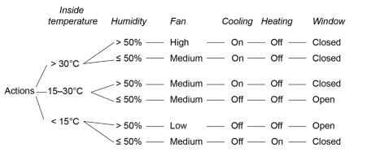
List the factors:
Sample answer:
- Inside temperature:
- Above 30°C
- Between 15°C and 30°C
- Below 15°C
- Humidity:
- Above 50%
- 50% or below
List the actions:
Sample answer:
- Fan: High, Medium, or Low
- Cooling: On or Off
- Heating: On or Off
- Windows: Open or Closed
State the rules:
Sample answer:
- Above 30°C:
- Humidity > 50%: Fan = High, Cooling = On, Windows = Closed
- Humidity ≤ 50%: Fan = Medium, Cooling = On, Windows = Closed
- Between 15°C and 30°C:
- Humidity > 50%: Fan = Medium, Cooling = On, Windows = Closed
- Humidity ≤ 50%: Fan = Medium, Cooling = Off, Windows = Open
- Below 15°C:
- Humidity > 50%: Fan = Low, Heating = On, Windows = Open
- Humidity ≤ 50%: Fan = Medium, Heating = On, Windows = Closed
Students make this decision tree using Lucidchart.
Extension activity: students watch Visual Guide to Decision Trees (6:25).

Verify the sources of data used in a decision support system
Activity 78: teacher-led discussion
Verifying data sources is a critical step in ensuring that a DSS provides reliable insights. By evaluating credibility, accuracy, and potential biases, decision-makers can make informed choices that lead to better outcomes. The following scenarios illustrate the importance of verifying data used in decision support systems:
A healthcare DSS relies on patient data from various sources such as electronic health records and lab results. If a clinician acts on unverified data (for example, incorrect medication history), it may lead to harmful drug interactions or inappropriate treatments, jeopardising patient safety.
In a financial DSS assessing loan applications, unverified credit scores or income statements can result in approving loans for individuals who are not creditworthy. This could lead to increased default rates and financial losses for the lending institution.
A retail DSS that uses sales data, supplier information, and inventory levels needs to verify these data sources to prevent stockouts or overstock situations. For example, relying on unverified sales forecasts may lead to excess inventory, causing increased holding costs and wasted resources.
In a DSS for emergency management, data about population density, infrastructure, and hazard zones must be verified. Incorrect or outdated data could hinder effective disaster response, potentially leading to loss of life or property during emergencies.
A business DSS uses market research data to inform strategic decisions. If the data collected from surveys or social media sentiment analysis is not verified, it could misguide marketing strategies, resulting in failed campaigns and wasted investment.
In a DSS used for urban planning, land use data, demographic information, and environmental impact assessments must be verified. Using inaccurate data can lead to poor planning decisions, such as inadequate infrastructure to support population growth.
In an energy DSS, real-time data from smart meters and grid sensors must be verified to manage supply and demand efficiently. If inaccurate data is used, it could lead to energy shortages or outages, affecting consumers and businesses.
A transportation DSS relies on data about routes, traffic conditions, and delivery schedules. If this data is unverified, it may result in inefficient routing and delays, increasing operational costs and diminishing customer satisfaction.
In an environmental DSS, data on emissions levels, water quality, and waste management must be verified to ensure compliance with regulations. Unverified data could result in legal penalties and damage to the organisation’s reputation.
In an educational DSS analysing student performance data, using unverified data can lead to incorrect conclusions about educational outcomes. This may affect funding decisions, curriculum development, and educational policies, ultimately impacting student success.
Activity 79: summarise the key points of the teacher-led discussion as to why data verification is important. Answer in the space below:
Sample answer:
In decision support systems (DSS), data is used to guide important decisions. However, not all data sources are reliable, accurate or free from bias. If incorrect or misleading data is used, it can lead to poor decision-making, financial losses or even safety risks.
Verifying data sources is essential for reliable insights in decision support systems (DSS).
Unverified patient data can lead to harmful treatments, jeopardising patient safety.
Inaccurate credit scores can result in approving loans for unqualified individuals, increasing default rates.
Verification of sales and inventory data is crucial to avoid stockouts or overstock situations and associated costs.
Accurate data on population density and hazards is vital for effective disaster response.
Unverified market research data can misguide marketing strategies and lead to failed campaigns.
Inaccurate land use and demographic data can result in poor planning decisions.
Real-time data verification is necessary to manage supply and demand and prevent energy shortages.
Unverified data may lead to inefficient routing and increased operational costs.
Verification of emissions and waste management data is essential for regulatory compliance.
Using unverified student performance data can impact funding, curriculum development, and educational policies

How to verify data sources
Activity 80: Students discuss the following checklist in relation to one of their Enterprise projects.

Check the source’s credibility
- Who collected the data? (For example, government agency, university, private company)
- Is the source well-known and reputable?
- Is the source biased in any way? (For example, sponsored research, political influence)

Evaluate the accuracy and timeliness
- When was the data collected? Is it still relevant?
- Are there any updates or revisions to the data?
- Was the data collected using reliable and valid methods?

Compare with other sources
- Do other reputable sources report similar data?
- Are there significant differences between sources? If so, why?

Assess data collection methods
- Was the data collected through surveys, sensors, or user inputs?
- Were the methods scientifically sound and free from bias?
- Was there a large and representative sample?

Look for transparency and documentation
- Is there a clear explanation of how the data was collected?
- Are the raw data and methodologies publicly available?

Identify any potential bias or manipulation
- Could the data have been altered or misrepresented?
- Is there an agenda behind the data collection or reporting?
Activity 81: evaluating data sources in a DSS scenario
A city council is using a decision support system (DSS) to decide whether to invest in more bike lanes. The DSS uses data from 3 sources:
- A cycling advocacy group that surveyed 500 local cyclists about their riding habits and preferences.
- A government transport agency that collected automated bike traffic data from sensors at major intersections over the past 5 years.
- A sports equipment retailer that shared sales data on bikes and accessories purchased in the city over the last year.
The council must verify the reliability of these sources before making a decision.
- Which source is likely to be the most reliable for understanding long-term cycling trends? Why?
Sample answer:
The government transport agency’s data is likely the most reliable because it is collected automatically from sensors, covers multiple years, and is less likely to be influenced by personal opinions or biases.
- What are some potential biases in the advocacy group’s survey? How could this affect the DSS?
Sample answer:
The advocacy group’s survey may be biased because it only includes cyclists, who are likely to support bike lanes. It does not account for non-cyclists' perspectives or traffic data on other modes of transport. This could skew the DSS toward a decision favouring cyclists without considering broader city needs.
- How useful is the retailer’s sales data for predicting bike lane usage? What limitations does it have?
Sample answer:
The retailer’s sales data has limitations because purchasing a bike does not guarantee that the buyer will use it for commuting. It also does not account for people who already own bikes or purchase second-hand. This data may give insight into bike popularity but is not a direct measure of usage.
- If the government transport agency’s data is from sensors in only a few locations, how could this impact the DSS?
Sample answer:
If the government transport agency’s sensors are placed only in certain areas, they might not represent cycling trends across the entire city. For example, if sensors are located mainly in the city centre, they won’t capture suburban cycling trends. This could lead to an incomplete understanding of overall bike usage.
- How could the city council improve data verification to ensure a well-informed decision?
Sample answer:
To improve data verification, the city council could:
- cross-check the cycling sensor data with independent studies
- expand the number of sensor locations for more comprehensive data
- consider surveys of all road users (not just cyclists) to balance perspectives
- use additional data sources, such as ride-sharing app statistics, to confirm trends.

Use a flowchart to develop a knowledge base of IF-THEN rules to be used by an expert system
Activity 82: revision
- What is an expert system?
Sample answer:
An expert system is a computer program that mimics human decision-making by applying a set of predefined IF-THEN rules to solve problems or make recommendations. These systems are used in fields like medicine, agriculture and engineering.
Understanding IF-THEN rules
IF-THEN rules are the foundation of an expert system. They work as follows:
- IF (a condition is met)
- THEN (an action or decision is made)
For example:
- IF the soil moisture is low, THEN activate the irrigation system.
- What is a flowchart?
Sample answer:
A flowchart visually represents the decision-making process of an expert system. It includes:
- decision nodes (represented by diamonds) that ask a question (for example, ‘Is the temperature high?’)
- process steps (rectangles) that show actions taken based on answers
- arrows that direct the flow from one step to the next.
Creating a flowchart helps organise knowledge logically before programming it into an expert system.

Design and model an automated smart system using a range of inputs and outputs
Activity 83: students design an automated smart system for diagnosing plant diseases in their Smart Garden
The automated smart system should integrate inputs and outputs to diagnose plant diseases. It should combine sensor data, user interactions, and machine learning to provide accurate diagnoses and recommendations. The automated smart system could be designed as a group project with aspects modelled in Tinkercad OR wokwi.
Students identify the system components.

Inputs
Sample answer:
- Sensor data: soil moisture sensors, temperature and humidity sensors, light intensity sensors, pH level sensors, camera for image analysis (to detect leaf colour and spots).
- User interaction: mobile app interface for user input (type of plant, visible symptoms), voice recognition for hands-free operation.
Processing
Sample answer:
- Data analysis: implement machine learning algorithms to analyse sensor data in conjunction with user inputs.
- Use image recognition algorithms to identify visible symptoms from photos taken by the user.

IF-THEN rules and decision-making
Sample answer:
Maintain a set of IF-THEN rules based on sensor data thresholds and visual symptoms. Cross-reference user inputs with real-time data from sensors to refine diagnoses.
Outputs
Sample answer:
- Visual display: diagnostic results displayed on the mobile app, graphical representation of sensor data (for example, moisture levels, light conditions).
- Recommendations: customised care instructions (for example, watering schedule, fertiliser application). Alerts for potential diseases based on sensor readings (for example, low moisture, high pH).
- Automated actions (if integrated with smart devices): automated watering system that adjusts based on soil moisture levels. Smart lighting system that provides additional light if sunlight is insufficient.
Activity 84: describe the workflow of the system.
Sample answer:
Sensors continuously collect data on soil moisture, temperature, humidity, light levels, and pH. Users can input symptoms via the app or take photos for analysis. The processing unit analyses sensor data alongside user inputs and images. The system conducts data analysis by identifying patterns and anomalies that indicate potential plant diseases.
The system applies IF-THEN rules to determine the most likely issues based on the collected data. Machine learning models refine diagnosis accuracy over time by learning from past data and user feedback.
Users can provide feedback on the effectiveness of the recommendations. The system learns from user feedback to improve future diagnosis and recommendations. The system generates and displays diagnostic results and recommendations on the app. It sends alerts for immediate action (for example, watering needed, disease detected). If conditions meet predefined thresholds (for example, soil moisture too low), the system triggers the automated watering system. It may adjust smart lighting if the plant requires more light.
Activity 85: students describe an example scenario from the user perspective.
Sample answer:
The user opens the app, inputs the type of plant, and takes a photo showing yellow leaves. The system collects data from sensors: soil moisture is low, light intensity is insufficient, and humidity levels are normal. The processing unit analyses the data, identifies yellow leaves, low moisture, and low light. The plant likely suffers from insufficient sunlight and dehydration. The app displays: ‘Your plant needs more sunlight and water’, and provides the recommendation: ‘Move the plant to a sunnier location and water it today’. The automated watering system activates if the user opts for it. After implementing the recommendations, the user provides feedback via the app, indicating improvement in plant health.

Implement automated processing using software
Activity 86: teacher-led discussion
The list of software used to automate processing is vast and expanding. Students unfamiliar with the office workspace may be unfamiliar with the use of software to automate repetitive tasks and streamline workflows. For example: software like Zapier will connect many different apps used in business and industry to streamline workflows.
Activity 87: students watch: How to Create Macros in Excel Tutorial (9:16).
They create a simple macro by following the tutorial and write a macro for one the spreadsheets they have created for this focus area.
Activity 88: Think, Pair, Share
Students interview their teachers on the most unpopular and repetitive tasks they must do during the day. They then consider which can be automated with software.
Activity 89: students identify the software used to automate processes in the Smart Garden.
This could include data collection and sensor integration using Arduino IDE: for programming microcontrollers that can interface with various sensors (soil moisture, temperature, humidity and so on) and actuators like water pumps and relays. Alternately Raspberry Pi can be used with Python to gather data from sensors and process it locally before sending it to the cloud.
Activity 90: students visit and explore Home Assistant.
They read through Understanding automations and propose a technical solution for their Smart Garden.

Assess the output produced by a decision support system, including graphing to detail the success of decisions and comparing the proposed versus the actual outputs
Monitoring the Smart Garden (or any of the suggested projects) will take time. It is recommended that the systems are in place prior to the commencement of the unit and extending the Networking project from Year 11 is considered. Initial student cohorts could be responsible for designing, simulating and modelling with proceeding cohorts constructing and implementing the physical project.
Activity 91: group activity
Assessing decision support system outputs in a Smart Garden.
Divide students into small groups and assign each group a specific plant in the Smart Garden.
Each group will use the DSS to gather initial data on their assigned plants, including:
- soil moisture levels
- temperature and humidity
- light conditions
- observations of plant health (for example, leaf colour, signs of disease).
Based on the DSS outputs, each group will receive recommendations for improving plant health (for example, adjusting watering schedules, fertilising, or changing light exposure). Groups implement these recommendations over a specified period (for example, 1–2 weeks). During the implementation period, groups will continue to monitor their plants, collecting data on plant health and environmental conditions. Students take pictures of their plants to visually document changes.
Groups will compile their data, including:
- initial readings (before recommendations)
- final readings (after implementing recommendations)
- observations of plant health improvements or issues.
Students create graphs to compare proposed outcomes from the DSS (for example, expected increase in moisture levels, growth rate) with actual outcomes observed in their plants (for example, changes in leaf colour, height). They use line graphs, bar graphs, or scatterplots to visually represent the data.

Explain how expert systems contribute to the efficiency of intelligent systems
Activity 92: teacher-led discussion
Intelligent systems use artificial intelligence (AI), machine learning (ML), and expert systems to solve problems, make decisions, and automate processes.
An expert system is a software that applies human expertise and rule-based decision-making to improve efficiency, accuracy, and performance in complex tasks.
How expert systems contribute to the efficiency of intelligent systems can be examined through:
- Supercomputers
- Digital assistants
- Autonomous vehicles
- Streaming services.
Activity 93: group work
Students are put into 4 groups. Each group is responsible for researching their topic and creating a 1–2 slide presentation or video clip that is collated with the others for class notes and study resources.

Supercomputers
Group 1
Explain how expert systems contribute to the efficiency of intelligent systems using supercomputers. Include the following concepts: fast data analysis, structured knowledge, automation of decisions, real-time adaption, real world examples.
Sample answer:
Supercomputers are powerful machines designed to process huge amounts of data very quickly. When combined with expert systems, which are computer programs that use a specific set of knowledge to make decisions, they can analyse large datasets efficiently, leading to faster and more informed decisions.
Expert systems can quickly analyse complex data in fields like climate science and genetics, helping researchers identify patterns and make predictions much faster than traditional methods.
Expert systems store specialised knowledge in a way that can be easily accessed and applied. This allows them to evaluate many potential scenarios in real-time, which is important for making accurate decisions in critical areas like medical diagnosis and finance.
These systems can automate complex decision-making tasks that usually require a lot of human expertise. For example, they can help manage resources in supply chains or predict maintenance needs in factories, reducing the need for human involvement and increasing efficiency.
With supercomputers, expert systems can analyse data as it comes in and adjust their recommendations based on the latest information. This is especially useful in fast-changing situations like financial markets or emergency responses.
Expert systems are used in scientific research, weather forecasting, and various simulations to improve accuracy and efficiency.
The IBM Summit Supercomputer uses AI-driven expert systems to optimise energy usage and support medical research, showcasing the powerful capabilities of combining supercomputers with expert systems.

Digital assistants
Group 2
Explain how expert systems contribute to the efficiency of intelligent systems using digital assistants. Include the following concepts: understanding user input, automation of tasks, learning from interactions, natural language processing (NLP), troubleshooting help, retrieving information efficiently, real world examples.
Sample answer:
Expert systems are special computer programs that help digital assistants, like Siri, Alexa, and Google Assistant, work better. They use a structured knowledge base filled with specific information to give accurate and relevant answers to user questions quickly.
Digital assistants use expert systems to understand the context of what users ask. For example, if you ask about the weather, the assistant can check real-time data and your location to give a tailored response.
These systems can automate routine tasks like setting up appointments, sending reminders, or managing to-do lists, which saves users time.
Expert systems use machine learning to learn from your interactions over time, helping them to provide more personalised experiences. They analyse your past preferences to recommend products or content you might like.
Expert systems improve the ability of digital assistants to understand and interpret user queries accurately. This helps them to generate coherent and appropriate responses, making conversations smoother.
When you encounter technical issues, digital assistants can use expert systems to provide guidance by accessing a database of common problems and solutions.
Expert systems help digital assistants quickly find relevant information from large amounts of data. They can prioritise information based on what is most important to the user.
For example, Alexa uses an expert system to learn your preferences and suggest music or news that you might enjoy.

Autonomous vehicles
Group 3
Explain how expert systems contribute to the efficiency of intelligent systems in autonomous vehicles. Include the following concepts: real time decision-making, route optimisation, object detection, learning and improvement, risk assessment, emergency response, communication with infrastructure, cooperative driving, personalised experience and compliance with traffic rules.
Expert systems are essential for making autonomous vehicles, like self-driving cars, more efficient and safer. Expert systems allow self-driving cars to make quick decisions using data from various sensors, like cameras and radar. They evaluate different driving situations to choose the safest and most effective actions. These systems can analyse traffic, road types, and weather conditions to find the best routes. They adjust routes based on real-time traffic data to save time and fuel. Autonomous vehicles use multiple sensors to understand their environment. Expert systems help identify objects like pedestrians, cyclists, and other vehicles, which is crucial for safe driving. By using machine learning, expert systems can improve their ability to recognise objects and respond to complex driving conditions over time. They learn from previous trips to make better decisions in the future.
Expert systems can predict potential accidents by analysing data from the vehicle and its surroundings. This helps the car take preventive actions to avoid collisions. In critical situations, expert systems determine the best emergency actions, such as braking or swerving, to enhance safety.
Autonomous vehicles can communicate with traffic signals and road signs to stay aware of their surroundings and make informed decisions. Expert systems enable self-driving cars to share information with each other, helping improve traffic flow and reduce congestion.
These systems learn from driver preferences to adjust settings like climate control and seat position, making the ride more comfortable.
Expert systems help autonomous vehicles follow traffic regulations by interpreting rules based on the current situation, ensuring safe and legal operation.
Tesla’s Autopilot uses an expert system to analyse road conditions in real-time, assisting with lane changes, parking, and emergency braking.
Expert systems enhance the efficiency and safety of autonomous vehicles by enabling real-time decision-making, optimising routes, detecting obstacles, and improving overall driving experiences.

Streaming services
Group 4
Explain how expert systems contribute to the efficiency of intelligent systems in streaming services.
Include the following concepts: user profiles, content recommendations, understanding user queries, content management, curating playlists, real-time analytics, improved efficiency, user engagement, content quality assessment.
Sample answer:
Expert systems are important tools that help streaming services, like Netflix, YouTube, and Spotify to provide a better experience for users. Expert systems analyse user behaviour, preferences, and viewing history to create detailed profiles. This helps streaming platforms recommend content that users will enjoy, increasing satisfaction and engagement.
They use a technique called collaborative filtering, which suggests content based on what similar users like. This makes recommendations more accurate and helps users discover new shows or music. Using natural language processing (NLP), expert systems can better understand what users are searching for. This means they can provide relevant search results, making it easier for users to find what they want.
Expert systems can automatically tag and categorise content by genre, themes, or actors. This helps streamline the organisation of content, making it simpler for users to browse and find new titles. Streaming services can use expert systems to create playlists based on trends, seasons, or user demographics, keeping the content fresh and interesting. Expert systems analyse user engagement metrics, such as how long people watch content and when they stop watching. This information helps services make better decisions about what content to acquire or produce. These systems automate processes like managing content delivery and optimising streaming quality. This makes the service more efficient and reduces costs related to bandwidth and storage.
Expert systems enable features like chatbots or virtual assistants that help users find content and answer questions. They can also send personalised notifications about new releases, keeping users engaged. Before streaming, expert systems check the quality of content (like video and audio) to ensure users get a good experience. They also analyse user feedback to understand audience sentiment toward specific content. Netflix uses an expert system in its recommendation algorithm to analyse what users have watched and predict what they might want to watch next. This kind of personalised recommendation helps keep users interested in the platform.
Expert systems enhance streaming services by providing personalised content recommendations, improving search functions, managing content, offering real-time insights, optimising operations, engaging users, and ensuring high content quality. These improvements lead to better user experiences and make streaming platforms more competitive in the market.

Activity 94: revision questions
How do expert systems contribute to the efficiency of autonomous vehicles?
Sample answer:
Expert systems help self-driving cars make real-time decisions by analysing sensor data (cameras, LiDAR, radar). They improve collision avoidance, route optimisation, and pedestrian detection, ensuring safe navigation.
Explain how streaming services like Netflix use expert systems for recommendations.
Sample answer:
Streaming services use expert systems to analyse user behaviour, watch history and preferences. AI-based algorithms suggest content by comparing similar viewing patterns, leading to a personalised experience.
Imagine you are developing an expert system for a new AI-powered digital assistant. What features would you include to improve user experience?
Sample answer:
I would include advanced natural language processing (NLP) to understand different accents and languages, smart task automation to schedule reminders and control smart devices, adaptive learning to remember user preferences and provide better recommendations, and privacy controls to allow users to manage how their data is used.

Appendix

Intelligent systems project ideas
The following matrix of project ideas for an Intelligent Systems project could be introduced in the Year 11 Networking systems and social computing focus area. This matrix provides project ideas with suggested platforms and activities. These projects allow students to explore various aspects of intelligent systems while engaging with different tools and platforms. Students should be encouraged to find connections with their Enterprise projects.
Project idea | Description | Tools/platforms
Smart home automation system | Design a system to control lights, fans and appliances remotely. | Arduino, Tinkercad, Scratch, Blockly,  Home assistant
Weather station | Build a station that collects data on temperature, humidity and rainfall. | Arduino, Python with Micro:bit, Google Sheets
Smart garden project | Create a garden system that monitors and waters plants based on environmental data. | Arduino, Scratch, Tynker, Python with Micro:bit
Health monitoring system | Develop a wearable device that tracks health metrics and transmits data to an app. | Arduino, Python, Google Cloud AI Platform
Smart waste management system | Design a smart bin that detects fill levels and sends alerts when it needs to be emptied. | Arduino, Tinkercad, Scratch
Smart traffic management system | Create a system using sensors to monitor and manage traffic flow. | AnyLogic, NetLogo, Arduino
Indoor air quality monitor | Build a device that measures air quality and displays the data. | Arduino, Python, Tableau
IoT-enabled Security System | Develop a home security system with sensors and cameras for real-time alerts. | Arduino, Python, Google Cloud AI Platform
Smart energy monitoring system | Monitor energy consumption and suggest optimisations based on data analysis. | Arduino, Python, Tableau, Home assistant
AI chatbot development | Create a chatbot that interacts with users and provides information. | Chatbot.com, Google Dialogflow, MIT App Inventor
Robotics challenge | Design and program robots to complete tasks, such as navigating mazes or performing routines. | LEGO Mindstorms, VEX Robotics, Sphero, Scratch
Game design with AI elements | Create games with AI components that react to player actions. | Scratch, Unity with C#
Data analysis project | Gather and analyse data on a topic of interest, presenting findings through visualisation. | Google Sheets, Python with Pandas, RStudio
IoT-based smart mirror | Build a mirror that displays weather, news and calendar events. | Arduino, Python, Tinkercad
Simulation of intelligent systems | Explore AnyLogic or NetLogo to model decision-making processes in various scenarios. | AnyLogic, NetLogo
Machine learning model development | Build and train models using IBM Watson Studio or Microsoft Azure for automated decision-making. | IBM Watson Studio, Microsoft Azure
Business process simulation | Model and analyse business processes to optimise operations using Simul8. | Simul8, Tableau
Data visualisation dashboard | Create dashboards using Tableau to support decision-making based on collected data. | Tableau, Google Cloud AI Platform

Using spreadsheets to investigate decision support systems
Create a spreadsheet as follows:
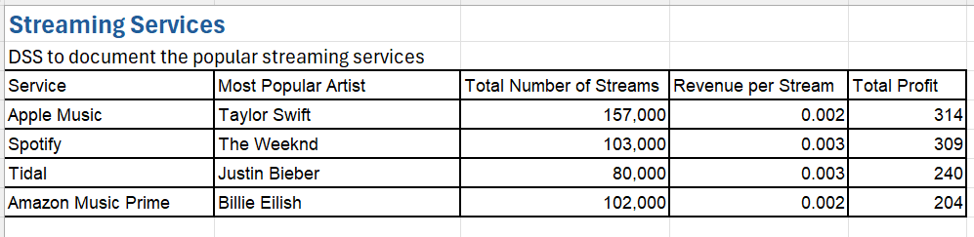
Any artist on any platform will receive a bonus when they reach 200,000 streams.
Add a column and indicate the percentage increase required by each artist to reach this milestone.
Sample answer:
To calculate the percentage increase required:
Formula:
=(200,000 − Current Streams) / Current Streams * 100
New column: "% Increase to Reach 200,000"
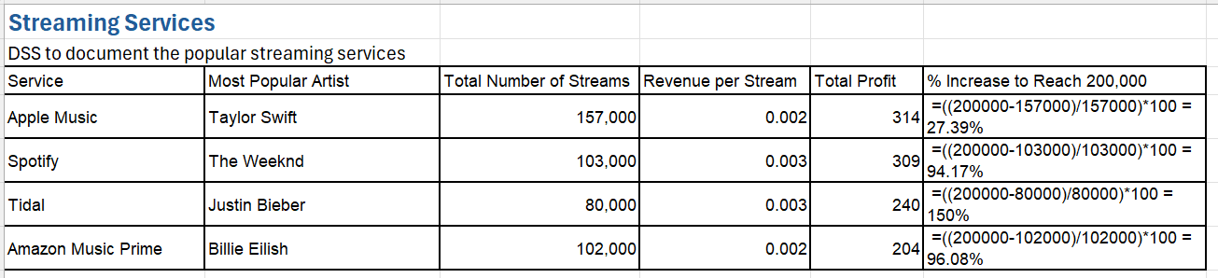
What would be the increase in profit for Justin Bieber if he was to reach 200,000 streams?
Sample answer:
To calculate the increase in profit:
Current streams: 80,000
Revenue per stream: 0.003
Additional streams to reach 200,000: 200,000 - 80,000 = 120,000
Additional profit: 120,000 * 0.003 = $360.00
New total profit:
$240.00 (current) + $360.00 = $600.00
If Justin Bieber were to reach 200,000 streams, his profit would increase by $360.00, making his total profit $600.00.
Fred Musk is considering buying a streaming service. Describe how this decision support system could be modified and what additional information he might need in the support system to make an informed decision.
Sample answer:
To help Fred Musk make an informed decision, the decision support system could be modified by adding data and metrics relevant to evaluating the financial, operational and competitive aspects of streaming services. This includes:
- Revenue analysis:
- monthly or yearly revenue trends per service
- average revenue per user (ARPU).
- Cost analysis:
- operational costs (for example, licensing fees, server maintenance)
- marketing expenses.
- User metrics:
- total number of subscribers
- churn rate (percentage of users cancelling subscriptions)
- market share and competitor data
- market share of each streaming service
- competitor analysis and growth trends.
- Future growth potential:
- predicted market growth
- demographics and regions with untapped potential.
Add some of the major columns and data to your spreadsheet that you think would be required for Fred to make an informed decision.

Modified spreadsheet example:
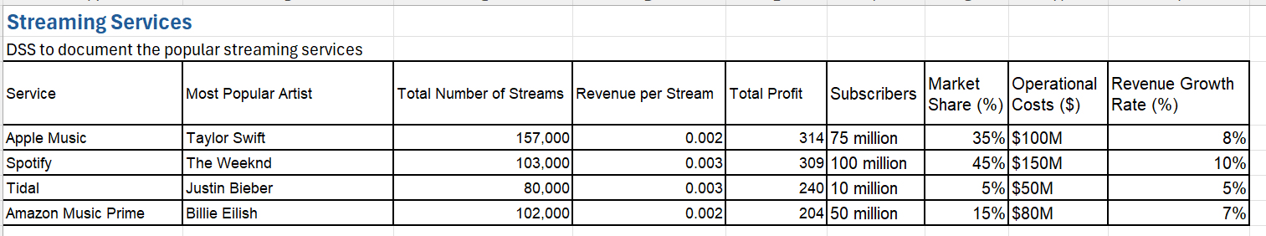These additional columns provide critical financial and market-related data for evaluating the feasibility of acquiring a streaming service.
Which one of the following best describes the decision-making in this spreadsheet:
- An infinite set of instructions where judgement may be required (unstructured)
- The use of a specified set of finite instructions (semi-structured)
- Automated decision (structured)
Sample answer:
The decision-making in this spreadsheet is semi-structured because:
- Finite instructions (for example, formulas to calculate revenue, profit and required streams) guide parts of the analysis.
- Human judgment is required to interpret the data, evaluate additional metrics (for example, market share, growth rate) and decide whether to invest.
This combination of structured calculations and the need for strategic decision-making makes it semi-structured.

Activity 7: using spreadsheets to investigate decision support systems
Below is a partially completed decision support system with the aim of making a decision about the purchase of stocks in a portfolio.
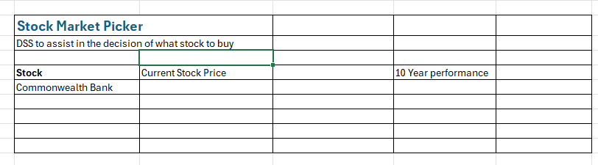
Complete the decision support system with headings that you think would be useful in deciding the purchase of stocks in a portfolio.
Sample answer:
Do some research on the companies you have chosen and populate the decision support system with real-life data on the value and performance of the stocks.
Sample answer:
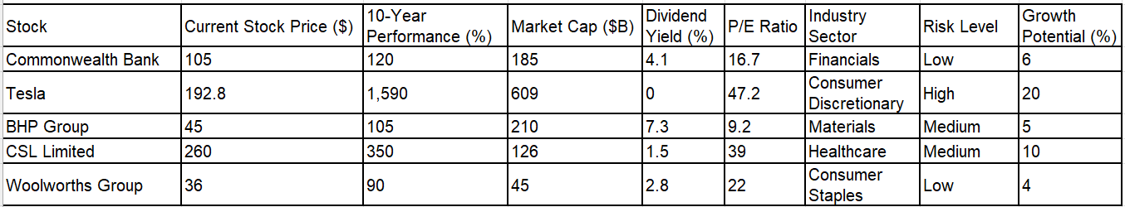
Based on your decision support system, if you were planning to buy and hold 5 stocks for a 10-year period with the intention of maximising your profit, which stocks would you buy today?
Sample answer:
- Tesla: exceptional 10-year growth and high future growth potential
- CSL Limited: strong past performance with promising growth in healthcare
- Commonwealth Bank: stable growth, high market cap and low risk
- BHP Group: strong dividends and consistent performance in materials
- Woolworths Group: reliable performance with low risk in consumer staples
Write a justification of why you chose the 5 stocks identified above.
Sample answer:
- Tesla: Tesla's remarkable 10-year growth and 20% projected future growth indicate significant long-term potential despite high risk. It is ideal for maximising profits in a growth-focused portfolio.
- CSL Limited: a strong performer in the healthcare sector with high 10-year returns and stable growth potential, suitable for long-term holding.
- Commonwealth Bank: as a financial powerhouse in Australia, its consistent performance, strong market cap and low risk make it a reliable choice.
- BHP Group: with its strong dividends and stable performance, BHP adds value to the portfolio through both income and capital growth.
- Woolworths Group: Woolworths provides stability in the portfolio, as consumer staples are less affected by market volatility, making it a good long-term hold.
These stocks balance high growth potential with stability and dividend income, creating a diversified and profitable portfolio for a 10-year investment horizon.
Which one of the following best describes the decision-making in this spreadsheet:
- An infinite set of instructions where judgement may be required (unstructured)
- The use of a specified set of finite instructions (semi-structured)
- Automated decision (structured)
Justify your response.
Sample answer:
The decision-making in this spreadsheet is semi-structured because of the combination of structured and unstructured processes.
- Structured elements: the data and formulas (for example, growth rates, dividend yields) provide a clear framework for analysis.
- Unstructured elements: human judgment is required to interpret the data, evaluate risk levels and balance growth potential with stability.

Create a medical diagnosis expert system
Create a medical diagnosis expert system that identifies common illnesses based on symptoms.
Illnesses to consider include cold, flu and allergies
Symptoms to consider include fever, cough, runny nose, sore throat and fatigue.
Create a table in Excel to act as the knowledge base.
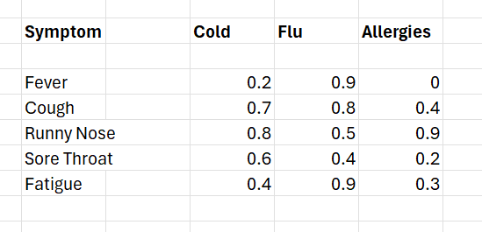

Certainty factors
Assign certainty factors (between 0 and 1) for each symptom based on the likelihood it relates to each illness.
Create the diagnosis logic
- In a new worksheet, create a list of symptoms where users can input ‘Yes’ or ‘No’.

- In another column, use IF statements to convert ‘Yes’ to 1 and ‘No’ to 0. For example, in cell B2:
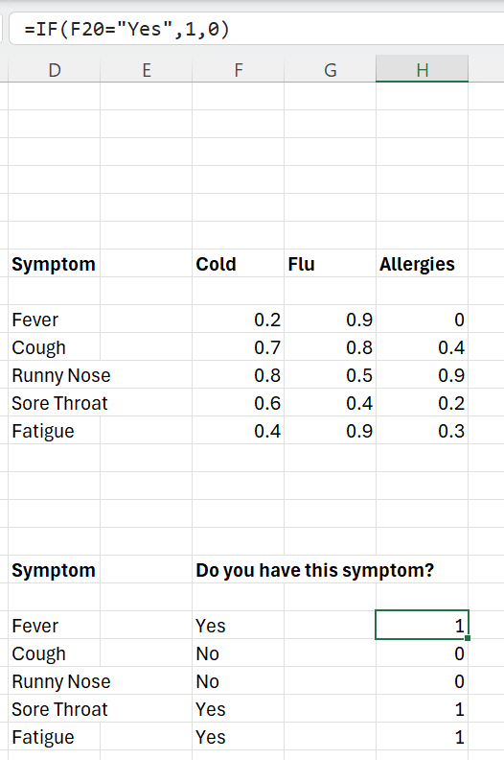
- Create formulas to calculate a diagnosis score for each illness.
For example, for Cold:
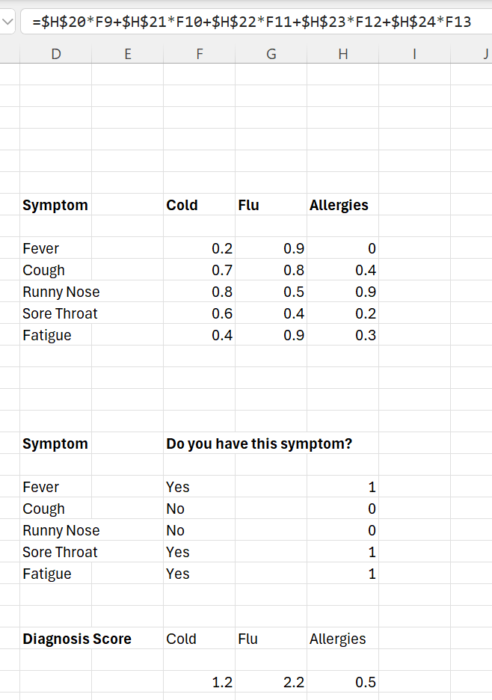

- Display the diagnosis.
Use an IF statement to suggest the illness with the highest score. For example:
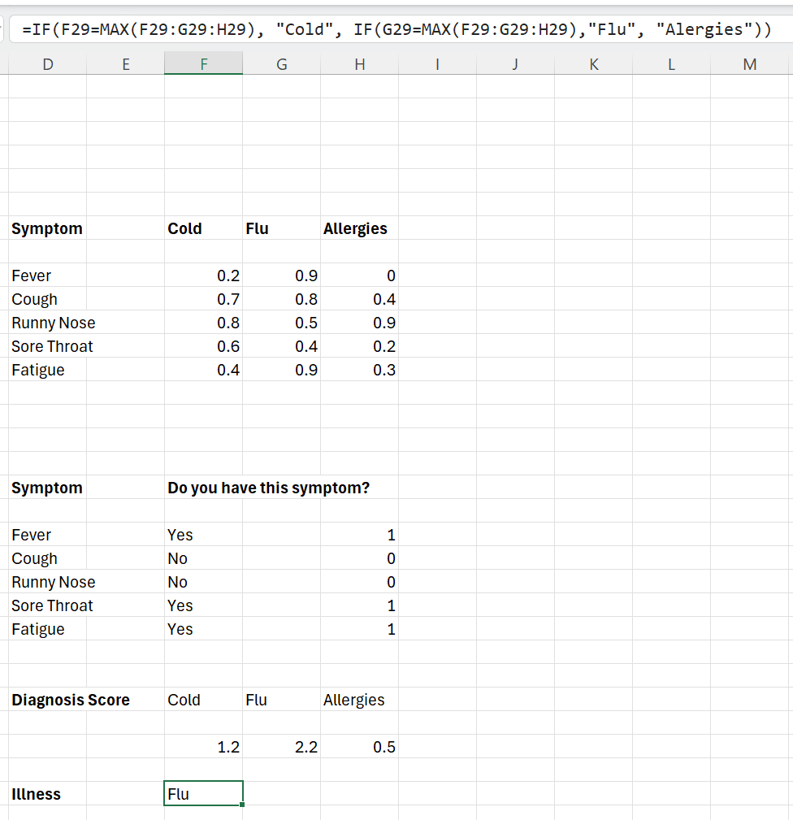

- Display the diagnosis result to the user clearly, such as:
‘Based on your symptoms, you may have: [Illness]’.
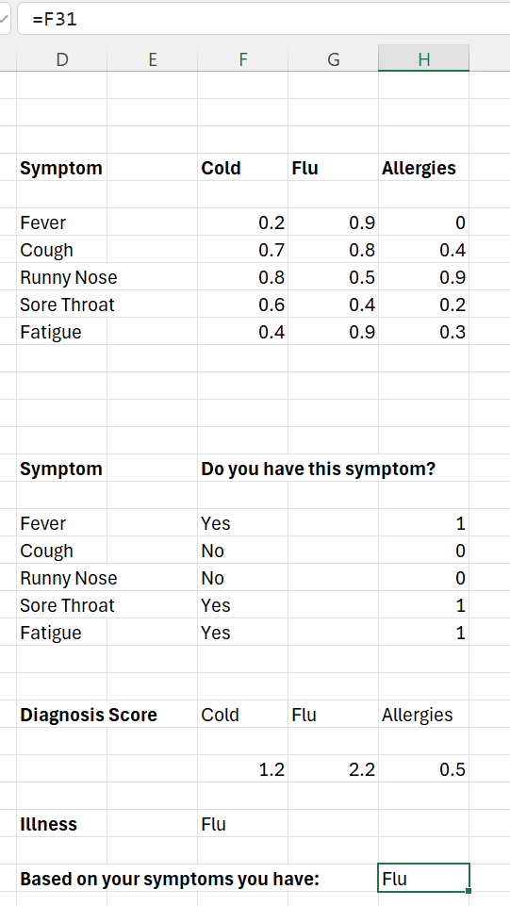
Input different combinations of symptoms to test the accuracy of the expert system.
Check if the diagnosis changes appropriately based on the symptoms provided.
- Discuss how the system worked and how certainty factors influenced decisions.
- Explore potential improvements, such as adding more symptoms or illnesses.
- Reflect on the limitations of expert systems.
- Add more illnesses. Expand the knowledge base with additional illnesses.
- Certainty factors adjustment: experiment with changing certainty factors to see how it impacts the diagnosis.
- User interface: create a more user-friendly interface using Excel’s features like data validation or conditional formatting.
- Create your own expert system for a relevant scenario using the skills you have developed.

Expert systems case study – Bureau of Meteorology
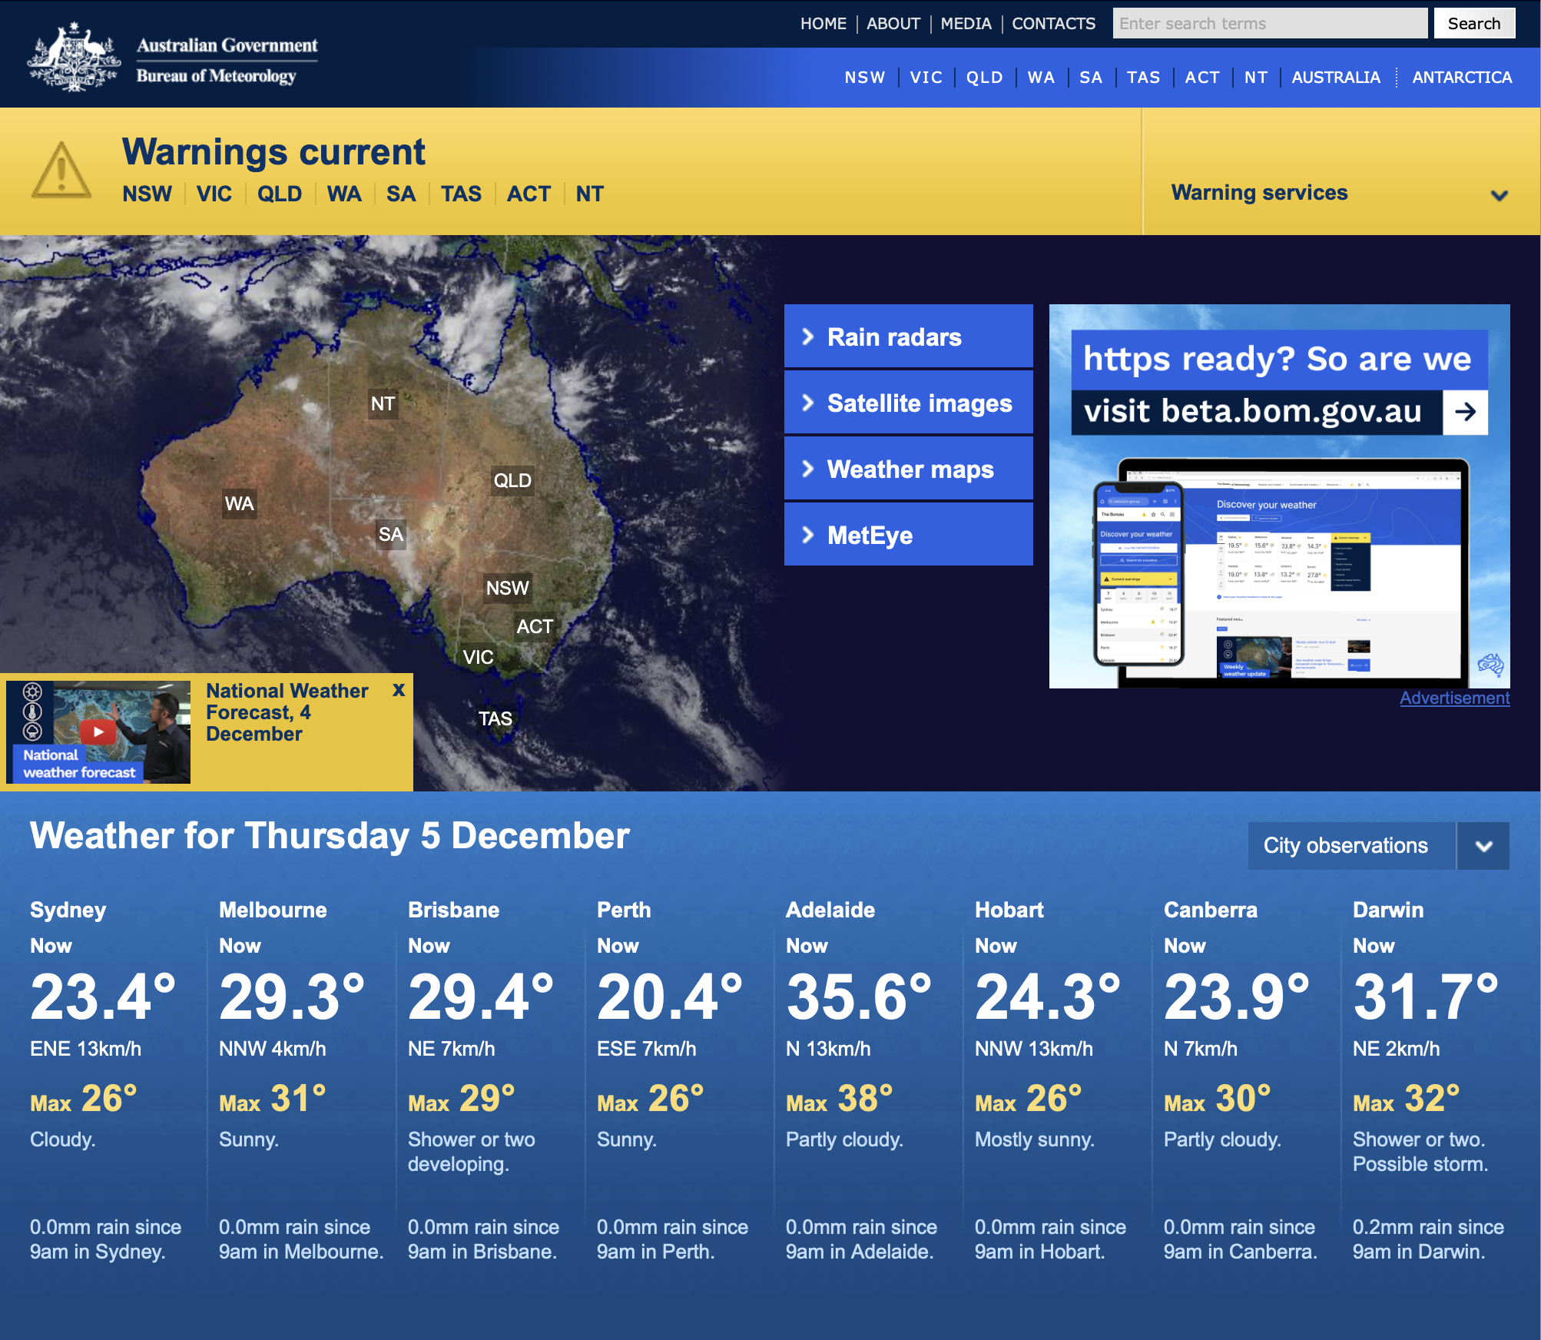
The Bureau of Meteorology provides users with an app which uses a knowledge base, inference engine, user interface and reasoning to assist people in making decisions and solving problems. Discuss the following components that would be used in this system:
- Knowledge base
- Inference engine
- User interface.

Sample answer:
- Knowledge base
The knowledge base is a repository of factual and procedural weather information. It contains data such as:
- historical and real-time meteorological data (for example, temperature, humidity, wind speed, rainfall and so on)
- weather models, patterns and algorithms to predict weather changes
- rules and relationships between meteorological phenomena (for example, how atmospheric pressure changes indicate storms).
- Inference engine
The inference engine uses the knowledge base to analyse data and derive conclusions. It:
- applies rules and algorithms to real-time data (for example, detecting when conditions indicate rain or storms)
- makes predictions (for example, ‘A thunderstorm is likely in the next 24 hours’)
- updates reasoning based on new data inputs, ensuring forecasts are as accurate as possible.
- User interface
The user interface is the app’s front-end, allowing users to interact with the system. It:
- displays weather forecasts, alerts and maps in an easy-to-understand format
- offers features like location-based forecasts, severe weather warnings and real-time updates
- collects user preferences, such as alert settings, to personalise the experience.

Describe whether this system would use forward chaining or backward chaining.
Sample answer:
The system would primarily use forward chaining.
- Reasoning: forward chaining starts with data (for example, real-time weather readings) and applies rules to reach conclusions (for example, ‘Rain is expected in this region’).
- Weather forecasting involves processing large volumes of input data to generate predictive outcomes, which aligns with the forward chaining approach.
- Backward chaining, on the other hand, is more suited for answering specific, goal-oriented queries (for example, ‘What needs to happen for it to snow tomorrow?’).
Would you consider this to be an expert system? Justify your response.
Sample answer:
Yes, this could be considered an expert system because:
- it uses a knowledge base containing expert-level information on weather patterns and forecasting models
- the inference engine applies rules and algorithms to analyse data and provide solutions or recommendations
- it helps users make decisions (for example, preparing for severe weather) by simulating the expertise of meteorologists
However, it relies on predefined rules and models rather than ‘learning’ like modern AI, which may limit its adaptability.

Describe how any of the following would apply to a weather forecasting app:
- Diagnosis
- Monitoring
- Process control
- Scheduling and planning.
Sample answer:
- Diagnosis
Identifying weather conditions based on data patterns (for example, detecting a cyclone or drought from current and historical data).
Example: ‘There is a high-pressure system causing clear skies in your area.’
- Monitoring
Continuously observing real-time weather data such as radar images, temperature changes and wind patterns.
Example: tracking the movement of a storm and issuing alerts as it progresses.
- Process control
Automating the collection and analysis of meteorological data through systems like weather satellites and ground stations.
Example: adjusting predictive models based on the latest sensor readings to refine the accuracy of forecasts.
- Scheduling and planning
Helping users plan activities based on future weather conditions (for example, scheduling outdoor events or determining optimal farming practices).
Example: ‘Rain is expected this weekend; plan to complete your outdoor tasks on Friday’.

The Internet of Things (IoT)
The Internet of Things (IoT) refers to a network of interconnected devices that communicate with each other and collect data. These devices include smart appliances, wearable technology and industrial sensors.
Impact on expert systems
The rise of IoT has created vast amounts of data that need to be processed and analysed. Expert systems have proliferated to manage and interpret this data, helping make decisions in real time. For example, in smart homes, expert systems analyse data from sensors to optimise energy usage, automate tasks and enhance security. In industries, IoT devices combined with expert systems enable predictive maintenance and more efficient operations.
- What is IoT and how does it work?
Sample answer:
IoT refers to a network of interconnected devices that collect, share and act on data over the internet. It works through sensors embedded in devices that gather data, transmit it via the internet and enable real-time actions or decisions. For example, a smart thermostat collects temperature data and adjusts room settings automatically.
- What societal needs have driven the development of IoT devices?
Sample answer:
- Convenience: automation of daily tasks (for example, smart home systems)
- Safety: improved security with smart locks and surveillance cameras
- Health: wearable devices for health monitoring, such as fitness trackers
- Efficiency: optimised energy usage through smart appliances and grids
- Provide examples of IoT devices and explain how they meet these needs.
Sample answer:
- Nest Thermostat: automatically adjusts heating and cooling, reducing energy costs
- Ring Doorbell: provides real-time video and alerts for home security
- Fitbit: tracks health metrics like heart rate and activity levels to promote wellness
- How has IoT changed people’s lives in terms of convenience, safety, or health?
Sample answer:
- Convenience: smart assistants like Alexa simplify tasks by controlling appliances or managing schedules
- Safety: IoT-enabled surveillance and alarm systems offer better home security
- Health: IoT devices like glucose monitors enable real-time health tracking, enhancing disease management
- What future advancements in IoT do you expect?
Sample answer:
- Greater interoperability between devices, allowing seamless integration across ecosystems
- Enhanced data security and privacy measures
- Expansion into smart cities, improving urban planning, traffic management and energy efficiency

Internet of Me (IoMe)
The Internet of Me (IoMe) is a concept where technology and services are tailored to meet individual user needs and preferences. This personalisation often involves collecting and analysing data on user behaviour, preferences and interactions.
Impact on expert systems
As consumers demand more personalised experiences, expert systems have adapted to deliver customised solutions. For instance, expert systems in healthcare can provide personalised treatment plans based on a patient’s unique medical history and preferences. In e-commerce, expert systems analyse browsing and purchase data to offer personalised product recommendations, enhancing the customer experience.
- What is the Internet of Me and how does it personalise technology?
Sample answer:
IoMe focuses on tailoring technology to individual users by collecting and analysing personal data. It creates personalised experiences by leveraging AI and user preferences to adapt services, such as shopping recommendations or fitness plans.
- How do personal data and user preferences shape IoMe systems?
Sample answer:
IoMe systems use personal data (for example, location, purchase history, health metrics) to understand user needs and predict future behaviours, allowing devices and services to offer relevant and customised experiences.
- Give examples of IoMe devices or services.
Sample answer:
- Amazon Alexa: offers tailored responses and recommendations based on user behaviour
- Spotify: suggests music playlists based on listening history
- Apple Watch: tracks personal health metrics and provides individualised insights
- How does IoMe address the increasing need for personalised experiences in everyday life?
Sample answer:
IoMe simplifies and enhances daily routines by adapting to individual preferences, such as creating a custom morning routine with a smart assistant or tailoring fitness plans based on real-time health data.
- What are the potential privacy or ethical concerns with IoMe?
Sample answers:
- Unauthorised data collection or breaches
- Over-reliance on personal data, which can lead to discrimination or bias
- Lack of transparency in how data is used or shared

Industry 4.0
Industry 4.0 refers to the fourth industrial revolution, characterised by the integration of digital technologies, automation and data exchange in manufacturing and industrial processes. This includes cyber-physical systems, IoT and cloud computing.
Impact on expert systems
Industry 4.0 has driven the need for smarter and more autonomous systems in manufacturing. Expert systems are used to monitor and control complex industrial processes, making decisions that optimise production, reduce waste and improve quality. These systems can also predict equipment failures before they occur, minimising downtime and maintenance costs. The automation and data-driven nature of Industry 4.0 have led to a widespread adoption of expert systems in modern manufacturing environments.
- What is Industry 4.0 and how is it different from previous industrial revolutions?
Sample answer:
Industry 4.0 is the fourth industrial revolution, focusing on the integration of IoT, AI, robotics and big data into manufacturing and business processes. Unlike earlier revolutions, which emphasised mechanisation, mass production and automation, Industry 4.0 emphasises connectivity, intelligence and autonomy in systems.
- How have people’s changing needs for efficiency, sustainability and customisation impacted the growth of Industry 4.0?
Sample answer:
- Demand for faster production has driven adoption of smart factories
- Sustainability goals have led to energy-efficient and waste-reducing technologies
- Consumer desire for personalised products has spurred the use of advanced manufacturing techniques like 3D printing
- Provide examples of Industry 4.0 technologies (for example, robotics, AI, smart factories).
Sample answer:
- Robotics: automated systems like Amazon’s warehouse robots optimise logistics
- AI: predictive maintenance systems that reduce downtime
- Smart factories: for example, Siemens uses IoT and AI to create adaptive, efficient production lines
- How has Industry 4.0 transformed the way businesses operate or produce goods?
Sample answer:
- Enhanced efficiency through automation and predictive analytics
- Real-time tracking and optimisation of supply chains
- Shift toward on-demand manufacturing, allowing faster response to customer needs
- What challenges or opportunities does Industry 4.0 create for the future workforce?
Sample answer:
- Challenges: automation may lead to job displacement in low-skill roles
- Opportunities: demand for skilled workers in areas like robotics, data analysis and AI programming
- Upskilling: workers must adapt to new technologies through training and education

References
This resource contains NSW Curriculum and syllabus content. The NSW Curriculum is developed by the NSW Education Standards Authority. This content is prepared by NESA for and on behalf of the Crown in right of the State of New South Wales. The material is protected by Crown copyright.
Please refer to the NESA Copyright Disclaimer for more information https://educationstandards.nsw.edu.au/wps/portal/nesa/mini-footer/copyright.
NESA holds the only official and up-to-date versions of the NSW Curriculum and syllabus documents. Please visit the NSW Education Standards Authority (NESA) website https://educationstandards.nsw.edu.au/ and the NSW Curriculum website https://curriculum.nsw.edu.au/.
Enterprise Computing 11–12 Syllabus © NSW Education Standards Authority (NESA) for and on behalf of the Crown in right of the State of New South Wales, 2022.
Enterprise Computing course specifications © NSW Education Standards Authority (NESA) for and on behalf of the Crown in right of the State of New South Wales, 2022.
Altitude Accelerator (27 June 2018) ‘Understanding the Internet of Me: When the Consumer becomes the Electronics’, Altitude Accelerator, accessed 15 September 2023.
AnyLogic (19 May 2021) ‘What is AnyLogic Simulation Software?’ [video], AnyLogic, YouTube, accessed 24 April 2025.
Australian Computer Society (2025) ICT News, Information Age website, accessed 24 April 2025.
Australian Computing Academy (n.d.) DT Challenge Blockly: Smart Garden [PDF 11 MB], Australian Computing Academy, accessed 24 April 2025.
Autodesk, Inc (2025) Hands-on projects, Tinkercad website, accessed 24 April 2025.
Basic ICT tutorials (Information Communication Technology) (14 April 2020) ‘Expert Systems – Lesson 1’ [video], Basic ICT tutorials (Information Communication Technology), YouTube, accessed 24 April 2025.
Basic ICT tutorials (Information Communication Technology) (15 April 2020) ‘Expert Systems – Lesson 2’ [video], Basic ICT tutorials (Information Communication Technology), YouTube, accessed 24 April 2025.
BBC News (12 January 2024) ‘Artificial intelligence comes to farming in India | BBC News’ [video], BBC News, YouTube, accessed 24 April 2025.
Bureau of Meteorology (2025) Bureau of Meteorology [website], accessed 24 April 2025.
Cannon W (2023) How Digital Workflows Streamline Your Business (5 Examples), Signaturely website, accessed 15 September 2023.
Capital Technology University ( 30 May 2023) ‘The Ethical Considerations of Artificial Intelligence’, Capital Technology University blog, accessed 24 April 2025.
CESE (Centre for Education Statistics and Evaluation) (2025) ‘Practical guides for educators’, NSW Department of Education website, accessed 24 April 2025.
Cepero R (5 November 2019) ‘Everything You Need to Know About Enterprise Data Storage’, Bleuwire blog, accessed 15 September 2023.
Cisco Networking Academy (2023) ‘Exploring Internet of Things with Cisco Packet Tracer’, Learning Collections – Cisco Packet Tracer, Cisco Networking Academy website, accessed 15 September 2023.
Cisco Networking Academy (2023) Cisco Networking Academy [website], accessed 15 September 2023.
Cloudcraft (2025) Cloudcraft [website], accessed 24 April 2025.
CodeMagic LTD (2019–2025) Wokwi [website], accessed 24 April 2025.
Condé Nast (2025) WIRED [website], accessed 24 April 2025.
Diamond P (2020) ‘Cloud storage vs. on-premises servers: 9 things to keep in mind’, Business Tech, Microsoft Business Insights and Ideas website, accessed 24 April 2025.
Econoscent (17 July 2020) ‘Visual Guide to Decision Trees’ [video], Econoscent, YouTube, accessed 24 April 2025.
edureka! (1 August 2018) 'Internet of Things (IoT) | What is IoT | How it Works | IoT explained | Edureka' [video], edureka!, YouTube, accessed 15 September 2023.
Endeavor Business Media, LLC (2025) IndustryWeek [website], accessed 24 April 2025.
Eye on Tech (11 July 2024) 'What is Industry 4.0? An Introduction’ [video], Eye on Tech, YouTube, accessed 24 April 2025.
GreggU (23 March 2020) 'Types of Decisions’ [video], GreggU, YouTube, accessed 24 April 2025.
Gruss R (14 September 2019) ‘Expert Systems’ [video], Richard Gruss, YouTube, accessed 24 April 2025.
HealthIMPACT Live (29 June 2016) ‘Dr. Ted Shortliffe on the Evolution of Medical AI and Bioinformatics’ [video], HealthIMPACT Live, YouTube, accessed 24 April 2025.
Home Assistant (2025) Home Assistant [website], accessed 24 April 2025.
Home Assistant (2025) ‘Understanding automations’, Documentation, Home Assistant website, 24 April 2025.
House of I.T (2021) ‘7 Components of IT Infrastructure and How They Work Together’, House of I.T blog, accessed 15 September 2023.
IBM Technology (1 October 2021) ‘What is AI Ethics?’ [video], IBM Technology, YouTube, accessed 24 April 2025.
Indeed Editorial Team (2023) ‘What is Network Hardware? (With Types and Best Practices)’, Career Development, Indeed website, accessed 15 September 2023.
IAEAvideo (International Atomic Energy Agency) (19 October 2017) ‘Decision Support System for Nuclear Emergencies Affecting Food and Agriculture’ [video], IAEAvideo, YouTube, accessed 24 April 2025.
Investment NSW (2023) ‘Sydney Startup Hub’, Innovation, NSW Government website, accessed 15 September 2023.
Kalodikis C (25 April 2024) ‘IoT & IoMe’ [video], Christopher Kalodikis, YouTube, accessed 24 April 2025.
Kalodikis C (19 August 2024) ‘Enterprise Computing Year 12 Unit 3: Intelligent Systems’ [video], Christopher Kalodikis, YouTube, accessed 24 April 2025.
Kumar A (2021) Agriculture Use Cases & Machine Learning Applications, Analytics Yogi website, accessed 15 September 2023.
LSE (London School of Economics) (2024) ‘How can we understand AI?’, AI and tech, LSE website, accessed 24 April 2025.
LSE (12 February 2025) ‘AI Emergency service 911 calls: the limitations of AI | LSE Research’ [video], LSE, YouTube, accessed 24 April 2025.
LSE (8 April 2025) 'Could this tech save lives? | LSE Research' [video], LSE, YouTube, accessed 24 April 2025.
Lucid Software Inc (2025) What is a Decision Tree Diagram, Lucidchart website, accessed 24 April 2025.
Melbourne Water (5 October 2015) ‘Flood Integrated Decision Support System (FIDSS)’ [video], Melbourne Water, YouTube, accessed 24 April 2025.
Microsoft Corporation (16 October 2022) ‘Cloudcraft Unravels the Mysteries of Microsoft Datacenters in Minecraft’, Minecraft Education blog, accessed 24 April 2025.
MIT (Massachusetts Institute of Technology) (n.d.) Moral Machine [website], accessed 24 April 2025.
MIT Technology Review (2025)MIT Technology Review [website], accessed 24 April 2025.
NetLogo Web (n.d.) NetLogo Web [website], accessed 24 April 2025.
NESA (NSW Education Standards Authority) (n.d.) ‘Glossary of key words’, Student guide, NESA website, accessed 23 October 2023.
NESA (n.d.) HSC sample examinations and familiarisation questions [website], NESA HSC Online Examinations website, accessed 23 October 2023.
Overshoot (30 June 2023) ‘I Automated my Garden Irrigation with Arduino’ [video], YouTube, Overshoot, accessed 24 April 2025.
Ranger S (3 February 2020) ‘What is the IoT? Everything you need to know about the Internet of Things right now’, ZDNet, accessed 15 September 2023.
SciTech (18 February 2024) ‘What is IoT? Internet of Things Explained’ [video], SciTech, YouTube, accessed 24 April 2025.
Siersted N (n.d.) 10 Edge computing use case examples, STL Partners articles, accessed 15 September 2023.
Simplilearn (26 March 2021) 'IoT In 2 Minutes | What Is IoT | Introduction To IoT | IoT Explained | Simplilearn' [video], Simplilearn, YouTube, accessed 15 September 2023.
Stratvert K (31 August 2019) 'How to Create Macros in Excel Tutorial' [video], Kevin Stratvert, YouTube, accessed 24 April 2025.
Stratvert K (17 December 2019) ‘IF Function in Excel Tutorial’ [video], Kevin Stratvert, YouTube, accessed 24 April 2025.
Stratvert K (2 October 2024) ‘VLOOKUP in Excel | Step-by-Step Tutorial for Beginners’ [video], Kevin Stratvert, YouTube, accessed 24 April 2025.
SXSW (4 April 2025) '10 Key Breakthrough Technologies of 2025' [video], SXSW, YouTube, accessed 24 April 2025.
TechCrunch Media LLC (2025) TechCrunch [website], accessed 24 April 2025.
Technovation (2025) ‘Raspberry Pi Powered IOT Garden,’ Raspberry Pi, Autodesk Instructables website, accessed 24 April 2025.
TechTalkCentral (10 July 2024) 'How to Build a Smart Garden with IoT' [video], TechTalkCentral, YouTube, accessed 24 April 2025.
TED (12 April 2025) 'OpenAI’s Sam Altman Talks ChatGPT, AI Agents and Superintelligence — Live at TED2025' [video], TED, YouTube, accessed 24 April 2025.
TEDx Talks (22 May 2016) 'The internet of things | Jordan Duffy | TEDxSouthBank' [video], TEDx Talks, YouTube, accessed 24 April 2025.
TEDx Talks (25 February 2021) 'The Internet of Everything | Tom Moran | TEDxNewcastleCollege' [video], TEDx Talks, YouTube, accessed 24 April 2025.
Terrell Hanna K and Pratt MK (2024) ‘What is a startup company?’, CIO strategy, TechTarget website, accessed 24 April 2025.
Two Teachers (5 June 2023)'Mastering Sales Forecasts with Consumer Trends, Seasonal Variations, and Competitor Insight' [video], Two Teachers, YouTube, accessed 24 April 2025.
Trinket (2015–2024) Put Interactive Python Anywhere on the Web, Trinket website accessed 24 April 2025.
UNESCO (United Nations Educational, Scientific and Cultural Organization) (7 February 2023) 'Ethics of AI: Challenges and Governance' [video], UNESCO, YouTube, accessed 24 April 2025.
US department of Transportation Federal Highway Administration (12 October 2023) ‘Decision Support Systems (DSS) for ICM’ [video], Federal Highway Administration USDOTFHWA, YouTube, accessed 24 April 2025.
Webmedy (October 2022) 'What is a Clinical Decision Support System?' [video], Webmedy, YouTube, accessed 24 April 2025.
ZDNet (4 February 2020) ‘5G: What it means for IoT’ [video], ZDNet, ZDNet website, accessed 15 September 2023.

© State of New South Wales (Department of Education), 2025
The copyright material published in this resource is subject to the Copyright Act 1968 (Cth) and is owned by the NSW Department of Education or, where indicated, by a party other than the NSW Department of Education (third-party material).
Copyright material available in this resource and owned by the NSW Department of Education is licensed under a Creative Commons Attribution 4.0 International (CC BY 4.0) license.

This license allows you to share and adapt the material for any purpose, even commercially.
Attribution should be given to © State of New South Wales (Department of Education), 2025.
Material in this resource not available under a Creative Commons license:
- the NSW Department of Education logo, other logos and trademark-protected material
- material owned by a third party that has been reproduced with permission. You will need to obtain permission from the third party to reuse its material.
Links to third-party material and websites
Please note that the provided (reading/viewing material/list/links/texts) are a suggestion only and implies no endorsement, by the New South Wales Department of Education, of any author, publisher, or book title. School principals and teachers are best placed to assess the suitability of resources that would complement the curriculum and reflect the needs and interests of their students.
If you use the links provided in this document to access a third-party's website, you acknowledge that the terms of use, including licence terms set out on the third-party's website apply to the use which may be made of the materials on that third-party website or where permitted by the Copyright Act 1968 (Cth). The department accepts no responsibility for content on third-party websites.

