Aquatic Technology 7–10 – Aquatic activities – teacher support resource
Beneath the surface: safety secrets
Contents
Unit overview 2
Glossary 4
Introduction to aquatic activities 8
Water safety – understanding the evidence 9
Improving safety in and around water 13
Technology and water safety 17
Identifying hazardous conditions 19
First aid including CPR 24
Sun safety 30
Water activities 35
Impact of aquatic activities on the environment 36
Snorkelling 38
Communication and safety 40
Risk assessment 45
Snorkelling skills 49
Emerging technologies 50
Licensing 52
NSW Boating Licence 52
Regulatory bodies 53
References 56

Unit overview
This resource supports schools’ implementation of the Aquatic activities focus area of the new Aquatic Technology 7–10 Syllabus. It can be adopted as is or adapted to meet the needs of individual school contexts.
The ‘Beneath the surface: safety secrets’ unit is an engaging and comprehensive 10-week program designed for Aquatic Technology 7–10 students. This unit offers a blend of theoretical knowledge, practical experiences and evaluative practices.
Why this learning is important:
- Safety awareness: understanding drowning statistics and water safety strategies can significantly reduce the risk of accidents and fatalities in aquatic environments.
- Skill development: teaching survival swimming and essential water skills empowers students to respond effectively in emergencies, enhancing their confidence and capabilities in the water.
- First aid preparedness: training students in CPR and first aid equips them with the knowledge to react appropriately during aquatic emergencies, potentially saving lives.
- Environmental responsibility: activities focused on snorkelling and marine safety promote awareness of environmental conservation, encouraging students to respect aquatic ecosystems.
- Technological literacy: familiarising students with apps and technologies that enhance water safety prepares them to use modern tools effectively for their protection and enjoyment.
Note: this resource is designed for easy conversion into a student booklet by removing answers within the response windows. Teacher notes (in blue) can be deleted before distributing to students. Teachers should adapt the resource to suit their school context. Alternative ideas are included for the project design brief. The resource can be introduced and delivered earlier in the term or used as an assessment.
School leaders and teachers should refer to Equipment Safety in Schools, Chemical Safety in Schools and Swimming and water safety for current information on safety and safe working practices.

Glossary
Note: provide students with the glossary table, leaving the definition column blank, so they can complete the activity throughout the term.
Each time you see a new word throughout the workbook, add its definition in the table below in case you need to refer to it later.
Table 1 – glossary
Word | Definition
alpha flag | A flag used on boats or at dive sites to indicate that there is a diver underwater in the vicinity; it signals other vessels to keep clear.
antiseptic | A substance that prevents the growth of disease-causing microorganisms; used to clean wounds and prevent infection.
boating | The activity of travelling by boat, including recreational and professional use on water.
buddy | A diving partner who assists and looks out for each other’s safety during underwater activities.
dive signals | Standard hand or body signals used by divers underwater to communicate important information.
diver-down flag | A red flag with a white diagonal stripe used to alert others that divers are below the surface nearby.
drone | An unmanned aerial vehicle used for surveillance, photography or rescue operations over water.
DRSABCD | An acronym used in first aid indicating the steps to follow: Danger, Response, Send for help, Airway, Breathing, CPR and Defibrillation.
envenomation | The process by which venom is injected by a bite or sting from a venomous animal.
face mask | A piece of diving or snorkelling equipment worn over the eyes and nose to allow clear vision underwater.
fins | Equipment worn on the feet to aid swimming by providing propulsion in water.
first aid | Immediate care given to a person who is injured or ill before professional medical help arrives.
foil blanket | Also known as a space blanket, it is a lightweight thermal blanket used to retain body heat in first aid situations.
hazard | A potential source of harm or danger in an aquatic environment.
heatstroke | A serious condition caused by the body overheating, often due to prolonged exposure to high temperatures.
hyperthermia | A condition where the body temperature rises above normal due to external heat exposure.
hypothermia | A dangerous drop in body temperature below normal, usually caused by prolonged exposure to cold water or weather.
kayaking | The activity of paddling a small, narrow watercraft using a double-bladed paddle.
licence | Official permission or certification to operate a boat or watercraft legally.
maritime | Related to the sea, navigation, shipping, or activities conducted on or near the water.
one-pager | A concise document summarising key information or concepts on a single page.
plunging wave | A type of breaking wave where the crest curls over and crashes down violently.
regulation | A rule or directive made and maintained by an authority to control activities, such as boating or water safety.
rip | A strong, narrow current of water moving away from the shore, which can be dangerous for swimmers.
risk assessment | The process of identifying, evaluating, and controlling risks to ensure safety.
sailing | The sport or activity of using sails to navigate a boat on water.
SharkSmart app | A mobile application providing real-time information and alerts about shark sightings and safety.
SMART drumline | A shark management device designed to capture sharks safely for tagging and relocation.
Smart Remote Area Rescue Tubes | Rescue flotation devices equipped with technology to assist lifeguards in remote or difficult-to-access areas.
snorkel | A tube allowing a person to breathe while swimming face-down on the water surface.
snorkelling | The activity of swimming on the water surface while using a snorkel and mask to observe underwater life.
surfing | The sport of riding waves on a surfboard.
surging wave | A wave that moves rapidly up the beach, often without breaking, and can cause strong currents.
Thermos | A container designed to keep liquids hot or cold for extended periods.
wetsuit | A garment made of neoprene worn to provide thermal insulation while in cold water.

Introduction to aquatic activities
This unit will equip students with knowledge and understanding of water safety, first aid and relevant regulations through practical and theoretical learning experiences.
Water safety
- Assess emergency situations and enhance safety
- Demonstrate swimming skills (200 metres, 25 metres clothed, 10 metres underwater, 3 minutes treading water)
First aid and sun safety
- Outline resuscitation steps (DRSABCD)
- Identify first aid treatments for aquatic injuries
- Recognise and address sun exposure risks
Water activities
- Identify aquatic activities and necessary equipment
- Assess environmental impacts of these activities
- Demonstrate communication and safety techniques
Regulations
- Investigate NSW maritime rules and boat licence requirements
- Discuss the role of education and technology in aquatic safety regulation

Water safety – understanding the evidence
Note: the Royal Life Saving Australia Drowning Report is released each year and the latest available data should be used for this analysis.
Teachers should use discretion and be aware of local incidence and potential impacts on their student cohort.
Visit Royal Life Saving Australia’s National Summer Drowning Toll. Use the interactive charts for this activity.
Scroll to the bottom of the webpage and select I Agree to be taken to this resource.
- Select the Time Series tab along the top. You will see a graph of summer drowning numbers from December to February for the most recent summer period.
- How many drownings occurred at the start of the summer period?
Sample answer:
1
- How many drownings occurred at the end of the summer period?
Sample answer:
104
- Compare the current year’s drowning numbers to the previous summer. Provide numbers of drownings to support your answer.
Sample answer:
There were 104 drownings in the summer of 24/25 whilst there were 99 drownings in the summer of 23/25. Both are well above the 5-year average of 90.
- Select the Bar Chart tab along the top. You will see a bar chart of drownings by different activities.
In which activity were most drowning deaths observed? How many deaths occurred while doing this activity?
Sample answer:
Swimming and recreating with 38 drownings.
- Select the Age Group filter on the left-hand side of the screen.
- In which age group did the greatest number of drowning deaths occur?
Sample answer:
35–64 with 38 drownings.
- How many drownings occurred in this age group?
Sample answer:
38
- Explain why you think there were so many deaths in this age group.
Sample answer:
People in the 35–64 age bracket could be prone to a variety of factors that increase risk of drowning including overconfidence, engaging in risky behaviours such as boating and rock fishing, reduced physical fitness and alcohol consumption. All these factors, combined with being in the water away from supervision, could increase their risk of drowning.
- Select the Body of Water filter on the left-hand side of the screen.
- In which body of water did the greatest number of drownings occur? How many drownings were there?
Sample answer:
There were 33 drownings at the beach. However, rivers and creeks saw 31 drownings.
- Explain why so many drownings could occur in this body of water.
Sample answer:
Both bodies of water a very treacherous. Beaches can experience dangerous rips and currents along with powerful waves. Large stretches of beach in Australia are unpatrolled, meaning that many swimmers could be in dangerous conditions with limited chance of rescue.
- Select the Sex filter on the left-hand side of the screen.
- Were more drownings seen in males or females? How many drownings occurred in males? How many females?
Sample answer:
Significantly more males than females drowned, with 82 males drowning compared to 18 females.
- Why do you think there is such a difference between the number of drownings between males and females?
Sample answer:
Males can be more likely to engage in risky behaviours and have larger participation rates in aquatic sports such as surfing.
Males can also be overconfident and ignore treacherous conditions.
- Select the State/Territory filter on the left-hand side of the screen.
- Which state had the most drowning deaths? What was the number?
Sample answer:
NSW had 33 drownings, 11 more than both Victoria and Queensland.
- Why do you think this state had the greatest number of drownings?
Sample answer:
NSW has a large population; coastline and waterways are regularly used throughout the year.
- Select the Map tab along the top. You will see a shaded map of Australia.
- Find and select your region by hovering over the map. How many drownings occurred in your region over summer?
Sample answer:
Southeastern Sydney – 0.
- Compare these statistics to a neighbouring region. Provide reasons for any similarities or differences in drowning number, for example, holiday region, particular aquatic activity.
Sample answer:
The Illawarra Shoalhaven area had 6 drownings. This could be because there are more unpatrolled beaches and rivers in the region, increasing the risk for swimmers.
- Select the Case List tab along the top. Choose one case from your own or a neighbouring region. Summarise the events surrounding this incident.
Sample answer:
A 15-year-old boy was standing on a rock shelf at Avoca with 2 friends. All of them were swept in. His 2 friends were able to get out, but the victim was not able to make it to safety.

Improving safety in and around water
Note: students will participate in a Jigsaw activity. Teacher allocates students a certain area (from the list below) in which they will become a water safety expert.
Teachers should use discretion and be aware of local incidence and potential impacts on their student cohort.
Use the Royal Life Saving Australia website to research and respond to the questions below about your allocated water setting:
- home
- farm
- inland waterways
- public pool
- beach
- holidays.
- Identify your setting.
Sample answer:
Inland waterways.
- Describe the physical characteristics of your setting.
Sample answer:
Inland waterways typically include rivers, lakes, streams and canals. These environments can have varying depths, flowing currents or still water, and natural features such as rocks, vegetation, and muddy or sandy bottoms. The water clarity can vary, and the surrounding areas may include banks, cliffs or gentle shores.
- Describe the environmental conditions that can impact water safety.
Sample answer:
Environmental conditions affecting safety include water flow speed (currents, floods), water temperature, weather conditions (rain, wind, storms), visibility (fog, darkness) and water quality (pollution, algae blooms). Seasonal changes can also influence water levels and hazards.
- Identify the potential water safety dangers and hazards.
Sample answer:
Potential dangers include strong or unpredictable currents, submerged obstacles (rocks, branches), sudden drop-offs, cold water temperatures leading to hypothermia, slippery banks, wildlife (such as snakes or aggressive fish) and poor water quality. Additionally, remote locations may delay rescue efforts.
- Explain how you could practise adequate water safety in this setting.
Sample answer:
Always wear a properly fitted life jacket when boating or swimming. Check weather and water conditions before entering the water. Never swim alone; use the buddy system. Avoid alcohol consumption near water. Be aware of local hazards and follow any safety signs or regulations. Have communication devices and emergency plans in place.
- List 2 sources or websites that could help educate people on water safety in this setting.
Sample answer:
- Royal Life Saving Society Australia (https://www.royallifesaving.com.au)
- NSW Department of Primary Industries – Water Safety (https://www.dpi.nsw.gov.au/fishing/safety)
- List 3 tips to ensure water safety in this setting.
Sample answer:
- Always supervise children and inexperienced swimmers closely.
- Wear appropriate safety gear, including life jackets, when on or near the water.
- Be aware of and avoid hazardous areas such as strong currents, deep water or slippery banks.
- Using this information, develop a one-pager on Canva or other software to educate people on your area of expertise. Include both visual (for example, photos or maps) and written information.

Sample answer:
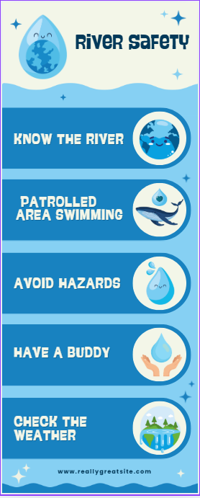

Technology and water safety
Note: introduce students to a KWLH scaffold on one of the following latest water safety technologies – drones, SMART drumlines, SharkSmart App or Smart Remote Area Rescue Tubes.
What do you know about drones, SMART drumlines, SharkSmart app or Smart Remote Area Rescue Tubes?
- Choose one of the water safety technologies mentioned above.
- Complete the first 2 columns of the table.
- Using the reading strategies below, read the information hyperlinked in the question.
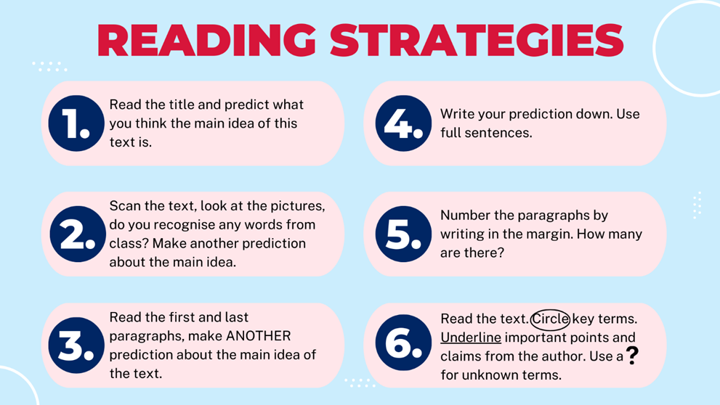
- Complete the second 2 columns of the table.
Table 2 – KWLH scaffold
What I know | What I want to know | What I learned | How I learn more
In this column write what you already know about the topic. | In this column write what you want to know about the topic. | In this column write down what you have learned about the topic. | In this column write about how you will learn more about the topic.

Identifying hazardous conditions
Note: use the stimulus provided to introduce students to a variety of dangerous situations and settings. Skills shown and discussed are then to be transferred and applied to the practical experience in still water.
Suggested activities
- Classroom discussion
- Answers to questions provided
- Summary of dot points during each video
Additional resources to support teacher knowledge
- Trouser floats – Life Jacket Made of Pants | Survival Tips (0:42)
- Fitting a life jacket – Marine Rescue NSW: Wearing a Lifejacket (0:46)
- Capsizing – Kayaking | How to Self-Rescue || REI (2:08)
- Buddy system – Navy Skills for Life – Water Survival Training – Buddy Towing (0:40)
- Use of alternative flotation device, for example, esky lids – Brothers rescued after clinging onto esky in shark-infested waters for hours (1:49)
Watch How to Spot a Rip Current (2:31).
Respond to the questions in the table below.
Table 3 – how to spot a rip current
Question | Answer
How many people know how to spot a rip? | Sample answer:  Research by surf safety organisations such as Surf Life Saving Australia indicates that a relatively low percentage of Australians can confidently identify a rip current. Surveys have shown that less than half of beachgoers can correctly spot a rip, with many people still unsure or mistaken about what to look for.
What is a rip and how do they form? | Sample answer:  A rip (or rip current) is a strong, narrow current of water that flows from the shore out towards deeper water, often through a gap in sandbars. Rips form when waves break strongly in some locations and weakly in others, causing water to accumulate near the shore and then flow back out to sea in concentrated channels.
What type of rips can be found? | Sample answer:  - Permanent rips are usually found in the same locations, usually near headlands, rocks or sandbanks.  - Fixed rips occur when water consistently flows out through a channel in a sandbar.  - Flash rips suddenly appear due to a change in wave conditions, tides or sand movement.  - Travelling rips move along the beach with changing wave action or tides.
Describe what to look for when identifying a rip? | Sample answer:  - Darker, deeper water: rips often appear as darker patches between areas of breaking waves.  - Fewer breaking waves: the water in a rip may look calmer with fewer or no waves.  - Rippled or choppy surface: the water in a rip may look rougher or disturbed compared to surrounding water.  - Foam, debris or sand: you may see foam, debris or sand being carried out to sea in the rip channel.
Do rips show these signs all the time? | Sample answer:  No, rips do not always display these signs clearly. Their appearance can change with tides, wave size and weather conditions. Sometimes rips are difficult to spot, especially in rough or changing surf, or on beaches with complex sandbar formations. Always use caution, swim between the flags at patrolled beaches, and ask lifeguards if unsure.
Watch How to survive a rip (1:38).
Respond to the questions in the table below.
Table 4 – how to survive a rip
Question | Answer
Will a rip pull you under the water? | Sample answer:  No, a rip current will not pull you under the water. Rips are strong currents that move you horizontally, away from the shore, not vertically downwards. However, panic or exhaustion can cause swimmers to struggle or sink, which increases the risk of drowning.
What are the main causes of drowning in a rip? | Sample answer:  The main causes of drowning in a rip are:  - panic: swimmers may panic when they realise they are being pulled away from shore, which leads to exhaustion and poor decision-making  - exhaustion: attempting to swim directly against the strong current back to shore can quickly tire even strong swimmers  - lack of knowledge: not knowing what a rip is or how to escape can result in ineffective or dangerous actions  - medical conditions: pre-existing health issues may be triggered by stress or exertion.
What are your options if you are caught in a rip? | Sample answer:  If you are caught in a rip:  - Stay calm and float. Keep yourself afloat and conserve energy.  - Raise your arm and signal for help. At a patrolled beach, lifeguards can assist you.  - Don’t try to swim directly against the current. Swimming straight back to shore is exhausting and unlikely to work.  - Swim parallel to the beach. Move sideways out of the rip current, toward areas where waves are breaking, then head back to shore.  - Let the rip take you out if needed. If you cannot escape, stay calm and keep floating, most rips eventually weaken beyond the breaking waves, allowing you to swim back in.
Watch the Beach Survival Guide (5:51).
Respond to the following questions.
Table 5 – beach survival guide
Question | Answer
Define a plunging wave. | Sample answer:  A plunging wave is a type of surf wave where the crest becomes unstable and curls forward, crashing down with force and creating a tube or barrel shape. These waves break suddenly and powerfully, often found on steep beach fronts.
Define a surging wave. | Sample answer:  A surging wave is a wave that does not fully break or form a crest; instead, it rushes up the beach face quickly and then retreats. These waves can knock people over and sweep them back into deeper water, especially on steep shorelines.
Define the term ‘rip’. | Sample answer:  A rip (or rip current) is a strong, narrow current of water that flows from the shore out towards deeper water, often through a gap in sandbars. Rips can quickly carry swimmers away from the beach.
What should you do with your arms when body surfing? | Sample answer:  When body surfing, you should stretch one arm out in front of you (usually your leading arm) to help guide and streamline your movement through the water, while the other arm is kept close to your side. This position helps you ride the wave smoothly and maintain balance.
What is the best way to spot a rip? | Sample answer:  The best way to spot a rip is to look for:  - darker, deeper water between areas of breaking waves  - fewer or no waves breaking in the rip area  - rippled or choppy water surface  - foam, debris or sand being carried out to sea.
List 2 do’s and 2 don’ts about getting stuck in a rip. | Sample answer:  Do’s:  - Stay calm and float to conserve energy.  - Raise your arm and signal for help.  Don’ts:  - Don’t try to swim directly against the rip current back to shore; this will tire you quickly.  - Don’t panic, as it can lead to exhaustion and poor decision-making.
Practical activity: students demonstrate their water skills by:
- swimming 200 metres in still water, swimming 25 metres fully clothed, swimming 10 metres underwater and treading water for 3 minutes
- maintaining safety, including removing clothing while treading water, making a trouser float and correctly fitting a life jacket.
Practise reading times by timing the different swimming. Also compare times and calculate differences between swimming fully clothed and in normal swim attire.
Optional: conduct these activities during timetable lessons, as an excursion or integrate prior to school swimming carnival. (See School swimming carnival supervision guide.)

First aid including CPR
Note: CPR mannequins are required for practical demonstration of DRSABCD. Use of an external first aid provider accredited to deliver HLTAID11 Provide First Aid is recommended.
Watch DRSABCD action plan explained (2:47).
Describe each step of the DRSABCD action plan in the table below.
D | Sample answer:  D – Danger: check for any danger to yourself, the patient and bystanders. Ensure the area is safe before approaching or helping.
R | Sample answer:  R – Response: check if the person is responsive by gently shaking their shoulders and asking loudly, ‘Are you okay?’ Look for any signs of consciousness or reaction.
S | Sample answer:  S – Send for help: if the person is unresponsive or seriously injured, call emergency services immediately (for example, Triple Zero 000 in Australia) or instruct someone else to do so.
A | Sample answer:  A – Airway: open the person's airway by tilting their head back and lifting the chin to ensure it is clear of obstructions.
B | Sample answer:  B – Breathing: check if the person is breathing normally by looking for chest movement, listening for breath sounds, and feeling for breath on your cheek for about 10 seconds.
C | Sample answer:  C – CPR (cardiopulmonary resuscitation): if the person is not breathing or only gasping, start CPR immediately. Perform chest compressions at a depth of about 5–6 cm at a rate of 100–120 compressions per minute, combined with rescue breaths (30 compressions followed by 2 breaths).
D | Sample answer:  D – Defibrillation: if an Automated External Defibrillator (AED) is available, turn it on and follow the voice prompts to deliver a shock if advised. Continue CPR until emergency help arrives or the person recovers.
Watch How to Perform Emergency CPR on an Adult (3:18).
Practical activity: students practise and demonstrate correct CPR procedure on mannequins/Little Anne’s (single person and partner).
Real world scenario: watch Bondi Rescue season 6, episode 4 (19:56), incorporating the use of CPR and a defibrillator.
After watching the video:
- engage in peer discussion about the elements of the DRSABCD used in the rescue, the importance of a debrief and reflection to first-aiders.
- create a flashcard (hand-drawn or using technology) for one of the following injuries encountered in aquatic environments. The flashcard should include a picture of the injury or animal responsible for causing the injury, a description of the injury/symptoms and the appropriate first aid treatment
- bleeding: from cuts, bites and abrasions
- soft tissue injuries: sprains and strains
- foreign bodies/puncture wounds for example, oyster, coral cuts, stingray barbs
- stings: compare treatments for different jellyfish (bluebottle, box jellyfish and Irukandji)
- envenomation: stonefish, blue-ringed octopus and cone snail
- breathing difficulties for example, asthma
- shock
- hypothermia
- hyperthermia and heatstroke.
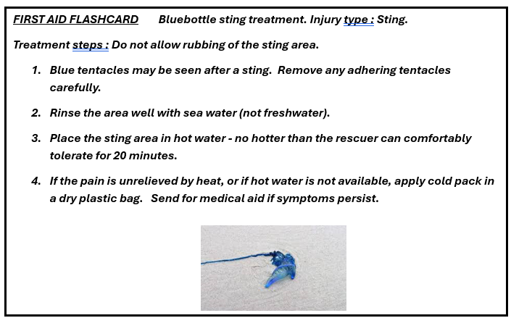
Practical activity: use the flashcards created to correctly treat a range of scenarios randomly selected by the classroom teacher. A selection of scenarios is provided below.
- A student is swimming at the beach and is stung by a blue-coloured jellyfish. They come out of the water in pain, with visible welts on their arm and experiencing itching and burning sensations.
- On your way to the beach for a surf you are walking down the sand dunes when you feel a sharp pain on your ankle. Your friend behind you says they saw a brown-coloured snake disappear into the bush near your foot. You begin to feel sick and want to vomit.
- While spearfishing with a friend, you accidentally shoot them above the right knee. The spear penetrates deeply into the thigh and protrudes out the opposite side.
- You and your friends have been at the beach all day. The average temperature was 40°C. As you pack up to leave for the day, one of your friends complains of dizziness, they can’t remember where they have put their towel and they feel like they are going to throw up.
- You are fishing on a rock shelf and in an attempt to avoid a freak wave, you step back onto sharp oysters, causing a deep laceration in the bottom of your foot. You start to feel faint.

Note: explain the need for each item on the first aid list.
Justify the need for the following first aid items whilst swimming or snorkelling:
Table 6 – first aid items
First aid item | Justification
Waterproof adhesive bandages | Sample answer:  These are essential for covering small cuts, blisters or abrasions and are designed to stay securely in place even when wet, preventing water and contaminants from entering the wound.
Antiseptic wipes/solution | Sample answer:  Used to clean wounds and prevent infections by killing bacteria and other pathogens commonly found in water environments.
Thermos of hot water | Sample answer:  Provides a warm water source to clean wounds gently, soothe stings or burns, and assist in treating hypothermia by helping to warm an injured or cold person.
Vinegar | Sample answer:  Specifically useful for treating jellyfish stings and other marine envenomation, as vinegar neutralises the toxins and prevents further nematocyst discharge.
Oxygen mask and tank (Oxy-Viva) | Sample answer:  Vital for providing oxygen in cases of drowning, near drowning or respiratory distress, which can occur in aquatic emergencies.
Foil blanket | Sample answer:  Helps retain body heat to prevent or treat hypothermia, a common risk after immersion in cold water.
Tweezers | Sample answer:  Useful for removing foreign objects such as fish spines, splinters, or debris from cuts or stings to reduce irritation and infection risk.
Asthma reliever and spacer | Sample answer:  Important for managing asthma attacks that may be triggered by cold water, stress, or allergens in the environment, ensuring quick and effective delivery of medication.

Sun safety
Note: to aid in preparation for this learning sequence the Cancer Council have arrange of secondary teaching resources available.
Read the following case studies prior to answering the questions below.
Case study 1: Jackson loves to skate, spending all his spare time at the local skate park. He leaves early in the morning and comes home only at dinner time. In summer he wears a cap under his helmet. He doesn’t think he can get sunburnt when he is skating as that only happens to people at the beach!

Case study 2: Sarah wears a hat all the time when she plays soccer. As the match starts early in the morning, she doesn’t think it is necessary to put sunscreen on her face, arms or legs.

Case study 3: Oscar never feels better than when he is outside. He loves to surf, ride his mountain bike and play tennis. In summer he spends many hours outside. He often gets a light tan and thinks that his ‘natural colour’ shows that he is fit and healthy.
(Cancer Council 2020)
- Are Jackson, Sarah and Oscar at risk of skin cancer? Explain why you believe this is or isn’t the case.
Sample answer:
Yes, all 3 are at risk of skin cancer.
Jackson spends long hours outdoors skating but assumes he can’t get sunburnt because he’s not at the beach, which is incorrect. UV radiation can cause skin damage anywhere outdoors.
Sarah wears a hat but doesn’t apply sunscreen during early morning matches, underestimating UV exposure even during less intense sunlight.
Oscar spends many hours outdoors in summer, often getting a tan, which indicates skin damage from UV exposure; tanning increases skin cancer risk.
- Outline the activities that might put these 3 young people at risk.
Sample answer:
Jackson: skating outdoors for extended hours, especially during peak UV times.
Sarah: playing soccer outdoors without sunscreen during morning hours.
Oscar: surfing, mountain biking, and tennis played for hours under strong sun exposure with insufficient protection.
- Outline the practices that these 3 young people are doing which may help reduce their risk of skin cancer.
Sample answer:
Jackson: wearing a helmet and a cap under it may provide some protection to his head and face.
Sarah: wearing a hat during soccer matches helps protect her face and neck from direct sun exposure.
Oscar: no specific protective practices mentioned, but his active lifestyle may encourage some awareness of health.
- Outline the information that these 3 young people need to know about the importance of sun protection.
Sample answer:
UV radiation can cause skin damage and skin cancer even when not at the beach.
Sunscreen should be applied regularly, even during early morning and late afternoon when UV rays can still be harmful.
Wearing protective clothing, hats, and sunglasses can significantly reduce UV exposure.
Tanning is a sign of skin damage, not health or fitness.
Reapplying sunscreen every 2 hours and after sweating or swimming is vital.
- Choose one of the young people in the case study. Provide 5 suggestions that could reduce their risk of skin cancer.
Sample answer:
Chosen: Jackson
- Apply broad-spectrum sunscreen with at least SPF 30 before skating and reapply every 2 hours.
- Wear a wide-brimmed hat or sun-protective helmet cover instead of just a cap.
- Wear UV-protective sunglasses to protect his eyes.
- Seek shade during peak UV hours (10 am to 4 pm) or take regular breaks indoors.
- Wear sun-protective clothing or long sleeves if possible while skating.
- Reorganise or add daily routines to each of these young peoples’ day so that they are following the SunSmart messages.
Sample answer:
Jackson:
- Apply sunscreen before leaving home.
- Wear a wide-brimmed hat or helmet cover.
- Take breaks in shaded areas during skating.
- Wear UV-protective sunglasses.
- Reapply sunscreen every 2 hours.
Sarah:
- Apply sunscreen before the soccer match, even if early morning.
- Continue wearing her hat and add UV-protective sunglasses.
- Wear a long-sleeve shirt or arm sleeves if possible.
- Drink plenty of water and take breaks in the shade.
- Reapply sunscreen after sweating.
Oscar:
- Apply sunscreen before all outdoor activities and reapply frequently.
- Wear a rash vest or UV-protective clothing while surfing.
- Use a wide-brimmed hat and sunglasses when not in the water.
- Limit outdoor activity during peak UV times or seek shade.
- Monitor skin for changes and avoid intentional tanning.

Practical activity: students create an infographic on Canva or similar software that could be used on social media to inform their peers about effective sun protection and increase their understanding of the risks associated with sun exposure and UV (ultraviolet) radiation. They should include reference to any technologies, materials, clothing, wearable accessories or behaviours that minimise exposure to the sun. An example has been provided below.
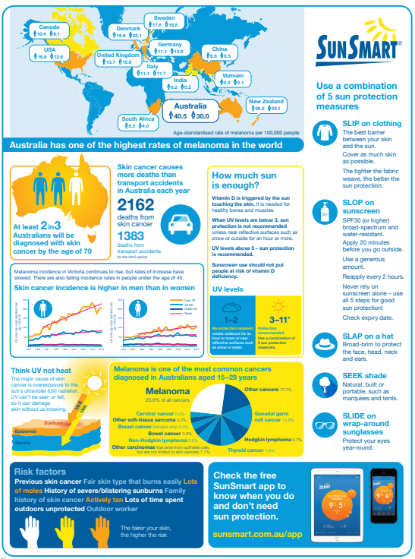
(Cancer Council Victoria 2016)
Teacher chunks and sequences demonstration of each process or series of processes to develop the one-pager.

Water activities
Note: activities will depend on school setting, resources and teacher skills/qualifications. Suggested aquatic activities could include:
- snorkelling
- surfing
- boating
- kayaking
- sailing
- teacher selected (as per conditions above).
This workbook provides teaching and learning activities for snorkelling.
Show students each piece of snorkelling equipment and demonstrate key features and correct fitting.

Impact of aquatic activities on the environment
Note: students will develop an understanding of marine souvenirs by engaging in a scaffolded reading exercise, class discussion and debate.
Prior to completing the planning template for the debate conduct a class discussion on the impact of snorkelling on the marine environment, including damage to coral and seagrass meadows, not harvesting molluscs/corals and so on as souvenirs, avoiding touching aquatic life and coral-safe sunscreens.
- Visit one of the following websites. As you read, use the scaffold provided to develop an understanding of the impact aquatic activities can have on the environment.
- The problem with marine souvenirs (The Reef World Foundation)
- How Australian coral became big business (ABC News)
- Divers fined $12k for taking protected coral near Tannum (Courier Mail)
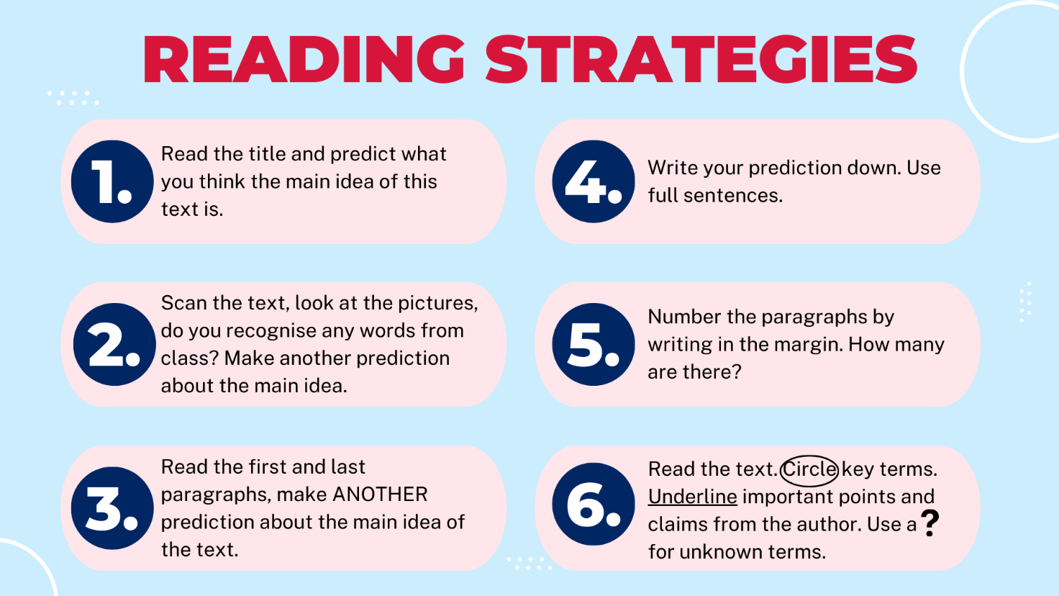
- Prepare for a debate on the question ‘Is taking a coral souvenir really that detrimental to the marine environment?’ by completing the planning template below.
Debate planner | Planning notes
Topic | Is taking a coral souvenir really that detrimental to the marine environment?
Side | For or against
Argument 1 | Explain your reasoning with supporting facts.  Sample answer:  A few individuals taking small pieces of coral as souvenirs may seem insignificant compared to other larger threats to coral reefs such as climate change, pollution, or commercial fishing. The removal of isolated coral fragments might not drastically affect the overall health or biodiversity of the reef ecosystem.
Argument 2 | Sample answer:  Coral reefs naturally experience fragmentation from storms, waves, and other natural processes. Some argue that small coral pieces taken as souvenirs are akin to this natural breakage, and reefs have the ability to regenerate and recover from minor physical disturbances over time.
Closing statements | Sample answer:  In closing, it’s important to consider that the removal of small coral pieces by individuals may have a minimal impact when compared to larger environmental pressures such as climate change and pollution. Additionally, coral reefs naturally undergo fragmentation through storms and other natural events, and they can often recover from minor disturbances. Therefore, taking a coral souvenir may be viewed similarly to these natural processes, suggesting that the impact of such actions might not always be as detrimental as often perceived.

Snorkelling
Use a variety of sources to research and complete the table of equipment below.
Visit OpenWaterHQ and read about how to clean and maintain your gear.
- Describe how to clean a snorkel.
Sample answer:
- Rinse the snorkel thoroughly with fresh water immediately after use to remove salt, sand and debris.
- Use warm, soapy water and a soft brush or cloth to clean inside and outside the snorkel tube.
- Pay special attention to the mouthpiece, cleaning it gently to remove any residue.
- Rinse thoroughly with fresh water to remove soap.
- Allow the snorkel to air dry completely before storing to prevent mould or mildew.
- Describe how to clean a face mask.
Sample answer:
- Rinse the mask with fresh water immediately after use to remove salt, sand and sunscreen.
- Use a soft cloth or sponge with mild soap to clean the silicone skirt and lens gently. Avoid abrasive materials that can scratch the lens.
- Rinse thoroughly with fresh water to remove soap residue.
- Let the mask air dry in a shaded area to avoid damage from direct sunlight.
- Describe how to clean your fins.
Sample answer:
- Rinse fins with fresh water after each use to remove salt, sand and dirt.
- If necessary, wash with mild soap and water, then rinse thoroughly.
- Check the straps and buckles for any debris and clean them carefully.
- Dry fins completely away from direct sunlight or heat sources to prevent warping or damage.
- Outline how to store your equipment.
Sample answer:
- Store all snorkelling and diving equipment in a cool, dry place away from direct sunlight.
- Avoid folding or bending fins and wetsuits excessively to prevent damage.
- Keep masks in a protective case or soft pouch to prevent scratches.
- Ensure all gear is completely dry before storage to prevent mould and unpleasant odours.
- Hang wetsuits on wide, padded hangers to maintain their shape.
Visit PADI to read about how to clean and maintain your wetsuit.
- Outline how to clean your wetsuit.
Sample answer:
- Rinse the wetsuit thoroughly with fresh water immediately after use to remove salt, sand and chlorine.
- Use a wetsuit shampoo or mild detergent diluted in water to gently wash the suit inside and out.
- Avoid harsh chemicals or bleach which can damage neoprene.
- Rinse thoroughly with fresh water to remove all soap.
- Hang the wetsuit inside out in a shaded, well-ventilated area to dry completely before turning it right side out to finish drying. Avoid direct sunlight and heat.

Communication and safety

Buddy system
Note: apply Connecting learning strategies.
Class completes a Think Pair Share:
- What are the benefits of having a buddy system?
- What makes a good buddy?
Provide students with individual thinking time, then complete a small group discussion and finally a class discussion.
Students may use the table provided to document their thoughts and discussions. Use images as inspiration for students.
Sample answers:
The buddy system means snorkelling in pairs or small groups rather than alone. A buddy can assist if the snorkeller experiences fatigue, cramps, or any unexpected issues. Having a buddy ensures that someone is always there to help or get assistance if needed.
A buddy helps less experienced snorkellers feel more comfortable in the water; your buddy can help identify any equipment issues; they can offer support in case of injury or challenging conditions
A good buddy is prepared, aware of the conditions, organised and is a good communicator.
Watch Top 10 Snorkelling Safety Tips (4:11).
Discuss the dangers associated with snorkelling and the importance of safety rules.
Sample answer:
Snorkelling is a popular and enjoyable water activity, but it carries certain dangers that require careful attention. One of the primary risks is drowning, which can happen if a snorkeller inhales water due to panic, fatigue or improper equipment use. Additionally, encounters with marine life such as jellyfish or sea urchins can result in stings or injuries. Environmental factors like strong currents, poor visibility and sudden weather changes can also pose serious threats. Equipment issues, such as ill-fitting masks or snorkels, can cause discomfort or breathing difficulties, increasing the risk of accidents.
To stay safe while snorkelling, it is essential to follow established safety rules. Using properly fitting and maintained gear helps prevent water inhalation and discomfort. Snorkelling with a buddy ensures help is available if needed and staying close to shore or a boat reduces the chance of becoming stranded. Understanding local water conditions and marine life hazards allows snorkellers to avoid dangerous situations. Finally, protecting against sun exposure and staying hydrated are important to prevent sunburn and exhaustion. By adhering to these safety measures, snorkellers can enjoy their experience while minimising the risks involved.

Diver below flag and dive signals
Read Dive flags 101.
- Describe the need for dive flags.
Sample answer:
The need for a ‘diver below’ flag: there are 2 types of diver-down flags used both nationally and internationally: the diver down flag and the alpha flag. The alpha flag, which is internationally recognized, is a blue and white coloured pennant tail flag. In North America, the diver down flag, which is a red flag with a white diagonal stripe, is used.
- Draw and colour the alpha flag and the diver down flag in the table below.
Table 7 – diver flag representations
Alpha flag | Diver down flag (North America)
Visit the DPI website and scroll down to the flag section.
- What rules apply with the use of dive flags when snorkelling from a boat or vessel?
Sample answer:
When snorkelling from a boat or vessel, the dive flag (commonly the diver down flag) must be displayed prominently to alert other boaters that there are snorkellers or divers in the water. The flag should be at least 600 mm × 600 mm in size and flown from the vessel or a buoy attached to the vessel. The vessel must stay within a safe distance from the flagged area and maintain a slow speed to avoid endangering those in the water. Other vessels are required to keep a distance of at least 50 metresmetres from the dive flag to prevent accidents.
- What rules apply with dive flags when snorkellers are carrying it on their person?
Sample answer:
When snorkellers carry a dive flag on their person, such as a float or buoy with the flag attached, it serves to signal their presence to nearby boats. The flag should be clearly visible above the water surface. Boats and other vessels are required to keep a safe distance (generally at least 50 metres) from the flagged snorkeller to avoid collisions or injury. Snorkellers should stay close to their flag and within safe proximity to boats or shore.
- What are the maritime safety rules when approaching snorkellers in the water from a boat?
Sample answer:
Boats must approach snorkellers cautiously and at a slow speed, maintaining a safe distance of at least 50metres from dive flags or snorkellers with flags. Operators should stay alert for any signs of snorkellers in the water and avoid creating large wakes that could endanger people. It is essential to keep clear of the flagged area and follow any local maritime regulations or guidelines designed to protect snorkellers. Communication with snorkellers and other vessels may also be necessary in busy areas.
Note: instead of showing the video, the teacher could demonstrate each of the hand signals used for communicating underwater or on the water when snorkelling and SCUBA diving.
Refer to and ensure adherence to the department’s Specific sport and physical activity guidelines for snorkelling.
Watch Learn your snorkelling hand signals (1:48).
Identify each of the following hand signals by labelling their meaning. Demonstrate each one with a partner.
Table 8 – dive signals
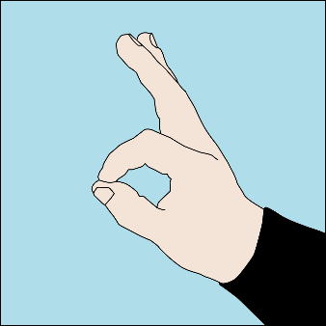 | 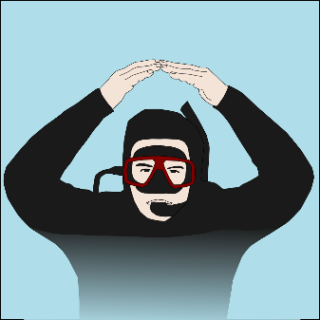 | 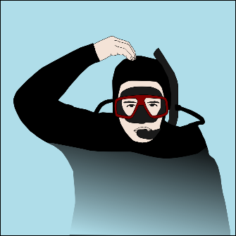 | 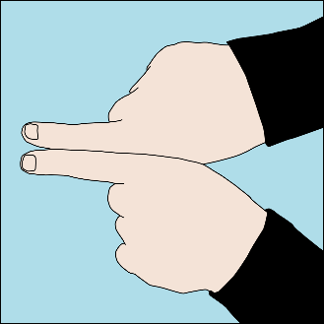
Sample answer:  Okay | Sample answer:  Okay | Sample answer:  Okay | Sample answer:  Buddy up
 | 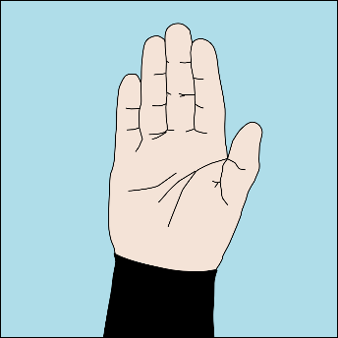 | 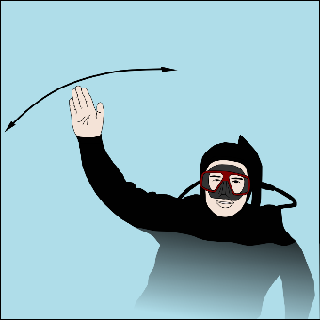 | 
Sample answer:  Go down or descend | Sample answer:  Stop | Sample answer:  Emergency on surface | Sample answer:  Go up or ascend

Risk assessment
Note: access the department’s safety requirements for snorkelling excursions accessed via the School Sport Unit in the staff portal. Show students why they are important.
Watch Top 10 Snorkelling Safety Tips (4:11) again. Brainstorm possible dangers at potential dive sites for a school excursion and suggest ways to reduce risk.
As a class, develop a risk assessment using the current approved WHS risk management.
Drowning is a leading cause of death, particularly for young children, and can occur in various bodies of water, including pools, rivers and even shallow containers.
A risk assessment for water activities is crucial for identifying potential hazards and implementing preventative measures to ensure safety. This proactive approach minimises the likelihood of accidents, injuries and even fatalities by addressing potential risks before they occur.
A risk assessment for a snorkelling excursion could include the following:
- a description of the location where the activity is to be conducted (this can be a real or hypothetical location)
- an identification of all hazards
- a description of the risk to the health and safety of individuals; what is the likelihood of the hazard occurring and what are the possible consequences associated with each identified hazard? Use the risk assessment matrix to rank the likelihood and consequence and determine the overall risk level (low, medium, high or extreme)
- what precautions will be taken to reduce or eliminate each of the risks. Include reference to specific equipment or safety procedures associated with the aquatic activity.
- the person responsible for putting each of the precautions in place.
Note that open water diving must not be undertaken:
- in conditions where visibility is less than 3 metres
- where the current is greater than 0.5 knots
- where unbroken waves are greater than 0.5 metres in height.
An open water site must be marked with a diver’s flag displayed in a recognised fashion, which is the international letter ‘A’.
Such sites should also have:
- safe entry and exit points with minimal water movement
- no obvious dangers, such as boat traffic or people fishing
- stable weather conditions with no obvious threat of a sudden change in the weather that could affect the safety of the activity.
Watch Top 10 Snorkelling Safety Tips (4:11) again.
Brainstorm possible dangers at potential dive sites for a school excursion and suggest ways to reduce risk.
Compile and document precautions/mitigation strategies for the following risks when snorkelling:
Table 9 – risk mitigation strategies
Risk | Likelihood/ probability  (1: not likely – 5: extremely likely) | Precaution/prevention
Poor weather and sea conditions | Sample answer:  4 | Sample answer:  Weather changes can occur quickly and significantly affect safety and visibility.
Snorkelling experience of participants | Sample answer:  3 | Sample answer:  Mixed experience levels are common, which can increase the risk of incidents.
Boat traffic | Sample answer:  3 | Sample answer:  Popular snorkelling areas may have moderate boat activity, creating collision risks.
Water temperature (cold exposure) | Sample answer:  2 | Sample answer:  Cold water is less common in some areas but can cause hypothermia if not prepared.
Dangerous marine animals for example, jellyfish, sharks | Sample answer:  2 | Sample answer:  Encounters are rare but possible, especially in certain regions or seasons.
Entanglement for example, fishing line | Sample answer:  2 | Sample answer:  Fishing lines and other debris may be present, but careful observation reduces risk.
Watch Shallow water blackout - the devastating cause of drowning in swimmers | 60 Minutes Australia (12:55).
Respond to the questions below.
- Define ‘shallow water blackout’.
Sample answer:
Shallow water blackout is a loss of consciousness caused by a lack of oxygen to the brain, occurring in swimmers or snorkellers during or immediately after breath-holding underwater.
- Describe how shallow water blackout occurs.
Sample answer:
It occurs when a person hyperventilates before diving or holding their breath, reducing carbon dioxide levels in the blood. Since the urge to breathe is triggered by rising carbon dioxide, the diver may not feel the need to breathe before oxygen levels become dangerously low, leading to sudden blackout underwater without warning.
- How is shallow water blackout treated?
Sample answer:
Immediate treatment involves removing the person from the water safely and providing rescue breathing or CPR if they are not breathing. Emergency medical assistance should be called immediately. Prevention is key, including avoiding hyperventilation and always snorkelling or diving with a buddy.
- Explain the importance of continual, steady breathing when conducting swimming and snorkelling activities.
Sample answer:
Continual, steady breathing helps maintain proper oxygen and carbon dioxide levels in the body, reducing the risk of hypoxia and shallow water blackout. It ensures the body remains relaxed and alert, improves endurance, and helps avoid panic. Proper breathing techniques are essential for safe and effective swimming and snorkelling.
- Consider the risks involved with snorkelling at the proposed excursion site. Develop a risk assessment using the current department approved template. The image below is current as of 15 August 2025.
Figure 1 – risk matrix and evaluation template
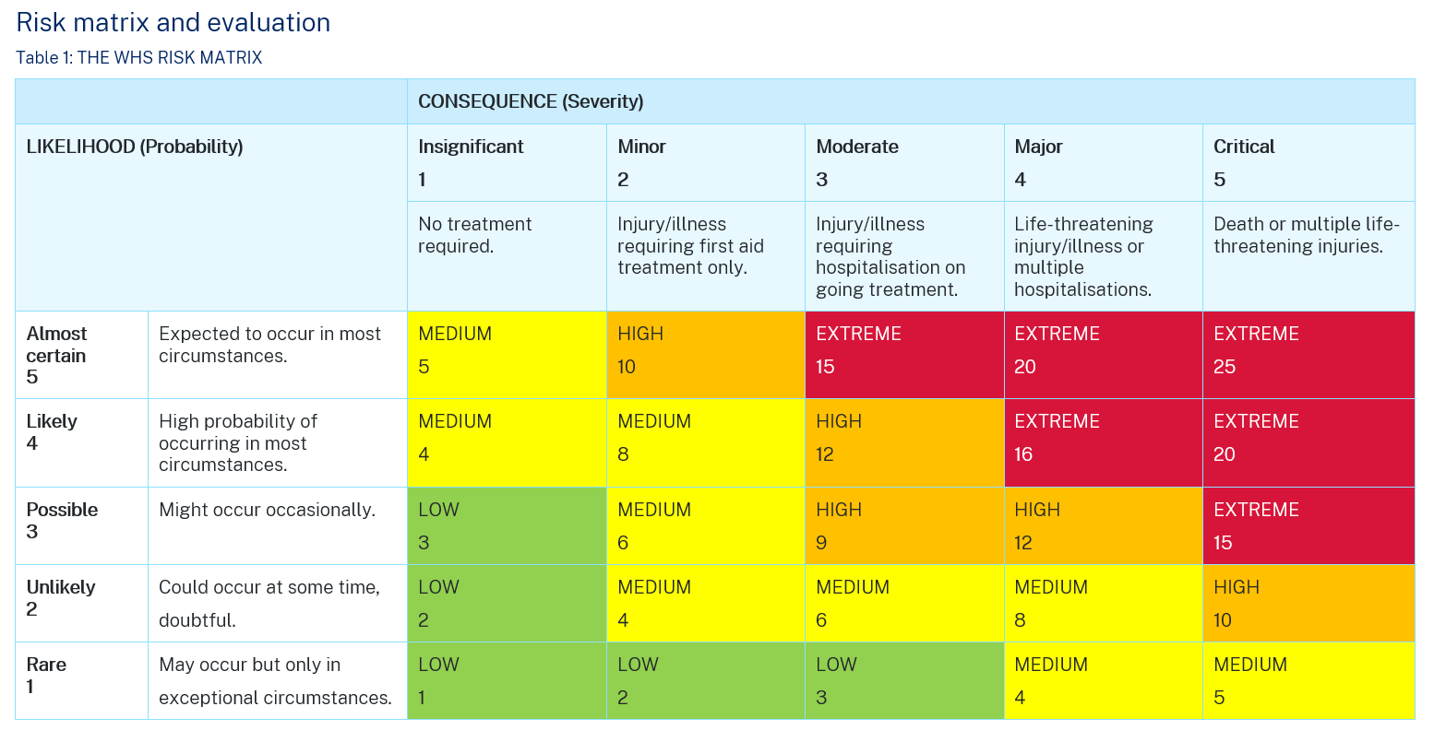

Snorkelling skills
Practical activity: demonstrate each of the following skills in a pool setting before progressing to enclosed/open water settings. Videos have been included to assist.
Students demonstrate the following snorkelling skills:
- scull 50 metres – basic demonstration: Back Scull - Improve your swimming with Personal Swimming (0:47) or detailed instruction: How To Scull: This Skill Will Change The Way You Swim! (3:09–5:04)
- duck dive to 2 metres depth – Duckdive – Advanced Snorkeling – PADI Open Water Diver Course demo (1:18)
- equalise pressure in ears – How To | Equalize (0:30)
- defog a mask – How to stop your dive mask fogging forever (2:07)
- fit a mask and fins correctly – How To Properly Check Your Dive Mask Fits (11:52)
- fin 400 metres
- clear mask underwater – How To | Mask Clear (0:50)
- recover a coin/weight in 2 metres of water
- swim 50 metres with snorkel but no mask
- treat a leg cramp in a buddy – How To Relieve Cramps While Scuba Diving - SDI Open Water Skills (1:06)
- use a tired snorkeller tow for 50 metres – Tired Diver Tow (Side Tow) (0:34)
- support an unconscious buddy for 5 minutes in deep water – Unconscious Diver on the Surface (0:58)
- snorkel in enclosed waters.

Emerging technologies
Note: students participate in a Jigsaw activity. Break the class into small groups and provide each group with an emerging snorkelling technology to investigate and report on to the class.
Jigsaw activity: in your allocated group, respond to one of the technologies in the table, prior to presenting to the class. As you listen to other groups present, make notes in the relevant section in the table.
Table 10 – snorkelling technologies
Technology | Description | Impact on snorkelling
GoPro  Video: How to Capture Underwater Dive + Snorkel Shots With Your GoPro (2:57) | Sample answer:  A compact, waterproof action camera designed for capturing high-quality video and photos underwater. | Sample answer:  Allows snorkellers to record and share underwater experiences, enhancing enjoyment and education.
Full face snorkel  Video: How It Works – Full Face Snorkel Mask(0:48) | Sample answer:  A snorkel mask that covers the entire face, allowing natural breathing through nose and mouth. | Sample answer:  Improves comfort and breathing ease, especially for beginners, increasing snorkelling accessibility.
Wetsuit technologies  Video: Shark Stop Wetsuits (0:37) | Sample answer:  Wetsuits designed with patterns and materials intended to deter shark interactions. | Sample answer:  Provides added safety and confidence for snorkellers in shark-prone areas, potentially reducing shark encounters.
Diver propulsion vehicles  Video: Introducing LEFEET P1: The Most Versatile Underwater Scooter (2:11) | Sample answer:  Battery-powered devices that pull divers or snorkellers underwater, increasing speed and range. | Sample answer:  Extends snorkelling range and reduces physical effort, allowing exploration of larger areas.
Reef Safe Sunscreen Guide | Sample answer:  Sunscreen formulated without harmful chemicals that damage coral reefs and marine life. | Sample answer:  Protects snorkellers’ skin while minimising environmental impact, supporting reef conservation.

Licensing

NSW Boating Licence
Suggested resource: NSW Boating Handbook.
Refer to the NSW Boating Handbook.
- Describe regulations specific to boaters/personal watercraft users in relation to snorkelling for example, minimum distances, dive flags.
Sample answer:
One key regulation is maintaining a minimum distance from snorkellers or dive flags, typically at least 50 metres. This distance helps prevent collisions and reduces the risk of injury from boat wakes. When snorkellers are in the water, vessels must display the appropriate dive flag (usually a red flag with a white diagonal stripe) to signal their presence. Boaters are required to slow down and keep clear of the flagged area, exercising heightened caution to avoid endangering snorkellers. Additionally, operators should always stay vigilant for snorkellers who may be submerged or difficult to see and avoid sudden or erratic movements near snorkelling zones. These regulations are designed to protect both snorkellers and boat operators, promoting safe coexistence on the water.
- Describe the requirements for obtaining a NSW boat licence.
Sample answer:
- Age requirement: applicants must be at least 12 years old to obtain a boat licence. Those under 16 may have specific restrictions.
- Knowledge and training: applicants need to complete a boating safety course or study the NSW Recreational Boat Driver Handbook to understand boating rules, safety, navigation and environmental responsibilities.
- Boat licence test: applicants must pass a boat licence test, which assesses knowledge of safe boating practices, navigation rules and maritime laws.
- Application process: once the test is passed, applicants can apply for the boat licence through Service NSW centres or online, providing necessary identification and paying the applicable fees.
- Licence classes: different licence classes may apply depending on the type and size of the vessel, such as personal watercraft (PWC) or commercial vessels.
- Validity and renewal: the boat licence is typically valid for 10 years and must be renewed before expiry to remain valid.
- Complete the online practice quiz.

Regulatory bodies
Watch Coastwatch Oz season 1, episode 8: Jet Ski Anger.
Describe the key roles of NSW Water Police and Fisheries Department.
Body | Role description
NSW Water Police | Sample answer:  The NSW Water Police is a specialised unit of the New South Wales Police Force responsible for enforcing laws and maintaining safety on the state’s waterways. Their role includes patrolling rivers, lakes, harbours and coastal areas to ensure compliance with maritime laws, preventing boating accidents, conducting search and rescue operations, investigating water-related crimes, and promoting safe boating practices. They work closely with other agencies to protect lives and property on the water.
Fisheries (Department of Primary Industries) | Sample answer:  The Fisheries division of the NSW Department of Primary Industries is responsible for managing and conserving the state’s aquatic resources. Their role includes regulating fishing activities to ensure sustainable fish stocks, protecting marine habitats, enforcing fisheries laws, issuing fishing licences and providing education on responsible fishing practices. Fisheries DPI works to balance environmental conservation with commercial and recreational fishing interests to support healthy and productive aquatic ecosystems.
Note: Brainstorming allows students to generate a large number of ideas. Previous learning in this unit should referred to during the brainstorm session.
Drawing on prior knowledge, brainstorm the role of education and technology in regulating aquatic activities.
Table 11 – the role of education and technology in regulating aquatic activities
Education | Technology
Raises awareness about water safety rules and regulations among the public. | Sample answer:  Enables real-time monitoring of aquatic areas using drones and surveillance cameras.
Provides training and certification for safe boating, diving, and lifesaving. | Sample answer:  Use of GPS (Global Positioning System) and tracking devices to enforce boating speed limits and restricted zones.
Promotes understanding of environmental protection and sustainable practices. | Sample answer:  Development of apps (for example, shark alerts, weather updates) to inform users about hazards.
Encourages responsible behaviour through public campaigns (for example, SunSmart, SharkSmart). | Sample answer:  Deployment of SMART drumlines and shark deterrent devices to reduce shark incidents.
Educates about the importance of using dive flags and safe distances. | Sample answer:  Advanced communication tools for emergency response and coordination in aquatic incidents.
Supports community engagement and volunteer training for patrol and rescue services. | Sample answer:  Use of electronic fishing licences and permits to regulate fishing activities.

References
This resource contains NSW Curriculum and syllabus content. The NSW Curriculum is developed by the NSW Education Standards Authority (NESA). This content is prepared by NESA for and on behalf of the Crown in right of the State of New South Wales. The material is protected by Crown copyright.
Please refer to the NESA Copyright Disclaimer for more information https://www.nsw.gov.au/education-and-training/nesa/copyright.
NESA holds the only official and up-to-date versions of the NSW Curriculum and syllabus documents. Please visit NESA https://www.nsw.gov.au/education-and-training/nesa and NSW Curriculum https://curriculum.nsw.edu.au.
Aquatic Technology 7–10 Syllabus © NSW Education Standards Authority (NESA) for and on behalf of the Crown in right of the State of New South Wales, 2024.
60 Minutes Australia (31 October 2018) ‘Shallow water blackout - the devastating cause of drowning in swimmers | 60 Minutes Australia’ [video], 60 Minutes Australia, YouTube, accessed 24 September 2025.
ABC Dive (20 August 2023) ‘Duckdive – Advanced Snorkelling – PADI Open Water Diver Course demo’ [video], ABC Dive, YouTube, accessed 24 September 2025.
BondiRescue (29 April 2023) ‘Lifeguard's Most Desperate Resuscitation | Bondi Rescue - Season 6 Episode 4 (OFFICIAL UPLOAD)’ [video], BondiRescue, YouTube, accessed 24 September 2025.
Cancer Council (2020) Think-Pair-Share-Ink: Years 7 & 8 [PDF 265 KB], accessed 17 March 2026.
Cancer Council Victoria (2016) SunSmart [PDF 3.1 MB] [infographic], accessed 17 March 2026.
Canva (2025) Creating a one-pager: How-tos, templates, and tips, Canva, website, accessed 24 September 2025.
Daniel Mann (3 August 2023) ‘How to stop your dive mask fogging forever’ [video], Daniel Mann, YouTube, accessed 24 September 2025.
dive SSI (1 March 2022) ‘Tired Diver Tow (Side Tow)’ [video], dive SSI, YouTube, accessed 24 September 2025.
——(26 February 2022) ‘Unconscious Diver on the Surface’ [video], dive SSI, YouTube, accessed 24 September 2025.
Global Triathlon Network (12 December 2023) ‘How To Scull; This Skill Will Change The Way You Swim!’ [video], Global Triathlon Network, YouTube, accessed 24 September 2025.
Heathcote A (10 May 2025) ‘How Australian coral became big business’, ABC News, accessed 24 September 2025.
Hesford H (14 June 2025) ‘The problem with marine souvenirs’, The Reef-World Foundation, accessed 24 September 2025.
PADI (14 August 2019) ‘How To | Equalize’ [video], PADI, YouTube, accessed 24 September 2025.
——(4 July 2019) ‘How To | Mask Clear’ [video], PADI, YouTube, accessed 24 September 2025.
Personal Swimming (8 December 2018) ‘Back Scull - Improve your swimming with Personal Swimming’ [video], Personal Swimming, YouTube, accessed 24 September 2025.
R33irby (5 June 2016) ‘Divers fined $12k for taking protected coral near Tannum’, Courier Mail, accessed 24 September 2025.
Royal Life Saving Australia (2026) Royal Life Saving Australia National Summer Drowning Toll, Royal Life Saving Australia website, accessed 24 September 2025
Save the Reef (n.d.) Reef Safe Sunscreen Guide, Save the Reef website, accessed 19 March 2026.
SDI - Scuba Diving International (23 July 2023) ‘How To Relieve Cramps While Scuba Diving - SDI Open Water Skills’ [video], SDI - Scuba Diving International, YouTube, accessed 24 September 2025.
Scuba Diver Magazine (30 July 2023) ‘How To Properly Check Your Dive Mask Fits’ [video], Scuba Diver Magazine, YouTube, accessed 24 September 2025.
State of New South Wales (n.d.) Drones, SharkSmart website, accessed 24 September 2025.
——(n.d.) SharkSmart app, SharkSmart website, accessed 24 September 2025.
——(n.d.) SMART Drumlines, SharkSmart website, accessed 24 September 2025.
State of New South Wales (Department of Education) (2025) ‘Swimming and water safety’, Specific sport and physical activity guidelines, School Sport Unit website, accessed 24 September 2025.
——(n.d.) ‘Data 1 - resource package’, Teaching and learning resources, Universal Resource Hub, accessed 24 September 2025.
St John WA (4 May 2018) ‘DRSABCD action plan explained!’ [video], St John WA, YouTube, accessed 24 September 2025.
Surf Life Saving Australia (5 October 2016) ‘How to Spot a Rip Current’ [video], Surf Life Saving Australia, YouTube, accessed 24 September 2025.
——(19 December 2018) ‘How to survive a rip’ [video], Surf Life Saving Australia, YouTube, accessed 24 September 2025.
Transport for NSW (2023) Boating Handbook, NSW Government, accessed 17 March 2026.
UNSW (17 December 2010) ‘The Beach Survival Guide’ [video], UNSW, YouTube, accessed 24 September 2025.
.
© State of New South Wales (Department of Education), 2026
The copyright material published in this resource is subject to the Copyright Act 1968 (Cth) and is owned by the NSW Department of Education or, where indicated, by a party other than the NSW Department of Education (third-party material).
Copyright material available in this resource and owned by the NSW Department of Education is licensed under a Creative Commons Attribution 4.0 International (CC BY 4.0) license.

This license allows you to share and adapt the material for any purpose, even commercially.
Attribution should be given to © State of New South Wales (Department of Education), 2026.
Material in this resource not available under a Creative Commons license:
- the NSW Department of Education logo, other logos and trademark-protected material
- material owned by a third party that has been reproduced with permission. You will need to obtain permission from the third party to reuse its material.
Links to third-party material and websites
Please note that the provided (reading/viewing material/list/links/texts) are a suggestion only and implies no endorsement, by the New South Wales Department of Education, of any author, publisher, or book title. School principals and teachers are best placed to assess the suitability of resources that would complement the curriculum and reflect the needs and interests of their students.
If you use the links provided in this document to access a third-party's website, you acknowledge that the terms of use, including licence terms set out on the third-party's website apply to the use which may be made of the materials on that third-party website or where permitted by the Copyright Act 1968 (Cth). The department accepts no responsibility for content on third-party websites.

