Agriculture Technology
7–10 – teacher support resource
From fleece to feast (12-week unit)

Contents
Unit overview 4
1. Sheep production in Australia 5
2. Sheep population in Australia 7
3. Sheep production zones in Australia 10
4. What do we get from sheep? 13
5. Sheep breeds 15
Breed comparison matrix 16
Sheep breeds spotlight 18
6. Safety first in the sheep yards 20
Hazard hunt in the sheep yards 20
About the animal 23
7. Ruminant digestive systems 23
8. Dietary requirements of sheep 25
Feed plan 28
9. Sheep reproductive systems 30
10. Breeding choices in sheep production 35
11. Australian Sheep Breeding Values (ASBVs) 38
12. Sheep pests and diseases 40
Zoonotic disease 42
Q fever case study on a sheep farm 43
13. Sheep handling – estimating age 45
14. Sheep handling – fat and condition scoring 47
Working on a sheep farm 51
15. Husbandry practices 51
Calendar of operations 57
16. How livestock are bought and sold 59
Sale observation 59
How do farmers sell their sheep? 63
17. Traditional and contemporary agricultural practices 65
Land management – learning from the past 65
Sustainable choices 69
18. Biosecurity 72
19. Sheep identification and traceability 75
Sheep in schools 75
Ear tagging of livestock 78
20. Record keeping 80
Using RFID tags for data collection 80
21. Technology in Australia’s sheep industry 86
Spotlight – David Unaipon 86
22. Careers 91
Wool enterprises 93
23. Wool production in Australia 93
24. Characteristics of wool 96
25. Wool processing 98
Follow the fibre 98
Wool uses 99
Wool in a circular economy 101
26. Agricultural issues – shearer shortage 103
Sheep meat enterprises 105
27. Australia’s sheep meat industry 105
28. Sheep meat market specifications 108
Sheep abattoir feedback 111
29. What makes quality lamb? 113
30. Understanding sheep carcase cuts 115
31. Agricultural issues – live exports 118
Appendix 121
Ear tagging 121
Printable model for cardboard or vinyl – appendix 122
Why good data matters 123
Careers in the sheep industry 125
National Wool Board funding allocation sheet 135
References 136

Unit overview
The ‘From fleece to feast’ unit is an engaging and practical learning program designed for Stage 5 agriculture technology students. This unit provides an in-depth exploration of one of Australia’s most important livestock industries, combining theoretical knowledge with practical experiences in sheep management, wool and meat production and sustainable farming practices.
Throughout the unit, students will investigate the key components of the Australian sheep industry, including breeding systems, nutrition, health management, wool classing, carcase assessment and marketing. They will engage in practical skills relevant to school farms and commercial enterprises, such as condition scoring, animal handling, record keeping and participating in seasonal husbandry tasks.
Students will develop a clear understanding of how the sheep industry operates and will apply their knowledge through engaging simulations and real-world problem-solving activities. This unit supports the development of agricultural literacy, digital data collection and ethical animal care, while encouraging students to consider future careers in the agriculture sector.
Note: this resource has been designed to facilitate the ready conversion into a student booklet by removing the sample answers within the response windows and tables. Teacher notes (in blue) can also be deleted before distributing to students.
Challenge questions and activities are included throughout the resource as an opportunity to extend a student’s application of knowledge and understanding of key concepts.
The resource is intended for you to adapt to suit to your school and your resources. Alternative or differentiated ideas are included within the teaching support slide deck and teaching program.
Refer to Equipment Safety in Schools, Animals in Schools and Chemical Safety in Schools for current information on safety and safe working practices in Agriculture Technology 7–10 (2024).

1. Sheep production in Australia
Note: introduce key terms before starting each section to support student understanding by linking core agricultural vocabulary to the lesson content. Encourage students to look out for how these terms are used in the activities that follow.
Key terms
Livestock – farm animals raised to produce food, fibre or work, like sheep, cattle and goats.
Export – sending Australian farm products, like wool and meat, to other countries for sale.
Agricultural enterprise – a farm or business that produces food or fibre as its main activity.
Sheep are one of Australia’s most important livestock species. Our country is a world leader in wool and sheep meat production, exporting to over 100 countries. Sheep farms are found in nearly every state, from dry inland stations to cooler southern pastures. The industry provides jobs in breeding, grazing, shearing, meat processing, transport and exports.
Changes in climate, markets and global demand all affect how many sheep are kept and what products are produced from them. By understanding these trends, we can see how farmers adapt and why sheep are such a valuable part of Australian agriculture.
Figure 1 – flock of sheep in paddock
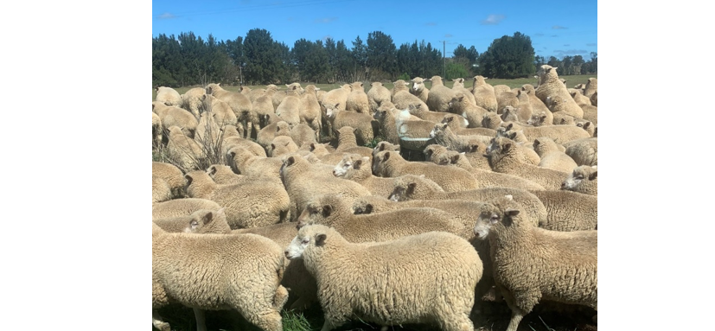
What do you already know?
Think-Pair-Share: answer the following in your workbook, then compare with a classmate.
List 3 products that come from sheep.
Where in Australia do you think most sheep are raised?
What do you think affects how many sheep farmers keep from year to year?

2. Sheep population in Australia
Key terms
Trend – a general pattern or direction something is moving in over time, such as rising or falling sheep numbers.
Drought – a long period without enough rainfall, which can reduce feed and sheep numbers.
Commodity – a raw agricultural product like wool or sheep meat that is bought and sold.
Australia’s sheep population has fluctuated (gone up and down) due to weather conditions, market demand and farming practices. Understanding these trends helps farmers and policymakers plan for the future.
Using the figures in the table below create a graph showing the change in the numbers of sheep in Australia from 2016 to 2022.
Table 1 – statistics from Agricultural commodities, Australia
Year | Sheep numbers (millions)
2016–17 | 72,125
2017–18 | 70,607
2018–19 | 65,755
2019–20 | 63,529
2020–21 | 68,047
2021–22 | 70,235
(Source: Commonwealth of Australia 2023)
Place the graph in the space below. Consider the following:
- the type of graph you need to create
- add a title and label the axes.
Data analysis
Use the graph you have created to answer the following questions:
What trends do you notice?
Identify years with large changes. What might explain these changes?
Sample answer:
There was a large drop in numbers between 2017–18 and 2018–19. This could have been due to the 2017–2020 drought that impacted farms.
The increase from 2019–20 to 2021–22 could be due to the increased rainfall during that period after the drought.
How do droughts, prices and exports influence sheep numbers?
Sample answer:
Drought reduces the availability of feed for sheep and forces producers to reduce stock numbers to feed appropriately.
When prices and export availability is increased, sheep numbers increase as producers breed more lambs to try receiving the higher prices on offer and fill consignments.

3. Sheep production zones in Australia
Key terms
Stocking density – how many animals are kept on a set area of land for example, the number of sheep per hectare of land.
Pasture – grass or plants grown to feed grazing animals like sheep.
Rainfall zone – areas grouped by how much rain they get each year, which affects farming decisions.
Sheep farming in Australia occurs in 2 broad regions: high rainfall zones and low rainfall zones. These zones influence the type of pastures available, stocking densities and breed suitability.
On the map of Australia, shade the:
- high rainfall areas (for example south-eastern Australia, Tasmania)
- low rainfall areas (for example western NSW, SA, WA)
- common sheep growing regions in Australia.
Create a colour coded legend or key for your map.
Figure 2 – blank map of Australia
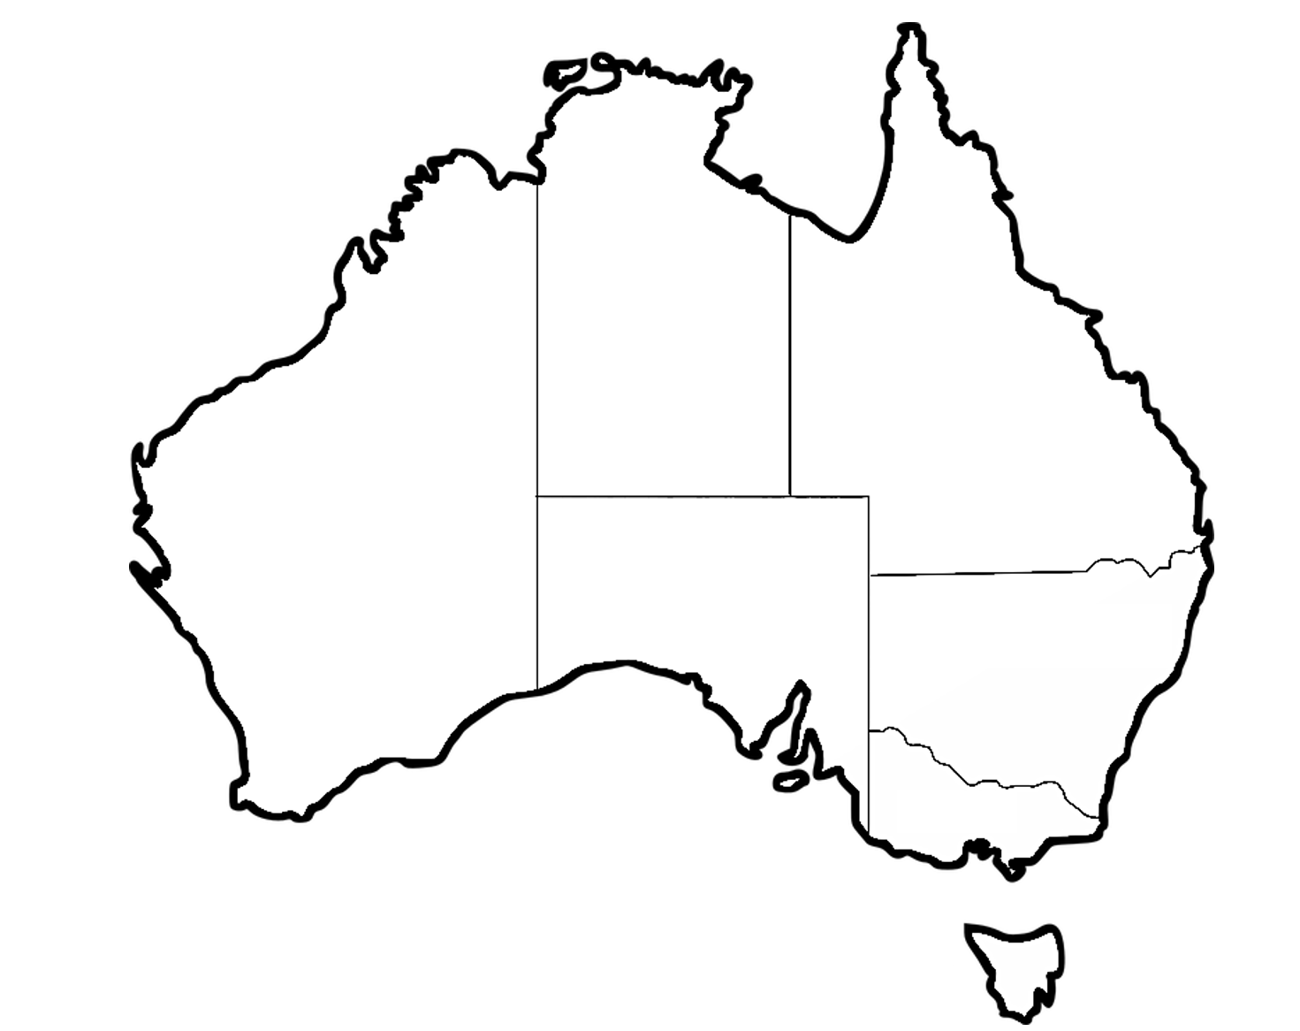
Explain why these areas are suitable for sheep farming. Refer to climate, soil types and pasture availability.
Sample answer:
High rainfall areas produce sheep on improved pastures and stock higher densities in production but tend to be smaller in size. The pasture they do grow is more abundant and nutritious. In lower rainfall areas, farms are larger with less sheep and are typically covered in native pastures and shrubs to sustain the sheep. These types of feeds are less nutritious.
Challenge question
If rainfall decreased in a wool-producing region, how might that affect the enterprise and decisions made by the farm manager?

4. What do we get from sheep?
Key terms
Raw product – an unprocessed item straight from the animal, like wool or meat.
By-product – a secondary product made during the processing of sheep, like lanolin or hides.
Value-added product – something made by changing a raw material to increase its use or value, like wool fabric.
In pairs, match items from the list, or objects displayed in the classroom, to 2 categories:
- Raw products
- Value-added products.
Products: fleece, insulation, offal, clothing, hides, pet food, meat.
Note: an example has been given for students in first row, answers are provided in the following rows.
Table 2 – products obtained from sheep production
Product | Raw or value-added? | Made from … | Common use
Example, lanolin cream | Value-added | Wool grease, by-product | skincare
Fleece | Raw | Wool | Clothing and textiles
Insulation | Value-added | Wool | Building materials
Offal | Raw | Organs, by-product | Human and animal food
Clothing | Value-added | Wool | Shirts, socks
Hides | Value-added | Skins, by-product | Clothing, footwear
Pet food | Value-added | Meat | Animal food
Meat | Raw | Meat | Human food
Which category appears most frequently in your daily life, wool-based, meat-based or by-product?
Compose a short paragraph describing how sheep contribute to everyday products in Australian households.

5. Sheep breeds
Key terms
Breed – a group of animals with similar characteristics, such as Merino or Dorper sheep.
Dual-purpose breed – a type of sheep that is used for both meat and wool.
Adaptation – features or characteristics that help an animal live in a specific place with different temperatures or food available.
Australia’s sheep industry relies on a wide variety of breeds, each suited to particular climates, environments, and end-products such as wool, meat or both (dual-purpose). Choosing the right breed is essential for a successful enterprise.
Figure 3 – examples of 2 common sheep breeds produced in Australia
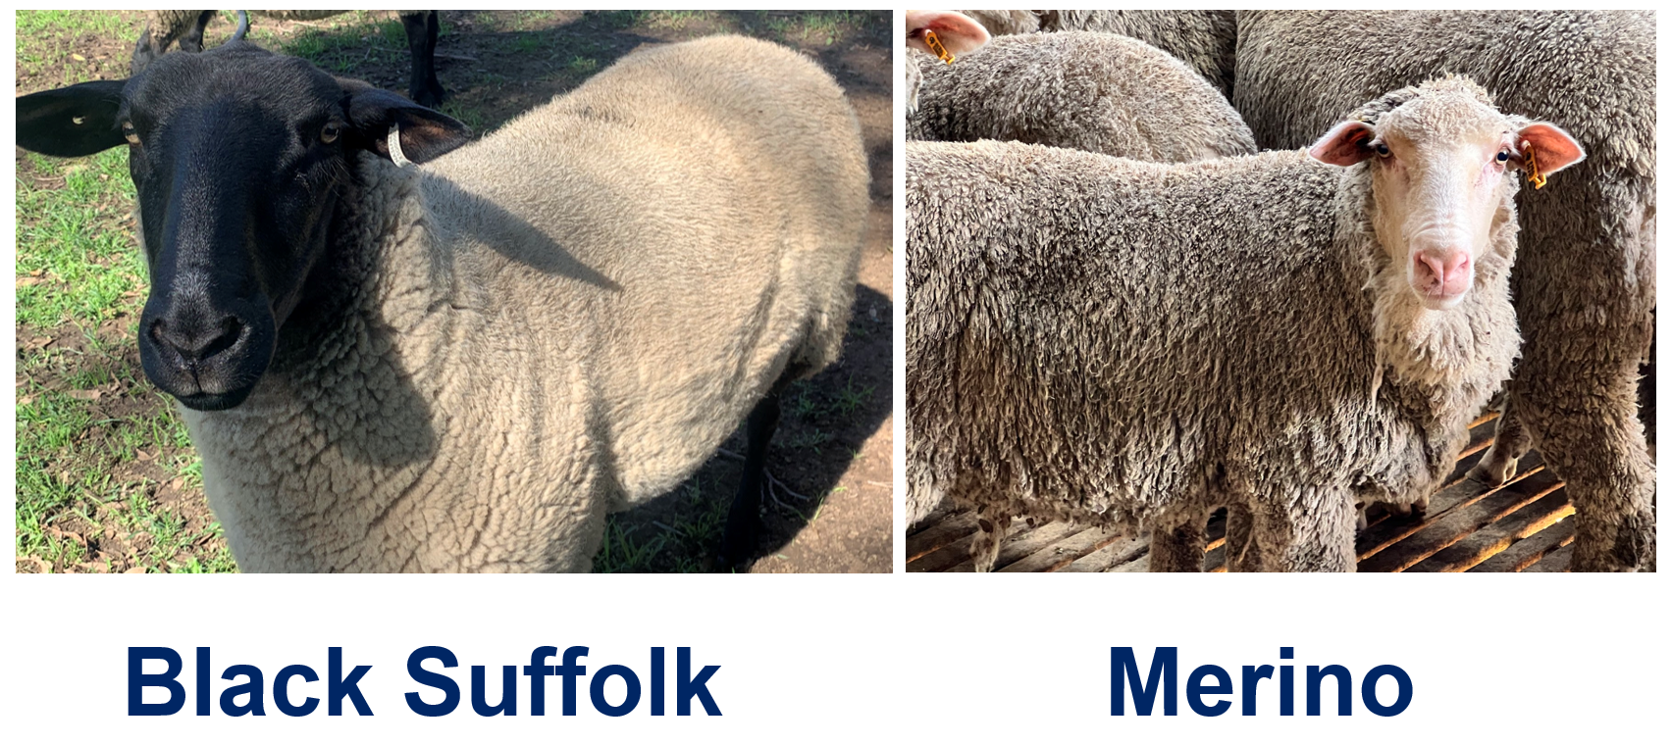

Breed comparison matrix
In pairs, complete the following table for 6 selected breeds.
Table 3 – characteristics of sheep breeds
Breed name | Main product | Preferred climate | Key physical features | Fibre diameter (if applicable) | Picture
Example: Merino | Wool | Temperate, arid inland | Wrinkled skin, large fleece | 18–24 microns | 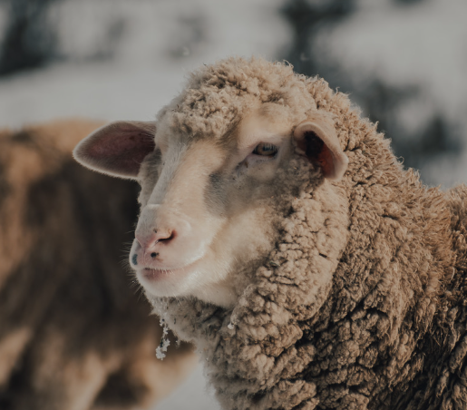
Challenge activity: rank your selected breeds from most to least versatile and justify your reasoning.

Sheep breeds spotlight
In this task, you will learn how to profile a sheep breed in detail and justify why it is suited to your local conditions.
Select one breed from the previous activity that may be suitable to grow in your local area. Research and complete the following detailed profile.
Note: a sample answer has been provided below.
Table 4 – breed profile
Profile | Information
Sheep breed | Dohne
Origin | Dohne was developed in South Africa with an initial one-off cross between the Peppin Merino and the German Mutton Merino.
Main product | Wool and meat (dual purpose)
Physical features | White fleece, plain bodied, open face, bare breech, lean and high yielding carcasses with even fat distribution.
Typical weight (adult) | Large-framed sheep, adult ewes weighing between 50–75 kg.
Horn status (horned/polled) | Polled
Preferred environment | Adapted to varied climates including harsh conditions.
Disease resistance or known issues | Plain body and open face reduces many potential health risks. Known for its natural resistance to internal and external parasites.
Why are they suitable in your local area? | Can withstand harsh conditions with low protein pastures.
Use the image below to draw distinguishing features of your sheep breed. Include ear placement, colouring and wrinkles.
Figure 4 – outline of sheep silhouette
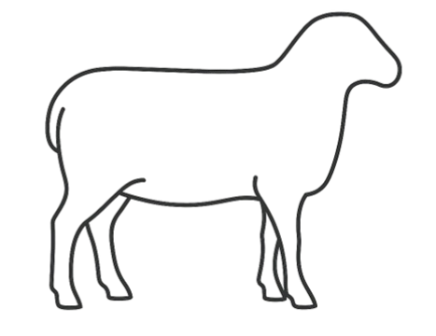

6. Safety first in the sheep yards
Key terms
Work Health and Safety (WHS) – rules and practices to keep people safe while working with animals and equipment.
Hazard – something that could cause harm or make a situation unsafe.
Risk – the chance that something could go wrong and cause harm.
The sheep yards are a hub of activity during marking time and drafting. It is also a workplace where many safety risks exist due to the presence of animals, tools and people. Being aware of these risks and knowing how to manage them helps protect workers and animals.

Hazard hunt in the sheep yards
Work in pairs to complete a safety audit by:
- observing the school’s sheep yards or watching a yard work video online
- identifying at least 5 hazards (for example, broken gate latch, slippery surfaces)
- completing the hazard table.
Figure 5 – sheep feeding
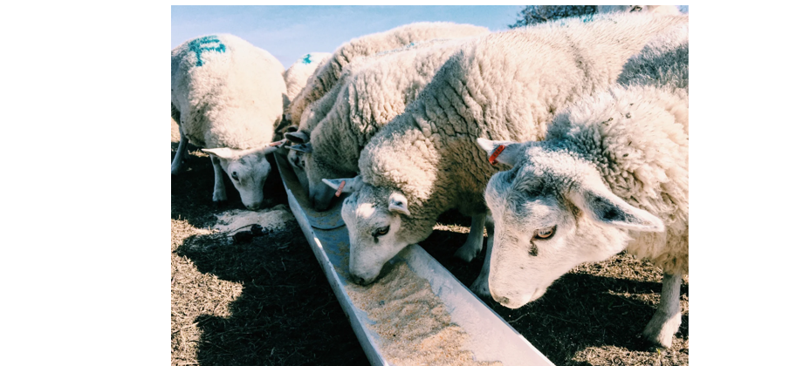

Table 5 – hazard identification and prevention activity
Hazard identified | Why it’s a risk | Who might be affected | How it can be controlled
Example: loose gate chain | Sheep can escape or get injured | Animals, students, workers | Replace chain with spring-loaded latch

Safety poster for the yards
Students design one of the following:
- ‘Safe handling zones’ sign for working dogs, students or spectators
- ‘Personal Protective Equipment (PPE) required’ sign for using the yards or drenching equipment
- ‘Emergency contact and first aid’ location signage
The poster must include:
- a clear, visible safety message
- a symbol or image
- colour use for impact and quick recognition.

Practical skills checkpoint
Table 6 – skills assessment checklist
Criteria | Checkbox
Students can identify and assess risks in practical workspaces. | ☐
Students can identify and use data from second-hand sources to support decision-making processes. | ☐

About the animal

7. Ruminant digestive systems
Key terms
Ruminant – an animal with a stomach that has 4 compartments, like sheep and cattle.
Digestion – the process of breaking down food so the body can absorb nutrients.
Microorganisms – tiny living things, like bacteria, that help sheep break down tough plant material in their stomachs.
Sheep are ruminants with a complex digestive system that allows them to break down tough plant material efficiently. Each part of the system plays a special role in extracting nutrients.
Draw a labelled diagram of a ruminant digestive system in the space provided. Include arrows to show the direction of food flow.
Ruminant digestive system
Sample answer:
See Ruminant digestive system [PDF 10 MB] by Meat & Livestock Australia for an age-appropriate, clear and coloured ruminant digestive system.
Match the digestive system organs to the functions within the table (note, they are not in order).
Organs to include: mouth and oesophagus, rumen, reticulum, omasum, abomasum, small intestine, large intestine.
Table 7– ruminant digestive system parts and functions
Organ | Function
 | First compartment of the main stomach, contains microorganisms that break down the plant material and digest the food.
 | Fourth compartment and referred to as the ‘true stomach’. It works like our stomach, using acid and juices to digest food and kill microbes from the first 2 compartments.
 | Second compartment of the main stomach. It works with the rumen and has bacteria and fungi to produce enzymes that help digest fibrous (tough) plant parts.
 | Some further breakdown may occur here. Takes in any extra water and gets the leftover waste ready to be pushed through to the rectum and out the anus as faeces.
 | Third compartment of the main stomach that absorbs a lot of the water out of the food mixture before it moves on.
 | This is where most digestion happens. Nutrients from the food are absorbed into the blood here through the villi.
The mouth is used to chew food and produce saliva.
The oesophagus transports food down into the rumen and back up from the rumen.

8. Dietary requirements of sheep
Key terms
Nutrient – a substance in food that animals need to grow, stay healthy and produce products.
Supplementary feeding – giving extra food like hay or grain when pasture isn't enough.
Feed ration – the amount and type of food given to animals each day.
Sheep need food to grow, stay healthy and produce wool or meat. Nutritional requirements change depending on the sheep’s:
- age (lamb or adult)
- production stage (pregnant, growing, lactating)
- condition (fat/thin, sick/healthy)
- season (pasture quality, weather).
Feeding the right diet at the right time supports animal health and productivity.
Table 8 – common feed types
Feed type | What it does | Best used for
Pasture | Maintenance – basic energy and fibre | Dry ewes, general grazing
Lucerne hay | Extra protein and calcium | Pregnant/lactating ewes
Grain | High in energy (carbs) | Finishing lambs, rams pre-joining
Pellets | Balanced protein and energy | Weaned lambs, lactating ewes
Salt lick/minerals | Boosts health and fertility | All sheep, especially in dry areas
Table 9 – nutrients needed by sheep
Nutrient | What it does | Sheep who need it most
Energy (carbohydrates) | Keeps sheep warm and active | Pregnant/lactating ewes, finishing lambs
Protein | Builds muscle and wool | Lambs, lactating ewes, young rams
Calcium | Supports bone growth and milk production | Pregnant/lactating ewes
Fibre | Keeps digestion healthy | All sheep – especially on grain diets
Vitamins/minerals | Keeps immune system strong | All sheep – especially during stress
Select ONE of the sheep from the identification cards and complete a mini feed plan to support its nutritional needs.
Sheep identification cards
Figure 6 – sheep identification cards
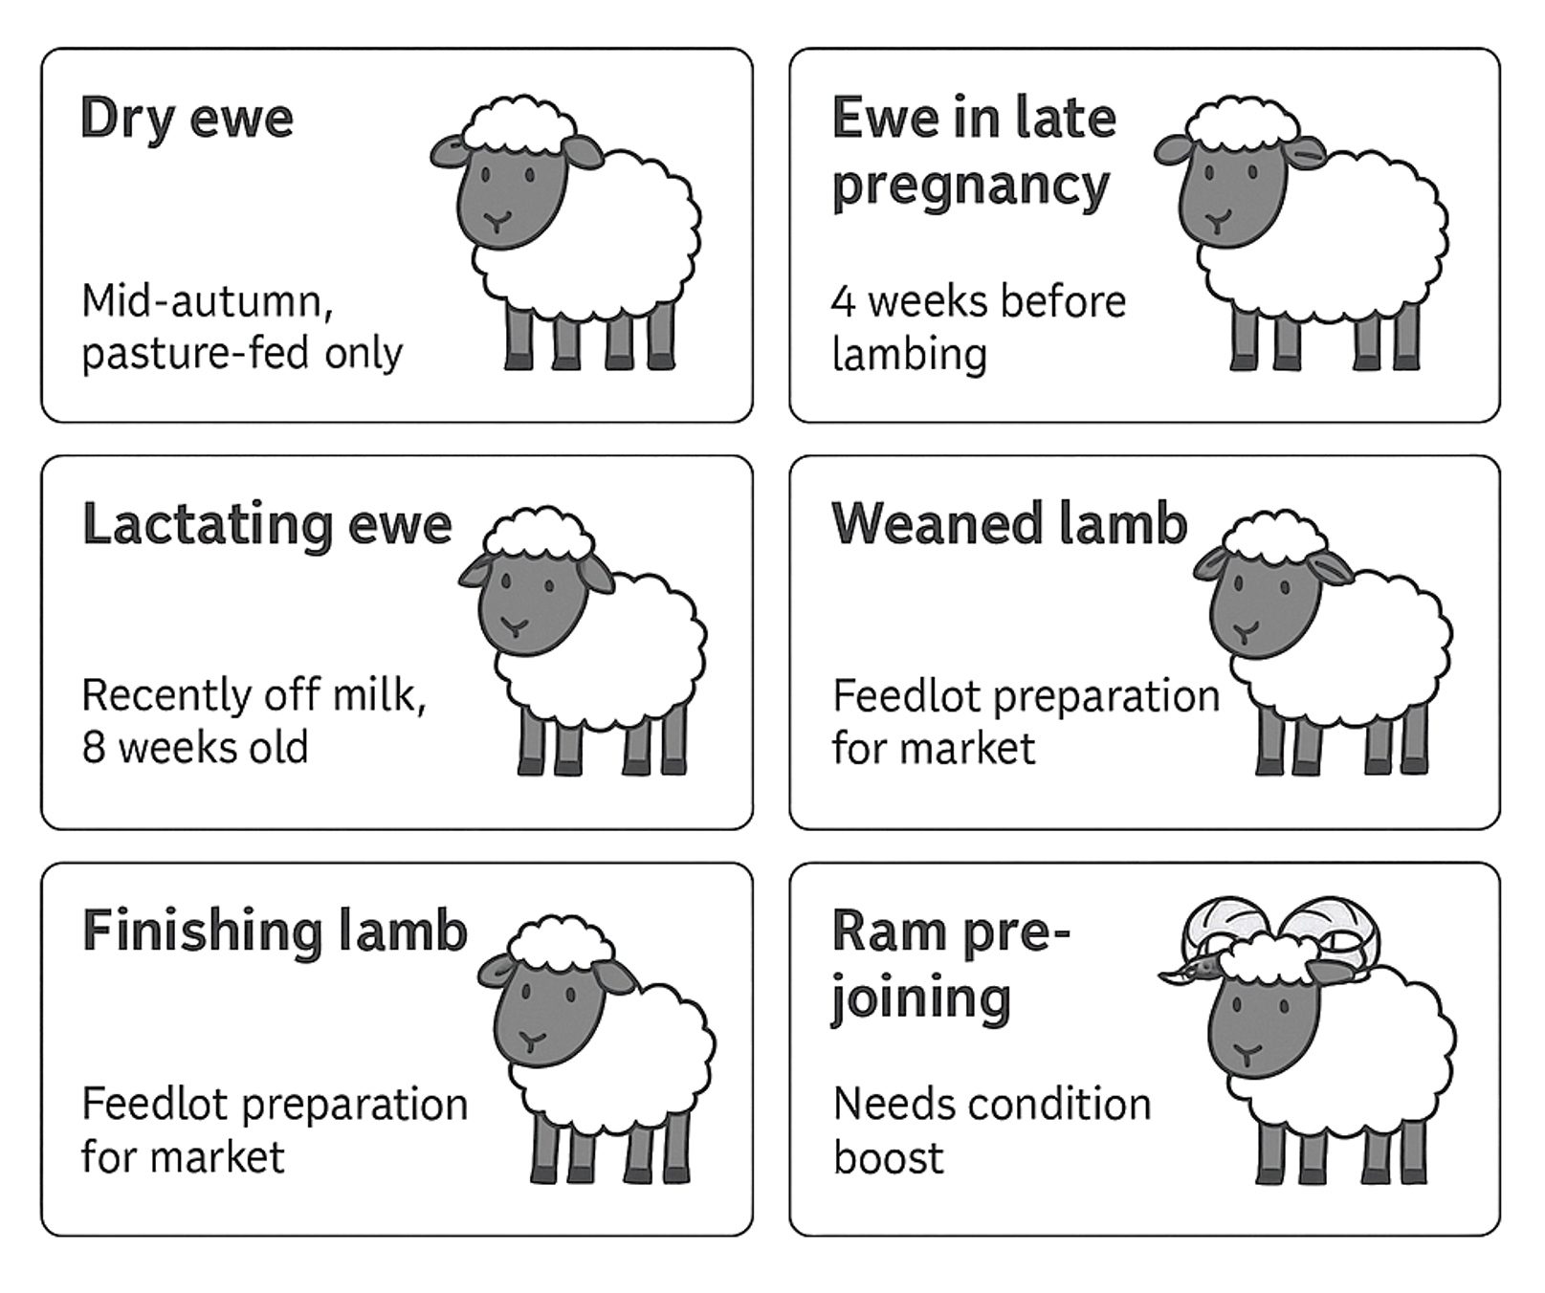
Mini feed plan
Note: a sample answer has been provided below.
Table 10 – mini feed plan
Sheep selected | Lactating ewe
What does this sheep need more of right now? | Energy, protein, calcium
What feed types are available? | Lucerne hay, pellets and pasture
How will I feed it safely? | Pasture will be available ad-lib; pellets will be supplemented in small amounts
What are the risks if feeding goes wrong? | Too many pellets can cause bloating
How do weather and pasture conditions change your plans? | If it is too dry and pasture grows slower, I will need to increase the lucerne hay and pellets
Challenge questions
- Why do pregnant ewes need more energy and calcium?
- What could happen if lambs are underfed post-weaning?

Feed plan
Feed budgeting helps ensure animals receive the right nutrition while keeping input costs within budget. Calculations are based on how much animals eat, what the feed costs and how long it’s needed.
Figure 7 – example feed ration for sheep
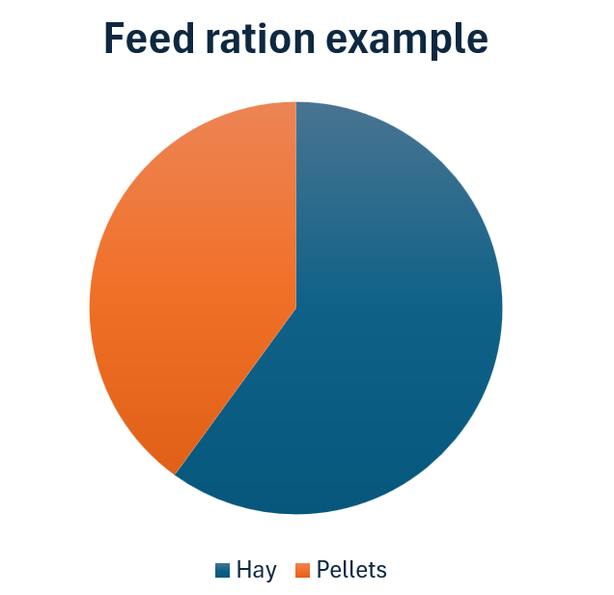
Feed calculation
A group of 50 ewes needs to be fed for 30 days. Each ewe eats 2.5 kg/day of mixed ration (60% hay at $300/tonne, 40% pellets at $600/tonne).
- Step 1: calculate total feed required.
- Step 2: break it into hay and pellet quantities.
- Step 3: work out the total cost of the feeding program.
Sample answer:
Step 1: 50 ewes × 2.5 kg/day = 125kg/day
125 kg/day × 30 days = 3,750 kg
Step 2: 3,750 ÷ 100 × 60 = 2,250 kg is 60% hay
3750 ÷ 100 × 40 = 1,500 kg are pellets.
Note: students may need support in calculating a percentage of an amount, there are multiple ways for this to be done.
Step 3: convert kilograms to tonnes using the fact that 1,000 kg = 1 tonne
2.25 t hay × $300 = $675
1.5 t pellets × $600 = $900
675 + 900 = $1,575 total.
Questions
- How could the farmer reduce costs without compromising nutrition?
- What might change the accuracy of the feed budget?
- What role does pasture quality play in feed budgeting?
Sample answer:
- Shop around for competitive suppliers, produce their own hay and store it until needed.
- Changes in consumption amounts of the flock, changes in weather conditions, quality of hay and pellets sourced.
- In a sheep grazing system, pasture plays a large role in feed budgeting. Higher quality pastures and increased availability of pastures reduces the amount of supplementary feeding required.

9. Sheep reproductive systems
Key terms
Reproduction – the process of animals making offspring (babies).
Fertilisation – when a sperm cell from the ram joins with an egg cell from the ewe to start a pregnancy.
Gestation – the length of time a ewe is pregnant, around 5 months for sheep.
Understanding the reproductive system of sheep is essential for managing breeding programs, improving productivity and ensuring animal welfare.
Draw a labelled diagram of the ewe and ram’s reproductive systems in the spaces provided.
Ewe reproductive system
Ram reproductive system
Match the reproductive system organs to the functions in the tables (note, they are not in order).
Ewe reproductive organs to include: ovary, oviduct, uterus, cervix, vagina, vulva.
Table 11 – reproductive system parts and functions (ewe)
Organ | Function
 | Contain the ova (eggs) and releases one each cycle. Also makes the hormones that control reproduction.
 | The outside part of the reproductive system. It protects the opening from dirt and germs.
 | A strong, tight muscle between the uterus and vagina. It keeps out germs during pregnancy and helps guide sperm through during mating.
 | The birth canal and where the ram’s semen goes during mating.
 | Where the lamb grows during pregnancy. It feeds the lamb, keeps it safe and helps push it out during birth.
 | Catches the egg after it’s released. This is where fertilisation happens if sperm is present. Then it carries the fertilised egg to the uterus.
Figure 8 – ewe with lamb
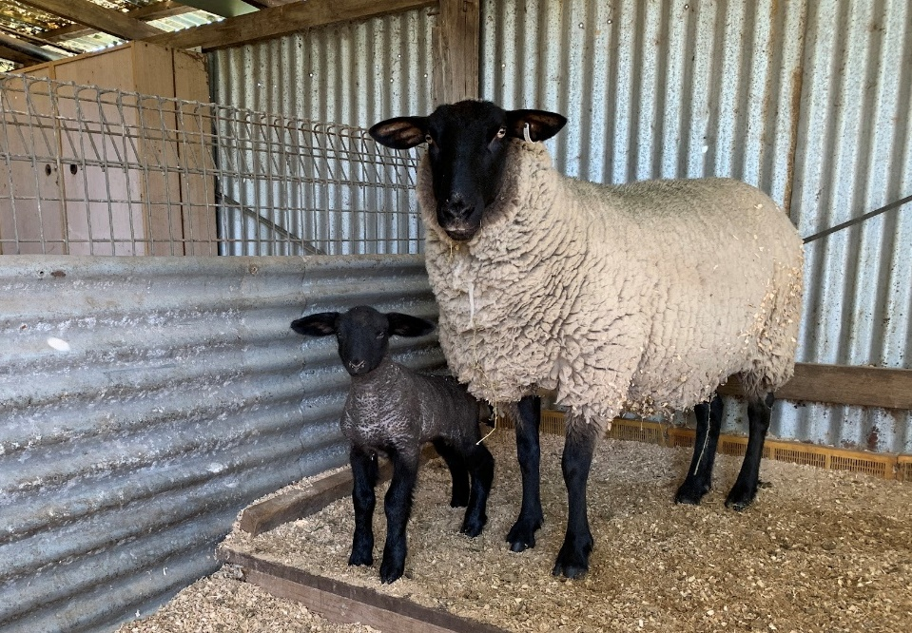
Ram reproductive organs to include: testes, scrotum, epididymis, vas deferens, urethra, accessory glands, penis.
Table 12 – reproductive system parts and functions (ram)
Organ | Function
 | A skin-covered sac that holds the testes outside the body to keep them cool, which helps sperm grow properly.
 | The final tube the sperm travels through inside the penis. It also carries urine, but never at the same time as semen.
 | Make the sperm (male sex cells) and the male hormone testosterone.
 | The organ used to deliver semen into the ewe during mating. It becomes firm when filled with blood during arousal.
 | A long, coiled tube attached to each testicle. It stores sperm, helps them mature and gets them ready for use.
 | These glands add liquid to the sperm to make semen. This liquid helps sperm move and stay alive.
 | A tube that carries the sperm from the epididymis to the urethra when the ram ejaculates.
Figure 9 – Suffolk ram
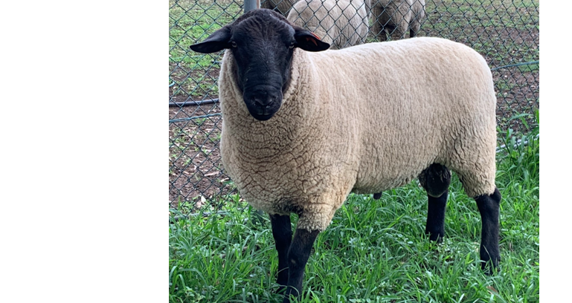
Challenge questions
- Why is the temperature control of the testes so important in ram fertility?
- What is the role of the cervix in protecting the ewe from infection?
- How do reproductive systems influence breeding program success?
Sample answers:
- Sperm production is highly temperature sensitive; heat can negatively impact sperm movement and increase sperm with abnormal shapes, potentially even causing death of these cells.
- It is a physical barrier against bacteria, viruses and other pathogens, preventing them from entering the uterus.
- Successful breeding programs rely on the ability of rams to sire viable offspring and ewes to conceive, carry and then rear lambs to weaning.

10. Breeding choices in sheep production
Key terms
Crossbreeding – mating 2 different breeds to combine their best traits.
Genetic traits – qualities passed from parents to offspring, like wool type or growth rate.
Selective breeding – choosing animals with desirable traits to be parents of the next generation.
Sheep producers don’t just breed animals at random — they use careful planning to produce lambs that suit specific markets, like wool or meat. Breeding systems are chosen based on what traits the farmer wants more of — like faster growth, better wool or disease resistance.
Different systems can help achieve those goals, but they come with trade-offs. For example, some systems improve performance quickly, while others protect the breed’s long-term genetics. Understanding the pros and cons of each system helps farmers make smart decisions that affect their entire flock.
For your assigned breeding system, create an A4 information sheet (one page maximum) that includes the following:
- description of the breeding system
- simple diagram showing how it works (stick figures, family trees, simple flow arrows)
- two benefits
- two risks.
Gallery walk
Use your information sheet and those supplied by the other groups to complete the following table about breeding systems. Remember to summarise the information.
Note: a sample answer has been provided below.
Table 13 – breeding systems in sheep production
Breeding system | Description | Benefits | Risks
Crossbreeding | Mating of animals from different breeds within the same species. | Hybrid vigour; improved meat traits | May lose wool quality in offspring
Inbreeding | Breeding system where closely related animals are mated. Can include sire to daughter or son to dam. | Trait uniformity | Increased genetic disorders
Outbreeding | Mating of animals of the same breed that have no closer relationship than at least 4 to 6 generations. | Maintains breed purity | Lower improvement rate
Linebreeding | A form of inbreeding where the degree of relationship is less intense and is usually directed towards keeping the offspring related to a highly-prized ancestor. Relationship is no closer than half-brother and half-sister breeding or cousins. | Keeps prized genetics | Moderate risk of inbreeding effects

Case study analysis
You’re running a sheep meat enterprise. You want lambs that grow quickly and reach market weight fast. You also want to avoid long-term health issues in your flock.
Compose a short paragraph explaining which breeding system you would choose and why, based on what you’ve learned.
Figure 10 – sheep eating in paddock
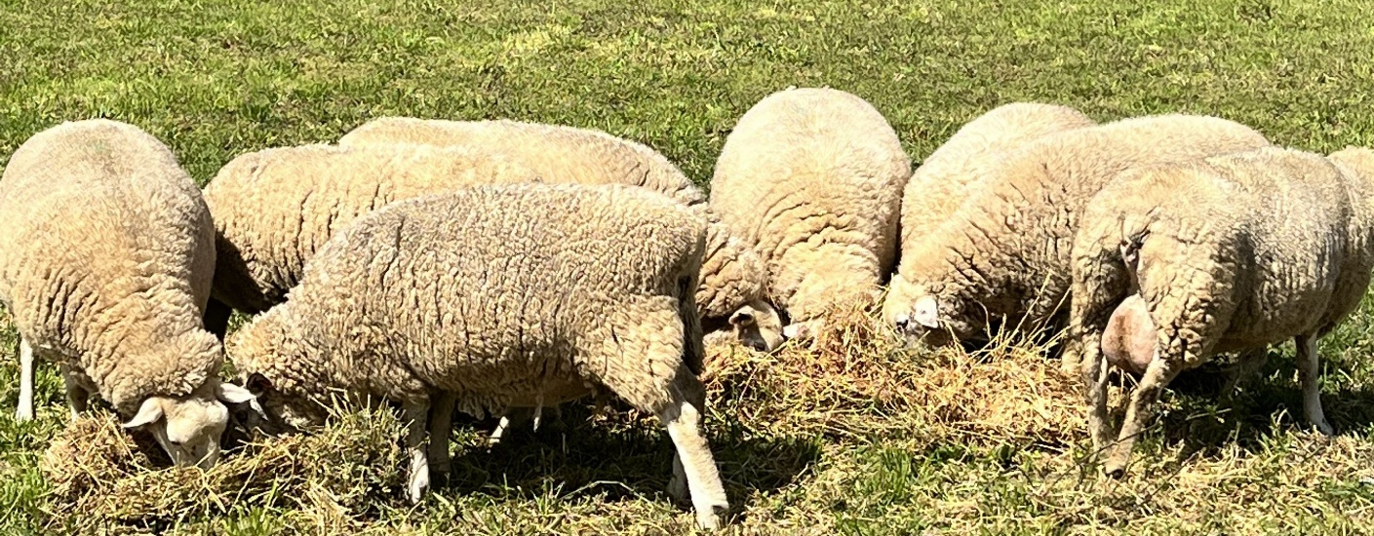

11. Australian Sheep Breeding Values (ASBVs)
Key terms
ASBV (Australian Sheep Breeding Value) – a number that predicts how likely an animal is to pass on good traits.
Worm resistance – a genetic trait where sheep are less affected by internal parasites.
Performance data – information about how an animal grows or produces that is used to guide breeding.
When farmers select rams for their flocks, they aim to enhance specific traits such as faster growth, superior wool quality or increased resistance to worms. Traditionally, these selections were based on the animal's appearance. However, appearances can be misleading, especially when environmental factors like drought or abundant feed influence how an animal looks.
To make more informed decisions, farmers now utilise Australian Sheep Breeding Values (ASBVs). ASBVs are like a genetic report card, providing estimates of an animal's potential to pass on desirable traits to its offspring. These values are calculated using data from the animal's performance and that of its relatives, offering a more accurate prediction of breeding outcomes.
For instance, if a farmer wants to improve worm resistance in their flock, they can select rams with favourable ASBVs for worm egg count. This approach allows for targeted improvements in the flock's genetics, leading to better health and productivity over time.
Simulation task
Below is a list of Bella Sheep Farms’ goals for their breeding program.
- A wool-focused enterprise in a high-rainfall area with parasite issues.
- A small farm that needs fast-growing lambs for market by 6 months.
- A drought-prone property where fertility and hardiness are top priorities.
The owner of Bella Sheep Farm is visiting a ram sale and the following 4 rams are within their budget.
Ram A: high growth, medium worm resistance, low reproduction
Ram B: high fleece weight, fine fibre, low growth
Ram C: high worm resistance, high reproduction, medium growth
Ram D: balanced traits across all categories
They can afford to purchase 2 rams this year. Which 2 rams would you select and why?
Explain the benefits of using ASBVs over visual selection methods.

12. Sheep pests and diseases
Key terms
Parasite – a living organism that lives on or in an animal and causes harm, like worms or lice.
Infection – when harmful germs enter the body and cause illness.
Prevention – actions taken to stop a disease or problem before it happens.
Sheep in Australia can be affected by a range of pests, parasites and diseases that reduce productivity, harm animal welfare and impact the quality of wool and meat. These health issues can spread quickly if not managed properly, costing farmers time, money and sometimes entire animals.
Some of the most common and serious parasites in Australian flocks include internal parasites like barber’s pole worm and liver fluke, and external parasites such as lice and blowflies. Blowflies, for example, can cause flystrike, a painful condition where maggots feed on the sheep’s flesh. Internal worms can lead to poor growth, weight loss, scours (diarrhoea) and even death if untreated.
Diseases like footrot, ovine Johne’s disease (OJD) and scabby mouth also pose major challenges for producers. These can spread between animals through contact or contaminated environments and may require strict biosecurity or vaccination programs to control.
Farmers use a mix of good animal husbandry, prevention strategies and targeted treatments to reduce the impact of these health threats. In this lesson, you'll focus on the symptoms, causes and control methods for some of the most common sheep parasites, and learn how good parasite management supports both animal welfare and farm success.
Activity
Select ONE of the parasites from the table below or a sheep disease that can be found in Australian sheep flocks.
Design and build an informative handout to be distributed to producers and the general public during the next major agricultural show in your local area. Your aim is to build awareness of the parasite or disease in the hopes to prevent it causing economic loss in the industry. Include symptoms, how to manage it and use correct terminology and visuals.
Table 14 – common parasites in sheep
Parasite | How do sheep become infected? | Symptoms | Prevention/treatment
Liver fluke | Eating fluke larvae on pasture. | Ill thrift, jaundice, anaemia, bottle jaw and sudden death. | Effective IPM programs, biosecurity, gazing management, avoiding wet areas and strategic drenching.
Black scour worm | Ingested from pasture. | Death, lethargy and collapse, weight loss, damage and inflammation to the lining of the stomach and small intestine resulting in diarrhoea. | Effective IPM programs, biosecurity, gazing management and drenching.
Barbers pole worm | Ingested from pasture. | Anaemia, lethargy, weakness and death. Pale gums and lining of eyelids, loss of condition. | Effective IPM programs, biosecurity, regular drenching, paddock rotation.
Sheep lice | Lice from other sheep or animals moving between individuals. | Irritation causes the sheep to bite, run, pull at their wool resulting in discoloured wool, reduction in weight and quality. | Good biosecurity and keeping stray sheep out are essential, quarantine new sheep until you know they are clear of infestations and dipping or backline drenches also work.
Round worm | Ingested from pasture. | Anaemia, lethargy, weakness, loss of condition and death. | Effective IPM programs, biosecurity, gazing management and drenching.

Zoonotic disease
Questions
What does ‘zoonotic disease’ mean?
Sample answer:
Diseases that can be transmitted from an animal to a human.
List 3 examples of zoonotic diseases that sheep carry.
Sample answer:
Q fever, scabby mouth and anthrax.
Why is it important to ensure good hygiene practices are used on a farm when treating livestock for disease?
Sample answer:
To prevent the transmission of these diseases from the sheep to the human.
What hygiene practices should be followed when treating and handling livestock?
Sample answer:
Washing of hands and antibacterial gel applied. Use of gloves and face mask or other PPE when infected animals are being handled. Washing of all tools used and clothing worn. Disposal of any infected materials that cannot be thoroughly cleaned.

Q fever case study on a sheep farm
Scenario
A small family-run sheep enterprise in regional NSW has just completed lambing season. One of the farm workers, 19-year-old Jessie, begins to feel unwell. They develop a high fever, fatigue, headache and muscle aches. After visiting the doctor and having blood tests, he is diagnosed with Q fever, a zoonotic disease caused by the bacterium Coxiella burnetii.
It turns out that Jessie had helped deliver several lambs without gloves or a face mask. Jessie also spent time cleaning the lambing shed, where dried birth fluids and faeces had collected in the dust. Their family had never heard of Q fever and didn’t know there was a vaccine available for people working with livestock.
After Jessie’s diagnosis, the local health department visits the farm. They provide information about managing Q fever risk, including:
- cleaning animal sheds with proper ventilation
- using PPE when handling animals during birthing
- getting vaccinated if working regularly with livestock.
Questions
What factors led to Jessie becoming infected with Q fever?
Sample answer:
Contact with bodily fluids, not wearing PPE, unvaccinated.
What changes should the family make to reduce the risk of future infection?
Sample answer:
Use PPE, vaccinate staff, training, better hygiene in sheds.
Why is it important for farmers to be educated about zoonotic diseases like Q fever?
Sample answer:
To prevent zoonotic diseases being transmitted which could cause lifelong illness and loss of income.
What responsibilities do farms have to protect visitors and workers from zoonotic risks?
Sample answer:
As an employer, farms need to implement processes and procedures to prevent illness and injury to workers and visitors as required by law.
Imagine your school farm was planning a lambing demonstration. What safety steps would you recommend to protect students and staff from disease?
Sample answer:
Educate staff and students on the dangers of zoonotic diseases, purchase and provide suitable PPE for all people involved in the process and recommend vaccination.

13. Sheep handling – estimating age
Key terms
Mouthing – checking a sheep’s teeth to estimate its age.
Incisors – the front teeth that are used to tell how old a sheep is.
Cull – to remove an animal from the flock, often due to age or poor health.
Mouthing is a practical way to estimate the age of a sheep by examining the development and wear of its incisor teeth. As sheep age, their teeth erupt, change shape and wear down in a predictable pattern. This helps farmers make informed decisions about which animals to keep for breeding, when to sell them and how to manage their feeding needs. It’s also important for animal welfare, as older sheep with worn teeth may struggle to graze and maintain condition.
Collect pictures of sheep teeth at different ages and complete the table below by determining the age of the sheep based on their teeth.
Table 15 – age estimation of sheep based on number and type of teeth
Image/diagram: | Age: | Number and type of teeth:
 | Lamb: up to 12 months | Full set of 8 baby teeth.
 | 12–18 months | Two adult teeth, the rest (6) are baby teeth.
 | 18–24 months | Four adult teeth, 4 baby teeth.
 | 24–36 months | Six adult teeth, 2 baby teeth.
 | 28–48 months | Eight adult teeth, no more teeth to erupt.
 | Adult | Full set of adult teeth showing wear from use.
Practical activity
Work in pairs to examine mouthing on real sheep (supervised). Complete:
- estimated age
- notes on tooth wear or damage
- comments on condition. (for example, would you keep or cull this sheep?)
Challenge question
Why is age estimation important when deciding whether to keep a sheep for breeding or send it to market?
Sample answer:
Age can help determine reproductive potential for future lamb production.

14. Sheep handling – fat and condition scoring
Key terms
Condition score – a rating of a sheep’s body fat and muscle, used to check health.
Fat cover – the layer of fat over a sheep’s ribs and spine that shows how well it’s been fed.
Backbone – a key area felt during condition scoring to assess body condition.
Condition scoring is a key livestock management tool that allows farmers to assess the amount of fat and muscle a sheep is carrying, based on how easily the animal’s backbone and short ribs can be felt. This score helps identify whether a sheep is underweight, in optimal condition or overweight. Unlike liveweight alone, which can be affected by factors such as gut fill and fleece weight, condition scoring gives a more accurate indication of the animal’s energy reserves and overall health.
Maintaining the appropriate condition score is essential for the health, welfare and productivity of sheep. Animals that are too thin may have poor reproductive performance, be more susceptible to disease and have lower survival rates during harsh conditions. Overweight sheep may also experience reduced fertility and birthing complications. Therefore, regular condition scoring enables timely and informed decisions regarding feeding programs, paddock rotation and marketing readiness.
Condition scoring is particularly valuable at key stages of production such as joining, lambing and weaning, where body condition can significantly influence outcomes. Producers aim to keep sheep within an ideal condition score range, often around a score of 3, to support optimal reproductive performance, efficient growth and high-quality wool and meat production.
Table 16 – condition scoring reference table
Score | Eye muscle | Backbone | Short ribs
1 | Very small | Bones form sharp narrow ridge. Each vertebra easily felt. | Ends of short ribs are obvious and easy to feel squarish ends.
2 | Small | Bones form narrow ridge, but the points are rounded. | Ends are well rounded but easy to press between them.
3 | Full eye muscle | Vertebrae only slightly elevated above eye muscle. Possible to feel each rounded bone but not press between them. | Well-rounded and filled with muscle.
4 | Full eye muscle with skin floating over it | Possible to feel most vertebrae with pressure, backbone smooth and slightly raised above eye muscle. | Only possible to feel or sense one or two short ribs.
5 | Full fat covered eye muscles | Spine only felt by pressing down firmly between fat covered eye muscles. | Virtually impossible to feel under the ends of the ribs.
Practical activity
Work in pairs to assess 5 sheep and complete the sheep condition scoring table for the flock.
Condition score
Record the condition score of each animal you assess with an X.
1.0 | 1.5 | 2.0 | 2.5 | 3.0 | 3.5 | 4.0 | 4.5 | 5.0
Challenge question
Why is a condition score of 3 often considered ideal for production animals?
Sample answer:
Ewes with a condition score of 3 generally have higher conception rates, increased lamb birth weights and better lamb survival. Ewes that are too low in condition struggle to conceive and carry or produce milk, and too high can cause difficulty lambing.

Practical skills checkpoint
Table 17 – skills assessment checklist
Criteria | Checkbox
Students can follow individual instructions to complete practical tasks successfully. | ☐
Students can collate and interpret first-hand data collected during practical activities. | ☐
Students can safely approach animals, observing appropriate body language and positioning to minimise stress. | ☐
Students can guide livestock into yards or pens using basic handling skills, ensuring the safety of both animals and handlers. | ☐
Students can apply basic hygiene practices, such as washing hands before and after working with livestock. | ☐

Working on a sheep farm

15. Husbandry practices
Key terms
Husbandry – the regular care and management of animals to keep them healthy and productive.
Marking – a group of tasks done to lambs, like tagging, vaccinating and castrating.
Joining – the process of putting rams with ewes for breeding.
To maintain a healthy, productive flock, sheep producers carry out a range of routine husbandry tasks across the production year. These tasks are critical for supporting animal welfare, preventing disease and ensuring the flock performs to its genetic and commercial potential. The timing of each practice is based on animal needs and the seasonal conditions in the region.
The table below includes common husbandry tasks undertaken on Australian sheep farms. For each, describe the activity, identify the tools used and explain when it is usually carried out and why.
Note: a sample answer has been provided below with a modelled example given in the first row.
Figure 11 – ear tag and applicator
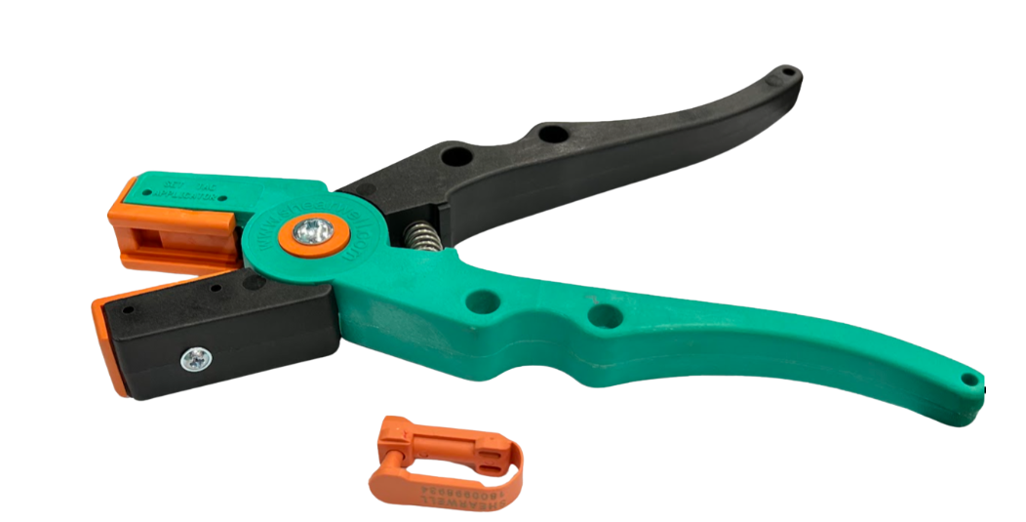

Table 18 – common husbandry practices on sheep farms
Task | Describe the activity | Tools used | When is it carried out? Why?
Example: Ear tagging | Plastic or metal tag applied to the ear for identification. | Ear tag applicator, tags | Usually occurs at marking (generally 6 weeks of age) to identify animals. Tags may be replaced later if lost or damaged.
Drenching | An oral veterinary medicine administered by a drenching gun. | Drench gun, drench | Typically in spring or after rain, based on worm burden or condition score.
Vaccination | An injected veterinary medicine administered under the skin or into the muscle to prevent diseases. | Vaccination gun, vaccine | First dose at marking, followed by a booster injection. Yearly boosters.
Castration | Severing of the vas deferens to prevent sperm being ejaculated. Can be done through removal of testes with a ring or scalpel or ruptured with a burdizzo. | Elastrator ring applicator, elastrator rings, scalpel or burdizzo | Only occurs in ram lambs that are not required to stay lambs. Occurs at marking.
Joining | Placing of rams with ewes for mating. | n/a | Occurs once (sometimes twice) per year on breeding farms, timing depends on ideal lambing season and seasonality of ewes.
Weaning | Removal of lamb from ewes to prevent further suckling. | n/a | 4–6 months of age depending on pasture, lamb condition and ewe body condition.
Dipping | Immersing sheep or applying solution to kill external parasites. | Plunge dip, shower dip or sheep jetting system | Occurs in areas where external parasites cause issues, such as lice. Usually undertaken in the lead up to the most prevalent season.
Tail docking | Removal of the tail either with a ring or hot knife. | Elastrator ring applicator, elastrator rings or gas knife | Occurs in breeds that have wool around the breech. Conducted at marking.
Shearing | Cutting off the fleece. | Electric shears | Depends on the type of enterprise conducted, usually happens once per year.
Crutching | Shearing the breech area of the sheep. | Electric shears | Done 6 months after shearing or just prior to active fly seasons such as summer.

Complete the table below by matching the equipment name with the photo.
Note: sample answer provided below.
Table 19 – common husbandry tool identification table
Equipment | Name
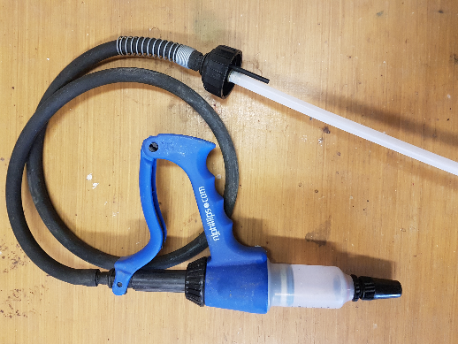 | Vaccination gun
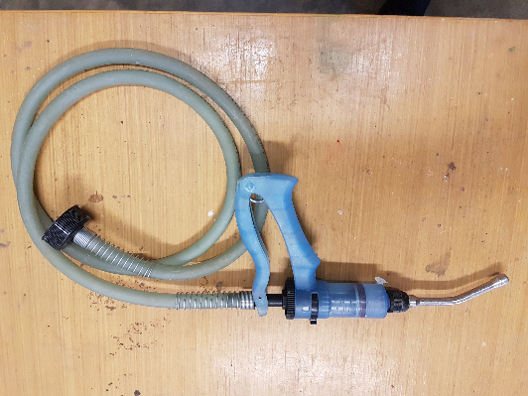 | Drench gun
 | Ear tag applicator
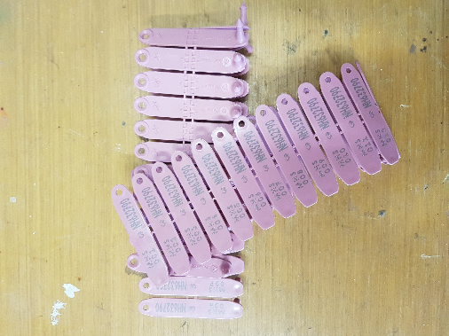 | Ear tags
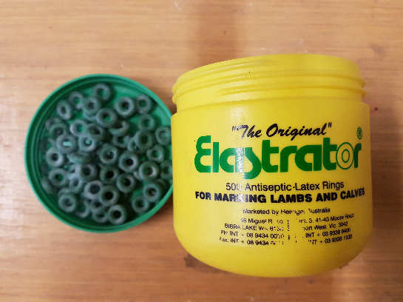 | Elastrator rings
 | Elastrator ring applicator
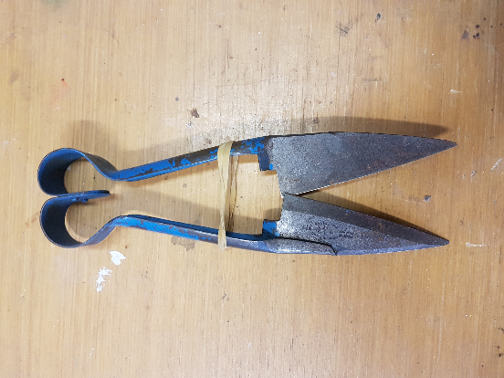 | Hand shears
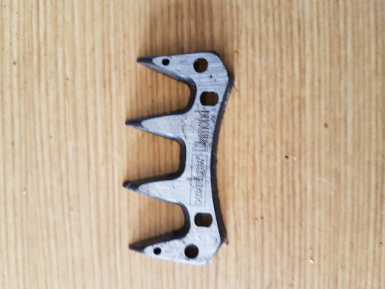 | Electric clipper
Challenge question
Construct a short paragraph on how poor use of equipment, for example incorrect tagging or dull shears, can negatively affect animal welfare and production outcomes.
Practical activity
In pairs, visit the school paddock or yards and select one animal. Complete the following:
- age estimate (based on mouthing or use of prior records)
- identify if the animal has been ear tagged, castrated, tail docked
- note any immediate husbandry needs (for example, dags, hoof trimming, parasite symptoms).
Questions
- Why is timing critical for some tasks (for example, vaccination before joining)? What would happen if these practices were skipped or done at the wrong time?
- How do poor tools or rushed handling impact sheep welfare and enterprise success?
Sample answers:
- Timing of certain activities, such as joining, ensures lambs are born at optimal times of the year when there is enough feed for ewes to maintain lactation and feed lambs adequately. If practices such as vaccination or drenching are not timed correctly, it leaves the flock open to pests and diseases.
- Use of poor or poorly maintained tools and rushed handling can impact the effectiveness of practices such as vaccination or drenching, leaving sheep susceptible to pests and disease. Poor tool quality can also cause pain and suffering during the husbandry practice being undertaken.

Calendar of operations
Planning and timing husbandry activities is essential for maintaining animal health, welfare and production. This calendar of operations helps producers manage workloads, improve productivity and reduce stress on the animals.
Using the operations listed in the table provided, complete the following in your own calendar of operations for either the school flock or a local sheep enterprise.
Identify the month(s) when each activity takes place and state the reason for the timing (for example “Shearing – September – allows sheep to be cooler during summer months and provides profit for the enterprise).
Note: a sample answer has been provided below with a modelled answer given in the first row.
Table 20 – tabular calendar of operations
Operation | Month | Timing | Reason
Example: Shearing | September | Once yearly | For profit in wool enterprise
Drenching | April  September  December | Prior to lambing.  December if required in wormy areas.  Prior to wet season in April. | Reduces worm burden. Prior to lambing gives the lambs protection for the first few months of life until they can be drenched
Vaccinating | September (ewes)  November (lamb)  December (lamb) | Yearly for mature animals, initial vaccine at marking then booster | Lambs will get their initial dose and require a booster according to vaccine around 2 weeks later, then they will have enough immunity to go into the yearly rotation
Hoof paring | When required | Depends on breed and ground hardness | Prevention of lameness and foot problems
Dagging | When required | This will depend on sheep breed and mulesing status | Prevention of flystrike in wool bearing breeds
Crutching | April | Six months after shearing and prior to joining | Allows ease of joining and assists in preventing flystrike
Ear tagging | November | Once in a lifetime unless tag is lost | Identification purposes and data collection
Joining | April | Once per year in breeding flocks | Produce lambs for sale or increasing flock size
Weaning | December | Once in a lifetime | Allow ewe to regain condition for next breeding cycle
Selling | April | Generally yearly | Profit
Marking | November | Occurs at generally six weeks of age | Range of husbandry practices conducted at once while lambs can still mother up for comfort
Culling | July | Usually once per year | Remove underperforming stock

16. How livestock are bought and sold
Key terms
Auction – a public sale where buyers bid to buy animals.
Saleyard – a place where live animals are sold in person.
Lot – a group of animals sold together with the same sale ID.
In Australia, sheep producers use a variety of systems to sell their animals, online platforms like AuctionsPlus, traditional saleyards and forward contracts. Understanding how auctions work helps farmers match their product to the best market.

Sale observation
- Visit auctionsplus.com.au, navigate to the Sheep section.
- Choose 3 different sheep lots that are relatively recent, with good detail and an open catalogue.
- Use this information from the website to complete the table below.
Table 21 – sale catalogue collection of data
Sale ID | Number of sheep | Breed | Location | Liveweight (kg) | Agent | Key sale description
Example | 285 | 100% Border Leicester/Merino | Leadville, NSW | Average 30.1 kg | Jamie Milling Pty Ltd | 285 Future breeder ewe lambs

Questions
Which sale had the most appealing sheep for a breeder wanting to increase or improve their flock? Explain your answer.
How do breed and liveweight influence the buyer interest?
Why might a producer choose to use AuctionsPlus instead of a saleyard?
Practical activity
Stage a mock auction form using your school’s flock. Work together as a class to prepare a sale listing for your flock. Include photographs that show the best attributes of the flock. Create an overview section that includes your location, breed, age/drop, liveweight (lowest, highest and average) and fat score (percentage of flock in each category).
Note: a sample answer has been provided below.
Merriwa Central School flock sale
Figure 12 – Merino sheep in shearing sheds
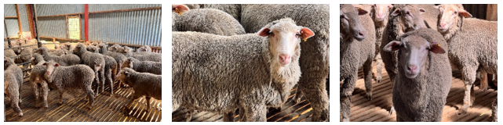
Overview
Form number | 100123546
Agent | Thomas Livestock Pty Ltd
Location | Merriwa, NSW
Breed | Merino
Age/Drop | 1 August 2024 to 15 September 2024
Weight | Low 23 kg – High 37 kg – Average 30.1 kg
Fat: | 41% score 1 (0–5mm)  56% score 2 (6–10mm)  3% score 3 (11–15mm)

How do farmers sell their sheep?
Marketing livestock is a strategic decision that can affect profit, quality control and workload. Different systems suit different enterprises. In this section, you will examine how sheep are sold in Australia and the pros and cons of each method.
Complete the following summary table for the 3 major marketing strategies.
Note: a sample answer has been provided below.
Table 22 – marketing systems for sheep production
Marketing system | Key features | Advantages | Disadvantages | Ideal use Scenario
Online livestock auctions (example, AuctionsPlus) | Online bidding | Wide access, convenience | Requires photos, description | Larger flock sales
Forward contracts | Pre-agreed price | Risk reduction | May miss higher prices | Predictable supply
Local saleyard auctions | Public auction, physical sale | Competitive pricing | Transport stress | Small local producers
Challenge question
As a sheep producer with 400 lambs ready for sale in spring, outline which marketing system you would use and why. Refer to breed type, market demand and resources available to you.

17. Traditional and contemporary agricultural practices
Key terms
Sustainability – farming in a way that looks after animals, land and resources for the future.
Regenerative agriculture – modern farming practice that improves soil, plants and biodiversity over time.
Integrated pest management (IPM) – a mix of natural and chemical methods to control pests with less harm.

Land management – learning from the past
For thousands of years, Aboriginal and Torres Strait Islander peoples have cared for the land using knowledge passed down through generations. These practices are not just part of the past, they are continually evolving alongside other agricultural practices.
In modern sheep production across NSW, some of these land care methods, like cool burns, rotational grazing guided by seasonal cycles and observation of native species as indicators of land health, are being recognised and used to reduce environmental damage, promote biodiversity and regenerate pastures.

Table 23 – similarities and differences
Practice element | Aboriginal practices | Early European practices | Contemporary practices
Fire management | Cultural burning used to promote native pasture regrowth, foster the growth of crops, reduce weeds and attract animals to the area | Fire suppression and tillage to remove weeds before planting | Controlled burns and IPM for weed control
Soil care | Managed and cultivated soil, use of native grasslands and careful observation of grazing impacts | Tillage, ploughing and clearing of land | Reduced till, rotational cropping and use of fertilisers
Animal observation | Understanding animal movement patterns, health signs and seasonal breeding behaviours | Introduction of hard hooved species for agriculture, fencing livestock into paddocks for care and observation | Livestock bred to withstand Australian conditions, stocking density considered in paddocks, feed inputs, veterinary care for sick livestock
Environmental impact | Regenerative, promotes biodiversity and long-term land health | Often extractive, removal of resources and nutrients without return | Long-term land health focus balanced with production goals. Regenerative agriculture increasing and rehabilitation of non-farmed areas

Creative comparison
Choose one traditional and one contemporary practice. Compose a short paragraph or argument evaluating:
- Which method is more sustainable in the long term?
- How could these methods be combined on a sheep farm?
Challenge question
Complete the sentence below and expand on your response:
‘Aboriginal land management practice is based on a system of understanding the interactions between the soil, living things, climate and spiritual and social connections …’
Use this sentence as a starting point for a paragraph. Explain how this system can benefit sheep production today, for example, by improving pasture condition, reducing parasites or supporting animal welfare.

Sustainable choices
Sheep farming in Australia plays a key role in our food and fibre industries. But the long-term success of any farm depends on how well it looks after its animals and its land. Farmers face pressure from climate change, land degradation, chemical resistance and water shortages, all of which are made worse by unsustainable practices.
Sustainable farming isn't about going back to the ‘old ways’, but combining modern science, traditional Aboriginal land management knowledge and new technologies to protect natural resources, improve productivity and support the welfare of animals.
Activity
In pairs or small groups, classify the following sheep farming practices as sustainable, unsustainable or context dependent. Use your own reasoning and explain briefly why you have placed them in each category.
Table 24 – sustainable and unsustainable farming practices
Farming practice | Classification | Why?
Rotational grazing
Overstocking during drought
Use of firestick farming to regenerate native pastures
Clearing paddock trees for more pasture
Use of chemicals for internal parasites
IPM (Integrated pest management)
Continuous cropping without fallow
Replanting native shelterbelts
Leaving chemical drums uncollected
Allowing unrestricted stock access to creeks
Question
Were there any that were hard to categorise? Why?
Scenario
You are helping manage a sheep property in central NSW that has:
- soil erosion in exposed paddocks
- parasite issues in sheep from wet summers
- weeds spreading in unused areas
- reduced pasture growth in heavily grazed areas.
Identify 2 sustainable practices that could improve the farm’s condition. Explain how they would help.
What Aboriginal land management technique could be integrated into this farm’s grazing system to improve soil or pasture health? Give an example of how it's used today.
Hint: firestick farming is still used by Aboriginal land managers in NSW to regenerate grasslands and prevent large-scale bushfires.

18. Biosecurity
Key terms
Biosecurity – the steps taken to stop diseases, pests or weeds from entering or spreading on a farm.
Invasive species – animals or plants that don’t belong and can harm farms or the environment.
Quarantine – isolating new or sick animals to stop disease spreading.
Biosecurity refers to the systems and behaviours that prevent the introduction and spread of pests and disease. Good biosecurity protects animal health and the entire industry.
In the Australian context, biosecurity is vital for safeguarding the health, productivity and sustainability of agricultural industries. With Australia's unique biodiversity and reliance on export markets, maintaining strong biosecurity practices is crucial to protect against the introduction and spread of invasive species and pathogens. By applying effective biosecurity practices, farmers can preserve animal and plant health, ensure food safety, maintain market access and uphold Australia's reputation as a producer of high-quality and safe agricultural products.
Table 25 – risk identification table
Biosecurity risk | How it enters the farm | Control measure
New stock | From market or other farms | Quarantine on arrival
People | Clothing, vehicles | Provide clean boots, footbath
Feed | Contaminated hay or grain | Check source, store securely
Wildlife | Contact with flock | Maintain fencing, reduce attractants
Questions
- What is biosecurity, and why is it important in agriculture?
Sample answer:
Biosecurity is the systems and behaviours that prevent the introduction and spread of pests and disease throughout the country, including in agriculture.
- What are some common pests and diseases that pose biosecurity risks to agricultural industries in Australia?
Sample answer:
Foot-and-mouth disease (FMD), avian influenza, swine flu, white spot disease.
- How do biosecurity practices contribute to the protection of animal and plant health?
Sample answer:
By preventing pests and diseases from entering the country in some cases so our industries cannot get them, and if they are already here, they can slow down the spread.
- What are the key stakeholders involved in biosecurity management in NSW and Australia, and what roles do they play?
Sample answer:
Key stakeholders are the people impacted by or interested in biosecurity management, such as farmers, border control and consumers. They each play a role in implementing biosecurity procedures and increasing awareness of safe practices.
- How can individuals, communities and industries contribute to enhancing biosecurity outcomes in agriculture?
Sample answers:
Following hygiene practices when travelling overseas or between farms, not taking potentially infected produce into agricultural zones and learning about ways to support local industry.
Biosecurity poster design
Create educational posters or other presentations about biosecurity in agriculture. Students working in small groups should focus on a different key area for messaging. Some ideas could be:
- Biosecurity practices at the border to keep unwanted pests and disease out.
- Responses of government when risks are identified.
- On-farm biosecurity practices and procedures.
- Responsibilities of different groups when a risk is suspected or detected.
- Current or potential biosecurity threats to Australian agriculture.
Provide resources and information about biosecurity principles, including prevention measures, quarantine protocols and reporting procedures.
Display the posters around the classroom or school to raise awareness about biosecurity.
Planning space
Challenge question
What could happen to the Australian sheep industry if a major disease like FMD (foot-and-mouth disease) entered the country?
Sample answer:
FMD could cause properties to be quarantined if they are infected and livestock to be destroyed to prevent further spread. Livestock movements across Australia could be shut down as well as exports, all causing severe financial issues for the industry.

19. Sheep identification and traceability
Key terms
Traceability – the ability to follow an animal’s movements through the supply chain.
Property Identification Code (PIC) – a unique code used to track where animals come from.
Electronic identification (eID) – a tag with a chip that stores and shares animal information.
Animal identification plays a key role in livestock management, serving several purposes that contribute to the efficiency and effectiveness of agricultural practices. Key points to cover:
- Biosecurity measures: in Australia, biosecurity is a top priority for protecting the health and productivity of livestock industries. Animal identification plays a critical role in biosecurity by enabling the fast tracing of animals in the event of disease outbreaks or biosecurity incidents. This is especially important given Australia's reputation for producing high-quality and disease-free livestock products for both domestic consumption and export markets.
- NLIS implementation: the National Livestock Identification System (NLIS) is a key component of Australia's biosecurity and traceability framework. NLIS is mandatory for the identification and traceability of cattle, sheep and goats.
- State-specific regulations: while the NLIS provides a national framework for livestock identification, each state and territory may have additional requirements. In NSW, for example, sheep and goats born after 1 January 2025 will require an eID tag before leaving a property; and from 1 January 2027, all farmed sheep and goats in NSW will require an eID tag. Access Accredited devices list for sheep and goats (PDF 578 KB) to see the range of tag types available.

Sheep in schools
Sheep must not be moved within NSW unless they have an approved ear tag in their ear. Approved ear tags are printed with the Property Identification Code (PIC). They can be either breeder tags (coloured according to the year of birth) or post-breeder tags (pink).
All sheep must be tagged before they leave the property on which they were born, including a school property. This tag should ideally be the breeder tag in the correct year colour. A sheep can only have one breeder tag. If a sheep bred at your school has lost its tag, it must be re-tagged with either your school breeder tag or your pink post-breeder tag before it leaves your school.
If sheep that have been purchased have several different tags, you can choose to tag them all with your pink post-breeder tags. Each time a sheep moves to another property it may be given the post-breeder tag of that property. This means a sheep can have several post-breeder tags.
Questions
- Recall what is biosecurity and why is it important for agriculture?
Sample answer:
Biosecurity is the systems and behaviours that prevent the introduction and spread of pests and disease throughout the country, including in agriculture.
- Why is animal identification important in livestock management and for biosecurity?
Sample answer:
Supports fast and accurate tracking of infected or impacted livestock and produce to trace back to the source and prevent further movement of pests and disease.
- Describe the National Livestock Identification System (NLIS) and how it works. Include the interaction between the eID tag, PIC number and NLIS database.
Sample answer:
NLIS is an online database where producers and agents upload livestock movements from property to property or end point (abattoir) using individual PIC numbers. eID tags track individual livestock on the database over their lifetime.
- Outline the purpose of the NLIS database.
Sample answer:
The purpose of the NLIS database is for the lifetime tracking of individual livestock for traceability in case of disease outbreak.
- Discuss the tagging requirements for animals leaving a property.
Sample answer:
All cattle, sheep and goats are tagged with an eID tag and individual number prior to moving from one property to another according to laws in NSW.
Methods of identification including eID and RFID tags
Research one example of animal identification available for livestock. Examples could include, eID tags, rumen bolus, microchipping, branding, ear notching and visual tags.
Each group will present its findings including:
- identification type and intended livestock use
- pictures or real-life samples for observation
- location of device when attached to the animal
- advantages and disadvantages of using this method.
ID system matching
Match the following identification methods to their purpose and characteristics.
Identification methods: NLIS/eID tag, ear mark, visual ear tag, tattoo
Table 26 – identification methods for livestock
Method | Description | Purpose
 | Plastic tag with printed number | Easy field ID
 | Contains microchip scanned by reader | National traceability
 | Ink into skin, often on ear | Backup for long-term ID
 | V-shaped notch or clip pattern | Visual ID in some states

Ear tagging of livestock
Animal tagging is a fundamental practice in livestock management, essential for both identification and traceability. Understanding the correct procedures and equipment for tagging livestock is necessary to ensure the welfare of livestock is maintained. Different tagging methods, such as visual identification and electronic ID (eID) tagging, serve various purposes and have specific guidelines. Animal welfare and maintaining proper hygiene during tagging procedures are vital. This lesson aims to equip students with the necessary knowledge and skills to perform tagging procedures ethically and safely, aligning with NSW animal welfare guidelines.
Questions
- Why is correct placement of a tag essential in animal production (consider animal welfare as well as farm management)?
Sample answer:
Comfort and reduce chances of tag loss.
- How do we prioritise animal welfare during tagging procedures?
Sample answer:
Clean and well-maintained equipment, reduced time away from mother if lambs, consider weather conditions during tagging.
- What are the WHS requirements for tagging live animals?
Sample answer:
Ensure sheep are well restrained, you are using appropriate equipment for the task and have had proper training. Wear PPE as required.
Equipment required
- Ear tags – eID or RFID are preferred, but general property tags can also be used.
- Tag applicator/pliers. Ensure you have the correct applicator for the tags you are using; different companies can have their own specialised applicators.
- Stuffed animals to apply tags to or cut-outs of animal ears using the templates supplied. Templates can be made from vinyl offcuts, thick cardboard, PET bottles or recycled plastic pots.
Figure 13 – selection of eID and RFID ear tags for sheep and cattle
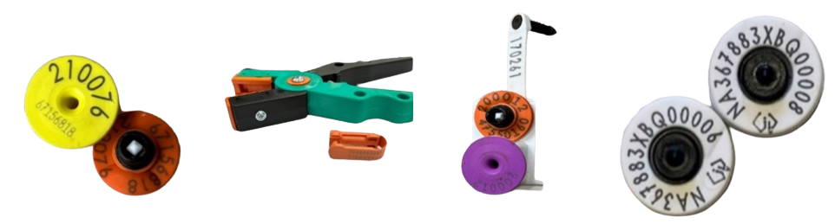
Practical activity
Follow teacher directions to apply different types of tags to the model animal ears in the correct placement.
Figure 14 – photographs demonstrating the practical activity on model animals
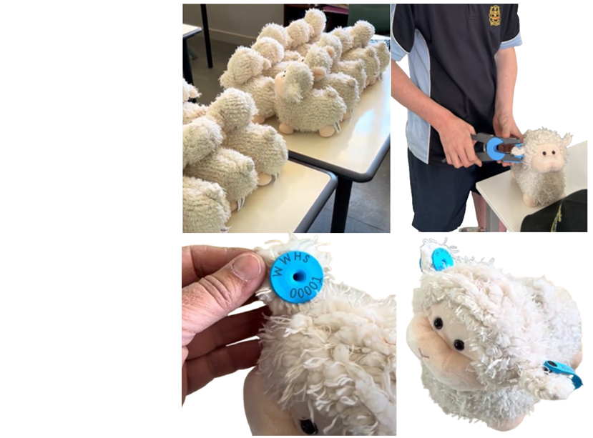

20. Record keeping
Key terms
Health records – notes about treatments like vaccinations or drenching.
Production records – data like fleece weight or lamb growth used to make farm decisions.
Financial records – information about farm income and costs that helps manage the business.
Effective record keeping allows sheep farmers to make informed decisions, meet legal requirements and track flock performance over time.
Note: a sample answer has been provided below.
Table 27 – types of records
Record type | What it includes | Why it’s important
Health | Drenching, vaccinations, treatments | Monitors welfare and prevents overuse
Reproduction | Joining, lambing, scanning | Tracks fertility and lambing success
Production | Weights, fleece test results | Supports selection and marketing
Identification | EID tags, ear marks | Animal tracking and traceability
Financial | Feed costs, sales, vet bills | Manages enterprise viability

Using RFID tags for data collection
RFID tags, known as Radio Frequency Identification tags, serve as a tool to track livestock animals such as cattle, sheep and goats by detecting a device with their unique 16-digit identification code. These tags are typically attached to the animal's ear and are accompanied by an RFID reader.
When scanned by a handheld RFID reader, the tag emits radio waves, allowing for identification and data retrieval without requiring line-of-sight, unlike traditional methods such as tattoos or barcode scanning. Information scanned can be stored on the handheld RFID reader or sent to another device such as a computer or smartphone via Bluetooth or a connecting cable.
This technology streamlines record-keeping and overall farm management, enhancing efficiency and accuracy in agricultural practices. Utilising RFID tags includes enhanced livestock analysis, improved weight monitoring and better decision-making regarding animal health and breeding.
Figure 15 –scanning a lambs eID ear tag with a handheld RFID scanner
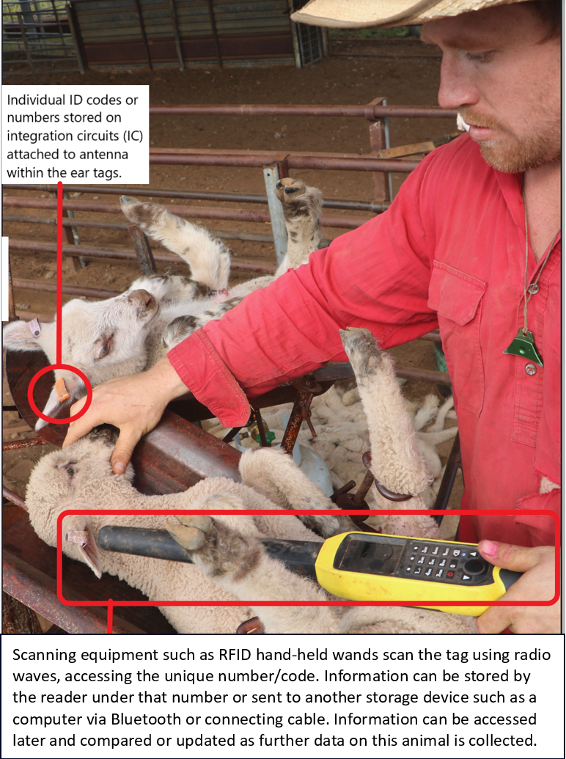
Questions
- What is RFID, and how does it work?
- Why is it important to accurately record information about livestock?
- How might RFID technology improve efficiency in animal management on a farm?
- What challenges do you foresee in using RFID technology for animal record-keeping?
Equipment required
- Stuffed animals or cardboard ear models, previously tagged by students
- RFID reader
- Computer with excel software
Practical activity: using RFID readers
- Using the NLIS tags applied to the animal models in the previous lesson, scan your allocated sheep.
- Input the weight of the sheep (as given to you by your teacher)
- Pass the RFID reader to the next ‘sheep handler’ to scan and input their data. Continue until the faux flock is complete.
Transferring data from the device to Microsoft Excel
- Connect the handheld reader to a computer using the connecting cable and download the csv file.
- Open the file using Excel.
Figure 16 – example of csv. file from an HR5 Gallagher handheld reader
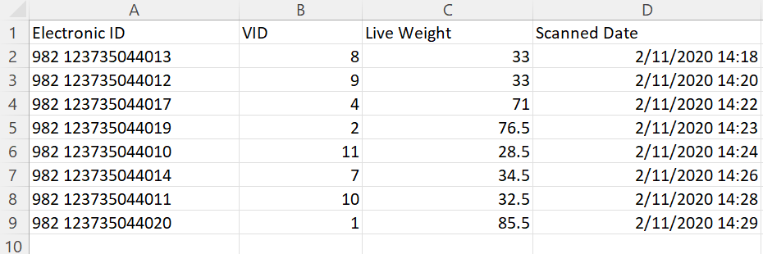
- Complete the following tasks using the firsthand data collected:
- Sort the data from highest weighing animal to lowest.
- Calculate average weight of mob.
- Calculate the difference between the heaviest and lightest animal.
Ongoing practical activities: update data each week according to the scenarios given below.
Week 1 scenario: Weighing day
Background: it's weighing day at the farm, and the farmer needs to record the weights of all the sheep in the flock to monitor their growth and health. The sheep are gathered in the holding pen, ready for inspection.
Task: use the RFID reader to scan the eID tags of each sheep and record their tag numbers and corresponding weights in the farm's database.
Week 2 scenario: Pregnancy check
Background: the farmer suspects that some of the ewes in the flock may be pregnant and wants to confirm their status for breeding purposes. The sheep are scanned by a contractor and separated into groups, with one group containing pregnant ewes, the others are not.
Task: use the RFID reader to scan the eID tags of the sheep in the designated pregnant group. Record the tag numbers of any ewes confirmed to be pregnant in the farm's database.
Week 3 scenario: Health inspection
Background: it's time for the monthly health inspection, and the farmer needs to check for any signs of illness or injury among the sheep. The flock is gathered in the yards, awaiting examination.
Task: use the RFID reader to scan the eID tags of each sheep as they pass through the inspection line. Record any observations or health concerns associated with each tag number in the farm's database.
Week 4 scenario: Drenching day
Background: to prevent parasite infestations, the farmer plans to administer drench to the entire flock. The sheep are rounded up and brought to the handling facilities for treatment.
Task: use the RFID reader to scan the eID tags of each sheep before and after drenching. Record the tag numbers of all treated sheep and any relevant dosage information in the farm's database.
Week 5 scenario: Breeding selection
Background: the farmer is selecting breeding stock for the upcoming lambing season and needs to allocate a sire for their next lambing. The flock is sorted into breeding groups based on age and lineage or culled.
Criteria
- Ram 04200 – this ram has breeding values for smaller lamb weights and is therefore better used over maiden or young ewes (less than 3 years old).
- Ram 03952 – this ram has breeding values for good mothering and developing ewe lambs that consistently have twins. This will be his last year in the flock and any ewe lambs he sires will be kept for breeders into the future.
- Ram 04277 – this ram has breeding values for large lamb weights and consistently has larger sized twin lambs. He should be used over older ewes with twin history.
- Ram 05600 – this ram is new to the flock and will be used to expand genetics. Use him over any ewes as he has breeding values that show average birthweight lambs and good meat quality.
Task: use the RFID reader to scan the eID tags of the sheep in each breeding group. Record any relevant data, such as parentage or previous lambing records associated with each tag number in the farm's database. Allocate each ewe into groups, based on the most suitable ram for joining this year. Add this data onto their file.

21. Technology in Australia’s sheep industry
Key terms
Innovation – a new tool or idea that improves how farming is done.
Efficiency – doing a task with less time, effort or waste.
Walk-over weigher – a device that automatically weighs sheep as they walk over it.

Spotlight – David Unaipon
Figure 17 – David Unaipon on the $50 Australian note

David Unaipon was a Ngarrindjeri man and inventor who imagined the future of agriculture. In 1909, he patented a shearing handpiece that used a straight-line motion—a big leap from the rotating designs of the time. This invention made shearing faster, safer and more efficient. Even though his design wasn’t widely adopted in his lifetime, it laid the foundation for the tools shearers still use today.
"If I can invent one great thing, I will be satisfied." – David Unaipon
Watch the video David Unaipon: Australia’s Da Vinci (9:07) to complete the following questions.
Questions
- What problem did David Unaipon try to solve?
Sample answer:
To improve efficiency and effectiveness of sheep shearing by making it faster and less labour-intensive.
- How did his invention change the shearing process?
Sample answer:
The mechanical handpiece allowed shearers to perform their work more quickly and with less physical strain, leading to increased productivity and reduced costs in the wool industry.
- What challenges did he face as an Aboriginal inventor?
Sample answer:
As an Aboriginal inventor in early 20th-century Australia, Unaipon faced systemic racism and discrimination. Despite his innovations, he struggled to gain recognition and financial reward for his work. Many of his inventions were not fully patented due to financial constraints, and he often did not receive credit for his contributions during his lifetime.
- Why do you think his invention matters today?
Sample answer:
It laid the groundwork for modern mechanical shearing tools, which continue to be used in the wool industry.
- What values or principles guided his work?
Sample answer:
David Unaipon was guided by a commitment to education, innovation and the betterment of society. He believed in the power of knowledge and sought to bridge the gap between Indigenous and Western cultures.
- What do you see on the $50 note that reflects his contribution?
Sample answer:
The background includes imagery of his mechanical shears, symbolizing his contributions to the wool industry. Additionally, the note contains microprint excerpts from his book Legendary Tales of the Australian Aborigines, reflecting his literary work and efforts to preserve Indigenous culture.
Modern sheep farms use a variety of technologies to improve efficiency, traceability and animal care.
Some of the modern technologies used on sheep farms in Australia today are set out in the table below.
Table 28 – types of technologies in the sheep industry
Technology | What it does | Benefit to farm
eID tags | Tracks sheep ID and history | Accurate records, less labour
Walk-over weigher | Weighs sheep automatically | Monitors growth rates
Electric shears | Removes wool from sheep | Reduces labour time and increases profit
Electronic dosing drench gun | Ensures correct dose | Improves parasite control
Choose one of the innovations showcased in the Australian Wool Innovation Research and Development playlist to complete the following:
- technology name
- what it does
- how it could improve production
- impact on environment, society or consumers.
Design your ‘farm of the future’ showing how technology would be used to care for sheep efficiently.
Planning space

22. Careers
From on-farm work to high-tech and global trade roles, the sheep industry offers diverse career opportunities. Knowing what’s available can help students plan rewarding futures.
Table 29 – example careers in the sheep industry
Job title | Main duties | Skills needed | Training pathway
Shearer | Harvest wool from sheep | Physical strength, technique | TAFE short course
Stock and station agent | Market and sell livestock | Sales, livestock knowledge | Cert III or IV Agriculture or Agribusiness
Wool classer | Assess and sort wool | Visual skills, standards knowledge | AWEX-accredited course
Animal technician | Lab-based animal health work | Data collection, ethics | Diploma or Bachelor in Animal Science
In small groups, using the careers cards given to you by your teacher, lay your cards in the order of the production and marketing chain – from sheep on the farm to the wool or meat reaching the consumer.
Using your careers card, read the industry scenario given to the class and identify which roles would be involved and how each would respond or be impacted.
Reflection: Which role appeals to you the most and why?

Practical skills checkpoint
Table 30 – skills assessment checklist
Criteria | Checkbox
Students select appropriate tools and equipment for specific tasks, ensuring efficiency and safety. | ☐
Students observe and record animal behaviour, identifying signs of illness or stress. | ☐
Students participate in basic animal management record-keeping, such as production or health records. | ☐
Students use a weighing crate or large animal scales to monitor animal growth and performance, recording data appropriate to the situation. | ☐
Figure 18 – vaccinating sheep
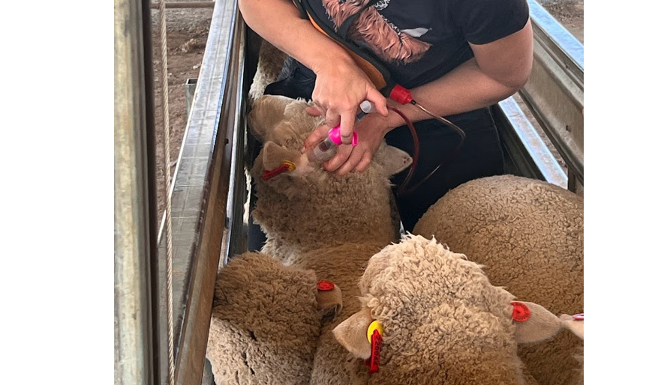

Wool enterprises
Key terms
Wool clip – the total amount of wool collected from a group of sheep in one shearing.
Infrastructure – the buildings and systems needed for farming, like shearing sheds or roads.
Investment – putting money into improvements that help the farm grow or produce more.
Biodegradable – able to break down naturally in the environment.
Consumer choice – the decisions people make when buying, using or reusing products.

23. Wool production in Australia
Australia is one of the largest wool producers in the world. Different states contribute varying amounts to the national wool clip based on sheep populations, rainfall zones and pasture quality.
Wool by numbers
Table 31 – wool production in Australia in 2023–2024
State | Sheep numbers shorn (million) | Shorn wool production (millions of kg):
New South Wales | 26.6 | 119.5
Victoria | 15.6 | 65.6
Western Australia | 12.5 | 55.0
South Australia | 11.0 | 58.0
Tasmania | 2.8 | 9.3
Queensland | 2.7 | 10.0
(Source: Australian Wool Innovation Limited 2024)
Each small group represents a different Australian state in a funding simulation. Each group will argue to the ‘National Wool Board’ (the teacher) that their state deserves investment in wool production infrastructure (for example, roads, shearing sheds, transport hubs, processing plants).
Groups must:
- use the provided wool production data
- research their state’s climate, rainfall, sheep breeds and wool types
- recommend realistic upgrades to improve wool production or market access
- build a justified, persuasive argument for funding
- pitch your funding argument to the National Wool board in 2 minutes or less. Visual stimulus may be used if relevant.
Planning scaffold
State: Victoria
- How much wool does your state produce? How does this compare to other states?
Sample answer:
65.6 million kg from 15.6 million sheep shorn.
- What environmental/climate factors affect production?
Sample answer:
Temperate climate, reliable rainfall in western districts, excellent pastures.
- What breeds are common?
Sample answer:
Strong Merino base, growing interest in dual-purpose breeds like Dohne.
- What is your main export focus?
Sample answer:
High-quality fine wool, strong export to Europe and China.
- What infrastructure issues exist?
Sample answer:
Bottlenecks in transport from western districts, ageing shearing sheds.
- What upgrades are you requesting and why?
Sample answer:
Better rural transport links, new shearing shed subsidies, digital wool classing tech.
This will improve efficiency and increase quality and market value.
Reflection
- Which factors most affected wool production across states?
- What types of infrastructure could improve wool quality or quantity?
- How do environmental conditions influence breed suitability?
- Why might some lower-producing states still deserve investment?

24. Characteristics of wool
Australia is one of the world's top wool producers, especially fine Merino wool. Wool is sold based on market specifications that influence the final product’s use (for example suits versus carpet) and its price. Wool is assessed based on fibre diameter, length, strength and appearance. Understanding how to assess wool visually helps farmers, classers and buyers make better decisions in the paddock and the shed.
Table 32 – characteristics of quality wool
Trait | Description | Market preference
Fibre diameter | Thickness of each fibre (microns) | Fine wool (17–21 µm) earns more; it's softer and used in premium clothing
Staple length | Length of wool fibre | Long, even staples are easier to process and spin
Staple strength | Measured in Newtons/kilotex (N/ktex) | Weak points cause breakage during spinning
Colour | Whiteness/brightness | Bright white preferred for dyeing
Crimp | Natural wave of the fibre | Consistent crimp indicates fineness and elasticity
Vegetable matter (VM) | Seeds, burrs, dust | Low VM increases value as it is easier to process
Practical activity
Examine 3 fleece samples or photographs.
Score the wool on each trait using the guide (5 = best, 1 = worst). Add the scores and then give each fleece an overall quality rating. Finally, match each fleece to its best market.

Table 33 – wool score card
Fleece ID | Wool colour | Crimp/character | Dust/VM | Staple length (cm) | Total score | Rating (poor/ average/ premium) | Suggested market
A
B
C

25. Wool processing
Once shorn, raw wool goes through a series of steps to become a usable product. Cleanliness, fibre length and strength affect how easily wool can be processed.

Follow the fibre
Sequencing activity
Put the following wool processing steps in the correct order into the table that follows:
- Carding
- Scouring
- Shearing
- Weaving or knitting
- Spinning
- Skirting.
Process descriptions
For each step, identify:
- what happens during the step
- what equipment is used (if known)
- what the outcome is.
Example
Scouring – wool is washed to remove grease and dirt using detergent and warm water. Clean wool is dried and ready for carding.
Figure 19 – wool sample

Table 34 – wool processing steps and descriptions
Processing step | Description

Wool uses
Wool is one of Australia’s most important agricultural products — not just for clothing, but for carpets, insulation, medical supplies and more. But what makes wool really stand out is its sustainability. Unlike synthetic fibres made from oil, wool is a natural, renewable resource that can break down in the environment, be reused or recycled, and produced with low energy.
Sustainable management of wool begins on the farm, where sheep are bred, fed and shorn in ways that look after the animals and the land. But it doesn’t end there — the type of wool grown, and the way it’s processed and used, also affects how eco-friendly a product is. In this lesson, you’ll explore the different ways wool is used, and how each product supports — or sometimes challenges — sustainable farming and consumer choices.
Note: sample answers have been provided in the product use column.
Table 35 – products made from wool and their sustainability evaluation
Product | Wool type used | Product use | Sustainability benefit | Challenges
Wool suit | Fine Merino | High-end clothing | Long-lasting, biodegradable | Dry clean only, blends may reduce recycling
Wool carpet | Medium wool | Durable flooring | Renewable, natural insulation | Expensive, hard to recycle post-use
Wool insulation | Coarse wool | Building material | Reduces energy use, non-toxic | Moisture sensitive
Wool bandages | Medical-grade fine wool | Medical use | Naturally antibacterial, biodegradable | Single use
Wool socks | Fine to medium wool | Everyday wear | Breathable, long-lasting, biodegradable | Blends with synthetics reduce recyclability
Wool-fibre mattress | Coarse/felted wool | Bedding | Insulating, biodegradable, natural fire retardant | Heavy, costly
Wool-felt craft items | Felted fine/medium wool | Craft and fashion accessories | Recyclable, low-energy production | Limited scale
Wool-polyester blend top | Low wool content | Fast fashion | Some comfort from wool | Mostly synthetic, not biodegradable
Questions
- What makes wool a renewable and sustainable fibre?
Sample answer:
Ability to breakdown in the environment, how sheep are farmed, and it is a grown fibre from a natural product (sheep).
- How does using wool reduce environmental waste?
Sample answer:
It breaks down naturally and doesn’t contribute to microplastic pollution, it also has a lower carbon footprint than synthetics and its durability reduces the need for frequent replacements.
- Why are blended wool products harder to recycle?
Sample answer:
It is difficult to separate the mixed materials when they are combined.

Wool in a circular economy
A circular economy is a way of thinking about products and resources that aims to reduce waste and keep materials in use for as long as possible. Instead of the traditional ‘make → use → throw away’ model, a circular economy encourages us to ‘make → use → reuse, recycle or return to the earth.’
Wool is a great example of a fibre that fits into this model because it’s renewable, biodegradable and recyclable.
Wool is one of the few truly circular fibres. But it only stays that way if everyone in the chain plays their part.
Questions
- What role do farmers play in making wool sustainable?
Sample answer:
Their role is to implement practices that benefit the environment, including using responsible land management techniques that contribute to long-term sustainability of the soil, natural resources and airways.
- How can manufacturers reduce their waste or pollution?
Sample answer:
They could implement sustainable practices such as using biodegradable detergents and water efficient machinery during the wool scouring process.
- What decisions do consumers need to make to keep wool in a circular economy?
Sample answer:
Consumers could choose to reuse, repair and recycle wool products where possible.
- What challenges stop wool from being reused or recycled?
Sample answer:
When wool is mixed with other materials like synthetics it makes it more difficult to recycle as do use of dyes.

26. Agricultural issues – shearer shortage
Australia’s wool industry relies on skilled shearers. With fewer workers entering the trade and others staying overseas, shortages are affecting producers, timelines and costs.
Use the information from the Overseas staff to fill the gap in busy periods to answer the following.
Questions
- Australia previously relied on New Zealand shearers to fill the gap during peak harvest times. What major event prevented this from happening?
Sample answer:
The COVID-19 pandemic disrupted the usual influx of New Zealand shearers into Australia. Travel restrictions and border closures halted their movement, leading to significant labour shortages in Australian wool sheds.
- Why did overseas shearers tend to travel to New Zealand to shear instead of Australia?
Sample answer:
Shearers preferred New Zealand due to the prevalence of crossbred sheep, which are generally easier to shear than Merinos. Additionally, New Zealand's shearing season aligned well with the off-season in the UK, making it a convenient choice for these workers.
- Describe the initiative from Australian Wool Innovation (AWI) to attract more shearers to Australian wool sheds.
Sample answer:
AWI launched an initiative that included a promotional video featuring young Welsh shearers working in New South Wales, highlighting the opportunities in Australia. AWI also offered training in shearing Merinos to help overseas workers adapt to Australian conditions.
- What are the short and long-term consequences of not filling shearing vacancies?
Sample answer:
Short term – unfilled shearing positions can lead to delays in wool harvesting, potentially affecting wool quality and farm operations.
Long term – increased pressure on the existing workforce, potential loss of income for farmers, and a decline in the overall efficiency and sustainability of the wool industry.
What could be done to attract more workers to shearing in Australia?
Table 36 – brainstorm table
Strategy | Who would implement it? | Benefits
Improve working conditions | Employers | More attractive job

Practical skills checkpoint
Table 37 – skills assessment checklist
Criteria | Checkbox
Students assess or compare farm products based on quality according to market specifications. | ☐

Sheep meat enterprises
Key terms
Processor – a company that turns live sheep into meat for sale.
Market specification – the preferred size, weight and quality of animals for a buyer.
Conformation – the shape and muscle build of an animal’s body.
Animal welfare – making sure animals are treated kindly and kept healthy.
Stakeholder – a person or group with an interest in a farming issue, like farmers or animal rights groups.

27. Australia’s sheep meat industry
Australia stands as one of the world's leading producers and exporters of sheep meat, encompassing both lamb and mutton. The industry plays a pivotal role in the nation's agricultural sector, contributing significantly to the economy and supporting rural communities.
Australia exports lamb and mutton to over 100 countries. Meat quality, breed suitability and market requirements influence how sheep are raised and sold. Key export destinations for sheep meat include: China, the United States of America and South Korea.
Key statistics of Australia’s sheep meat industry – 2024
- National flock size: approximately 74 million head in 2024.
- Lamb production: reached a record 629,385 tonnes in 2024, marking a 6% increase from the previous year.
- Mutton production: totalled 255,098 tonnes in 2024, a 22% rise compared to 2023.
- Export volume: Australia exported 359,229 tonnes of lamb and 255,098 tonnes of mutton in 2024.
- Export destinations: Australian sheep meat was exported to over 100 countries, with major markets including the United States, China and South Korea.
Colour the top 3 export destinations or Australian sheep meat on the map below.
Figure 20 – blank world map

Questions
- Why do you think these countries are major importers of Australian sheep meat?
- What factors might influence a country's preference for lamb or mutton?
- How does Australia's sheep meat industry impact its economy and international trade relations?

28. Sheep meat market specifications
Different markets have different expectations for the size, condition and quality of lamb and mutton. Understanding specifications helps producers target their product effectively and meet consumer demands, both domestically and overseas.
Practical activity
Look at 5 sheep in the school paddock. Record their estimated liveweight, age, condition score and breed. Then use the specification tables to decide which market each animal would best suit.
For the purpose of this activity, you can estimate carcase weight using the following formula and assume dressing percentage of the livestock is a standard 50%.
Estimated carcase weight = liveweight × dressing percentage.
Example: sheep A is 54 kg on the school scales. Estimated carcase weight = 54 × 50% = 27 kg

Table 38 – school sheep data collection
Animal ID | Breed | Estimated liveweight | Estimated carcase weight | Fat score | Best market option | Reason

Specification tables
Table 39 – domestic lamb
Market segment | Carcase weight (kg) | Preferred market fat scores | Comment
Supermarket lamb | 18–22 | 2 and 3 | Second cross preferred
Food service lamb | 20–25 | 2 and 3 | Lean and high yielding preferred
Other domestic lamb | Variable | 2–4 | Range of types depending on end user requirements
Table 40 – export lamb
Market segment | Carcase weight (kg) | Preferred market fat scores | Comment
Heavy export | 20–30 | 2–4 | North America prime cuts
Light export | 10–16 | 2 | Mainly Middle Eastern markets
‘Haj’ market | 35–41 | - | Market is for lambs (6–12 months). Entire males with long tail preferred
Table 41 – export sheep meat markets for hogget and mutton
Market segment | Carcase weight (kg) | Preferred market fat scores | Comment
Heavy export | Greater than 20 | 2–4 | Heavy carcase weights preferred
Light export | 14–16 | 1–2 | Lightweight, lean carcases
Live sheep | n/a | n/a | Wethers more than 50 kg liveweight

Sheep abattoir feedback
After animals are processed, feedback on carcase weight and fat score helps producers refine future decisions. This information ensures flocks meet market needs and improve in productivity over time.
Using the market specifications tables and the information collected for each of the animals below, identify one or more suitable markets for selling the animal. Add your answers in the far-right column.
Note: sample answer provided in suitable markets column.
Table 42 – example sheep data
Animal ID | Breed/age | Liveweight (kg) | Carcase weight (kg) | Fat score | Suitable markets
101 | First cross 6 months | 30 | 18 | 3 | Possibly domestic supermarket or other
201 | First cross 8 months | 41 | 23 | 3 | Domestic food service
301 | Suffolk 12 months | 55 | 41 | 2 | Heavy export or other domestic lamb (depends on tooth count)
401 | Second cross 6 months | 32 | 20 | 2 | Domestic supermarket
501 | Second cross 8 months | 42 | 25 | 3 | Domestic food service
Calculate the dressing percentage for each animal using the formula:
Dressing percentage = carcase weight ÷ liveweight × 100
Challenge question
Which animal is most efficient in converting feed to meat? What factors might influence dressing percentage?

29. What makes quality lamb?
Australian sheep producers must meet strict market specifications to sell their lamb domestically and internationally. These specifications are set by buyers and processors to ensure consistent quality. Lamb that meets the right weight, fat cover, colour and tenderness standards earns a higher price and is more likely to be accepted by premium markets.
Markets will often reject or discount carcases that are:
- too lean or too fat
- too heavy or too light
- dark in colour (a sign of stress before slaughter)
- lacking intramuscular fat (marbling) or have uneven fat coverage.
These traits are influenced by farm-level decisions such as breed choice, feeding and animal handling. Understanding what buyers want helps farmers make better breeding, feeding and handling decisions.
Match the market specification with its meaning and why it matters.
Specifications to include: marbling, fat score, carcase weight, conformation, colour.
Table 43 – market specification terms
Specification term | Meaning | Why it matters
 | The weight of the animal after slaughter, with skin, head and organs removed | Ensures it fits processing and retail packaging standards
 | Amount and distribution of fat cover on the carcase | Prevents drying out, affects eating quality
 | Visual appearance of lean meat | Bright pink equals freshness, dark meat equals lower value
 | Small flecks of fat in the muscle | Improves flavour, juiciness
 | Shape and muscle development of the carcase | Well-muscled animals yield more meat and fetch better prices
Real-world decisions
Complete the table to show how farmers influence market specifications. Make a decision if the farmer decision has a positive or negative effect on meat quality.
Table 44 – on-farm decisions and their effects
Producers’ decision | Effect on specification | Positive or negative?
Choose a terminal sire breed (for example White Suffolk) | Increases muscle conformation
Overfeed animals before sale | Raises fat score above ideal range
Handle animals calmly before slaughter | Improves meat tenderness and colour
Sell lambs at 60 kg liveweight | Results in ideal 22 kg carcase weight
Graze on low-quality pasture | Slows growth, reduces marbling

Exit ticket
Why do markets have specific quality requirements for lamb, and how do these impact the way sheep are raised?

30. Understanding sheep carcase cuts
After slaughter, a sheep is processed into a variety of cuts that differ in value, use and consumer preference.
Every time we buy lamb chops, roasts or shanks at the shop, we’re looking at the result of a whole production process. Once lambs are processed, their carcases are divided into primal cuts, which are then broken down further into familiar retail portions.
The value of each cut depends on tenderness, fat coverage, flavour, bone content and demand. For example, loin chops are quick to cook and popular in Aussie BBQs, while shanks need long, slow cooking but are full of flavour.
Marketing lamb effectively means knowing what the customer wants – and providing the right cut, at the right quality, at the right time.
Carcase cut and labelling task
Using the MLA lamb primal cuts poster, label this simplified diagram of a lamb carcase with the following cuts:
- neck
- shoulder
- loin
- rack
- leg
- shank
- flank.
Figure 21 – blank sheep outline
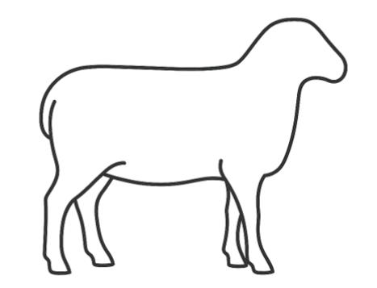
Note: sample answers have been provided in the Value tier column.
Table 45 – cut comparison table
Cut | Cooking method | Description | Value tier
Loin | Grilling, frying | Very tender, boneless | High
Shoulder | Roasting, stewing | Flavourful, more connective tissue | Medium
Shank | Braising, slow cook | Tough, needs time | Low
Rack | Roasting | Premium, tender, fancy cut | High
Leg | Roasting, grilling | Versatile, lean, large cut | Medium
Neck | Stewing | Cheap, flavourful | Low
Flank | Grilling, stir-fry | Thin cut, low fat | Low
Questions
- Why do some cuts sell for more money?
- Which cuts would a chef choose for fine dining? For a budget meal?
- How might breeding or feeding affect tenderness and fat content?

31. Agricultural issues – live exports
Live sheep export contributes to the Australian economy but raises concerns about animal welfare. Government and industry must balance these factors when making decisions about its future.
Use the information from Pasture.io, Australia’s Live Export Industry: What It’s Worth & How Agtech Plays a Role, to answer the following.
Questions
- What is live export?
Sample answer:
The selling of animals to an overseas market and shipping them alive to be slaughtered in the country that has purchased them.
- How much is it worth to Australia annually?
Sample answer:
It contributes around $250 million to the economy annually.
- Where do most exported sheep go?
Sample answer:
From the Western Australian market, typically the sheep are sold to the Middle Eastern markets.
- Why is the trade controversial?
Sample answer:
Conditions for the animals in other countries that purchase them are not necessarily governed by Australia and can be inhumane. During transport, heat conditions can be excessive during certain times of the year.
Complete the stakeholder analysis table.
Note: sample answers have been provided in the table below.
Table 46 – stakeholder analysis table
Stakeholder | Concerns/needs | View on live export
Farmer | Reliable income stream | Support continuation
Animal welfare group | Animal welfare during transport | Oppose or want stricter controls
Government | Public concern versus trade relationships | Mixed
Challenge question
Should Australia ban live sheep exports? Compose a persuasive paragraph, using evidence to support your opinion.

Practical skills checkpoint
Table 47 – skills assessment checklist
Criteria | Checkbox
Students assess or compare farm products based on quality according to market specifications. | ☐

Appendix

Ear tagging
Printable model for cardboard or vinyl – appendix
Figure 22 – diagram of cow’s ear with NLIS tag correctly placed


Printable model for cardboard or vinyl – appendix
Figure 23 – diagram of cow’s ear
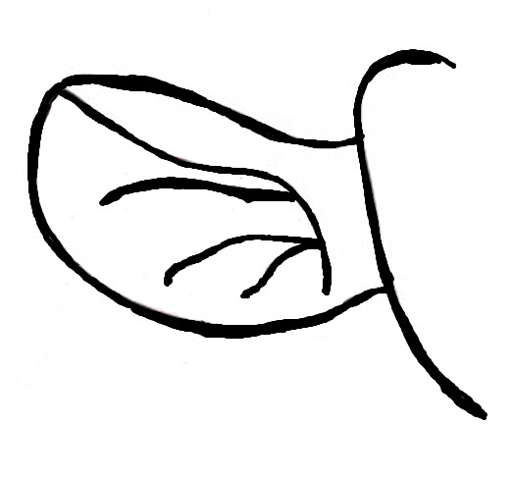

Why good data matters
Table 48 – sample data for 20 sheep used in the previous scenarios
VID | Sex | Age | Weight (kg) | Pregnancy status | Health inspection | Sire ID | Previous lambing
001 | Female | 2 | 45.2 | No | Good | 04200 | Maiden
002 | Female | 5 | 41.8 | No | Good | 03952 | Twin
003 | Female | 5 | 50.5 | Yes | Lame, front right hoof | 03952 | Twin
004 | Female | 3 | 48.9 | Yes | Good | 04283 | Single
005 | Female | 5 | 46.3 | Yes | Good | 04200 | Twin
006 | Female | 3 | 42.7 | Yes | Good | 03952 | Twin
007 | Female | 2 | 47.1 | Yes | Good | 04200 | Twin
008 | Female | 3 | 44.6 | No | Pinkeye | 04283 | Single
009 | Female | 3 | 49.8 | No | Good | 04277 | Single
010 | Female | 2 | 43.5 | Yes | Flystrike, breech | 03952 | Single
011 | Female | 3 | 48.0 | No | Good | 03952 | Empty
012 | Female | 4 | 46.9 | Yes | Good | 04200 | Twin
013 | Female | 2 | 51.2 | No | Good | 04200 | Maiden
014 | Female | 2 | 48.8 | No | Pinkeye | 04200 | Single
015 | Female | 4 | 44.3 | No | Good | 04277 | Single
016 | Female | 4 | 50.0 | Yes | Foot abscess | 04277 | Single
017 | Female | 2 | 45.7 | Yes | Open wound on back right leg | 04277 | Maiden
018 | Female | 5 | 48.5 | Yes | Good | 04200 | Empty
019 | Female | 4 | 46.6 | No | Good | 04200 | Single
020 | Female | 5 | 42.1 | Yes | Lame, back left hoof | 03952 | Twin

Careers in the sheep industry
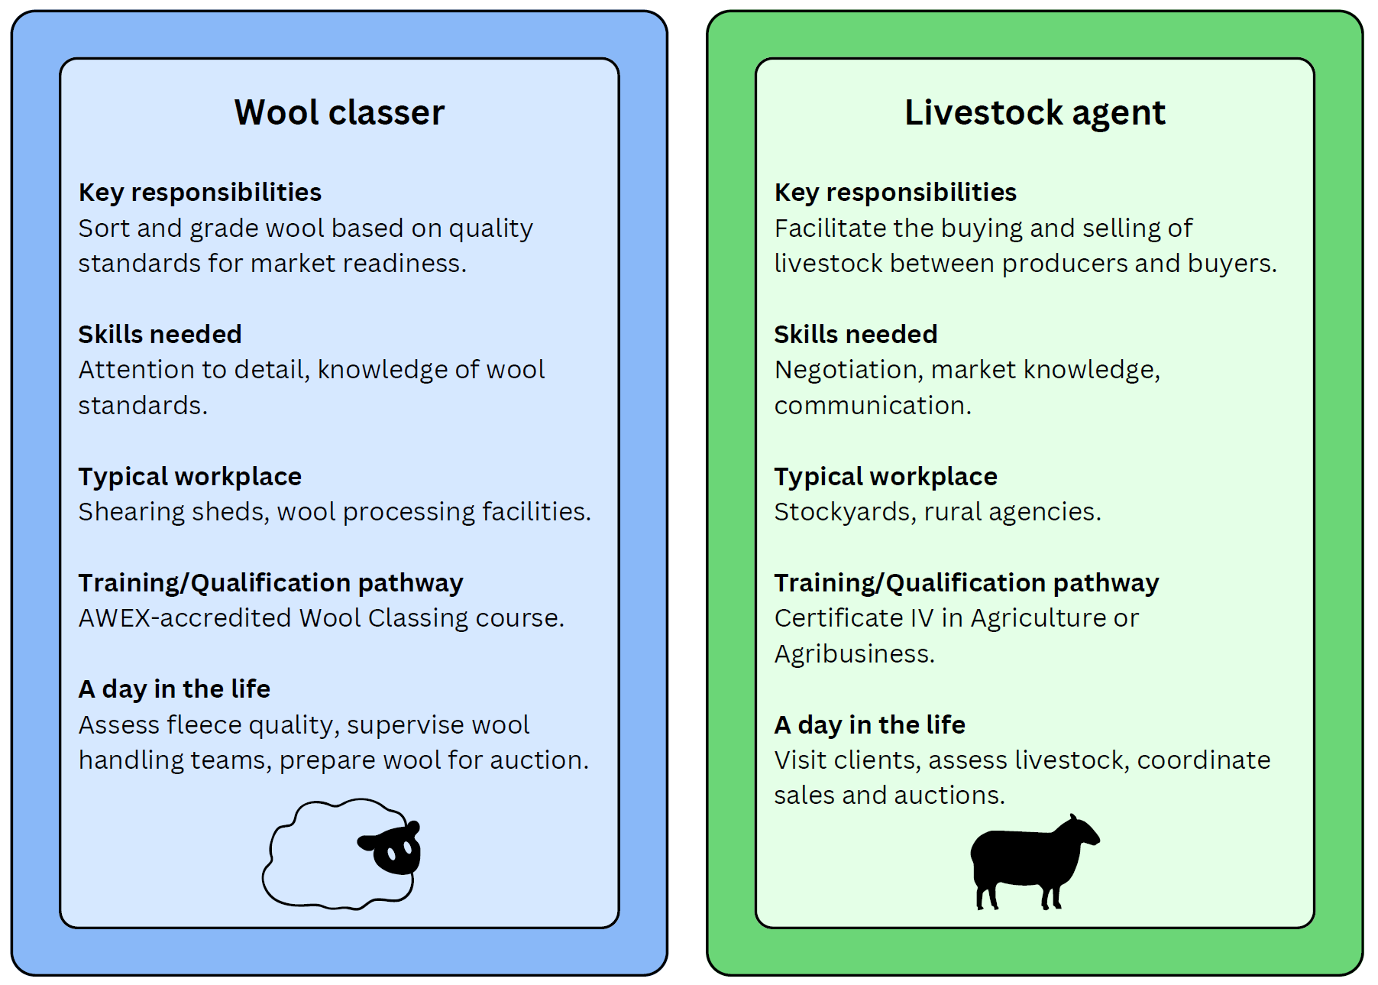
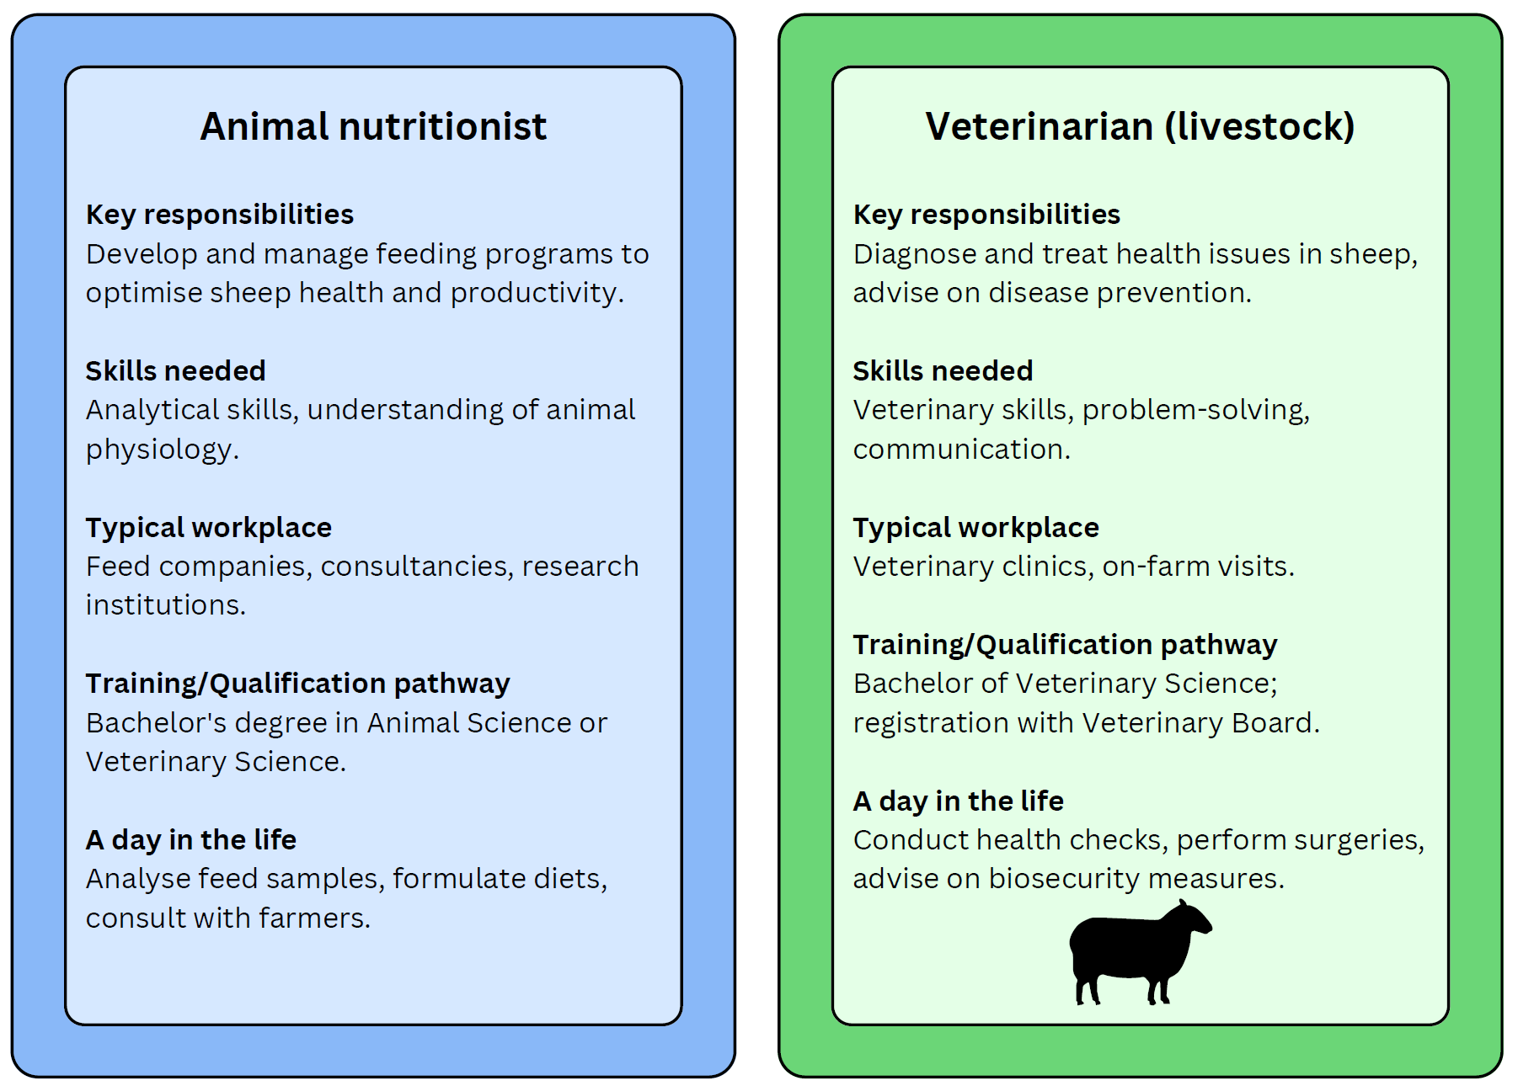
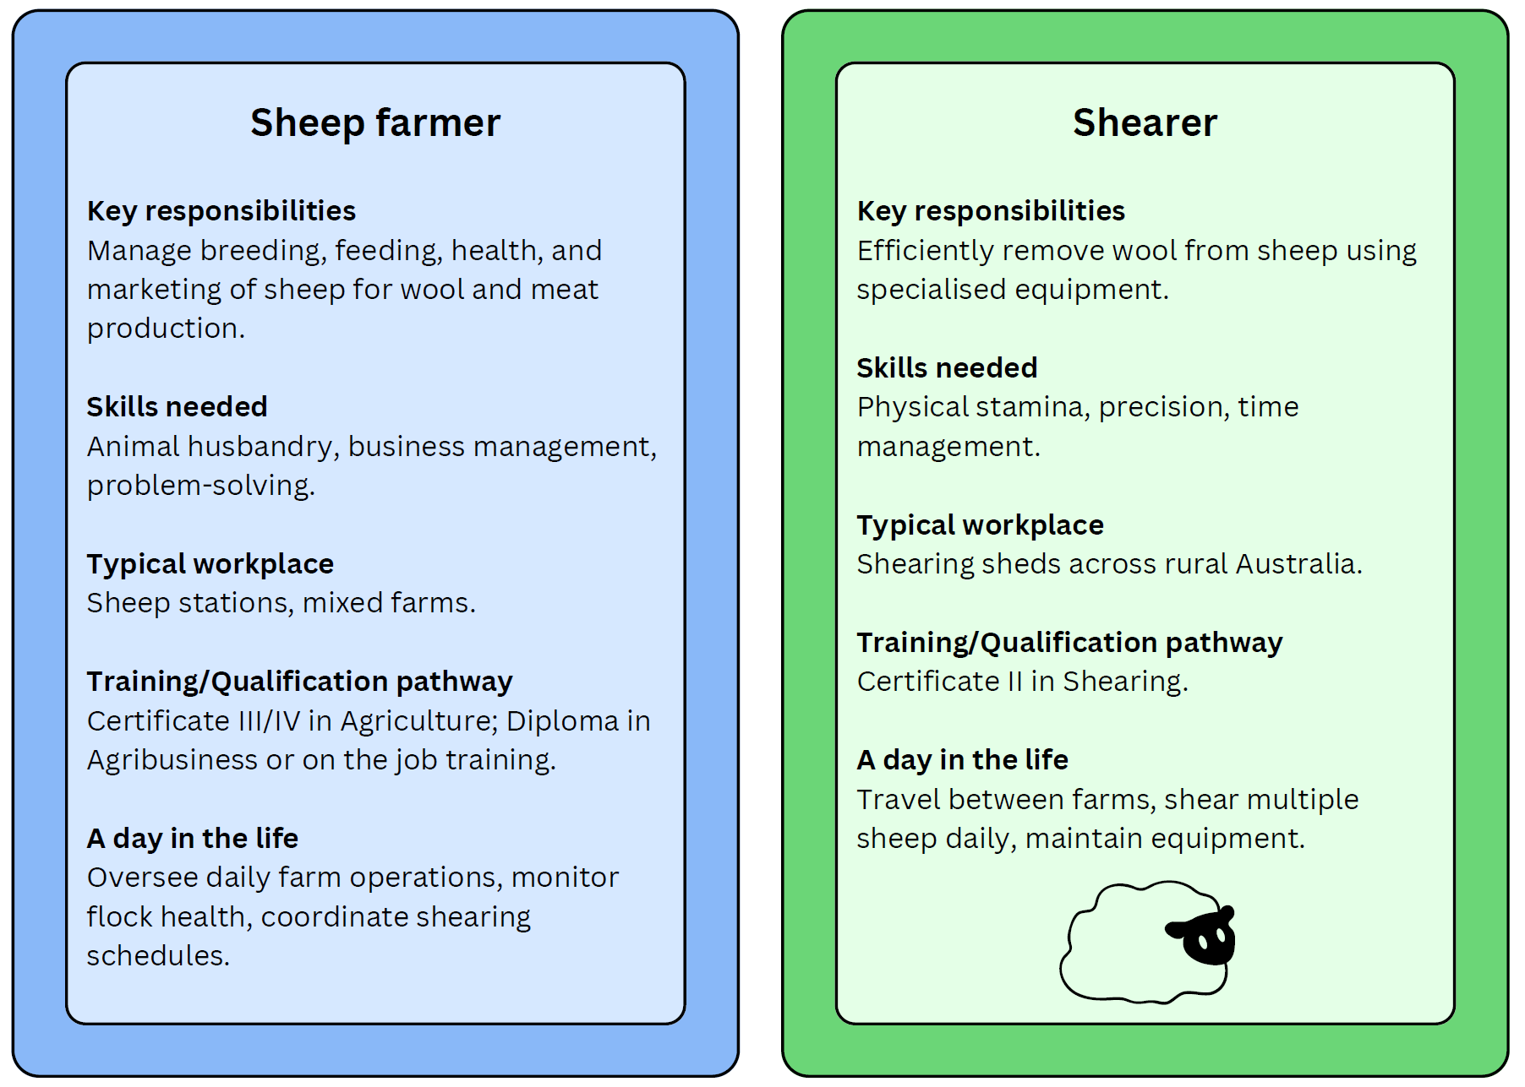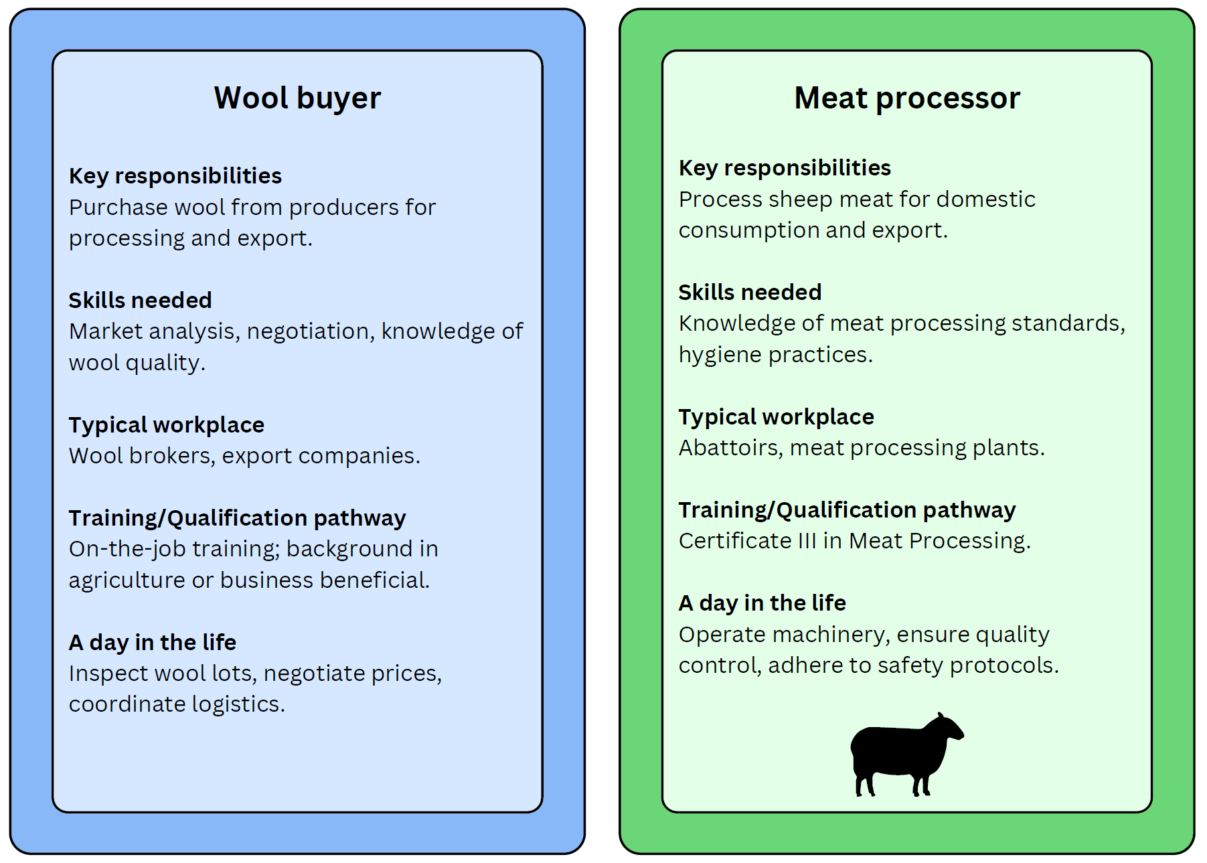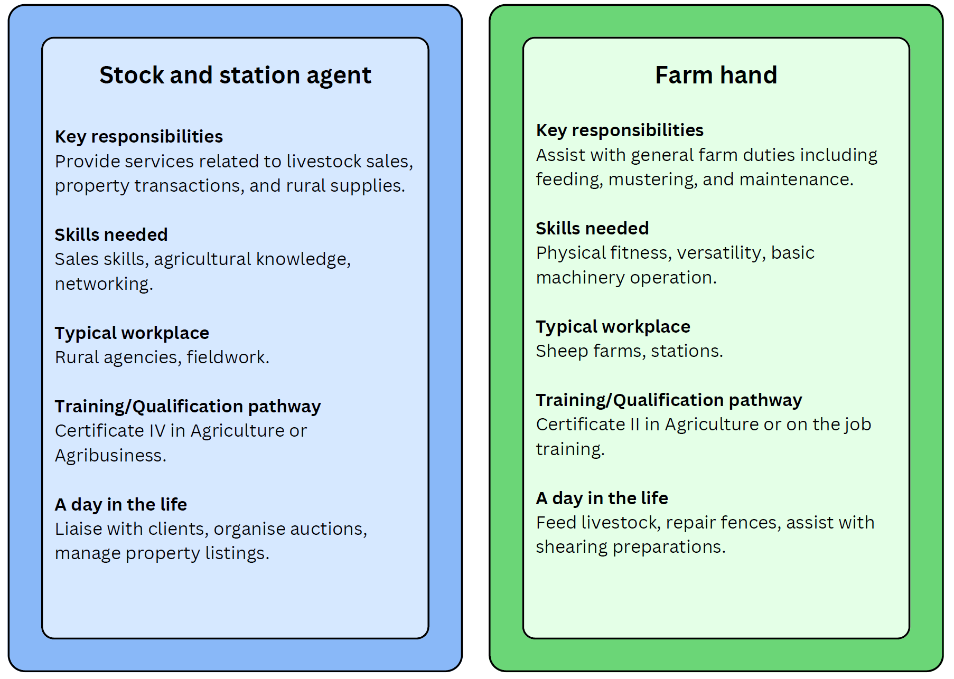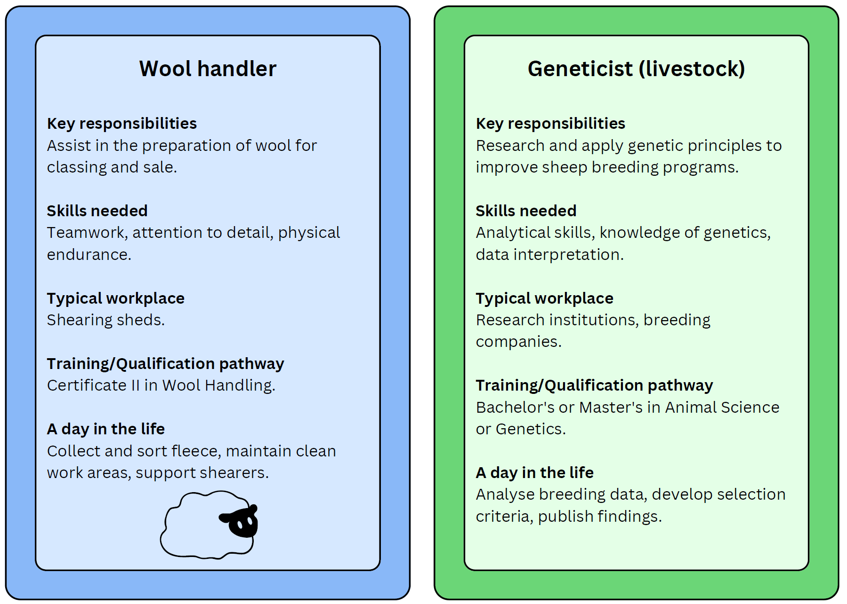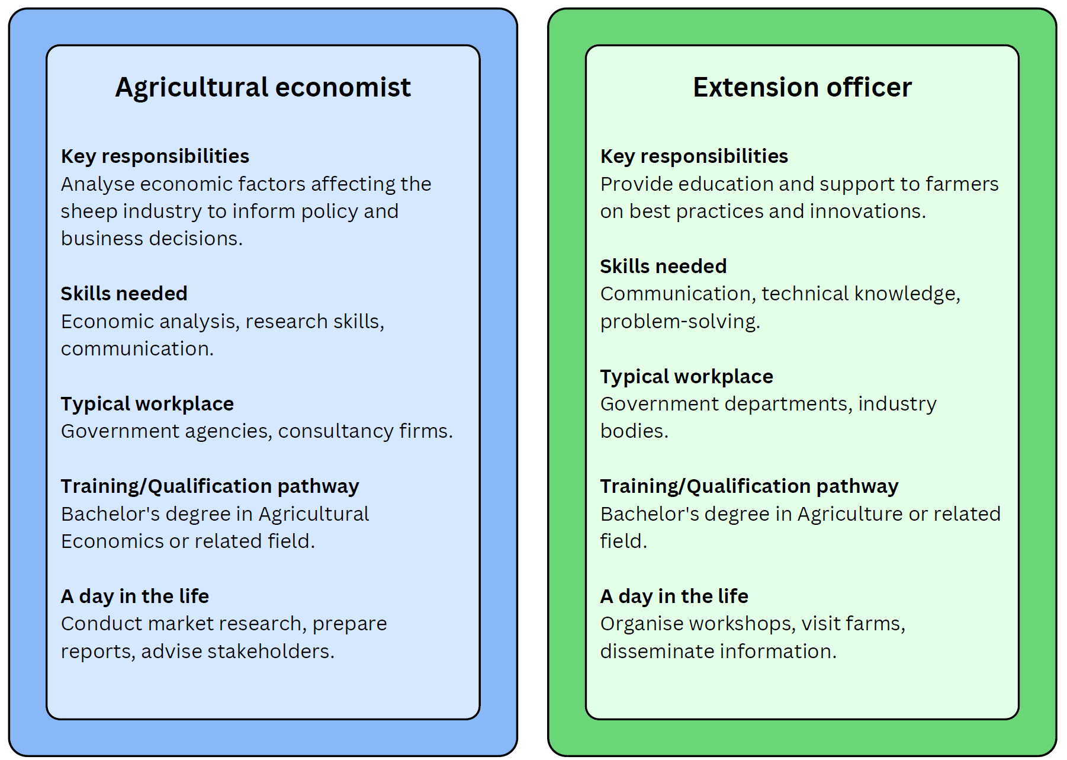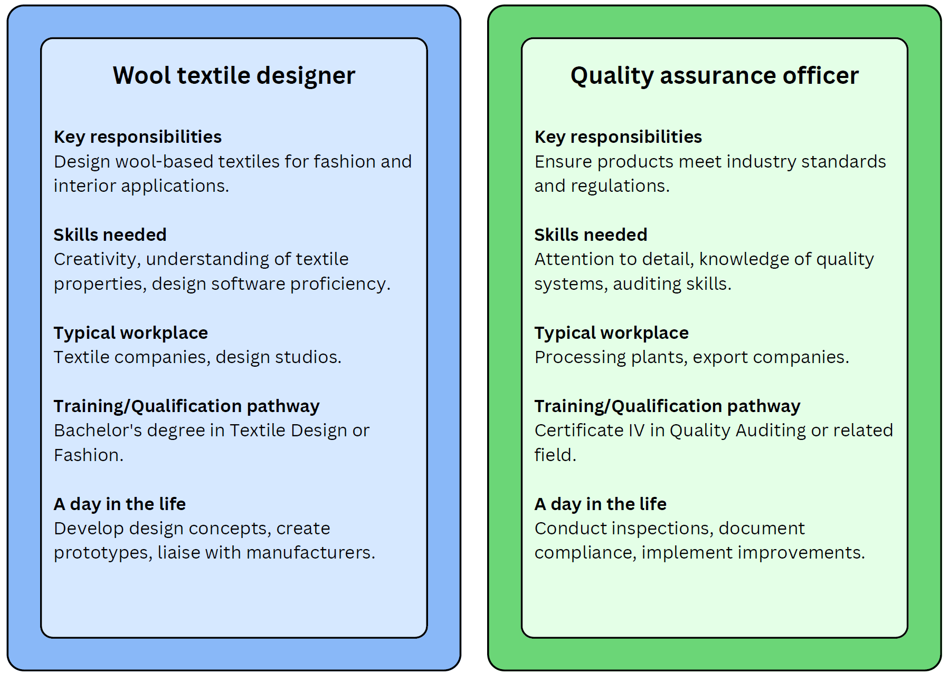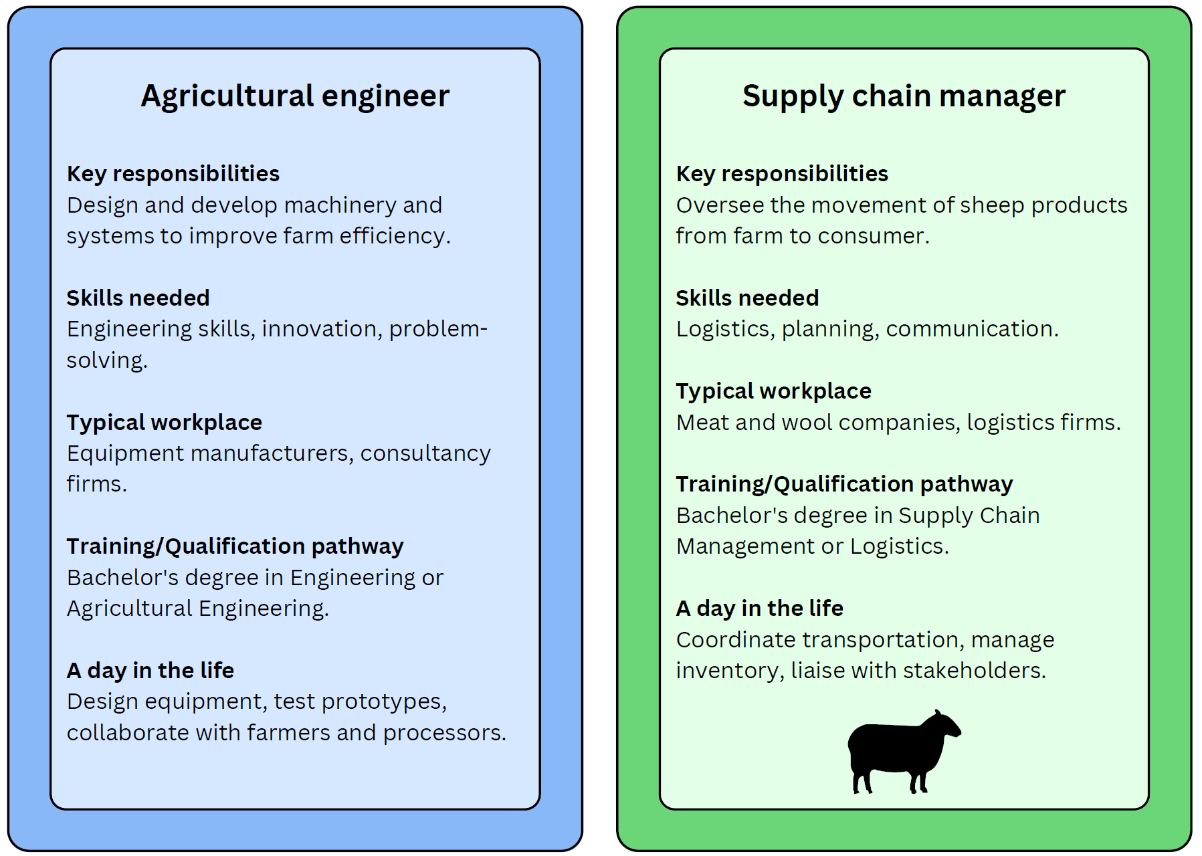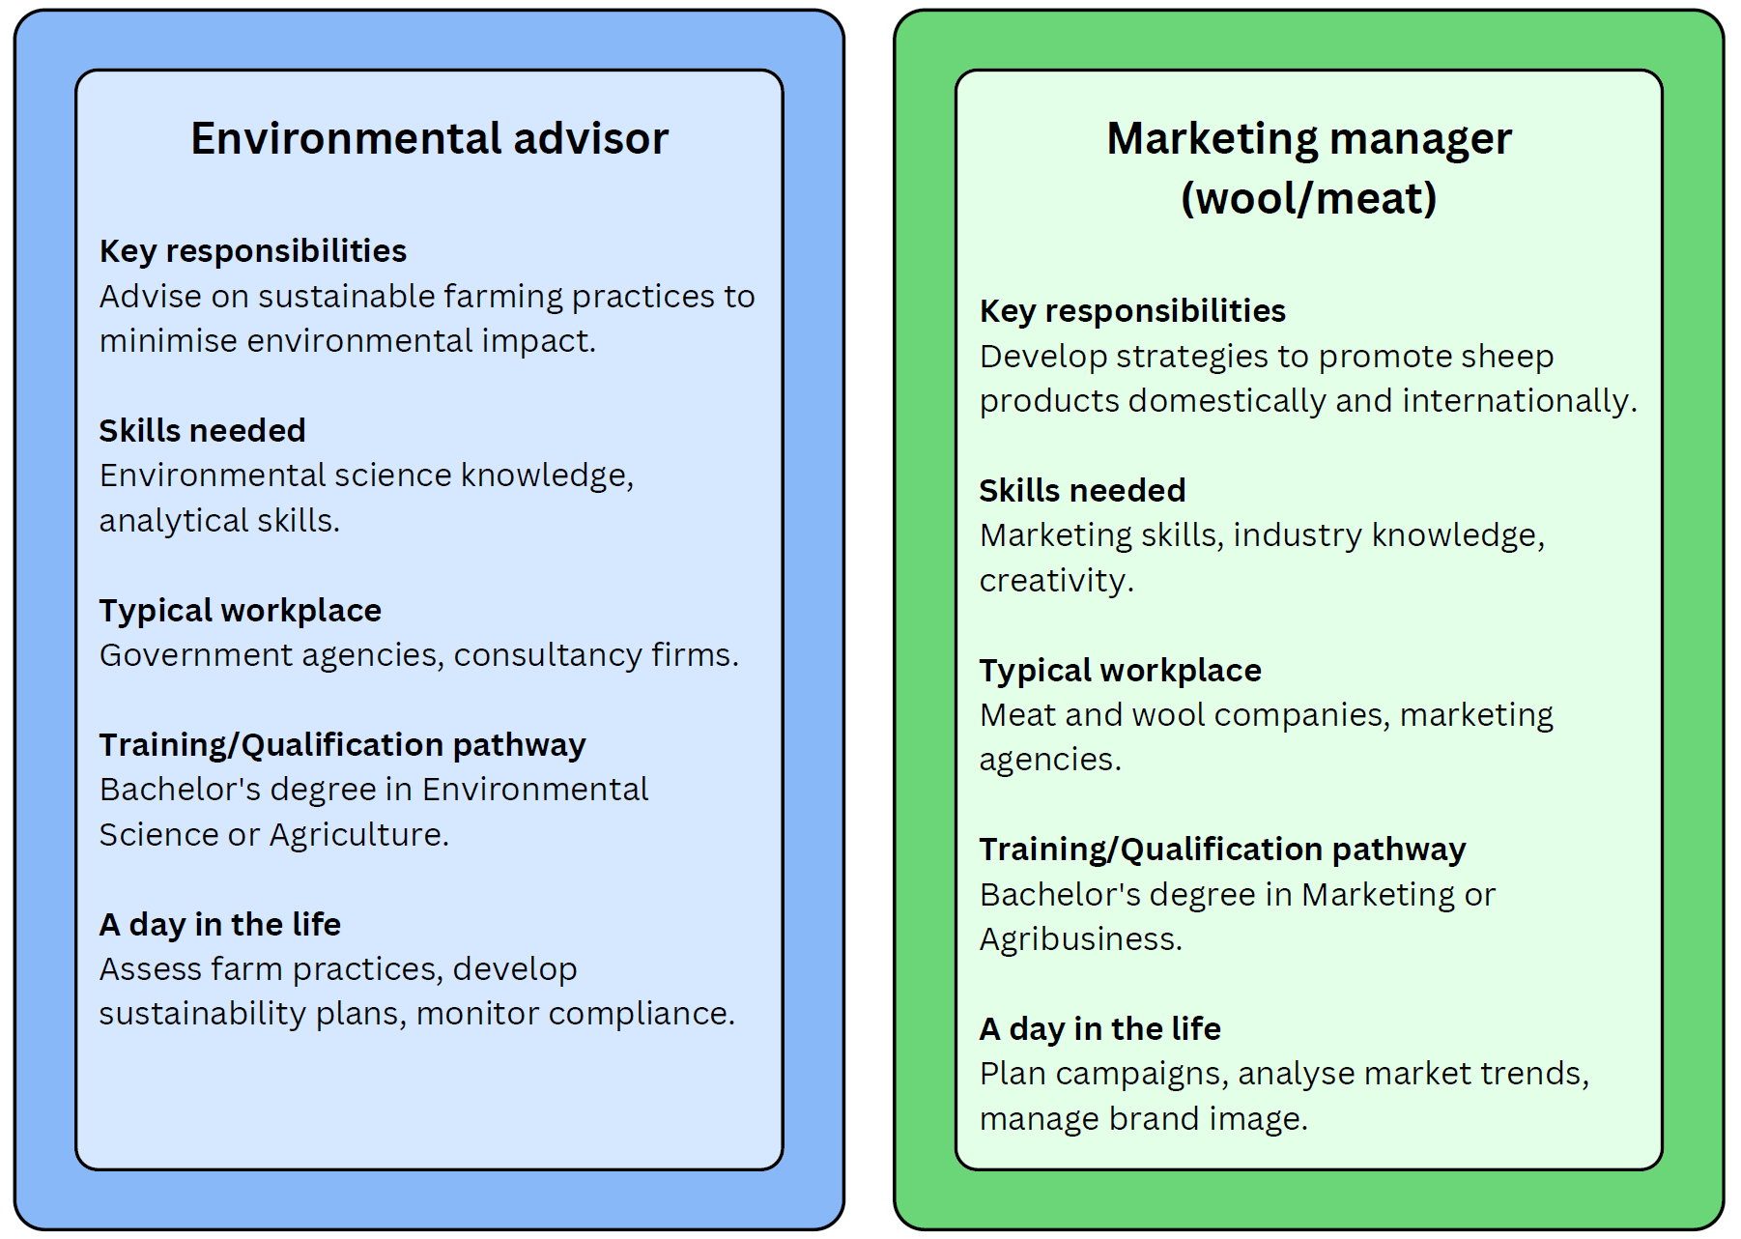

National Wool Board funding allocation sheet
Table 49 – teacher marking rubric
Criteria | Score (1–5)
Use of data
Understanding of state conditions
Realism of upgrades
Persuasiveness of pitch
Collaboration/clarity
You can either:
- Allocate funding ‘points’ to each group (based on score)
- Pick one or two states for a larger ‘investment’ and explain why.

References
This resource contains NSW Curriculum and syllabus content. The NSW Curriculum is developed by the NSW Education Standards Authority. This content is prepared by NESA for and on behalf of the Crown in right of the State of New South Wales. The material is protected by Crown copyright.
Please refer to the NESA Copyright Disclaimer for more information https://educationstandards.nsw.edu.au/wps/portal/nesa/mini-footer/copyright.
NESA holds the only official and up-to-date versions of the NSW Curriculum and syllabus documents. Please visit the NSW Education Standards Authority (NESA) website https://educationstandards.nsw.edu.au and the NSW Curriculum website https://curriculum.nsw.edu.au.
Agriculture Technology 7–10 Syllabus © NSW Education Standards Authority (NESA) for and on behalf of the Crown in right of the State of New South Wales, 2024.
Australian Wool Innovation Limited (2024) Sheep Numbers by State, Australian Wool Innovation Limited website, accessed 19 September 2025.
Commonwealth of Australia (2023) Agricultural Commodities, Australia: Statistics on the production of principal agricultural commodities including cereal and broadacre crops, horticulture and livestock, Australian Bureau of Statistics website, accessed 19 September 2025.

© State of New South Wales (Department of Education), 2025
The copyright material published in this resource is subject to the Copyright Act 1968 (Cth) and is owned by the NSW Department of Education or, where indicated, by a party other than the NSW Department of Education (third-party material).
Copyright material available in this resource and owned by the NSW Department of Education is licensed under a Creative Commons Attribution 4.0 International (CC BY 4.0) license.

This license allows you to share and adapt the material for any purpose, even commercially.
Attribution should be given to © State of New South Wales (Department of Education), 2025.
Material in this resource not available under a Creative Commons license:
- the NSW Department of Education logo, other logos and trademark-protected material
- material owned by a third party that has been reproduced with permission. You will need to obtain permission from the third party to reuse its material.
Links to third-party material and websites
Please note that the provided (reading/viewing material/list/links/texts) are a suggestion only and implies no endorsement, by the New South Wales Department of Education, of any author, publisher, or book title. School principals and teachers are best placed to assess the suitability of resources that would complement the curriculum and reflect the needs and interests of their students.
If you use the links provided in this document to access a third-party's website, you acknowledge that the terms of use, including licence terms set out on the third-party's website apply to the use which may be made of the materials on that third-party website or where permitted by the Copyright Act 1968 (Cth). The department accepts no responsibility for content on third-party websites.

