Technology 7–8 – Textile materials and production processes – teacher support resource
Sew sustainable, sew awesome!

Contents
Teacher support resource and unit overview 3
Glossary 4
Textile tales – a beginner's journey 6
Where are textiles? 6
What do textiles look like, feel like, sound like? 8
Fibres, yarns and fabrics 10
Fibres 11
Safety in textiles 15
Equipment in textiles 17
Do now – Textile equipment revision 19
How do I use a sewing machine? 20
Threading the machine 20
Filling and inserting a bobbin 22
Controlling the machine direction and speed 23
Seam sample 25
Fancy machine stitching 27
Fabric decoration 29
Appliqué 31
Stencilling 33
Sun printing 38
Sew sustainable, sew awesome! 42
Identifying and defining 42
Design situation 42
Design brief 42
Researching and planning 43
Spheres of influence 45
How many bags and plastics? 46
The life of a plastic bag 47
Logo design 48
Investigating products and systems developed by Aboriginal and Torres Strait Islander peoples 49
Aboriginal carrying items 49
Aboriginal weaving 50
Weaving 52
Contemporary uses of plastics 57
Plastics experiment – plastic fusion 61
Project development 66
The design and production process 66
Identifying and defining 67
Researching and planning 69
Producing and implementing 75
Testing and evaluating 79
Appendix 82
Appendix 1 – instructions for pencil case 82
Appendix 2 – instructions for Option 1 – drawstring backpack 83
Appendix 3 – instructions for Option 2 – wall organiser 88
Appendix 4 – weaving types 92
References 93

Teacher support resource and unit overview
Note: this resource has been designed to facilitate the ready conversion into a student booklet by removing the answers within the response windows. Teacher notes can be deleted before distributing to students.
This resource has been sectioned into 3 parts. It is intended for you to adapt these as suited to your school and your resources. They can be delivered as they present in their separate parts or combined and integrated throughout the 20 weeks. Each section, however, is written to be hierarchical.
Part 1 – ‘Textile tales – a beginner’s journey’
This part of the unit will introduce textiles, machinery, equipment, skill and design possibilities.
Part 2 – ‘Sew sustainable, sew awesome!’
This part of the unit will allow students to develop an understanding of the environmental considerations and the reason for their project development. The design brief will be introduced in this section of the program.
Part 3 – ‘Achieving vision – project development’
This final part of the unit will focus on the designing element of the project, the project’s final development and evaluation.
If your class is participating in the plastic fusion section of the program, it is recommended that the collection of plastics starts at the beginning of the unit to ensure enough plastics can be collected for when they are needed. This is a great visual activity to show your students the amount of plastic that would be otherwise thrown to landfill.
Refer to Equipment Safety in Schools, Animals in Schools and Chemical Safety in Schools for current information on safety and safe working practices in technology 7–8.

Glossary
Note: sample answers are provided in the table below.
Table 1 – glossary
Word | Definition
Aesthetics | The visual appeal of a design.
Appliqué | A sewing technique in which fabric pieces are sewn onto a larger piece of fabric to create a design or pattern.
Bobbin | A reel that is filled with thread and placed in the bobbin case to provide the lower thread when sewing fabric.
Bobbin case | This holds the bobbin, which is located underneath the needle plate of the sewing machine.
Consciously | Being aware of and focusing on something to make a deliberate choice.
Durability | The ability of an object to withstand wear, pressure, damage and deterioration over time.
Equipment | Tools, machinery or supplies needed for a particular task.
Ergonomics | Designing for people so that the design and the human body work well together.
Ethics | Morals and values that guide our behaviour and decision-making. What is right and wrong, good and bad, acceptable or unacceptable.
Fabric | A material made by weaving, knitting or bonding fibres together. This is what is used to make textile items. Fabric can be made from natural or synthetic fibres.
Fibre | These are found in plants, animals and synthetic materials and are spun together to form yarns, which are then used to make a fabric.
Fusing | Bonding 2 or more materials together using heat or the pressure of adhesives.
Innovative | Something new, original and inventive.
Inspiration | Something that sparks creativity and innovation when designing.
Properties | The characteristics of an object or material.
Raw edge | The untreated or unfinished edge of a piece of fabric. This is usually the cut edge.
Seam | A line of stitching that joins 2 pieces of fabric together.
Seam allowance | The space between the edge of the fabric and the sewn seam.
Silhouette | The shape or overall 2-dimensional outline of a textile item.
Stencilling | A decorative technique involving creating a design by applying paint through a template which has cut areas to allow the paint to create the design.
Textile | Materials made from fibres like cotton, wool or synthetic materials. They are used to make things like clothes, blankets and curtains. Textiles are created by weaving, knitting or other methods to form fabrics.
Weave | A method where 2 sets of yarns (called the warp and weft yarns) or threads are interlaced at right angles to create fabric.
Yarn | A long, continuous strand of fibres that is used for knitting, crocheting, weaving and textiles.

Textile tales – a beginner's journey
Note: throughout Part 1 – ‘Textiles tales – a beginner’s journey’ of this unit, teachers will be introducing and developing a range of skills and understanding about textiles with students. These will then be transferred across and implemented throughout their design phase and project development. Students are encouraged to use their sample work to contribute towards a class bunting and choose their 2 best samples to use in a simple pencil case towards the end of their skill development.

Where are textiles?
Think about your last 24 hours, from the time you woke up in bed to when you went back to bed. Around the concept maps below, write down examples of textile items you came across.
Figure 1 – 'Textiles in 24 hours' concept map
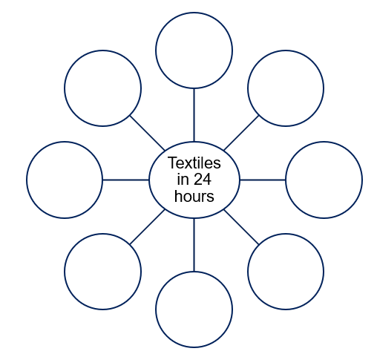
Sample answers:
Pillow, quilt, sheets, carpet, pyjamas, clothes, towel, tea towel, textiles in the car or bus, shoes, school bag, dilly bag.
Access the video Textiles: What are they? where do they come from? (8:50) and watch from 0:00 to 2:50. Add any other textile items mentioned that you don’t already have on your list.
Think, Pair, Share activity
Choose one new item on your list that you didn’t realise was a textile item. Share this with the person beside you and add their example above. Discuss other places from the video where textiles are used that we don’t usually know about.

What do textiles look like, feel like, sound like?
Note: provide students with a range (5 to 10) of small fabric samples. These should be no larger than a standard sticky note.
On the Y-chart graphic organiser below, write down words describing what fabric looks, feels and sounds like.
Figure 2 – Y chart graphic organiser to describe what fabric looks, feels and sounds like
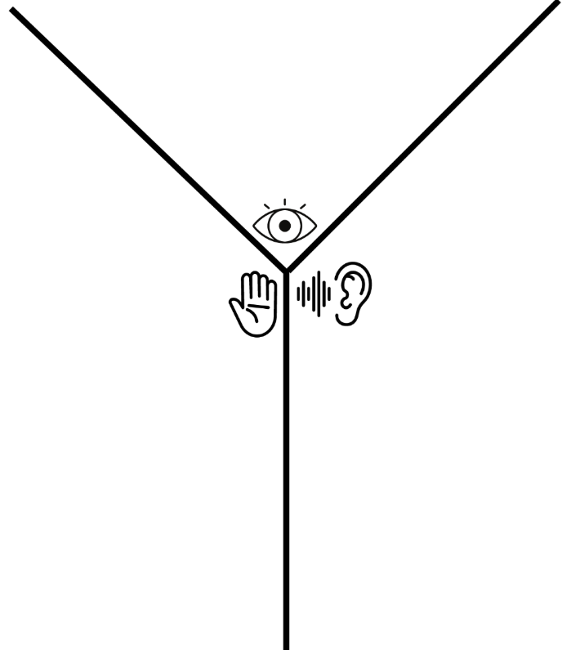
Note: sample answers for the Y-chart could include:
- look: shiny, fluffy, colourful, matte, sheer, furry
- feel: smooth, rough, cold, warm, soft, crisp, firm, stretchy, itchy
- sound: silent, crunchy, squeaking, rustling, swooshing, crumpling, swishing.
Consider the similarities and differences between the fabrics.
What do you think makes fabrics different and why do we need different types of fabrics? Answer in the space provided below.
Sample answer:
Fabrics are different because of what they have been made from and how they have been made.
We need different types of fabrics because they are used for different purposes, for example, to wear, to walk on, for medical reasons, to carry things.

Fibres, yarns and fabrics
Fibres are small particles that are twisted together to form a yarn. Yarn is then either woven or knitted together to form a fabric.
Figure 3 – fibres, yarns and fabrics
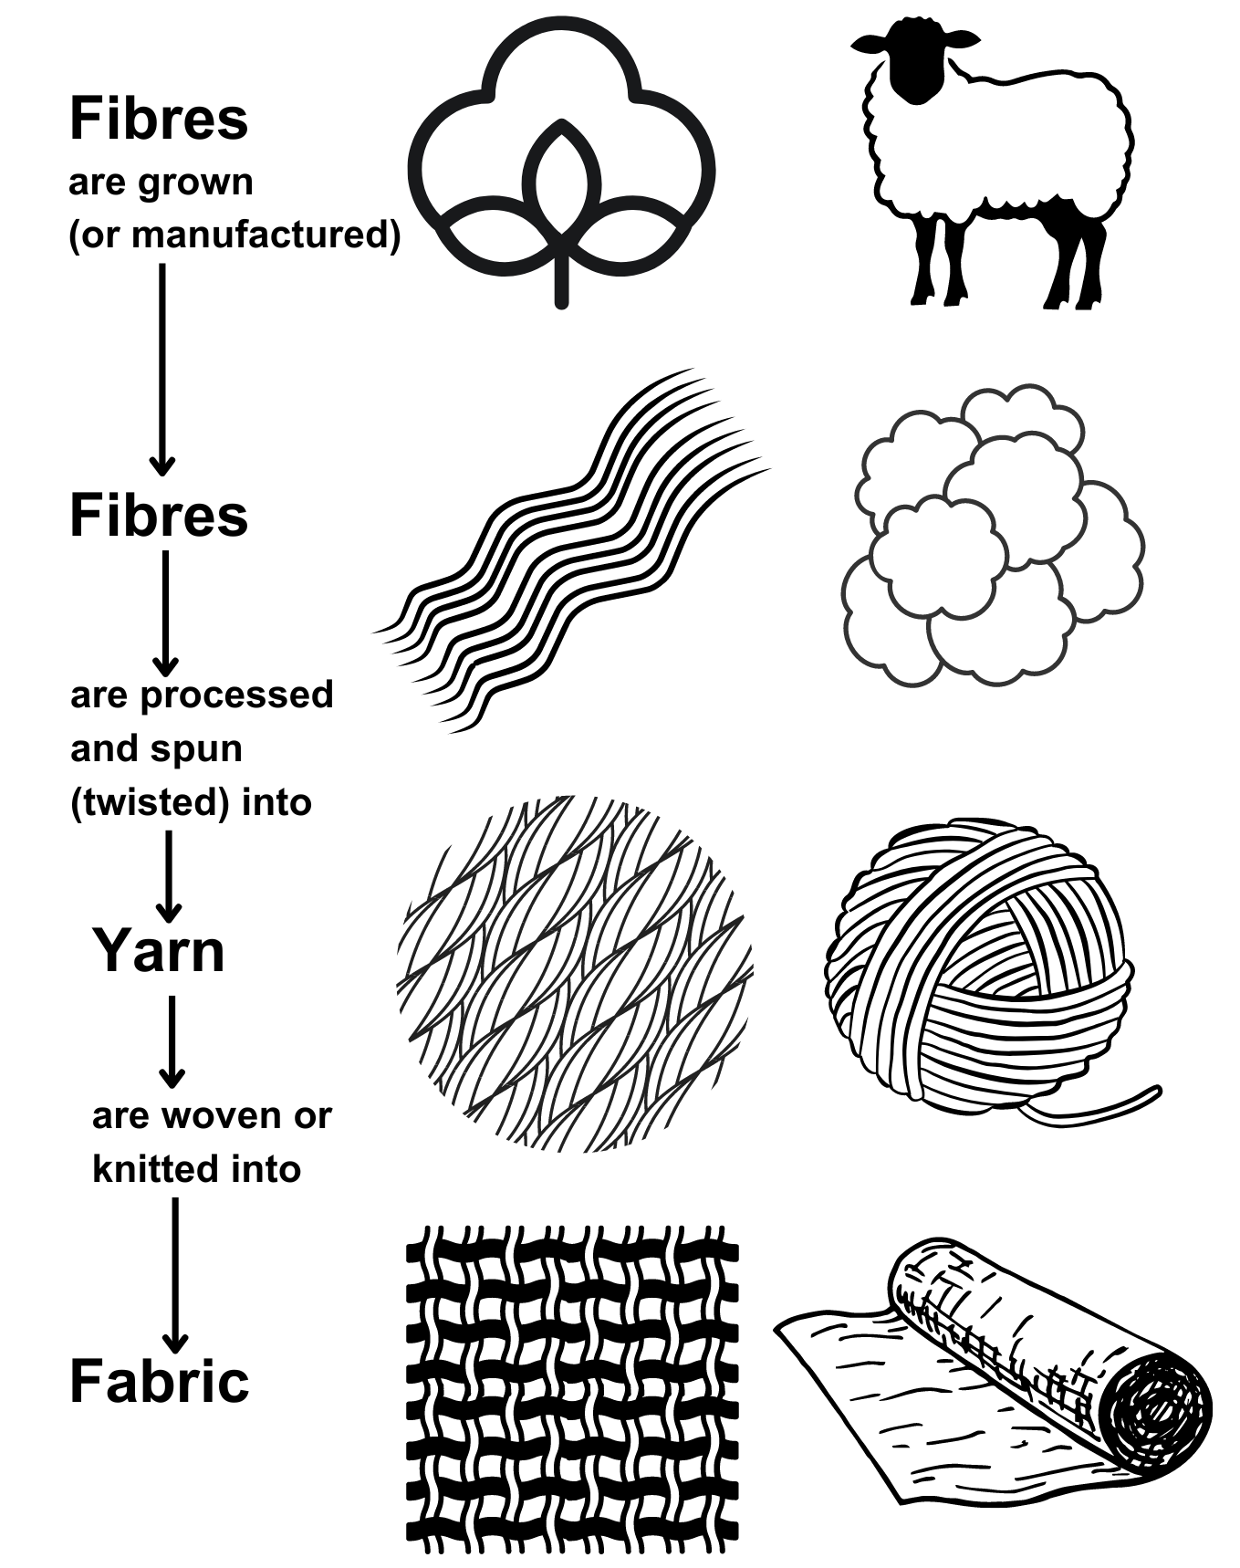

Fibres
Note: as a class, discuss and brainstorm fibres that students know. For example: wool, cotton, silk, cashmere, polyester, nylon, rayon.
Natural fibres are grown in nature and include wool (sheep), cotton (plant), silk (worm), cashmere (goat hair) and angora (rabbit hair). Manufactured fibres are human-made fibres from materials, such as wood, coal and oil, producing fibres such as nylon, polyester, acrylic and rayon. Fibres are spun (drawn out and twisted) to join the fibres to produce long, smooth threads called yarns.
Hands-on activity
Give every student a cotton ball (cosmetic product) and discuss how this represents a cotton fibre that has been picked from a cotton plant, and cleaned and brushed so that most of the fibre strands are going in the same direction.
To make a yarn, fibres are drawn (pulled out) and twisted. Demonstrate the process to students, explaining the process as you go. Engage in a student competition to create the longest yarn from the one cotton ball. They need to be gentle and separate the fibres from the ball and twist them together to form a yarn.
Discuss the characteristics of the yarn they have created.
Paste the yarn you have twisted from the cotton fibres in the space below.

Classification of fibres
Note: discuss the classification of fibres as a class. Using the fibres students identified previously, discuss where they come from.
Complete the tree diagram below to classify different types of fibres.
Figure 4 – types of fibres
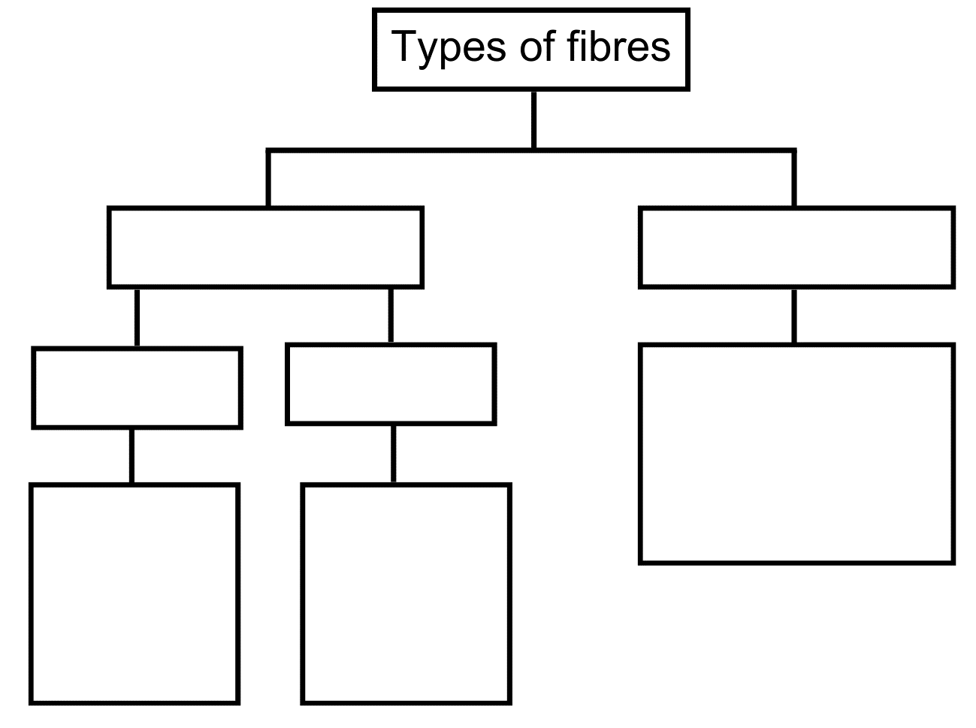
Note: answers are on the following page.

Figure 5 – types of fibres answers
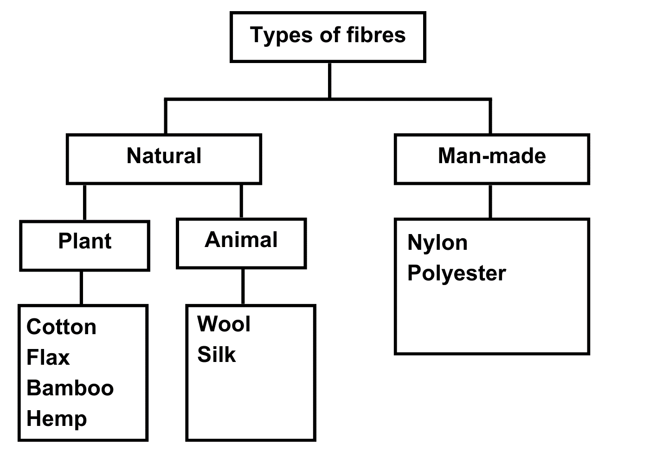

Cotton and wool
We will now look at 2 of our most used fibres, wool and cotton, to see why and where they are used. While watching the following video clips, complete the table below.
- wool: The Innovator (1:47)
- cotton: Cotton Products and Uses (3:07).
Table 2 – wool and cotton comparison
Wool | Cotton
Why is wool chosen for each of the examples in the clip? | Where is cotton used?
Sample answer:  The way that it felt when it was touches, softness, comfort, to reduce bad odours, the way it smelt, for warmth and comfort, for stretch and comfort in exercise. | Sample answer:  Cotton seed used for feed, canvas, books, household items, insulation, astronauts, kitchen items, cooking oil.
Do now
In the space below, sketch one textile item you would use cotton for and one textile item you would use wool for. Explain why underneath each sketch.

Safety in textiles
For each of the images below write down what the safety message is for working safely in the textile room.
Note: sample answers provided below.
Table 3 – safety issues in the textile room
Image | Safety issues in the textile room
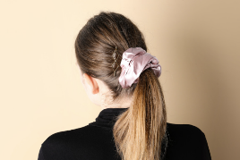 | Tie hair back
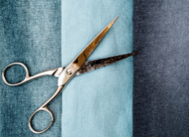 | Carry scissors correctly
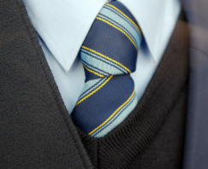 | Remove tie and hoodies or tuck in
 | Do not speed
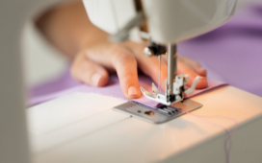 | Keep fingers safely away from the needle
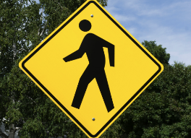 | Walk safely in the textile room
 | Turn power off after use
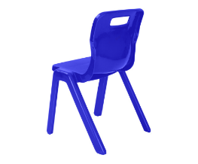 | Sit on chair correctly and safely
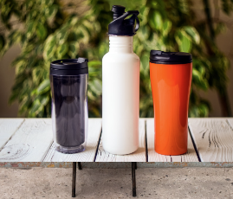 | No water near sewing machine
 | Only one person at a machine at one time
Using one or more of the safety considerations in textiles, design an A4 poster to share a safety message with other students. Alternatively, design, film and produce a safety video.
Note: this poster can either be completed digitally or by hand.

Equipment in textiles
Note: this activity can either be completed in the booklet as a written task or the teacher can cut out each picture and description, and in pairs, students can complete the following activity.
Sample answers have been provided.
- Shuffle the cards and lay them face down on a table.
- Students take turns flipping over 2 cards to find matching equipment with its description.
- Students name each piece of equipment as they flip the cards over.
Table 4 – textile equipment and a description of their use
Equipment | Name of equipment | Description and use
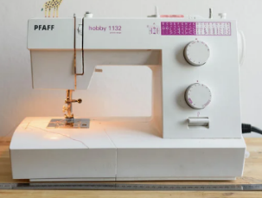 | Sewing machine | A machine that is used to sew fabric together.
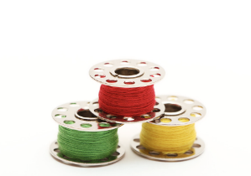 | Bobbin | This holds the thread that form the stitching on the underside of the fabric.
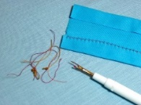 | Unpick | Used to cut or remove the stitches from a line of sewing.
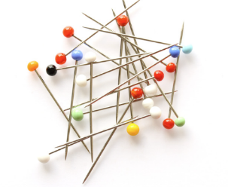 | Pins | Used to secure fabric temporarily.
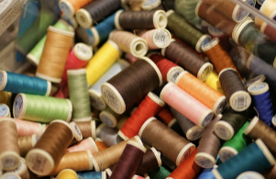 | Sewing thread | Yarn that is used to stitch fabric together.
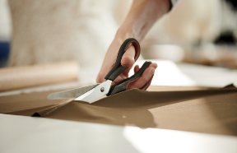 | Fabric scissors | Sharp scissors that are used to cut through fabric with ease.
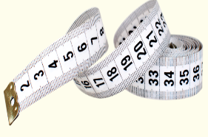 | Tape measure | A flexible ruler used to measure length when using fabric.
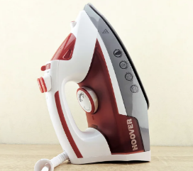 | Iron | This is heated and used to remove wrinkles and creases from fabric.
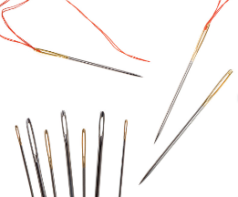 | Hand-sewing needle | Used with thread to pierce through fabric and hand sew pieces of fabric together.
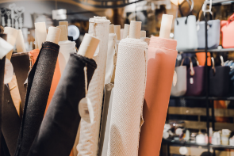 | Fabric | This is made up of yarns that are woven or knitted together and is used to make textile items.

Do now – textile equipment revision
Draw a line from the piece of textile equipment to the correct description in the table below.
Table 5 – matching activity
Name of equipment |  | Description
Sewing machine |  | This is heated and used to remove wrinkles and creases from fabric.
Bobbin |  | This is used to cut or remove the stitches from a line of sewing.
Unpick |  | Sharp scissors that are used to cut through fabric with ease.
Pins |  | This is made up of yarns that are woven or knitted together and is used to make textile items.
Sewing thread |  | Used with thread to pierce through fabric and hand sew pieces of fabric together.
Fabric scissors |  | A flexible ruler used to measure length when using fabric.
Iron |  | A machine that is used to sew fabric together.
Tape measure |  | Yarn that is used to stitch fabric together.
Hand sewing needle |  | This holds the thread that form the stitching on the underside of the fabric.
Fabric |  | Used to secure fabric temporarily.

How do I use a sewing machine?
Note: all sample work completed by students can be used to create a class bunting (see instructions in Spotlight easy bunting). Students may also choose 2 of their best samples to use in creating a small pencil case carry item (instructions in Appendix 1 – instructions for pencil case). All these skills will need to be explicitly taught to ensure adequate skill development.

Threading the machine
Note: provide students with an image of the sewing machine in your room in A4 size that they will use to label using the activity below.
Use a sewing machine in your room to go around and point out the different parts of the machine and explain their function. Get students to use the terms below to label the machine as you do this. Students now choose 5 different parts of the machine that they think are the most important ones for them to remember and fill out the table below, explaining their purpose.
Use the following terms to label your sewing machine parts during your teacher’s demonstration. Cross them off as you use them.
Table 6 – sewing machine terms
Bobbin winder | Hand wheel | Shuttle cover (bobbin housing) | Spool pins
Needle | Reverse stitch lever | Thread guides | Stitch length dial
Feed dogs | Needle throat plate | Stitch selector | Presser foot
Presser foot lever | Stitch width selector | Tension control | Take-up lever

Complete the table below by identifying parts of the sewing machine and explain their function. The first row has been completed as an example.
Table 7 – parts of the sewing machine and their purpose or function
Parts of the sewing machine | Its purpose or function
Reverse stitch lever | The machine will sew in reverse while the lever is pushed.
Note: demonstrate to students how to thread the machine. This can be added as a label, showing the direction of the thread on their sewing machine diagram. Instruct students to sit at their machine and test their memory recall of the sewing machine parts by calling out a part randomly and getting them to point to it. Then ask students to show you how they can correctly thread the sewing machine.
Practical activity
Thread the sewing machine and ask your teacher to check it once you have completed this.

Filling and inserting a bobbin
Note: demonstrate to students how to correctly fill and insert the bobbin. Get the class to summarise the steps into 3 simple dot points. Students fill a bobbin and insert it correctly. How a Sewing Machine Works via animation (0:26) can be shown to help demonstrate how the bobbin works.
Watch How a Sewing Machine Works via animation (0:26) to help understand and explain why we use 2 threads.
Describe how to fill and insert a bobbin in 3 simple steps in the space below. This must be written in a way that you will understand when you look back.
Sample answer:
- Ensure the bobbin is inserted into the bobbin case going in the correct direction.
- Make sure that you can see and hear that the bobbin case is in the machine correctly.
- Use the hand wheel to slowly wind the needle down into the needle plate so that the bobbin thread comes on top of the needle plate.
Practical activity
Thread a bobbin and insert it into the machine. Ask your teacher to check this once you have completed this step.

Controlling the machine direction and speed
Note: demonstrate to students how to use the sewing machine guides to assist in safely managing the direction of the sewing, how to manage speed and how to pivot. Use the template below by printing it on A4 paper. This is easier without thread, so they can see how well they control the sewing machine.
Practical activity
Using the template provided below, sew along the lines as accurately as possible. Remember this is not a race, we are aiming for accuracy and perfection. Show your teacher when the activity is complete so that they can provide you with some feedback.
Complete the table below by identifying what machine settings are needed for a straight stitch.
Table 8 – practical stitching activity
Stitch length | Sample answer: 2.5
Stitch width | Sample answer: 0
Stitch selector | Sample answer: - - - - - -

Controlling the machine speed and direction
Sew on top of these lines (see below) as accurately as possible. You will also need to start and stop at the beginning and end of the lines and practice backstitching (reversing for 2 stitches).
Figure 6 – stitching template
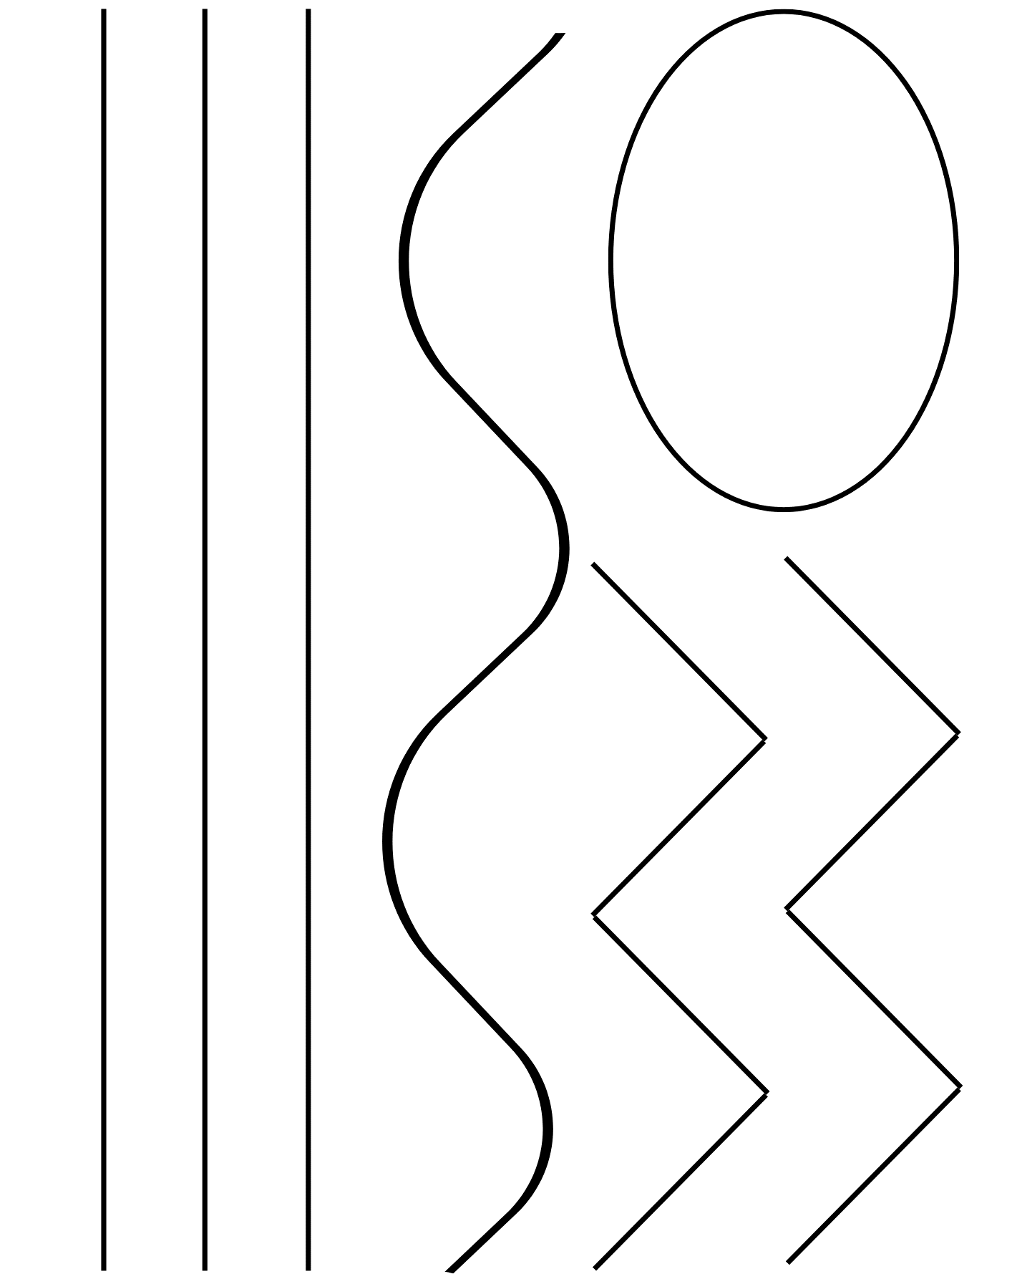

Seam sample
Note: discuss with students what a seam is and where do we find them – students can point to a seam on the item of clothing they are wearing. Demonstrate how to sew a successful seam. Students complete a sample.
Seam success: in the space below, make a list of the main points your teacher has discussed and shown you that will help your seam sample to be a success.
Sample answers:
- Make sure edges are straight
- Measure the seam allowance and mark it either with pins or a fabric marker
- Reverse at the beginning and the end for 3 to 4 stitches only
- Keep your fingers away from the needle and use the guide plate at the correct seam allowance to ensure you sew straight.
Following these steps, complete a seam sample and include it on the next page for your teacher to check.
Seam sample instructions
- Line up the 2 raw edges so that they align.
- Measure and mark 1.5 cm from the edge of your raw edge.
- Line up the edge of your fabric with the 1.5 cm guide on your needle throat plate.
- Reverse at the beginning and end of the seam.
- Extension: finish the edge of your seam sample with a zig zag stitch.

My seam sample
Paste your seam sample in the space below.
Reflect on your seam sample by completing the Plus, Minus, Interesting (PMI) chart below. In the space, list something that went well in the plus section, something that needs some improving in the minus section, and finally something you found interesting about this technique or how you might use it in a project.
Plus | Minus | Interesting

Fancy machine stitching
Note: demonstrate some patterned stitches to students, showing them how to change the pattern selector settings.
You can also use the sewing machine to add some decorative stitches to your textile items. You will need to experiment with 3 different stitches and label the sewing machine settings so you can come back to them.
Practical activity
Paste your machine stitching sample in the space below.
In the table below, identify the settings on your sewing machine used for each stitch in the sample.
Table 9 – stitch selections
Stitch selector | Stitch width | Stitch length | Sketch of stitch
Note: students can apply their knowledge and skill of seams by producing a pencil case or class bunting (see Appendix 1 – instructions for pencil case for instructions) by using the samples they produce in the following fabric decoration samples.
Do now
In the spaces below, complete the following:
So far, the skill(s) I have enjoyed the most and have had the most success with are:
The skill or area that I find the most challenging is:

Fabric decoration
Note: students will be encouraged to incorporate technology throughout this section of the workbook. The type of technology used and listed are suggestions only and will depend on your available resources. Students can also use non-technological ways to create templates and stencils.
In the concept map provided below, brainstorm different ways fabric can be decorated.
Discuss where you have seen that method of decoration.
Note: some suggested decoration techniques have been provided below.
Figure 7 –fabric decoration techniques concept map
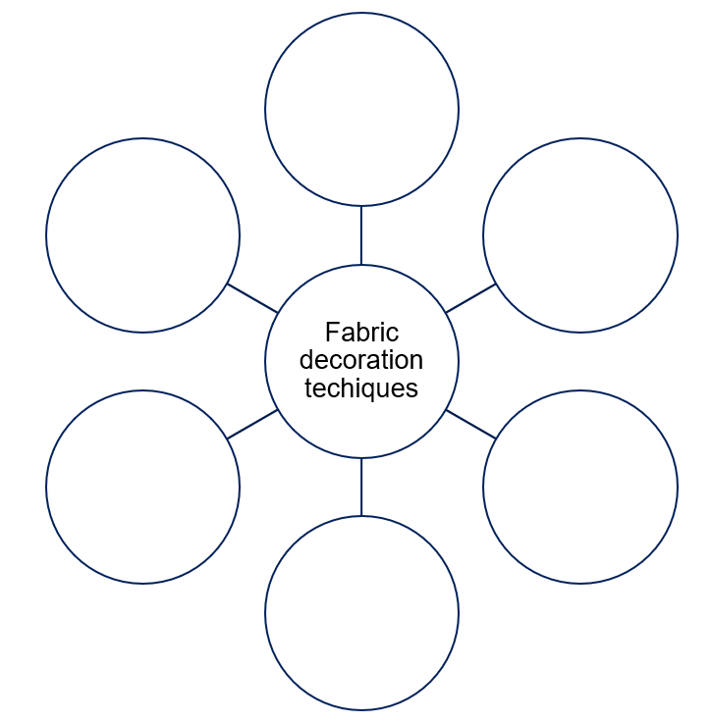

Figure 8 – sample completed fabric decoration techniques concept map
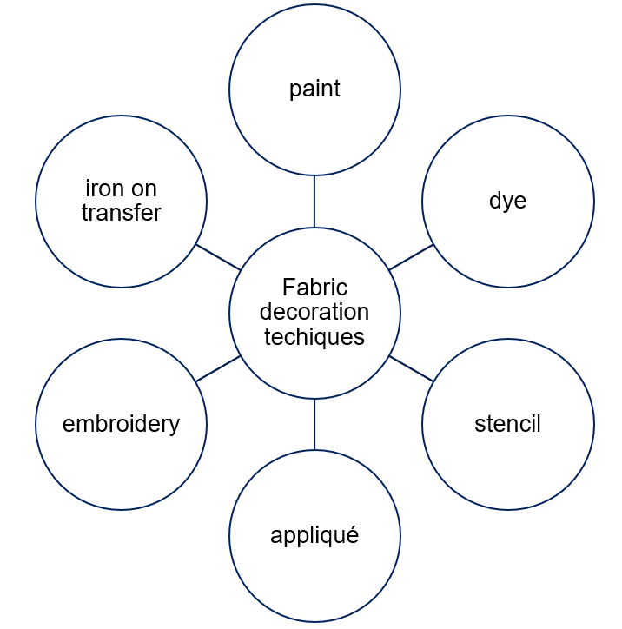

Appliqué
Note: students can use this sample for the class bunting or choose it as one of their 2 samples for the pencil case. Show examples or images of appliqué.

What is appliqué?
Appliqué is a decorative textile technique where pieces of fabric are sewn or glued onto a fabric background to create designs or patterns.
Practical activity

Process of appliqué
After the teacher demonstration, complete the following steps using the word bank below.
base fabric | fusible | template | appliqué
iron | remove | secure | back
- Create a template for the shape you will use as your appliqué shape (this can be done on the computer or by hand on paper).
- Choose your base fabric (what you will stick your appliqué shape to) and your appliqué material (this can be a fabric, fabric scraps or fused plastic).
- Iron the paper-backed fusible heat bonding web onto the back of your appliqué material.
- You can now carefully remove the paper backing.
- Place the appliqué shape onto your base fabric and secure with dry heat from the iron.
- You can now choose how you will sew the appliqué shape to secure it. This can be done by hand or on the sewing machine.

Appliqué idea generation
Sketch what you would like your appliqué sample to look like in the space below.

Evaluate – appliqué
Reflect on your appliqué lesson by completing the PMI chart below. In the space, list something that went well in the plus section, something that needs some improving in the minus section and finally something you found interesting about this technique or how you might use it in a project.
Table 10 – blank PMI chart
Plus | Minus | Interesting

Stencilling
Note: students can use this sample for the class bunting or choose it as one of their 2 samples for the pencil case. Discuss and demonstrate to students how stencils are cut and the need to consider negative and positive spaces. A laser cutter or cutting machine can be used to create the stencils. Alternate options are included below.
The work sample provided uses a logo designed on Canva and cut by a cutting machine on freezer or greaseproof paper. Alternatively, students can draw and cut a stencil by hand.

What is stencilling?
Stencilling is a method of applying designs to fabric by using a stencil. A stencil is a thin sheet of paper or plastic with a pattern cut out of it. When the stencil is placed on the fabric and paint is applied, the paint passes through the cut-out areas to create the design on the fabric.

Process of stencilling
Use the following resources to assist your demonstrations.
- How to Make a Stencil – wikiHow
- How to Stencil Fabric – wikiHow

Note: sample stencilling process. Remove this for student booklet.
Steps to use the cutting machine to make a stencil are shown below.
Table 11 – steps to make a stencil
Step | Description
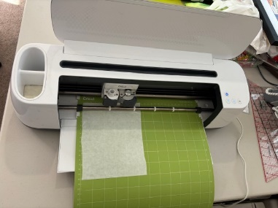 | Attach the freezer paper to the sticky mat provided.
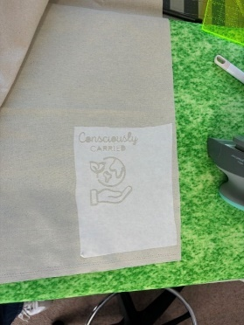 | Sample of the cut logo on the freezer paper once it has been ‘weeded’ (this is the process of removing the shapes to be stencilled). This can be completed with special weeding tools or tweezers for finer lines and shapes.
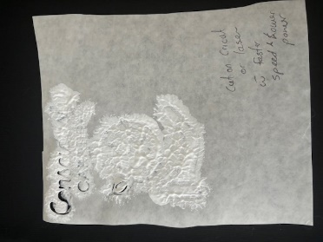 | Place the stencil freezer paper onto the fabric and apply fabric paint. The sticky nature of the freezer paper should be enough to secure the stencil onto the fabric and avoid it moving.
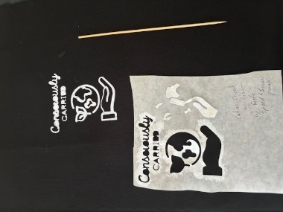 | Leave to dry and carefully remove the freezer paper to reveal the finished stencil.

Practical activity
After viewing How to Build Paper or Plastic Stencils in class and watching a demonstration, answer the following questions in the space below to show your understanding before making a stencil.
What is a bridge?
Why is negative and positive space important when designing a stencil?
Provide an example of positive and negative space in the box below.
Answer the following statements about stencilling as true or false. The table contains sample answers.
Table 12 – true or false statements about stencilling
Stencilling statement | True or false
It is best to use lots of intricate and complicated shapes when stencilling | F
Any design can be used as a stencil | F
The stencil should be secured to the fabric before you apply paint | T
It is best to leave your paint to dry before removing the stencil | T

Stencilling idea generation
Sketch what you would like your stencil sample to look like in the space below.

Evaluate – stencilling
Reflect on your stencil design by completing the PMI chart below. In the space below, list something that went well in the plus section, something that needs some improving in the minus section and finally something you found interesting about this technique or how you might use it in a project.
Table 13 – blank PMI chart
Plus | Minus | Interesting

Sun printing
Note: students can use this sample for the class bunting or choose it as one of their 2 samples for the pencil case. Magical Summer SunPrinting on Fabric is an example of an online resource you can refer to.

What is sun printing?
We use the power of the sun to intensify the painted colours on the fabric, while we block out a design with the silhouette shapes which block the sun. This will result in a lighter colour in the shape and pattern, leaving a subtle print.
Practical activity
Materials needed
- Sunshine
- White fabric
- Acrylic paints
- Gloves or paintbrushes
- Board covered in black plastic
- Fabric medium if fabric is to be washed
- Water
- Decorative shapes
Note: decorative shapes can be anything that sits flat on a wet surface. It can include household items or large leaves off plants. This example uses foam cut from the cutting machine; however, foam shapes can also be purchased.

Process of sun printing
In the table below, document the steps involved in sun printing.
Note: sample answers have been provided. Alternatively, you can print off the steps for the students and mix them up, getting them to put the steps back into the correct sequence.
Steps | Instructions
1 | Choose and collect shapes for your design.
2 | Assemble your painting area.
3 | Wet the fabric thoroughly.
4 | Paint your fabric. If using gloves, use each finger for a different colour. It is recommended you stick to around 3 colours.  The paint can be painted in a diagonal pattern, in stripes or in a checkboard pattern.
5 | While the fabric is still wet, apply your shapes and decorative item so they sit flat on the wet fabric.
6 | Place in direct sunlight, out of the wind and allow to completely dry.
7 | Remove the shapes and iron the fabric to heat set the paint.

Sun printing idea generation
Sketch what you would like your sun printing sample to look like in the space below.

Sample sun printing
Figure 8 – sun printing sample
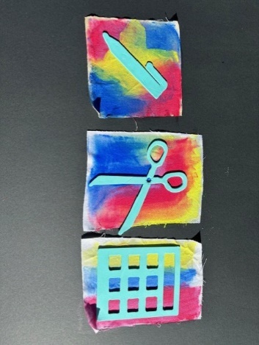 | 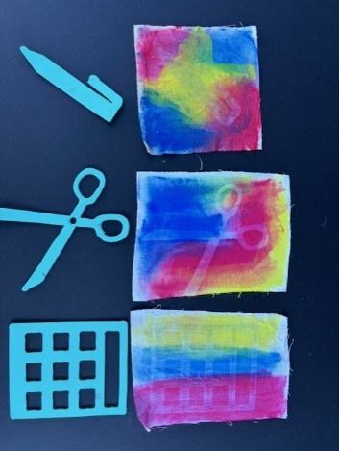 | 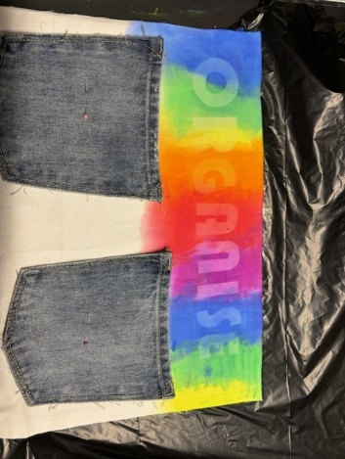
Review activity – never have I ever
Now that you have completed a term learning how to use the sewing machine and decorate fabric, complete this ‘Never have I ever’ activity to highlight 3 areas that you improved on most throughout the term and will need to remember in the future. Place a tick in the correct box in the table below.
Table 14 – 'Never have I ever ...' activity
Have | Never have I ever … | Have not
 | had to unpick stitching.
 | sewn in a crooked line.
 | placed the bobbin in the machine the wrong way.
 | forgotten to put the presser foot down when sewing.
 | sewn too fast.
 | ironed my appliqué the wrong way.
 | designed a successful stencil.
 | sewn on cotton fabric.
 | created a sun print.
 | pinned fabric together.
Choose your 3 highlights, or most improved moments of the term and write them in the space below.
My top 3 things I learned this term are:

Sew sustainable, sew awesome!
Note: throughout Part 2 – ‘Sew sustainable, sew awesome!’ of the program, teachers will be introducing the design brief and project to the students. This will allow for a deeper understanding of the functionality of the project and the design issues that surround their choices.
Please be advised that the plastic fusing technique demonstrated in this program serves as merely one illustrative approach towards achieving outcome TE4-SDP-01, in which students explain the relationships between sustainability, design, and production. Educators retain the flexibility to explore alternative methods based on their school's unique circumstances. These alternatives may encompass eco-dyeing and printing, as well as upcycling, among others.

Identifying and defining

Design situation
Aboriginal and/or Torres Strait Islander communities have long relied on local materials to create tools for carrying goods. But now, with our resources dwindling and the need for carrying items still vital, we face a challenge. We must design items for carrying that not only serve practical needs but also help address environmental issues, such as reducing use of single-use plastics and protecting our land. By taking on this challenge, we can protect our environment for the future while honouring Aboriginal and/or Torres Strait Islander traditions of resourcefulness and caring for Country.

Design brief
Your task is to create a carry item for yourself that addresses an environmental problem, for example, reducing single-use plastics. This item should spread awareness to others about the issue.
Your challenge is to design a carry item for your own personal use that helps stop single-use plastic being used, or another environmental issue of your choosing, from going into our landfill and ruining our environment.

Researching and planning
What words do you think about when you hear the word ‘landscape’?
Note: create a gallery of images, quotes and texts for students to explore. Consider images that depict a clean landscape and images that show damaged landscape. Use the words students come up with to create a digital word cloud to display in the classroom.
Sample answers: beach, country, green, trees, mountains.
Discuss the differences among these images and causes.
Figure 9 – landscape image examples
 |  | 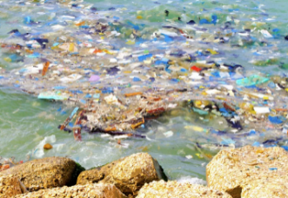 | 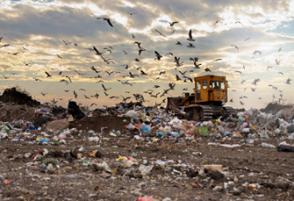
Create your own picture collage using a combination of Australian landscape images that you admire, combined with images of landscapes that have been impacted by environmental changes.
This is your inspiration for your project.
If computers aren’t available for this, you can use a collection of magazines.
Sample answer:
Figure 10 – sample collage
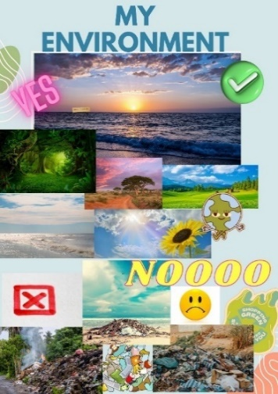
After watching Take 3 – Connection (6:04), do a Think, Pair, Share around this question.
How are we connected to the land and the waterways?
What were the common themes that were noticed among the class? You may come back and add to these tables throughout the lessons.
Table 15 – our use and impact on land and water
How we use land and water | How we impact land and water
Sample answer:  swimming, horse riding, kayaking, fishing, camping, hiking | Sample answer:  plastic waste, pollution, land degradation, climate change
Table 16 – Aboriginal and Torres Straight Islander peoples use and connections to land and water
Ways Aboriginal and Torres Strait Islander peoples use and connect to land and water | How we can care for our land and water
Sample answer:  Spiritual and cultural practices, sustainable land management and subsistence activities.  This relationship is reinforced through ceremonies, storytelling and legal efforts to secure land rights, promoting both community wellbeing and environmental stewardship.  Their traditional ecological knowledge and sustainable practices ensure the preservation and respectful use of natural resources. | Sample answer:  Make better consumer choices, for example, do not buy produce in plastic containers.

Spheres of influence
As individuals, we often think that we on our own can’t make a difference or have an impact on these issues. After watching 4:6 EP4 PERSONAL ACTION (6:40), complete the ‘Sphere of influence’ activity (this was mentioned between 2:10 and 2:27).
Consider what you can do to control and who you might influence about these issues.
Figure 11 – spheres of influence
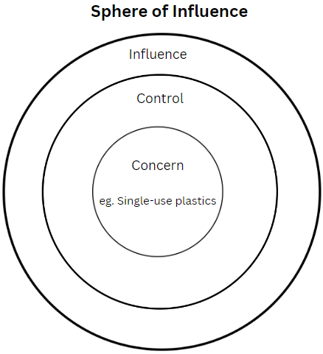

How many bags and plastics?
Note: you (and your class) need to collect several sets of different plastics, including plastic shopping bags, fruit and vegetable bags, feed bags, food packaging, paper bags and reusable packages.
As a class, brainstorm all the different types of bags and packaging that you might come across.
Using the table below, record the number of shopping bags and food plastics brought into your house over the next week. At the end of the week, bring your results into school and calculate the number of single-use shopping bags brought into your home for that week. We will then calculate the weekly totals as a class.
Table 17 – shopping bags brought into your home for that week
Type of shopping bag | Mon | Tues | Wed | Thu | Fri | Sat | Sun
Plastic shopping bag
Plastic fruit and vegetable bag
Paper bags
Reusable bag or box
Biodegradable carry bag
Single-use plastic food packaging
Weekly total
Reflection questions
- What percentage of all plastics were single-use plastics?
- Calculate the total number of shopping bags used by your household for one year (multiply the number for one week by 52).
- If everyone in your class is using reusable bags, what is the total number of single-use bags that they are now not bringing into everyone’s homes?

The life of a plastic bag
Let’s now look at one change that we can all make – ban the bag – by viewing The Life of a Plastic Bag (2:33).
You will begin to make your change by designing your own carry item that shares an environmental message, such as the banning of plastic or using recycled soft plastics as part of your design.
Note: throughout the next part of the project, you can either choose to get your students to create a logo that they can incorporate into their project design and/or recycle soft plastics to incorporate fused plastics into their project design.

Logo design
Logos are often used to create a meaning or send a message. Create a logo for the ‘Sew sustainable, sew awesome!’ project you are designing.
Sample answer:
Figure 12 – sample logo designs
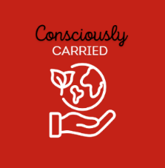 | 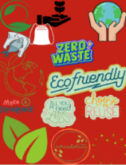 | 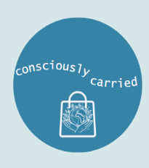 | 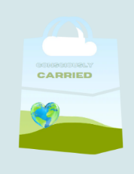
My Sew sustainable, sew awesome! logo design
Do now
My logo design will spread this message to the public …
This is why it will be successful in spreading this message …

Investigating products and systems developed by Aboriginal and Torres Strait Islander peoples
Note: consulting with Aboriginal and/or Torres Strait Islander communities is essential to the development of meaningful Aboriginal and/or Torres Strait Islander Histories and Culture embedded across the curriculum. Aboriginal and/or Torres Strait Islander peoples are the owners and custodians of their knowledge and cultures and should be consulted when aspects of Aboriginal and/or Torres Strait Islander Histories and Cultures are being incorporated into the school curriculum. If you want to establish an authentic relationship with Aboriginal communities, you should understand local community protocols and engage with the community respectfully and authentically. Remember that any information shared by Aboriginal and/or Torres Strait Islander peoples remains their intellectual property.
The learning activities that follow have been sourced from public-facing materials available online.

Aboriginal carrying items
Traditionally, Aboriginal and/or Torres strait Islander peoples relied on the natural resources around them to carry and transport important items for food and shelter. After watching Indigenous bags and textiles (2:41), research one item that the Aboriginal communities used to carry their goods and answer the questions in the table below.
Note: sample answers provided.
Table 18 – questions and sample answers
Question | Answer
Include an image of your textile carry item.
What is the name of your carry item? | Kun-maj (small fishing bag).
What did they use to make this carry item? | Natural organic fibres such as freshwater plants.
What was your carry item used to transport? | Food items, such as fish and shells.
How did they make this carry item a success? | It was constructed with large holes to allow for the water to drain. It would need to be made strong enough to last the distance of transporting. It would have to be made from local resources.

Aboriginal weaving
Note: invite local Aboriginal and Torres Strait Islander peoples in to teach students how to weave and the importance of weaving. Alternatively, review the following videos and watch the most suitable for your context. Use the content in the PowerPoint; ‘Sew sustainable, sew awesome!’ for students to complete the questions below. Sample answers have been provided below.
- Weaving Workshop (19:12) – extended overview of Aboriginal weaving
- Waking up Indigenous weaving practices | Art Works (4:43)
- We Can, We Do: Aunty Connie Hart breaks all the rules to keep tradition alive (3:26).
Answer the following questions in the space provided.
Note: sample answers are provided below.
What materials are used for Aboriginal and/or Torres Strait Islander weaving?
Sample answer:
Grasses, reeds, bark fibres and other plant materials.
The selection of materials is often specific to the region and the availability of resources.
What techniques are used?
Sample answer:
Twining, coiling and plaiting.
Techniques are passed down through generations and are integral to creating functional and decorative items.
What is the cultural significance of weaving?
Sample answer:
Generalised view: it is linked to the land, with materials collected during specific seasons. Weaving items, such as baskets, mats and fish traps are not only functional but also carry cultural stories and are used in ceremonies.
What types of items are woven by Aboriginal and/or Torres Strait Islander peoples?
Sample answer:
- Baskets and bags
- Mats
- Fish traps and nets
- Ornamental items and ceremonial objects
What is our ethical responsibility with Indigenous Cultural Intellectual Property (ICIP)?
Sample answer:
It is essential to respect ICIP rights, ensuring that traditional knowledge and cultural expressions are protected and that Aboriginal communities maintain control over their cultural heritage.
Do now
A company wants to use a traditional Indigenous design for a new line of t-shirts. What should the company do to respect ICIP?

Weaving
Note: outline the process of industrial weaving and show Weaving Machine Animation and Basic Principle of Weaving (0:10).
Woven fabric is created by weaving threads together using a machine called a loom. It involves arranging threads vertically (the warp) and weaving threads horizontally (the weft threads) over and under the warp threads. There are different weaving patterns, such as plain weave, twill weave and satin weave, each creating unique textures and designs. The properties of the materials used, like cotton, wool, silk or synthetic fibres, affect the fabric's strength, softness and durability.
Note: hand out small swatches of different types of woven fabrics. Hand out Appendix 4 – weaving types for students to see the different patterns created by different weaves. Guide students to feel the texture of the different fabrics and note the differences.
Sample discussion: plain weave and satin weave are 2 types of fabric patterns that look and feel different because of how they are made. Plain weave is strong and durable, with threads going over and under each other in a simple crisscross pattern, giving it a rough texture and a matte finish. It's used for things like shirts and sheets.
Satin weave, on the other hand, has a shiny, smooth surface because the threads float over several others before going under one, making it less durable but very soft and glossy, perfect for fancy dresses and luxury items. Plain weave is easier to make, while satin weave is more complex and delicate.
Figure 13 – example of plain weave pattern
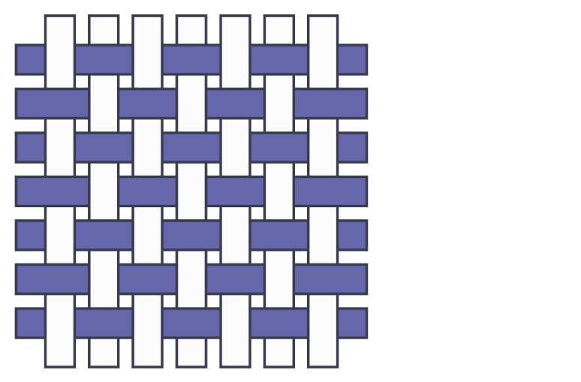

Paper weaving
Note: use 2 sheets of A5-sized paper per student. This can get tricky explaining how to rule up and cut paper. Check all measuring by each student before they cut their paper – get them to hold it up in the air.
Show an example of paper weaving. Explain that this is what fabric looks like when magnified. Each strip of paper represents a yarn that has been woven to make the fabric. See the table below for instructions on paper weaving.
Table 19 – paper weaving instructions
Instructions | Diagram
Fold the piece of paper in half, lengthwise. | 
Draw a line 1 cm from the open edge (not the fold) down the length of the piece of paper. | 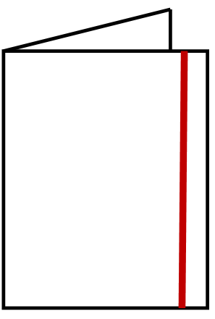
Measure and mark the 2 cm point along the line. | 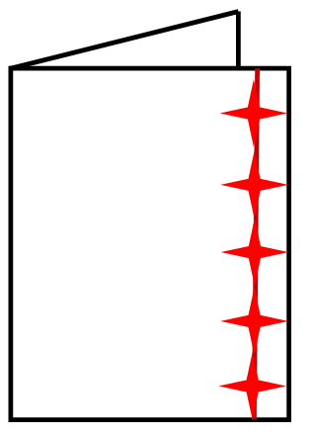
Do the same along the fold.  Ensure students start measuring from the same-end edge as before. The easiest way is to tell them not to flip it over or turn it around – just put their ruler at the bottom of the piece of paper. | 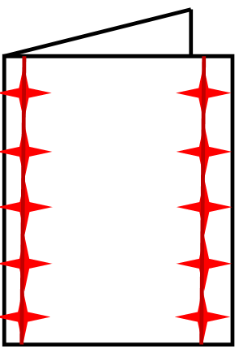
Join the dots to form lines. | 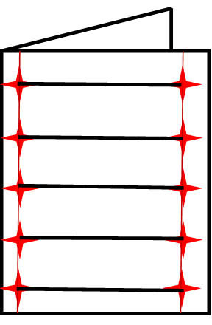
Cut along the lines you just drew.
Make sure students don't cut all the way through and end up with strips.
Give out the second piece of paper.
Measure and mark 2 cm points along the short edge of the paper. | 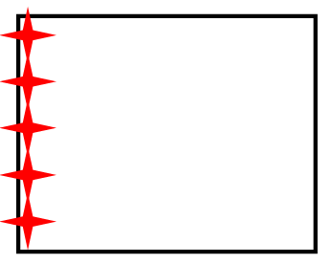
Do the same to the other side.  Ensure students start measuring from the same-end edge as before. The easiest way is to tell them not to flip it over or turn it around – just put their ruler at the bottom the piece of paper. | 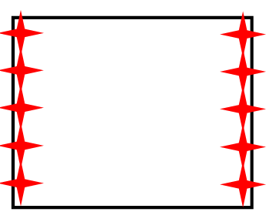
Join the dots. | 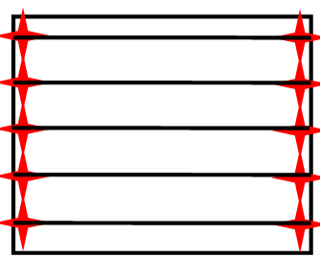
Cut along the lines.
This time, you want them to cut it into strips of paper.
Begin a plain weave – over one, under one. | 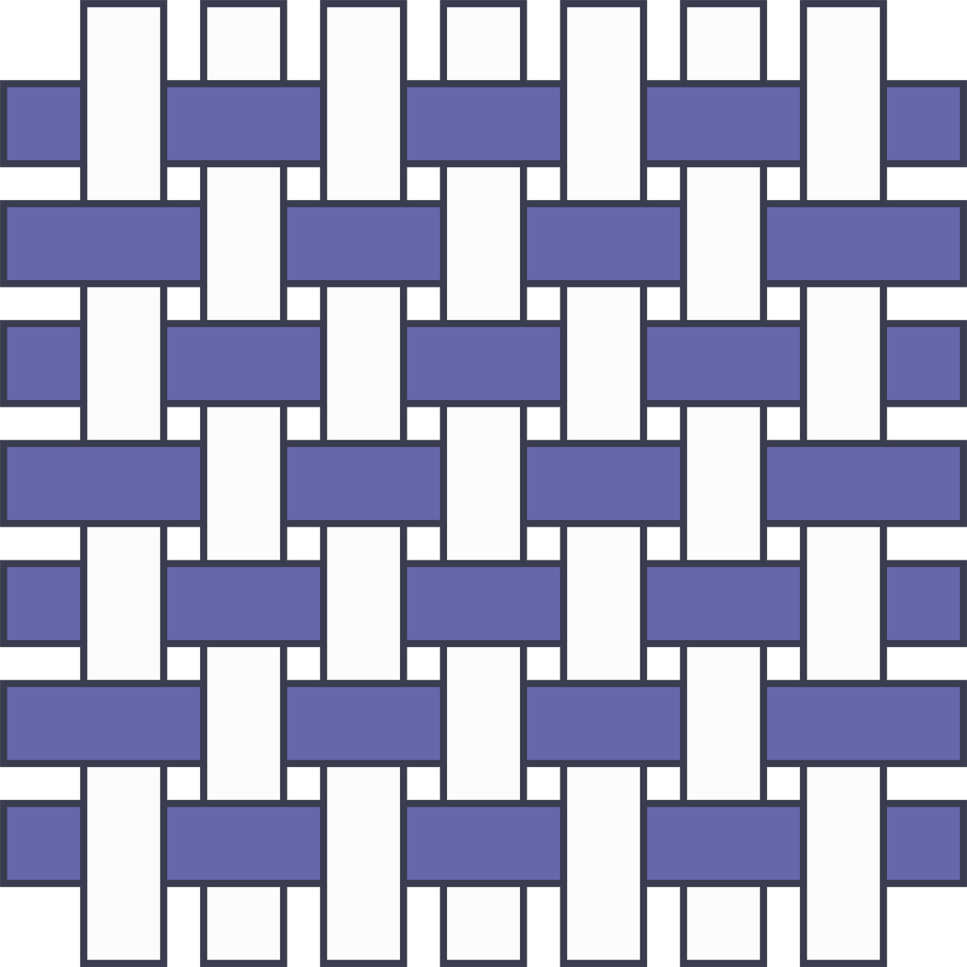

Loom weaving
Practical activity
Figure 14 – loom weaving example
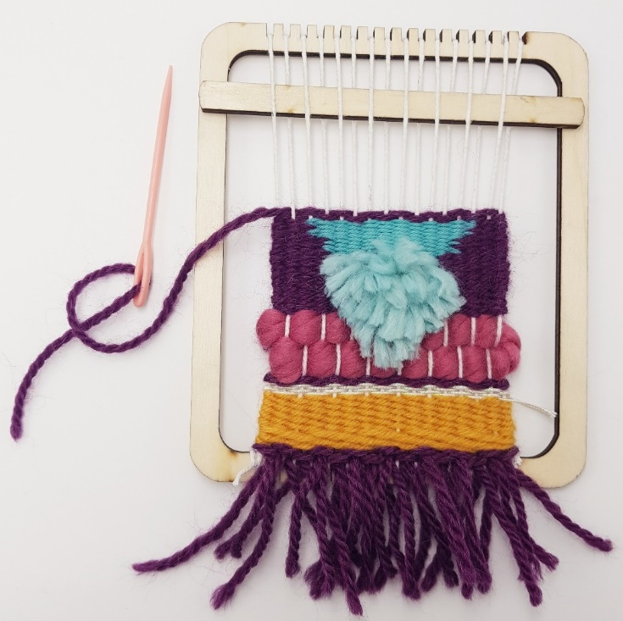
Note: students are either given a laser-cut mini loom or can be instructed to create their own using strong cardboard. See the Loom weaving resources on the department’s website for more details.
Students require lengths of yarn in various weights and colours.

Contemporary uses of plastics
Note: the following resources can be used to illustrate to your students the innovative ways that plastics and alternate materials are being used. You can choose to watch one, some or all of them with your class. Please note you must be signed in with your department account to access YouTube clips in schools.
- Is this a better use for plastic bags? (13:38) is a 13-minute video. We recommend removing 4:05 to 5:25 and 7:53 to 11:00.
- Can Your Chip Bags Save Lives? (16:35) (watch 0:00 to 5:30)
- Boomerang Bags.
While watching the video clips, complete the following table.
Table 20 – 'This is SUCH a Better Use for Plastic Bags' questions and sample answers
Questions | Answers
Why is plastic fusing a good technique? | Sample answer:  You can keep layering until you get the correct thickness.
What was one of the issues they found once they cut up their plastic strips and how did they overcome this? | Sample answer:  It didn’t bond through all of the layers. They ironed them individually.
What other material did they compare their fused plastic to? | Sample answer:  Leather.
List one plastic bag fact. | Sample answer:  We use them for 12 minutes.  They last 500 years.  Sea turtles think they are jellyfish and eat them.
How did they hold they plastic strips together for strength? | Sample answer:  By weaving the strips.
Table 21 – 'Your Chip Bags Can Save Lives' questions and sample answers
Questions | Answers
What are some of the properties of the chip packets? | Sample answer:  Heat reflector, strong, colourful.
What were some of the uses for the recycled chip packets? | Sample answer:  Drawstring bag, safety blanket, pillow, sleeping bag, dog blanket.
Table 22 – 'Boomerang Bags' questions and sample answers
Questions | Answers
What is the main purpose of Boomerang Bags? | Sample answer:  Making bags, diverting waste, starting conversations, fostering sustainable behaviour and having fun.
What properties does fused plastic have as a material? Complete See-Think-Wonder on the following page.
Use these as discussion starters for each section of the See-Think-Wonder:
- I see that plastics have the following qualities and properties. What properties do you see that fused plastic has (consider positive and negative properties)?
- I think that by reusing plastic bags and other materials, we can help the environment in these ways. What environmental issues do you see these resources helping?
- I wonder what else I could make with plastic bags or recycled materials?
Sample answer:
I see strength, waterproof, cheap, easy to use, easy to clean, doesn’t fray, wouldn’t be comfortable to wear.
I think to reduce landfill, stop it entering our waterways.
I wonder about hammocks, bags, wallets, bucket hats.
Figure 15 – sample completed See-Think-Wonder
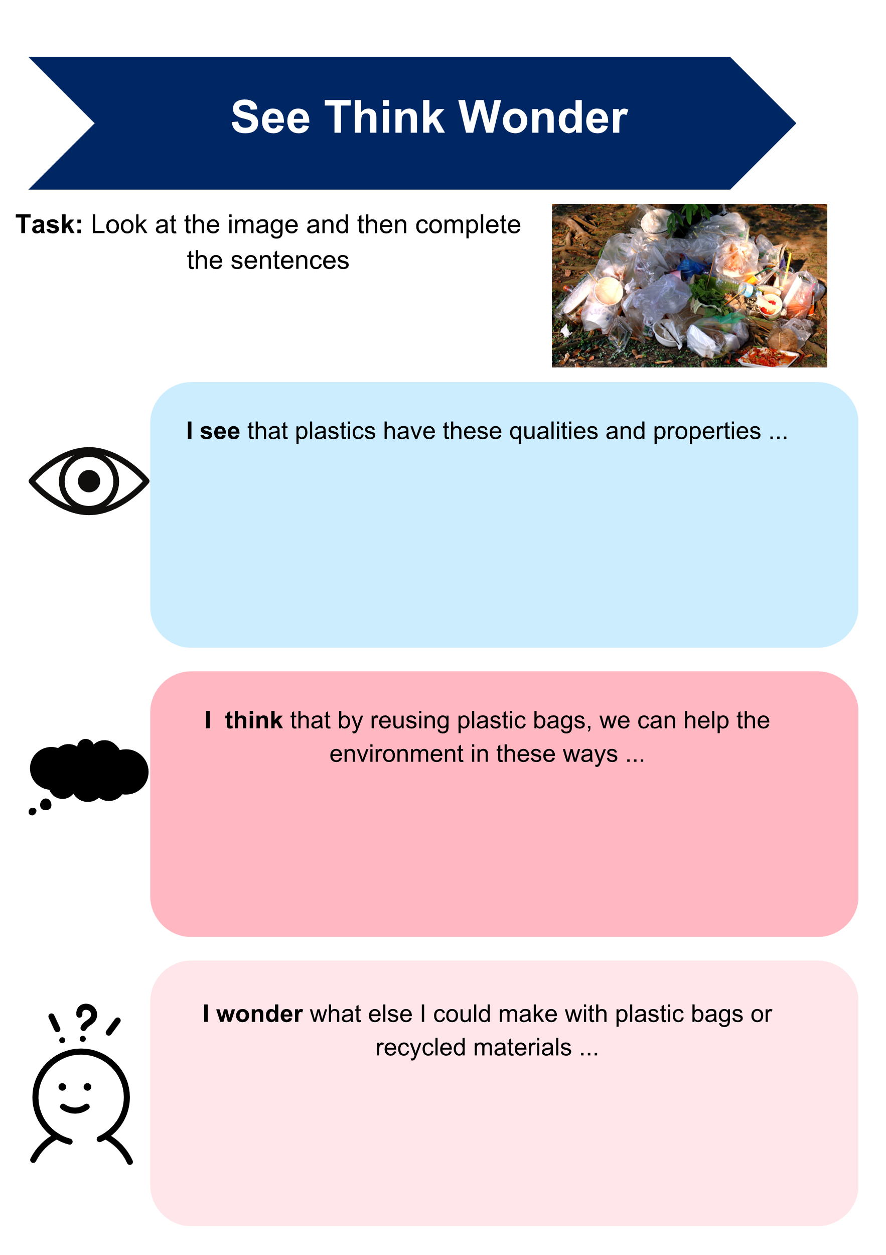

Plastics experiment – plastic fusion
Note: safety alert! The outcome of plastic fusion will depend on the type of plastics you have available. It is recommended that clean and dry plastic food packaging or plastic shopping bags are used.
To reduce risk and hazards all plastic must be fused in an open and well-ventilated area. The iron temperature will depend on the type amount, and thickness of your plastics. Strict and direct supervision is always required. The plastic fuses very quickly under direct heat, and therefore fumes should not be an issue and are minimal. It is important to point out to students that the fused plastic will still be hot once the iron has been removed. Therefore, they should wait for the plastic to cool before touching it.

Sample process for fusing plastics
- Collect materials and equipment needed: plastics (must be cleaned and trimmed to lay flat), baking paper (avoid waxy), scissors, iron, ironing board (or old towel).
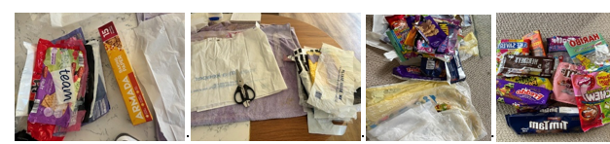
- Cut plastics to create your design or collage.
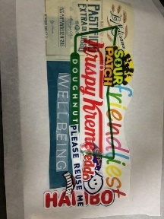
- Lay your 6 to 8 layers of plastics down. This amount will vary, depending on the thickness of the bags (be mindful of inks that may transfer). Place the final design on the top, followed by a translucent layer. Sandwich this between baking paper underneath and on top of the plastic. This must be larger than the plastics to avoid making a mess of the iron or ironing surface. Be aware of any possible air bubbles.
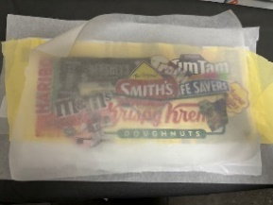
- With the iron set at a medium setting (this will change slightly depending on the thickness and types of plastics), iron steadily and evenly over the design. The fusing will take place quite quickly and will be hot to touch once finished. For best results, iron on both sides.
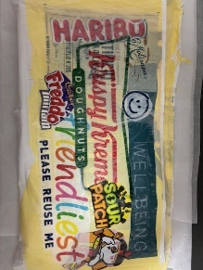
Video tutorials
- How to Fuse Plastic Bags -- Recycling Craft! (6:39)
- Beginners' Guide to Plastic Bag Recycling – How to Make a Wallet (14:06)
- How to make FABRIC from PLASTIC grocery bags – Upcycling Plastic (2:24)

Fusing plastic
Note: students are to complete the activities below. Sample answers have been provided on some activities. Please note that if fused well, students can use fused plastic as an alternative for an appliqué material which has been used in cutting machines (not laser machines however).
Make a list of safety considerations and tips when working with fusing plastic around the graphic below.
Figure 16 – sample safety graphic

Sample answer:
Correct iron temperature, well-ventilated space, teacher supervision, be aware of the heat of plastics before touching them, don’t let the iron come into direct contact with plastics, do not leave iron on for too long, turn iron off after use.
What equipment will you need to organise before you begin your plastic fusion?
Sample answer:
Plastics, old towel, iron, scissors, baking paper.

Create a list of simple steps on how to fuse plastic in the table below. Sample answer has been provided.
Table 23 – table to input instructions of how to fuse plastics
Step | Instructions
1. | Collect materials and equipment needed.
2. | Cut plastics to create your design or collage.
3. | Lay your 6 to 8 layers of plastics down. Place the final design on the top, followed by a translucent layer of plastic. Sandwich this between baking paper underneath and on top of the plastic. This must be larger than the plastics to avoid making a mess of the iron or ironing surface. Be aware of any possible air bubbles.
4. | With the iron set at a medium setting (this will change slightly depending on the thickness and types of plastics), iron steadily and evenly over the design. The fusing will take place quite quickly and will be hot to touch once finished. For best results iron on both sides.
Tips for success – What do you have to remember to have successful plastic fusing?
Sample answer:
Right number of layers, correct iron temperature, no air bubbles, large layer of baking paper to not make a mess, don’t iron for too long.

Practical activity
Complete a sample of plastic fusing and place it in the space below.

Plastic fusion – evaluation
Reflect on your plastic fusion process by completing the PMI chart below. In the space, list something that went well in the plus section, something that needs some improving in the minus section and finally something you found interesting about this technique or how you might use it in a project.
Table 24 – blank PMI chart
Plus | Minus | Interesting

Project development
Note: throughout Part 3 – ‘Achieving vision – project development’ students will use their skills and knowledge to design, project, manage and develop their ‘Sew sustainable, sew awesome!’ project. Most of this section of the unit is student-driven; however, throughout the development of their project, skills will need to be explicitly taught for this to be completed and managed successfully. Students are to document their process either digitally or on paper.

The design and production process
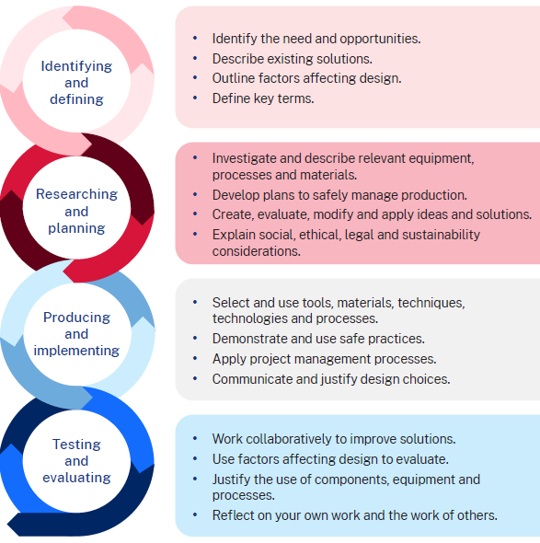

Identifying and defining
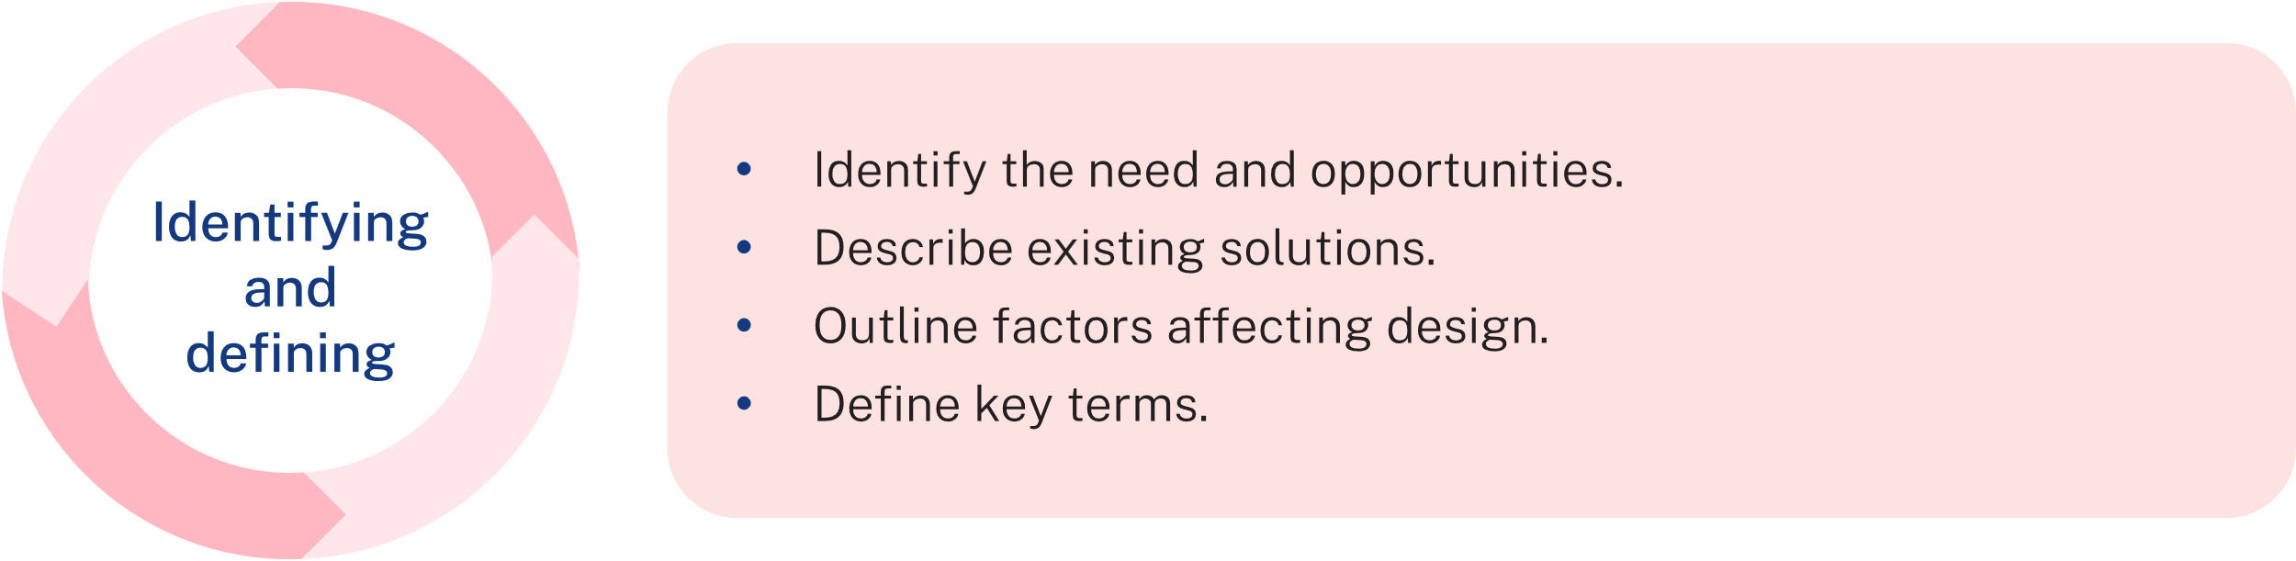
Reminder of the design brief
Design a carry item for your own personal use that helps to stop single-use plastics, or another environmental issue of your choosing, from going into our landfill and ruining our landscapes.

Factors affecting design
Design is about making things look good (aesthetics) and work well (functionality). A good design balances how something looks with how it works. When you're designing your carry item, think about how it looks, how strong it is, how comfortable it is to use, if it's made ethically and how safe it is.
In the table below, describe how your design will meet each of the listed factors that affect design.
Table 25 – factors and how the design could address them
Factor affecting design | Description of how my design could address the factor
Aesthetics (how it looks)
Durability (how strong it is)
Ergonomics (how comfortable is it to use)
Ethics
Safety

Criteria for success
List a minimum of 3 criteria which you will evaluate if your design is successful in meeting the design brief.
Sample answer:
Environmental impact – the item reduces single-use plastics and/or uses recycled fabric. The item is reusable.
Functionality – the item is strong, easy to use, comfortable and fits my items.
Aesthetics – the design looks good.
Cultural and ethical considerations – the design respects Aboriginal and Torres Strait Islander peoples traditions and is made using ethical practices.

Researching and planning
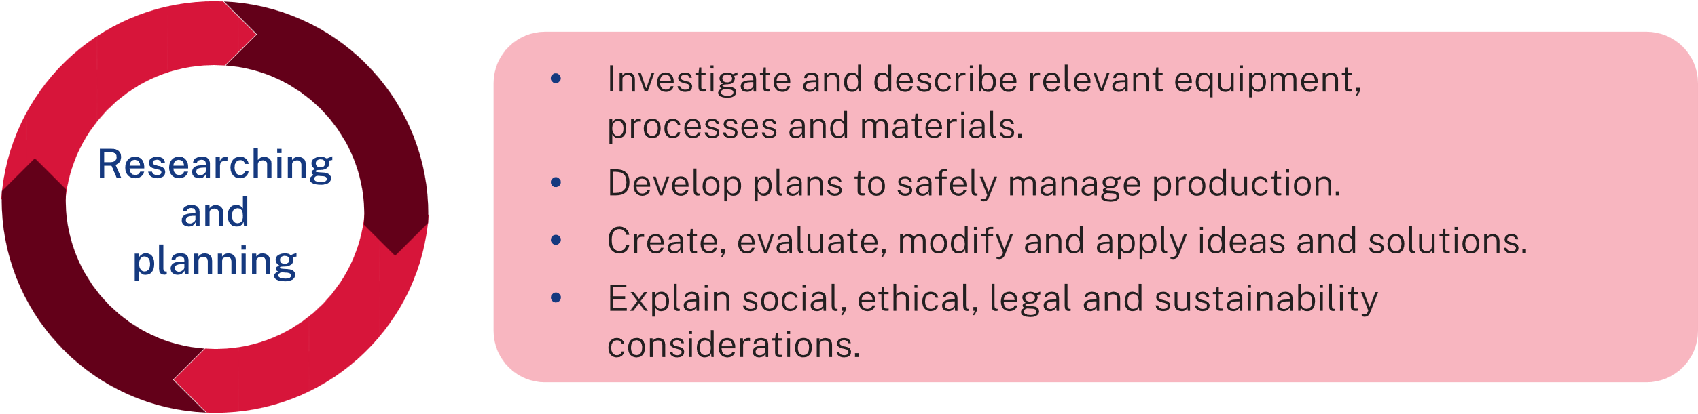

Idea development – type of carry item
In the space below, brainstorm different designs. You can use sketches to show the design style.
Figure 17 – carry item designs brainstorm
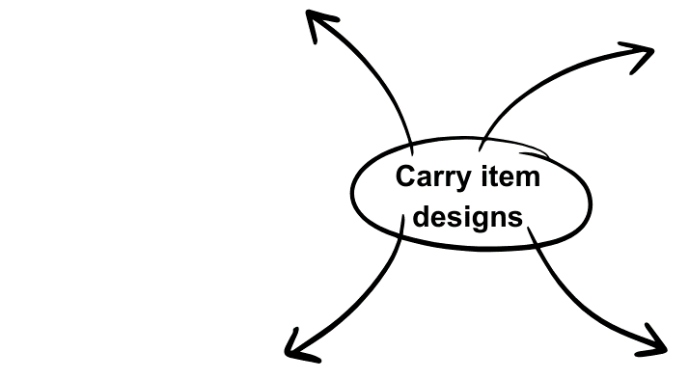

Idea development – decoration
In the space on the following pages, sketch 3 different design ideas for your carry item. Each design should be labelled with design features.
Recall your past research and experimentation with different fabric decoration techniques:
- machine fancy stitches
- appliqué (using fabric, fabric scraps or fused plastic)
- sun printing
- stencilling
- fused plastic.

Design idea 1
Design idea 2

Design idea 3

Evaluation of design ideas
For each design idea, complete the PMI chart below and evaluate.
Design 1
Table 26 – blank PMI chart
Plus | Minus | Interesting
Description of design 1, including how it meets the criteria for success and factors affecting design.
Design 2
Table 27 – blank PMI chart
Plus | Minus | Interesting
Description of design 2, including how it meets the criteria for success and factors affecting design.
Design 3
Table 28 – blank PMI chart
Plus | Minus | Interesting
Description of design 3, including how it meets the criteria for success and factors affecting design.

Final design
In the space below, explain the design you have chosen to make.
Sample scaffold:
I have chosen to make design 3 because …
It meets the design brief by …
The design is suitable because it meets the factors affecting design by …
The design meets the criteria for success by …

Using technology to communicate final design
Using software of your choice, draw and label your final design.
Note: The sample below is drawn using Microsoft Paint. Other options could be Inkscape, Adobe Illustrator, Adobe Express and Canva.
Figure 18 – labelled final design example
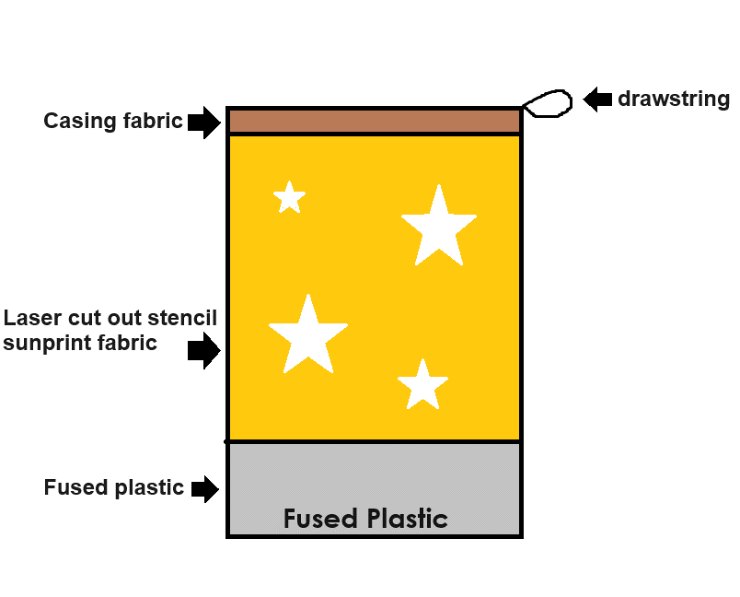

Producing and implementing
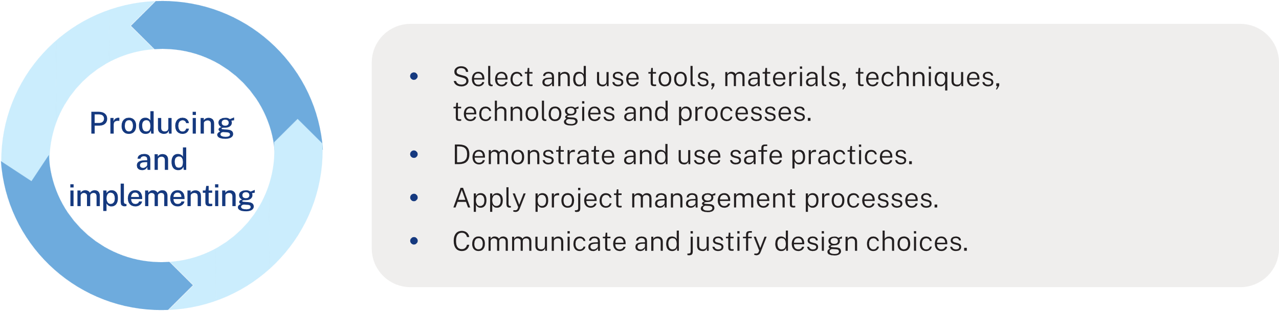

Creating an action plan
An action plan breaks down the project into smaller, manageable tasks to ensure the project is completed on time.

Steps to create an action plan
- Define the goal – What is the final product you want to create? What specific features or design elements will it have (for example, fused plastics, stencilling, sun printing, embroidery)?
- List the tasks – break down the project into smaller tasks.
- Estimate the time for each task – think about how long each task will take. Be realistic and consider any other commitments you have (school, extracurricular activities and so on).
- Set deadlines – assign a deadline for each task. Make sure the deadlines are spread out and achievable. Work backwards from the final due date to ensure you have enough time for everything.
- Create a timeline – use a calendar or planner to map out your tasks and deadlines. This can be a simple list with dates or a more detailed timeline with specific days and times.
- Gather resources – make a list of all the materials and resources you will need.
Note: provide students with the template on the following pages to complete their own action plan. If this is the first time that students have completed an action plan, go through it together as a class. Walk through each step with students, giving them time to fill out their templates. Once students have completed their action plans, review them together. Discuss any adjustments that might be needed to make the plans more realistic or achievable.

My action plan
Complete the action plan prompts in the space provided below.
Project goal – What are you making? Describe your final product.
Steps and timeframes – outline the tasks you need to do to complete your project. Provide an estimate of how many lessons you think each step will take.
Table 29 – steps and their timeframe
Steps | Timeframe

Timeline – use the table below to identify the weeks for each task.
Table 30 – timeline of the week and what steps need to be taken for each task
Week | Step
Progress tracking – How will you keep track of your progress?
Remember to check off tasks as you complete them. You can adjust your plan if needed.
Reflection – What did you learn from creating your action plan? How will it help you complete your project?

Testing and evaluating
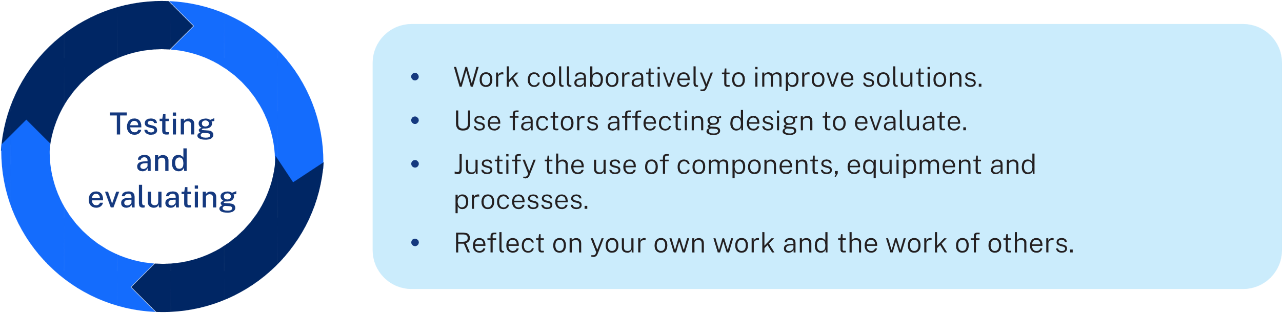

Project evaluation
Evaluate your final product in terms of your success criteria. Place a tick in the face icon column that best reflects how your design meets the success criteria.
Note: refer to the PowerPoint for key to the icons in the evaluation table below.
Table 31 – criteria for success table
Criteria for success |  |  | 

Explain how your completed carry item meets the design brief and criteria for success in the space below.
Sample answer:
I think my pencil case turned out really well. It meets the criteria for success in the following ways:
- environmental impact: it's great because it helps reduce single-use plastics since it's reusable.
- functionality: it is strong and durable, so it will last a long time. The drawstring closure makes it easy to open and close and it comfortably holds all my belongings.
- aesthetics: I decorated how I like, using the fabric decoration techniques we did in class and I think it looks really good.
- cultural and ethical considerations: in selecting designs, I ensured respect for indigenous traditions, avoiding cultural appropriation. It also shows a respect for the environment, as it is reusable.

Final project
Include pictures of your final project.
Note: pictures of multiple sample finished products are included below.
Figure 19 – sample finished products
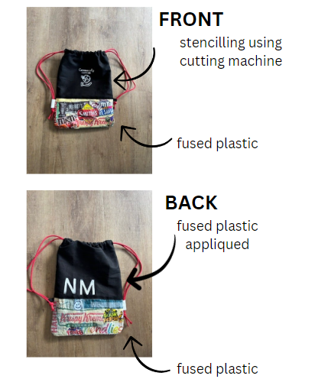 | 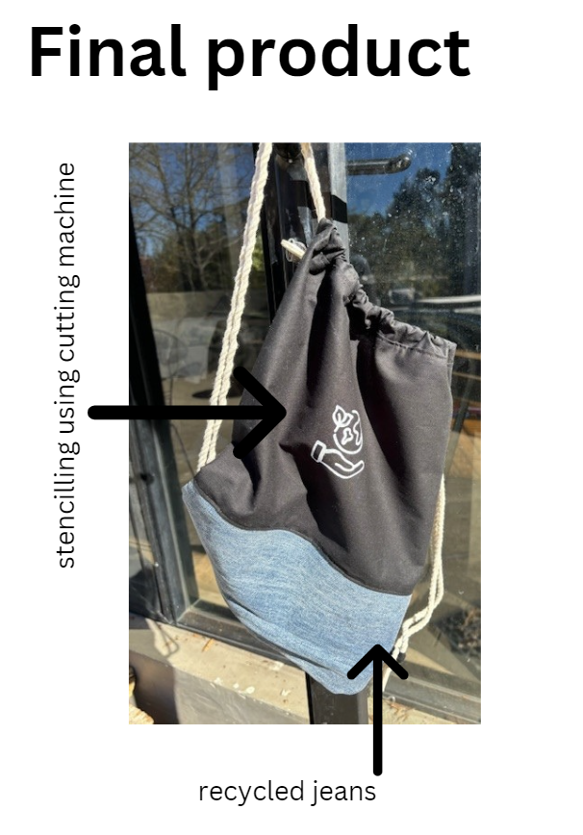
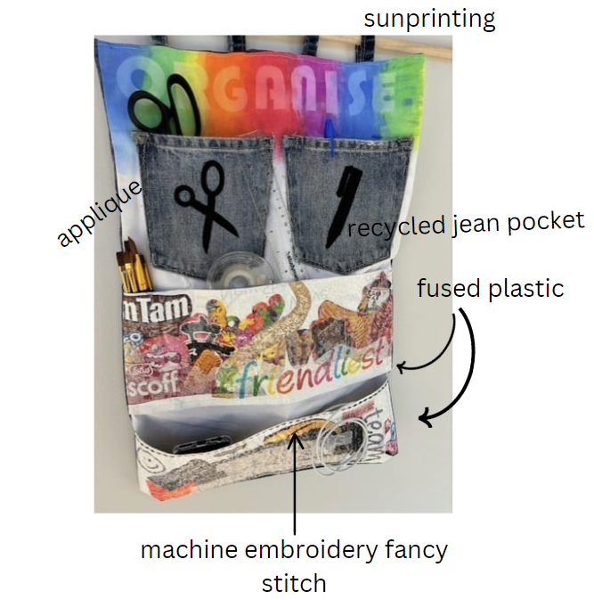

Appendix

Appendix 1 – instructions for pencil case
Resources
- 2 pieces of fabric that have been decorated as part of the fabric decoration samples (approximately 25 cm × 20 cm)
- 20 cm strips of hook and loop tape
- Sewing machine
- Iron
Instructions
- Prepare the edges – fold each long edge of the fabric down 1 cm and iron them with a hot iron.
- Attach the hook and loop strips – place one-half of the hook and loop strip on each folded end, 1.5 cm from each side of the fabric. Pin the hook and loop strips in place, ensuring you are looking at the wrong side of the fabric.
- Sew the hook and loop strips – sew along the top and bottom edges of both hook and loop strips.
- Fold the fabric in half with the right sides touching and the hook and loop strips back-to-back, then iron.
- Sew the seams – turn the fabric inside out and sew the side seams in a straight line using a straight stitch.
- Secure the edges – use a zig-zag stitch to sew along the edges for added durability.
- Finish – turn the pencil case right-side out. Your pencil case is now complete and ready to use!

Appendix 2 – instructions for Option 1 – drawstring backpack
Note: dimensions given are suggestions only. Depending on the materials available to your students, the dimensions can be adjusted. The 2 work samples provided incorporate recycled fabrics and plastic fusing. Extra options and resources are available at Bag & Purse Projects.
Materials needed
- 2 pieces of main fabric (35 cm × 50 cm). If students are adding a contrasting base, reduce the size of the main fabric and adjust, remembering to include a 1.5 cm seam allowance in your adjustments.
- 2 pieces of casing fabric (35 cm × 7 cm)
- 2 pieces of fabric or material for loops
- Cord (2 × 1.5 m)
- Sewing thread
- Decorative items
- Plastics (if fusing)
Table 32 – instructions for Bag 1 and 2
Instructions | Bag 1 | Bag 2
Students to make pattern pieces and cut fabrics or materials to size. | 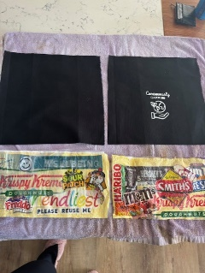 | 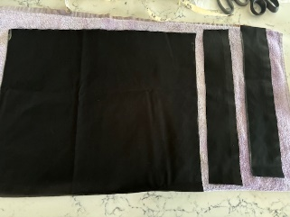
Decorate fabrics as needed.  Bag 1: plastic fusing for the base, appliqué using fused plastic, stencilling  Bag 2: stencilling | 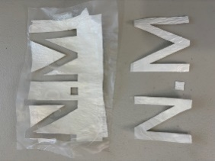  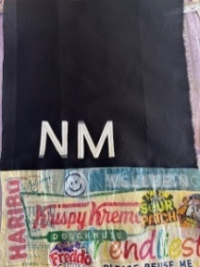  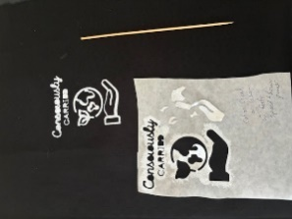 | 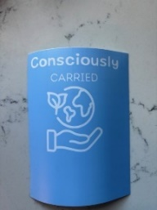  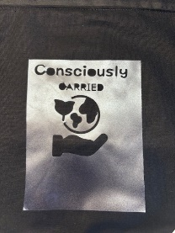  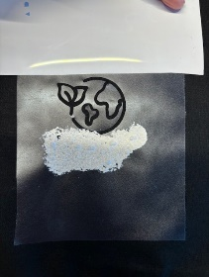
Attach base fabric if required. | 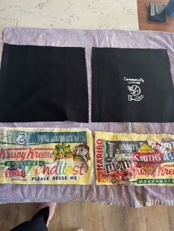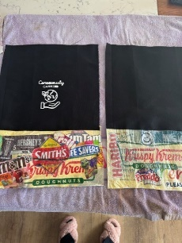
Fold casing ends so they measure 1.5 cm and iron. |  | 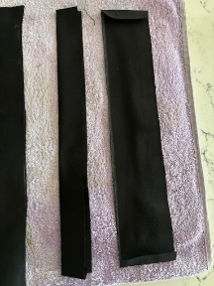
Attach casing to the top of the bag on each piece, measuring in 1.5 cm from either side. |  | 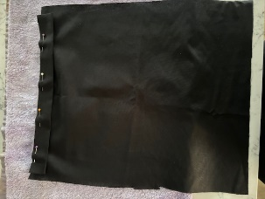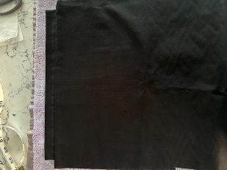
Sew loops – fold in, along the long edge, and iron. Fold in half again and iron. | 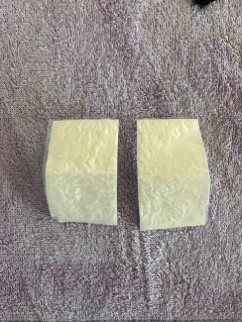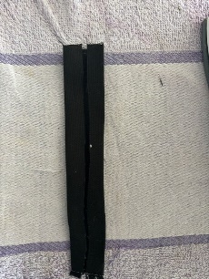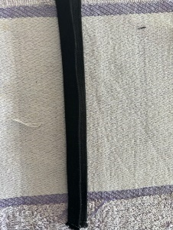 | 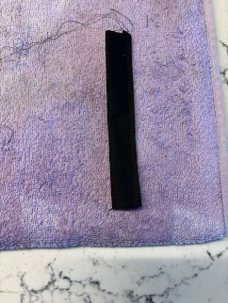
Attach loops with a pin in between the front and back of bag. |  | 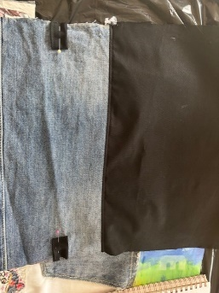
Sew the front and back of the bag together. | 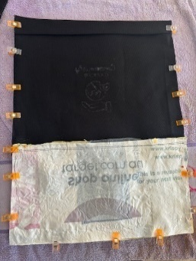  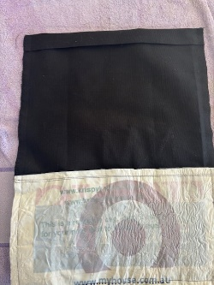 | 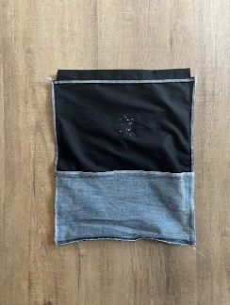  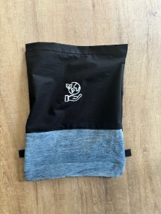
Turn the bag right side out and thread the cord through with the first piece going in and out in one direction and the second piece going in and out in the opposite direction. Attach through the loop tab with a knot. | 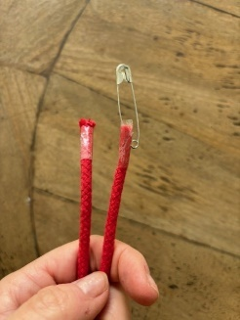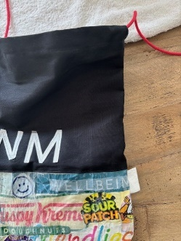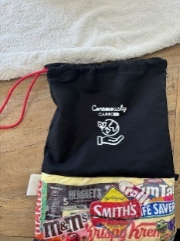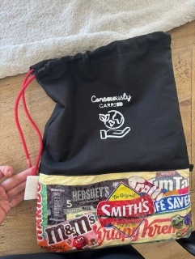 | 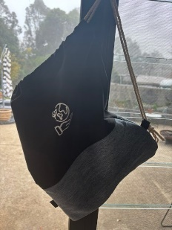
The finished product. | 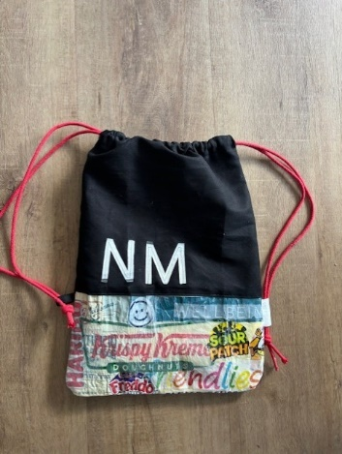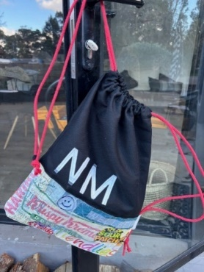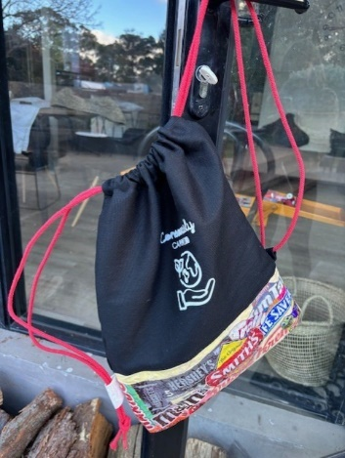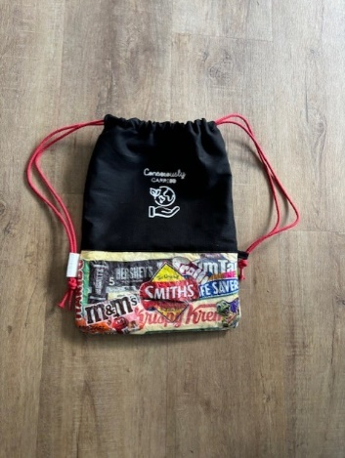 | 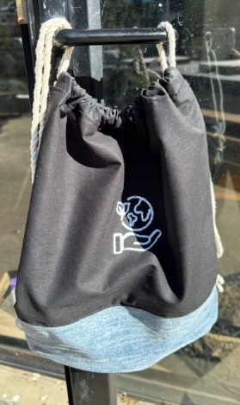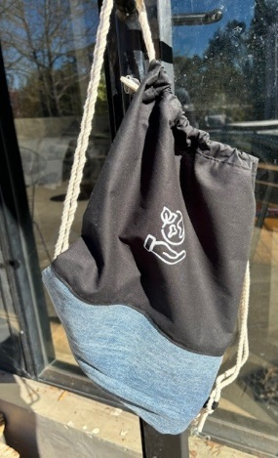

Appendix 3 – instructions for Option 2 – wall organiser
Note: dimensions given are suggestions only. Depending on the materials available to your students, the dimensions can be adjusted. The work sample provided incorporates recycled fabrics and plastic fusing. The following are extra resources: craft organiser, Sewing machine organiser, garden apron, cord organiser, calico toy organiser.
Materials needed
- 2 pieces of main fabric (40 cm × 60 cm)
- Fabrics for pockets (long pocket: 15 cm × 40 cm)
- Fabrics for loops
- Decorative items and materials
- Plastics for plastic fusing
Table 33 – instructions for wall organiser
Instructions | Images
Students to make pattern pieces and cut fabrics to size. | 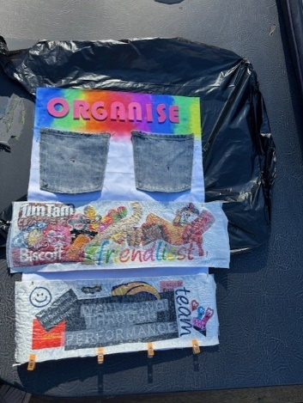
Apply decorative techniques, for example:  - sun printing  - appliqué. | 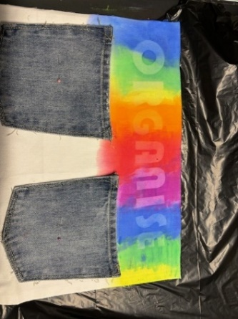  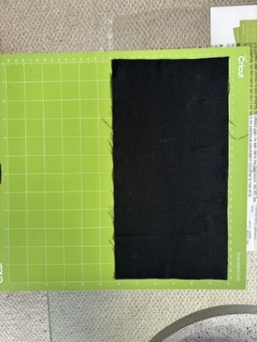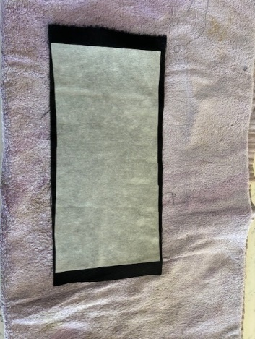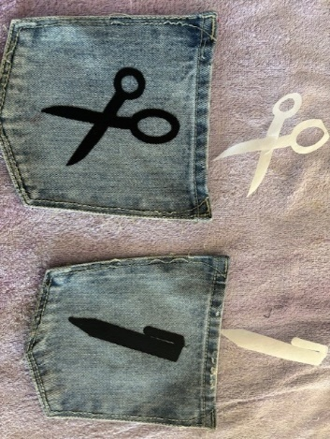
Attach pockets to the front piece. | 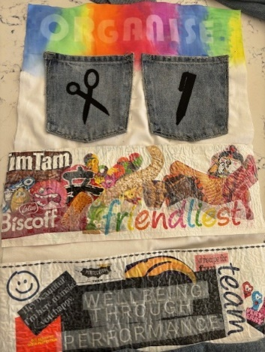
Iron the 2 top pieces down 1.5cm. Sew the front to back down the sides and bottom only.
Secure the loops in place with a pin and then topstitch along the top edge. | 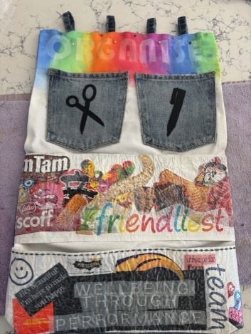
The finished product. | 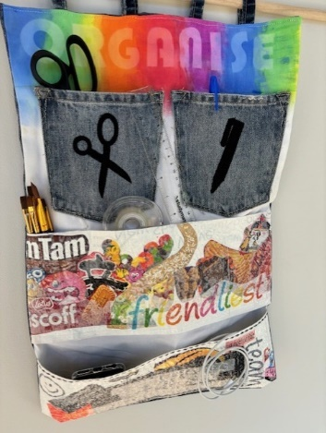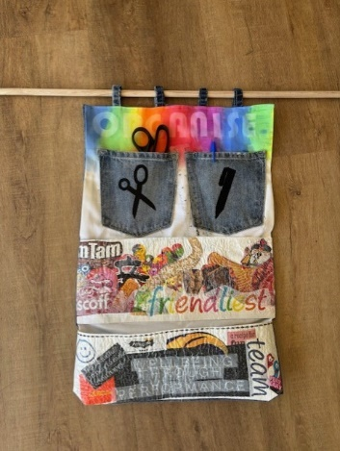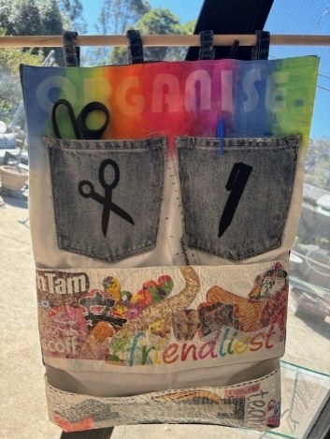  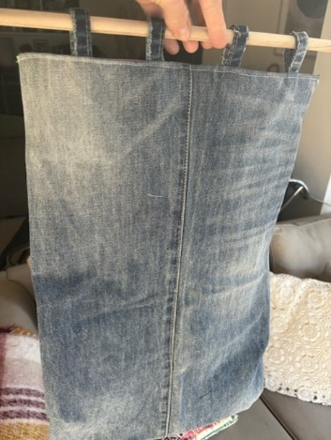

Appendix 4 – weaving types
Figure 20 – weaving type examples
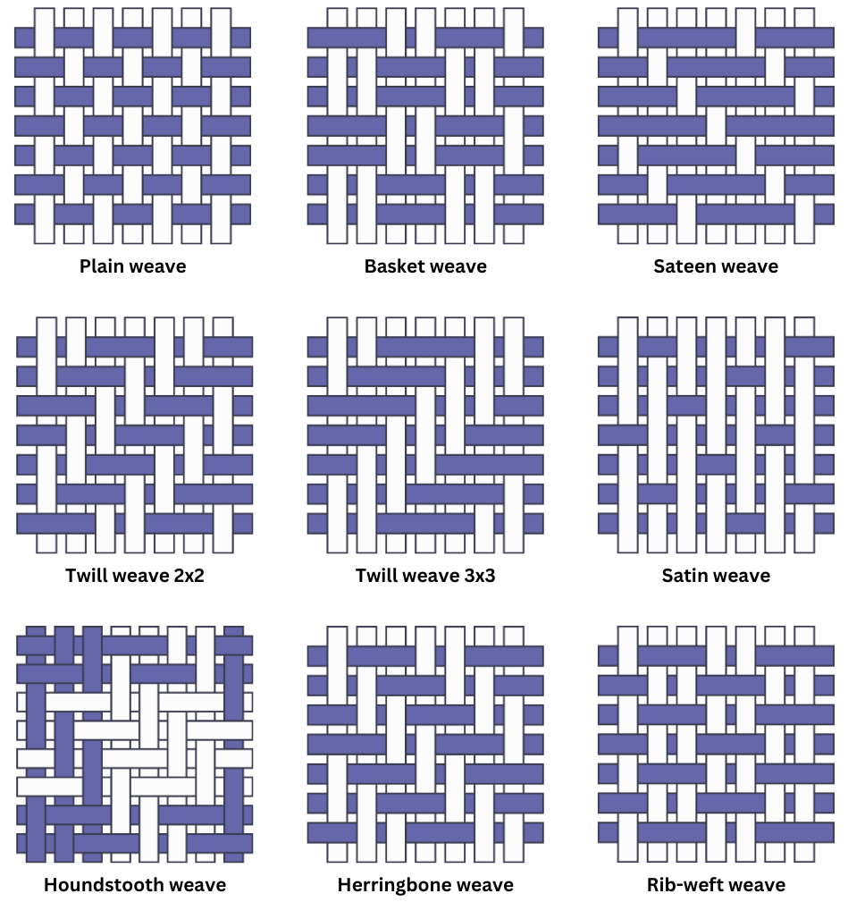

References
This resource contains NSW Curriculum and syllabus content. The NSW Curriculum is developed by the NSW Education Standards Authority. This content is prepared by NESA for and on behalf of the Crown in right of the State of New South Wales. The material is protected by Crown copyright.
Please refer to the NESA Copyright Disclaimer for more information https://educationstandards.nsw.edu.au/wps/portal/nesa/mini-footer/copyright.
NESA holds the only official and up-to-date versions of the NSW Curriculum and syllabus documents. Please visit the NSW Education Standards Authority (NESA) website https://educationstandards.nsw.edu.au and the NSW Curriculum website https://curriculum.nsw.edu.au.
Technology 7-–8 Syllabus © NSW Education Standards Authority (NESA) for and on behalf of the Crown in right of the State of New South Wales, 2023.
ABC (Australian Broadcasting Corporation) (17 May 2022) 'Indigenous bags and textiles' [video], ABC Education, ABC website accessed 17 June 2024.
ABC iview (12 September 2021) 'Waking up Indigenous weaving practices | Art Works' [video], ABC iview, YouTube, accessed 12 June 2024.
ABC News (Australia) (9 July 2018) 'We Can, We Do: Aunty Connie Hart breaks all the rules to keep tradition alive' [video], ABC News (Australia), YouTube, accessed 12 June 2024.
Boomerang Bags (7 March 2014) 'The Life of a Plastic Bag' [video], Boomerang Bags, YouTube, accessed 17 June 2024.
Boomerang Bags (2022) Boomerang Bags [website], accessed 17 June 2024.
Brothers Make (24 September 2022) 'Beginners' Guide to Plastic Bag Recycling - How to Make a Wallet´ [video], Brothers Make, YouTube, accessed 17 June 2024
Brothers Make (27 May 2023) 'Is this a better use for plastic bags?' [video], Brothers Make, YouTube, accessed 14 June 2024.
Brothers Make (2 March 2024) 'Can Your Chip Bags Save Lives?' [video], Brothers Make, YouTube, accessed 17 June 2024.
Cool.org (25 August 2020) 'Take 3 – Connection' [video], Cool.org, Vimeo, accessed 17 June 2024.
CottonAustralia (18 August 2020) 'Cotton Products and Uses´[video], CottonAustralia, YouTube, accessed 14 June 2024.
DiPietro B (21 May 2023) ‘Magical Summer SunPrinting on Fabric’, MadeByBarb Tutorials, accessed 17 June 2024.
Jenn’s Creativity Corner (29 April 2017) 'How to Fuse Plastic Bags -- Recycling Craft!' [video], Jenn’s Creativity Corner, YouTube, accessed 17 June 2024.
Mrs Deeming Tech (17 May 2020) 'Textiles: What are they? where do they come from?' [video], Mrs Deeming Tech, YouTube, accessed 17 June 2024.
Sewers Delight (25 November 2026) 'How a Sewing Machine Works via animation' [video], Sewers Delight, YouTube, accessed 9 June 2024.
Take 3 for the Sea (29 June 2023) '4:6 EP4 PERSONAL ACTION' [video], Take 3 for the Sea, YouTube, accessed 17 June 2024.
The Rocks (9 November 2020) 'Weaving Workshop' [video], The Rocks, YouTube, accessed 17 June 2024
The Woolmark Company (3 June 2016) 'The Innovator' [video], The Woolmark Company, YouTube, accessed 24 July 2024.
Upcycle DesignLab (12 March 2022) 'How to make FABRIC from PLASTIC grocery bags – Upcycling Plastic' [video], Upcycle DesignLab, YouTube, accessed 17 June 2024.
wikiHow (2023) ‘How to Make a Stencil’ (Medford K rev), Stencil Art and Craft, wikiHow website, accessed 10 June 2024.
wikiHow and Cho J (2024) ‘How to Stencil Fabric’, Stencil Art and Craft, wikiHow website, accessed 10 June 2024.

© State of New South Wales (Department of Education), 2024
The copyright material published in this resource is subject to the Copyright Act 1968 (Cth) and is owned by the NSW Department of Education or, where indicated, by a party other than the NSW Department of Education (third-party material).
Copyright material available in this resource and owned by the NSW Department of Education is licensed under a Creative Commons Attribution 4.0 International (CC BY 4.0) license.

This license allows you to share and adapt the material for any purpose, even commercially.
Attribution should be given to © State of New South Wales (Department of Education), 2024.
Material in this resource not available under a Creative Commons license:
- the NSW Department of Education logo, other logos and trademark-protected material
- material owned by a third party that has been reproduced with permission. You will need to obtain permission from the third party to reuse its material.
Links to third-party material and websites
Please note that the provided (reading/viewing material/list/links/texts) are a suggestion only and implies no endorsement, by the New South Wales Department of Education, of any author, publisher, or book title. School principals and teachers are best placed to assess the suitability of resources that would complement the curriculum and reflect the needs and interests of their students.
If you use the links provided in this document to access a third-party's website, you acknowledge that the terms of use, including licence terms set out on the third-party's website apply to the use which may be made of the materials on that third-party website or where permitted by the Copyright Act 1968 (Cth). The department accepts no responsibility for content on third-party websites.

