Technology 7–8 portfolio template

Contents
Overview 4
Title page 5
Identifying and defining 6
What is a design problem? 6
What is a design brief? 6
Sample design brief 7
Design considerations 8
What are the criteria to evaluate success? 9
Researching and planning 11
Existing solutions 11
Image set 1 – for example, metal jewellery 11
Image set 2 – for example, polymer clay jewellery 12
Image set 3 – other sources of inspiration for my solution 12
Materials, equipment and processes 12
Design development 13
Design idea 1 14
Design idea 2 15
Design idea 3 15
Optional student activity – SCAMPER 16
Producing and implementing 17
Final design 17
Example 17
What is a justification? 18
Scaffold – justification for the final design 18
Tools, materials, technologies and processes 19
Production steps 19
Example of production steps 20
Testing and evaluating 22
What is an evaluation? 22
Peer feedback 22
Self-evaluation 23
Class notes/booklet 25

Overview
This Technology 7–8 design portfolio template has been set up in MS Word as an alternative to using the Google site’s Portfolio Sample Technology Mandatory (staff only).
The headings follow the design and production process. Each page sets out associated design process activities and tasks for the student to complete.
Teachers can adapt this template to suit their school and class requirements.
Notes with grey background indicate information to support the teacher and student. This can be deleted once the student understands the instructions and completes the task.
Pink feature boxes indicate a Task to be completed by the student. Teachers can adjust the task or edit the instructions. Space is provided for students to add their response.

Title page
Some suggested headings which could be used for this document are as follows:
- Technology 7–8
- Focus area:
- Unit name:
- Name:
- Class:
- Teacher:

Identifying and defining
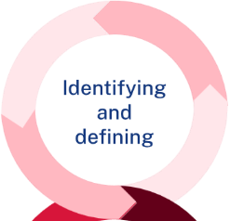

What is a design problem?
A 'design problem' helps identify a need or issue to be solved and provides background information to explain why it is a problem.
Task – the design problem for you to solve
Type into your portfolio the design problem that your teacher has outlined for you.
[Student response.]

What is a design brief?
The design brief follows the ‘problem’ and clearly states how you intend to solve the design problem.
- Begin the design brief with ‘I am going to design and make ....’. This is followed by a general description of the product or solution you feel will answer the design problem.
- Be flexible with your description. This should allow you to explore ideas for a product or solution that is the best match for the problem. For example, if you are designing a solution to help feed animals, avoid limiting the solution idea to an automated feeder at this stage of the project.
- Outline what the product or solution will do (its functions) and who it is for (for example, children). You might also mention other considerations such as the basic cost of manufacture or a lower and upper cost limit, circuit requirements safety, general size or other points you feel are important.
- Describe the general properties or characteristics of the materials to be used. For example, strong, tough, flexible, natural, manmade, recycled, water-proof or similar general descriptions. Avoid stating the exact materials that will be used (for example, pine, steel, Perspex and so on.).

Sample design brief
Please find a student sample of a design brief below.
I am going to design and make a security device that will make my house look occupied when, in fact, it is empty. Police statistics clearly show that houses are much more likely to be broken into when they are empty. Consequently, if the house looks occupied it is likely to be safe.
The device will be mobile so that it can be moved from room to room, easy to set up and control and cheap to make. It must not be powered by mains voltage and in this way, it will be completely safe to be left ‘on’ for a long time and will not be affected by power cuts. It will be activated by anyone approaching the hose from the front or back.
It must deter even professional crooks from taking an interest in our house and even convince people in the street that the house is occupied.

Task – your design brief
Create a short design brief for the design problem given by your teacher.
Use the example above to help structure your design brief.
[Student response.]

Design considerations
Design considerations provide additional details or criteria that help create boundaries to guide the project. They may include ‘must haves’ such as choice of materials or limitations such as the amount of time for production.
Task – your considerations for this project
Create a list of considerations for your project. This can be done with your teacher and as a class discussion.
Considerations for my project include:
- [student response]
- [student response]
- [student response.]

What are the criteria to evaluate success?
The criteria to evaluate success is one of the most important sections of your design folio. As the designer, you need to explain what your product or solution must do to solve the problem and how it will look, in order to be considered successful.
The criteria should be based on the factors that affect design. This will also help guide your decisions throughout the design process.
Task – your criteria to evaluate success
Below are some of the factors affecting design. Go through the definitions with the teacher and come up with some examples – at least 3 criteria points under each factor to ensure that you design a successful product.
Definition
Function: the ability of a product or solution to perform the task for which it was designed.
To be successful, my product or solution must:
[Student response.]
Aesthetics: the physical appearance of a product and its visual appeal to the target market.
To be successful, my product or solution must:
[Student response.]
Ergonomics: the relationship between the user and their physical or work environment.
To be successful, my product or solution must:
[Student response.]
Safety: safe design is about identifying hazards early in the design process to eliminate or minimise risk of injury throughout the life of a product.
To be successful, my product or solution must:
[Student response.]
Quality: a measure of excellence, often linked to performance and durability. A high-quality product is expected to perform well for the expected period of time.
To be successful, my product or solution must:
[Student response.]
Cost: the amount of money required for the development of a product. A budget can help manage finances.
To be successful, my product or solution must:
[Student response.]

Researching and planning

Once the problem is understood, extensive research needs to be carried out. This involves collecting information that considers all aspects of the problem. Information can be found in magazines, books, catalogues, past designs and the internet. Research must be ongoing during the design process.
See the specific research and planning requirements required for your project in the assessment task and student booklet. Your teacher will also guide you. Your research may include:
- design Inspiration – collect a range of images that will provide inspiration for your own idea. This could include hobbies, interests, nature, buildings or existing products
- research into materials, processes, tools and techniques
- safety – machinery, tools, equipment and PPE

Existing solutions
Students can produce a collage of images of existing solutions, with annotations.
These may appear in image sets of their inspiration.
Task – research of existing solutions

Image set 1 – for example, metal jewellery
[Student response.]

Image set 2 – for example, polymer clay jewellery
[Student response.]

Image set 3 – other sources of inspiration for my solution
[Student response.]

Materials, equipment and processes
Teacher instruction: there is an option to embed worksheets about tools, techniques, materials, components and processes for students to complete and upload to their portfolio.
Students should also be guided to experiment through practical activities and prototyping.
Task – explore a range of materials, equipment and process suitable for your design project
Materials – characteristics and properties.
[Student response.]
Equipment and safety considerations.
[Student response.]
Processes – including evidence of experimentation.
[Student response.]

Design development
All ideas should be considered and documented, no matter how novel or imaginative. Simple sketches or drawings with annotation (labelling) can be used to show design ideas or digital tools such as OnShape or TinkerCAD can be used.
Design ideas are then evaluated to select the ones that are most promising for further development. A PMI analysis could be used to work out the strengths and weaknesses of each design idea.
- P – Plus / Positives
- M – Minus / Negatives
- I – Interesting / Improvements / Inspiration
The PMI activity could be completed individually or with a peer to help assess and identify opportunities to enhance the design. Alternately, students could be asked to complete the 'SCAMPER' or ‘Crazy 8’s’ activity with their peers to evaluate the designs.
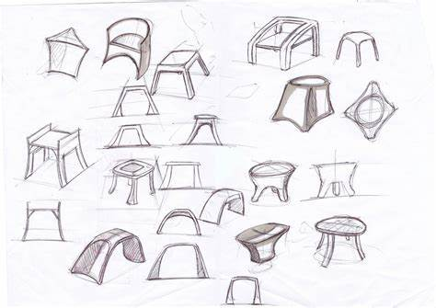
Task – sketch and evaluate design ideas
- Sketch 4 to 6 design ideas for your product. These will be thumbnail sketches such as the ones above.
- Label the functional and aesthetic features of each design.
Function – the features that make the product work.
Aesthetics – the features that make the product look good.
- Complete a Plus Minus Interesting (PMI) analysis of each idea to show a development to your solution.

Design idea 1
[Insert sketch.]
Table 1 – PMI analysis for Design idea 1
Plus | Minus | Interesting
- [Student response.]  - [Student response.] | - [Student response.]  - [Student response.] | - [Student response.]  - [Student response.]

Evaluation
Through this process, I will implement __________________________________in the next design; and change _________________________, in order to achieve _________________.

Design idea 2
[Insert sketch.]
Table 2 – PMI analysis for Design idea 2
Plus | Minus | Interesting
- [Student response.]  - [Student response.] | - [Student response.]  - [Student response.] | - [Student response.]  - [Student response.]

Evaluation
Through this process, I will implement __________________________________in the next design; and change _________________________, in order to achieve _________________.

Design idea 3
[Insert sketch.]
Table 3 – PMI analysis for Design idea 3
Plus | Minus | Interesting
- [Student response.]  - [Student response.] | - [Student response.]  - [Student response.] | - [Student response.]  - [Student response.]

Evaluation
Through this process, I will implement __________________________________in the next design; and change _________________________, in order to achieve _________________.

Optional student activity – SCAMPER
Table 4 – SCAMPER analysis
Problem | New idea possibilities...
Substitute
Combine
Adapt
Modify
Put
Eliminate
Reverse

Producing and implementing
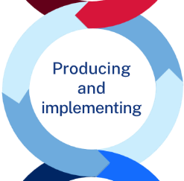

Final design
Task – insert a drawing of your final design
Your final design drawing should:
- be colour rendered and represent the materials you will use to make the final product
- include all measurements and label the aesthetic and functional features.

Example
Figure 1 – student final design example
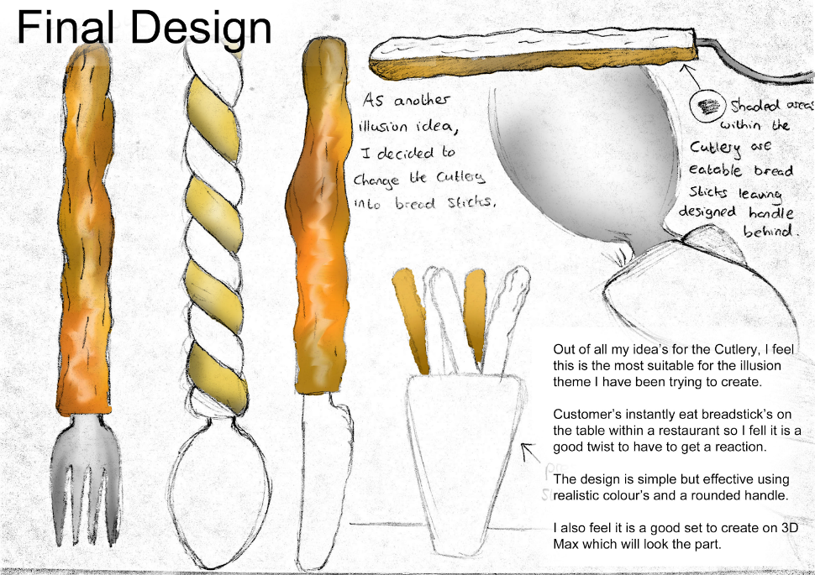
[Student response.]

What is a justification?
A justification is the support of an argument, opinion or conclusion.
‘Justify’ means that you must use evidence and examples to prove something about the topic. Your writing should be convincing and include strong arguments and facts to support your case. To justify, is to provide reasons 'why', with evidence.
Task – write a justification about the selection of this design as the 'best solution' to meet the design brief

Scaffold – justification for the final design
I have chosen to create/make [student to insert design idea] to solve the problem of [insert describe problem].
This meets the success criteria by [list the ways this design meets the success criteria].
The final design I have chosen is [describe the design here].
This is the best of the ideas I researched and designed because:
[supporting statement 1 as to why this is the best idea/design to solve the problem].
Additionally, this design:
[supporting statement 2 as to why this is the best design].

Tools, materials, technologies and processes
Task – document the tools, materials, technologies and processes used during prototyping and developing the final product or solution

Tools
[Student to insert photo or drawing and description of the tools to be used.]

Materials and components
[Student to insert photo or drawing and description of the materials and/or components to be used.]

Technologies
[Student to insert photo or drawing and description of the technologies to be used.]

Processes
[Student to insert photo or drawing and description of the processes to be used.]

Production steps
Production steps detail all the work that occurred in the creation of your final product.

Example of production steps

Step 1 – measuring materials
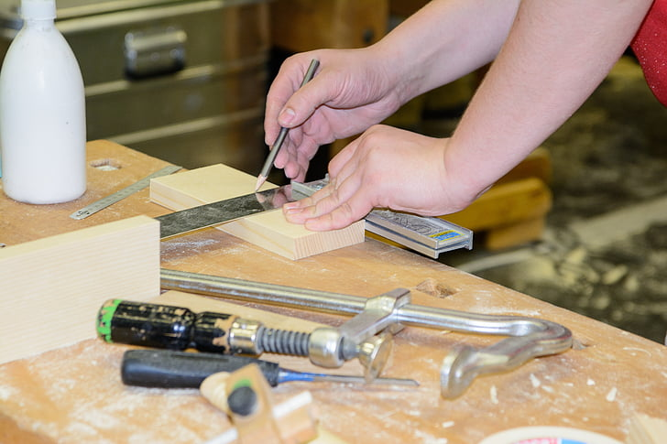

Step 2 – cutting materials
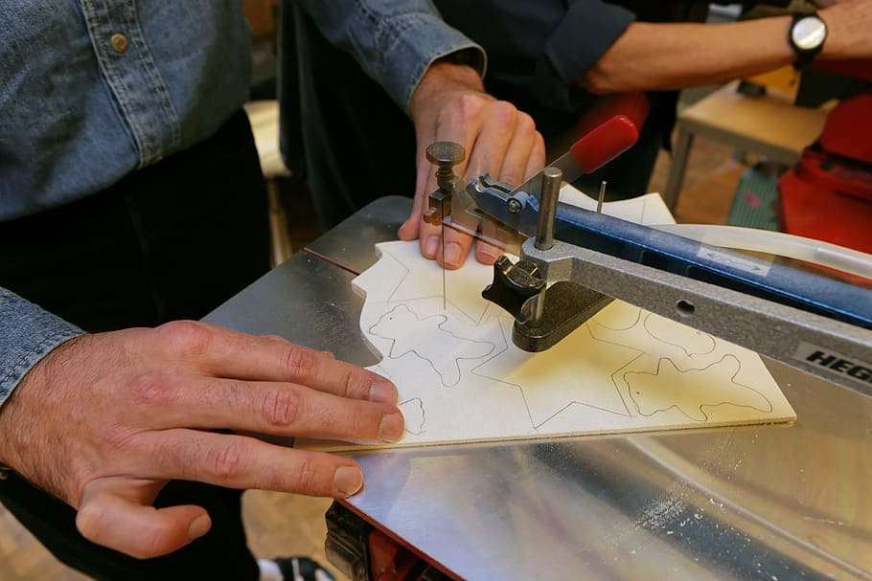

Step 3 – sanding
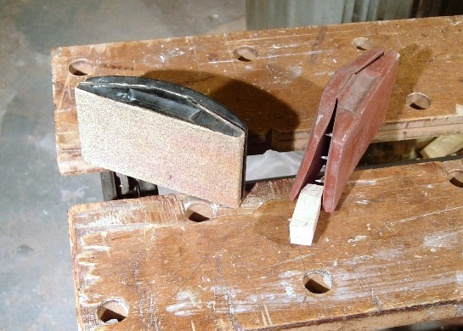
Task – document each step of production
If you have access to a camera: take a photo, upload your photo, add a step number and write the process steps. You might also include safety features or an analysis of how or why things may not have gone to plan in certain steps. Add more rows as needed.
If you are unable to use a camera: draw the production step or find an accurate image on the internet.

Steps in production
Instruction | Reference image | Safety features | Did things go to plan? Why/why not?
- [Student to insert photos or drawings and brief description of the production steps.] | [Insert reference image.]

Testing and evaluating


What is an evaluation?
An evaluation is a crucial part of any design portfolio, where you make a judgement based on a set of criteria. It is a document that outlines how you went, including the positives and negatives of your design experience and what modifications could be made in future.

Peer feedback
Teacher instruction: choose one of the following peer feedback activities that best meet your students' needs or upload or insert an alternate activity.
Task A – invite a peer to evaluate your final product
Invite another student to provide feedback on your product or solution by asking them to respond to the questions below.
- What did you like?
- What didn’t you like so much?
- What did you wish my solution had?
- Do you have any ideas or suggestions to share?
[Student response.]
Task B – invite a peer to evaluate your final product
Upload the completed peer evaluation (teacher to provide template) here.
[Student response.]

Self-evaluation
Teacher instruction: choose one of the following evaluation activities that best meet your students' needs or upload or insert an alternate activity.
Task A – you are to develop a 300-word self-evaluation of your final product
In this evaluation you must outline if you were successful or not by using the initial points that you identified in the 'Criteria to evaluate success', when compared with your final product.
- Explain the design problem which was presented to you and the solution you came up with (your product).
- Evaluate the success of your product by comparing the final solution to your initial Criteria to Evaluate Success – How well did you meet each criteria, what evidence do you have?
You could consider discussing some of the following points as below, but relate them to your own product:
- Potential customer, function, aesthetics, overall quality, finish, materials, shape and form, cost and budget, safety, sustainability and so on.
- What would you do differently next time – improvements, modifications, materials, production processes, project management.
[Student to insert written response; option to include photos/drawings.]
Task B – evaluate the success of your project in meeting your design criteria
List the criteria for success that you created in the ‘Identifying and defining’ part of your folio.
Hint: you can add space for more criteria if needed.
Add a comment about how well your product or solution has or hasn’t met each criteria.
Table 5 – student evaluation of criteria
Criteria | Student evaluation
Criteria 1 | [Student response.]
Criteria 2 | [Student response.]
Criteria 3 | [Student response.]

Class notes/booklet
Teacher instruction: there is an option to embed class notes or other worksheets for students to complete and upload to their portfolio.

© State of New South Wales (Department of Education), 2025
The copyright material published in this resource is subject to the Copyright Act 1968 (Cth) and is owned by the NSW Department of Education or, where indicated, by a party other than the NSW Department of Education (third-party material).
Copyright material available in this resource and owned by the NSW Department of Education is licensed under a Creative Commons Attribution 4.0 International (CC BY 4.0) license.

This license allows you to share and adapt the material for any purpose, even commercially.
Attribution should be given to © State of New South Wales (Department of Education), 2025.
Material in this resource not available under a Creative Commons license:
- the NSW Department of Education logo, other logos and trademark-protected material
- material owned by a third party that has been reproduced with permission. You will need to obtain permission from the third party to reuse its material.
Links to third-party material and websites
Please note that the provided (reading/viewing material/list/links/texts) are a suggestion only and implies no endorsement, by the New South Wales Department of Education, of any author, publisher, or book title. School principals and teachers are best placed to assess the suitability of resources that would complement the curriculum and reflect the needs and interests of their students.
If you use the links provided in this document to access a third-party's website, you acknowledge that the terms of use, including licence terms set out on the third-party's website apply to the use which may be made of the materials on that third-party website or where permitted by the Copyright Act 1968 (Cth). The department accepts no responsibility for content on third-party websites.

