Technology 7–8 – Materials and production processes –teacher resource
Bling it on

Contents
Teacher support resource 4
Workplace health and safety (WHS) 4
Safe working habits 4
WHS activity 5
Class expectations for the workshop 6
Design and production processes 8
Identifying and defining 9
Mixed materials jewellery collage 9
Prior knowledge 10
Exit ticket – sticky note 11
Types of jewellery 12
Functional features of jewellery 13
Materials for jewellery 14
What is a design brief? 16
Sentence scaffolds for writing a design brief 17
Design problem 18
Design brief 18
Factors affecting design 19
Criteria for success 19
Criteria for success in jewellery design 20
Describe existing solutions 22
Glossary 23
Research and planning 26
History of jewellery and adornments 26
Contemporary Aboriginal jewellery designs 27
Research jewellery items made by Aboriginal or Torres Strait Islander peoples 28
Cultural jewellery – gallery walk 30
Biomimicry in design 35
Case study – Larsen Jewellery 37
Larsen Jewellery’s commitment to ethical and sustainable practices. 37
Equipment, processes and materials 38
Time management 38
Time management plan 39
Tools 41
Research of processes 50
Metal 51
Cast acrylic 65
Polymer clay 72
History of polymer clay 72
3D printing using ABS and PLA 81
Create, evaluate, modify and apply ideas and solutions 86
Inspiration mood board 86
Crazy 8 idea generation 87
SCAMPER (Substitute, Combine, Adapt, Modify, Put, Eliminate, Reverse) 88
Producing and implementing 89
Process 89
Final design choice – justification 91
Student scaffold for ‘Justify’ 92
Testing and evaluating 94
Peer feedback – two stars and a wish 95
Peer feedback – TAG 96
Factors affecting design evaluation 97
Self-evaluation 98
Appendix 1 100
Metal (copper, brass, silver) 100
Equipment 100
Key processes 100
Acrylic or timber 101
Equipment 101
Key processes 101
Polymer clay 102
Equipment 102
Key processes 102
3D Printing (PLA, ABS) 103
Equipment 103
Key processes 103
References 104

Teacher support resource
Note: this resource has been designed to facilitate the ready conversion into a student booklet by removing the answers within the response boxes. Teacher notes and sample answers can be deleted before distributing to students.
Scenario: you are a designer tasked with creating a unique piece of jewellery that reflects sustainability, cultural significance or inspiration from nature (biomimicry). Your design must combine at least 2 different materials (for example, metals, polymers, wood) to showcase how contrasting materials can work together to create an aesthetically pleasing and functional piece.
Note: teachers may like to nominate what product students will design and produce. Possible products may include laser cutting of acrylic or timber jewellery, polymer clay (FIMO) modelled jewellery, brass, copper or silver wire or sheet jewellery, or 3D printed ABS or PLA jewellery. The choices offered to students will depend on the experience of the teacher, availability of resources, technology, materials and rooming requirements.

Workplace health and safety (WHS)
In schools we have access to a range of technologies that have the potential to harm if misused or used incorrectly. It is important to follow safe working habits when working in the metal workshop. Safety is the responsibility of everyone in the workshop.
Refer to Equipment Safety in Schools, Animals in Schools, and Chemical Safety in Schools for current information on safety and safe working practices in Technology 7–8.

Safe working habits
The following are a list of safe working habits:
- Keep your working area clean and tidy. Offcuts can have sharp edges that will cut your skin. Scraps and offcuts should be placed in an offcuts box or in the workshop bin.
- Keep the floor areas clear, especially walkways.
- Replace tools in the tool racks as soon as you have finished with them.
- Always walk in the workshop, holding tools and materials down to avoid touching other workers.
Hand tools
- Never use hand tools that may be broken. Report all broken tools to the teacher.
- When working with sharp tools, such as chisels, work away from the body, keeping your hands away from the sharp edge.
Machine safety
- Stay outside of yellow lines marking machine zones when the machine is being used.
- When using the drill press, clamp all materials to the drill press table.
- Always turn the machine off before leaving the machine.
- Clear all waste and shavings using a dustpan and brush. Using your hands or blowing shavings can lodge metal in your skin or eyes.
- Learn how to stop the machine before you learn how to start it.
Heating and soldering
- Handle dip solutions, fluxes and solder carefully. Remove metals from solutions using the correct tongs. Wash your hands thoroughly when you have finished.
- Always hold a flame away from the body. Keep the flame on the heat pads or fire bricks
- Always treat materials in the hot area as ‘hot’. Always handle with tongs

WHS activity
Note: sample answers are provided in the table below.
In the table below outline 4 safety issues in the metal workshop. Include issues that may occur with tools, equipment and heating metal.
Table 1 – WHS activity
Number | Safety issue
1 | Sharp metal offcuts causing cuts
2 | Hot area, use of heat burns
3 | Heavy metals on benches
4 | Sharp ends of metal lengths causing cuts
For each of the issues identify what you would do to fix the safety issue.
Table 2 – WHS activity
Number | Safety issue solution
1 | Place all offcuts into the scrap bins. Collect with dustpan and brooms.
2 | Treat everything at the hot bench as hot. Only pick up metals on the hot bench using pliers.
3 | Remove all sharp ends of metal items files.
4 | Place useable offcuts into offcut bins or racks. Keep benches clear for working.

Class expectations for the workshop
- Responsible behaviour and safe working habits are essential to protect people, equipment and projects from injury or damage.
- At the beginning of the lesson, line up outside the workshop.
- Make sure hair is tied back and remove jewellery, scarves and ties.
- Make sure you have the correct fully enclosed leather shoes on. Correct footwear is essential to comply with WHS; otherwise you will not be permitted to participate.
- Report all accidents to your teacher immediately.
- No running in the workshop.
- No throwing objects in the workshop.
- Make sure you have all the necessary equipment.
- Put an apron on.

Design and production processes
Design and production processes include:
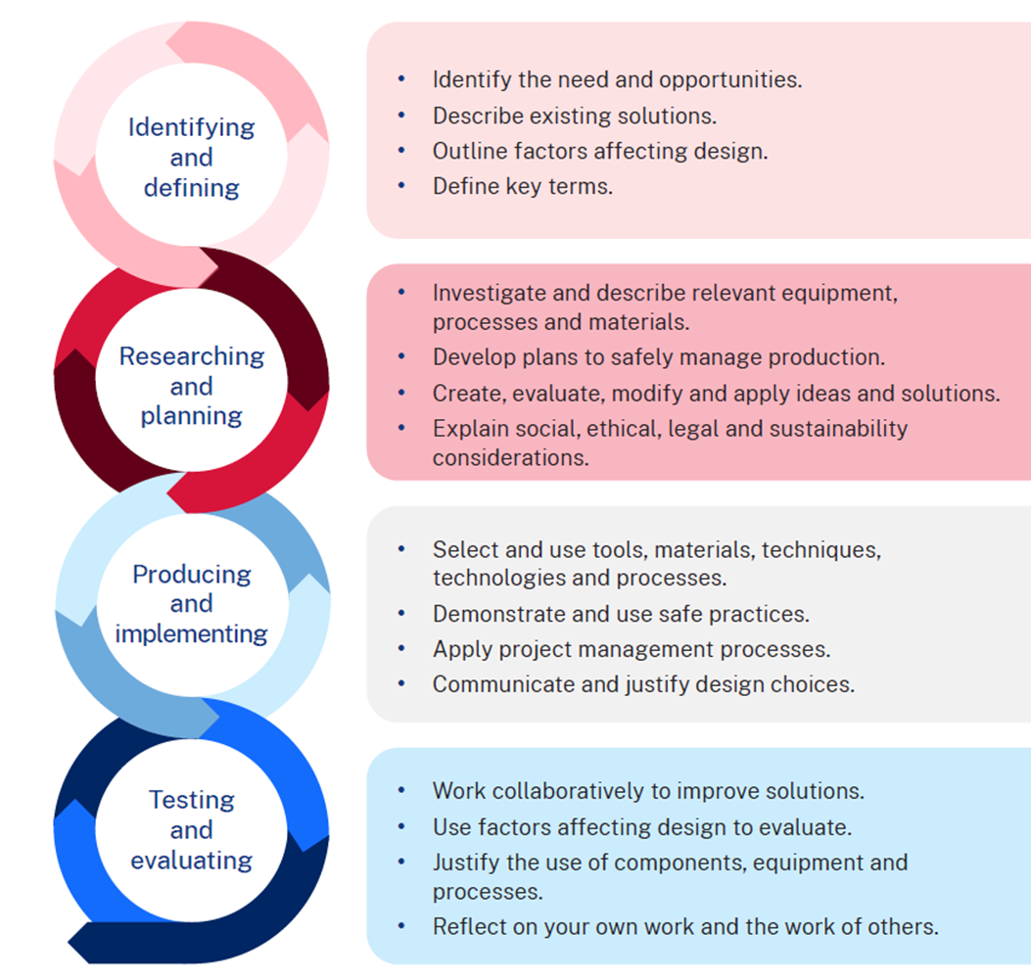

Identifying and defining
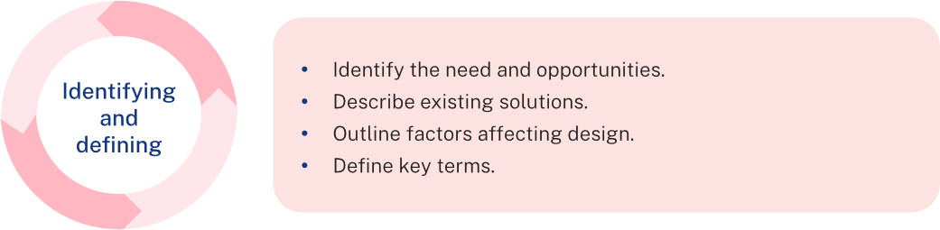

Mixed materials jewellery collage
In the space below, list items that jewellery can be made from.
Sample answer:
Animals' teeth, shells, gems (diamonds), bone, plastics, precious metals (gold, silver), other metals (copper, brass, stainless steel), found objects (pebbles, twigs), leather, feathers, beads, glass, timber, polymers and more.
In the space below, design a collage showcasing various mixed material jewellery pieces.

Prior knowledge
Use the KWHL table to document what you already know about jewellery pieces, materials used and processes for making it. What else do you want to know? At the end of the learning sequence, complete the last 2 columns to reflect on your learning.
Figure 1 – KWLH chart
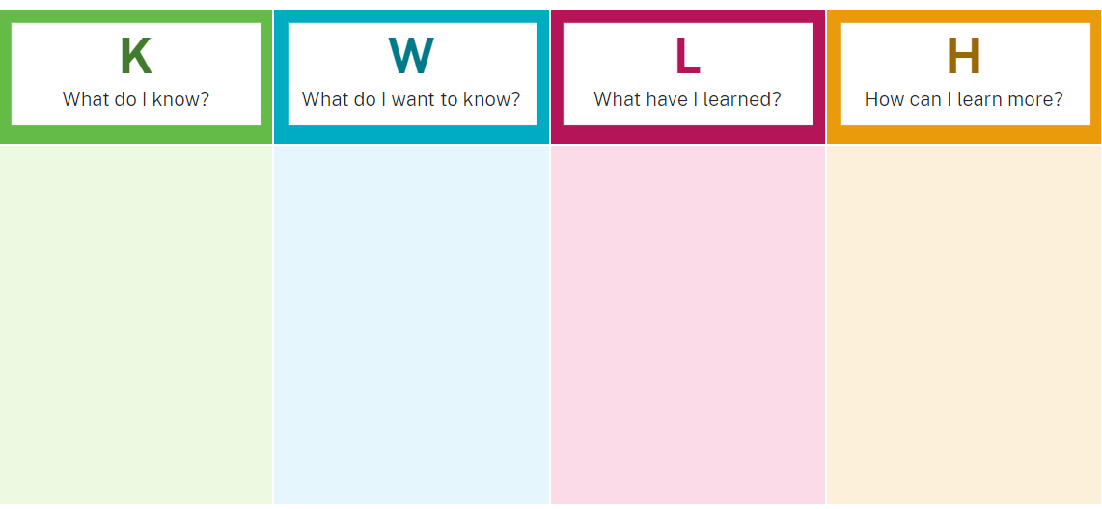

Exit ticket – sticky note
At the end of the lesson, complete the questions below to reflect on your learning and hand in to the teacher.
Figure 2 – exit ticket with 3 questions
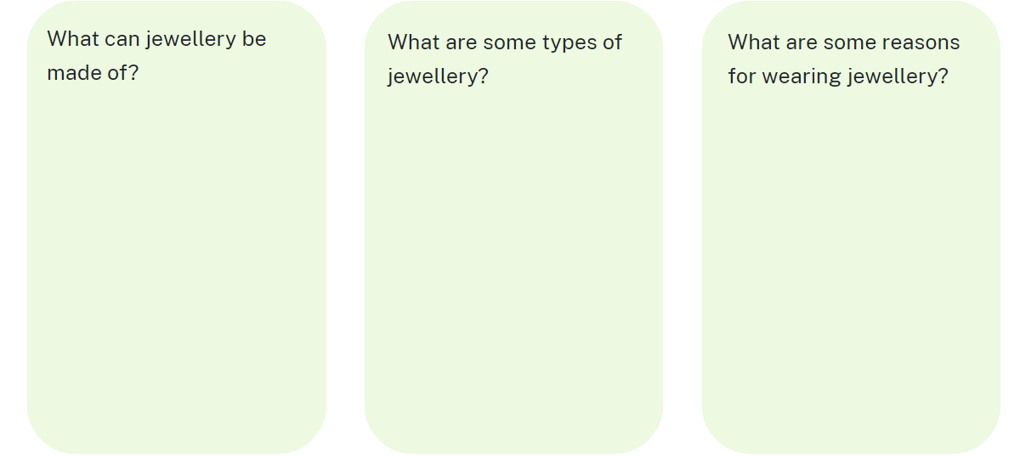

Types of jewellery
Brainstorm types of jewellery in the diagram provided.
Note: suggested responses are included in the PowerPoint presentation.
Figure 3 – ‘Types of jewellery’ concept map
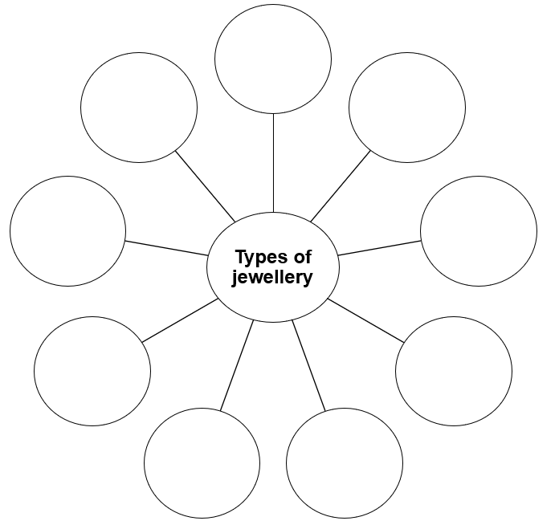
Reasons for wearing jewellery
In the space below list reasons for wearing jewellery.
Sample answer:
Decoration, status, wealth, royalty, engagement, marriage, mark an occasion.

Functional features of jewellery
The functional features of jewellery refer to the practical aspects that enhance usability, comfort, durability and safety. While jewellery is often seen as decorative, functional design ensures it serves its purpose effectively. Key functional features include:
- clasp and fastening mechanisms
- secure and easy-to-use clasps (lobster, spring ring, toggle, magnetic)
- adjustable chains or bands to fit different sizes
- material durability
- use of metals and materials that resist tarnishing, corrosion and wear (for example, gold, platinum, stainless steel)
- scratch-resistant finishes and reinforced structures
- comfort and ergonomics
- lightweight design to prevent strain during prolonged wear
- smooth edges and hypoallergenic materials to avoid irritation
- adjustable features for a customised fit (ring resizing, bracelet extenders)
- flexibility and adaptability
- interchangeable elements (charms, pendants, stackable rings)
- symbolic or utility functions
- functional engravings (medical IDs, initials, QR codes)
- hidden compartments or lockets.
Incorporating these functional features ensures that jewellery is not only aesthetically pleasing but also practical and long-lasting.

Materials for jewellery
Jigsaw activity – research your allocated material, focusing on its characteristics (distinguishing traits) and properties (attributes or qualities). Complete the table below.
Note: sample responses have been included below.
Table 3 – characteristics and properties of materials
Material | Characteristics (distinguishing traits) | Properties (attributes/qualities) | Common uses in jewellery
Brass | Colour (golden-yellow hue)  Texture (smooth or polished finish)  Weight (light to medium weight) | Malleability (can be easily shaped)  Corrosion resistance (less prone to tarnishing)  Ductility (can be drawn into thin wires) | Rings, earrings and pendants  Decorative elements
Copper | Colour (reddish-brown hue)  Texture (can be polished or left natural)  Patina (develops a green patina over time) | Malleability (easy to work with)  Conductivity (excellent conductor)  Antimicrobial properties (resistant to bacteria) | Rings, bracelets and artisan pieces  Mixed media jewellery
Silver | Colour (bright, shiny appearance)  Texture (can be polished or matte)  Tarnishing (can tarnish over time requiring cleaning) | Malleability (easy to shape and work with)  Durability (high strength)  Hypoallergenic (in pure form) | Fine jewellery, rings and necklaces  Earrings and bracelets
Plastics | Colour variety (clear, opaque)  Texture (matte, glossy)  Transparency (clear vs tinted) | Lightweight (easy to wear)  Flexibility (can bend without breaking)  Easy to work with | Costume jewellery – bangles, rings, earrings, pendants
Polymer clay | Colour (wide range of vibrant colours)  Texture (smooth, can be patterned)  Finish (can be glossy or matte after baking) | Malleability (easy to shape when conditioned)  Lightweight (does not add weight to jewellery)  Variety of finishes (can be painted) | Custom beads, charms, figurines
Natural materials | Appearance (wood grain, stone patterns)  Colour (natural variations in hues)  Source (derived from wood, stone, shell) | Texture (varies greatly; rough, smooth, porous)  Sustainability (often eco-friendly)  Durability (some are more fragile than others) | Beads, pendants, organic jewellery

What is a design brief?
The ‘design brief’ follows the ‘problem’ of the design situation and states clearly how you intend to solve the design problem.
The design brief should be a general description that allows you flexibility regarding the type of product you intend to make.
Do not be specific about materials. Instead describe the materials to be used as strong, tough, flexible, natural, manmade, recycled, water-proof or similar general descriptions.
Mention points such as safety, general size, what it will do (its functions), general properties of the materials needed and who it is for (for example, children).
Design brief example
I am going to design and create a unique piece of wearable jewellery that reflects inspiration from the natural environment. This product will be suitable for a teenager and designed to express personal style while being lightweight, comfortable and safe to wear.
The design will combine contrasting materials that are strong, flexible and safe for everyday use. The piece will be small in size, easily worn on the wrist or around the neck and will feature a secure fastening mechanism to ensure it stays in place.

Sentence scaffolds for writing a design brief
Use the sentence starters below to help you write your own design brief.
What are you designing and why?
- I am going to design and make a piece of jewellery that ...
- This product will help solve the problem of ...
- I was inspired by ...
Who is it for?
- My design is intended for ...
- The target user is ...
- This piece will suit people who ...
What will it do? (Function)
- The purpose of the jewellery is to ...
- It needs to be able to ...
- It should be easy to ...
What materials will you use? (General properties, not specifics)
- I will use materials that are ... (flexible, strong, waterproof, lightweight, recycled)
- The materials must be safe, durable and ...
- I want to combine materials with different textures such as ...
Safety and comfort
- The design will have smooth edges to ...
- I will make sure the jewellery is safe by ...
- It must be comfortable to wear because ...

Design problem
You are a designer tasked with creating a unique piece of jewellery that reflects sustainability, cultural significance or inspiration from nature (biomimicry). Your design must combine at least 2 different materials (for example metals, polymers, wood) to showcase how contrasting materials can work together to create an aesthetically pleasing and functional jewellery piece.

Design brief
Use this box to write your own design brief, using the sentence scaffolds above, related to solving the design problem.

Factors affecting design
What makes good jewellery?
In the space below, brainstorm and list the important characteristics of a good piece of jewellery.
Table 4 – ‘Characteristics of well-made jewellery’ table
Number | What are characteristics of well-made jewellery?
1 | No sharp edges that will cut skin or clothes when being worn.
2 | Ease to put on and take off
3
4
5

Criteria for success
How will you judge whether your jewellery design and product is a success? A criteria for success is developed so that the product can be judged using a common language across all products produced by the class. Criteria for success will be developed with a focus on function, aesthetics, ergonomics, durability and sustainability.
Function
Function refers to whether a design works and helps the users meet their goals and needs. For jewellery, some questions may include questions such as:
- Is the design easy to put on and remove?
- Does it stay in position (such as attached to ears or clothing)?
Aesthetics
Aesthetics refers to how a product looks and feels. Is it pleasant to look at? For jewellery, we may look at how the processes of construction have been completed to enhance its appeal.
Ergonomics
The relationship between the user and their physical or work environment. How comfortable is the product to use or wear?
Durability
Durability refers to the long physical reliability of a product. Examples include the development of products that can take wear and tear without breaking down. Reliability of components, ease of maintenance and material choices are important features for products that are intended to be durable.
Sustainable design
Sustainable design is a design approach that seeks to minimise negative environmental, social and economic impacts. The intention with sustainable design is to reduce or completely eliminate negative environmental impacts through thoughtful designs.

Criteria for success in jewellery design
Using the following tables, list criteria to judge a good piece of jewellery.
Table 5 – ‘Criteria for success – function’ table
Number | Criteria for success – function
1
2
3
Table 6 – ‘Criteria for success – aesthetics’ table
Number | Criteria for success – aesthetics
1
2
3
Table 7 – ‘Criteria for success – ergonomics’ table
Number | Criteria for success – ergonomics
1
2
3
Table 8 – ‘Criteria for success – durability’ table
Number | Criteria for success – durability
1
2
3
Table 9 – ‘Criteria for success – sustainable design’ table
Number | Criteria for success – sustainable design
1
2
3

Describe existing solutions
Describe the characteristics and features of different pieces of existing jewellery items. Find images of 3 jewellery pieces that may reflect cultural or biomimicry inspiration.
For each item, answer the following questions:
- What is it and what materials is it made from?
- What are the features of this item?
- What are the characteristics of the item? (Consider material choice and production methods.)
- Who is the product made for and how do you know?
- Is it of high quality and how do you know?
Table 10 – ‘Existing jewellery solutions’ research
Image of an existing jewellery item | Characteristics and features of this jewellery item
[Insert image here]
[Insert image here]
[Insert image here]

Glossary
Note: edit the glossary table to include relevant terms for your material context.
Students complete the table progressively by filling in an appropriate definition for each term.
Table 11 – glossary
Term | Definition
3D printing | A process of additive manufacturing; creating three-dimensional objects by layering materials based on a digital design.
ABS | Acrylonitrile Butadiene Styrene – a strong, lightweight plastic often used in 3D printing and modelling.
Acrylic (continuous cast) | A type of acrylic plastic that is clearer and more durable than standard acrylic, commonly used in jewellery and display products.
Alloys | A mixture of metals and other metals or non-metals. Alloys are used to improve the characteristics of the pure metals such as strength or corrosion resistance.
Anneal | A heat treatment used to soften metals, making them easier to shape or bend.
AS 1100 | The Australian Standards for Engineering drawing. Used so manufacturers can make products designed by engineers or product designers
Biomimicry | Designing products that imitate natural forms, patterns or systems to create efficient and sustainable solutions.
Brass | An alloy of copper and zinc, often used in jewellery for its gold-like appearance and corrosion resistance.
Copper | A non-ferrous metal. Highly conductive of heat and electricity. Used for plumbing and electrical work
Culture | The ideas, customs and social behaviours of a society, which can influence jewellery design and material choices.
Define | Clearly explain the meaning of a term or describe the key characteristics of a process or material.
Evaluate | Review and reflect on the success of the product, considering how well it meets the brief and how it could be improved.
Ferrous | A metal that contains iron, making it prone to rusting unless treated or alloyed.
Flux | A paste or liquid applied to metal to help solder flow and bond during the joining process.
Gauge | A measure of wire thickness. The smaller the gauge number, the thicker the wire.
Identify | Recognise and name the key features, tools or materials needed for a project.
Implement | Put the plan into action, applying techniques and processes to bring the design to life.
Laser cutter | A machine that uses a laser to cut or engrave materials like metal, acrylic and wood with high precision; subtractive manufacturing.
Mandrel | A tool or stake used to shape metal, often in ring or bracelet making.
Patina | The surface colour or texture that develops on metal over time or through chemical treatments, creating unique finishes.
Pickle | An acidic solution used to clean metal by removing oxidation or scale after heating or soldering.
PLA | Polylactic acid – a biodegradable plastic used in 3D printing, made from renewable resources like corn starch.
Plan | Develop a series of steps and timelines to organise how a project will be completed, including materials, tools and processes.
Polymer (FIMO modelling clay) | A type of plastic-based clay that can be shaped and hardened by baking, often used in jewellery and craft projects.
Produce | Create the final product by following the design plan and using appropriate materials and tools.
Prototype | A preliminary model of a product used to test and refine the design before final production.
Quench | Rapidly cooling heated metal by immersing it in water or oil to harden or strengthen it.
Research | Investigate and gather information about materials, techniques and tools to inform design and production decisions.
Sheet metal | Metals rolled into a sheet form. Includes coated steel, copper tin plate.
Silver | A precious metal used for jewellery. A shiny greyish white metal. Highly conductive. Also used in computer manufacturing.
Sustainability | The practice of creating products that have minimal impact on the environment, using materials that can be reused or recycled.
Test | Examine the product to ensure it functions correctly and meets design criteria.

Research and planning
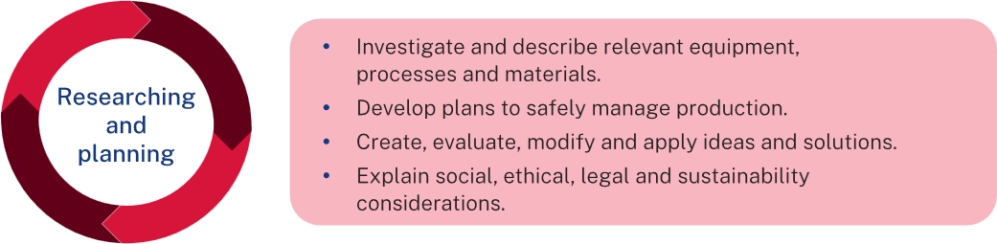

History of jewellery and adornments
Humans have adorned themselves with feathers, bones, grasses, animal teeth and seeds since ancient times. Jewellery made from shells and bones have been found from ancient times. Small pieces of jewellery were worn, just as we wear jewellery today.
Aboriginal peoples have made and worn necklaces and rings throughout their histories. Jewellery is commonly made from beads, stones, bones and feathers found locally.
Trade was practised between neighbouring Aboriginal language groups as well as over vast distances between language groups of different environmental regions. Stones, ochres, tools, ceremonial items and other resources that were not normally available within one area could be obtained through trade with another area.
Trade was not only a method of sharing resources but also a form of sharing culture. Trade required people from different areas and different cultures to respect each other’s rights, boundaries and cultural differences. Trade also enabled members from different languages to share aspects of the sacred narratives and ceremonies that explain the origins of people and the natural and spiritual world.
Cultural knowledge and practices were shared and strengthened during ceremonial gatherings. Great respect and social bonding were developed through an understanding of cultural differences and religious traditions. Trade routes were part of the songlines, the network of travel routes that passed through language groups across Australia. The vast network of songlines crossed the Australian continent from west to east and north to south. Shell jewellery from the Dampier Peninsula in northwestern Australia was traded as far as the south coast of the continent, a distance of 1,600 kilometres.

Contemporary Aboriginal jewellery designs
Note: consulting with Aboriginal and/or Torres Strait Islander communities is essential to the development of meaningful Aboriginal and/or Torres Strait Islander Histories and Culture embedded across the curriculum. Aboriginal and/or Torres Strait Islander peoples are the owners and custodians of their knowledge and cultures and should be consulted when aspects of Aboriginal and/or Torres Strait Islander Histories and Cultures are being incorporated into the school curriculum. If you want to establish an authentic relationship with Aboriginal communities, you should understand local community protocols and engage with the community respectfully and authentically. Remember that any information shared by Aboriginal and/or Torres Strait Islander peoples remains their intellectual property.
The learning activities that follow have been sourced from public-facing materials available online.
Research contemporary examples of Aboriginal jewellery. Select examples from the websites below or other sources and complete the table below.
- Aboriginal Jewellery | Traditional & Contemporary Indigenous ...
- First Nations | Fashion, Jewellery & Accessories
- JEWELLERY FEATURING INDIGENOUS ARTWORK
- Aboriginal Jewelry – Etsy
- Aboriginal gifts, made in Australia – Rocklily Wombats
- Aboriginal Jewellery – Bits of Australia
- Gillawarra Arts
- Aboriginal Jewellery for Sale Online | Australia - Dreamtime Kullilla-Art
- Jewellery featuring aboriginal and fractal graphics, Australian icons ...
- First Nations Jewellery – national museum shop

Research jewellery items made by Aboriginal or Torres Strait Islander peoples
Research jewellery items made by Aboriginal peoples. Some examples of how this table has been completed are provided below for reference. Students can add their own images from the prompt.
Table 12 – ‘Researching Aboriginal and Torres Strait Islander jewellery’ table
Image or description | Materials used | Purpose or function | Techniques or methods | Cultural significance
[Add an image of a Tasmanian Aboriginal Shell Necklace here.] | Local shells such as maireener, black crows and toothies. | Adornment for ceremonies and trade. | Hand-collected shells are cleaned, polished and threaded into necklaces. | A tradition passed down through generations, symbolising cultural identity and connection to the land and sea.
[Add an image of a gumnut and quandong necklace by Cleonie Quayle here.] | Gumnuts, quandong seeds and synthetic polymer paint. | Contemporary jewellery piece reflecting natural Australian flora. | Natural seeds are painted and strung together to create vibrant necklaces. | Represents a fusion of traditional materials with contemporary design, highlighting the significance of native plants in Aboriginal culture.
[Add an image of an Aboriginal beaded necklace here.] | Glass beads, seeds and natural fibres. | Personal adornment and expression of cultural motifs. | Beads are intricately arranged and threaded to form patterns significant to the artist's community. | Beaded jewellery often conveys stories, clan affiliations and individual identity within Aboriginal societies.
[Add an image of Silver Jewellery Engraved with Aboriginal Dreamtime Symbols here.] | Sterling silver | Modern adornment incorporating traditional symbolism. | Silver pieces are engraved with motifs representing Dreamtime stories. | Bridges contemporary jewellery practices with ancient Aboriginal narratives, preserving cultural stories through wearable art.
[Add an image of a Traditional Aboriginal Necklace with Animal Teeth here.] | Animal teeth, sinew and natural fibres. | Worn during ceremonies to signify hunting prowess and spiritual connection. | Teeth are cleaned, sometimes carved, and strung using traditional knotting techniques. | Symbolises the wearer's skills and deep connection to the animal world, integral to many Aboriginal peoples’ spiritual beliefs.

Cultural jewellery – gallery walk
Note: exploring traditional jewellery from various cultures provides insight into their unique artistic expressions and cultural significance. Curate a selection of notable pieces, and accompany each image with a description, materials used, purpose/function, techniques or methods and cultural significance. Use these images and information for a gallery walk for students to collect information. Students are also welcome to find their own cultural jewellery examples to complete the analysis.
Table 13 – ‘Gallery walk’ table
Cultural jewellery | Materials used | Purpose/function | Techniques/methods | Cultural significance
[Add an image here.]  Australian Aboriginal necklace  Kangaroo incisor ornament of 88 kangaroo teeth suspended from a strip of dressed kangaroo skin by loops 1850-1860 | Natural materials like shells, seeds, feathers, wood, ochre and animal bones. | Used in ceremonies, storytelling, trade, and personal adornment. Symbolises connection to Country, kinship and spirituality. | Hand-carved, shaped, and painted; natural dyes like ochre applied; often woven or strung together with plant fibres. | Reflects deep cultural connections to the land, Dreamtime stories and identity.
[Add an image here.]  Maasai beaded necklace  African tribe of Kenya | Glass beads, leather and metal wire. | Worn during ceremonies and daily life to signify age, social status, marital status and wealth. | Intricate beadwork patterns are hand-stitched onto leather backings, with colours and designs conveying specific meanings. | Beadwork is central to Maasai identity, with each colour symbolising different aspects of life (for example, red for bravery, blue for the sky).
Comparison of Masai jewellery to Aboriginal jewellery | Both cultures use jewellery for storytelling and status display. Maasai pieces use glass beads, while Aboriginal jewellery uses natural, locally-sourced materials. | Aboriginal jewellery focuses more on spiritual and environmental connections, while Maasai jewellery often emphasises social hierarchy. | Maasai beadwork is more intricate with colour symbolism, whereas Aboriginal techniques emphasise natural aesthetics and storytelling. | Both celebrate cultural heritage, though Aboriginal jewellery places a stronger emphasis on environmental harmony.
[Add an image here.]  Rajasthani Meenakari jewellery | Gold, enamel and gemstones. | Adorned by royalty and brides, symbolising wealth and auspiciousness. | Meenakari involves enamelling intricate designs onto gold surfaces, often depicting floral and animal motifs. | Originating in Rajasthan, India, Meenakari showcases the region's rich artistic heritage and is integral to traditional bridal attire.
Comparison of Rajasthani Meenakari jewellery to Aboriginal jewellery | Aboriginal jewellery uses natural, organic materials compared to the refined luxury of gold and gemstones in Meenakari. | Meenakari is more ornamental and tied to wealth, while Aboriginal jewellery reflects practical and spiritual elements. | Aboriginal techniques rely on hand-crafting and natural dyes, whereas Meenakari involves highly-skilled goldsmithing. | Both preserve their cultural identity, but Aboriginal jewellery focuses on environmental and spiritual connections.
[Add an image here.]  Native American turquoise jewellery | Turquoise stones, silver and leather. | Serves as personal adornment and is believed to offer protection and healing. | Handcrafted silver settings encase turquoise stones, often featuring intricate stamp work and engravings. | Turquoise holds spiritual significance among Native American tribes, symbolising life, luck and health.
Comparison of Native American jewellery to Aboriginal jewellery | Aboriginal jewellery shares a spiritual focus but uses materials like ochre and shells, compared to turquoise and silver. | Both use jewellery as a medium for spiritual and cultural expression. | Native American jewellery often incorporates metalwork, while Aboriginal pieces are primarily organic and environmentally aligned. | Both cultures emphasise connection to nature, with Aboriginal designs being more symbolic of Country and Dreamtime stories.
[Add an image here.]  Egyptian faience broad collar | Faience beads, semi-precious stones and gold. | Worn by both genders in life and death, often placed on mummies for protection in the afterlife. | Stringing multiple rows of beads in a broad, collar-like arrangement, sometimes with counterpoise for balance. | Symbolised wealth, status and provided religious protection; colours held specific meanings (for example green for fertility).
Comparison of Egyptian faience collar jewellery to Aboriginal jewellery | Aboriginal jewellery does not focus on funerary uses but shares symbolic meaning through colours and patterns. | Egyptian collars emphasise decorative complexity and hierarchy, while Aboriginal jewellery remains functional and symbolic. | Aboriginal jewellery prioritises environmental sustainability, whereas Egyptian collars reflect a more structured, aesthetic role. | Both integrate cultural stories, though Aboriginal jewellery emphasises a more holistic and land-based worldview.

Biomimicry in design
Biomorphic design or biomimicry is design inspired by nature.
Shapes inspired by leaves, feathers and shells are used to design items such as earrings and necklaces. Natural materials, such as stones, can be incorporated into the design and added to the piece.
Table 14 – ‘Biomimicry in design’ table
Image from nature | How I have been inspired by it
 | Cockle shells. This one was selected for its colour and texture of the repetitive lines.
 | Conch. Shell is aged and has been partially destroyed by the actions of the ocean causing the openings shown. Negative space/openings can be shaped into jewellery designs.
 | Cross section of a shell’s interior. Selected for the interesting shapes and patterns, vertical, curved and horizontal lines are wrapping together in an interesting spiral.
 | Leaves can be found in all gardens. Many interesting colours may be found especially around autumn. Shapes of leaves can differ tremendously and can provide inspiration for jewellery shapes.
 | As leaves dry the cells contract. They crinkle and form shapes that can be imitated in metal.
Activity
Select 3 examples from those shown above or hunt for your own natural shapes.
Study the shapes and draw using pencil lines each in the box below. Think about the size of your drawing. Try to draw it at a size suitable for a pendant or earrings.
Include all inner details of the selected shape. Write short notes and ideas to aid your drawing.
Table 15 – ‘inspiration drawings’ table
Example | Drawings and notes of inspiration from nature/biomimicry
1
2
3

Case study – Larsen Jewellery

Larsen Jewellery’s commitment to ethical and sustainable practices.
Watch Larsen Jewellery - The Design Process (0:50) and answer the questions below.
Overview: Larsen Jewellery is an Australian company specialising in bespoke fine jewellery, including engagement rings and wedding bands. They are renowned for their dedication to ethical sourcing and environmental sustainability.
What are 2 ways Larsen Jewellery ensures their materials are ethically sourced?
Why might a customer choose lab-grown diamonds instead of traditional ones from Larsen Jewellery?
List one environmental initiative the company uses to reduce its ecological footprint.
How does Larsen Jewellery show a commitment to both people and the planet in their business practices?

Equipment, processes and materials
Note: teachers should consider the available resources, equipment and teaching spaces when planning the direction of student projects and practical experiences. For example, if you have access to a multifunctional workshop, students may explore metalwork, laser cutting (acrylic or timber), and 3D printing. Alternatively, if working in a general classroom setting, you may choose to focus on polymer clay or CAD-based jewellery design.
Use the materials, equipment and processes outlined in Appendix 1 to help determine the most suitable approach for your context.

Time management
Time management is the planning we do to make sure our project is completed in the time we have available. When we are planning for time management for this project, we need to look at the time we have available and the tasks we need to do to complete the project.
Time available
Question | Answer
How many weeks do we have available for this unit of work?
How many practical lessons do we have in a week?
How many practical lessons do we have to complete our jewellery piece?

Time management plan
Create and evaluate a timeline for completing your jewellery project.
Break down your project into key phases. These could include:
- research and inspiration
- design sketches and mood board
- prototyping and practice with materials
- making your final jewellery piece
- finishing and polishing
- testing, feedback and evaluation.
Estimate the time you think each phase will take.
Create a visual timeline (such as a Gantt chart) to show when you will complete each step.
Mark milestones for important tasks, such as when you plan to finalise your design or start production.
Note: students may create their project timeline online (using tools such as Excel, Google Sheets or Canva) or complete it using the Gantt chart provided below in this booklet. Choose the option that best suits your class resources and student needs.

Gantt chart for time management
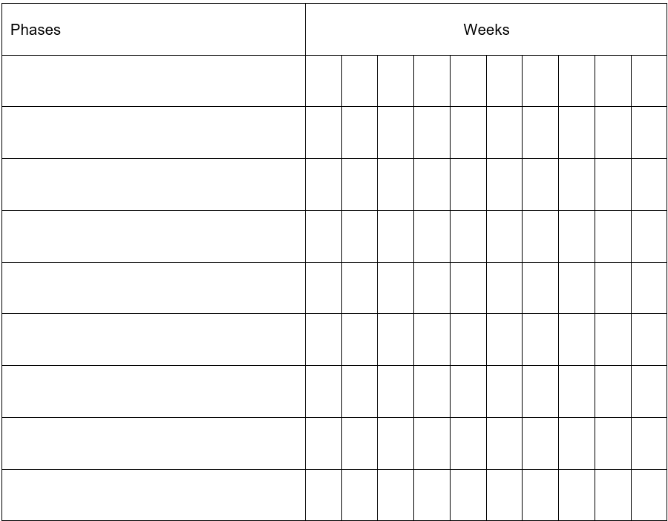

Tools
Complete the table by outlining the function of the tools you will use.
Teacher note: a wide selection of tools for different materials has been provided. Please delete the rows that are not used within your context.
Table 16 – jewellery tools table
Name | Picture | Function
Ring sizers | 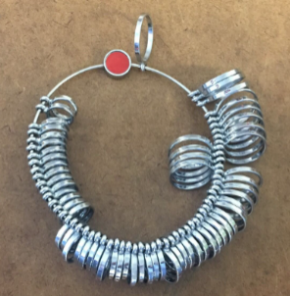 | Ring sizers are used to accurately measure the size of a person’s finger when making a ring.
Ring mandrel/ Triblet | 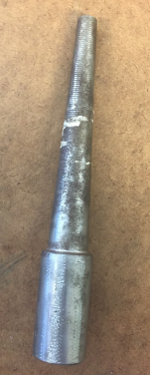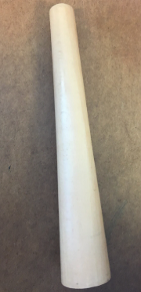 | A ring mandrel is used to find the size of a ring being made. Measures are equal to the sizes found on the ring sizer.
Burnisher: straight and curved | 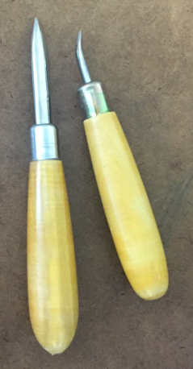 | Used to smooth and polish metal surfaces, removing scratches and marks.
Ring holder clamp | 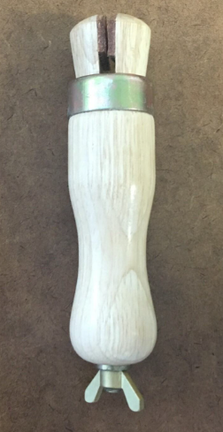 | Holds rings securely in place while polishing, filing or setting stones.
Letter punch | 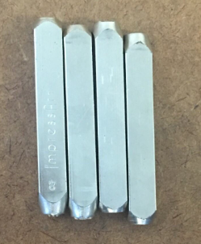 | Used to stamp letters and numbers into metal for personalization or marking.
Bezel roller | 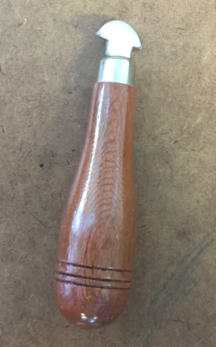 | Rolls over the bezel edge to secure a stone in place.
Polishing paper emery sticks | 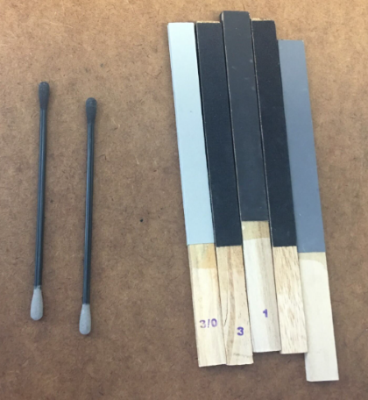 | Used to smooth and polish metal surfaces. Available in various grits.
Bezel pusher | 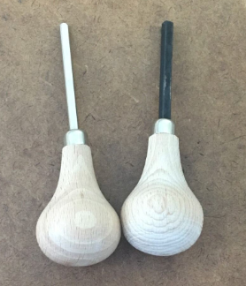 | Used to push the bezel over the stone to secure it.
Half round sanding sticks | 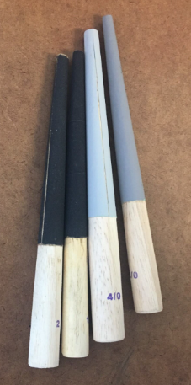 | Sanding sticks with a half-round shape, used for smoothing curved surfaces.
Metal stamping hammer | 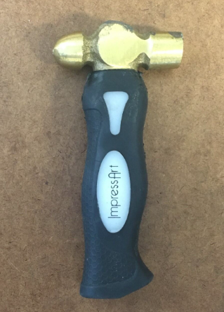 | Used to stamp designs, letters and patterns into metal.
Tinsman’s mallet | 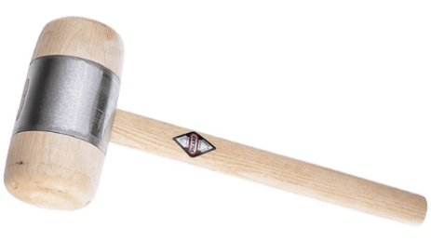 | Used to straighten sheet metal projects.
Jewellery saw | 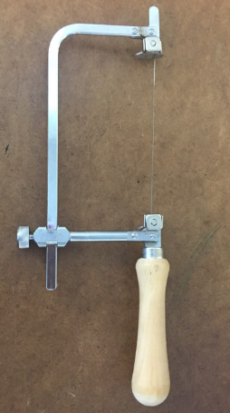 | Used to cut intricate shapes in sheet metal or plastic.
Cross-locking tweezers | 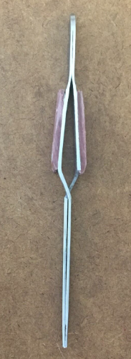 | Hold small pieces of metal or stones firmly without applying constant pressure.
Tin snips | 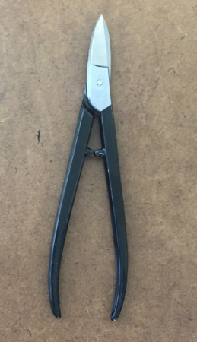 | Used to cut sheet metal. Able to cut curves and straight. Similar to scissors but for flat metal sheet.
Tweezers | 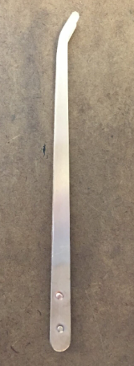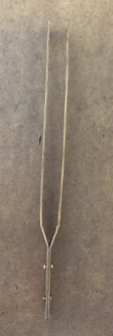 | Used for handling small components, stones or metal pieces.
Paint brushes | 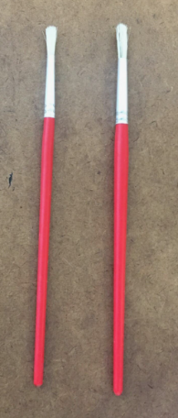 | Used to apply polishing compounds, flux or clean small jewellery pieces.
Jeweller’s brass head hammer | 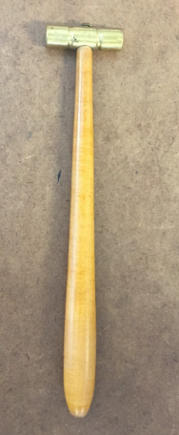 | A hammer with a brass head used for forming and shaping metal without marking it.
Ball pein hammer | 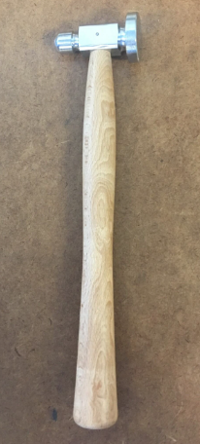 | Heavier hammer used on metals. Ball pein end can be used to decorate metal.
Planishing hammer | 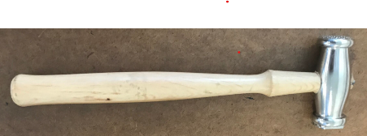 | Used to give a textured effect to metal.
Jeweller’s bench pin | 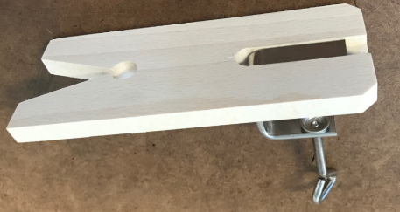 | Provides a stable surface to support metal while sawing, filing and shaping.
Ring clamp | 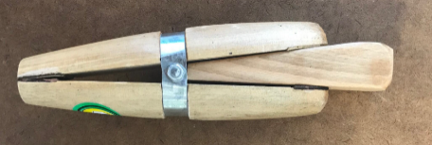 | Used for holding rings and metal while polishing
Divider calliper | 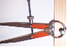 | Used to measure and mark precise distances and diameters.
Steel rule |  | Measures metal pieces accurately.
Tri-square | 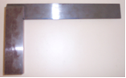 | Ensures metal edges are cut and shaped at right angles.
Metal vice | 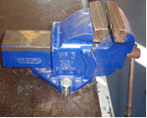 | Holds metal securely in place while cutting, filing, shaping or hammering.
Safety glasses | 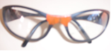 | Protect eyes from metal fragments and debris.
Metal scribe | 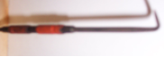 | Marks precise lines on metal surfaces for cutting or shaping.
Bench shear | 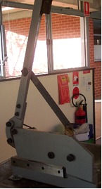 | Cuts straight lines in sheet metal.
Drill press | 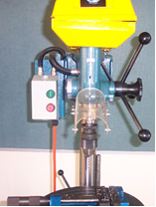 | Drills precise holes into metal pieces.
Hand files | 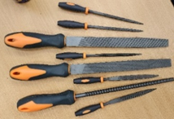 | Used to reduce size or shape of metal products.
Pliers | 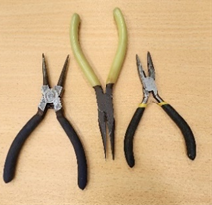 | Pliers of various sizes used to hold metal products and form small bends. Plier types are often known by the shape of the jaws or the use it is designed for.
Wire cutters | 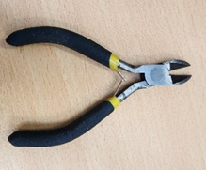 | Used to cut wire material or cable. Like scissors for metal wire.
Pasta rolling machine | 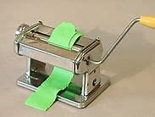 | Used to condition polymer clay into different thicknesses of clay sheets.
Templates, cutters and shaping tools | 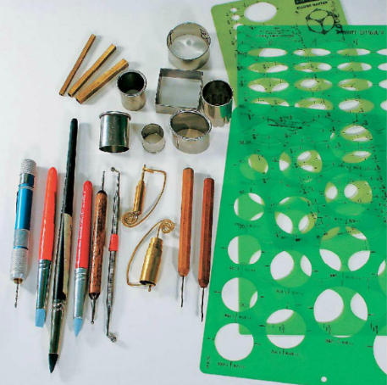 | Useful for creating a wide variety of shapes and design elements.

Research of processes
Note: this resource provides information and sample projects for a variety of materials and processes, including metalwork, 3D printing (ABS and PLA), cast acrylic and polymer clay.
Teachers should select the content that best suits their own teaching context, based on the tools, equipment and materials available in their school. You may choose to focus on one or 2 material types and can disregard the sections that are not relevant to your setting.
If time and resources allow, students may also combine different materials to create a mixed-material jewellery design, further enhancing creativity and problem solving.
The aim is to provide flexibility so that students can achieve the learning outcomes of the unit while you adapt the practical projects to the resources and facilities you have.
Use the materials, equipment and processes outlined in Appendix 1 to help determine the most suitable approach for your context.

Metal

Annealing
Before it may be shaped, metal needs to be in a soft state. The process to soften metals is called annealing.
Metals are made up of grains of atoms. As the metal is worked, bent, hammered or shaped, these grains become compressed and hard. As the grains harden they become locked together and limit the amount of shaping that can be done. Annealing allows the copper grain to reset to its original state, removing the stress in the material.
Figure 4 –annealed vs worked copper
Annealed copper | Worked copper
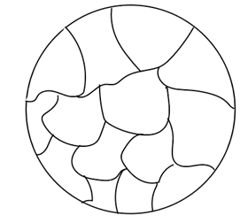 | 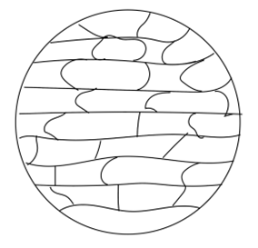
The structure of grain in pure copper. Grains are full. Material is soft. Copper will return to this structure after annealing. | The structure of grain after working (hammering, bending). The grain is compressed and flattened. In this state it is harder to bend or work.
Annealing copper involves heating the metal to a dark red colour, about 480°C and quenched in water or pickle solution.

Activity: annealing questions
Answer the following questions in the space provided.
Why is it easy to bend the copper at the beginning of the project?
Sample answer:
The copper is soft with well-rounded grain structure.
Why is it difficult to unbend it?
Sample answer:
Copper that has been worked becomes compressed and brittle.
What does annealing do to make the material easier to bend?
Sample answer:
Annealing returns the material to a soft state.
Why does temperature of annealing matter?
Sample answer:
Copper must be heated to a cherry red colour (about 480°C) to allow the grain to reform.
Metalworkers often stop to anneal the project during the forming. Why is this important?
Sample answer:
This is important so further work can be completed without breaking the material.

Pickling
Metals react to the oxygen in the air. The surface of the metal forms an oxide layer. When metals are heated this reaction is much greater. Oxide layers on heated metal objects often appears black. Pickle solutions will ‘eat away’ the oxide surface layer. Pickling is like a chemical bath. The copper is placed into the solution with copper or plastic tongs (never steel). When removed from the pickle solution, the metal should be washed in cold water and dried before further working.
A simple pickle solution for copper can be made from 1:6 citric acid to water. Even though the solution is relatively safe, gloves should always be used when handling chemicals.

Soldering
Soldering is the process of joining 2 pieces of metal using a different metal with a lower melting point. The joining metal is called solder. When joining metals to make jewellery, silver solder such as ‘Bakers’ soldering flux is used. Silver solder is used by plumbers to join copper water pipes as it is non-toxic.

Process of soldering
- The join should be clean and neat and close fitting. Soldering will not fill gaps.
- Push the join together to remove gaps. Place your project on the fire bricks ready for soldering.
- Cut a small piece of solder ready to place on the join.
- Using a small brush, paint a small amount of flux on the join. The flux will draw the solder into the join. Only place a small amount in the join or the flux will draw solder onto parts of your project that you do not want it to be.
- Using pliers, place the solder on the join and heat with the torch. Heat around the join on your jewellery piece before waving the torch over the solder. This will allow heating of the whole join and not just the solder, producing a better, more stable join.
- The solder will glisten and become very shiny as it melts and enters the join. Take the heat off as it melts and turn off the torch.
- Inspect the join and test. Excess solder can be carefully filed away using jewellers needle files.

Finishing metal jewellery
When you finish a piece of jewellery, you're making it look smooth and shiny by carefully removing scratches from the surface.
- Start with a file – use a needle file to remove any deep scratches or rough spots. This will leave smaller lines on the surface that all go in the same direction.
- Use sandpaper to smooth it – use special sandpaper called wet and dry abrasive. It comes in different ‘P’ numbers:
- Low P numbers (like P60) are rougher. They remove more material.
- High P numbers (like P2500) are very fine. They make the surface really smooth.
- Work from rough to fine – start with a coarse grit to remove file marks, then slowly use finer grits until the scratches become tiny or disappear altogether.

Basic skills project – twist ring

Developing your knowledge and understanding of working with metal and metal workshop tools
Figure 5 –a small bracelet made up of twisted wire
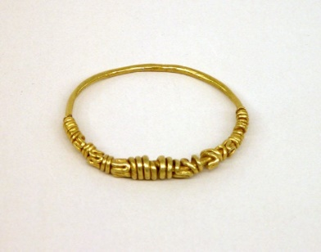
‘Small bracelet of twisted wire’ by Public domain museum image is in the Public domain.
Figure 6 – a ring with a snake’s head
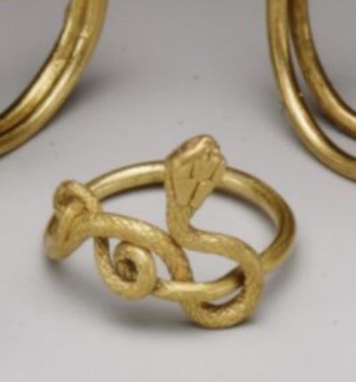
‘Ring with snake’s head’ by Public domain museum image is in the Public domain.
Construction steps
- Cut a piece of brass wire 200 mm long.
- Bend the wire in half and place one end in the vice.
- Using pliers, twist the wire. This process will also harden the wire.
- To anneal, or soften the wire, heat it until it changes colour using the propane gas torch.
- Twist the wire a second time and anneal it again.
- Put the wire in the vice and pull it hard to straighten any bends.
- Hammer the wire flat using a metal hammer.
- Bend the wire around a ring mandrel, overlapping the ends.
- Cut off excess wire using tin snips or pliers.
- Carefully file the ends square and adjust the ring until the ends meet.
- Place the ring in 'helping hands', apply solder/flux, and heat using the propane gas until the solder 'runs'.
- Clean up the joint with a 150 mm file, then sand the ring with 'wet and dry' paper.

Evaluation of twist ring
On the line below, place an X on the rating that you think matches the quality of your ring.
Poor quality | Fair quality | Good quality | High quality
Answer the following prompts in the space provided to evaluate your design and process.
What was the most difficult part to make or do? Explain your answer.
What parts of your project worked well?
Do you think your project was a success? Why?
What would you change to improve your project?

Basic skills project – knot ring

Developing your knowledge and understanding of working with metal and metal workshop tools
Figure 7 – an early medieval Viking finger ring
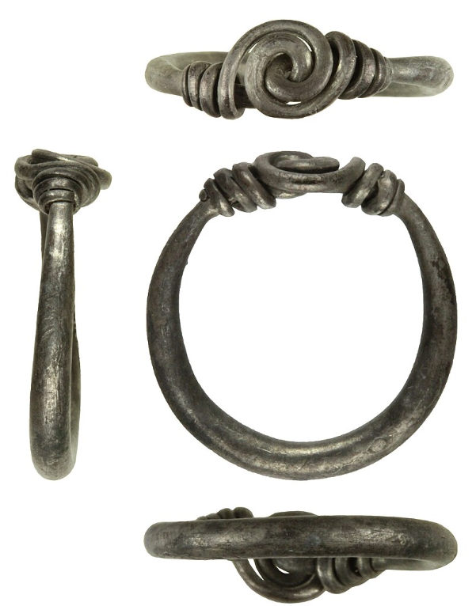
‘Early medieval Viking finger ring’ by Salisbury and South Wiltshire Museum is licensed under CC-BY-2.0.
Construction steps
- Cut 2 pieces of brass wire120 mm long.
- Bend each wire in half and slightly bend each end so the circle end is pointing up on one piece and down on the other.
- Place one piece of brass into the other piece (as seen in demonstration).
- Place the long end piece in a vice and pull tightly using pliers to form a knot.
- Place the knot ring on metal square and using a hammer flatten the knot.
- Bend the knot ring around a ring mandrel, overlapping the ends. To anneal, or soften the wire, heat it until it changes colour using the propane gas torch.
- Cut off excess wire using tin snips.
- Carefully file the ends square and adjust the ring until the ends meet.
- Place the ring in 'helping hands', apply solder/flux, and heat using the propane gas until the solder 'runs'.
- Clean up the joint with a 150 mm file, then sand the ring with 'wet and dry' paper.
- Apply a coat of clear lacquer.

Evaluation of knot ring
On the line below, place an X on the rating that you think matches the quality of your ring.
Poor quality | Fair quality | Good quality | High quality
Answer the following prompts in the space provided to evaluate your design and process.
What was the most difficult part to make or do? Explain your answer.
What parts of your project worked well?
Do you think your project was a success? Why?
What would you change to improve your project?

Basic skills project – pendant
Figure 8 – two gold pendants
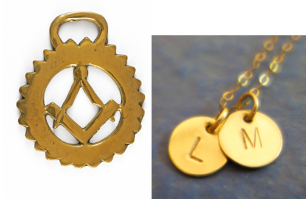
Construction steps
- Draw your design on paper.
- Glue the paper design to the brass plate using a small amount of PVA glue. Carefully mark out where you want the centre punch marks to go.
- Drill any holes that are required.
- Remove burrs from the exit side of the drill holes with a smooth file.
- Cut the outside to shape with tin snips and file the edges smooth.
- Use the punches to lightly punch in your pattern.
- Wash off the paper pattern and excess PVA glue with water.
- Polish the pendant with a metal polish or you can leave it with an antique finish.
- Brush on a coat of acrylic based protective coating to prevent your project from tarnishing.

Evaluation of pendant
On the line below, place an X on the rating that you think matches the quality of your ring.
Poor quality | Fair quality | Good quality | High quality
Answer the following prompts in the space provided to evaluate your design and process.
What was the most difficult part to make or do? Explain your answer.
What parts of your project worked well?
Do you think your project was a success? Why?
What would you change to improve your project?

Basic skills project – decorative flat ring

Construction steps
Using a flat piece of brass or silver, design and make a decorative ring. You can use the nail punch, decorative punches, drill press or engraver to decorate your ring.
See A Simple Sterling Silver Band Ring : 19 Steps (with Pictures) - Instructables for guidance.
Evaluation of ring
On the line below, place an X on the rating that you think matches the quality of your ring.
Poor quality | Fair quality | Good quality | High quality
Answer the following questions in the space provided to evaluate your design and process.
What was the most difficult part to make/do? Explain your answer.
What parts of your project worked well?
Do you think your project was a success? Why?
What would you change to improve your project?

Basic skills project – cuff bracelet

Using brass, copper or silver wire or sheet, decorate and make a cuff bracelet.

Construction steps

Construction steps
- Measure your wrist size by wrapping light gauge copper wire around your wrist. Now straighten it and measure how long to make your bracelet.
- Cut bracelet to correct length using pliers or tin snips.
- Mitre the corners using tin snips.
- File the ends round.
- Using calipers, mark a border on both sides of the bracelet (approximately. 2 mm).
- Stipple the surface using a hammer and punch. Be sure to hammer on a metal base.
- Lightly hammer (peening) the bracelet flat to counter any curling.
- Emery cloth the back of the bracelet to remove hammer marks.
- Wet and dry (paper) both sides of the bracelet.
- Hand shape the bracelet around a round mandrel (use a wooden mallet if necessary).
- Engrave name/phrase, and so on. on the back of bracelet.
- Spray on a light coat of clear lacquer.

Evaluation of cuff bracelet
On the line below, place an X on the rating that you think matches the quality of your ring.
Poor quality | Fair quality | Good quality | High quality
Answer the following prompts in the space provided to evaluate your design and process.
What was the most difficult part to make or do? Explain your answer.
What parts of your project worked well?
Do you think your project was a success? Why?
What would you change to improve your project?

Cast acrylic

What is it?
Continuous cast acrylic is a high-quality plastic sheet used to make things like jewellery, signs and displays. It became popular in the mid-1900s because it's clear, strong, and easy to shape – especially using a laser cutter.

What is it made from?
It’s made from a plastic called PMMA (polymethyl methacrylate). Here’s how it’s made:
- A special liquid (called a monomer) is poured between 2 shiny metal belts.
- It’s then heated and pressed until it becomes solid.
- This method makes very smooth, even sheets – perfect for cutting and engraving.

Key properties
- Super clear – it is almost like glass.
- Tough and lightweight – it won’t break easily.
- Great for laser cutting – it is easy to cut, engrave, or shape.
- UV and weather resistant – it won’t get damaged easily outdoors.

Safety when using acrylic
When you're cutting or sanding acrylic:
- Wear safety glasses and gloves – the edges can be sharp.
- Work in a ventilated space – dust and fumes can be irritating.
- Be careful near flames – acrylic is flammable.
- Dispose of scraps properly – it's recyclable, so don’t throw it in the general bin.

Fun facts
- Acrylic is often used instead of glass because it’s lighter and doesn’t shatter.
- Laser cutters can make very detailed designs in acrylic.
- Continuous cast acrylic is stronger and more consistent than other types of acrylic.
- It’s perfect for making personalised and professional-looking jewellery!
Activity
Answer the following questions in the space provided.
Why is acrylic a good material for jewellery making?
List 2 safety rules to follow when laser cutting acrylic.
What’s one cool thing you could design using acrylic?
Name one everyday product made from acrylic (besides jewellery).

Basic skills project – pendant

Construction steps
- Design the pendant – open design software and create the shape of the pendant. Keep the design simple and clear.
- Add a small hole (2–3 mm) at the top of the pendant for attaching the jump ring.
- Include any patterns or initials for engraving.
- Ensure the design fits within the dimensions of the acrylic or timber sheet.
- Prepare the material – select the acrylic or timber sheet.
- Apply masking tape to the surface to reduce burn marks (optional, more common for timber).
- Place the sheet into the laser cutter.
- Set up the laser cutter – upload the design file to the laser cutter's software.
- Set the correct power and speed settings:
- acrylic – medium power, high speed.
- timber – lower speed, higher power.
- Position the design on the software to maximise material usage.
- Ensure the laser is correctly focused on the material.
- Laser cutting and engraving – start with engraving (if included in the design).
- Proceed to cut the outline of the pendant. Monitor the cutting process to ensure no fire or excessive smoke occurs.
- Clean and finish – remove the cut pendant from the laser cutter. Peel off any masking tape.
- Lightly sand timber edges if necessary to smooth rough edges. For acrylic, wipe with a damp cloth to remove residue.
- Assemble the pendant – attach a jump ring through the hole at the top. Add the pendant to a chain or cord.
- Final check – ensure the hole is properly sized for the jump ring. Confirm there are no sharp edges. Polish or lightly sand for a professional finish.

Evaluation of laser cut pendant
On the line below, place an X on the rating that you think matches the quality of your ring.
Poor quality | Fair quality | Good quality | High quality
Answer the following questions in the space provided to evaluate your design and process.
What was the most difficult part to make/do? Explain your answer.
What parts of your project worked well?
Do you think your project was a success? Why?
What would you change to improve your project?

Basic skills project – cuff bracelet (heating and bending)
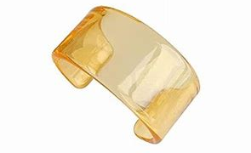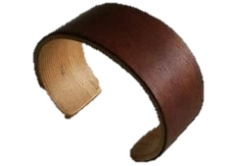
Construction steps
- Design the bracelet using an open design software and create a rectangle or curved shape (approximately 30–40 mm wide, 150–180 mm long) that fits around the wrist. Add any cut-out designs or engravings to the bracelet. Ensure the design’s width matches the material's bending capabilities.
- Prepare the material – select the acrylic or plywood sheet (3 mm thickness recommended).
- Apply masking tape if desired to prevent burn marks. Place the material into the laser cutter.
- Set up the laser cutter – upload the bracelet design file to the laser cutter software.
- Adjust the settings:
- acrylic – medium power, high speed.
- plywood – lower speed, higher power.
- Position the design on the sheet to minimise material waste. Check the laser focus and ensure the material is secured.
- Laser cutting and engraving – start with engraving if applicable. Proceed to cut the bracelet shape.
- Monitor the process and ensure the design cuts cleanly.
Bending the bracelet (acrylic)
- Heat the acrylic strip evenly with a strip heater or heat gun along the bending line.
- Once softened, carefully bend the acrylic around a cylindrical form such as a can or tin, to the desired shape.
- Hold in place until cooled and hardened.
Bending the bracelet (plywood)
- Soak the plywood in hot water for 10–15 minutes to soften the fibres. Clamp the softened plywood around a cylindrical form such as a can or tin. Allow the plywood to dry and set in the desired shape (24 hours recommended).
- Finishing – lightly sand the edges of plywood to smooth rough areas. Clean acrylic with a soft cloth to remove any residue or fingerprints. Check the bracelet for fit and make adjustments if needed.
- Ensure the bracelet fits comfortably around the wrist. Check for smooth edges and even bends. Make sure all cut-out designs or engravings are clear and precise.

Evaluation of cuff
On the line below, place an X on the rating that you think matches the quality of your cuff.
Poor quality | Fair quality | Good quality | High quality
Answer the following questions in the space provided to evaluate your design and process.
What was the most difficult part to make/do? Explain your answer.
What parts of your project worked well?
Do you think your project was a success? Why?
What would you change to improve your project?

Basic skills project – layered ring
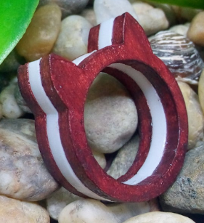
Construction steps
Follow the instructions as set out here: Laser Cut Jewellery: Layered Acrylic Rings : 4 Steps (with Pictures) - Instructables.

Evaluation of ring
On the line below, place an X on the rating that you think matches the quality of your ring.
Poor quality | Fair quality | Good quality | High quality
Answer the following questions in the space provided to evaluate your design and process.
What was the most difficult part to make/do? Explain your answer.
What parts of your project worked well?
Do you think your project was a success? Why?
What would you change to improve your project?
Polymer clay

Polymer clay

History of polymer clay
Polymer clay was first developed in the 1930s. A German doll maker named Kathe Kruse experimented with new materials for doll heads and stumbled upon a formula for a pliable, mouldable material. This eventually led to the development of polymer clay as an artistic medium. Fimo, one of the earliest brands, was introduced in the 1960s and quickly became popular with artists and hobbyists for creating jewellery, figurines and decorative objects.

Composition of polymer clay
Polymer clay is not a natural clay, but a synthetic material made from:
- PVC (Polyvinyl Chloride) – the main base, providing flexibility and durability
- plasticisers – these make the clay soft and mouldable until cured
- pigments – added to create a wide range of colours
- fillers – sometimes used to change the texture or appearance of the clay.
When heated, the plasticisers harden the clay, resulting in a solid and durable piece. This process is called curing and typically occurs at temperatures between 110°C and 130°C.

Safety of polymer clay
Polymer clay is generally safe to use, but it is important to follow some basic safety guidelines:
- proper ventilation – bake polymer clay in a well-ventilated area to avoid any fumes that may occur if overheated
- temperature control – always use an oven thermometer to prevent burning. Overheated polymer clay can release harmful gases
- avoid food contact – do not use kitchen utensils or bake polymer clay in the same oven used for food
- hand washing – wash hands thoroughly after handling clay to avoid ingesting any residue.

Fun facts
- Polymer clay stays soft until baked, allowing unlimited time for design and shaping.
- Artists use polymer clay to create miniature food models, jewellery and even dollhouse decorations.
Activity
Answer the following questions in the space provided.
Who first helped develop polymer clay, and what was it originally used for?
Name 2 ingredients found in polymer clay and explain what they do.
Why is it important to bake polymer clay in a well-ventilated area?

Basic skills project – conditioning by hand, pasta machine or food processor
Conditioning polymer clay is essential to prepare it for crafting, as it ensures the material is soft, flexible and workable. This process aligns and activates the polymer particles, enhancing the clay's strength, durability and ability to hold intricate details after baking. Conditioning also prevents issues like crumbling or cracking by rehydrating the clay and creating a smooth, uniform texture. It eliminates air bubbles, improves bonding between pieces and allows for even mixing of colours or additives. Without proper conditioning, the final product may be weak, brittle or lack the desired finish, making this step crucial for achieving high-quality results.
Conditioning polymer clay by hand
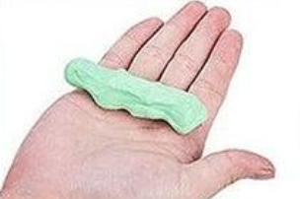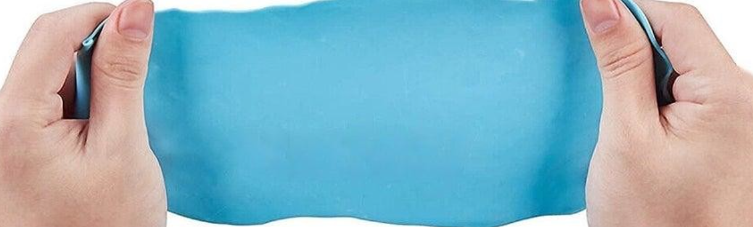
- Break the clay: cut or break the clay into smaller, manageable pieces. This helps reduce the effort needed to start conditioning.
- Warm the clay: hold the pieces in your hands to warm them up. The heat from your hands will make the clay softer and more pliable.
- Roll and flatten: roll the clay into a ball and then flatten it into a disc. Repeat this step several times.
- Fold and repeat: fold the flattened clay in half and press it together. Continue folding, pressing and rolling until the clay is smooth and pliable.
- Check for readiness: properly conditioned clay should have an even texture, free of cracks and should not crumble when stretched.

Conditioning polymer clay with a pasta machine
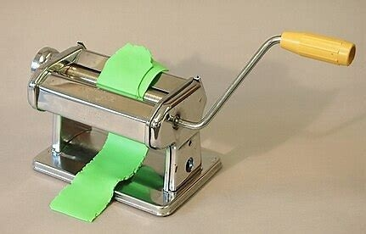
- Cut the clay: slice the clay into thin pieces to fit through the pasta machine rollers.
- Start at the thickest setting: set the pasta machine to its thickest setting. Pass the clay through the rollers.
- Fold and roll: fold the clay in half and feed it back into the machine, fold side first. Repeat this process several times.
- Gradually reduce thickness: adjust the pasta machine to thinner settings as the clay becomes more pliable. Alternate between thick and thin settings to avoid overworking one area.
- Check consistency: once the clay passes through smoothly without cracks or crumbles, it is ready for use.
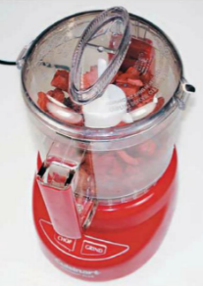
Conditioning polymer clay with a food processor
- Cut the clay: chop the clay into small pieces to fit inside the food processor.
- Add clay to the processor: place the pieces into the food processor bowl. Add a small amount of clay softener or mineral oil if the clay is particularly stiff.
- Pulse the processor: use the pulse setting to break the clay into smaller bits and begin blending it together.
- Continue blending: allow the processor to run until the clay forms a cohesive mass. If needed, stop occasionally to scrape down the sides.
- Knead by hand: remove the blended clay and knead it by hand to finish the conditioning process. Ensure it is smooth and pliable before use.
Tips for successful conditioning
- Start small: conditioning small amounts of clay is easier and faster.
- Avoid overheating: be cautious not to overheat the clay, especially with a food processor, as this can alter its consistency.
- Clean tools: clean tools between colours to prevent contamination.
- Patience is key: proper conditioning can take several minutes, but it’s essential for achieving durable, flexible creations.
Note: if you are using a pasta machine or food processor, purchase a small, cheap model which will only be used for polymer clay.

Basic skills project – shaping flat shapes, balls, beads
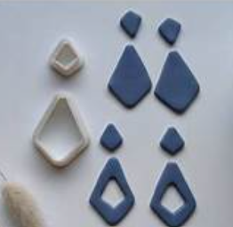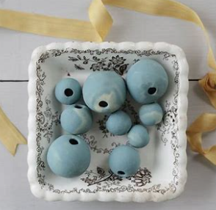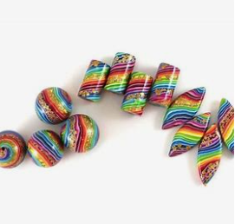
Construction steps
Making flat shapes
- Condition the clay: warm and soften the polymer clay by kneading it until it is pliable.
- Roll out the clay: use a rolling pin, acrylic roller or pasta machine to roll the clay into an even, flat sheet. Aim for the desired thickness.
- Cut the shapes: use cookie cutters, shape templates or a craft knife to cut out flat shapes like circles, squares or custom designs.
- Smooth edges: gently smooth the edges with your fingers or a clay tool to remove any roughness.
- Bake the shapes: place the shapes on a baking surface lined with parchment paper and bake according to the manufacturer’s instructions.
Making balls
- Condition the clay: knead the clay to make it soft and workable.
- Form a cylinder or cube: roll the clay into a small cylinder or cut a cube for equal amounts. This ensures consistent ball sizes.
- Roll into a ball: place the clay between your palms and roll it in a circular motion to form a smooth, round ball.
- Check for imperfections: inspect the ball for cracks or fingerprints and smooth them out with your fingers.
- Bake the balls: arrange the balls on parchment paper or in a bead rack and bake as directed.
Making beads
- Condition the clay: knead the clay thoroughly to soften it.
- Shape the bead: roll the clay into a ball for round beads, flatten it for disc beads or mould it into other shapes like tubes or ovals.
- Pierce a hole: use a needle, toothpick or skewer to pierce through the bead for stringing. Rotate the tool gently to avoid distorting the shape.
- Refine the hole: ensure the hole is even and smooth by rotating or reinserting the piercing tool.
- Bake the beads: place the beads on a baking surface or suspend them on skewers or bead racks to maintain their shape during baking. Follow the clay manufacturer's baking guidelines.

Evaluation of beads
On the line below, place an X on the rating that you think matches the quality of your beads.
Poor quality | Fair quality | Good quality | High quality
Answer the following questions in the space provided to evaluate your design and process.
What was the most difficult part to make or do? Explain your answer.
What parts of your project worked well?
Do you think your project was a success? Why?
What would you change to improve your project?

Basic skills project – simple canes
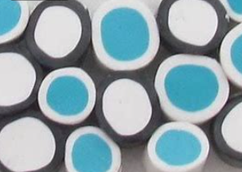 | 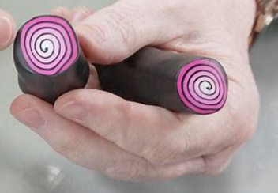 | 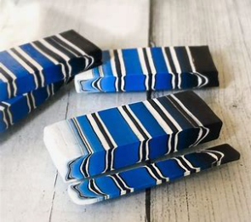
Bulls eye | Jelly roll | Multicoloured striped cane

Construction steps
- Condition the clay: knead and roll the polymer clay until it is soft, pliable and free of cracks. Use multiple colours if creating a patterned cane.
- Plan the design: decide on the type of cane you want to create, such as a spiral, checkerboard, flower, or geometric pattern. Sketch the design if needed to visualise the layout.
- Create clay sheets or logs: roll out clay into thin sheets for layered designs or shape them into logs for simpler patterns. Use an acrylic roller or pasta machine for even thickness.
- Layer the clay: stack or wrap clay sheets as per your design. For example, for a spiral cane, roll one sheet into a log and wrap it with contrasting layers of clay. For a checkerboard cane, alternate layers of different colours.
- Form the cane: shape the stacked clay into a log, cylinder or triangular prism depending on the design. Press gently to remove air pockets while keeping the pattern intact.
- Reduce the cane: gently roll and compress the cane to reduce its size and stretch the pattern. Start from the centre and work outward to maintain an even shape. Rotate and stretch the cane evenly to prevent distortion.
- Cut and check the pattern: use a sharp blade to slice the cane and inspect the pattern inside. Adjust as needed by reshaping or adding layers. Slice and use: once the cane is complete, slice it into thin pieces for use in jewellery, embellishments or other projects.
Tips
- Work on a cool surface to prevent clay from becoming too soft.
- Use cornstarch or a release agent if the clay sticks to tools.
- Store leftover cane shapes wrapped in plastic or wax paper to prevent drying or distortion.
- Polymer clay canes are versatile and can be used to create intricate designs for beads, pendants and decorative surfaces.

Evaluation of cane
On the line below, place an X on the rating that you think matches the quality of your cane.
Poor quality | Fair quality | Good quality | High quality
Answer the following questions in the space provided to evaluate your design and process.
What was the most difficult part to make/do? Explain your answer.
What parts of your project worked well?
Do you think your project was a success? Why?
What would you change to improve your project?

3D printing using ABS and PLA

History of ABS and PLA
ABS (Acrylonitrile Butadiene Styrene) and PLA (Polylactic Acid) are 2 of the most popular materials used in 3D printing.
ABS was developed in the 1940s and became widely used in the automotive, construction and toy industries due to its strength and flexibility. It is famously used in LEGO bricks.
PLA was developed more recently as an environmentally friendly alternative to petroleum-based plastics. Derived from renewable resources like corn starch or sugarcane, PLA became popular in the 2000s as the demand for sustainable materials grew.

Composition of ABS and PLA
ABS is made from 3 monomers:
- Acrylonitrile – provides chemical resistance and hardness
- Butadiene – adds toughness and impact resistance
- Styrene – improves rigidity and surface finish.
PLA is made from fermented plant starch (like corn), resulting in a biodegradable plastic. It is lactic acid-based and polymerised into long molecular chains.

Properties
ABS – it is strong, durable, and heat-resistant, but can produce fumes when heated.
PLA – it is biodegradable, easy to print, and available in various colours, but less heat-resistant and more brittle than ABS.

Safety of ABS and PLA
- Ventilation – ensure proper ventilation when printing with ABS, as it can emit fumes that may irritate the respiratory system. PLA emits fewer fumes and is generally considered safer.
- Temperature control – avoid overheating ABS, which can release toxic chemicals. PLA prints at lower temperatures, reducing the risk of harmful emissions.
- Handling and storage – store both materials in a cool, dry place to prevent moisture absorption, which can affect print quality.
- Post-processing – sanding or cutting ABS and PLA can generate fine particles. Wear a mask and work in a ventilated area.
- Disposal – PLA is biodegradable, while ABS is recyclable. Consider environmentally-friendly disposal methods.

Fun facts
- PLA is often used for food packaging and disposable utensils due to its biodegradable properties.
- ABS is used in automotive parts, protective gear and musical instruments.
- PLA can be composted under industrial conditions, while ABS must be recycled.
- ABS and PLA are versatile and widely used in 3D printing, offering exciting opportunities for creativity and design. Understanding their properties and handling them safely helps students create high-quality prints while being environmentally conscious.

Basic skills projects – earrings, pendant, ring
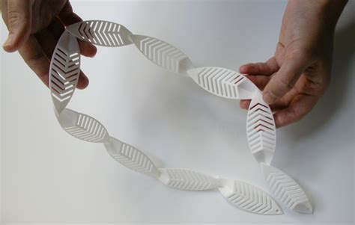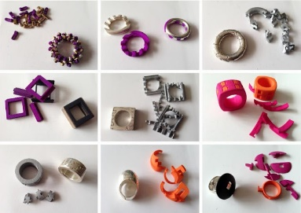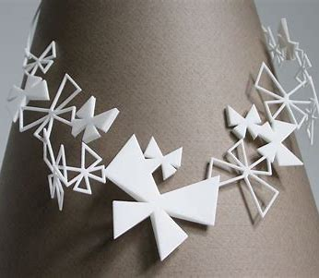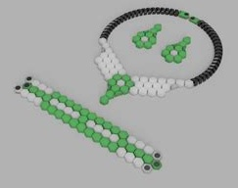
Design the jewellery in CAD software
- Open CAD software, for example TinkerCAD, Fusion 360, Onshape or Blender.
- Create the design: design your earrings, pendant or ring. Ensure dimensions and features, for example ring size, pendant hole or earring hook placement, are accurate.
- Check scale and proportions: ensure the design matches real-world sizes for wearable comfort.
Prepare the design for printing
- Export the file: save the design in STL or OBJ format, the standard for 3D printing.
- Import into slicer software, open the file in a slicer, for example Cura, FlashPrint or PrusaSlicer.
Adjust print settings:
- Layer height: set a finer resolution (for example, 0.1–0.2 mm) for smoother jewellery.
- Infill: choose a high percentage (for example, 50–100%) for durability.
- Support structures: add supports for overhangs or intricate features.
- Material: select ABS or PLA based on preference and printer compatibility.
Set up the 3D printer
- Load filament: insert ABS or PLA filament into the printer. Ensure the filament spool is properly mounted.
- Preheat the printer: set the appropriate temperature (for example, 190–220°C for PLA, 230–250°C for ABS).
- Calibrate the printer: level the print bed and check nozzle alignment to ensure accuracy.
Print the jewellery
- Start printing: send the sliced file to the printer via USB, SD card or Wi-Fi.
- Monitor the print: check periodically to ensure no errors occur, such as filament jams or bed adhesion issues.
- Cool down: allow the printed piece to cool on the bed to prevent warping, especially with ABS.
Post-processing the jewellery
- Remove supports: carefully detach any support structures using pliers or a craft knife.
- Sand and polish: smooth edges and surfaces with fine-grit sandpaper or polishing tools.
- Paint or coat (optional): add paint or a clear coat for colour or shine.
Add findings and finish
- Earrings: attach hooks or studs to the printed earring pieces using jump rings or glue.
- Pendant: thread a chain or cord through the hole or loop.
- Ring: ensure a smooth, comfortable fit for the wearer; resize if necessary.
Final inspection
- Check for any rough edges or defects.
- Test the jewellery for durability and wearability.

Evaluation of 3D printed jewellery
On the line below, place an X on the rating that you think matches the quality of your jewellery.
Poor quality | Fair quality | Good quality | High quality
Answer the following questions in the space provided to evaluate your design and process.
What was the most difficult part to make/do? Explain your answer.
What parts of your project worked well?
Do you think your project was a success? Why?
What would you change to improve your project?

Create, evaluate, modify and apply ideas and solutions

Inspiration mood board
Create a mood board to represent inspiration for your jewellery piece; including culture, sustainability, biomimicry, a range of materials and processes.
Note: students may create their mood board online (using platforms like Canva, Google Slides or similar design software) or by hand, using magazines, printouts or sketches glued onto a page. Choose the format that best suits your classroom resources and students’ preferences.

Crazy 8 idea generation
Crazy 8 is an ideation method used to generate multiple visual ideas for the same concept. Set a timer for one minute per box. In each of the 8 boxes, sketch or describe a different jewellery idea. Don’t worry about neatness – the aim is to create lots of ideas quickly. Be creative and don’t overthink!
Figure 9 – Crazy 8 idea generation squares

SCAMPER (Substitute, Combine, Adapt, Modify, Put, Eliminate, Reverse)
SCAMPER is a creative brainstorming technique designed to help students generate new ideas. This tool is primarily used to help generate ideas for new products and services by encouraging you to think about how you could improve existing ones. Watch SCAMPER a creative thinking technique (5:15).
Complete the table below to generate ideas for jewellery design.
Table 17 – ‘SCAMPER’ table
Problem item | Answer
Substitute
Combine
Adapt
Modify
Put
Eliminate
Reverse

Producing and implementing
In this stage of the design process, we document the tools, materials, technologies and processes used during prototyping and developing the final product or solution.
Figure 10 – producing and implementing processes
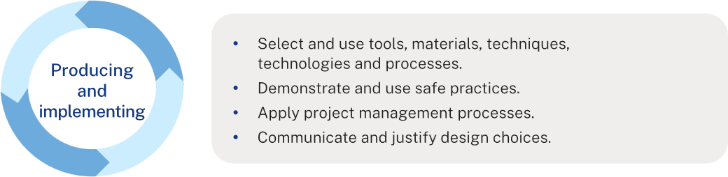

Process
As you make your jewellery, record each step of the process.
- Use the correct words from your glossary when describing the tools, materials and techniques you used.
- If you can, take a photo of each step. Add the step number and a short explanation.
- If you don’t have a camera, you can draw the step or find a clear image online.
- You may also note:
- any safety steps you followed
- what went well and what didn’t go as planned (and why).
This will help show the progression of your work and demonstrate your understanding of the design and production process.
Note: students may complete this documentation online (for example, using Word, Google Docs, or design software) or in the space provided in this booklet, depending on your class context and available resources.
In the space below, create a list of steps in production. Include photos or drawings and a brief description of the production steps.
Suggested steps for polymer clay jewellery:
- Sketch out your jewellery design (earrings, pendants, rings, and so on.).
- Consider colour schemes, patterns and textures.
- Choose the type of polymer clay suitable for your design.
- Condition the clay by kneading it until soft and pliable.
- Use a pasta machine or roller to create even thickness.
- Mix colours if needed to achieve desired shades.
- Roll out the clay to the required thickness.
- Cut out shapes using cutters, templates or freehand techniques.
- Add details like textures, stamps or impressions.
- Combine different clay pieces if layering or stacking designs.
- Insert metal findings like jump rings or embed earring posts before baking.
- Smooth edges using a silicone tool or your fingers.
- Preheat the oven to the manufacturer’s recommended temperature (typically 110–130°C).
- Place pieces on a baking tray lined with baking paper or ceramic tiles to prevent warping.
- Bake for the specified time (usually 15–30 minutes, depending on thickness).
- Once cooled, sand edges and surfaces with fine-grit sandpaper (400–1000 grit) for a smooth finish.
- Buff with a soft cloth or a rotary tool for a polished look.
- Apply varnish, resin or glaze if a glossy finish is desired.
- Attach findings such as earring hooks, jump rings or necklace chains using pliers.
- Ensure all attachments are secure.
- Check for any imperfections and make final adjustments.

Final design choice – justification
Note: a justification is the support of an argument, opinion or conclusion. Justifying means that you must use evidence and examples to prove something about the topic. Student writing should be convincing and include strong arguments and facts to support their case. To justify, is to provide reasons 'why', with evidence.
When you choose your final jewellery design, you need to justify your decision. This means explaining why you chose that design and showing how it meets the project requirements.
In your justification, you should:
- Describe your final design – what it looks like and its main features
- Explain how it meets the design problem – Does it reflect culture, sustainability, or nature (biomimicry)?
- Show how it meets your success criteria – think about function, comfort, aesthetics, durability, and sustainability
- Compare with your other ideas – explain why this design is better than the other options you considered
- Use evidence – refer to your research, inspiration mood board, or feedback you received.
Tip: be specific. Don’t just say ‘I like this design better’. Instead, give reasons such as ‘This design is more sustainable because it uses recycled materials.’ or ‘The shape is inspired by leaves, which links to my biomimicry theme’.

Student scaffold for ‘Justify’
Use some of the following prompts below to help write your justification. Complete the sentences in your own words, using the blank box below.
Design choice
- I have chosen to design and make …
- My design is inspired by …
Meeting the Design problem
- This design solves the problem of …
- It reflects (culture/sustainability/biomimicry) through …
Meeting the success criteria
- My design is functional because …
- It is comfortable and safe to wear because …
- The materials are … (durable, lightweight, recycled).
- It is visually appealing because …
Evidence and justification
- My research showed that …
- Feedback from peers/teachers suggested …
- Overall, this is the best choice because …
Note: example of a justification using the above scaffold:
I chose to design a leaf-shaped pendant inspired by nature (biomimicry).
It solves the problem of creating a unique, meaningful piece by showing a connection to the environment.
The design is lightweight, safe and comfortable with smooth edges.
It uses recycled acrylic and metal findings, making it both durable and sustainable.
Feedback suggested the leaf design was stylish and meaningful, so it best meets my success criteria.

Testing and evaluating
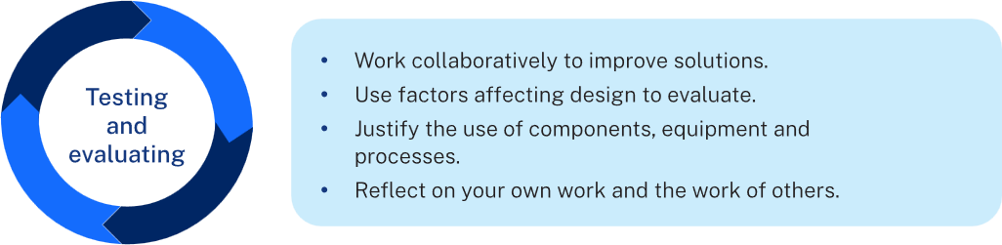
After making your jewellery, you need to test and evaluate it to see how well it meets your design brief and success criteria.
- Peer feedback: ask classmates for 2 positives and one suggestion for improvement.
- Test: check if it functions as planned – against the criteria for success (function, aesthetics, durability, safety).
- Evaluate: reflect on your own work – what worked well, what could be improved and how it meets your design goals.

Peer feedback – two stars and a wish
Note: two stars and a wish can be used as peer feedback at any stage throughout the project. The student swaps their work with a peer. Peer provides feedback by writing down 2 positive comments and one suggestion for improvement. Work is swapped back and the feedback is discussed verbally.
During the project, you will give and receive peer feedback using two stars and a wish.
- Swap your work with a classmate.
- Your peer will write down:
- 2 positive comments about your work
- one suggestion (a ‘wish’) for improvement.
- Swap back and discuss the feedback together.
This helps you see what is working well and what you could improve.
Figure 11 – ‘Two stars and a wish’ template
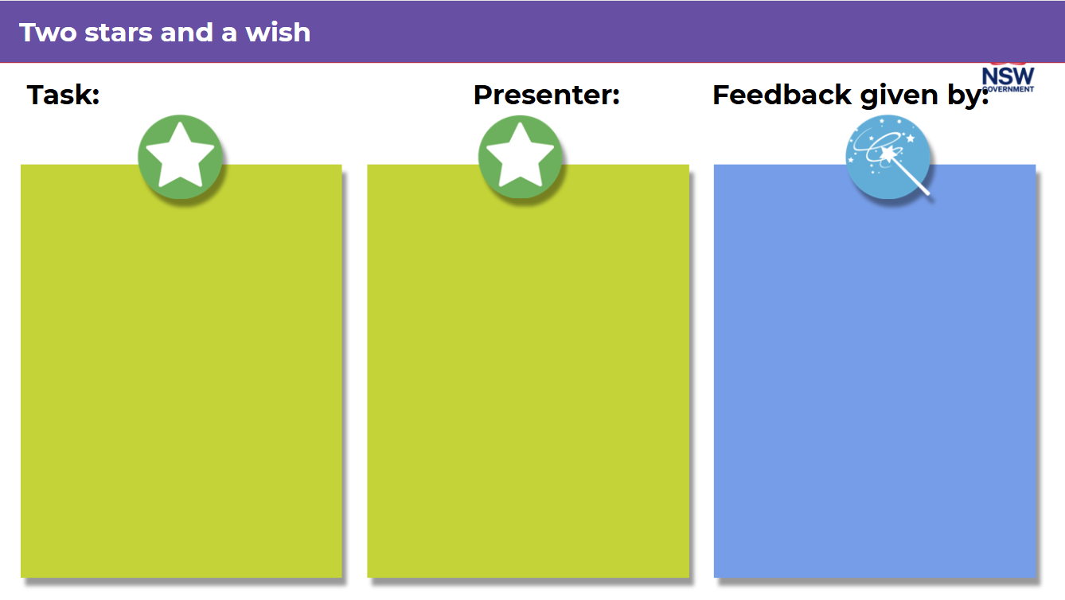

Peer feedback – TAG
Students can also use TAG protocol to gain feedback from their peers. This can be done verbally or in writing and discussed between peers.
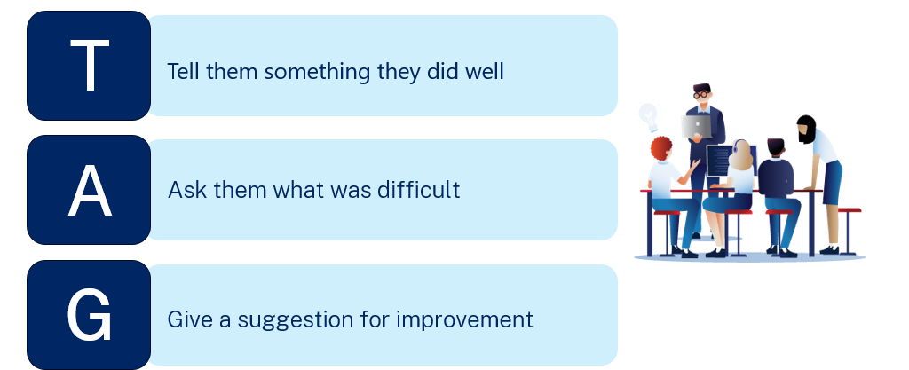
Complete a peer assessment on a peer's jewellery using the TAG method in the graphic below.
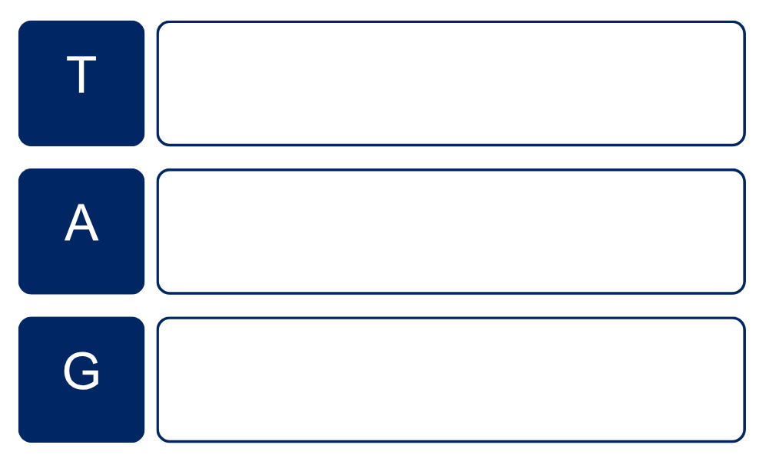

Factors affecting design evaluation
Go back to the criteria for success you wrote earlier. For each one, write if you met it or not, and give a reason.
Example:
Criteria: ‘My jewellery will be safe to wear.’
Did I meet it? Yes, because I filed and sanded all the sharp edges.
Complete your evaluation in the table below.
Criteria | Comment/evaluation

Self-evaluation
Evaluate the success of your process and product.
Write about your project using the questions below to help you.
- Was your project successful? Why or why not?
- Did your jewellery solve the design problem you were given?
- How well did it meet your criteria for success? Give examples.
- What worked really well in your design? (for example, function, look, comfort and durability)
- What could you improve next time? (for example, materials, techniques and time management)
- Who would your jewellery suit as a customer?
- Was your design safe and sustainable?
Tip: use evidence from your project (photos, sketches, teacher/peer feedback) to back up your ideas.
You may also add photos or drawings of your final product to support your evaluation.
Example evaluation:
The design problem was to create jewellery using different materials with a theme of culture, sustainability or nature. I made a leaf‑shaped pendant from recycled acrylic.
One of my criteria was that the jewellery should be safe and comfortable. I met this by sanding all the sharp edges. Another criterion was that it should be visually appealing, which I achieved by engraving a leaf pattern. I also aimed for sustainability by using recycled acrylic, though I had to buy new metal findings.
The best part of my design is the engraved pattern, which links to my nature theme. A challenge was making the engraving deep enough, which I solved by testing the laser settings.
If I did this again, I would improve the chain length and allow more time for production. Overall, I am proud of my pendant because it looks professional and links strongly to my design theme.

Appendix 1

Metal (copper, brass, silver)

Equipment
- Cutting and shaping tools: jeweller’s saw, metal shears, tube cutter, dremel
- Forming tools: mandrels, hammers, dapping blocks, pliers
- Drilling and piercing: drill press, needle files, small bits
- Soldering and joining: torch, flux, solder, pickle pot, tweezers
- Finishing tools: files, polishing paper, buffing machine, stamps
- Measuring: ruler, dividers, callipers, scribes
- Safety gear: glasses, gloves, apron, dust mask

Key processes
- Design and plan: sketch or CAD, measure and mark accurately
- Form and shape: sawing, bending, dapping, annealing
- Join: soldering, fusing, riveting
- Refine: filing, sanding, polishing, applying patina
- Assemble: wire wrapping, attaching findings
- Optional: stone setting (bezel/prong), stamping

Acrylic or timber

Equipment
- Cutting tools: laser cutter, scroll saw, coping saw, rotary tool
- Drilling tools: drill press, small bits
- Sanding and finishing: files, sanding tools, buffing wheels, woodburning tools
- Assembly: clamps, pliers, wire cutters, adhesives
- Software (for laser): Inkscape, Illustrator
- Optional tools: CNC router, strip heater

Key processes
- Design and plan: hand sketch or CAD, prototype
- Material prep: peel acrylic film, sand timber
- Cut and engrave: laser cut or hand saw
- Form: heat bend acrylic, steam bend timber
- Join: adhesives, screws, lamination
- Detail: etching, staining, painting, engraving
- Finish: sand, polish, seal
- Assemble: add hooks, jump rings, rivets

Polymer clay

Equipment
- Conditioning tools: pasta machine, acrylic roller
- Cutting and shaping: blades, cutters, stamps, moulds
- Drilling: hand drill, toothpicks, skewers
- Sculpting tools: ball stylus, dotting tools, extruder
- Baking tools: oven, ceramic tile, parchment
- Finishing: sandpaper, buffing cloth, varnish
- Assembly: pliers, findings, epoxy, cutters

Key processes
- Condition clay: soften and prep
- Shape and form: roll, cut, sculpt, texture
- Bake and cure: use separate oven; follow temps
- Sand and finish: refine surfaces
- Decorate: paint, foil, glaze, mica powders
- Assemble: add findings (pre/post bake)
- Optional: caning, resin coating

3D Printing (PLA, ABS)

Equipment
- 3D printer
- Filament: PLA (eco-friendly), ABS (durable)
- Software: TinkerCAD, Fusion360, Onshape, Cura
- Post-processing: sandpaper, knives, polishers, epoxy
- Assembly: pliers, glue, magnets, jewellery findings

Key processes
- Model: design in CAD
- Slice: adjust settings (layer height, infill, supports)
- Print: monitor print job
- Refine: remove supports, sand, polish
- Decorate: paint, engrave, resin coat
- Assemble: drill/tap holes, add components
- Optional: use dual-material, flexible filaments

References
This resource contains NSW Curriculum and syllabus content. The NSW Curriculum is developed by the NSW Education Standards Authority. This content is prepared by NESA for and on behalf of the Crown in right of the State of New South Wales. The material is protected by Crown copyright.
Please refer to the NESA Copyright Disclaimer for more information https://educationstandards.nsw.edu.au/wps/portal/nesa/mini-footer/copyright.
NESA holds the only official and up-to-date versions of the NSW Curriculum and syllabus documents. Please visit the NSW Education Standards Authority (NESA) website https://educationstandards.nsw.edu.au and the NSW Curriculum website https://curriculum.nsw.edu.au.
Technology 7–8 Syllabus © NSW Education Standards Authority (NESA) for and on behalf of the Crown in right of the State of New South Wales, 2023.
Australian Curriculum, Assessment and Reporting Authority (ACARA) (2010) Critical and Creative Thinking learning continuum [PDF 58 KB], Australian Curriculum, Assessment and Reporting Authority, accessed 12 November 2024.
The Australian Museum (2021) Tasmanian Aboriginal shell necklaces, Australian Museum website, accessed 19 November 2024.
Collins M (3 October 2022) 'My Creative Process When Designing a New Jewellery Collection' [video], Megan Collins, YouTube, accessed 31 January 2025.
Innovato Design (14 September 2020) Traditional Jewelry by Country - Explore The Fascinating Cultures From All Around The World, Innovato Design website, accessed 3 February 2025.
Larsen Jewellery (2025) The Larsen Difference, Larsen Jewellery website, accessed 3 February 2025.
Mabray A and Otterbein K (2011) Look Learn & Create Polymer Clay, Creative Publishing International Inc, Minnesota.
Next Generation Science (5 May 2023) ‘Properties of materials' [video], Next Generation Science, YouTube, accessed 26 November 2024.
State of New South Wales (Department of Education) (16 May 2024) Using effective feedback, NSW Department of Education website, accessed 12 November 2024.
——(5 January 2025) Introducing student peer assessment, NSW Department of Education website, accessed 31 January 2025.
——(6 January 2025) Strategies for student peer assessment, NSW Department of Education website, accessed 31 January 2025.
——(August 2021) Crazy 8’s, Pedagogy and Strategies, NSW Department of Education website, accessed 12 November 2024.
——(n.d.) ‘Activating prior knowledge (Previously KWLH)’, Digital Learning Selector, NSW Department of Education website, accessed 31 January 2025.
——(n.d.) ‘Exit tickets’, Digital Learning Selector, NSW Department of Education website, accessed 31 January 2025.
——(n.d.) ‘Jigsaw’, Digital Learning Selector, NSW Department of Education website, accessed 31 January 2025.
——(n.d.) ‘Peer feedback’, Digital Learning Selector, NSW Department of Education website, accessed 12 November 2024.
——(n.d.) ‘Plus, Minus, Interesting (PMI)’, Digital Learning Selector, NSW Department of Education website, accessed 28 January 2025.
——(n.d.) ‘Quick writes’, Digital Learning Selector, NSW Department of Education website, accessed 31 January 2025.
——(n.d.) ‘SCAMPER’, Pedagogy and Strategies, NSW Department of Education website, accessed 31 January 2025.
——(n.d.) ‘Writing scaffolds’, Digital Learning Selector, NSW Department of Education website, accessed 28 January 2025.
——(n.d.) Differentiation Adjustment Tool, NSW Department of Education website, accessed 19 November 2024.
——(n.d.) Digital Learning Selector, NSW Department of Education website, accessed 26 November 2024.
——(n.d.) Inclusive Practice hub, NSW Department of Education website, accessed 19 November 2024.

© State of New South Wales (Department of Education), 2025
The copyright material published in this resource is subject to the Copyright Act 1968 (Cth) and is owned by the NSW Department of Education or, where indicated, by a party other than the NSW Department of Education (third-party material).
Copyright material available in this resource and owned by the NSW Department of Education is licensed under a Creative Commons Attribution 4.0 International (CC BY 4.0) license.

This license allows you to share and adapt the material for any purpose, even commercially.
Attribution should be given to © State of New South Wales (Department of Education), 2025.
Material in this resource not available under a Creative Commons license:
- the NSW Department of Education logo, other logos and trademark-protected material
- material owned by a third party that has been reproduced with permission. You will need to obtain permission from the third party to reuse its material.
Links to third-party material and websites
Please note that the provided (reading/viewing material/list/links/texts) are a suggestion only and implies no endorsement, by the New South Wales Department of Education, of any author, publisher, or book title. School principals and teachers are best placed to assess the suitability of resources that would complement the curriculum and reflect the needs and interests of their students.
If you use the links provided in this document to access a third-party's website, you acknowledge that the terms of use, including licence terms set out on the third-party's website apply to the use which may be made of the materials on that third-party website or where permitted by the Copyright Act 1968 (Cth). The department accepts no responsibility for content on third-party websites.

