Technology 7–8 –

Materials and production processes – teacher resource
Metal-morphosis

Contents
Teacher support resource 3
Glossary 4
Where in the earth do metals come from? 8
From raw metal ore to finished metal products 8
Types of metals 9
Metal sustainability 11
Sheet metal 12
The design and production process 13
Factors affecting design 14
Example 14
Three alternative designs 16
Safety 18
Safety rules in the metal workshop 18
TAS safety resource 19
Sample safety test 20
Materials, tools and techniques 21
Tools and machine identification 21
Folding sheet metal into a 3D object 26
Measuring up 29
Parallel – What does it mean? 30
Joining metal 31
The pop rivet 31
Surface finishes 33
Ethical use of metal 35
Renewable and non-renewable resources 37
Metal meets innovation – Indigenous trade before European contact 39
Technological traditions 40
Metal tools 40
Ethical and legal considerations in design and production 45
Introduction to ethics and legal considerations 45
Class discussion and brainstorm 45
Understanding Intellectual Property (IP) 47
What is Intellectual Property? 47
Types of IP in design and production 47
Project management – base project 49
Working drawing 1 – tray development 50
Working drawing 2 – metal frame 51
Working drawing 3 – assembled base project 52
Potential design 1 53
Potential design 2 54
Potential design 3 55
Parts list 56
Time management 56
Construction steps 57
Base project 57
Evaluation 59
References 60

Teacher support resource
Note: this resource supports schools’ implementation of the Materials and production processes focus area of the new Technology 7–8 Syllabus. It can be adopted as is or adapted to meet the needs of individual school contexts.
This unit will introduce students to metal, machinery, tools and equipment through a small project that incorporates a range of production techniques.
Students will develop the knowledge, understanding and skills required to design, manage, plan and produce a high-quality metal product and evaluate its effectiveness.
Note: this resource has been designed to facilitate the ready conversion into a student booklet by removing the answers within the response boxes. Teacher notes (in blue) and sample answers can be deleted before distributing to students.
Refer to Equipment Safety in Schools and Chemical Safety in Schools for current information on safety and safe working practices in Technology 7–8.

Glossary
Note: sample answers are provided in the table below.
Table 1 – glossary terms and definitions
Term | Definition
Bench vice | A clamping device fixed to a benchtop that holds metal securely while working.
Centre punch | A pointed tool used to mark metal before drilling to help guide the drill bit.
Drill bit (HSS) | A high-speed steel bit used to drill holes in metal.
Engineer's square | A precision tool used to check and mark right angles on metal.
File | A tool with a rough surface used to smooth sharp edges or shape metal.
G clamp | A clamp shaped like the letter G used to hold metal pieces together securely.
Hack saw | A hand saw with a fine blade used for cutting metal.
Machine vice | A portable vice used to hold metal workpieces securely, often on a drill press.
Magnetic folder | A machine that uses magnets to hold sheet metal in place while folding it to shape.
Mild steel | A low-carbon steel that is soft, easy to cut, drill and shape.
Parallel | Two or more lines that are equal distance apart.
Pan brake | A bending machine used to make folds in sheet metal for trays and boxes.
Pedestal drill | A large, fixed drill used to make accurate holes in metal.
Pop rivet | A type of fastener used to join thin pieces of metal permanently.
Rivet gun | A tool used to install pop rivets and join sheet metal.
Scriber | A sharp tool used to mark accurate lines on metal.
Sheet steel | A flat, thin piece of metal commonly used in metalwork projects; it can be cut, shaped or joined.
Steel rule | A metal ruler used for precise measuring in millimetres.
Tin snips | Hand shears designed for cutting thin sheet metal.
Vice grips | Locking pliers used to grip and hold metal pieces firmly.
Wet and dry paper | Abrasive paper used with water to smooth or polish metal surfaces.
What do I know about ‘metal’?
Think of 10 things you used in the past 24 hours that were made from metal. They could be small to very large items. Complete the activities below by identifying things made from metal and describing how metal behaves, feels and looks. Use metal-specific vocabulary where possible.
What I have used that is made from metal …

Metal looks like … | Metal feels like … | Metal smells like …
(Describe its colour, finish, shine and texture) | (Describe what metal feels like to touch) | (Try describing the smell after cutting, drilling or heating it)

Interesting things I know about metal … | What I want to learn about metal …
(Think about where it comes from, what it can do or how we use it.) | (What questions do you have about how metal is made, used or shaped?)

Where in the earth do metals come from?
Metals are strong, solid materials that are all around us – in buildings, tools, cars, electronics and more. But metals don’t start out as shiny sheets or bolts. Most metals come from rocks called ores that are mined from the Earth.
These ores are crushed, melted and purified to remove other materials. This process creates pure metal or metal alloys, which are then shaped into useful forms like rods, sheets or bars. These can be cut, drilled, bent or joined to create everyday products.
Just like timber comes from trees, metal comes from natural resources – but the journey from rock to metal ruler is very different.
In the space below, describe the difference between raw metal ore and finished metal.
Sample answer:
Raw metal ore is rock taken from the Earth that contains metal mixed with other materials. Finished metal that you are using at school has been melted, cleaned and shaped so it can be used to make tools, parts or products.

From raw metal ore to finished metal products
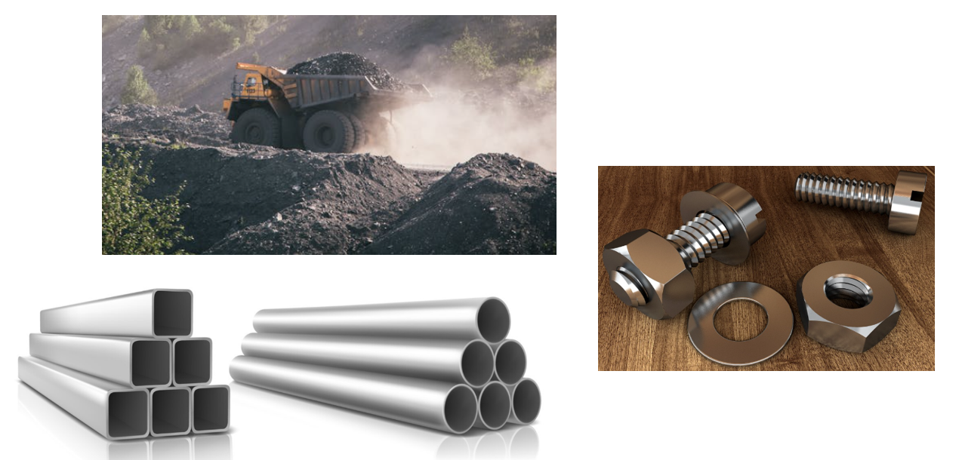

Types of metals
Metals are usually solid materials that are used in everyday products because of their strength, durability and ability to be shaped. Some metals occur in pure form, while others are alloys – made by combining 2 or more metals to improve their properties.
You will explore a variety of common metals and alloys, compare their features and understand where and why they are used in the real world.
Optional student activity prompts:
- Choose 2 metals and compare their corrosion resistance and uses.
- Which metals are alloys? How are they made?
- Which metals would you use in a project that stays outdoors? Why?
- Which metal would be the easiest to shape into a curved tray? Why?
Note: suggested answers are provided in the table.
Metal | Physical properties | Common uses
Mild steel | Strong, low carbon, dense | Car bodies, construction, metal trays
Stainless steel | Hard, strong, shiny | Kitchenware, marine applications, medical tools, outdoor fixtures
Aluminium | Lightweight, soft, silver in colour | Cans, window frames, aircraft parts
Copper | Reddish brown in colour, soft, excellent conductor | Wires, pipes
Brass  (Copper + Zinc) | Gold-like in colour, corrosion resistant | Door handles, musical instruments, taps
Bronze  (Copper + Tin) | Tough, reddish brown in colour, wear resistant | Medals, sculptures
Zinc | Brittle, dull-grey | Coating for steel, die casting
Titanium | Very strong, lightweight | Aerospace, medical implants

Metal sustainability
Watch Metals recycling - WELS (Waterpedia Environmental Learning Series) (4:59).
In the diagram below, briefly outline the steps involved in the recycling of steel or aluminium
Note: sample answers provided in the image below.
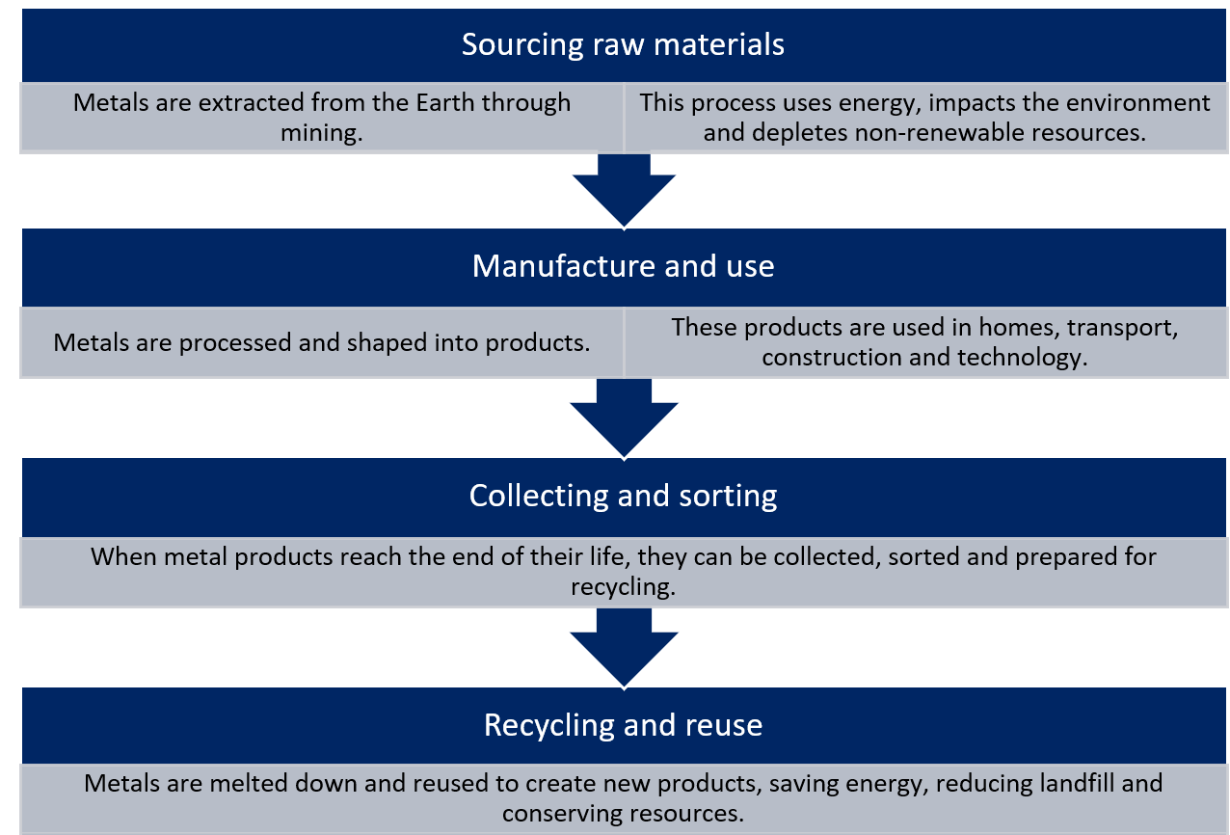

Sheet metal
Learning intention
To explore the properties, types, finishes and uses of sheet metal and understand how it can be protected against corrosion.
Success criteria
✔ Identify and describe different types of sheet metal
✔ Understand the common thicknesses and applications
✔ Explain various surface finishes and their purposes
✔ Recognise methods of corrosion protection
Types of sheet metal
Match the sheet metal type with its correct description.
Sheet metal type | Description
1. Aluminium | a. Strong, rust-resistant steel coated in zinc
2. Galvanised steel | b. Soft, lightweight metal often used in roofing and signs
3. Stainless steel | c. Contains chromium, resistant to rust and has a shiny finish
4. Copper | d. Reddish-brown metal, good conductor, often used in wiring
Your answers:
1. ___ 2. ___ 3. ___ 4. ___

The design and production process
Throughout Technology 7–8, you will follow a design and production process, which is a continuous cycle used to develop your projects. In this unit, we will focus on metal-based solutions. You will document your design and production processes in this workbook and assessment folio throughout the unit.
There are 4 main steps in the process that help to create a quality solution to design challenges or problems. Evaluation happens at each step and is constant throughout the process.
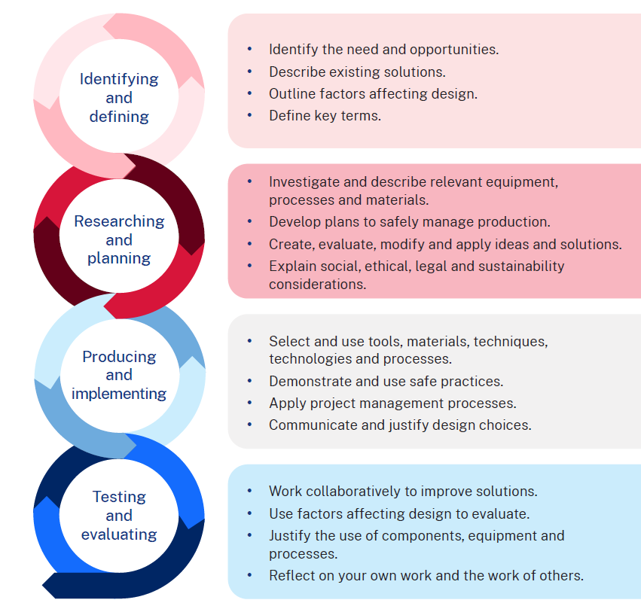

Factors affecting design
When designing and making a small multipurpose metal project, a variety of factors influence the overall success of the final product. These considerations help ensure that the tray is practical, safe and appealing for its intended use. Key factors include functionality or (how well the tray performs its intended purpose), durability (resistance to wear, corrosion and everyday use) and aesthetics (appearance, finish and visual appeal). Ergonomics should also be considered, ensuring the tray is comfortable and easy to handle. Safety is vital in both the production process and the finished product, while materials selection impacts weight, strength and corrosion resistance. By addressing these factors during the design stage, a high-quality, user-friendly and long-lasting tray can be produced.

Example
Product name: common household items (cutlery, pots and pans).
Table 2 – factors affecting design
Design factor | Factors affecting design
Safety | Handles are designed to stay cool during cooking and prevent burns. Edges are rounded or smoothed to avoid cuts. Non-toxic, food-safe coatings and materials are used to prevent harmful chemical transfer. Secure fittings ensure handles and lids remain stable during use.
Durability | Stainless steel, aluminium and other corrosion-resistant metals are used to withstand repeated washing, high heat and everyday wear. Reinforced joints, rivets and welding ensure long-term use without loosening or warping.
Ethics | Many manufacturers source materials responsibly, use recyclable metals and aim to reduce waste and energy consumption in production. Ethical practices may also include fair labour and supporting local manufacturing.
Ergonomics | Handles are shaped for a comfortable grip and balanced weight distribution. Pot handles are positioned to reduce wrist strain and cutlery is designed to fit comfortably in the hand during use.
Aesthetics | Available in various finishes such as polished, brushed or coloured coatings to match kitchen décor. Shapes and styles can range from sleek modern designs to traditional or decorative patterns.
Accessibility | Lightweight designs make items easier to lift, especially for elderly users. Larger, easy-grip handles and utensils cater to those with reduced dexterity. Clearly visible markings (for example, measuring lines in saucepans) assist users with vision impairments.

Three alternative designs
Your challenge is to take the base metal tray project and imagine 3 different, practical purposes it could be adapted for. Each purpose should involve the addition of at least one unique feature that transforms the tray to suit that purpose.
This activity will help you explore how a single design can be customised and reimagined, based on user needs, function and context.
Instructions
- Carefully examine the base tray project you’ve started building.
- Think of 3 distinct, realistic uses it could be adapted for.
- For each purpose, describe:
- What feature(s) you would need to add
- Why that feature is necessary.
The intended purpose
Portable candle holder

Design features
Carry handle
Wind shield/decorative panel

Sketch proposed design additions
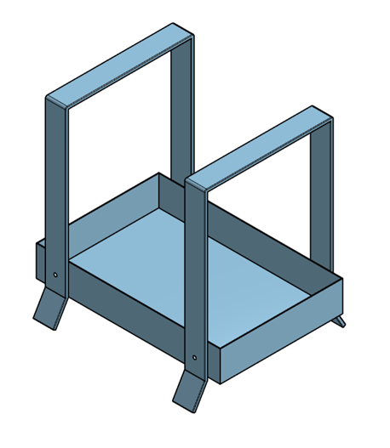

Justification of the proposed design
The handle is needed to carry it safely.
The wind shield is required to protect the candle flame when it is being moved around or used outdoors.

Safety
Teacher note: refer to Equipment Safety in Schools and Chemical Safety in Schools for current information on safety and safe working practices in Technology 7–8.

Safety rules in the metal workshop
For each image below, write the safety message for working safely in the metal workshop.
Note: sample answers have been provided below.
Table 3 – safety rules for metal workshop
 | 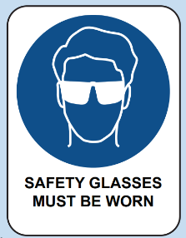 | 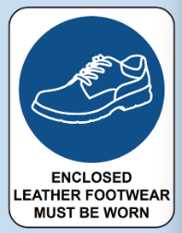
Tie hair back. | Wear eye protection. | Wear enclosed leather shoes.
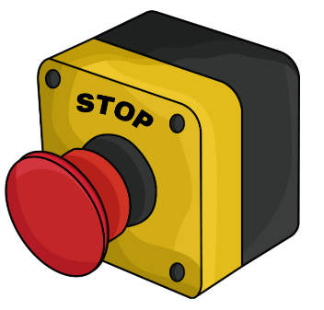 |  | 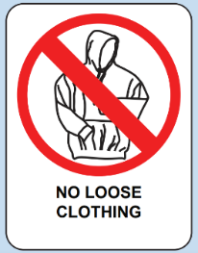
Know where emergency stops are. | First aid. | Remove ties and loose clothing or tuck in.

TAS safety resource
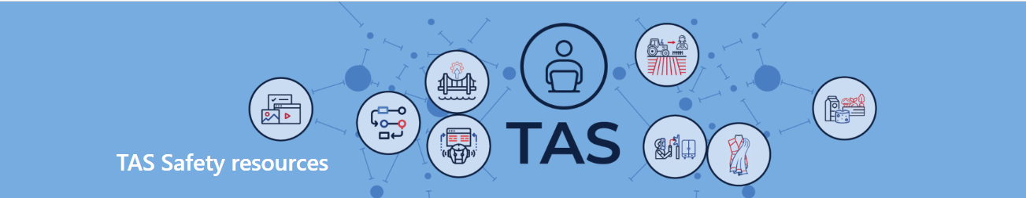
Teacher note: the TAS Safety resources (staff only) are created for Department of Education schools, using relevant information from Equipment Safety in Schools (ESIS). These resources have been developed specifically for the equipment and machinery that has been approved for use in department schools.
Safety tests are mandated by ESIS for selected equipment and machinery.
The tests may be attempted in electronic or other formats with the result recorded and retained as per the department’s records management policy.
Students must provide the correct answer (with or without support) to each question on the safety test as evidence that they knew correct procedures at that point in time for the tool, equipment or machine. Students may attempt each test multiple times to achieve the correct answers.

Sample safety test
All department developed and endorsed safety tests are available in the TAS Statewide Staffroom (staff only).

Magnetic folder
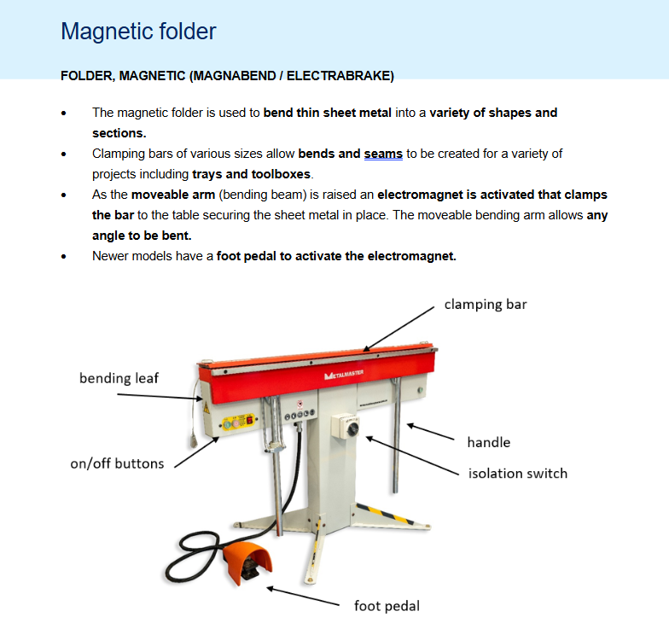

Materials, tools and techniques

Tools and machine identification
For each image below, write the name and use of each tool.
Note: sample answers have been provided.
Table 4 – tool identification
Tool image | Tool or machine name | Use
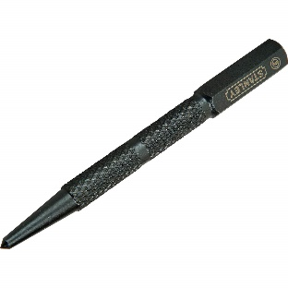 | Centre punch | A pointed tool used to mark metal before drilling to help guide the drill bit.
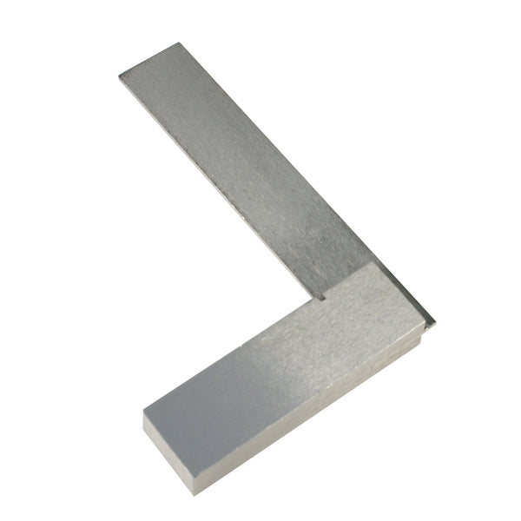 | Engineer's square | A precision tool used to check and mark right angles on metal.
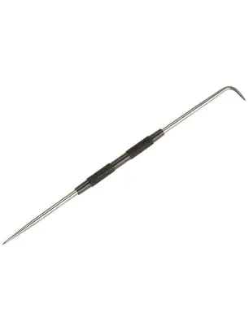 | Scriber | A sharp tool used to mark accurate lines on metal.
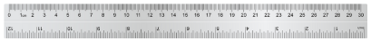 | Steel rule | A metal ruler used for precise measuring in millimetres.
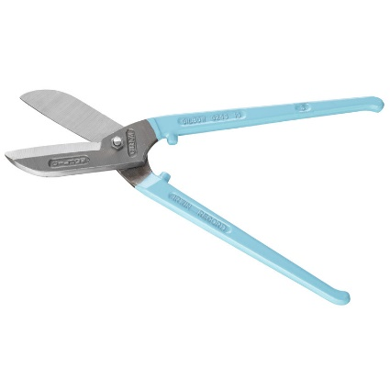 | Tin snips | Scissors designed for cutting thin sheet metal.
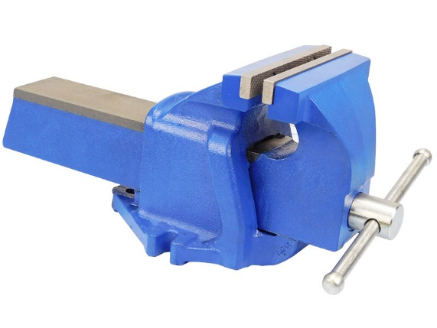 | Bench vice | A clamping device fixed to a benchtop that holds metal securely while working.
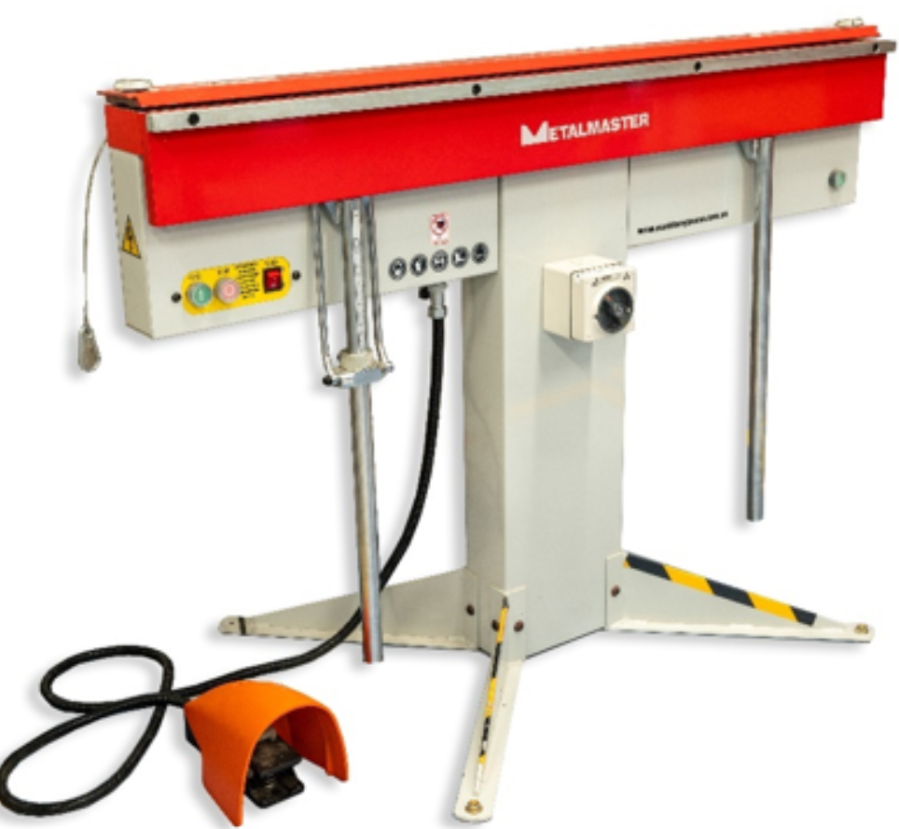 | Magnetic folder | A machine that uses magnets to hold sheet metal in place while folding it to shape.
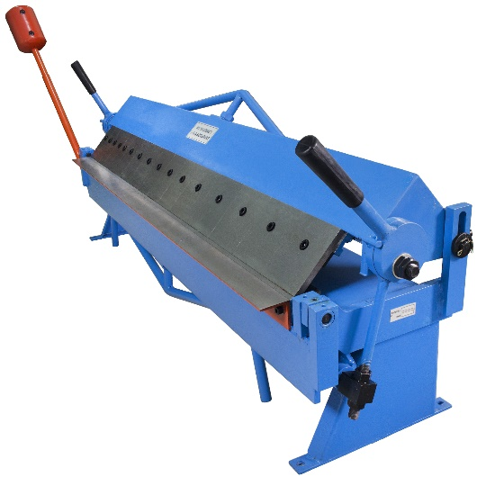 | Pan brake | A bending machine used to make folds in sheet metal for trays and boxes.
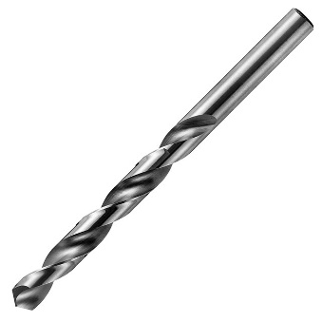 | Drill bit (HSS) | A high-speed steel bit used to drill holes in metal.
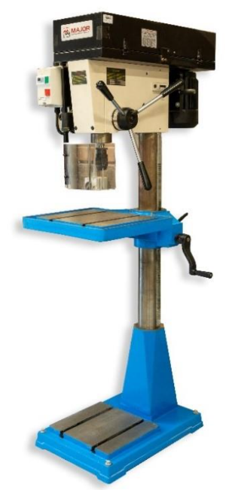 | Pedestal drill | A large, fixed drill used to make accurate holes in metal.
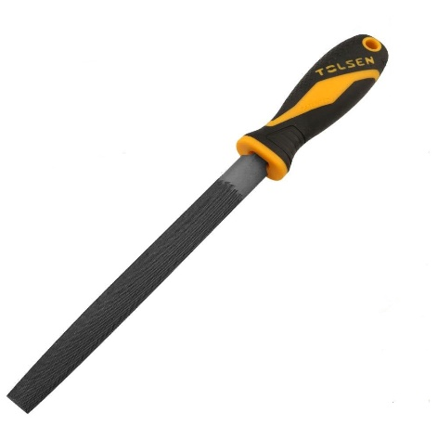 | File | A tool with a rough surface used to smooth sharp edges or shape metal.
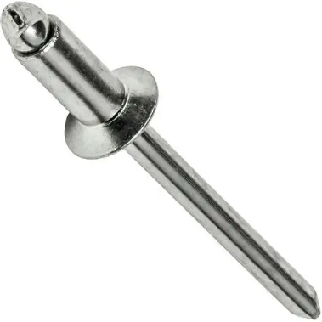 | Pop rivet | A type of fastener used to join thin pieces of metal permanently.
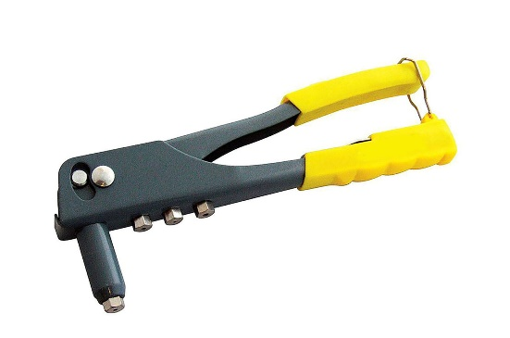 | Rivet gun | A tool used to install pop rivets and join sheet metal.
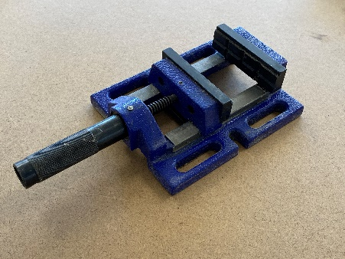 | Machine vice | A portable vice commonly used on a drill press to safely clamp small workpieces.

Folding sheet metal into a 3D object
Step 1 – introducing the cube net (conceptual foundation)
Learning intention: understand how a flat pattern (net) becomes a 3D object.
- Introduce the term ‘net’ using visual examples (for example, packaging box, cube net, prism nets).
- Show how 6 equal squares arranged as a cross can be cut and folded into a cube.
- Students cut out a paper cube net, fold it and glue or tape it together.
Discussion prompts:
- What happens if a square is missing?
- Why do we need flaps (tabs)?
- Where might this apply in real-world manufacturing?
Step 2 – identifying tabs and folding mechanisms
Learning intention: understand the role of tabs in joining materials.
- Examine paper cube and identify which faces required tabs to hold it together.
- Introduce terms: ‘tab’, ‘fold line’, ‘cut line’ and ‘join’.
- View real metal items (for example, toolboxes, tins, cases) and locate where folding and tabbing occur.
- Students annotate diagrams showing fold directions and tab placements.
Step 3 – applying geometry to metal patterns
Learning intention: use geometric concepts to draw and label metal net layouts.
- Teach key terms: ‘parallel’, ‘perpendicular’, ‘angle’, ‘line of symmetry’, ‘90° fold’, ‘radius’.
- Students draw a simple tray net on graph paper (for example, base + 4 sides with tabs).
- Fold lines are dashed; cut lines are solid.
- Emphasise accuracy and planning.
Step 4 – transferring layout to metal surface
Learning intention: use tools to mark out an accurate design on sheet metal.
- Demonstrate use of steel rule, scriber, engineer’s square, centre punch.
- Students mark out their tray or box design on light-gauge sheet metal.
- Emphasise checking dimensions, measuring twice, and marking clearly.
Safety note: introduce PPE, clean work area, and secure clamping.
Step 5 – cutting, filing and preparing edges
Learning intention: safely cut and prepare metal for folding.
- Students cut out their marked designs using tin snips.
- Use a flat smooth file to remove rough edges.
- Check all lines and fold zones before proceeding.
Reinforce safe snipping technique, secure sheet firmly, avoid sharp offcuts
Step 6 – folding sheet metal into shape
Learning intention: fold metal using tools and apply correct angles.
- Demonstrate folding using a pan brake or magnetic folder.
- Fold edges upward to 90° or required angle.
- Students follow their marked fold lines to shape their tray/box.
Tip: fold in the correct sequence so tabs aren’t trapped. Clamp where needed.
Step 7 – joining and securing the shape
Learning intention: join components using basic techniques (for example, riveting).
- Drill holes at tab joins using pedestal drill.
- Fix with pop rivets using a rivet gun.
- Check alignment and squareness throughout the process.
Alternative joining methods: screws, tabs-and-slots, or tacking (teacher demo).
Step 8 – evaluating and reflecting
Learning intention: assess product accuracy and evaluate design process.
- Students photograph and annotate their finished product.
- Complete reflection questions:
- What was most challenging?
- Where were your measurements or folds most accurate?
- How could your process improve?
- Would this design be suitable for repeated production?

Measuring up
Measure easily found metal items to the nearest millimetre with the ruler shown and provide your answer in the space provided.
Note: answers provided below.
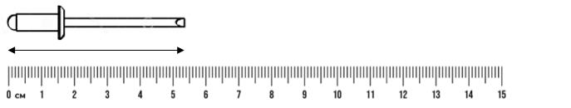
54 mm
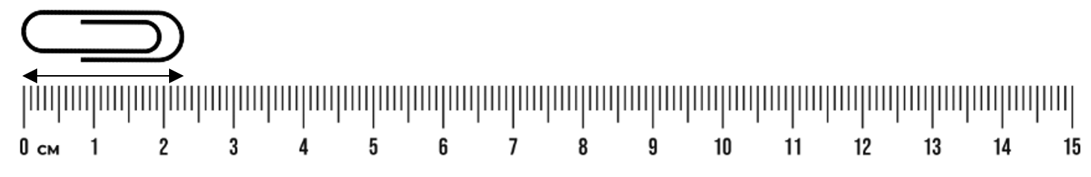
23 mm
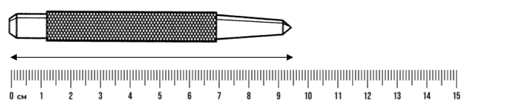
95 mm

Parallel – What does it mean?
Note: Connecting learning .Teachers support students to make connections within and across learning to develop increasingly complex schemas.
Class conducts a Think-Pair-Share:
In pairs students consider how to explain the concept of parallel lines to the class group.
Example answer: parallel lines are 2 or more lines that are equal distance apart.
How has this concept been applied in your project?
Example answer: it is important that the marking out of the fold lines of each side of the tray are parallel. If they are not, then the tray will not be square and the sides will be uneven in height.
Table 5 – examples of parallel lines
Example | How they are parallel
Train tracks | The 2 rails stay the same distance apart all the way.
Rungs on a ladder | Each rung is parallel to the others.

Joining metal
When we build with metal, simply placing 2 pieces together won’t hold them in place. Metal parts need strong, secure joining methods to stay connected and handle pressure or movement. In metalwork, we use fasteners and joining techniques to make sure metal parts stay fixed and perform their function safely.
There are several ways to join metal. These include mechanical fasteners like pop rivets, nuts and bolts or screws (in softer metals), as well as more permanent options like spot welding and brazing. The method chosen depends on the type of metal, the tools available and the purpose of the final product.
There are many types of nails and screws, each designed for different jobs and we’ll look at them more closely in this unit.

The pop rivet
The pop rivet is used to permanently join sheet metal. It is inserted into a drilled hole and fastened with a rivet gun.
Figure 1 – the pop rivet
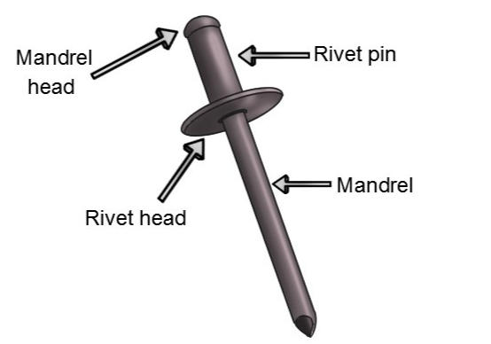
Use the list below to identify and label the images of different screws.
- bolts and nuts: common for joining thicker pieces or parts that may need to be taken apart for later
- screws: used in soft metals or when fastening to materials like plastic or timber. Requires pre-drilling
- spot welding: a fast, permanent method for joining sheet metal using electrical current and pressure
- brazing: a process that uses a filler metal heated with a torch to join metal pieces without melting the base metal
- tabs and folds: bending sheet metal to create tabs that can be slotted or joined into other folded parts. Often used in trays and enclosures.
Table 6 – metal joining methods
Joining method | Description
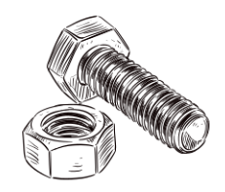
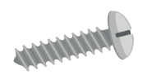
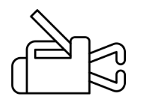

Surface finishes
Finishing metal is important to protect it from rust, wear and damage. A good finish also makes the metal look more appealing and improves its durability, especially if the item will be handled often or used outdoors.
Finishes can protect metal from:
- corrosion (like rusting)
- scratches and wear
- heat or moisture damage
- discolouration and dullness.
Some common metal finishes include paint, powder coating, polishing, and galvanising.
Activity 1 – complete the sentences using words from the word bank below.
Word bank
corrosion | shine | abrasion | smooth | moisture | protect
heat | rust | lasting | appearance | grime | coating
The ideal metal finish should:
- help __________ the metal from __________ and __________
- create a __________, durable surface with a clean __________
- be resistant to __________, __________ and everyday __________
- add a __________ that improves the look and life of the object.
Activity 2 – types of metal finishes
The table below provides pre-filled descriptions and common uses for teacher reference. These can be used as prompts or scaffolds to guide student responses during the investigation.
Table 7 – surface finishes
Type of finish | Description | Common uses
Paint | A liquid colour finish applied to clean metal; helps protect against rust. | School projects, machinery, furniture
Powder coating | Dry powder sprayed and baked onto the metal, forming a hard, protective layer. | Outdoor furniture, bike frames, appliances
Polishing | Smoothing the metal with abrasives until it reflects light; no coating added. | Decorative items, trophies, display pieces
Galvanising | Coating steel with a layer of zinc to prevent rusting. | Gutters, poles, fences
Bluing | A controlled rust process that gives steel a dark blue/black finish. | Tools, firearm parts, steel artwork
Clear coat (Lacquer) | A transparent protective layer to enhance shine and resist oxidation. | Aluminium signs, jewellery, artistic pieces

Ethical use of metal
Watch Repurposed Season 1 Episode 1: It Takes Grit (23:10).
This documentary explores steelmaking from recycled materials in an industrial setting. It provides a close-up of steel mills, recycling centres, supply chains and workers committed to sustainable practices as a case study about ethics and materials within metalwork.
Note: sample answers are provided below.
- What is meant by the term ‘circular economy’ as used in the video? Why is it important in metal production?
A circular economy means materials are reused or recycled instead of thrown away. In metal production, it helps reduce mining, saves energy and keeps materials in use longer, which is better for the environment.
- What types of scrap materials are collected and recycled into new steel in the video?
Items like old car parts, washing machines, steel beams and industrial offcuts are collected. These are melted down and reused to make new products.
- What ethical benefits are shown in the video when recycled steel is used instead of mining new raw materials?
Recycling steel reduces the need for mining, which can damage ecosystems. It also lowers energy use, cuts carbon emissions and helps reduce landfill waste, all of which are more ethical choices for the planet.
- How does the steel mill ensure safety for its workers? Why is this important when considering ethical manufacturing?
The mill uses safety equipment, clear processes and proper training. Ethical manufacturing includes looking after people, not just making products, so protecting workers is essential.
- The video shows the journey of scrap metal from collection to finished product. Why is transparency in the production process an ethical strength?
Transparency helps consumers and businesses know where materials come from and how they were handled. It builds trust and helps support environmentally and socially responsible choices.
- The video highlights the role of local communities and jobs. How does metal recycling support ethical outcomes for people?
It provides jobs in recycling, transport and manufacturing. Local economies benefit, and people have meaningful work, which is an important part of ethical and sustainable industry.
- Why is using recycled steel considered a more sustainable and ethical option compared to sourcing virgin steel?
Recycled steel uses less energy, doesn’t require mining and reduces greenhouse gases. It also makes use of existing materials that might otherwise be wasted, making it both sustainable and ethical.
- Imagine you are designing a small metal product. How could you apply ethical considerations like those shown in the video to your design process?
I could use recycled or scrap metal, design for durability so it lasts longer and avoid waste by carefully planning my cuts. I’d also make sure it can be recycled again later.

Renewable and non-renewable resources
Write a description of what is meant by the following terms listed in the table below.
Note: suggested answers are provided in the table.
Table 8 – definitions of renewable and non-renewable terminology
Term | Description
Resource | A supply of something useful or valuable that can be used to make products.
Natural resource | A material found in nature that is used by humans, such as metal ore or water.
Renewable natural resource | A natural material that can be replaced naturally in a short time, like solar energy or plants.
Non-renewable resource | A material that takes millions of years to form and cannot be replaced quickly, like metal ores or fossil fuels.
Resource management | The careful use and protection of resources to avoid waste and long-term damage.
Mining | The process of digging into the Earth to remove valuable minerals or metal ores.
Recycling | The process of collecting and reusing materials to reduce waste and save energy.

Why is metal recycling considered an important part of sustainable resource use?
Metals like aluminium, steel and copper are non-renewable because they come from ores that take millions of years to form. Recycling helps us reuse these materials instead of mining new ones. It uses less energy, reduces pollution and helps protect natural environments.

Metal meets innovation – Indigenous trade before European contact
Lesson overview:
To initiate a discussion to build student understanding in the following areas:
- awareness that Aboriginal and Torres Strait Islander Peoples traded and used metal items before European settlement
- recognition of how metal objects were innovatively used and widely disseminated, leading to increased inter-community trade across Aboriginal groups
- develop balanced argumentative skills by evaluating the pros and cons of introduced metal items in Aboriginal societies.
Use the following websites and the excerpt from the book Innovation, First Knowledges by Ian J McNiven & Lynette Russell, 2023 to guide class discussion on Indigenous trade before European contact.
Websites:
- Trade with the Makasar | Australia’s Defining Moments Digital Classroom | National Museum of Australia
- Macassan History and Heritage

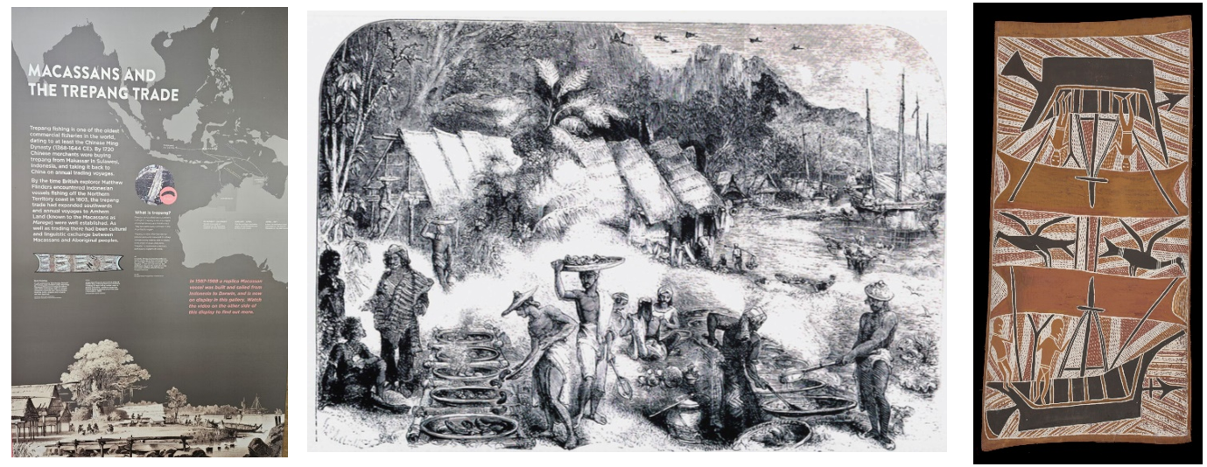
Image sources:
‘Macassans and the Trepang trade’ from The Museum and Art Gallery of the Northern Territory, image taken by Paul Budde, 2023.
‘Macassans at Victoria, Port Essington’ drawn in 1845 by HS Melville, published in the Queen, 8 February 1862.
‘Makasar Prau’ by Birrikitji Gumana is licensed by Buku-Larrnggay Mulka.

Technological traditions

Metal tools
If you walk into the Ian Potter Centre of the National Gallery of Victoria in Melbourne's Federation Square and head upstairs to the 19th Century Australian Art gallery, the first work you see is an oil painting by Harden Sidney Melville dated 1874 and labelled Torres Strait canoe and five men at the site of a wreck on the Sir Charles Hardy Islands, off Cape Grenville, North East Australia. Melville created the painting in England based on memories and sketches he made while he was a young artist aboard the HMS Fly during its hydrological survey of Torres Strait for the British Admiralty in the mid-1840s. It shows a group of Torres Strait Islanders in a huge double-outrigger canoe: they have voyaged nearly 200 kilometres south along the Great Barrier Reef and have stopped off at the Sir Charles Hardy Islands To salvage items that have washed up on the rocky shore from the wreck of a European sailing ship.
Torres Strait Islanders converted metal for tools and soon learned that the many European ships that came to grief on the treacherous and often unmapped coral reefs of the region were a great source of metal. Shipwreck salvaging by Torres Strait Islanders during the 19th century was an innovation that probably had its origins back in the 18th century, when Torres Strait and the northern Great Barrier Reef became a shipping route for the emerging colony of New South Wales. A curious tiny fragment of Chinese ceramic material dating to the 1500s and excavated by Ian on Mabuyag in western Torres Strait possibly points to even earlier salvaging.
It is no secret that First Nations Australians immediately took advantage of the introduction of metal to their world by British colonisers. As anthropologist Nic Peterson pointed out, uptake of metal usually occurred where it could be easily substituted for the existing technology. Examples of Aboriginal uptake of metal substitutes for stone implements include spearheads and hafted chisels. Anthropological archaeologist Harry Allen adds that the speed of uptake of metal by different Aboriginal groups was determined less by ideas of perceived technological efficiency and more by concerns of security of supply of metal and ensuring that traditional technologies continued as a backup.
Aboriginal uptake of metal pre-dates British invasion: metal-using Makassan trepang fishers from Indonesia visited Australia’s northern shores from at least the 1700s (see chapter 6). Archaeological excavations of the Makassan trepang-processing stations in Arnhem land have produced a wide array of metal items including bronze fishhooks, copper coins, steel axe heads and fragments of iron cauldron. Apart from trading metal with local host communities along the Arnhem Land coast, the introduction of Makassan objects, especially those made of metal intensified regional exchange networks amongst Aboriginal communities especially between coastal and inland groups. It is also likely that Aboriginal people obtained metal objects when they visited Makassan on praus. The crew of HMS Fly, including Melville, were informed of such visits when they pulled into Port Essington on the Northern Territory coast in 1845. Indeed, they observed a prau arrive with an Aboriginal man on board who had travelled to Makassar the previous year.
Archaeological excavations of Aboriginal middens associated with campsites along the Coburg Peninsula by Scott Mitchell revealed a major increase in the use of imported in land stone coinciding with the period of Makassan visits. Mitchell argues that this change reflected increased trade between coastal and inland groups due to the desire of Makassan objects such as metal by inland communities (which coastal communities had aplenty) and the desire for prestigious in land stone by coastal communities (which in land communities had aplenty). He adds that the main incentive for increased trade was enhancement of social relationships between coastal and inland groups.
Excerpt from: Innovation, First Knowledges by Ian J McNiven & Lynette Russell, 2023 © Thames and Hudson Australia 2023
Ask students to discuss and answer the following questions:
- Identify trade items – What items (especially metal) were being traded? (for example, knives, axes, tools, metal fishing hooks, ceramics).
- Evidence of exchange – How are these exchanges visible in imagery and documented in Aboriginal and Torres Strait Islander cultural expressions? Consider rock art, local languages, borrowed technologies.
- Impacts of introduced metals. Divide the class into 2 groups:
- Group A – identify the benefits and opportunities created by introducing metal items.
- Group B – identify the challenges, risks or impacts on traditional practices, focusing on the effects of trade and the introduction of new materials on Aboriginal communities.
Note: students could possibly use online collaboration tools such as Miro or Whiteboard.
Using a table students add their responses.
Note: sample answers are provided in the table below.
Table 9 – benefits and drawbacks of introducing metal items
Benefits | Drawbacks
Enhanced tools: fishing hooks, spear heads leading to better hunting or fishing and greater mobility of trade. | Disruption: introduction of diseases or social upheaval.
Network expansion: metal goods became trade commodities among Aboriginal groups. | Environmental or dependency risks: overfishing (trepang), reliance on external goods, weakening autonomy.
Cultural enrichment: metal tools may have facilitated innovations, shaping new traditions and crafting techniques. | Environmental impact: metal implements perform differently to traditional materials such as stone axes. This can affect the harvesting of bark and the long-term effect of the tree.
Opportunity to link traditional skills with newer materials. | Cultural change: erosion or transformation of traditional practices due to outside influence.
Reflection questions: Individually, students reflect on the stimulus and activity and consider the questions below.
- Was the trade predominantly positive? Negative? Mixed?
Example answer: it had clear positives – Aboriginal and Torres Strait Islander Peoples gained access to durable metal tools like fishhooks, spearheads and axes that could improve hunting, fishing and woodworking efficiency. It also strengthened regional trade networks, particularly between coastal and inland communities, as metal items became valuable trade goods. However, there were negatives, such as environmental impacts (for example, metal axes making cleaner cuts on trees, slowing their regrowth), changes to traditional practices and the risk of dependency on externally-sourced materials.
- Can we see parallels with modern-day trade or technology exchange?
Example answer: the way new technologies today (for example, smartphones, renewable energy tech) are rapidly adopted and integrated into existing systems, sometimes replacing older methods.
Global trade still functions on the exchange of specialised resources (for example, rare earth minerals from one region for manufacturing elsewhere).
Just as Aboriginal communities assessed the benefits and risks of metal adoption, today’s communities weigh the environmental, cultural and economic impacts of adopting new technologies.
- How might Aboriginal communities have adapted creatively to the arrival of metal?
Example answer: they adapted by incorporating metal into existing cultural and technological frameworks. For example:
Replacing stone spear tips with metal ones, increasing durability and reducing the need for frequent replacement.
Adapting binding techniques to securely attach metal prongs to wooden shafts.
Salvaging metal from shipwrecks or modifying traded items into new tools, showing problem-solving and resourcefulness.
Integrating metal into trade systems, creating new networks or strengthening old ones.

Ethical and legal considerations in design and production

Introduction to ethics and legal considerations
Watch the following video: ETHICS (5:04).

Class discussion and brainstorm
Discuss the following question: What is the difference between ethical and legal?. Create 2 columns on the board and list student ideas. Clarify key terms (for example, ‘IP’, ‘safety’, ‘sustainability’, ‘diversity’, ‘inclusion’ and ‘accessibility’).
From the class discussion determine the differences between ethical and legal considerations. Suggest a real-world example to help clarify your definition.
Note: the answers provided below are suggestions only.
Table 10 – difference between ethical and legal
Consideration | Definition, with examples
Ethical | Doing what is right or fair in design and production, even if not required by law.  Example: In 2022, a small online store was called out for selling tote bags with a design copied from a local Indigenous artist without permission.  Example: A council had to replace picnic tables in a public park because the original design blocked wheelchair access.
Legal | Rules and laws that must be followed in design and production (breaking them can have penalties).  Example: Apple sued Samsung in a high-profile case over copying smartphone design features.  Example: A retailer in NSW was ordered to modify its store entrance after being found in breach of disability access requirements.
How could ethics and legal considerations apply to my project?
Students identify at least one ethical and one legal consideration relevant to their own project.
My project enhancement idea: ___________________________________________
One ethical consideration in my project:
Example answer: I will ensure my design is inclusive by making the handle shape comfortable for both left- and right-handed users.
Real-world example: Many gaming console controllers, like the Xbox Adaptive Controller, are designed to be comfortable and usable for people with different abilities.
One legal consideration in my project:
Example answer: I will only use images and graphics that I have created myself or are licensed for free use, to avoid breaching copyright.
Real-world example: Canva provides a library of copyright-cleared images and icons for designers to legally use in projects.
Reflection
Why is it important for designers to think about ethical and legal considerations?
Example answer:
It protects users, respects other creators’ work, avoids legal trouble and helps create products that are fair, safe and sustainable.
Real-world example:
Dyson conducts extensive safety testing and secures patents for its vacuum designs to ensure user safety, product quality and legal protection.

Understanding Intellectual Property (IP)

What is Intellectual Property?
Example answer: Intellectual Property (IP) refers to creations of the mind – such as inventions, designs, artistic works, symbols, names and images – that are protected by law.

Types of IP in design and production
Table 11 – types of IP in design and production
IP type | What it protects | Example
Copyright | Artistic works, drawings, written material, software | A jewellery maker’s original design sketches
Design rights | The visual appearance of a product (shape, pattern, configuration) | The unique shape of a Coca-Cola bottle
Patents | How an invention works (new products, processes, methods) | Dyson’s cyclone vacuum technology
Trademarks | Words, symbols, logos that identify a brand | Nike ‘Swoosh’ logo

How can I protect my ideas and work?
Some ways to protect your ideas and work involve:
- automatic protection – some IP rights (like copyright in Australia) are automatic as soon as the work is created and recorded
- registration – other IP rights (like patents, design registration, trademarks) require you to apply and be granted protection by IP Australia or another official body
- duration – different types of IP last for different time periods (for example, copyright usually lasts for the life of the creator plus 70 years in Australia)
- enforcement – IP owners can take legal action if someone uses their protected work without permission.

Why does IP matter for designers?
IP matters for designers because it:
- protects your ideas from being copied
- allows you to earn income from your creations (for example, selling and licensing)
- builds brand recognition and trust
- encourages innovation by rewarding creative effort.

How IP may apply to my project
Consider the following questions:
- What part(s) of your own design could be protected by IP?
- What type of IP protection would be most suitable and why?

Project management – base project
The working drawings provided are for the base project.

Working drawing 1 – tray development
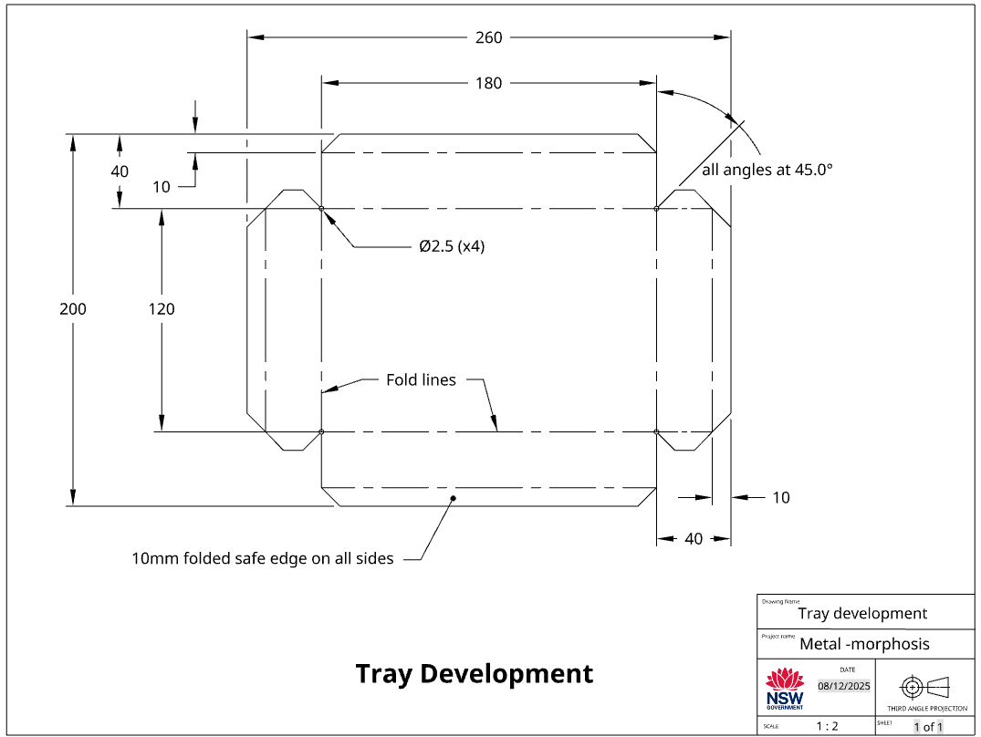

Working drawing 2 – metal frame
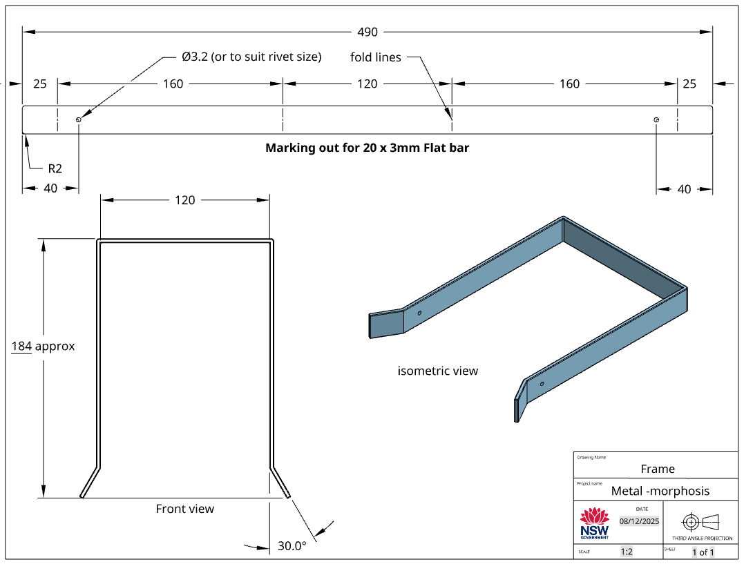

Working drawing 3 – assembled base project
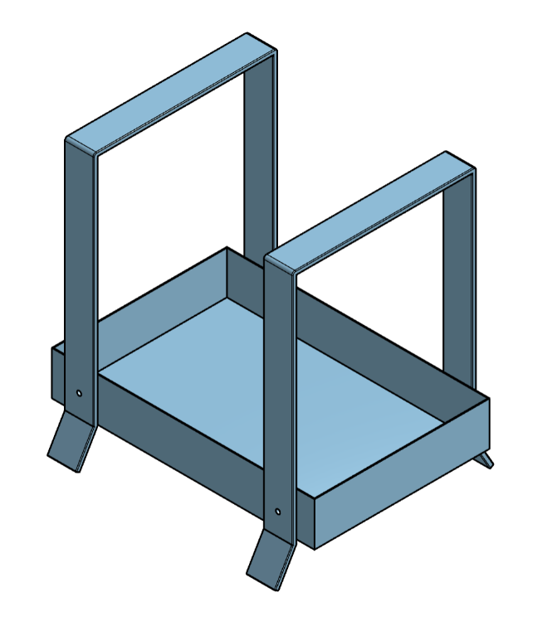

Potential design 1
Enhancements: flat bat handle and sheet metal side.
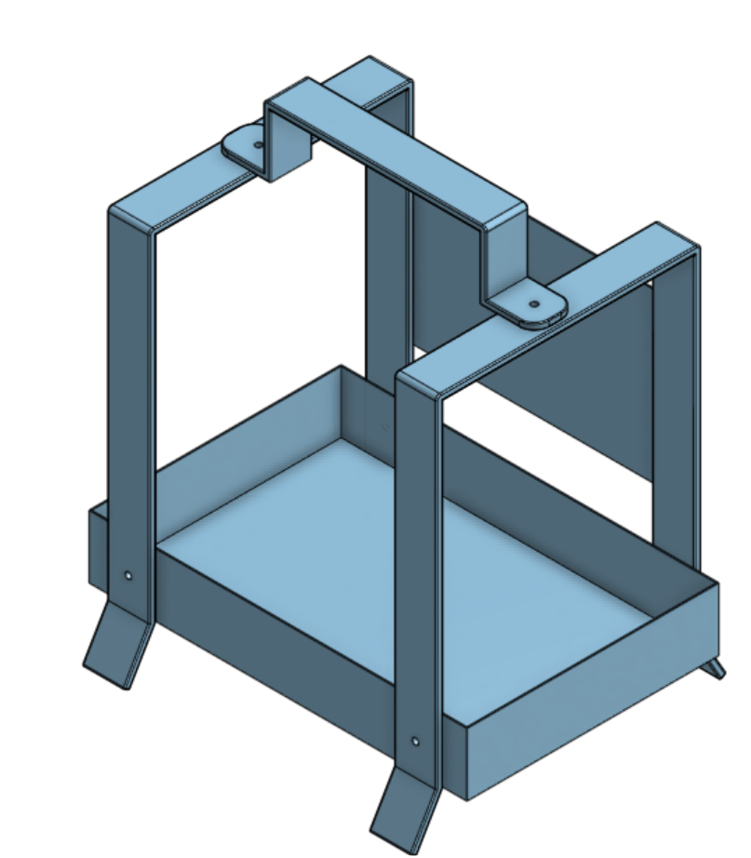

Potential design 2
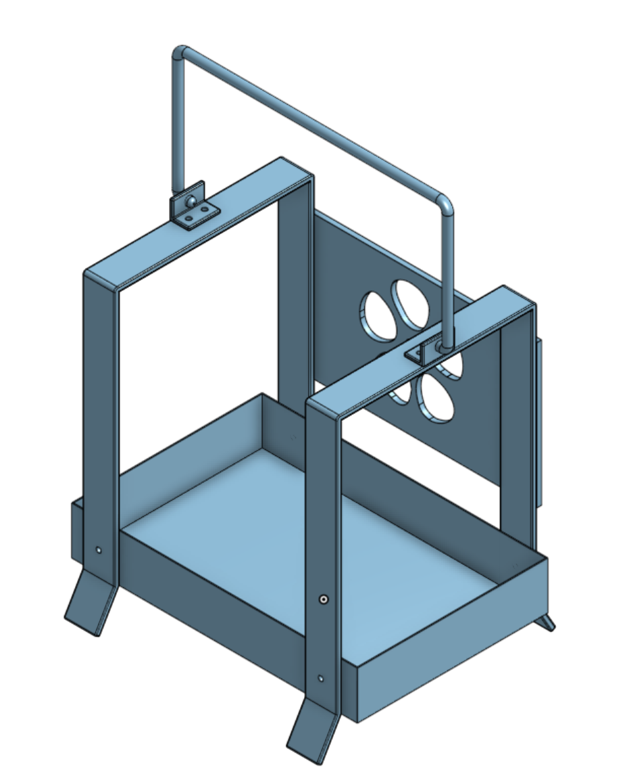

Potential design 3
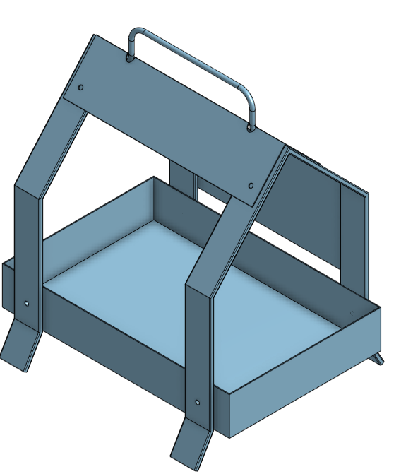

Parts list
The parts list describes the type of material to be used, the dimensions of the material, the number of parts, the name of each part and other information relevant to the manufacture of the project. It is presented as a table. Complete the table below for your project adding the additional parts of your design.
Table 12 – parts list
No. | Description | Qty | L mm | W mm | T mm | Material
1 | Tray | 1 | 260 | 200 | 0.55 | 0.55 mm gal sheet
2 | Frame | 2 | 590 | 20 | 3 | Mild steel flat bar
3
4
5
6

Time management
Time management is the planning we do to make sure our project is completed in the time we have available. When we are planning the time management for this project, we need to look at the time we have available and the tasks we need to do to complete the project.
Time available
Table 13 – time management considerations
Question | Answer
How many weeks do we have available to make the multipurpose tray?
How many practical lessons do we have in a week?
How many practical lessons do we have to complete the project?
What tasks do we need to do and how long will they take?
In the table provided below, sort the following construction steps into the correct order then estimate how much time should be allocated to each task.
- Deburr all cut edges  - Mark out, cut tray sides and base  - Mark out and drill holes for handle and fixings  - Bend tray base and sides into shape  - Pop rivet or sport weld tray sides to base  - Clean and prepare all surfaces for finishing | - Apply protective finish  - Attach handle to tray  - Mark out and cut handle brackets or supports  - Rivet and attach handle brackets to tray  - Final assembly and inspection  - Prepare or smooth edges for safety

Construction steps

Base project
Table 14 – projected time for steps of project
Step | Task | Estimated time  (in lessons)
1 | Mark out and cut base tray
2 | Deburr and file all cut edges
3 | Pop rivet or sport weld tray sides to base
4 | Mark out and drill holes for rivets
5 | Mark out and cut frame brackets or supports including fold lines
6 | Bend tray base and sides into shape
7 | Rivet and attach frame brackets to tray
8 | Bend both frames

Design additions
Note: example provided for reference only.
Table 15 – project time for design elements of project]
Step | Task | Estimated time  (in lessons)
9 | Mark out and cut handle to length
10 | Bend handle to shape
11 | Attach handle to frame pieces
12 | Mark out and cut sheet metal back panel. Clean and prepare all surfaces for finishing
13 | Mark out and drill holes in back panel to suit
14 | Fasten back panel to frame using pop rivets
15 | Clean and prepare all surfaces for finishing (filing and sanding)
16 | Apply protective finish

Evaluation
- On the line below, place an X that matches the way you like to work?

I like working on my own |  |  |  | I like working with others
- On the line below, place an X that matches the amount of time you had to make your metal tray?

I had enough time |  |  | My project was rushed
- On the line below, place an X that you think matches the quality of your multipurpose metal tray?

Poor quality | Fair quality | Good quality | High quality
- What task in the designing or making of your multipurpose metal tray did you find the most difficult?
- What task in the designing or making of your multipurpose metal tray did you enjoy the most?
- Is there anything you would do differently on your next technology project?
- Are there any skills that you developed making your multipurpose metal tray that you will use outside school?

References
This resource contains NSW Curriculum and syllabus content. The NSW Curriculum is developed by the NSW Education Standards Authority. This content is prepared by NESA for and on behalf of the Crown in right of the State of New South Wales. The material is protected by Crown copyright.
Please refer to the NESA Copyright Disclaimer for more information https://educationstandards.nsw.edu.au/wps/portal/nesa/mini-footer/copyright.
NESA holds the only official and up-to-date versions of the NSW Curriculum and syllabus documents. Please visit the NSW Education Standards Authority (NESA) website https://educationstandards.nsw.edu.au/ and the NSW Curriculum website https://curriculum.nsw.edu.au/.
Technology 7–8 Syllabus © NSW Education Standards Authority (NESA) for and on behalf of the Crown in right of the State of New South Wales, 2023.

© State of New South Wales (Department of Education), 2025
The copyright material published in this resource is subject to the Copyright Act 1968 (Cth) and is owned by the NSW Department of Education or, where indicated, by a party other than the NSW Department of Education (third-party material).
Copyright material available in this resource and owned by the NSW Department of Education is licensed under a Creative Commons Attribution 4.0 International (CC BY 4.0) license.

This license allows you to share and adapt the material for any purpose, even commercially.
Attribution should be given to © State of New South Wales (Department of Education), 2025.
Material in this resource not available under a Creative Commons license:
- the NSW Department of Education logo, other logos and trademark-protected material
- material owned by a third party that has been reproduced with permission. You will need to obtain permission from the third party to reuse its material.
Links to third-party material and websites
Please note that the provided (reading/viewing material/list/links/texts) are a suggestion only and implies no endorsement, by the New South Wales Department of Education, of any author, publisher, or book title. School principals and teachers are best placed to assess the suitability of resources that would complement the curriculum and reflect the needs and interests of their students.
If you use the links provided in this document to access a third-party's website, you acknowledge that the terms of use, including licence terms set out on the third-party's website apply to the use which may be made of the materials on that third-party website or where permitted by the Copyright Act 1968 (Cth). The department accepts no responsibility for content on third-party websites.

Ian McNiven & Myles Russell-Cook, ‘Seeing What They Saw: Harden Sidney Melville’s Torres Strait canoe and five men at the site of a wreck on the Sir Charles Hardy Islands, off Cap Grenville, North East Australia, 1874, NGV Magazine, 25, 2020, pp. 14-17.
Grave & McNiven, ‘Geochemical Identification of Asian Stoneware Jars from Torres Strait, Northeast Australia.
Nicolas Peterson, ‘Ethno-Archaeology in the Australian Iron Age’, in Gale de G Sieveking, Ian H Longworth & KE Wilson (eds), Problems in Economic and Social Archaeology (Duckworth, London, 1976), pp. 265-75.
Macknight, The Voyage to Marege’.
Macknight, The Voyage to Marege’.
Joseph B Jukes, Narrative of the Surveying Voyage of HMS Fly, Volume 1 ( T & W Boone, London, 1847), p.359
Scott Mitchell, ‘Foreign Contact and Indigenous Exchange Networks on the Cobourg Peninsula, North Western Arnhem Land’, Australian Aboriginal Studies, 2, 1995, pp. 44-8.

