Technology 7–8 – Materials and production processes – teacher resource – steps in production
Metal-morphosis (10-week unit)
Contents
Multipurpose metal tray 2
Safety 2
Working drawing – assembled base project 3
Steps in production 4
Potential designs 5
Steps in production 6
Base – tray 6
Marking a parallel line to an edge 9
Preparing for relief holes 14
Centre punching and drilling 14
Folding the flat development into a tray 20
Folding into a box 25
Joining sheet metal 31
The pop riveting process. 31
The frame 33
The measuring and marking out process 34
Preparing for folding the frame 36
Marking out the location for the rivets on the frame 40
Alternative solutions 46
References 48

Multipurpose metal tray
The multipurpose metal tray project introduces students to the core practices of working with metals in a school workshop. Designed as an engaging and achievable task for all learners, it guides students through the safe and accurate use of hand tools and workshop equipment while progressively building their confidence in practical skills. Students learn to read and interpret drawings, measure and mark out materials, fold and shape components, and explore joining methods suitable for sheet metal.
As the tray takes form, students apply fabrication processes to construct the base frame and design a functional handle, with scope to personalise the project through creative choices and decorative features. Alongside practical making, the project reinforces safe working principles, workshop routines and correct tool use, ensuring that students develop sound habits from the outset. By the conclusion of the unit, students will have produced a durable and functional product while gaining valuable experience in design thinking, material selection and hands-on fabrication.
Explicit teaching strategies are integral in the delivery of this unit.
This project provides opportunity for substantial student input. The examples given in this document provide a step-by-step guide in production leading to student success for a variety of student abilities. All aspects of production may be reviewed and adjusted to suit individual student need.

Safety
We encourage the use of the department’s safety resources available through the Statewide Staffroom (department staff only) throughout this unit.

Working drawing – assembled base project
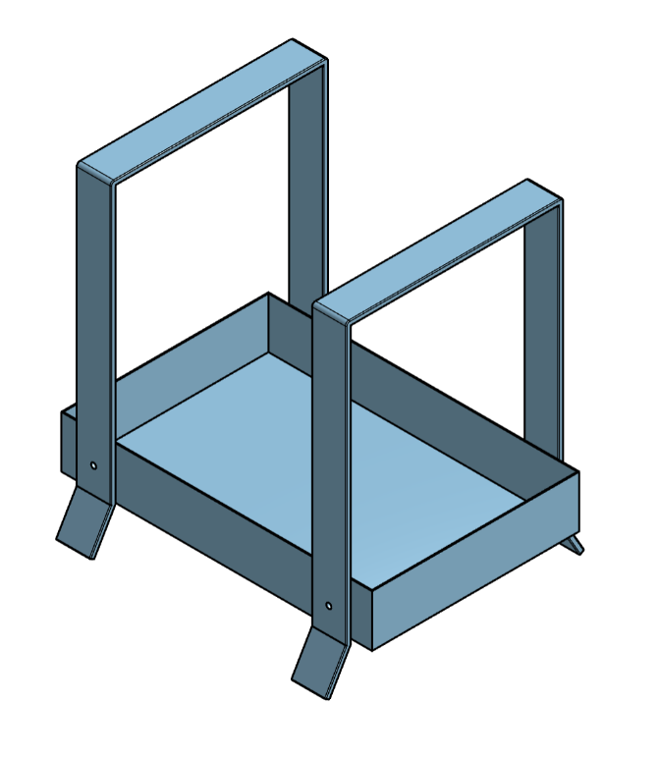

Steps in production
Tray development
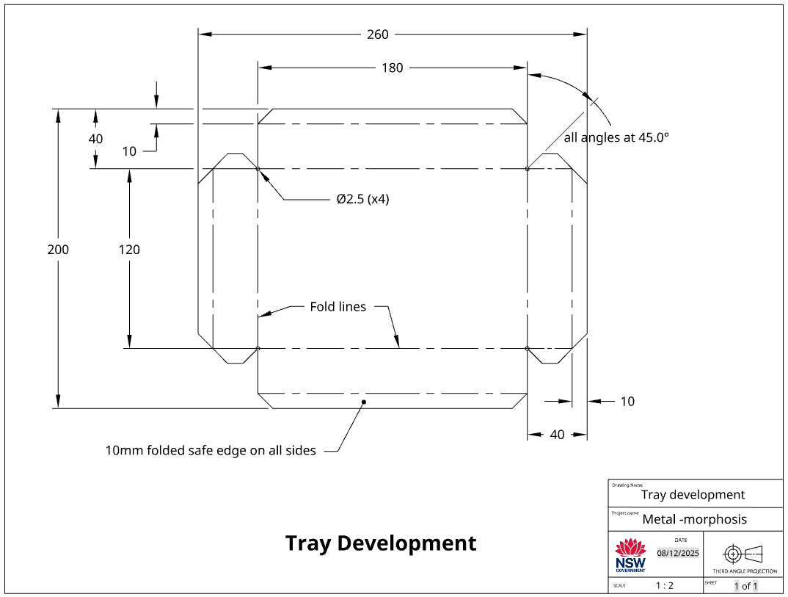
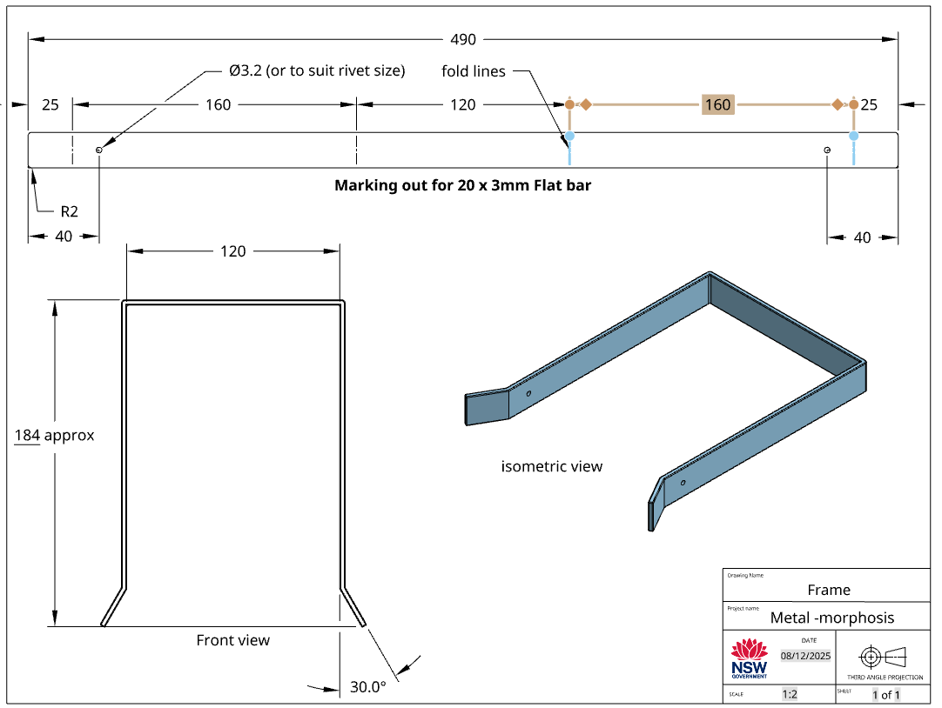

Potential designs
Option 1 | 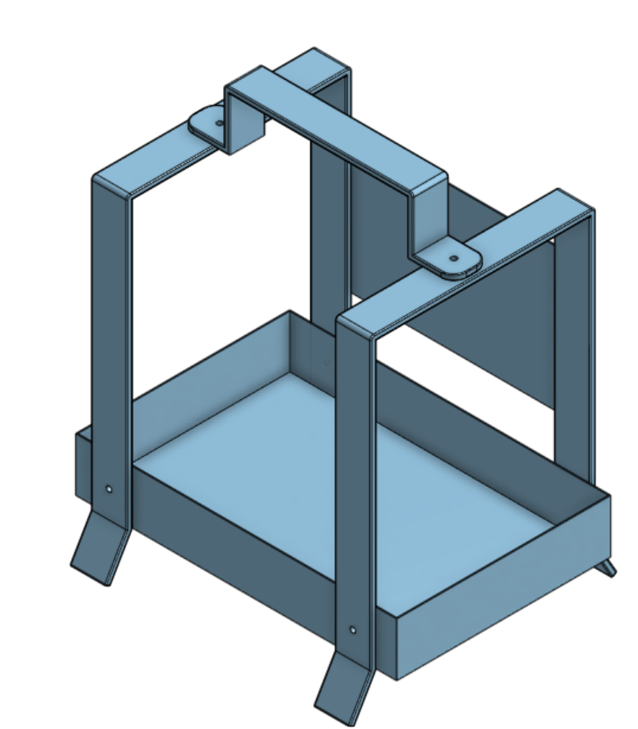 | 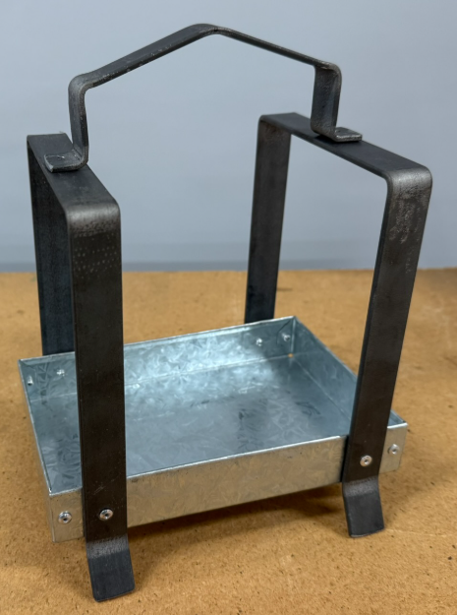
Option 2 | 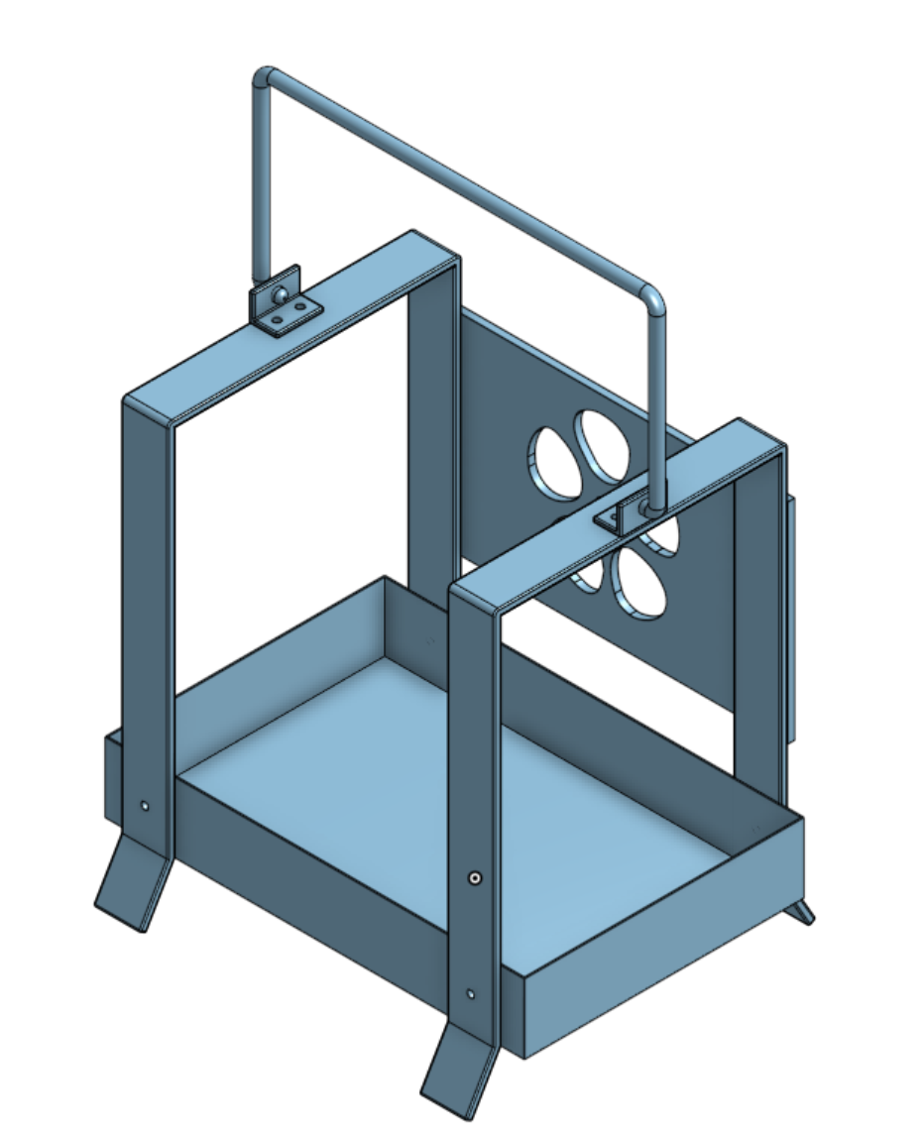 | 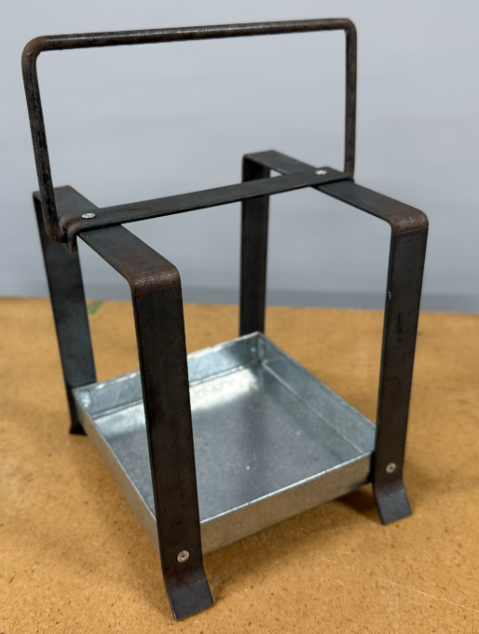
Option 3 | 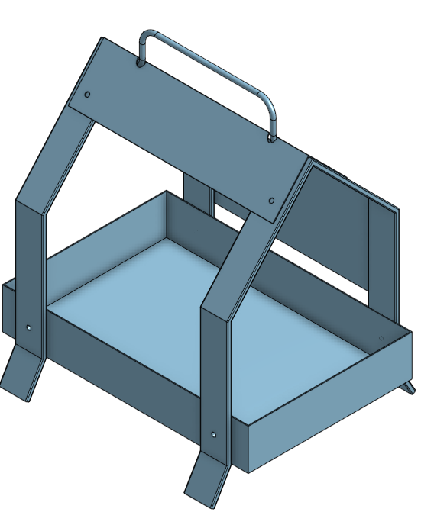 | 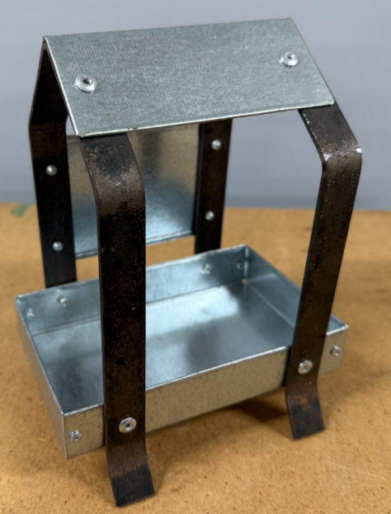

Steps in production

Base – tray
Materials
- Steel sheet, galvanised 0.55mm
Figure 1 – steel sheet
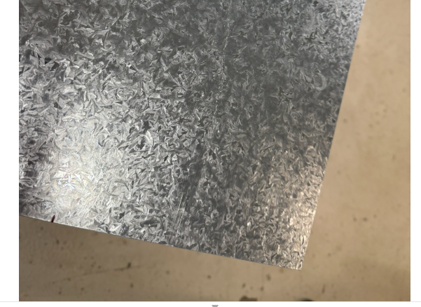
Tools for measuring marking out:
- rule
- engineers square
- rafter square
- combinations square
- scriber
- narrow point permanent marker
Note: the use of black marker in this document is so the lines can be easily seen in the photos. Typically, black markers are not used and the marking out is only completed using a scriber.
Figure 2 – marking out tools
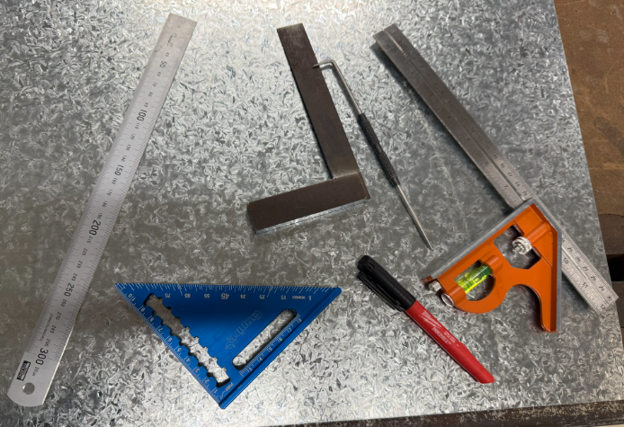
Instruction | Reference image
Have the workshop plans (development – flat plan) available to reference for measuring and marking out to plan. | 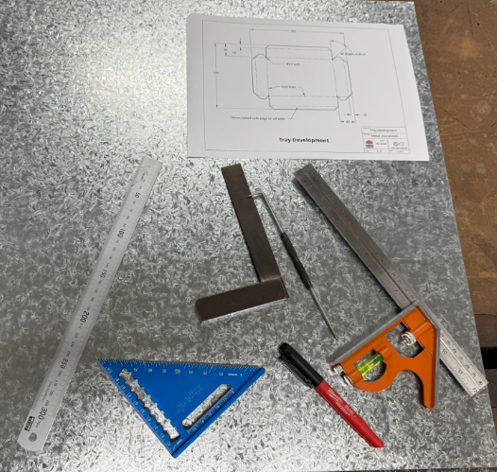
Mark out a reference rectangle using the 2 major dimensions:  260 × 200mm.  The 200mm measurement is being referenced in the photo.  Ensure the correct use of the ruler and engineer’s square or combination square to enable marking out of a true rectangle. | 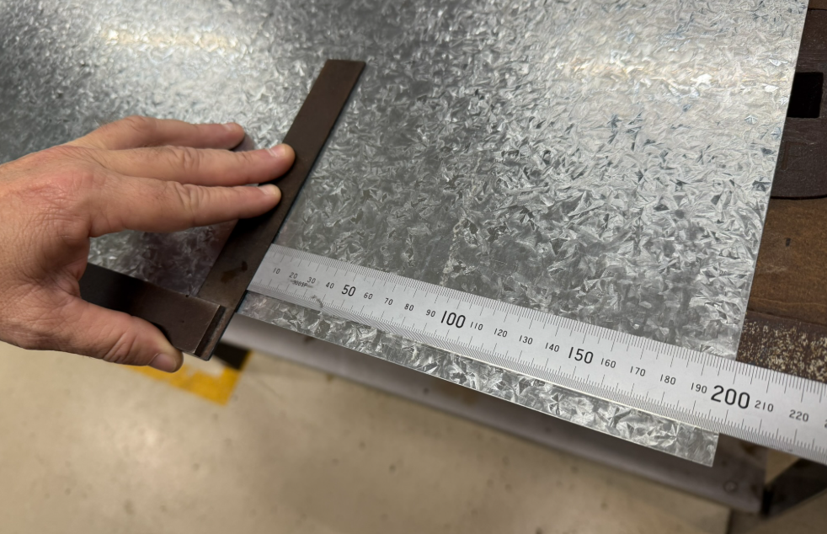
The 260mm measurement is being referenced in the photo. | 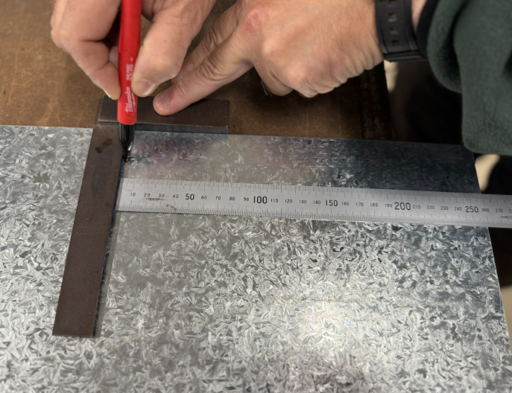
Continue to mark out the 260 × 200 mm rectangle. | 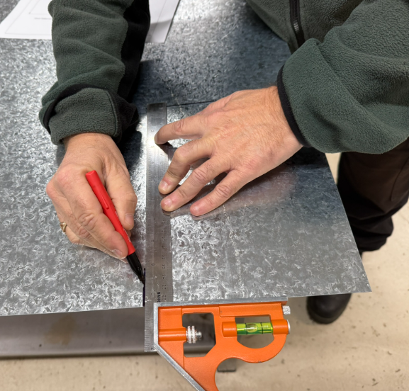
The 260 × 200 mm rectangle marked out using back marker. This is ready for cutting to size using the guillotine. | 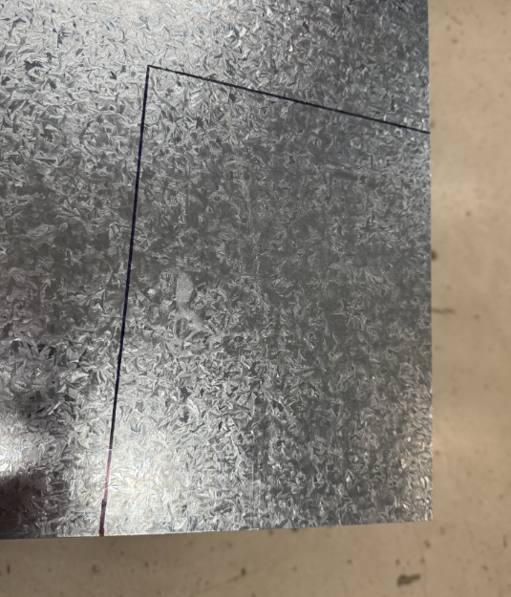
The guillotine and the material ready to be inserted and to be sheared to size. | 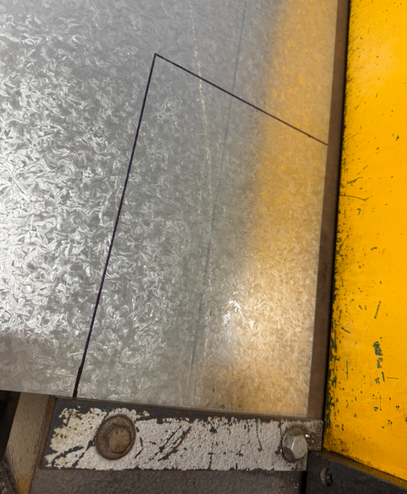

Marking a parallel line to an edge
Instruction | Reference image
Set the combination square to 10mm and hold hard against the edge. | 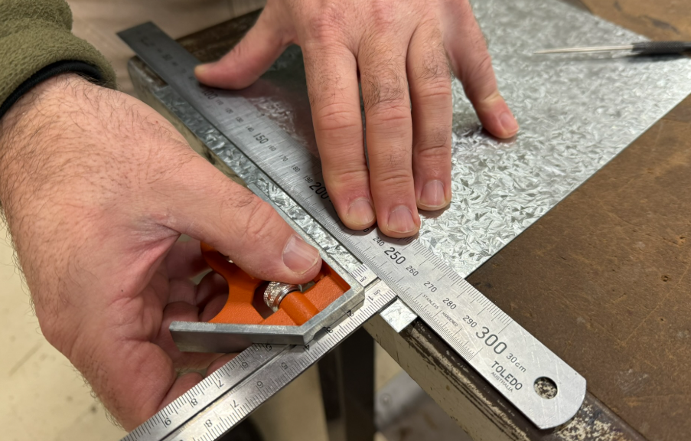
Use the combination square as a marking gauge to accurately ensure that a 10mm (parallel) line can be aligned to the edge. | 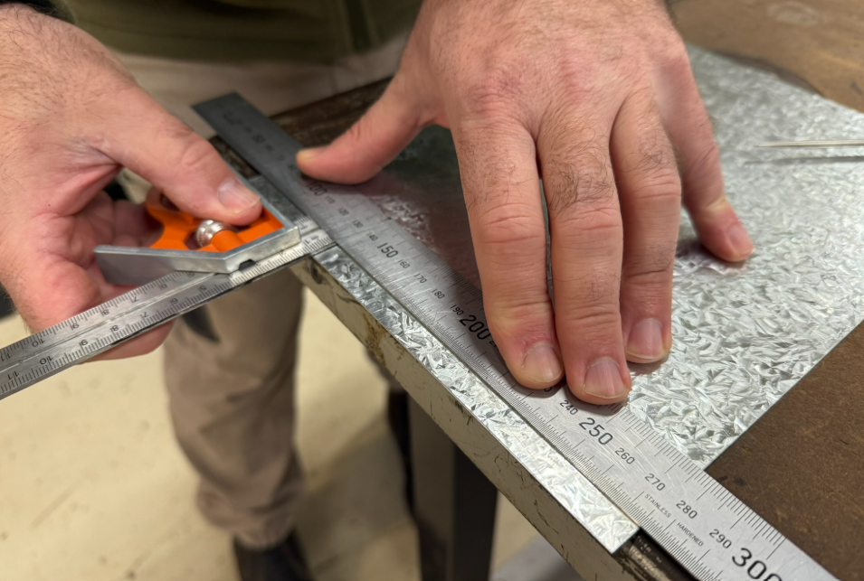
When a 10mm reference has been set, continue to scribe the 10mm line.  The 10mm line will be the reference for the safety edge. | 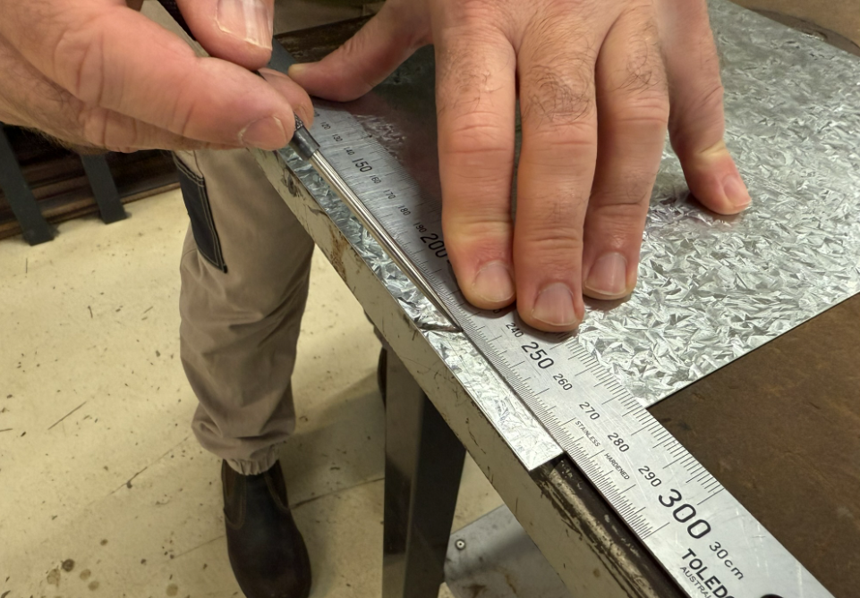
The diagram illustrates a 10mm metal line that has been scribed parallel to the edge. | 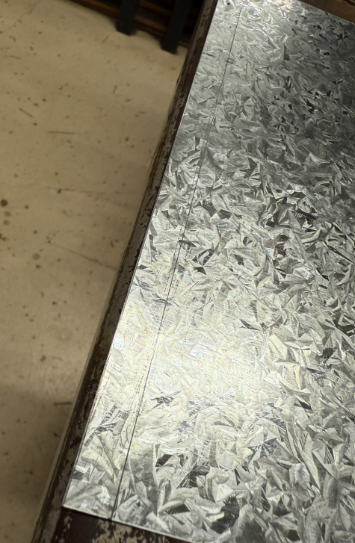
Continue to measure and mark out a 10mm line around the perimeter. | 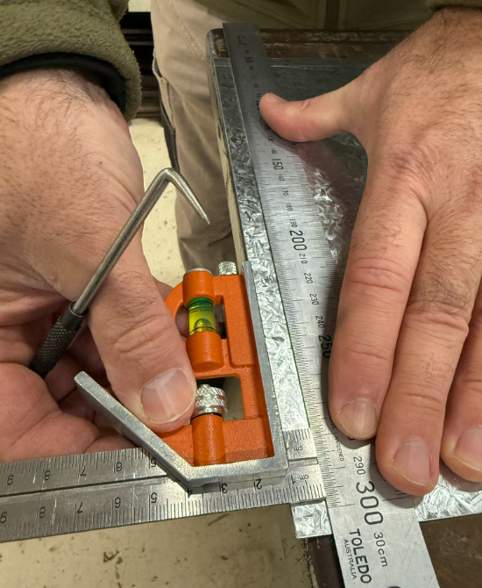
Complete the scribing process. | 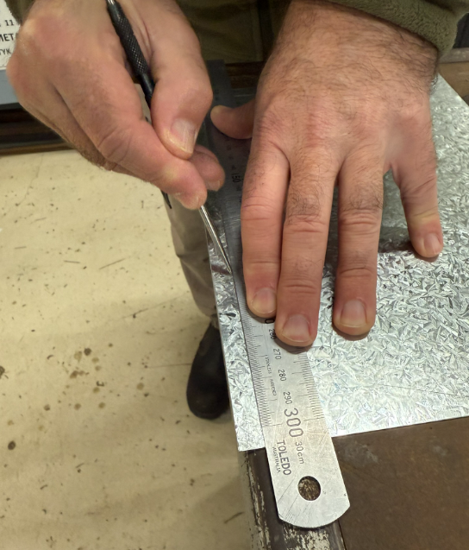
Continue the process with a 40mm line that is scribed around the perimeter.  Use the combination square as a reference to quickly and accurately set this distance from the edge. | 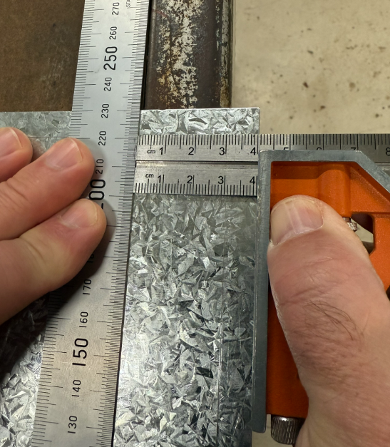
By referencing the edge at each end of the sheet, the combination square ensures the accurate and efficient marking of a parallel line. | 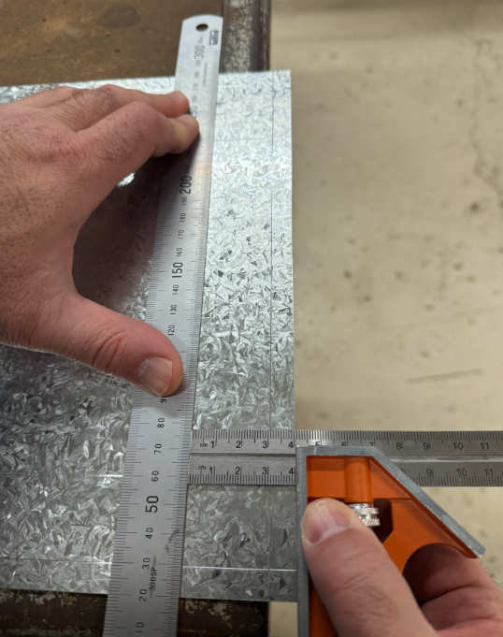
Continue to mark the 40mm line around all 4 edges. | 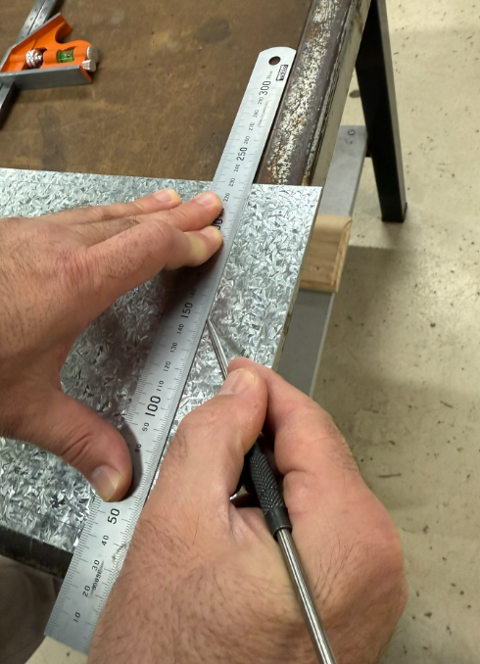
Mark the diagonals. | 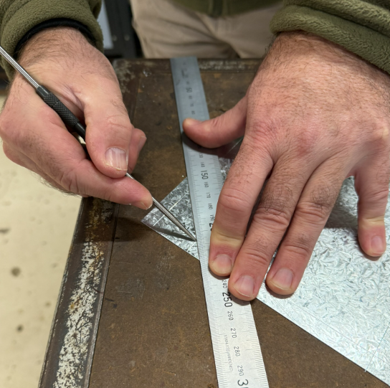
Use the rafter square to establish a 45-degree angle. A combination square may also be used to accurately mark out the 45-degree angles required for the tabs. | 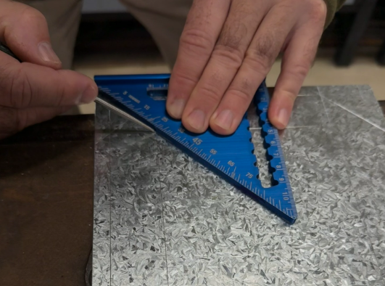
You should now have finished and completed the marking out process. | 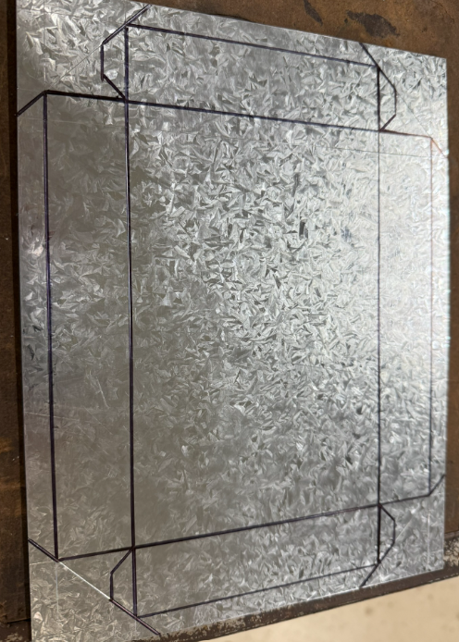

Preparing for relief holes

Centre punching and drilling
Figure 3 – Tools used for centre punching the location of the holes.
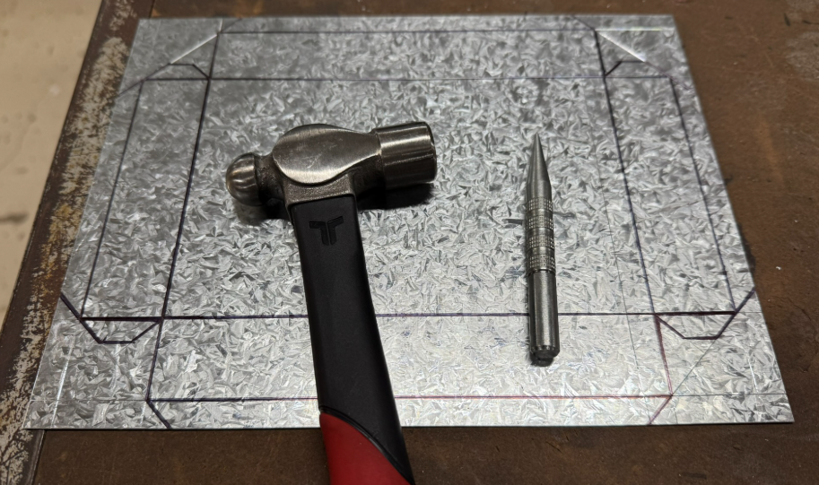
Instruction | Reference image
Lightly tap the centre punch to mark the position of each relief hole.  These marks will guide the cordless drill in the next step, so only a small indentation is needed.  Caution: do not strike the punch too hard as this can deform the sheet metal. Use a gentle, controlled tap. | 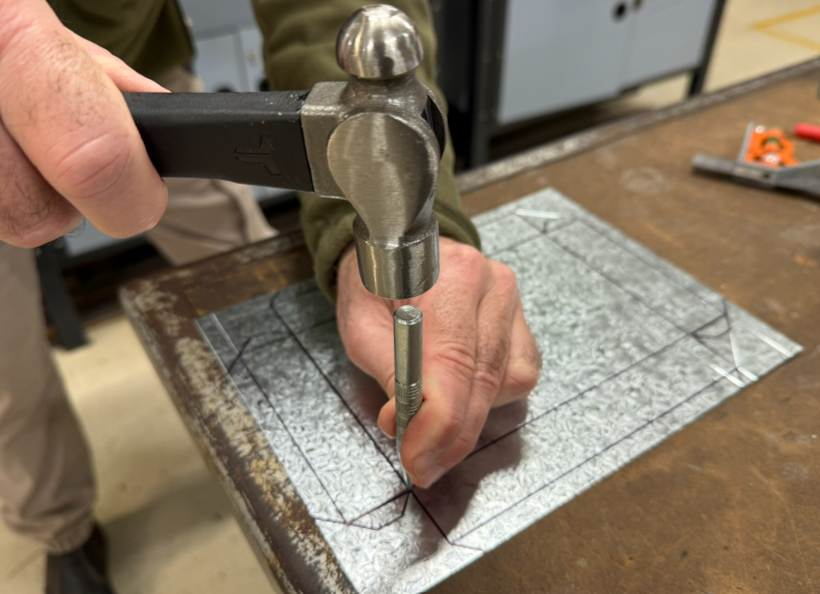
Use a battery-powered (cordless) drill to drill each relief hole. Avoid using a drill press for this task. A battery-powered drill allows the work to be completed more efficiently and with less risk.  Select a 3.2mm drill bit, ensuring it is sharp and securely tightened in the chuck.  Place a piece of soft scrap material, such as timber or plywood, underneath the sheet metal. This will protect the workbench surface and prevent burrs on the underside of the hole.  Maintain a steady grip on the drill, apply light pressure and allow the drill bit to cut at its own pace. | 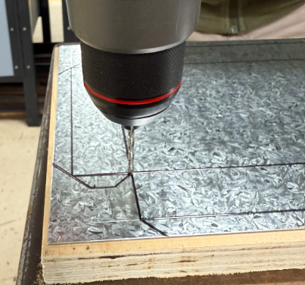
This completes the relief holes. | 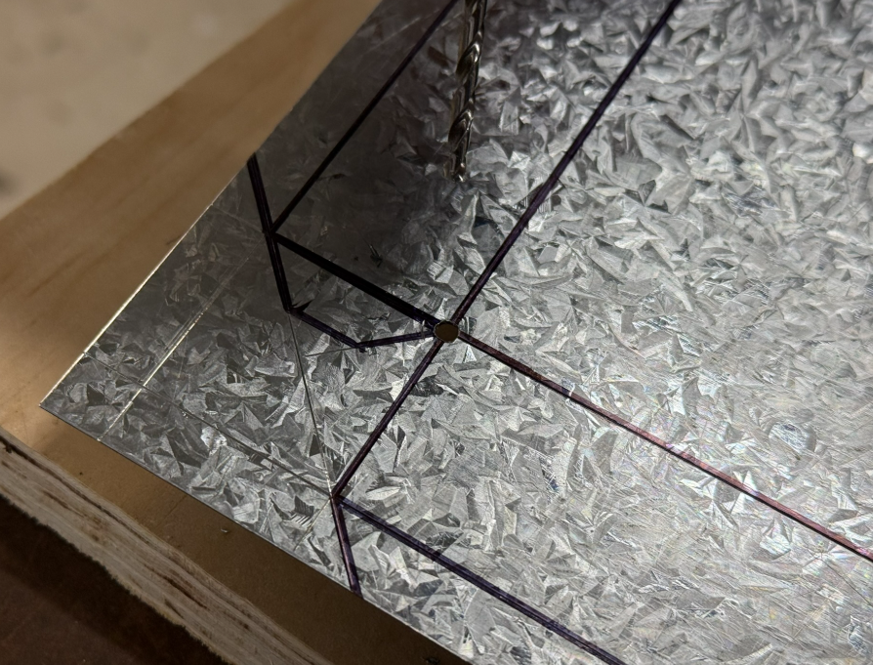
Use the guillotine to shear away the first set of 45-degree waste pieces.  Cut accurately along the marked line to remove the waste material.  Check that the cut follows the line closely to maintain accuracy for the next stage of fabrication. | 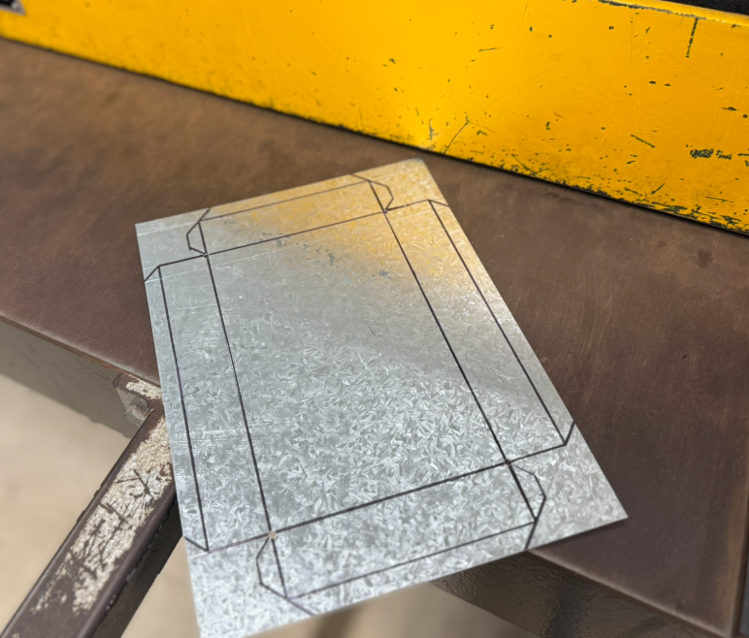
Align the material in the guillotine. | 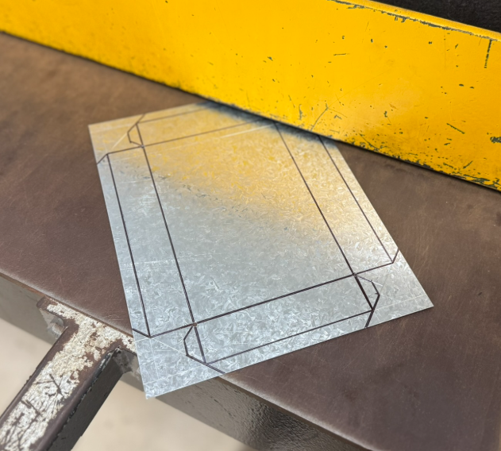
Sight the line on the cutting edge of the guillotine. | 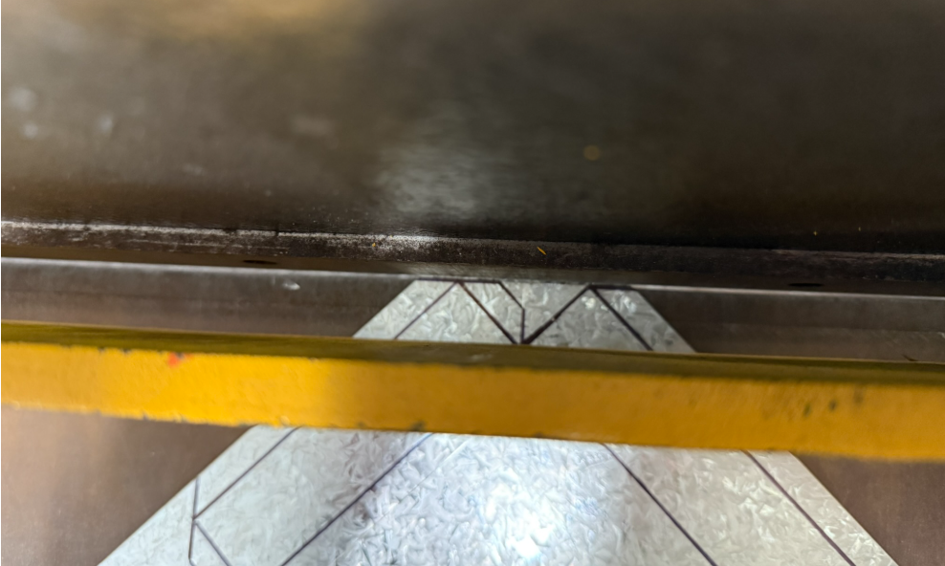
Make the first cut. | 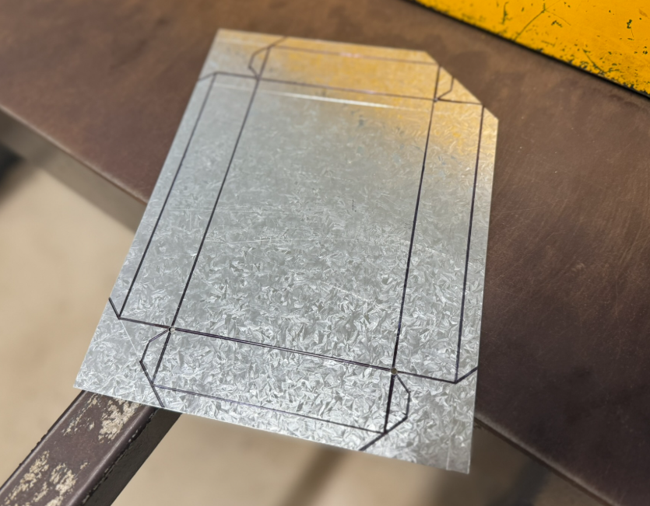
Repeat this process for all 4 edges. | 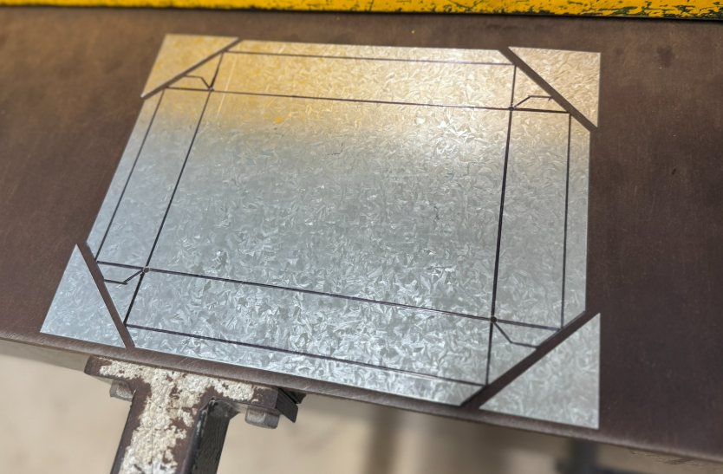
Remove the remaining waste material.  Tools required: tin snips or aviation snips.  Carefully cut along the marked line to remove the remaining waste material.  Keep the snips aligned with the line to ensure accuracy and a clean edge.  Note: be careful not to cut past the line and remove the tab. | 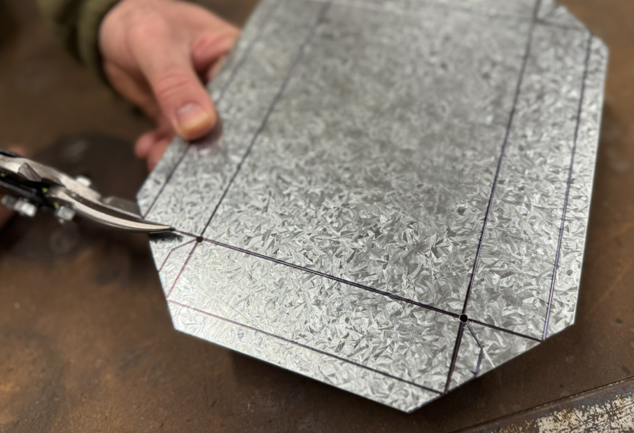  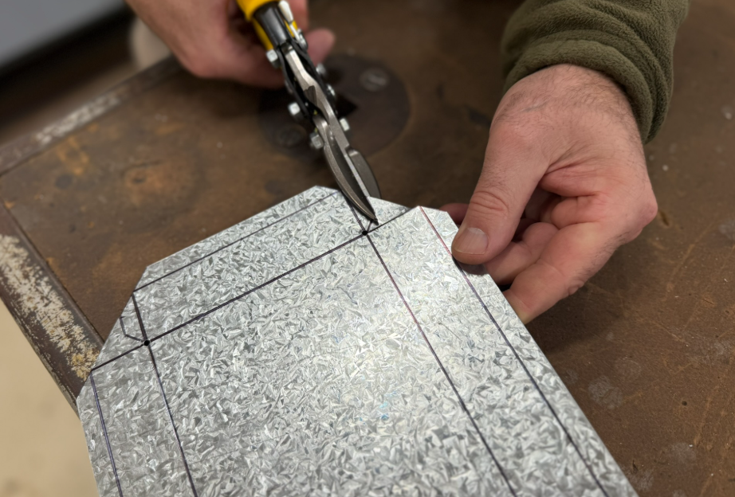
Continue the process for all 4 corners. | 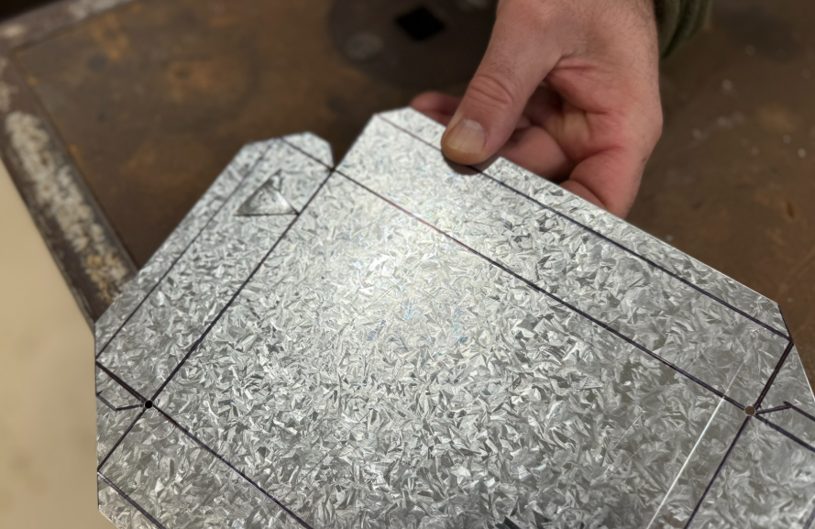  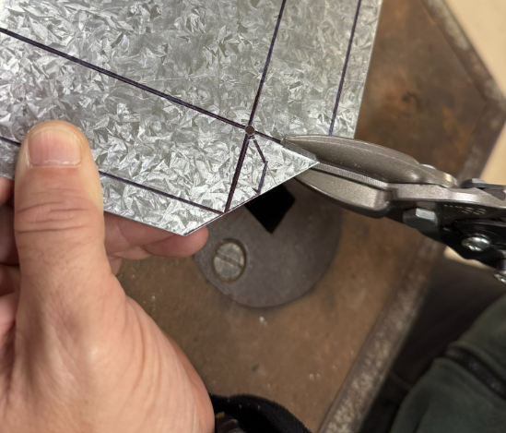  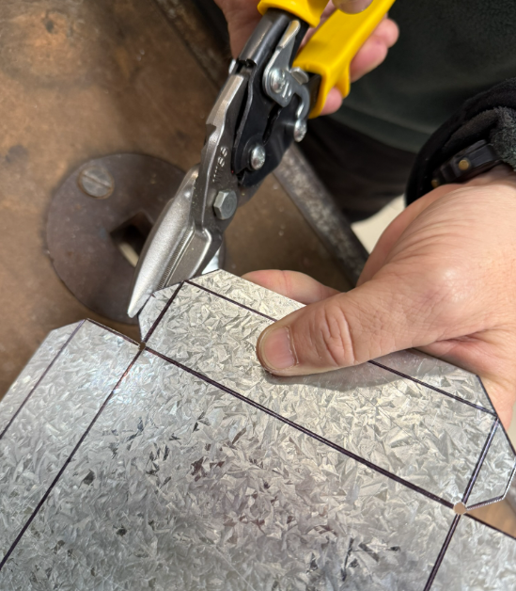
You should have a completed sheet metal shape.  This shape should match the plans. | 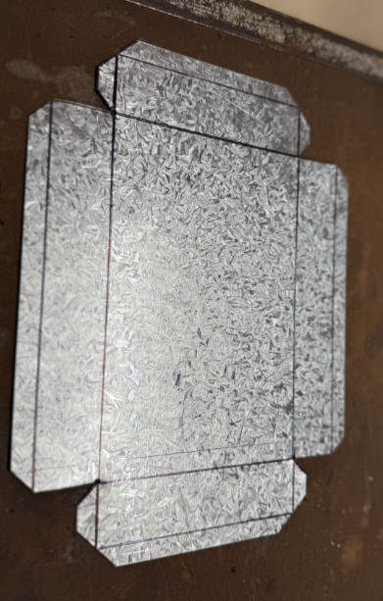

Folding the flat development into a tray
Machine required: pan brake (folding machine).
Figure 4 – using a pan brake
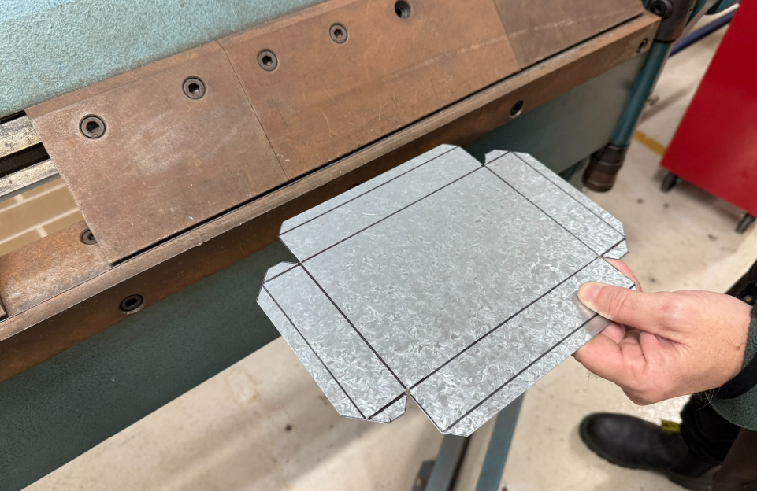
Instruction | Reference image
Begin by folding the safety edges.  Use the 10mm parallel line as the reference point to ensure accuracy in the folding process. | 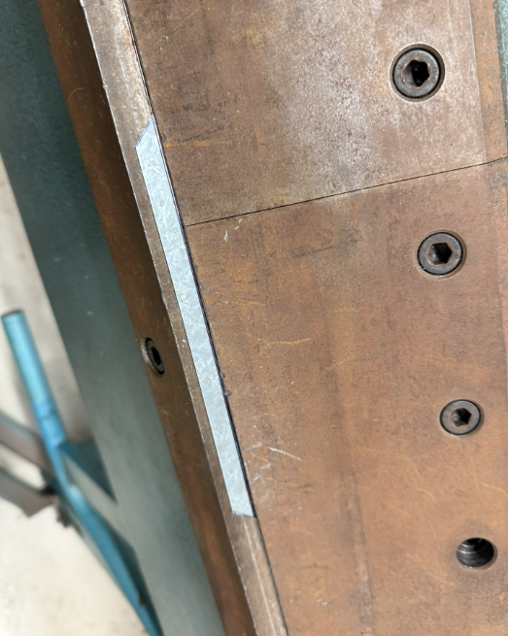
The competed fold. | 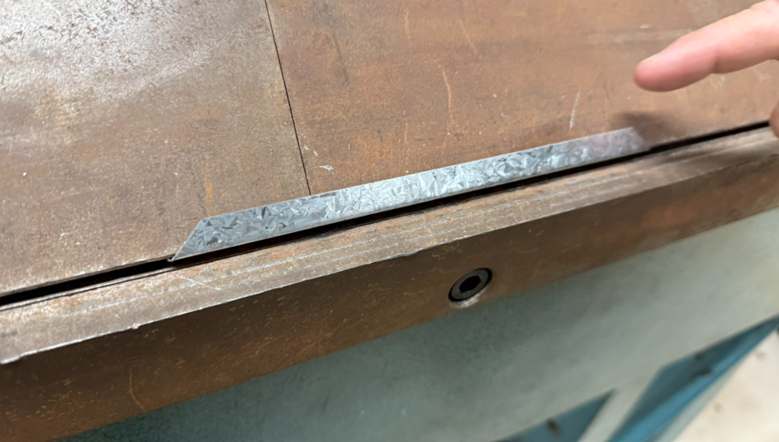
The competed fold partially removed to show the limit for the fold. | 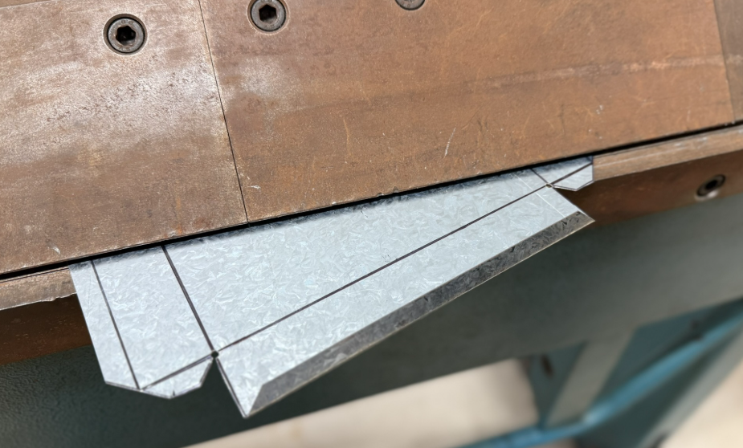
Note: a Magnetic (Magna) Bender is an alternative folding or bending machine that can also be used. | 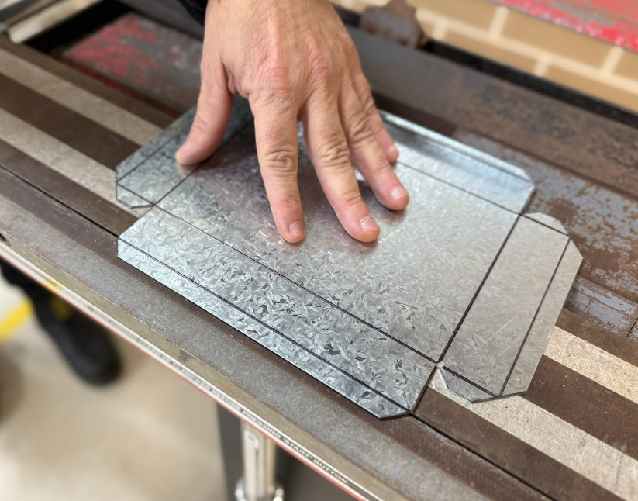
Position the magnets along the 10mm edge then engage the magnetic clamp following the safe operating procedure to complete the bend.  Align the magnets on the 10mm edge and use the magnetic clamp, as per the safe operating procedure, to perform the bend.  Place the magnets on the 10mm edge and activate the magnetic clamp safely to finish the bend. | 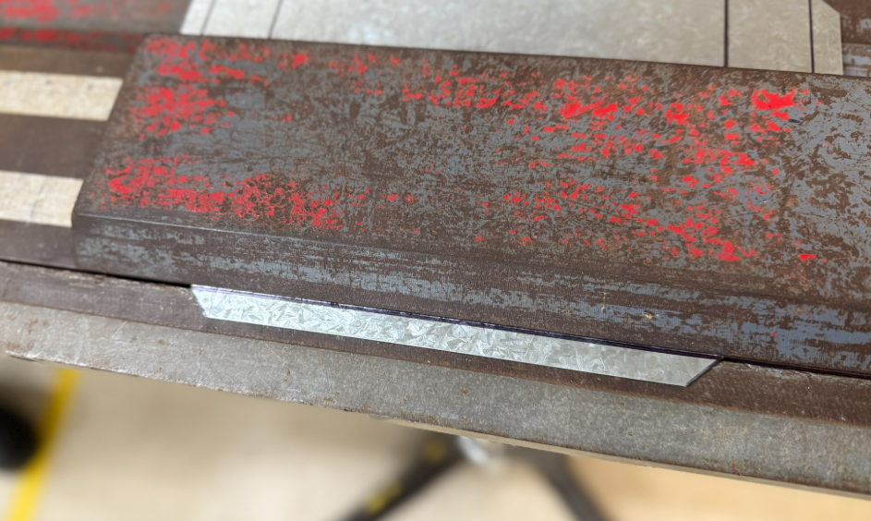
Raise the handle. | 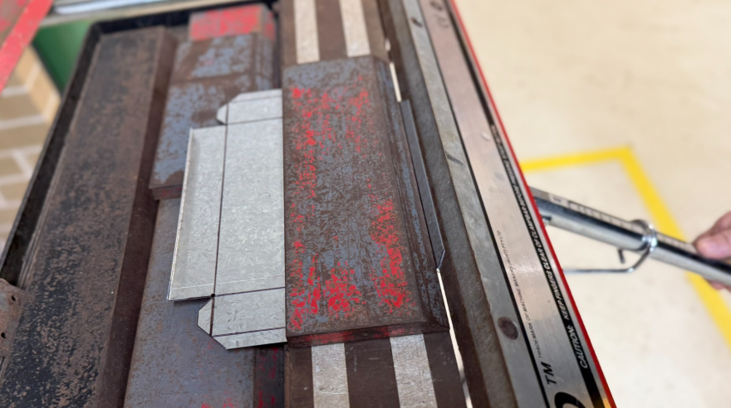
The competed fold. | 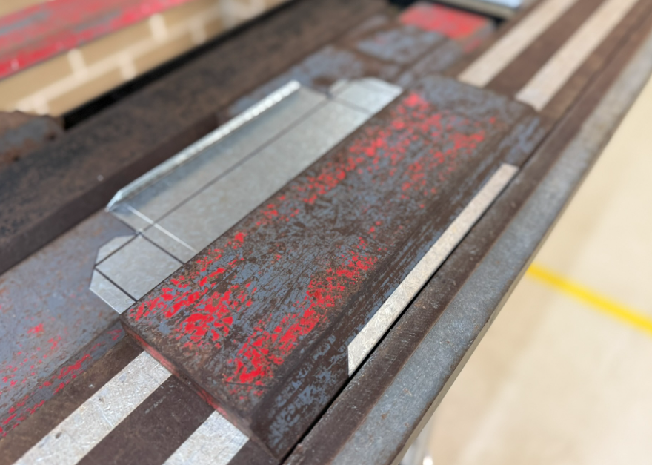
The competed fold with the magnets removed for reference to the folding limits. | 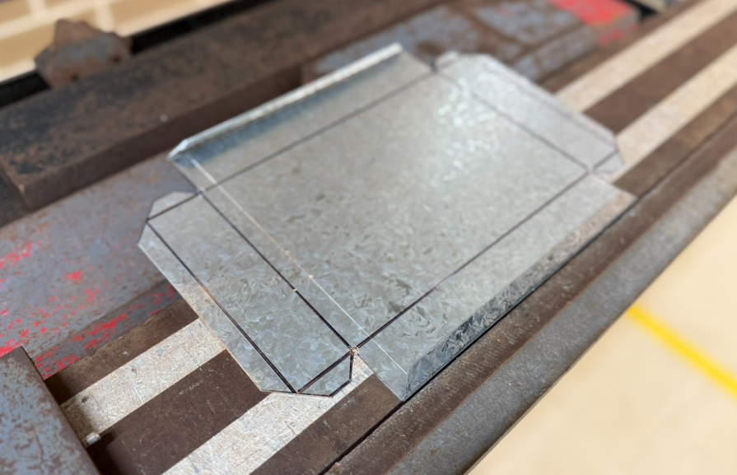
Folding the ends using the pan brake. | 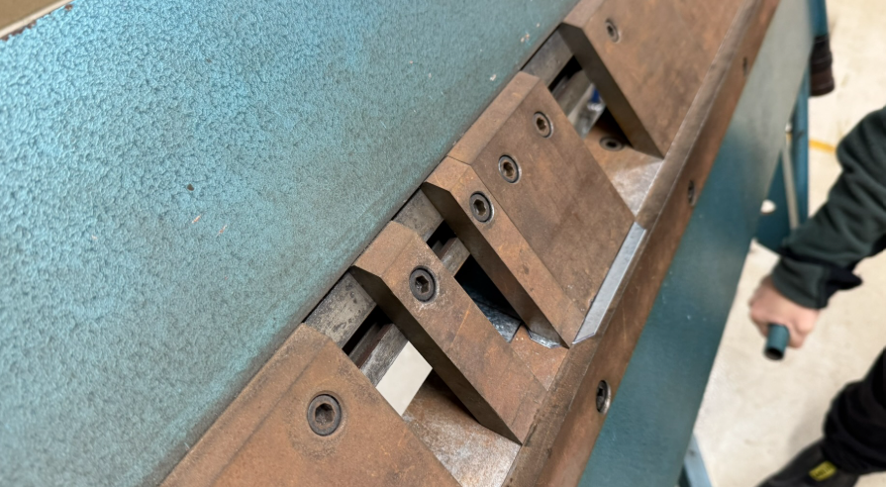
Folding the ends using the magnetic folder. | 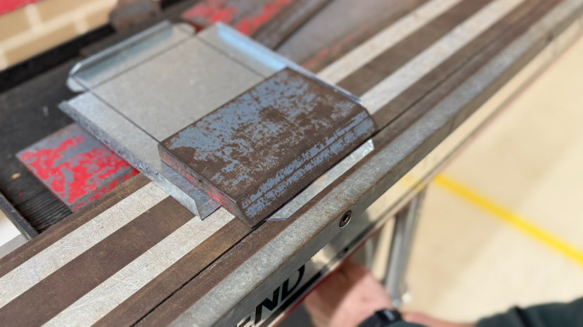
Beating the safety edges into final shape.  Tool used: tinman’s mallet. | 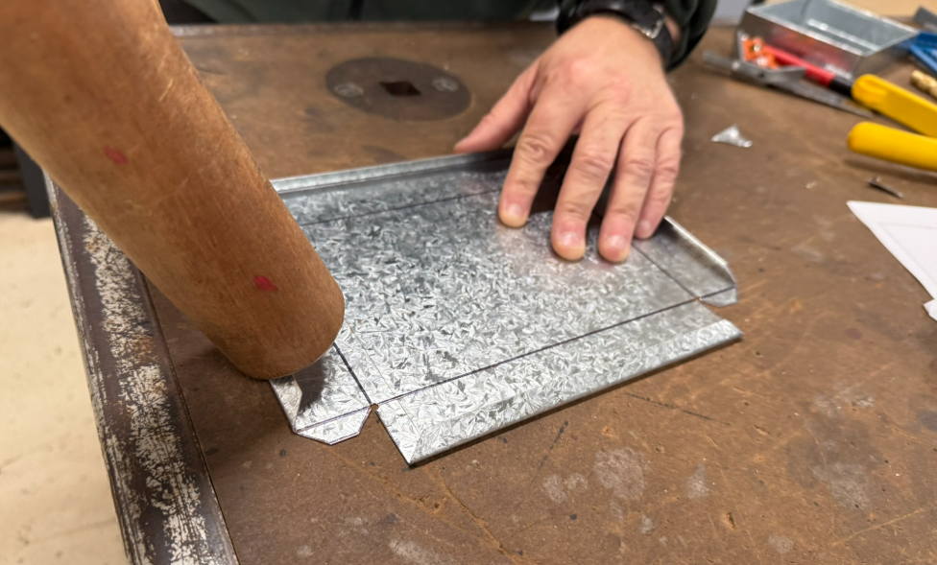
Beating the safety edges into final shape.  Alternative tool: ball pein hammer. | 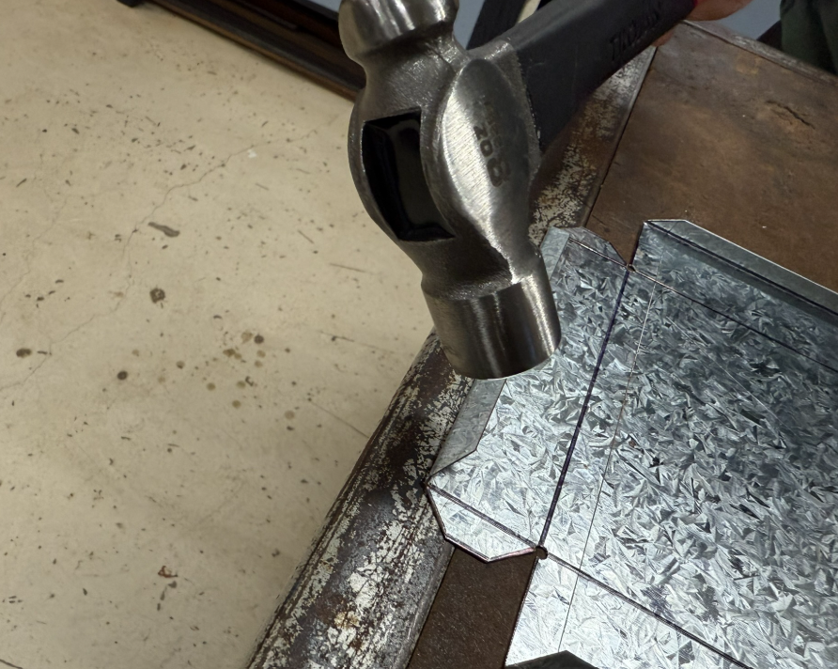
Complete the safety edge leaving a small ‘tube’ visible.  Note: use the edge of the tinman’s mallet and/or ball pein hammer when completing the fold. | 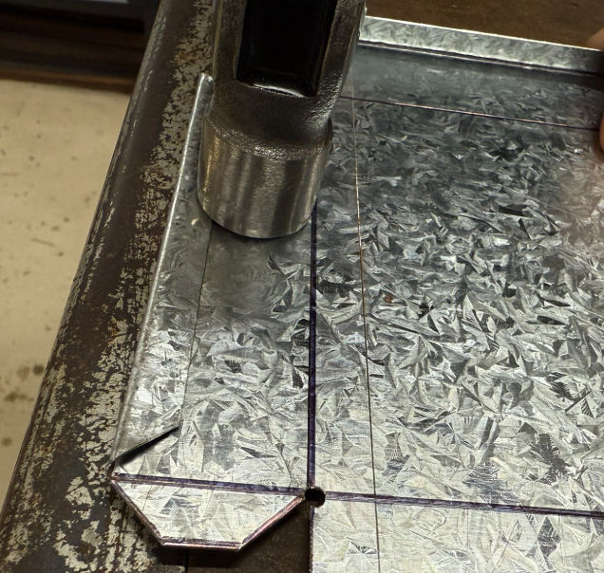  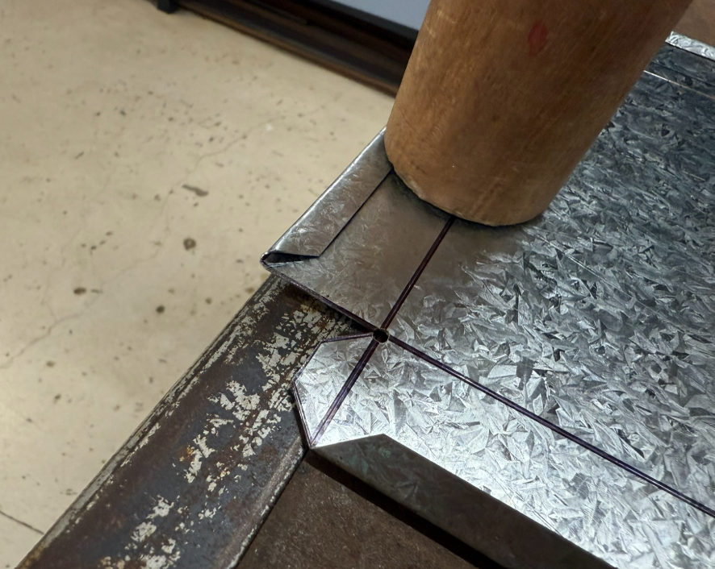
Using the magna bender to complete and form the safety edge.  Note: the magnets are not placed on the edge, rather stepped back approximately 3 to 4 mm from the round edge preserving the round form. | 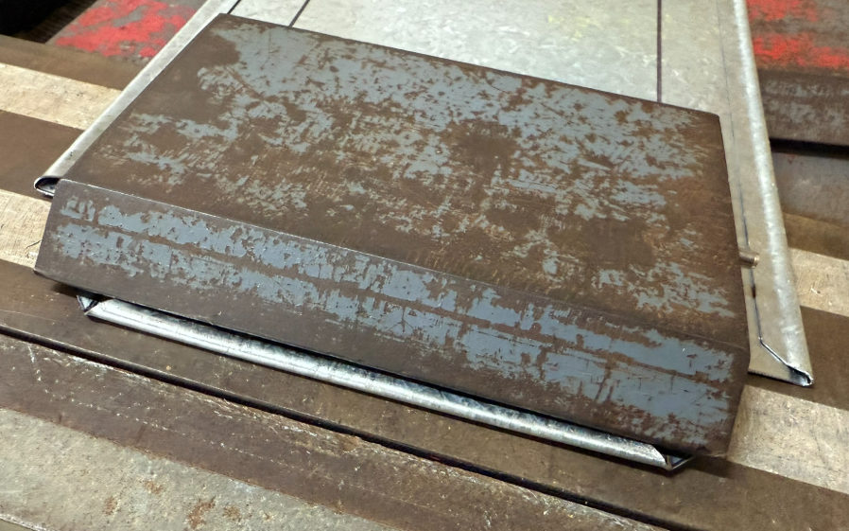
The safety edges are prepared and ready for the flat development to be folded into a ‘box’ tray. | 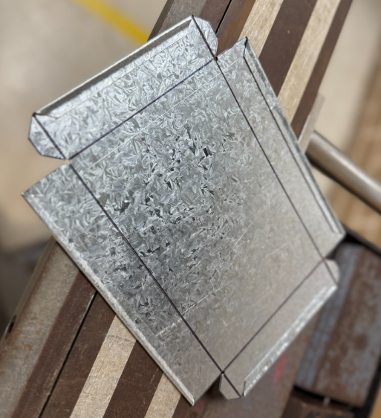

Folding into a box
Note: the tabs and the ‘long edge’ are folded first.
Figure 5 – folding the edges
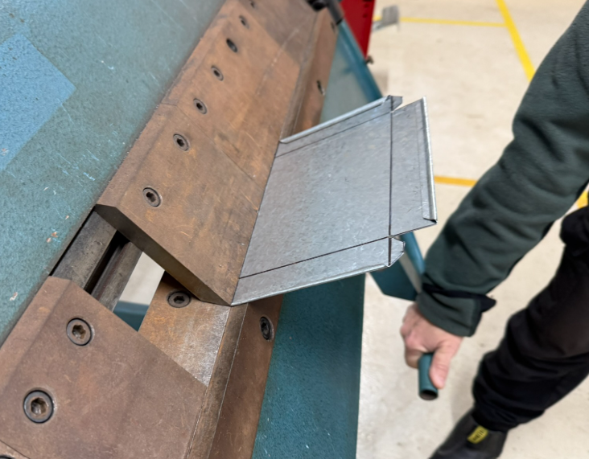
Instruction | Reference image
Bend and stop at 95 degrees. The spring in the sheet steel will ‘bounce’ the sheet into a nice 90-degree bend. | 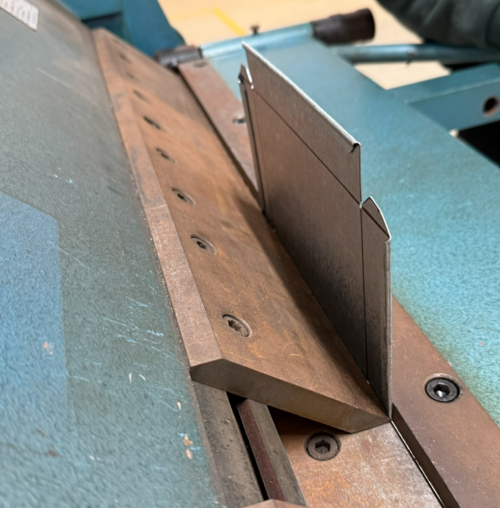
Check that the bend is at 90 degrees using an engineer’s square. | 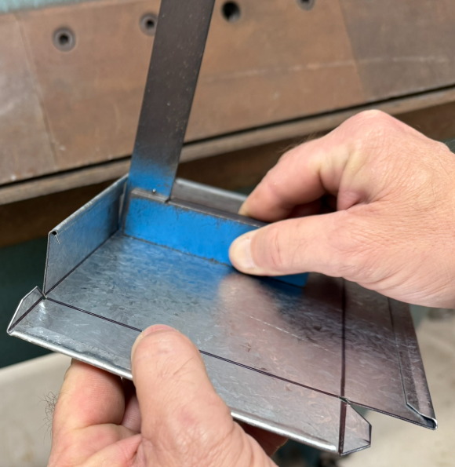
Alternative method using the magna bender. | 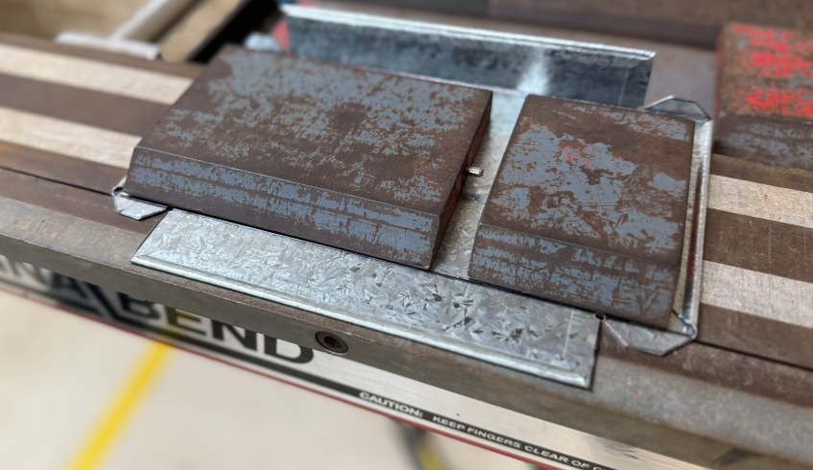
Fold both sides to 90 degrees, allowing for the spring in the sheet steel. | 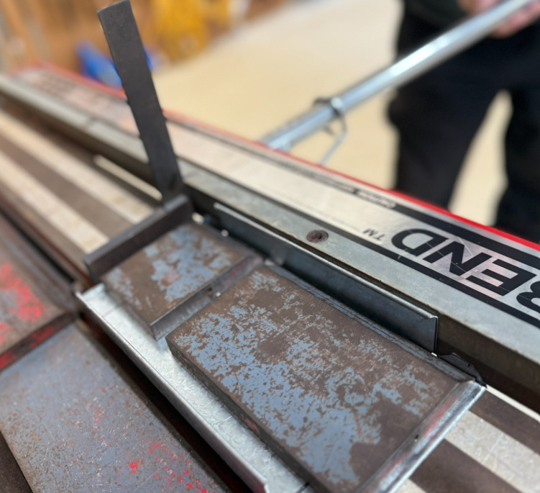
Using pliers, bend the tabs in slightly to allow them to fold ‘inside the box’ for the next step. | 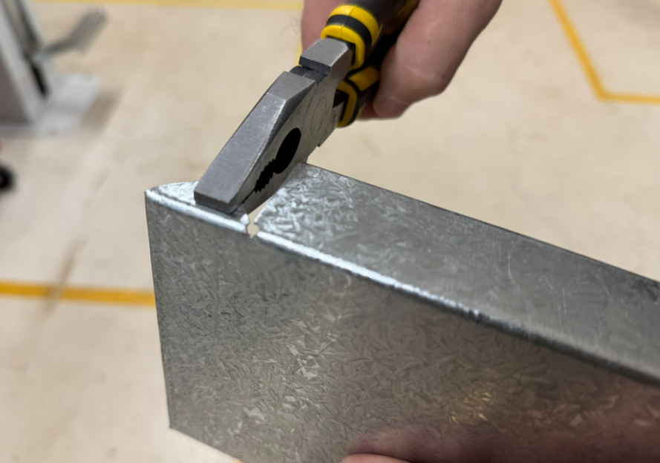
Use the pan brake to fold the end into position. | 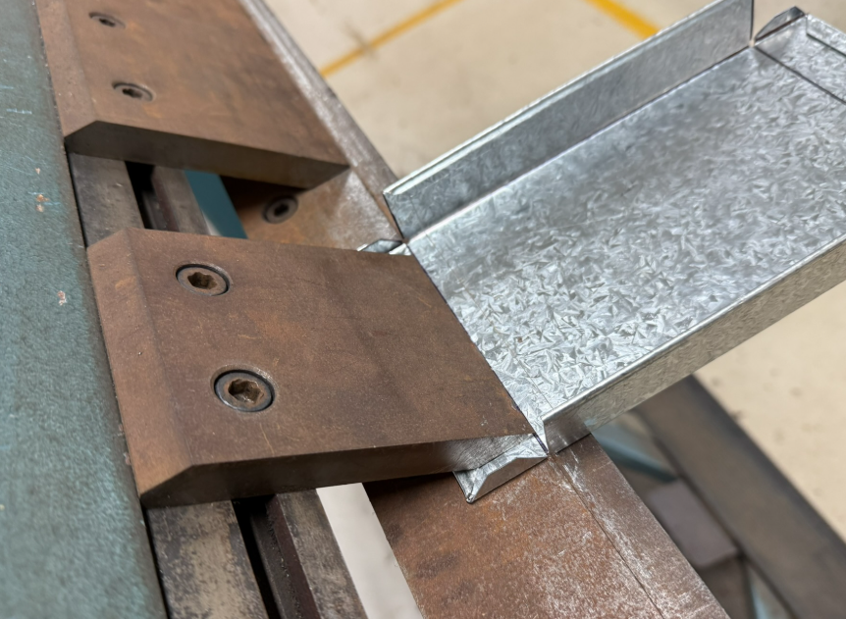
Stop at 90 degrees.  Caution: do not overbend past 90 degrees as the sides will crimp and deform. | 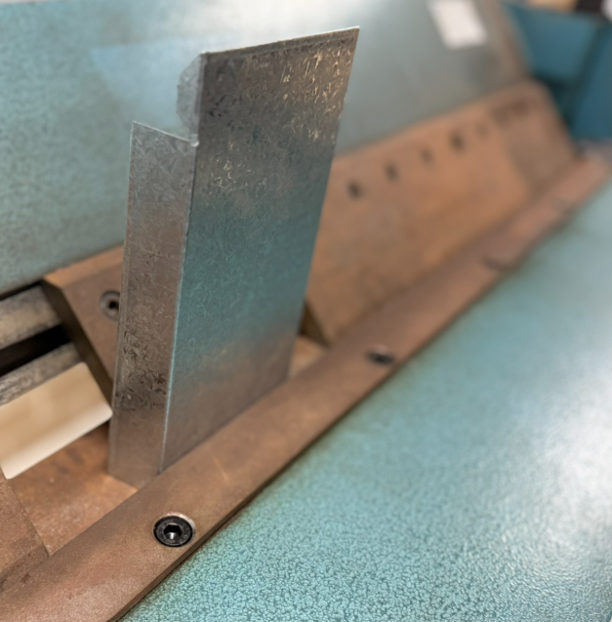
Alternative method using the magna bender. | 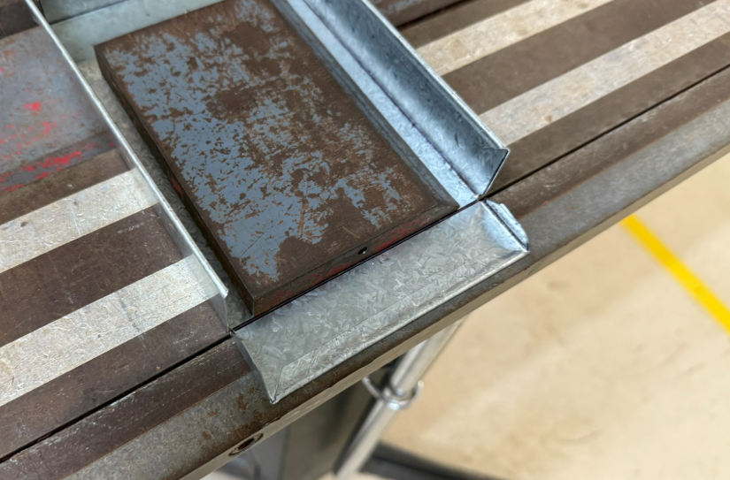
Note the tabs sliding nicely to the inside of the box/tray. | 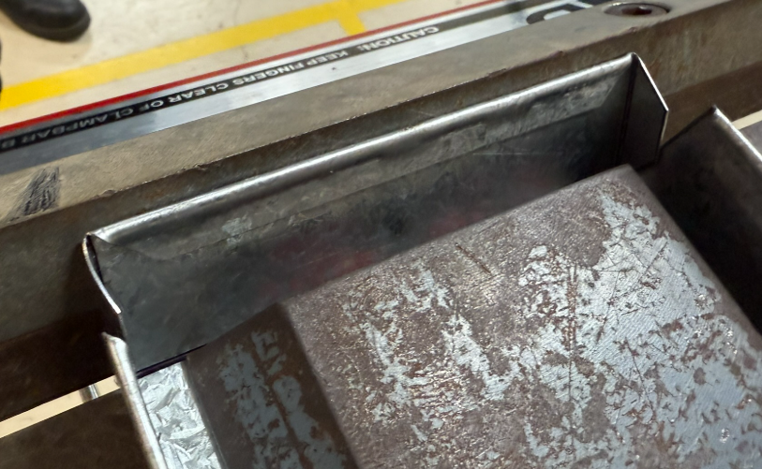
The folded tray. | 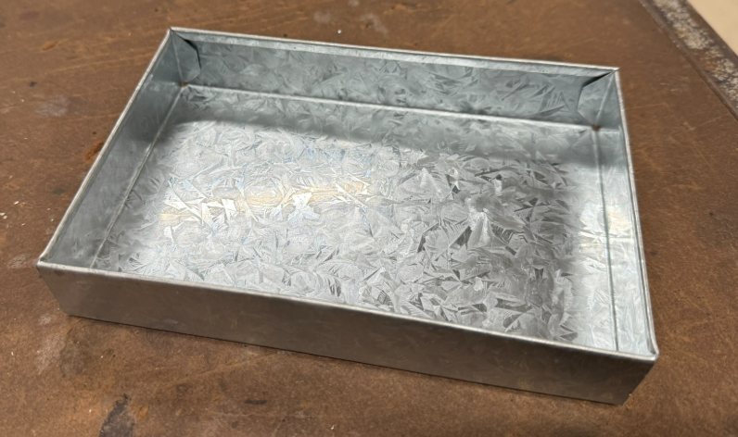
Note: the corners meet and the safety edges have clearance for the sides to connect at the top. | 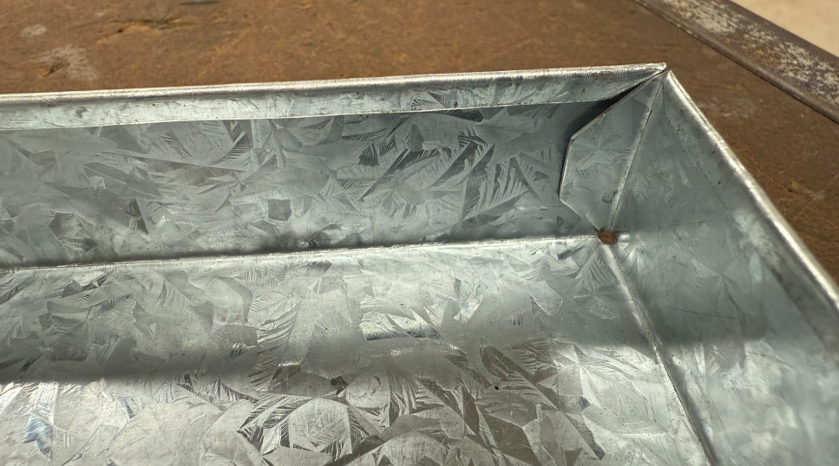
Marking out for riveting
Tools:
- dividers
- rulers
- combination square
Figure 6 – completed corner detail
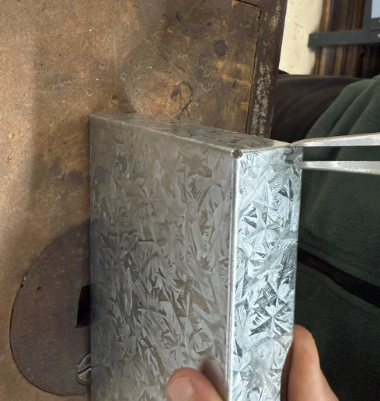
Instruction | Reference image
Using a black marker, locate the centre point of the box and then locate the midpoint of the tab (not seen in the photo). | 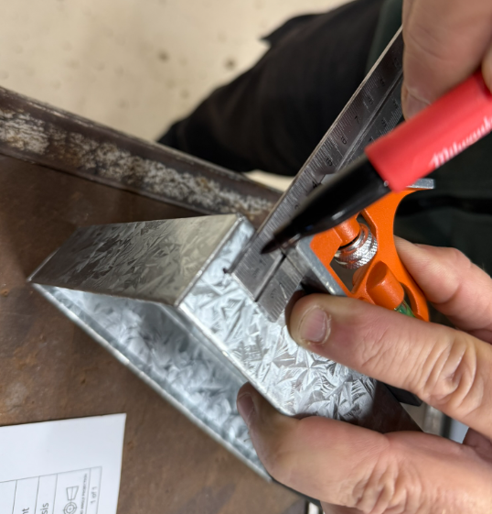
Prepare for drilling.  Use a piece of square hollow section as a guide and sacrificial support to drill for the rivets. | 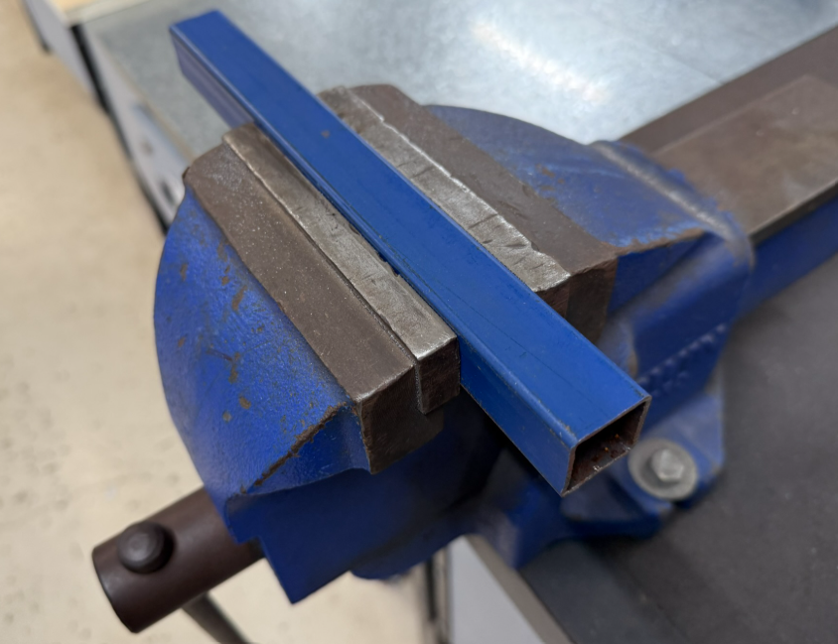
Use a clamp to hold in position.  This method prevents the tray from moving whilst centre punching and drilling. An accurate and steady work area has now been created. | 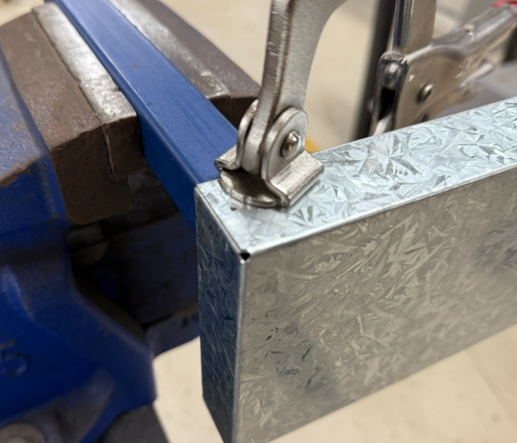
Centre punch lightly on the mark. | 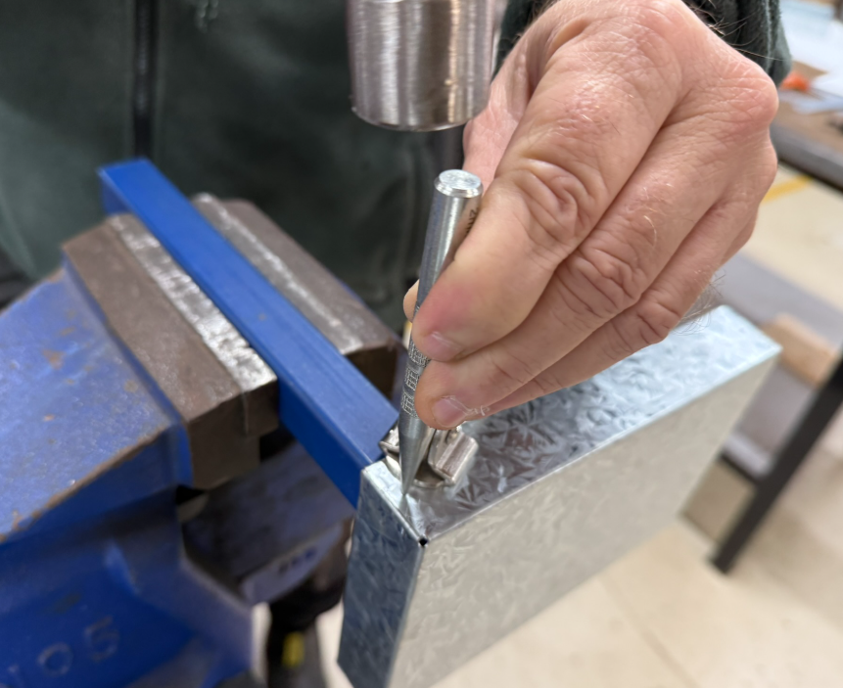
Drill using a 3.2mm drill.  Use the battery drill for ease of access and safety. | 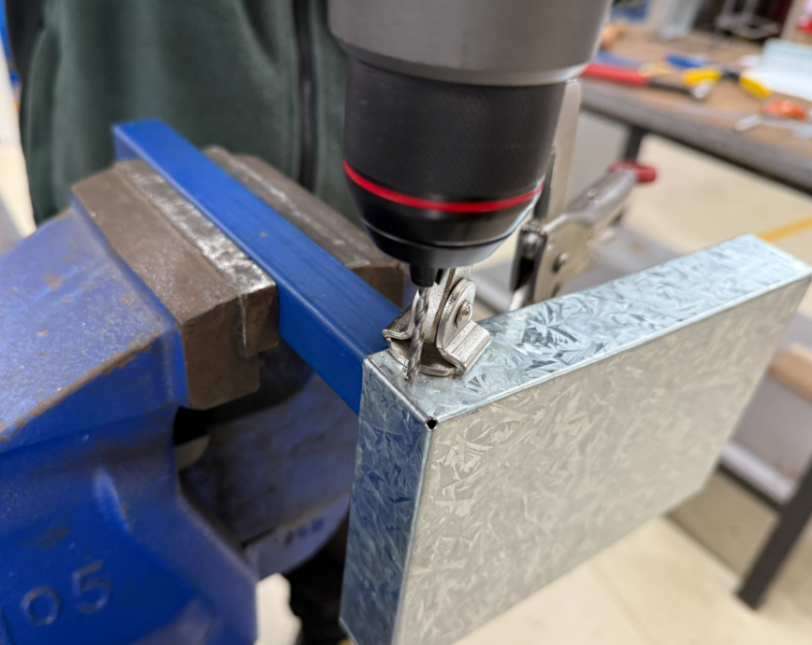

Joining sheet metal

The pop riveting process.
Tools:
- pop rivet gun
- pop rivets
Figure 7 – pop rivets and a pop rivet gun
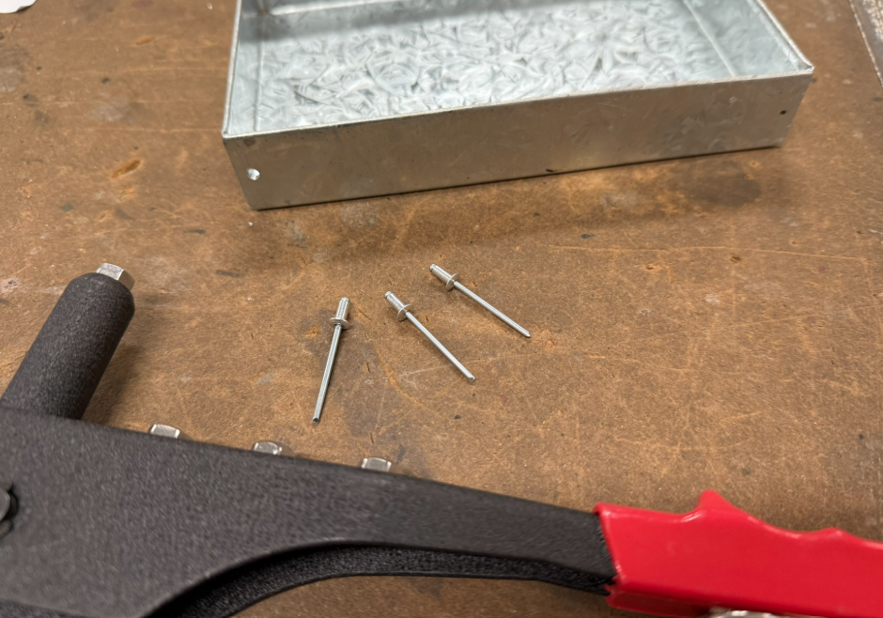
Figure 8 – inserted pop rivet
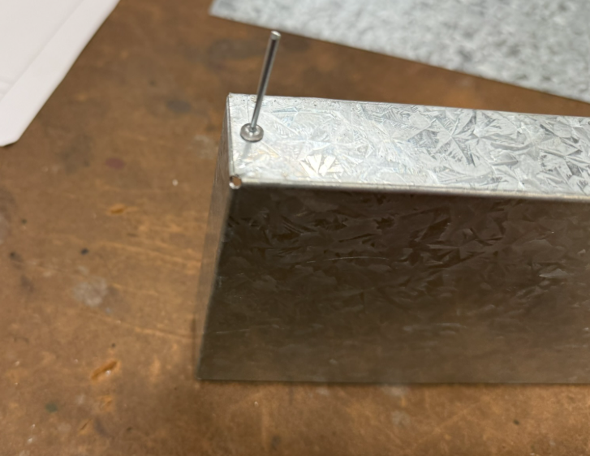
Instruction | Reference image
Use the pop rivet gun to complete the join. | 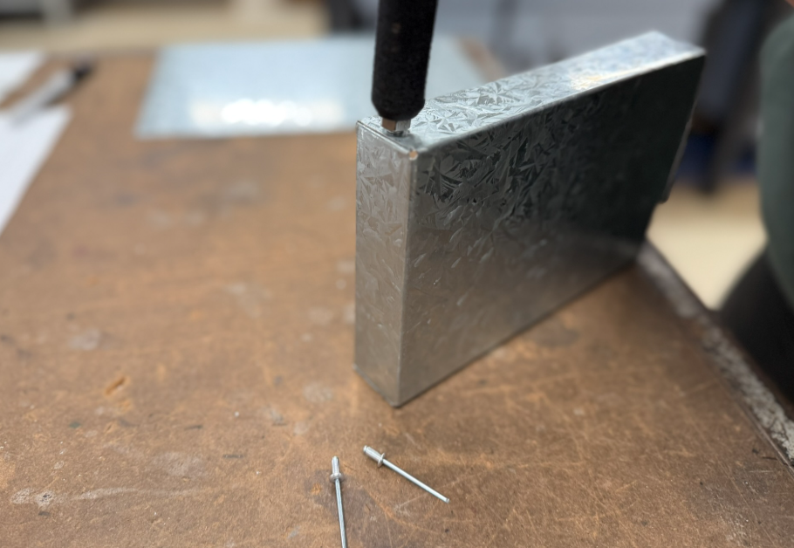
You should have an installed pop rivet.  This method is secure and strong. | 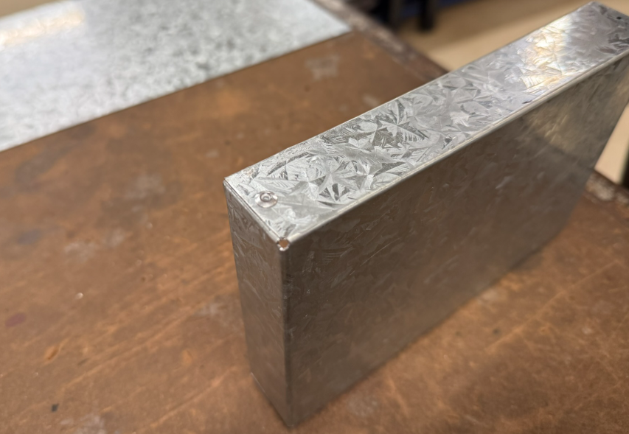
All 4 corners are now pop rivetted.  The tray should sit flat on the bench.  Quality test – Does the tray rock or sit flat? | 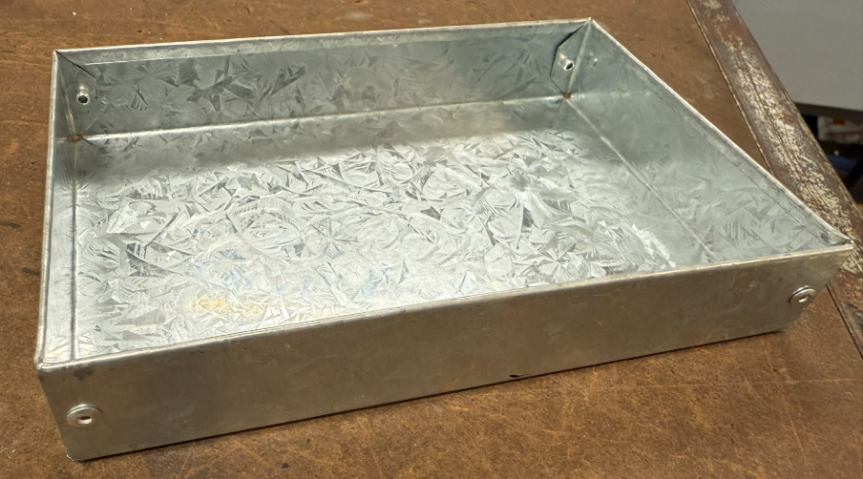

The frame
Material: 20 × 3 mm mild steel.
Figure 9 – metal frame dimensions
Figure 10 – folded metal frame
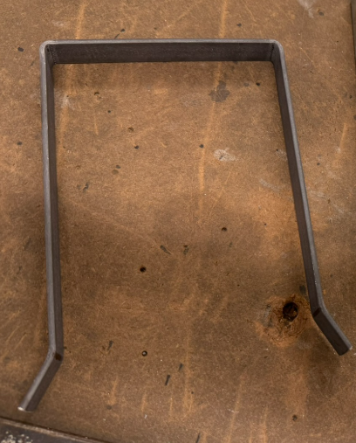
This is what the complete shape will look like prior to installation.
Two of these are required.

The measuring and marking out process
Instruction | Reference image
Measure and mark to a distance of 490mm from the end. | 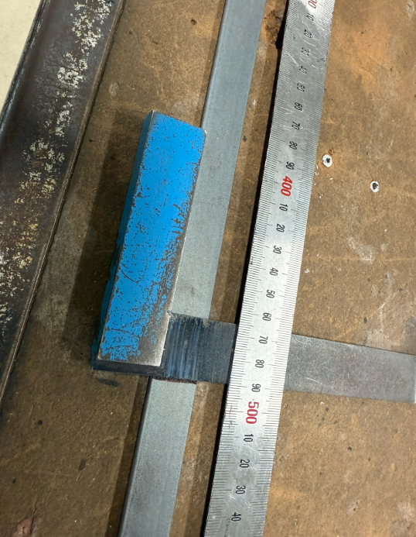
Hacksaw to the line. | 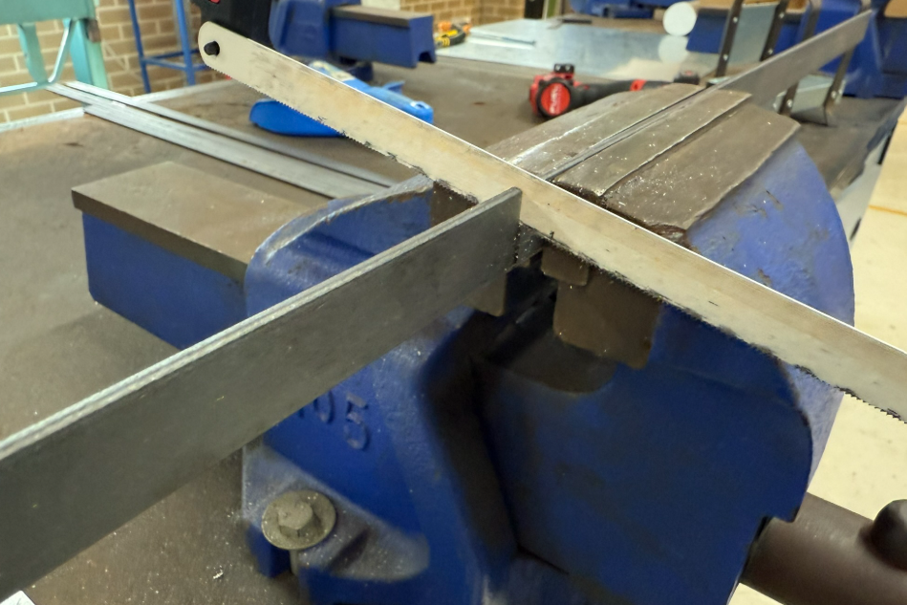
File the ends square and remove the sharp edge. It may be slightly rounded for an improved appearance. | 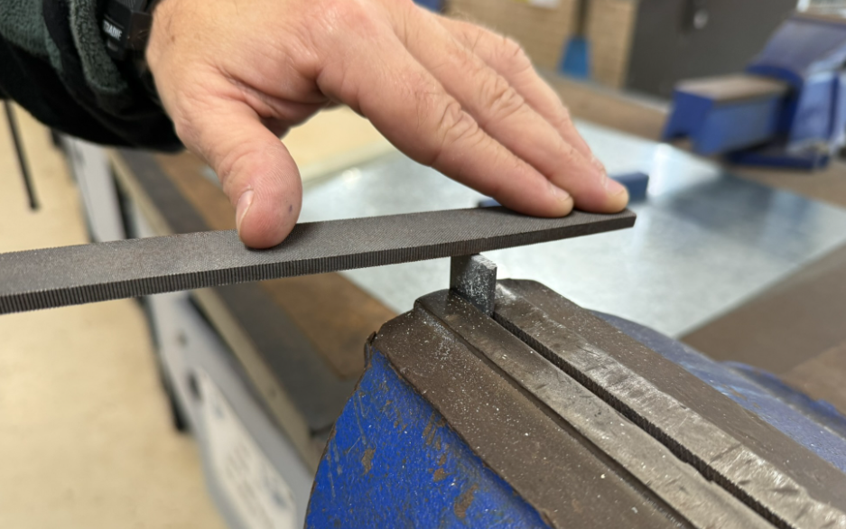
Remove the sharp edges and burrs.  Use a flat smooth file for this process. | 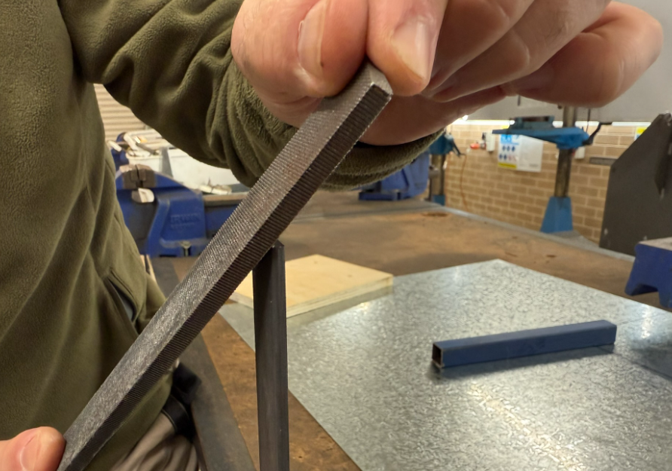
Round the corner to form a light round with approximately a 3mm radius. | 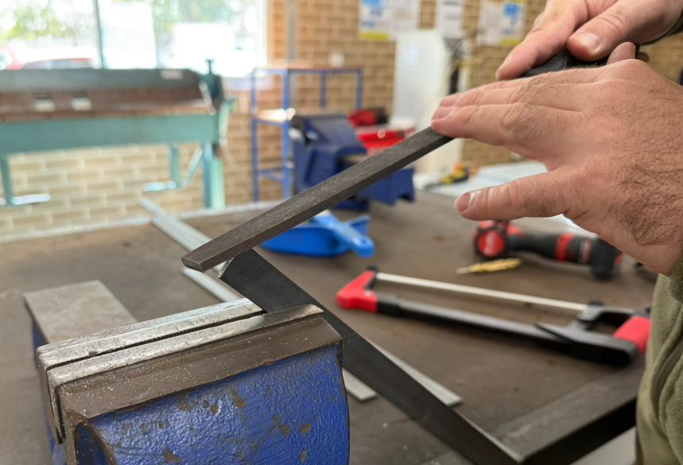

Preparing for folding the frame
Material: 20 × 3mm flat mild steel.
Instruction | Reference image
Mark out the ends at 25mm. | 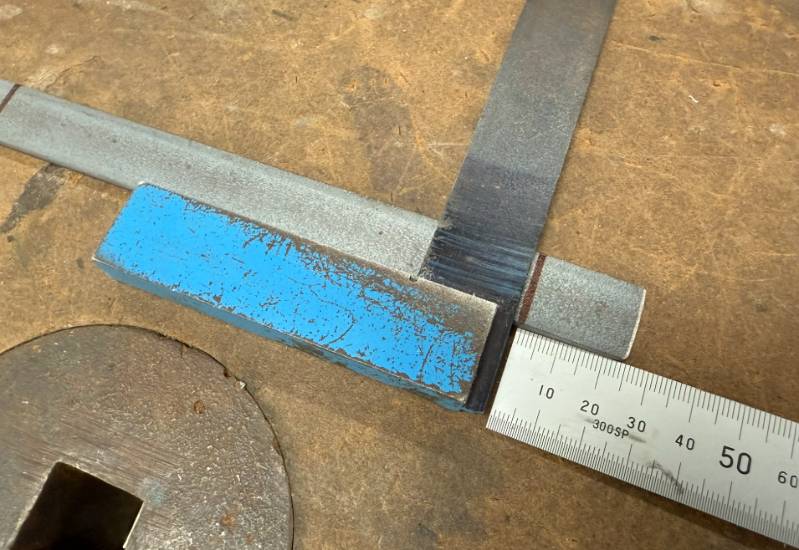
160 mm length, measured and marked out. | 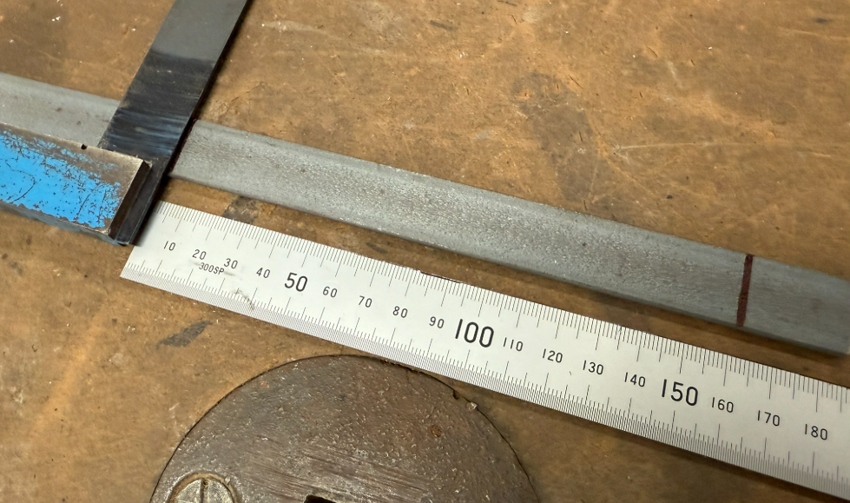
120 mm length, measured and marked out. | 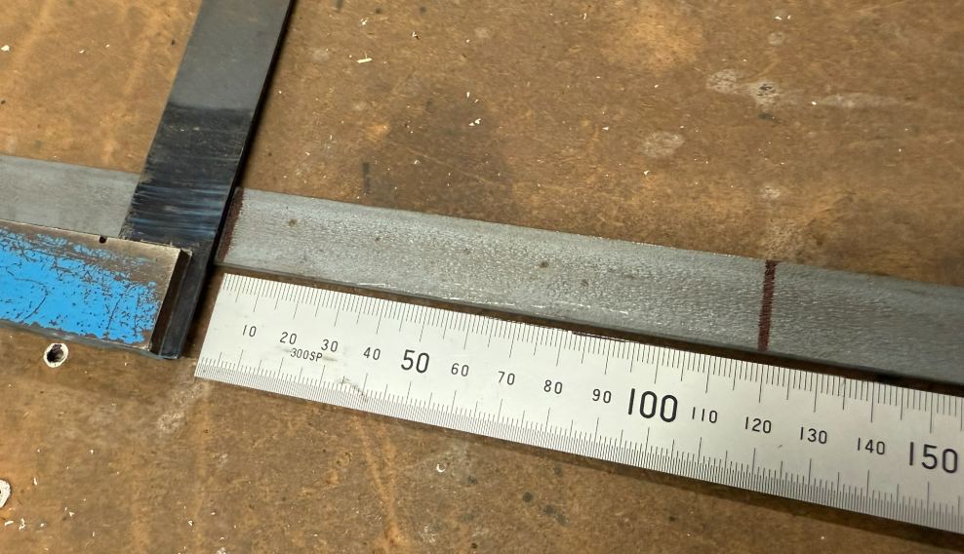
Prepare the frame for the riveting process (to be completed after the next sequence of bending steps). | 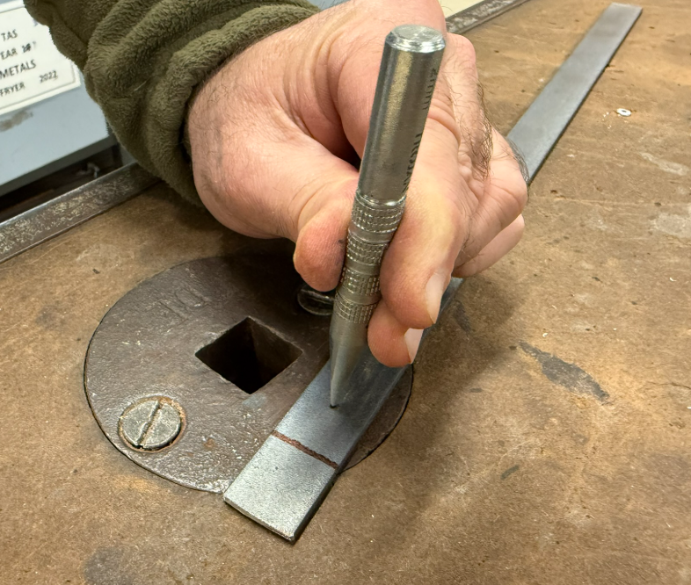
Drill using the 3.2mm drill. | 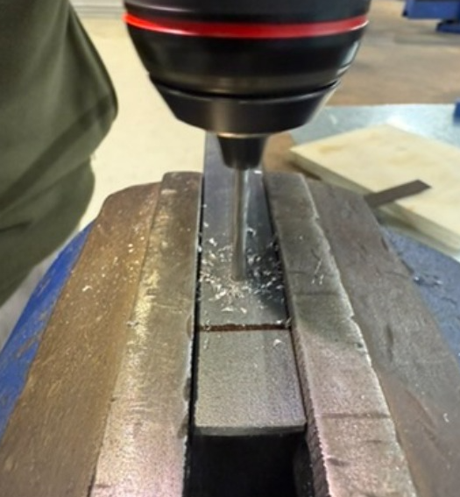
Ensure the material is square in the vice before the bend. | 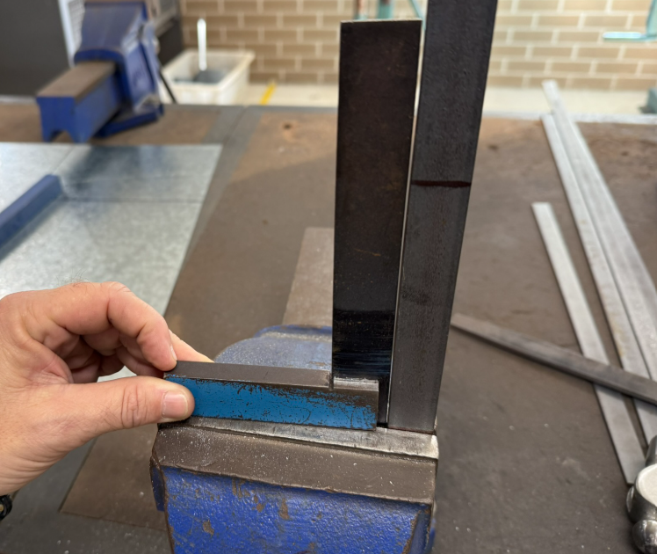
Using a hammer, strike at the base and bend to the line. | 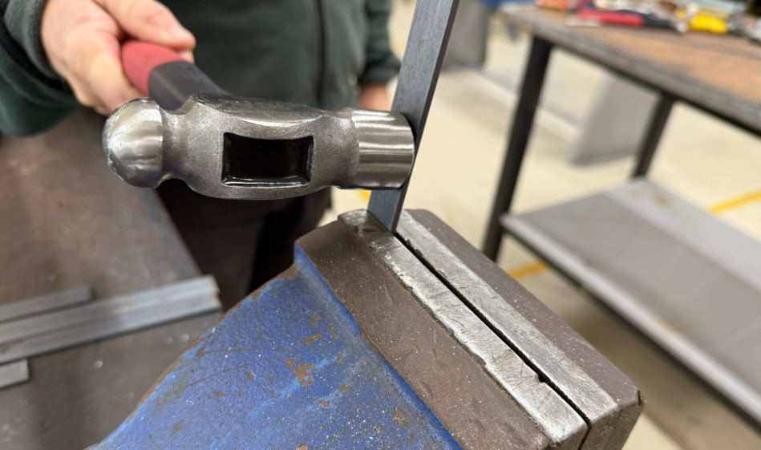
Complete the 90-degree bend. | 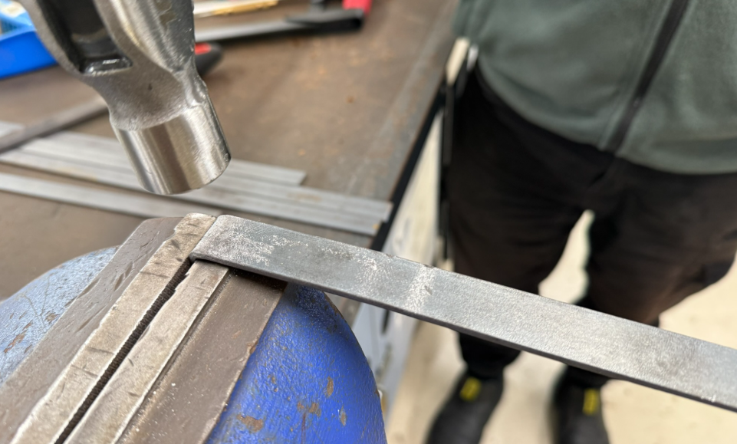
Ensure the folded frame is square (90 degrees) and repeat for the other marked out and measured lines. | 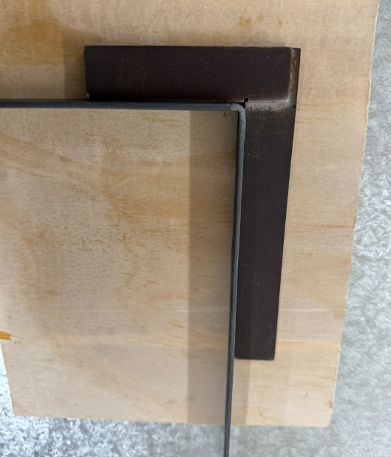
Repeat the process to create the fold on the other side. | 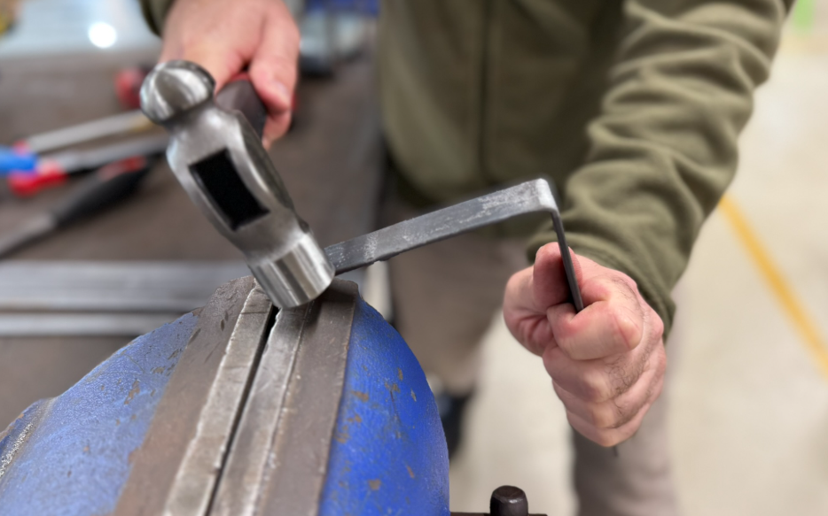
Check it is square using an engineer’s square. | 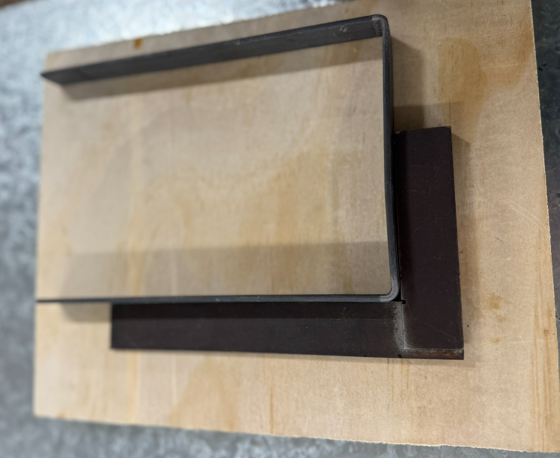
Bend the feet to approximately 30 degrees. | 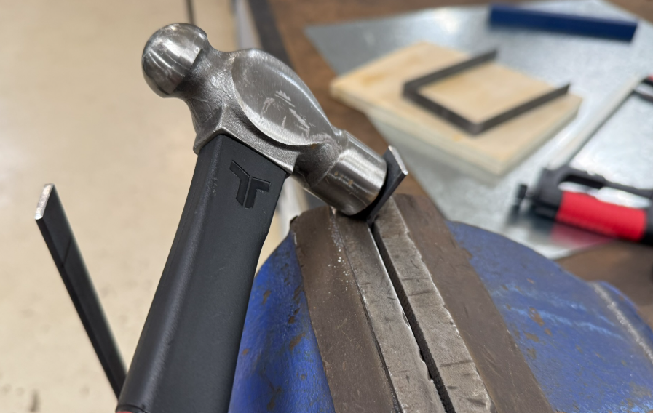
This completes the frames and the sheet steel box, making them ready for assembly. | 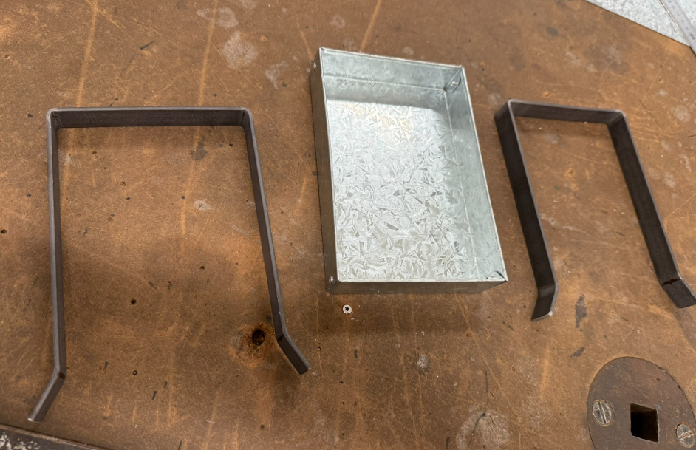

Marking out the location for the rivets on the frame
Tools:
- dividers
- combination square
- rule
Figure 11 – marking 25 mm from the edge
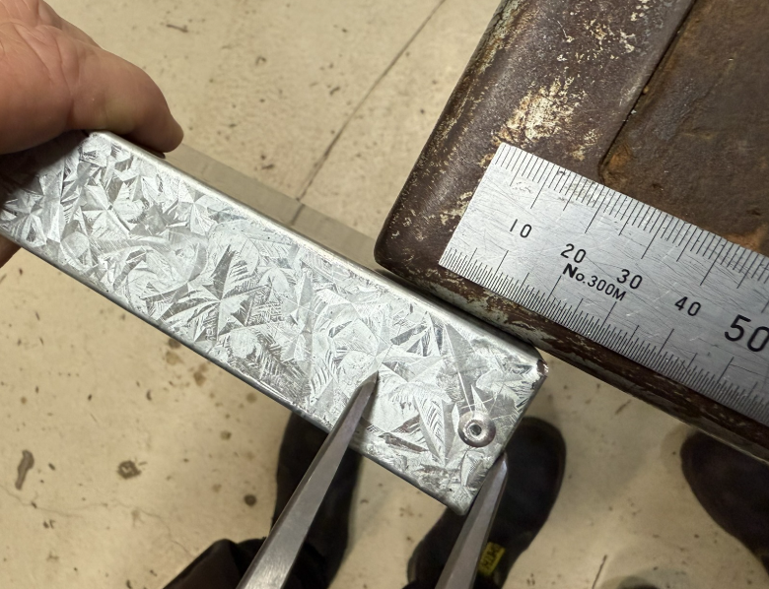
Instruction | Reference image
Find the middle at 15mm. | 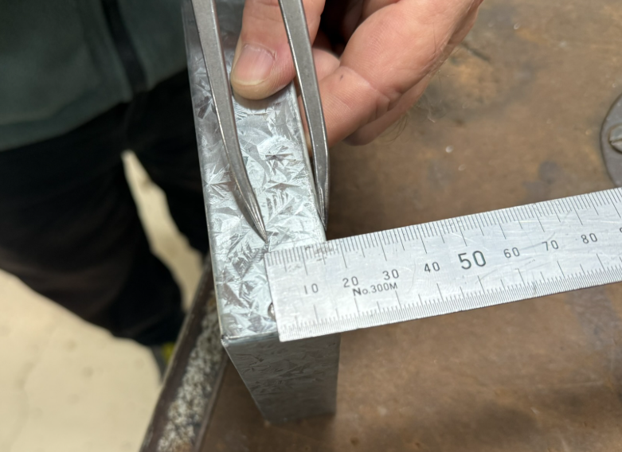
Mark with a black marker. | 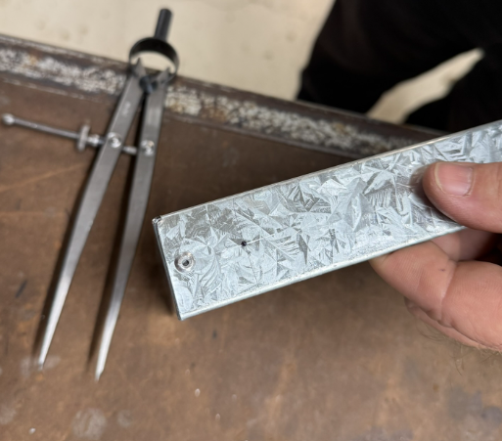
Clamp using the previous procedure and prepare to centre punch and drill a 3.2mm hole. | 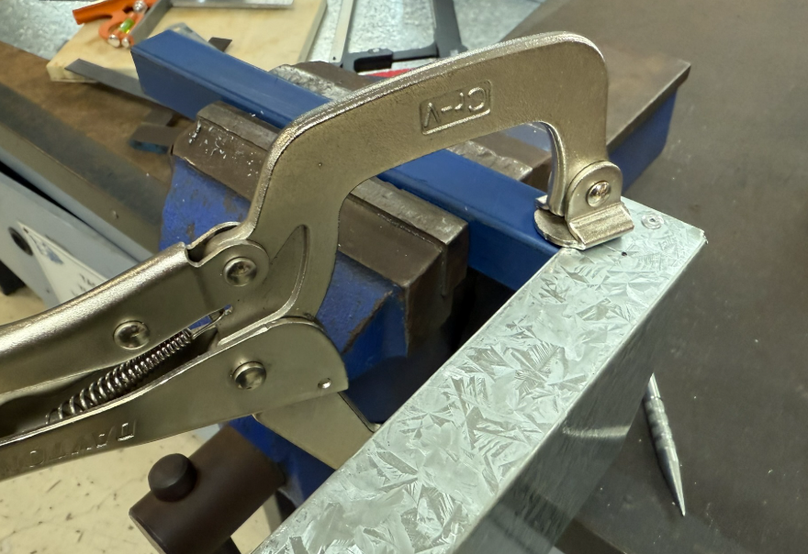
Lightly centre punch hole location. | 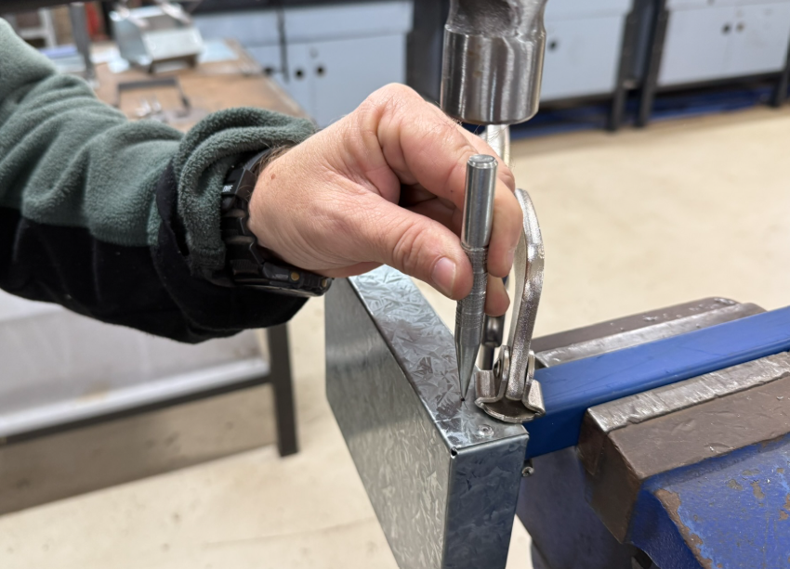
Complete the drilling process using the battery drill and 3.2mm drill. | 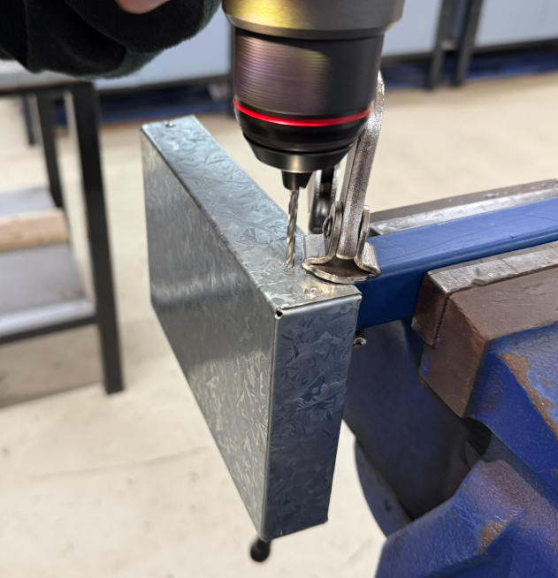
Rivet the frame to the base/tray/box | 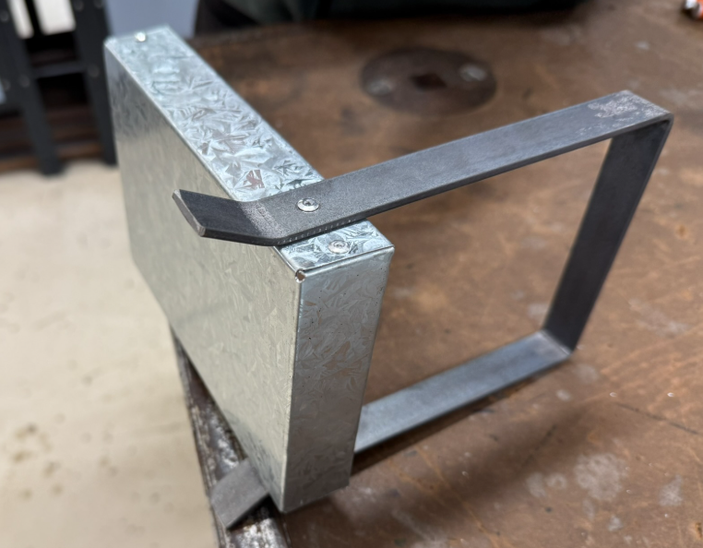
Mark out and clamp using the multi grips.  Drill for the next rivet. | 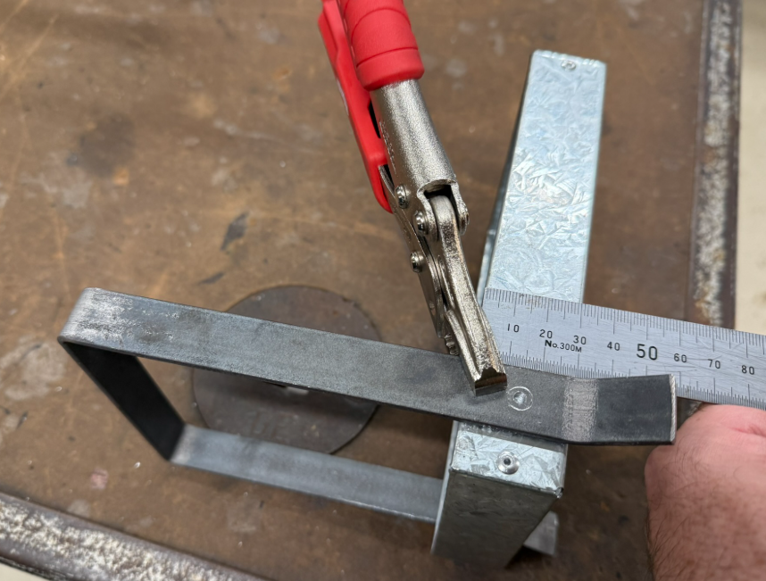
Use the predrilled hole in the frame as a guide to locate the rivet hole in the box. | 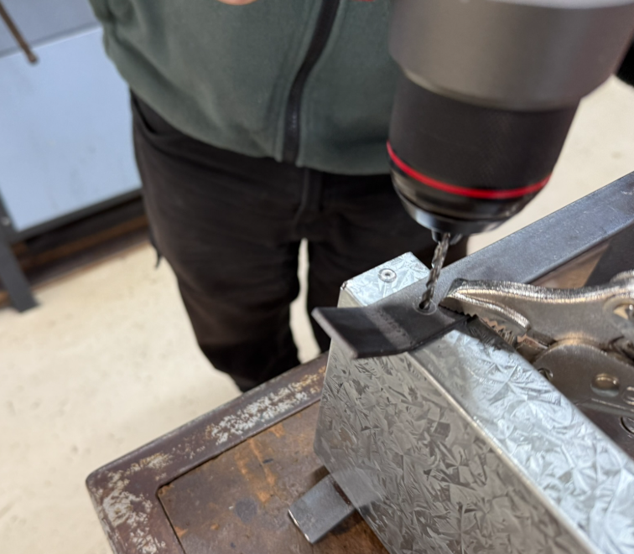
Complete the riveting process. | 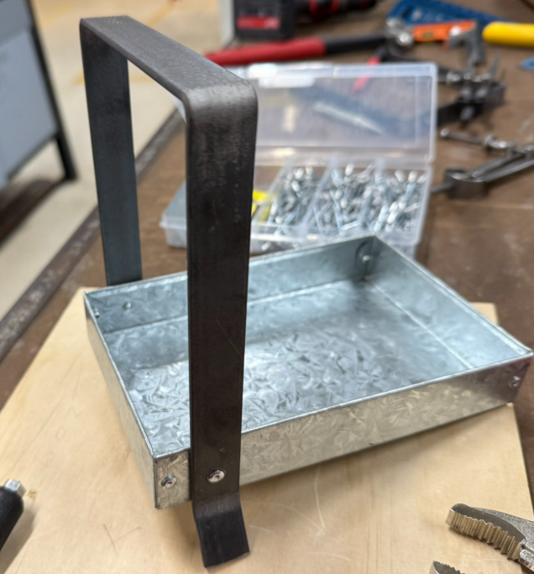
The frame rivetted onto the box. | 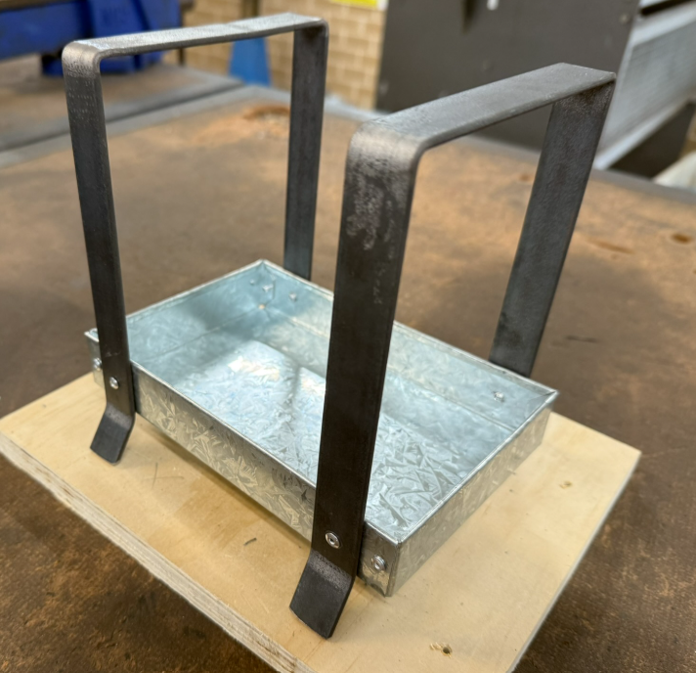
You should now have a handle design option. | 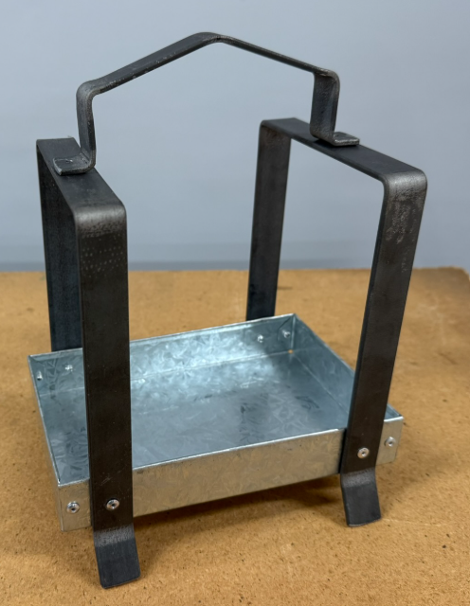

Alternative solutions
The project provides opportunity for individual student design changes to be made to suit their need. These may involve 3D printing, laser cutting or other metalwork methods.
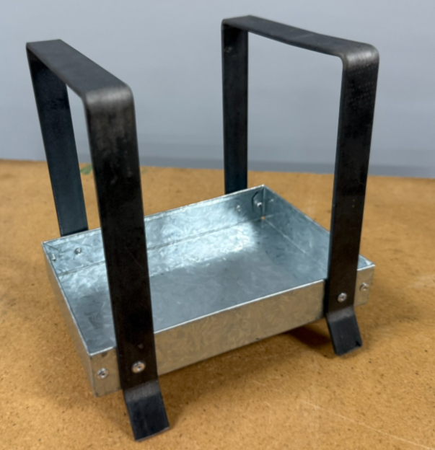
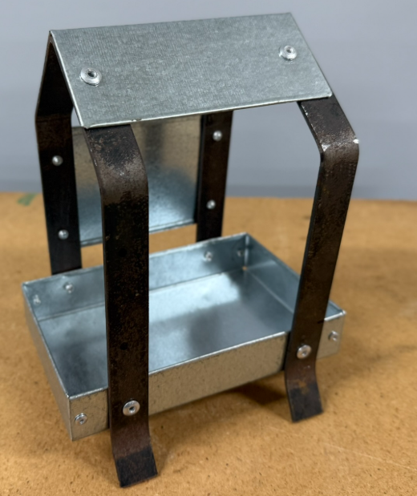

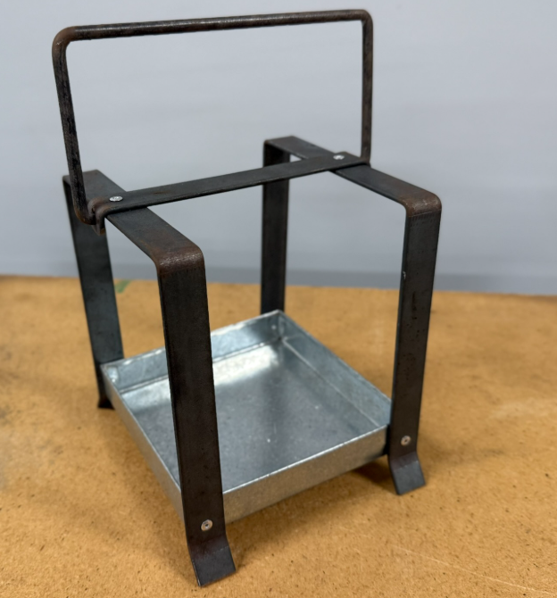

References
This resource contains NSW Curriculum and syllabus content. The NSW Curriculum is developed by the NSW Education Standards Authority. This content is prepared by NESA for and on behalf of the Crown in right of the State of New South Wales. The material is protected by Crown copyright.
Please refer to the NESA Copyright Disclaimer for more information https://educationstandards.nsw.edu.au/wps/portal/nesa/mini-footer/copyright.
NESA holds the only official and up-to-date versions of the NSW Curriculum and syllabus documents. Please visit the NSW Education Standards Authority (NESA) website https://educationstandards.nsw.edu.au/ and the NSW Curriculum website https://curriculum.nsw.edu.au/home.
Technology 7–8 Syllabus © NSW Education Standards Authority (NESA) for and on behalf of the Crown in right of the State of New South Wales, 2022.

© State of New South Wales (Department of Education), 2025
The copyright material published in this resource is subject to the Copyright Act 1968 (Cth) and is owned by the NSW Department of Education or, where indicated, by a party other than the NSW Department of Education (third-party material).
Copyright material available in this resource and owned by the NSW Department of Education is licensed under a Creative Commons Attribution 4.0 International (CC BY 4.0) license.

This license allows you to share and adapt the material for any purpose, even commercially.
Attribution should be given to © State of New South Wales (Department of Education), 2025.
Material in this resource not available under a Creative Commons license:
- the NSW Department of Education logo, other logos and trademark-protected material
- material owned by a third party that has been reproduced with permission. You will need to obtain permission from the third party to reuse its material.
Links to third-party material and websites
Please note that the provided (reading/viewing material/list/links/texts) are a suggestion only and implies no endorsement, by the New South Wales Department of Education, of any author, publisher, or book title. School principals and teachers are best placed to assess the suitability of resources that would complement the curriculum and reflect the needs and interests of their students.
If you use the links provided in this document to access a third-party's website, you acknowledge that the terms of use, including licence terms set out on the third-party's website apply to the use which may be made of the materials on that third-party website or where permitted by the Copyright Act 1968 (Cth). The department accepts no responsibility for content on third-party websites.

