Technology 7–8 – Materials and production sample assessment task
Metal-morphosis
Contents
Task description 2
Submission details 3
Steps to success 4
What is the teacher looking for? 5
Marking guidelines 6
Student-facing rubric 7
Teacher-facing rubric 9
Student folio scaffold 11
The design and production process 14
Support and alignment 16
References 17

Task description
Type of task: practical design and production project with an associated communication folio.
This is a practical project delivered in a metal room equipped with standard tools and equipment. Students will design and manufacture a multipurpose metal holder, incorporating fundamental metalworking techniques and processes. The project will focus on creating a functional and aesthetically pleasing product, primarily based around a sheet metal tray with formed rails or supports. The project has opportunities for students to explore additional variations such as a small organiser, bird feeder or decorative items to meet an intended purpose.
Outcomes
A student:
- applies processes in the planning, management, and production of projects TE4-PPM-01
- selects and safely uses tools, materials, technologies, and processes TE4-SAF-01
- explains how materials, systems, and components contribute to solutions TE4-MSC-01
- communicates and evaluates design ideas and solutions TE4-DES-01
- describes the practices and processes of designers and producers TE4-PDP-01
Technology 7–8 Syllabus © NSW Education Standards Authority (NESA) for and on behalf of the Crown in right of the State of New South Wales, 2023.
Suggested weighting: 25%
Tasks include: manufacture a specific base design from sheet metal and flat bar. Research and justify your choice of features and materials used. Use design thinking to produce a project that meets an intended need beyond the base design. Describe your project development and design process through a digital or hard-copy folio.

Submission details
Format of submission
- Practical project is to be completed and submitted in class.
- Folio must be submitted digitally or printed.
Teacher note: the folio can take the format that best suits your school context and students, such as completing the sample folio documentation scaffold as a booklet or electronically.

Steps to success
Table 1 – assessment preparation schedule
Steps | What I need to do and when I need to do it
Produce – base design | Using existing plans, accurately manufacture the base design consisting of the sheet metal tray and steel flat bar frame.  Complete this in Week 6.
Research – design options | Explore 3 existing tray or product ideas. Analyse function, form and user needs.  Complete this in Week 5.
Design development | Develop 3 design ideas, evaluate with PMI and select the final design.  Complete this in Week 5.
Design | Produce annotated sketches or CAD of at least 2 design options. Select one design to produce with justification.  Complete this in Week 5.
Planning for production and construction | Write a step-by-step process plan. List tools and materials. Justify choices. Manufacture the design, documenting each stage with photos or notes.  Complete this in Weeks 6 to 10.
Ethics and IP | Research and reflect on IP, copying and design rights. Suggest protection strategies. Complete this in Week 9.
Evaluation | Assess product success using criteria. Include peer review and suggestions for improvement.  Complete this in Week 10.

What is the teacher looking for?
In this task, the teacher will be evaluating your practical work and folio work based on several key criteria. Here is what to focus on for each aspect of your project:
- your ability to follow safe working practices with metal tools and equipment
- quality and accuracy of the final product (smooth edges, correct dimensions, neat joins and appropriate finish)
- evidence of a well-planned, iterative design process with effective use of images to communicate design thinking
- execution and function of the individual design feature with reference to the intended purpose
- appropriate justification of designed elements
- understanding of the ethical considerations when designing and manufacturing a commercial product or project
- a clear, well-structured folio with diagrams, photos, tables and justified decisions.

Marking guidelines
Table 2 – assessment marking guidelines
Grade | Marking guideline descriptors
A | - The student showcases extensive practical skills and highly creative customisations  - Detailed folio with clear communication of ideas, processes and design thinking  - Excellent Intellectual Property (IP) research and evaluation
B | - The student displays thorough practical skills with purposeful and well-developed design modifications  - Folio clearly documents the design process with relevant annotations and sound IP understanding
C | - The student displays sound practical execution and functional design elements  - Folio shows key stages of development with sound annotations  - Demonstrates a general understanding of ethical and IP issues
D | - Student presents basic construction with limited refinement or justification  - Folio includes minimal documentation and unclear design process  - Limited awareness of ethical or IP considerations
E | - Student presents an incomplete project or folio; shows little understanding of design process, technical skills or IP awareness; minimal or no evidence of evaluation

Student-facing rubric
Criteria | Limited | Basic | Sound | High | Outstanding
Safe use of tools and workshop practices  TE4-SAF-01 | Rarely follows safety procedures; needs frequent reminding on how to be safe. | Follows some safety procedures with prompting. | Usually follows safety procedures and handles tools appropriately. | Consistently safe and responsible with all tools and processes. | Independently applies WHS practices and models safety for peers.
Construction of base tray and application of skills  TE4-PPM-01 | Base design incomplete or inaccurate; very limited metal skills. | Base design completed with limited accuracy and skills. | Base design meets specifications with adequate metalwork skills shown. | Base design is accurate and demonstrates thorough metalwork skills. | Base design is precise, well-finished and demonstrates very high metalwork skills.
Individually researched and designed purpose-built design additions  TE4-DES-01 | Addition not present or elementary. | Basic addition with limited reference to purpose. | Functional addition with evidence of planning. | Innovative addition that enhances function and form. | Creative, well-integrated addition that clearly meets intended purpose.
Design process documentation and visual communication  TE4-PPM-01 | Limited or no documentation; few images or notes. | Some design stages shown; basic sketches or unlabelled photos. | Sound documentation of processes; some sketches/photos with annotations. | Clear documentation of stages; effective sketches, images and captions. | Highly detailed, visually engaging documentation with annotations showing deep understanding.
Research into ethical issues and IP  TE4-PDP-01 | Minimal research or understanding of IP/copyright. | Basic notes on IP with limited relevance. | Sound research and identification of ethical considerations. | Thoughtful explanation of design protection and IP relevance. | Insightful, well-reasoned analysis of IP issues; clear personal response on design ownership.
Justification and evaluation of design  TE4-DES-01 | No evaluation or irrelevant statements. | Basic justification with minimal reflection. | Justifies choices with some evaluation against purpose. | Well-reasoned justification and reflection on design success. | Deep critical reflection with evaluation linked to intended use, user needs and design improvement.

Teacher-facing rubric
Criteria | Limited | Basic | Sound | High | Outstanding
Safe use of tools and workshop practices  TE4-SAF-01 | Student requires frequent supervision and reminders to use tools safely. | Student inconsistently follows WHS protocols and often needs prompting. | Student demonstrates safe use of tools and generally works responsibly. | Student consistently demonstrates safe, confident and independent tool use. | Student consistently models exemplary safety practices and supports peers.
Construction of base tray and application of skills  TE4-PPM-01 | Construction is incomplete or lacks accuracy; demonstrates minimal skill development. | Base design is complete but lacks precision; developing practical skills evident. | Base design meets design specifications; skills demonstrated are sound and consistent. | Base design is completed with a high level of accuracy and finish; student applies a range of refined metalwork techniques. | Base design is completed to a very high standard with excellent precision, complex shaping and outstanding execution.
Individually researched and designed purpose-built design additions  TE4-DES-01 | Design lacks a clear purpose or function; minimal creativity evident. | Design addition shows a basic understanding of purpose; limited innovation. | Design addition serves the intended purpose and reflects appropriate design choices. | Design addition is purposeful, well-developed, and enhances the tray's usability and appeal. | Design addition demonstrates creativity, user-centred thinking and high-quality execution that clearly enhances the original project.
Design process documentation and visual communication  TE4-PPM-01 | Limited or no documentation; few images or notes. | Some design stages shown; basic sketches or unlabelled photos. | Sound documentation of processes; some sketches and photos with annotations. | Clear documentation of stages; effective sketches, images and captions. | Highly detailed, visually engaging documentation with annotations showing deep understanding.
Research into ethical issues and IP  TE4-PDP-01 | Minimal research or understanding of IP/copyright. | Basic notes on IP with limited relevance. | Sound research and identification of ethical considerations. | Thoughtful explanation of design protection and IP relevance. | Insightful, well-reasoned analysis of IP issues; clear personal response on design ownership.
Justification and evaluation of design  TE4-DES-01 | No evaluation or irrelevant statements. | Basic justification with minimal reflection. | Justifies choices with some evaluation against purpose. | Well-reasoned justification and reflection on design success. | Deep critical reflection with evaluation linked to intended use, user needs and design improvement.

Student folio scaffold
Your folio must clearly communicate the development of your project and demonstrate your understanding of the design process. Use the headings below to structure your folio:
- Title page
- Your name, project title, class and date
- Design brief and project intent
- What is the purpose of your tray project?
- Who is it designed for?
- What specific need will it meet?
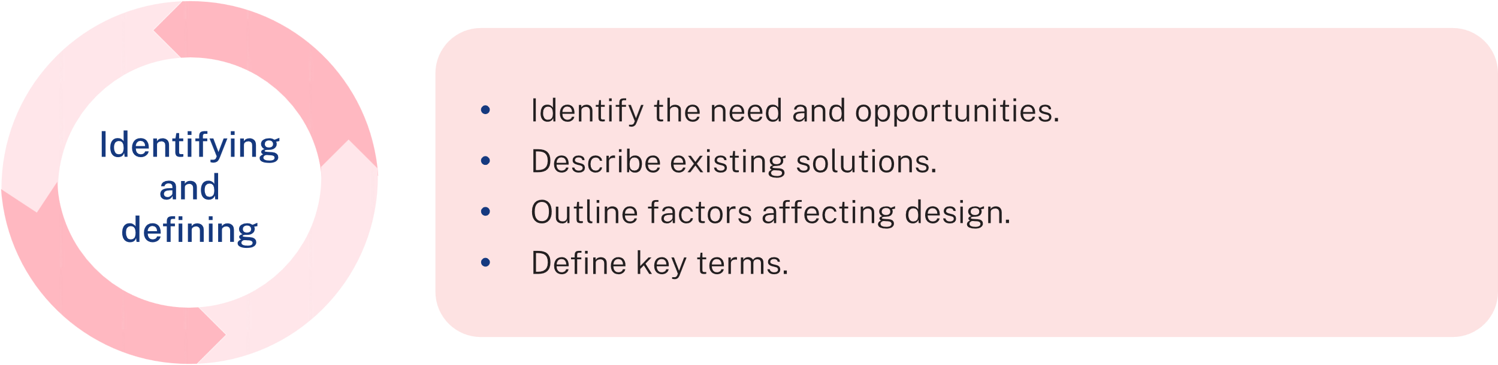
- Existing product research
- Collect 2 to 3 images of similar products (for example, trays, caddies and holders)
- Annotate the images to identify useful features and materials used
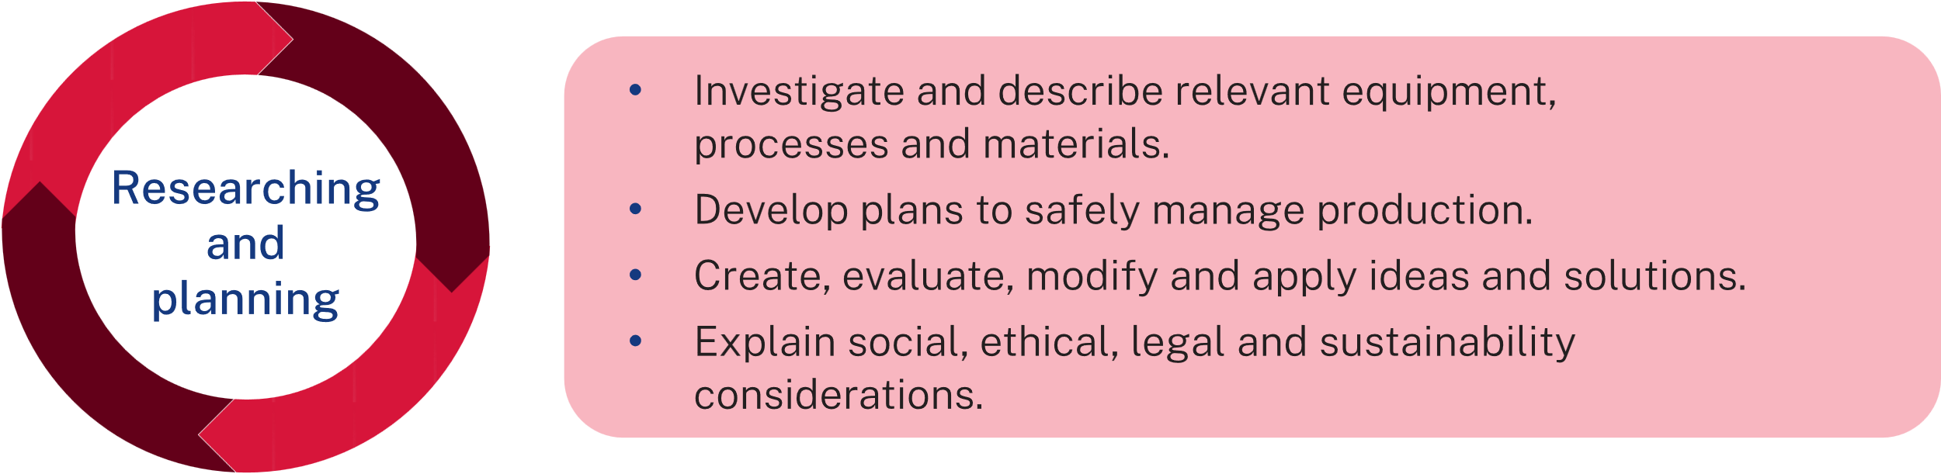

- Design concepts and sketches
- Include 3 proposed design alternatives to the base project
- Annotate each with:
- the intended purpose
- design features
- sketches of design additions
- justification of your design decisions: Why did you choose this version? How does it meet your intended purpose?
- Planning and production
- Include a step-by-step plan of how you made your tray and additions
- Record tools used and safety considerations
- Include photos of each stage with brief captions
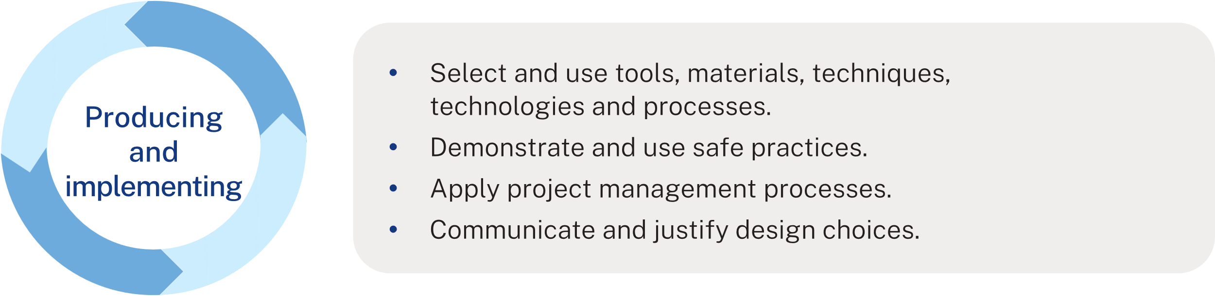
- Ethical design and IP research
- Write a short response outlining
- What is intellectual property (IP)?
- Why is it important when designing?
- How could you protect your ideas?
- Evaluation and peer feedback
- Reflect on the success of your project. What worked well? What could be improved?
- Include at least one comment of feedback from a peer and how you responded to it.
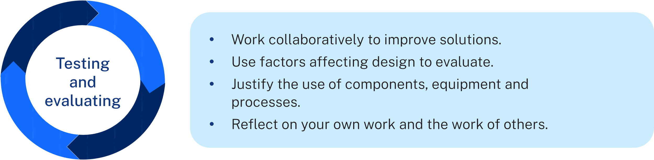
Use this scaffold or the checklist below to ensure you complete all sections before submission in Week 10.

Student checklist
- Title page
- Design brief or project intent
- Research and planning
- Design concepts or sketches and justification
- Step-by-step construction process
- Ethical design and IP research
- Evaluation with suggested improvements

The design and production process
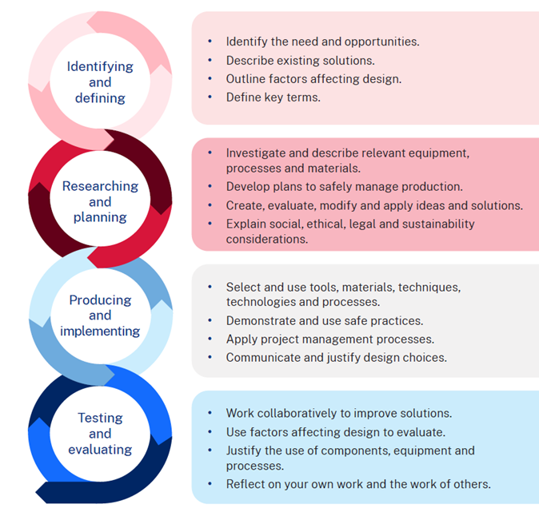

Note: this is a suggested layout for the ‘three alternative designs’ activity.
The intended purpose
Design features
Sketch proposed design additions
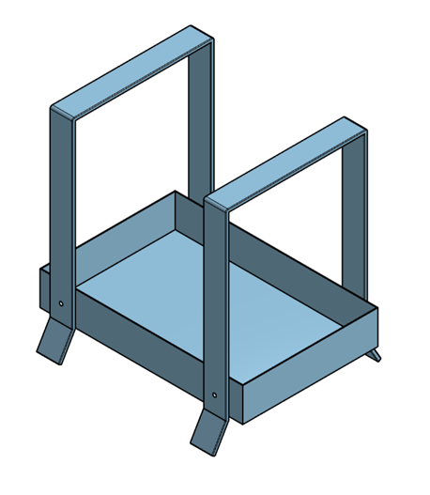
Justification of the proposed design

Support and alignment
Resource evaluation and support: all curriculum resources are prepared through a rigorous process. Resources are periodically reviewed as part of our ongoing evaluation plan to ensure currency, relevance and effectiveness. For additional support or advice, or to provide feedback, contact the TAS Curriculum team by emailing TAS@det.nsw.edu.au.
Differentiation: further advice to support Aboriginal and Torres Strait Islander students, students learning English as an additional language or dialect (EAL/D), students with a disability and/or additional needs and High Potential and gifted students can be found on the Planning, programming and assessing 7–12 webpage. This includes the Inclusion and differentiation advice 7–10 webpage.
Assessment: further advice to support formative assessment is available on the Planning, programming and assessing 7–12 webpage. This includes the Classroom assessment advice 7–10. For summative assessment tasks, the Assessment task advice 7–10 webpage is available.
Explicit teaching: further advice to support explicit teaching is available on the Explicit teaching webpage. This includes the CESE Explicit teaching – Driving learning and engagement webpage.
Consulted with: Curriculum and Reform, Inclusive Education, Multicultural Education, Aboriginal Outcomes and Partnerships and subject matter experts.
Alignment to system priorities and/or needs: School Excellence Policy, Our Plan for NSW Public Education.
Alignment to the School Excellence Framework: this resource supports the School Excellence Framework elements of curriculum (curriculum provision) and effective classroom practice (lesson planning, explicit teaching).
Alignment to Australian Professional Standards for Teachers: this resource supports teachers to address Proficient Teacher Standard Descriptors [3.2.2, 3.3.2].
Creation date: September 2025

References
This resource contains NSW Curriculum and syllabus content. The NSW Curriculum is developed by the NSW Education Standards Authority. This content is prepared by NESA for and on behalf of the Crown in right of the State of New South Wales. The material is protected by Crown copyright.
Please refer to the NESA Copyright Disclaimer for more information https://educationstandards.nsw.edu.au/wps/portal/nesa/mini-footer/copyright.
NESA holds the only official and up-to-date versions of the NSW Curriculum and syllabus documents. Please visit the NSW Education Standards Authority (NESA) website https://educationstandards.nsw.edu.au/ and the NSW Curriculum website https://curriculum.nsw.edu.au/home.
Technology 7–8 Syllabus © NSW Education Standards Authority (NESA) for and on behalf of the Crown in right of the State of New South Wales, 2023.

© State of New South Wales (Department of Education), 2025
The copyright material published in this resource is subject to the Copyright Act 1968 (Cth) and is owned by the NSW Department of Education or, where indicated, by a party other than the NSW Department of Education (third-party material).
Copyright material available in this resource and owned by the NSW Department of Education is licensed under a Creative Commons Attribution 4.0 International (CC BY 4.0) license.

This license allows you to share and adapt the material for any purpose, even commercially.
Attribution should be given to © State of New South Wales (Department of Education), 2025.
Material in this resource not available under a Creative Commons license:
- the NSW Department of Education logo, other logos and trademark-protected material
- material owned by a third party that has been reproduced with permission. You will need to obtain permission from the third party to reuse its material.
Links to third-party material and websites
Please note that the provided (reading/viewing material/list/links/texts) are a suggestion only and implies no endorsement, by the New South Wales Department of Education, of any author, publisher, or book title. School principals and teachers are best placed to assess the suitability of resources that would complement the curriculum and reflect the needs and interests of their students.
If you use the links provided in this document to access a third-party's website, you acknowledge that the terms of use, including licence terms set out on the third-party's website apply to the use which may be made of the materials on that third-party website or where permitted by the Copyright Act 1968 (Cth). The department accepts no responsibility for content on third-party websites.

