Technology 7–8

Materials and production processes (timber) – teacher support resource
My BBQ rules (20-week unit)

Contents
Teacher support resource and unit overview 4
Glossary 5
What ‘wood’ you know? 7
Parts of a tree 8
Parts of tree 8
Tree to timber 9
Timber terms 10
Safety 11
Safety rules in the timber workshop 11
Hazards in the timber workshop 13
TAS safety resources 13
Materials, tools and techniques 14
Timber tools, machines and their use 14
The design and production process 19
Factors affecting design 20
Designer – furniture maker 22
Timber designer case study 23
Measurement 25
FEWTEL 26
Measurement in the workshop – skill tester 27
Joining timber 28
Types of screws 28
Screw head shapes 29
Types of screw heads 29
Types of nails 30
Woodworking joints 31
Types of timbers 32
Properties of timbers 33
Radiata pine 33
Jarrah or Tasmanian oak 34
Sustainability 35
Renewable and non-renewable resources 35
Sustainable timber sourcing 36
Aboriginal and Torres Strait Islanders peoples materials, products and systems 37
Materials 37
Aboriginal and Torres Strait Islander innovations 38
Tools and equipment 38
Aboriginal art and symbols 39
Indigenous Cultural and Intellectual Property (ICIP) 41
Surface finishes 43
Finishes 44
Types of finishes 45
Preparation for surface finishing 46
Mini folio 47
The sign 47
Design brief 48
Design ideas 49
Evaluate 51
Skill development 52
I see, I think, I wonder 52
Project management – BBQ caddy 53
Working drawings 53
Key features of working drawings 53
Working drawings for the BBQ caddy 54
Time management 56
Cutting list 58
References 59

Teacher support resource and unit overview
Note: this resource supports schools’ implementation of the Materials and production processes focus area of the new Technology 7–8 Syllabus. It can be adopted as is or adapted to meet the needs of individual school contexts.
This resource has been divided into 2 parts. You can decide which section(s) to use; suited to your school and your resources.
Part 1 – ‘Introduction activity – the sign’
This section of the unit will introduce students to timber, machinery, tools and equipment through a small project that incorporates a range of production techniques.
Part 2 – ‘Project and folio – BBQ caddy’
Students will develop the knowledge, understanding and skills required to design, manage, plan and produce a high-quality timber product and evaluate its effectiveness.
Note: this resource has been designed to facilitate the ready conversion into a student booklet by removing the answers within the response boxes. Teacher notes and sample answers can be deleted before distributing to students.
Refer to Equipment Safety in Schools, Animals in Schools, and Chemical Safety in Schools for current information on safety and safe working practices in Technology 7–8.

Glossary
Note: sample answers have been provided.
Table 1 – glossary
Term | Definition
bench hook | A tool to secure workpieces on a bench during cutting.
butt joint | A simple joint where 2 pieces of wood are joined often end to side.
countersunk screws | Screws designed to sit flush with the material's surface.
disc sander | A machine with a rotating, abrasive disc for sanding surfaces.
dovetail saw | A small saw used for cutting dovetail joints.
dowel | A cylindrical rod used to reinforce joints.
end grain | The exposed surface when wood is cut perpendicular to growth rings.
grain | The alignment and texture of wood fibres.
jack plane | A woodworking plane used for smoothing rough timber.
machine vice | A device to hold workpieces securely while drilling.
pedestal drill | A fixed, upright drill for precise drilling.
plywood | A strong, stable wood panel made from glued layers of veneer.
PVA | Common woodworking adhesive, also known as wood glue.
Radiata pine | A versatile, fast-growing softwood used in construction and furniture.
rebate joint | A joint where one piece of wood has a rebate (rectangular portion cut out) to fit another piece.
sliding bevel | An adjustable tool for measuring and transferring angles.
tenon saw | A saw for making fine, accurate cuts.
timber finishes | Coatings applied to wood to protect and enhance its appearance.
timber vice | A clamping device to hold wood securely on a workbench.
try square | A tool for measuring and marking right angles.

What ‘wood’ you know?
Think of 10 things you used in the past 24 hours that were made from timber. They could be small to very large items. Complete the activities below, identifying things you have used that are made from timber. Build on this by adding words to describe timber, for example, how it feels, smells, looks and sounds. Include timber-specific words you know.
What I have used that is made from timber …

Timber looks like … | Timber feels like … | Timber smells like …

Interesting things I know about timber … | What I want to learn about timber …

Parts of a tree
Trees grow in native forests and on tree plantations. Timber is the wood from trees after the trees have been cut down. Timber is used to build wooden houses and wooden furniture. It is used to make paper. Timber can also be also known as lumber.
Many plants produce wood. Wood is the sturdy hard part of a plant that forms the structure of the living plant. Not all wood is suitable for conversion into timber. Timber is produced from wood that grows straight in long lengths and ideally is free of defects that will reduce the timber’s strength.
In the space below, describe the difference between wood and timber.
Sample answer:
Wood is still in the form of a tree or branches and logs. It becomes timber after it has been converted to useable lengths and shapes and after it has been seasoned. Seasoning is the process of removing much of the moisture from timber.

Parts of tree
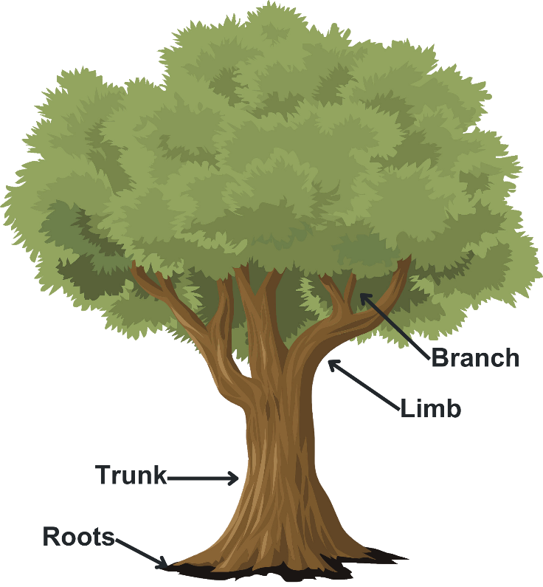 | 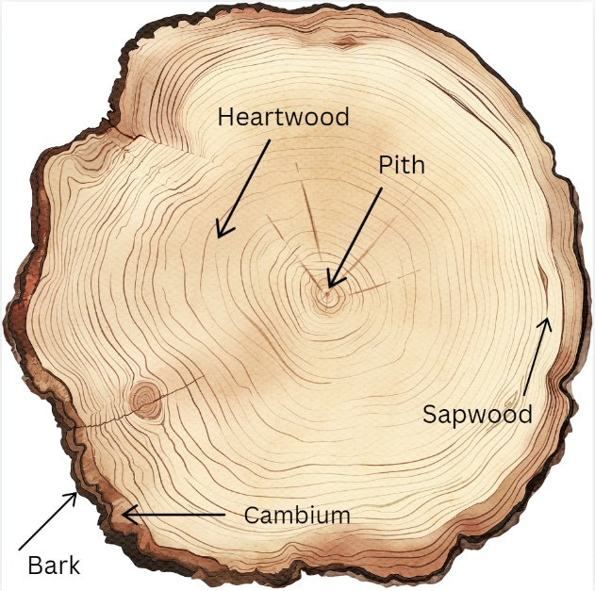

Tree to timber
Watch From Trees to Lumber: Watch how boards are made from pine trees (8:12).
In the diagram below, briefly outline the steps involved in producing timber from trees.
Note: sample answer provided.
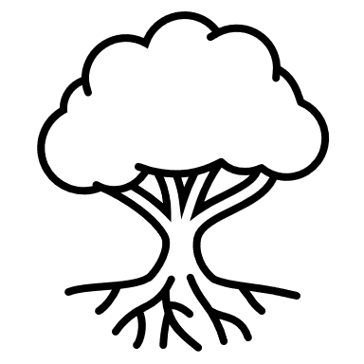
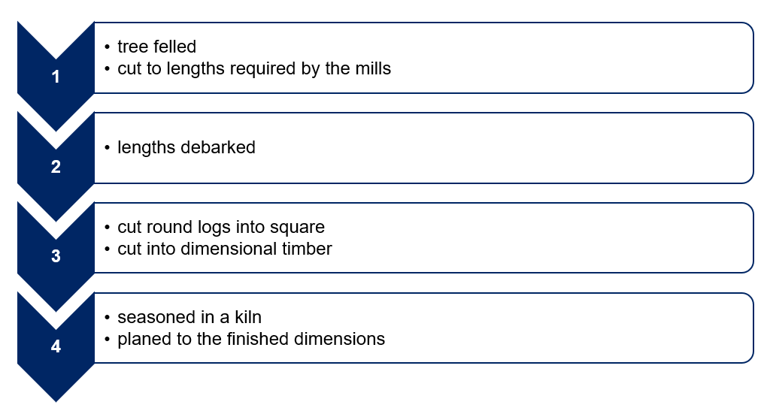

Timber terms
Complete and label the diagram below with the following timber terms (teacher answer provided in PPT).
- Label
- Length
- Width
- Thickness
- With the grain
- Across the grain
- Face
- Edge

Safety
Teacher note: refer to Equipment Safety in Schools, Animals in Schools, and Chemical Safety in Schools for current information on safety and safe working practices in Technology 7–8.

Safety rules in the timber workshop
For each image below, write the safety message for working safely in the timber workshop.
Note: sample answers have been provided.
Safety rules in the timber workshop
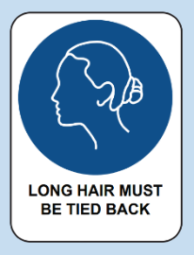 | 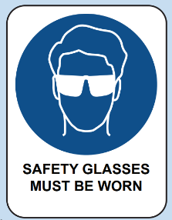 |  | 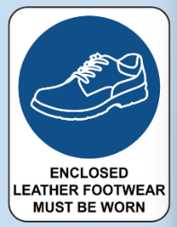
Tie hair back | Wear eye protection |  | Wear enclosed leather shoes
 |  |  | 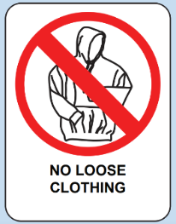
Hazard sign. Chemical Storage Area. | SDS Folder. Provides health and safety information about hazardous substances including first aid. |  | Remove ties and hoodies or tuck in.
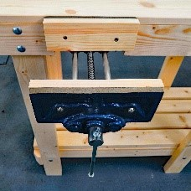 | 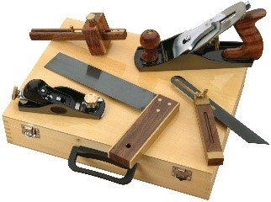 |  | 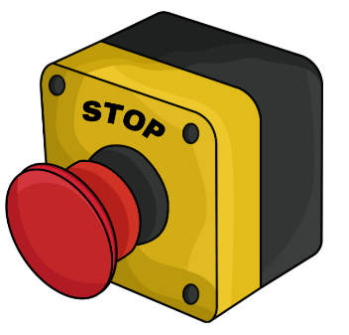
Clamp down materials. | Use tools appropriately and watch demonstrations carefully before use. |  | Turn power off after use and know where emergency stops are.

Hazards in the timber workshop
Watch Timber Technology - Workshop Walkthrough (5:37) (staff only) and discuss as a class.

TAS safety resources
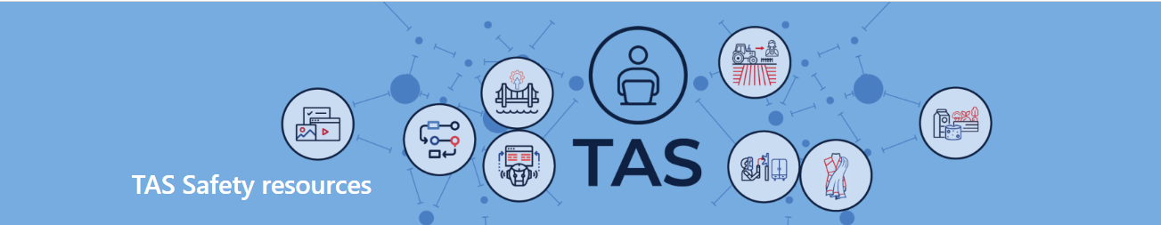
Teacher note: the TAS Safety resources (sharepoint.com) (DoE staff only) are created for Department of Education schools, using relevant information from Equipment Safety in Schools (ESIS). These resources have been developed specifically for the equipment and machinery that has been approved for use in department schools.
Safety tests are mandated by ESIS for selected equipment and machinery.
The tests may be attempted in electronic or other formats with the result recorded and retained as per the department’s records management policy.
Students must provide the correct answer (with or without support) to each question on the safety test as evidence that they knew correct procedures at that point in time for the tool, equipment or machine. Students may attempt each test multiple times to achieve the correct answers.

Materials, tools and techniques

Timber tools, machines and their use
For each image below, write the name and use.
Note: sample answers have been provided.
Tool image | Tool name | Use
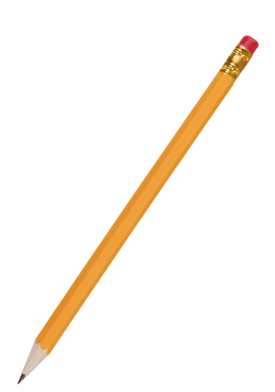 | pencil | A pencil is used to mark out timber. The graphite does not absorb into the timber’s pours, so it is easy to remove.
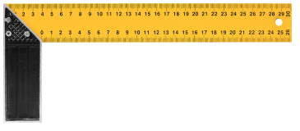 | try square | Try squares are used to mark lines perpendicular to an edge and to check for square. This is useful when marking timber ready to cut to length.
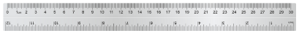 | rule | Used to measure when woodworking. A rule is more accurate than a tape measure. This can be used to mark timber ready for cutting and for marking out joints.
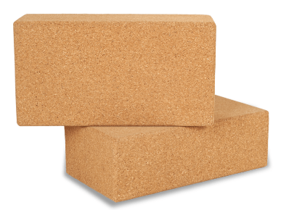 | cork sanding block | Used to sand the projects. It ensures the paper is flat and helps the user apply even pressure. This is great when sanding scratches and other marks from timber.
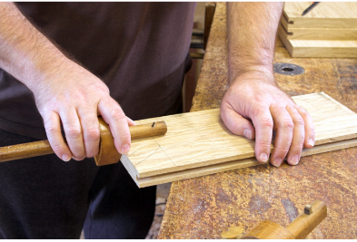 | marking gauge | Marks a line parallel to an edge, side or end. This is an effective tool to mark rebate joints.
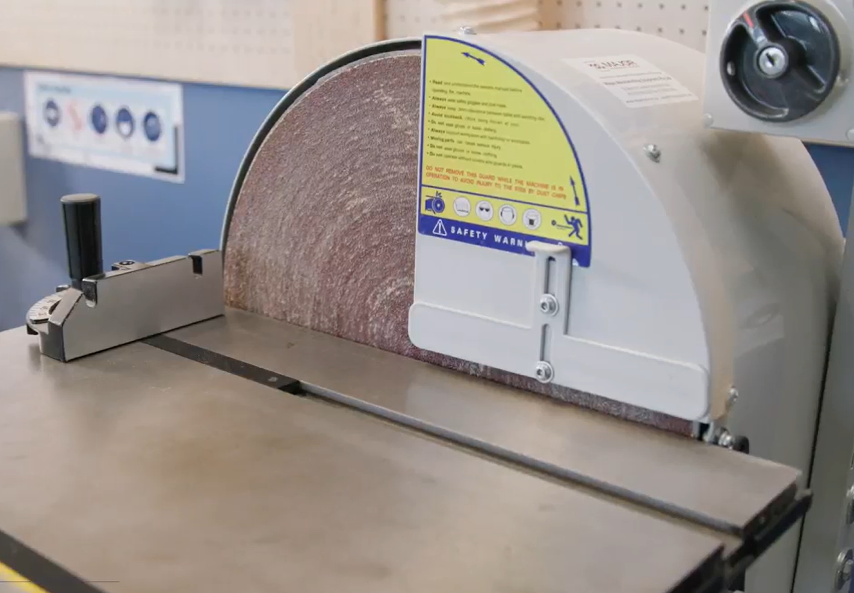 | disc sander | The disc is used to sand end grain. This is an effective tool to use to square ends of timber after cutting.
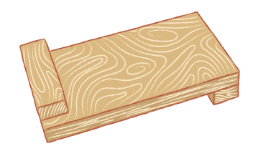 | Bench hook | This tool is used to hold timber securely whilst cutting. It can be used when cutting timber to length and cutting joints.
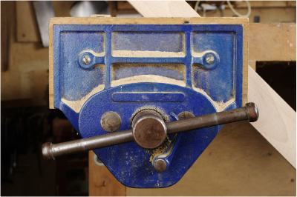 | bench vice | Used to secure objects such as timber. This is useful for many things including chiselling out rebate joints.
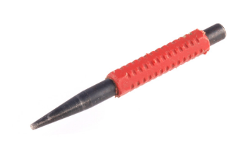 | nail punch | Nail punches are used to punch nails below the surface of the timber. This is for aesthetic reasons when filled with wood putty and to protect the sharp edges of tools such as planes and chisels.
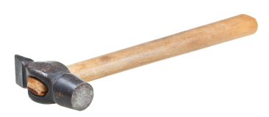 | warrington hammer | Sometimes called a cross pein hammer, this is a general woodworking hammer. The cross pein is useful when starting small nails.
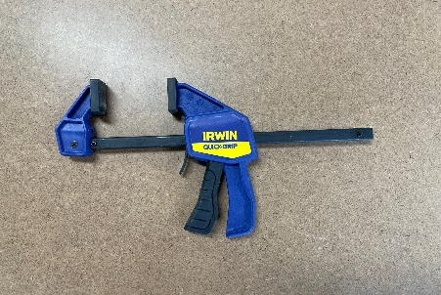 | quick release F cramp | This is many students’ favourite cramp as it is quick to use, however, it does not tighten as much as a G cramp.  This is an excellent cramp to secure work pieces when using hand and power tools.
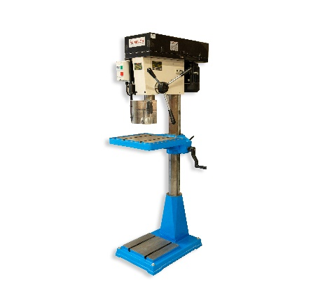 | drill press | An accurate drill with variable speed that can be used to drill holes, large and small with bits such as twist and Forstner.
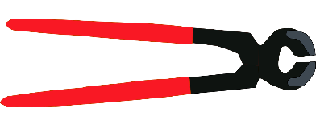 | pincers | Pincers use the power of a lever to remove nails. This is a great tool for removing bent nails.
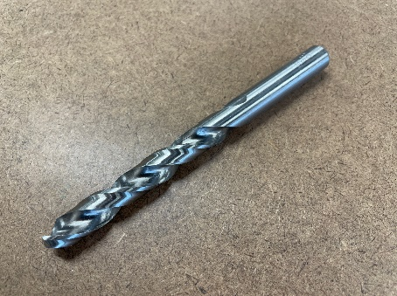 | twist drill bit | A drill bit for general use, this can create a variety of hole sizes, depending on the bit size.
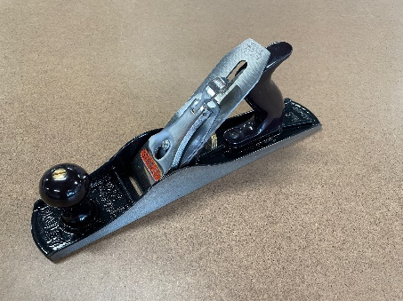 | jack plane | A general-purpose plane that can be used to plane timber to width and create some decorative edge treatment such as chamfers.
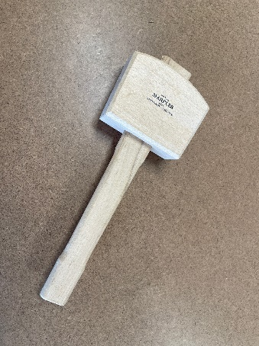 | wooden mallet | A mallet is used to apply controlled force for driving chisels, assembling joints, and setting dowels without damaging the wood.
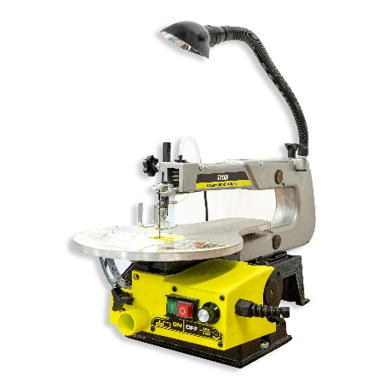 | scroll saw | The small reciprocating blade of the scroll saw is ideal for cutting curves in relatively thin pieces of timber.
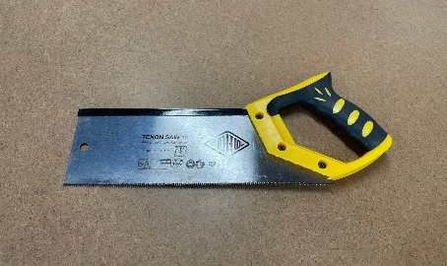 | tenon saw | A fine-toothed, backsaw used for making precision cuts in woodworking, especially for cutting tenons (projections on the end of a piece of wood for joining).
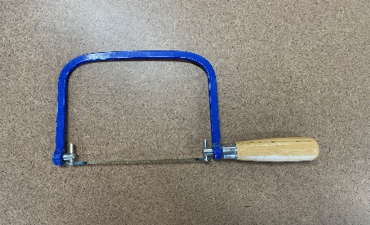 | coping saw | A small, thin-bladed saw used for making intricate cuts and curved shapes in wood. It is commonly used for detailed woodworking tasks like cutting out patterns or trimming.
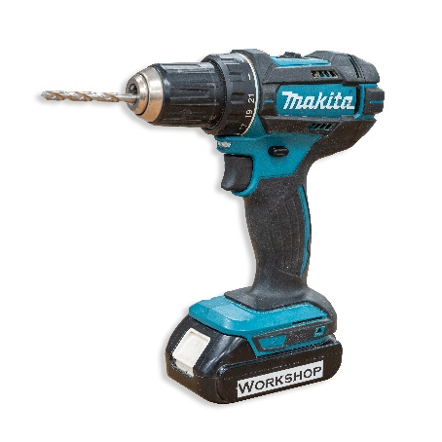 | cordless drill | A versatile power tool used for drilling holes in various materials, including wood, metal and plastic. With the right attachments, it can also be used for driving screws and other fasteners.

The design and production process
Throughout Technology 7–8, you will follow a design and production process, which is a continuous cycle used to develop your projects. In this unit, we will focus on timber-based solutions. You will document your design and production processes in this workbook and your BBQ caddy assessment folio throughout the unit.
There are 4 main steps in the process that help to create a quality solution to design challenges or problems. Evaluation happens at each step and is constant throughout the process.
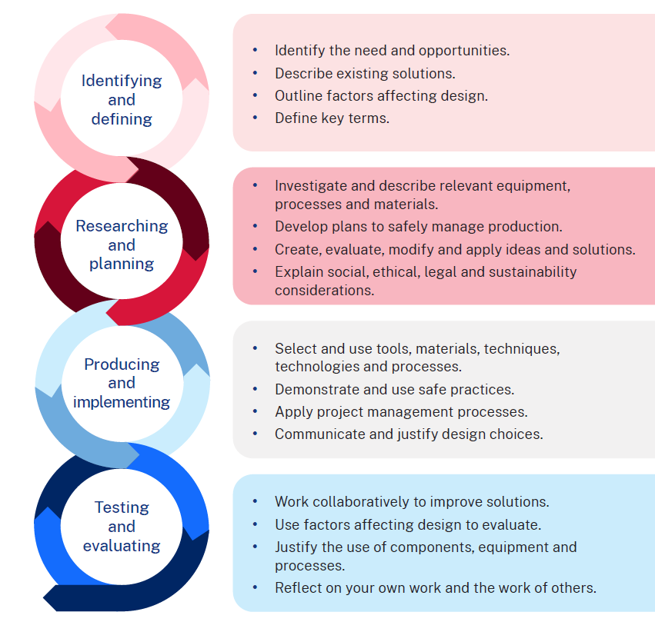

Factors affecting design
There are many factors that affect design. These must be considered when creating a product, system or solution to ensure the success of a project. By carefully considering these factors during the design process, designers, producers and manufacturers can create more effective and efficient solutions. Factors affecting the success and quality of designs include accessibility, aesthetics, durability, ergonomics, ethics, functionality and safety.
Briefly describe each term around the diagram below.
Note: suggested answers are provided on the following page.
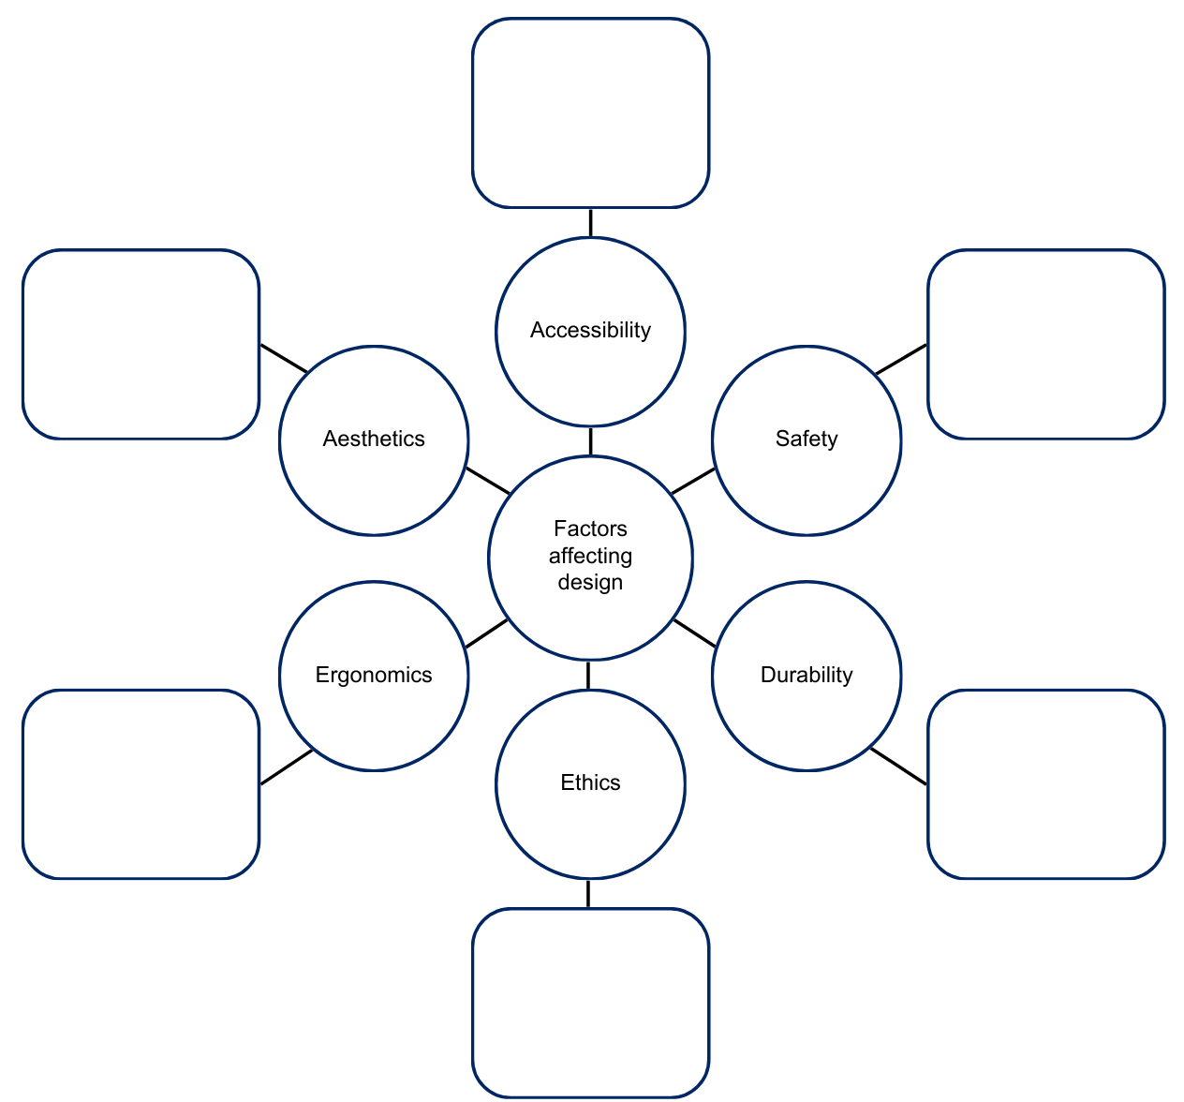

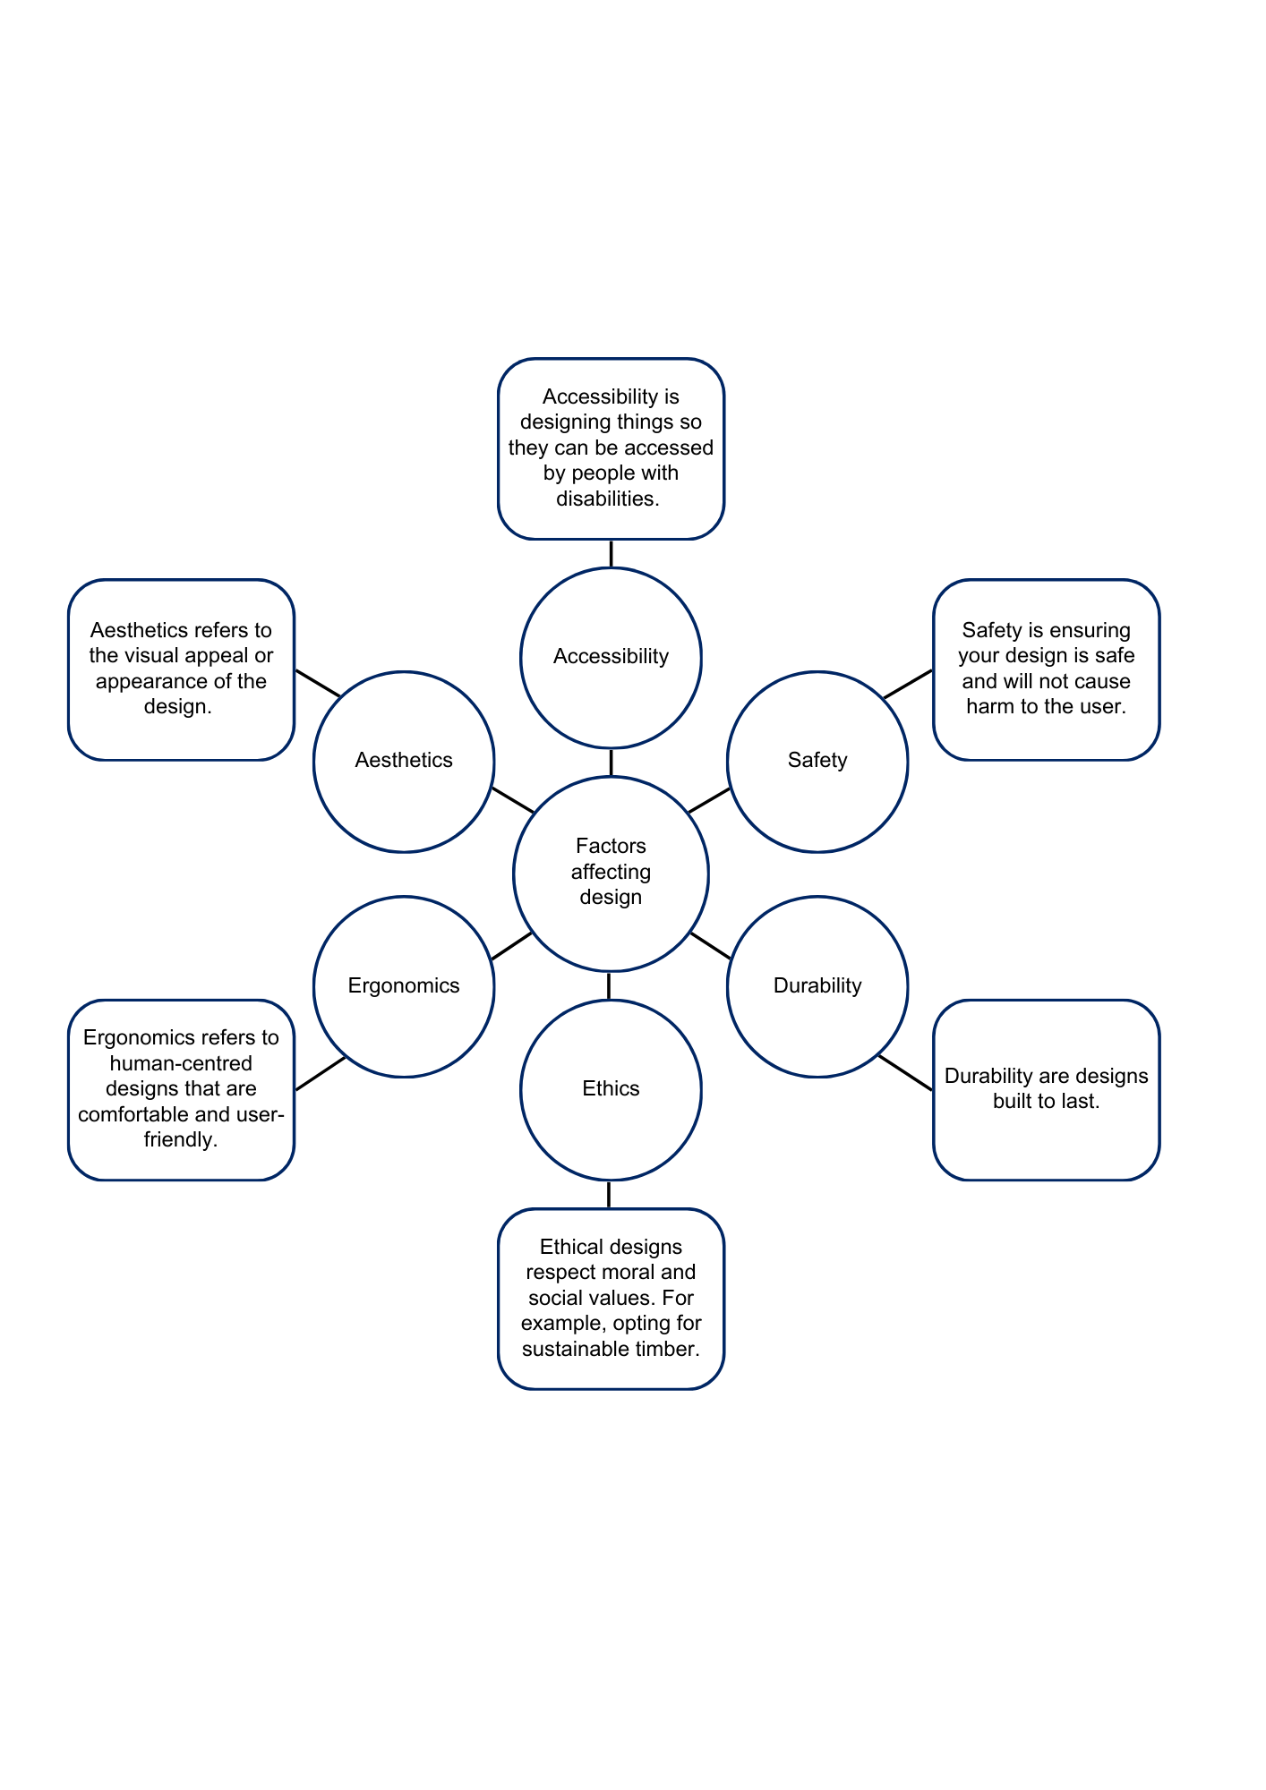

Designer – furniture maker
Watch Designer, Furniture Maker (Episode 87) (4:47). Answer the following questions in the spaces provided.
Note: sample answers provided.
- How does Judson start his day?
Checking emails from clients and drawing for hour. Then he meets clients and they tell him what they’re looking for.
- Judson says ‘A career in woodworking can take you in all different directions’ – list 3 directions it can take you.
Tradeshow, storefronts, signage
- True or False – Judson creates cheap, fast-fashion timber pieces designed to last a season and be replaced. Explain your response.
False. Judson creates high-end pieces he hopes will be passed down for generations.
- How does Judson describe the pieces he creates for his clients?
He creates pieces for clients that they’ll live with for a long time – they are heirlooms. Each piece is timeless and unique.
- Woodworking is a career with a lot of opportunities for growth. List some possible careers Judson mentioned.
Joiner, fabricator, entrepreneur, factory worker or designer and producer of displays, office spaces, store fronts and signs.
- What is Judson’s adrenaline rush?
Building something from start to finish and delivering to the client and they’re happy. Coming up with a brand new original unique Judson Beaumont design.

Timber designer case study
Research a designer in the Australian timber industry who resonates with you. It could be a woodworker or furniture maker who is also:
- sustainable: someone who considers the environmental impacts and incorporates this into their work
- Aboriginal: someone who values and respects Aboriginal and Torres Strait Islander designs, materials and crafting techniques and who embodies culture in their work
- emerging or innovative: someone who thinks outside the box and designs unique and unusual products
- female: someone who is making change in a male-dominated industry and carving their way with quality products
- inspiring: an Australian designer doing amazing things in this diverse industry who inspires you.
Create a fact sheet on the design of your choice. Use the following headings:
- Who and what
- Name of the person or business and who they are and what their work represents.
- What has made them successful?
- The designers work
- Describe the products, techniques, materials and/or systems they use. Be specific about the designs, techniques and materials used and how they are used. Explain the design process they follow and makes their work unique. Include annotated images.
- Impact of their work
- Explain the impact of their work. Consider how they contribute to ethical or sustainable design and/or their impact on society.

Note: see below for a list of possible designers.
Category | Possible designers
Sustainable | - Bombora Custom Furniture
Aboriginal | - Madji Indigenous Furniture  - Manapan
Emerging/ Innovative | - e9design
Female | - Victorian Woodworkers Association  - Heartwood Timber Designs

Measurement
Measure each object to the nearest millimetre with the ruler shown and provide your answer in the space provided.
Note: answers provided.
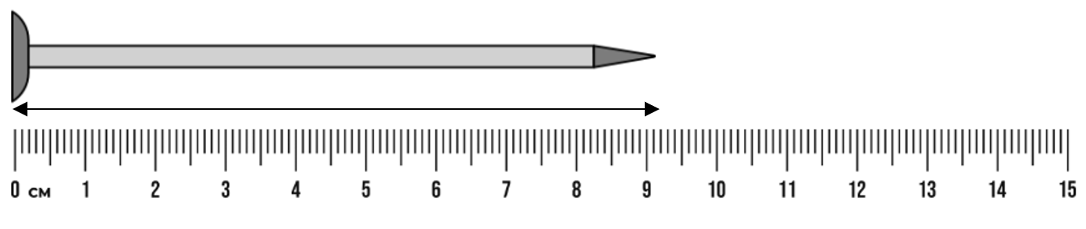
903 mm
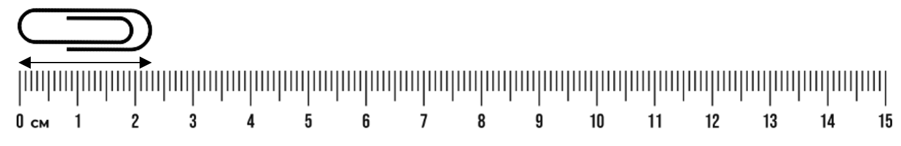
23 mm
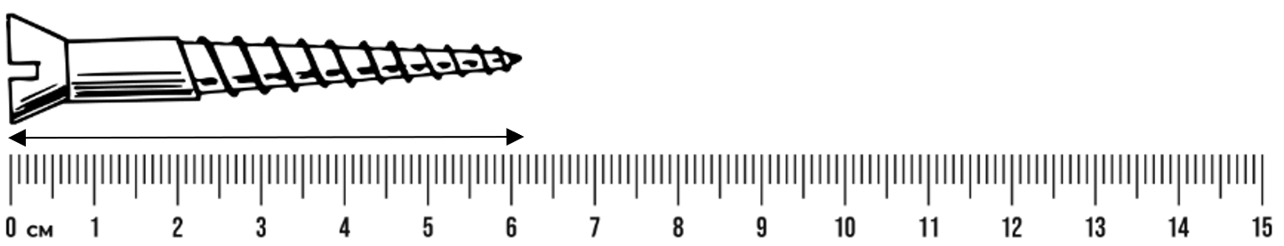
62 mm

FEWTEL
The acronym FEWTEL helps you remember the correct order for processing wood into a finished, usable product. By following this sequence, you handle the wood more efficiently, save time and reduce the risk of accidents.
Acronym | Description | Process
F | Face side | Select and mark the face side.
E | Face edge | Select and mark the face edge.
W | Width | Check and cut timber to width.
T | Thickness | Check and plane timber to desired thickness.
E | Square end | Square one end.
L | Length | Measure and mark length.
Using the FEWTEL process, mark out the piece of timber below into 4 equal pieces. You may have an offcut of up to 20 mm. Remember to check that each end is square.
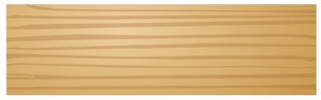

Measurement in the workshop – skill tester
Your teacher will provide a range of timber samples labelled with a letter. Using a metal rule, measure the length, width and thickness of each piece and write your answers in the table below. Check with your teacher to see if you were correct.
Piece | Length (mm) | Width (mm) | Thickness (mm)
A
B
C
D
E
F
G
H

Joining timber
When we make things, some methods alone won’t hold materials together securely. If we join 2 pieces without extra support, they could easily fall apart. To fix this, we use fasteners to keep them attached. Fasteners can be mechanical, like nails or screws, or chemical, like glue.
There are many types of nails and screws, each designed for different jobs, and we’ll look at them more closely.

Types of screws
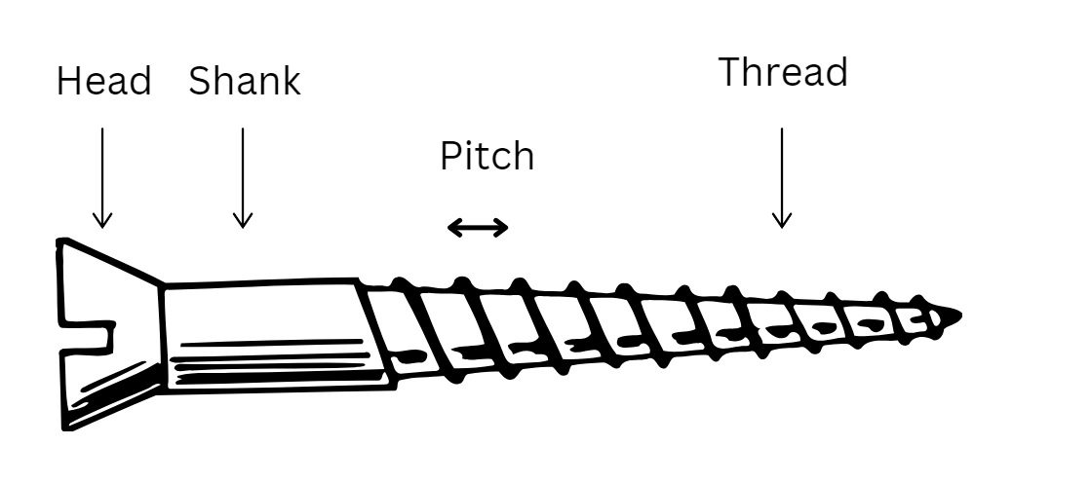
Use the list below to identify and label the images of different screws.
- Sheet metal screw: a short screw with coarse threads and a typically round head, used to fasten sheet metal or other thin materials.
- Drywall screw: features a bugle-shaped head and a thin shank, designed specifically to secure drywall to studs, but often serves as a versatile screw.
- Wood screw: usually has coarse threads and a pointed tip that cuts into the wood to form its own threads.
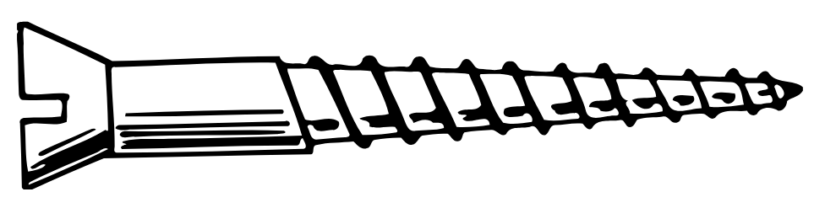
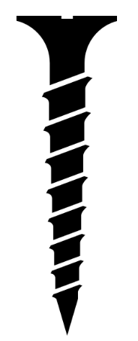
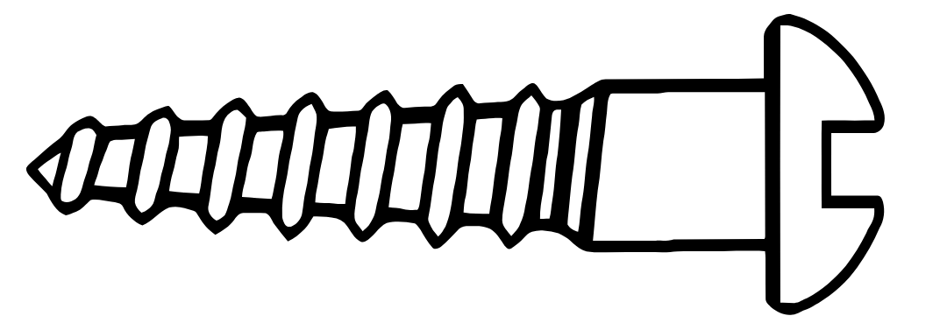

Screw head shapes
Use the list below to identify and label the images of different screw head shapes.
- Flat head
- Round head
- Pan head
 |  | 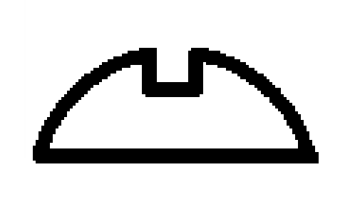

Types of screw heads
Use the list below to identify and label the images of different screw head types.
- Phillips head
- Square head
- Allen head
- Slotted/Flat head
 |  |  | 

Types of nails
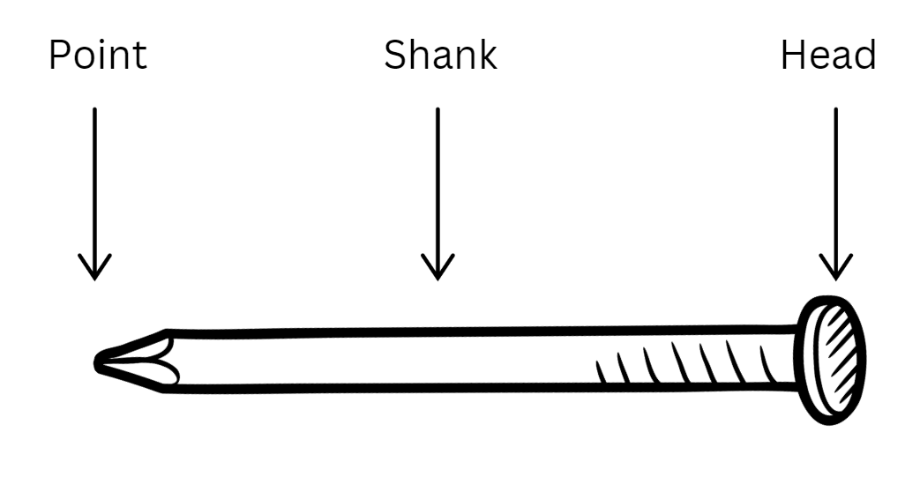
Use the list of nails below to label the images of screws in the table.
- Common nail: as a large, flat head and is used for general purposes.
- Finishing nail: features a small barrel-shaped head and a thin shank, designed to be driven below the surface and concealed with putty.
- Screw nail: has a flat head and a spiral shank that twists like a screw when driven in.
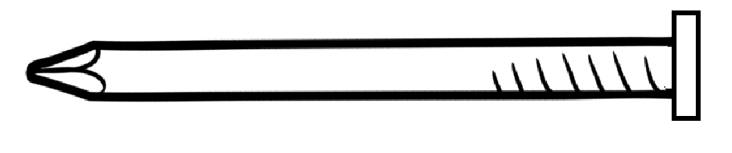 | 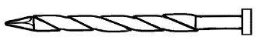 | 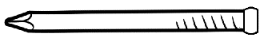

Woodworking joints
Complete the table below to outline these common woodworking joints.
Joint | Name | Common applications | Other names
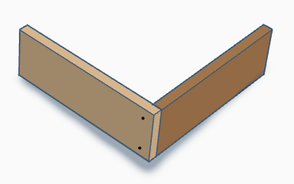
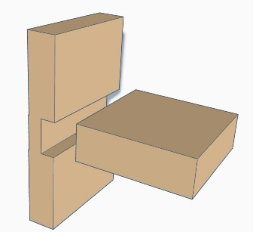
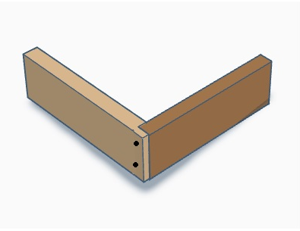

Types of timbers
Softwoods and hardwoods are used by designers, producers and manufacturers for specific purposes.
In the space below, outline the differences in structure between hardwoods and softwoods.
Note: suggested answers provided.
Feature | Hardwoods | Softwoods
Physical Properties | Denser, harder, more durable | Lighter, softer
Fibre Structure | Higher density of longer, thicker-walled fibres | Fewer, shorter, less dense fibres
Growth Rings | More irregular and varied in size | More uniform and distinct
Types

Properties of timbers
Complete the tables below, outlining the properties and characteristics of the different types of timber.

Radiata pine
Properties and characteristics | Answer
Botanical name
Other common names
Tree description
Timber colour
Grain and texture
Density
Durability
Sustainability
Uses

Jarrah or Tasmanian oak
Properties and characteristics | Answer
Botanical name
Other common names
Tree description
Timber colour
Grain and texture
Density
Durability
Sustainability
Uses

Sustainability

Renewable and non-renewable resources
Write a description of what is meant by the following terms.
Term | Description
Resource
Natural resource
Renewable natural resource
Non-renewable resource
Resource management
Harvesting
Logging
Discuss why wood is a sustainable building material.

Sustainable timber sourcing
Watch Sustainable Wood from Sustainable Forests (15:35).
Compare traditional timber sourcing practices with sustainable timber sourcing practices. Use Canva or Adobe Express to create an engaging poster or informative fact sheet.
Words which could assist in your resource:
- conservation
- deforestation
- reforestation
- plantations
- agroforests.
Websites and webpages which could assist include:
- The importance of Australian sustainable timber
- Forester Time with Gavin Livingston: Forestry 101. Managing today's forests for tomorrow's generations – Forest Learning
- Responsible Wood

Aboriginal and Torres Strait Islanders peoples materials, products and systems
Note: consulting with Aboriginal and/or Torres Strait Islander communities is essential to the development of meaningful Aboriginal and/or Torres Strait Islander Histories and Culture embedded across the curriculum. Aboriginal and/or Torres Strait Islander peoples are the owners and custodians of their knowledge and cultures and should be consulted when aspects of Aboriginal and/or Torres Strait Islander Histories and Cultures are being incorporated into the school curriculum. If you want to establish an authentic relationship with Aboriginal communities, you should understand local community protocols and engage with the community respectfully and authentically (see Getting to know local Aboriginal and/or Torres Strait Islander Histories and Cultures). Remember that any information shared by Aboriginal and/or Torres Strait Islander peoples remains their intellectual property.
The learning activities that follow have been sourced from public-facing materials available online.

Materials
Aboriginal and Torres Strait Islander Peoples used a variety of tools, utensils and weapons as they hunted, fished and gathered foods. Some technology was simple with the item being made, used for its purpose and then thrown away. Other items needed more complex methods of making them, like heat and pressure to set sap, and fibres to determine the shape, flexibility and durability of the item.
Australia contains many different climates and environments, but the basic pattern of Aboriginal life was the same. Small groups moved with the seasons over their territory. All the tools, utensils and weapons made by Aboriginal people were adapted to the environment in which they were used. They were developed over many generations and made from readily available materials.
In the space below, list materials used by Aboriginal and Torres Strait Islander Peoples.
Suggested answer:
Stone, wood, bark, vine, plant fibre, resin, shells, hair, sinew, bones, teeth, ochre
Important materials not found in local areas were traded, exchanged or given as gifts.

Aboriginal and Torres Strait Islander innovations
Using reading strategies, read and discuss the following articles.
- Yandi (coolamon) fact sheet (PDF)
- 13 Indigenous innovations that are truly amazing

Tools and equipment
Aboriginal and Torres Strait Islander people invented many tools, pieces of equipment and technology to use in everyday life. This technology was made using natural resources in highly creative ways.
Use the resources listed below to complete the table. Try to include items made from timber.
- Aboriginal Plant use and Technology
- Tools & Technology – Deadly Story
Tool or equipment (name and picture) | Description of use

Aboriginal art and symbols
Note: read the notes within the program regarding Aboriginal art before completing this activity.
Aboriginal art is vibrant, diverse and carries important cultural meaning. Throughout time, it has been used as a mode through which knowledge and stories are passed down through the generations. When you look at Aboriginal art, you will see that symbols are often used and their meanings and ways of depicting them vary greatly across nations. Examples of symbols engraved or painted on rock art sites show a record of the use of these marks for tens of thousands of years.
Read: Understanding symbols in Aboriginal art – Red Kangaroo
Research: Where is the local place of yarning for Aboriginal people in your local area?
Teacher sample: NSW Government declaration to protect cultural significance of Aboriginal ceremonial site – City of Newcastle (local sacred site in Newcastle NSW).
Create your own symbols as a form of communicating a local space that is important to you below.

Indigenous Cultural and Intellectual Property (ICIP)
What is our ethical responsibility with Indigenous Cultural Intellectual Property (ICIP)?
Sample answer:
It is essential to respect ICIP rights, ensuring that traditional knowledge and cultural expressions are protected and that Aboriginal communities maintain control over their cultural heritage.

Investigate fake Aboriginal art
Read First Nations artists and souvenir sellers back crackdown on fake Indigenous art and identify important issues and actions raised in the article in the space below.
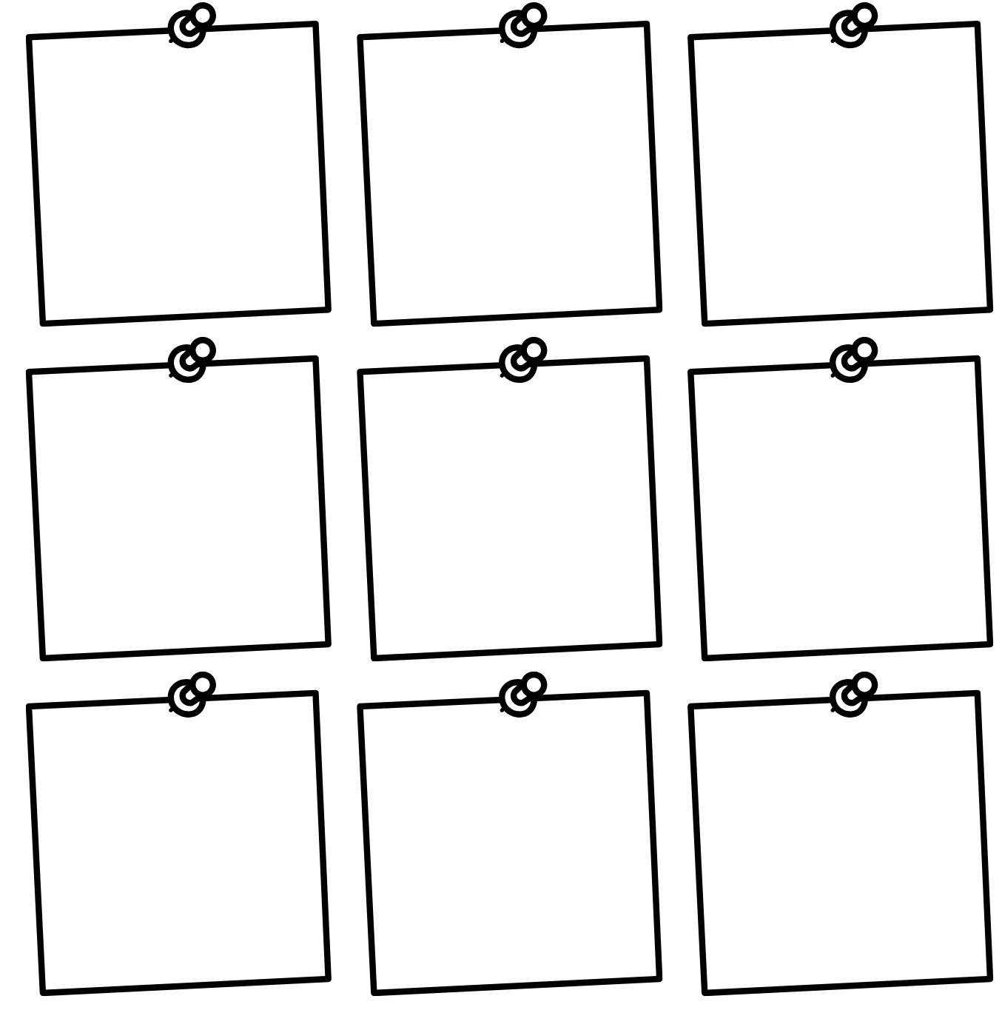
Do now
A company wants to use a traditional Indigenous design for a range of outdoor equipment. What should the company do to respect ICIP?

Surface finishes
Finishing timber is essential for enhancing its durability, protecting it from environmental factors, improving its aesthetic appeal and ensuring ease of maintenance. These benefits contribute to the longevity and performance of wooden products in various applications.
Protection from environmental factors
- Moisture resistance: finishing helps seal the wood, preventing moisture absorption that can lead to warping, swelling or decay.
- UV protection: many finishes contain UV inhibitors that protect the wood from sun damage, preventing fading and degradation over time.
- Hygiene: as natural timber is porous, it is often vital for reasons of hygiene that it be sealed.
Durability
- Wear resistance: a good finish increases the durability of the timber surface, making it less susceptible to scratches, dents and abrasion.
- Chemical resistance: finishes can protect wood from spills and stains caused by chemicals, oils and other substances.
Aesthetics
- Appearance: finishing can enhance the natural beauty of the wood, bringing out its colour, grain and texture.
- Variety of finishes: different types of finishes (such as stains, varnishes or oils) allow for various visual effects and styles, catering to design preferences.
Ease of maintenance
- Cleaning: finished surfaces are generally easier to clean and maintain than raw timber, as they repel dirt and grime.
- Longevity: regularly finished surfaces can last longer, reducing the need for frequent repairs or replacements.

Preventing pests and fungi
- Insect resistance: some finishes can deter pests, such as termites or wood-boring insects, from damaging the timber.
- Fungi protection: finishes can also inhibit the growth of mould, mildew and fungi which can compromise the integrity of the wood.
Structural integrity
- Stability: properly finished timber is less prone to cracking or splitting, which helps maintain its structural integrity over time.

Finishes
Complete the sentences by using words from the word bank below.
Word bank
scratches | shelf | durable | thinner | steam
apply | sunlight | flaking | flexible | use
The ideal finishing material should possess the following qualities:
- It should be hard, _________________ and resistant to _________________.
- _________________ and elastic; resistant to cracking with timber movement.
- Able to withstand exposure to _________________ and weathering.
- Resistant to water and _________________.
- Pre-mixed, ready to _________________ and easy to _________________.
- Inexpensive, readily available and able to be reduced with a common _________________ such as water or turpentine.
- Non-toxic, heat resistant and have a long _________________ life
- Able to be re-coated without _________________.

Types of finishes
There is a range of finishes that can be applied to timber, including oil, wax, varnish, lacquer, stain, paint and water-based finish. Provide a description and common use for each of the listed finishes in the table below.
Note: sample answers provided.
Type of finish | Description | Common uses
Varnish | A clear, hard finish that protects the wood. | Furniture and floors
Oil | Natural oils penetrate the wood, enhancing its grain. | Furniture, cutting boards, and decorative items
Stain | A coloured finish that changes the wood’s colour while showing the grain. | Enhancing the appearance of wood before applying a topcoat
Lacquer | A fast-drying finish that creates a hard, high-gloss surface. | Furniture and cabinetry
Shellac | A natural resin that provides a warm, amber tone. | Fine furniture and antiques
Wax | A soft finish that gives a low-sheen surface and enhances the wood’s look. | Furniture and decorative items; requires regular maintenance
Water-based finish | A finish that uses water as the solvent, less toxic and quick-drying. | Indoor furniture and floors

Consider how and where your BBQ caddy will be used. What finishes would be suitable for your project? Give a brief explanation for your choice.

Preparation for surface finishing
The quality of a finish on wood depends a lot on how smooth and clean the wood surface is before you apply it. Clear finishes, like varnish or lacquer, can make any scratches or marks on the wood more noticeable. This is why it’s important to prepare the wood surface properly before putting on the finish. Taking the time to make the surface nice and smooth will help ensure that the final look is great. The following procedure should be used.
Write a description of each step for preparing a surface for either a clear or opaque finish in the spaces provided.
Step | Description
Cleaning up | Removing pencil marks and excess glue
Removal of dents | Using the iron and possibly wood filler
Initial use of abrasive paper
Final use of abrasive paper
Application of finish

Mini folio

The sign
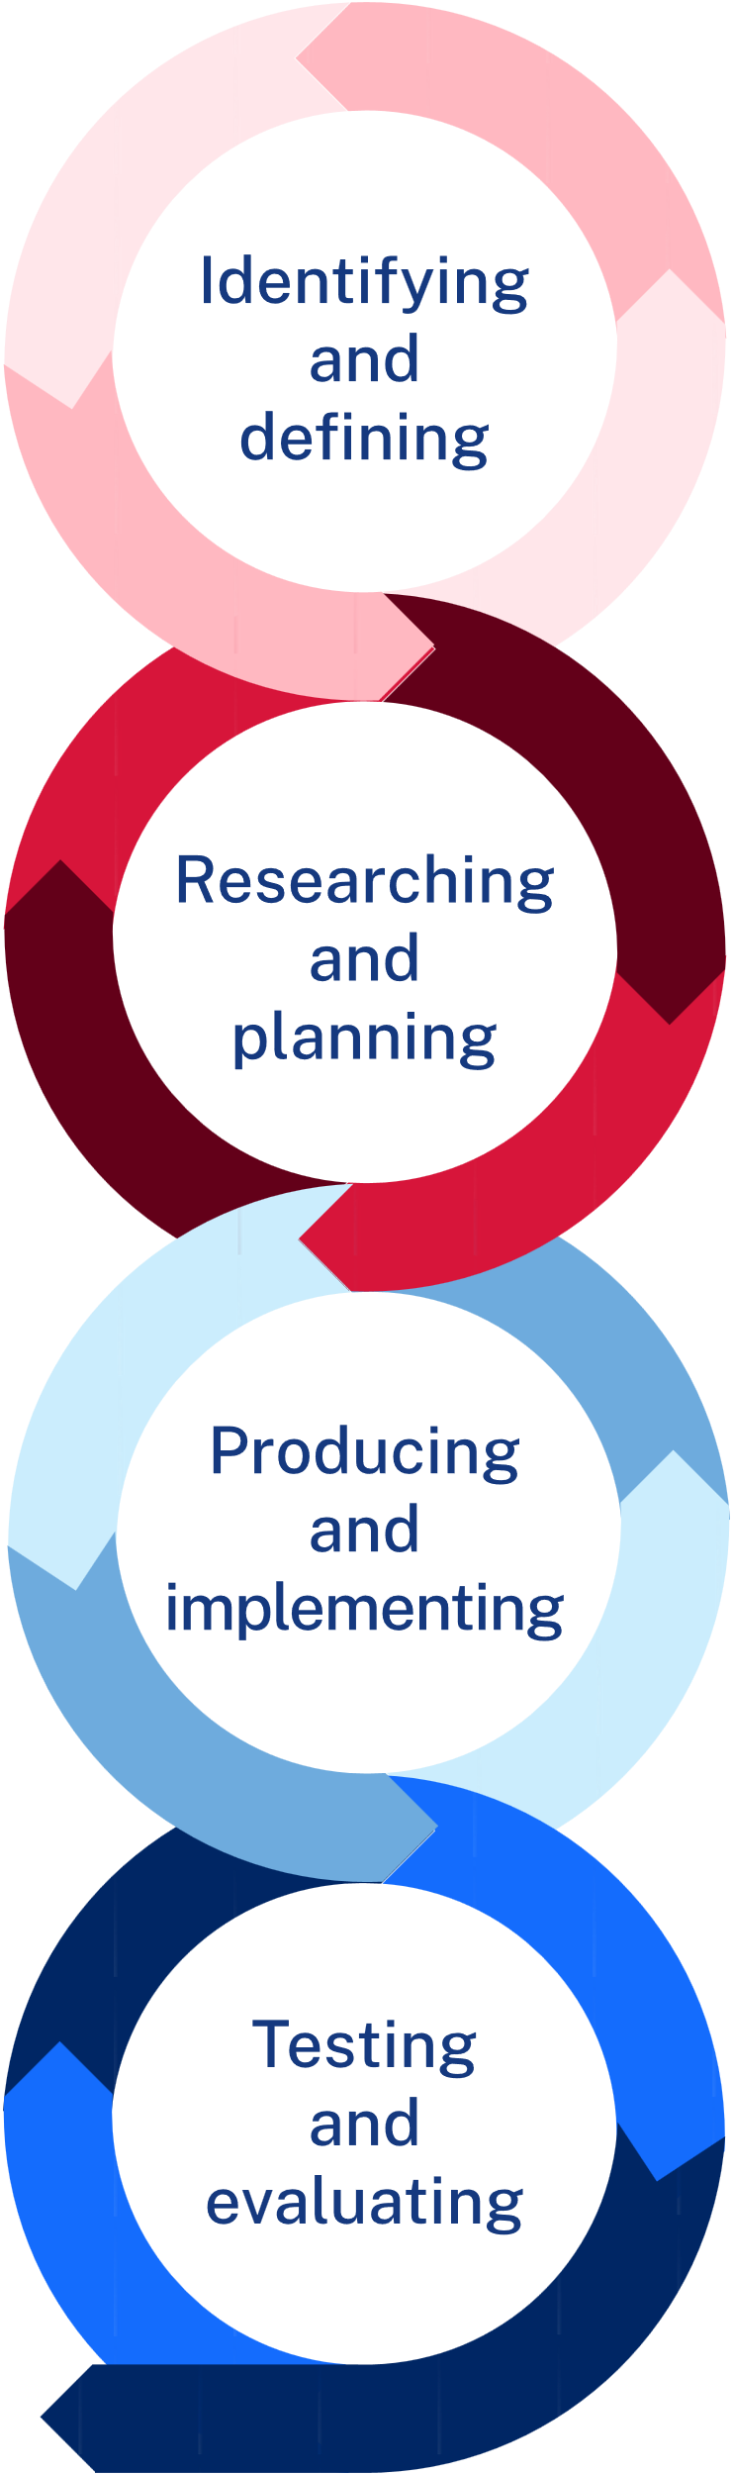

Design brief
Create a custom door sign from radiata pine, featuring a graphic or logo along with a title or name. The sign should include a chamfered edge and at least one aesthetic enhancement such as wood burning, colour and/or laser print transfer. The final product should be finished to ensure durability and a polished appearance.

Limitations
You have 4 lessons. The width and length will largely be determined by the material and your teacher. Keep your design simple to ensure you have adequate time to complete it.
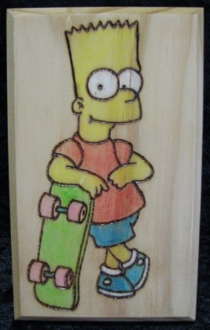
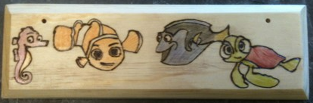

Design ideas
Roughly sketch 2 design ideas. Experiment with logo design, font size and style and/or transfer of graphics or pictures which inspire you. Annotate each design to describe your choices.

Design idea 1
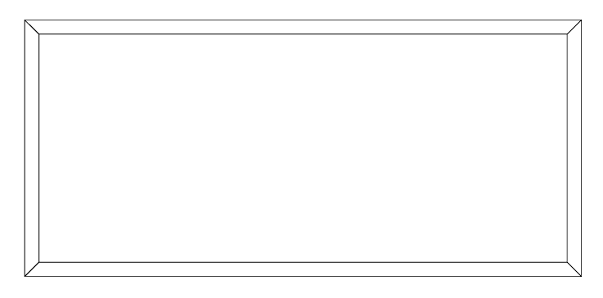

Design idea 2

Final idea
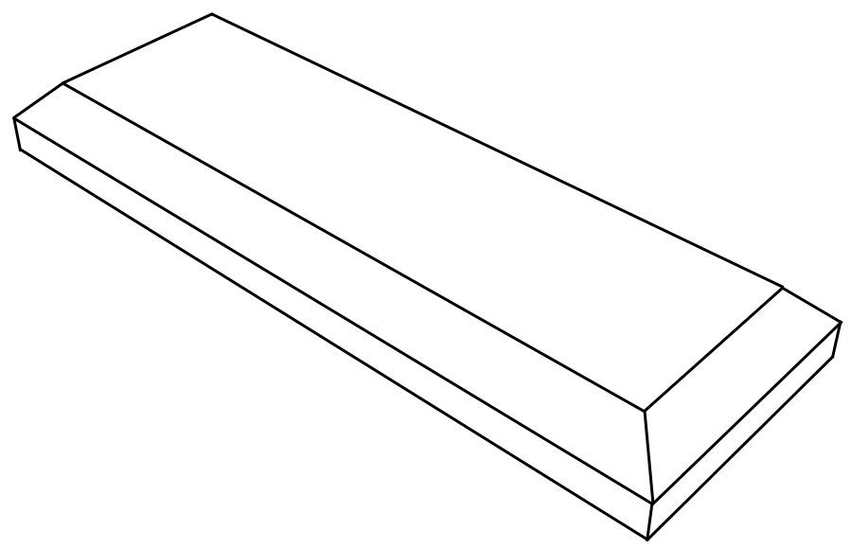
Justification
Which design have you selected and why? Consider the design brief and limitations in your response below.

Working drawing
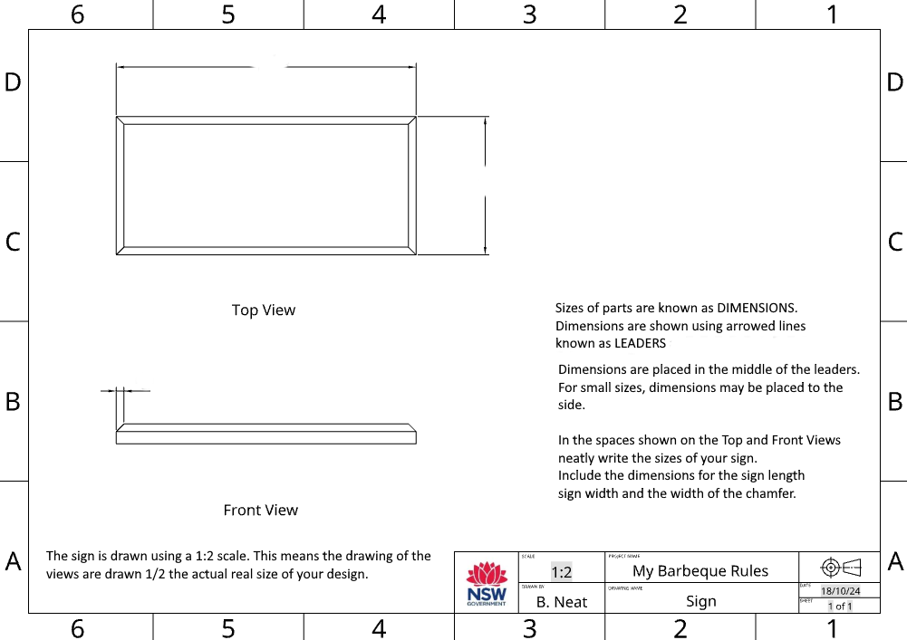

Evaluate
Does your project satisfy the design brief? Are you happy with your project? Explain in the space below.

Skill development

I see, I think, I wonder
Your teacher will demonstrate the use of new tools, techniques and machinery. When prompted, record your thoughts about what see, what you think will happen and what you wonder about the result. Were your initial thoughts confirmed or did something different happen? Why?
Note: sample answers provided.
  I see |   I think |   I wonder
I see a piece of scrap timber and a tool called a plane. The teacher has marked out with a pencil where the chamfer edge will go. | I think the plane might dig into the timber or I think the plane might fall off the pointed edge of the timber. | The timber ribbons were cool. I wonder how I will make the chamfer edge even and not wider at one edge from the other on my project.

Project management – BBQ caddy
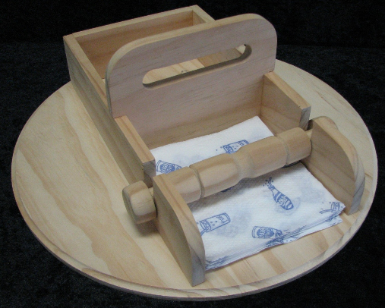

Working drawings
Working drawings are detailed and precise drawings used in the construction and manufacturing of a product or structure. They provide essential information that guides builders, engineers and manufacturers in creating the design as intended.

Key features of working drawings
- Detailed specifications – they include specific measurements, materials and construction methods necessary for building or assembling the product
- Multiple views – working drawings often show different views of the object, such as top, front, side and isometric views to give a complete understanding of its shape and structure
- Dimensions and annotations – they include dimensions (sizes) and notes that explain how parts fit together, how they should be installed and any other important details
- Scale representation – working drawings are usually created to scale, meaning that the dimensions on the drawing are proportional to the actual size of the object

Purpose of working drawings
- Guidance for construction – they provide clear instructions for builders and contractors on how to construct a building or product accurately
- Communication tool – working drawings communicate the designer's intentions to all stakeholders involved in the project, ensuring everyone is on the same page
- Quality control – they serve as a reference for checking the quality and correctness of the work during construction or manufacturing
- Planning – working drawings help in planning the order of operations, estimating costs and determining the materials needed

Working drawings for the BBQ caddy
The drawing below shows a pictorial view of the finished project. A pictorial refers to a drawn picture of the object showing 3 dimensions and the style used here is known as an isometric view. It also includes 2 dimensional orthogonal or orthographic views. These views include top, side and end views. Generally, the number of views you need in a drawing depends on how much detail you need to build the project. Some projects require only 2 views.

Pictorial drawing
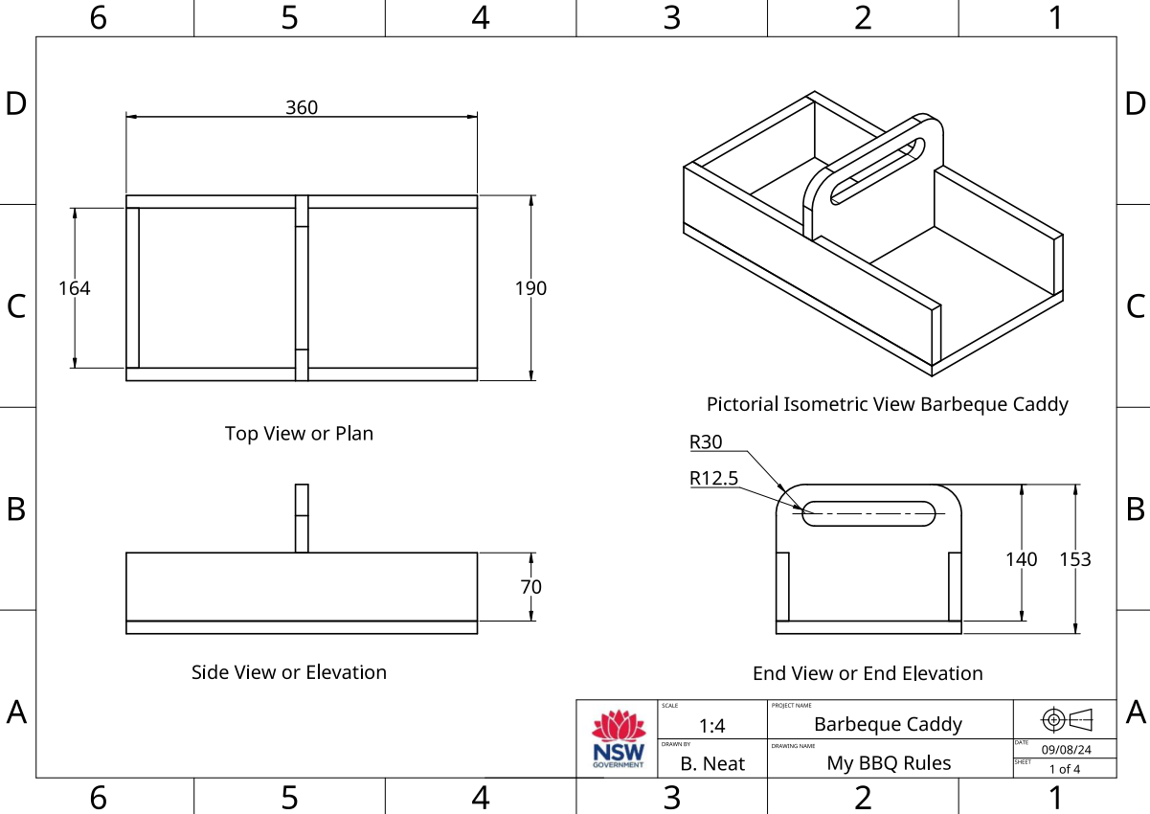

Orthogonal drawing
The following drawing, an orthogonal or orthographic drawing, presents more information about the individual parts of the project. The scale used in both drawings is 1:4. In other words the parts are drawn a quarter of the actual size of the parts.
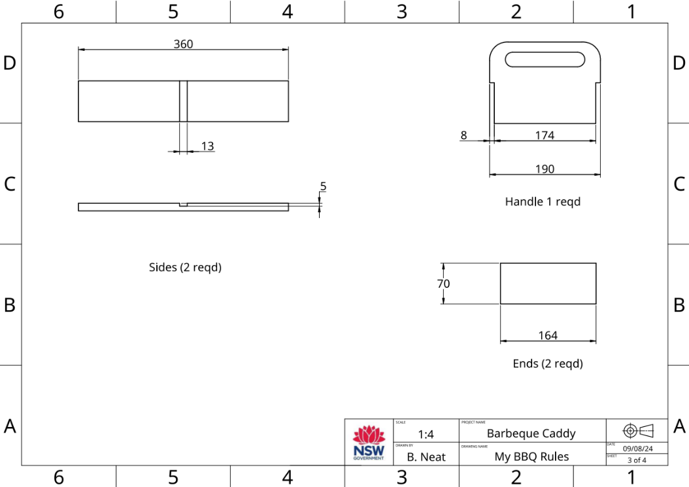
The next orthogonal (orthographic) drawing of the handle is drawn at a scale of 1:1. In other words, the drawing is drawn at the same size as the final part. 1:1 scale can be used as a template to mark out your actual part.
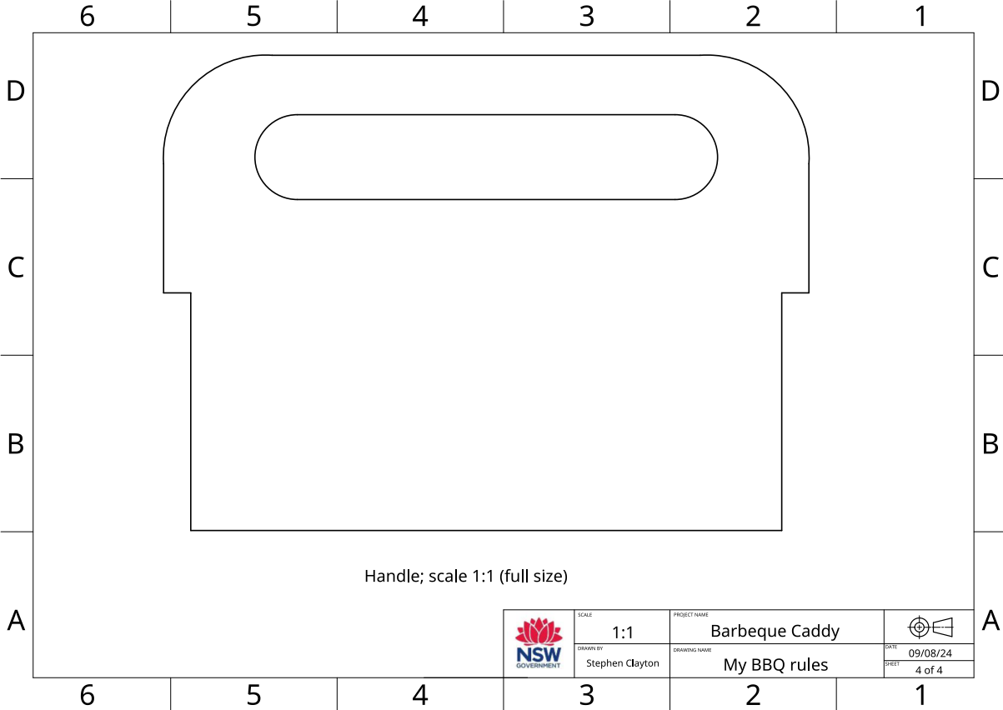

Time management
Time management is the planning we do to make sure our project is completed in the time we have available. When we are planning the time management for this project, we need to look at the time we have available and the tasks we need to do to complete the project.
Time available
Question | Answer
How many weeks do we have available to make the BBQ caddy?
How many practical lessons do we have in a week?
How many practical lessons do we have to complete the BBQ caddy?
What tasks do we need to do and how long will they take?
In the space below, create a list of steps in production.
Suggested answer:
- Prepare drawings
- Mark out and cut sides and ends
- Mark out and cut handle
- Mark out and cut housing joints
- Mark out and cut halving joint
- Mark out, drill and cut out napkin holder recess
- Design and make the napkin weight
- Glue, nail and clamp caddy together
- Attach base and plane to size
- Prepare and apply finish
In the table below, estimate in hours how long each step will take.
Step | Estimated time  (in lessons)
Prepare drawings
Mark out and cut sides and ends
Mark out and cut handle
Mark out and cut housing joints
Mark out and cut halving joint
Mark out, drill and cut out napkin holder recess
Design and make the napkin weight
Glue, nail and clamp caddy together
Attach base and plane to size
Prepare and apply finish
Use this information to inform the time management section of your folio.

Cutting list
The cutting list describes to the builder the type of material to be used, the dimensions of the material, the number of parts, the name of each part and other information relevant to the manufacture of the project. It is presented as a table. Complete the table below for your project.
No. | Description | Qty | L mm | W mm | T mm | Material | Notes (joinery methods used)

References
This resource contains NSW Curriculum and syllabus content. The NSW Curriculum is developed by the NSW Education Standards Authority. This content is prepared by NESA for and on behalf of the Crown in right of the State of New South Wales. The material is protected by Crown copyright.
Please refer to the NESA Copyright Disclaimer for more information https://educationstandards.nsw.edu.au/wps/portal/nesa/mini-footer/copyright.
NESA holds the only official and up-to-date versions of the NSW Curriculum and syllabus documents. Please visit the NSW Education Standards Authority (NESA) website https://educationstandards.nsw.edu.au/ and the NSW Curriculum website https://curriculum.nsw.edu.au/.
Technology 7–8 syllabus © NSW Education Standards Authority (NESA) for and on behalf of the Crown in right of the State of New South Wales, 2023.
Archae-aus, 2024, Yandi (coolamon) fact sheet (PDF), Archae-aus, accessed 19 November 2024.
Australian National Botanic Gardens Education Services (2020) Aboriginal Plant use and Technology [PDF 376 KB], Australian National Botanic Gardens Education Services, accessed 19 November 2024.
Bombora Furniture (2024) About Bombora Custom Furniture | Recycled Timber Furniture & Custom Wooden Cabinetry, Bombora Custom Furniture website, accessed 19 November 2024.
City of Newcastle (6 July 2022) 'NSW Government declaration to protect cultural significance of Aboriginal ceremonial site', City of Newcastle, accessed 19 November 2024.
Deadly Story (2023) 'Tools & Technology', Science, Technology & Engineering, Deadly Story website, accessed 19 November 2024.
Devow D (6 October 2017) '13 Indigenous innovations that are truly amazing', Téa&Belle Collective, accessed 19 November 2024.
e9design (4 July 2023) 'The E9 Design Story: Sustainable Australian Furniture Using Technology', e9design, accessed 19 November 2024.
Forest Learning Limited (FWPA) (n.d.) 'Forester Time with Gavin Livingston: Forestry 101. Managing today's forests for tomorrow's generations', Resources, Forest Learning website, accessed 19 November 2024.
Heartwood Timber Designs (2020) Heartwood Timber Designs [website] accessed 19 November 2024.
Madji Indigenous Furniture (2024) Madji Indigenous Furniture [website], accessed 19 November 2024.
Manapan (2024) Manapan [website] accessed 19 November 2024.
NSW Department of Education (2024) 'Getting to know local Aboriginal and/or Torres Strait Islander Histories and Cultures', Aboriginal Education and Communities, NSW Department of Education website, accessed 19 November 2024.
Rayonier Inc. (1 October 2021) 'From Trees to Lumber: Watch how boards are made from pine trees' [video], Rayonier Inc., YouTube, accessed 19 November 2024.
Red Kangaroo (2024) Understanding symbols in Aboriginal art, Red Kangaroo website, accessed 19 November 2024.
Responsible Wood (2023) Responsible Wood [website], accessed 19 November 2024.
Responsible Wood (2023) The importance of Australian sustainable timber, Responsible Wood website, accessed 19 November 2024.
Richardson H, Testa C, Lee J (3 February 2023) 'First Nations artists and souvenir sellers back crackdown on fake Indigenous art', ABC News, accessed 19 November 2024.
Thompson R and Dryen D (4 March 2022) 'Beyond Ordinary: Contemporary Women Makers', Victorian Woodworkers Association, accessed 19 November 2024.
WorkBC's Career Trek (11 June 2020) 'Designer, Furniture Maker (Episode 87)' [video] WorkBC's Career Trek, YouTube, accessed 19 November 2024.

© State of New South Wales (Department of Education), 2025
The copyright material published in this resource is subject to the Copyright Act 1968 (Cth) and is owned by the NSW Department of Education or, where indicated, by a party other than the NSW Department of Education (third-party material).
Copyright material available in this resource and owned by the NSW Department of Education is licensed under a Creative Commons Attribution 4.0 International (CC BY 4.0) license.

This license allows you to share and adapt the material for any purpose, even commercially.
Attribution should be given to © State of New South Wales (Department of Education), 2025.
Material in this resource not available under a Creative Commons license:
- the NSW Department of Education logo, other logos and trademark-protected material
- material owned by a third party that has been reproduced with permission. You will need to obtain permission from the third party to reuse its material.
Links to third-party material and websites
Please note that the provided (reading/viewing material/list/links/texts) are a suggestion only and implies no endorsement, by the New South Wales Department of Education, of any author, publisher, or book title. School principals and teachers are best placed to assess the suitability of resources that would complement the curriculum and reflect the needs and interests of their students.
If you use the links provided in this document to access a third-party's website, you acknowledge that the terms of use, including licence terms set out on the third-party's website apply to the use which may be made of the materials on that third-party website or where permitted by the Copyright Act 1968 (Cth). The department accepts no responsibility for content on third-party websites.

