Technology 7–8 –

Materials and production processes (timber) – teacher resource
Boxing clever – my phone stand (10-week unit)

Contents
Teacher support resource and unit overview 3
Glossary 4
What ‘wood’ you know? 6
Tree to timber 7
Timber terms 8
Safety 9
Safety rules in the timber workshop 9
Hazards in the timber workshop 11
TAS safety resources 11
Materials, tools and techniques 12
Timber tools, machines and their use 12
The design and production process 17
Factors affecting design 18
Design considerations for the phone stand 20
Measurement 21
Measurement in the workshop – skill tester 22
Types of timbers 23
Properties of timbers 24
Radiata pine 24
Tasmanian oak 25
Sustainability 26
Renewable and non-renewable resources 26
Joining timber 27
Types of screws 27
Screw head shapes 28
Types of screw heads 28
Types of nails 29
Woodworking joints 30
Aboriginal and Torres Strait Islander peoples’ materials, products and systems 31
Materials 31
Aboriginal and Torres Strait Islander innovations 32
Tools and equipment 32
Indigenous Cultural and Intellectual Property (ICIP) 33
Surface finishes 35
Finishes 36
Types of finishes 37
Preparation for surface finishing 38
Mini folio – phone stand 39
Design brief 40
How I will use my phone stand 40
Decoration 40
Design ideas 42
Justification 42
Project management – phone stand 43
Working drawings for the phone stand 43
Working drawing 1 – box 43
Working drawing 2 – lid 44
Cutting list 45
Time management 45
Construction steps 46
Evaluation 48
References 49

Teacher support resource and unit overview
Note: this resource supports schools’ implementation of the Materials and production processes focus area of the new Technology 7–8 Syllabus. It can be adopted as is or adapted to meet the needs of individual school contexts.
This resource has been presented with some options such as the choice of adding a decoration to the lid and the type of finish.
This unit will introduce students to timber, machinery, tools and equipment through a small project that incorporates a range of production techniques.
Students will develop the knowledge, understanding and skills required to design, manage, plan and produce a high-quality timber product and evaluate its effectiveness.
Note: this resource has been designed to facilitate the ready conversion into a student booklet by removing the answers within the response boxes. Teacher notes (in blue) and sample answers can be deleted before distributing to students.
Refer to Equipment Safety in Schools, Animals in Schools, and Chemical Safety in Schools for current information on safety and safe working practices in Technology 7–8.

Glossary
Note: sample answers are provided in the table below.
Table 1 – glossary
Term | Definition
bench hook | A tool to secure workpieces on a bench during cutting.
butt joint | A simple joint where 2 pieces of wood are joined often end to side.
countersunk screws | Screws designed to sit flush with the material's surface.
disc sander | A machine with a rotating, abrasive disc for sanding surfaces.
dovetail saw | A small saw used for cutting dovetail joints.
end grain | The exposed surface when wood is cut perpendicular to growth rings.
flush | Where adjoining surfaces are level.
grain | The alignment and texture of wood fibres.
jack plane | A woodworking plane used for shaping and smoothing rough sawn timber.
machine vice | A device to hold workpieces securely while drilling.
pedestal drill | A fixed, upright drill for precise drilling.
plywood | A strong, stable wood panel made from glued layers of veneer.
PVA | Common woodworking adhesive, also known as wood glue.
Radiata pine | A versatile, fast-growing softwood used in construction and furniture.
rebate joint | A joint where one piece of wood has a rebate (rectangular portion cut out) to fit another piece.
sliding bevel | An adjustable tool for measuring and transferring angles.
tenon saw | A saw for making fine, accurate cuts.
timber finishes | Coatings applied to wood to protect and enhance its appearance.
timber vice | A clamping device to hold wood securely on a workbench.
try square | A tool for measuring and marking right angles.

What ‘wood’ you know?
Think of 10 things you used in the past 24 hours that were made from timber. They could be small to very large items. Complete the activities below, identifying things you have used that are made from timber. Build on this by adding words to describe timber, for example, how it feels, smells, looks and sounds. Include timber-specific words you know.
What I have used that is made from timber …

Timber looks like … | Timber feels like … | Timber smells like …

Interesting things I know about timber … | What I want to learn about timber …

Tree to timber
Watch From Trees to Lumber: Watch how boards are made from pine trees (8:12).
In the diagram below, briefly outline the steps involved in producing timber from trees.
Note: sample answer provided.
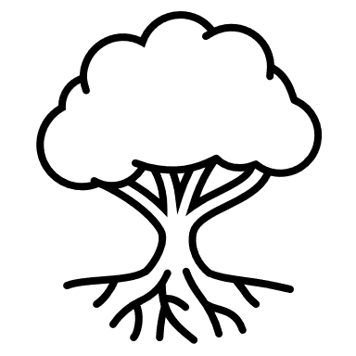
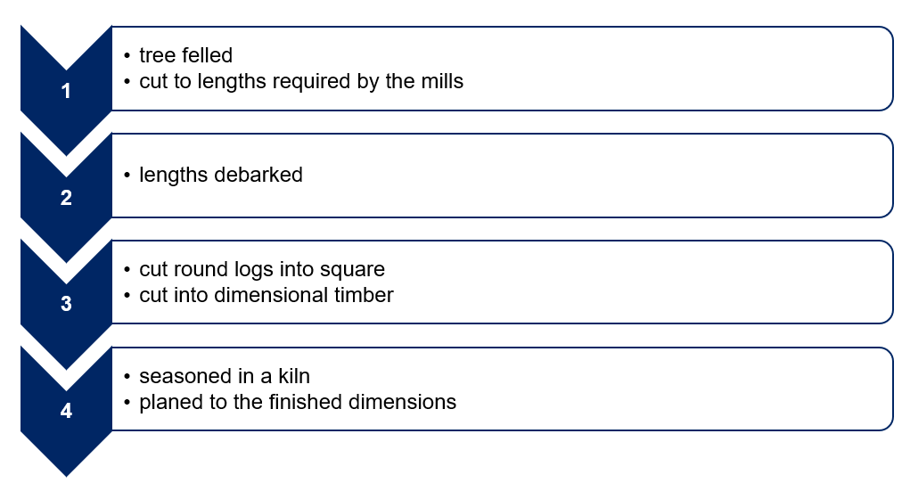

Timber terms
Complete and label the diagram below with the following timber terms (teacher answer provided in PPT).
- Label
- Length
- Width
- Thickness
- With the grain
- Across the grain
- Face
- Edge

Safety
Note: refer to Equipment Safety in Schools, Animals in Schools, and Chemical Safety in Schools for current information on safety and safe working practices in Technology 7–8.

Safety rules in the timber workshop
For each image below, write the safety message for working safely in the timber workshop.
Note: sample answers have been provided.
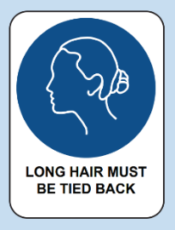 | 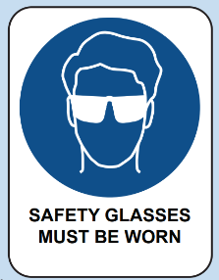 | 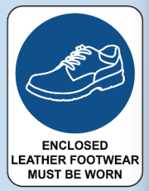
Tie hair back | Wear eye protection | Wear enclosed leather shoes
 |  | 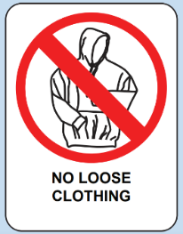
Hazard sign. Chemical Storage Area. | SDS Folder. Provides health and safety information about hazardous substances including first aid. | Remove ties and hoodies or tuck in.
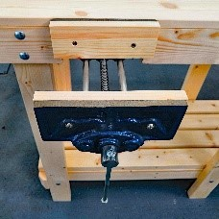 | 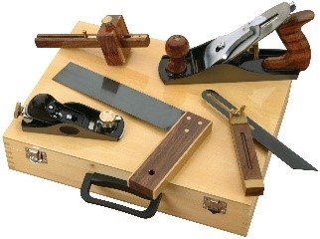 | 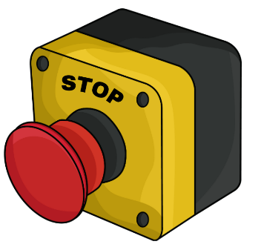
Clamp down materials. | Use tools appropriately and watch demonstrations carefully before use. | Turn power off after use and know where emergency stops are.

Hazards in the timber workshop
Watch Timber Technology - Workshop Walkthrough (5:37) (staff only, able to download to use in your LMS) and discuss as a class.

TAS safety resources
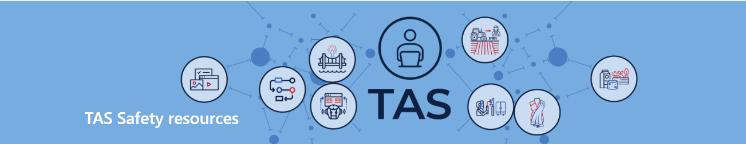
Note: the TAS Safety resources (sharepoint.com) (DoE staff only) are created for Department of Education schools, using relevant information from Equipment Safety in Schools (ESIS). These resources have been developed specifically for the equipment and machinery that has been approved for use in department schools.
Safety tests are mandated in ESIS for selected equipment and machinery.
The tests may be attempted in electronic or other formats with the result recorded and retained as per the department’s records management policy.
Students must provide the correct answer (with or without support) to each question on the safety test as evidence that they knew correct procedures at that point in time for the tool, equipment or machine. Students may attempt each test multiple times to achieve the correct answers.

Materials, tools and techniques

Timber tools, machines and their use
For each image below, write the name and use.
Note: sample answers have been provided.
Tool image | Tool name | Use
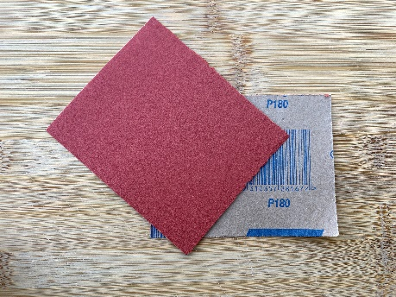 | abrasive paper | Used to abrade or sand the surface of timber to shape, smooth and remove marks. The number on the paper indicates the grit – the higher the number, the finer the paper. Modern abrasive papers are made from garnet and aluminium oxide.
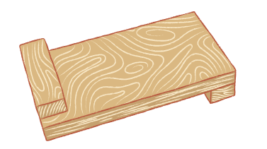 | bench hook | This tool is used to hold timber securely while cutting. It can be used when cutting timber to length and cutting joints.
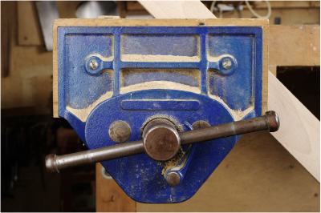 | bench vice | Used to secure objects such as timber. This is useful for many things including chiselling out rebate joints.
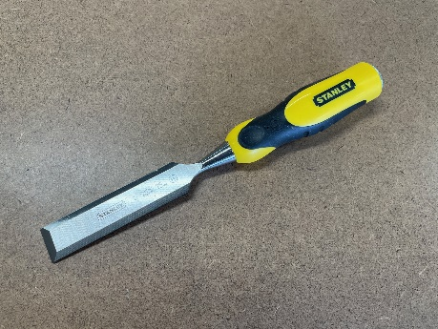 | chisel | Used to remove timber in the making of joints and timber features.
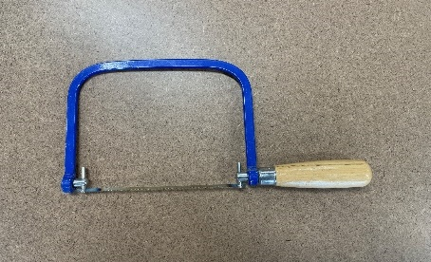 | coping saw | A small, thin-bladed saw used for making intricate cuts and curved shapes in wood. It is commonly used for detailed woodworking tasks like cutting out patterns or trimming.
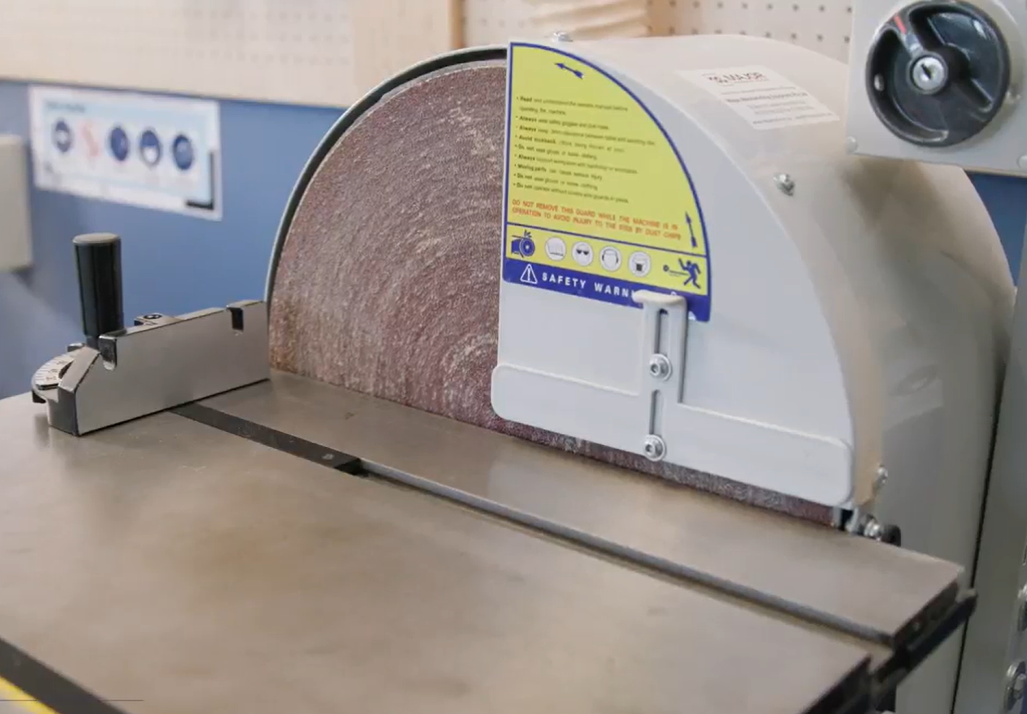 | disc sander | The disc is used to sand end grain. This is an effective tool to use to square ends of timber after cutting.
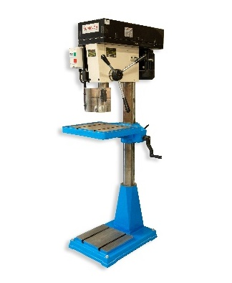 | drill press | An accurate drill with variable speed that can be used to drill holes, large and small with bits such as twist and Forstner.
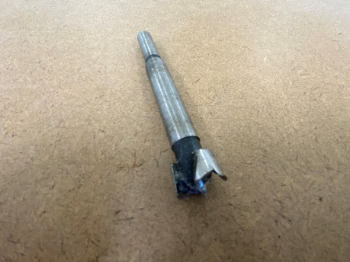 | Forstner bit | Used to drill accurate holes in timber with minimal tear out. They are available in a range of diameters.
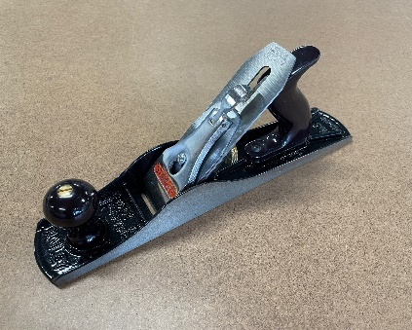 | jack plane | A general-purpose plane that can be used to plane timber to width and create some decorative edge treatment such as chamfers.
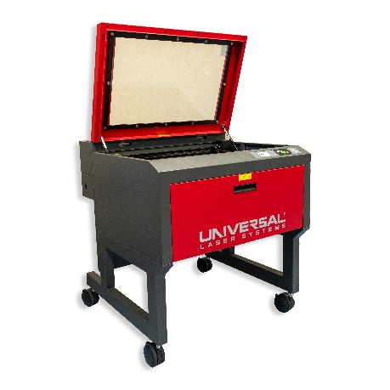 | laser engraver | Images are burnt into materials such as timber by a focused laser beam. The images are created on computer software then downloaded onto the laser engraver.
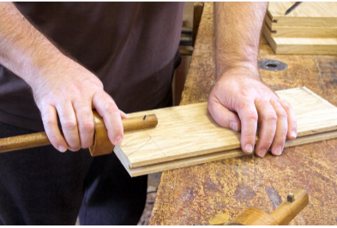 | marking gauge | Marks a line parallel to an edge, side or end. This is an effective tool to mark rebate joints.
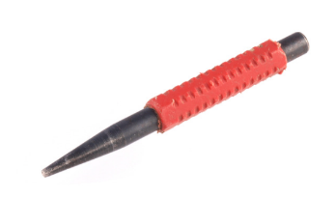 | nail punch | Nail punches are used to punch nails below the surface of the timber. This is for aesthetic reasons when filled with wood putty and to protect the sharp edges of tools such as planes and chisels.
 | pincers | Pincers use the power of a lever to remove nails. This is a great tool for removing bent nails.
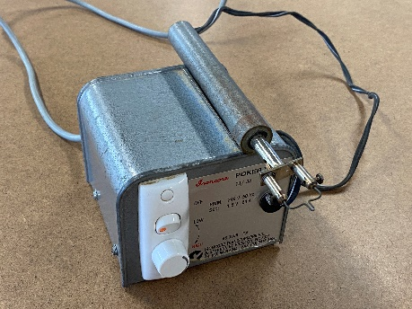 | pokerwork tool | A heated metal tip is used to burn designs into timber, this process is called pyrography.
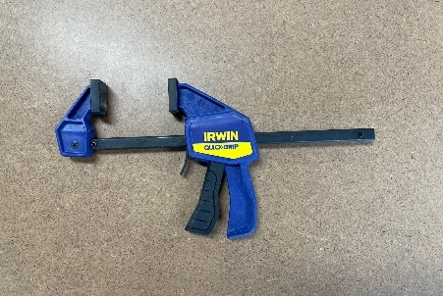 | quick release F cramp | This is the favourite cramp for many students as it is quick to use, however, it does not tighten as much as a G cramp.  This is an excellent cramp to secure work pieces when using hand and power tools.
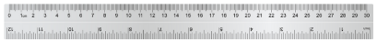 | rule | Used to measure when woodworking. A rule is more accurate than a tape measure. This can be used to mark timber ready for cutting and for marking out joints.
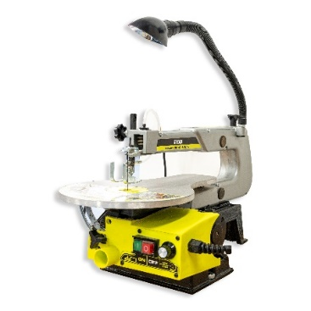 | scroll saw | The small reciprocating blade of the scroll saw is ideal for cutting curves in relatively thin pieces of timber.
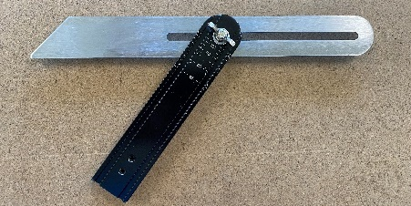 | sliding bevel | Used to mark out and check angles other than right angles.
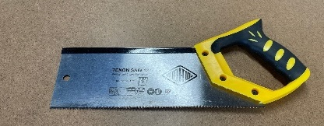 | tenon saw | A fine-toothed, backsaw used for making precision cuts in woodworking, especially for cutting tenons (projections on the end of a piece of wood for joining).
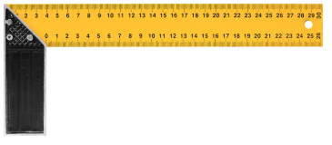 | try square | Try squares are used to mark lines perpendicular to an edge and to check for square. This is useful when marking timber ready to cut to length.
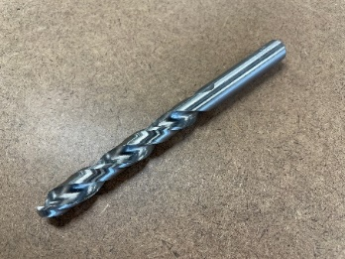 | twist drill bit | A drill bit for general use that can create a variety of hole sizes, depending on the bit size.
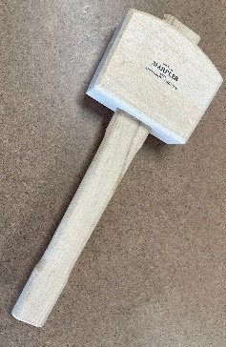 | wooden mallet | A mallet is used to apply controlled force for driving chisels, assembling joints, and setting dowels without damaging the wood.

The design and production process
Throughout Technology 7–8, you will follow a design and production process, which is a continuous cycle used to develop your projects. In this unit, we will focus on timber-based solutions. You will document your design and production processes in this workbook and your phone stand assessment folio throughout the unit.
There are 4 main steps in the process that help to create a quality solution to design challenges or problems. Evaluation happens at each step and is constant throughout the process.
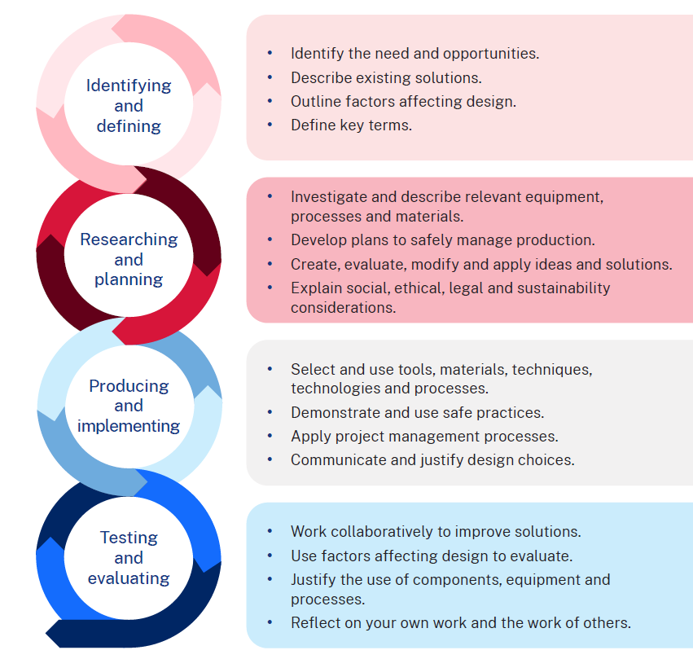

Factors affecting design
There are many factors that affect design. These must be considered when creating a product, system or solution to ensure the success of a project. By carefully considering these factors during the design process, designers, producers and manufacturers can create more effective and efficient solutions. Factors affecting the success and quality of designs include accessibility, aesthetics, durability, ergonomics, ethics, functionality and safety.
Briefly describe each term around the diagram below.
Note: suggested answers are provided on the following page.
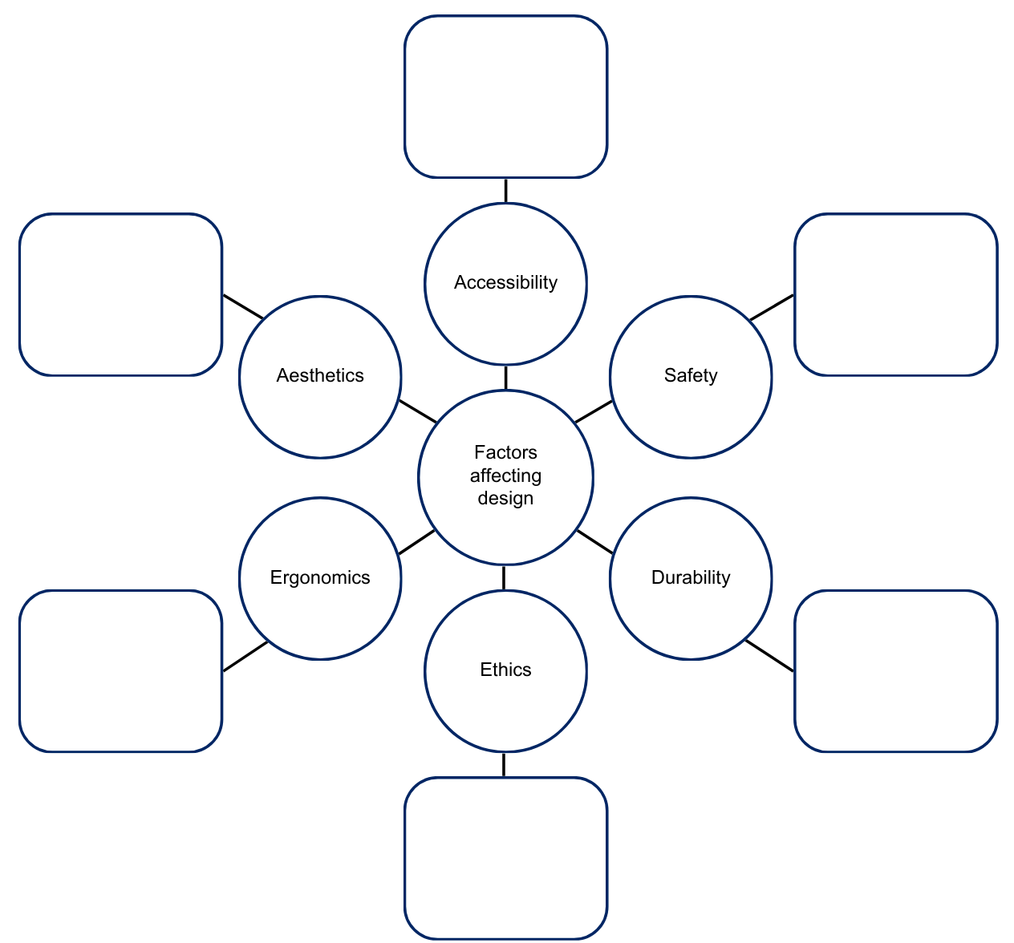

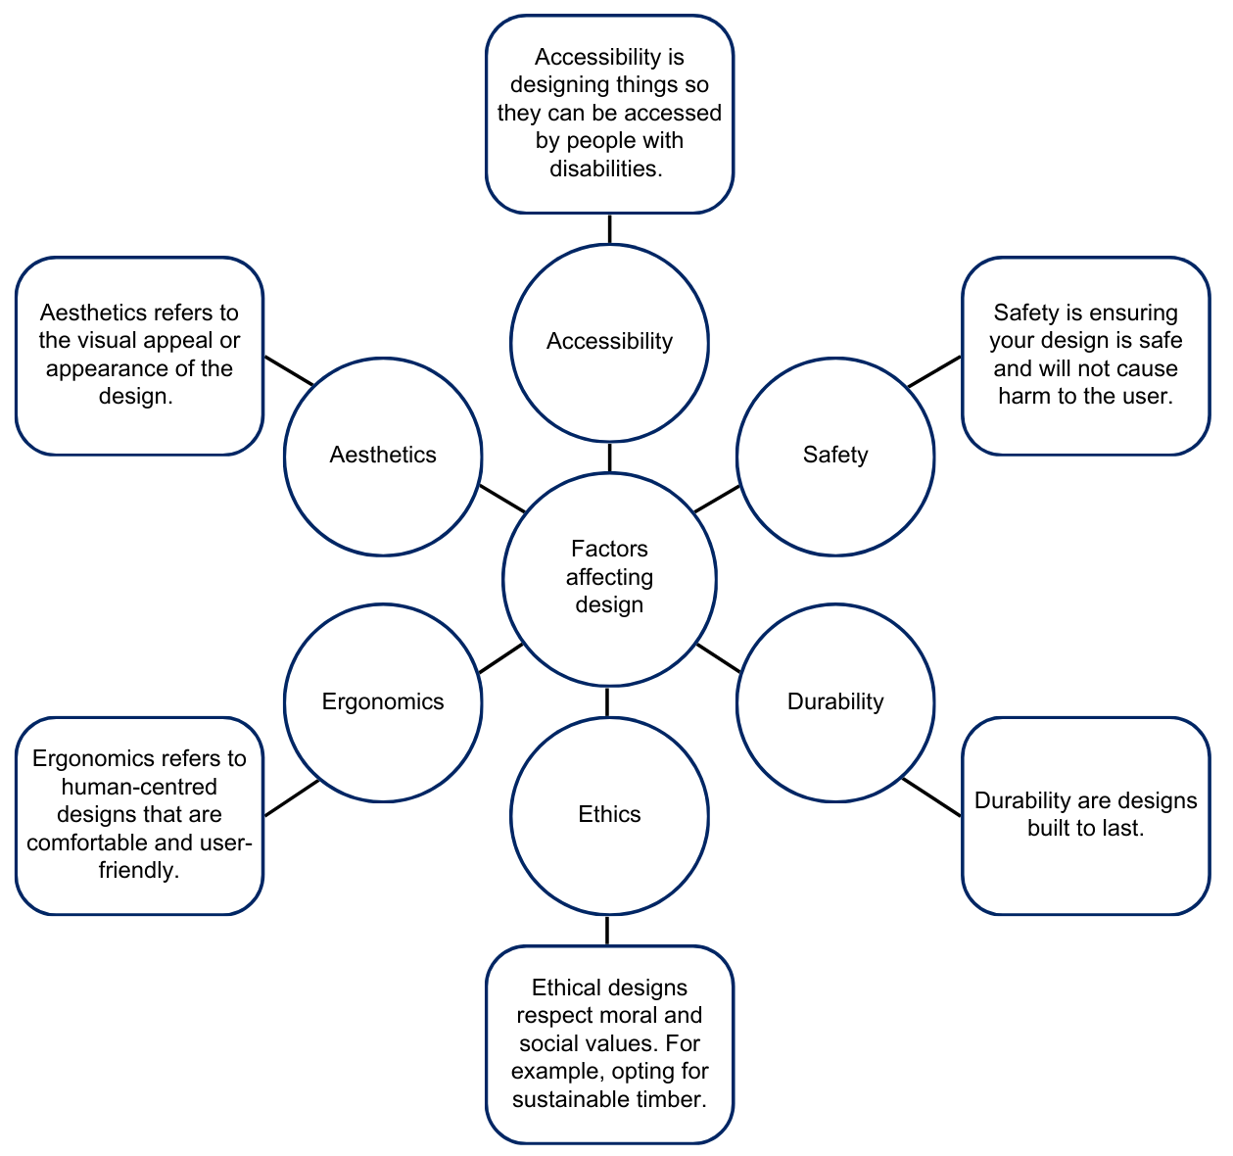

Design considerations for the phone stand
Things I might store in the box section …

Common sizes of mobile phones …

Decoration ideas for the lid …

Measurement
Measure each object to the nearest millimetre with the ruler shown and provide your answer in the space provided.
Note: answers provided.
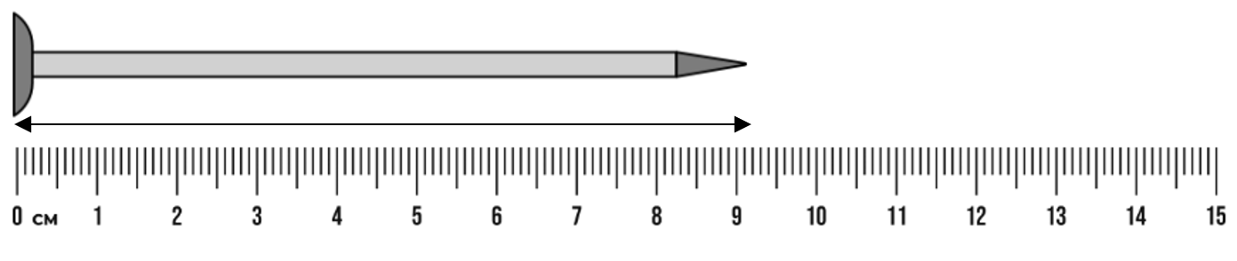
903 mm
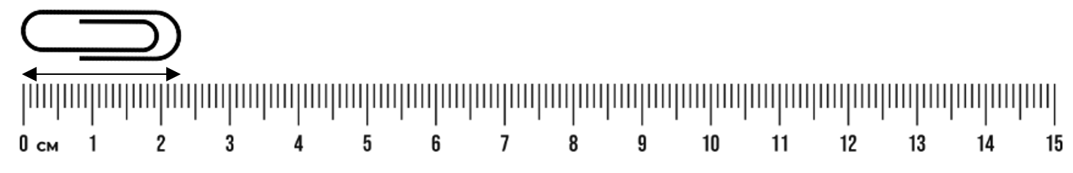
23 mm
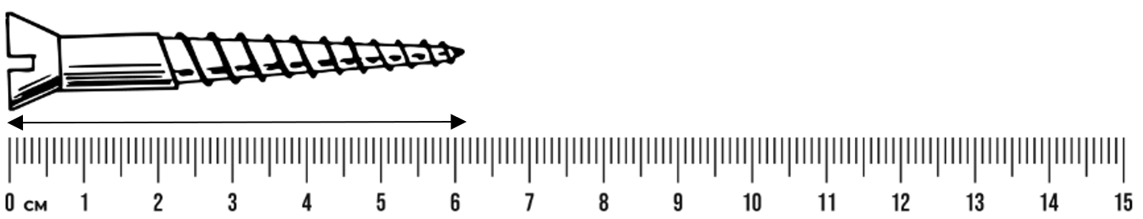
62 mm

Measurement in the workshop – skill tester
Your teacher will provide a range of timber samples labelled with a letter. Using a metal rule, measure the length, width and thickness of each piece and write your answers in the table below. Check with your teacher to see if you were correct.
Piece | Length (mm) | Width (mm) | Thickness (mm)
A
B
C
D
E
F
G
H

Types of timbers
Softwoods and hardwoods are used by designers, producers and manufacturers for specific purposes.
In the space below, outline the differences in structure between hardwoods and softwoods.
Note: suggested answers provided.
Feature | Hardwoods | Softwoods
Physical properties | Denser, harder, more durable | Lighter, softer
Fibre structure | Higher density of longer, thicker-walled fibres | Fewer, shorter, less dense fibres
Growth rings | More irregular and varied in size | More uniform and distinct
Types | Jarrah  Spotted gum  Sydney blue gum  Tasmanian blackwood  Tasmanian oak | Hoop Pine  Huon pine  Kauri pine  Oregon  Radiata pine

Properties of timbers
Complete the tables below, outlining the properties and characteristics of the different types of timber.

Radiata pine
Properties and characteristics | Answer
Botanical name | Pinus radiata
Other common names | Monterey Pine, Insignis Pine
Tree description | Evergreen tree, 30–50 metres tall, straight trunk, conical crown, rough dark grey to brown bark.
Timber colour | Pale yellow to light brown heartwood; lighter sapwood.
Grain and texture | Straight and even grain, medium to coarse texture; easy to work with.
Density | Ranges from 500–600 kg/m³, depending on moisture content and growth conditions.
Durability | Moderately durable; natural resistance to decay and insects but best treated for outdoor use.
Sustainability | Grown in plantations; sustainable choice with responsible forestry practices.
Uses | Construction (framing, beams, flooring), furniture, plywood, fencing, decking, packaging.

Tasmanian oak
Properties and characteristics | Answer
Botanical name | Eucalyptus delegatensis
Other common names | Tasmanian Ash, Victorian Ash, Mountain Ash
Tree description | Tall evergreen tree, can grow up to 60 metres; straight trunk with a smooth, greyish bark.
Timber colour | Light to medium brown with pinkish or yellow hues; colour may darken with age.
Grain and texture | Fine to medium grain with a straight texture; generally has a smooth finish.
Density | Density ranges from 600–800 kg/m³, depending on the specific species and moisture content.
Durability | Moderately durable; has good resistance to wear but can be susceptible to insect attack.
Sustainability | Often sourced from sustainably managed forests in Tasmania and Victoria; considered eco-friendly.
Uses | Furniture, flooring, cabinetry, joinery, and decorative items; widely used in construction.

Sustainability

Renewable and non-renewable resources
Write a description of what is meant by the following terms.
Term | Description
Resource
Natural resource
Renewable natural resource
Non-renewable resource
Resource management
Harvesting
Logging
Discuss why wood is a sustainable building material.

Joining timber
When we make things, some methods alone won’t hold materials together securely. If we join 2 pieces without extra support, they could easily fall apart. To fix this, we use fasteners to keep them attached. Fasteners can be mechanical, like nails or screws, or chemical, like glue.
There are many types of nails and screws, each designed for different jobs, and we’ll look at them more closely.

Types of screws
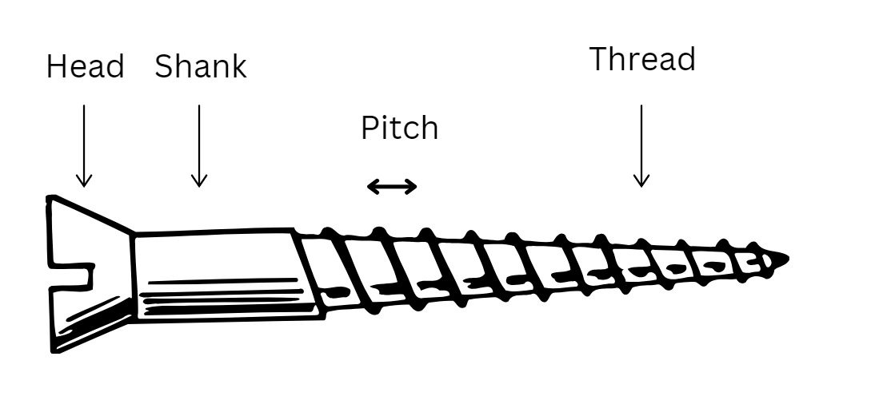
Use the list below to identify and label the images of different screws.
- Wood screw: usually has coarse threads to provide a very strong grip in the timber. A pilot hole is necessary, often used on door hinges.
- Particleboard screw: usually has coarse threads the entire length of the shank and a pointed tip so it can be driven into the timber without a pilot hole, often used to assemble kitchen cabinets.

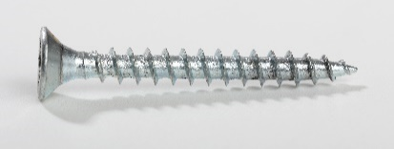
‘Wood screw’ by Dmitry Makeev is licensed under CC BY 3.0

Screw head shapes
Use the list below to identify and label the images of different screw head shapes.
- Flat head
- Round head
- Pan head.
 |  | 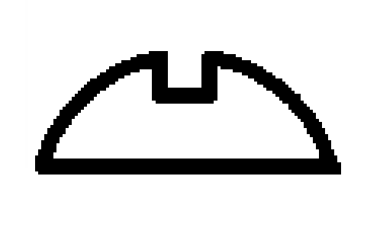

Types of screw heads
Use the list below to identify and label the images of different screw head types.
- Phillips head
- Square head
- Allen head
- Slotted/Flat head
 |  |  | 

Types of nails
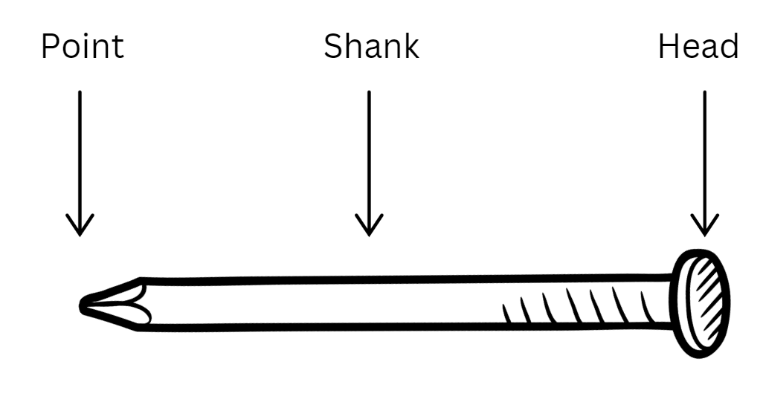
Use the list of nails below to label the images of screws in the table.
- Panel pin: a smaller, light duty nail used for cabinetwork where the head can be punched below the surface and concealed with putty.
- Bullet head: general purpose construction nail, smaller head allows it to be driven flush with the surface.
- Flat head: has a large, flat head to resist being pulled through the timber.
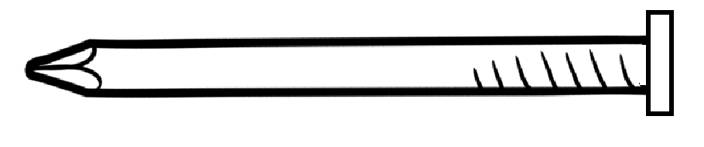 | 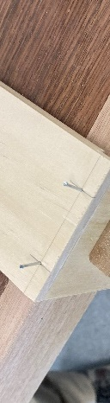 | 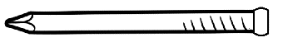

Woodworking joints
Complete the table below to outline these common woodworking joints.
Joint | Name | Common applications | Other names
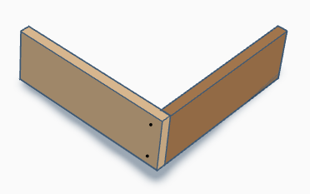
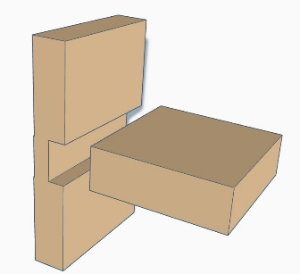
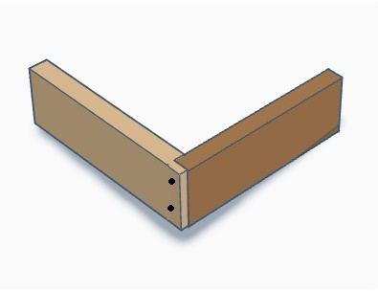

Aboriginal and Torres Strait Islander peoples’ materials, products and systems
Note: consulting with Aboriginal and/or Torres Strait Islander communities is essential to the development of meaningful Aboriginal and/or Torres Strait Islander Histories and Culture embedded across the curriculum. Aboriginal and/or Torres Strait Islander peoples are the owners and custodians of their knowledge and cultures and should be consulted when aspects of Aboriginal and/or Torres Strait Islander Histories and Cultures are being incorporated into the school curriculum. If you want to establish an authentic relationship with Aboriginal communities, you should understand local community protocols and engage with the community respectfully and authentically (see Universal Resources - Aboriginal Education). Remember that any information shared by Aboriginal and/or Torres Strait Islander peoples remains their intellectual property.
The learning activities that follow have been sourced from public-facing materials available online.

Materials
Aboriginal and Torres Strait Islander peoples used a variety of tools, utensils and weapons as they hunted, fished and gathered foods. Some technology was simple with the item being made, used for its purpose and then thrown away. Other items needed more complex methods of making them, like heat and pressure to set sap, and fibres to determine the shape, flexibility and durability of the item.
Australia contains many different climates and environments, but the basic pattern of Aboriginal life was the same. Small groups moved with the seasons over their territory. All the tools, utensils and weapons made by Aboriginal people were adapted to the environment in which they were used. They were developed over many generations and made from readily available materials.
In the space below, list materials used by Aboriginal and Torres Strait Islander peoples.
Suggested answer:
Stone, wood, bark, vine, plant fibre, resin, shells, hair, sinew, bones, teeth, ochre
Important materials not found in local areas were traded, exchanged or given as gifts.

Aboriginal and Torres Strait Islander innovations
Using reading strategies, read and discuss the following articles:
- Australian Artefact Fact Sheet: Yandi Dish (Coolamon) (PDF 918 KB)
- 13 Indigenous innovations that are truly amazing

Tools and equipment
Aboriginal and Torres Strait Islander people invented many tools, pieces of equipment and technology to use in everyday life. This technology was made using natural resources in highly creative ways.
Use the resources listed below to complete the table. Try to include items made from timber.
- Aboriginal Plant use and Technology
- Tools & Technology – Deadly Story
Tool or equipment (name and picture) | Description of use

Indigenous Cultural and Intellectual Property (ICIP)
What is our ethical responsibility with Indigenous Cultural Intellectual Property (ICIP)?
Sample answer:
It is essential to respect ICIP rights, ensuring that traditional knowledge and cultural expressions are protected and that Aboriginal communities maintain control over their cultural heritage.

Investigate fake Aboriginal art
Read First Nations artists and souvenir sellers back crackdown on fake Indigenous art and identify important issues and actions raised in the article in the space below.

Do now
A company wants to use a traditional Indigenous design for a range of outdoor equipment. What should the company do to respect ICIP?
It is important to respect Elders and the roles of men and women. Local Aboriginal peoples should be invited to share their Cultural Knowledges with students and staff when engaging with Aboriginal histories and Cultural Practices. Companies should:
- seek permission from the design owner
- provide proper attribution and language
- identify who created the design
- identify the language group
- avoid misuse or appropriation
- explore story, nation and cultural meaning
- work with their local Aboriginal community to put these in place.

Surface finishes
Finishing timber is essential for enhancing its durability, protecting it from environmental factors, improving its aesthetic appeal and ensuring ease of maintenance. These benefits contribute to the longevity and performance of wooden products in various applications.
Protection from environmental factors
- Moisture resistance: finishing helps seal the wood, preventing moisture absorption that can lead to warping, swelling or decay.
- UV protection: many finishes contain UV inhibitors that protect the wood from sun damage, preventing fading and degradation over time.
- Hygiene: as natural timber is porous, it is often vital for reasons of hygiene that it be sealed.
Durability
- Wear resistance: a good finish increases the durability of the timber surface, making it less susceptible to scratches, dents and abrasion.
- Chemical resistance: finishes can protect wood from spills and stains caused by chemicals, oils and other substances.
Aesthetics
- Appearance: finishing can enhance the natural beauty of the wood, bringing out its colour, grain and texture.
- Variety of finishes: different types of finishes (such as stains, varnishes or oils) allow for various visual effects and styles, catering to design preferences.
Ease of maintenance
- Cleaning: finished surfaces are generally easier to clean and maintain than raw timber, as they repel dirt and grime.
- Longevity: regularly finished surfaces can last longer, reducing the need for frequent repairs or replacements.

Preventing pests and fungi
- Insect resistance: some finishes can deter pests, such as termites or wood-boring insects, from damaging the timber.
- Fungi protection: finishes can also inhibit the growth of mould, mildew and fungi which can compromise the integrity of the wood.
Structural integrity
- Stability: properly finished timber is less prone to cracking or splitting, which helps maintain its structural integrity over time.

Finishes
Complete the sentences by using words from the word bank below.
Word bank
scratches | shelf | durable | thinner | steam
apply | sunlight | flaking | flexible | use
The ideal finishing material should possess the following qualities:
- It should be hard, _________________ and resistant to _________________.
- _________________ and elastic, resistant to cracking with timber movement.
- Able to withstand exposure to _________________ and weathering.
- Resistant to water and _________________.
- Pre-mixed, ready to _________________ and easy to _________________.
- Inexpensive, readily available and able to be reduced with a common _________________ such as water or turpentine.
- Non-toxic, heat resistant and have a long _________________ life
- Able to be re-coated without _________________.

Types of finishes
There are a range of finishes that can be applied to timber, including oil, wax, varnish, lacquer, stain, paint and water-based finish. Provide a description and common use for each of the listed finishes in the table below.
Note: sample answers provided.
Type of finish | Description | Common uses
Varnish | A clear, hard finish that protects the wood. | Furniture and floors
Oil | Natural oils penetrate the wood, enhancing its grain. | Furniture, cutting boards, and decorative items
Stain | A coloured finish that changes the wood’s colour while showing the grain. | Enhancing the appearance of wood before applying a topcoat
Lacquer | A fast-drying finish that creates a hard, high-gloss surface. | Furniture and cabinetry
Shellac | A natural resin that provides a warm, amber tone. | Fine furniture and antiques
Wax | A soft finish that gives a low-sheen surface and enhances the wood’s look. | Furniture and decorative items; requires regular maintenance
Water-based finish | A finish that uses water as the solvent, less toxic and quick drying. | Indoor furniture and floors

Activity
Consider how and where your phone stand will be used. What finishes would be suitable for your project? Give a brief explanation for your choice.

Preparation for surface finishing
The quality of a finish on wood depends a lot on how smooth and clean the wood surface is before you apply it. Clear finishes, like varnish or lacquer, can make any scratches or marks on the wood more noticeable. This is why it’s important to prepare the wood surface properly before putting on the finish. Taking the time to make the surface nice and smooth will help ensure that the final look is great. The following steps in the table below should be used.
Write a description of each step for preparing a surface for either a clear or opaque finish in the spaces provided.
Step | Description
Cleaning up | Removing pencil marks and excess glue.
Removal of dents | Using the iron and possibly wood filler.
Stopping nails and dents | Use a putty to fill any nail holes or small imperfections.
Use of abrasive paper | Sand the timber along the grain to remove any marks or lines.

Mini folio – phone stand
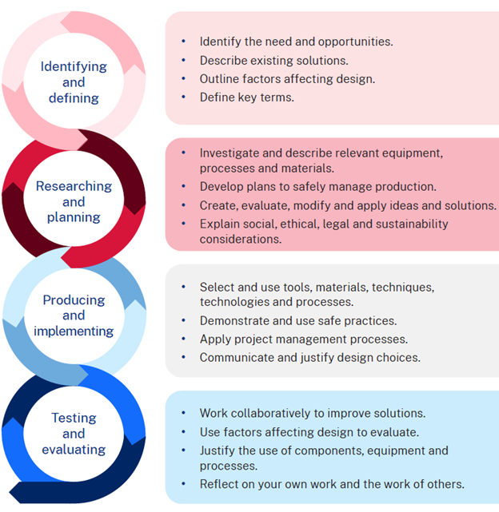

Design brief
Construct a phone stand for your desk or bedside table and include at least one aesthetic enhancement such as wood burning or laser engraving. The final product should be finished to ensure durability and a polished appearance. The project must be completed in 10 weeks including the time needed to learn about how to use tools and machines safely and the application of a finish.

How I will use my phone stand
Describe where you will use your phone stand and what you will store in the box component.

Decoration
The following are samples of designs produced with a pokerwork tool that burns a line into the timber followed by colouring in the picture with coloured pencils.
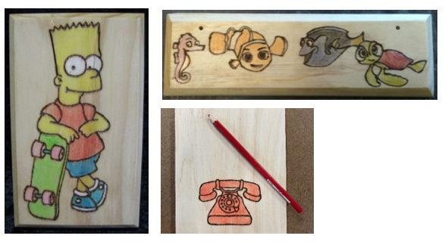
On the following page, sketch 2 design ideas for the lid. Experiment with logo design, font size and style and/or transfer of graphics or pictures which inspire you. Annotate each design to describe your choices.

Design ideas

Design idea 1

Design idea 2

Justification
Which design have you selected and why? Consider the design brief and limitations in your response below.

Project management – phone stand

Working drawings for the phone stand
The drawing below shows an orthogonal drawing of the box component including top, side and end views. Generally, the number of views you need in a drawing depends on how much detail you need to build the project. Some projects require only 2 views.
There is also a pictorial view of the finished project. The pictorial style used here is known as an isometric view.

Working drawing 1 – box
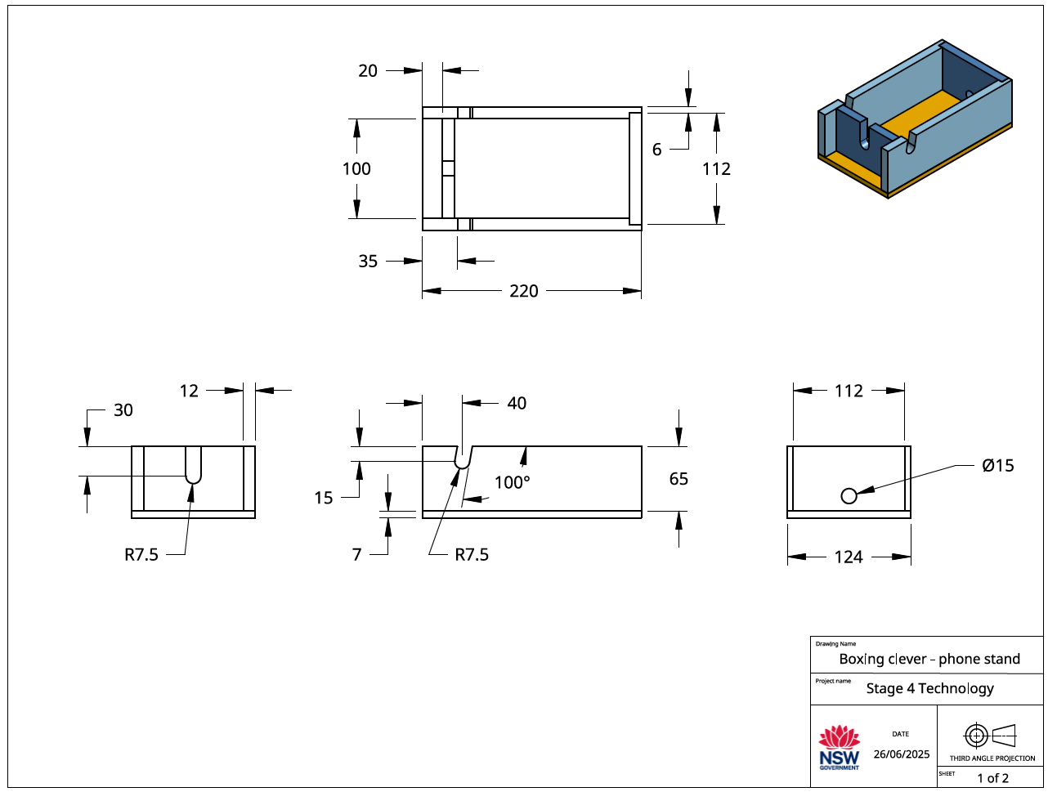

Working drawing 2 – lid
The following drawing, an orthogonal or orthographic drawing, presents more information about the lid and how it fits into the box.
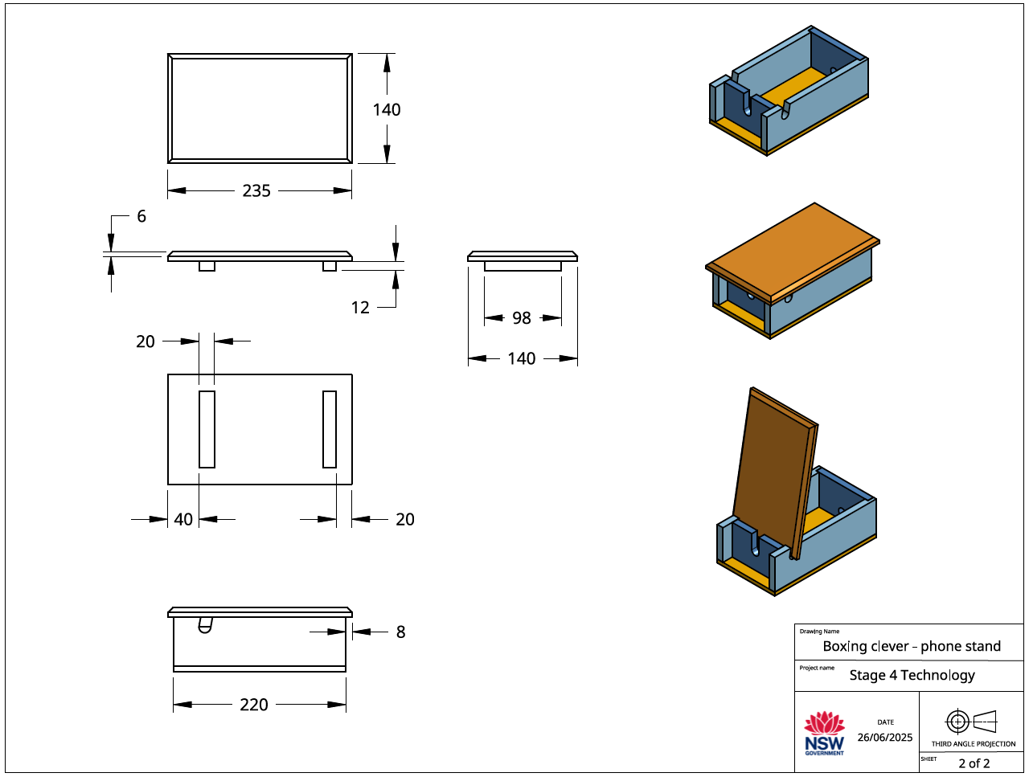

Cutting list
The cutting list describes to the builder the type of material to be used, the dimensions of the material, the number of parts, the name of each part and other information relevant to the manufacture of the project. It is presented as a table. Complete the table below for your project.
No. | Description | Quantity | Length mm | Width mm | Thickness mm | Material
1 | Sides | 2 | 220 | 65 | 12 | Radiata pine
2 | Back | 1 | 112 | 65 | 12 | Radiata pine
3 | Front | 1 | 100 | 65 | 12 | Radiata pine
4 | Base | 1 | 220 | 124 | 7 | Plywood
5 | Lid | 1 | 235 | 140 | 12 | Radiata pine
6 | Strips | 2 | 98 | 20 | 12 | Radiata pine

Time management
Time management is the planning we do to make sure our project is completed in the time we have available. When we are planning the time management for this project, we need to look at the time we have available and the tasks we need to do to complete the project.
Time available
Question | Answer
How many weeks do we have available to make the phone stand?
How many practical lessons do we have in a week?
How many practical lessons do we have to complete the phone stand?

What tasks do we need to do and how long will they take?
In the table provided, sort the following construction steps into the correct order then estimate how much time should be allocated to each task.
Apply a suitable finish  Mark out, cut and sand parts for lid  Mark out, drill holes and cut slots for lid  Glue and nail base to box  Sand box edges flush  Mark out and cut rebate joints | Mark out and cut sides and ends  Sand all parts ready for finishing  Sand sides and ends to length  Glue and nail sides and ends  Glue and nail lid together  Plane and sand base flush with box

Construction steps
Step | Task | Estimated time (in lessons)
1 | Mark out and cut sides and ends
2 | Sand sides and ends to length
3 | Mark out and cut rebate joints
4 | Mark out, drill holes and cut slots for lid
5 | Glue and nail sides and ends
6 | Sand box edges flush
7 | Glue and nail base to box
8 | Plane and sand base flush with box
9 | Mark out, cut and sand parts for lid
10 | Glue and nail lid together
11 | Sand all parts ready for finishing
12 | Apply a suitable finish

Evaluation
- On the line below, place an X that matches the way you like to work.

I like working on my own |  |  | I like working with others
- On the line below, place an X that matches the amount of time you had to make your phone stand.

I had enough time |  |  | My project was rushed
- On the line below, place an X that you think matches the quality of your phone stand.

Poor quality | Fair quality | Good quality | High quality
- What task in the designing or making of your phone stand did you find the most difficult?
______________________________________________________________________________
- What task in the designing or making of your phone stand did you enjoy the most?
______________________________________________________________________________
- Is there anything you would do differently on your next technology project?
______________________________________________________________________________
- Are there any skills that you developed making your phone stand that you will use outside school?
______________________________________________________________________________
______________________________________________________________________________

References
This resource contains NSW Curriculum and syllabus content. The NSW Curriculum is developed by the NSW Education Standards Authority. This content is prepared by NESA for and on behalf of the Crown in right of the State of New South Wales. The material is protected by Crown copyright.
Please refer to the NESA Copyright Disclaimer for more information https://educationstandards.nsw.edu.au/wps/portal/nesa/mini-footer/copyright.
NESA holds the only official and up-to-date versions of the NSW Curriculum and syllabus documents. Please visit the NSW Education Standards Authority (NESA) website https://educationstandards.nsw.edu.au/ and the NSW Curriculum website https://curriculum.nsw.edu.au/.
Technology 7–8 Syllabus © NSW Education Standards Authority (NESA) for and on behalf of the Crown in right of the State of New South Wales, 2023.
Australian National Botanic Gardens Education Services (2000) Aboriginal Plant use and Technology [PDF 376 KB], Australian National Botanic Gardens Education Services, accessed 19 November 2024.
Bombora Furniture (2024) About Bombora Custom Furniture, Bombora Custom Furniture website, accessed 19 November 2024.
City of Newcastle (6 July 2022) 'NSW Government declaration to protect cultural significance of Aboriginal ceremonial site', City of Newcastle, accessed 19 November 2024.
Deadly Story (n.d.) 'Tools & Technology', Science, Technology & Engineering, Deadly Story website, accessed 19 November 2024.
Devow D (6 October 2017) '13 Indigenous innovations that are truly amazing', Téa&Belle Collective, accessed 19 November 2024.
e9design (4 July 2023) 'The E9 Design Story: Sustainable Australian Furniture Using Technology', e9design, accessed 19 November 2024.
Forest Learning Limited (FWPA) (n.d.) 'Forester Time with Gavin Livingston: Forestry 101. Managing today's forests for tomorrow's generations', Resources, Forest Learning website, accessed 19 November 2024.
Heartwood Timber Designs (2020) Heartwood Timber Designs [website], accessed 19 November 2024.
Jaworski M (n.d.) Australian Artefact Fact Sheet: Yandi Dish (Coolamon) [PDF 918 KB], Archae-aus, accessed 19 November 2024.
Madji Indigenous Furniture (2024) Madji Indigenous Furniture [website], accessed 19 November 2024.
Manapan (2024) Manapan [website], accessed 19 November 2024.
State of New South Wales (Department of Education) (2024) 'Getting to know local Aboriginal and/or Torres Strait Islander Histories and Cultures', Aboriginal Education and Communities, NSW Department of Education website, accessed 19 November 2024.
Rayonier Inc. (1 October 2021) 'From Trees to Lumber: Watch how boards are made from pine trees' [video], Rayonier Inc., YouTube, accessed 19 November 2024.
Red Kangaroo (2024) Understanding symbols in Aboriginal art, Red Kangaroo website, accessed 19 November 2024.
Responsible Wood (2023) Responsible Wood [website], accessed 19 November 2024.
Responsible Wood (2023) The importance of Australian sustainable timber, Responsible Wood website, accessed 19 November 2024.
Richardson H, Testa C, Lee J (3 February 2023) 'First Nations artists and souvenir sellers back crackdown on fake Indigenous art', ABC News, accessed 19 November 2024.
Thompson R and Dryen D (4 March 2022) 'Beyond Ordinary: Contemporary Women Makers', Victorian Woodworkers Association, accessed 19 November 2024.
WorkBC's Career Trek (11 June 2020) 'Designer, furniture maker (Episode 87)' [video], WorkBC's Career Trek, YouTube, accessed 19 November 2024.

© State of New South Wales (Department of Education), 2025
The copyright material published in this resource is subject to the Copyright Act 1968 (Cth) and is owned by the NSW Department of Education or, where indicated, by a party other than the NSW Department of Education (third-party material).
Copyright material available in this resource and owned by the NSW Department of Education is licensed under a Creative Commons Attribution 4.0 International (CC BY 4.0) license.

This license allows you to share and adapt the material for any purpose, even commercially.
Attribution should be given to © State of New South Wales (Department of Education), 2025.
Material in this resource not available under a Creative Commons license:
- the NSW Department of Education logo, other logos and trademark-protected material
- material owned by a third party that has been reproduced with permission. You will need to obtain permission from the third party to reuse its material.
Links to third-party material and websites
Please note that the provided (reading/viewing material/list/links/texts) are a suggestion only and implies no endorsement, by the New South Wales Department of Education, of any author, publisher, or book title. School principals and teachers are best placed to assess the suitability of resources that would complement the curriculum and reflect the needs and interests of their students.
If you use the links provided in this document to access a third-party's website, you acknowledge that the terms of use, including licence terms set out on the third-party's website apply to the use which may be made of the materials on that third-party website or where permitted by the Copyright Act 1968 (Cth). The department accepts no responsibility for content on third-party websites.

