Technology 7–8 – Materials and production processes (timber)
Boxing clever – my phone stand (10-week unit)

Contents
My phone stand 2
Steps in production 2
Weeks 1–2 2
Weeks 3–4 5
Weeks 5–6 11
Weeks 7–8 18
Weeks 9–10 29
Phone stand construction summary 37
References 38

My phone stand
The phone stand introduces a range of skills essential to the production of quality timber projects. This project develops a wide range of skills, including marking out, sawing, disc sanding, drilling and finishing. Explicit teaching strategies are integral in the delivery of this project.
The project focuses on techniques relevant to making, and the examples given in this document provide a step-by-step guide to production leading to student success for a variety of student abilities. With more proficient cohorts, students may extend the project to include decoration of the sides and lid or even incorporating a charging pad in the lid. All aspects of production may be reviewed, changed and documented to suit an individual student’s personal circumstances. Suggestions will be made for design changes throughout this document.
This phone stand should accommodate most smart phones however we suggest that the class teacher should include some research of phone sizes as part of research and project planning.

Steps in production

Weeks 1–2
Instruction | Reference image
Select timber  Select timber 12 mm thick and 65 mm wide to use for the sides and ends of the box. | 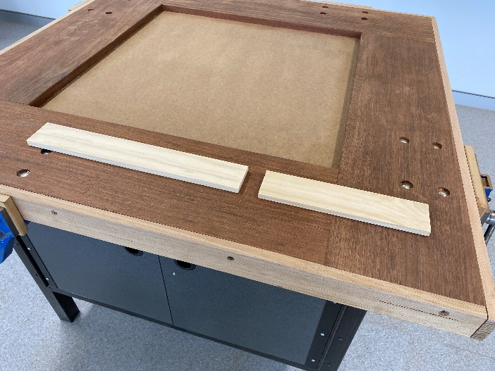
Mark out  Start by marking out the sides by drawing a line 2–3 mm from the end using a try square, rule and pencil. Next mark out the length of each side leaving a gap of 10 mm between pieces as waste for cutting.  Repeat this process for the ends of the box. | 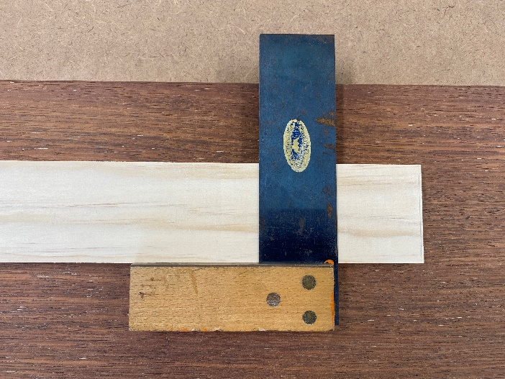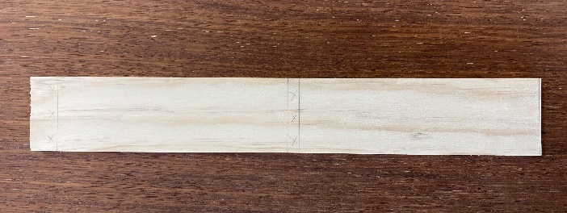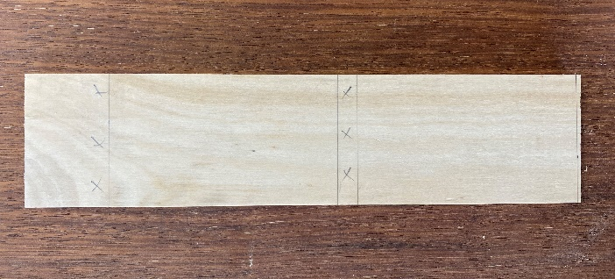
Cut timber to length  Support the timber on a bench hook and cut between the pieces using a tenon saw. After cutting, the pencil lines should be visible on the end of each piece.  Construction tip: use a second bench hook to support longer pieces of timber. | 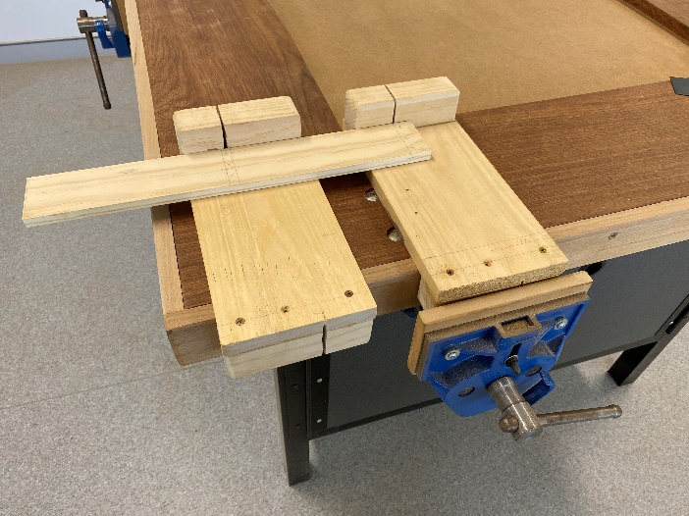  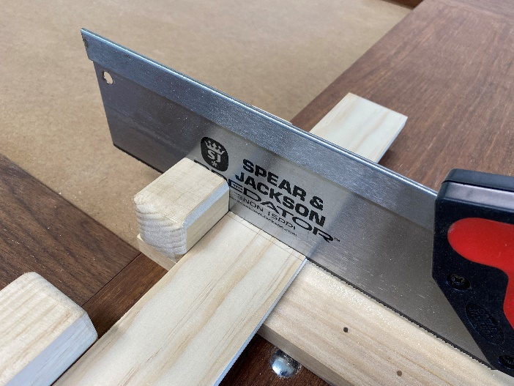
Disc sanding  Use the disc sander to remove the waste from the end of each piece down to the line, keep the timber square to the disc and flat on the table.  Safety tip: PPE must be worn and restrain long hair.  Safety tip: dust extraction must be used when disc sanding.  Safety tip: Staff only disc sander safety resources. | 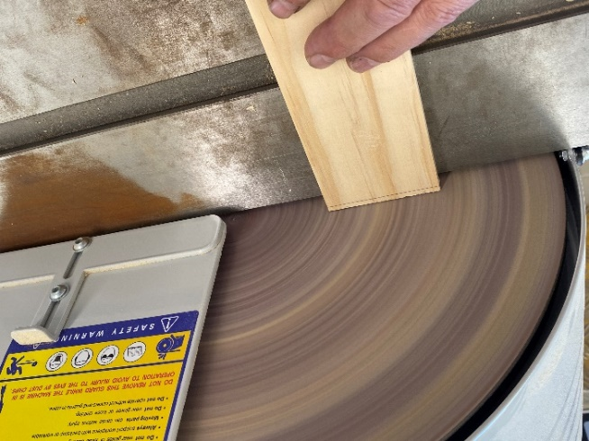  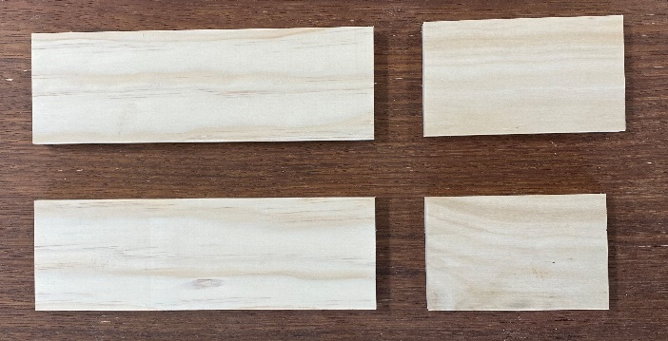

Weeks 3–4
Instruction | Reference image
Mark out rebate joints  Using a try square, rule and pencil, mark lines across the face 12 mm from one end of each side for the rebate joints. Square this line down each edge.  Use a marking gauge to scribe a line around the end of each piece. This line should be positioned half the thickness of the timber (6 mm). | 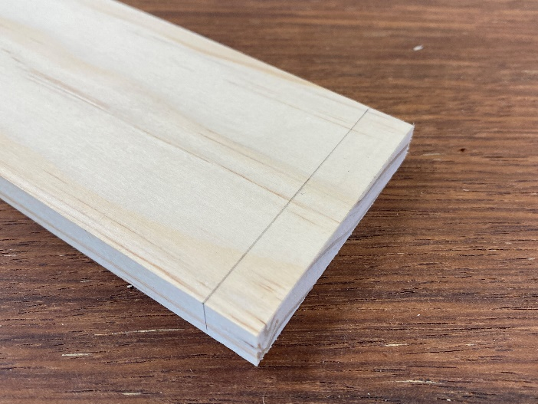
Mark depth of rebate  Use a marking gauge to scribe a line around the end of each piece to mark the waste. This line should be positioned half the thickness of the timber (6 mm). | 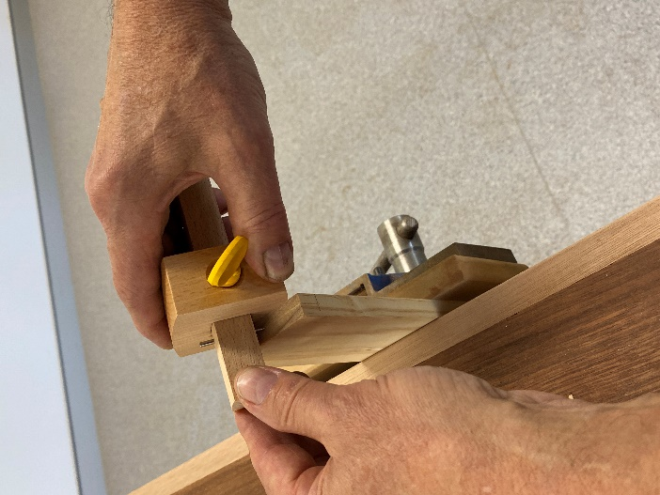
Cut rebate joints  Clamp a piece of scrap timber (with a square end) on top of each side in turn. This will be used to guide the tenon saw and protect the timber from accidental damage. Slowly cut down to the marking gauge line on the timber. | 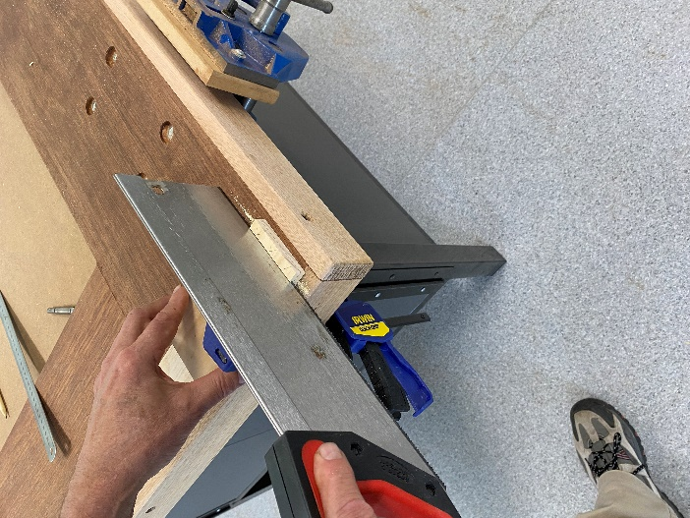  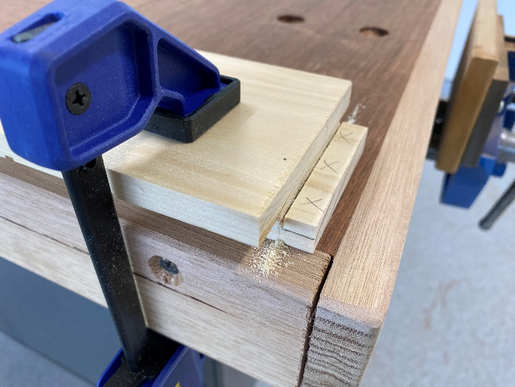
Chisel waste from rebate joints  Clamp the side vertically in the vice. Select a firmer chisel 19 mm wide and using a mallet to tap the chisel, remove half of the waste.  The student should stand so they can judge that the face of the chisel remains vertical. Repeat this step, positioning the chisel 1.5 mm from the line. Finally, position the chisel in the marking gauge groove and remove the last part of the waste. | 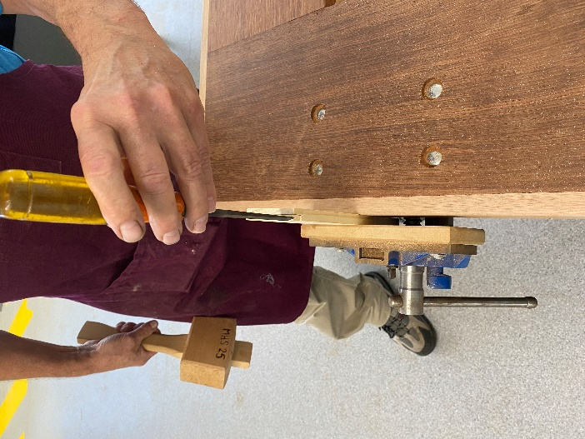  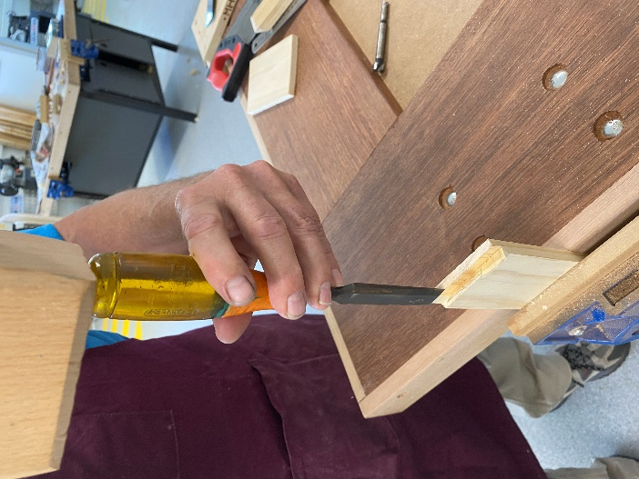
Check the fit  Check to see if the end fits neatly. Sometimes the timber must be laid flat in the vice and the chisel used horizontally to pare away any uneven parts.  Safety tip: keep both hands on the chisel handle at all times when paring! | 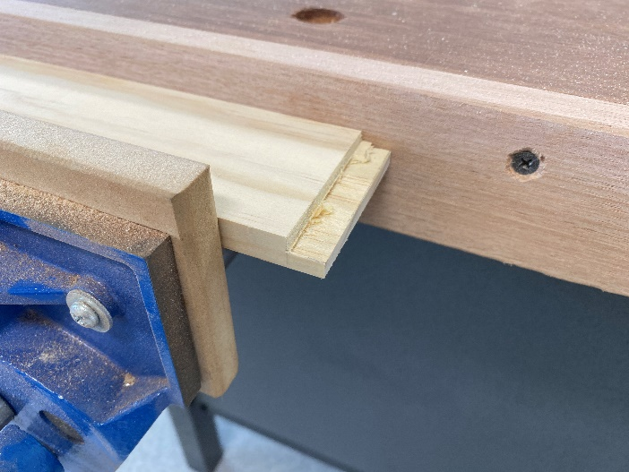  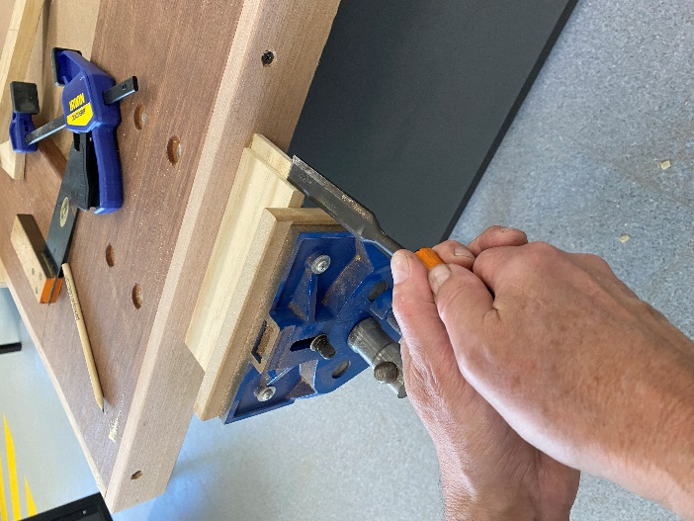
Mark out cut-outs  Mark out the positions of the cable hole in the back and the bottom of the cut-outs on the front and sides. | 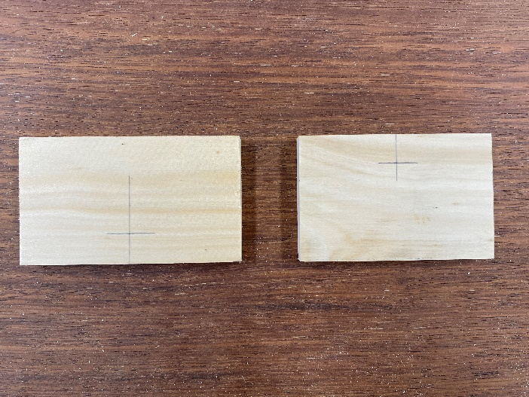
Drill holes  Clamp each piece of timber in a machine vice and drill a 15 mm hole through each piece using a Forstner bit.  Safety tip: PPE must be worn and restrain long hair.  Construction tip: position a piece of scrap timber underneath to prevent the drill chipping the back of the hole. | 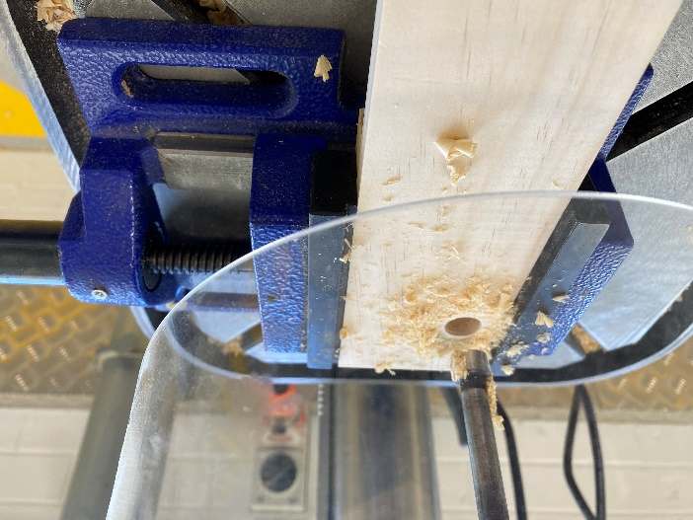
Mark out cut outs  Use a try square or sliding bevel set to 80° to draw lines at a tangent to the holes at the bottom of the cut-outs.  Also square a line across each edge. | 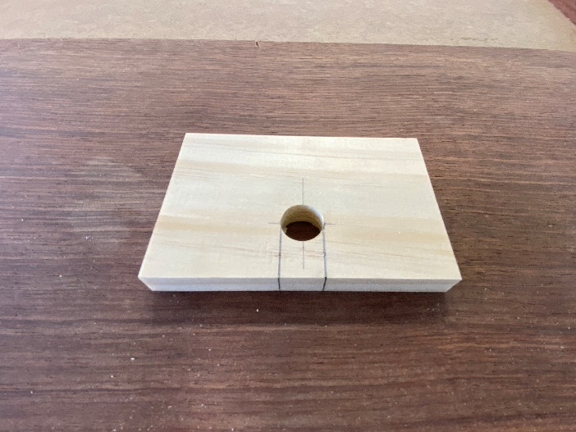  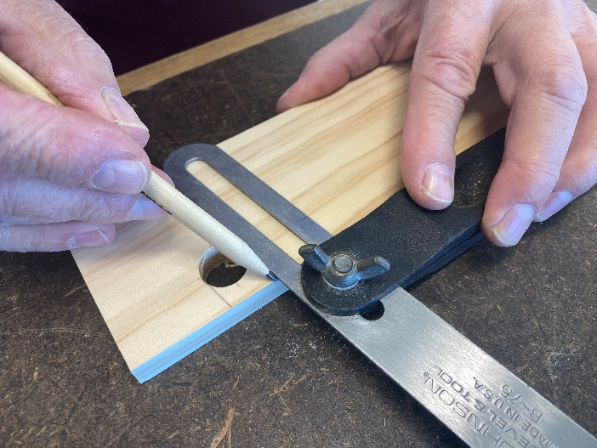
Saw cut outs  Use a scroll saw to cut down each side of the cut-outs in the front, back and 2 sides.  Alternatively, a coping saw, Japanese pull saw or a dovetail saw can be used for this step. | 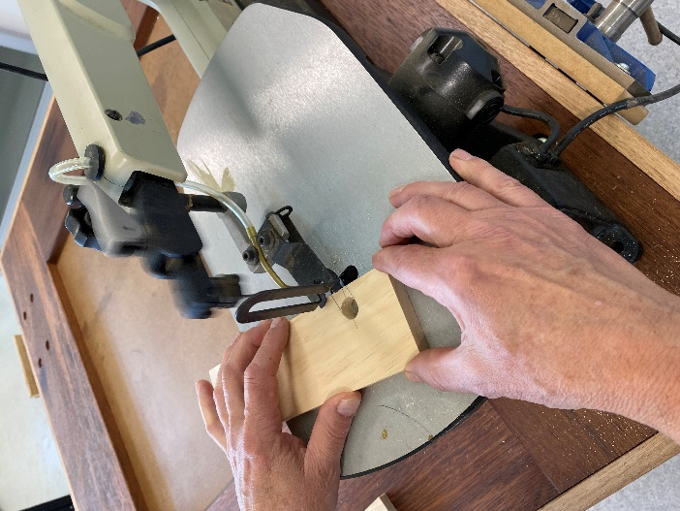
Sanding cut-outs  With the timber held in the vice, wrap abrasive paper around a piece of dowel, file or strip of timber and smooth the inside surface of each cut-out. | 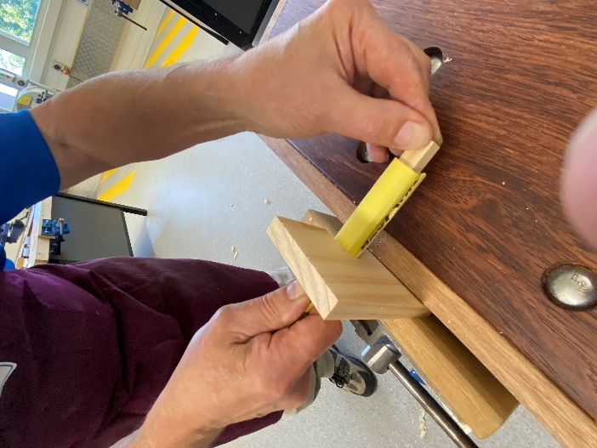  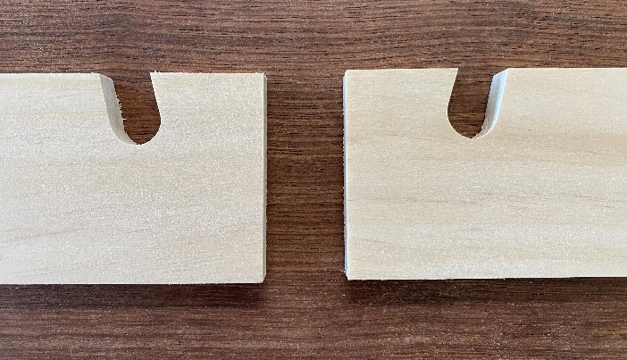
Sanding  Use a 120-grit abrasive paper and a cork block to sand all surfaces.  Always sand in the direction of the grain. | 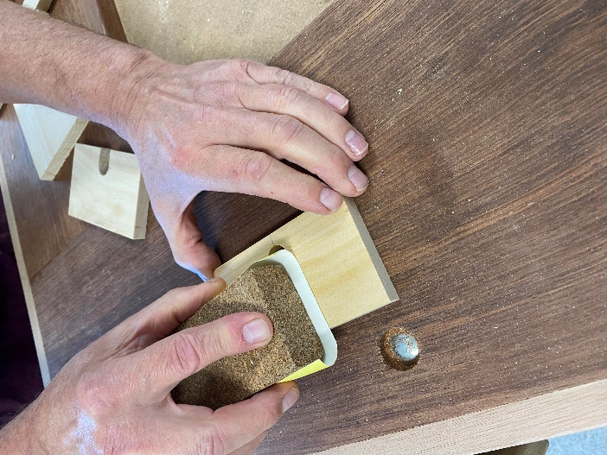

Weeks 5–6
Instruction | Reference image
Pre-nailing sides  Mark out the position of 3 panel pins, 6 mm from each end as shown. These should be evenly spaced. | 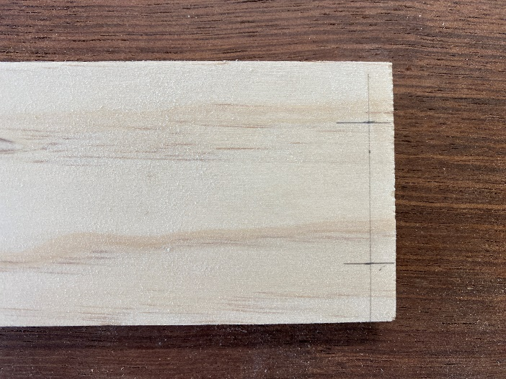
Nailing  Drive panel pins using a Warrington hammer, the tips of the nails should just protrude through the other side. | 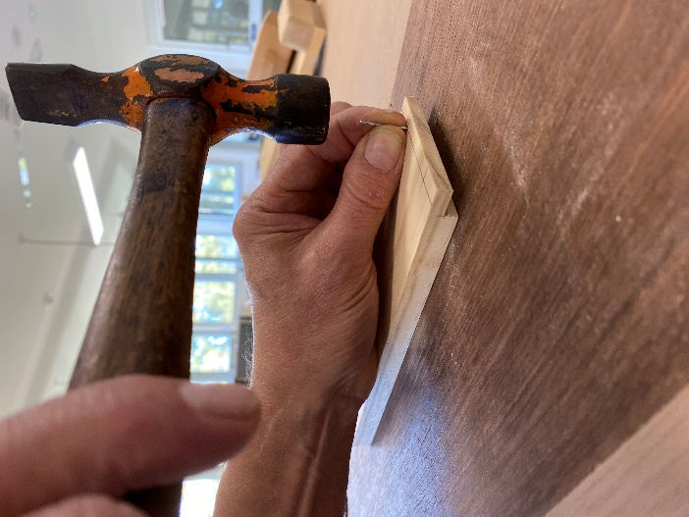
Prepare for assembly  Arrange the 4 pieces on a bench to ensure that the hole in the back is at the bottom and the angled surface on the front piece faces upwards.  Construction tip: this is an important step to ensure all the pieces join correctly. | 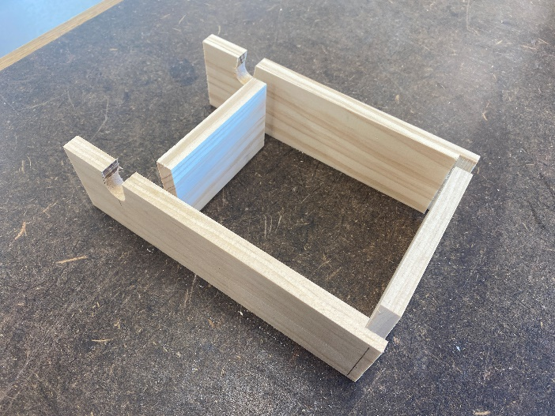
Position timber – step 1  Clamp the back piece vertically in the vice with approximately 20 mm extending above the benchtop. Place an offcut 12 mm thick under the end of the side to keep it horizontal when nailing. | 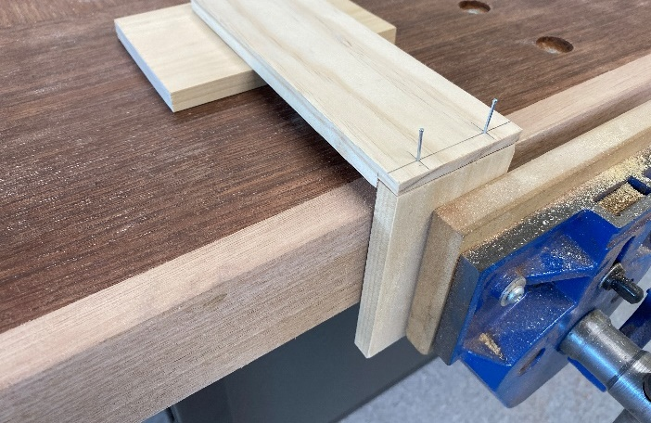
Glue  Spread glue on each side of the joint and press down onto the joint. The panel pins should just bite into the rebate. | 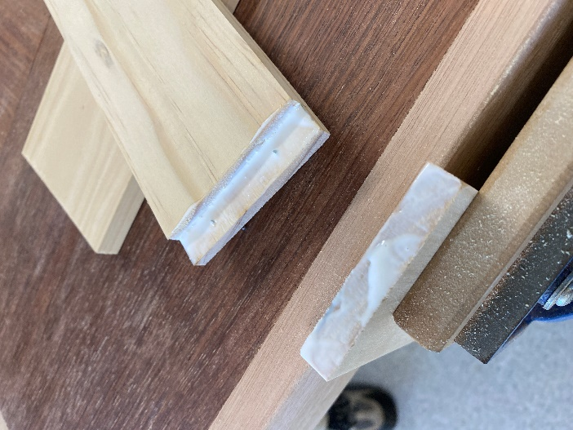
Nail box together  Drive the nails into the timber until they are flush then nail punch them below the surface. This will produce an ‘L’ shape. | 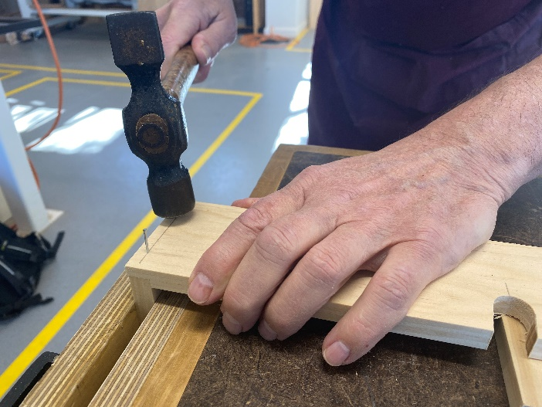
Clean up  Wipe away any excess glue using a damp sponge or rag. | 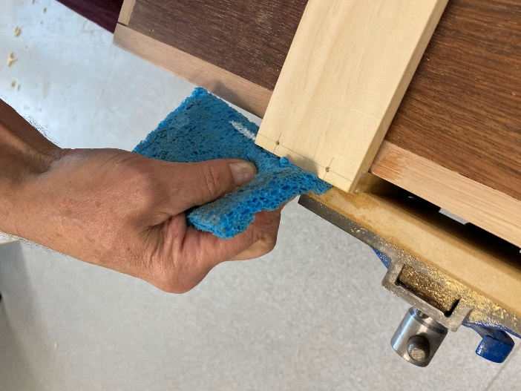
Nail box together – step 2  Clamp the timber to the bench then spread glue on the joint surfaces of the second side and the end piece, ensure the edges are flush.  The 3 pieces of timber will produce a ‘U’ shape. Next drive the nails into the timber then punch them below the surface. Remove any glue squeezed out.  Construction tip: this task is much easier if students work in pairs. | 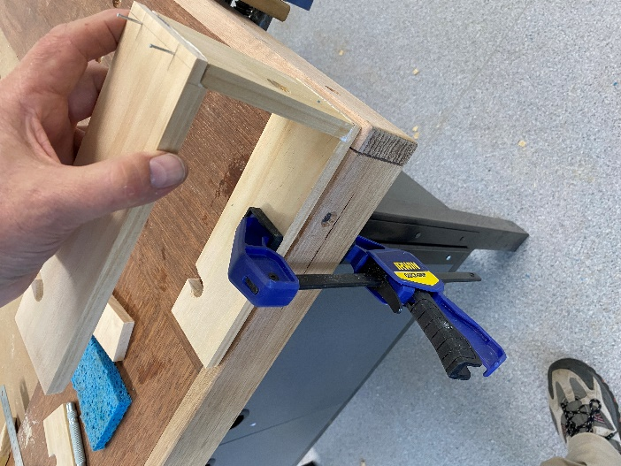  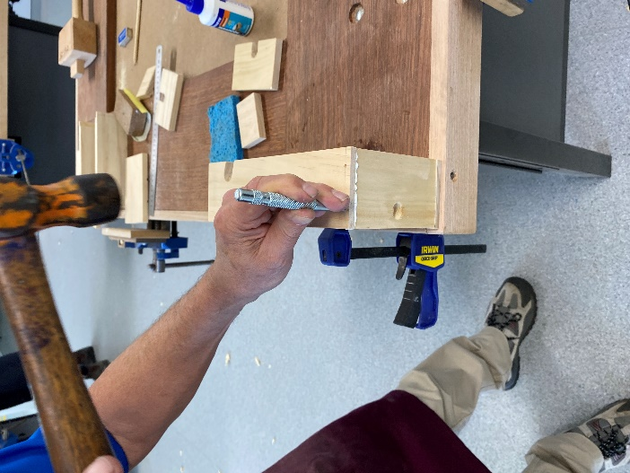
Clamp front piece – step 3  Now spread glue on the ends of the front piece and position 20 mm from the ends of the sides as shown.  Lightly clamp the timber and check each side. This will produce the box shape.  Construction tip: quick grip style clamps are best for this operation. | 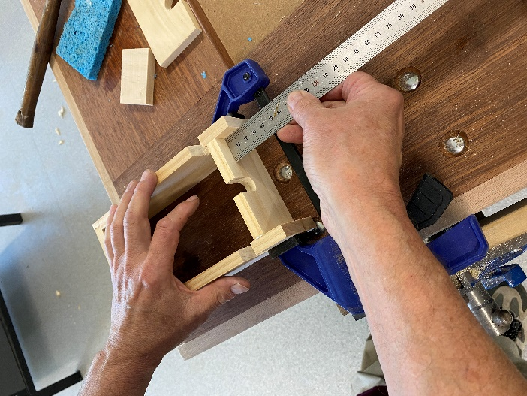
Check for square  Use a try square to check the inside of the box and adjust before applying more clamping pressure.  Adjust by gently squeezing diagonally until you are satisfied that the box is square.  Construction tip: add a brace across the bottom to ensure the box doesn’t move out of square when it is being stored to dry. | 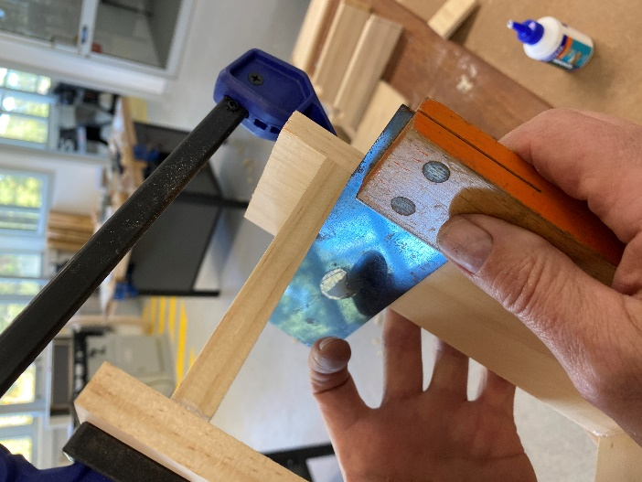
Clamp project  Add a second clamp across the nailed end and check the diagonals to ensure the box will dry square.  Construction tip: if a project dries out of square, soften the glue with warm water and reposition, you don’t need to take it apart. | 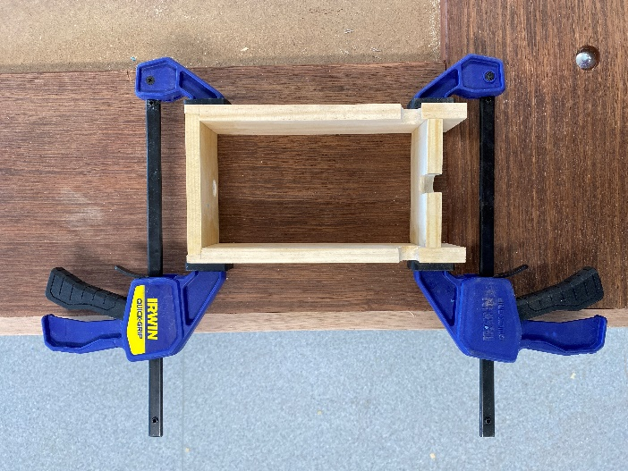
Sand the top and bottom  Construction tip: once dry, use a sanding board as shown to ensure the top and bottom surfaces are flush. | 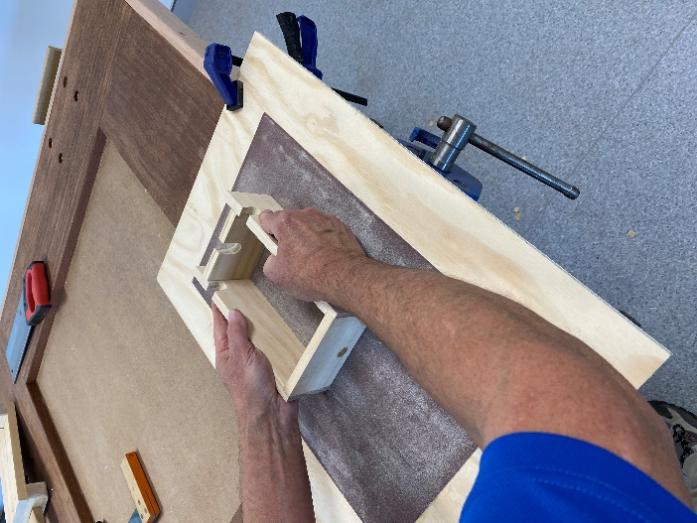
Sand the end  Once dry, clamp the box low in the vice and use a small random orbital sander to ensure the rebate joints are flush. Care must be taken to keep the sander flat on the timber. | 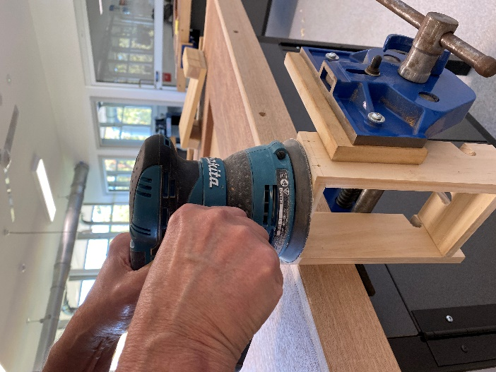
Assembled box  Give the box a final hand sanding with a fine abrasive (240+) along the grain before attaching the base.  Construction tip: ensure you sand the inside of the box at the same time. | 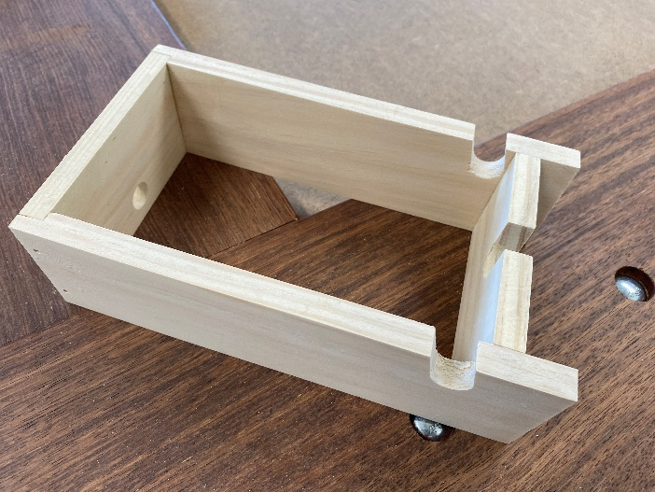

Weeks 7–8
Instruction | Reference image
Mark out plywood base  Mark out the plywood base using a try square, rule and pencil. Start by marking a line 2–3 mm from the end. | 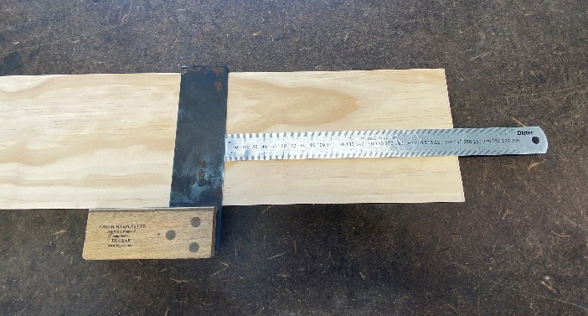
Cut plywood base  Support the timber across bench hooks and cut to length using a tenon saw. | 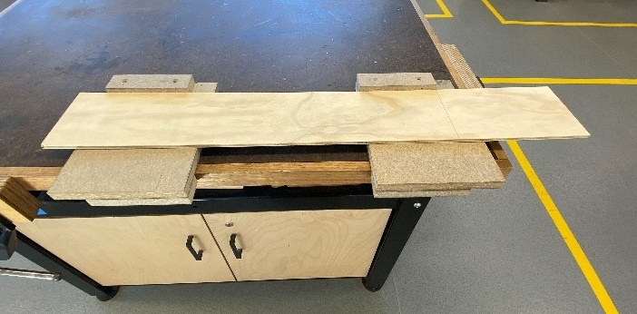
Plywood base  The base should be 3–5 mm longer and wider than the box so that it can be made flush with the box later. | 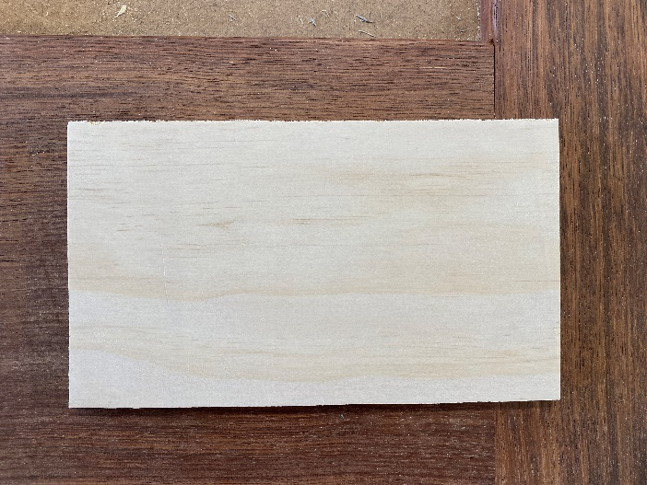
Pre-nail base  Mark lines on the base to align with the centre of the sides of the box.  Evenly space nails along the lines and drive nails just into the plywood, 8–10 nails will be sufficient. | 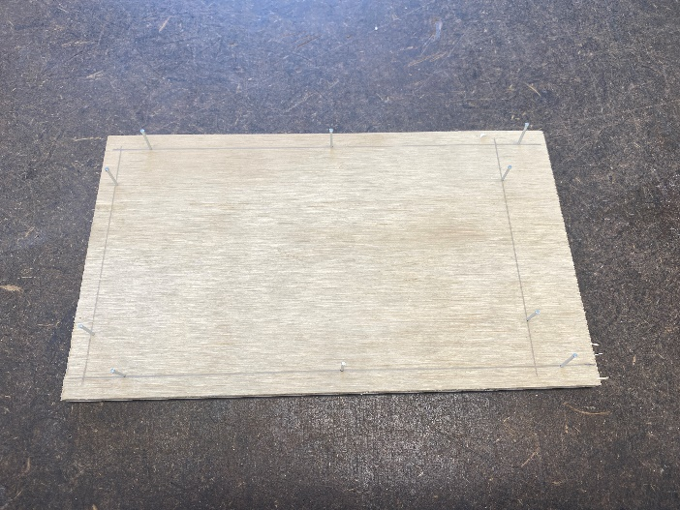
Attach base  Glue and nail the base in position onto the box. | 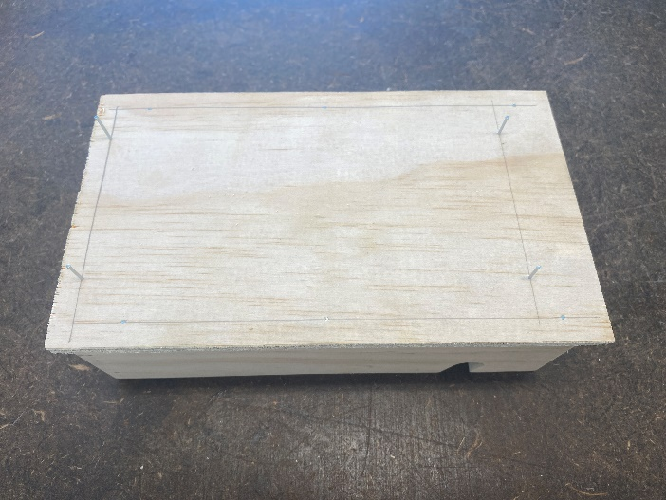
Punch nails  Punch the heads of the nails below the surface. | 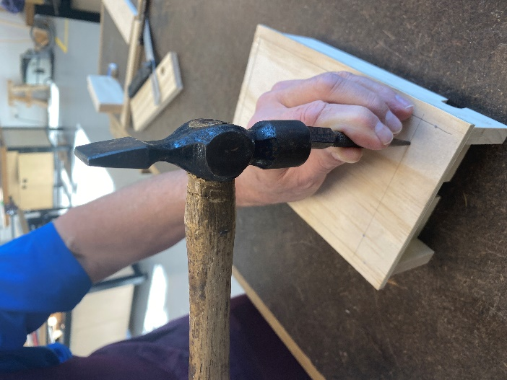
Glue only option for base  Alternatively, students can work in pairs to glue and clamp the base to the box. | 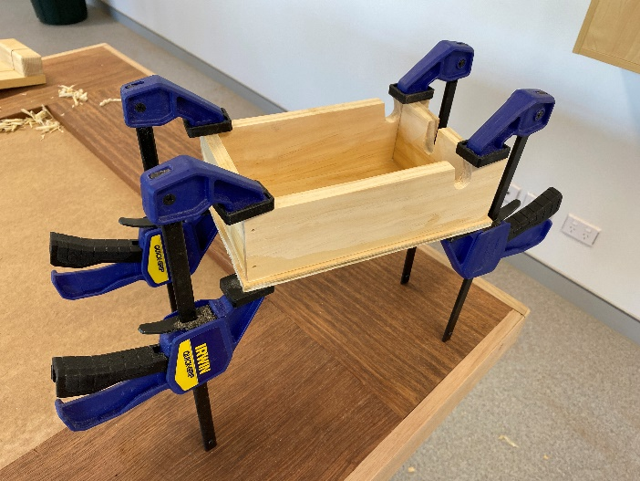
Plane long edges of base flush  Once the glue has dried, clamp the box low in the vice and plane the edges to ensure the base does not overhang the box. | 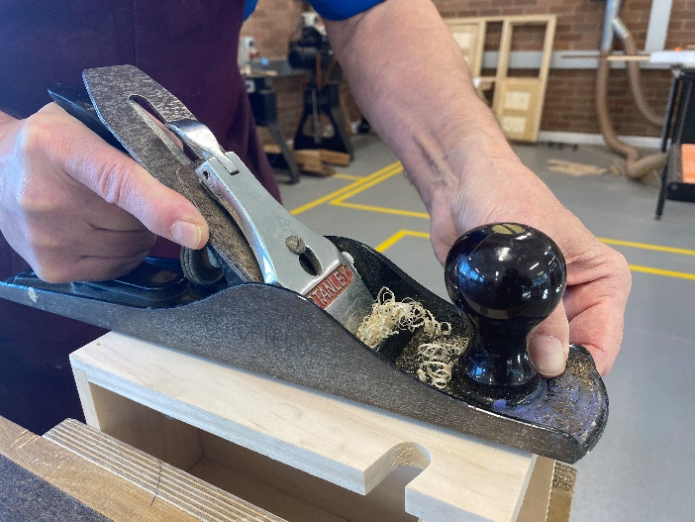
Plane ends of base flush (extension task)  The ends can be planed by working from the outside towards the centre then repeating from the other side until the plywood is flush with the box.  Alternatively, students may use a palm sander or a sanding board. | 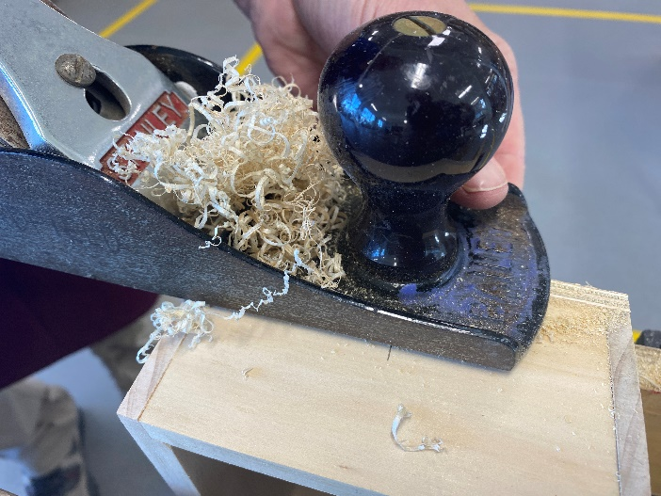  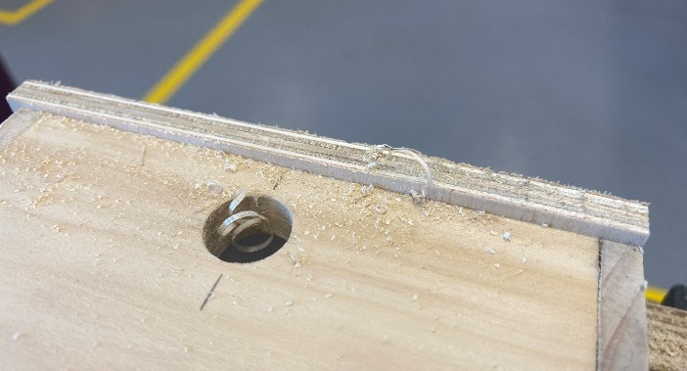
Final sand of box  Remove all pencil marks with an eraser then sand all surfaces using a cork block and 120+ grit abrasive paper. Always sand with the grain. | 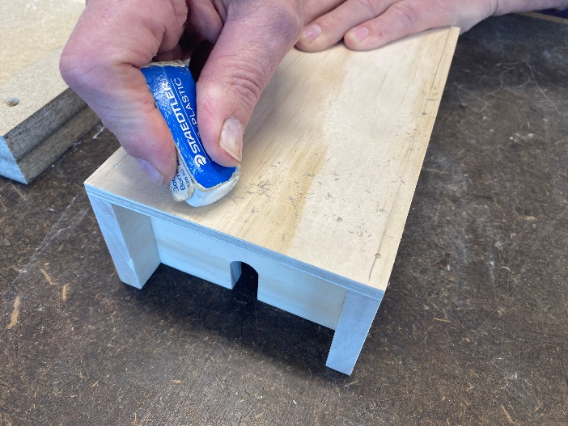  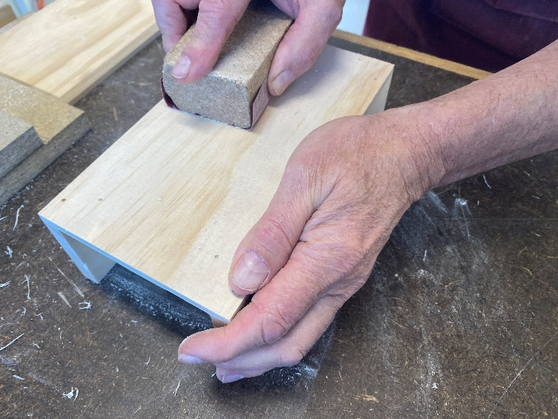
Make lid  Mark out the lid using a try square, rule and pencil.  Cut to length then square each end using the disc sander.  Safety tip: when using the disc sander PPE must be worn and restrain long hair. | 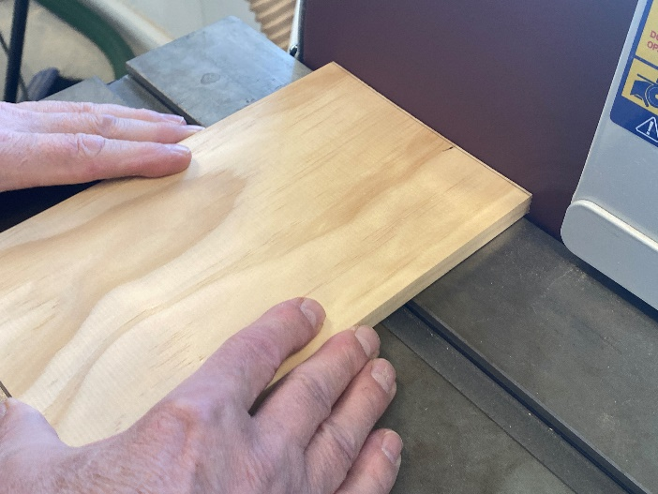
Marking out a chamfer  The lid will have a chamfer around the top edge. Begin by marking a pencil line 6 mm away from the edges using a pencil.  This can be done by using your fingers as a pencil gauge. | 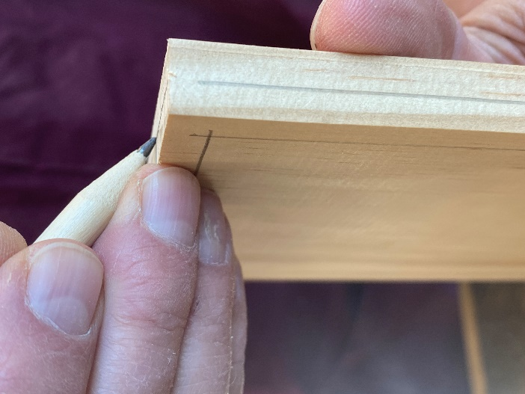
Planing chamfer  Position the timber low in the vice and plane the long edges by holding the plane at 45°. | 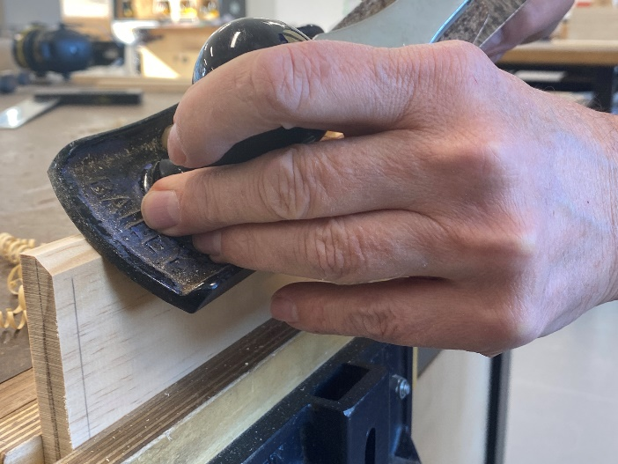
Disc sand ends at 45°  Adjust the angle of the disc sander table to 45° then use the disc sander to remove the waste from each end down to the lines.  Safety tip: when using the disc sander PPE must be worn and restrain long hair. | 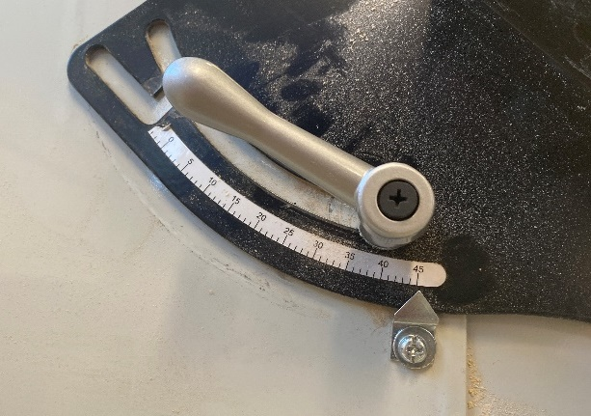  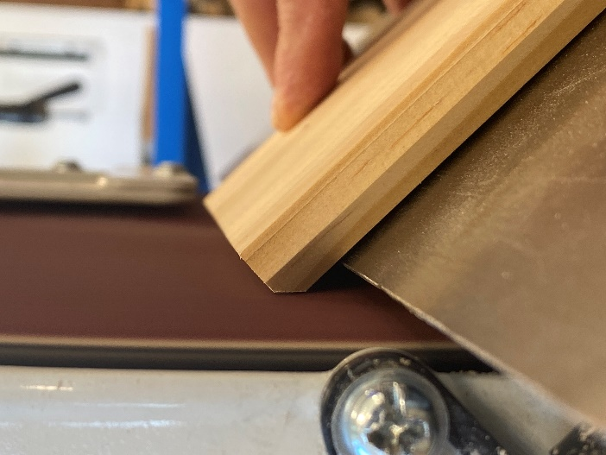
Plane chamfers on ends (extension task)  Alternatively, students can plane the chamfer on the ends using a similar technique as shown previously, planing from the ends to the centre. | 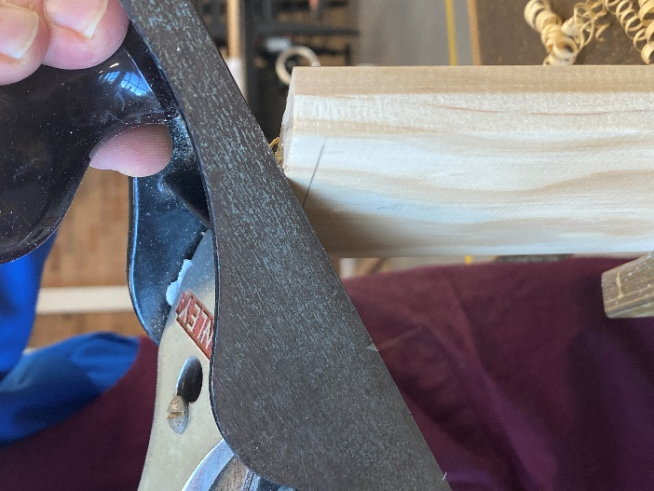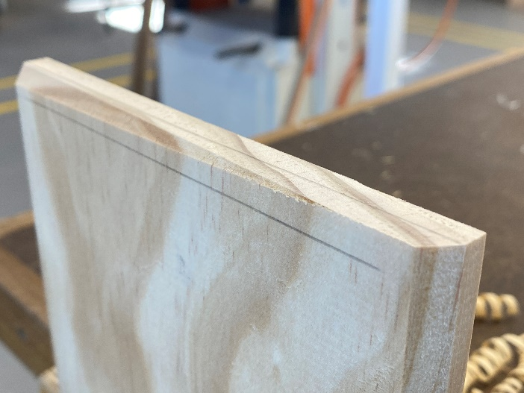
Final sanding of lid  Remove all pencil marks with an eraser then sand all surfaces using a cork block and 120+ grit abrasive paper. Always sand with the grain.  Construction tip: use a bench hook as a stop to stabilise the timber when sanding. | 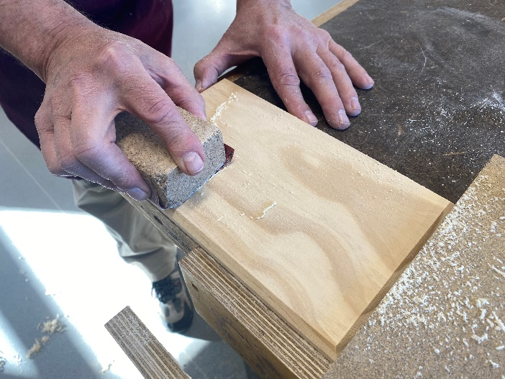
Making strips for lid  Measure the inside of the box. The locating strips must be 2 mm shorter.  Mark out 2 strips of timber 12 mm × 20 mm and cut to length using a tenon saw.  Disc sand the ends square, check to make sure the strips will fit inside the box. | 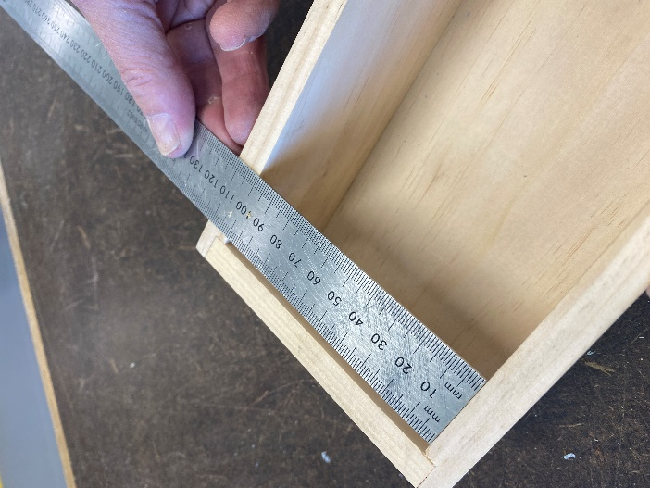  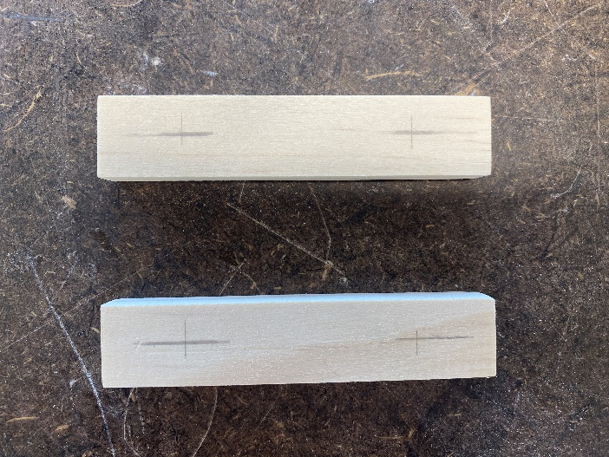
Pre-nailing strips  Mark out positions for 2 nails on each piece and pre-nail. | 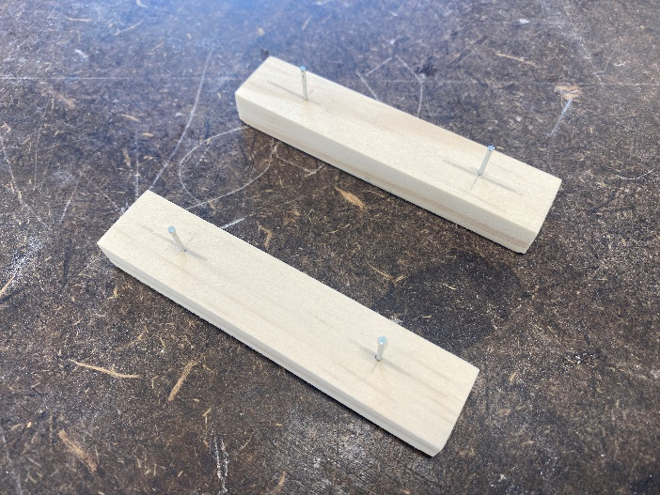
Nailing jig  Use a jig similar to the one shown to accurately locate each strip of timber.  Construction tip: use a template or jig to ensure the strips are positioned correctly. | 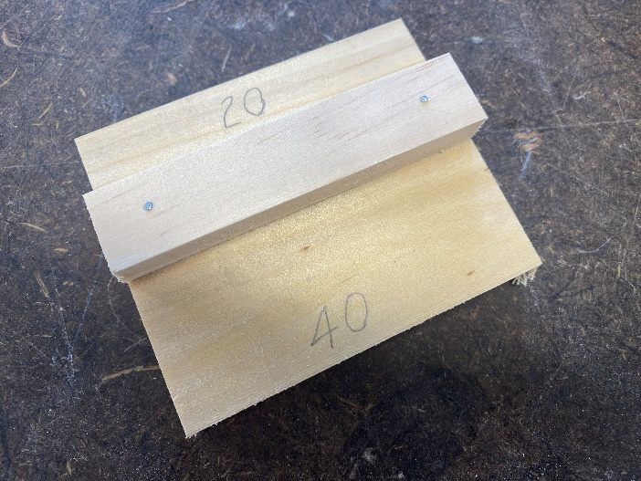
Gluing and positioning strip  Apply glue to the underside of the strip and position using one side of the jig.  Repeat for the second strip.  Note: the positions are different to suit the shape of the box. | 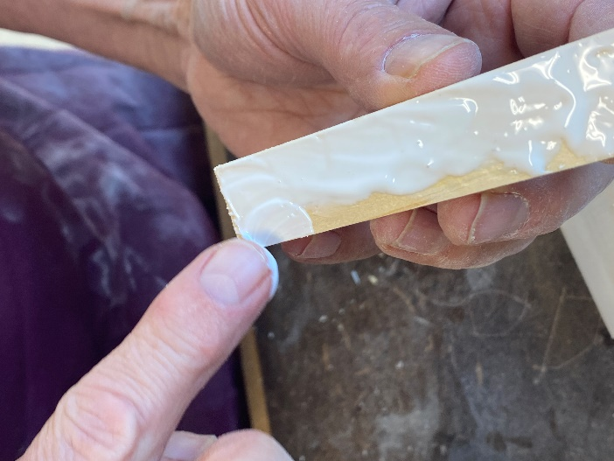  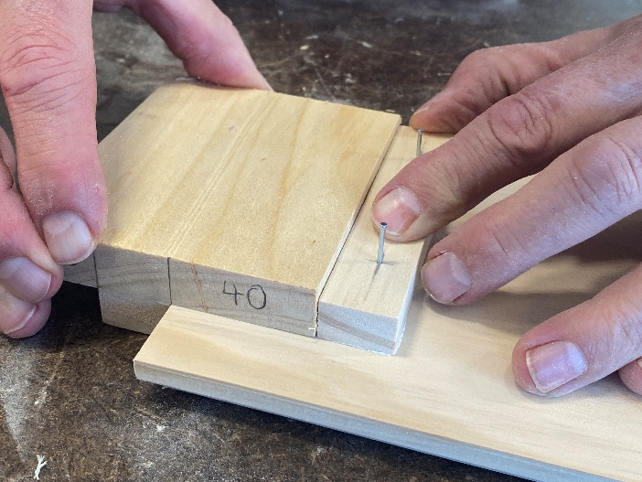
Gluing and nailing  Drive in the nails and punch below the surface. | 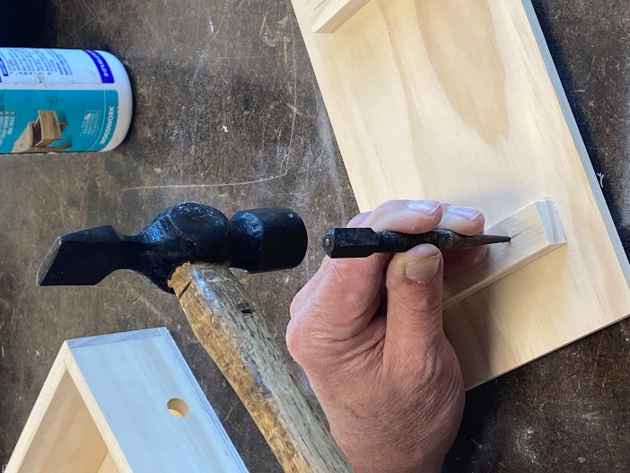
Clean up  Wipe away any excess glue using a damp sponge or rag. | 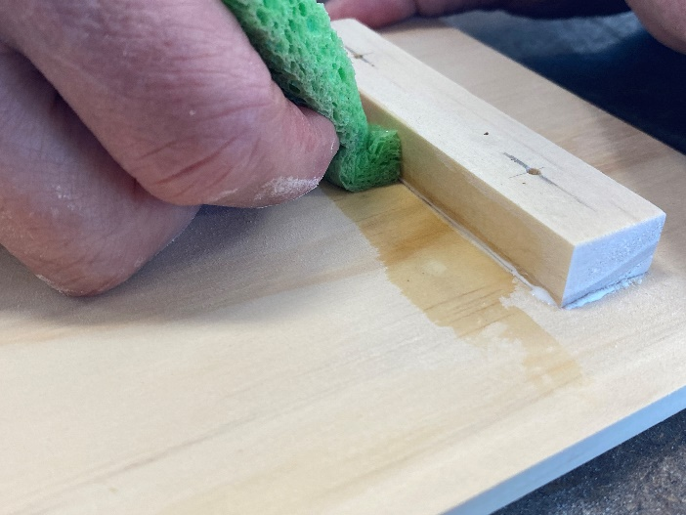
Stopping nail holes  Cover the nail holes by pressing a water-based timber putty into the holes. Use water-based putty/stopping so it is easy to clean up. Using disposable gloves and a putty knife will help keep fingers clean too. | 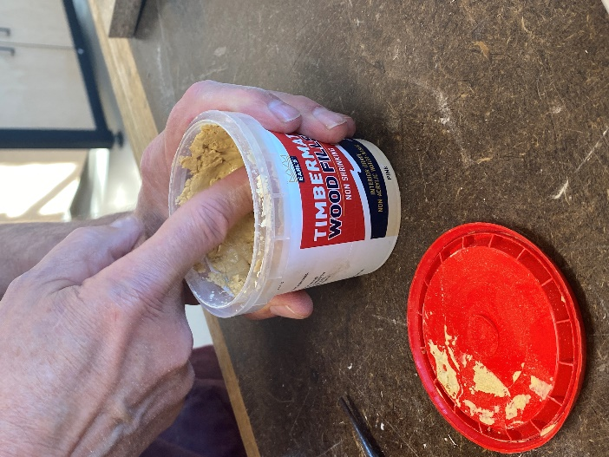  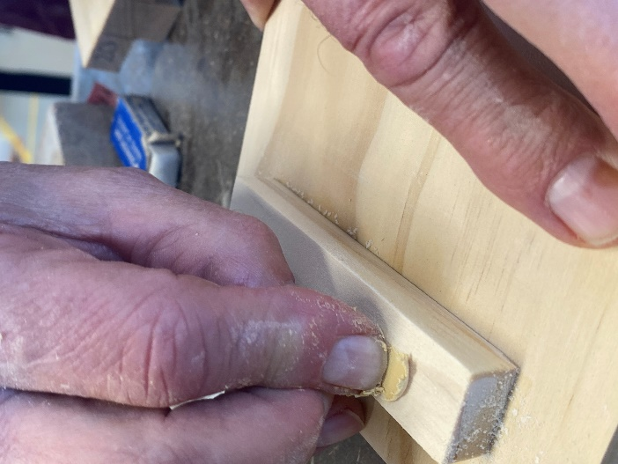
Final sand  Once the putty has dried, lightly sand along the grain to remove dry putty from the surface. You should only see a small dot of putty where it covers the nail hole. | 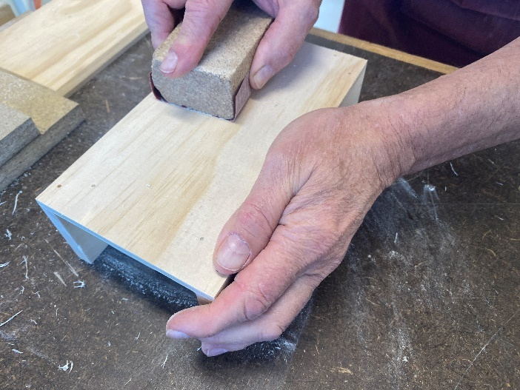

Weeks 9–10
Instruction | Reference image
Decorate phone stand (optional)  You may choose to decorate the project using techniques such as pokerwork or laser engraving. | 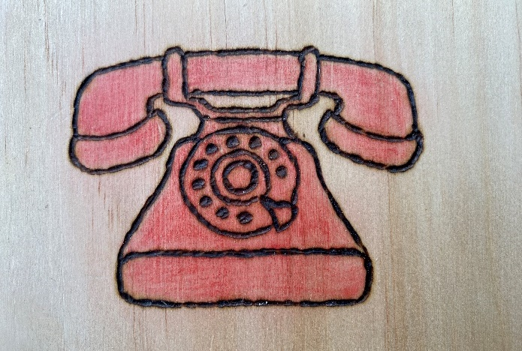  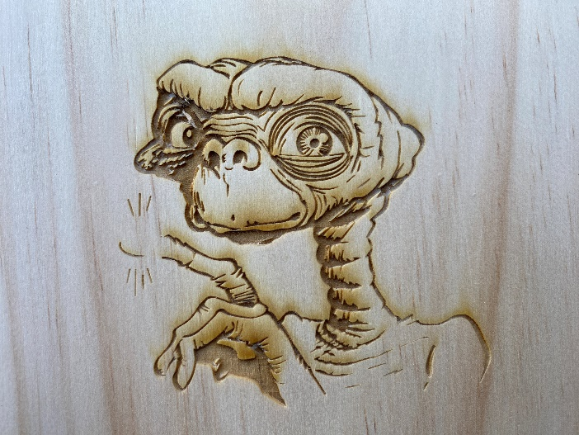
Select a design  The simpler the design, the easier it will be to burn the picture onto the timber. In this image some of the lighter lines will be left off. | 
Pokerwork  Select a design and print it out or alternatively use a design you have drawn yourself.  Use a soft pencil to shade the back of the image. | 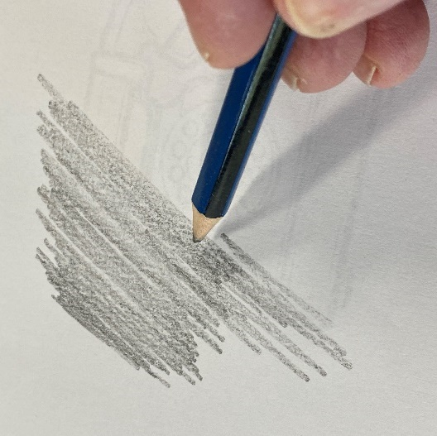
Transfer design  Transfer the design onto the timber by taping down the paper and tracing all lines using a pencil. Press quite hard to press the pencil shading onto the timber. For best results go over the lines a few times | 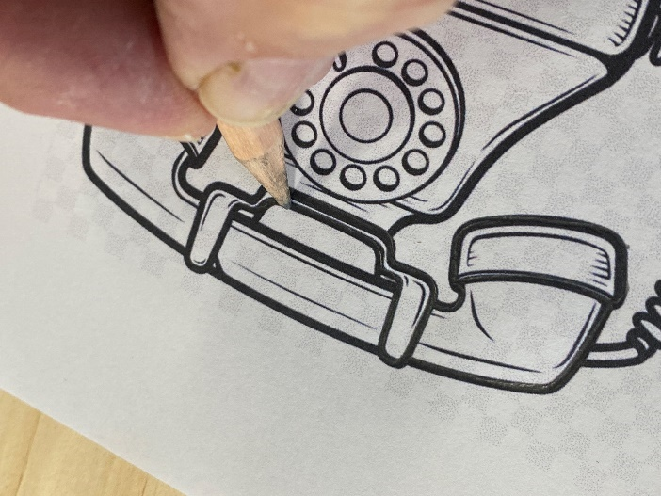
Transferred image  The graphite you shade onto the back of the image will affect the darkness of the image. | 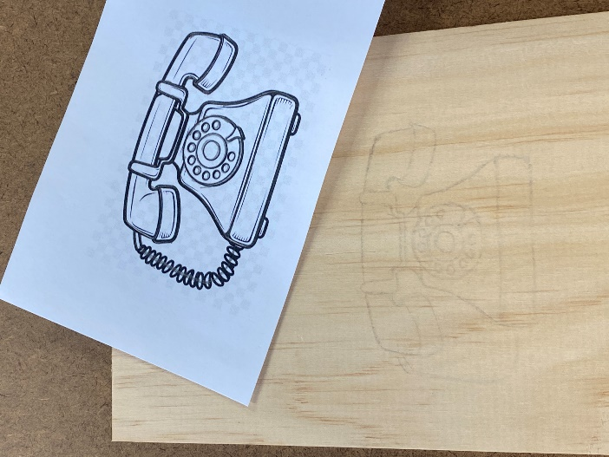
Retrace the image  You will usually need to go over the image with a pencil to make it stand out. | 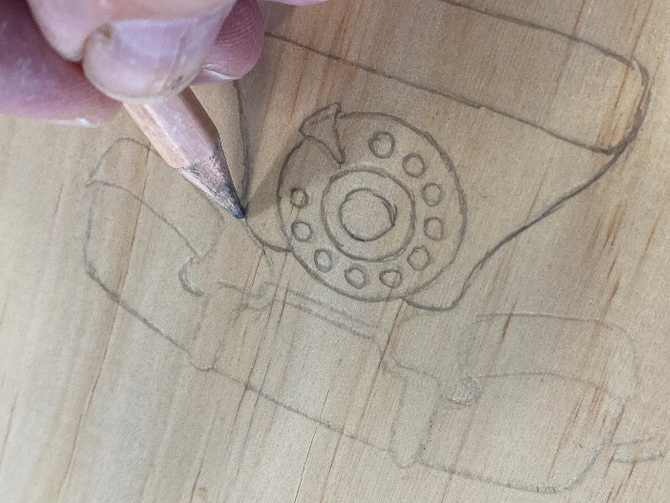
Pokerwork practice  Before you start your design, practice using the pokerwork tool on some scrap timber. The key is to try and get a consistent line thickness.  Construction tip: ensure tip is not bent, the finer the tip the thinner the lines will be. | 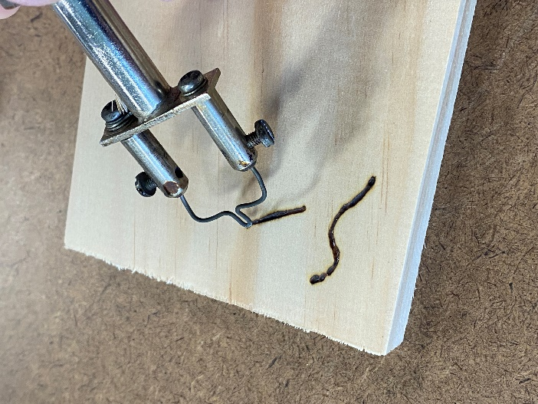
Using the pokerwork tool  Carefully burn over your lines using the pokerwork tool.  Safety tip: the tip of the pokerwork tool is very hot.  Construction tip: have a practice on a piece of scrap timber. | 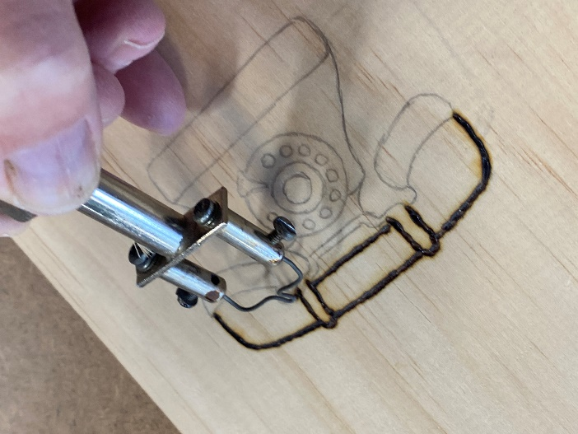
Completed image  Once you have finished have a good look to make sure all the lines are of a similar thickness. | 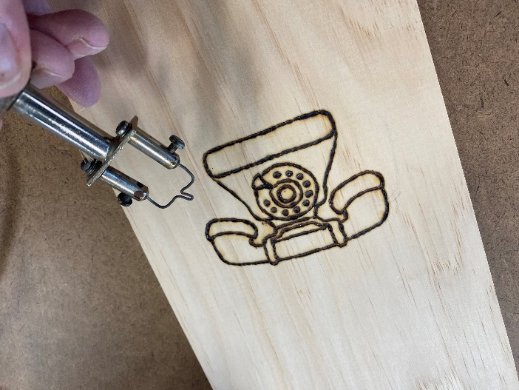
Sand surface  Lightly sand the burnt design and touch up any missing lines. | 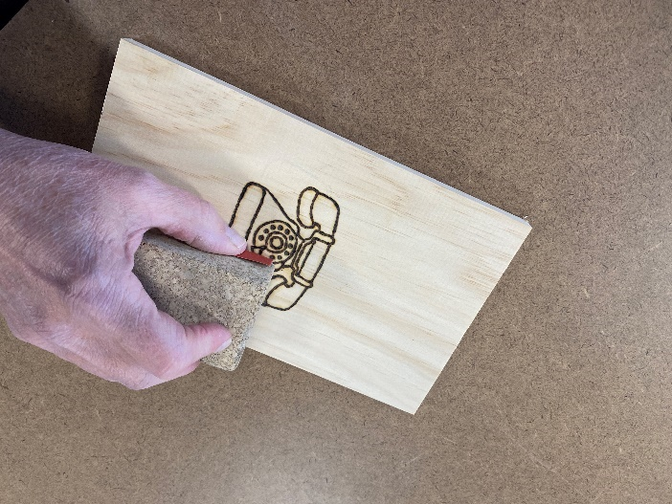
Embellishing design  Decorate the design using coloured pencils. | 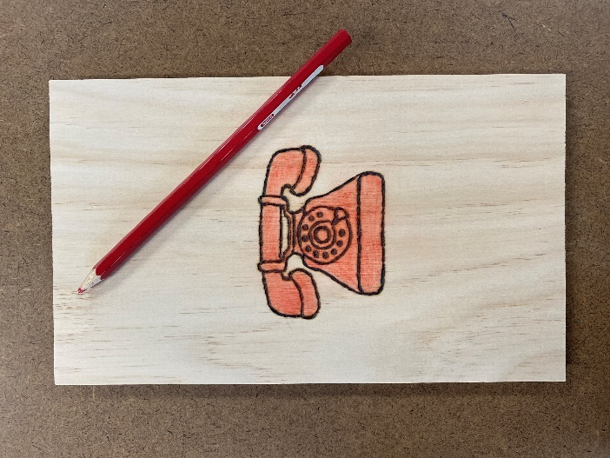
Applying finish  A number of finishes are suitable for sealing this project such as wax, oil, shellac or clear lacquer.  Apply a clear finish to the sign, here we are using a soft cabinetmaker’s wax applied with a soft cloth. | 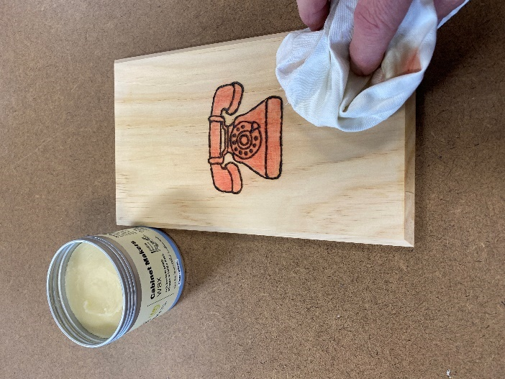
Finished pokerwork design  The entire phone stand has now been waxed and buffed and is ready to use. | 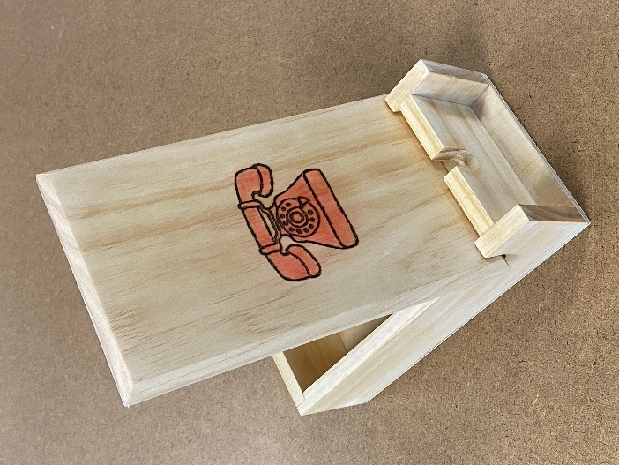
Laser engraver  You may choose to use a laser engraver to burn a design into the timber. Select a suitable design or draw one yourself and load it onto the software program used at your school. | 
Laser engraving  In this image there is some minor discolouration caused by the burning of the lines into the timber. These can be removed by light sanding along the grain. | 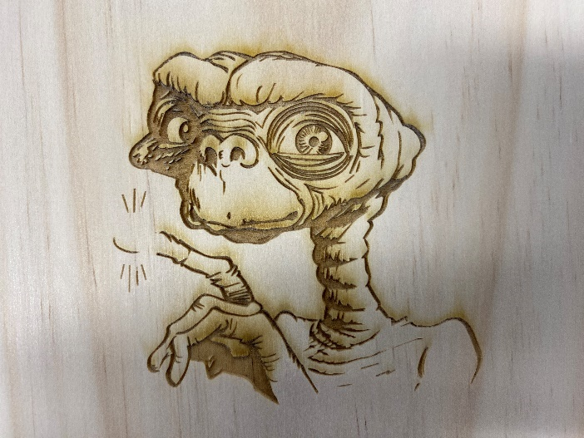
Finished design  The entire phone stand has now been waxed and buffed and is ready to use. | 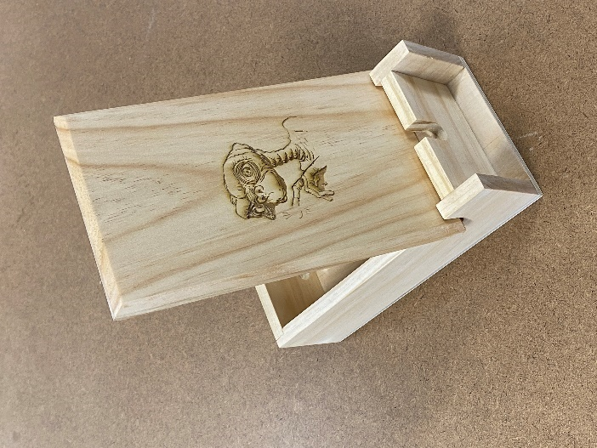
Phone on display  Phone on stand with charging cable connected. | 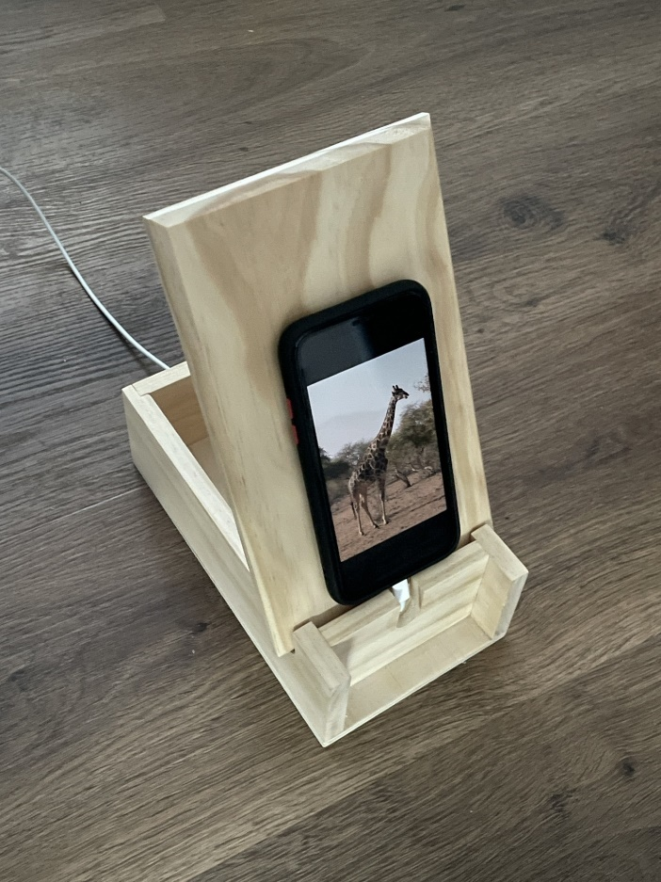

Phone stand construction summary
Weeks 1–2
- Mark out and cut sides and ends.
- Disc sand the ends square.
Weeks 3–4
- Mark out and cut rebate joints.
- Mark out and drill holes.
- Mark out, cut and sand slots.
Weeks 5–6
- Glue, nail and clamp the box together.
- Sand top and bottom surfaces flush.
Weeks 7–8
- Mark out and cut the base.
- Glue and nail base and plane flush with sides and end.
- Mark out, cut and sand the lid.
- Mark out chamfer and plane at an angle, disc sand ends at 45°.
- Attach strips to the underside of lid.
Weeks 9–10
- Create your design on the lid.
- Prepare for finishing.
- Apply the finish.

References
This resource contains NSW Curriculum and syllabus content. The NSW Curriculum is developed by the NSW Education Standards Authority. This content is prepared by NESA for and on behalf of the Crown in right of the State of New South Wales. The material is protected by Crown copyright.
Please refer to the NESA Copyright Disclaimer for more information https://educationstandards.nsw.edu.au/wps/portal/nesa/mini-footer/copyright.
NESA holds the only official and up-to-date versions of the NSW Curriculum and syllabus documents. Please visit the NSW Education Standards Authority (NESA) website https://educationstandards.nsw.edu.au/ and the NSW Curriculum website https://curriculum.nsw.edu.au/.
Technology 7–8 Syllabus © NSW Education Standards Authority (NESA) for and on behalf of the Crown in right of the State of New South Wales, 2023.

© State of New South Wales (Department of Education), 2025
The copyright material published in this resource is subject to the Copyright Act 1968 (Cth) and is owned by the NSW Department of Education or, where indicated, by a party other than the NSW Department of Education (third-party material).
Copyright material available in this resource and owned by the NSW Department of Education is licensed under a Creative Commons Attribution 4.0 International (CC BY 4.0) license.

This license allows you to share and adapt the material for any purpose, even commercially.
Attribution should be given to © State of New South Wales (Department of Education), 2025.
Material in this resource not available under a Creative Commons license:
- the NSW Department of Education logo, other logos and trademark-protected material
- material owned by a third party that has been reproduced with permission. You will need to obtain permission from the third party to reuse its material.
Links to third-party material and websites
Please note that the provided (reading/viewing material/list/links/texts) are a suggestion only and implies no endorsement, by the New South Wales Department of Education, of any author, publisher, or book title. School principals and teachers are best placed to assess the suitability of resources that would complement the curriculum and reflect the needs and interests of their students.
If you use the links provided in this document to access a third-party's website, you acknowledge that the terms of use, including licence terms set out on the third-party's website apply to the use which may be made of the materials on that third-party website or where permitted by the Copyright Act 1968 (Cth). The department accepts no responsibility for content on third-party websites.

