Technology 7–8 – Materials and production processes (timber) – sample assessment task notification
Boxing clever – my phone stand

Contents
Task description 2
Submission details 3
Steps to success 3
What is the teacher looking for? 6
Marking guidelines 7
Student-facing rubric 8
Teacher-facing rubric 12
Appendix A – sample folio documentation scaffold 13
Mini folio – phone stand 13
Design brief 14
How I will use my phone stand 14
Design ideas 14
Project management – phone stand 16
Working drawings for the phone stand 16
Working drawing 1 – box 16
Working drawing 2 – lid 17
Cutting list 18
Time management 18
Construction steps (delete steps before sharing with students) 19
Evaluation of my phone stand 20
Support and alignment 22
References 23

Task description
Type of task: practical project and folio
Outcomes being assessed:
A student:
- applies processes in the planning, management and production of projects TE4-PPM-01
- communicates and evaluates design ideas and solutions TE4-DES-01
- selects and safely uses tools, materials, technologies and processes TE4-SAF-01
Technology 7–8 Syllabus © NSW Education Standards Authority (NESA) for and on behalf of the Crown in right of the State of New South Wales, 2023.
Suggested weighting: 50%
Design, make and document a personalised timber phone stand by researching materials, planning the project and constructing a high-quality final product.
The mobile phone has become an essential part of our lives to communicate, research, entertain and record and share our lives. You will design a phone stand to sit on a desk or table, so that your mobile phone can be easily viewed including while it is being charged. You will have an opportunity to personalise your project with graphics to reflect your abilities and interests.
To support your production of a high-quality, personalised phone stand, you will need to complete the mini-folio and production requirements listed below.
- Describe where your phone stand will be used in your home.
- Produce a list of the construction steps for your project and suggest the number of lessons that will be needed to complete key tasks.
- Develop a cutting list for the project based upon the working drawings provided.
- Create and evaluate a design for the lid of the box component.
- Present a completed phone stand with a decoration on the lid and suitable finish applied.
- Evaluate your project.

Submission details
Format of submission
The final submission should include:
- a timber phone stand that is made in class
- a project mini-folio documenting design and production.
Note: the folio can take the format that best suits your school context and students, such as completing the sample folio documentation scaffold (Appendix A) as a booklet or electronically.

Steps to success
Table 1 – assessment preparation schedule
Step | What I need to do and when I need to do it
- Describe where your phone stand will be used in your home | - Where in your home will your phone stand will be used?  - Describe where the phone stand will be located and if possible, provide a photograph.  - Describe any items you may store in the box component.  Complete this step in Week 2.
- Develop a cutting list for the project based upon the working drawings provided | - Complete the cutting list for the phone stand by referring to the working drawings.  Complete this step in Week 4.
- Produce a list of the construction steps for your project and suggest the number of lessons that will be needed to complete key tasks | - Estimate how much time should be allocated to the parts of the phone stand design and production.  - Place the 12 construction steps into the correct order.  - Estimate how many lessons should be allocated to each step.  Complete this step in Week 6.
- Create and evaluate a design for the lid of the box component | - Draw 2 detailed sketches, each representing a different design idea. Show your design from different angles, such as the front view and side view, or with a pictorial drawing, such as isometric.  - Add annotations to each sketch, explaining key features. Include materials, dimensions, special features or any unique design elements.  - Review your 2 sketches and pick the design you think is the best. Write a clear justification for your choice. Address the following points  - aesthetics: What makes this design visually appealing?  - user needs: How does this design meet the needs of potential users?  Complete this step in Week 9.
- Present a completed phone stand with a decoration on the lid and suitable finish applied | - Safely construct a high-quality phone stand.  - Complete this in class throughout the semester. A suggested timeframe is set out below  - Week 2 – mark out, cut and disc sand sides and ends square.  - Week 3 – mark out and cut rebate joints, drill holes and cut slots.  - Week 4 – mark out and drill holes and cut slots.  - Week 5 – glue, nail and clamp the box together.  - Week 6 – sand top and bottom surfaces flush.  - Week 7 – mark out, cut and attach the base, plane flush with sides and end.  - Week 8 – mark out, cut and sand the lid, mark out chamfers then plane sides and disc sand ends at 45°. Attach strips to the underside of lid.  - Week 9 – create your design on the lid and prepare for finishing.  - Week 10 – apply the finish and present for marking.  Complete this step in Week 10.
- Evaluate your project by considering how it relates to your planning and production | - Provide feedback on how satisfying or difficult you found the tasks and activities involved in making or designing the phone stand.  - Consider where you may use these skills in the future.  Complete this step in Week 10.

What is the teacher looking for?
In this task, the teacher will be evaluating your practical work (phone stand) and folio work based on several key criteria. Here is what to focus on for each aspect of your project:
- Construct your phone stand according to the design plan. Ensure it is square, has quality joints and is finished to a high standard.
- Apply safety practices throughout your project. Demonstrate an understanding of safe working methods to ensure both personal safety and the safety of others.
- Be thorough in your documentation, as this will help convey your thought process and understanding. Use clear language and visuals to support your explanations.

Marking guidelines
Table 2 – assessment marking guidelines
Grade | Marking guideline descriptors
A | The project is exceptionally well-made, demonstrating creativity, thorough research, planning, management and a very high level of quality. All components are completed to a very high standard, with extensive documentation and clear justification for design choices.
B | The project is well-made with good creativity and research. Most components are completed to a high standard and documentation is thorough, though some areas may lack depth or detail in justification.
C | The project is made to a sound standard. Some creativity, research and planning is evident. Components are completed to a sound level with an adequate level of competence demonstrated.
D | The project shows limited execution and creativity. Many components are incomplete, demonstrating a limited level of competence and there is minimal research. Documentation is unclear, lacking depth and justification.
E | The project does not meet the production requirements. The documentation is elementary. The project shows very limited competence in processes and skills.

Student-facing rubric
Table 3 – rubric for assessment
Criteria | Limited | Basic | Sound | High | Outstanding
- Describe where your phone stand will be used in your home  TE4-DES-01 | Limited attempt at idea development. | Produces some basic ideas. | Selects a final design from a range of sound ideas, sketches or pictures, providing a written justification. | Clearly develops ideas through detailed developed ideas, sketches or pictures that link to the project, providing a clearly written justification. | Demonstrates extensive knowledge through well-developed ideas, sketches or pictures, providing a thorough written justification.
- Develop a cutting list for the project based upon the working drawings provided  TE4-PPM-01 | Limited attempt to create a cutting list. | Produces a partial cutting list for the project. | Creates a cutting list with correct dimensions for all parts. | Creates a cutting list with correct dimensions and quantities for all parts. | Creates a cutting list with correct dimensions, quantities and materials for all parts.
- Produce the construction steps for your project and suggest the number of lessons that will be needed to complete key tasks  TE4-PPM-01 | Limited attempt to create a set of construction steps. | Produces a partial list of construction steps for the project. | Produces a mostly correctly ordered list of construction steps for the project. | Produces a mostly correctly ordered list of construction steps for the project with a good estimate of the time expected for each task. | Produces a correctly ordered list of construction steps for the project with an accurate estimate of the time expected for each task.
- Create and evaluate a design for the lid of the box  TE4-DES-01 | Limited attempt at idea development. | Produces some basic idea sketches. | Selects a final design from a range of sound sketches, providing a written justification. | Clearly develops ideas through detailed sketches and annotations that link to the project. | Demonstrates extensive knowledge through well-developed ideas and insightful annotations in sketches.
- Present a completed phone stand with a decoration on the lid and suitable finish applied  TE4-PPM-01 | Limited attempt at project completion, no lid. | Constructs a partially completed project with a lid. | Completes a functional phone stand to an adequate standard, ensuring it is:  - mostly square  - has close fitting joints  - finished to a satisfactory quality. | Completes a functional phone stand to a high standard, ensuring it is:  - square  - has high-quality joints  - finished to a high quality. | Completes a functional phone stand with a decorated lid to a very high standard, ensuring it is:  - square  - has high-quality joints  - finished to a high quality.
- Evaluate your project by considering how it relates to your planning and production  TE4-DES-01 | Limited attempt to evaluate the project. | Lists some positive and negative aspects of the project. | Discusses main features of the project, identifying areas for improvement. | Provides an evaluation of making the project, its features and suggests specific improvements and steps to implement them. | Provides an extensive evaluation of making the project, its features and where these skills may be used in the future.
- Safety  TE4-SAF-01 | Limited understanding of safety practices, with significant risks present. | Basic understanding of safety practices, with some minor risks present. | Demonstrates sound knowledge of safety practices, ensuring a generally safe working environment. | Demonstrates thorough understanding of safety practices, ensuring a safe and efficient working environment. | Demonstrates extensive knowledge and application of safety practices, ensuring a highly safe and efficient working environment throughout the project.

Teacher-facing rubric
Table 4 – rubric for assessment
Criteria | Limited | Basic | Sound | High | Outstanding
TE4-PPM-01: applies processes in the planning, management and production of projects | Does not apply effective processes, resulting in an unworkable project. | Basic processes resulting in unclear construction steps and limited management. | Basic processes with some inconsistencies in construction steps and resource use. | Appropriate processes with mostly effective construction steps and resource use. | Detailed and logical processes with clear adherence to construction steps.
TE4-DES-01: communicates and evaluates design ideas and solutions | Does not communicate or evaluate effectively with no justification. | Limited communication with little evaluation or justification. | Sound communication with some evaluation. | Thorough communication and evaluation. | Extensive communication and evaluation with thorough justification.
TE4-SAF-01: selects and safely uses tools, materials, technologies and processes | Neglects safety practices, posing significant risks in production. | Inadequate safety practices, leading to potential risks. | Adequate selection and application of safety practices. | Accurate selection and use of tools and technologies. Applies safety procedures well. | High level of competence in selecting and safely using a range of tools and materials.
Technology 7–8 Syllabus © NSW Education Standards Authority (NESA) for and on behalf of the Crown in right of the State of New South Wales, 2023.

Appendix A – sample folio documentation scaffold

Mini folio – phone stand
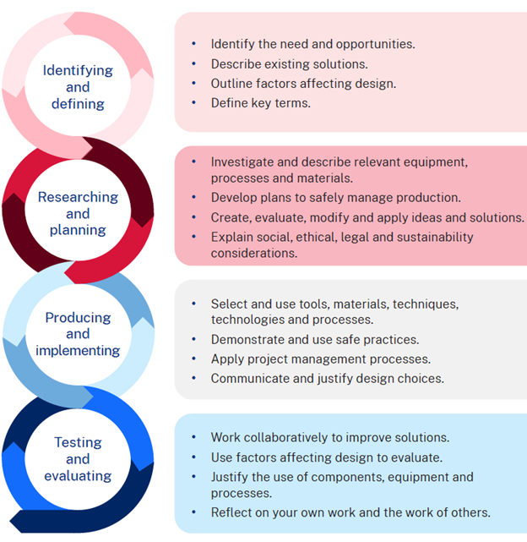

Design brief
Construct a phone stand for your desk or bedside table and include at least one aesthetic enhancement such as wood burning or laser engraving. The final product should be finished to ensure durability and a polished appearance. The project must be completed in 10 weeks including the time needed to learn about how to use tools and machines safely and the application of a finish.

How I will use my phone stand
Describe where you will use your phone stand and what you will store in the box component.

Design ideas
Sketch 2 design ideas for the lid. Experiment with logo design, font size and style and/or transfer of graphics or pictures which inspire you. Annotate each design to describe your choices.
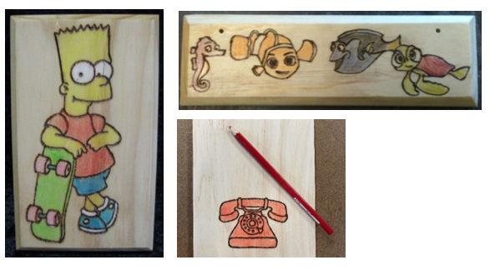

Design idea 1

Design idea 2

Justification
Which design have you selected and why? Consider the design brief and limitations in your response below.

Project management – phone stand

Working drawings for the phone stand
The drawing below shows an orthogonal drawing of the box component including top, side and end views. Generally, the number of views you need in a drawing depends on how much detail you need to build the project. Some projects require only 2 views.
There is also a pictorial view of the finished project. The pictorial style used here is known as an isometric view.

Working drawing 1 – box
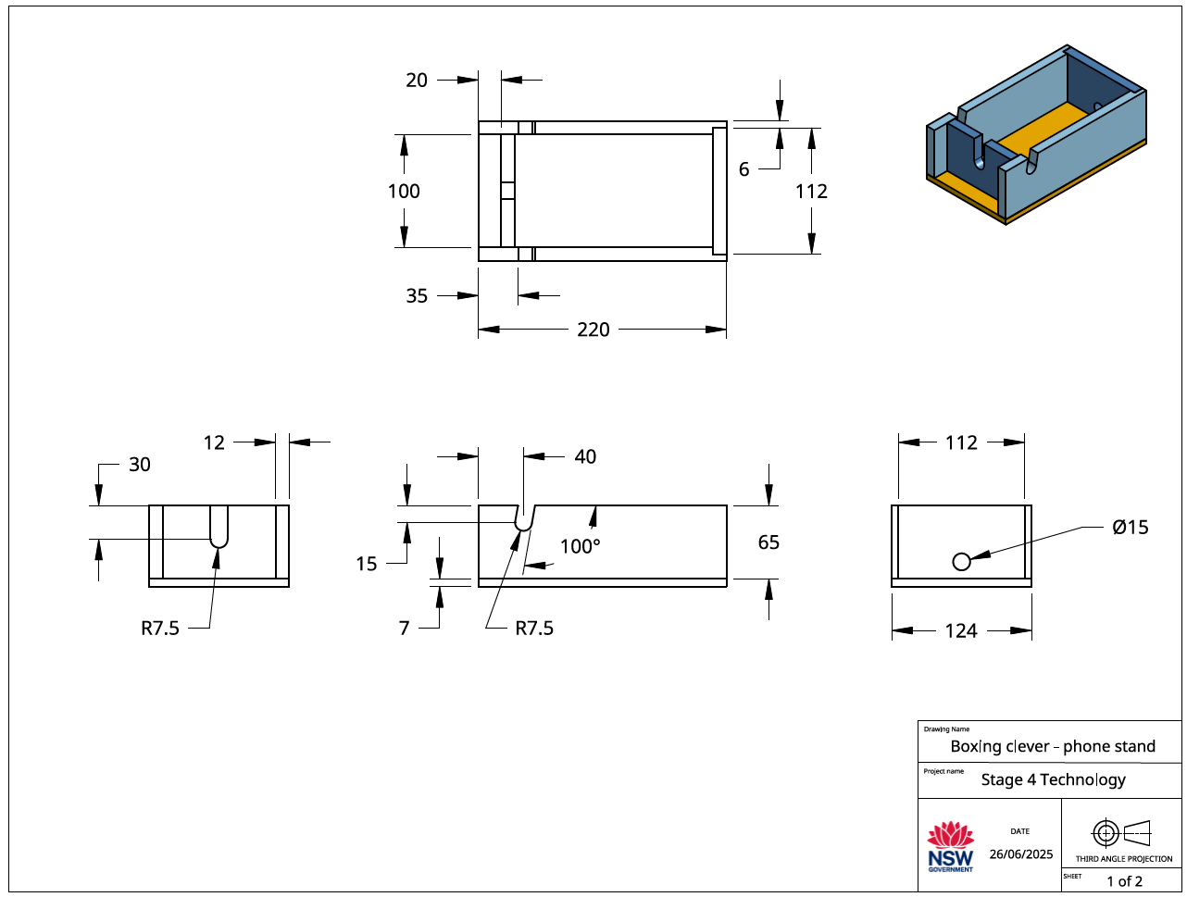

Working drawing 2 – lid
The following drawing, an orthogonal or orthographic drawing, presents more information about the li and how it fits into the box.
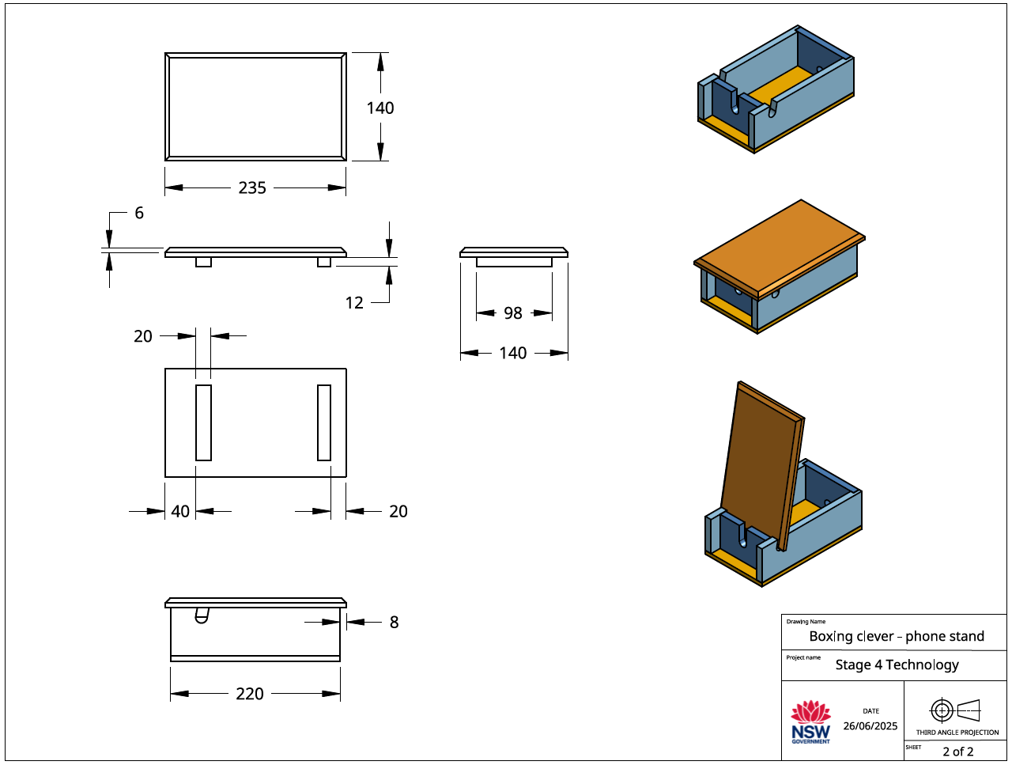

Cutting list
The cutting list describes to the builder/maker the type of material to be used, the dimensions of the material, the number of parts, the name of each part and other information relevant to the manufacture of the project. It is presented as a table. Complete the table below for your project.
No. | Description | Quantity | Length mm | Width mm | Thickness mm | Material
1 | Sides
2 | Back
3 | Front
4 | Base
5 | Lid
6 | Strips

Time management
Time management is the planning we do to make sure our project is completed in the time we have available. When we are planning the time management for this project, we need to look at the time we have available and the tasks we need to do to complete the project.
Time available
Question | Answer
How many weeks do we have available to make the phone stand?
How many practical lessons do we have in a week?
How many practical lessons do we have to complete the phone stand?
What tasks do we need to do and how long will they take?
In the table provided, sort the following construction steps into the correct order then estimate how much time should be allocated to each task.
Apply a suitable finish  Mark out, cut and sand parts for lid  Mark out, drill holes and cut slots for lid  Glue and nail base to box  Sand box edges flush  Mark out and cut rebate joints | Mark out and cut sides and ends  Sand all parts ready for finishing  Sand sides and ends to length  Glue and nail sides and ends  Glue and nail lid together  Plane and sand base flush with box

Construction steps (delete steps before sharing with students)
Step | Task | Estimated time (in lessons)
1 | Mark out and cut sides and ends
2 | Sand sides and ends to length
3 | Mark out and cut rebate joints
4 | Mark out, drill holes and cut slots for lid
5 | Glue and nail sides and ends
6 | Sand box edges flush
7 | Glue and nail base to box
8 | Plane and sand base flush with box
9 | Mark out, cut and sand parts for lid
10 | Glue and nail lid together
11 | Sand all parts ready for finishing
12 | Apply a suitable finish

Evaluation of my phone stand
- On the line below, place an X that matches the way you like to work.

I like working on my own |  |  | I like working with others
- On the line below, place an X that matches the amount of time you had to make your phone stand.

I had enough time |  |  | My project was rushed
- On the line below, place an X that you think matches the quality of your phone stand.

Poor quality | Fair quality | Good quality | High quality
- What task in the designing or making of your phone stand did you find the most difficult?
____________________________________________________________________________________________________________________________________________________________
______________________________________________________________________________
______________________________________________________________________________
- What task in the designing or making of your phone stand was the most rewarding?
____________________________________________________________________________________________________________________________________________________________
______________________________________________________________________________
______________________________________________________________________________
- Is there anything you would do differently on your next technology project?
____________________________________________________________________________________________________________________________________________________________
______________________________________________________________________________
______________________________________________________________________________
- Are there any skills that you developed making your phone stand that you will use outside school?
____________________________________________________________________________________________________________________________________________________________
______________________________________________________________________________
______________________________________________________________________________

Support and alignment
Resource evaluation and support: all curriculum resources are prepared through a rigorous process. Resources are periodically reviewed as part of our ongoing evaluation plan to ensure currency, relevance and effectiveness. For additional support or advice, or to provide feedback, contact the TAS Curriculum team by emailing TAS@det.nsw.edu.au.
Differentiation: further advice to support Aboriginal and Torres Strait Islander students, students learning English as an additional language or dialect (EAL/D), students with a disability and/or additional needs and High potential and gifted students can be found on the Planning, programming and assessing 7–12 webpage. This includes the Inclusion and differentiation 7–10 advice webpage.
Assessment: further advice to support formative assessment is available on the Planning, programming and assessing 7–12 webpage. This includes the Classroom assessment advice 7–10. For summative assessment tasks, the Assessment task advice 7–10 webpage is available.
Explicit teaching: further advice to support explicit teaching is available on the Explicit teaching webpage. This includes the CESE Explicit teaching – Driving learning and engagement webpage.
Consulted with: Curriculum and Reform, Inclusive Education, Multicultural Education, Aboriginal Outcomes and Partnerships and subject-matter experts.
Alignment to system priorities and/or needs: School excellence, Our Plan for NSW Public Education.
Alignment to the School Excellence Framework: this resource supports the School excellence elements of curriculum (curriculum provision) and effective classroom practice (lesson planning, explicit teaching).
Alignment to Australian Professional Standards for Teachers: this resource supports teachers to address Proficient Teacher Standard Descriptors 3.2.2, 3.3.2.
Creation date: 22 May 2024.

References
This resource contains NSW Curriculum and syllabus content. The NSW Curriculum is developed by the NSW Education Standards Authority. This content is prepared by NESA for and on behalf of the Crown in right of the State of New South Wales. The material is protected by Crown copyright.
Please refer to the NESA Copyright Disclaimer for more information https://educationstandards.nsw.edu.au/wps/portal/nesa/mini-footer/copyright.
NESA holds the only official and up-to-date versions of the NSW Curriculum and syllabus documents. Please visit the NSW Education Standards Authority (NESA) website https://educationstandards.nsw.edu.au and the NSW Curriculum website https://curriculum.nsw.edu.au.
Technology 7–8 Syllabus © NSW Education Standards Authority (NESA) for and on behalf of the Crown in right of the State of New South Wales, 2023.
Brookhart SM (2018) ‘Appropriate Criteria: Key to Effective Rubrics’, Frontiers in Education, volume 3(22):1–12, doi:10.3389/feduc.2018.00022, accessed 18 April 2024.
CESE (Centre for Education Statistics and Evaluation) (2020) What works best: 2020 update, NSW Department of Education, accessed 17 April 2024.
Fisher D and Frey N (1 November 2009) ‘Feed Up, Back, Forward’, ASCD (Association for Supervision and Curriculum Development): Educational Leadership magazine, 67(3), accessed 1 May 2024.
Hattie J and Timperley H (2007) ‘The Power of Feedback’, Review of Educational Research, 77(1): 81–112, doi:10.3102/003465430298487.
NESA (NSW Education Standards Authority) (2024) ‘Proficient Teacher Standard Descriptors’, Achieve Proficient Teacher accreditation, NSW government website, accessed 5 February 2025.
Panadero E and Jonsson A (2013) ‘The use of scoring rubrics for formative assessment purposes revisited: A review’, Educational Research Review, 9:129–144, doi:10.1016/j.edurev.2013.01.002, accessed 1 May 2024.
Wiliam D (2017) Embedded Formative Assessment, 2nd edn, Solution Tree Press, Bloomington, IN.
© State of New South Wales (Department of Education), 2025
The copyright material published in this resource is subject to the Copyright Act 1968 (Cth) and is owned by the NSW Department of Education or, where indicated, by a party other than the NSW Department of Education (third-party material).
Copyright material available in this resource and owned by the NSW Department of Education is licensed under a Creative Commons Attribution 4.0 International (CC BY 4.0) license.

This license allows you to share and adapt the material for any purpose, even commercially.
Attribution should be given to © State of New South Wales (Department of Education), 2025.
Material in this resource not available under a Creative Commons license:
- the NSW Department of Education logo, other logos and trademark-protected material
- material owned by a third party that has been reproduced with permission. You will need to obtain permission from the third party to reuse its material.
Links to third-party material and websites
Please note that the provided (reading/viewing material/list/links/texts) are a suggestion only and implies no endorsement, by the New South Wales Department of Education, of any author, publisher, or book title. School principals and teachers are best placed to assess the suitability of resources that would complement the curriculum and reflect the needs and interests of their students.
If you use the links provided in this document to access a third-party's website, you acknowledge that the terms of use, including licence terms set out on the third-party's website apply to the use which may be made of the materials on that third-party website or where permitted by the Copyright Act 1968 (Cth). The department accepts no responsibility for content on third-party websites.

