Technology 7–8 – food practices – teacher resource
More than just a sandwich

Contents
Teacher support resource 2
What is a nutrient? 3
Function of nutrients 4
Macro and micronutrients 5
Nutrient sources activity 6
What nutrients do I need? 8
Nutritional value in bush foods 10
Bush foods 11
Recommended dietary intake 13
What is a serve? 16
Meal plan 19
Food industries in New South Wales 20
Community food initiatives contributing to sustainability 22
The design and production process 24
References 26

Teacher support resource
Note: this resource has been designed to facilitate the ready conversion into a student booklet by removing the answers within the response boxes. Teacher notes can be deleted before distributing to students.
School leaders and teachers should consult with students and their parents or carers regarding how to support their religious and/or dietary requirements. Alternate food options should be provided for students to meet learning outcomes.
Refer to Equipment Safety in Schools, Animals in Schools, and Chemical Safety in Schools for current information on safety and safe working practices in technology 7–8.

What is a nutrient?
There are 6 essential nutrients that the body needs to function properly. These are found in the food we eat. Nutrients are compounds in foods and they are vital to life and health.
In the table below, outline the 6 essential nutrients with the correct example of food sources.
Note: solution provided.
Table 1 – nutrients and food sources
Nutrient | Food sources
Carbohydrates | Bread, pasta, rice, cereals, sugar, fruit
Proteins | Beef, chicken, pork, lamb, eggs, seafood, nuts
Fats | Oils, avocado, salmon, butter, seeds, nuts
Vitamins | Vitamin C, A and folic acid – fruits and vegetables  B group vitamins and fibre – grains and cereals  Vitamins A, D and E (fat soluble) – full fat dairy and egg yolks  Vitamin K – milk, vegetables, soya bean oil
Minerals | Calcium and magnesium – milk and dairy products  Iron and zinc – red meat  Iodine – seafood and vegetables
Water | As a beverage and a component of many foods especially vegetables and fruits

Function of nutrients
Nutrients perform a variety of different functions in the body. In the table below, outline the function of the listed nutrients.
Note: solution provided.
Table 2 – nutrients and their functions
Nutrient | Function
Carbohydrates | Provide energy
Proteins | Promote growth and repair of muscles and cells in the body
Fats | Protects internal organs, move some vitamins around the body and helps to regulate body heat
Vitamins | Support body functions and the immune system
Minerals | Calcium – keeps teeth and bones strong  Fibre – helps to remove waste from the body
Water | Supports digestion and keeps the body hydrated
Nutrients can be categorised into 2 groups known as macronutrients and micronutrients. These groups refer to the amount of nutrients required by the body.
- Macronutrients – nutrients the body needs in large amounts to function properly. They provide the body with energy and building blocks the body needs for growth, development and daily activities.
- Micronutrients – nutrients the body needs in smaller amounts to function properly. They play crucial roles in metabolism, immune system function and bone health.

Macro and micronutrients
Use the table below to categorise the nutrients into micronutrients and macronutrients.
Note: solutions provided.
Table 3 – macronutrients and micronutrients
Macronutrients | Micronutrients
Carbohydrates | Vitamins
Proteins | Minerals
Fats
Water

Nutrient sources activity
Look at the image of a balanced meal in Figure 1. Identify the food sources and nutrients in the meal. In the table below, provide the function of each of the identified nutrients.
Note: solution provided.
Table 4 – balanced meal
Food item | Nutrient | Function
Quinoa | Carbohydrates | Provide energy
Chicken breast | Protein | Promote growth and repair of muscles and cells in the body
Avocado | Fats | Protects internal organs, move some vitamins around the body and helps to regulate body heat.
Cherry tomatoes | Vitamin C | Support body functions and the immune system
Alfalfa sprouts | Vitamin K, magnesium | Supports bone and blood health.  Supports muscle and nerve health.
Rocket leaves | Vitamin C, folate | Support body functions and the immune system.  Supports cell health.
Figure 1 – balanced meal example
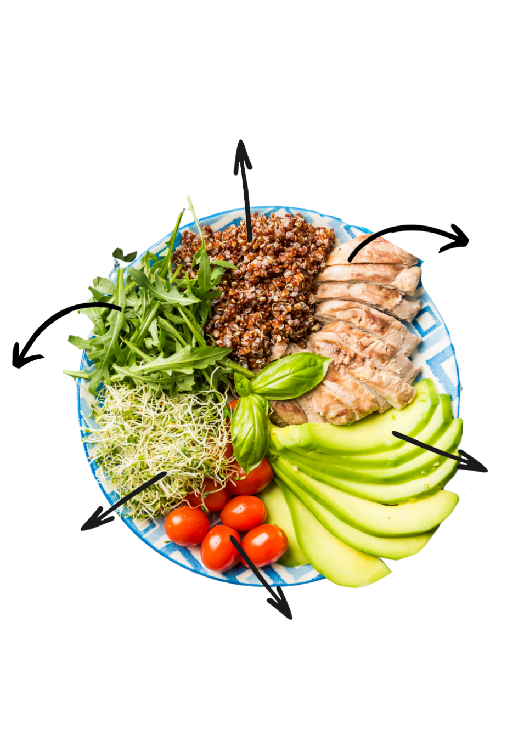

What nutrients do I need?
Everyone requires different quantities of each nutrient. The quantities are different from person to person and are dependent on age, life stages and gender as well as personal health circumstances.
The image below is from the Australian Guide to Healthy Eating. The Australian Guide to Healthy Eating is a food selection guide that visually represents the proportion of different food groups recommended for consumption each day.
The guide is broken down into food groups. These food groups can also be reflective of the 6 essential nutrients.
Figure 2 – Australian Guide to Healthy Eating
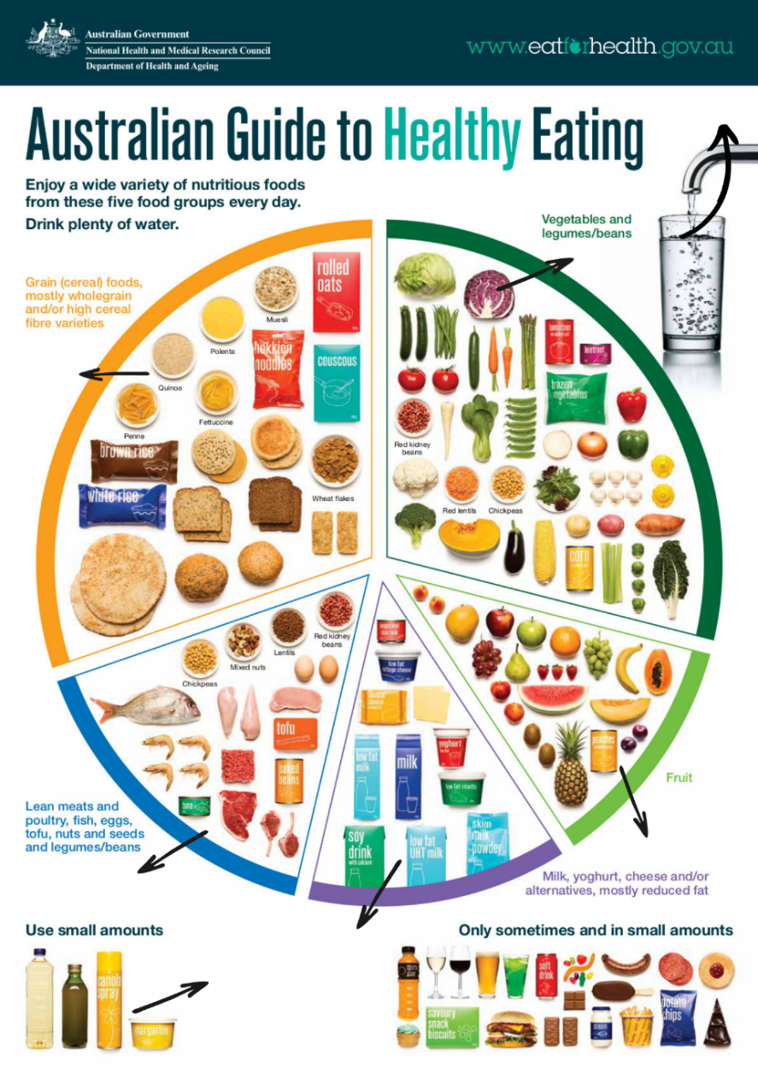
‘Australian guide to healthy eating’ by Eat For Health is licensed under CC BY 4.0.
Use the Australian Guide to Healthy Eating in Figure 2 on the previous page to identify the most likely nutrient(s) for each food group in the table below. Don’t forget to look outside of the chart.
Note: solutions provided.
Table 5 – food groups and nutrients
Food group | Nutrients
Grain (cereal) foods, mostly wholegrain and/or high cereal fibre varieties | Carbohydrates
Vegetables and legumes/beans | Vitamins, minerals and carbohydrates
Fruit | Carbohydrates, vitamins
Milk, yogurt, cheese and/or alternatives, mostly reduced fat | Fats, minerals (vitamin D, calcium)
Lean meats and poultry, fish, eggs, tofu, nuts and seeds and legumes/beans | Protein and minerals (iron)
Use small amounts | Fats
Water | Water
Only sometimes and in small amounts | Carbohydrates and fats

Nutritional value in bush foods
Aboriginal and Torres Strait Islander peoples developed sophisticated farming and land management practices. These practices were effective and sustainable in enabling a varied diet.
In places with ample rainfall, like the coastal and tropical regions of Australia, there was a wide variety of plants and animals to eat. However, in drier areas, with less rainfall, the choices were fewer, and water was scarce. Despite this, First Nations peoples were skilled at finding adequate food.
The diet of Aboriginal and Torres Strait Islander peoples was nutritionally balanced and rich in nutrients. They obtained a significant portion of their energy from protein sources, such as fish, shellfish, goanna and kangaroo. They consumed a range of fresh fruits and vegetables providing them with essential fibre and micronutrients.
Fat intake among Aboriginal and Torres Strait Islander peoples was low, primarily because the fat they did consume came from hunted game or caught fish. Nevertheless, their diet consisted of bush foods that were packed with valuable nutrients for good health.
Using reading strategies, read the article High antioxidants, vitamins: The Australian bush tucker diet you should try.
Figure 3 – reading strategies
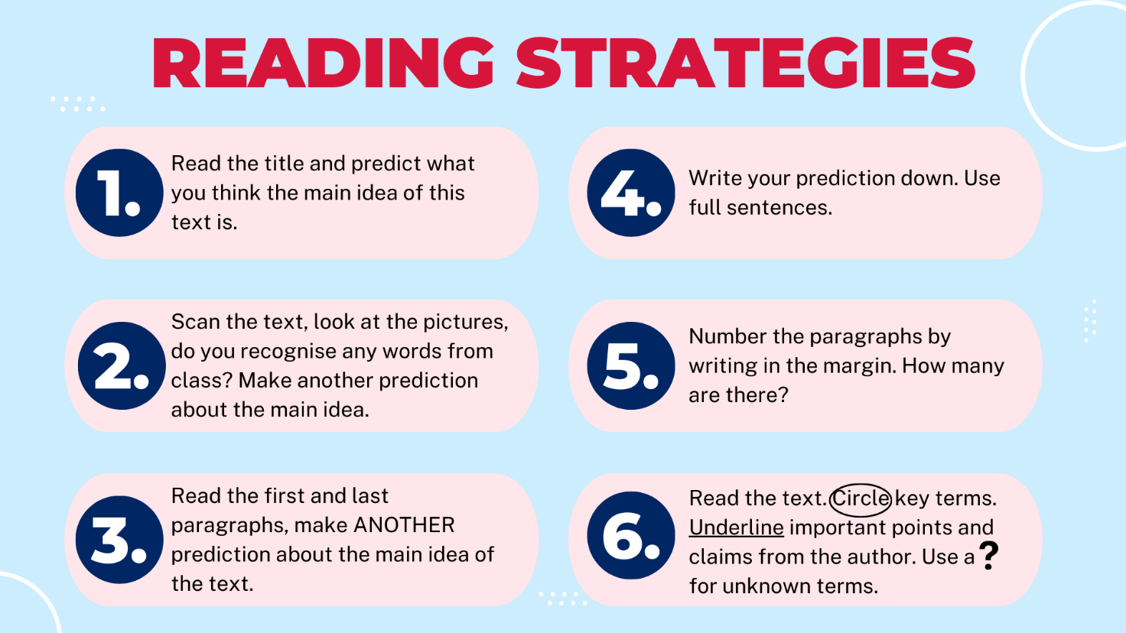

Bush foods
There are many ingredients native to New South Wales (NSW), below is a selection. Using research skills, complete the table below and locate their region for growth on the map.
Table 6 – ingredients native to NSW
Food item | Location | Flavour | Nutrient
Finger limes
Anise myrtle
Lilly pilly berries
Macadamia nuts
Wattleseed
Dorrigo pepper
Figure 4 – NSW spatial map
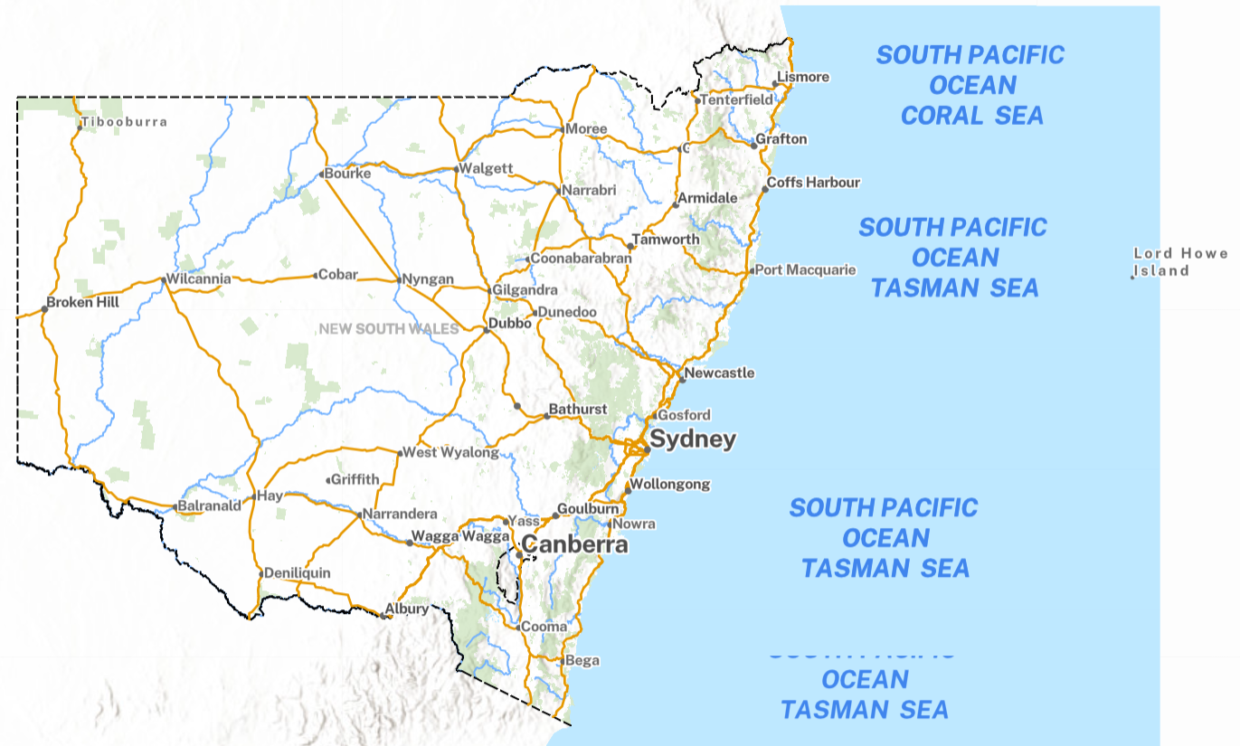
‘NSW Spatial map’ by NSW Government’s Spatial Collaboration Portal is licensed under the Creative Commons Attribution By (CC BY) Licence.

Recommended dietary intake
Nutrition Australia have developed a Healthy Eating Pyramid based on the Australian dietary guidelines. It is another visual representation of the proportion of foods we should be eating to maintain a healthy lifestyle.
Watch The Healthy Eating Pyramid (14:00) and use the recommended dietary intake information for teenagers to complete the table below.
Note: solution provided.
Table 7 – teenager dietary intake
Age | Vegetables and legumes | Fruit | Grain (cereal) foods | Lean meat and poultry, fish, eggs, nuts and seeds | Milk, yoghurt, cheese | Additional serves
Males  12–13 | 5 $\frac{1}{2}$ | 2 | 6 | 2 $\frac{1}{2}$ | 3 $\frac{1}{2}$ | 0–3
Females  12–13 | 5 | 2 | 5 | 2 $\frac{1}{2}$ | 3 $\frac{1}{2}$ | 0–2 $\frac{1}{2}$
Males  14–18 | 5 $\frac{1}{2}$ | 2 | 7 | 2 $\frac{1}{2}$ | 3 $\frac{1}{2}$ | 0–5
Females  14–18 | 5 | 2 | 7 | 2 $\frac{1}{2}$ | 3 $\frac{1}{2}$ | 0–2 $\frac{1}{2}$

What is a serve?
The ‘serve size’ is a set amount stated by the Australian guidelines and this doesn’t change. It is a standard measurement. This amount may not be the same as a portion size. A portion size is how much you eat. For some people their portion might include 2 serves, for others, their portion size may be $\frac{1}{2}$ a serve.
Have a look at the recommended serves for different age groups and genders.
Table 8 – recommended serves
Group | Vegetables and legumes beans | Fruit | Grain (cereal) foods, mostly wholegrain | Lean meat and poultry, fish, eggs, nuts and seeds | Milk, yoghurt, cheese and/or alternatives
Boys 12–13 | 5 $\frac{1}{2}$ | 2 | 6 | 2 $\frac{1}{2}$ | 3 $\frac{1}{2}$
Boys 14–18 | 5 $\frac{1}{2}$ | 2 | 7 | 2 $\frac{1}{2}$ | 3 $\frac{1}{2}$
Girls 12–13 | 5 | 2 | 5 | 2 $\frac{1}{2}$ | 3 $\frac{1}{2}$
Girls 14–18 | 5 | 2 | 7 | 2 $\frac{1}{2}$ | 3 $\frac{1}{2}$
Source: ‘Healthy eating for children’ by Eat For Health.
Using the meal plan below, calculate the serves of each of the food groups.
Table 9 – meal plan
Meal | Food items | Serves
Breakfast | 30 g wheat cereal flakes, $\frac{1}{2}$ cup reduced fat milk  1 large boiled egg
Morning tea | 1 medium apple  1 crumpet with a light spread or margarine
Lunch | Chicken and salad sandwich  2 slices wholemeal bread, 80 g chicken breast, 1 slice reduced fat cheese, 1 cup mixed salad, 1 tsp mayonnaise
Afternoon snack | Cheese and tomato with crackers  3 crispbreads, 1 reduced fat cheese slice, 1 medium tomato
Dinner | Beef kebab with rice and vegetables  65 g cooked lean beef, $\frac{1}{2}$ cup cooked brown rice, $\frac{1}{2}$ cup sweet corn, $\frac{1}{2}$ cup cooked carrot, $\frac{1}{2}$ cup cooked beans
After dinner snack | 200 g yogurt with 1 cup canned peaches
In the table below, identify the total serves of each food group.
Note: solution provided.
Table 10 – total serves
Vegetables and legumes | Fruit | Grain (cereal) foods | Lean meat and poultry, fish, eggs, nuts and seeds | Milk, yoghurt, cheese | Additional serves
5 | 2 | 6 | 2 $\frac{1}{2}$ | 3$\frac{1}{2}$ | 2
In the space below, identify the specific group of people this meal plan would be suitable for. You will need to suggest some changes to the meal plan to support your response.
Note: solution provided.
Sample answer:
This meal plan would be suitable for a boy aged 12 to 13 years old with the following changes.
- Add an additional $\frac{1}{2}$ serving of vegetables, for example, one cup raw salad vegetables, such as cucumber sticks, for an afternoon snack.

Meal plan
Using your knowledge of nutrients, food groups and serving sizes develop a one-day meal plan for an adolescent of your choosing. Use the table below to scaffold your plan.
Table 11 – age and gender
Age | Gender
Table 12 – meal and food items
Meal | Food items
Breakfast
Morning tea
Lunch
Afternoon snack
Dinner
After dinner snack
Calculate the number of serves in your meal plan above.
Table 13 – number of serves
Vegetables and legumes | Fruit | Grain (cereal) foods | Lean meat and poultry, fish, eggs, nuts and seeds | Milk, yoghurt, cheese | Additional serves

Food industries in New South Wales
There are a number of food industries in NSW. Each one plays a vital role in ensuring the availability of safe and nutritious food for Australians to eat.
Use the information available at Industry – NSW Food Authority to name and describe some food-related industries in New South Wales. Provide your answers in the diagram below. An example has been provided for you.
Figure 6 – food industry in NSW
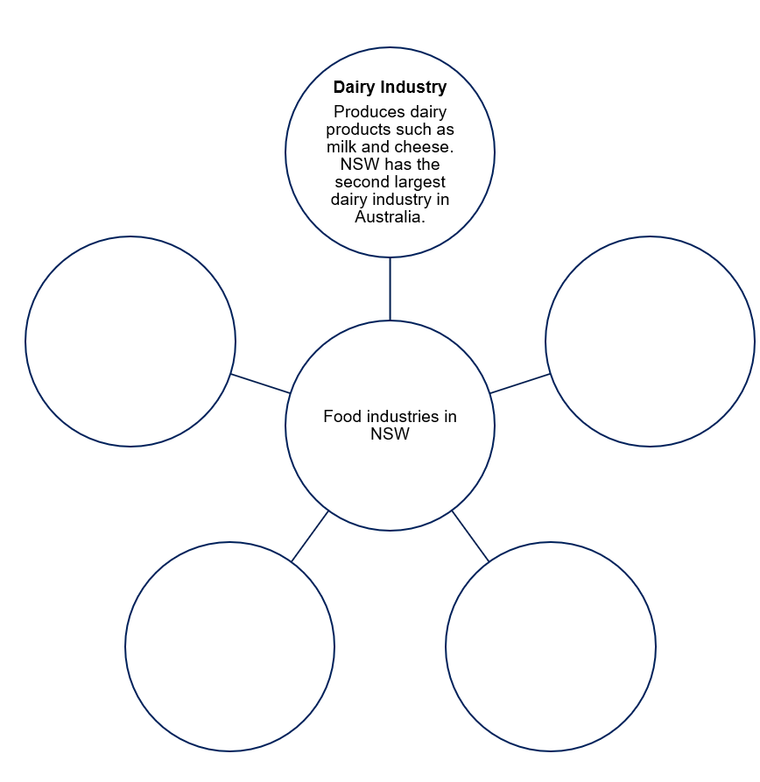

Community food initiatives contributing to sustainability
Complete a visual vocab for the words below. Provide a definition and an image in the space provided.
Table 14 – vocabulary
Word | Image | Definition
Community
Initiative
Sustainability
Using your definitions above, re-write the following sentence in the space provided:
Community food initiatives contributing to sustainability.
Everyone has the right to access nutritious and safe food, however through a variety of circumstances sometimes people do not have this access. Community food initiatives develop programs that provide food to those in need, while minimising the impact on landfill. Some of these community food initiatives include:
- About SecondBite - SecondBite
- OzHarvest Australia | Australia’s leading food rescue organisation
- Foodbank | Ending Hunger in Australia
- Addi Road Food Pantry | Addison Road Community Organisation.
Use the list of community food initiatives to develop a one-page summary of a chosen food initiative. Once completed, you will participate in a gallery walk with your classmates. Include the following in your one-page summary.
- Name of community food initiative.
- Describe what your chosen food initiative does.
- Describe how they contribute to sustainability in the community.
- Include images and/or videos about your community initiative.

The design and production process
Throughout technology 7–8, you will follow a design and production process, which is a continuous cycle used to develop your projects. In this unit of work, we will focus on food-based solutions. Your workbooks will act as your folio throughout this unit, documenting your process.
There are 4 main steps in the process that help to provide a solution to design problems. Evaluation happens at each step and is constant throughout the process.
Figure 7 – design and production process
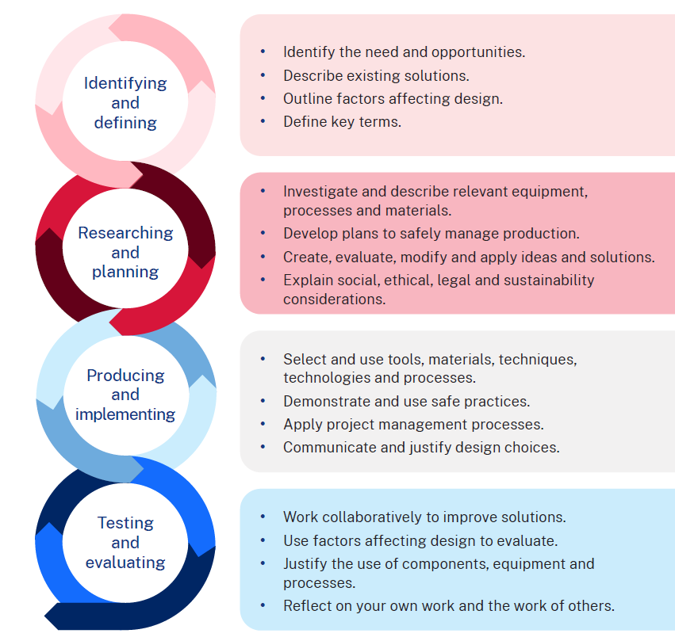
In your workbook you are working on the identifying and defining and researching and planning components of the design and production process. Your recipe book will help to guide you through the producing and implementing and testing and evaluating steps.

References
This resource contains NSW Curriculum and syllabus content. The NSW Curriculum is developed by the NSW Education Standards Authority. This content is prepared by NESA for and on behalf of the Crown in right of the State of New South Wales. The material is protected by Crown copyright.
Please refer to the NESA Copyright Disclaimer for more information https://educationstandards.nsw.edu.au/wps/portal/nesa/mini-footer/copyright.
NESA holds the only official and up-to-date versions of the NSW Curriculum and syllabus documents. Please visit the NSW Education Standards Authority (NESA) website https://educationstandards.nsw.edu.au/ and the NSW Curriculum website https://curriculum.nsw.edu.au.
Technology 7–8 Syllabus © NSW Education Standards Authority (NESA) for and on behalf of the Crown in right of the State of New South Wales, 2023.
Addison Road Community Organisation (2024) Addi Road Food Relief & Rescue, Addi Road Food Pantry website, accessed 1 May 2024.
ClickView (14 July 2020) 'The Healthy Eating Pyramid' [video], ClickView, YouTube, accessed 22 April 2024.
ClickView (15 July 2020) 'Safety In The Domestic Kitchen - Food Technology' [video], ClickView, YouTube, accessed 9 April 2024.
ClickView (21 October 2020) 'Food Groups And Nutrition' [video], ClickView, YouTube, accessed 11 April 2024.
emmymade (3 July 2020) 'FRUIT SANDO -- Japanese Fruit Sandwich Recipe Test' [video], emmymade, YouTube, accessed 29 April 2024.
Food Bank (2024) Food Bank [website], accessed 1 May 2024.
Jamie Oliver (27 April 2012) 'Jamie Oliver on knife skills - 30-Minute Meals' [video], Jamie Oliver, YouTube, accessed 11 April 2024.
Mitchelson A (2018) High antioxidants, vitamins: The Australian bush tucker diet you should try, The New Daily website, accessed 19 April 2024.
National Health and Medical Research Council (n.d.) The guidelines | Eat For Health, Eat For Health website, accessed 22 April 2024.
National Health and Medical Research Council (2021a) Australian Guide to Healthy Eating, Eat For Health website, accessed 15 April 2024.
National Health and Medical Research Council (2021b) Recommended number of serves for children, adolescents and toddlers, Eat For Health website, accessed 22 April 2024.
NSW Government (2020) Spatial Map Viewer, Spatial Collaboration Portal website, accessed 1 May 2024.
NSW Government Food Authority (2024) Industry, NSW Government Food Authority website, accessed 23 April 2024.
NSW Government Food Authority (n.d.) ‘Hand Washing’, Factsheets, guides and policies, NSW Government Food Authority website, accessed 9 April 2024.
Nutrition Australia (2021) Healthy Eating Pyramid, Nutrition Australia, accessed 22 April 2024.
Ozharvest (2024) OZHARVEST [website], accessed 1 May 2024.
Science Buddies (10 March 2020) 'See Germs! Hand Washing Science Experiment’ [video], Science Buddies, YouTube, accessed 9 April 2024.
Second Bite (2024) About Us, Second Bite website, accessed 1 May 2024.
WinnyHayes (1 July 2022) 'Japanese Fruit Sando' [video], WinnyHayes, YouTube, accessed 29 April 2024.

© State of New South Wales (Department of Education), 2024
The copyright material published in this resource is subject to the Copyright Act 1968 (Cth) and is owned by the NSW Department of Education or, where indicated, by a party other than the NSW Department of Education (third-party material).
Copyright material available in this resource and owned by the NSW Department of Education is licensed under a Creative Commons Attribution 4.0 International (CC BY 4.0) license.

This license allows you to share and adapt the material for any purpose, even commercially.
Attribution should be given to © State of New South Wales (Department of Education), 2024.
Material in this resource not available under a Creative Commons license:
- the NSW Department of Education logo, other logos and trademark-protected material
- material owned by a third party that has been reproduced with permission. You will need to obtain permission from the third party to reuse its material.
Links to third-party material and websites
Please note that the provided (reading/viewing material/list/links/texts) are a suggestion only and implies no endorsement, by the New South Wales Department of Education, of any author, publisher, or book title. School principals and teachers are best placed to assess the suitability of resources that would complement the curriculum and reflect the needs and interests of their students.
If you use the links provided in this document to access a third-party's website, you acknowledge that the terms of use, including licence terms set out on the third-party's website apply to the use which may be made of the materials on that third-party website or where permitted by the Copyright Act 1968 (Cth). The department accepts no responsibility for content on third-party websites.

