Technology 7–8 – food practices – recipe booklet
More than just a sandwich

Contents
Recipe booklet 2
Glossary 3
Safety in the domestic kitchen 5
Safety and hygiene in the kitchen 7
Washing hands – learning activity 8
The danger zone – learning activity 9
Common kitchen utensils and equipment 12
Kitchen scavenger hunt 14
Measuring equipment 16
Kitchen procedures 20
Tortilla wrap 21
Knife safety – learning activity 23
Breakfast sandwich 25
Oven safety 28
Evaluate – breakfast sandwich 30
Hygiene and safety 31
Banh mi (Vietnamese sandwich) 34
Japanese fruit sandwich 38
Vegetable flatbread 42
Terminology – learning activity 47
Hamburger 49
References 53

Recipe booklet
Note: this resource has been designed to facilitate the ready conversion into a student booklet by removing the answers within the response windows. Teacher notes can be deleted before distributing to students.
This resource is intended for you to adapt as suited to your school and your available resources. Additional recipes, learning resources and activities have been included in this resource allowing for school choice.
School leaders and teachers should consult with students and their parents or carers regarding how to support their religious and/or dietary requirements. Alternate food options should be provided for students to meet learning outcomes.
Refer to Equipment Safety in Schools, Animals in Schools, and Chemical Safety in Schools for current information on safety and safe working practices in technology 7–8.

Glossary
Many of the following words will gather more meaning to you as you work through the booklet.
Each time you see a new word throughout the workbook you can add its definition in the table below in case you need to refer back later.
Note: solution provided.
Table 1 – a glossary of words and their definitions
Word | Definition
bacteria | A microorganism in food that may cause disease.
biological contamination | The presence of organisms in food that could cause food poisoning or food spoilage, for example, mould.
chemical contamination | The presence of unwanted chemicals in food that could cause illness or spoilage, for example, cleaning spray.
contamination | The presence of foreign material or substance in food that could cause illness or spoilage.
cross-contamination | The transfer of bacteria or microorganisms from one food substance to another, for example, blood from red meat onto fresh salad ingredients.
danger zone | A temperature range where bacteria can multiply rapidly.
domestic kitchen | Similar to the home in terms of equipment and utensils.
equipment | Electrical goods used in kitchens.
evaluate | To draw a conclusion or to assess after a process has been completed.
food waste | Food intended for human consumption that is wasted or lost.
hygiene | Conditions and practices to preserve and promote health.
ignition | The act of starting the heat or lighting the fire in a gas oven.
ingredients | Foods or substances that are combined to make a particular dish.
measure | To check the size or weigh an ingredient to a certain amount.
physical contamination | The presence of a foreign object not intended to be in the food, for example, hair.
recipe | A set of instructions for preparing a dish, usually with an ingredient list and a method.
safety | To make sure that something is kept secure or safe.
thermometer | A piece of equipment used to measure temperature.
utensil | A device used in the domestic kitchen, usually handheld.
Note: for students with an EAL/D background, and for students with disability, the glossary can be provided complete so that they have additional time to understand the key terms with bilingual dictionaries. The glossary can be provided to students in their preferred communication mode.

Safety in the domestic kitchen
Access the video resource Safety In The Domestic Kitchen – Food Technology (14:20).
After watching Safety in the domestic kitchen – Food Technology, create a list of safety expectations to follow in the kitchen in the table below.
Note: the table below has the safety rules included. Provide the table with the column blank for students to complete the activity. Alternatively adapt the activity to include some of the safety expectations are left in the table to support students with disability and reduce cognitive load.
Table 2 – safety expectations in the domestic kitchen
Safety expectations
Wear clothes that are not loose or baggy, and wear shirts with sleeves.
Wear sturdy, lace up shoes. No open shoes.
Remove jewellery.
Wear an apron and gloves if required.
When passing a knife to someone, pass with the handle first.
Have the sharp edge of the knife facing away from you when cleaning.
Always use a chopping board when cutting food.
Avoid carrying knives around the kitchen.
Sweep up broken glass or crockery immediately and dispose by wrapping in sheets of newspaper.
Use oven mitts when removing food from the oven.
Open saucepan lids away from yourself to avoid burns.
Fire extinguishers should be checked regularly.
Check any electrical equipment including the cord is in good working condition, and do not use near water.
Keep food out of the danger zone, between 5–60°C.
Store chemicals and cleaning products away from children.
Wash hands thoroughly in hot water whenever you prepare food.

Safety and hygiene in the kitchen
Complete the activity below by filling in what is correct or wrong in the blank spaces.
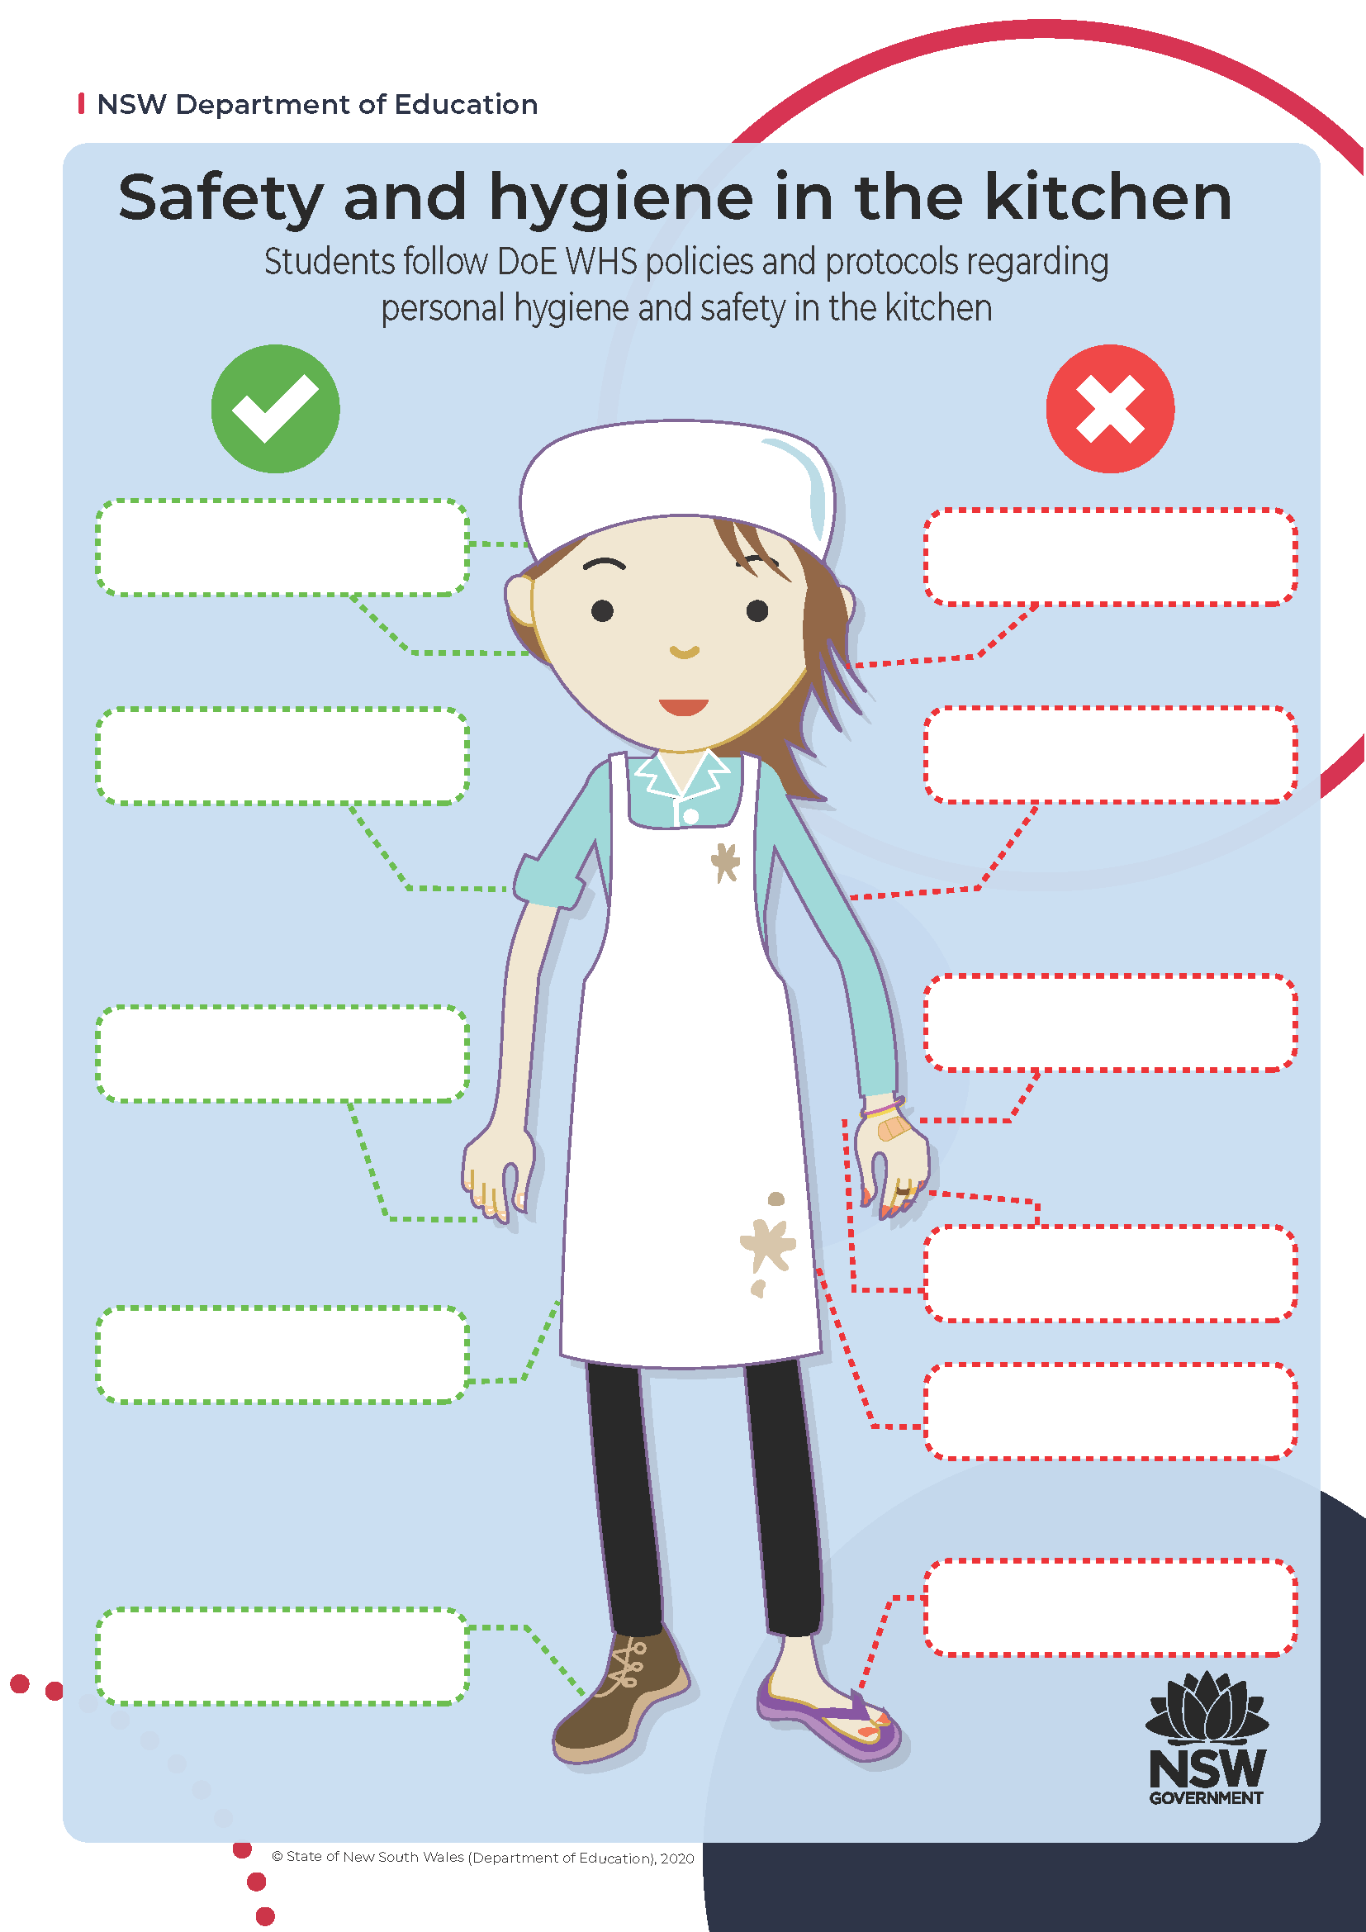

Washing hands – learning activity
Access the following video to show the importance of washing your hands properly: See Germs! Hand Washing Science Experiment (1:22).
To reinforce your understanding of the importance of handwashing, read the fact sheet NSW Food Authority – Factsheets, guides and policies: Hand Washing and then write the 5 steps of correct handwashing in the space below.


The danger zone – learning activity
Using the below blank thermometer, label the lowest marker on the thermometer as 0°C. Label each of the remaining markers as 10°C, 20°C, 30°C, and continue until you reach 100°C.
Cut and paste all labels on the next page to create the food safety temperature zone thermometer. Using coloured pencils, colour in red the ‘temperature danger zone’, colour in blue the ‘frozen food zone’, colour in green the ‘cold food zone’ and colour in yellow the ‘hot food zone’.
Figure 1 – blank food safety temperature zone thermometer
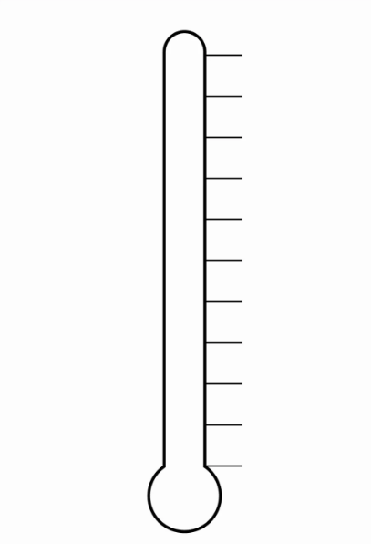
Note: have students cut out the information below and paste onto the blank thermometer in the correct positions. See answers on the next page. Alternatively, students can complete it electronically using the More than just a sandwich PowerPoint.

Bacteria grow quickly
Hot food zone 60°C to 100°C
Bacteria do not grow
Cold food zone 0° to 5°C
Refrigerated foods need to be kept at 5°C or below
Temperature danger zone 5°C to 60°C
Bacteria are destroyed
The temperature danger zone is when it is easiest for harmful bacteria to grow in food
Hot food needs to be kept at 60°C or above
Bacteria are dormant
Frozen food zone -10°C to 0°C

The danger zone – suggested answers
Figure 2 – sample solution for food safety temperature zone thermometer activity

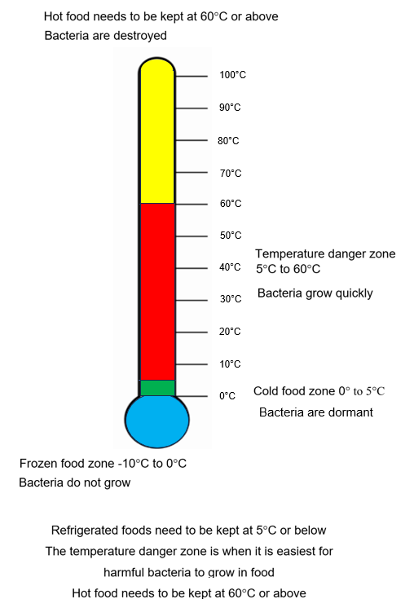

Common kitchen utensils and equipment
Complete the table below by naming the pieces of equipment and writing its function.
Table 3 – common kitchen utensils and their functions
Item | Name | Function
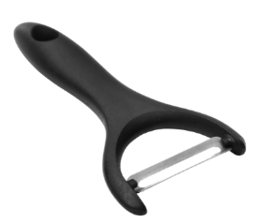
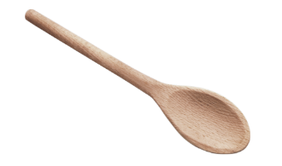
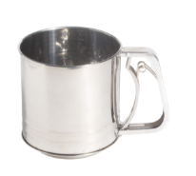
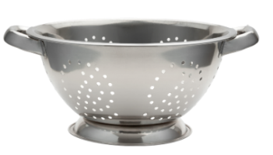
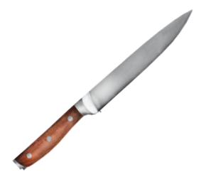
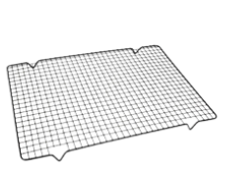
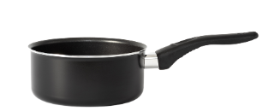
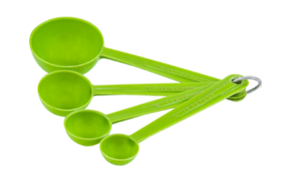
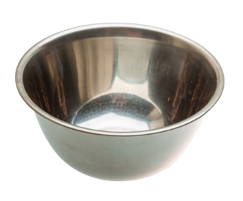
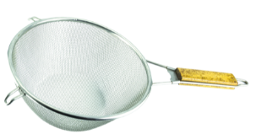
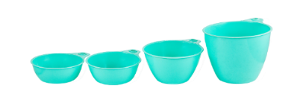
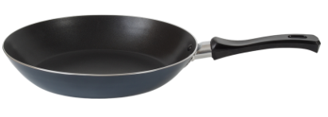
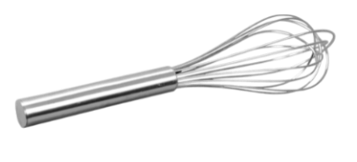
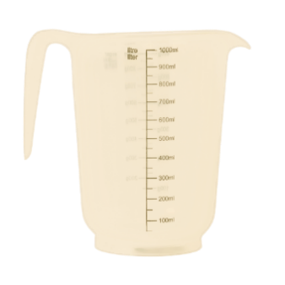

Kitchen scavenger hunt
Find the following equipment in your school kitchen. Complete the table by describing its location.
Table 4 – a list of equipment and their location within the school kitchen
Equipment | Location
Measuring cups
Tongs
Washing up liquid
Ovens
Microwaves
Tongs
Measuring spoons
Fire extinguisher
Mixing bowls
Oven slides
Muffin tins
Baking paper
Mixing spoons
Measuring jug
Cooling racks
Graters
Oven mitts
Hand soap
Paper towel
Tea towels

Measuring equipment
When you work in a kitchen you must deal with all sorts of food and ingredients. You may be required to prepare food for one person or many people. It is important that you follow measurements given in recipes so that the food ends up with the desired taste and quantity.
There are 2 main reasons why we measure ingredients when preparing food. These are:
- to avoid food wastage
- to produce the desired taste, look and texture of what we are making.
Most recipes developed in Australia and many other countries follow the metric system. This is an international system for measuring food ingredients.
There are 3 main items or pieces of equipment used to measure food in the school kitchen. These are:
- measuring cups
- measuring spoons
- measuring jug.

Measuring cups
Measuring cups are used to measure dry food ingredients such as rice, flour or sugar. To use measuring cups accurately, the measurement should be level with the top of the cup. Dip the required measuring cup into the food, and smooth away any overflowing ingredients with the back of a butter knife.
Table 5 – measuring cup sizes, their capacity in millilitres and their abbreviation
Measuring cup sizes | Capacity in millilitres | Abbreviation
1 cup | 250 millilitres | 1 C
$\frac{1}{2}$ cup | 125 millilitres | $\frac{1}{2}$ C
$\frac{1}{3}$ cup | 80 millilitres | $\frac{1}{3}$ C
$\frac{1}{4}$ cup | 60 millilitres | $\frac{1}{4}$ C
Label each of the measuring cups below with its corresponding cup size.
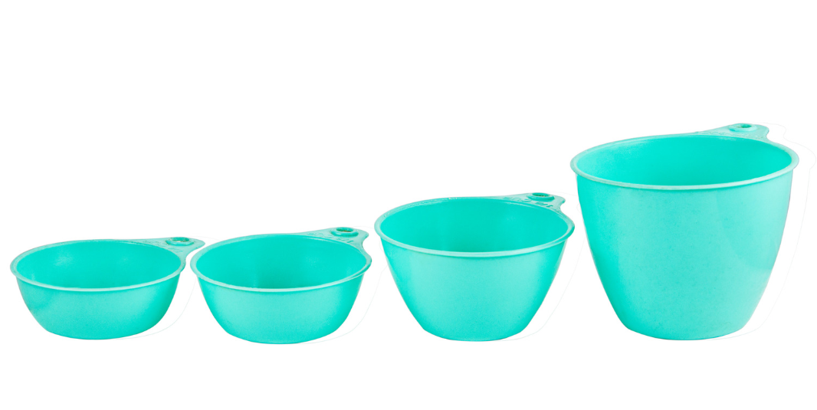

Measuring spoons
Measuring spoons are used to measure small amounts of both liquid and solid ingredients such as flour, water, oil, spices, or milk. To use spoons accurately, the measurement should be level with the top of the spoon. Use the back of a butter knife to smooth and scrape away excess ingredients on the top of the spoon.
Table 6 – measuring spoon sizes, their capacity in millilitres and their abbreviation
Measuring spoon sizes | Capacity in millilitres | Abbreviation
1 tablespoon | 20 millilitres | 1 tablespoon = 1 TBS
1 teaspoon | 5 millilitres | 1 teaspoon = 1 tsp
$\frac{1}{2}$ teaspoon | 2.5 millilitres | $\frac{1}{2}$ teaspoon = $\frac{1}{2}$ tsp
$\frac{1}{4}$ teaspoon | 1.25 millilitres | $\frac{1}{4}$ teaspoon = $\frac{1}{4}$ tsp
Label each of the spoon measures on the picture below.
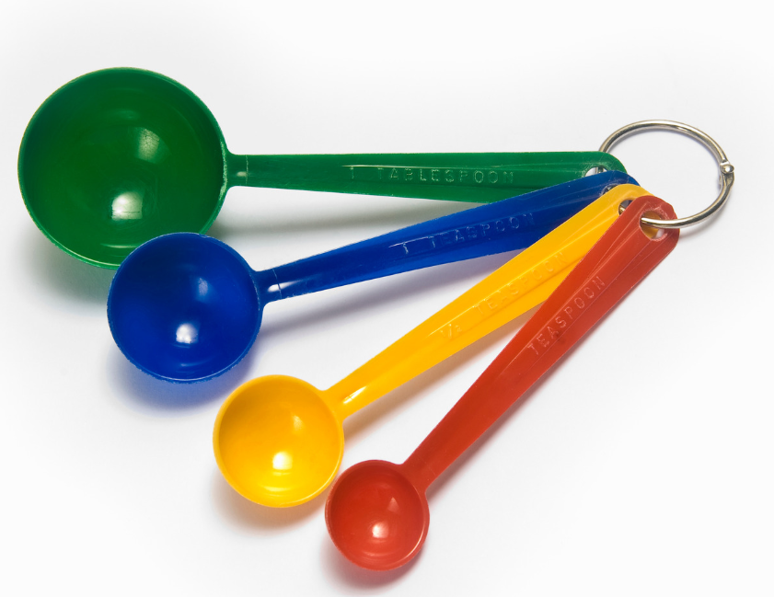

Measuring jugs
Measuring jugs are used to measure liquids such as water, milk, oil or cream. To use a measuring jug accurately, place the jug onto a tabletop or flat surface and slowly pour in the required ingredient until the desired amount is reached. Some measuring jugs will have markings on either side of the jug, one measuring in $\frac{1}{4}$ C, $\frac{1}{2}$ C, 1 C, and so on. and the other side measuring in millilitres (ml).
Figure 3 – measuring jug
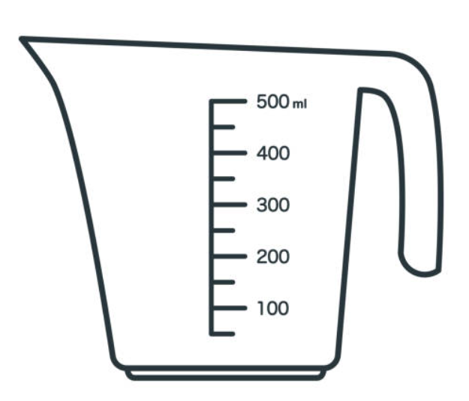

Kitchen procedures
Complete the following activity by using the word bank provided below.
safety | hands | hot | equipment | hygiene | bench | footwear
practical | ingredients | correct | clean | spills | dry | floor
Prepare yourself for your ___________ lessons by being organised. You must have all your equipment on the day.
- Before entering the kitchen
Tie hair back, check you have the correct ___________ and put your apron on.
- Upon entering the kitchen
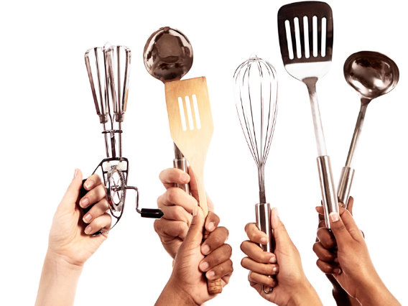
Have your recipe ready and visible to follow.
Wash your __________.
Collect ______________ and _______________.
- During the lesson
Use your own workspace.
Keep your workspace __________ and tidy.
Use correct ______________ procedures. Use the correct equipment for a particular task.
Be aware of ____________ issues. Clean up any ______________ immediately.
- Cleaning up should be a team effort
One person wash, one person dry. Both put away equipment in its _____________ place.
Wash up in _________, soapy water.
Clean and __________ the sink, remove any food scraps.
Clean your ___________ top. Sweep the ___________.

Tortilla wrap
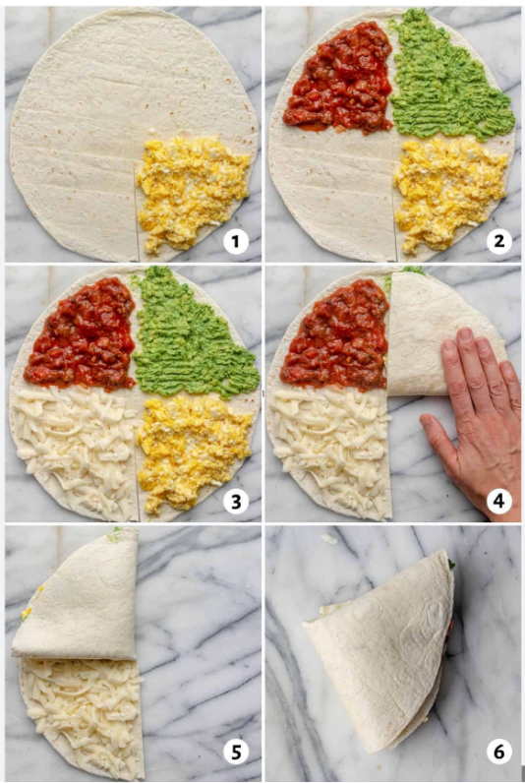
Serves 2

Ingredients
2 tortilla flat breads
2 TBS refried beans
$\frac{1}{2}$ C shredded or BBQ chicken
2 TBS Mexican cheese or similar
2 TBS guacamole (homemade or purchased)
2 TBS salsa
$\frac{1}{2}$ tsp olive oil

Method
- Place tortilla flat onto a cutting board. Cut a slit from the outside edge of the tortilla straight to the middle point.
- Fill each quarter of the tortilla in the following order, a) refried beans b) chicken c) guacamole d) salsa and cheese.
- Fold the tortilla triangles onto themselves until you have a layered wrap.
- Lightly brush olive oil over both sides of the folded wrap. Use a sandwich press to toast, or toast lightly in a frypan until cheese is melted.
Note: to make guacamole, combine $\frac{1}{4}$ mashed avocado, 1 tsp sour cream, 4 finely chopped cherry tomatoes, salt and pepper and a small squeeze of lime or lemon juice.

Tortilla wrap check
The equipment you will need to complete this recipe, is listed below. Finish the table by filling in the equipment location within the school kitchen.
Table 7 – a list of equipment and their location within the school kitchen
Equipment | Location
tray
stainless steel plate
white cutting board
knife
measuring cups
measuring spoons
mixing spoon
spatula
pastry brush
small bowls
sandwich press
Access the video Jamie Oliver on knife skills -– 30-Minute Meals (5:01) to learn some tips and tricks.


Knife safety – learning activity
There are many different types of knives available in the kitchen. Each knife has a specific purpose. Label the parts of the knife using the terms below.

tip | butt | spine | blade | heel | handle
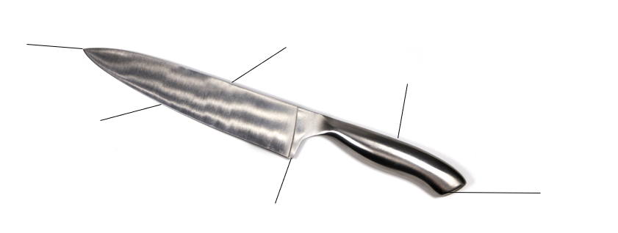
Note: the activity below contains the answers. Remove bolding before printing.
Answer the following questions. Cross out the incorrect answer.
- When carrying knives, do you carry them with the knife tip up or down?
- When knives are not being used, do you store them on the bench top or in a drawer or knife block?
- As soon as you have finished using a knife you should place it in the sink with hot water.
Yes or no?
- A safe knife to use is sharp or blunt?
- When passing a knife to another person, do you pass it holding the tip or handle?

Evaluate – tortilla wrap
Reflect on your previous practical lesson by completing the PMI chart below. In the space, list 3 things that went well in the plus section, 3 things that need some improving in the minus section and finally 3 things you found interesting.
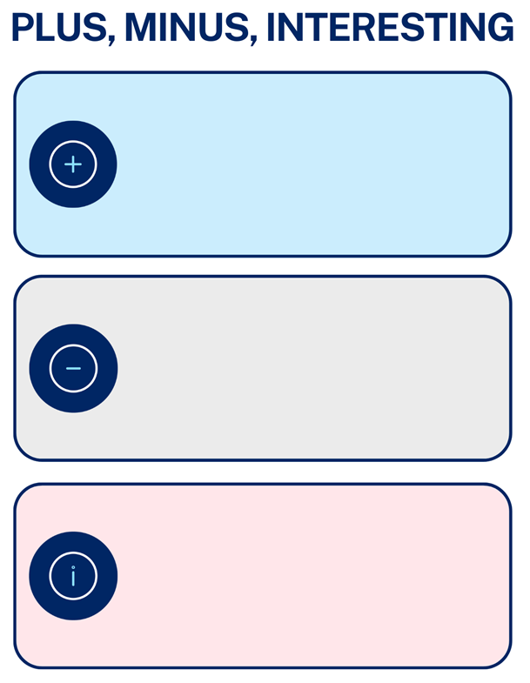

Breakfast sandwich
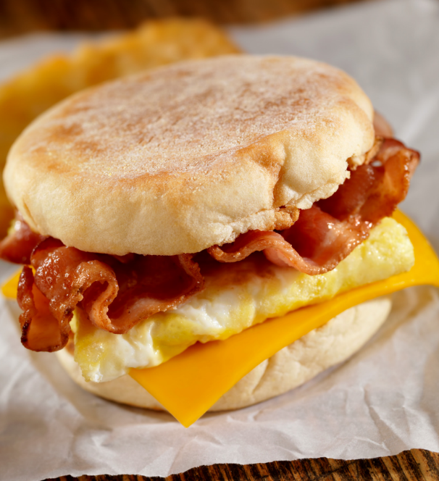
Serves 2
Ingredients
2 large eggs
1 TBS milk
Salt and black pepper
$\frac{1}{2}$ tsp chopped chives
1 tsp olive oil
2 rashers bacon
2 slices cheddar or tasty cheese
2 English muffins
2 tsp butter or margarine
BBQ or tomato sauce
Method
- Preheat oven to 170°C. Whisk eggs together with milk, salt, pepper and chopped chives in a medium mixing bowl.
- Line an oven tray with baking paper and lay bacon flat in a single layer. Place tray in oven and bake for 10–15 minutes. When cooked, transfer bacon onto a plate lined with paper towel to drain. When cool, break each rasher of bacon in half to be able to fit onto sandwiches.
- Pour olive oil into a medium frypan. Heat over medium to high heat and pour in egg mixture. Allow egg to cook until solid. Place cooked egg onto a chopping board, slice egg omelette in half. Fold each half circle into quarters to fit onto muffin.
- When eggs and bacon are both cooked, either toast the cut muffins in a toaster or in an oven with the muffins placed cut side up on an oven tray. Toast until edges are crispy and lightly browned. Butter the muffin.
- Use a spatula to place eggs and bacon onto the base of the toasted muffin. Top with cheese slice and sauce.

Breakfast sandwich check
The equipment you will need to complete this recipe, is listed below. Finish the table by filling in the equipment location within the school kitchen.
Table 8 – a list of equipment and their location within the school kitchen
Equipment | Location
tray
stainless steel plates
whisk
large mixing bowl
oven tray
spatula
oven mitts
medium frypan
chopping board
measuring spoons
knife
toaster
butter knife

Oven safety
Using an oven is an important part of food preparation, and it is vital that you always use safe practices to avoid injury. The most common types of ovens are gas and electric.
Table 9 – electric and gas ovens
Electric oven | Gas oven
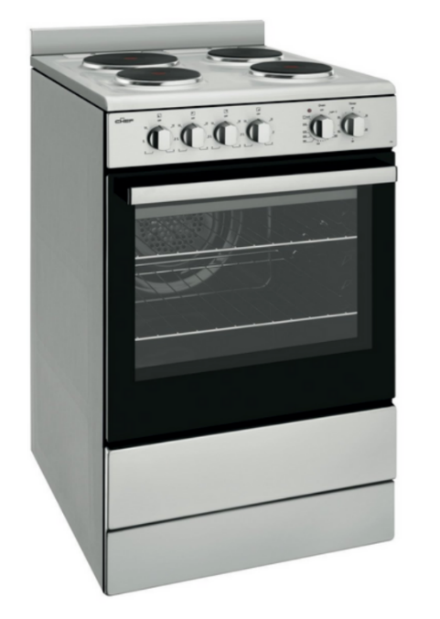 | 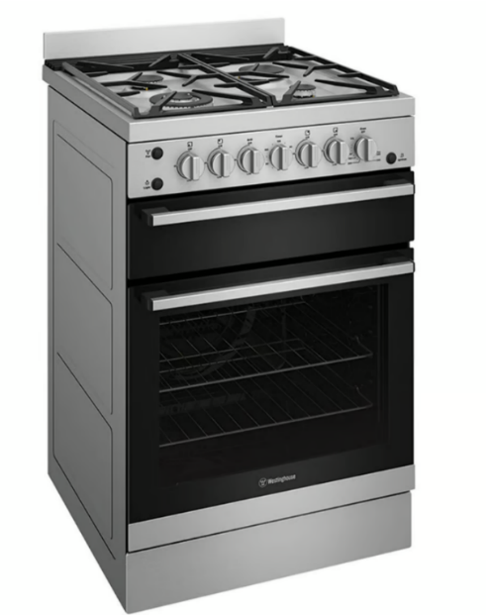
An electric oven uses electricity to provide heat. | A gas oven uses gas and flame to provide heat.
To turn an electric oven on, turn the knob to the required temperature. The light will go out once the oven has reached the required temperature.
To turn a gas oven on, turn the control knob to the required temperature and press the automatic ignition at the same time, holding for 10 to 15 seconds.
When moving dishes in and out of the oven, always use oven mitts to avoid burns. Ensure the oven mitts are dry, and not wet, to avoid scalds.
When opening the oven door, stand to the side, not in front, and communicate to others around you that the oven door will be opened. This will help to avoid steam burns and trips and falls in the kitchen.
Avoid carrying hot items around the kitchen. Prior to removing hot items from the oven, set out a cooling rack close by and then set down hot items to cool on the rack.


Oven safety – learning activity
Looking at the pictures of the 2 ovens, write a list of 4 differences that you can see in the images.
Note: the activity below has the answers given as a sample. Remove answers before printing.
Sample answer:
- The grill is separated from the oven in the picture of the gas oven. The electric oven has a combined grill and oven.
- The stovetops are different, one being electric and the other gas.
- There are more dials on the gas oven compared to the electric oven.
- The gas oven has an ignition button on the front face to ignite the gas to create a flame.
Write your own set of 5 safety rules when using the oven in your school kitchen.
Sample answer:
- Remove food from the oven using oven mitts to avoid burns.
- Never leave the door of the oven open after removing food.
- Do not place items on the stovetop as it may be hot.
- Make sure to turn off the stovetop when not in use.
- Make sure that the dials on the gas oven are off as the gas can still be leaking out.

Evaluate – breakfast sandwich
Reflect on your previous practical lesson by completing the PMI chart below. In the space list 3 things that went well in the plus section, 3 things that need some improving in the minus section and finally 3 things you found interesting.

Hygiene and safety
Wherever you are preparing food, it is important to ensure you are taking safety precautions to prevent food contamination. Food contamination can occur when food is affected by another substance making it unsafe to eat. There are 3 main types of contamination. These are:
- physical – when an object gets into food, for example a band aid
- chemical – when a chemical substance spoils food, for example cleaning spray coming into contact with food
- biological – when a food is made unsafe by the presence of living organisms, for example mould.
It is also important to store food correctly to prevent cross contamination. See the NSW Food Authority NSW Food Authority – Factsheets, guides and policies: Keep food separate factsheet.

Hygiene and safety – chopping boards
Chopping boards could cause risk for cross contamination. Cross contamination is when bacteria or germs can spread from one food to another, for example, blood from raw meat dripping onto fresh salad ingredients.
Your kitchen at school may have a collection of different coloured chopping boards or they may have one colour of chopping boards, for example, white. Whatever colour boards your school has, it is very important that they are washed with hot soapy water every time you use them. Chopping boards should also be allowed to air dry after being patted down with paper towel to remove most of the moisture. Colour-coded chopping boards are helpful in preventing cross contamination. Use the image below to decide what chopping board to use for what food item.
Figure 4 – sample colour-coded chopping boards
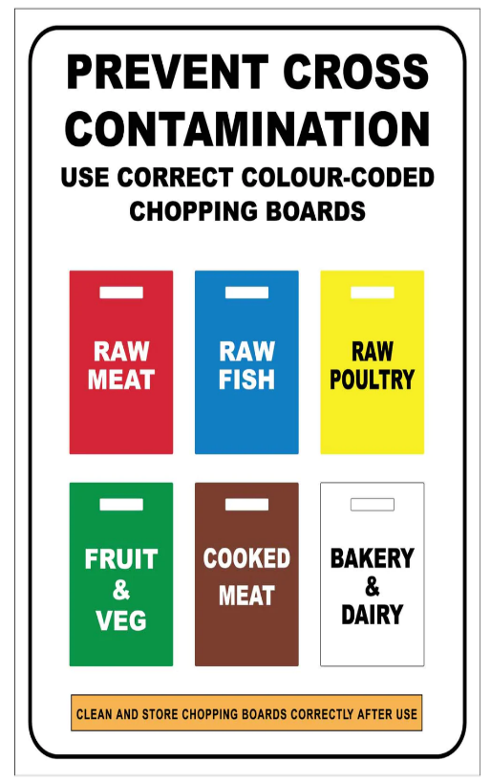

Chopping boards – learning activity
Complete the activity in the table below. Write the correct coloured chopping board to use for the food item.
Note: the table has the suggested answers in column 2. Provide a table for students to complete with information only in column 1.
Table 10 – food items and what coloured chopping board to use
Food item | Coloured chopping board to use
Cheese | White chopping board
Steak cooked on the BBQ | Brown chopping board
Apples and bananas for fruit salad | Green chopping board
Raw prawns | Blue chopping board
Uncooked sausages | Red chopping board

Banh mi (Vietnamese sandwich)
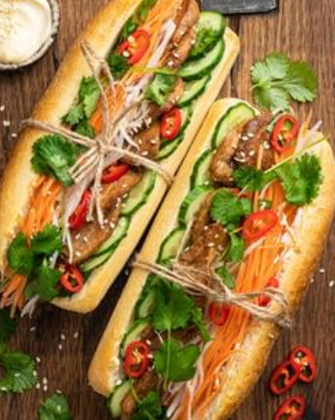
Serves 2
Ingredients
2 crusty long bread rolls
2 TBS butter or margarine
2 TBS mayonnaise
1 tsp olive oil
6 slices quick-cook pork belly, or 1 chicken thigh, cooked and sliced
$\frac{1}{2}$ Lebanese cucumber, finely sliced lengthways
2 shallots, sliced lengthways
1 carrot
$\frac{1}{2}$ C boiling water
2 TBS white sugar
1 tsp salt
50 ml rice wine or apple cider vinegar
4–6 fresh coriander stalks
$\frac{1}{2}$ red chilli, chopped finely (optional)
2 tsp hoisin sauce

Method
- Using a vegetable peeler, peel carrots into thin ribbons. Pickle carrots by dissolving salt and sugar in the hot water, then add the vinegar. Add carrot to mixture and allow to stand for 20 minutes. Drain, using a sieve and use in the following recipe.
- Heat olive oil in a medium size frypan. Fry pork belly slices for 2 to 3 minutes until crisp and golden. Remove slices from pan and allow to drain on absorbent paper.
- Split rolls down the centre, spread margarine or butter and then mayonnaise. Layer in ingredients of pork belly slices, cucumber and shallots.
- Add drained carrot batons and coriander, sprinkle with chilli (use gloves when working with chilli). Drizzle hoisin sauce into banh mi.
- Close sandwich together and secure with a paper serviette.

Banh mi check
List the equipment you will need to complete this recipe and state the purpose or the function of this piece of equipment in the space provided.
Note: the table has the completed answers in columns 1 and 2. Provide a blank table for students to complete the activity.
Table 11 – equipment and their purpose or function
Equipment | Purpose or function
tray | To carry the ingredients or equipment back to the working space.
stainless steel plates | To carry individual ingredients back to the working space.
knife | To cut ingredients, such as carrots for the banh mi.
green cutting board | Used to cut fruit and vegetables only to prevent cross-contamination.
medium mixing bowl | A bowl used to combine ingredients.
sieve | Used to drain the liquid from the solid ingredients.
medium frypan | To cook the pork belly slices in.
tongs | Used to move food or turn it over while cooking food in the hot frypan.
butter knife | Used to spread ingredients such as margarine or mayonnaise over the bread surface.
measuring cups | Used to measure dry ingredients in a recipe.
measuring spoons | Used to measure smaller amounts of ingredients in a recipe
serviette | Used to secure the banh mi, so that the ingredients don’t spill out of the roll.

Research – learning activity
Write a paragraph to explain about the history of the banh mi. What are its origins and what does the term banh mi mean?

Evaluate – banh mi
Reflect on your previous practical lesson by completing the PMI chart below. In the space list 3 things that went well in the plus section, 3 things that need some improving in the minus section and finally 3 things you found interesting.

Japanese fruit sandwich
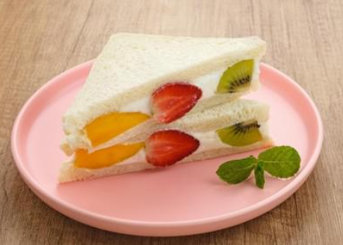
Serves 2
Ingredients
4 slices fresh white bread (toast thickness)
125 ml cream
2 tsp caster sugar
1 kiwifruit
4 strawberries
$\frac{1}{2}$ orange
Method
- Pour cream into a clean bowl. Whip using an electric beater until soft peaks form in the cream. Gradually add caster sugar (do not add all at once). Whip cream with each small addition of sugar until hard peaks form. Do not over whip.
- Prepare bread by removing crusts with a serrated knife.
- Prepare fruit by slicing strawberries in half and then slicing orange pieces and kiwifruit rounds to be the same thickness as the strawberries.
- Using a spatula, spread a thin layer of cream onto one slice of bread.
- Assemble fruit on the creamed bread slice beginning with 3 pieces of fruit placed diagonally from one corner to the other. This is where you will slice your sandwich in half. Add more fruit to fill the bread evenly.
- Add whipped cream on top of the fruit to cover it fully. Wrap sandwiches in plastic wrap and place in the fridge for 30 minutes. Remove and slice with a sharp bread knife. Serve straight away.

Japanese fruit sandwich check
List alternate foods you could use to complete this recipe in the space provided.
Table 12 – ingredients and alternate foods that could be used instead
Ingredients | List alternate foods
White toast thickness bread
Cream
Caster sugar
Kiwifruit
Strawberries
Orange
Watch Emmy create her own Japanese fruit sandwich varieties: Fruit Sando – Japanese Fruit Sandwich Recipe Test (to 13:00).

Kitchen verbs – learning activity
Circle the verbs that are written in the method for the Japanese fruit sandwich. Use a device to research the meaning of each word. Hint: there are at least 12 verbs contained in the method.
Note: the table has the completed answers in both columns. Provide a blank table for students to complete. To reduce cognitive load students with disability may complete this activity as a matching activity. See PowerPoint.
Table 13 – kitchen verbs and their meaning
Verb | Meaning
pour | To tip a liquid from a container in a steady stream
whip | To beat or move an ingredient very fast in a specified direction
form | To bring together parts or combine to create a product
add | Join one item to another
prepare | To make something ready to cook or eat
slice | To cut an ingredient smaller from something larger
spread | To extend or move an ingredient over a space or item
assemble | To fit together separate components or parts of a meal
wrap | To enclose something in a soft material
place | To place a food in a particular position
remove | To take something away
Serve | To present to someone

Evaluate – Japanese fruit sandwich
Reflect on your previous practical lesson by completing the PMI chart below. In the space list 3 things that went well in the plus section, 3 things that need some improving in the minus section and finally 3 things you found interesting.

Vegetable flatbread
Serves 2
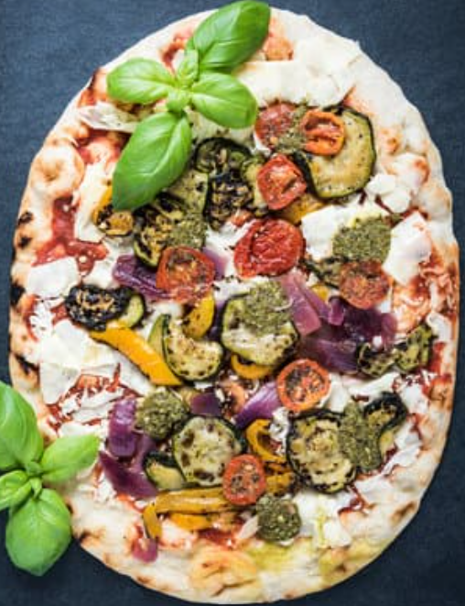
Ingredients
1 $\frac{1}{2}$ C self-raising flour
1 C Greek yoghurt
$\frac{3}{4}$ C ricotta cheese
$\frac{1}{2}$ C grated parmesan cheese
$\frac{1}{2}$ small red onion, finely sliced
1 tomato, finely sliced
$\frac{1}{2}$ red capsicum, finely sliced
3 mushrooms, finely sliced
4 basil leaves
1 TBS olive oil
Salt and pepper
Method
- Preheat oven to 180°C.
- Mix flour and yoghurt in a bowl. Once it has come together, using your hands knead the dough on a floured surface until smooth. Roll the dough into a large rectangle until about $\frac{1}{2}$ cm in thickness. Place baking paper on a large baking tray, spray the paper with non-stick spray, and transfer dough onto the tray.
- Spread half of the ricotta cheese onto one-half of the dough. Sprinkle with half of the parmesan cheese.
- Carefully fold the other half of the dough on top of the cheese side. Sprinkle the remaining ricotta and parmesan.
- Layer the finely-sliced vegetables over the top of the dough, brush olive oil over the vegetables and then sprinkle with salt and pepper and torn basil leaves.
- Bake for 22 to 25 minutes, until edges are slightly browned. Cut into pieces and serve hot.

Vegetable flatbread check
List the equipment you will need to complete this recipe and describe the characteristics of this piece of equipment.
Note: the table has the completed answers in column 1. Provide a blank table for students to complete the activity. The first row is a sample answer.
Table 14 – equipment and their description
Equipment | Description
tray | Sample answer: large, plastic, flat, able to carry ingredients
stainless steel plates
green cutting board
knife
large mixing bowl
oven tray
butter knife
rolling pin
pastry brush
measuring cups
measuring spoons
cooling rack

Measurement – learning activity
Complete the following questions about measuring ingredients in the kitchen.
Note: the activity below has the answers bolded or given as a sample. Remove bolding and answers before printing. Students may respond to question 5 through demonstrating the correct measuring procedures using a measuring jug and water.
- To measure $\frac{1}{2}$ C flour, would you use:
- measuring cups
- measuring spoons
- measuring jug
- How many teaspoons are in one tablespoon? Demonstrate your understanding by showing your working out.
Sample answer:
1 teaspoon equals 5 millilitres; therefore 4 teaspoons make one tablespoon
- Explain how to measure 1 and $\frac{1}{2}$ C water.
Sample answer:
To measure 1 and $\frac{1}{2}$ C of water, use a measuring jug and firstly measure 1 C, and pour this into a bowl and then measure the $\frac{1}{2}$ C. Make sure to put the measuring jug flat on a bench top to check accuracy.
- Look at the scale on the measuring jug. Colour the jug to indicate where $\frac{1}{2}$ C water would be measured.
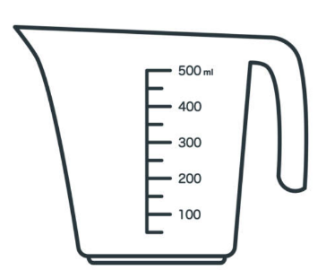

Vegetable flatbread – learning activity
Make a list of alternate toppings you could use in your flatbread pizza.

Evaluate – vegetable flatbread
Reflect on your previous practical lesson by completing the PMI chart below. In the space list 3 things that went well in the plus section, 3 things that need some improving in the minus section and finally 3 things you found interesting.

Terminology – learning activity
For each of the cooking terms listed below, write a definition and give an example of a food that may be prepared in this way.
Note: the table has the completed answers in columns 2 and 3. Provide a table for students to complete with information only in column 1.
Table 15 – cooking term, their definition and a food example
Cooking term | Definition | Food example
bake | To cook using dry heat, usually in an oven. | Cake
combine | To mix 2 or more foods together. | Mixing egg and milk
fry | To cook in hot fat or oil, usually in a shallow frypan. | Fried egg
grate | To reduce food into small shreds by rubbing the food on a grate. | Cheese
knead | To mix flour and milk into a dough or paste using hands. | Bread dough
layer | To place or arrange ingredients by placing them on top of one another. | Ingredients in a lasagne are layered
melt | To heat a food until it becomes more liquefied. | Melting cheese
slice | To cut a thin piece of food from a larger portion. | Slice of bread
toast | To cook or brown food from exposure to heat. | Marshmallows
whip | To beat or mix a food ingredient very rapidly. | Whipping cream
whisk | Beat or stir ingredients using rapid movement. | Whisking eggs

Hamburger
Serves 2
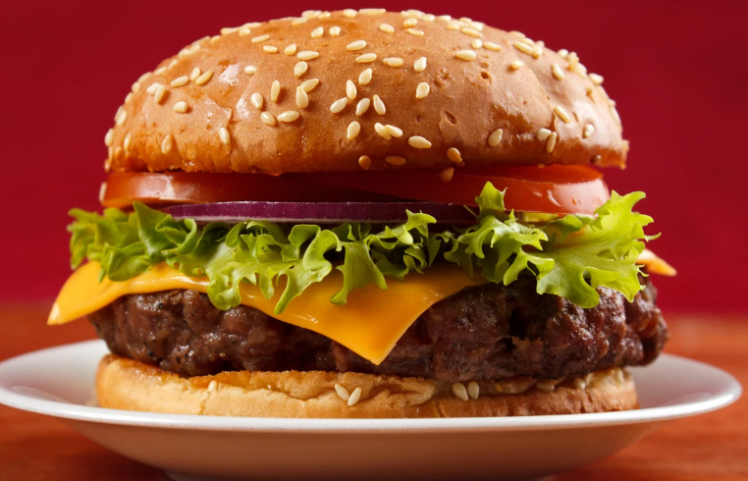
Ingredients
2 hamburger buns
250 g lean beef mince
1 egg
$\frac{1}{4}$ C breadcrumbs
Salt and pepper
1 small tomato
2 iceberg lettuce leaves
2–4 slices beetroot
2 slices tasty cheese
1 TBS olive oil
Tomato or BBQ sauce
Method
- Place mince, egg, breadcrumbs and salt and pepper into a medium mixing bowl. Using your hands, combine ingredients and then make 2 patties. Place patties onto a plate.
- Wash lettuce leaves and slice the tomato.
- In a medium frypan, heat olive oil and then fry the patties for 3–4 minutes on each side. Press patties gently using a spatula while they are frying in the pan to keep them flattened.
- Cut hamburger buns in half and toast buns under the grill or in a toaster.
- When patties are cooked through, place each patty onto the bottom half of the burger bun. Top the patty with cheese and remaining salad ingredients.
- Add tomato or BBQ sauce as required.

Hamburger check
Equipment used in kitchens can be dangerous. From the given list of equipment write a set of safety considerations in the space provided.
Note: the table has the completed answers in column 2. Provide a table for students to complete with information only in column 1.
Table 16 – equipment and their safety considerations
Equipment | Safety considerations
Glass mixing bowl | Be sure to clean mixing bowls thoroughly. Make sure that you handle glass bowls with care. Do not tap utensils on the side of glass mixing bowls.
Grill | Always use oven mitts when removing food from the grill. Always make sure that the grill is turned off after use.
Hot oil for frying | Make sure to use an apron when using hot oil. Use tongs and a spatula to move food in the frypan. Be careful of splatters from hot oil. Make sure that the heat is turned off directly after finishing cooking.
Knife | Always carry a knife with the tip pointed down. Never leave a knife in the sink. Always use the correct knife for the job.
Oven | Ovens should not be left on after use, and food should be removed from the oven using oven mitts.
Stovetop | Make sure to turn off elements when they are not in use. Make sure that handles from saucepans and frypans are not over hanging the front edge of the stovetop.

Evaluate – hamburger
Reflect on your previous practical lesson by completing the PMI chart below. In the space list 3 things that went well in the plus section, 3 things that need some improving in the minus section and finally 3 things you found interesting.

References
This resource contains NSW Curriculum and syllabus content. The NSW Curriculum is developed by the NSW Education Standards Authority. This content is prepared by NESA for and on behalf of the Crown in right of the State of New South Wales. The material is protected by Crown copyright.
Please refer to the NESA Copyright Disclaimer for more information https://educationstandards.nsw.edu.au/wps/portal/nesa/mini-footer/copyright.
NESA holds the only official and up-to-date versions of the NSW Curriculum and syllabus documents. Please visit the NSW Education Standards Authority (NESA) website https://educationstandards.nsw.edu.au/ and the NSW Curriculum website https://curriculum.nsw.edu.au/home.
Technology 7–8 Syllabus © NSW Education Standards Authority (NESA) for and on behalf of the Crown in right of the State of New South Wales, 2023.
ClickView (15 July 2020) ‘Safety In The Domestic Kitchen -– Food Technology [video]’, ClickView, YouTube, accessed 9 April 2024.
Emmymade (3 July 2020), ‘FRUIT SANDO – Japanese Fruit Sandwich Recipe Test’ Emmymade, YouTube, accessed 29 April 2024.
Jamie Oliver (27 April 2012) ‘Jamie Oliver on knife skills -– 30-Minute Meals [video]’, Jamie Oliver, YouTube, accessed 11 April 2024.
Science Buddies (10 March 2020) ‘See Germs! Hand Washing Science Experiment [video], Science Buddies, YouTube, accessed 9 April 2024.
State of New South Wales through the NSW Food Authority (n.d.) ‘Keep food separate’, NSW Food Authority, accessed 1 July 2024.
State of New South Wales through the NSW Food Authority (n.d.) ‘Hand Washing’, NSW Food Authority, accessed 9 April 2024.
WinnyHayes (1 July 2022) ‘Japanese Fruit Sando [video]’, WinnyHayes, YouTube, accessed 29 April 2024.

© State of New South Wales (Department of Education), 2024
The copyright material published in this resource is subject to the Copyright Act 1968 (Cth) and is owned by the NSW Department of Education or, where indicated, by a party other than the NSW Department of Education (third-party material).
Copyright material available in this resource and owned by the NSW Department of Education is licensed under a Creative Commons Attribution 4.0 International (CC BY 4.0) license.

This license allows you to share and adapt the material for any purpose, even commercially.
Attribution should be given to © State of New South Wales (Department of Education), 2024.
Material in this resource not available under a Creative Commons license:
- the NSW Department of Education logo, other logos and trademark-protected material
- material owned by a third party that has been reproduced with permission. You will need to obtain permission from the third party to reuse its material.
Links to third-party material and websites
Please note that the provided (reading/viewing material/list/links/texts) are a suggestion only and implies no endorsement, by the New South Wales Department of Education, of any author, publisher, or book title. School principals and teachers are best placed to assess the suitability of resources that would complement the curriculum and reflect the needs and interests of their students.
If you use the links provided in this document to access a third-party's website, you acknowledge that the terms of use, including licence terms set out on the third-party's website apply to the use which may be made of the materials on that third-party website or where permitted by the Copyright Act 1968 (Cth). The department accepts no responsibility for content on third-party websites.

