Technology 7–8 – Food and agricultural practices – teacher resource
Scrambled

Contents
Teacher support resource 3
Glossary 4
How do you have your eggs? 7
Egg cooking methods 8
Food memories 12
How are eggs good for us? 15
What is a nutrient? 15
Function of nutrients 16
Macro and micronutrients 17
Nutrient sources activity 18
Information hunt 20
Cheesy eggs on toast 21
What if I can’t eat eggs? 23
Commercial egg substitutes 25
Emu eggs 26
Why are eggs in so many recipes? 30
Parts of an egg and their function 30
Function of eggs 34
Types of eggs 39
Egg sorting activity 43
Where do our eggs come from? 47
Let’s ‘egg-splore’ our egg industry 47
What’s trending 51
Animal welfare 55
Chicken coop visits 57
How do they get to me? 61
How are eggs packaged and distributed? 61
Egg labelling 62
Sustainability 68
Home food audit 69
What is being done? 71
Nationally 71
NSW 73
Local government 74
The Australian egg industry 77
What else can we do? 78
What else can eggs be used for? 83
Let’s celebrate eggs 85
Egg café 85
Appendix 87
Appendix 1 – practical activity 1 87
Appendix 2 – practical activity 2 88
Appendix 3 – birds and their eggs answers 89
Appendix 4 – feed lab cards (practical activity 5) 90
References 93

Teacher support resource
Note: this resource has been designed to facilitate the ready conversion into a student workbook by removing the answers within the response windows. Teacher notes (in blue) can be deleted before distributing to students.
Please note that throughout the resource you will see the ‘get scrambled’ icon as a cue for students to engage in independent activities. When the teacher instructs students to go and ‘get scrambled’ they will know that this is time for them to complete the scrambled task as instructed. This icon will also indicate a ‘do now’ activity which is labelled throughout as a ‘scrambled activity’.

School leaders and teachers should consult with students and their parents/carers regarding how to support their religious and/or dietary requirements. Alternate food options should be provided for students to meet learning outcomes.
Refer to Equipment Safety in Schools, Animals in Schools, and Chemical Safety in Schools for current information on safety and safe working practices in Technology 7–8.

Glossary
Many of the following words will gather more meaning to you as you work through the workbook.
Each time you see a new word throughout the workbook you can add its definition in the table below in case you need to refer to it later.
Note: the table below has the definitions included. Provide the table with the definition column blank to your students to complete the activity throughout the term.
Word | Definition
aeration | The process by which air is incorporated into food products to increase volume.
barn-laid eggs | Sometimes called cage-free, these eggs are produced in a farming system that allows the hens to wander freely in a shed.
binding | The process during which egg works like glue in joining ingredients together.
biosecurity | Implementing measures to prevent the introduction and spread of harmful diseases.
boiling | When a food item is cooked in bubbling hot water that reaches a boiling temperature of 100°C.
baking | The process of cooking food from the heat from an oven.
cage eggs | These eggs are produced from hens that are housed in cages inside large, climate-controlled sheds.
coagulation | Changing from a liquid to a solid. When heated or cooled the proteins in eggs coagulate.
dust bathe | A dust bathe is a behaviour in birds where they roll or wallow in dust or sand. Chickens are known for taking dust baths to keep their feathers in good condition and to prevent infestations of mites and lice.
emulsification | Blending of 2 ingredients that do not normally combine, for example oil and water. Helps to join these ingredients in recipes such as cakes and mayonnaise.
egg wash | A mixture of beaten eggs and a liquid that is brushed onto baked goods such as pies before baking to give them a shiny, golden-brown finish.
ethical | Ethical refers to principles, values, and standards of conduct that guide individuals or groups in determining what is right or wrong, good or bad.
free-range eggs | Free range eggs come from hens that have access to an outdoor range during the day but are housed during the night in comfortable sheds.
FSANZ (Food Standards Australia and New Zealand) | Food Standards Australia and New Zealand is a government authority responsible for developing food standards for Australia and New Zealand.
frying | When food is cooked in hot oil or butter on a frypan.
layers | Layers are chickens specifically bred and raised for the purpose of producing eggs.
organic eggs | Eggs produced without the use of chemicals. An organic label logo will verify this.
pasture-raised eggs | A free-range production that has lower stocking density and rotational grazing so that there is always lots of ground cover for the hens.
poaching | When food is cooked gently in water or liquid at a temperature just below boiling point, where the bubbles are small and gentle.
thickening | When making the liquid thicker by adding egg yolk.
scrambled | When eggs have been cooked in a pan while stirring them.
sustainability | Using resources and living in a way that meets our needs today without making it harder for future generations to meet their needs.
Note: for students with English as an additional language or dialect (EAL/D) background, and for students with disability, the glossary can be provided complete so that they have additional time to understand the key terms with bilingual dictionaries. The glossary can be provided to students in their preferred communication mode.
Meet Scrambled. You will see Scrambled throughout the workbook. This will indicate an individual activity that you will need to complete.

How do you have your eggs?
There are many ways to cook and eat eggs. Eggs are a common food item found in Western diets and many other cultures around the world. What we want to know is ‘How do you have your eggs’?
After completing the free word cloud generator as a class, summarise some of the popular ways that your class use and eat eggs.
Sample answer:
Fried, scrambled, poached, boiled, in cakes, omelette, in a smoothie, cooking cakes.
Discussion question
After seeing the word cloud and watching Get cracking Australia! Families (0:30), are there any new ways to use eggs that you did not know of? List them here.
As you can see, eggs are so versatile, we can cook them in a variety of ways, as well as use them as an ingredient in a variety of recipes.


Egg cooking methods
Complete the table by matching the correct definition with the method of cooking and provide either a recipe OR an image of eggs using that method.
Note: remove the examples. The solution is provided in the PowerPoint.
Table 1 – ways to cook eggs
Method | Definition | Egg example
boiling | Eggs are beaten together and then cooked gently in a pan, usually with butter or oil. The mixture is stirred to create soft, fluffy pieces. | Sample answer:  Curried egg sandwich
frying | A liquid, usually water, is heated to its boiling point (100°C), causing bubbles to form and rise to the surface. Food is submerged into the bubbling liquid to cook. | Nasi goreng  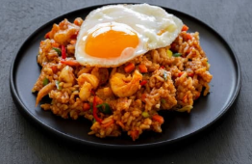
scrambled | Food or agents such as egg yolks which can be used in custards and sauces such as hollandaise to thicken and enrich. | Scrambled eggs
poaching | Food is cooked using dry heat, typically in an oven. Heat surrounds the food, cooking it evenly from all sides. | 
baking | Food is cooked in hot oil or fat. | Muffins, cakes
thickening | Food is gently cooked in simmering liquid (usually water, sometimes with vinegar) just below the boiling point. The food is submerged in the liquid and cooked without reaching a boil. | Custard
Practical activity 1
Safe and hygienic egg handling – coop to kitchen
Eggs need to be handled carefully to keep us safe. Like other foods, eggs can carry bacteria, such as Salmonella, that might cause food poisoning if they aren’t handled correctly. That’s why it is important to collect, clean, store and cook eggs properly.
The following instructions can help you collect eggs from the school farm safely and hygienically.
After reading through this, make a list of tools or equipment you will need to complete the activity.
Collection
- Wash hands or put on gloves before heading to the chicken coop.
- Prepare egg trays or cartons for safe egg transport.
- Collect eggs from nesting boxes, handling them carefully to avoid cracks.
- Wipe away visible dirt with a soft cloth, avoiding excessive cleaning in the coop.
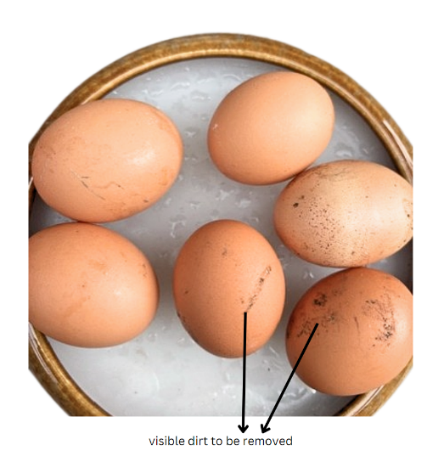
Transport
Place eggs in the carton, pointed end down to ensure yolk stability.
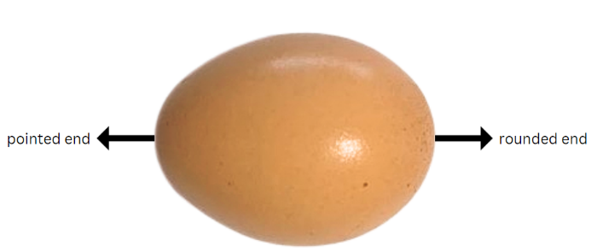
Washing hands
Wash hands thoroughly with soap and warm water for at least 20 seconds after handling eggs.
Surface hygiene
Clean any surfaces the eggs have touched with sanitising wipes or a clean cloth and disinfectant.
Inspecting the eggs
Check the eggs for cracks or irregularities. Discard any damaged eggs to avoid contamination.
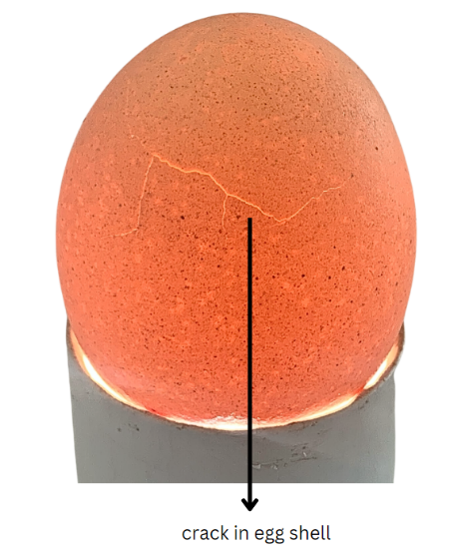
Note: to easily see cracks in eggshells, shine a torch light from one end through the egg.

Storage
- Store eggs in the refrigerator at or below 4°C. Use a thermometer to confirm the temperature.
- Label the carton used, or individual eggs with the date collected. Fresh eggs can be kept refrigerated for up to 6 weeks.
Discussion or hinge questions
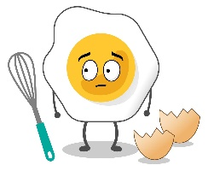
Why is it important to handle eggs carefully at each step, from collection to storage? What risks are involved if we do not follow proper hygiene practices?
How do the storage and handling requirements for eggs compare to other types of food? What similarities or differences can you identify?

Food memories
Often, we remember certain events, memories or emotions simply by remembering the food that we ate. We call these food memories. For example, you might remember eating ice cream on a summer holiday.
Think of a food memory that you have had and write it below. It could be a good or bad food memory. Write it in the space provided.
Note: remove the sample answers.
Sample answer:
My most outstanding memory of eating something was when I ate a curry that was really spicy, and it made my mouth water.
Describe where you were, or why you ate that dish. Was there a celebration involved?
Sample answer:
It was a hot day at the beach and the ice cream van arrived, so we all had a delicious cold ice cream.
Would you describe it as a good or bad food memory and what was it about the food that made it so memorable? For example, was it the look of it, the taste of it or the smell of it?
Sample answer:
It was a bad food memory because the food was too spicy to eat and enjoy.
If you were to describe this food to someone else, what would you say?
Sample answer:
I ate a vanilla ice cream at the beach. It was in a crunchy waffle cone with chocolate topping. The ice cream was cold and started dripping down my hand. The taste of it was delicious though so I didn’t mind.

Using some of the descriptive sensory words discussed in class, describe each of the images below. Remember to consider the look, smell, taste and texture.
Here are some prompt words for your sensory descriptions. You can add some more of your own.
strong | salty | creamy | crumbly | smooth | mild | firm
tangy | bland | runny | shiny | sweet | crunchy
Note: remove sample answers for the student workbook.
Table 2 – sensory description of food
Food item | Sensory words
 | Sample answers  A cold, crisp, creamy, white and shiny ice cream in a crunchy, sugary waffle cone.
 | A stack of fluffy pancakes covered in a sweet caramel sauce, topped with fresh sweet strawberries.
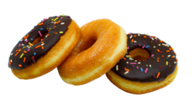 | Sweet tasting, fluffy, cold donuts covered with a dark, hard, chocolate topping and sweet and crunchy coloured sprinkles.
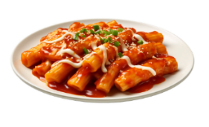 | A plate of hot, strong smelling tomato pasta. The pasta is cooked al dente which means it is firm yet tender. This is coated in a rich and sweet tasting tomato sauce which is bright red in colour. It is sprinkled with melted and strong parmesan cheese.
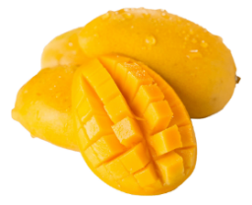 | A sweet, juicy, aromatic mango that is oval shaped with a smooth, firm skin with flesh that is soft and juicy when you eat it.

How are eggs good for us?

What is a nutrient?
Eggs are a nutrient-dense food. There are 6 essential nutrients that the body needs to function properly. These are found in the food we eat. Nutrients are compounds in foods, and they are vital to life and health.
In the table below, outline the 6 essential nutrients with the correct example of food sources.
Note: remove sample responses for the student workbook.
Table 3 – nutrients and food sources
Nutrient | Food sources
Carbohydrates | Bread, pasta, rice, cereals, sugar, fruit
Proteins | Beef, chicken, pork, lamb, eggs, seafood, nuts
Fats | Oils, avocado, salmon, butter, seeds, nuts
Vitamins | Vitamin C, A and folic acid – fruits and vegetables  B group vitamins and fibre – grains and cereals  Vitamins A, D and E (fat soluble) – full-fat dairy and egg yolks  Vitamin K – milk, vegetables, soya bean oil
Minerals | Calcium and magnesium – milk and dairy products  Iron and zinc – red meat  Iodine – seafood and vegetables
Water | As a beverage and a component of many foods especially vegetables and fruits

Function of nutrients
Nutrients perform a variety of different functions in the body. In the table below, outline the function of the listed nutrients.
Note: remove sample responses for the student workbook.
Table 4 – nutrients and their functions
Nutrient | Function
Carbohydrates | Provide energy
Proteins | Promote growth and repair of muscles and cells in the body
Fats | Protects internal organs, move some vitamins around the body and helps to regulate body heat
Vitamins | Support body functions and the immune system
Minerals | Calcium – keeps teeth and bones strong  Fibre – helps to remove waste from the body
Water | Supports digestion and keeps the body hydrated
Nutrients can be categorised into 2 groups known as macronutrients and micronutrients. These groups refer to the amount of nutrients required by the body.
- Macronutrients – nutrients the body needs in large amounts to function properly. They provide the body with energy and building blocks the body needs for growth, development and daily activities.
- Micronutrients – nutrients the body needs in smaller amounts to function properly. They play crucial roles in metabolism, immune system function and bone health.

Macro and micronutrients
Use the table below to categorise the nutrients into micronutrients and macronutrients.
Note: remove sample responses for the student workbook.
Table 5 – macronutrients and micronutrients
Macronutrients | Micronutrients
Carbohydrates | Vitamins
Proteins | Minerals
Fats
Water

Nutrient sources activity
Look at the image of a balanced meal in Figure 1. Identify the food sources and nutrients in the meal. In the table below, provide the function of each of the identified nutrients.
Note: remove sample responses for the student workbook.
Table 6 – balanced meal
Food item | Nutrient | Function
quinoa | Carbohydrates | Provide energy
chicken breast | Protein | Promote growth and repair of muscles and cells in the body
avocado | Fats | Protect internal organs, move some vitamins around the body and help to regulate body heat
cherry tomatoes | Vitamin C | Support body functions and the immune system
alfalfa sprouts | Vitamin K, magnesium | - Support bone and blood health  - Support muscle and nerve health
rocket leaves | Vitamin C, folate | - Support body functions and the immune system  - Support cell health
Figure 1 – balanced meal example
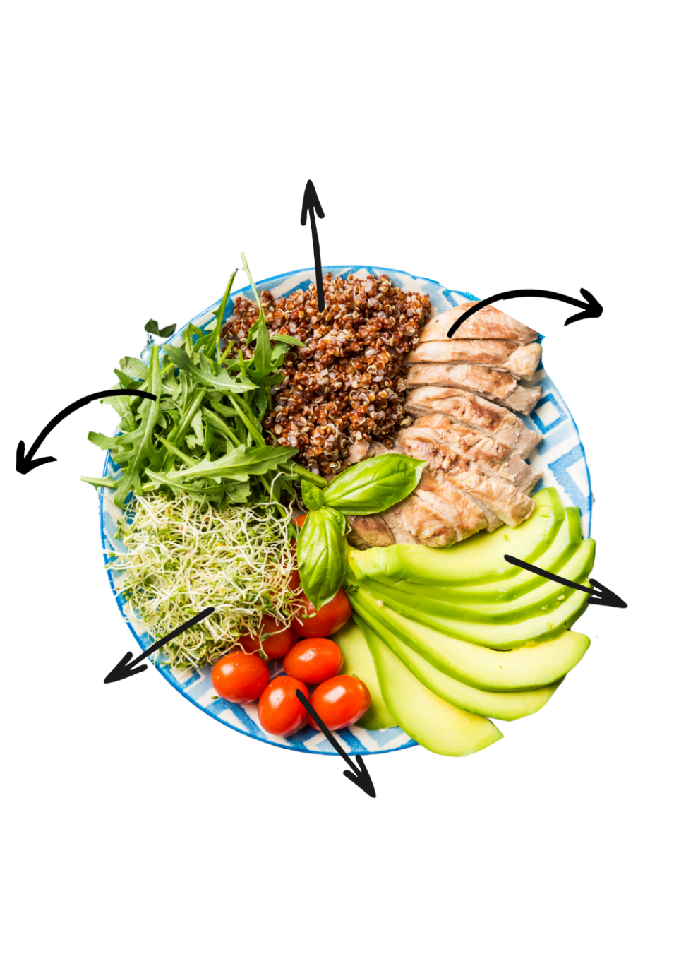
Design your own balanced meal in the space below. Annotate your meal like the image above to identify the food source, nutrient and function.

Information hunt
Using the article The Health Benefits of Eggs and the summaries from the class, complete the following questions.
Note: remove sample responses for the student workbook.
- Which part of the egg contains vital healthy fats, vitamins, minerals and antioxidants?
Yolk
- What vitamins and minerals are found in the average serving of 2 eggs?
An average serving of 2 eggs contains:
- 82% of your daily vitamin D requirements
- 50% of your daily folate requirements
- 25% of your daily riboflavin (Vitamin B2) requirements
- 40% of your daily selenium requirements.
Eggs also contain useful amounts of vitamins A, E, B5, B12, as well as iron, iodine and phosphorus – all vital nutrients in supporting your healthy, balanced diet.
- How much protein does a single egg contain?
6.3 grams
- What does the following statement mean?
While some other foods contain proportionately more protein than eggs, the high quality and bioavailability of protein in eggs is truly second to none.
The protein found is eggs is of the highest quality.
- How are eggs beneficial to your eyes?
Eggs are rich in important vitamin, minerals and antioxidants that have been found to support eye health.

Cheesy eggs on toast
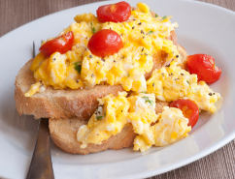
The images below make up the Cheesy eggs on toast dish in the image above. Label the ingredients and the correct nutrients found in each.
Note: remove sample responses for the student workbook.
Table 7 – cheesy eggs on toast ingredients
Ingredient | Ingredient name | Nutrients
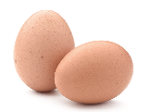 | Eggs | Protein, fats, vitamins A, D, E, B5, B12, folate, riboflavin (vitamin B2), iron, iodine, phosphorus
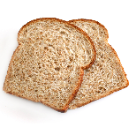 | Wholemeal bread | Carbohydrates, fibre
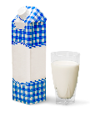 | Milk | Calcium, protein, fat, vitamin D
 | Olive oil | Fats
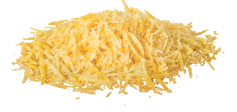 | Grated cheese | Mineral – calcium, protein, fat, vitamin D
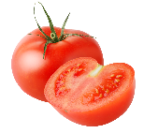 | Tomatoes | Vitamin C
The above dish is one example of how eggs can be incorporated into everyday meals. In the space below provide another example of how you could eat eggs in your everyday diet.
Student responses may differ

Scrambled activity
Look at our character, Scrambled, above. Within the given time frame, jot down as many ideas as you can think of for how Scrambled can contribute to promoting and being part of good health.

What if I can’t eat eggs?
Several groups of people are unable to eat eggs due to a variety of reasons. After completing a class brainstorm, choose one of these groups and identify the reasons why they can’t have eggs in their diet. What do they use instead?
Note: remove sample answers for the student workbook.
Sample answer:
Vegans.
Most vegans consider it unethical to consume eggs as they come from an animal. They might use chia seeds or tofu instead as a binder.
Unfortunately, some people have medical reasons why they can’t eat eggs. These are known as allergies and intolerances.
A food allergy is a response by the immune system where the body believes the food consumed, or something in the food, is harmful. This will lead to an allergic reaction in the gut, skin and breathing. It can even lead to a life-threatening condition known as anaphylaxis. Egg allergies are one of the more common food allergies in childhood.
If you have a food intolerance, you may be able to eat a small amount of the food, but symptoms will often be like having an allergic reaction. An intolerance does not involve the immune system and instead relates to difficulties digesting the food. Symptoms are usually less severe.
So, what options do these people have?
Use the resource 16 household substitutes for eggs to get you through the shortage to create a summarised list of options available to substitute eggs. Next to each substitute provide a suitable example of a recipe that it could be used in.
Note: remove sample answers for the student workbook.

Egg substitute | Example | Egg substitute | Example
Aquafaba | Meringue | Tofu | Scrambled eggs
Chia or flaxseed | Pudding | Fruit puree | Muffins
Agar powder | Macaroons | Vinegar and baking soda | Cakes
Banana | Choc chip cookies | Powdered substitutes | Pikelets
It is time to do some detective work. It can be tricky for those that can’t eat eggs as sometimes the food is disguised in packaged foods. Using the link https://allergyfacts.org.au/allergy/egg/ and the ASCIA Egg Allergy Guide (PDF 141 KB), search for pantry items that would need to be avoided. List those food items here.
Food items in the pantry that contain hidden eggs

Commercial egg substitutes
Along with the options you have researched, there are commercial products that can be purchased to replace eggs in recipes. Examples of these can be seen below.
Figure 2 – commercial egg substitutes
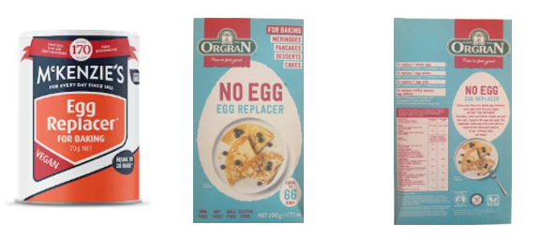
If you discovered that you had to stop eating eggs, how would you manage? How would you feel? Explain your answer below.

Emu eggs
Prior to European settlement, Aboriginal and Torres Strait Islander Peoples incorporated eggs from native animals into their traditional diet and food practices.
Using reading strategies, read the article Did you know emu eggs are a nutritious, chef-approved ingredient with a deep Indigenous connection?
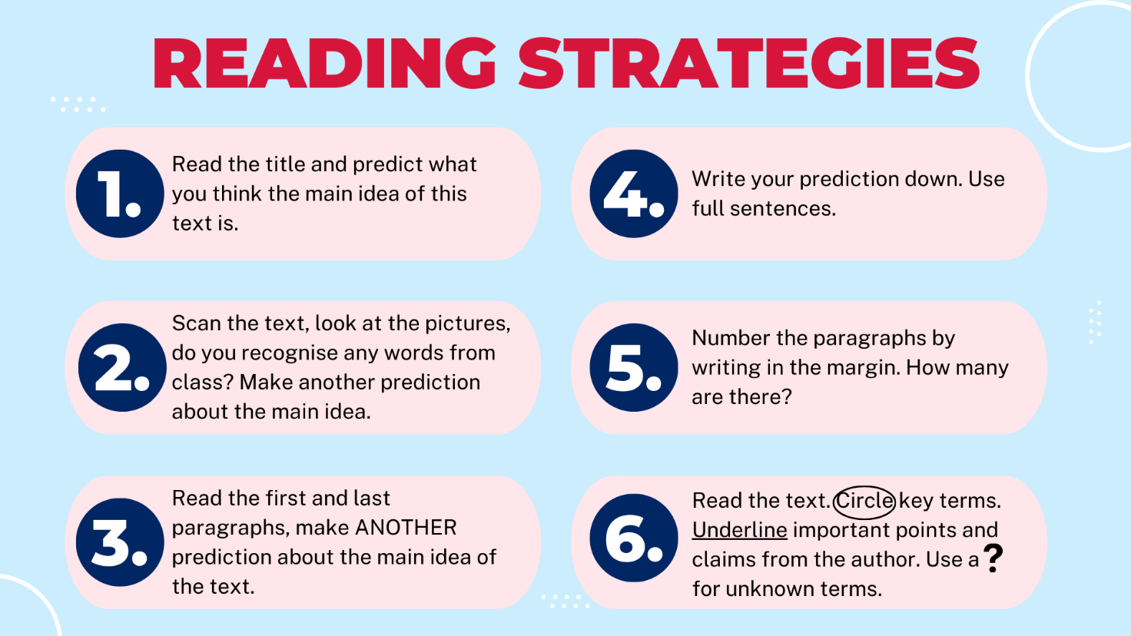
Annotate the emu egg with its nutritional properties and other useful facts that you read. This may include suitable dishes it can be used in.
Figure 3 – emu egg
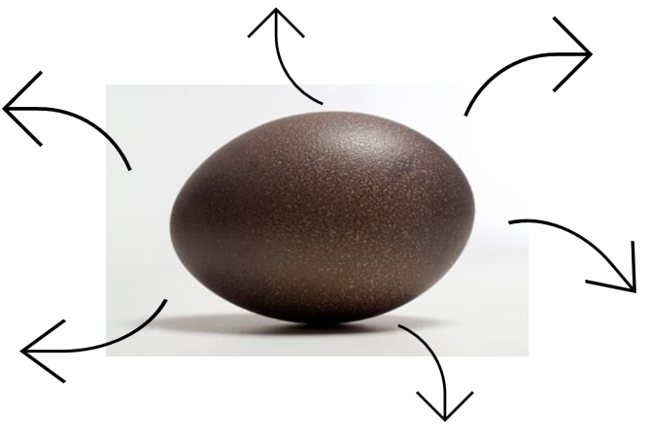
Aboriginal and/or Torres Strait Islander People didn’t just use the emu egg for its nutritional value, their sustainable farming methods ensured that the whole egg was used for generations to come. Watch In the footsteps of his great-grandmother, Jareece searches for emu eggs and his mob carve their history (2:30) to answer the following questions.
Note: remove sample answers for the student workbook.
- What are the signs that the emu nest is close by?
Coming and going tracks on the ground.
- Explain the importance of the use of the stick.
It is used to not leave scents behind and is taken far away from the nest so that the female emus will keep coming back.
- Outline the steps that are taken to create the carved and painted emu eggs for storytelling.
Note: remove sample answers for the student workbook.
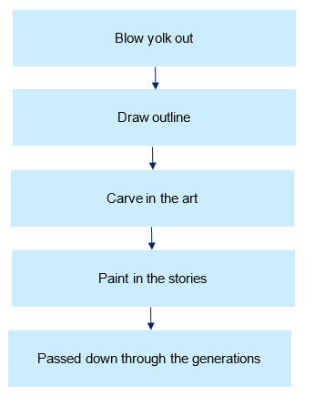
Sketch a design on the emu egg template in your workbook that could be carved into an emu egg.
What story are you leaving behind for future generations?


Why are eggs in so many recipes?

Parts of an egg and their function
Let’s have a closer look at the parts of an egg and why they are so popular.
Practical activity 2

Eggs-amining egg structure
Materials
- 1 raw chicken egg per student (or per group)
- A small bowl or plate
- Paper towels for cleaning up
Instructions
- Carefully crack the egg:
- Hold the egg gently and tap it on a flat surface (for example the side of the bowl) to crack it.
- Slowly pull apart the shell over the bowl, letting the contents fall into the bowl. Be gentle to avoid breaking the yolk.
- Observe the egg:
Look closely at the cracked egg. Can you see:
- the egg white (albumen)
- the yolk
- a small white spot on the yolk (the germinal disc)
- a whitish string extending from the yolk to the shell (chalaza)
- the shell
- a bubble in one end of the shell
- thin membrane on the inside of the shell?
- Draw the egg:
- In the space below, draw the cracked egg showing both the shell and the contents in the bowl.
- Label each part of the egg: yolk, germinal disc, chalaza, albumen (egg white).
- Clean up:
- Dispose of the eggs and shells properly or place them in a compost bin if available.
- Wipe down your workspace with a paper towel and antibacterial wipes or spray.
- Wash your hands thoroughly after completing the activity.
Roles of different parts of the egg
Use the following words to fill in the spaces in the table below.
yolk | hatching | protects | freshness
protein | white spot | shell | two
Note: solution provided as underlined words below.
Table 8 – part of the egg
Part of the egg | Function in chick development | Nutritional information
shell | The hard outer layer that protects the egg from bacteria and physical damage. It is porous, allowing gases to exchange. | Primarily made of calcium carbonate. Shells are not consumed but provide a barrier to protect the egg.
albumen (egg white) | Provides water and protein to the developing embryo. It cushions and protects the yolk. | Rich in protein (about 3.6 g per egg white), low in fat and carbohydrates.
yolk | The main food source for a growing chick, containing fats, proteins, and nutrients. | High in fat (4.5 g) and protein (2.7 g), contains vitamins like Vitamin D and minerals such as iron.
chalaza | Two twisted strands that anchor the yolk in the centre of the egg. They help keep the yolk stable. | Mostly protein, though consumed as part of the egg white.
germinal disc (blastodisc) | The small white spot on the yolk where fertilisation would occur. If fertilised, it would become the embryo (developing chick). | A negligible part in terms of nutrition, often not noticed when consuming eggs.
air cell | Located at the wider end of the egg, it provides the first breath of air for the chick just before hatching. | The air cell is not consumed but is used as an indicator of freshness (larger air cells mean the egg is older).
In the space below, choose one part of the egg structure, for example the air cell, and write a short story pretending to be its character. It is titled ‘Who am I?’. Your story should contain at least 3 important facts to the reader. You may like to draw your own character – a bit like our Scrambled.
Sample answer:
Hi, I am an air cell. I have a very important role in egg development. If it wasn’t for me, a small little chick may not survive. I am very clever as I can grow to different sizes. Some people might look at me to find out how old the egg might be and whether the egg has gone bad. I can’t be seen from the outside unless you shine a light. You can find me at the chubby end of the egg, not the pointy end. If I am a fresh egg, I will be quite small, if I am an older egg I will grow larger.

Function of eggs

Let’s egg-splore
Eggs have several functional properties that make them an important ingredient in many recipes. Watch the video THE FUNCTION OF EGGS IN BAKING | whole eggs, egg whites, egg yolks (2:44–4:40) to answer the following questions.
Note: sample answers are provided. Remove before printing.
- What is egg made up with?
water, fat, protein
- What will the protein in the egg do when heated?
coagulation
- What does the fat in egg add to dishes?
moisture and richness
Leavening – to leaven means to make something rise and become light by adding air or gas bubbles, giving it a soft and airy texture.
- How does the water in the egg help with leavening?
lift and rise baked goods
- How are egg whites useful for adding air?
they can hold a large amount of air, up to 8 times their original volume
- How are egg yolks useful in baking?
flavour, richness, moisture, bind and thicken
- How do egg yolks thicken a custard?
they gel as they are heated
Below is a list of the different functions of eggs. Choose the correct definition with the function and name a suitable recipe or find an image of a food that uses this function of eggs.
Note: remove sample answers for the student workbook.
Table 9 – function of eggs summary
Function | Definition | Example
coagulation | Sample answer  Changing from a liquid to a solid. When heated or cooled the proteins in eggs coagulate. | Sample answer  Fried egg, custard
aeration and leavening | The process by which air is incorporated into food products to increase volume. | Meringue, cakes
emulsification | Blending of 2 ingredients that do not normally combine, for example oil and water. Helps to join these ingredients in recipes such as cakes and mayonnaise. | Cakes, mayonnaise
binding | The coagulation of the egg proteins works like glue in joining ingredients together. | Rissoles
egg wash | A mixture of beaten eggs and a liquid that is brushed onto baked goods such as pies, before baking to give them a shiny, golden-brown finish. | Meat pie
Choose from the definitions below and write it into the correct function in the table above.
Table 10 – function of eggs definitions
The process by which air is incorporated into food products to increase volume. | A mixture of beaten eggs and a liquid that is brushed onto baked goods such as pies, before baking to give them a shiny, golden-brown finish.
Changing from a liquid to a solid. When heated or cooled the proteins in eggs coagulate. | Blending of 2 ingredients that do not normally combine, for example oil and water. Helps to join these ingredients in recipes such as cakes and mayonnaise.
Changing from a liquid to a solid. When heated or cooled the proteins in eggs coagulate.

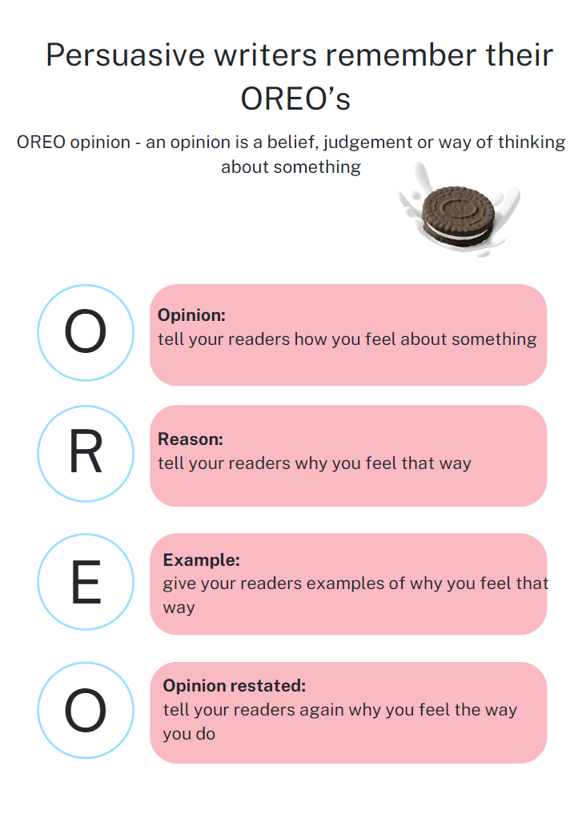
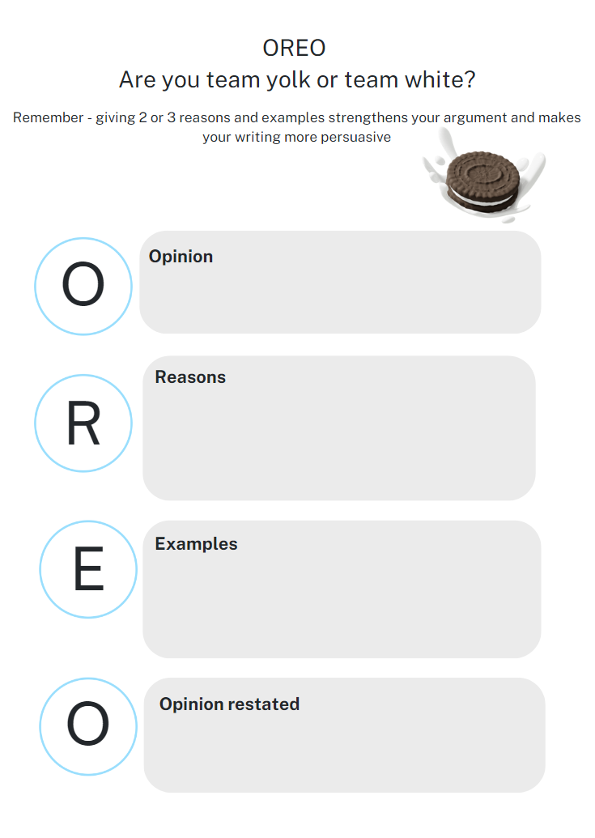
Scrambled activity
Complete the table below with statements about the functions of eggs as either true or false.
Table 11 – function of eggs true or false table
Statement | True or false
Eggs can only be used in recipes for added flavour. | Sample answer  False
You can overcook a scrambled egg. | True
When aerating eggs, they can only double in volume. | False
Aeration is the process of adding air by beating egg whites. | True
Eggs help oils and liquids combine through emulsification. | True

Types of eggs
Note: the teacher will explain the process of a jigsaw activity before beginning this activity and divide the class into groups to ensure that this activity can run successfully.
Most of us think that we only get eggs from chickens. In small groups, complete the following jigsaw activity to learn more. Use 18 Varieties of Eggs, Explained to assist with your research.

Table 12 – jigsaw activity
Topic: Bird/animal – | Response: Record key information/answers | Other important information/questions:

Jigsaw activity

Table 13 – jigsaw summary table
  Sharing session | Key information shared:

The eggs we buy at the supermarket also vary. Look at the images of different egg cartons available at the supermarket and make a list of the different words and labels that you see.
Table 14 – list of egg words in supermarket
List of words on egg cartons
Sample answers:
large
free range
organic
700 g
Cage-free
800 g
X-large
barn-laid
ready to pour eggs
pastured eggs
large
600 g
Pasture-raised carbon-neutral

Discussion questions
What are the main differences with the types of eggs sold in a supermarket?
Sample answer:
The size and weight of the eggs, where the eggs came from, the types of egg farms the chicken are on.
How would using different eggs in recipes change the finished product?
Sample answer:
How wet or dry the recipe is, how many eggs you would need to use in a recipe, the change on cooking time, the change of texture in a recipe.
Practical activity 3

Egg sorting activity
Materials per group
- A selection of chicken eggs
- different sizes from supermarkets (large, extra-large, jumbo)
- different production systems (free-range, organic, caged, barn)
- different breeds if available (Australorp or ISA Brown – brown; Sussex or Silkie – white; Araucana – blue; bantam breeds – small size)
- Digital kitchen scales for a more accurate reading
- Ruler or sewing tape (for measuring size to show mm)
- Calculator (optional, for price calculations)
- Paper towel
- Access to eggs from other species or breeds (duck, quail, goose) – optional
Instructions
- Weigh eggs:
- Use the digital kitchen scales to weigh 3 individual eggs from each category.
- Record the mean weight of each egg group on your worksheet under the correct category (large, extra-large, jumbo).
- Measure size and shape:
- Use a ruler or sewing tape to measure the length and width of each egg to the nearest millimetre. Describe its shape (round, oval).
- Record the mean length and width for each category.
- Visual comparison:
- Look closely at the colour of each egg's shell. Record your observation on the worksheet.
- Price comparison:
- Calculate the price of each carton of eggs, then divide the price by the number of eggs in the carton to find the individual price of each egg.
- Yolk colour comparison – optional:
- After recording the weights, sizes, and prices, carefully crack open one egg from each group to compare yolk colours. Record your observation on the worksheet.
- Further activity – optional:
- If you have access to eggs from other species (duck, quail, goose), or a range of different breeds, repeat the same procedure with these eggs.
Note: adjust this table depending on what eggs you have available. There are 3 empty rows where you can add eggs from other species (duck, quail, goose) or a range of different breeds.

Comparison table
Table 15 – egg comparison table
Egg type | Weight (g) | Length (mm) | Width (mm) | Shape | Shell colour | Yolk colour –optional | Price (per egg)
Large
Extra-large
Jumbo
Free-range
Organic
Caged
Barn
Discussion/workbook question
Review and compare your findings and discuss why eggs might differ in size, colour, or price depending on their source or how they were produced.
Using the hand below recall 5 finger facts that you have learned so far about eggs. Each fact should fit in, or around each finger.

Where do our eggs come from?
‘The NSW egg industry is diverse and varied with 34% of all egg production in Australia occurring in NSW. The Food Authority licenses approximately 300 businesses in this industry.’ (NSW Food Authority 2025)

Let’s ‘egg-splore’ our egg industry
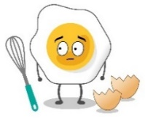
Use the following website Australia's Egg Industry Overview to gain on overview of how large and important the Australian egg industry is.
Get those calculators out, there is some numeracy work to do!
Fact 1
Per capita egg consumption grew to 263 eggs consumed each year in Australia = 15 kg per person, per year.
What else weighs 15 kg?
Sample answer: 2 car tyres, 39 cans of soft drink, large fire extinguisher, microwave
Calculate how many eggs this is each week. Do you eat that many eggs each week?
Sample answer: 5

Fact 2
New South Wales produced 34.20% of Australia’s eggs, Queensland produced 31.25% and Victoria produced 19.47%. Label this on the pie chart below.
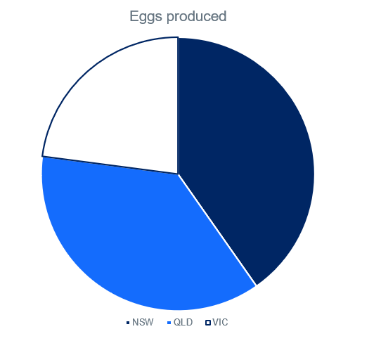
Fact 3
There are 3 main egg farming systems used in Australia: free range, cage and barn-laid. Free range egg production has grown significantly over the last 15 years and now makes up 56.5% of all grocery retail sales.
After watching the videos Free Range Farming System (0:25), Caged Farming System (0:17), Barn Farming System (0:20), add these terms to your glossary.
For each of the egg farming systems, complete the Plus, Minus, Interesting (PMI) chart by identifying:
- A positive feature of that system
- A negative or minus feature of that system
- An interesting feature of that system.
Use the information from the videos, and Egg production systems in Australia to assist with your chart. Remember to consider production efficiency, farm management and animal welfare.
Table 16 – Plus, Minus, Interesting chart of egg farming systems
Egg type | Positive | Minus | Interesting
Free-range eggs
Cage eggs
Barn-laid eggs
Organic eggs
Approximately 2% of supermarket sales in Australia are through the sale of organic eggs. Organic eggs are laid by hens that have been fed organically grown grain. Organic eggs are produced without the use of chemicals.
Add a Plus, Minus, Interesting (PMI) point about organic eggs to the PMI chart.
Fact 4
Egg production has changed significantly over the last few years Let’s look at how egg production has changed.
Using the statistics shared in class from the Australian Egg Industry Overview, plot them on this graph to show a visual representation of how egg production has changed from 2016–2023.
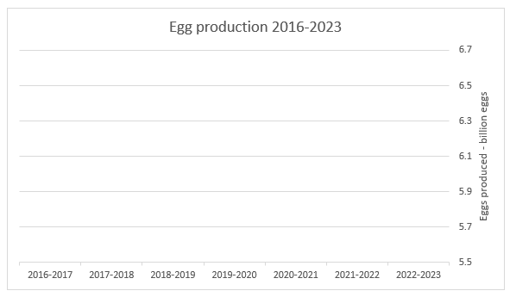
Complete an overview of how the NSW egg industry has changed using How the NSW egg industry was hatched (PDF 995 KB). Pick 5 key dates that had an impact and place in date order. The First Fleet is summarised for you.
Table 17 – egg industry timeline
Date | Significance of this date for the NSW egg industry
First Fleet | On the fleet of ships bound for Botany Bay, a total of 122 fowls, including 87 chickens, were documented.

What’s trending
Watch Future Farmers – Farming eggs in Australia: Meet the farmer (1:30–4:14), to revise the different types of egg farms. On the chart below, label what percentage of each type of egg is sold in Australia’s supermarkets.
Note: sample answers = 40% are cage eggs, 10% are barn-laid and 50% are free-range.
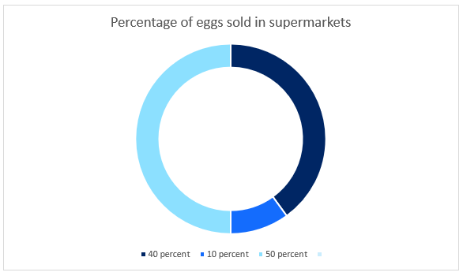
The farmer talks about pasteurised eggs. What does this mean?
Sample answer:
Hens roost in mobile sheds that are moved around and spend most of their day outside.
In the video, Josh and his mum talk about how technology has helped them at their egg farm. Watch the final section of Future Farmers: Australian Agriculture – Farming eggs in Australia (5:47–8:55), Egg tech, and record in the table below the pieces of technology they use, why it is there and what improvements it makes.
Note: remove the sample answers.
What is the technology? | Why is it there? | What does it improve?
Sample answer  Mobile sheds | Sample answer  Farm sustainability | Sample answer  Gives the land a chance to recover, chicken get fresh grass
Renewable energy | Low carbon footprint | Solar panels run motors which run feeders and conveyor belts
Special nests | Economically | Collect eggs more easily
Timers | When doors need to be open and closed, lights come on and off | Allows for this to be done automatically
Josh also talks about how this technology helps the chickens ethically. What does he mean by this? Add this word to your glossary.
It is now your turn to choose a new piece of technology and complete the following activity from page 70 of Industry insights – Poultry Supporting document – NSW DPI Schools Program (PDF 2.5 MB) by NSW Department of Primary Industries.
Current and emerging technologies in the poultry industry include:
- Poultry shed technologies: for example, 3D printing metal and plastic replacement parts; cleaning and sanitising robots, automated egg collection, remote controlled environment control (temperature, humidity, wind, light); artificial intelligence (AI) and sensor surveillance with detection of ill birds and predators; automated door openers for barns.
- Feeding technologies: for example, drones for flock surveillance; automated feeding and watering systems.
- Management technologies: for example, integrated electronic real-time marketing, finance; infrastructure, pasture and flock management software and applications; AI for sorting eggs and birds for packing and processing; use of solar to increase sustainability and profit.
Select a poultry industry-specific technology from the list above or find one of your own. Use the internet to compile a 1–2-page report on your selected technology.
Your report should include:
- Name of the technology
- Images of the technology
- Thorough description of how the technology works
- Description of how the technology is used to improve production efficiency
- A table contrasting the advantages and disadvantages associated with using the technology.
Complete the sentence starter: ‘Technology has helped the egg industry by …’

Animal welfare
‘Animal welfare and ethical treatment of animals is the human responsibility to provide and adopt standards of care and respect to the animals in their care.’ (Dunford 2023)
In Australia we have the RSCPA charity that provides animal care and protection across the country. Using the resource RSPCA Our role – Enforcing the law, list the role of a RSPCA animal welfare inspector.
Note: remove the sample answers.
Sample answer:
To enforce animal welfare law and investigate animal cruelty offences.
Click on your state and list 3 interesting facts about their role in NSW.
Sample answer:
- Investigate abandoned animals.
- They also deliver education to the community.
- They are authorised to enter private property.
- If you witness animal cruelty you can contact them.
Access the resource Animal in schools – Poultry – Fowls and watch the video Housing requirements for chickens (3:58) to see how Galston High School designed their poultry facility. Create a checklist for an RSPCA inspector to ensure laying hens are being well cared for and animal welfare is achieved.
Note: remove the sample answers.
Table 18 – laying hen welfare checklist
Laying hen animal welfare checklist
Sample answers: wood shavings
Adequate space for roaming
Correct temperature
Ventilation
Shelter
Perch
Fencing/security
Rodent control
Feeder
Light
There are many concerns involved in caring for animals and animal welfare. Choose one welfare area of interest to you from the resource Layer Hens – RSPCA Knowledgebase and provide a summary of the main concern that you could share with others.
Practical activity 4

Chicken coop visits
For schools without poultry and poultry facilities, take a virtual tour of Numeralla Free-Range Egg Farm – Tocal College 360 (8:53).
Instructions
- Join your class teacher on a tour of the school chicken coop.
- Observe the different areas within the coop listed in the checklist below.
- Which of the following did you observe during your visit?
Part of coop observed | Yes | No
Feeding station (where the chickens get their food)
Drinking station
Nesting boxes
Perches
Shady areas
Areas to dust bathe (dirt or sandy areas they dig into)

Draw the coop layout, labelling the various sections (nesting, feeding, perching).

Handling chickens
Before approaching the chickens, you should understand how to behave around them to avoid causing stress.
- Move slowly and quietly.
- Don’t chase or startle the chickens.
- Keep hands low and open when approaching a chicken.

Animal welfare in the chicken coop
Materials
- Tape measure
- Pen and paper
- NSW Animals in Schools guidelines on space requirements.
Instructions
According to the guidelines, check the coop’s size to make sure it provides enough space per hen. The minimum space requirements are:
- Nesting box space: 1 box per 4 hens
- Perching space: 15 cm per hen
- Floor space: 0.20 to 0.5 square metres per hen, depending on the coop design, age and type of bird.
Measure the coop
- Nesting boxes: count the number of nesting boxes. Does the coop have the right number of boxes for the number of hens?
- Perching space: measure the total length of perches. Does the coop provide 15 cm per hen?
- Floor space: measure the floor area of the coop. Calculate whether there is enough floor space per hen according to the guidelines.
Discussion questions
Do you think the coop meets welfare requirements? If not, how could it be improved?
Why is space important for hens?
Create an animal welfare slogan or design an idea for a sign to educate others on the importance of caring for laying hens and promoting their wellbeing.

How do they get to me?

How are eggs packaged and distributed?
Have you thought about how eggs get from the farm into your home? We call this process the production and distribution process.
Watch the following videos JourneyV1O_Final_LowerAudioMix (1) (1:46) and Future Farmers: Australian Agriculture (4:14–5:37) and each time you see or hear a new step in the process, write it in the spaces below. We will then use this information to create a flowchart outlining the journey that eggs take to get from the farm to our homes.
Note: the solutions have been provided. Remove them before printing.
Nest | Conveyor belt
Stack trays | Grading room
Light for cracks | Weighed, sorted, tested for quality
Put into box | Date stamped
Clean and dirty eggs sorted | Packed
Pallet | Sent to store

Egg labelling
There are laws that say what information needs to go onto egg packaging. This is to keep egg consumers informed and safe.
Do some investigating and look again at the photos of the different egg packages. What are some of the labels that you notice? List them below.
Note: sample answers have been provided.
Free range, Pastured eggs, 300 g, Organic, Best before, Cage free, X-large, Pasture-raised, carbon neutral, Barn laid

What does all this labelling mean?
Use the resource Egg Types & Labels to help understand some of the labelling. Add new terms to your glossary.
Food Standards Australia New Zealand (FSANZ) write the Food Standards Code which legally enforces that all food sold is safe to eat. FSANZ also set the food labelling standards in this code. Use the information available in Food labels – What do they mean? to identify some of the labelling requirements in New South Wales. Provide your answers in the diagram below. An example has been provided for you.
Figure 4 – food label diagram
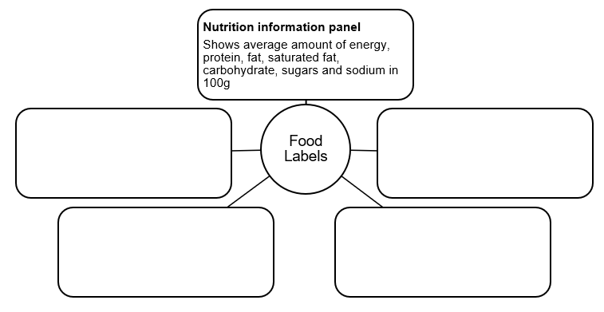
Using the egg carton image below, design and label it according to the key pieces of information we must include.
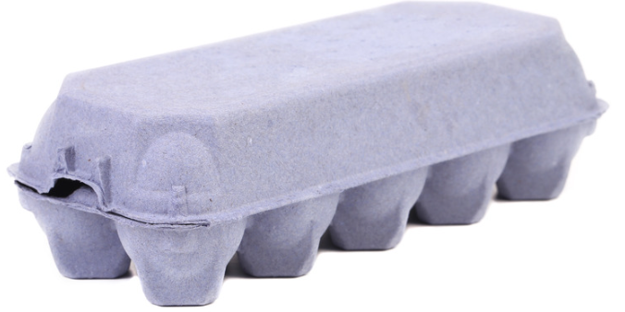

Egg-splore how technology and labelling
To explore how technology is helping the labelling of eggs watch Egg Industry Traceability -Josh's Rainbow Eggs Case Study (4:08) and answer the what, why, how table below.
Table 19 – egg Industry traceability: what, why, how
WHAT is the technology? | WHY do they use it? | HOW does it work?
Sample answer:  Traceability uses technology to show the egg producer where the egg came from to where it goes. | It is used as an ‘insurance policy’ for egg quality and biosecurity so if things go wrong it can be traced and fixed. | An app on the phone is used to log the information about the egg batch and then the eggs are stamped.
Choose one of the ‘You Can’t Say That’ activity cards and describe the supply chain stage in the space below. Remember, you can’t use the words listed on the sheet.

Josh’s mum mentions biosecurity in the video. Do you know what this means?
What is biosecurity?
Sample answer:
The system that is used to prevent and control the introduction of infectious diseases that negatively impact egg production.
Biosecurity checklist to keep your layer hens safe
This is a checklist can be used when working with chickens on the school farm. Tick the box next to each item once it has been checked or completed.
Hygiene practices
☐ Wash your hands properly after handling chickens or collecting eggs.
☐ Use clean equipment when working with chickens or in the chicken coop.
☐ Wash all equipment used after working with chickens or in the chicken coop.
☐ Clean faeces from the bottom of your shoes after working in the chicken coop.
Food and water safety
☐ Make sure wild and other domestic birds (turkeys, ducks and geese) cannot reach the chickens’ feed or water.
☐ Only feed chickens food scraps that are fresh and animal-product free.
☐ Make sure chickens have clean drinking water and troughs.
Chicken health check
☐ Look for any signs of illness, such as pale comb, diarrhoea, swollen eyes and bald patches.
☐ Isolate any sick chickens and inform a teacher immediately.

Preventing pests
☐ Check the chicken enclosure for holes or gaps that foxes and rodents could enter.
☐ Ensure all chicken feed is stored in a rodent-proof container.
What makes you say that?
Now you understand more about animal welfare, chicken coop requirements and biosecurity, after each of the statements below, answer the question ‘What makes you say that?’ (Thinking routine – What Makes You Say That).
Statement – ‘The chickens are unwell.’
What makes you say that?
Sample answer:
Signs of illness are pale comb, diarrhoea, swollen eyes and bald patches.
Statement – ‘The chicken feed and water are all safe.’
What makes you say that?
Sample answer:
Other domestic birds cannot reach their food and water, food scraps are fresh and free of animal products, drinking water is clean.
Statement – ‘Biosecurity risks are very low thanks to me.’
What makes you say that?
Sample answer:
I wash my hands, the equipment is clean, equipment is washed after use, I remove all chicken faeces from shoes.
Choose one or more biosecurity concerns or advice and design an awareness poster that could inform the public and reduce biosecurity risks. In the space below design your biosecurity awareness poster.

Sustainability
After discussing with your class teacher what sustainability means, write your own definition into your glossary.
We all have a role to play in being sustainable. Start by completing the Ecological Footprint Calculator activity to determine your ecological footprint. Place your results below.
Note: sample answers have been provided.
My personal Earth Overshoot Day is:
Sample answer:
26 April
If everyone lived like this, we would need:
Sample answer:
3.1 earths
How many Earths would our whole class need?
List 3 of the details given to explain why you currently can’t get your Footprint score within the means of one planet (select the see details link).
Sample answer:
- Food makes up my biggest consumption category.
- My carbon footprint is the biggest by land type.
- Mobility is the second biggest consumption by category.
Now you know this information, select the question How do you feel? and summarise one of the suggestions given for you to improve. What can you do to move the date?
Sample answer:
Using renewable energy has been suggested by taking transit, riding my bicycle or walking instead of solo driving once a month or even better, once a week.

Home food audit
Watch Life of A Strawberry (1:53) and take note of any environmental impact throughout its journey from the farm to our fridge.
You can see how important it is that we all try to reduce our ecological footprint. One easy way of making changes to our ecological footprint is to start in our own homes.
Make a list of common items in a pantry and read the labels to complete the following table. Also include in this list some fresh fruits and vegetables that you have at home.
Table 20 – food audit
Food item | Where has this food item come from? | Is this within 100 km of your home? | For fruit and vegetables, is it in season?
As a class discuss some of the findings from this research table. What are some of the improvements needed to have an impact on sustainability? Consider the following points:
- Produce that is purchased in the supermarket often has been in transit or cold-stored for days or weeks.
- When a food item travels long distances to get to your dinner table, it means it has a larger carbon footprint due to fuel used for transportation, whether by airplane, boat, truck, or by other modes.
- Cold storage can impact and compromise nutritional value and flavour.
- Local produce is fresher often picked within 24 hours of purchase.
Answer the question above in the space below.
Sample answer:
Many of the students in our class buy fruit and vegetables that are out of season. It is likely that these are travelling a long way from where we live which means the transport is having a big impact on our environment.

What is being done?

Nationally
The Australian Commonwealth Government wrote the ‘National Food Waste Strategy: Halving Australia’s food waste by 2030’ (Commonwealth of Australia 2017). The National Food Waste Strategy provides a framework to support action towards halving Australia’s food waste by 2030. The report states everyone has a role to play in reducing food waste and now is the time to act.
Looking at the Waste hierarchy featured in this strategy, place a tick, or highlight which of the examples below where you could make an impact.
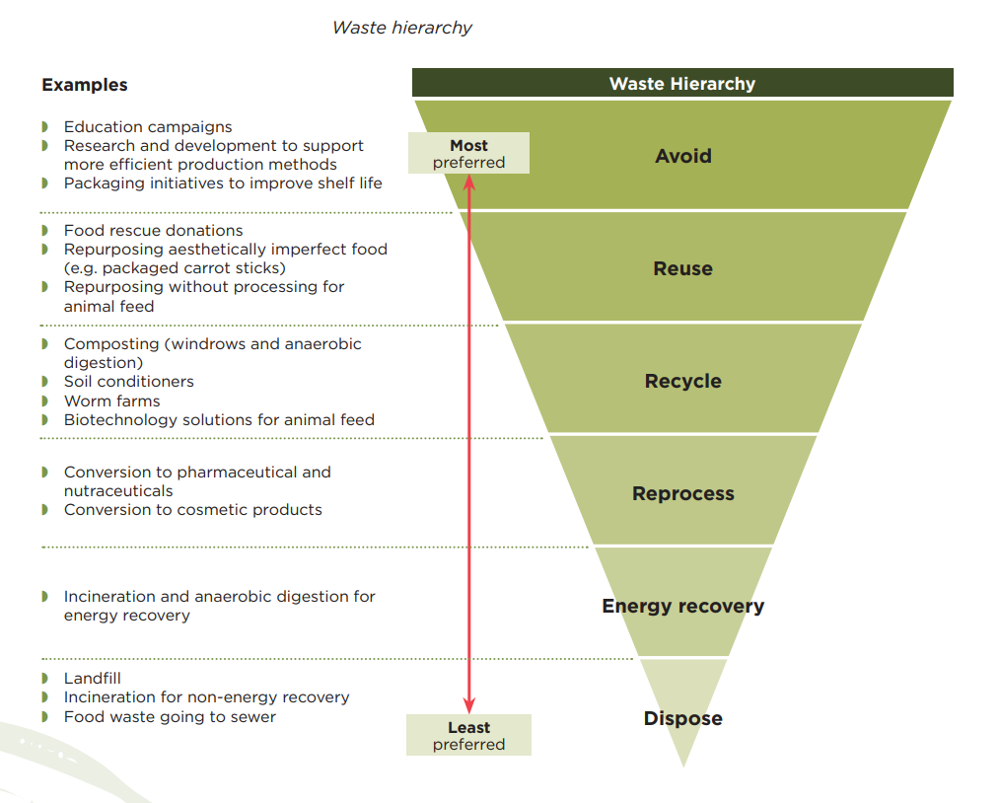
‘Waste hierarchy (PDF 4.5 MB)’ by Commonwealth of Australia is licensed under CC-BY-4.0.
Halving Australia’s food waste by 2030 is the target of a National Food Waste Strategy A Roadmap for reducing Australia's food waste by half by 2030 (PDF 593 KB). Have a look at the infographic below. List what is it saying about households.
Sample answer:
The first graph shows that households throw out the largest amount of food waste to landfills and sewers per year.
The apple chart says that households have the largest percentage of food waste per year.
The third chart states that household food waste costs $10 billion dollars per year.
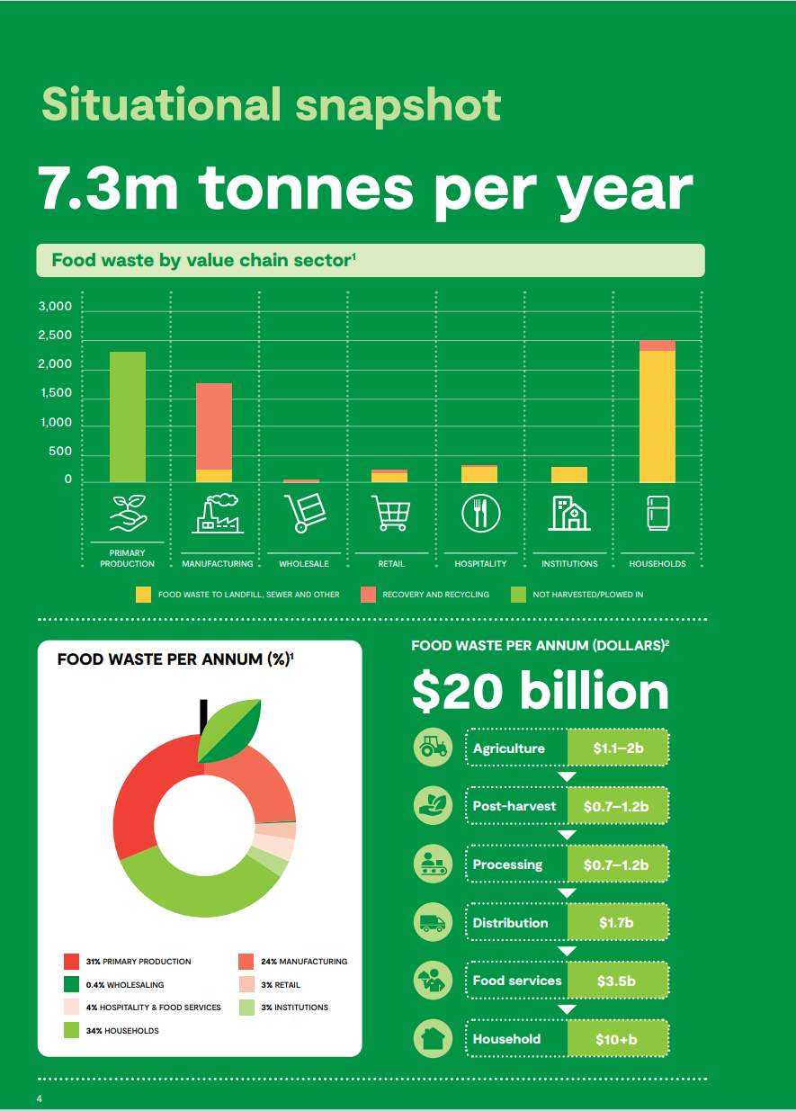
Source: A Roadmap for reducing Australia's food waste by half by 2030, Food Innovation Australia Limited (2019)

NSW
The NSW Government has implemented the Love Food Hate Waste strategy that helps households and business make the most of their food. It is run by the NSW Environment Protection Authority.
Take a look at the NSW Environment Protection Authority’s fun YouTube channel Love Food Hate Waste NSW to see how they are trying to educate and encourage people to waste less food in their homes.
Watch For the Love of Food eat that oddly shaped apple (0:30), For the Love of Food savour every slice (0:30) and For the Love of Food shop to a list and plan your meals (0:30).
It is now your turn. In small groups design your own ‘For the Love of food …’ clip and write your script in the space below. Remember, the script only needs to go for thirty seconds so the message must be clear.

Local government
Note: this is a learning activity and may not result in an actual letter being sent.
Learn about how Sydney’s Inner West Council is expanding food recycling to schools and childcare centres. Research FOGO information for households, how it works for households, and the benefits of reducing food waste.
Draft a letter or email to your local council encouraging them to introduce this program.
This is a learning activity only. You will not send the letter or email.
Your email/letter can either be informative or persuasive. Use a writing scaffold to help create your draft email/letter.
Once your teacher has approved your content, follow the 5 steps below to write it.

Sample letter layout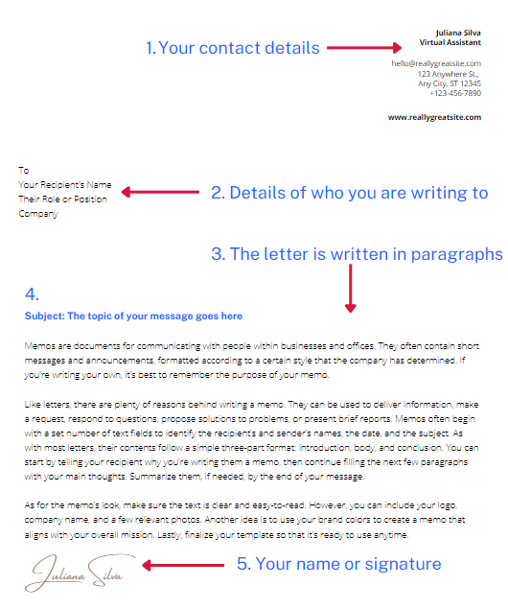

Letter to the council

The Australian egg industry
In this video, a worker in the egg industry describes how sustainability contributes to safe food production for the nation and future generations. They ‘continue to improve so that we can continue to supply.’ (Australian Eggs 8 February 2023).
Watch Australian egg industry sustainability (2:38). Use the information in the video and what you have learned in class so far to provide examples of what the egg industry is doing to remain sustainable. An example has been provided.
Figure 5 – egg industry sustainability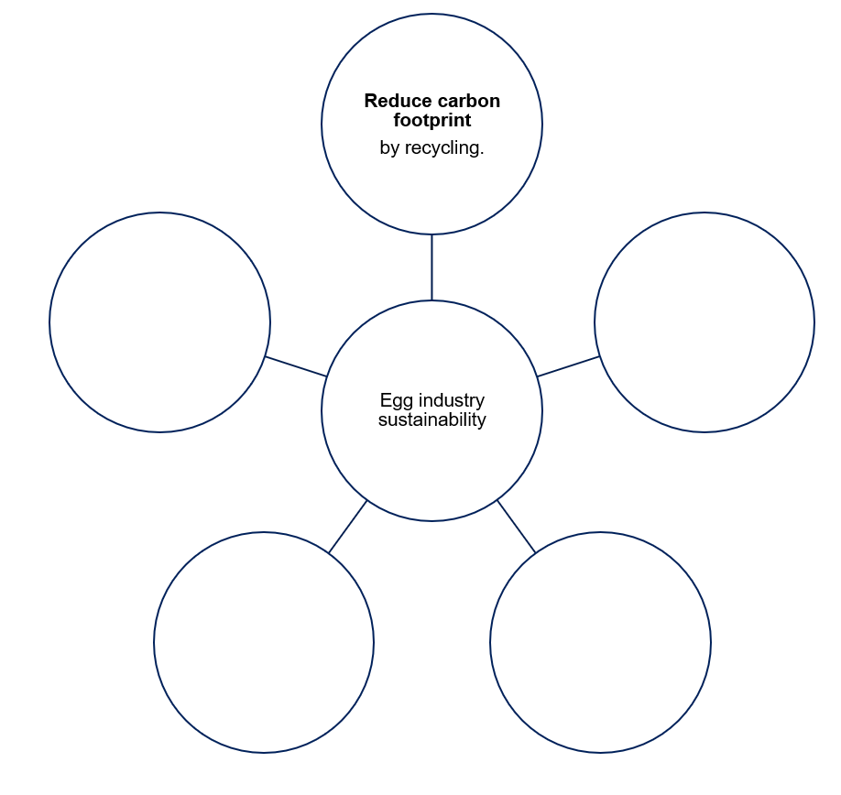

What else can we do?
Did you know over one-third of food waste occurs at the household level with most going to landfill?
What about our chickens? Remember, we can feed our chickens food waste scraps. Don’t forget to remember the animal welfare and biosecurity requirements we learned about earlier.
In the table below, research 3 different recipes that would be suitable to make at home and would provide adequate food scraps for chickens. This would assist with keeping the chickens healthy along with reducing the food waste going into our landfill.
Table 21 – recipes for food scraps
Recipe | What food scraps could be used for chickens’ feed?
Practical activity 5
Designing a balanced diet for layer hens
Introduction
Just like humans, animals need a balanced diet to stay healthy. A balanced diet helps ensure that chickens, particularly layer hens (hens that produce eggs), have all the essential nutrients they need to lay strong, nutritious eggs. Many of the nutrients we need – like protein, vitamins, and minerals – are also important for hens, especially when they are laying eggs regularly.
You will take on the role of ‘feed scientists’. Your mission is to create the perfect chicken feed that maximises egg production while keeping the hens healthy.
When hens are producing eggs, they have high nutritional demands. Here are the key components of a hen’s diet:
- Protein: supports muscle growth and egg production. Hens need higher protein levels during egg production.
- Carbohydrates: provide energy to keep hens active and healthy.
- Calcium: crucial for strong eggshells.
- Fats: helps with energy storage and maintaining a healthy metabolism.
- Vitamins and minerals: vitamins like A, D, and E, and minerals such as phosphorus are important for growth, immune function, and eggshell strength.
The target nutrients for egg-laying hens
- Protein: 16–18% for egg production
- Calcium: high, for strong eggshells
- Energy (Carbohydrates/Fats): moderate, for energy
- Vitamins/minerals: important for overall health
Feed ingredient selection
Choose 3 to 5 feed ingredients from your ‘Feed lab cards’ and list them below. Write down their nutrient values (Protein %, Calcium %, Energy %). The aim is to meet the layer hen’s nutritional requirements listed in the target nutrients section above (or as close as possible).
Table 22 – feed lab
Ingredient | Protein (%) | Calcium (%) | Energy (%) | Additional nutrients
Feed mix justification
- Explain why you chose these ingredients.
- How will this feed mix support egg production?
- Look back at the recipes you chose for food scraps. Would you need to change any of them? Explain why or why not.

Practical activity 6
Egg packaging design
Aboriginal and/or Torres Strait Islander Peoples have long used the paperbark tree (Melaleuca species) for practical and cultural purposes. Paperbark was especially useful for wrapping food during cooking, and as a water-resistant material for carrying or storing food.
Scenario
You and your team have been hired by a company that sells organic, free-range eggs. The company wants to design new egg packaging that is not only protective but also environmentally friendly. They want the packaging to be made from sustainable or recycled materials. This is crucial because more customers are demanding eco-friendly products, and the company is committed to reducing its environmental footprint.
Your job is to design a prototype for the new egg packaging, and your design must meet certain criteria to be successful. The company will test the packaging by dropping an egg from 1 m high, so it needs to protect the egg from breaking. You’ll also have to think about the look and feel of the packaging to attract eco-conscious customers.
Rules for the design
- Materials – you can only use sustainable or recycled materials such as cardboard, paper, newspaper, used paper towels, or any other biodegradable or recyclable materials. Plastic or Styrofoam are not allowed.
- Size and shape – the packaging should fit a standard chicken egg and should not take up more space than a typical egg carton. Maximum size: 15 cm (length) × 10 cm (width) × 10 cm (height).
- Weight limit – the weight of the packaging cannot exceed 50 g. Lighter packaging is better for transportation costs and environmental impact.
- Protection – your design must protect the egg when dropped from a height of 1 m. The egg cannot crack or break during the drop test.
- Design appeal – the packaging must also be visually appealing to eco-conscious consumers. Think about how it would look on a store shelf.
Before exploring egg storage options, explore how Aboriginal and/or Torres Strait Islander Peoples used paperbark and other local resources and materials to preserve and store their foods.
Consider adding a company logo or environmental messaging to promote the eco-friendly nature of the product.

What else can eggs be used for?
Did you know that eggs are used for purposes other than eating?
Look at Dyeing eggs take my family back to an Orthodox Easter in Romania as an example.
Research another example of how eggs are used other than just for cooking and eating.
Table 23 – other uses for eggs
What is the egg used for? | How is this done?
Sample answer  Dyeing eggs in the lead up to Easter to play a competitive game of easter egg knocking. | Sample answer  Two people take 2 dyed eggs. One person holds the egg in their hands. The other person uses the top of their egg to knock the other one. Whoever’s egg doesn’t crack wins. This is believed to bring them good luck.
Now that you’ve gathered plenty of knowledge about eggs and their uses, it is time to let your imagination run wild.
Complete a creative writing piece titled ‘A Day in the life of an egg’.
A day in the life of eggs

Let’s celebrate eggs

Egg café
Research and design a full day menu that incorporates eggs. Your menu must include a breakfast, lunch, dinner and dessert, and you may add a snack food if you like. Get excited, it’s time to celebrate eggs!
You can also design a name and logo for your egg café.
Figure 6 – egg café menu
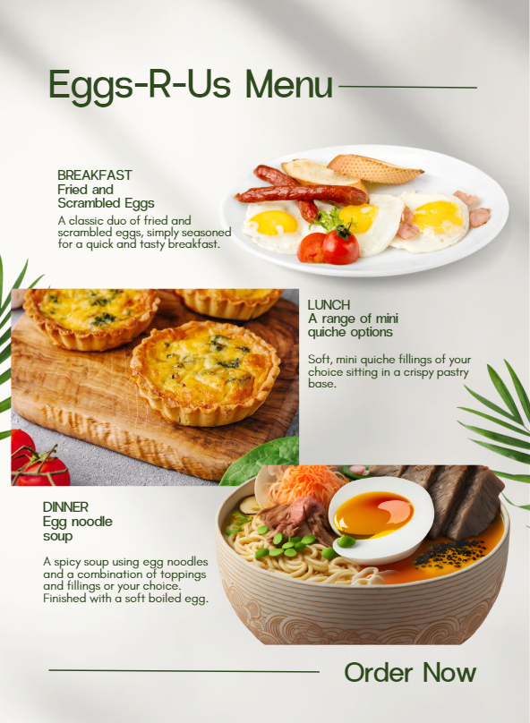
You now get to choose your final egg recipe from your menu design for our egg festival week.
Complete a food order for your teacher.
Before your practical lesson, on your individual recipe you will need to complete the following:
- Identify all safety considerations.
- Identify hygiene concerns and how you will overcome them.
- List the equipment you will need.
- Complete an action plan to show your teacher to ensure you will complete the practical in the given timeframe.
Complete a PMI of your egg café menu design.
Table 24 – PMI egg café
Plus | Minus | Interesting

Appendix

Appendix 1 – practical activity 1
Discussion or workbook questions
- Why is it important to handle eggs carefully at each step, from collection to storage? What risks are involved if we don’t follow proper hygiene practices?
This question encourages students to think critically about the potential hazards, like bacterial contamination, and how proper handling reduces these risks.
- How do the storage and handling requirements for eggs compare to other types of food? What similarities or differences can you identify?
This helps students connect their learning about egg handling to broader food safety practices, encouraging them to apply their knowledge to other foods.

Appendix 2 – practical activity 2
Sample diagrams
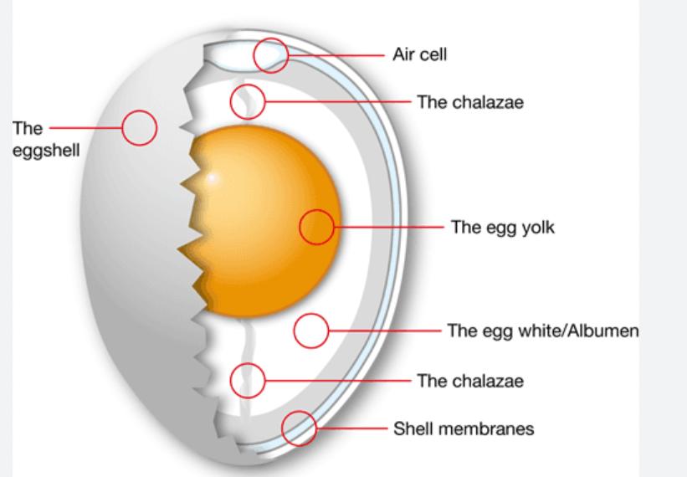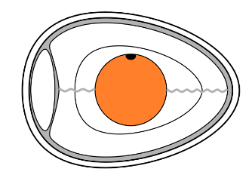
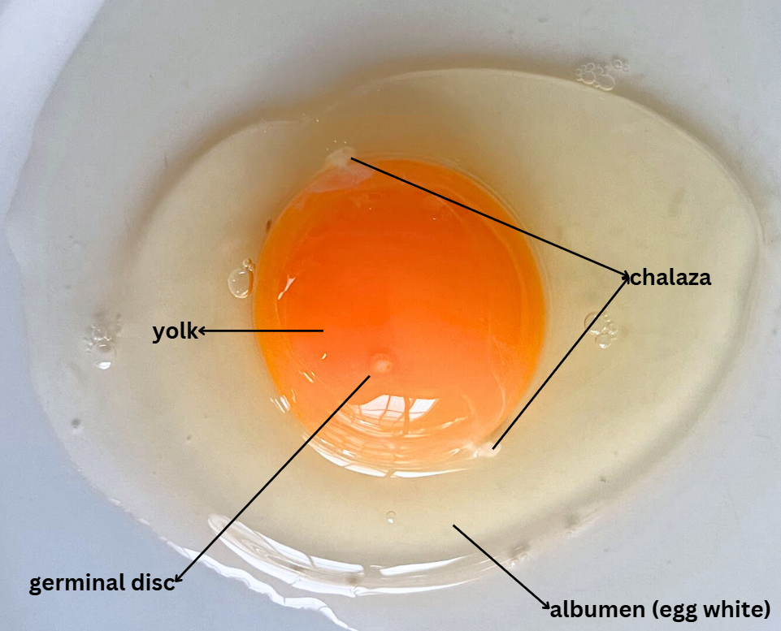

Appendix 3 – birds and their eggs answers
Bird | Egg
Goose  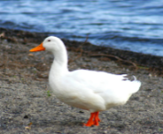 | Goose egg  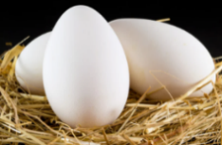
Duck  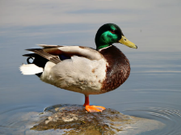 | Duck egg  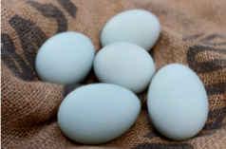
Chicken  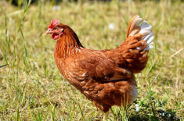 | Chicken egg  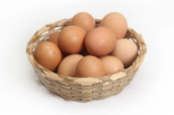
Quail   | Quail egg  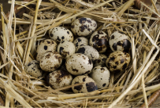
Turkey  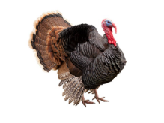 | Turkey egg  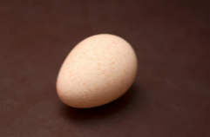
Emu  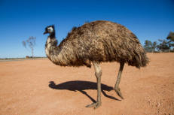 | Emu egg  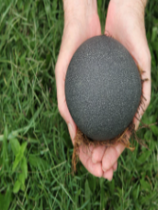

Appendix 4 – feed lab cards (practical activity 5)
Feed lab cards
Corn  Nutritional content  - Carbohydrates: high  - Protein: low (7%)  - Calcium: none  Description  Corn is a great source of energy for hens. It is a high-carbohydrate ingredient but lacks protein and calcium, so it needs to be balanced with other nutrient-rich ingredients. | Soybean meal  Nutritional content  - Protein: high (44%)  - Fats: low  - Calcium: none  Description  Soybean meal is an excellent source of protein, essential for egg production and muscle health. It should be used in combination with carbohydrate sources like corn.
Limestone  Nutritional content  - Calcium: very high (36%)  - Protein: none  - Carbohydrates: none  Description  Limestone is crucial for strong eggshells, providing high levels of calcium. It’s essential to include this for egg-laying hens, but it should be balanced with protein and energy sources. | Sunflower seeds  Nutritional content  - Fats: high (45%)  - Protein: moderate (15%)  - Calcium: none  Description  Sunflower seeds provide healthy fats and a moderate amount of protein, making them great for energy and maintaining the hens' metabolism. However, they lack calcium.
Fish meal  Nutritional content  - Protein: very high (65%)  - Vitamins: high (A, D)  - Calcium: moderate  Description  Fish meal is a high-protein ingredient that also provides vitamins A and D, helping to support overall health and egg production. It can be expensive, so use it sparingly in your mix. | Alfalfa  Nutritional content  - Fibre: high  - Vitamins: high (A, E, K)  - Protein: moderate (17%)  Description  Alfalfa is rich in fibre and vitamins, supporting digestion and general health. It also contains moderate protein, which is helpful for hens during egg production.
Molasses  Nutritional content  - Carbohydrates: very high (sugars)  - Protein: none  - Calcium: none  Description  Molasses adds sweetness and energy to the feed, making it more palatable. However, it lacks protein and calcium, so it should be used in small amounts. | Bone meal  Nutritional content  - Calcium: very high (32%)  - Phosphorus: high  - Protein: none  Description  Bone meal is a great source of calcium and phosphorus, which are essential for eggshell strength. However, it needs to be balanced with protein and energy-rich ingredients.
Wheat  Nutritional content  - Carbohydrates: high  - Protein: moderate (12%)  - Calcium: low  Description  Wheat provides a good balance of energy and protein for hens, but it lacks calcium. It works well when combined with calcium-rich and high-protein ingredients. | Oats  Nutritional content  - Carbohydrates: high  - Protein: moderate (13%)  - Calcium: low  Description  Oats are a good source of energy and provide some protein. They help with digestion but need to be combined with higher calcium and protein sources for laying hens.

References
This resource contains NSW Curriculum and syllabus content. The NSW Curriculum is developed by the NSW Education Standards Authority. This content is prepared by NESA for and on behalf of the Crown in right of the State of New South Wales. The material is protected by Crown copyright.
Please refer to the NESA Copyright Disclaimer for more information https://educationstandards.nsw.edu.au/wps/portal/nesa/mini-footer/copyright.
NESA holds the only official and up-to-date versions of the NSW Curriculum and syllabus documents. Please visit the NSW Education Standards Authority (NESA) website https://educationstandards.nsw.edu.au/ and the NSW Curriculum website https://curriculum.nsw.edu.au.
Technology 7-–8 Syllabus © NSW Education Standards Authority (NESA) for and on behalf of the Crown in right of the State of New South Wales, 2023.
ABC (Australian Broadcasting Corporation) (2 August 2023) ‘Future Farmers: Australian Agriculture – Farming eggs in Australia’ [video], ABC Education, ABC website, accessed 20 January 2025.
ASCIA (Australasian Society of Clinical Immunology and Allergy (2023) Dietary Guide – Egg Allergy [PDF 141 KB], ASCIA, accessed 5 May 2025.
Australian Eggs (14 August 2018) ‘Barn Farming System’ [video], Australian Eggs, Vimeo, accessed 20 January 2025.
——(14 August 2018) ‘Caged Farming System’ [video], Australian Eggs, Vimeo, accessed 20 January 2025.
——(14 August 2018) ‘Free Range Farming System’ [video], Australian Eggs, Vimeo, accessed 20 January 2025.
——(6 September 2018) ‘Get cracking Australia! Families’ [video], Australian Eggs, YouTube, accessed 20 January 2025.
——(22 October 2019) ‘JourneyV1O_Final_LowerAudioMix (1)’ [video], Australian Eggs, Vimeo, accessed 20 January 2025.
——(13 April 2022) ‘Egg Industry Traceability -Josh's Rainbow Eggs Case Study’ [video], Australian Eggs, YouTube, accessed 20 January 2025.
——(8 February 2023) ‘Australian egg industry sustainability’ [video], Australian Eggs, YouTube, accessed 20 January 2025.
Australian Eggs Limited (2002–2025) About Egg Farming, Australian Eggs website, accessed 20 January 2025.
——(2002–2025) Australia's Egg Industry Overview, Australian Eggs website, accessed 20 January 2025.
——(2002–2025) Egg Types & Labels, Australian Eggs website, accessed 20 January 2025.
Baker Bettie (26 May 2018) ‘THE FUNCTION OF EGGS IN BAKING | whole eggs, egg whites, egg yolks’ [video], Baker Bettie, YouTube, accessed 20 January 2025.
Commonwealth of Australia (2017) National Food Waste Strategy: Halving Australia's Food Waste by 2030 [PDF 4.5 MB], Australian Government, accessed 20 January 2025.
Dunford M (2023) Industry insights – Poultry Supporting document: NSW DPI Schools Program [PDF 2.5 MB], Department of Primary Industries, accessed 28 January 2025.
Egg Farmers of Australia (2020) How the NSW egg industry was hatched [PDF 995 KB], Egg Farmers Australia, accessed 20 January 2025.
Food Innovation Australia Limited (FIAL) (2019) A Roadmap for reducing Australia's food waste by half by 2030 [PDF 593 KB], report to Australian Government, Food Innovation Australia Limited, accessed 20 January 2025.
Food Standards Australia New Zealand (n.d.) Food labels: What do they mean? [PDF 725 KB], accessed 20 January 2025.
Global Footprint Network (n.d.) Ecological Footprint Calculator, Global Footprint Network website, accessed 20 January 2025.
Hickey A (27 May 2023) ‘18 Varieties of Eggs, Explained’, Tasting Table, accessed 20 January 2025.
MultiVu (21 April 2026) ‘Life of A Strawberry’ [video], MultiVu, YouTube, accessed 20 January 2025.
NSW Department of Primary Industries and Regional Development) (n.d.) Egg production systems in Australia, New South Wales Government website, accessed 20 January 2025.
NSW Environment Protection Authority (1 June 2022) ‘For the Love of Food shop to a list and plan your meals’ [video], NSW Environment Protection Authority, YouTube, accessed 20 January 2025.
——(4 May 2022) ‘For the Love of Food savour every slice’ [video], NSW Environment Protection Authority, YouTube, accessed 20 January 2025.
——(6 June 2022) ‘For the Love of Food eat that oddly shaped apple’ [video], NSW Environment Protection Authority, YouTube, accessed 20 January 2025.
——(24 October 2024) FOGO information for households, EPA website, accessed 20 January 2025.
NSW Food Authority (2025) Eggs, NSW Government Food Authority website, accessed 2 May 2025.
President and Fellows of Harvard College (2011) What Makes You Say That? (Adapted) [PDF 168 KB], Project Zero, accessed 21 January 2025.
RSPCA Australia (2025) Enforcing the law, RSPCA Australia website, accessed 20 January 2025.
——(2025) Layer Hens, RSPCA Australia website, accessed 20 January 2025.
Safca A (12 April 2023) ‘Dyeing eggs take my family back to an Orthodox Easter in Romania’, SBS Food, accessed 20 January 2025.
State of New South Wales (Department of Education) (2024) Fowls – environment, NSW Department of Education website, accessed 10 April 2025.

© State of New South Wales (Department of Education), 2025
The copyright material published in this resource is subject to the Copyright Act 1968 (Cth) and is owned by the NSW Department of Education or, where indicated, by a party other than the NSW Department of Education (third-party material).
Copyright material available in this resource and owned by the NSW Department of Education is licensed under a Creative Commons Attribution 4.0 International (CC BY 4.0) license.

This license allows you to share and adapt the material for any purpose, even commercially.
Attribution should be given to © State of New South Wales (Department of Education), 2025.
Material in this resource not available under a Creative Commons license:
- the NSW Department of Education logo, other logos and trademark-protected material
- material owned by a third party that has been reproduced with permission. You will need to obtain permission from the third party to reuse its material.
Links to third-party material and websites
Please note that the provided (reading/viewing material/list/links/texts) are a suggestion only and implies no endorsement, by the New South Wales Department of Education, of any author, publisher, or book title. School principals and teachers are best placed to assess the suitability of resources that would complement the curriculum and reflect the needs and interests of their students.
If you use the links provided in this document to access a third-party's website, you acknowledge that the terms of use, including licence terms set out on the third-party's website apply to the use which may be made of the materials on that third-party website or where permitted by the Copyright Act 1968 (Cth). The department accepts no responsibility for content on third-party websites.

