Technology 7–8 – Food and agricultural practices – recipe booklet
Scrambled – 20-week unit

Contents
Recipe booklet 4
Kitchen safety 5
Safety and hygiene in the kitchen is everyone’s responsibility! 6
Food hygiene 6
Personal hygiene 8
Hand washing – an experiment 10
Washing-up procedure 12
Kitchen equipment 14
Kitchen equipment – solution 15
Equipment find a word 16
Equipment find a word – solution 17
Knife use and safety 18
Methods of cooking 20
How to follow a recipe 21
Label the parts of a recipe 22
Boiled egg with toast fingers 23
Boiled egg with toast fingers check 24
Evaluate – boiled egg with toast fingers 25
Egg in a hole 26
Egg in a hole check 27
Measuring in the kitchen 31
Folded eggs 33
Folded eggs check 34
Evaluate – folded eggs 35
Cloud eggs 36
Cloud eggs check – aeration/leavening ‘egg-speriment’ 37
Evaluate – cloud eggs 39
Pikelets with jam and cream 40
Pikelet check – egg substitutes 41
Evaluate – pikelets 42
Raspberry muffins 43
Evaluate – raspberry muffins 44
French toast with berries and honey 45
French toast check 46
Evaluate – French toast with berries and honey 47
Cheeseburger 48
Cheeseburger check 50
Cheeseburger check – binding ‘egg-speriment’ 51
Evaluate – cheeseburger 53
Bread case quiches 54
Bread case quiches check – egg wash ‘egg-speriment’ 56
Evaluate – bread case quiches 58
Lacy egg wraps with berries and cream 59
Evaluate – lacy egg wraps with berries and cream 60
Breakfast egg wrap 61
Breakfast egg wrap check – emulsification ‘egg-speriment’ 62
Evaluate – breakfast egg wrap 65
The nude food trend 66
Fried rice with egg ribbons 67
Fried rice with egg ribbons check 68
Evaluate – fried rice with egg ribbons 70
Shakshuka 71
Shakshuka check 73
Evaluate – shakshuka 74
Shakshuka – a long history 75
Spanish tortilla 76
Spanish tortilla check 77
Evaluate – Spanish tortilla 79
Egg café – final recipe 80
Egg café – final recipe, continued 81
Egg café – final recipe, continued 82
Evaluate – egg café, final recipe 83
References 84

Recipe booklet
Note: this resource has been designed to facilitate the ready conversion into a student recipe booklet by removing the answers within the response windows. Teacher notes can be deleted before distributing to students.
This resource is intended for you to adapt as suited to your school and your available resources. Additional recipes, learning resources and activities have been included in this resource allowing for school choice.
School leaders and teachers should consult with students and their parents or carers regarding how to support their religious and/or dietary requirements. Alternate food options should be provided for students to meet learning outcomes.
Refer to Equipment Safety in Schools, Animals in Schools, and Chemical Safety in Schools for current information on safety and safe working practices in Technology 7–8.

Kitchen safety
Working in the kitchen is fun, but it is important that we know how to be safe. Here are some important rules that we should follow when working in the kitchen.
Note: kitchen safety rules have been provided. Rules can be removed, and class discussion can be had to create a class set of rules. To reduce cognitive load, rules can be provided.
- Make sure you have permission before you start cooking.
- Ensure that you have washed your hands thoroughly before you handle any food or equipment.
- Make sure you have the correct personal protective equipment (PPE), including apron and correct footwear.
- Be very cautious of knives in the kitchen.
- Keep preparation areas clean and collect all ingredients before you start to cook.
- Always use oven gloves when removing hot items from the oven.
- Make sure that saucepan handles are turned in so they are not hanging over the edge of the stovetop.
- Secure your chopping board using a damp cloth.
- Clean up spills straight away to prevent accidents from occurring.
- Do not place electrical equipment near water.
- Be sure to use hot soapy water when washing-up and use a clean tea towel to dry dishes.
- Do not place knives into a sink filled with water.

Safety and hygiene in the kitchen is everyone’s responsibility!
Note: the definitions have been included below. Provide the document with answers removed for students to complete the activity.
Define the term safety in the space below.
- The state of being free from harm or danger.

Food hygiene
Test yourself! Answer the following questions by circling the correct response.
Note: the activity below contains the answers in bold. Remove bolding before printing.
- What is the most common type of food poisoning?
- E.Coli
- Salmonella
- Campylobacter
- Listeria
- What is the recommended temperature for a fridge?
- 1-10°C
- Below 12°C
- Below 5°C
- Below 15°C
- Where in the fridge would you store uncooked bacon?
- bottom shelf
- middle shelf
- top shelf
- in the door
- Bacteria are too small to see with the naked eye.
- True
- False
- What does bacteria need to assist in its growth?
- Warmth
- Food
- Time
- All of the above
- You can reheat leftovers as many times as you want.
- True
- False
- If something is cooked on the outside, it will be cooked inside.
- True
- False
- You only wash your hands when they look dirty.
- True
- False
Define the term hygiene.
Sample answer:
The practice of keeping yourself and your surroundings clean to prevent illness or the spread of disease.

Personal hygiene
Personal hygiene refers to the cleanliness of the person handling food.
In the picture below identify areas where the chef is demonstrating excellent personal hygiene.
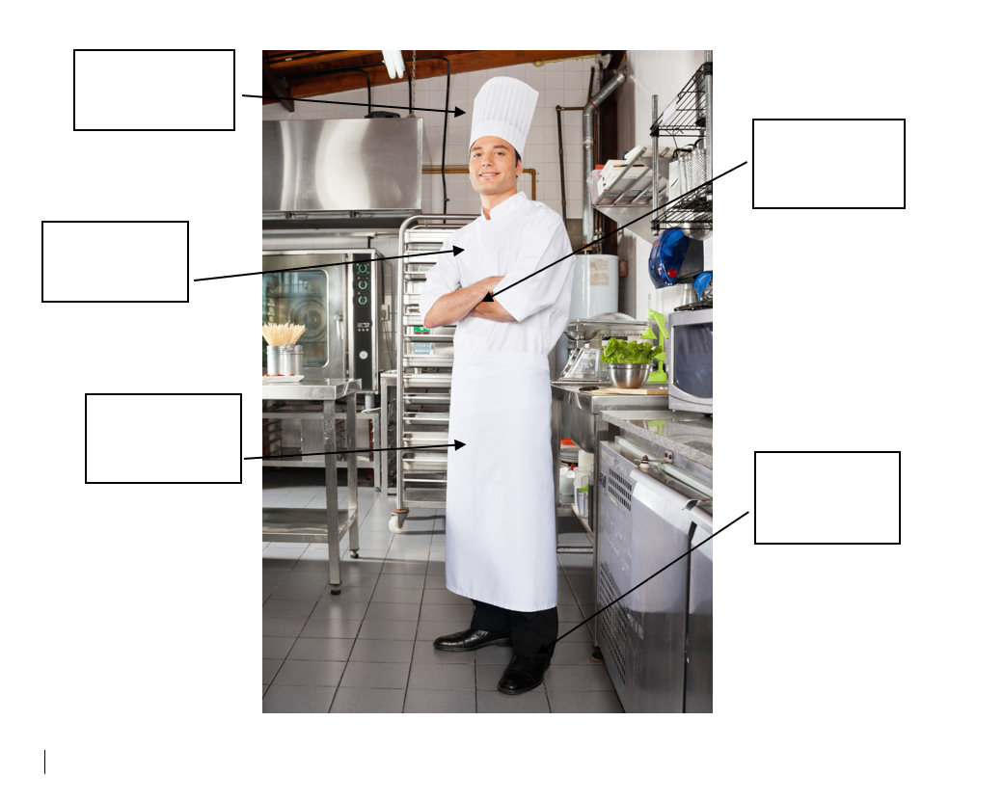
Access the video resource Four Golden Rules of food safety (1:45)
After watching the video, complete the table below.
Note: sample answers have been provided
Four golden rules of food safety
keep it cold.
keep it clean.
keep it hot.
check the label.

Hand washing – an experiment
Teacher can provide a demonstration or students can also participate. Discussion should be had around the observations and then conclusion as to how soap or dishwashing detergent aids in health and safety.
How does soap work? Why does soap help to stop you from getting sick? Here is a simple experiment to demonstrate how soap or dishwashing detergent can help keep you healthy.
Equipment required
- 1 white dinner plate
- 1 small dish or bowl
- Water
- Black pepper
- Dishwashing detergent
Method
- Pour 1 teaspoon of dishwashing detergent into the small bowl.
- Pour a small amount of water onto the white plate, enough to cover the surface. Cover the surface of the water with pepper.
- Dip the tip of your finger onto the surface of the water and pepper mix. What happens? (Observation 1).
- Now dip the tip of your finger into the detergent and then onto the water and pepper mix. What happens now? (Observation 2).
- Why does this happen? (Conclusion)
- Write your responses for steps 3 to 5 in the spaces below.

Observation 1 (Step 3)
Observation 2 (Step 4)
Conclusion (Step 5)

Washing-up procedure
- Pile the dirty dishes in the sink and fill with cold water.
- Add some detergent and rinse them around.
- Place the dishes and cutlery on the sink to dry.
Is this how you wash up?
After your first demonstration lesson, your teacher will guide you on the most hygienic way to wash up. Remember to always use a clean, dry tea towel.
Reorder the washing-up steps below to create the correct flow for washing-up in the kitchen.
Note: A sample answer has been provided. Remove right-hand column answers before printing.
Place cutlery in the hot water to soak. |  | 1 | Fill the sink with hot, soapy water.
Wash the pots and pans. |  | 2 | Use a dish brush, sponge and gloves.
Fill the sink with hot, soapy water. |  | 3 | Glasses and cups get washed first.
Wipe down all benches and sink top. |  | 4 | Place cutlery in the hot water to soak.
Wash the plates. |  | 5 | Wash the plates.
Glasses and cups get washed first. |  | 6 | Mixing bowls and containers are the next to be cleaned.
Dry all kitchen equipment with a clean, dry tea towel. |  | 7 | Remove cutlery from the sink and rinse with hot water.
Use a dish brush, sponge and gloves. |  | 8 | Wash the pots and pans.
Remove cutlery from the sink and rinse with hot water. |  | 9 | Dry all kitchen equipment with a clean, dry tea towel.
Mixing bowls and containers are the next to be cleaned. |  | 10 | Put away all kitchen equipment.
Put away all kitchen equipment. |  | 11 | Wipe down all benches and sink top.

Kitchen equipment
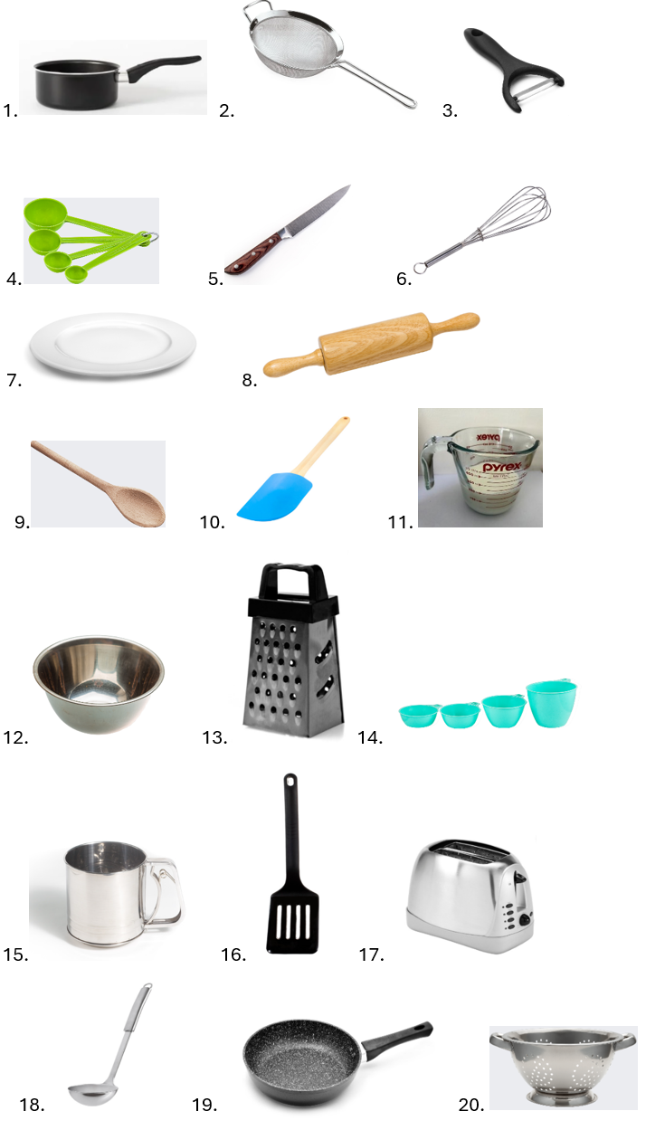
Match the picture to the word by placing the number in the empty box.
peeler
Chef’s knife
saucepan
plate
wooden spoon
colander
sifter
grater
spatula
measuring cups
frypan
ladle
whisk
measuring spoons
rolling pin
measuring jug
scraper
mixing bowl
toaster
sieve

Kitchen equipment – solution
Answers for kitchen equipment. Remove before printing.
peeler | 3
Chef’s knife | 5
saucepan | 1
plate | 7
wooden spoon | 9
colander | 20
sifter | 15
grater | 13
Spatula | 10
measuring cups | 14
frypan | 19
ladle | 18
whisk | 6
measuring spoons | 4
rolling pin | 8
measuring jug | 11
scraper | 16
mixing bowl | 12
toaster | 17
sieve | 2

Equipment find a word
Find the pieces of equipment listed on the previous page in the word search puzzle below.
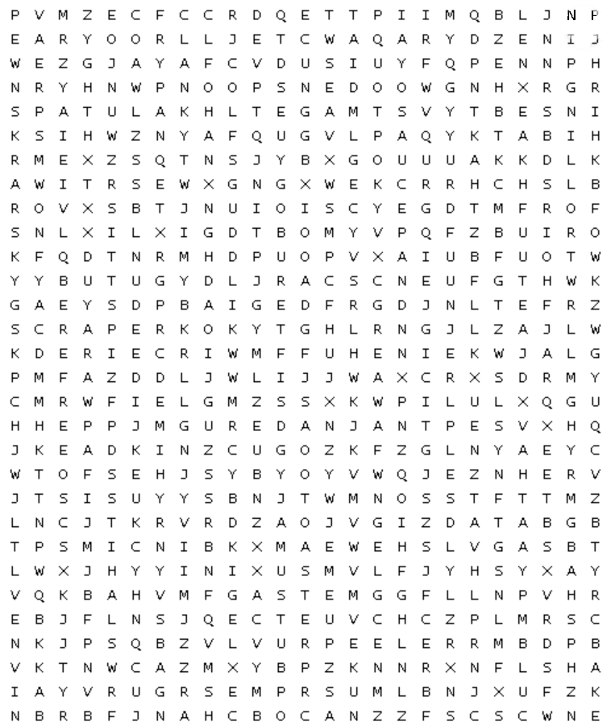

Equipment find a word – solution
Solution provided for teacher use. Remove before printing booklet.
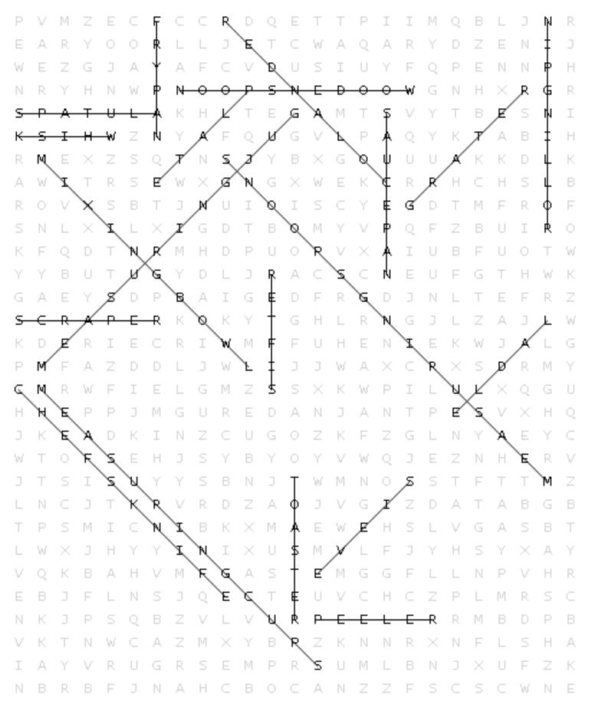

Knife use and safety
Access the video resource Jamie Oliver on knife skills - 30-Minute Meals (5:02).
There are different types of knives available to use in a kitchen. Knives have a specific purpose.
Teacher demonstration and introduction of the Chef’s knife to students with information and detail provided on the parts of the knife. Teacher demonstration can be provided for students on cutting and slicing, with finger and hand placement being demonstrated as most important.
Label the parts of the knife using the given terms.
tip | spine | handle | butt | blade | heel

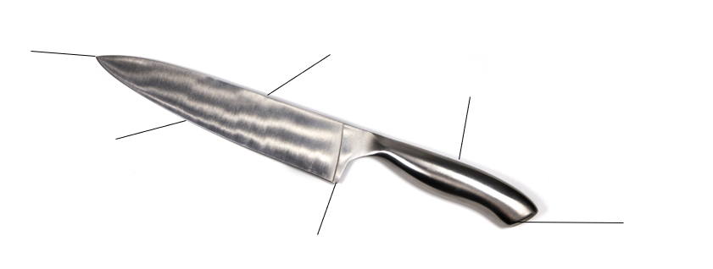
Note: the table below has the knife description, usage and examples included. Provide the table with these columns blank for students to complete the activity after a demonstration from the teacher. Alternatively adapt the activity to include some of the information in the table to support students with disability and reduce cognitive load.
Table 1 – 3 types of knives used in a kitchen, with a description, use and food examples for each
Type of knife | Blade description | Used for | Examples
Chef’s knife  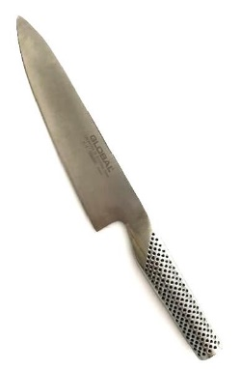 | A wider, longer blade | General chopping and slicing of most foods | Dicing an onion, chopping carrots, slicing meat
paring knife  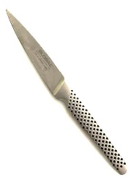 | A narrow short blade | Making smaller detailed cuts or cutting smaller foods | Hulling strawberries, cutting wedges of lime, peeling kiwi fruit
serrated knife  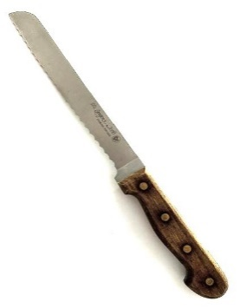 | Tooth-like, jagged blade | Cutting foods with a firm exterior but being soft and delicate inside | Slicing a loaf of bread, slicing a tomato

Methods of cooking
Teacher demonstration should be provided on how to use cookers found in the school kitchens.
Using a cooker safely helps to avoid injury. It is important to understand how to use the cooker properly. Cookers used in schools could be either gas or electric.
When removing food from the cooker, it is important to remember to always use oven mitts to avoid burns. When opening the oven door, be sure to stand to the side and not directly in front to avoid burns. Avoid carrying hot items around the kitchen and use a cooling rack to set down hot items.
Label the 2 parts of the cooker in the space provided.
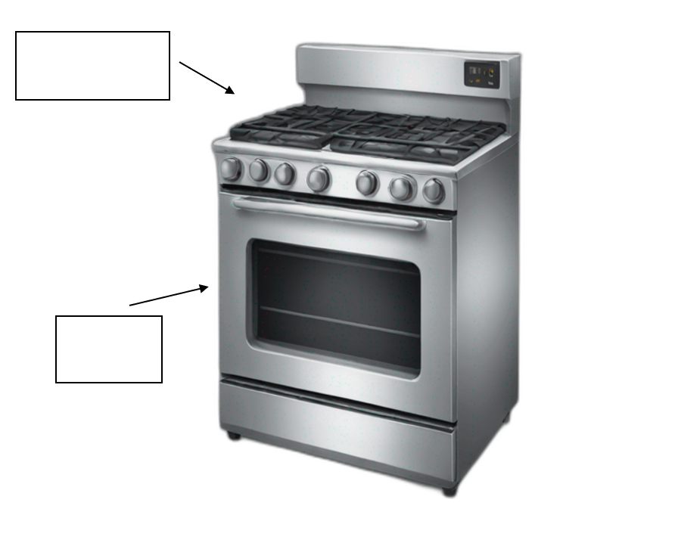
Answer the following statements to show how the food item might be cooked using the cooker.
Question | Answer
Peas are boiled on the …
Cakes will be baked in the …
Eggs will be scrambled on the …
Fish will be poached on the …
Chips will be fried on the …

How to follow a recipe
Reading a recipe and following the steps is the key to making a successful dish in the kitchen. Here are some simple steps when learning to cook. Use the word bank below to complete the sentences.
Read, correct, Follow, equipment, time, Prepare, ingredients
- ________ the recipe before you start so that you understand what will be required.
- Have the right ________________ to create the dish.
- Make sure that you have the ________________ in the ______________ amounts.
- Plan your ____________ and make sure that you have enough.
- _____________ before you start. Make sure that you have ingredients and equipment ready to go.
- _____________ the steps of the recipe.

Label the parts of a recipe
Answers have been provided. Remove before printing.
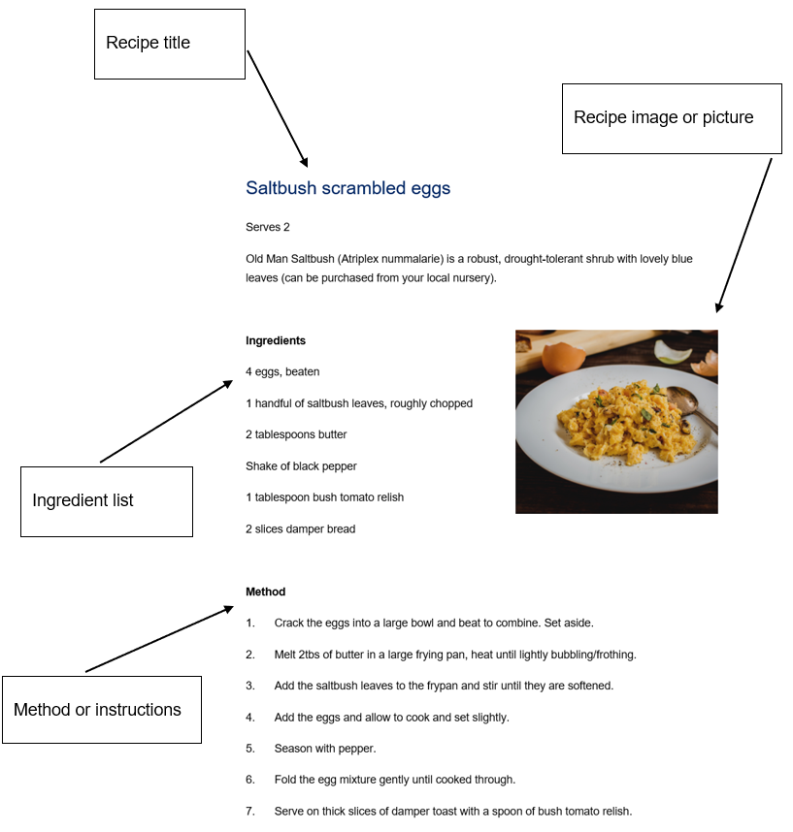

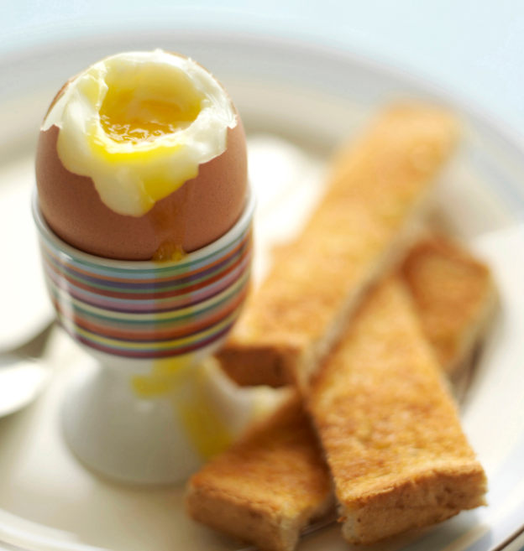
Boiled egg with toast fingers
Serves 1
Ingredients
1 large egg
1 wholemeal slice bread
1 teaspoon butter or margarine
Salt and pepper
Method
- Half fill a small saucepan with water, and place on the stovetop on high heat. Once the water is boiling, gently lower the egg into the boiling water using a slotted spoon. Set a timer for 4 minutes, this will give you an egg with a runny yolk which is perfect for dipping toast soldiers. If you want the egg to be slightly firmer, boil the egg for 5 minutes.
- When the timer has sounded, carefully lift the egg out of the boiling water using the slotted spoon. Place the egg into an egg cup.
- Place bread into the toaster and toast. Spread toast with butter or margarine when toasted, and then cut into long strips to dip into the egg.
- Once the egg has cooled slightly, place onto a chopping board and hold the egg on its side, using a butter knife cut the top edge off the egg, lifting it up quickly to not lose the contents.
- Serve the boiled egg warm with salt and pepper and toast fingers.
Method of cooking:

Boiled egg with toast fingers check
The equipment you will need to complete this recipe is listed below. Finish the table by filling in the equipment location within the school kitchen.
Table 2 – a list of equipment and their location within the school kitchen
Equipment | Location
tray
stainless steel plate
white cutting board
butter knife
small saucepan
measuring spoons
slotted spoon
egg cup
Chef’s knife
dinner plate

Evaluate – boiled egg with toast fingers
Reflect on your previous practical lesson by completing the PMI chart and the sensory description below. In the PMI list 3 things that went well in the plus section, 3 things that need some improving in the minus section and then 3 things you found interesting about the practical. When completing the sensory description, write one sentence for each of the 5 senses regarding what you have prepared. Remember – taste, smell, sight, touch and sound.
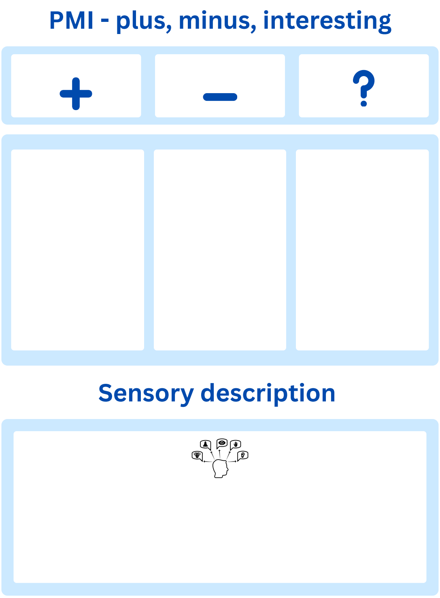

Egg in a hole
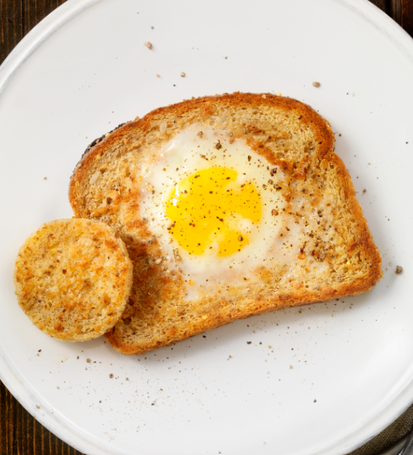
Serves 1
Ingredients
1 large egg
$\frac{1}{4}$ cup smooth ricotta
$\frac{1}{2}$ teaspoon parsley
Pepper
1 slice wholemeal bread
Spray oil
Method
- Using a chopping board and an 8 cm scone cutter or cookie cutter, cut a hole in the centre of the piece of bread.
- Heat a medium-sized frypan over medium to high heat and spray the pan with a little cooking spray.
- Place the bread slice onto the heated pan and crack the egg into the centre of the piece of bread. After 2 minutes flip the bread and egg using a spatula and cook for another minute. Your egg in the hole should be golden brown and crispy.
- Remove your toast and egg from the pan and place onto your serving plate. Season with pepper, sprinkle parsley and top with smooth ricotta.
- Serve hot.
Method of cooking:

Egg in a hole check
The equipment you will need to complete this recipe is listed below. Finish the table by filling in the equipment location within the school kitchen.
Table 3 – a list of equipment and their location within the school kitchen
Equipment | Location
tray
stainless steel plate
white cutting board
scone or cookie cutter
frypan
spatula
serving plate
measuring spoons
measuring cups

Coagulation ‘egg-speriment’
Question
What happens to an egg when heat is applied?
Materials/ingredients
Frypan
2 x whole egg
1 x egg white
1 x egg yolk
Timer
Temperature gauge/thermometer
Oil if not using a non-stick pan
Method
- Heat frypan to medium heat.
- Add whole egg, fry and time until it is a solid, observe changes and measure temperature of egg once it has coagulated.
- Scramble the second egg and add it to heated pan. Time until it is solid, observe changes and measure temperature once it has coagulated. Allow this egg to overcook, creating a curdling effect and measure temperature.
- Add egg yolk to heated pan, fry and time until is it solid, observe changes and measure temperature once it has coagulated.
- Add egg white to heated pan, fry and time until is it a solid, observe changes and measure temperature once it has coagulated.
Table 4 – parts of an egg with table provided for time, observation and temperature for an experiment
Egg | Time | Observation | Temperature
whole egg
scrambled egg
egg yolk
egg white
Note: remove conclusion from student workbook before printing.
Conclusion
When heat is applied to egg the proteins change from a liquid state to a solid. This process is called coagulation. Egg whites coagulate quicker than egg yolks. Egg curdles at around 77 degrees Celsius.

Evaluate – egg in a hole
Reflect on your previous practical lesson by completing the PMI chart and the sensory description below. In the PMI list 3 things that went well in the plus section, 3 things that need some improving in the minus section and then 3 things you found interesting about the practical. When completing the sensory description, write one sentence for each of the 5 senses regarding what you have prepared. Remember – taste, smell, sight, touch and sound.

Measuring in the kitchen
There are multiple pieces of equipment that help us to measure ingredients in the kitchen. It is important to understand how to use the equipment and measure properly to make sure that the dishes we are creating will turn out how we want them.
Measuring cups usually come in 4 different sizes; 1 cup, $\frac{1}{2}$ cup, $\frac{1}{3}$cup and $\frac{1}{4}$ cup. They are used to measure dry ingredients like flour or sugar. They are also used to measure non-pourable ingredients like sour cream or yoghurt. When measuring it is important to overfill the cup and then scrape the excess using the back of a butter knife. | 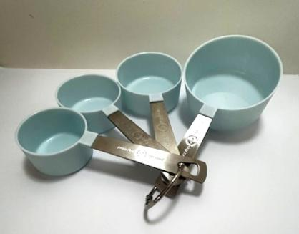
Measuring spoons usually come in 4 different sizes; 1 tablespoon, 1 teaspoon, $\frac{1}{2}$ teaspoon, $\frac{1}{4}$ teaspoon. They are used to measure smaller amounts of ingredients like salt, soy sauce, honey or herbs and spices. Make sure to level the surface of the spoon when measuring dry ingredients. | 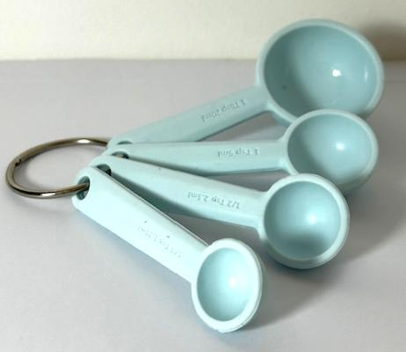
Measuring jugs are used for pourable ingredients like milk or water. Measuring jugs will have measurements on the side of the jug to show levels of where to measure. When filling a measuring jug to the correct level, the measuring jug should be level on the benchtop to ensure the correct measurement is reached. | 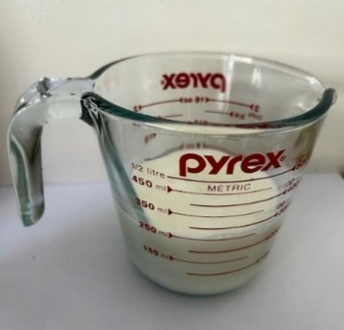
Scales are used for food when amounts are given in measurements of grams or kilograms. Food should be placed on top of the scale and weight needs to be checked as food is added. Examples could be butter or flour. | 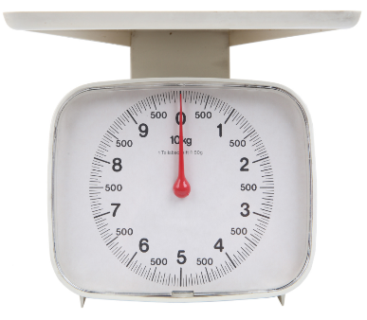

Measurement in practice
Complete the following activity to test your skills.
- $\frac{1}{3}$ cup + $\frac{1}{3}$ cup =
- $\frac{1}{2}$ cup + $\frac{1}{2}$ cup =
- $\frac{1}{2}$ cup + $\frac{1}{4}$ cup =
- 1 cup + 1 cup =
- $\frac{1}{2}$ cup + 1 cup =
- 300 grams + 150 grams =
- 90 grams + 100 grams =
Bonus question 1 – What’s another name for 1000 grams?
Bonus question 2 – I only have a 1 cup measure and a $\frac{1}{4}$ cup measure. How do I measure 1$\frac{3}{4}$cups?
Bonus question 3 – for the 2 pieces of measuring equipment below, write in the space provided the amount shown being weighed or measured.
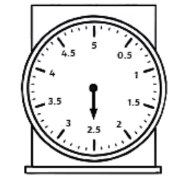 | 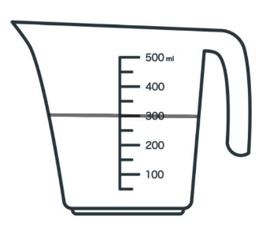
___________ kilograms | ___________ millilitres

Folded eggs
A demonstration should be provided to students on how to separate egg yolks from egg whites. You can refer students to the slide in the PowerPoint resource.
Serves 2
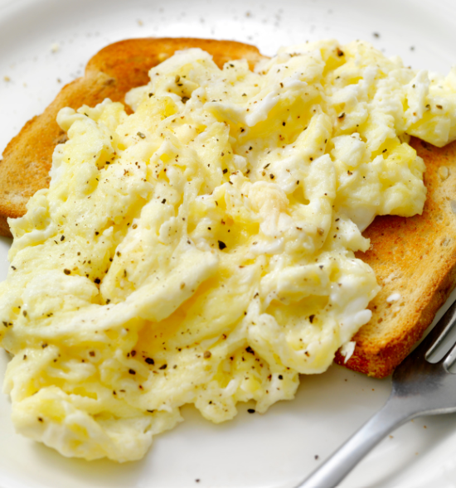
Ingredients
2 eggs
1 tablespoon cream
1 tablespoon milk
Salt and pepper
1 teaspoon butter
1 piece wholemeal bread
Method
- Using 2 small bowls, separate one of your eggs. Using the yolk and the other complete egg, whisk together with the cream, and season with salt and pepper.
- Melt the butter in a small, non-stick frypan over high heat. Swirl the butter to allow it to coat the base, and then pour in your egg mixture. Leave the egg mixture to sit for about 10 seconds to help the egg set on the bottom.
- Using a rubber or wooden spatula, drag the egg mixture from one side of the pan to the other. Wait for 5 seconds to allow the egg to set, and then tilt the pan allowing the non-cooked egg to run freely over the pan.
- Continue to push the cooked egg into the uncooked egg, tilting the pan gently each time. Rotate the egg in the pan using the spatula. You need to work quickly as the egg will be cooked within a minute. Serve your cooked eggs onto a slice of buttered toast.
Method of cooking:

Folded eggs check
The equipment you will need to complete this recipe is listed below. Finish the table by filling in the equipment location within the school kitchen.
Table 5 – a list of equipment and their location
Equipment | Location
tray
stainless steel plate
frypan
butter knife
measuring spoons
serving plate
spatula
small bowls
whisk

Evaluate – folded eggs
Reflect on your previous practical lesson by completing the PMI chart and the sensory description below. In the PMI list 3 things that went well in the plus section, 3 things that need some improving in the minus section and then 3 things you found interesting about the practical. When completing the sensory description, write one sentence for each of the 5 senses regarding what you have prepared. Remember – taste, smell, sight, touch and sound.

Cloud eggs
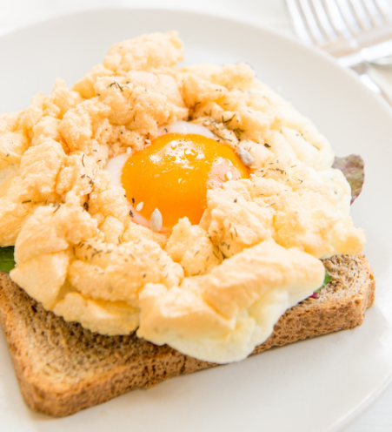
A demonstration should be provided to students on how to beat egg whites to different levels of peak using an electric mixer. Refer to experiment below.
Serves 2
Ingredients
2 eggs
Salt and pepper
1 tablespoon grated parmesan cheese
Method
- Preheat your oven to 180° Celsius. Line an oven tray with baking paper.
- Crack and separate both eggs. Place egg whites into a clean, medium-sized glass bowl. Be careful not to damage the yolks.
- Using an electric mixer, beat the egg whites until stiff peaks form.
- Gently fold the salt, pepper and parmesan into the egg whites.
- Move the whipped egg white mixture onto the tray, forming 2 cloud shapes. Use a spoon to create an indent on the centre top of the egg white clouds. Bake in the preheated oven for 5 minutes.
- Carefully remove your partially-baked clouds from the oven and place the egg yolks into the indent in the cloud. Bake for a further 3–4 minutes.
- Serve your egg cloud on a piece of hot buttered toast.
Method of cooking:

Cloud eggs check – aeration/leavening ‘egg-speriment’
Question
How does egg white change the longer it is beaten?
Materials/ingredients
Electric hand beater
3 egg whites
3 bowls
Method
- Beat egg white to a soft peak. Time this and observe the texture.
- Beat egg white to a firm peak. Time this and observe the texture.
- Beat egg white to a stiff peak. Time this and observe the texture.
- Over beat egg white. Time this and observe the texture.
Results
Table 6 – a results table for created egg white peaks, with columns for time, observation and use
Type of peak | Time | Observation | Use
no peak
soft peak
firm peak
stiff peak
over beating
Note: remove conclusion from student workbook before printing.
Conclusion
The more air that is added to the egg, the stiffer the egg white becomes. This has a range of different uses.

Evaluate – cloud eggs
Reflect on your previous practical lesson by completing the PMI chart and the sensory description below. In the PMI list 3 things that went well in the plus section, 3 things that need some improving in the minus section and then 3 things you found interesting about the practical. When completing the sensory description, write one sentence for each of the 5 senses regarding what you have prepared. Remember – taste, smell, sight, touch and sound.

Pikelets with jam and cream
Serves 2
Ingredients
1 $\frac{1}{4}$ cups plain flour
2 $\frac{1}{2}$ teaspoons baking powder
2 tablespoons white sugar
1 egg
$\frac{3}{4}$ cup milk
$\frac{1}{2}$ teaspoon vanilla extract
2 teaspoons butter
Strawberry jam and cream to serve
Method
- Whisk flour, baking powder and sugar in a bowl. Make a well in the centre, add egg, milk and vanilla extract. Whisk until the batter is almost lump-free.
- Melt butter in a non-stick frypan over medium-high heat. Spread the butter around the pan by moving the pan carefully in a circular motion.
- Place 2 tablespoons of batter into the heated frypan. Cook until bubbles appear on the surface of the pikelet, and then flip and cook on the other side, usually about 1 to 1 $\frac{1}{2}$ minutes on each side.
- Repeat with the remaining batter.
- Serve pikelets warm with strawberry jam and cream.
Method of cooking:

Pikelet check – egg substitutes
Complete a comparison of a recipe in class that uses eggs, versus the same recipe using an egg substitute and outline your observations in the table below.
Table 7 – an observation table for a comparison of pikelets made with egg or an egg substitute
Observation | Recipe with egg | Recipe with egg substitute
Pikelets | 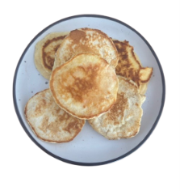 | 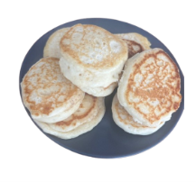
Taste
Appearance
Texture
Time taken
Cost

Evaluate – pikelets
Reflect on your previous practical lesson by completing the PMI chart and the sensory description below. In the PMI list 3 things that went well in the plus section, 3 things that need some improving in the minus section and then 3 things you found interesting about the practical. When completing the sensory description, write one sentence for each of the 5 senses regarding what you have prepared. Remember – taste, smell, sight, touch and sound.

Raspberry muffins
Serves 2
Ingredients
2 $\frac{1}{4}$ cups self-raising flour
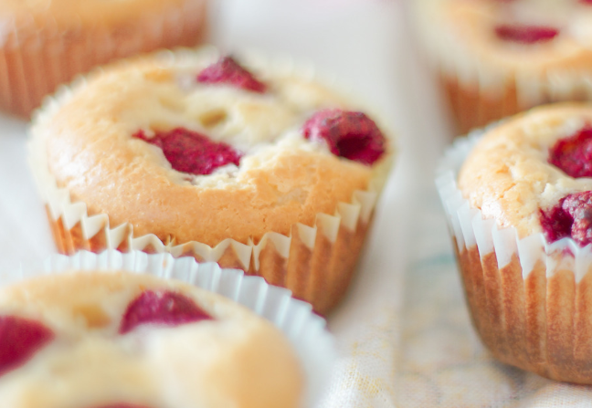
1 cup caster sugar
Pinch salt
100 grams butter, melted
1 cup buttermilk
2 eggs, lightly beaten
1 teaspoon vanilla extract
200 grams frozen or fresh raspberries
Icing sugar to dust
Method
- Preheat oven to 180° Celsius.
- Line a 12-hole muffin tray with paper cases.
- Sift flour, sugar and salt into a large bowl. Whisk melted butter, buttermilk, egg and vanilla in a bowl and stir into the dry ingredients. Do not over mix, the mixture should be thick and lumpy. Add 3 quarters of the berries to the mix and stir through gently. Spoon mixture into the lined muffins tray, and then divide the remaining berries equally among the uncooked muffins.
- Bake muffins for 25 to 30 minutes, or until a skewer inserted into the centre of the muffin comes out clean.
- Just before serving dust with icing sugar.
Method of cooking:

Evaluate – raspberry muffins
Reflect on your previous practical lesson by completing the PMI chart and the sensory description below. In the PMI list 3 things that went well in the plus section, 3 things that need some improving in the minus section and then 3 things you found interesting about the practical. When completing the sensory description, write one sentence for each of the 5 senses regarding what you have prepared. Remember – taste, smell, sight, touch and sound.

French toast with berries and honey
Serves 2
Ingredients
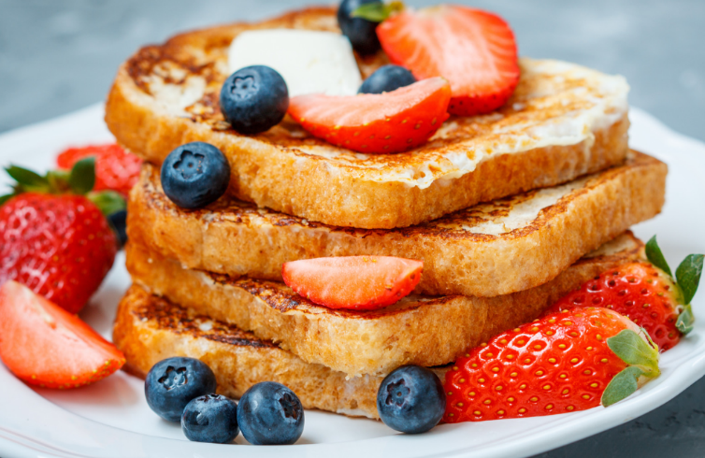
2 eggs
1 teaspoon caster sugar
Pinch each of salt and cinnamon
$\frac{1}{2}$ teaspoon vanilla extract
$\frac{1}{2}$ cup milk
4 slices white bread, can be stale bread
Olive oil spray
$\frac{1}{2}$ cup berries or a berry mix, could be fresh or frozen
2 tablespoons honey
Method
- Whisk together the eggs, caster sugar, salt, cinnamon, vanilla and milk in a shallow dish or mixing bowl. Heat a non-stick frypan over medium to high heat, then spray with olive oil spray.
- Dip the pieces of bread into the egg mixture, coating both sides well. Allow the mixture to soak in a little, but not so much that the bread falls apart.
- Lower the soaked bread into the frypan using a spatula and fry for 2 minutes on both sides or until golden brown. If your pan is large enough cook 2 pieces of bread at the same time.
- Transfer the cooked bread to a plate and keep warm while cooking the remaining bread. Divide the toast between 2 serving plates. Drizzle the honey on the toast and top with berries.
Method of cooking:

French toast check
Circle the verbs that are written in the method for the French toast with berries and honey. Use a device to research the meaning of each word. Hint: there are at least 10 verbs contained in the method.
Note: the table has the completed answers in both columns. Provide a blank table for students to complete. To reduce cognitive load students with disability may complete this activity as a matching activity. See PowerPoint.
Table 8 – kitchen verbs and their meaning
Verb | Meaning
whisk | To move food with quick, light, sweeping motions.
heat | To increase temperature of an object.
spray | To project a liquid in a dispersive manner.
dip | To lower into a liquid.
coating | To add an outer layer.
allow | To permit to.
lower | To let descend into something.
fry | To cook in hot fat or oil.
transfer | To move from one place to another.
divide | To split or separate into 2 or more parts.
drizzle | To add a thin stream of a liquid ingredient, trickled over the food.

Evaluate – French toast with berries and honey
Reflect on your previous practical lesson by completing the PMI chart and the sensory description below. In the PMI list 3 things that went well in the plus section, 3 things that need some improving in the minus section and then 3 things you found interesting about the practical. When completing the sensory description, write one sentence for each of the 5 senses regarding what you have prepared. Remember – taste, smell, sight, touch and sound.

Cheeseburger
Serves 2
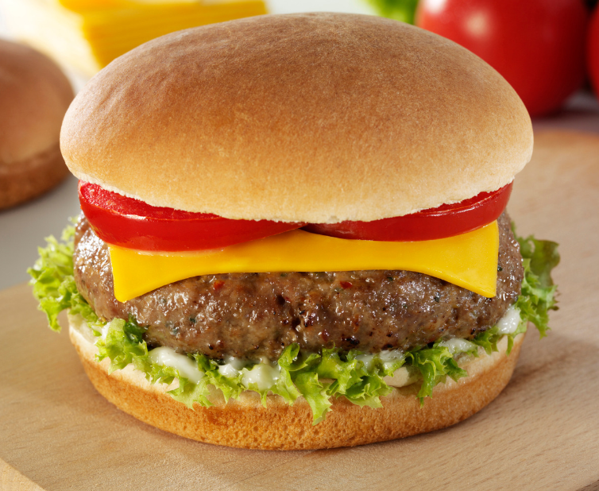
Ingredients
200 grams lean beef mince
Salt and pepper
$\frac{1}{4}$ Spanish onion, chopped super fine
$\frac{1}{4}$ cup breadcrumbs
1 egg
2 hamburger buns
2 slices cheese
1 large tomato, washed and sliced
2 lettuce leaves, washed
Olive oil spray
1 tablespoon butter or margarine
Tomato or BBQ sauce
Method
- In a medium bowl combine mince, salt and pepper, finely chopped onion, breadcrumbs and egg. Combine well, and shape into 2 hamburger patties. Place the patties onto a plate and refrigerate for 5–10 minutes.
- Prepare salad ingredients. Slice the burger buns in half.
- Turn on the grill to a medium heat and heat a frypan on the stove on a medium to high heat. Spray the frypan with olive oil.
- Cook patties for 2–3 minutes on each side, ensuring the patty is cooked all the way through. When the patties are almost cooked, place the hamburger buns, already split, into the grill and toast. When the patties are cooked, remove from the frypan and keep warm.
- When the burger buns are golden and toasted, remove from the grill and spread both sides with butter or margarine.
- Assemble the cheeseburgers using the patty, cheese, salad ingredients and sauce.
- Serve hot.
Method of cooking:

Cheeseburger check
List the equipment you will need to complete this recipe and state the purpose or function of this piece of equipment in the space provided.
Note: the table has the completed answers in columns 1 and 2. Provide a blank table for students to complete the activity.
Table 9 – equipment and their purpose or function
Equipment | Purpose or function
tray | To carry ingredients or equipment back to the working space.
stainless steel plate | To carry individual ingredients back to the working space.
measuring scales | Used to measure ingredients when given in grams or kilograms.
measuring cups | Used to measure the dry ingredients.
measuring spoons | Used to measure smaller amounts of ingredients in a recipe.
medium bowl | A bowl used to combine ingredients.
wooden spoon | Used to help mix and combine the ingredients.
serving plate | Used to present the meal.
chopping board | Used for cutting the salad ingredients on.
Chef’s knife | To cut ingredients.
frypan | Used to cook the burger patties in on the stovetop.
spatula | Used for turning the burger patties when cooking in the frypan.
butter knife | Used for spreading the butter or margarine on the burger buns.

Cheeseburger check – binding ‘egg-speriment’
This can be completed as part of the demonstration lesson.
Question
What function does an egg have in burger patties?
Materials/ingredients
1 x ingredients for hamburger patties from Cheeseburger recipe
Method
- Follow the recipe instructions to make the cheeseburger patties with the following adjustments.
- Divide the ground meat into 2 portions:
- one portion will have half an egg added (test group)
- the other portion will not have an egg (control group).
- Mix each portion well.
- Shape both portions into patties.
- Cook the patties/meatballs.
- Observe how well the patties hold together during cooking.
Results
Table 10 – an observation table for patty types, with and without an egg, and observations
Patty type | Observation
Test group (egg added)
Control group (no egg added)
Conclusion
Note: remove conclusion from student workbook before printing.
The burger patty with the egg will stay intact because the egg proteins coagulate when heated, binding the ingredients together. The portion without the egg may fall apart or crumble.
This simple experiment demonstrates the egg's role as a natural binder in cooking.

Evaluate – cheeseburger
Reflect on your previous practical lesson by completing the PMI chart and the sensory description below. In the PMI list 3 things that went well in the plus section, 3 things that need some improving in the minus section and then 3 things you found interesting about the practical. When completing the sensory description, write one sentence for each of the 5 senses regarding what you have prepared. Remember – taste, smell, sight, touch and sound.

Bread case quiches
Serves 2
Ingredients
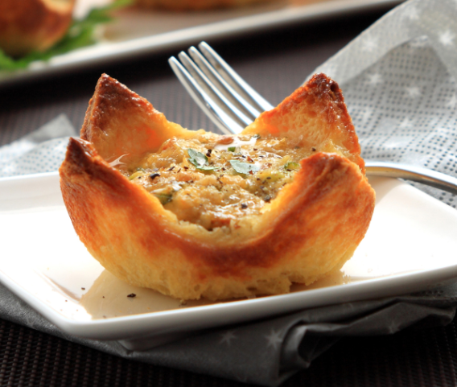
1 rasher bacon, rind removed and diced
$\frac{1}{4}$ white onion, finely diced
1 teaspoon olive oil
6 slices white bread, fresh
2 eggs
$\frac{2}{3}$ cup milk
$\frac{1}{3}$ cup grated tasty cheese
2 teaspoons parsley, finely chopped
Salt and pepper
Olive oil spray
Method
- Preheat oven to 180.
- Heat olive oil in a small frypan over high heat. Add the chopped bacon and onion, and sauté for 2 minutes. Remove from the heat and set aside.
- Cut the crusts from the edges of the bread, and using a rolling pin, flatten the bread one piece at a time.
- Lightly spray a 6-hole muffin tin with spray, and then press the bread into the muffin holes.
- Place muffin tray into the oven for 3 minutes, remove from the oven and set aside.
- Whisk together the eggs, milk, parsley and salt and pepper in a medium bowl.
- Divide the cooled bacon and onion between the bread cases and then top with grated cheese.
- Pour 2 $\frac{1}{2}$ tablespoons of egg mixture into each bread case and immediately place the muffin tray into the oven.
- Bake for 12–15 minutes until the top is lightly golden and the filling is set.
- Remove from the oven and rest for 5 minutes before serving. The filling may deflate while resting.
- Serve warm.
Method of cooking:

Bread case quiches check – egg wash ‘egg-speriment’
This can be completed as part of the demonstration lesson.
Question
How does adding egg wash to bread change the appearance?
Materials/ingredients
Bread case quiche recipe
3 eggs
Milk
Method
Complete the bread case quiche demonstration. Before placing in oven, brush some of the bread cases with the following:
- Egg yolk and water
- Egg yolk and milk
- Egg white and water
- Egg white and milk
- Whole egg and water
- Whole egg and milk
- The remainder without any egg wash
Results
Question – What is the difference in observations between the types of quiches?
Table 11 – an observation table on the types of egg wash
Type of egg wash | Observation
egg yolk + water
egg yolk + milk
egg white + water
egg white + milk
whole egg + water
whole egg + milk
no egg wash
Conclusion
Note: remove conclusion from student workbook before printing.
The protein in the egg white creates a glossy effect and the fat in the egg yolk makes it go brown.

Evaluate – bread case quiches
Reflect on your previous practical lesson by completing the PMI chart and the sensory description below. In the PMI list 3 things that went well in the plus section, 3 things that need some improving in the minus section and then 3 things you found interesting about the practical. When completing the sensory description, write one sentence for each of the 5 senses regarding what you have prepared. Remember – taste, smell, sight, touch and sound.

Lacy egg wraps with berries and cream
Serves 2
Ingredients
100 grams plain flour
45 grams castor sugar
40 grams butter
2 large eggs
Method
- Preheat the oven to 140° Celsius.
- Mix eggs and castor sugar until sugar has dissolved, then add melted butter and mix well.
- Sift flour into egg mixture and mix well. Use a whisk to remove any lumps in the batter.
- Heat a medium frypan on the stove at low to medium heat.
- Pour the batter into a piping bag and then cut a small hole at the bottom of the piping bag.
- Squeeze the batter from the piping bag over the heated pan and move your hand in a circular motion to form a lacy pattern. Cook for around 2 minutes.
- Use a spatula and carefully slide it under the lace batter, then flip to cook on the other side.
- Carefully roll the lace wrap into a cylinder and place onto an oven tray covered with baking paper. Keep warm in the oven.
- Use remaining batter and keep lacy wraps warm.
- Serve wraps with fresh berries and cream.
Method of cooking:

Evaluate – lacy egg wraps with berries and cream
Reflect on your previous practical lesson by completing the PMI chart and the sensory description below. In the PMI list 3 things that went well in the plus section, 3 things that need some improving in the minus section and then 3 things you found interesting about the practical. When completing the sensory description, write one sentence for each of the 5 senses regarding what you have prepared. Remember – taste, smell, sight, touch and sound.

Breakfast egg wrap
Serves 2
Ingredients
2 eggs
1 teaspoon water
1 teaspoon plain flour
Salt and pepper
2 teaspoons olive oil
$\frac{1}{2}$ avocado, or 1 tablespoon avocado dip
1 teaspoon lemon juice
$\frac{1}{4}$ teaspoon garlic powder
1 cup baby spinach or rocket
1 small tomato, sliced
1 tablespoon feta, crumbled
Method
- In medium bowl, place eggs, water, flour, salt and pepper; whisk until well combined and flour is dissolved.
- Heat the olive oil in a non-stick pan over a medium heat. Pour the egg mixture into the pan and tilt the pan to spread the egg mixture. Cook for about 3 minutes until the egg mixture has completely set.
- Gently slide a spatula under the egg mixture, flip and allow to slightly brown. Slide onto a plate and allow to cool. While cooling, mash the avocado in a small bowl with lemon juice, garlic powder and salt and pepper.
- Spread the mashed avocado mix over the entire egg wrap, top with baby spinach, and add sliced tomato and crumbled feta. Roll up tightly; secure each end with a paper serviette and slice in half.
Method of cooking:

Breakfast egg wrap check – emulsification ‘egg-speriment’
This can be completed as part of the demonstration lesson.
Question
What will happen if we add egg to an oil and water mixture?
Materials/ingredients
2 clear jars or bowls
Water ($\frac{1}{2}$ cup for each jar)
Oil ($\frac{1}{2}$ cup for each jar)
1 egg yolk
Whisk or spoon
Method
- Set up 2 jars:
- In the first jar, combine water and oil without the egg yolk (control).
- In the second jar, combine water, oil and an egg yolk.
- Mix both jars:
- Stir or shake the contents of both jars vigorously for 1–2 minutes.
Demonstrate this also in a mayonnaise recipe which can be shared with class for their breakfast egg wrap.
Mayonnaise recipe
Ingredients:
- 1 egg yolk (emulsifier)
- 1 cup of oil (fat)
- 1 teaspoon mustard (optional, enhances emulsification)
- 1 tablespoon vinegar or lemon juice (acid)
- Salt to taste
Procedure:
- Place the egg yolk in a bowl.
- Whisk in mustard and vinegar/lemon juice.
- Gradually add oil in a thin stream while whisking vigorously.
- Continue whisking until the mixture thickens and becomes creamy.
Results
- What was the difference in how the 2 hollandaise recipes were completed?
- Describe what they both looked like and their texture.
Conclusion
Note: remove conclusion from student workbook before printing.
In the first jar (without the egg yolk), the oil and water will quickly separate.
In the second jar (with the egg yolk), the mixture will remain creamy and uniform because the lecithin in the egg yolk acts as an emulsifier, stabilising the oil and water.

Evaluate – breakfast egg wrap
Reflect on your previous practical lesson by completing the PMI chart and the sensory description below. In the PMI list 3 things that went well in the plus section, 3 things that need some improving in the minus section and then 3 things you found interesting about the practical. When completing the sensory description, write one sentence for each of the 5 senses regarding what you have prepared. Remember – taste, smell, sight, touch and sound.

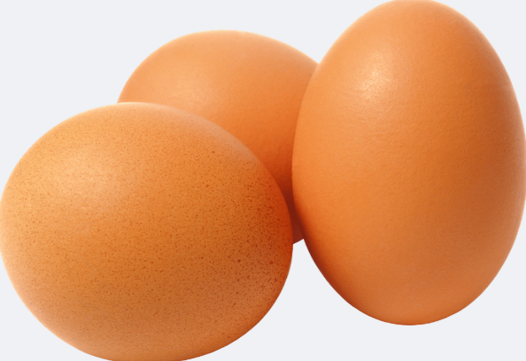
The nude food trend
What is it? – the trend or movement of nude food aims to reduce single use plastics, foil or plastic containers, or any excess packaging that is required to transport food. The egg is a perfect example of a nude food! No packaging required as eggs have their own perfect container.
Why do we need nude foods? – As we have seen in A Roadmap for reducing Australia's food waste by half by 2030, households are the main culprits for the highest amount of food waste in the country with most of this waste going to landfill. If we can move towards more of these foods that don’t require huge amounts of packaging, we will help in the reduction of this waste. It is thought that up to 50% of items in school bins come from food and drink packaging.
What can you do to help?
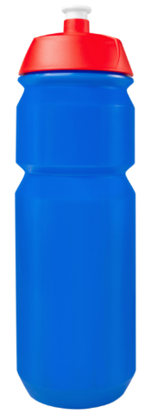
- Use washable containers each day for school to transport food.
- Use a water bottle that can be washed and refilled.
- Use reusable utensils when needed. Buy more fresh fruit and vegetables that are not packaged in soft plastics.
- Don’t purchase multipacks of snack foods that come in a large cardboard box with multiple packs inside.
- Don’t use cling wrap, plastic bags or foil.
- Don’t use single serve items.
Can you think of any other foods that are great examples of nude foods?
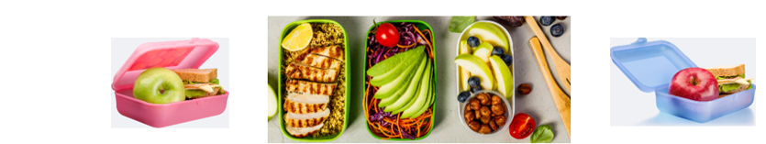

Fried rice with egg ribbons
Serves 4
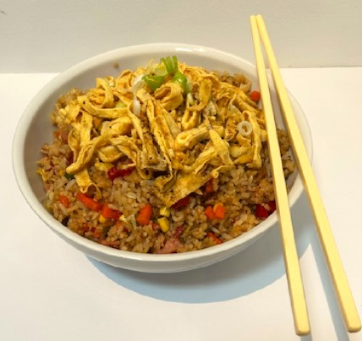
Ingredients
2 eggs
Salt and pepper
2 tablespoons vegetable oil
2 garlic cloves, finely chopped
$\frac{1}{2}$ brown onion, finely chopped
2 rashers bacon, rind removed and roughly chopped
1 cup frozen mixed vegetables (carrot, peas and corn)
2 cups cooked white rice
$\frac{1}{2}$ cup shallots, finely chopped
1 tablespoon soy sauce
$\frac{1}{2}$ teaspoon sesame oil
$\frac{1}{4}$ teaspoon white pepper
Method
Egg ribbons
- Lightly beat the eggs in a bowl with a fork and season with salt and pepper. Heat a non-stick frypan over medium heat. Spray the pan with cooking spray.
- Add approximately 2 tablespoons of egg to the pan and swirl to coat the base of the pan. Let the egg cook over low heat until set and flip using a spatula. Continue to cook until set, and then remove from the pan onto a chopping board. Repeat with the remaining egg mix.
- When all of the egg is cooked, stack the egg pancakes on top of one another, roll up and thinly slice into ribbons. Use on top of the fried rice.
Fried rice
- Heat $\frac{3}{4}$ of the vegetable oil in a fry pan. Add chopped garlic, onion and bacon. Cook for 2 minutes until onion has softened.
- While cooking, add your soy sauce, sesame oil and pepper together, then whisk.
- Add vegetables to the frypan and cook for another 2 minutes, then add in cooked rice and mix all ingredients thoroughly in the pan. Once all ingredients are incorporated, spread your sauce ingredients around the pan, continuing to mix.
- Transfer your fried rice to a large serving bowl, top with egg ribbons and garnish with shallots.
Method of cooking:

Fried rice with egg ribbons check
List the equipment you will need to complete this recipe.
Note: the table has the completed answers provided. Provide a blank table for students to complete the activity.
Table 12 – a list of equipment
Equipment list
tray | spatula
stainless steel plate | wooden spoon
chopping board | serving bowl
measuring cups | measuring spoons
mixing bowl | Chef’s knife
fork | frypan

Evaluate – fried rice with egg ribbons
Reflect on your previous practical lesson by completing the PMI chart and the sensory description below. In the PMI list 3 things that went well in the plus section, 3 things that need some improving in the minus section and then 3 things you found interesting about the practical. When completing the sensory description, write one sentence for each of the 5 senses regarding what you have prepared. Remember – taste, smell, sight, touch and sound.

Shakshuka
Serves 3
Ingredients
1 tablespoon olive oil
1 small red onion, peeled, halved and sliced
1 clove garlic, crushed
$\frac{1}{2}$ red capsicum, sliced into thin strips
1 tomato, diced
400 grams can crushed tomatoes
1 tablespoon tomato paste
$\frac{1}{2}$ cup chicken stock
1 teaspoon EACH cumin and paprika
$\frac{1}{4}$ teaspoon black pepper
$\frac{1}{2}$ teaspoon salt
3 eggs
1 tablespoon fresh parsley, roughly chopped
Crusty bread to serve
Method
- Preheat oven to 180° Celsius.
- Heat oil in a medium oven-proof frypan over high heat. Add garlic and onion and cook for 2 minutes until the onion is translucent.
- Add capsicum and cook for one minute. Add diced tomato, cook for 2 minutes until broken down and it becomes more pasty.
- Add canned tomatoes, tomato paste, stock, paprika, cumin, salt and pepper. Mix to combine.
- Lower the heat to medium low and simmer the mix for 5 minutes until just thickened.
- Using a dessert spoon, make indentations in the mixture and carefully crack the eggs in. Leave to cook for one minute until the edges of the white are set.
- Cover the frypan with a lid and steam on the stovetop for 3 minutes until yolks are set.
- Remove from the stove, scatter with parsley and serve with crusty bread slices.
Method of cooking:

Shakshuka check
List the equipment you will need to complete this recipe and describe the characteristics of this piece of equipment.
Note: the table has the completed answers in column 1. Provide a blank table for students to complete the activity. The first row is a sample answer.
Table 13 – equipment and their description
Equipment | Description
tray | Sample answer: large, flat, plastic, able to carry ingredients
stainless steel plate
measuring spoons
Chef’s knife
chopping board
measuring cups
frypan
dessert spoon
spatula
serrated knife

Evaluate – shakshuka
Reflect on your previous practical lesson by completing the PMI chart and the sensory description below. In the PMI list 3 things that went well in the plus section, 3 things that need some improving in the minus section and then 3 things you found interesting about the practical. When completing the sensory description, write one sentence for each of the 5 senses regarding what you have prepared. Remember – taste, smell, sight, touch and sound.

Shakshuka – a long history
Shakshuka, which can also be spelt Shakshouka, has a long history around the world as a dish that can be served for breakfast, lunch or dinner. Using your device, research shakshuka and answer the following questions on this dish which is so widely served around the world in both homes and restaurants.
- What does the name ‘shakshuka’ translate to?
- What is the country that is thought to have originally created the dish?
- What countries now serve this dish as one of their staple cuisines?
- List some other ingredients that could be substituted into this dish.

Spanish tortilla
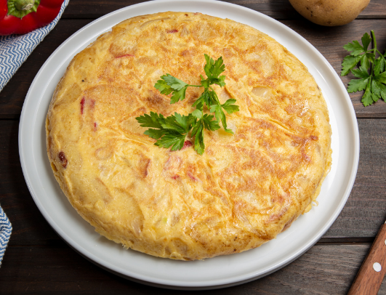
Serves 4
Ingredients
600 grams all-purpose potatoes, peeled and cut into $\frac{1}{2}$ cm slices
1 small onion, finely sliced
$\frac{1}{3}$ cup olive oil
5 eggs
Salt and pepper
1 tablespoon fresh parsley, roughly chopped
Method
- Heat oil in a non-stick frypan over medium heat. Add onion and potatoes. Place a lid on the frypan and gently cook the potatoes for 20 minutes or so, turning the potatoes 3 or 4 times with a spatula until soft and cooked through. If the potatoes sizzle and are browning, turn the heat down. While the potatoes are cooking, whisk the eggs in a separate bowl and season with salt and pepper.
- When potatoes are cooked through, remove them from the frypan with a slotted spoon onto paper towel to absorb any excess oil. Discard any excess oil from the pan into a heat-proof container. Turn the stove to medium-high, and also turn on the grill to high.
- Return the potatoes to the frypan and pour over the egg. Cook for 5 minutes or until the underside is golden brown. If the centre is uncooked, put the tortilla under the grill for 3 minutes until the centre is cooked.
- Remove the pan from heat and allow to rest for 2 minutes. Place a chopping board or large plate on top of the frypan and flip to turn out the tortilla upside down. Sprinkle parsley over the tortilla and serve warm.
Method of cooking:

Spanish tortilla check
List the equipment you will need to complete this recipe and describe the characteristics of this piece of equipment.
Note: the table has the completed answers in column 1. Provide a blank table for students to complete the activity. The first row is a sample answer.
Table 14 – equipment and their description
Equipment | Description
tray | Sample answer: large, flat, plastic, able to carry ingredients
stainless steel plate
Chef’s knife
chopping board
measuring spoons
measuring cups
frypan
mixing bowl
whisk
spatula
slotted spoon
serving plate

Evaluate – Spanish tortilla
Reflect on your previous practical lesson by completing the PMI chart and the sensory description below. In the PMI list 3 things that went well in the plus section, 3 things that need some improving in the minus section and then 3 things you found interesting about the practical. When completing the sensory description, write one sentence for each of the 5 senses regarding what you have prepared. Remember – taste, smell, sight, touch and sound.

Egg café – final recipe
Complete the following blank recipe template with your chosen final recipe after completing your Egg café menu.
Serves 2
Ingredients

Method

Action plan

Egg café – final recipe, continued
Equipment

Safety considerations

Hygiene concerns

Egg café – final recipe, continued
Complete the following food order and submit to your teacher on the due date. Only complete the equipment section if there is a speciality piece of equipment that is not housed in the kitchen that you will complete your practical lesson in.
Student name
Teacher
Class
Recipe name
Ordering for (circle the amount of people the recipe is for) | 1 2 4 people
Ingredients
Speciality equipment required

Teacher sign off

Evaluate – egg café, final recipe
Reflect on your previous practical lesson by completing the PMI chart and the sensory description below. In the PMI list 3 things that went well in the plus section, 3 things that need some improving in the minus section and then 3 things you found interesting about the practical. When completing the sensory description, write one sentence for each of the 5 senses regarding what you have prepared. Remember – taste, smell, sight, touch and sound.

References
This resource contains NSW Curriculum and syllabus content. The NSW Curriculum is developed by the NSW Education Standards Authority. This content is prepared by NESA for and on behalf of the Crown in right of the State of New South Wales. The material is protected by Crown copyright.
Please refer to the NESA Copyright Disclaimer for more information https://educationstandards.nsw.edu.au/wps/portal/nesa/mini-footer/copyright.
NESA holds the only official and up-to-date versions of the NSW Curriculum and syllabus documents. Please visit the NSW Education Standards Authority (NESA) website https://educationstandards.nsw.edu.au/ and the NSW Curriculum website https://curriculum.nsw.edu.au.
Technology 7–8 Syllabus © NSW Education Standards Authority (NESA) for and on behalf of the Crown in right of the State of New South Wales, 2022.
ClickView (15 July 2020) ‘Safety In The Domestic Kitchen - Food Technology’ [video], ClickView, YouTube, accessed 10 April 2025.
Incredible Egg (17 June 2020) 'What Causes Eggs to Coagulate?' [video], Incredible Egg, YouTube, accessed 10 April 2025.
Jamie Oliver (27 April 2012) ‘Jamie Oliver on knife skills -– 30-Minute Meals’ [video], Jamie Oliver, YouTube, accessed 11 April 2024.
NSW Food Authority (22 June 2023) ‘Four Golden Rules of food safety [video]’, NSWFoodAuthority, YouTube, accessed 10 April 2025.
Science Buddies (10 March 2020) ‘See Germs! Hand Washing Science Experiment’ [video], Science Buddies, YouTube, accessed 10 April 2025.

© State of New South Wales (Department of Education), 2025
The copyright material published in this resource is subject to the Copyright Act 1968 (Cth) and is owned by the NSW Department of Education or, where indicated, by a party other than the NSW Department of Education (third-party material).
Copyright material available in this resource and owned by the NSW Department of Education is licensed under a Creative Commons Attribution 4.0 International (CC BY 4.0) license.

This license allows you to share and adapt the material for any purpose, even commercially.
Attribution should be given to © State of New South Wales (Department of Education), 2025.
Material in this resource not available under a Creative Commons license:
- the NSW Department of Education logo, other logos and trademark-protected material
- material owned by a third party that has been reproduced with permission. You will need to obtain permission from the third party to reuse its material.
Links to third-party material and websites
Please note that the provided (reading/viewing material/list/links/texts) are a suggestion only and implies no endorsement, by the New South Wales Department of Education, of any author, publisher, or book title. School principals and teachers are best placed to assess the suitability of resources that would complement the curriculum and reflect the needs and interests of their students.
If you use the links provided in this document to access a third-party's website, you acknowledge that the terms of use, including licence terms set out on the third-party's website apply to the use which may be made of the materials on that third-party website or where permitted by the Copyright Act 1968 (Cth). The department accepts no responsibility for content on third-party websites.

