Technology 7–8 Food and agricultural practices – sample assessment task 1 notification
Scrambled
Contents
Task description 2
Submission details 4
Steps to success 4
What is the teacher looking for? 7
Marking guidelines 8
Student support material – folio template 10
Design and production process 10
Help – we’re in a scramble! 11
Identifying and defining 11
Design brief (need) 11
Opportunities 11
Researching and planning 16
Research 16
Final design 18
Planning 20
Testing 21
Producing and implementing 22
Testing and evaluating 23
Evaluate 23
Bibliography 24
Student-facing rubric 25
Support and alignment 30
References 31

Task description
Type of task: folio and final product
Outcomes being assessed:
A student:
- communicates and evaluates design ideas and solutions TE4-DES-01
- applies processes in the planning, management and production of projects
TE4-PPM-01
- selects and safely uses tools, materials, technologies and processes TE4-SAF-01
Technology 7–8 Syllabus © NSW Education Standards Authority (NESA) for and on behalf of the Crown in right of the State of New South Wales, 2023.
Suggested weighting: 25%
Help – we’re in a scramble!
Did you know, during 2022–2023, egg sales turned over $1,194,700,000 (or $1194.7 million)?
Eggs are an important part of our country’s economy. However due to supply issues there has been a decline in the sale of eggs. You are required to design and produce a product to encourage the purchase and continued use of eggs in Australia.
You are required to design and produce your idea for an audience of your choosing. For example, the local community, school peers, teachers, parents or community members.
Note: teachers may like to nominate what product students will design and produce. Possible products may include: a nutritious food product using eggs, a nutritious food product to feed chickens with educational packaging that encourages egg production, a digital recipe book of egg recipes, an agricultural product that supports egg production such as a self-feeder using recycled materials, a food truck to service the local community educating about the importance/value of eggs, an innovative new egg product for supermarket shelves including packaging design.
Use the design and production process as outlined in the folio template below to design and produce a product that encourages the purchase and continued use of eggs.
Throughout the process you will be required to communicate reasons for your choices and safely use appropriate tools, materials, technologies and processes when applying a design process.

Submission details
Note: teacher should consider submission from students in line with their school assessment policy. Students may require alternate ways to demonstrate their understanding.
- The completed folio is to be submitted using the following scaffold.
- The submission of the product associated with this task is to be negotiated with the teacher.

Steps to success
This task is designed to be completed in class and has been written into the program of learning for the Scrambled unit. You will need to consider the ‘when I need to do it’ aspect of the table below should this be used as a take home task.
Option: you may like to complete this table as a class.
Table 1 – assessment preparation schedule
Steps | What I need to do and when I need to do it
Brainstorm ideas | What do I need to do? Record all your initial ideas and thoughts. You may have some questions at this time; write them down and seek out the responses.  When do I need to do it? Do this after reading through the task requirements.
Pre-existing solutions | What do I need to do? Research products that already exist. Think about how they encourage the purchase and continued use of eggs in Australia.  When do I need to do it? This section can be done in class. It may also be beneficial to go to the supermarket and have a look at what is out there on the shelves.
Criteria for success | What do I need to do? Record the criteria for success determined as a class. Try to contribute to the class discussion to make sure you are confident in how the factors affecting design will impact your project.  When do I need to do it? This will be done in class.
Key terms | What do I need to do? Throughout this task, you will come across some new terminology. Record these in the Key terms table.  When do I need to do it? This should be done throughout the task, as it is ongoing.
Research | What do I need to do? Complete the research questions. Break these down and ensure you have the required detail for each question.  When do I need to do it? This needs to be completed prior to refining your initial ideas.
Brainstorm | What do I need to do? Now you have some ideas, know what is already available on the market, and know how the factors affecting design will impact your product and background information, you can refine your initial ideas. Record 3 ideas and include a description.  In class you will participate in a gallery walk and receive feedback on your ideas.  When do I need to do it? The gallery walk will take place during class time.
Final design | What do I need to do? Use the feedback that you now have and decide on your final design. You will need to sketch an image and use colours and annotations to clearly communicate your design.  When do I need to do it? This will need to be completed after participating in the gallery walk and receiving your feedback.
Plan your production | What do I need to do? Think about all the equipment and materials you will need for your product. Record it and justify why you need it. Then you will need to complete a procedural text. This should give numbered instructions on how to produce your design into a final product.  When do I need to do it? This should be done prior to starting the testing and production of your product.
Test it out | What do I need to do? Practise any aspect of your product that is something new you have not used before. Record all the testing and changes you make.  When do I need to do it? This should be done prior to starting the production of your final product.
Produce your product | What do I need to do? Produce your product. Ensure you allow enough time to complete your product. Throughout the process of production, take photos/screenshots to show the process you go through.  Don’t forget to take a photo of your product when you have finished it.  When do I need to do it? This should be done once you have finished testing out the components of your product and recording the changes to your procedural text.
Evaluate your product | What do I need to do? Participate in a gallery walk and receive feedback on your product. Record this feedback. Using the factors affecting design statements you created in the Criteria for success step and the feedback you received, complete the evaluation section of your folio.  When do I need to do it? This will be done in class time.
Bibliography | What do I need to do? Throughout the task you will use different sources of information. Record all sources of information you use here.  When do I need to do it? Record the details of the source in your bibliography as you use the source for your task. This is ongoing.

What is the teacher looking for?
The teacher is looking for students to apply project management strategies throughout the planning and development of their product.
Throughout the project, the teacher is looking for communication skills of the students as they share their ideas and provide feedback to others.
Students are required to evaluate pre-existing products, as well as evaluate their own ideas for products and those of their peers.
Selecting and safely using tools, materials, technologies and processes that are appropriate to their product will be vital in producing a suitable product that is of outstanding quality.

Marking guidelines
Table 2 – assessment marking guidelines
Grade | Marking guideline descriptors
A | - Student demonstrates extensive skills in applying project management processes, including the planning and production of their project.  - Student demonstrates a high level of competence in communicating and evaluating pre-existing products and their own design ideas and solutions.  - Student confidently selects and safely uses appropriate tools, materials, technologies and processes throughout their project.  - Student produces a suitable product of outstanding quality.
B | - Student demonstrates thorough skills in applying project management processes, including the planning and production of their project.  - Student demonstrates a thorough ability to communicate and evaluate pre-existing products and their own design ideas and solutions.  - Student selects and safely uses appropriate tools, materials, technologies and processes throughout their project.  - Student produces a suitable product of high quality.
C | - Student demonstrates sound skills in applying project management processes, including the planning and production of their project.  - Student demonstrates a sound ability to communicate and evaluate pre-existing products and their own design ideas and solutions.  - Student selects and safely uses tools, materials, technologies and processes throughout their project.  - Student produces a mostly suitable product of sound quality.
D | - Student demonstrates basic skills in applying project management processes, including the planning and production of their project.  - Student demonstrates a limited level of competence in communicating and evaluating pre-existing products and their own design ideas and solutions.  - Student selects and safely uses tools, materials, technologies and processes throughout their project some of the time.  - Student produces a somewhat suitable product of low quality.
E | - Student demonstrates elementary skills and knowledge in project management processes, including the planning and production of their project.  - Student demonstrates very limited skills in communicating and evaluating pre-existing products and their own design ideas and solutions.  - Student selects and safely uses tools, or materials, or technologies, or processes throughout their project.  - Student produces a product of little suitability or a product of limited quality.

Student support material – folio template

Design and production process
Throughout this task you will use the following design and production process. This process allows for continuous refinement of ideas and solutions and acts as a guide to help keep you on track.
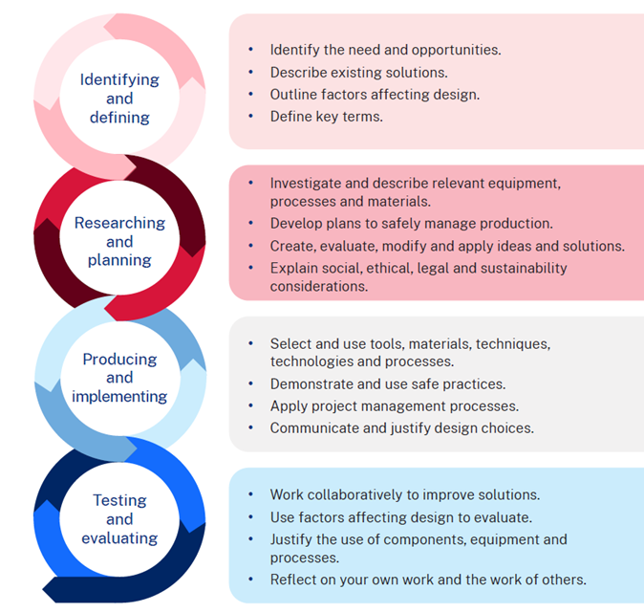

Help – we’re in a scramble!

Identifying and defining
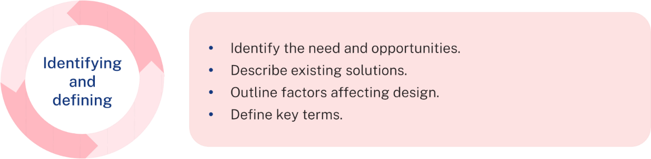

Design brief (need)
Design and produce a product to encourage the purchase and continued use of eggs in Australia.

Opportunities
In the space below record all your initial ideas and questions.

Pre-existing solutions
Research products on the market which are re-imagining/reinventing and encouraging the purchase and continued use of eggs.
In the table below, evaluate 3 contemporary, innovative or sustainable solutions that already exist and encourage the purchase and continued use of eggs in Australia.
Consider the following questions in your evaluation of each product:
- What is the name of the product?
- How is it packaged?
- What are 2 advantages of this product?
- How is it used?
Product | Evaluation
Sample response  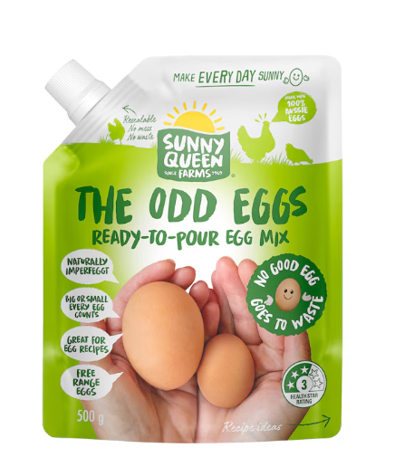  Sunny Queen Farms – The Odd Eggs Ready-to-Pour Egg Mix | Sample response  New food products from Sunny Queen. The Odd Eggs Free Range Egg Mix 500 g is a new product available at Woolworths. It uses the perfectly good, but odd-sized eggs, and packages them in an easy-to-pour pouch with a resealable lid. These eggs can then be used in the home to create all your favourite egg dishes, without any shells to clean up. This is a great solution that helps to minimise waste from odd-shaped eggs, and encourages the use of eggs with the resealable lid.
Reflect on the 3 products you have evaluated above. Identify 3 important points you have learnt.

Criteria for success – factors affecting design
Note: construct the criteria for success as a class. You will need to refer to factors affecting design. Examples of factors affecting design include aesthetics, ergonomics, ethics, finance, functionality, safety and sustainability.
Sample criteria
- Sustainability – my product will use only sustainable materials.
- Sustainability – my product will promote the sustainability of eggs.
- Safety – my product will be safe to consume.
- Safety – I will use safe practices when producing my product including all relevant personal protective equipment (PPE).
- Functionality – my product will work in its intended way for its intended purpose.
- Aesthetics – my product will be presented neatly, with all materials finished to a high standard.
- Ergonomics – my product will be easy to use and store. It will be conducive with pre-existing products surrounding its location.
- Finance – my product will be affordable to produce and purchase.

Key terms
Use this space below to record all key terms throughout this project. These will be identified throughout your classwork. The first row has been done for you.
Key term | Definition | Example
sustainability | Supporting the needs of the present without compromising the ability of future generations to meet their needs. | Using local and seasonal ingredients in food preparation, which reduces the carbon footprint associated with transporting food and agricultural products over long distances.

Researching and planning
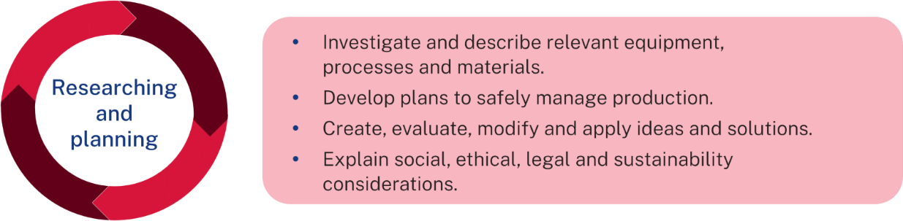

Research
Complete the following research questions. You may like to use your own research, as well as information you have learnt in class. This will help you to make informed design decisions.
Be sure to record your sources of information in the bibliography below.
- Describe the process eggs undertake prior to being available on the supermarket shelves.
- List 3 technologies used in the production of eggs.
- Explain the legal considerations associated with egg production.
- Investigate the nutritional value of eggs – include the benefits of consuming eggs and provide an example of a food product suitable for an adolescent that contains eggs.
- Describe how the Australian egg industry is contributing to sustainability.

Brainstorm
Think about your initial ideas at the beginning of this folio and what you now know about the egg industry. In the space below narrow your ideas down to 3. While you are narrowing them down, think about the factors affecting design and how your ideas could meet the criteria for success.
Once complete, seek feedback on your ideas. Ask your peers to complete a PMI on your ideas. Your teacher will help to facilitate this process.
Idea – image | Description | Audience | Feedback
Sample response    Mini cheesy egg bite  Yellow – egg and cheese mix  Green – capsicum  Red – tomato  Pink – bacon  Blue – muffin liner | Sample response  This is a mini cheesy egg bite. This egg bite includes eggs, cheese, tomato, bacon and capsicum. It can be made in a large batch and kept in the freezer to eat on busy mornings by defrosting and heating in the microwave or air fryer.  It promotes the purchase and use of eggs by being a convenient snack or breakfast option.  It is sustainable as it is a good option to switch out ingredients to what is available at the time which helps to minimise food waste. | Sample response  This mini cheesy egg bite would be aimed at adolescents who are struggling to eat breakfast before school. They could defrost this the night before, heat it up in the morning and eat it on the way to school. | Sample response  Plus – sounds yummy. Helps to minimise food waste. Uses common kitchen equipment. Includes vegetables and proteins  Minus – takes time to defrost  Interesting – the customisation of ingredients in this product

Final design
In the space below, sketch your final idea. Use colours and annotations to clearly communicate your design.

Use the space in the table below to indicate the equipment and materials you plan to use. Justify its use. An example has been done for you in relation to an egg carrier.
Equipment/material | Justification of use
cardboard | Cardboard will be used in some of the construction of the self-feeder. Cardboard is lightweight, therefore does not add significant weight to the final product. It is a natural-based product so won't cause harm to the chickens if it is ingested. It can be manipulated into different shapes, and therefore is easy to construct with. It is an easy-to-recycle product, which makes it a more sustainable product.

Planning
In the space below, develop a plan for producing your product. This should be in the form of a procedural text.

Testing
Test out components of your design, making changes as required. Record your testing and changes below. Remember to edit your procedural text above to include the changes you have made. It is a good idea to include pictures of your testing here.

Producing and implementing
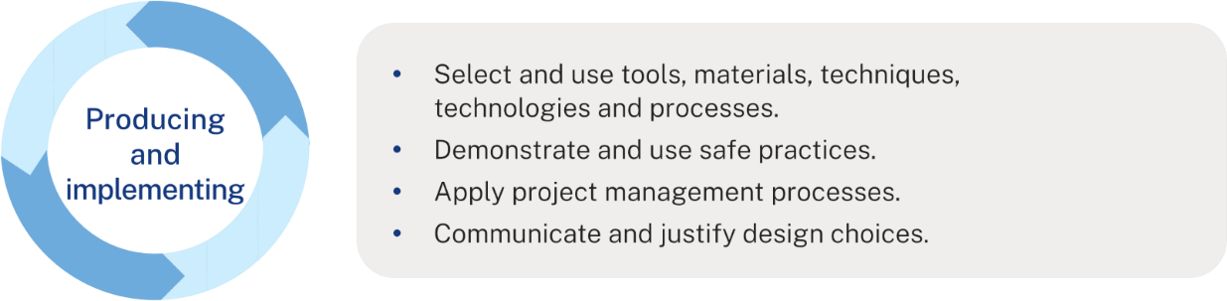
Produce your product
Produce your product using the procedural text you created and edited above. You may find you need to make changes to your procedural text as you go. This is fine; record the changes. Throughout the production process, take photos and include them here. Include a picture of your final product.

Testing and evaluating
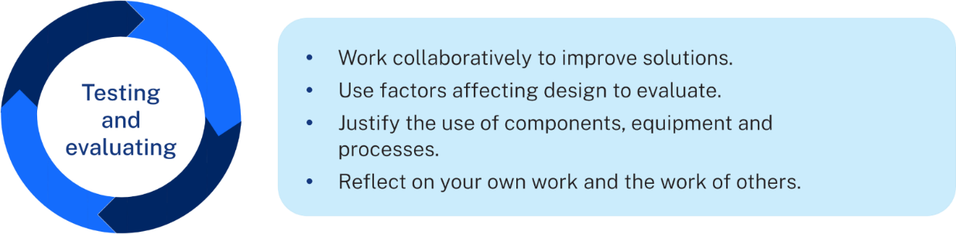

Evaluate
Complete a gallery walk with your peers. Your teacher will direct you on how to do this. Include the evaluations you receive from your peers in the space below.
Using the factors affecting design from the Criteria for success step, evaluate your product in the space below. Ensure you refer to the materials, equipment and processes you used throughout.

Bibliography
Record all the resources you gained information from in your folio here.

Student-facing rubric
Table 3 – rubric for assessment
Criteria | Limited | Basic | Sound | High | Outstanding
Identifying and defining | Few or no ideas/questions are explored. | Few ideas/questions with limited detail or relevance. | Some relevant ideas/questions with adequate detail. | Several relevant ideas/questions with good detail. | Multiple innovative and relevant ideas/questions.
 | Limited or no existing solutions are recorded. | Identifies some existing solutions | Describes 2–3 existing products. | Evaluates 3 existing products. | Thoroughly evaluates 3 relevant existing products.
 | Reflection is limited or not attempted. | 1–2 reflection points are included. | 2–3 reflection points are included with some detail. | Reflection includes 3 detailed points. | Reflection includes 3 insightful points.
 | Few or no key terms are included. | Some key terms used throughout the task are recorded. | Student includes most key terms used throughout their task with some definitions and examples. | Student includes a variety of key terms used throughout their task. Definitions and examples are included for most key terms. | Student includes a variety of key terms used throughout their task. Definitions and detailed examples are included for all key terms.
Researching and planning | Minimal or no research completed. | Responses to research questions are incomplete. | Provides basic responses to research questions. | Provides clear and accurate responses to research questions. | Provides detailed, accurate responses to research questions.
 | Minimal or no ideas presented; no evidence of design factors or feedback. | Presents fewer than 3 ideas; limited consideration of design factors or feedback. | Presents 3 ideas; considers basic design factors; integrates some feedback. | Presents 3 original ideas; considers factors affecting design; integrates feedback effectively. | Presents 3 highly original and well-developed ideas; effectively considers factors affecting design; insightful feedback integration.
 | No clear final concept provided. | Final concept lacks creativity or feasibility; limited justification or links to research. | Final concept is sound, feasible and somewhat justified, with basic links to research. | Final concept is creative, feasible and justified, with clear links to research and criteria for success. | Final concept is highly creative, feasible and well-justified, with strong links to research and criteria for success.
 | Minimal steps outlined in plan. | Limited or unclear plan with few steps of production outlined. | Adequate plan with the main steps of production outlined. | Clear and logical plan with most steps of production outlined. | Highly detailed, clear, and logical plan with all steps of production outlined.
 | Few materials or equipment required are listed. | Some materials or equipment are identified. | Most required materials and equipment are outlined. | Required materials and equipment outlined. | Required materials and equipment thoroughly outlined.
 | Little to no testing conducted, and no records of changes or reflection provided. | Minimal testing conducted, with limited records of changes and reflection. | Adequate testing conducted, with some records of changes made and basic reflection. | Thorough testing conducted, with clear records of changes made and good reflection on improvements. | Extensive testing conducted, with detailed records of changes made and insightful reflection on improvements.
Producing and implementing | Product is incomplete and produced with limited adherence to the plan. | Product is produced to a basic standard, following some of the plan. | Product is produced to a sound standard, mostly following the plan. | Product is produced to a high standard, following the plan closely. | Product is produced to an outstanding standard, following the plan closely.
 | Evidence of production and final product are limited or not included. | Some evidence of production and final product are included. | Evidence of production and final product are included. | Evidence of production and final product are included. | Evidence of production and final product are included.
Testing and evaluating | No or minimal evaluation provided; lacks reference to design factors, materials or processes. | Provides a limited evaluation of the product, with minimal reference to design factors or processes used. | Provides a basic evaluation of the product, with some reference to design factors and processes used. | Provides a clear evaluation of the product, linking to factors affecting design, materials and processes. | Provides a thorough evaluation of the product, linking back to factors affecting design, materials and processes used.
 | No bibliography is provided. | Provides an incomplete or inaccurate bibliography. | Provides a basic bibliography with some sources referenced. | Provides a clear and mostly accurate bibliography with all sources referenced. | Provides a comprehensive bibliography with all sources referenced accurately.

Support and alignment
Resource evaluation and support: all curriculum resources are prepared through a rigorous process. Resources are periodically reviewed as part of our ongoing evaluation plan to ensure currency, relevance and effectiveness. For additional support or advice, or to provide feedback, contact the TAS Curriculum team by emailing TAS@det.nsw.edu.au.
Differentiation: further advice to support Aboriginal and Torres Strait Islander students, students learning English as an additional language or dialect (EAL/D), students with a disability and/or additional needs and High Potential and gifted students can be found on the Planning, programming and assessing 7–12 webpage. This includes the Inclusion and differentiation advice 7–10 webpage.
Assessment: further advice to support formative assessment is available on the Planning, programming and assessing 7–12 webpage. This includes the Classroom assessment advice 7–10. For summative assessment tasks, the Assessment task advice 7–10 webpage is available.
Explicit teaching: further advice to support explicit teaching is available on the Explicit teaching webpage. This includes the CESE Explicit teaching – Driving learning and engagement webpage.
Consulted with: Curriculum Implementation, Inclusive Education, Multicultural Education, Aboriginal Education Advisors and subject matter experts.
Alignment to system priorities and/or needs: School excellence policy, Our Plan for NSW Public Education.
Alignment to the School Excellence Framework: this resource supports the School Excellence Framework elements of curriculum (curriculum provision) and effective classroom practice (lesson planning, explicit teaching).
Alignment to Australian Professional Standards for Teachers: this resource supports teachers to address Proficient Teacher Standard Descriptors 5.1.2, 5.3.2, 5.4.2.
Creation date 7 April 2025.

References
This resource contains NSW Curriculum and syllabus content. The NSW Curriculum is developed by the NSW Education Standards Authority. This content is prepared by NESA for and on behalf of the Crown in right of the State of New South Wales. The material is protected by Crown copyright.
Please refer to the NESA Copyright Disclaimer for more information https://educationstandards.nsw.edu.au/wps/portal/nesa/mini-footer/copyright.
NESA holds the only official and up-to-date versions of the NSW Curriculum and syllabus documents. Please visit the NSW Education Standards Authority (NESA) website https://educationstandards.nsw.edu.au/ and the NSW Curriculum website https://curriculum.nsw.edu.au/home.
Technology 7–8 Syllabus © NSW Education Standards Authority (NESA) for and on behalf of the Crown in right of the State of New South Wales, 2023.
Brookhart SM (2018) ‘Appropriate Criteria: Key to Effective Rubrics’, Frontiers in Education, volume 3(22):1–12, doi:10.3389/feduc.2018.00022, accessed 7 April 2025.
CESE (Centre for Education Statistics and Evaluation) (2020) What works best in practice, NSW Department of Education, accessed 7 April 2025.
——(2020) What works best: 2020 update, NSW Department of Education, accessed 7 April 2025.
——(2021) Growth goal setting – what works best in practice, NSW Department of Education, accessed 7 April 2025.
Fisher D and Frey N (1 November 2009) ‘Feed Up, Back, Forward’, ASCD (Association for Supervision and Curriculum Development): Educational Leadership magazine, 67(3), accessed 7 April 2025.
Griffin P (2017) Assessment for Teaching, Cambridge University Press, Port Melbourne, Victoria.
Hattie J and Timperley H (2007) ‘The Power of Feedback’, Review of Educational Research, 77(1): 81–112, doi:10.3102/003465430298487.
Panadero E and Jonsson A (2013) ‘The use of scoring rubrics for formative assessment purposes revisited: A review’, Educational Research Review, 9:129–144, doi:10.1016/j.edurev.2013.01.002, accessed 7 April 2025.
Sherrington T (2019) Rosenshine’s Principles in Action, John Catt Educational Limited, Melton, Woodbridge, accessed 7 April 2025.

© State of New South Wales (Department of Education), 2025
The copyright material published in this resource is subject to the Copyright Act 1968 (Cth) and is owned by the NSW Department of Education or, where indicated, by a party other than the NSW Department of Education (third-party material).
Copyright material available in this resource and owned by the NSW Department of Education is licensed under a Creative Commons Attribution 4.0 International (CC BY 4.0) license.

This license allows you to share and adapt the material for any purpose, even commercially.
Attribution should be given to © State of New South Wales (Department of Education), 2025.
Material in this resource not available under a Creative Commons license:
- the NSW Department of Education logo, other logos and trademark-protected material
- material owned by a third party that has been reproduced with permission. You will need to obtain permission from the third party to reuse its material.
Links to third-party material and websites
Please note that the provided (reading/viewing material/list/links/texts) are a suggestion only and implies no endorsement, by the New South Wales Department of Education, of any author, publisher, or book title. School principals and teachers are best placed to assess the suitability of resources that would complement the curriculum and reflect the needs and interests of their students.
If you use the links provided in this document to access a third-party's website, you acknowledge that the terms of use, including licence terms set out on the third-party's website apply to the use which may be made of the materials on that third-party website or where permitted by the Copyright Act 1968 (Cth). The department accepts no responsibility for content on third-party websites.

