Technology 7–8 – Engineering technologies and systems – teacher resource
Heli launcher

Contents
Unit overview 4
Glossary 5
Introduction to engineering systems 7
Engineered products 7
What engineered systems or products have you used today? 8
Force, motion and energy 9
Flight 10
Tumblewing flyer relay 10
Generating lift 11
Identify flight characteristics applied to helicopters 12
Boomerang flight 13
Rotor design 16
Rotor blade materials 16
Idea development 17
Annotated idea sketches 18
End of section student skills formative assessment checklist 19
Safety 20
Safety rules in the timber workshop 20
Hazards in the timber workshop 21
TAS safety resources 22
End of section student skills formative assessment checklist 22
Launcher 23
Manufacture 23
Peer and self-evaluation 24
Quality control record 24
End of section student skills formative assessment checklist 24
Communicating engineering ideas 25
CAD 25
3D modelling 25
Orthogonal drawing 26
End of section student skills formative assessment checklist 27
Materials 28
Material properties applied to engineering projects 28
Materials research 28
Material selection and justification 29
Adhesives 30
End of section student skills formative assessment checklist 31
Rotor 32
Manufacture 32
Peer and self-evaluation 33
Quality control record 33
End of section student skills formative assessment checklist 34
Collaborative flight evaluation 34
How does rotor design impact lift? 34
Criteria for success 35
Flight tests 36
Test 1 37
Test 2 37
Test 3 38
Test 4 38
Test 5 39
Test 6 39
Ongoing flight evaluation 40
Rotor blade adjustments 40
Final evaluation 41
Heli hang time competition 43
End of section student skills formative assessment checklist 44
References 45

Unit overview
This resource supports schools’ implementation of the Engineering systems and technologies focus area of the new Technology 7–8 Syllabus. It can be adopted as is or adapted to meet the needs of individual school contexts.
The ‘Heli launcher’ unit is an engaging and comprehensive 10-week program designed for Technology 7–8 students. This unit offers a blend of theoretical knowledge, practical experiences and evaluative practices, focusing on the engineering and construction of a working helicopter rotor and launcher. Throughout the unit, students will gain insights into engineering processes, materials and production processes.
The central task is for students to construct a launcher using provided plans and engineer their own helicopter rotor for testing. This activity provides an opportunity for students to collaborate, think critically and apply engineering and technology principles to a real-world context. The unit encourages creativity and problem-solving, culminating in the heli launcher hang time competition.
Note: this resource has been designed to facilitate the ready conversion into a student booklet by removing the answers within the response windows. Teacher notes (in blue) can be deleted before distributing to students.
The resource is intended for you to adapt to suit your school and your resources. Alternative ideas are included for the project design brief. The resource can be introduced and delivered earlier in the term or used as an assessment.
Refer to Equipment Safety in Schools and Chemical Safety in Schools for current information on safety and safe working practices.

Glossary
Note: provide the table with the definition column blank for students to complete the activity throughout the term.
Each time you see a new word throughout the workbook you can add its definition in the table below in case you need to refer to it later.
Table 1 – glossary
Term | Definition
aerodynamics | The study of how air moves around objects. It is crucial for understanding how helicopters generate lift.
angular velocity | The rate of rotation of an object around an axis, which is important for the spinning motion of helicopter blades.
blade | The rotating part of the helicopter that generates lift. The design and angle of the blades affect the helicopter's performance.
Centre of gravity | The point where the mass of an object is balanced. In a helicopter toy, it affects stability and flight behaviour.
cross section | An object’s cross section refers to the shape or area of a specific slice taken through that object.
drag | The resistance an object faces when moving through air. It influences how high and how long a helicopter can fly.
elevator | A control surface used in larger aircraft, but in the context of a helicopter toy, it can refer to the pitch control of the blades.
energy | Energy is the capacity to do work or produce change and can exist in various forms, such as kinetic or potential energy.
force | Force is a push or pull upon an object resulting from its interaction with another object. It has both magnitude and direction.
kinetic energy | Kinetic energy is the energy of an object in motion.
launcher | A mechanism used to propel the helicopter toy into the air. It can use elastic potential energy, such as in a rubber band launcher.
lift | The upward force generated by the helicopter blades as they move through the air. It is essential for the helicopter to ascend.
material properties | The characteristics of materials (like strength, weight and flexibility) that affect the design and functionality of the helicopter toy.
motion | Motion refers to the change in position of an object over time.
potential energy | Potential energy is the stored energy of an object due to its position or configuration
prototype | An initial model of the helicopter toy used to test and refine design concepts before final production.
stability | The ability of the helicopter toy to maintain its position and orientation during flight, influenced by its design and weight distribution.
thrust | The forward force produced by the helicopter blades, which helps in achieving lift and controlling flight direction.
velocity | The speed of the helicopter in a specific direction, important for understanding how it will travel during flight.
work | The energy transferred when a force is applied to move an object. In the context of the launcher, work is done to propel the helicopter.

Introduction to engineering systems

Engineered products
Note: Connecting learning strategies may be used by teachers to support students.
Class Think-Pair-Share: What engineered systems have you used today?
Provide students with individual thinking time, then a small group discussion and finally a class discussion.
Students draw links between engineering and its importance to their everyday lives, for example, cooking their breakfast, getting to school or even flushing the toilet.
Students may use the table provided to document their thoughts and discussions. Use images as inspiration for students.
Figure 1 – different engineered products
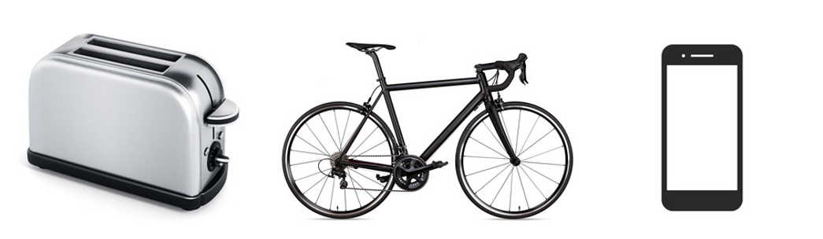
Sample answers:
- Skateboard
- Hair dryer
- Train

What engineered systems or products have you used today?
During the Think-Pair-Share activity, complete the table below for 3 engineered products. Consider how they might work and what materials they have been made from.
Table 2 – engineered products
Engineered product | How it might work | Materials used
Bicycle | As I pedal the front gear moves the chain that causes the rear tyre to move. The size of the gears makes it easier or harder to pedal the bicycle. | Steel

Force, motion and energy
Watch Newton's 3 Laws, with a bicycle – Joshua Manley (3:32).
Respond to the questions in the table below.
Note: sample answers have been provided.
Table 3 – Newton’s 3 Laws
Question | Answer
What is Newton's First law of motion, and how does it relate to the concept of inertia? Provide an example from everyday life. | Newton's First law of motion states that an object will stay at rest or keep moving in a straight line at a constant speed unless acted upon by an external force. Things like to keep doing what they're already doing. If something is still, it wants to stay still. If it's moving, it wants to keep moving.  If the car suddenly accelerates, you might feel like you're being pushed back into your seat. That's because your body wants to stay at rest while the car is starting to move.
According to Newton's second law of motion, what is the relationship between force, mass and acceleration? | The force needed to move an object is equal to the mass of the object multiplied by its acceleration. This means that heavier objects require more force to move the same amount as lighter ones.
Have you ever experienced the effects of inertia when riding a bicycle? Explain a situation where you noticed it. | When riding a bicycle, you experience inertia in various ways. If you're cycling and suddenly stop pedalling, the bike keeps moving forward for a while. Because of inertia the bike wants to keep moving even though you're not pedalling.
Why is it harder to start pedalling a bicycle compared to maintaining its speed once it's moving? | Starting to pedal a bicycle is harder because you're overcoming inertia. You need to apply enough force to start it moving. Once the bike is moving, it becomes easier to maintain speed because the bike's inertia helps it keep going.

Flight

Tumblewing flyer relay
Watch How to make a Tumblewing Walkalong Flyer (2:27).
Note: in place of watching the video, the teacher can demonstrate the tumblewing production and flight.
Practical activity
Make a tumblewing flyer, practise flying it and then have a relay race. Brainstorm answers to the questions below. Write your responses in the space provided.
Note: sample answers have been provided.
How does the tumblewing fly?
Sample answer:
As it descends, the wings catch the air. The design allows the wings to create lift even as they rotate or tumble.
How does the cardboard help the tumblewing stay in the air?
Sample answer:
The small distance allows for a phenomenon known as the ‘ground effect’. When flying close to a surface, the air pressure beneath the wings increases, which can enhance lift and improve stability during flight. This effect can be particularly beneficial during the initial phases of descent.

Generating lift
Figure 2 – forces acting on a plane in flight
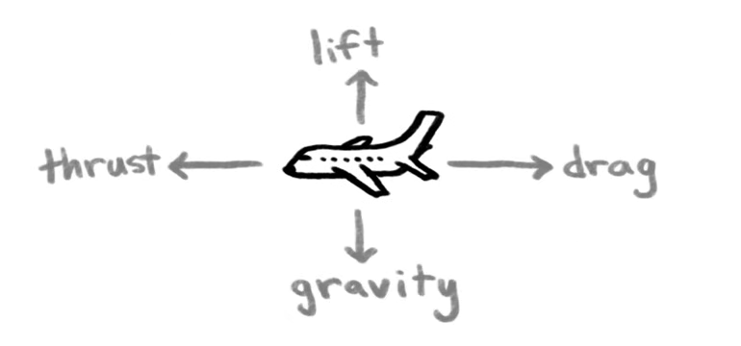
Watch How Do Airplanes Fly? (3:11).
Change the shape of the aerofoil below to create more lift. Annotate your sketch to explain why your shape generates lift.
Note: sample answers have been provided.
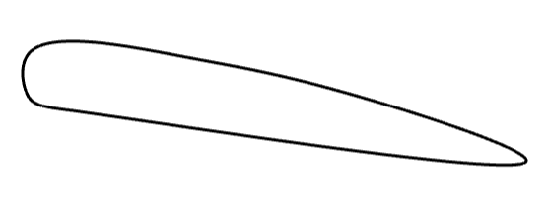

Identify flight characteristics applied to helicopters
Watch How Does a Helicopter Work: Everything You Need to Know About Helicopters (7:59).
Note: sample answers have been provided below.
Label the diagram of a helicopter to indicate the forces of ‘lift’, ‘weight’, ‘thrust’, and ‘drag’.
Figure 3 – helicopter
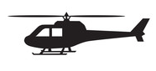
Explain how each force effects flight.
Sample answer:
Lift, thrust, drag, and weight are the 4 essential forces that affect flight. Lift is the upward force generated by the wings as air moves faster over them, allowing the aircraft to rise; it must exceed weight, the downward force due to gravity, for ascent. Thrust is the forward force produced by engines or propellers that propels the aircraft through the air, and it must overcome drag, the resistance force that opposes motion due to the aircraft's shape and surface characteristics. For stable flight, lift must equal weight, and thrust must equal drag, enabling the aircraft to maintain altitude and speed during various phases of flight.

Boomerang flight
Watch The First Inventors – Season 1, Episode 4 (0:00–12:34, 26:20–31:30) about the boomerang and David Unaipon’s inventive work using the boomerang to create vertical flight.
Note: in addition to watching The First Inventors, teachers should connect with community and local Aboriginal knowledge holders, inviting them to be part of the conversation around the traditional and modern use of boomerangs. These community members may choose to share their knowledge and demonstrate how boomerangs were and continue to be used. Students could also be provided with boomerangs to examine closely and, if culturally appropriate – with correct permissions, guidance from a local Aboriginal knowledge holder and access to a safe area – they may have the opportunity to fly them.
When was the boomerang invented?
Sample answer:
The boomerang was invented by Aboriginal people tens of thousands of years ago.
The First Inventors video states that the boomerang was invented around 10,000 years ago. The oldest known returning boomerang was found in South Australia and is estimated to be about 10,000 years old. However, Aboriginal oral histories and cultural practices suggest that boomerangs may have been used for tens of thousands of years prior, potentially up to 50,000 years, reflecting the long and continuous connection Aboriginal peoples have with Country.
Is the boomerang an aerofoil? Justify your response.
Sample answer:
Yes, a boomerang can be considered an aerofoil because it is designed to generate lift when thrown. An aerofoil is a shape that, when air flows over it, creates a difference in air pressure above and below the surface, resulting in lift.
When a boomerang is thrown, its wings are angled and shaped in such a way that air moves faster over the top surface than the bottom surface, creating lower pressure above the wing and higher pressure below. This pressure difference generates lift, allowing the boomerang to rise and, due to its unique shape and rotational motion, to return to the thrower.
Using a sketch, describe the air pressure around the boomerang.
Explain how a boomerang achieves lift.
Sample answer:
When a boomerang is thrown, its wings are angled in such a way that air moves faster over the top surface than the bottom surface, creating lower pressure above the wing and higher pressure below. This pressure difference generates lift, allowing the boomerang to rise and, due to its unique shape and rotational motion, to return to the thrower. In addition, the cross-section shape of the boomerang being thicker at the front causes air to flow over and under the boomerang in a way that produces lift.
Who first saw the link between the boomerang and powered flight?
Sample answer:
David Unaipon.
Describe David Unaipon’s theory of using the boomerang to produce vertical lift.
Sample answer:
David Unaipon, a Ngarrindjeri man from South Australia, was an Aboriginal Australian inventor and writer who developed a theory about how a boomerang generates lift, which was similar to the principles of aerodynamics. He proposed that the boomerang's curved shape and spinning motion through the air creates a difference in air pressure on its surfaces, much like an aerofoil. This difference in pressure generates lift, allowing the boomerang to stay aloft and return to the thrower. Unaipon's insights into the boomerang's flight dynamics demonstrated his deep understanding of both traditional knowledge and scientific principles.
Describe the performance of the first prototype that the UNSW students produced.
Sample answer:
The first prototype did rise above the ground as the rotors spun, however, the flight was not stable. The prototype moved from side to side and eventually crashed.
Explain why this test flight has special significance for Uncle Moogy Sumner.
Sample answer:
Uncle Moogy could see the knowledge of his ancestors come to life. He grew up knowing David Unaipon and seeing his theory applied and the truth of his knowledge was very special to him.
Compare the flight of the first prototype and last prototype.
Sample answer:
The first flight was difficult to control. The drone moved radically from side to side and was difficult to control. The second flight differed in that it flew much higher and could be controlled by the pilot on the ground, eventually landing safely.
Sketch your ideal cross section of a boomerang ‘arm’.

Rotor design

Rotor blade materials
Brainstorm the types of materials that could be used for real helicopter blades and toy helicopter blades. Document your responses in the table provided.
Note: if available, sample materials such as balsa, aluminium, carbon fibre and plastics could be presented for students to examine for such properties as weight and flexibility.
Sample answers have been provided below.
Table 5 – rotor blade materials
Real helicopter blades | Prototype toy helicopter blades
Aluminium  Carbon fibre  Wood  Titanium  Steel | Plastic  Balsa  Medium to large pine craft sticks

Idea development
Think-Pair-Share – students form into groups of 3–5 and each student a completes an annotated sketch of an aerofoil idea. Within their groups, students then share their understanding of how their idea will work.
Note: sample answers have been provided.
Table 6 – aerofoil cross section
Sketch of an aerofoil cross section
Table 7 – aerofoil cross section annotation
Annotation
This shape is thicker at the front than at the back, angled up and flat on the bottle. This is to encourage air flow to be quicker on top than on the bottom. This increases pressure underneath the aerofoil and therefore lift.

Annotated idea sketches
Individually produce 4 annotated sketches for aerofoil ideas.
Note: using the ideas from the previous activities, use students’ prior knowledge to sketch and annotate aerofoil ideas.
Sample answers are provided below.
Table 8 – annotated idea sketches
Sketch | Annotation
 | Round edges to encourage smooth air flow. Angled higher at the front to try and create high pressure and therefore lift on the underside of the aerofoil.

End of section student skills formative assessment checklist
Table 9 – skills assessment checklist
Students can | Checkbox
- explain how planes and helicopters fly. | ☐

Safety
Note: refer to Equipment Safety in Schools and Chemical Safety in Schools for current information on safety and safe working practices in Technology 7–8.

Safety rules in the timber workshop
For each image below, write the safety message for working safely in the timber workshop.
Note: sample answers have been provided.
Table 10 – safety rules in the workshop
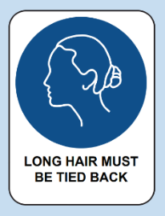 | 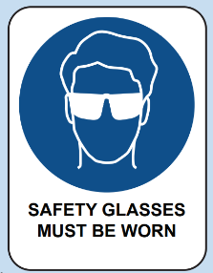 | 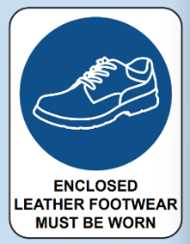
Tie hair back | Wear eye protection | Wear enclosed leather shoes
 | 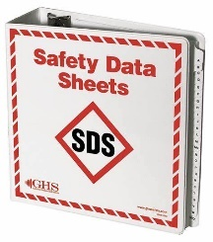 | 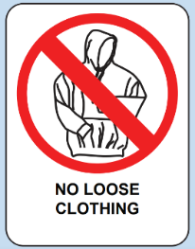
Hazard sign. Chemical Storage Area. | SDS Folder. Provides health and safety information about hazardous substances including first aid. | Remove ties and hoodies or tuck in.
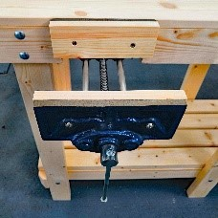 | 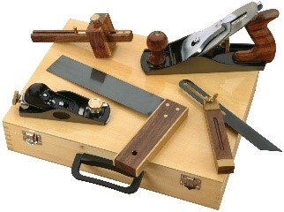 | 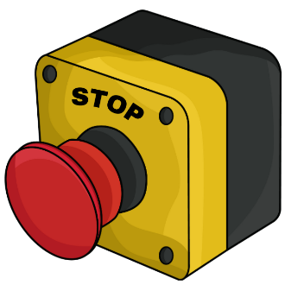
Clamp down materials. | Use tools appropriately and watch demonstrations carefully before use. | Turn power off after use and know where emergency stops are.

Hazards in the timber workshop
Watch Timber Technology - Workshop Walkthrough (5:37) (DoE staff only) and discuss as a class.

TAS safety resources
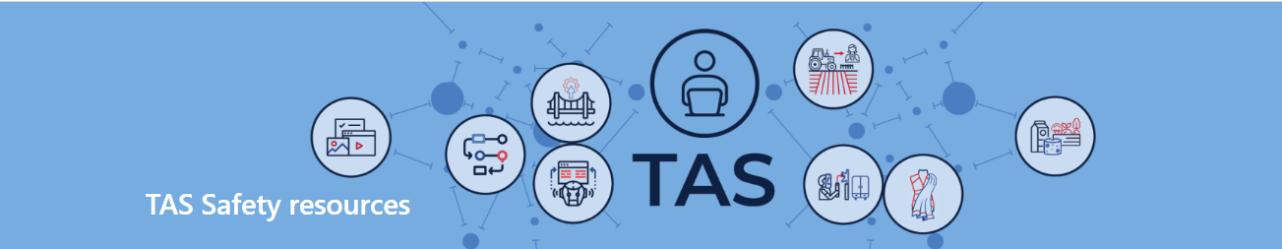
Note: the TAS Safety resources (sharepoint.com) are created for Department of Education schools, using relevant information from Equipment safety in schools (ESIS). These resources have been developed specifically for the equipment and machinery that has been approved for use in department schools.
Safety tests are mandated by ESIS for selected equipment and machinery.
The tests may be attempted in electronic or other formats with the result recorded and retained as per the Department's records management policy.
Students must provide the correct answer (with or without support) to each question on the safety test as evidence that they knew correct procedures at that point in time for the tool, equipment or machine. Students may attempt each test multiple times to achieve correct answers.

End of section student skills formative assessment checklist
Table 11 – skills assessment checklist
Students can | Checkbox
- know the safety requirements for the workshop, tools, equipment and machines. | ☐

Launcher

Manufacture
Practical activity
Students will be guided to complete each step of the ‘heli launcher’ project, watching teacher demonstration first, then by process of gradual release of responsibility, students will experiment with each tool, machine and technique.
Required resources for each student:
• Orthogonal drawing of launcher
• 200 mm × 90 mm × 6 mm plywood
• 200 mm × 30 mm × 19 mm radiata pine
• 300 mm × 9 mm dowel
• 10 mm aluminium tubing
• 12 mm radiata pine
• Small wood screws
• PVA adhesive
• String.
Teacher demonstrates each process step-by-step, highlighting safe practices and common mistakes. Engage students by asking them to identify potential hazards during the demonstration.
Note: using the production procedure can help pre-plan learning sequences and resources required.

Peer and self-evaluation

Quality control record
Note: continually engaging in quality control processes through self and peer evaluation can lead to increased product quality and improved processes. Students can engage in this activity at regular intervals as determined by the teacher.
A sample solution is provided in the table below.
Table 12 – production quality evaluation
Production step | Describe what have you done well | Describe what could be improved
Mark out sides to size | One side was made exactly to size. | The second side was not as accurate. I could use the accurate side as a template.

End of section student skills formative assessment checklist
Table 13 – skills assessment checklist
Students can | Checkbox
- accurately and safely produce components for an engineered solution. | ☐

Communicating engineering ideas
Practical activity
Introduce CAD software and demonstrates its use in small steps. The software selected should meet the school and student needs. Examples of potential use include:
- 3D modelling of the mechanism
- drawing an orthogonal to AS1100.
Students to complete drawing of project component.

CAD
CAD stands for Computer-aided design. It's a type of software that helps people create detailed drawings and models of objects, buildings, and even machines using a computer. CAD makes it easier to design and visualise ideas, allowing users to see how their creations will look and function before they are built. It is widely used in fields like architecture, engineering and product design.

3D modelling
3D modelling is the process of creating a three-dimensional representation of an object or scene using computer software. In 3D modelling, designers build a virtual version of something, which can be anything from a simple shape to a complex character or environment. These models can be viewed from different angles and manipulated just like real objects. 3D modelling is commonly used in industries like animation, video game design, architecture, and product development to visualise and present ideas before they are made in real life.
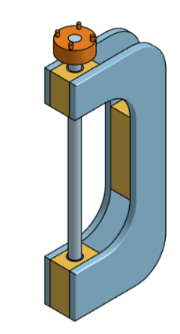

Orthogonal drawing
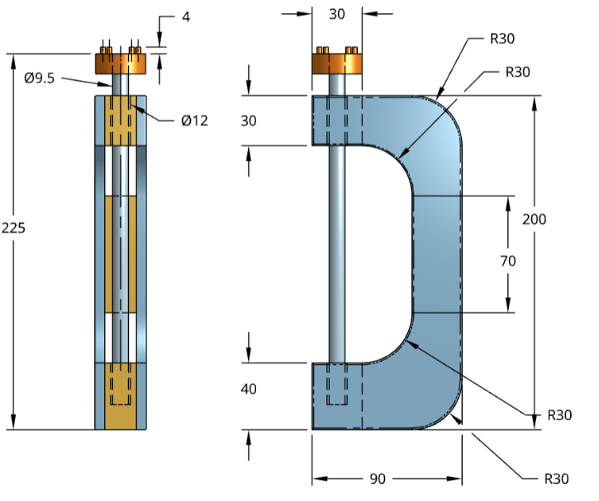Orthogonal drawing, according to AS1100, refers to a method of representing three-dimensional objects in 2 dimensions using multiple views, typically the front, top and side views. AS1100 is the Australian Standard for technical drawing, which provides guidelines for creating clear and accurate engineering drawings. In orthogonal drawing, each view shows only 2 dimensions, but when combined, they provide a complete picture of the object's shape and size. This method is essential for accurately conveying design specifications in engineering and architecture.

End of section student skills formative assessment checklist
Table 14 – skills assessment checklist
Students can | Checkbox
- produce a drawing to aid with the production of an engineered solution. | ☐

Materials
Note: using the ideas from the previous activities, use students’ prior knowledge to develop a collaborative class discussion.
Engineers consider a wide range of materials such as timber, composite materials, polymers and metals when developing engineered solutions. Properties such as strength, durability, weight and workability will be taken into consideration to ensure the correct materials are selected.

Material properties applied to engineering projects

Materials research
Jigsaw – form students into groups of 3–5 with each student researching and describing the properties of one material. Each student shares their understanding their material with the group. The group selects and justifies the most appropriate materials.
Potential materials to consider:
- plywood
- radiata pine
- aluminium
- acrylic
- mild steel
- balsa
- cardboard
- PVC.

Note: sample answers have been provided below.
Table 15 – material descriptions
Material | Description
Plywood | Plywood is lightweight and is made from thin layers of wood veneer glued together, enhancing its strength and stability.
Radiata pine | Radiata pine is lightweight and has good strength and durability, with a fine and even texture that allows for easy finishing.
Aluminium | Aluminium is a lightweight, corrosion-resistant metal with excellent strength-to-weight ratio. It is highly malleable.
Balsa | Balsa wood is a very lightweight wood with a high strength-to-weight ratio. It has a fine grain and can be easily cut and shaped.
Cardboard | Cardboard is a lightweight and versatile material but can be easily damaged if not handled properly.

Material selection and justification
Note: sample answers are provided below.
Table 16 – material selection and justification
Material selected | Justification
Plywood | Plywood would be suitable for the sides of the launcher due to its strength and availability in thin sheets.

Adhesives
Using the information in the table, rank the adhesives from most to least suitable for the joining radiata pine to plywood.
Note: sample answers are provided below.
Table 17 – adhesive ranking
Adhesive | Rank
Contact adhesive is a strong glue that bonds on contact. You apply it to both surfaces, let it dry for a bit, and then press them together. This type of adhesive is useful for projects that require a strong, immediate bond.
Epoxy is a two-part adhesive made up of a resin and a hardener. When mixed together, it creates a super-strong bond that can fill gaps and is resistant to heat and chemicals. It is ideal for more demanding projects like bonding metal.
PVA (polyvinyl acetate) is a white, water-based glue that dries clear and is also known as school glue or craft glue. It’s easy to clean up with water before it dries. Its commonly used in woodwork.
Hot glue is a thermoplastic adhesive that comes in solid sticks and is applied using a hot glue gun. When heated, the glue melts and can be applied to various surfaces. It cools and hardens quickly, forming a strong bond. Students often use it for making models, assembling decorations, or attaching different materials together, like fabric, wood and plastic.
Gorilla glue is a polyurethane adhesive that expands as it dries, creating a very strong bond. It’s brown and can be a bit messy, so it’s important to use it carefully. It’s great for heavy-duty projects and can bond wood, metal and ceramics.

End of section student skills formative assessment checklist
Table 18 – skills assessment checklist
Students can | Checkbox
- identify materials to use in each component and explain why. | ☐

Rotor

Manufacture
Practical activity
Students will be guided to complete each step of the ‘heli launcher’ project, watching the teacher demonstration first. Then, by process of gradual release of responsibility, students will experiment with each tool, machine and technique.
Required resources for each student:
• sketches of blade design
• milk bottle lid
• large paddle pop sticks or balsa
• 300 mm × 9.5 mm dowel
• tub of water
• masking tape
• hot glue.
Teacher demonstrates each process step-by-step, highlighting safe practices and common mistakes. Engage students by asking them to identify potential hazards during the demonstration.
Note: using the production procedure can help pre-plan learning sequences and resources required.

Peer and self-evaluation

Quality control record
Note: continually engaging in quality control processes through self and peer evaluation can lead to increased product quality and improved processes. Students can engage in this activity at regular intervals as determined by the teacher.
A sample solution is provided in the table below.
Table 19 – production quality evaluation
Production step | Describe what have you done well | Describe what could be improved
Rotor blade curves | The rotor blades all curved consistently when wet, bent using the dowel and taped down overnight. | Cutting the blades to shape before bending could have made future steps more accurate.

End of section student skills formative assessment checklist
Table 20 – skills assessment checklist
Students can | Checkbox
- Accurately and safely produce components for an engineered solution.
- Test, collaboratively evaluate and apply rectification measures.

Collaborative flight evaluation

How does rotor design impact lift?
Brainstorm how rotor designs impact lift. This will help to conceptualise any changes to shapes, angles and dimensions that may be needed to carry as you test, evaluate and rectify your helicopter.
Note: using the ideas from the previous activities, encourage students to consider Newton’s Laws (force, energy and motion) and lift, drag, thrust and weight when brainstorming their responses.

How does your rotor design impact lift?
Sample response:
- Blade shape and aerofoil design: the shape of the rotor blades, including their aerofoil profile, directly influences the lift generated.
- Angle of attack: the angle at which the rotor blades meet the oncoming air (angle of attack) is crucial for lift generation. Adjusting this angle allows pilots to control lift; a higher angle increases lift to a certain point before causing stall.
- Blade pitch: the pitch of the blades can be adjusted to change the angle of attack throughout the rotor's rotation, allowing for variable lift during different flight conditions, such as take-off, hovering and landing.
- Blade number and configuration: the number of blades can affect how lift is distributed and how the helicopter responds to different flight manoeuvres. More blades can increase lift but may also increase drag.
- Material and weight: the materials used for rotor blades impact their weight and stiffness, which in turn affects their ability to generate lift and respond to aerodynamic forces. Lightweight, strong materials allow for more efficient designs that enhance lift.

Criteria for success
Engineers test and evaluate engineered products to ensure that they are safe, fit for purpose and meet quality control measures. The following table has established criteria to aid with evaluating your prototypes.
Note: in this activity, students develop an understanding of the criteria that their protype will be evaluated on. Teachers can also consider working with students to write their own criteria.
Table 21 – criteria for success
Specification | High | Medium | Low
Height | Rotor reaches a height of 5 metres or more. | Rotor reaches a height between 3 and 5 metres. | Rotor reaches a height of less than 3 metres.
Airtime | Rotor stays airborne for 5 seconds or more. | Rotor stays airborne for 3–5 seconds. | Rotor stays airborne for less than 3 seconds.
Trajectory | Rotor follows a straight, stable path with minimal deviation. | Rotor follows a somewhat stable path with moderate deviation. | Rotor has an erratic trajectory with significant deviation.
Durability | Rotor shows no signs of damage after 10 flights. | Rotor shows minor wear and tear but functions after 10 flights. | Rotor is damaged or non-functional after 10 flights.
Repeatability | Rotor performs consistently (same height and airtime) across 5 consecutive flights. | Rotor shows some variation in performance across 5 flights. | Rotor performance varies widely across 5 flights, with inconsistent results.

Flight tests
Practical activity
Allocate students to small groups. After explaining and demonstrating safe launching procedures. Students are to observe and record each other’s flights documenting each test in accordance with the criteria for success. Students should be encouraged to compare designs and flight to help make suggestions for improvements.
Note: highlight safety precautions for launching, including one person in the launch area and wearing safety glasses.

Test 1
Table 22 – flight test 1 notes
Specification | Flight notes
Height
Airtime
Trajectory
Durability
Repeatability

Test 2
Table 23 – flight test 2 notes
Specification | Flight notes
Height
Airtime
Trajectory
Durability
Repeatability

Test 3
Table 24 – flight test 3 notes
Specification | Flight notes
Height
Airtime
Trajectory
Durability
Repeatability

Test 4
Table 25 – flight test 4 notes
Specification | Flight notes
Height
Airtime
Trajectory
Durability
Repeatability

Test 5
Table 26 – flight test 5 notes
Specification | Flight notes
Height
Airtime
Trajectory
Durability
Repeatability

Test 6
Table 27 – flight test 6 notes
Specification | Flight notes
Height
Airtime
Trajectory
Durability
Repeatability

Ongoing flight evaluation
Using your test data, notes and criteria for success, consider the following questions:
- Does your helicopter consistently fly to a satisfactory height?
- Is the launcher comfortable to hold and efficient to operate?
Explain in the space below.
Note: sample answers are provided in the space below.
The helicopter consistently launched to a height of around 3.5 metres. One time it flew much higher.
The pull string was sometimes difficult to hold and grip onto.
There were 5 successful launches but on the 6th attempt one of the rotor blades broke.

Rotor blade adjustments
Describe any changes that you made to your rotor design because of your testing and evaluation. Did your changes have a positive or negative on your helicopter flight?
Note: sample answers are provided in the space below.
I applied more glue to the broken rotor blade.
I noticed other rotors that flew higher had blades at a different angle to mine.
I trimmed 10mm from my rotor blades. This enabled the helicopter to fly consistently higher.

Final evaluation
Using the criteria for success below, assess how your project achieves for each specification. Explain the reasons for your selections in the box below.
Note: if students developed their own criteria in an earlier activity, the student’s own criteria should be used.

Table 28 – criteria for success
Specification | High | Medium | Low
Height | Helicopter reaches a height of 5 metres or more. | Helicopter reaches a height between 3 and 5 metres. | Helicopter reaches a height of less than 3 metres.
Airtime | Helicopter stays airborne for 5 seconds or more. | Helicopter stays airborne for 3–5 seconds. | Helicopter stays airborne for less than 3 seconds.
Trajectory | Helicopter follows a straight, stable path with minimal deviation. | Helicopter follows a somewhat stable path with moderate deviation. | Helicopter has an erratic trajectory with significant deviation.
Durability | Helicopter shows no signs of damage after 10 flights. | Helicopter shows minor wear and tear but functions after 10 flights. | Helicopter is damaged or non-functional after 10 flights.
Repeatability | Helicopter performs consistently (same height and airtime) across 5 consecutive flights | Helicopter shows some variation in performance across 5 flights. | Helicopter performance varies widely across 5 flights, with inconsistent results.

Heli hang time competition
Conduct a rotor verse rotor knockout competition where the rotor with the longest airtime is victorious. Only the airtime of the rotor that stays intact is measured.
This is the ultimate test of flight and durability.
Note: this activity is a suggestion. Any competition can be used.
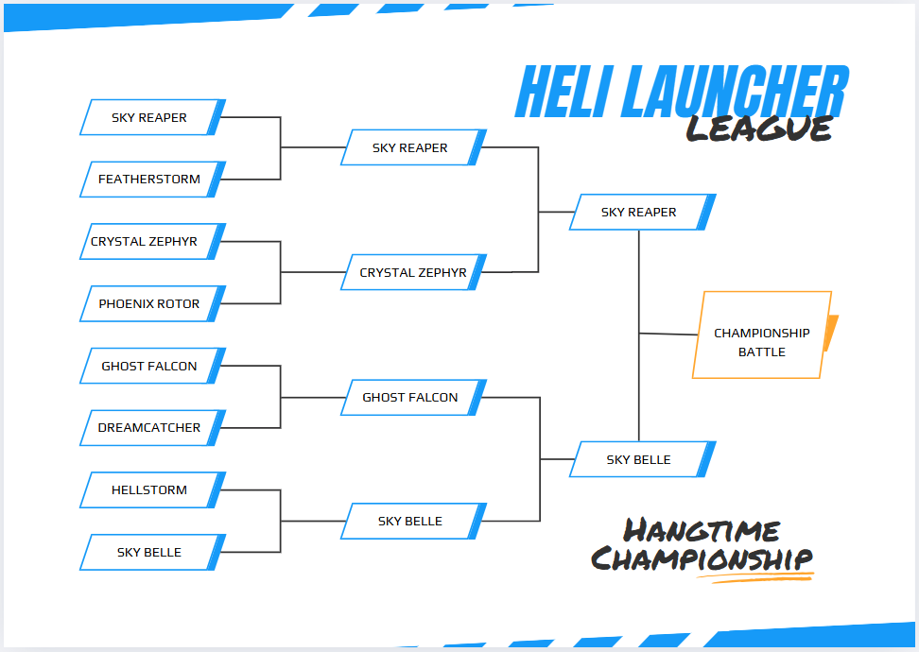

End of section student skills formative assessment checklist
Table 29 – skills assessment checklist
Students can | Checkbox
- test, collaboratively evaluate and apply rectification measures

References
This resource contains NSW Curriculum and syllabus content. The NSW Curriculum is developed by the NSW Education Standards Authority. This content is prepared by NESA for and on behalf of the Crown in right of the State of New South Wales. The material is protected by Crown copyright.
Please refer to the NESA Copyright Disclaimer for more information https://educationstandards.nsw.edu.au/wps/portal/nesa/mini-footer/copyright.
NESA holds the only official and up-to-date versions of the NSW Curriculum and syllabus documents. Please visit the NSW Education Standards Authority (NESA) website https://educationstandards.nsw.edu.au/ and the NSW Curriculum website https://curriculum.nsw.edu.au/home.
Technology 7–8 Syllabus © NSW Education Standards Authority (NESA) for and on behalf of the Crown in right of the State of New South Wales, 2023.
Berhrendt L (2023) ‘Navigating The Future’ [television program], The First Inventors (season 1, episode 4), Network Ten, Sydney.
minutephysics (9 April 2015) 'How Do Airplanes Fly?' [video], minutephysics, YouTube, accessed 1July 2025.
Ottawa Citizen (8 January 2014) 'How to make a Tumblewing Walkalong Flyer' [video]’, Ottawa Citizen, YouTube, accessed 8 July 2025.
Science ABC (26 December 2019) 'How Does A Helicopter Work: Everything You Need To Know About Helicopters' [video], Science ABC, YouTube, accessed 8 July 2025.
TED-Ed (20 September 2012) ‘Newton's 3 Laws, with a bicycle’ [video], TED-Ed, YouTube, accessed 15 February 2025.

© State of New South Wales (Department of Education), 2025
The copyright material published in this resource is subject to the Copyright Act 1968 (Cth) and is owned by the NSW Department of Education or, where indicated, by a party other than the NSW Department of Education (third-party material).
Copyright material available in this resource and owned by the NSW Department of Education is licensed under a Creative Commons Attribution 4.0 International (CC BY 4.0) license.

This license allows you to share and adapt the material for any purpose, even commercially.
Attribution should be given to © State of New South Wales (Department of Education), 2025.
Material in this resource not available under a Creative Commons license:
- the NSW Department of Education logo, other logos and trademark-protected material
- material owned by a third party that has been reproduced with permission. You will need to obtain permission from the third party to reuse its material.
Links to third-party material and websites
Please note that the provided (reading/viewing material/list/links/texts) are a suggestion only and implies no endorsement, by the New South Wales Department of Education, of any author, publisher, or book title. School principals and teachers are best placed to assess the suitability of resources that would complement the curriculum and reflect the needs and interests of their students.
If you use the links provided in this document to access a third-party's website, you acknowledge that the terms of use, including licence terms set out on the third-party's website apply to the use which may be made of the materials on that third-party website or where permitted by the Copyright Act 1968 (Cth). The department accepts no responsibility for content on third-party websites.

