Technology 7–8 –Engineering technologies and systems – teacher resource – steps in production
Heli launcher (10-week unit)

Contents
The Heli launcher 2
Steps in production 3
Launcher handle 3
Spindle and launching plate 15
Alternative solutions 19
Hub and rotor design 20
Experimenting with ideas 22
References 24

The Heli launcher
The Heli launcher is a fun project for all students. Construction introduces a range of skills essential to the production of quality-engineered solutions. The project develops deep knowledge and understanding of key engineering principles in additional to developing students’ practical skills. Explicit teaching strategies are integral in the delivery of this unit.
The project provides opportunities for substantial student input. The examples given in this document provide a step-by-step guide in production leading to student success for a variety of student abilities. With more proficient cohorts, all aspects of production may be reviewed, changed and documented to suit an individual student’s personal circumstances. Some suggestions will be made for alternative solutions.
Helicopters typically have between 2 and 5 blades. This unit will provide students with the opportunity to test and evaluate blade size, shape, number and angle of attack.
Note: refer to Equipment Safety in Schools, and Chemical Safety in Schools for current information on safety and safe working practices in Technology 7–8.

Steps in production

Launcher handle
Materials
- 2 pieces of 200 mm × 90 mm × 6 mm plywood
- 1 piece of 150 mm × 30 mm × 19 mm radiata pine
Instruction | Reference image
Mark out profiles for the launcher handle as per the plans provided using rule and try square (alternatively use a template).  Students complete marking out, clearly indicating wastage and cutting lines. | 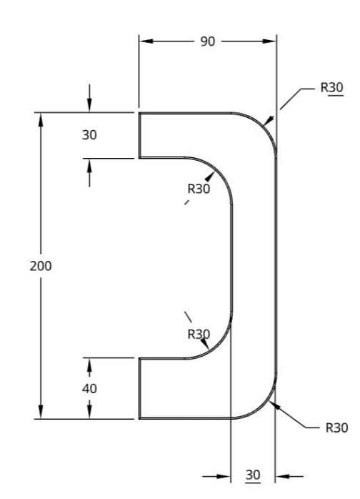  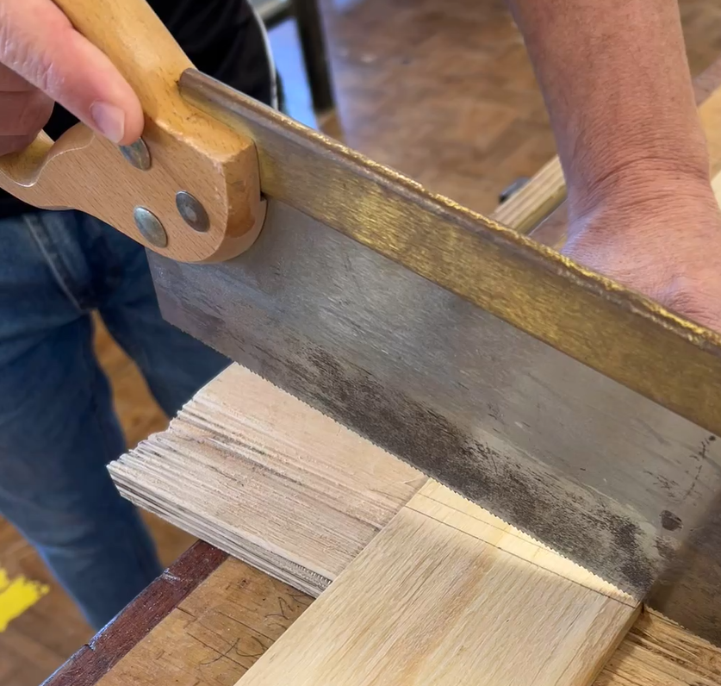  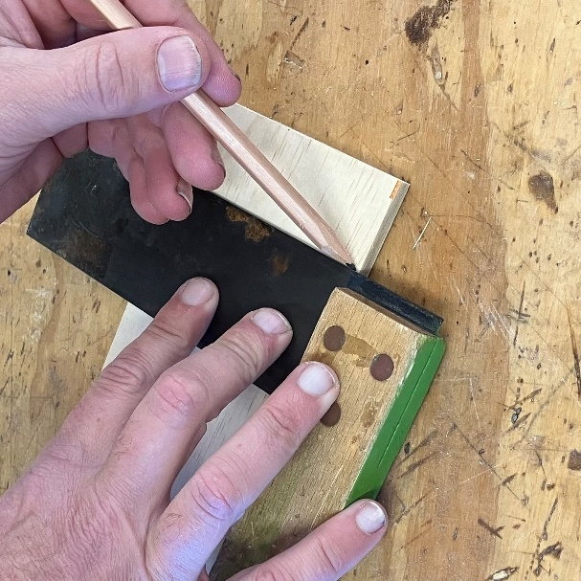  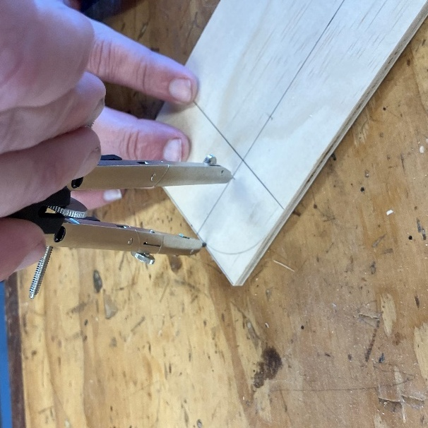
Pin the 2 sides together using 12 mm panel pins.  Cut sides using coping saw or scroll saw.  Optional: drill clearance holes for internal corners. | 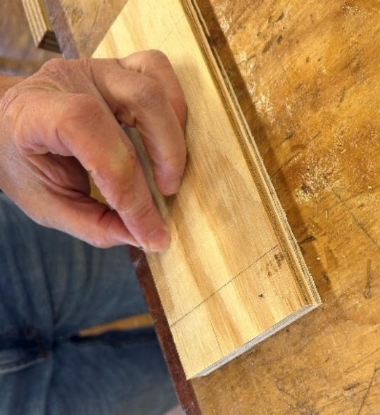  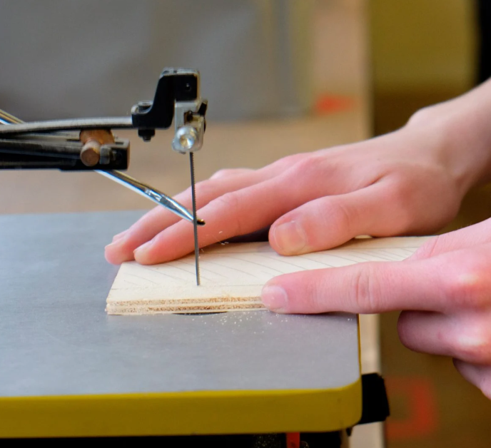  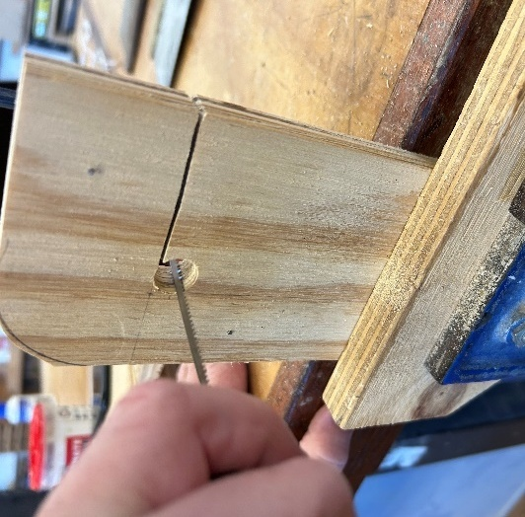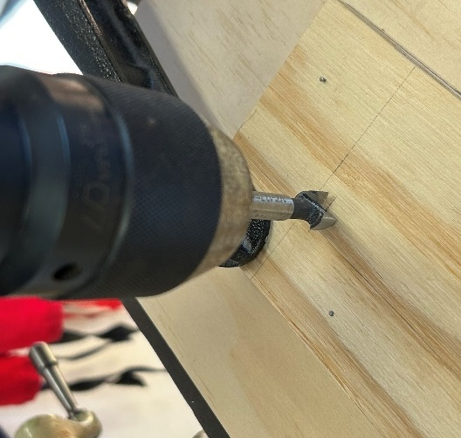
Sand smooth, focusing on the internal edges. External edges are to be tidied after final assembly. | 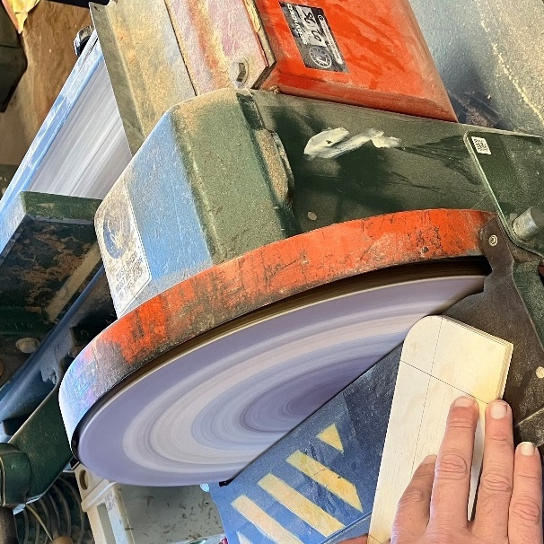
Mark out the 3 handle blocks for launcher as per the plans provided using rule and try square. This will include marking the centre for the spindle holes on the top block.  Cut the 70 mm handle block to length. Leave the top and base blocks uncut. | 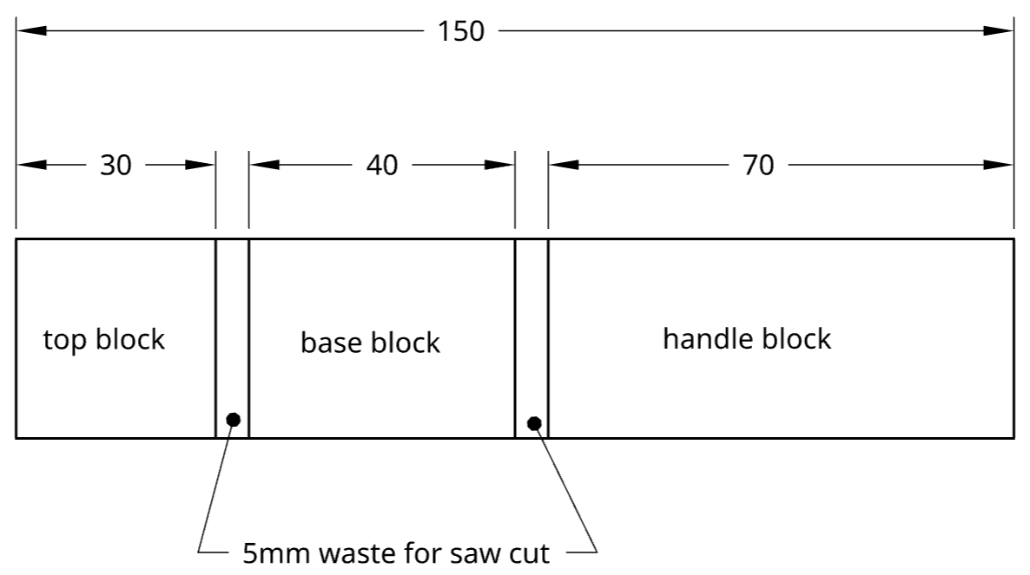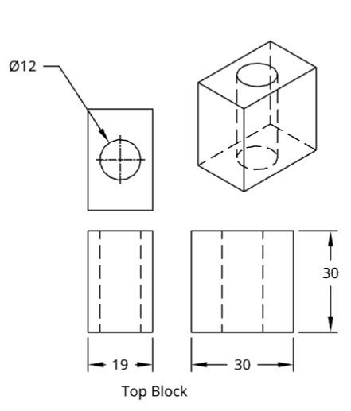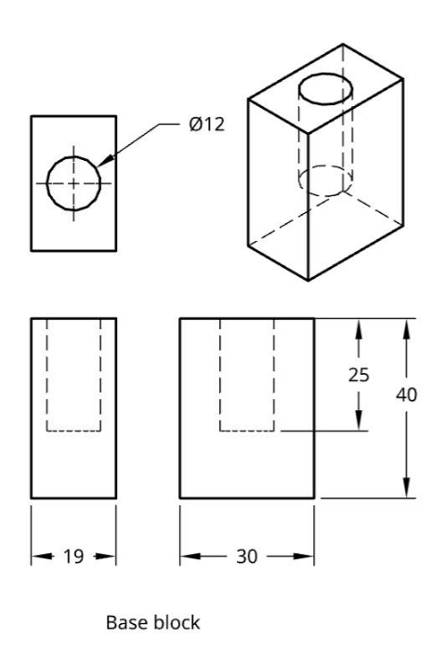  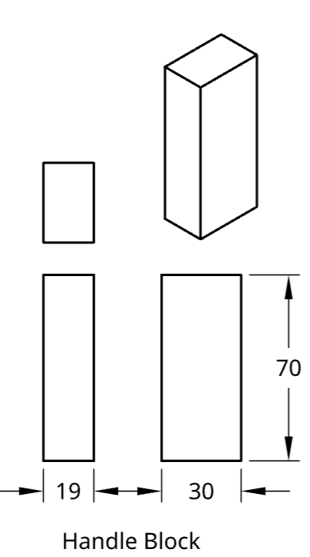
Do not cut the base or top spindle blocks to length yet.  Mark the centre point using diagonals on the top block. | 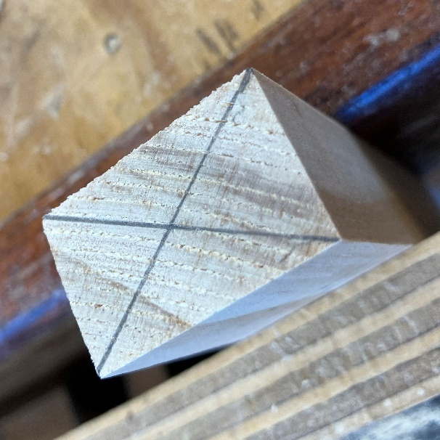
Set the depth stop on the drill press to 50 mm below the top surface.  Drill hole through top block and base spindle blocks using pedestal drill. Teacher ensures safety demonstration and references to the SOP.  Optional: create a jig to secure the block whilst drilling. | 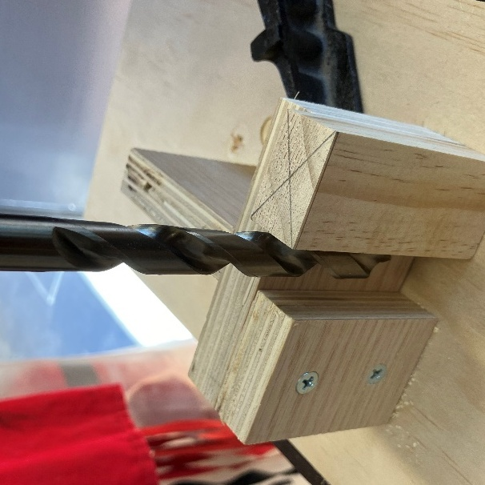  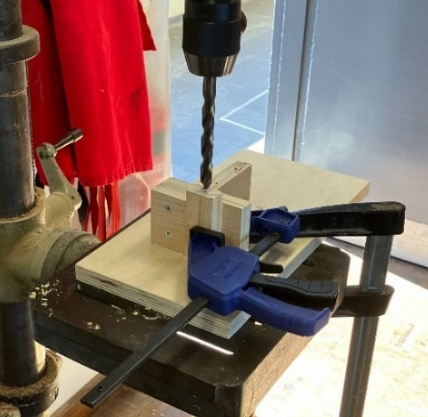
After drilling, cut the top and bottom blocks to length. | 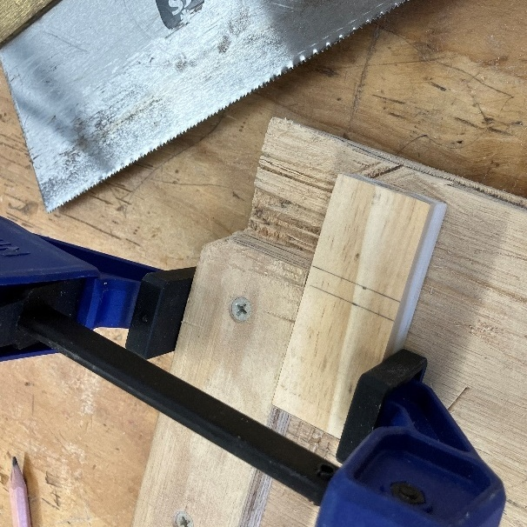  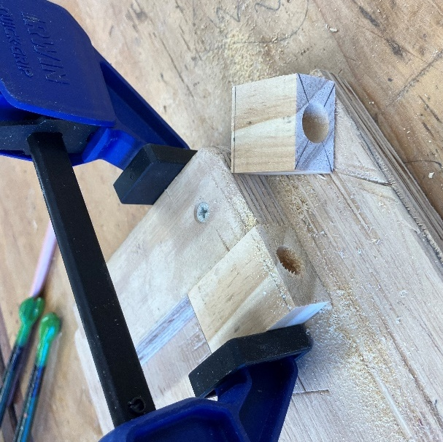
Cut aluminium tube to 50 mm. Remove burrs or sharp edges with a file. | 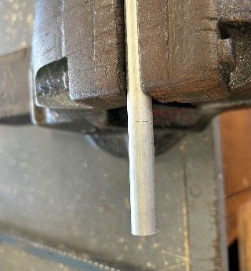  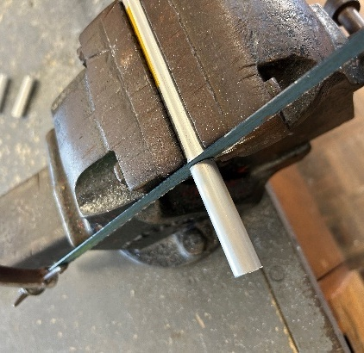
Insert the aluminium tube into the timber (both pieces) and cut to length. Use a file to ensure the tube is flush with the timber surfaces. | 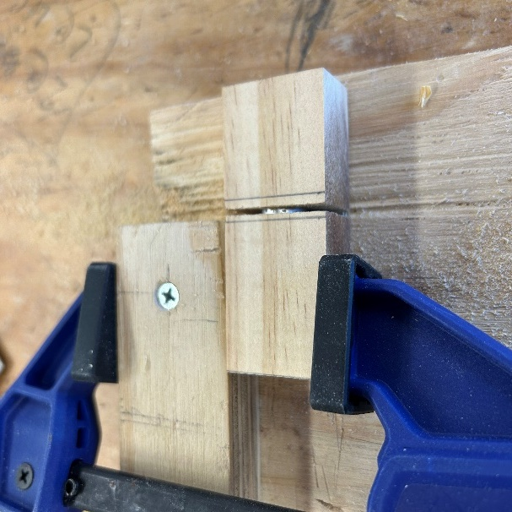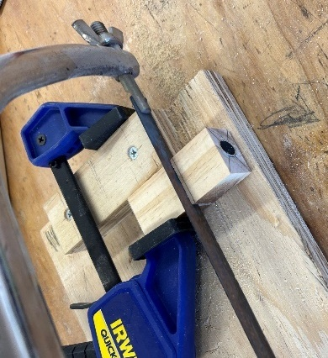  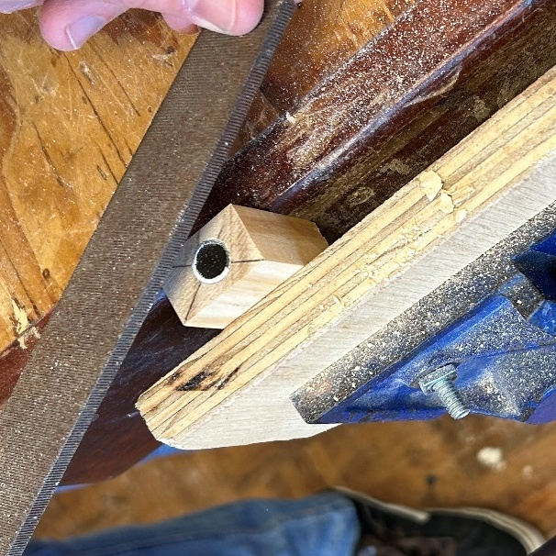
Assemble and glue handle. Panel pins can be used to secure the sides to the blocks whilst the glue dries.  Note: when positioning the top and base blocks housing the spindle, use a piece of 9.5 mm dowel to ensure holes are in alignment before securing.  Avoid glue around the spindle and ensure to wipe excess with a wet sponge or rag. | 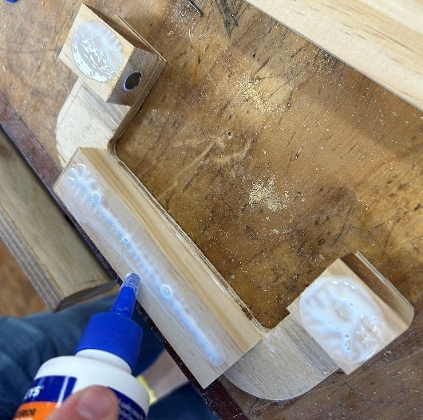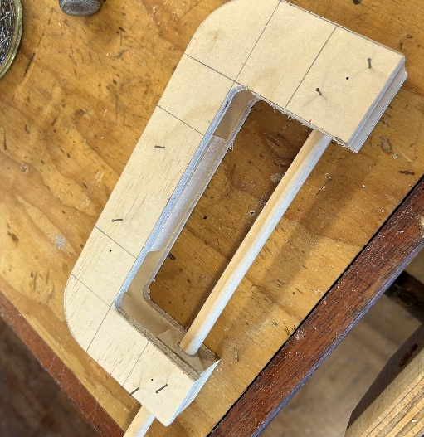  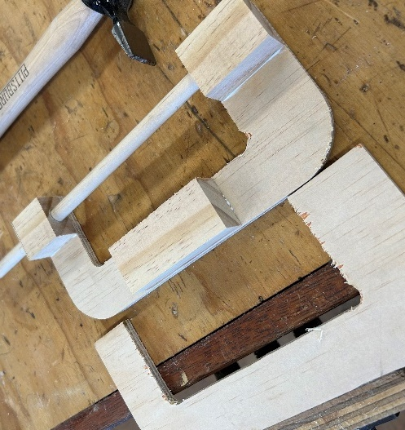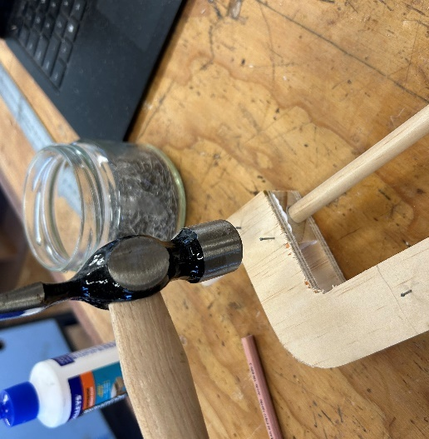  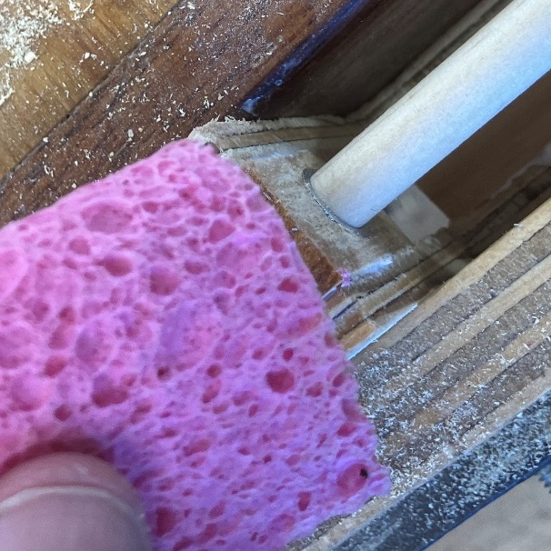
Sand and prepare all surfaces for an appropriate timber finish. | 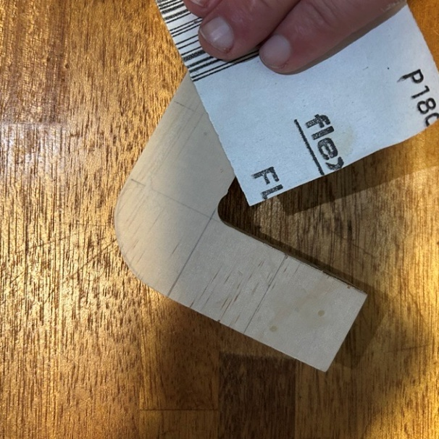
Apply a suitable timber finish.  Note: avoid liquid-based finishes from entering the aluminium-lined holes. | Options include:  - oil  - wax  - polyurethane timber finishes  - acrylic paints  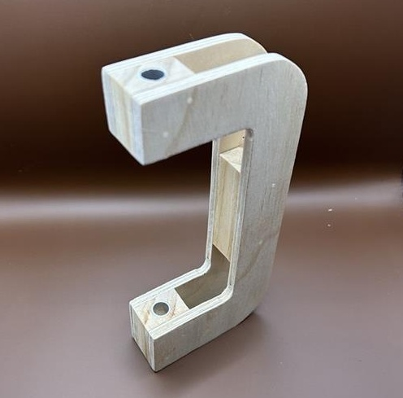

Spindle and launching plate
Note: this is a suggested prototype design.
Instruction | Reference image
Mark out centre of launching plate in accordance with plans.  Mark out position for locating pins. | 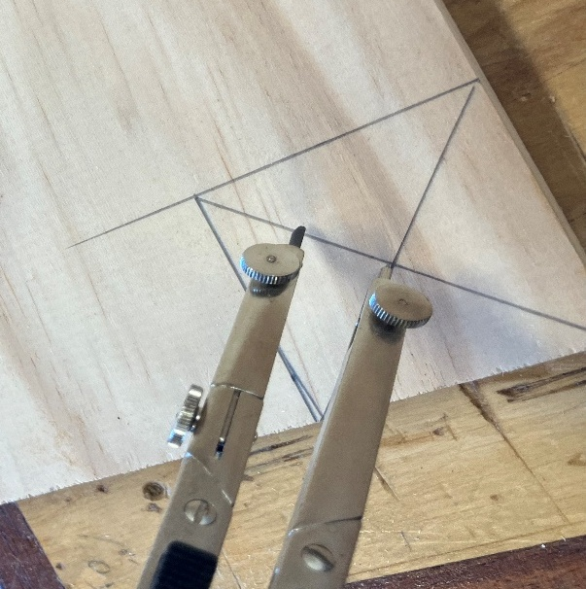
Cut launching plate disc using 30 mm hole saw. | 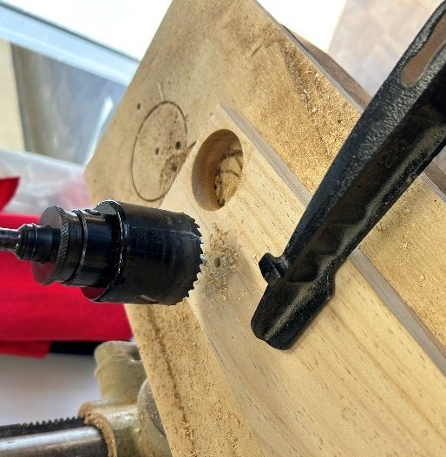
Enlarge the launching plate centre to 9.5 mm. To fit dowel spindle.  Secure the launching plate in a vice supported by material underneath to avoid tear out. | 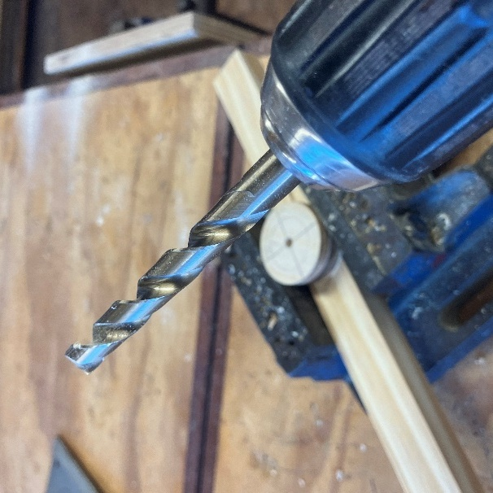
Drill pilot holes to house pins or screws. | 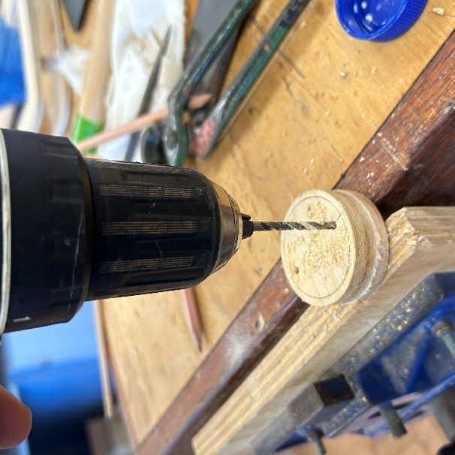
Carefully sand the launching plate smooth. | 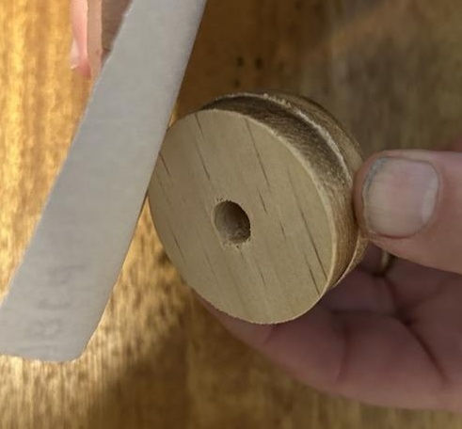
Screw in rotor hub locating screws. Or insert pins as per student design.  Note: this is a suggested prototype design. | 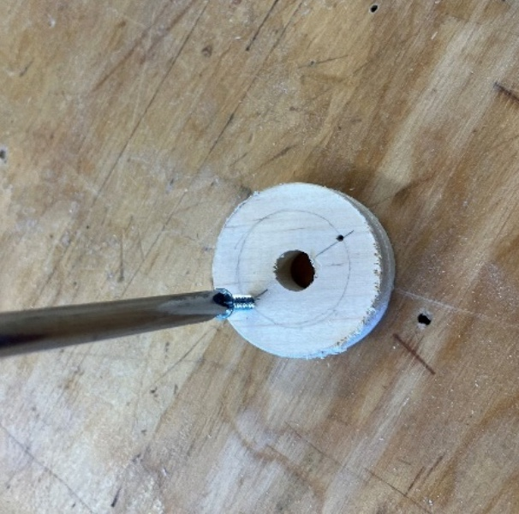
Mark and cut dowel to length ensure a gap can be achieved between the launcher handle and launching plate.  (Approximately 225 mm.) | 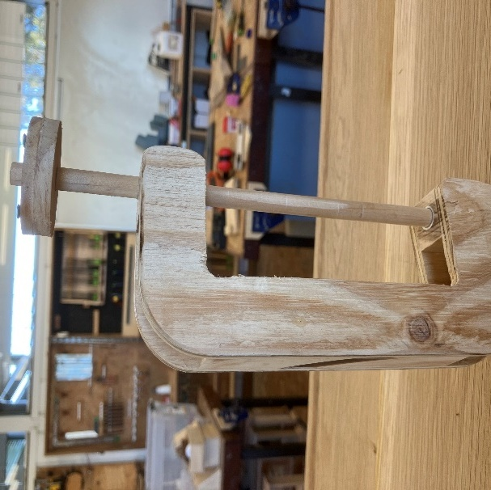
Glue spindle and launching plate.  Optional: the spindle could protrude 10 mm above the surface of the launching plate to assist locating the rotor hub. | 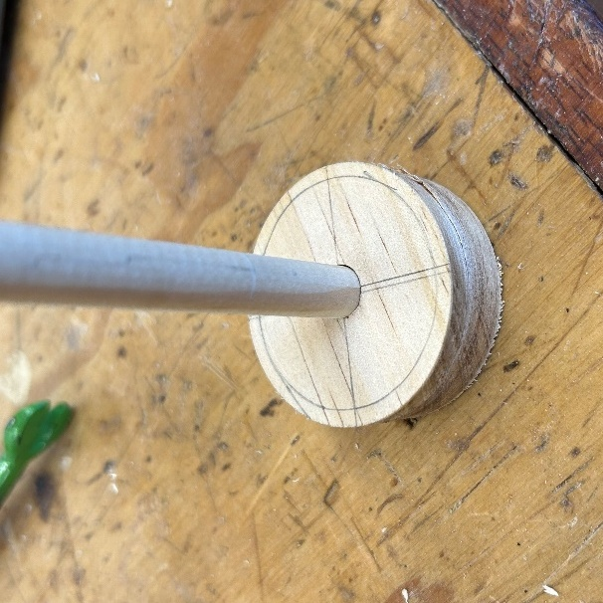
Optional: drill 2 mm diameter (or appropriate) hole in spindle to attach/ secure the pull string. | 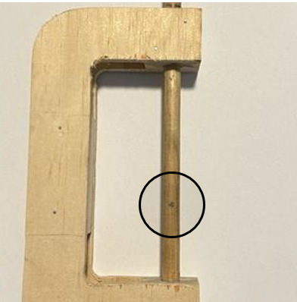
Optional: using a timber wax or dry soap will reduce the friction between the spindle and the aluminium housing. | 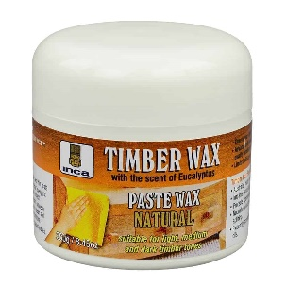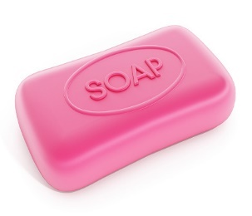
Finished Heli launcher. | 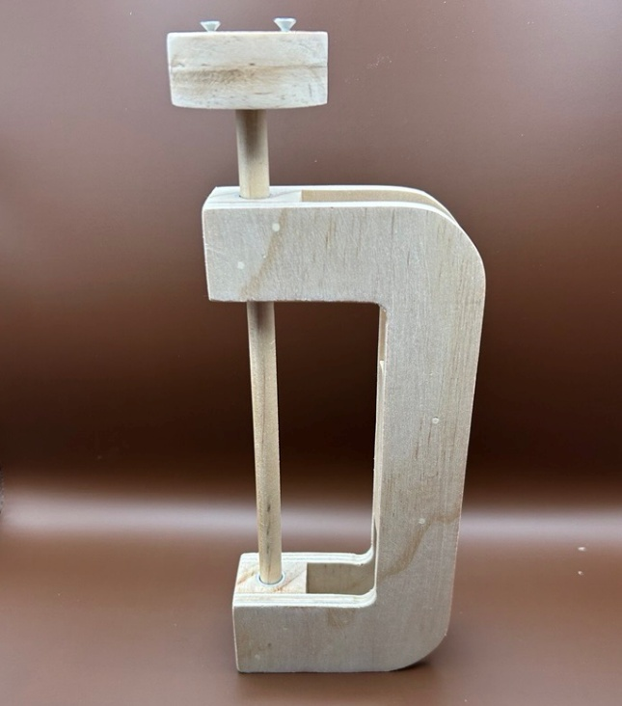

Alternative solutions
The project provides opportunities for individual student input into the design, engineering and production of the rotor hub and blades to achieve maximum lift. In delivering the project and developing student skills and knowledge, a range of final products may be produced, tested and evaluated.
The provided solution, using medium tongue depressors, a milk bottle lid and hot glue has been tested, consistently producing considerable lift above 5 m.
It is encouraged to experiment with other solutions. These may involve 3D printing, laser cutting or other methods.

Hub and rotor design
Note: this is a suggested prototype design.
Instructions | Reference image
Prior to installing the locking screws in the launcher, use panels pins to locate the centre for the docking holes in the rotor hub (bottle top). | 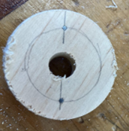  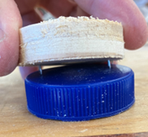
Drill 3 holes. One in the centre of the cap to allow clearance of spindle and 2 where the screws from the launch plate will engage the hub. | 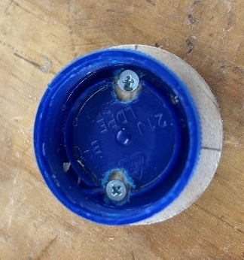
Soak 4 tongue depressors (rotor blades) in water and bend over a piece of dowel. Tape in place and leave for 24 hours. | 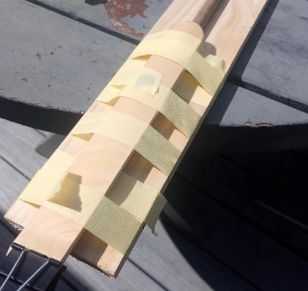
Shape one rotor blade to the required shape as designed by the students. Include a curve where the blade attaches to the hub.
Attach rotor blade to hub using hot glue, ensuring all blades have the same angle of attack. | 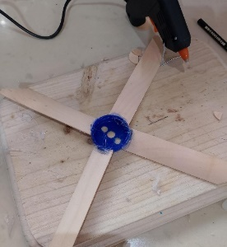
Test, evaluate, document and adjust.  Safety  Eye protection is essential when testing the Heli launcher.  A suitable open area is required such as a school oval. | 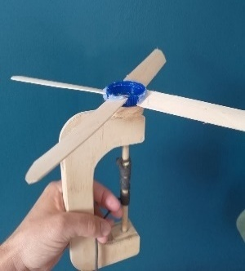

Experimenting with ideas
Students should be encouraged to engineer, test and evaluate potential solutions such as those in the table below.
Types of experimentation | Reference image
Experimenting with different blade materials. | 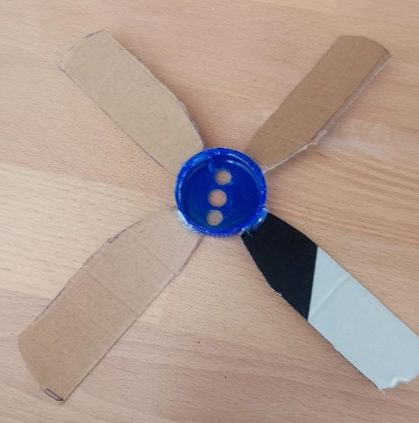
Experimenting with different blade shapes.  This could be done with physical experiments as shown or through digital simulations. | 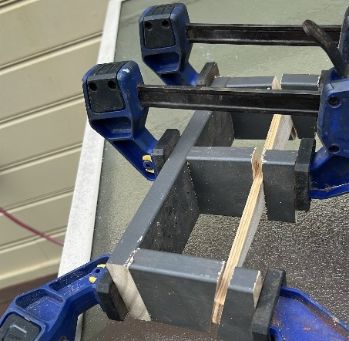
Experimenting with different hub designs considering 3D printing. These may include accompanying launching plates. | 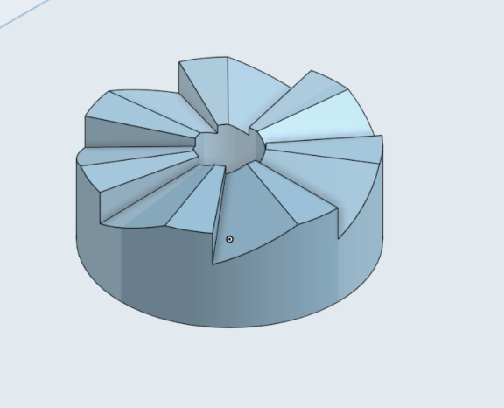
Experimenting with hub and blade materials. This may also include laser cutting and 3D printing options. | 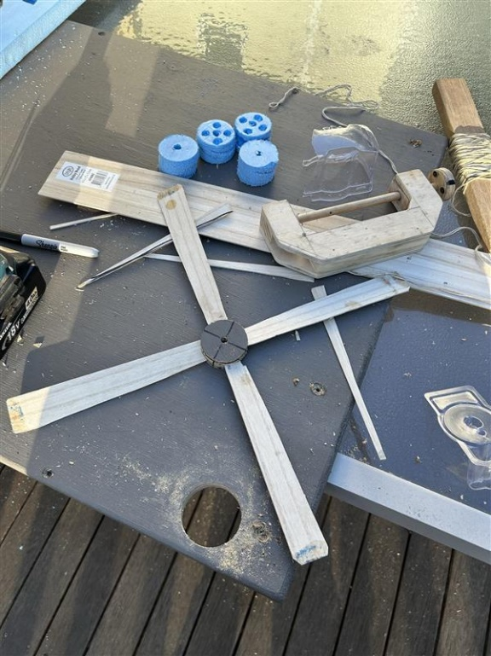

References
This resource contains NSW Curriculum and syllabus content. The NSW Curriculum is developed by the NSW Education Standards Authority. This content is prepared by NESA for and on behalf of the Crown in right of the State of New South Wales. The material is protected by Crown copyright.
Please refer to the NESA Copyright Disclaimer for more information https://educationstandards.nsw.edu.au/wps/portal/nesa/mini-footer/copyright.
NESA holds the only official and up-to-date versions of the NSW Curriculum and syllabus documents. Please visit the NSW Education Standards Authority (NESA) website https://educationstandards.nsw.edu.au/ and the NSW Curriculum website https://curriculum.nsw.edu.au/home.
Technology 7–8 Syllabus © NSW Education Standards Authority (NESA) for and on behalf of the Crown in right of the State of New South Wales, 2023.

© State of New South Wales (Department of Education), 2025
The copyright material published in this resource is subject to the Copyright Act 1968 (Cth) and is owned by the NSW Department of Education or, where indicated, by a party other than the NSW Department of Education (third-party material).
Copyright material available in this resource and owned by the NSW Department of Education is licensed under a Creative Commons Attribution 4.0 International (CC BY 4.0) license.

This license allows you to share and adapt the material for any purpose, even commercially.
Attribution should be given to © State of New South Wales (Department of Education), 2025.
Material in this resource not available under a Creative Commons license:
- the NSW Department of Education logo, other logos and trademark-protected material
- material owned by a third party that has been reproduced with permission. You will need to obtain permission from the third party to reuse its material.
Links to third-party material and websites
Please note that the provided (reading/viewing material/list/links/texts) are a suggestion only and implies no endorsement, by the New South Wales Department of Education, of any author, publisher, or book title. School principals and teachers are best placed to assess the suitability of resources that would complement the curriculum and reflect the needs and interests of their students.
If you use the links provided in this document to access a third-party's website, you acknowledge that the terms of use, including licence terms set out on the third-party's website apply to the use which may be made of the materials on that third-party website or where permitted by the Copyright Act 1968 (Cth). The department accepts no responsibility for content on third-party websites.

