Technology Year 7–8 – Engineering technologies and systems – sample assessment task notification
Heli launcher
Contents
Task description 2
Submission details 2
Steps to success 4
What is the teacher looking for? 6
Marking guidelines 7
Student-facing rubric 8
Teacher-facing rubric 11
Engineering report scaffold 13
The design and production process 13
Report format 14
Student checklist 18
Support and alignment 19
References 20

Task description
Type of task: heli launcher and rotor construction with an associated engineering report.
Outcomes being assessed:
A student:
- applies processes in the planning, management and production of projects TE4-PPM-01
- selects and safely uses tools, materials, technologies and processes TE4-SAF-01
- explains how materials, systems and components contribute to solutions TE4-MSC-01
- communicates and evaluates design ideas and solutions TE4-DES-01T
Technology 7–8 Syllabus © NSW Education Standards Authority (NESA) for and on behalf of the Crown in right of the State of New South Wales, 2023.
Suggested weighting: 25%
Using the design and production process, students will construct a suitable engineered system/machine to launch a helicopter rotor. Students will also complete an engineering report.
Use the design and production process to produce an engineered system that reliably launches a helicopter-style rotor consistently into the air, monitoring flight height and duration.
Use aeronautical principles and data to evaluate the performance of the flying rotor.
Work collaboratively to test, modify and improve the performance of the flying rotor.

Submission details
The final submission should include:
- heli launcher practical project with rotor
- accompanying engineering report.
Note: the engineering report can take the format that best suits your school context and students. A suggested report format is provided at the end of this document.

Steps to success
Table 1 – assessment preparation schedule
Steps | What I need to do and when I need to do it
Construct the launcher | Safely construct a high-quality launcher.  Complete this in class in accordance with teachers’ specifications and dimensions.  Complete this in Week 6.
Research – aeronautical principles | Helicopter flight principles – explain how lift is generated by the rotor blades.  Identify how aeronautical principles like force, motion and energy might apply to your design.  Complete this in Week 2.
Research – existing designs | Compare existing helicopter launcher toys and boomerang aerodynamics.  Complete this in Week 3.
Research – materials and sustainability | Identify and justify materials for: launcher body, spindle or pull-string mechanism, rotor hub and blades.  Discuss the sustainability and safety of these materials.  Complete this in Week 4.
Research – Aboriginal engineering perspectives | Briefly describe an engineered system or aerodynamic design used by Aboriginal or Torres Strait Islander peoples (for example, boomerangs, fish traps, Woomera).  Complete this in Week 5.
Rotor design | Use sketches, diagrams, CAD drawings and annotations to present your design and development process.  Sketch or digitally model at least 3 alternative rotor designs.  Justify your final design selection based on performance potential, ease of manufacture and safety.  Complete this in Week 7.
Rotor development and construction | Include a production plan or flowchart for the rotor development.  Describe step-by-step how the rotor was built.  Include labelled photos or diagrams and display safe work practices.  Complete this in Week 8.
Testing the rotor | Describe how you tested the rotor and launcher by outlining the testing procedures you followed and what variable you observed (such as consistent flight height and/or duration). Support your descriptions with photographs or diagrams of the testing process and setup. Record your results using tables or charts to clearly represent comparisons and improvements made through modifications.  Complete this in Week 9.
Conclusion | Summarise your findings and how your design solved the original problem.  Complete this in Week 10.

What is the teacher looking for?
In this task, the teacher will be evaluating your practical work on the launcher and rotor construction based on key criteria. Here’s what to focus on for the practical aspect of your project:
- Construct your launcher according to the design plan.
- Ensure its spindle mechanism rotates freely without resistance, has quality joints and is finished to a high standard.
- Research and design of your rotor.
- Apply aeronautical principles in the development of your rotor design.
- Apply safety practices throughout your project.
- Demonstrate an understanding of safe working methods to ensure both personal safety and the safety of others.
In this task, the teacher will be evaluating the associated engineering report based on the following key criteria:
- Thorough documentation. This will help convey the processes undertaken and your understanding of the key engineering concepts.
- Use of clear language and visuals to support your explanations of rotor development and construction.
- Document testing results that are easily understood using tables and charts.

Marking guidelines
Table 2 – assessment marking guidelines for launcher component
Grade | Marking guideline descriptors
A | The project is exceptionally well made, demonstrating excellent dimensional tolerances. All components are completed to a very high standard, with extensive documentation and clear justification for rotor design choices. Testing results are clearly presented using appropriate charts and tables. An appropriate conclusion is provided detailing how the design solved the problem.
B | The project is well-made with all components fitting and working. Most components are completed to a high standard, and documentation is thorough, though some areas may lack depth or detail in justification. Testing results are presented using charts and or tables. A conclusion is provided with some understanding of how the design solved the problem.
C | The project is made to a sound standard with all components working together. Components are completed to a sound level with an adequate level of competence demonstrated. Documentation lacks depth in research and justification. Some testing results are presented. A sound conclusion is provided of how the design solved the problem.
D | The project shows limited execution. Many components are incomplete, demonstrating a limited level of competence, and there is minimal research. Documentation is unclear, lacking depth and justification.
E | The project does not to meet the requirements of the task. The documentation is elementary and/ or incomplete. The project shows very limited competence in processes and skills, with incomplete or poorly fitted components.

Student-facing rubric
Table 3 – rubric for assessment
Criteria | Limited | Basic | Sound | High | Outstanding
Construct the launcher | The launcher is incomplete or poorly constructed with minimal function. | Basic construction is evident but may not function reliably; limited finish or accuracy. | Launcher functions; generally, well made with some minor flaws. | Launcher functions well; good craftsmanship and finish. | Launcher is precise, durable, high-quality finish and performs consistently.
Research – aeronautical principles | Little or no explanation of flight or aeronautical concepts. | Identifies basic principles with limited detail or relevance. | Provides sound explanation of lift, aerofoil shape or rotor motion. | Thoroughly explains flight principles, linking to design choices. | Extensive well-supported explanation of aeronautical principles, with clear application to rotor performance.
Research – existing designs | No reference or evaluation of similar products. | Identifies one or 2 similar designs with minimal evaluation. | Describes and evaluates a range of pre-existing helicopters or launchers. | Clearly compares existing designs, highlighting useful features. | Evaluates and applies features from multiple designs with deep insight into function and ergonomics.
Research – materials and sustainability | Minimal research into material properties or sustainability. | Lists materials with limited analysis of properties or impact. | Discusses suitability and sustainability of materials used. | Selects and justifies materials based on sustainability and performance. | Thorough, critical evaluation of material choices, including environmental and engineering justification.
Rotor development and construction | Rotor is incomplete or lacks function. | Rotor is constructed but may not perform as intended. | Rotor is functional; some evidence of aerodynamic shaping. | Rotor construction is neat and functional; shows thoughtful development. | Rotor is well-balanced, efficient and demonstrates refinement through testing.
Rotor design | No clear evidence of design thinking. | Basic rotor shape with minimal consideration of lift or balance. | Rotor design incorporates some aeronautical considerations. | Design reflects an understanding of lift, drag and rotation. | Design is innovative and optimised through iterative improvements.
Testing the rotor | Little to no testing conducted or documented. | Some testing attempted; minimal recording of results. | Rotor was tested; some results/observations are documented. | Rotor tested multiple times with results used to make changes. | Extensive testing with well-documented data used to drive meaningful improvements.
Conclusions | No conclusions or reflections presented. | Basic summary; conclusions lack clarity or detail. | Clear summary that links findings to design. | Informed conclusions about the success and limitations of the design. | Insightful conclusions with specific evaluation of rotor-launcher interaction and proposed improvements.

Teacher-facing rubric
Table 4 – rubric for assessment
Criteria | Limited | Basic | Sound | High | Outstanding
TE4-MSC-01:  Explains materials, systems and components  (for example, rotor aerodynamics, launcher mechanisms, material properties) | Does not explain contributions of materials or systems. | Identifies components or materials with minimal explanation. | Provides basic explanation of rotor function or material suitability. | Demonstrates good understanding of aerodynamics and material choice. | Provides detailed insight into how components, materials and systems contribute to overall performance.
TE4-PPM-01:  Applies processes in planning, management and production  (for example, launcher construction, rotor development, testing cycles) | Does not apply effective processes, resulting in incomplete or poorly managed work. | Attempts a plan or timeline but with inconsistencies in managing resources or time. | Applies a design and production process with moderate success. | Applies logical processes with evidence of planning, testing and revision. | Manages project effectively with clear planning, implementation and refinement of design solutions.
TE4-DES-01:  Communicates and evaluates design ideas and solutions  (for example, engineering report, design choices, testing reflection) | Provides minimal communication of ideas; evaluation is missing or vague. | Limited justification of design ideas; evaluation is unclear or incomplete. | Communicates ideas with some clarity; basic evaluation included. | Effectively communicates design intent; includes clear evaluation of results and improvements. | Thoroughly communicates and justifies design choices using technical language, supported by testing and data.
TE4-SAF-01:  Selects and safely uses tools, materials and technologies  (for example, safe use of cutting, assembly and testing tools in practical sessions) | Unsafe practices evident; does not follow correct tool use or safety procedures. | Inconsistent safety or tool use; demonstrates limited awareness of risks. | Demonstrates safe use of tools and processes with some supervision. | Consistently applies safe practices and selects appropriate tools and materials. | Demonstrates leadership in safety, consistently modelling best practice with confident tool use.

Engineering report scaffold

The design and production process
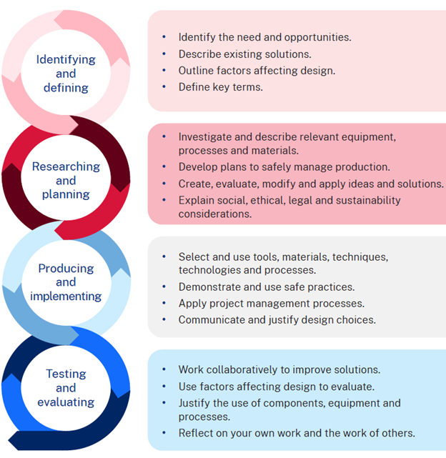

Report format
Engineers use engineering reports to communicate the results of their work to colleagues, clients, supervisors and the public. Engineering reports usually use the format as follows.

1. Title page
Include:
- Report title
- Your full name
- Date
- Class and teacher's name

2. Table of contents
List all report sections with correct page numbers.

3. Introduction
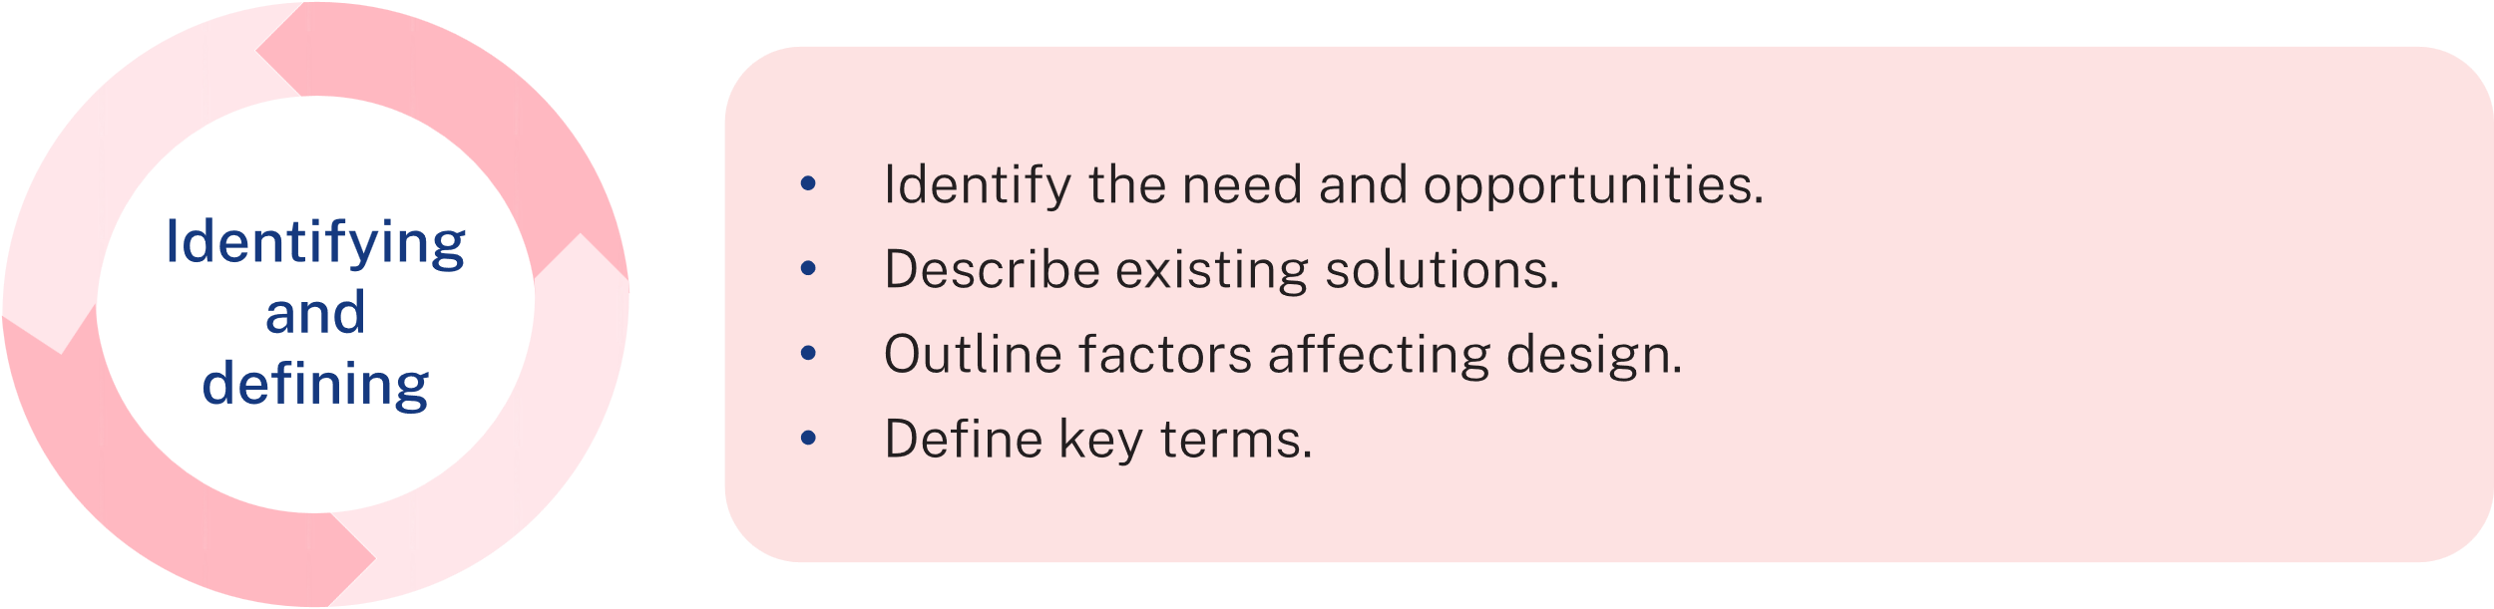
- Briefly outline the purpose of the report.
- Describe the design problem: How can you engineer a pull-string launcher that reliably and safely launches a rotor to achieve height and stable flight?
- State the goal: combine an ergonomic launcher and efficient rotor design using aeronautical principles.

4. Research
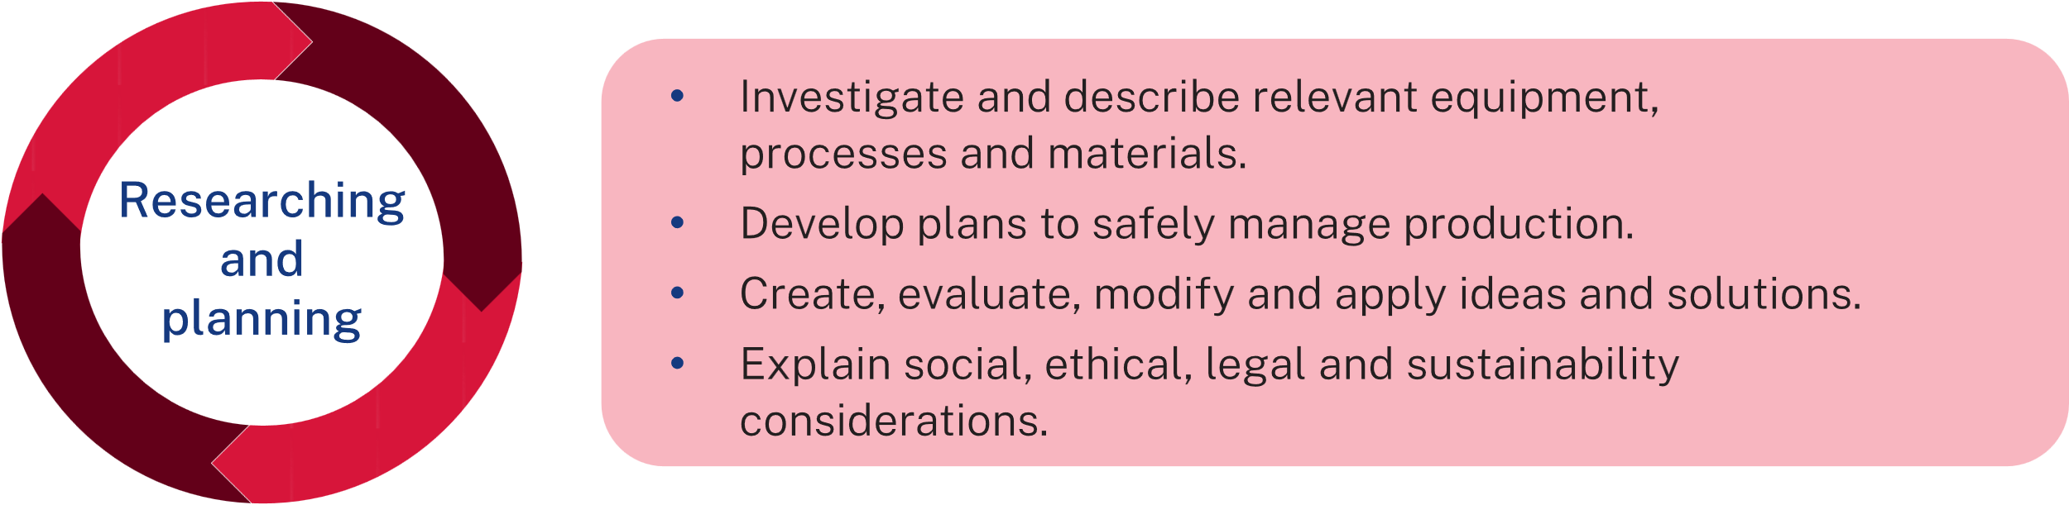
In this section, demonstrate your background knowledge and engineering understanding.

Helicopter flight principles
- Explain how lift is generated by rotor blades (refer to aerofoil research).
- Identify how aeronautical principles like force, motion and energy apply to your design.

Existing design analysis
- Compare existing helicopter launcher toys and boomerang aerodynamics.

Materials research
- Identify and justify materials for: launcher body, spindle or pull-string mechanism, rotor blade.
- Discuss sustainability and safety of these materials.

Aboriginal engineering perspectives
- Briefly describe an engineered system or aerodynamic design used by Aboriginal or Torres Strait Islander peoples (for example, boomerangs, fish traps, Woomera and so on.)

5. Design process
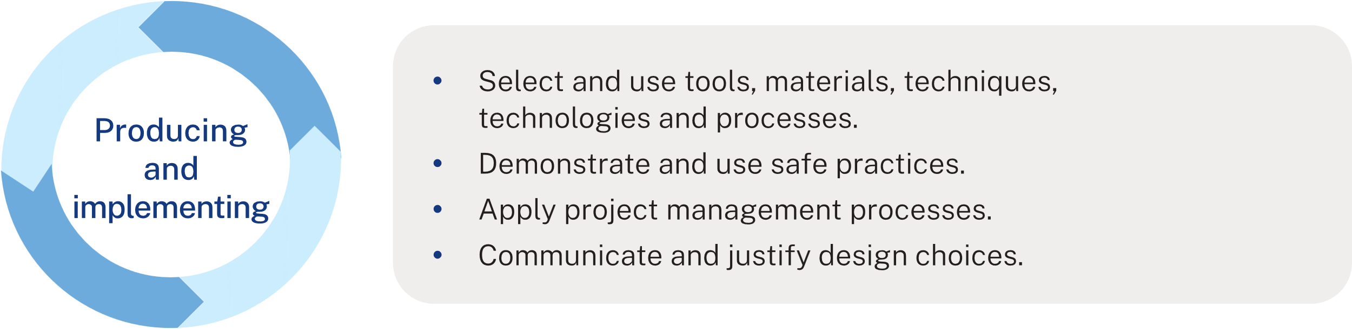
Use sketches, diagrams, CAD drawings and annotations to present your development process.

Design development
- Sketch or digitally model at least 3 rotor designs.
- Justify final design selection based on performance potential, ease of manufacture and safety.

Planning for production
- Include a production plan or flowchart for the rotor development.
- Identify safety protocols.

6. Construction
Describe step-by-step how the rotor was built.
Include labelled photos or diagrams and highlight safe work practices.

7. Testing
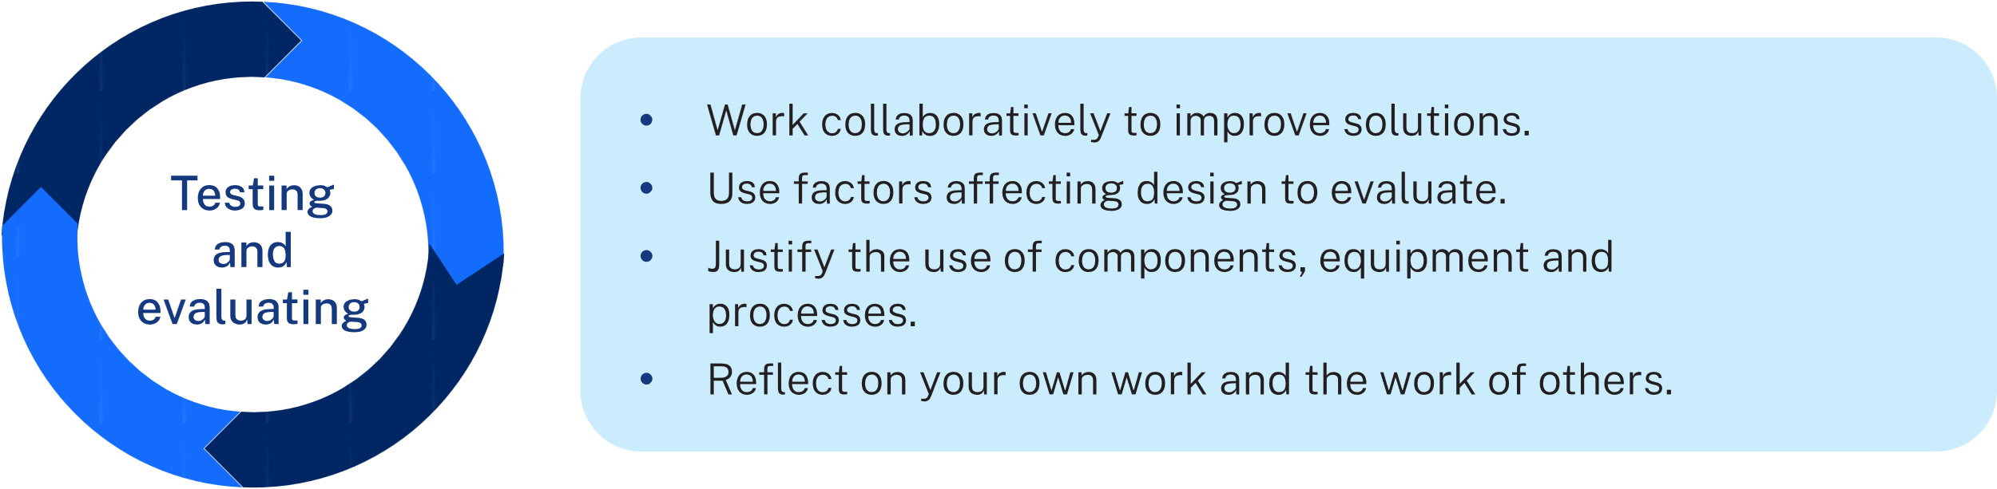
Describe how you tested the rotor and launcher:
- Testing procedures
- Observations
- Photos or diagrams
- Tables or charts of results.

8. Evaluation
- Evaluate performance: Did it meet your goals?
- Identify strengths and weaknesses
- Suggest improvements
- Include peer feedback (if collected).

9. Conclusion
Summarise your findings and how the design solved the original problem.

10. References
List all sources used (for example, websites, videos, articles and class notes).

Student checklist
☐ Title page
☐ Table of contents
☐ Introduction outlines problem and goal
☐ Research includes lift principles, materials and sustainability
☐ Design drawings that are annotated and justified
☐ Step-by-step construction process
☐ Testing includes data, presented in tables and charts
☐ Evaluation with suggested improvements
☐ Conclusion summaries learning
☐ References provided

Support and alignment
Resource evaluation and support: all curriculum resources are prepared through a rigorous process. Resources are periodically reviewed as part of our ongoing evaluation plan to ensure currency, relevance and effectiveness. For additional support or advice, or to provide feedback, contact the TAS Curriculum team by emailing TAS@det.nsw.edu.au.
Differentiation: further advice to support Aboriginal and Torres Strait Islander students, students learning English as an additional language or dialect (EAL/D), students with a disability and/or additional needs and High Potential and gifted students can be found on the Planning, programming and assessing 7–12 webpage. This includes the Inclusion and differentiation 7–10 advice webpage.
Assessment: further advice to support formative assessment is available on the Planning, programming and assessing 7–12 webpage. This includes the Classroom assessment advice 7–10. For summative assessment tasks, the Assessment task advice 7–10 webpage is available.
Consulted with: Curriculum and Reform, Disability Inclusion, Aboriginal Education Advisors, Curriculum and subject matter experts.
Alignment to system priorities and/or needs: School Excellence Policy, Our Plan for NSW Public Education.
Alignment to the School Excellence Framework: this resource supports the School excellence elements of curriculum (curriculum provision) and effective classroom practice (lesson planning, explicit teaching).
Alignment to Australian Professional Standards for Teachers: this resource supports teachers to address Proficient Teacher Standard Descriptors 3.2.2, 3.3.2.
Creation date: 18 July 25

References
This resource contains NSW Curriculum and syllabus content. The NSW Curriculum is developed by the NSW Education Standards Authority. This content is prepared by NESA for and on behalf of the Crown in right of the State of New South Wales. The material is protected by Crown copyright.
Please refer to the NESA Copyright Disclaimer for more information https://educationstandards.nsw.edu.au/wps/portal/nesa/mini-footer/copyright.
NESA holds the only official and up-to-date versions of the NSW Curriculum and syllabus documents. Please visit the NSW Education Standards Authority (NESA) website https://educationstandards.nsw.edu.au/ and the NSW Curriculum website https://curriculum.nsw.edu.au/home.
Technology 7–8 Syllabus © NSW Education Standards Authority (NESA) for and on behalf of the Crown in right of the State of New South Wales, 2023.
Brookhart SM (2018) ‘Appropriate Criteria: Key to Effective Rubrics’, Frontiers in Education, volume 3(22):1–12, doi:10.3389/feduc.2018.00022, accessed 16 February 2025.
CESE (Centre for Education Statistics and Evaluation) (2020) What works best: 2020 update, NSW Department of Education, accessed 25 April 2025.
——(2020) What works best in practice, NSW Department of Education, accessed 16 February 2025.
Griffin P (2017) Assessment for Teaching, Cambridge University Press, Port Melbourne, Victoria.
Hattie J and Timperley H (2007) ‘The Power of Feedback’, Review of Educational Research, 77(1): 81–112, doi:10.3102/003465430298487.
Panadero E and Jonsson A (2013) ‘The use of scoring rubrics for formative assessment purposes revisited: A review’, Educational Research Review, 9:129–144, doi:10.1016/j.edurev.2013.01.002, accessed 27 April 2025.

© State of New South Wales (Department of Education), 2025
The copyright material published in this resource is subject to the Copyright Act 1968 (Cth) and is owned by the NSW Department of Education or, where indicated, by a party other than the NSW Department of Education (third-party material).
Copyright material available in this resource and owned by the NSW Department of Education is licensed under a Creative Commons Attribution 4.0 International (CC BY 4.0) license.

This license allows you to share and adapt the material for any purpose, even commercially.
Attribution should be given to © State of New South Wales (Department of Education), 2025.
Material in this resource not available under a Creative Commons license:
- the NSW Department of Education logo, other logos and trademark-protected material
- material owned by a third party that has been reproduced with permission. You will need to obtain permission from the third party to reuse its material.
Links to third-party material and websites
Please note that the provided (reading/viewing material/list/links/texts) are a suggestion only and implies no endorsement, by the New South Wales Department of Education, of any author, publisher, or book title. School principals and teachers are best placed to assess the suitability of resources that would complement the curriculum and reflect the needs and interests of their students.
If you use the links provided in this document to access a third-party's website, you acknowledge that the terms of use, including licence terms set out on the third-party's website apply to the use which may be made of the materials on that third-party website or where permitted by the Copyright Act 1968 (Cth). The department accepts no responsibility for content on third-party websites.

