Technology 7–8 – Digital and Engineering technologies – teacher resource
Park&Ride

Contents
Unit overview 3
Glossary 4
Think of a sequence name 7
Setting the scene – parking guidance system 7
Public transport and sustainability 8
First program: blink.py 13
Make 2 LEDs blink: blink_2leds.py 13
Servo verses DC motor 14
Moving a servo arm: servo_basic.py 16
Moving a servo arm to specific angles: servo_3steps.py 16
Code for first prototype: servo_boomgate.py 17
Force, motion and energy – levers and forces on a boom 18
Force, motion and energy 18
Levers 19
Woomera – Aboriginal application of the lever 22
Comparing sensor technology 25
Plotting sensor technology cost versus accuracy 26
Code for sensor type A 26
Code for boom gate prototype with sensor type A 27
Code for sensor type B 27
Linkage systems 28
Prototype production, testing and evaluation 31
Folding boom gate design 33
Annotated ideas sketches 33
Introduction to CAD 35
3D modelling 35
Orthogonal drawing 36
Drawing components 37
Materials selection and justification 37
Materials research 37
Component manufacture and assembly 40
Testing and evaluation 42
Code for ultrasonic sensor 44
Code for OLED module: OLED.py 45
RFID swipe cards: read_card_id.py 45
Connecting RFID and servo: RFID_servo.py 46
References 47

Unit overview
This resource supports schools’ implementation of the Digital and communication technologies and Engineering technologies and systems focus areas of the new Technology 7–8 syllabus. It can be adopted as is or adapted to meet the needs of individual school contexts.
The ‘Park&Ride’ unit is an engaging and comprehensive 20-week program designed for Technology 7–8 students. This unit blends 2 focus areas through theoretical knowledge, practical experiences and evaluative practices, focusing on the engineering and construction of a working prototype of a parking system. Throughout the unit, students will gain insights into digital and communication technologies, engineering processes, materials and production processes.
The central task is for students to construct a prototype of a secure carpark accessed via an automated folding boom gate. This activity provides an opportunity for students to collaborate, think critically and apply digital, communication, engineering and technology principles to a real-world context. The unit encourages creativity and problem-solving.
Note: this resource has been designed to facilitate the ready conversion into a student booklet by removing the answers within the response windows. Teacher notes (in blue) can be deleted before distributing to students.
The resource is intended for you to adapt to suit to your school and your resources. Alternative ideas are included for the project design brief. The resource can be introduced and delivered earlier in the term or used as an assessment.
Refer to Equipment Safety in Schools and Chemical Safety in Schools for current information on safety and safe working practices in Technology 7–8.

Glossary
Note: provide the table with the ‘Definition’ column blank for students to complete the activity throughout the term.
Each time you see a new word throughout the workbook you can add its definition in the table below in case you need to refer back later.
Table 1 – glossary
Word | Definition
3D modelling | The process of creating a three-dimensional representation of an object using computer software.
Accessibility | The design of products, devices, services or environments to be usable by people with various disabilities or limitations.
Aesthetic | The visual appeal or attractiveness of a product or design.
Assembly | The process of putting together components to form a complete product or system.
Boom gate | A barrier that can be raised or lowered to control vehicle access, commonly used at parking lots, toll booths and restricted areas.
CAD | Software used to create precision drawings or 3D models of physical components.
Code | A set of instructions written in a programming language that a computer or device can execute.
Design | The process of planning and creating a product, system or structure to meet specific needs.
Energy | The capacity to do work or cause change, existing in forms such as kinetic, potential, thermal or electrical.
Evaluation | The assessment of a product or system to determine its effectiveness, quality or value.
Force | A push or pull that can cause an object to move, stop or change shape.
Functionality | The ability of a product or system to perform the tasks or functions it is designed for.
Isometric | A type of 3D drawing where the 3 axes are equally foreshortened and the angle between any 2 axes is 120 degrees, used to represent objects clearly.
LED | A semiconductor device that emits light when an electric current passes through it.
Lever | A rigid bar that rotates around a fixed point (fulcrum) to amplify force or change the direction of motion.
Linkage | A mechanical assembly of connected parts designed to transmit motion and force.
Linkage bar | A rigid component in a linkage system that connects 2 or more parts to transmit motion.
Linkage pin | A small cylindrical component used to connect parts of a linkage, allowing rotation or movement.
Motion | The change in position of an object over time relative to a reference point.
Motor | A machine that converts electrical energy into mechanical motion.
Orthogonal | At right angles (90 degrees) to a given line or surface.
Prototype | An early sample or model built to test a concept or process.
Public transport | Systems of transportation available for use by the public, such as buses, trains and trams.
Sensor | A device that detects changes in the environment and converts them into signals for measurement or control.
Servo | A device or system that uses feedback to precisely control the position, speed or acceleration of a mechanical component.
Sketch | A freehand drawing used to quickly capture ideas or concepts.
Society | A group of individuals living together in a community, sharing common institutions, culture and norms.
Structural integrity | The ability of a structure or component to withstand its intended load without failure.
Testing | The process of evaluating a product or system to ensure it meets design specifications and functions correctly.
Urbanisation | The process by which an increasing percentage of a population lives in cities and urban areas.

Setting the scene – parking guidance system
Note: Connecting learning
Class Think-Pair-Share:
- Where have you seen boom gates used?
- Why were they used?
- What engineered systems are like boom gates?
Provide student with individual thinking time, then small group discussion and finally class discussion.
Students may use the table provided below to document their thoughts and discussions. Use images as inspiration for students.
Sample answers are provided for the first image. These can be removed for conversion into a student workbook.
Table 2 – different engineered products
Image | Discussion points
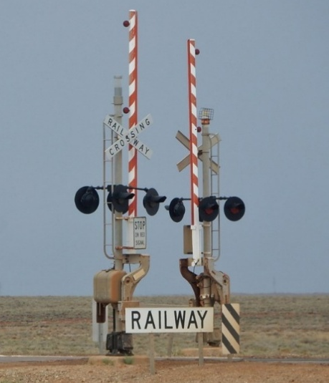 | Sample answers:  - Car park  - Level crossing  - Train station

Public transport and sustainability
Teacher note: after watching the short video provided below break students into 6 small groups to complete a jigsaw activity addressing the questions below.
Sample answers are provided. These can be removed for the conversion into a student workbook.
Watch United Nations ESCAP’s Sustainable transport development in Asia and the Pacific (3:53).
In your allocated group, respond to one of the sets of questions in the table, prior to presenting to the class. As you listen to other groups present their responses, make notes in the relevant section in the table below.
Questions | Answers
Societal needs  - What are some of the societal needs that arise from rapid urbanisation?  - How do you think transport systems can be engineered to address these societal needs? | - Increased mobility for a growing urban population.  Reduction of negative impacts like air pollution, traffic congestion and road accidents.  Ensuring transport systems are safe, inclusive, accessible and affordable for all, including vulnerable populations like pedestrians, cyclists and motorcyclists.  Addressing challenges related to gender equality and safety in transport.  - Developing integrated urban and transport plans that prioritise green and healthy transport options.  Implementing smart transport systems to efficiently manage traffic and reduce congestion.  Designing infrastructure that improves safety for all users, including separate lanes for cyclists and pedestrians.  Using technology to enhance accessibility and inclusivity for diverse groups.
Engineered solutions  - What is meant by ‘low carbon transport’ and how can it contribute to sustainability in urban areas?  - Identify an example of a smart transport solution to help reduce greenhouse gas emissions. Describe how it works. | - Low carbon transport refers to transportation methods and technologies that produce minimal greenhouse gas emissions, such as electric vehicles or energy-efficient public transit.  It contributes to sustainability by reducing the carbon footprint of urban transport, thereby improving air quality and mitigating climate change.  - An example is the adoption of smart transport systems that use data and technology to optimise traffic flow, reduce congestion and improve fuel efficiency.  These systems might include real-time traffic monitoring, intelligent traffic signals and integrated public transit scheduling, which collectively reduce unnecessary idling and improve overall transport efficiency.
Evaluating technologies  - How can electric mobility improve the sustainability of transport systems?  - Why is it important to consider inclusivity and accessibility when designing transport systems? | - Electric mobility reduces reliance on fossil fuels, lowering greenhouse gas emissions and air pollutants.  Electric vehicles tend to have higher energy efficiency and can be powered by renewable energy sources, further enhancing sustainability.  - To ensure that all individuals, regardless of gender, physical ability, age or socioeconomic status, can safely and affordably access transport.  Inclusive transport systems promote social equity and enable broader participation in economic and social activities.
Impact of engineering on sustainability  - How do engineering technologies in the transport sector help in reducing air pollution and traffic congestion?  - What role does integrated urban and transport plans play in achieving sustainable development goals? | - By developing cleaner technologies such as electric vehicles and energy-efficient engines.  Implementing smart traffic management systems to optimise flow and reduce idling times.  Designing urban infrastructure that supports public transit, cycling and walking, thereby reducing reliance on private fossil-fuel vehicles.  - They enable coordinated development that aligns transport infrastructure with urban growth.  Such plans encourage green and healthy transport environments, reduce emissions, improve accessibility and support inclusive mobility.  They help assess current mobility states and identify improvements using tools like the Sustainable Urban Transport Index (SUTI).
Road safety and sustainability  - Based on the video, why is road safety a critical component of a sustainable transport system?  - What strategies could be implemented to reduce road traffic deaths and injuries while promoting sustainable transport? | - Road crashes cause a high number of fatalities and injuries, especially in Asia-Pacific where 60% of global road deaths occur.  A sustainable transport system must protect the most vulnerable users – pedestrians, cyclists and motorcyclists – to ensure safe mobility for all.  - Holistic strategies combining infrastructure improvements, education and enforcement of traffic laws.  Supporting global and regional action plans such as the Second Decade of Action for Road Safety (2021–2030) aiming to halve deaths and injuries.  Designing safer urban environments with dedicated lanes, better lighting and traffic calming measures.
Future considerations  - By 2050, a significant portion of the world's population will live in urban areas. How could engineers prepare for this change to ensure sustainable transport?  - What innovations in engineering do you think could support the creation of a safe and affordable transport system for all? | - By planning and developing integrated urban transport systems that can handle high-density populations efficiently.  Incorporating low-carbon technologies and smart systems from the outset.  Ensuring transport systems are inclusive, accessible and safe for all users.  - Development of electric and autonomous vehicles to reduce emissions and improve safety through advanced sensors and AI.  Smart infrastructure such as adaptive traffic signals and real-time data analytics to optimise traffic flow.  Inclusive design innovations like accessible transit vehicles and infrastructure for people with disabilities.  Use of renewable energy sources to power transport systems affordably and sustainably.

First program: blink.py
Type the following code:
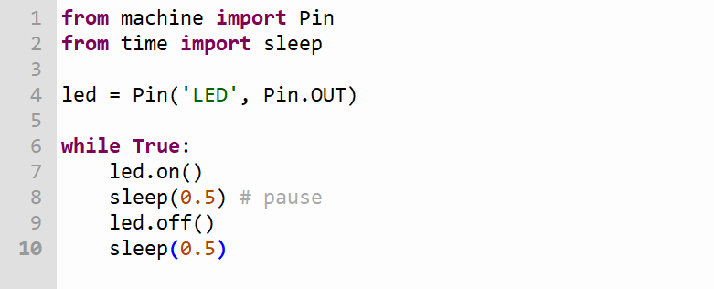

Make 2 LEDs blink: blink_2leds.py
Type the following code:
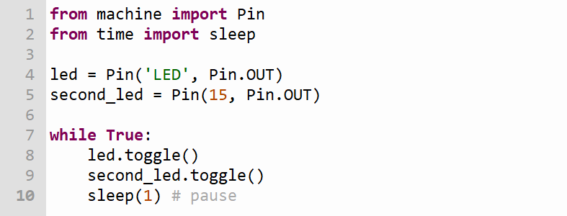

Servo verses DC motor
Teacher note: the learning activity below is best paired with physical examples of components, allowing students to witness or experiment with their operation.
Sample answers are provided. These can be removed when converting this resource to a student workbook.
Watch What is a servo motor and what does it do? (3:28) and How a DC motor works in 3D – Working principle of DC motor (4:00)
Complete the Plus, Minus, Interesting (PMI) table for a servo and DC motor in the tables below.
Servo
Table 3 – component selection and justification – servo PMI
Plus | Minus | Interesting
Describe the good things about a servo.  High precision and accurate control of position, speed and acceleration.  Excellent torque at low speeds and good dynamic response.  Closed-loop control system reduces errors and allows for precise movements.  Ideal for applications requiring precise positioning (for example, robotics, CNC machines).  Can maintain a position when not moving (holding torque). | Describe the negative things about a servo.  More complex and expensive than simple DC motors.  Requires a feedback device (encoder or resolver) and a controller, increasing system complexity.  More complicated to maintain and troubleshoot.  Typically, heavier and larger due to additional components. | Describe the interesting things about a servo.  Uses PID control algorithms or other advanced control techniques to improve performance.  Can be AC or DC powered, with brushless servo becoming more common.  Often integrated into closed-loop mechatronic systems combining sensors, actuators and controllers.
DC motor
Table 4 – component selection and justification – DC motor PMI
Plus | Minus | Interesting
Describe the good things about a DC motor.  Simple design, easy to control and operate.  Generally lower cost compared to servo motors.  Provides good torque and speed control with simple electronics (for basic applications).  Widely available and easy to maintain. | Describe the negative things about a DC motor.  Less precise control of position without added feedback systems.  Brushes and commutators cause wear and require maintenance in brushed DC motors.  Performance can degrade over time due to brush wear.  Less suitable for applications requiring high precision or dynamic response. | Describe the interesting things about a DC motor.  Comes in brushed and brushless varieties, with brushless DC motors offering better efficiency and less maintenance.  Can be used in a wide range of applications, from toys to industrial machinery.  Speed and torque characteristics are well understood and easy to model.

Moving a servo arm: servo_basic.py
Type the following code:
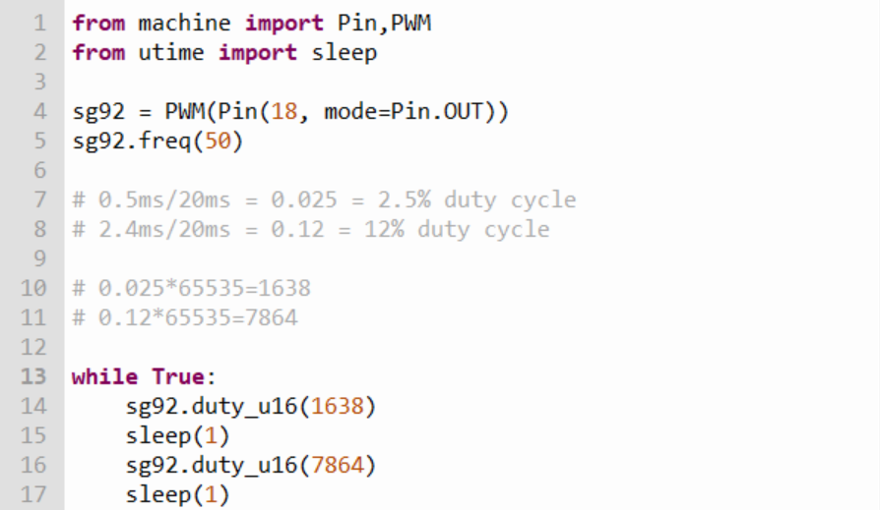

Moving a servo arm to specific angles: servo_3steps.py
Type the following code:
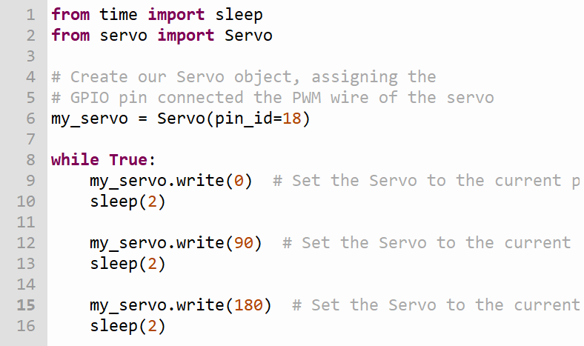

Code for first prototype: servo_boomgate.py
Type the following code:
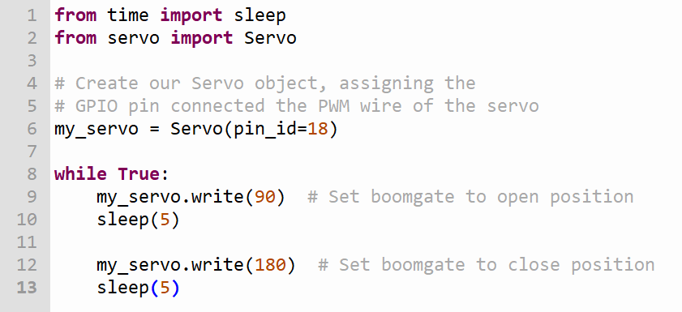

Force, motion and energy – levers and forces on a boom

Force, motion and energy
Teacher note: physical examples to show force, motion and energy could help student understanding as they watch the video below or read the stimulus. Teacher to select from these options based on their own students.
Sample answers are provided. These can be removed for conversion to a student workbook.
Read the information below or watch Newton's 3 Laws, with a bicycle (3:32) prior to completing the table at the end of this section.
What is force?
Force is a push or pull that can change the way an object moves. Imagine pushing a toy car; when you push it, you are applying a force. Forces can make things start moving, stop moving or change direction. They can come from different sources, such as gravity pulling us down to the ground or a person pushing an object.
What is motion?
Motion is when an object changes its position. If you've ever thrown a ball or ridden a bike, you’ve experienced motion. It can be described in terms of speed and direction. For example, if a car is moving north at 60 kilometres per hour, we can say it’s in motion.
What is energy?
Energy is what makes things happen. It’s what allows us to do work, like moving objects or powering machines. There are different types of energy, such as:
- Kinetic energy: this is the energy of moving objects. The faster something moves, the more kinetic energy it has. For example, a speeding car has more kinetic energy than a slow-moving bicycle.
- Potential energy: this is stored energy based on an object's position. For example, when you lift a ball up high, it has potential energy because of its height. If you drop it, that potential energy turns into kinetic energy as it falls.
How are they related?
Forces cause motion, and energy is what allows forces to work. When you push a swing (force), it moves back and forth (motion), and the energy from your push helps the swing move.
 | Definition | Examples
Force | Identify essential features.  Force is a push or pull upon an object resulting from its interaction with another object. Force can cause an object to start moving, stop moving, change direction or change shape. | Pushing a swing  Gravity pulling objects downward
Motion | Motion is the change in position of an object over time. An object is in motion if it is moving relative to a reference point. | A train moving along tracks  A ball rolling across a floor
Energy | Energy is the capacity to do work or cause change. It exists in various forms, such as kinetic, potential, thermal and electrical. | Kinetic energy in a moving car  Potential energy in a stretched rubber band

Levers
Teacher note: sample answers are provided. These can be removed for conversion to a student workbook.
Watch Simple machines: levers (2:43)
Complete the table below.
 | Definition | Sketch | Example
1st order lever | Identify essential features.  A 1st order lever has the fulcrum placed between the effort (force applied) and the load (resistance to be moved). | 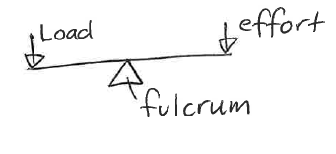 | Seesaw
2nd order lever | A 2nd order lever has the load positioned between the fulcrum and the effort. The effort and load move in the same direction, and the effort arm is longer than the load arm, providing a mechanical advantage. | 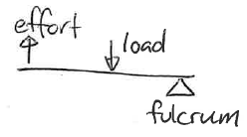 | Wheelbarrow
3rd order lever | A 3rd order lever has the effort applied between the fulcrum and the load. The effort and load move in the same direction, but the load arm is longer than the effort arm, so it provides a speed advantage rather than a force advantage. | 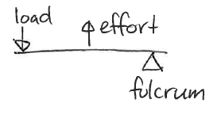 | Tweezers

Woomera – Aboriginal application of the lever
Teacher note: the Woomera is an Aboriginal innovation that demonstrates sophisticated knowledge of force and motion. It was developed and used by some Aboriginal Nations, particularly across central and northern parts of Australia, and in certain regions of western NSW. However, it was not used by all Aboriginal Peoples in NSW. Different Nations developed tools and technologies that were suited to their local environments and ways of living on Country.
When teaching about the Woomera, it is important to also encourage students to explore the technologies and innovations used by the Aboriginal Peoples of their local area, and to seek guidance from local Aboriginal community members or organisations for culturally accurate information.
Read the passage about the Woomera below prior to answering the question.
Figure 1 – reading strategies
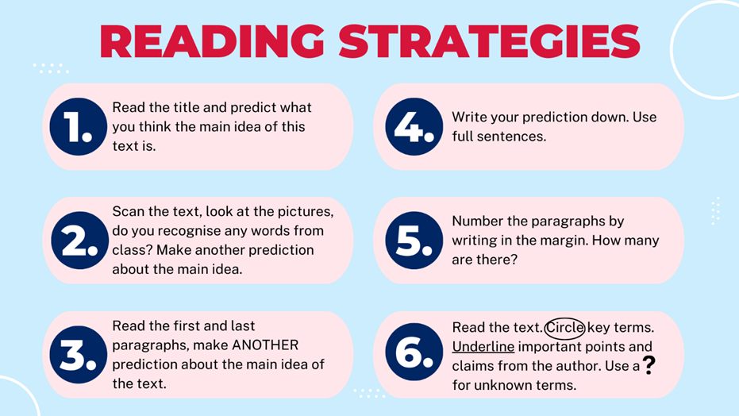
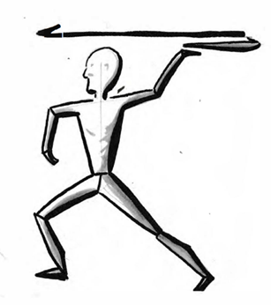
The Woomera is an Aboriginal engineering innovation used by some Nations, particularly in central and northern Australia and western NSW. It is embedded in culture, survival, ceremony and Country. Applying an understanding of force and motion as applied through a lever, it helps launch spears further and with greater force. It is typically a long, flat piece of wood. It has a shape like a large stick or paddle.
To use the innovation, a person places one end of the spear on a small spike on the Woomera. By holding the other end of the Woomera, the person can use their arm to throw the spear. The Woomera acts like a lever, allowing the person to throw the spear much farther than they could by hand.
When someone uses the Woomera, they swing it back and then forward, releasing the spear at just the right moment. This motion gives the spear extra speed and distance, due to the increased length of the throwing arm and Woomera combination.
The Woomera is a sophisticated tool developed to support sustainable living, food gathering and survival. It allows spears to be thrown more accurately and from a greater distance.
Using your knowledge of levers, explain why a Woomera increases throwing force.
Teacher note: sample answer is provided and can be removed for conversion to student workbook
The Woomera increases throwing force because it functions as a lever, effectively extending the length of the thrower’s arm and increasing the distance over which force is applied to the spear.
The Woomera acts like a 3rd order lever, where the effort (the thrower's hand applying force) is between the fulcrum (the pivot point near the hand) and the load (the spear at the other end).
By increasing the length of the lever arm (the combined length of the arm plus the Woomera), the thrower can apply force over a greater distance.
This longer lever arm allows the spear to accelerate more during the throw, increasing its speed and therefore its kinetic energy.
Because kinetic energy depends on the square of velocity, even a small increase in speed results in a much greater throwing force when the spear is released.
The Woomera also helps control the motion and timing of the throw, allowing for a more efficient transfer of energy from the thrower to the spear.
Practical activity: on the school oval or a similar open area, students could measure and evaluate the distance of hand-thrown tennis balls and tennis balls thrown using a ball launcher.

Comparing sensor technology
Complete the table below by comparing different types of sensors.
Sensor type | Detection | Range/  distance | Accuracy | Relative cost | Possible application
Infrared
Ultrasonic
Magnetometer
RFID
Time of flight
Induction loops

Plotting sensor technology cost versus accuracy
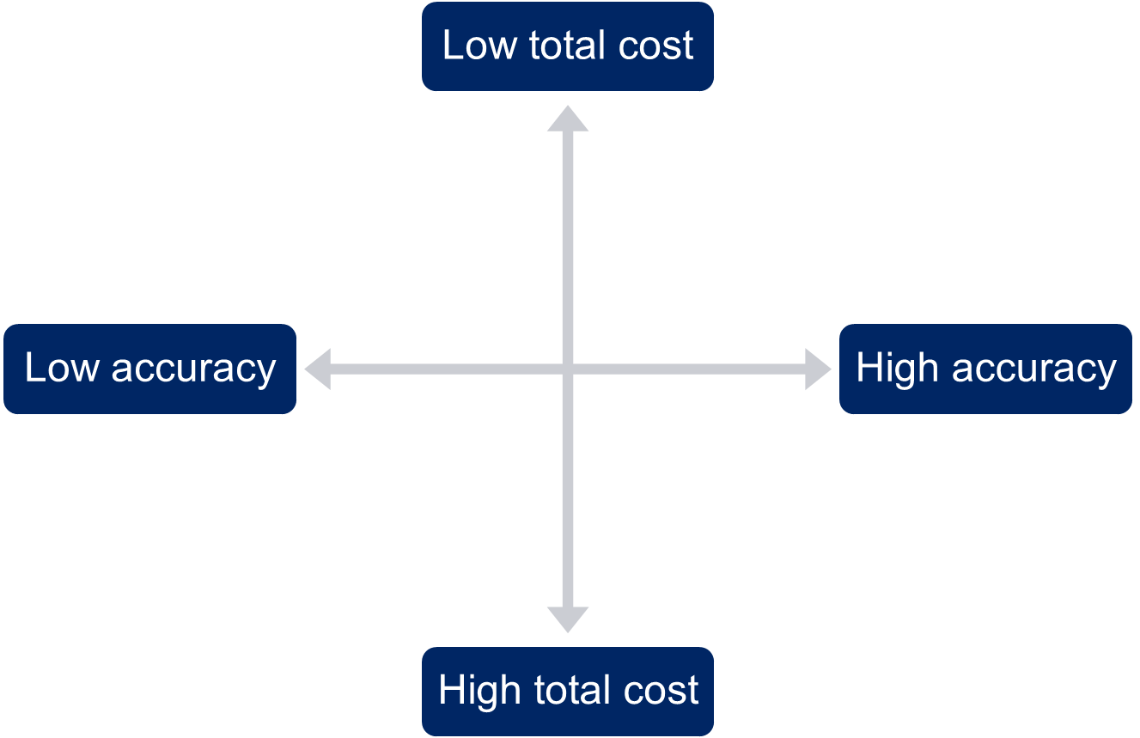

Code for sensor type A
Type this code: infrared_sensorA.py
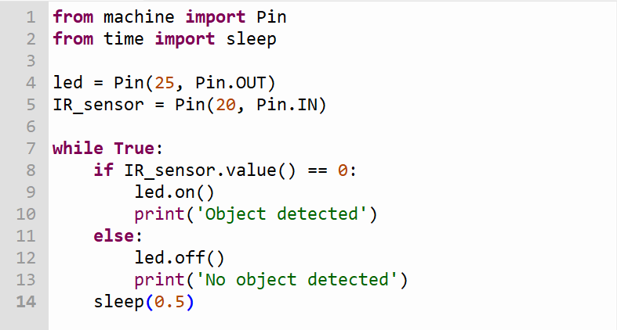

Code for boom gate prototype with sensor type A
Type the following code:
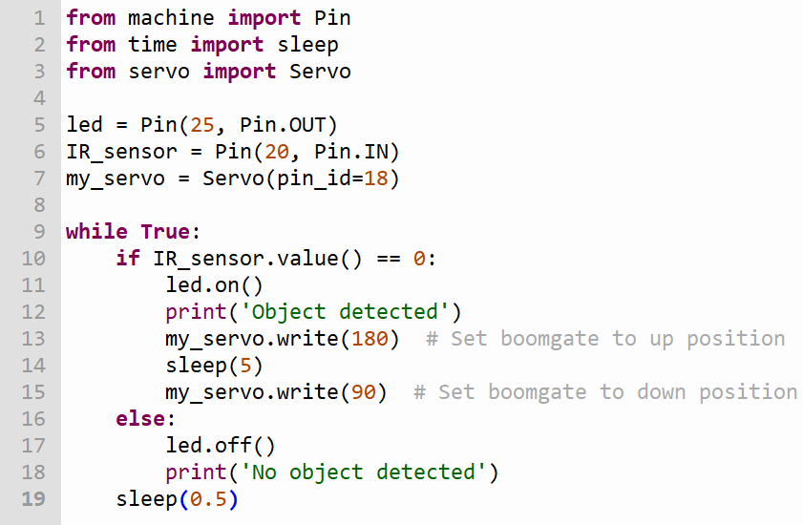

Code for sensor type B
Type this code: infrared_sensorB.py
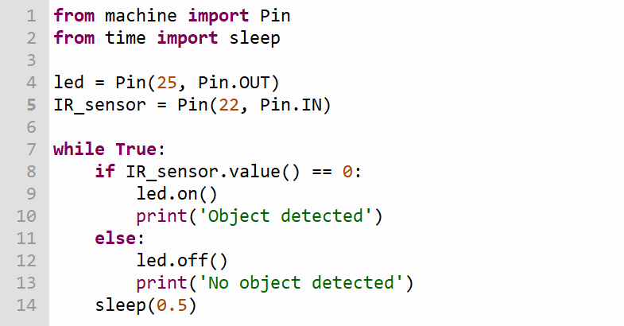

Linkage systems
Teacher note: prior to students reading and completing this activity, provide students with tangible examples of linkage systems so that they can see how they work.
There are many types of linkage mechanisms available to engineers. They are great for changing the direction of motion, or in the case of a boom gate, creating a fold. A folding boom gate typically uses a five-bar linkage mechanism.
Prior to sketching a five-bar linkage read the explanation below and watch Folding barrier gate (0:22)
Five-bar linkage mechanism explained
What is a linkage?
A linkage is a system made of bars (or links) connected by pin or rotating joints that work together to create movement. Linkages help transfer motion and force from one part to another. They are used in many machines, like cranes and robotic arms.
What is a five-bar linkage?
A five-bar linkage is a specific type of linkage that has 5 links (bars) connected in a way that allows them to move together. These links are usually connected by rotating joints, allowing them to pivot and create different types of motion.
Components of a five-bar linkage
- Links: there are 5 bars in total
- Joints: these are the points where the links connect. They allow the links to rotate
- Ground link: one of the links is usually fixed in place. This is called the ground link, and it acts as a base for the other links to move around. In the case of a boom gate, this link will be connected to a motor or servo.
How does it work?
When you push or pull one of the links in a five-bar linkage, it causes the other links to move in a coordinated way. This can create different types of movement, like lifting, lowering, or even turning an object.
Why is it useful?
Five-bar linkages are useful in many machines because they can convert one type of motion into another. For example, they can take a straight motion from a pedal and turn it into a circular motion in a wheel. This makes them widely used in engineering and design.
Real-world examples
You can see five-bar linkages in action in various places, like:
- robotic arms that need to reach and grab objects
- bicycles where the pedals move the wheels
- mechanical toys that move when you press a button.
Sketch what you think a five-bar linkage system for a folding boom gate would look like. Label the components.
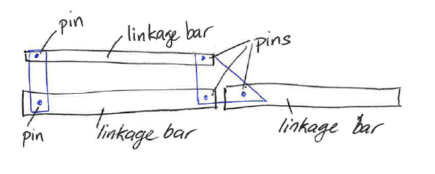
Consider a multilevel car park. Outline the factors that could impact the size of each lever arm.

Prototype production, testing and evaluation
Practical activity
Using technic Lego, Meccano, cardboard and split pins or similar, demonstrate the production of a five-bar linkage prototype.
Demonstrate several sample linkages that show movement similar to a folding boom.
Students work in small groups to produce and evaluate multiple prototypes, experimenting with arm lengths and pin locations.
Teacher note: sample answers are provided. These can be removed for conversion to a student workbook.
Sketch your linkage that most closely represents the movement of a folding boom gate. Annotate your sketch showing motion and force applied.
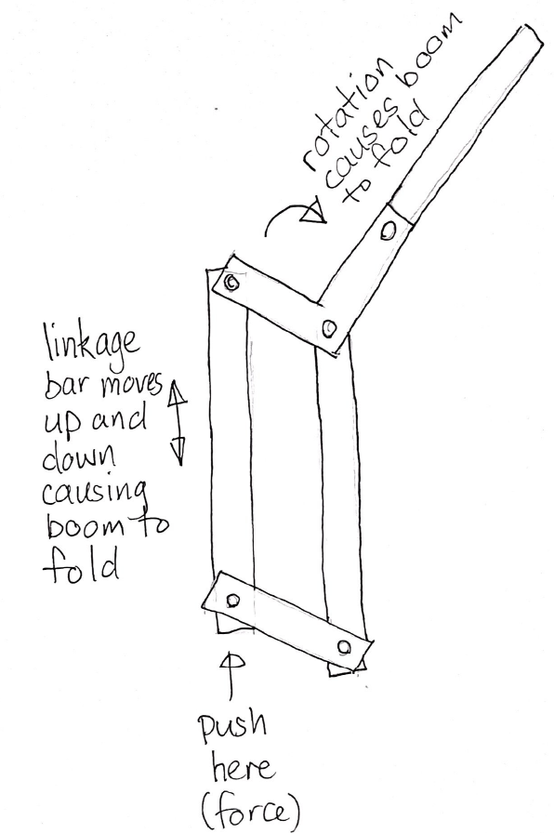

Complete the evaluation table for at least 2 of your prototypes.
Prototype sketch | Describe what worked well | Explain what could be improved
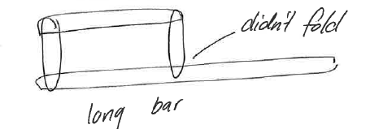 | Talk about the main features of what worked well.  When one bar moved so did the others. | What would you improve?  Why?  What do you think the change would lead to?  The straight bar at the bottom meant the boom, didn’t fold.  Using 2 shorter bars on the bottom should result in a folding boom gate.

Folding boom gate design

Annotated ideas sketches
Individually produce 4 annotated sketches for a folding boom gate.
Teacher note: using the ideas from the previous activities and students’ prior knowledge, sketch and annotate boom gate ideas.
Sample answer is provided. This can be removed for conversion into a student workbook.
Table 5 – annotated ideas sketches
Sketch | Annotation
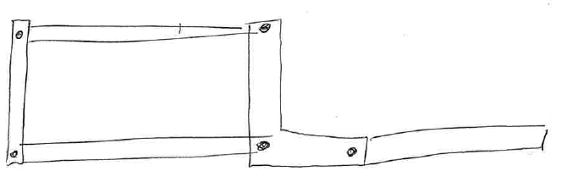 | An annotation is a note or comment added to your sketch to explain, give extra information or share your thoughts.  This sketch has 5 linkage bars and pins.  The idea of the ‘L’ shape linkage bar is that it should result in the boom folding when the 2 long bars on the left move.

Introduction to CAD
CAD stands for Computer-Aided Design. It's a type of software that helps people create detailed drawings and models of objects, buildings, and even machines using a computer. CAD makes it easier to design and visualise ideas, allowing users to see how their creations will look and function before they are built. It's widely used in fields like architecture, engineering and product design.

3D modelling
3D modelling is the process of creating a three-dimensional representation of an object or scene using computer software. In 3D modelling, designers build a virtual version of something, which can be anything from a simple shape to a complex character or environment. These models can be viewed from different angles and manipulated just like real objects. 3D modelling is commonly used in industries like animation, video game design, architecture and product development to visualise and present ideas before they are made in real life.
Figure 2 – 3D model of folding boom
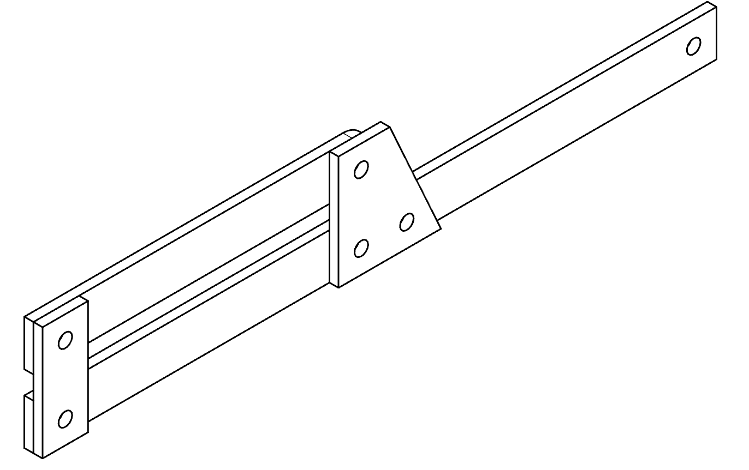

Orthogonal drawing
Figure 3 – orthogonal drawing sample
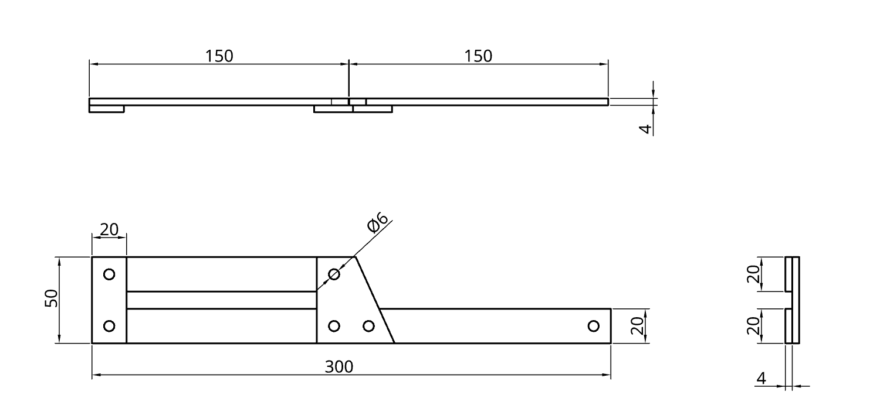
Orthogonal drawing, according to Australian Standard (AS) 1100, refers to a method of representing three-dimensional objects in 2 dimensions using multiple views, typically the front, top and side views. AS 1100 is the Australian Standard for technical drawing, which provides guidelines for creating clear and accurate engineering drawings. In orthogonal drawing, each view shows only 2 dimensions, but when combined, they provide a complete picture of the object's shape and size. This method is essential for accurately conveying design specifications in engineering and architecture.

Drawing components
Practical activity
Introduce CAD software and demonstrate its use in appropriately chunked steps. The software selected should meet the school’s and students’ needs. Examples of potential use:
- 3D modelling of the mechanism
- drawing an orthogonal drawing to AS 1100.
Students to complete drawing of folding boom gate using appropriate CAD software.

Materials selection and justification
Teacher note: using the ideas from the previous activities, use students’ prior knowledge to develop collaborative class discussion.
Sample answers for description of materials are provided in the table below. These answers can be removed for conversion to a student workbook.
Engineers consider a wide range of materials such as timber, composite materials, polymers and metals when developing engineered solutions. Properties such as strength, durability, weight and workability will be taken into consideration to ensure the correct materials are selected.

Materials research
Jigsaw activity – form into groups of 3–5 students. Each student researches and describes the properties of one material. Each student then shares their understanding of their material with the group. The group selects and justifies the most appropriate material for the linkage bars of a folding boom gate.
Potential materials to consider:
- ply
- aluminium
- fibreglass
- steel
- timber
- PVC.
Table 6 – materials descriptions
Material | Description
Ply | Plywood is crafted by bonding thin wood veneer layers with perpendicular grains, providing strength and resistance to bending. It's lightweight and affordable but can absorb moisture, risking warping or delamination outdoors without proper sealing.
Aluminium | Aluminium is a lightweight metal known for its excellent corrosion resistance and good strength-to-weight ratio. It does not rust, making it ideal for outdoor applications like boom gates. Aluminium is easy to fabricate and maintain, and its light weight reduces the effort needed to lift and lower the gate arm.
Fibreglass | Fibreglass is a composite material consisting of fine glass fibres embedded in a resin matrix. It is strong yet lightweight, highly resistant to weather, corrosion and chemicals, and does not conduct electricity. These properties make fibreglass an excellent choice for boom gates that require durability and resistance to environmental damage.
Steel | Steel is a strong and durable metal alloy, capable of withstanding heavy loads and impacts. It is heavier than aluminium and fibreglass and can rust if exposed to moisture unless properly coated or galvanised. Steel’s strength makes it suitable for heavy-duty boom gates, but it requires regular maintenance to prevent corrosion.
Timber | Timber is a natural material with good strength and aesthetic appeal. It is heavier than many engineered materials and can be affected by moisture, insects and rot if not properly treated. Timber can be easily shaped but requires ongoing maintenance, such as sealing, to ensure durability when used outdoors.
PVC | PVC is a lightweight, plastic material resistant to moisture and corrosion. It is easy to clean and maintain but has lower strength and rigidity compared to metals or composites. PVC can degrade under prolonged exposure to UV light unless stabilised. It is typically used for non-structural parts or covers in boom gate systems.

Component manufacture and assembly
Practical activity
Components can be manufactured in a variety of ways, including using hand tools and equipment, laser cutting and 3D printing.
The method of manufacture will determine the teaching and learning strategies. Students will be guided to complete each step of the folding boom gate, watching teacher demonstration first. Then by process of gradual release of responsibility, students will experiment with each tool, machine and technique.
Safety note: the disc sander cannot be used for this project as the materials’ sizes do not comply with safe operating procedures. School leaders and teachers should refer to Equipment Safety in Schools.
Teacher demonstrates each process step-by-step, highlighting safe practices and common mistakes. Engage students by asking them to identify potential hazards during the demonstration.
Table 7 – production process
Step in production | Student notes
Mark out lengths for each linkage bar leaving a 5 mm gap for the kerf.
Tools: pencil, metric rule, try square.
Mark out centres for holes to accommodate bolts.
Tools: pencil, metric rule, try square, dividers or marking gauge.
Drill clearance holes using drill press with material secured in machine vice.
Tools: pedestal drill, machine vice, drill bit.
Cut linkage bars to length.
Tools: tenon saw, bench hook.
Round ends of long linkage bars to allow for rotation.
Tools: bench vice, file.
Assemble linkage bars ensuring washer between surfaces and don’t overtighten to allow linkage to rotate.
Tools: spanners, screw drivers.
Test fabricated linkage.
Adjust as required.
Retest and continue adjustment until correct function is achieved.
Attach to servo.

Testing and evaluation
Evaluation criteria | Rating  (1 lowest –  5 highest) | Comments
Functionality
Does the boom gate operate as intended?
Design completeness
Is the design fully realised with all components present?
Structural integrity
Does the boom gate withstand operational stress without failing?
Ease of operation
Is the boom gate easy to open and close?
Aesthetic appeal
Does the final product look visually appealing?
Materials used
Are the materials appropriate for the intended use and environment?
Innovation and creativity
How original and creative is the design?
Accuracy of movement
Does the linkage system operate smoothly and accurately?
Time efficiency
How efficiently does the gate operate in terms of time to open/close?
Other

Code for ultrasonic sensor
Type the following code:
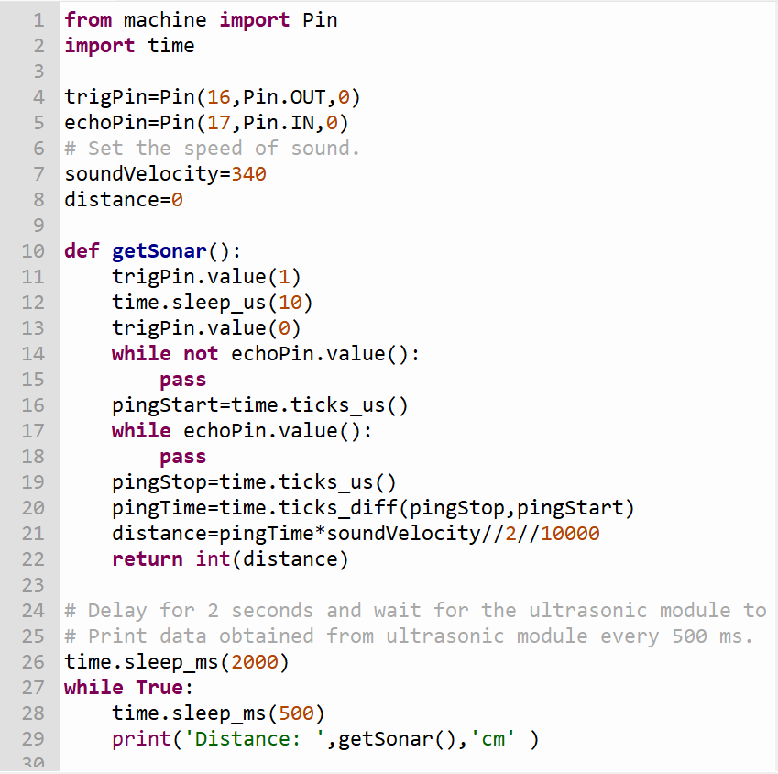

Code for OLED module: OLED.py
Type the following code:
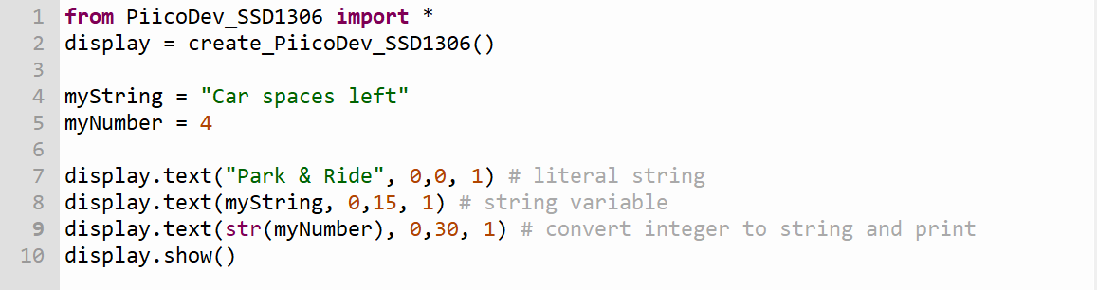

RFID swipe cards: read_card_id.py
Type the following code:
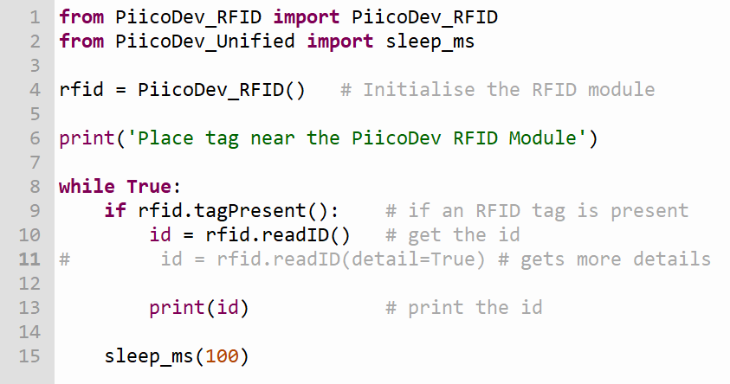

Connecting RFID and servo: RFID_servo.py
Type the following code:
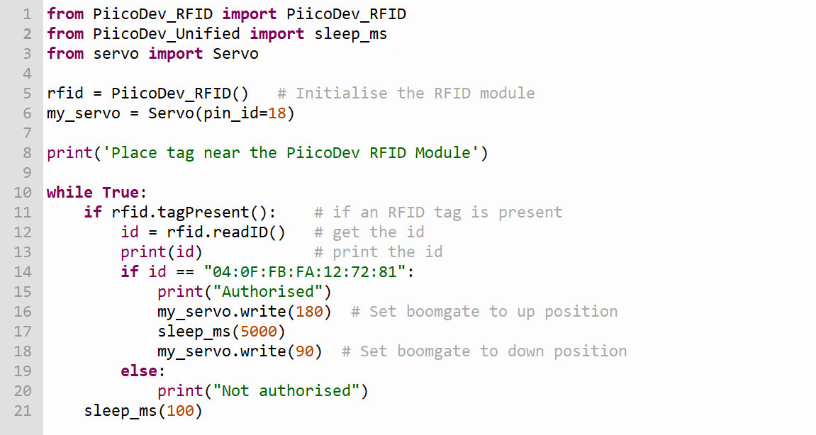

References
This resource contains NSW Curriculum and syllabus content. The NSW Curriculum is developed by the NSW Education Standards Authority. This content is prepared by NESA for and on behalf of the Crown in right of the State of New South Wales. The material is protected by Crown copyright.
Please refer to the NESA Copyright Disclaimer for more information https://educationstandards.nsw.edu.au/wps/portal/nesa/mini-footer/copyright.
NESA holds the only official and up-to-date versions of the NSW Curriculum and syllabus documents. Please visit the NSW Education Standards Authority (NESA) website https://educationstandards.nsw.edu.au/ and the NSW Curriculum website https://curriculum.nsw.edu.au/home.
Technology 7–8 Syllabus © NSW Education Standards Authority (NESA) for and on behalf of the Crown in right of the State of New South Wales, 2023.
Engineezy (7 December 2024) Teaching a robot some hand-eye coordination, Engineezy, YouTube, accessed 17 September 2025.
Let’s Grow Up (21 April 2025) ‘How a DC motor works in 3D – Working principle of DC motor’ [video], Let’s Grow Up, YouTube, accessed 17 September 2025.
Mia Wang (7 June 2025) ‘DC boom barrier gate with folding arm' [video], Mia Wang, YouTube, accessed 17 September 2025.
MooMooMath and Science (27 May 2020) ‘Simple machines: levers' [video], MooMooMath and Science, YouTube, accessed 17 September 2025.
TAJFUN PLANINA (5 November 2015) ‘Hydraulic tractor crane DOT 50K' [video], TAJFUN PLANINA, YouTube, accessed 17 September 2025
TED-Ed (20 September 2012) ‘Newton's 3 Laws, with a bicycle' [video], TED-Ed, YouTube, accessed 17 September 2025.
The Engineering Mindset (13 December 2022) ‘What is a servo motor and what does it do?' [video], The Engineering Mindset, YouTube, accessed 17 September 2025.

© State of New South Wales (Department of Education), 2025
The copyright material published in this resource is subject to the Copyright Act 1968 (Cth) and is owned by the NSW Department of Education or, where indicated, by a party other than the NSW Department of Education (third-party material).
Copyright material available in this resource and owned by the NSW Department of Education is licensed under a Creative Commons Attribution 4.0 International (CC BY 4.0) license.

This license allows you to share and adapt the material for any purpose, even commercially.
Attribution should be given to © State of New South Wales (Department of Education), 2025.
Material in this resource not available under a Creative Commons license:
- the NSW Department of Education logo, other logos and trademark-protected material
- material owned by a third party that has been reproduced with permission. You will need to obtain permission from the third party to reuse its material.
Links to third-party material and websites
Please note that the provided (reading/viewing material/list/links/texts) are a suggestion only and implies no endorsement, by the New South Wales Department of Education, of any author, publisher, or book title. School principals and teachers are best placed to assess the suitability of resources that would complement the curriculum and reflect the needs and interests of their students.
If you use the links provided in this document to access a third-party's website, you acknowledge that the terms of use, including licence terms set out on the third-party's website apply to the use which may be made of the materials on that third-party website or where permitted by the Copyright Act 1968 (Cth). The department accepts no responsibility for content on third-party websites.

