Technology 7–8 – Digital and Engineering technologies – sample assessment task notification
Park&Ride
Contents
Task description 2
Submission details 3
Steps to success 3
What is the teacher looking for? 5
Student-facing rubric 6
Teacher-facing rubric 9
Student support material 12
Engineering report scaffold 12
The design and production process 12
Report format 13
1. Title page 13
2. Table of contents 13
3. Introduction 13
4. Research 14
5. Planning process 14
6. Construction 14
7. Testing 15
8. Evaluation 15
9. Conclusion 15
10. References 15
Support and alignment 16
References 17

Task description
Type of task: prototype and engineering report
Outcomes being assessed:
A student:
- explains relationships between sustainability, design and production TE4-SDP-01
- describes the practices and processes of designers and producers TE4-PDP-01
- explains how materials, systems and components contribute to solutions TE4-MSC-01
- applies processes in the planning, management and production of projects TE4-PPM-01
- demonstrates technological literacy to safely interact in digital environments TE4-DIG-01
- uses data and digital systems to code, design and produce projects TE4-DIG-02
Technology 7–8 Syllabus © NSW Education Standards Authority (NESA) for and on behalf of the Crown in right of the State of New South Wales, 2023.
Suggested weighting: 50%
Students will produce an engineering report on the design development, manufacture and evaluation of a functioning automated folding boom gate prototype.
Research, design, produce and evaluate a functioning automated folding boom gate.
- Explain how engineered solutions can address sustainability.
- Describe 3 components needed to automate servo operation.
- Develop an automated control system to operate a folding boom gate.
- Document the design of an automated folding boom gate prototype.
- Record the testing and evaluation of the automated folding boom gate system against a criteria.

Submission details
The final submission should include:
- automated folding boom gate prototype
- accompanying engineering report.

Steps to success
Table 1 – assessment preparation schedule
Steps | What I need to do and when I need to do it
Introduction | Briefly outline the purpose of the report. Describe the design problem and state the goal.  Complete this in Week 1.
Sustainability research | Research the impact public transport has on the environment compared to personal vehicles.  Explain how public transport can address sustainability.  Complete this in Week 2.
Component research | Research the components used in the system. This could include the servo motor, microcontroller, RFID, sensors and electronic circuit.  Describe 3 components.  Complete this in Week 6.
Servo system assembly | In small groups, assemble all components needed for the servo to operate.  Images of assembled servo system are included in the report.  Complete this in Week 12.
Coding | Completing coding as per teacher instruction.  Code is included in the report.  Complete this in Week 15.
Automated folding boom gate design and documentation | Develop your boom gate design.  Draw boom gate design in CAD.  Complete this in Week 16.
Testing and evaluation | After constructing your folding boom, assemble it with your servo.  Test, make necessary changes based on evaluation, retest and repeat until there is successful operation. Document this process.  Complete this in Week 18.
Conclusion | Summarise your findings and state how the design solved the original problem.  Complete this in Week 19.
References | List all sources used (for example websites, videos, articles and class notes).  Compile this list of sources as you complete each section.

What is the teacher looking for?
In this task, the teacher will be evaluating the associated engineering report based on the following key criteria:
- fully functional automated boom gate operation
- thorough documentation that conveys the processes undertaken and understanding of the key engineering concepts
- use of precise language and visuals to support explanation of rotor development and construction
- testing results that are easily understood using tables and charts
- clear and concise evaluation of process and performance.

Student-facing rubric
Table 2 – rubric for assessment
Criteria | Limited | Basic | Sound | High | Outstanding
Introduction | No introduction included. | A basic introduction lacking detail has been included. | A brief outline of the report has been provided. | Briefly outlines the purpose of the report, describing the design problem and stating the goal. | Outlines the purpose of the report, clearly describing the design problem and describing the goal.
Sustainability research | Limited research has been included. | Some research is evident. | Describes how public transport can address sustainability. | Explains how public transport can address sustainability. | Explains how public transport can address sustainability, discussing positive and negative features.
Component research | Limited research has been included. | Some research is evident. | Three components have been researched and some of the features described. | Three components have been researched with the main features of each being described. | Three components have been researched with the main features of each and their role within the system described.
Servo system assembly | The servo system assembly is incomplete and non-functional. | The servo system assembly is complete but contains errors that affect its operation. | The servo system assembly is complete and functions at a satisfactory standard. | The servo system assembly is complete and demonstrates a high level of quality and reliable performance. | The servo system assembly is completed to an exceptional standard and operates excellently.
Coding | Some coding is evident. | Code meets basic requirements but contains bugs or performance issues. | Code meets essential functional requirements. The control logic is effective despite some inefficiencies and limited error handling. | Code meets most functional requirements. It is well-organised, chiefly with minor issues. Control logic is effective with minor inefficiencies and some error handling. | Code fully meets all functional requirements. It is well-structured, modular and readable. The control logic is efficient and includes comprehensive error handling.
Automated folding boom gate design and documentation | Elementary evidence of design thinking. | Design sketches/incomplete CAD drawings have been included. | Design sketches and completed CAD drawings with basic dimensions included. | Design sketches with annotations and completed CAD drawings with dimensions included. | Design sketches with annotations showing design progression and completed CAD drawings with dimensions and notes included.
Testing and evaluation | Limited evidence of testing and evaluation. | Some testing and evaluation is evident. | Some testing with evidence of evaluation presented. | Multiple tests have been carried out, with a thorough evaluation. | Multiple tests and design iterations are completed, with extensive evaluations carried out.
Conclusion | No conclusion included. | A basic conclusion lacking detail has been included. | A general summary has been provided. | Summary of findings in relation to the design problem is provided. | A detailed summary of findings in relation to the design problem is provided.
References | No references included. | Incomplete references have been included. | Minimal references have been included. | References have been included. | Extensive references from a variety of source types have been included.

Teacher-facing rubric
Table 3 – teacher rubric
Criteria | Limited | Basic | Sound | High | Outstanding
Automated folding boom gate (TE4-PPM-01, TE4-MSC-01) | The boom gate does not operate or servo automation is non-functional. | The boom gate operates inconsistently or with frequent faults. | The boom gate operates reliably but may have minor issues. | The boom gate operates smoothly with consistent automation. | The boom gate operates flawlessly with innovative and efficient automation.
Engineering report content (TE4-SDP-01, TE4-PDP-01, TE4-DIG-01) | Report lacks key sections and understanding of key concepts; poor language use; minimal visuals. | Report includes some sections and basic understanding with limited language precision and visuals. | Report addresses all required sections with clear explanations and adequate visuals. | Report is thorough and well-articulated with precise technical language and effective visuals. | Report is outstandingly comprehensive and insightful, and demonstrates a deep understanding of all concepts with excellent language and rich visuals.
Design development and planning (TE4-PPM-01, TE4-DIG-02) | No clear design development or justification; minimal or no sketches/CAD models. | Some sketches or models included with basic annotations; weak justification for final design. | Multiple sketches or CAD models with annotations; reasonable justification for final design choice. | Detailed sketches or CAD models with thorough annotations; strong and clear design justification. | Extensive, highly detailed design development with expert-level annotations and a compelling, well-justified final design choice.
Construction and control system development (TE4-MSC-01, TE4-DIG-02) | Construction undocumented or poorly documented; control system missing or non-functional. | Basic documentation with limited detail; control system partially developed or integrated. | Construction process documented with labelled photos/diagrams; control system developed and integrated. | Well-documented construction with detailed labelled visuals; control system fully developed and operates efficiently. | Exceptionally detailed and professional documentation; integrated advanced control system with effective operation and innovation.
Testing and evaluation (TE4-PPM-01) | No or inadequate testing and evaluation reported. | Testing procedures described with limited data or analysis; evaluation lacks detail. | Testing procedures clearly described with data presented; evaluation outlines strengths and weaknesses. | Comprehensive testing with detailed data (tables/charts); clear, insightful evaluation including suggestions for improvement. | Rigorous, methodical testing with extensive data analysis and evaluation demonstrating critical thinking; includes peer feedback and thorough recommendations.
Report presentation and communication | Report poorly structured; language unclear; visuals and referencing largely absent. | Report includes most required sections; language generally clear; some use of visuals and referencing. | Well-structured report with clear sections; language mostly precise; adequate use of visuals and accurate referencing. | Professionally structured report; clear and concise language; strong visuals and consistent, proper referencing. | Exceptionally well-presented report with polished, precise language; expert use of visuals; flawless referencing and formatting.

Student support material

Engineering report scaffold

The design and production process
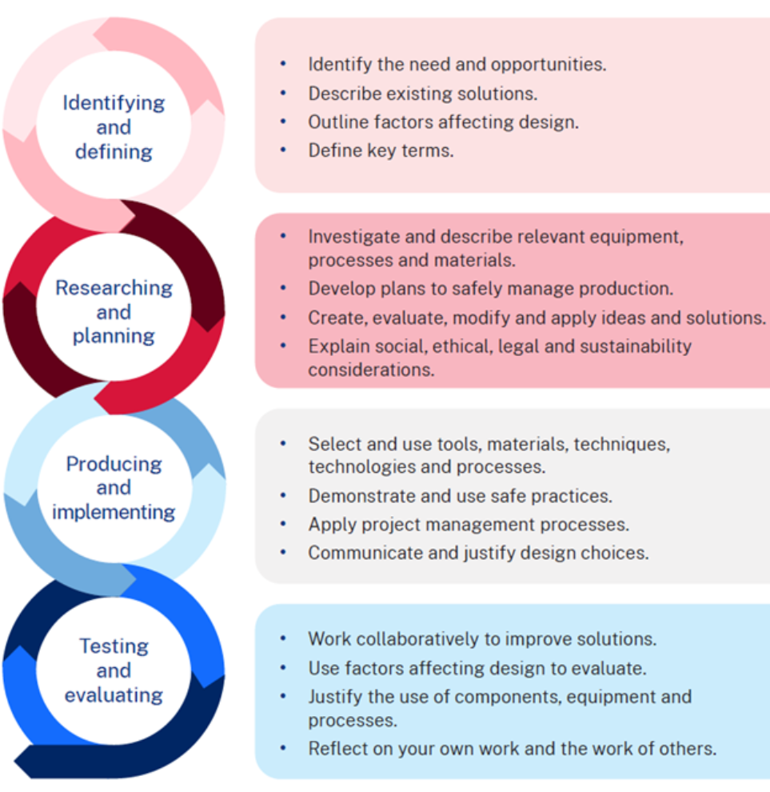

Report format
Engineers use engineering reports to communicate the results of their work to colleagues, clients, supervisors and the public. Engineering reports usually use the format below.

1. Title page
Include:
- Report title
- Your full name
- Date
- Class and teacher's name.

2. Table of contents
List all report sections with correct page numbers.

3. Introduction
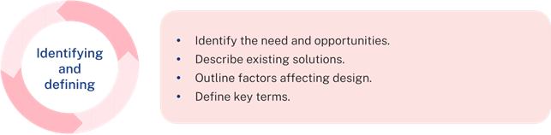
Outline the purpose of the engineering report.
Describe the design problem: How can car entry and exit into a carpark be controlled?
State the goal: produce a prototype of an automated folding boom gate.

4. Research
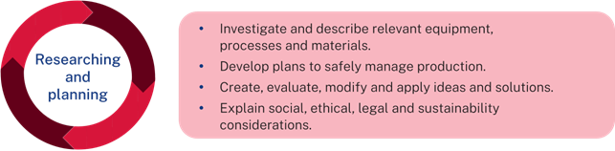
In this section, demonstrate your background knowledge and engineering understanding.

Sustainability
- Explain how engineered solutions can address sustainability.

Components
- Describe 3 components needed to automate servo operation.

5. Planning process
Use sketches, diagrams, CAD drawings and annotations to present your development process.
Design development
- Sketch or digitally model at least 3 automated folding boom gates.
- Justify your final design selection based on performance potential, ease of manufacture and safety.

6. Construction
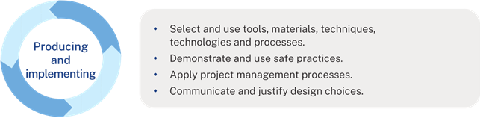Develop an automated control system to operate a folding boom gate.
Include labelled photos or diagrams.

7. Testing
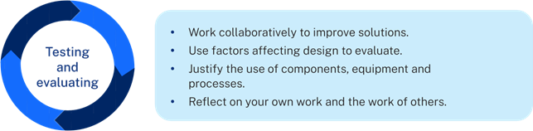
Describe how you tested the servo operation and automated folding boom gate:
- Testing procedures
- Observations
- Photos or diagrams
- Tables or charts of results.

8. Evaluation
Evaluate performance: Did it meet your goals?
- Identify strengths and weaknesses.
- Suggest improvements.
- Include peer feedback (if collected).

9. Conclusion
Summarise your findings and how the design solved the original problem.

10. References
List all sources used (for example, websites, videos, articles and class notes).

Support and alignment
Resource evaluation and support: all curriculum resources are prepared through a rigorous process. Resources are periodically reviewed as part of our ongoing evaluation plan to ensure currency, relevance and effectiveness. For additional support or advice, or to provide feedback, contact the TAS Curriculum team by emailing tas@det.nsw.edu.au
Differentiation: further advice to support Aboriginal and Torres Strait Islander students, students learning English as an additional language or dialect (EAL/D), students with a disability and/or additional needs and High Potential and Gifted students can be found on the Planning programming and assessing 7–12 webpage. This includes the Inclusion and differentiation 7–10 advice webpage.
Assessment: further advice to support formative assessment is available on the Planning programming and assessing 7–12 webpage. This includes the Classroom assessment advice 7–10. For summative assessment tasks, the Assessment task advice 7–10 webpage is available.
Alignment to system priorities and/or needs: School excellence, Our Plan for NSW Public Education.
Alignment to the School Excellence Framework: this resource supports the School excellence elements of curriculum (curriculum provision) and effective classroom practice (lesson planning, explicit teaching).
Alignment to Australian Professional Standards for Teachers: this resource supports teachers to address Proficient Teacher Standard Descriptors [3.2.2, 3.3.2].
Creation date: 19 September 2025

References
This resource contains NSW Curriculum and syllabus content. The NSW Curriculum is developed by the NSW Education Standards Authority. This content is prepared by NESA for and on behalf of the Crown in right of the State of New South Wales. The material is protected by Crown copyright.
Please refer to the NESA Copyright Disclaimer for more information https://educationstandards.nsw.edu.au/wps/portal/nesa/mini-footer/copyright.
NESA holds the only official and up-to-date versions of the NSW Curriculum and syllabus documents. Please visit the NSW Education Standards Authority (NESA) website https://educationstandards.nsw.edu.au/ and the NSW Curriculum website https://curriculum.nsw.edu.au/home.
Technology 7–8 Syllabus © NSW Education Standards Authority (NESA) for and on behalf of the Crown in right of the State of New South Wales, 2023.
Brookhart SM (2018) ‘Appropriate Criteria: Key to Effective Rubrics’, Frontiers in Education, volume 3(22):1–12, doi:10.3389/feduc.2018.00022, accessed 10 September 2025.
CESE (Centre for Education Statistics and Evaluation) (2020) What works best: 2020 update, NSW Department of Education, accessed 10 September 2025.
——(2020) What works best in practice, NSW Department of Education, accessed 10 September 2025.
——(2021) Growth goal setting – what works best in practice, NSW Department of Education, accessed 10 September 2025.
Fisher D and Frey N (1 November 2009) ‘Feed Up, Back, Forward’, ASCD (Association for Supervision and Curriculum Development): Educational Leadership magazine, 67(3), accessed 10 September 2025.
Griffin P (2017) Assessment for Teaching, Cambridge University Press, Port Melbourne, Victoria.
Hattie J and Timperley H (2007) ‘The Power of Feedback’, Review of Educational Research, 77(1): 81–112, doi:10.3102/003465430298487.
Panadero E and Jonsson A (2013) ‘The use of scoring rubrics for formative assessment purposes revisited: A review’, Educational Research Review, 9:129–144, doi:10.1016/j.edurev.2013.01.002, accessed 10 September 2025.
Sherrington T (2019) Rosenshine’s Principles in Action, John Catt Educational Limited, Melton, Woodbridge.
Wiliam D (2017) Embedded Formative Assessment, 2nd edn, Solution Tree Press, Bloomington, IN.

© State of New South Wales (Department of Education), 2025
The copyright material published in this resource is subject to the Copyright Act 1968 (Cth) and is owned by the NSW Department of Education or, where indicated, by a party other than the NSW Department of Education (third-party material).
Copyright material available in this resource and owned by the NSW Department of Education is licensed under a Creative Commons Attribution 4.0 International (CC BY 4.0) license.

This license allows you to share and adapt the material for any purpose, even commercially.
Attribution should be given to © State of New South Wales (Department of Education), 2025.
Material in this resource not available under a Creative Commons license:
- the NSW Department of Education logo, other logos and trademark-protected material
- material owned by a third party that has been reproduced with permission. You will need to obtain permission from the third party to reuse its material.
Links to third-party material and websites
Please note that the provided (reading/viewing material/list/links/texts) are a suggestion only and implies no endorsement, by the New South Wales Department of Education, of any author, publisher, or book title. School principals and teachers are best placed to assess the suitability of resources that would complement the curriculum and reflect the needs and interests of their students.
If you use the links provided in this document to access a third-party's website, you acknowledge that the terms of use, including licence terms set out on the third-party's website apply to the use which may be made of the materials on that third-party website or where permitted by the Copyright Act 1968 (Cth). The department accepts no responsibility for content on third-party websites.

