Technology 7–8 – Digital and communication technologies – teacher support resource
Drive with data

Contents
Teacher support resource and unit overview 4
Planning a long-distance road trip before smartphones and GPS 5
Sharing your road trip stories 5
What are Songlines? 7
Kamilaroi Highway 8
Data types 9
Types of data 10
Trip considerations for an electric vehicle (EV) 11
An EV driving holiday 12
Trip planning – brainstorm 12
Spreadsheets 13
Types of electric vehicles 14
Compare costs and emissions of different EVs 15
Charging EVs 16
Public charging 16
EV charging plug types 17
EV charging etiquette 18
EV range 19
Collecting EV data 20
Importing data into a spreadsheet 20
Structure of the EV dataset 21
Opening dataset file 23
Filtering data 29
Sorting data 29
Factors to consider when choosing a BEV for the trip 31
Online searchable EV data 32
Car with greatest range (sold in Australia) 33
Non-government sources of EV specifications data 34
Comparing BEVs 35
Searching for EV charging locations 36
EV charging stations 39
Example destination calculations – Bourke 42
Example destination calculations – Menindee 43
Example strategy and processes to plan a trip to Bourke 44
Summary information 44
Lots of combinations 48
Examples of more sophisticated charging time calculations 48
Decisions? or Decisions! 49
Excel tables 50
Introduction to Excel formulas 51
Arithmetic operators 52
Control structures – sequence 53
Sequence – guided practice 54
Sequence – extended independent practice 55
Getting user input – guided practice 56
Comparison operators 57
Control structures – selection 58
If-else statements 59
Elif statements 60
Elif – guided 61
Control structures – for loops 62
While loops 64
While loop with user input 65
Differences between for loops and while loops 66
Functions 67
Why use functions 67
Functions – guided practice 68
Authentic, accurate and timely 69
Trip planning apps 71
References 73

Teacher support resource and unit overview
Note: this resource has been designed to facilitate the ready conversion into a student booklet by removing the answers within the response windows. Teacher notes (in blue) can be deleted before distributing to students.

Planning a long-distance road trip before smartphones and GPS
Imagine planning a long car trip for a holiday or to visit relatives before smartphones or GPS devices existed. You would need to rely on paper maps, written directions and maybe even ask people for guidance along the way. Planning the route carefully was important to make sure you didn’t get lost and to estimate how long the journey would take.

Sharing your road trip stories
Think about your own experiences or stories you’ve heard about road trips. What do you remember about the distance, the time it took, how you navigated and how you kept track of your location? Sharing these stories helps us understand how travel has changed over time.
Choose a destination in NSW that you would like to visit. It might be:
- a family member’s home
- a place you have always wanted to go
- a cultural or natural site that interests you.
Using The Australian Institute of Aboriginal and Torres Strait Islander Studies (AIATSIS) and Gambay maps, research the information below.
The Aboriginal Country or Nation your home or school is located on.
The Aboriginal Country or Nation of your chosen destination.

The traditional language(s) spoken in the area(s) of your chosen destination.
Trace your route on the maps and, in the space below, note other Aboriginal Countries or Nations you would cross on your journey.
Class discussion:
Before colonisation, without modern roads or infrastructure, how might Aboriginal people have travelled this route?
Outline how knowledge of Country could inform planning, decision making and communication.

What are Songlines?
Note: watch What are song lines? (1:52).
What do Songlines mean to Aboriginal and Torres Strait Islander people?
What are some of the key components of Songlines?

Kamilaroi Highway
Use a map (such as Google Maps) to trace the Kamilaroi Highway (B51) and mark major towns along the route, for example:
- Willow Tree
- Gunnedah
- Narrabri
- Walgett
- Bourke.
- Identify what Aboriginal Nations or Countries the Kamilaroi Highway passes through and mark each Nation or Country along the highway.
- Find one language word, totem or cultural practice from each Nation or Country.
Class discussion:
Reflect on the similarities and differences between this Songline journey and using digital GPS or digital maps. Reflect on what makes Songlines unique as a knowledge and communication system compared to modern technology.

Data types
When we look at different kinds of information, whether it’s on a watch, an odometer, a map or a trip planner, the information is made up of different kinds of data. To understand and explain this information clearly, it helps to know about the basic types of data. Data types tell us what kind of information we are dealing with, and this affects how we use and interpret it.
- Numbers (integers and decimals)
- Integers: whole numbers without fractions or decimals (for example, 1, 25, 100).
- Decimals: numbers with fractional parts (for example, 3.14, 0.5).
- Text (characters and strings)
- Characters: single letters, digits, or symbols (for example, A, 7, #).
- Strings: a sequence of characters forming words or sentences (for example, New York, speed).

Types of data
Complete the table below by stating the data type presented in the image.
Image | Analogue/digital | Data type presented

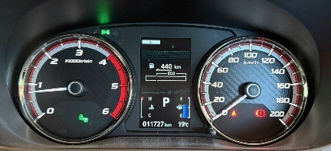

Trip considerations for an electric vehicle (EV)
Imagine you are planning a long car trip for a holiday or to visit family. Sometimes, people use petrol or diesel cars, and sometimes they use electric vehicles (EVs).
Think about what challenges you might face when planning your trip with each type of car. For example, how is refuelling a petrol car different from charging an EV?
Instructions
Write your ideas about trip planning for petrol/diesel cars and for EVs in the Venn diagram below.
- In one circle, list challenges unique to internal combustion engine cars.
- In the other circle, list challenges unique to EVs.
- In the middle, write challenges that are common to both.
- After you finish, we will share and discuss your ideas as a class.


An EV driving holiday
Complete the Plus, Minus, Interesting (PMI) table below, considering the following points:
- What are some of the benefits of using an EV for this type of road trip? (Plus.)
- What are the challenges of using an EV for this type of road trip? (Minus.)
- How does using an EV for this type of road trip affect planning for the trip? (Interesting.)
Plus | Minus | Interesting

Trip planning – brainstorm
In the diagram below, list things to consider when planning a trip in an EV.
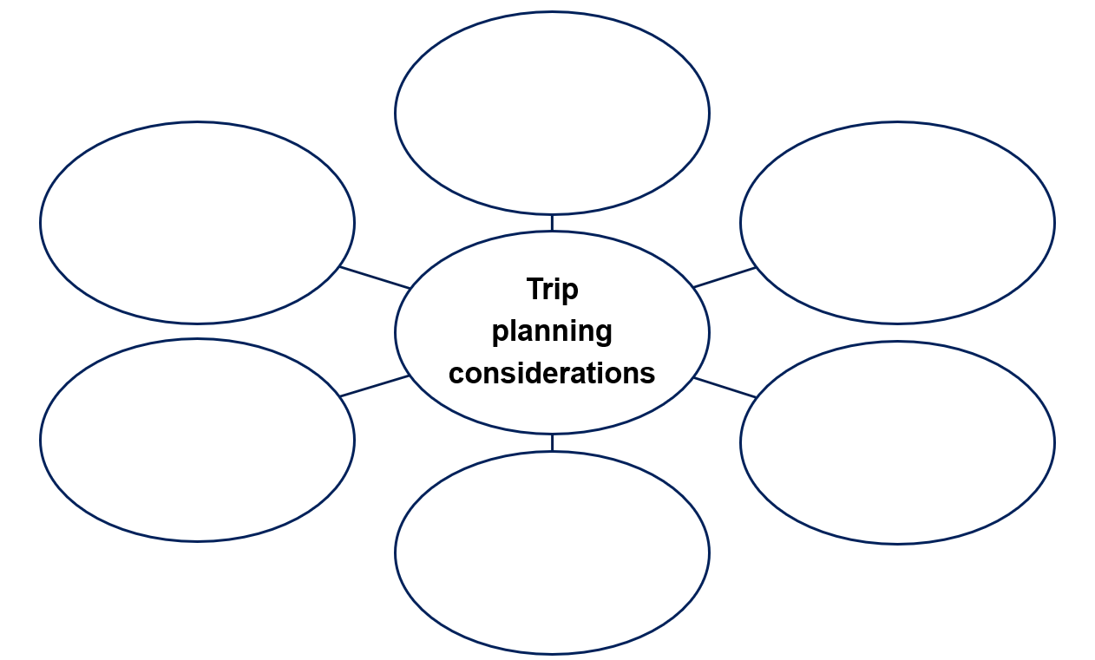
Note: watch Planning an Outback road trip in an EV (6:43).

Spreadsheets
Note: activate prior knowledge by reviewing how number data can be organised into tables. Check students’ previous experience with spreadsheets.
Guide students to set up their digital workspace including file and folder organisation.
Introduce spreadsheet software to be used. Demonstrate how to enter data and save spreadsheet files.
Watch:
- How to create formulas in Microsoft Excel (1:37).
- Multiplication in Microsoft Excel (0:41).
- Creating Microsoft Excel formulas and functions (1:39).
- Excel Tutorial for Beginners (16:16).

Types of electric vehicles
Use What electric vehicle is right for me? or Green vehicle guide to provide an outline and examples of the following types of vehicles.
Vehicle type | Outline (for example, source of energy and tailpipe emissions) | Examples
Battery electric vehicles (BEVs)
Hybrid electric vehicles (HEVs)
Plug-in hybrid electric vehicles (PHEVs)
Internal combustion engines (ICE)

Compare costs and emissions of different EVs
Element | BEV | BEV | PHEV | PHEV | Hybrid | Hybrid
Model
Variant
Price
Tailpipe emissions
Average annual cost
Electric range

Charging EVs
Note: before students plan their trips, it is important that they determine the importance of the vehicle, charge type and time it takes to fully charge the battery.
Watch Explainer: EV charging options in Australia (1:32) and How to charge an EV | Do you fast charge? Or slow charge? Charging EVs and hybrid explained! (8:49).

Public charging
List factors to consider when using public charging.

EV charging plug types
Identify these charging plugs.
  © State of New South Wales (Transport for NSW) |   © State of New South Wales (Transport for NSW)
Answer: CCS2 | Answer: CHAdeMO
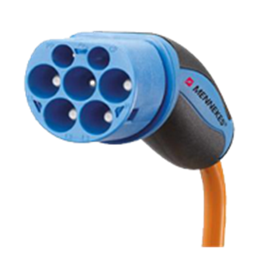  © State of New South Wales (Transport for NSW) | 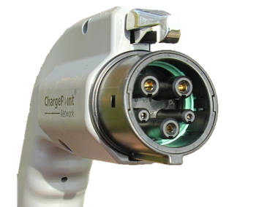  Michael Hicks / Flickr “mulad” / CC-BY-2.0
Answer: Mennekes (Type 2) | Answer: J1772 (Type 1)

EV charging etiquette
Class discussion:
What is the proper etiquette to follow when using a public EV charging station?
What are other important responsibilities EV users should keep in mind while charging their vehicle?
NRMA has a recent article on EV charging etiquette. The Australian Electric Vehicle Association also offers this advice on electric vehicle charging etiquette.

EV range
What is meant by the term ‘EV range’?
Sample answer:
In the diagram below, list factors that could affect the range of an EV.
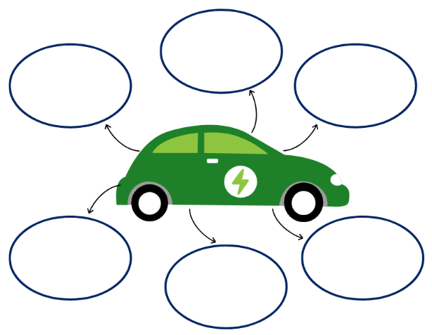
Note: sample answers for the above diagram are supplied in the PowerPoint.

Collecting EV data

Importing data into a spreadsheet
An Australian-specific BEV dataset can be downloaded from the Electric Vehicle Index. Scroll down to section 7 ‘Vehicle specification information’.
Figure 1 – screenshot of part of Australian Automotive Association research data webpage
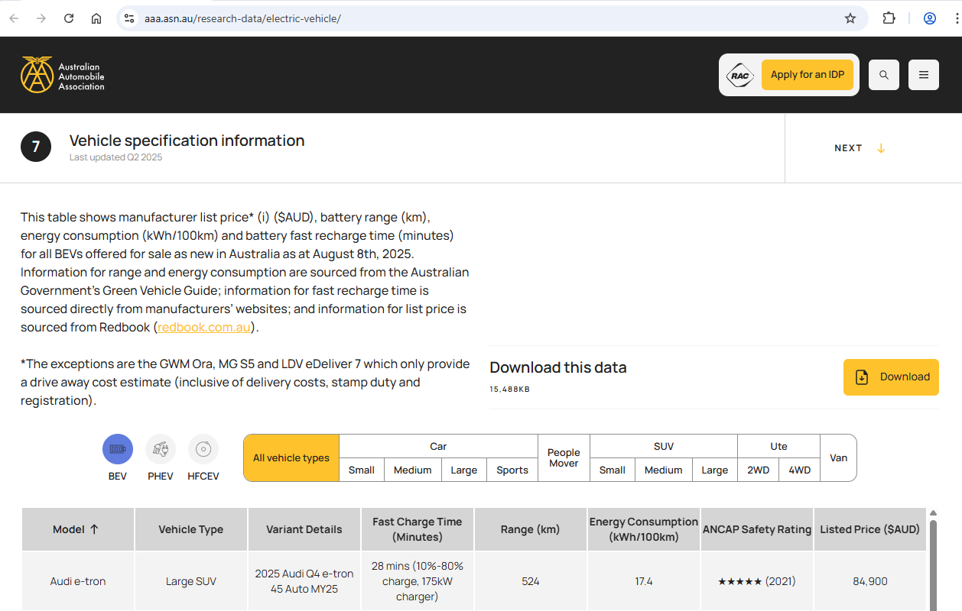
The download button is a link to the latest available dataset for BEVs offered for sale as new. In this example we are downloading vehicle specifications current up to March 2025. At the time of publication, its link was:
Vehicle Specifications March 2025 CSV (aaa.asn.au/wp-content/uploads/2025/05/Vehicle_Specifications_MAR_25.csv)
Right-click on the Download button and choose Save link as … and save to your user workspace folder. The file format is comma delimited and will import into a spreadsheet.

Structure of the EV dataset
This dataset has the following 10 attributes:
Attribute | Data type | Field description
Vehicle type | text/string | Categories representing 11 vehicle type definitions
Fuel type | text/string | Categories representing 3 EV fuel types (BEV, PHEV and HFCEV)
Model | text/string | Model of manufacturer’s vehicle
Variant details | text/string | Specific variations of key attributes for EV model
Listed price ($AUD) | currency | Manufacturer’s retail list price in Australian dollars
Fast charging time (minutes) | text/string | Time to add a specific amount of range to vehicle battery
ANCAP rating | text/string | Vehicle's safety performance
ANCAP van rating | text/string | Vehicle's safety performance
Range (km) | number/integer | Maximum distance for travel on a fully charged battery
Energy consumption (kWh/100 km) | number/float | Total electrical energy consumed over specified distance measured in lab tests
By default, some spreadsheet programs may format these columns as ‘General’, however, there are 2 main data types within this dataset – text and number. Remember, these were introduced earlier in the unit when learning about data representations and data types.
Why could it be useful to have Range (km) and Energy consumption (kWh/100 km) as a number data type?
For Listed price ($AUD), a third (spreadsheet) data type to use could be currency. This will work for all cars, except 3, listed in this dataset.
Without a minor change, which 3 cars will it be difficult to assign a currency data type to? And why?
Why is Fast charging time (minutes) not listed as some type of time data type?
Note: when comparing data from different sources, always check the units are the same. For example, some sources may report Energy consumption as kWh/100 km while other sources report it as Wh/km.

Opening dataset file
The Australian-specific BEV dataset can be imported into a spreadsheet document in 2 different ways.
Method 1: open from file menu
Open Vehicle_Specifications_MAR_25.csv directly from the Open file dialog box. The text import wizard will start:
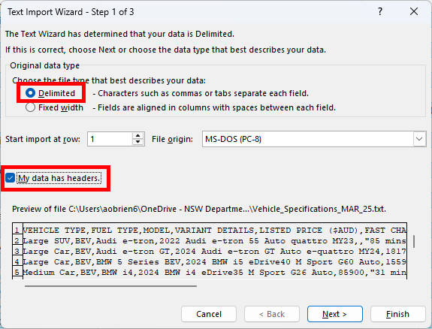
Select the Delimited radio button.
Select ‘My data has headers’ checkbox. Select Next.
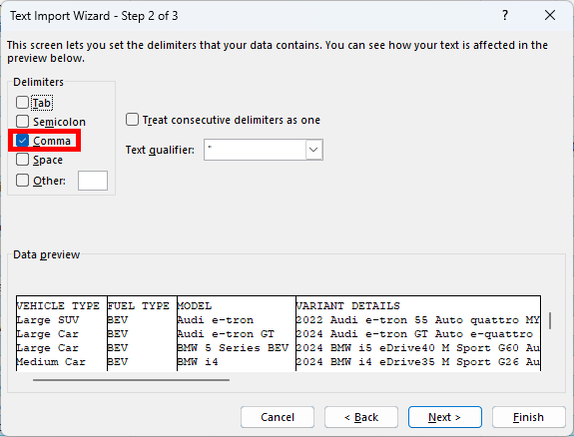
Deselect ‘Tab’ checkbox and select ‘Comma’ checkbox. Select Next.
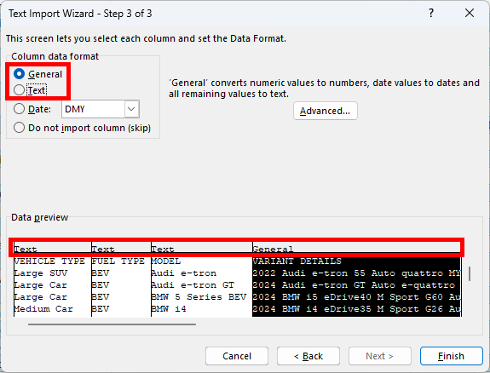
Optionally change Column data format types from ‘General’ (default) to ‘Text’ for each column or use more options from within the spreadsheet. Select Finish.
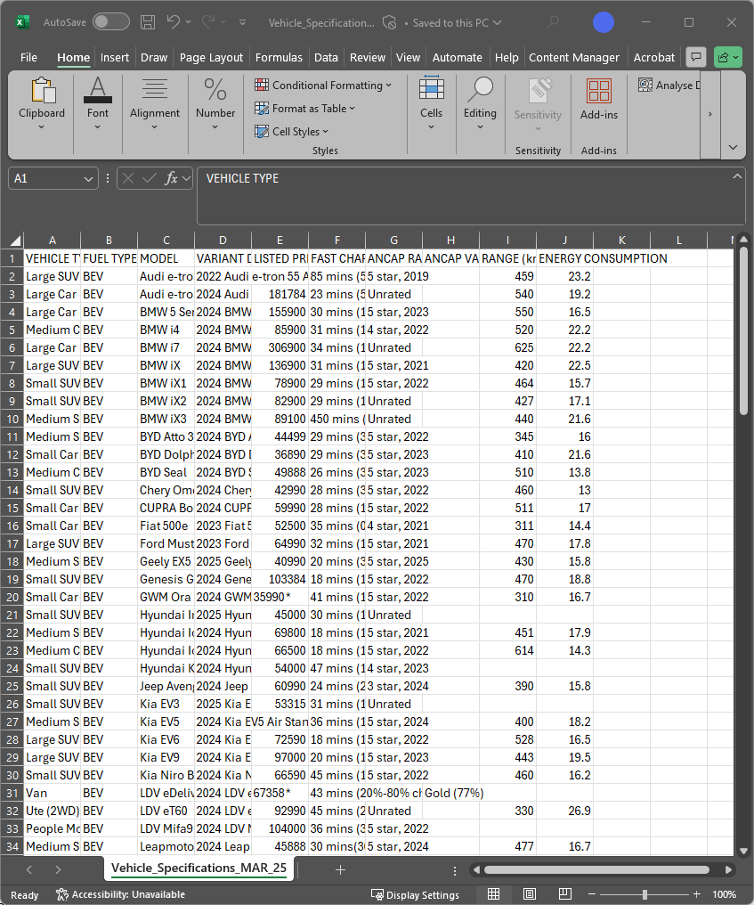
When import wizard has finished, the result should look like above. Column widths are all the same and may need to be changed to make all data visible. No extra formatting applied.
Note: watch How to create and format tables in Microsoft Excel (0:55).
Method 2: use Get data from Data menu.
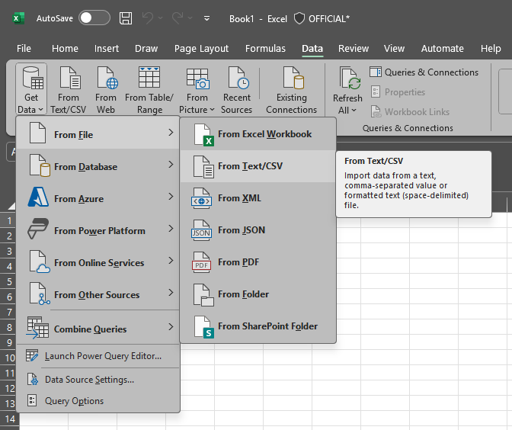
This is also available from the From Text/CSV button next to Get Data.
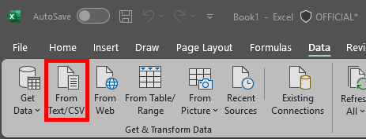

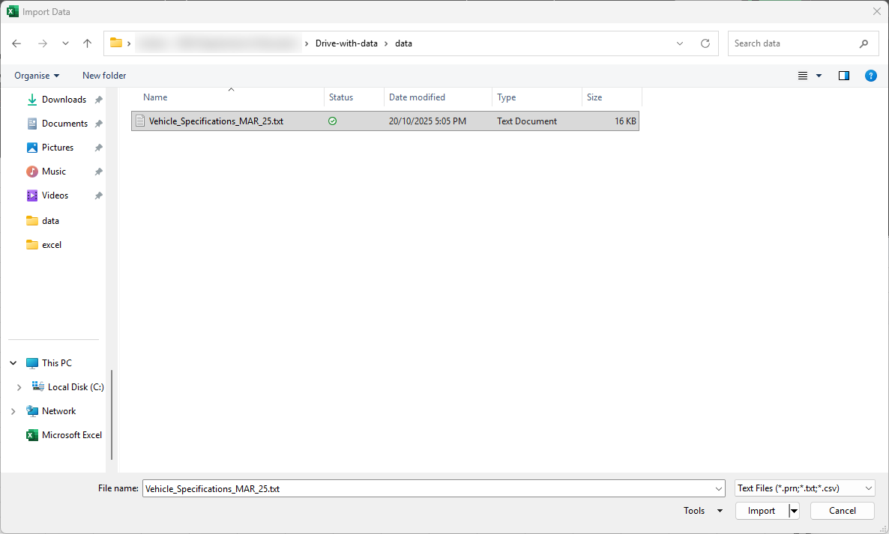
Navigate to the folder where the dataset file was saved to, select it and select Import.
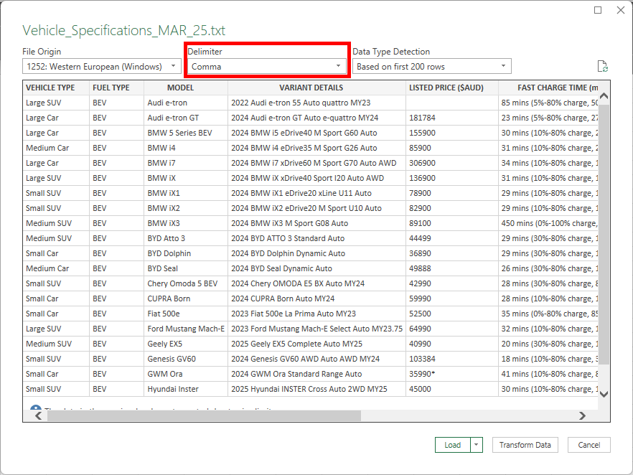
Check Delimiter shows ‘Comma’ option and then select Load.

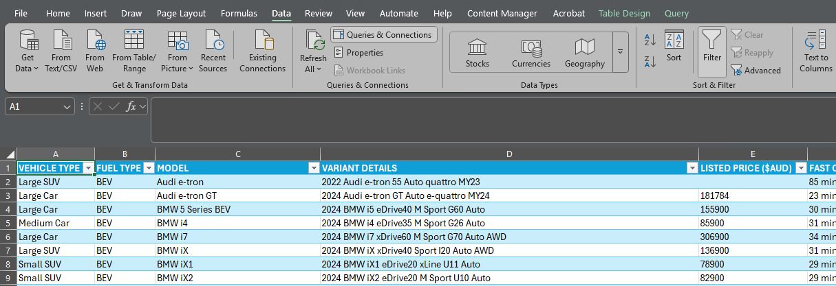
When ‘From Text/CSV’ wizard has finished, the result should look similar to the above. Column widths are set to varying widths so each cell is visible but may need to be changed to make all columns, or relevant columns, visible. In this process, the data is placed in a table and filter controls are automatically added to the table headers. Use the column header arrows to ‘Sort’ and ‘Filter’ data in columns as required.
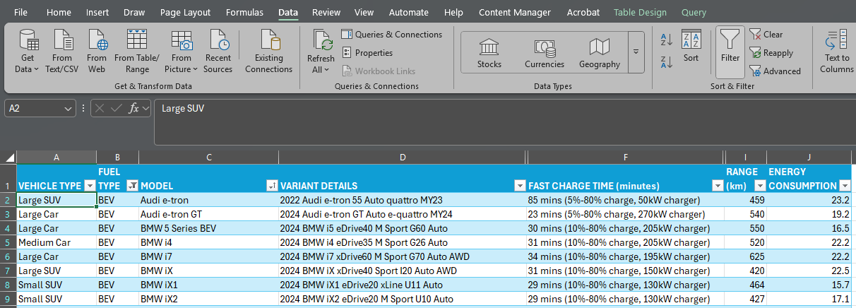
In this dataset, there are 117 rows.
How many different cars are listed in this dataset?
How many different types of EVs are listed in this dataset?

Filtering data
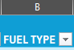
Note: watch How to filter data in a range or table in Microsoft Excel (1:05).
The Vehicle_Specifications_MAR_25.csv dataset has different types of EVs. To view only the BEVs, use the column header arrow for ‘Fuel Type’ to temporarily hide other fuel types.

Sorting data
Uncheck HFCEV and PHEV, then select OK.
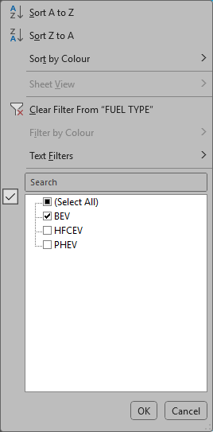
How many cars in this dataset are the fuel type BEV?
To find the EVs with the largest range, select the column header for Range (km) and select Sort Largest to Smallest.
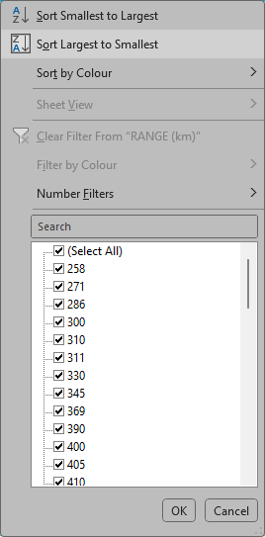
Which EV in this dataset has the largest range?

Factors to consider when choosing a BEV for the trip
Search for and select BEV models (limited to only BEV types) available in Australia. Things to consider when selecting an EV model:
- battery capacity
- energy consumption
- EV range (some provided data on ranges may not be accurate or not take into account various conditions such as hilly landscapes and extreme temperature ranges)
- charging capability (some data on ranges looks appealing but may also come with long charging times)
- charging type (not all destinations have charging stations for all plug types. Adapter cables or portable charging stations may need to be considered).
Consider these and any other factors that could be relevant for the EV road trip and rank these factors from most important to least important.
1.
2.
3.
4.

Online searchable EV data
To confirm its validity, compare data from multiple sources. In addition to the dataset previously downloaded, the following websites provide EV specifications data.
https://www.greenvehicleguide.gov.au/Vehicle/Search
Search by Fuel type = Pure electric.
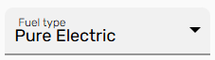
Scroll down and right-click on Download CSV link.
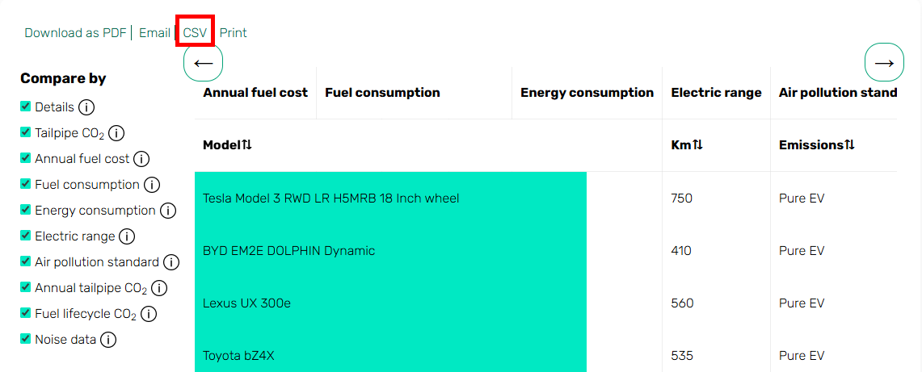
Use the same steps to import this CSV file into a spreadsheet.
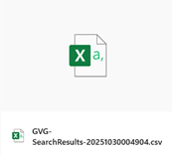
How many electric vehicles does the Green Vehicle Guide list?
https://www.vesr.gov.au/
Search by make and model or browse and compare by engine type or body type. Electric engine type equals BEV. How many BEVs are currently available to browse?

Car with greatest range (sold in Australia)
The Transport for NSW webpage on available electric vehicles has a sortable table for all BEVs and fuel cell electric vehicles (FCEVs) currently available in Australia.
According to this webpage, how many BEVs are available in Australia?
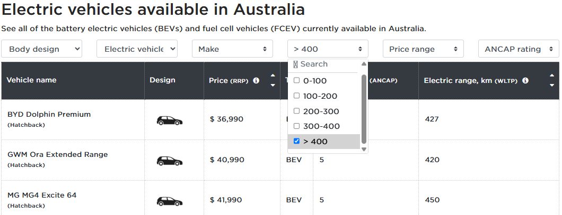
Screenshot from Transport for NSW website © State of New South Wales (Transport for NSW)
Use Worldwide Harmonised Light Vehicle Test Procedure (WLTP) range (km) filter drop-down menu to select cars in the highest range category (>400). How many EVs have an electric range greater than 400 km?

What is WLTP range?
Which car listed in this table has the greatest range?

Non-government sources of EV specifications data
- View the Redbook cars website.
How many electric vehicles does Redbook list?
How can BEVs be filtered out of the total electric vehicle list?
Note: Unfortunately, Jetcharge does not allow for sorting by range and charge type.
- Select BEV from the ‘Car Type’ dropdown menu and select Search.
How many BEVs does Jetcharge list?

Comparing BEVs
Record data for your top 4 BEVs you are considering using on the trip.
Data | Car option 1 | Car option 2 | Car option 3 | Car option 4
Cost
Range (km)
Battery capacity
Energy consumption
Charge time
Fast charge time

Searching for EV charging locations
There are a few options for searching for EV charging locations, including:
- discrete datasets that can be imported into spreadsheets
- interactive maps that can be used to manually gather similar information but with the added benefit of immediate linking to other types of connected information about destinations.
Transport for NSW provides datasets on charging stations in NSW. Some datasets are separated into Destination Chargers (AC) and Fast Chargers (DC) and Upcoming Fast Chargers. At the time of publication, these required an account to access.
A similar dataset can be downloaded from Transport NSW EV Charger locations dataset.
Use Method 2 (Get data from Data menu) from earlier in the unit to import this CSV file into a spreadsheet. This method gets data into a spreadsheet quicker, which can make it easier to find answers to questions such as the following:
How many charging stations are listed in this dataset?
Which operator and charging stations have the largest number of stations (or charging bays as listed in column F)?
How many different operators are listed in this dataset?
Which local government area has the highest number of charging stations?
How many charging stations are listed as ‘Upcoming’?
What can we discern from this view of the dataset?
Focus on the number of stations, number of plugs, charger type, charger rating and the 3 columns showing the number of each type of plug. (Note: disregard that row 13 is intentionally hidden because it is ‘upcoming’.)
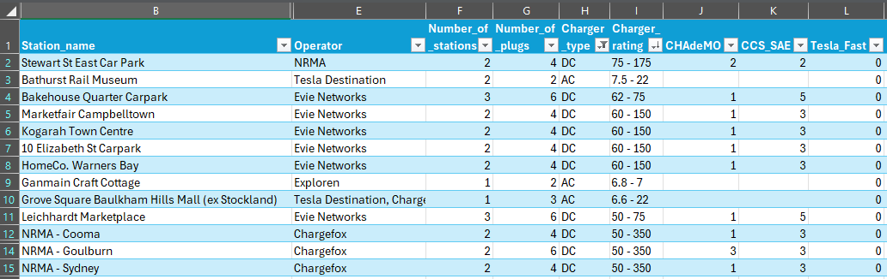
Class discussion:
What strategy can we use on data values that are a range, for example, 50 to 350?
How can we make these data values more useable when sorting?
How can we filter and sort this spreadsheet table to show the chargers with the highest charging rate first?

Use the Transport for NSW electric vehicle charging map to your nearest charging station in NSW:
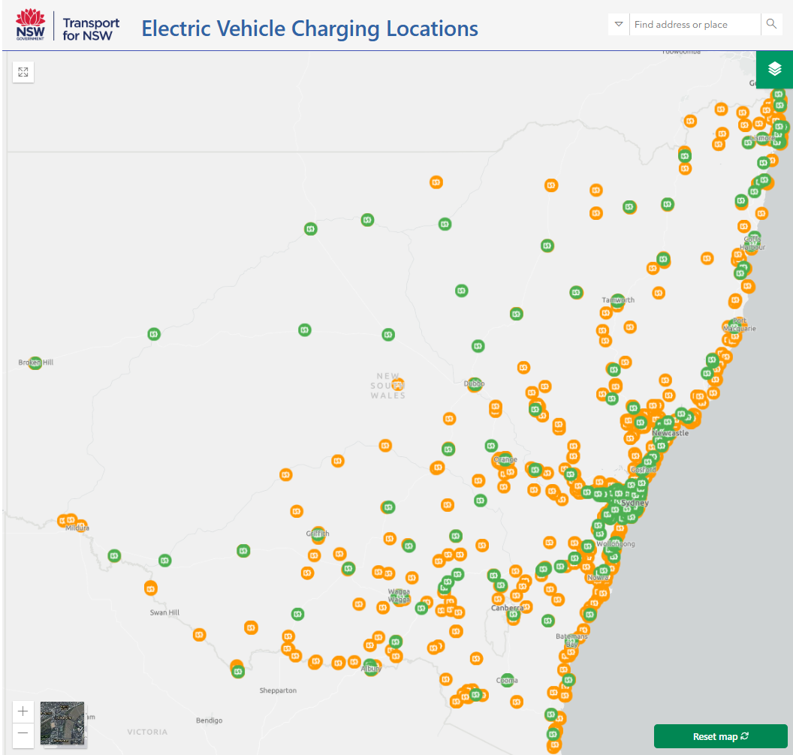
Screenshot from Transport for NSW website © State of New South Wales (Transport for NSW)

EV charging stations
When planning an EV trip, it is important to remember how public EV charging stations operate. The following references may be useful for searching for and checking coverage of commercial public EV charging station providers in Australia.
- bp pulse charging network
- ChargeFox charging network
- ChargePoint charging network
- EV Charging Stations Australia Map
- EVie charging network
- EV Powerhouse Tesla Superchargers Locations in Australia
- EVUp charging network
- JOLT charging network
- NRMA charging network
- Tesla charging network

Google Maps can be useful in determining the road distances and estimated travel times between destinations. Routes can be broken up into separate segments to calculate segment distances and help plan stops for recharging. Google Maps can also be used to locate EV charging stations.
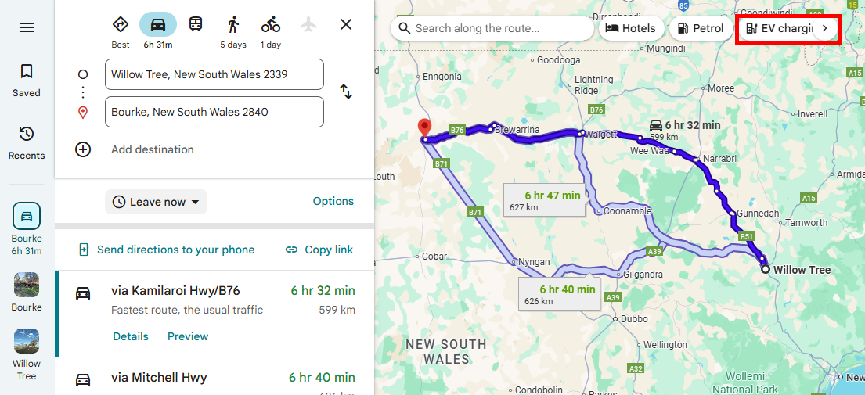
Map data © 2025 Google
Details about individual charging stations along the selected path can be seen on the left side of the page or by clicking directly on the red charge icons on the map.
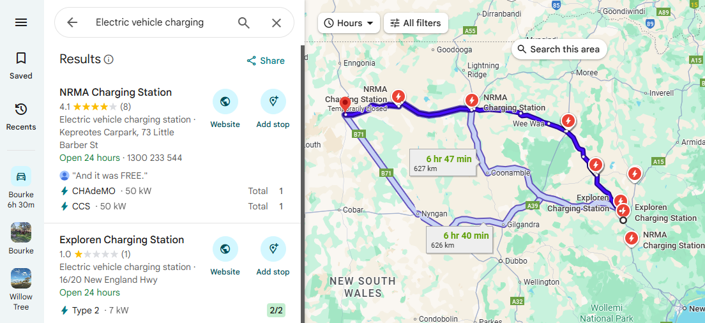
Map data © 2025 Google

The NSW Department of Planning, Industry, and Environment (DPIE) developed this interactive map below in collaboration with zero emissions transport specialist advisory Evenergi.
This map is free for anyone to use. While its primary purpose is to help people plan where to install new fast charging stations for electric cars in NSW by showing the best locations, it may be helpful to use its current data and layers to quickly visualise where existing charging stations are located (and, conversely, where they are not).
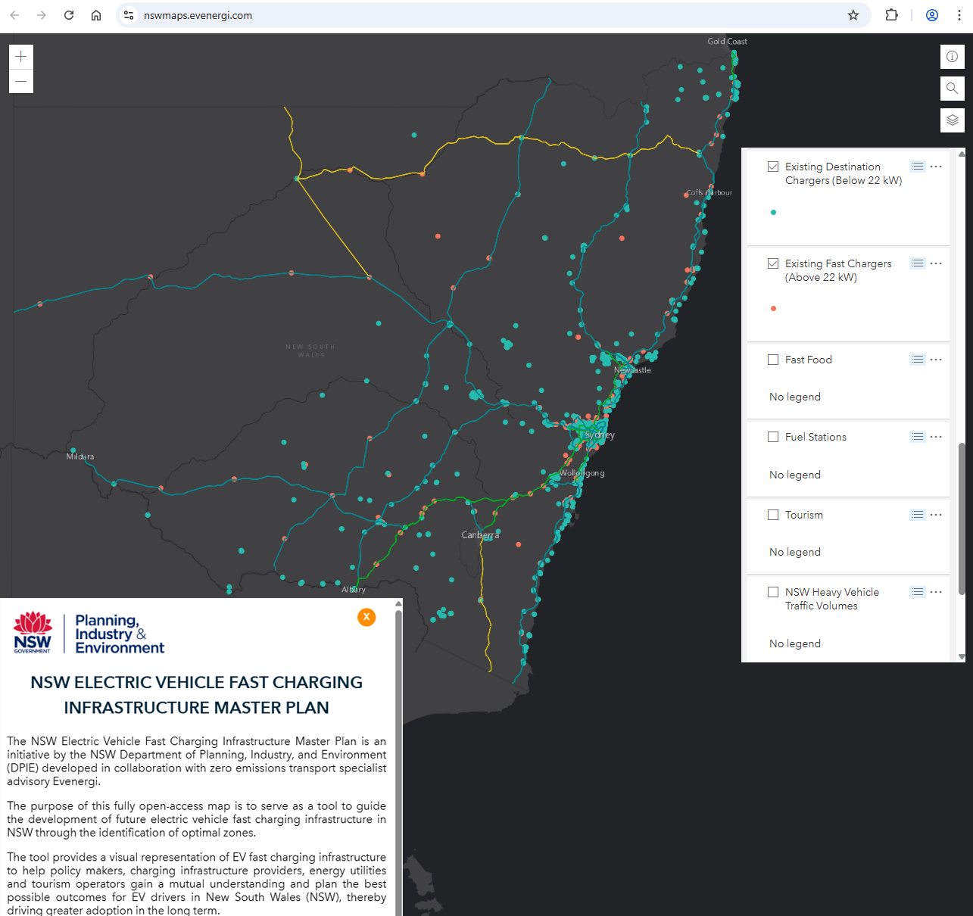
Screenshot from Evernergi website © State of New South Wales (NSW Department of Planning, Industry & Environment)

Example destination calculations – Bourke
Starting at Willow Tree (NSW), how far is it to Bourke (NSW)?
Answer: 599 km but different mapping platforms can vary, particularly if they take slightly different paths. In this example OpenStreetMap has selected a slightly different path of 609 km.
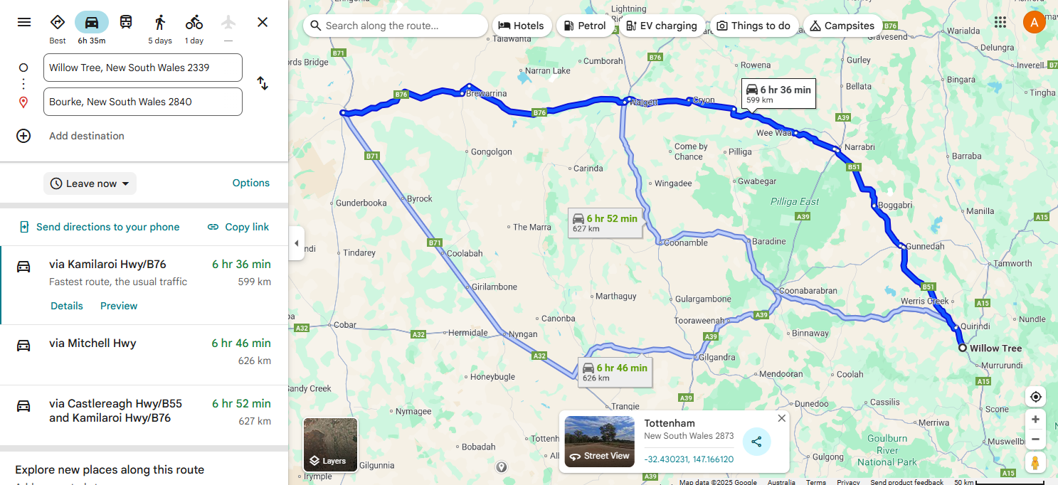
Map data © 2025 Google
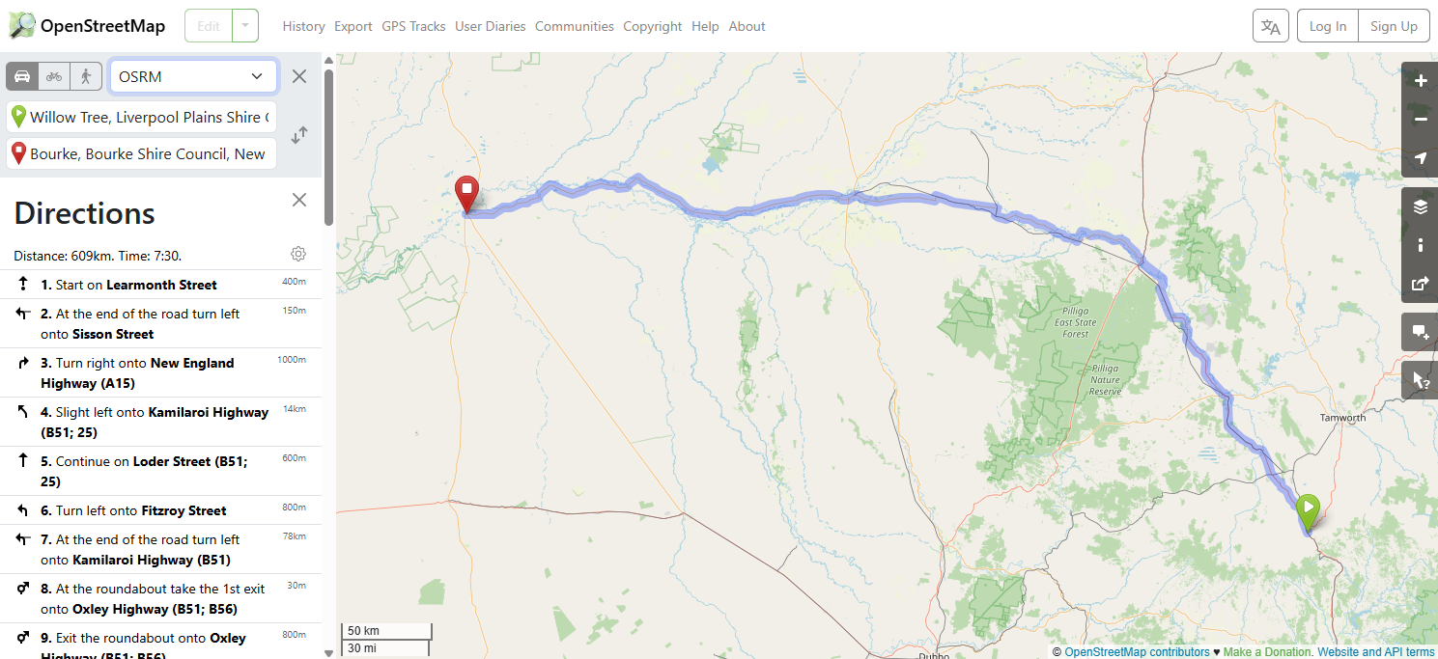
Map data from OpenStreetMap © OpenStreetMap

Example destination calculations – Menindee
Starting at 105 Phillip Street, Parramatta (NSW), how far is it to Menindee (NSW)?
Answer:
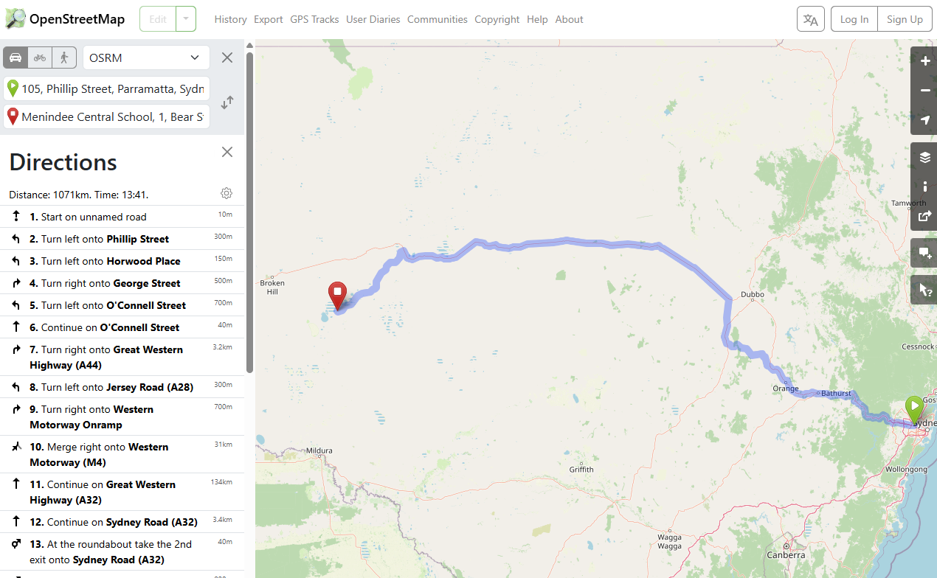

Example strategy and processes to plan a trip to Bourke
For these example calculations, we will consider driving a 2024 Tesla Model 3 Rear-Wheel Drive Auto from Willow Tree, NSW, to Bourke, NSW. We could, but are not going to, use the Tesla trip planning app. Some data sources list a range of 513 km to 629 km (WLTP). We will use the lower end of the range to ensure we are not stranded in between towns. Conveniently, a range of 513 km is notably less than the destination distance of 599 km so we cannot do this on a single charge. We need to plan a stop in a town to recharge the battery. But where?

Summary information
- EV: 2024 Tesla Model 3 Rear-Wheel Drive Auto (not a long-range model*). *Be specific about the make/model and year when collecting car specification data
- Battery capacity: 62.5 kWh
- Energy consumption: 13.2 kWh/100 km (or 0.132 kWh/km)
- Destination distance: 599 km
- AC charging: 11 kW, Type 2 plug
- DC charging: 170 kW, CCS combo plug
In a spreadsheet, do a simple calculation to check the validity of the listed range.
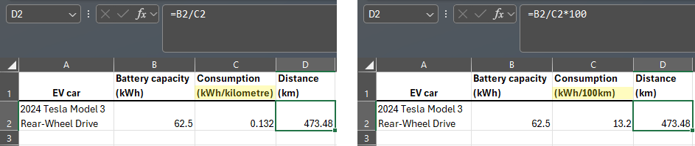
- 473.48 km is significantly less than the advertised range of 513 km.
- 450 km (449.8 km) is the range we will aim to find a charging station within which also gives us a 5% adjustment for different driving conditions.
Note: we have not considered the impact higher driving speeds has on EV range. Faster car speeds will lower the EV’s range.
An initial ‘Goldilocks’ assessment:
- Willow Tree to Narrabri = 194 km (too short a distance?)
- Willow Tree to Brewarrina = 501 km (too long a distance?)
- Willow Tree to Walgett = 368 km (maybe just right?)
Before we lock in Walgett as the stop to charge the battery before continuing to Bourke, what are the charging options?
Town | Operator | No. chargers | Plug type | Charge rating
Gunnedah | Chargefox | 4 | CCS | 47 kW
Gunnedah | NRMA | 2 | CCS | 50 kW
Narrabri | NRMA | 4 | 2x CCS  2x CHAdeMO | 47 kW
Narrabri | Tesla | 4 |  | 300 kW
Walgett | NRMA | 1 | CCS | 64 kW
Brewarrina | NRMA | 1 | CCS | 50 kW
Another consideration is what the state of charge (SoC) is by the time you reach a town. Using various apps and the assumption of consistent speed, the following approximate SoC values show the decrease in battery charge from 100% at town locations along the single journey:
- Gunnedah: ~75% SoC (this means there is approximately 75% percent battery charge left)
- Narrabri: ~56% SoC
- Walgett: ~14% SoC (this means there is approximately 14% percent battery charge left).
In theory we could just make it to Walgett. But there is currently only one 64 kW charger available for use. Hopefully it will be available and working when we arrive. Otherwise, our trip may end up taking longer than we planned for.
We can calculate approximately how long it takes to recharge from 14% to 80%, using formulas in a spreadsheet or an online EV charge time calculator. This calculator suggests that it will take approximately 43 minutes to charge to 80% capacity.
To calculate the amount of time it will take to charge an EV, use the following formula:
$$charge time= \frac{battery capacity}{charge power ×0.9}$$
The spreadsheet below shows the range of charging times calculated with this formula based on different charging rates. The calculations are for charging to 100% charge but combine an average power efficiency (0.9) adjustment.
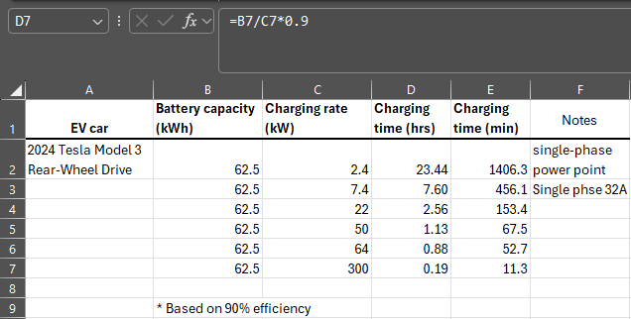
Row 6 of the spreadsheet shows the same charging rate value as used in the online calculator above, but for 100% charged.

Lots of combinations
The below is an example of using a spreadsheet to compare and calculate different combinations of journey segments.
Importantly, battery discharge is dependent on many factors (such as car speed and ambient temperature), and accurate values for remaining battery charge rely on more sophisticated calculations and algorithms. However, the spreadsheet below shows a general trend which may help inform decisions about where to stop and for how long.
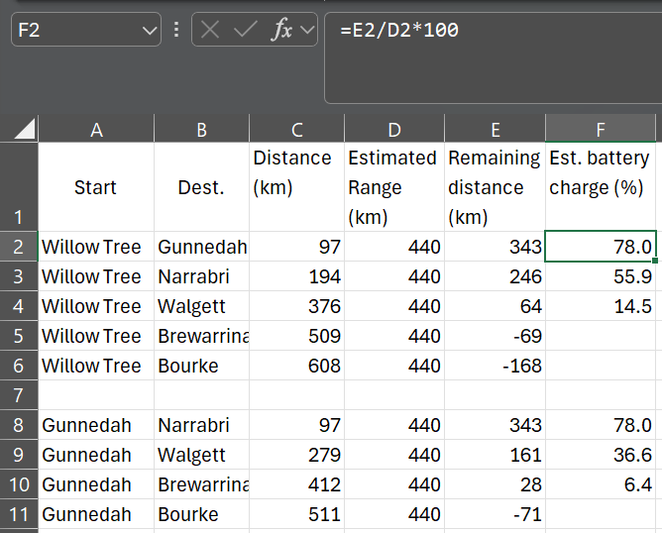
The estimated range used was 440 km because it produced reasonably useful estimates of battery charge values when compared to EV trip planner apps using the same destination data.

Examples of more sophisticated charging time calculations
Watch Sydney to Darwin EV route planning (8:48). Take note of the graphs in the spreadsheet which is explained in the video from 2:25. Notice how increased speed reduces range, leading to more frequent charging and longer overall trip times. Remember faster car speeds will lower the EV’s range.
Explore the Google Sheets EV Range Calculator which visually shows the relationship between energy consumption and speed, and the impact of speed on range.
Note: units are imperial but illustrate the relationship.

Decisions? or Decisions!
Is it going to be quicker or more efficient to stop in at closer towns such as Gunnedah or Narrabri than travel on a single charge to Walgett?
Which town(s) will you plan to stop at? How long will you need to stay to recharge or partially charger the battery? What can you do while waiting for the charger to finish?

Excel tables
All about Excel tables (10:16) provides a good introduction to Microsoft Excel tables.
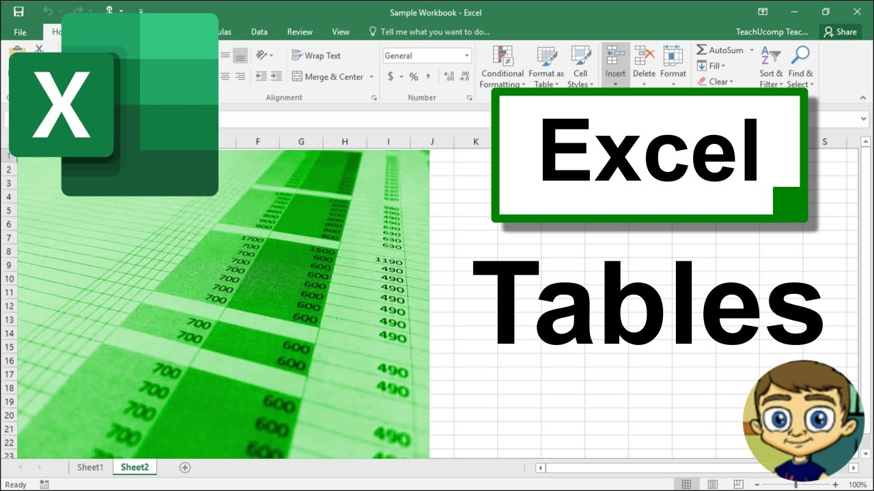

Introduction to Excel formulas
Beginner's guide to Excel functions and formulas (8:47) provides a good introduction to Microsoft Excel.


Arithmetic operators
Complete this table using a = 10 and b = 4.
Operator | Operation | Sample Expression | Result
+ |  | a + b
- |  | a – b
 | Multiplication | a x b
 | Division

Control structures – sequence
Type the code below.
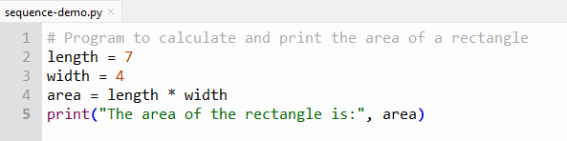
Run the program and check you get the below output.
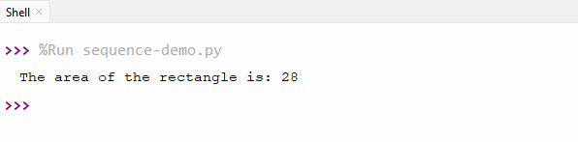
If you change the value of width from 4 to 9, what output do you get?
Type the code below.
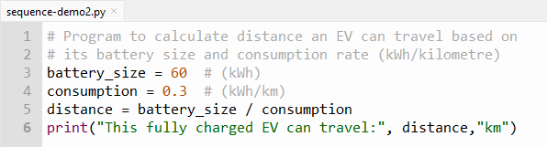
What output do you get?

Sequence – guided practice
Type the code below.
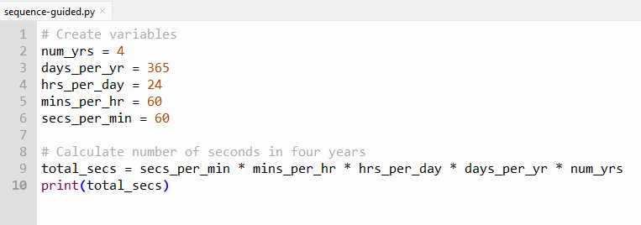
Run the program and check you get the below output.
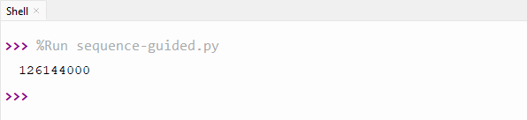
Type the code below.
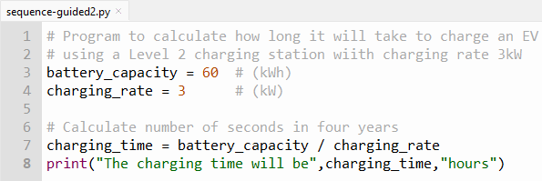
What output do you get?

Sequence – extended independent practice
Type the code below.
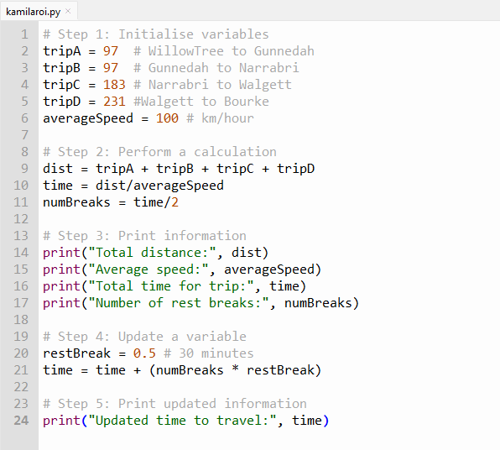
Run the code and check the output.
Adjust the value for averageSpeed and re-run.

Getting user input – guided practice
Type the code below.
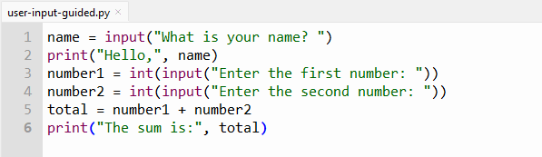
Run the code and enter your name and 2 numbers.
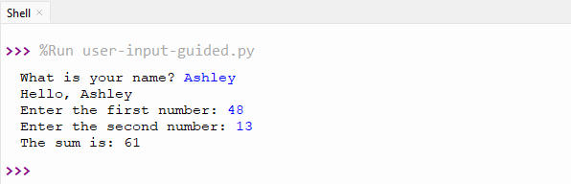
This image above shows the output for “Ashley” and the 2 numbers – 48 and 13. Check your output below is correct for the name and 2 numbers you entered.
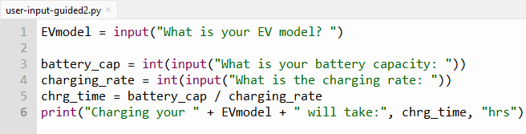
What output do you get?

Comparison operators
Complete the table below.
Operator | Operation | Example expression | Result
 | Equivalent to |  | True if the value of a is equal to the value of b  False otherwise
 | Not equal to |  | True if a isn’t equal to b  False otherwise
< |  |  | True if a is less than b  False otherwise
 | Less than or equal to |  | True if a is less than or equal to b  False otherwise
> |  |  | True if a is greater than b  False otherwise
 | Greater than or equal to |  | True if a is greater than or equal to b  False otherwise

Control structures – selection
If statements are the most basic form of selection.

Type the code below.
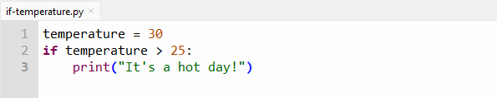
What is the output?
Change the value of ‘temperature’ to 25.
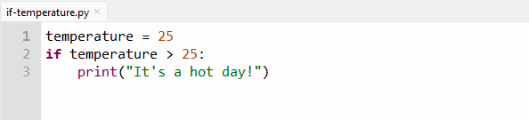
What is the output now?

If-else statements
If-else statements extend the if statement by providing an alternative block of code to execute if the condition is false.
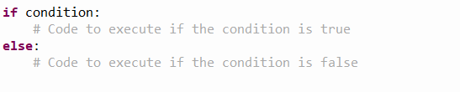
Type the code below.
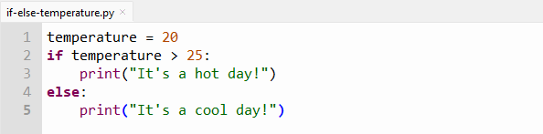
What is the output?
Change the value of ‘temperature’ to 35.
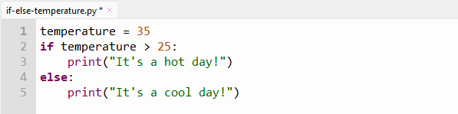
What is the output now?

Elif statements
Elif statements allow for multiple conditions to be checked sequentially. If the first condition is false, it checks the next condition.
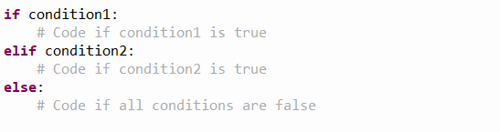
Type the code below.
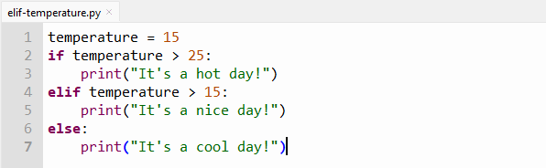
What is the output?

Elif – guided
Type the code below.
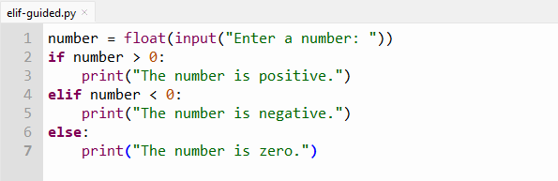
Run the program with the values below and record the output below.
Value entered | Output
17
-31
4578.3
-0.082
“negative 5”
What type of values will this program accept?

Control structures – for loops
You use a for loop in Python when you want to repeat something a certain number of times or when you want to go through each item in a list or each character in a word.
A for loop is generally used when you know the exact number of repetitions (or iterations) you need to perform. This is the general syntax of a for loop.

- for is the keyword that starts (or initiates) the loop.
- item is a variable name you use to keep track of the current thing you are working with.
- in is a keyword that links the variable to the list or collection you want to go through.
- iterable is the list or collection of items you want to repeat.
- code block is the set of instructions you want to do for each item.
Type the code below.
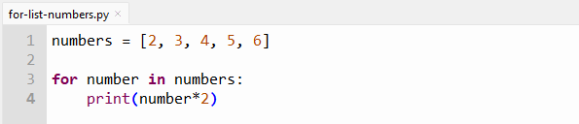
What is the output?

A range in Python is a way to list out numbers in order. Most of the time, these numbers go up one by one, such as 1, 2, 3, 4. But you can also choose to skip numbers if you want. You can make a range by using the range() command, and you can give it 1, 2 or 3 numbers to tell it where to start, where to stop, and how much to skip by.
To go through the numbers from 0 to 10 in Python, you use the ‘for i in range(11)’
Type the code below and run.
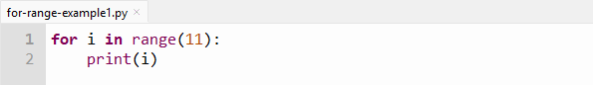
Type the code below and run.
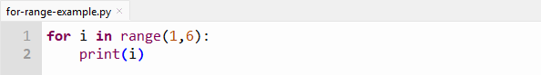
Type the code below and run.
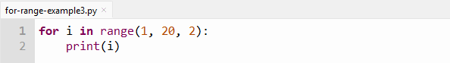
What is the output?
for-range-example1.py | for-range-example2.py | for-range-example3.py

While loops
A while loop keeps going as long as a certain condition is true. You use it when you don’t know how many times you will need to repeat something.
It’s good for when you want to do some actions repeatedly until some condition changes. This is the general syntax of a while loop.
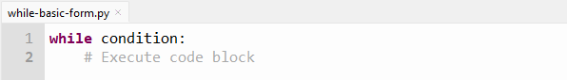
- while is the keyword that starts (or initiates) the loop.
- condition is an expression evaluated for truthiness that defines the exit condition.
- code block is the set of instructions that the program repeats each time the loop runs.
Type the code below.
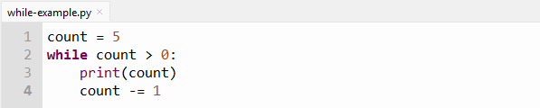
What is the output?
Answer: 5
4
3
2
1

While loop with user input
Getting user input from the command line is a common use case of while loops in Python. We can use a while loop to keep asking the user to type something.
Type the code below and run the program.
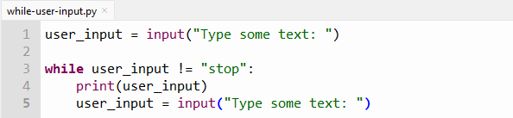
Describe what happens when you run this program.
Suggested answer: the program asks you to type something. If you type anything other than "stop", it prints what you typed and asks you again. This loop runs until you type the word "stop".

Differences between for loops and while loops
Complete the table below comparing for loops and while loops.
For loop | While loop
Starts with the keyword _________ | Starts with the keyword _________
Number of repeats is _________ | Number of repeats is _________
Good for lists, strings (and tuples, dictionaries and sets) | Good for repeating until something happens
Needs a _________ to _________ | Needs a _________ to _________
_________ and _________ for set tasks | Useful for ___________ or changing situations

Functions
A function is a set of instructions that does a specific job when you ask it to. You give a function a name so you can use it anytime without rewriting the instructions. Functions can take inputs, work with them, and sometimes give back an answer.
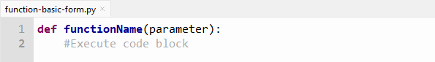
- def is the keyword that begins the function definition.
- functionName is the name you give to your function (it must be a valid Python identifier).
- parameters are optional and are extra information you can give the function to use, and there can be one or more, separated by commas.
- : colon punctuation shows the end of the function header (this is the first line).
- code block is the set of instructions that the function does when you use it (or when it is ‘called’).

Why use functions
How do functions help with good programming practices?
Suggested answer:
They help by letting you:
- split your code into smaller, easier parts
- use the same code many times without copying it
- make fewer mistakes because you don’t repeat code
- find and fix problems more easily
- encourage you to write clear explanations about what the code does.

Functions – guided practice
Type the code below.
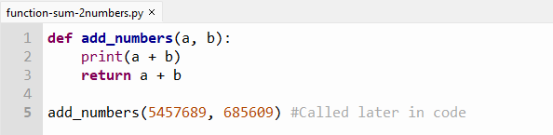
What is the output?
Answer: 6143298
Type the code below.
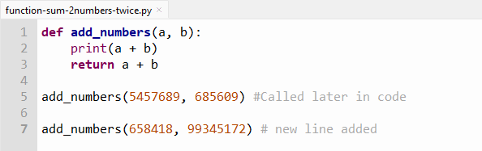
What is the output?
Answer: 6143298
100003590

Authentic, accurate and timely
Answer the questions below in the space provided.
Authenticity and source evaluation
What information would you want to know about the organisations that produced Report A and Report B to determine if the data is authentic?
How might the sources’ perspectives or goals influence the way data is presented?
Accuracy and timeliness
Report A provides current registered EV numbers by postcode. Why is it important to know how recently this data was collected?
Report B contains projections. What assumptions might affect the accuracy of these projections?
Data interpretation
Based on Table 1 in the PowerPoint, which area currently has the highest concentration of EVs?
How do the projected growth rates in Table 2 in the PowerPoint affect the distribution of EVs after 2 years?

Considering Table 3 in the PowerPoint, are the current charging stations evenly distributed based on EV numbers in each area?
Making recommendations
Given the data, where should the local government prioritise installing new EV charging stations? Explain your reasoning.
How might the council address concerns from residents in rural outskirts?
What additional information or data might help improve planning decisions?
Reflection on data challenges
How can differences between current data (Report A) and projected data (Report B) create challenges for planning infrastructure?
Why is it important to consider multiple data sources when making decisions about public infrastructure?

Appendix

Trip planning apps
Note: listed apps were useable via their website and without requiring creation of an account when resource was published. Discourage students from creating accounts on these platforms.
Various types of trip planning apps are available. When searching for an EV road trip planning app, make sure to focus on EV chargers and navigation features. Sample of these platforms are listed below.
These resources provide information for trip planning and examples of apps to find charging stations:
- Navigate With Trip Planner (1:14)
- Road Trips Made Easy (0:39)
- How to use Plugshare and A Better Route Planner ABRP - EV road trip - No Tesla Supercharger? - CCS (16:40)
- Google Maps to use AI to help drivers locate electric-car charging stations
- New ways to power up your electric vehicle adventures with Google Maps
- Set up your vehicle profile in the Google Maps app
Finding EV chargers
- NSW electric vehicle charging map
- PlugShare Australia
- chargeatlarge (from the Electric Vehicle Council, Australia)
Navigation helpers (typically do not provide charging information)
- OpenStreetMap
- drivebestway
- waze
- HereWeGo
List travel planning apps you have used.

References
This resource contains NSW Curriculum and syllabus content. The NSW Curriculum is developed by the NSW Education Standards Authority. This content is prepared by NESA for and on behalf of the Crown in right of the State of New South Wales. The material is protected by Crown copyright.
Please refer to the NESA Copyright Disclaimer for more information https://educationstandards.nsw.edu.au/wps/portal/nesa/mini-footer/copyright.
NESA holds the only official and up-to-date versions of the NSW Curriculum and syllabus documents. Please visit the NSW Education Standards Authority (NESA) website https://educationstandards.nsw.edu.au and the NSW Curriculum website https://curriculum.nsw.edu.au.
Technology 7–8 Syllabus © NSW Education Standards Authority (NESA) for and on behalf of the Crown in right of the State of New South Wales, 2023.
A Better Routeplanner (2025) A Better Routeplanner [website], accessed 27 October 2025.
Australian Automobile Association (2025) EV Index Data Sources, Australian Automobile Association website, accessed 27 October 2025.
Australian Automobile Association (2025) Vehicle Specifications MAR 25 [CSV], Australian Automobile Association website, accessed 27 October 2025.
Australian Institute of Aboriginal and Torres Strait Islander Studies (AIATSIS) (2025) Map of Indigenous Australia, Australian Institute of Aboriginal and Torres Strait Islander Studies website, accessed 27 October 2025.
ChargeAtLarge (2025) ChargeAtLarge App [website], accessed 27 October 2025.
Department of Infrastructure, Transport, Regional Development, Communications, Sport and the Arts (2022) Types of Electric Vehicles Explained, Department of Infrastructure, Transport, Regional Development, Communications, Sport and the Arts website, accessed 27 October 2025.
DriveBestWay (2025) Distance Calculator for Driving Between Australian Cities, DriveBestWay website, accessed 27 October 2025.
First Languages Australia (2025) Gambay: First Languages Map, First Languages Australia website, accessed 27 October 2025.
HERE Technologies (2025) Wego [website], accessed 27 October 2025.
OpenStreetMap Foundation (2025) OpenStreetMap [website], accessed 27 October 2025.
PlugShare LLC (2025) Electric Vehicle Charging Map, PlugShare website, accessed 27 October 2025.
RedBook Australia (2025) Research & Value Cars, RedBook Australia website, accessed 27 October 2025.
Transport for NSW (2025) Available electric vehicles, Transport for NSW website, accessed 27 October 2025.
Transport for NSW (2025) NSW electric vehicle charging map, Transport for NSW website, accessed 27 October 2025.
NSW Department of Climate Change, Energy, the Environment and Water (2025) Vessel and Electric Supply Registry (VESR) [website], VESR website, accessed 27 October 2025.
Waze Inc. (2025) Waze Live Map, Waze website, accessed 27 October 2025.

© State of New South Wales (Department of Education), 2023
The copyright material published in this resource is subject to the Copyright Act 1968 (Cth) and is owned by the NSW Department of Education or, where indicated, by a party other than the NSW Department of Education (third-party material).
Copyright material available in this resource and owned by the NSW Department of Education is licensed under a Creative Commons Attribution 4.0 International (CC BY 4.0) license.

This license allows you to share and adapt the material for any purpose, even commercially.
Attribution should be given to © State of New South Wales (Department of Education), 2023.
Material in this resource not available under a Creative Commons license:
- the NSW Department of Education logo, other logos and trademark-protected material
- material owned by a third party that has been reproduced with permission. You will need to obtain permission from the third party to reuse its material.
Links to third-party material and websites
Please note that the provided (reading/viewing material/list/links/texts) are a suggestion only and implies no endorsement, by the New South Wales Department of Education, of any author, publisher, or book title. School principals and teachers are best placed to assess the suitability of resources that would complement the curriculum and reflect the needs and interests of their students.
If you use the links provided in this document to access a third-party's website, you acknowledge that the terms of use, including licence terms set out on the third-party's website apply to the use which may be made of the materials on that third-party website or where permitted by the Copyright Act 1968 (Cth). The department accepts no responsibility for content on third-party websites.

