Technology 7–8 – Digital and communication technologies – teacher resource
Behind the screen

Contents
Teacher support resource 3
Glossary 4
Digital platforms 9
Case study: YouTube 11
Digital portfolio – documenting research 1 11
Artificial Intelligence (AI) 14
Digital portfolio – documenting research 2 16
Aboriginal communication practices 18
Analysing infographics and planning 22
Digital portfolio – key insights 27
Digital portfolio – drafting infographic layout 29
Digital tools 30
Checklist for using Canva as a digital tool 30
Checklist for digital safety and ethical image use 31
Writing a script 32
Digital portfolio – script 33
Digital portfolio – storyboard 37
Voiceover 44
Digital portfolio – voiceover (extension activity) 46
Combining visuals, audio and motion 47
Digital portfolio – production (extension activity) 49
Refine and enhance 50
Digital portfolio – post-production (extension activity) 51
Present and evaluate motion graphics video 52
Digital portfolio – self-reflection and evaluation 53
Reflection 54
References 55

Teacher support resource
The purpose of this sample program of learning, ‘Behind the screen’, is to develops students' technological literacy and digital communication skills through investigating the history, development and impact of digital platforms. Students will apply the design process to research, analyse, and produce an infographic and motion graphics video using digital tools.
Note: this resource has been designed to facilitate the ready conversion into a student workbook by removing the answers within the response windows. Teacher notes (in blue) and sample answers can be deleted before distributing to students.

Glossary
Many of the following words will gather more meaning to you as you work through the workbook.
Each time you see a new word throughout the workbook you can add its definition in the table below in case you need to refer to it later.
Note: the table below has the definitions included. Provide the table with the definition column blank to your students to complete the activity throughout the term.
Word | Definition
algorithm | A step-by-step procedure required to solve a problem. Algorithms may be presented in many ways, for example written instructions, flow charts or using a computer programming language.
artificial intelligence (AI) | Artificial intelligence (AI) refers to computer systems that appear to use human-like intelligence to learn, reason and problem solve.
colour palette | A colour palette is a selection of colours used in a particular design or artistic project. It serves as a guide for the colours that will be used together to create a cohesive and harmonious visual outcome. Colour palettes can vary widely, ranging from a few complementary colours to a broader spectrum of shades and tones. They are commonly used in graphic design, fashion, interior design and various forms of visual art to evoke specific emotions or themes and to ensure consistency throughout the work.
contrast | Contrast refers to the difference between 2 or more elements in a design, such as colour, size or shape. High contrast makes elements stand out and can be used to draw attention to important information, making it easier to read and understand.
cybersecurity | The protection of information technology elements, including hardware and software, data or network services.
data ownership | Data ownership is the concept that refers to who has the rights to control and make decisions about data. This includes the ability to access, modify, share and delete information. When you own your data, you have the power to decide how it is used and who can see it. In the digital world, understanding data ownership is important for protecting your personal information and privacy.
data tracking | Data tracking is the process of collecting and monitoring information about how people use websites, apps or devices. This can include things like what pages you visit, how long you spend on them and what products you buy. Companies use data tracking to understand user behaviour and improve their services, but it can also raise privacy concerns if done without consent.
digital footprint | A digital footprint is the trail of data you leave behind when you use the internet. This includes things like the websites you visit, the posts you make on social media and the information you share online. Your digital footprint can be used to see what you like and how you interact online, and it can affect your online reputation and privacy.
digital platform | A digital platform is a website or application that allows users to create, share and interact with content like videos, pictures, music and articles. Examples include social media sites, streaming services and blogs. It's where people can connect and share their ideas and experiences online.
digital sustainability | Digital sustainability is the practice of using technology and digital resources in a way that is environmentally friendly and socially responsible. This means reducing waste, conserving energy and ensuring that digital practices do not harm the planet or communities. It involves considering the long-term effects of technology on the environment and striving to create systems that support both people and the planet.
environmental impact | Environmental impact is the effect that an action, project or activity has on the natural environment. This can include changes to air and water quality, land use, wildlife habitats and climate. Understanding environmental impact is important for making decisions that protect the planet and ensure that natural resources are used responsibly and sustainably.
ethical use | Ethical use refers to using technology, information and resources in a responsible and fair way. This means respecting the rights of others, following laws and guidelines, and avoiding actions that could harm people or the environment. In a digital context, it includes things like not plagiarising, respecting privacy and using information appropriately.
font pairing | Font pairing is the practice of using 2 or more different fonts together in a design. The goal is to create a visually appealing and harmonious combination that enhances readability and communicates the desired tone or message effectively.
layout | Layout refers to the arrangement of visual elements on a page or screen. It involves organising text, images and other components to create a clear and appealing design that enhances user experience and communication.
melody | Melody is a sequence of musical notes that are perceived as a single entity. It is often the most memorable part of a song and is created by combining different pitches in a harmonious way. In spoken language, melody can refer to the intonation and rhythm of speech.
pace | Pace refers to the speed at which audio content is delivered. In speech or music, it can affect the overall flow and mood. A fast pace can create excitement or urgency, while a slow pace can make content feel more relaxed or dramatic.
pause | A pause is a brief silence in audio that can create emphasis, allow for reflection or help organise thoughts. In speech, pauses can be used for dramatic effect or to give the listener time to absorb information.
personal data | Personal data is information that can be used to identify you as an individual. This includes things like your name, address, phone number, email, and any other details that relate specifically to you, such as your age or interests. It's important to protect your personal data because it can be used by others without your permission.
phishing | Phishing is a type of online scam where attackers impersonate legitimate organisations or individuals to trick people into providing sensitive information, such as passwords, credit card numbers or other personal details. This is often done through deceptive emails, messages or websites that appear to be trustworthy.
pitch | Pitch refers to how high or low a sound is perceived. It is determined by the frequency of audio waves. In music, different pitches create melodies, while in speech, pitch can convey emotions or indicate questions and statements.
privacy settings | Privacy settings are controls that allow you to manage who can see your personal information and how it's shared on websites and apps. By adjusting these settings, you can decide what information is public, who can contact you, and what data can be collected about you. This helps protect your personal data and maintain your privacy online.
screen time | Screen time refers to the amount of time a person spends using devices with screens, such as computers, tablets, smartphones and televisions. This includes activities like watching videos, playing games, browsing the internet or using apps. It's important to balance screen time with other activities, like playing outside, reading and spending time with family and friends, to maintain a healthy lifestyle.
tonality | Tonality refers to the quality or character of a sound that conveys emotion or mood. In music, tone can describe the richness or brightness of a sound, while in speech, tone can indicate the speaker's feelings or attitude, such as excitement, seriousness or sarcasm. The tone can greatly influence how a message is received by the listener.
visual hierarchy | Visual hierarchy in design is the way in which elements are arranged to show their importance. This is often achieved through size, colour and placement, helping users understand what to focus on first, such as headlines being larger and bolder than body text.
volume | Volume is the loudness or softness of audio. It determines how easily a listener can hear the audio. Adjusting the volume can change the emotional impact of a piece, making it more engaging or allowing for emphasis on certain elements.
white/negative space | White space, also known as negative space, is the empty area around and between design elements. It helps to reduce clutter, improve readability, and create a more balanced and appealing design. It can also guide the viewer’s attention to important content.
Note: for students with English as an additional language or dialect (EAL/D) background, and for students with disability, the glossary can be provided complete so that they have additional time to understand the key terms with bilingual dictionaries. The glossary can be provided to students in their preferred communication mode.

Digital platforms
A digital platform is a website or application that allows users to create, share and interact with content like videos, pictures, music and articles. Examples could include social media, streaming services, gaming and blogs. It's where people can connect and share their ideas and experiences online.
Complete the concept map below with digital platforms that you regularly use or know of.
Figure 1 – digital platforms concept map
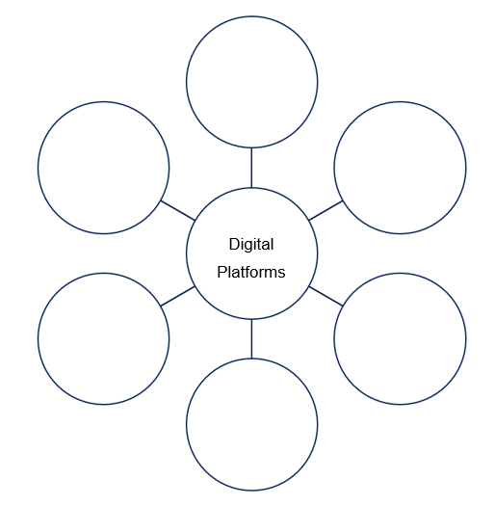
Sample responses:
YouTube, Netflix, Spotify, Roblox and so on.
You engage with one video on YouTube about basketball… and now your feed is full of sports content. Why?
As a class, discuss the following terms and record your response in the glossary:
- algorithm
- cybersecurity
- data tracking
- digital footprint
- digital platform
- personal data
- phishing
- privacy settings.

Case study: YouTube
When and why was it created?
YouTube was founded in February 2005 as a video-sharing platform. The founders aimed to create an easy way for people to upload, share and view videos online, addressing the need for a user-friendly video hosting service that could accommodate the growing demand for video content.
Who were the founders?
The platform was founded by Chad Hurley, Steve Chen and Jawed Karim. They sought to solve the problem of sharing videos on the internet, as existing methods were often cumbersome and did not support the ease of uploading and viewing videos that users desired.
How has it changed over time?
Since its inception, YouTube has significantly evolved, introducing features like live streaming, 360-degree videos, and monetisation options for creators through ads and subscriptions. The platform has expanded its content offerings, including YouTube Originals, educational channels, and a vast array of user-generated content, transforming into one of the largest video platforms globally.
What data does it collect and how is it used?
YouTube collects various data types, including user interactions (likes, shares, comments), viewing history, search queries and demographic information. This data is used to personalise content by recommending videos based on individual viewing habits, which enhances user engagement and retention.
What safety and privacy tools are available?
YouTube provides several safety settings and tools to help users stay safe, such as the ability to set up restricted mode to filter out potentially inappropriate content, manage privacy settings for uploaded videos, and control who can comment on users’ videos. Additionally, users can report inappropriate content and block other users to create a safer viewing experience.

Digital portfolio – documenting research 1
Begin a digital portfolio, where you document your initial research.
Name of the digital platform:
Identify the founders and their original vision.
Describe the key features of the platform.
Explain the purpose and function of the platform.
Outline 3 key historical developments.
Record 6 key statistics. For example, the number of users, where they are located, their demographic information, their average screen time and other insights unique to the platform.

Think, Pair, Share
- What kinds of personal information does the digital platform collect?
- What is one safe habit you could adopt when using this platform?

Artificial Intelligence (AI) and algorithms
As a class, discuss:
How does your platform know what to show you?
What kind of information might it be collecting?
As a class discuss and add definitions to the glossary:
- artificial intelligence (AI)
- data ownership
- digital sustainability
- environmental impact
- ethical use
- screen time.
As a class engage with the following videos:
- Netflix Research: Recommendations (2:33). This video briefly outlines the function of recommendation algorithms used by Netflix.
- TikTok's CEO on its future — and what makes its algorithm different (5:06–7:44). This snippet of the interview focuses on how TikTok algorithms work.
- The YouTube Algorithms in 2025 — Explained! (0:01–4:07). This snippet of the interview focuses on how YouTube recommendations work.
Answer the following questions about using digital platforms.
What data is collected?
Sample answer:
Digital platforms typically collect a variety of data, including user profiles (demographics, location), interaction data (likes, shares, comments), browsing history, search queries, device information and engagement metrics (watch time, click-through rates).
Who owns the data and content created?
Sample answer:
Ownership of data and content created on digital platforms typically resides with the platform itself, as outlined in their terms of service. Users often retain some rights to their content; however, by uploading to the platform, they may grant the platform a licence to use, distribute and display that content.
How does the AI ‘learn’ and make recommendations?
Sample answer:
AI on digital platforms learns through machine learning algorithms that analyse the collected data to identify patterns and trends. By processing vast amounts of user interaction data, the AI can make personalised recommendations, suggesting content that aligns with individual user preferences and behaviours based on similarity to past interactions.
What are the potential ethical concerns?
Sample answer:
Ethical concerns include issues related to privacy, data security and user consent, as many users may not fully understand how their data is collected and used. Additionally, there are concerns about the potential for manipulation through algorithmic bias and misinformation.

Digital portfolio – documenting research 2
Continue your research into your chosen digital platform and answer the following questions.
What does your platform use AI for?
How does your platform impact society? For example, behaviour, screen time and mental health.
How does your platform affect the environment? For example, energy use and digital waste.
What responsibility do we have as digital users and creators?

Extension activity – screen time data collection
To help students reflect on their personal technology use, practise collecting and interpreting data. Throughout the week, students record their approximate daily screen time in their digital portfolio.
Teacher note: at the end of the week, students submit their total screen time through an anonymous form created by the teacher, for example using Google Forms. The teacher checks the appropriateness of the data and then shows the class the results.
Questions can be posed for discussion for example:
- What is the total combined screen time for the class?
- What is the average screen time per student?
- What is the most commonly used digital platform in our class?
- What categories do these platforms fall into, for example social, streaming, gaming?
- What is one interesting insight or trend we notice from this data?

Aboriginal communication practices
As a class, discuss:
Before books, printing or digital platforms, how did people pass on knowledge?
How do stories survive over thousands of years?
Indigenous Cultural and Intellectual Property (ICIP) is everyone’s responsibility. It is essential to respect ICIP rights, ensuring that traditional knowledge and cultural expressions are protected and that Aboriginal communities maintain control over their cultural heritage.
Teacher note: refer to the First Nations Content on Canva to further explore the work of contemporary Aboriginal and Torres Strait Islander artists, illustrators and designers.
Complete the following table by adding example images of the communication methods.
Method | Description | Image
Message sticks | Message sticks are traditional communication tools used by Aboriginal Peoples to convey messages or information between different groups. They are often carved or decorated with symbols and designs that represent the sender's identity or the purpose of the message, serving as a form of non-verbal communication.
Sand drawings | Sand drawings are temporary artworks created by Aboriginal artists using fine sand to form intricate patterns and images. They often tell stories, depict cultural events or convey spiritual significance. Sand drawings are typically made in specific locations and may be erased after the purpose is fulfilled, reflecting the transient nature of the art form.
Songlines | A songline is a traditional Aboriginal concept that represents the pathways of ancestral beings across the land and sky. Songlines are expressed through songs, stories and cultural practices, and visually represented through art, connecting significant places and holding spiritual and navigational meaning.
Pictographs | Pictographs are important for storytelling and sharing knowledge. They use symbols and images to convey messages about culture, nature and community values, helping to connect people to their history and identity.
Petroglyphs | Petroglyphs are carvings or engravings made on rock surfaces. They are used by Aboriginal Peoples to tell stories, share cultural knowledge and mark important places. These images connect people to their history and the land, often depicting animals, symbols or events that hold special meaning.

What messages or knowledge are being shared?
Sample answer:
Aboriginal cultural expressions, such as message sticks, sand drawings and songlines, share a wide range of messages and knowledge, including creation stories, moral lessons, cultural practices, and connections to the land. They convey important teachings about identity, kinship, environmental stewardship and the spiritual significance of places and natural elements.
What visual elements are used to communicate meaning without written language?
Sample answer:
Various visual elements are employed to communicate meaning, including symbols, colours, patterns and shapes. For instance, specific symbols may represent animals, plants or ancestral beings, while patterns can denote group identity or clan affiliation. The use of colour can also convey emotions or signify particular themes, allowing for rich, layered meanings that do not rely on written language.
How do these methods rely on story, symbol, place and memory?
Sample answer:
These methods are deeply intertwined with story, symbol, place and memory. Stories provide context and meaning, embedding cultural knowledge within narratives that are passed down through generations. Symbols serve as visual shorthand for complex ideas and relationships, while specific places are often tied to stories and cultural practices, reinforcing the connection between people and their environment. Memory plays a crucial role, as these cultural expressions rely on collective recollection and shared experiences, ensuring that knowledge is preserved and transmitted within the community. Together, these elements create a rich tapestry of cultural identity and continuity.

As a class, discuss:
What can we learn from Aboriginal ways of communicating that help us become more thoughtful and intentional infographic designers?
Key concepts may include:
- knowledge is layered and contextual
- visuals carry deep meaning
- layout, shape, sequence and symbol matter.

Analysing infographics and planning
Below is an infographic design based on the digital platform Netflix. It is a sample of what you are to create for your chosen digital platform.
Figure 2 – practical project – Netflix example
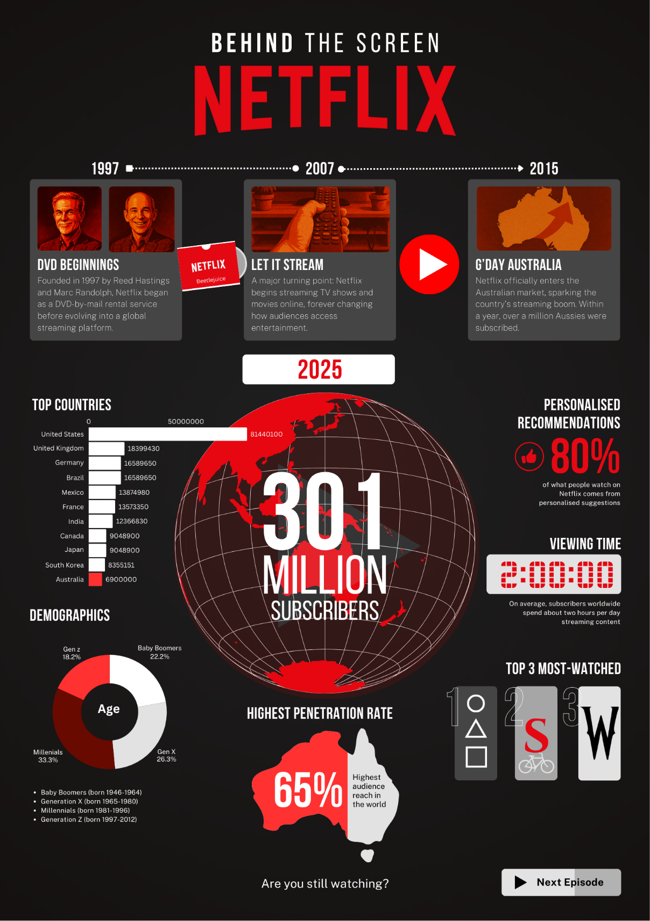

Analyse the following Canva templates and use as inspiration for your infographic. Consider the layout, visual hierarchy, colour palette, use of negative space, contrast and fonts.
Figure 3 – Canva template – data visualisation example
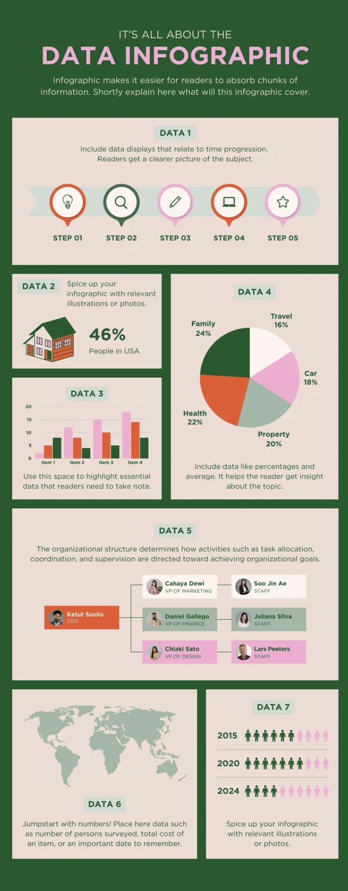
Figure 4 – Canva template – process flows example
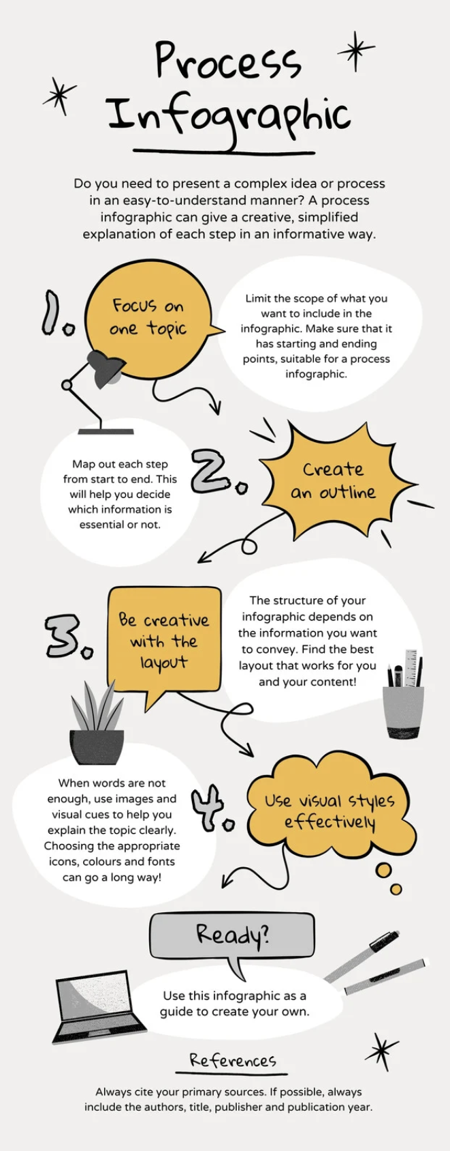

Figure 5 – Canva template – timeline example
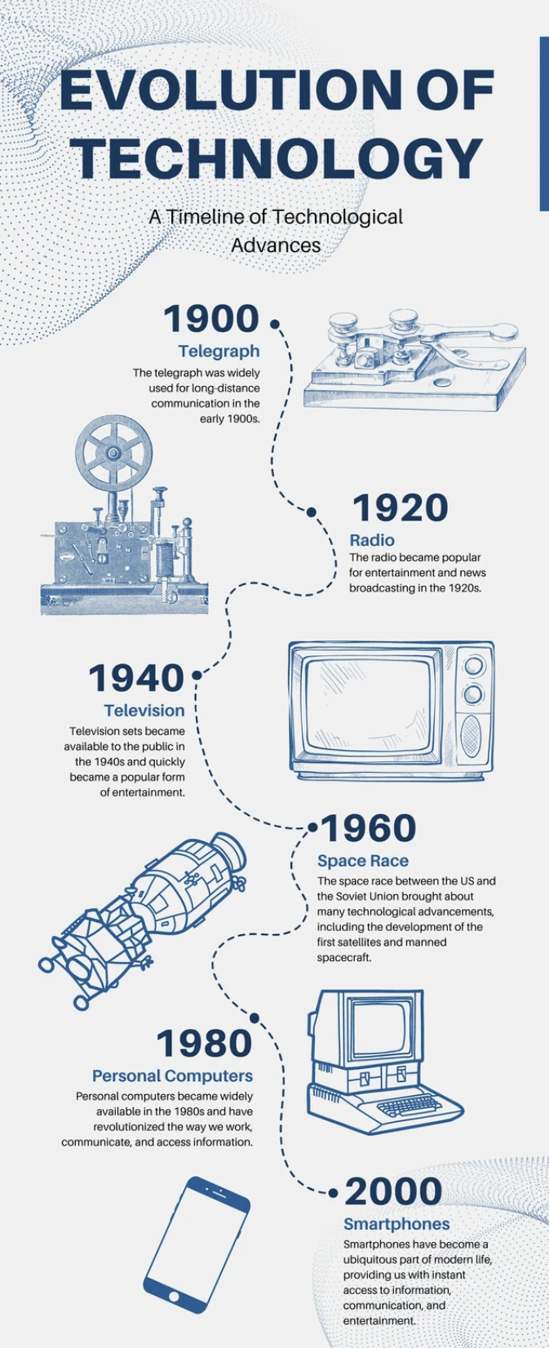

Think, Pair, Share
- What are the qualities of an effective infographic?
Below is a sample layout for the Netflix infographic using simple greyscale text boxes, sample fonts and basic decorative elements like lines.
Figure 6 – Netflix – layout example
- 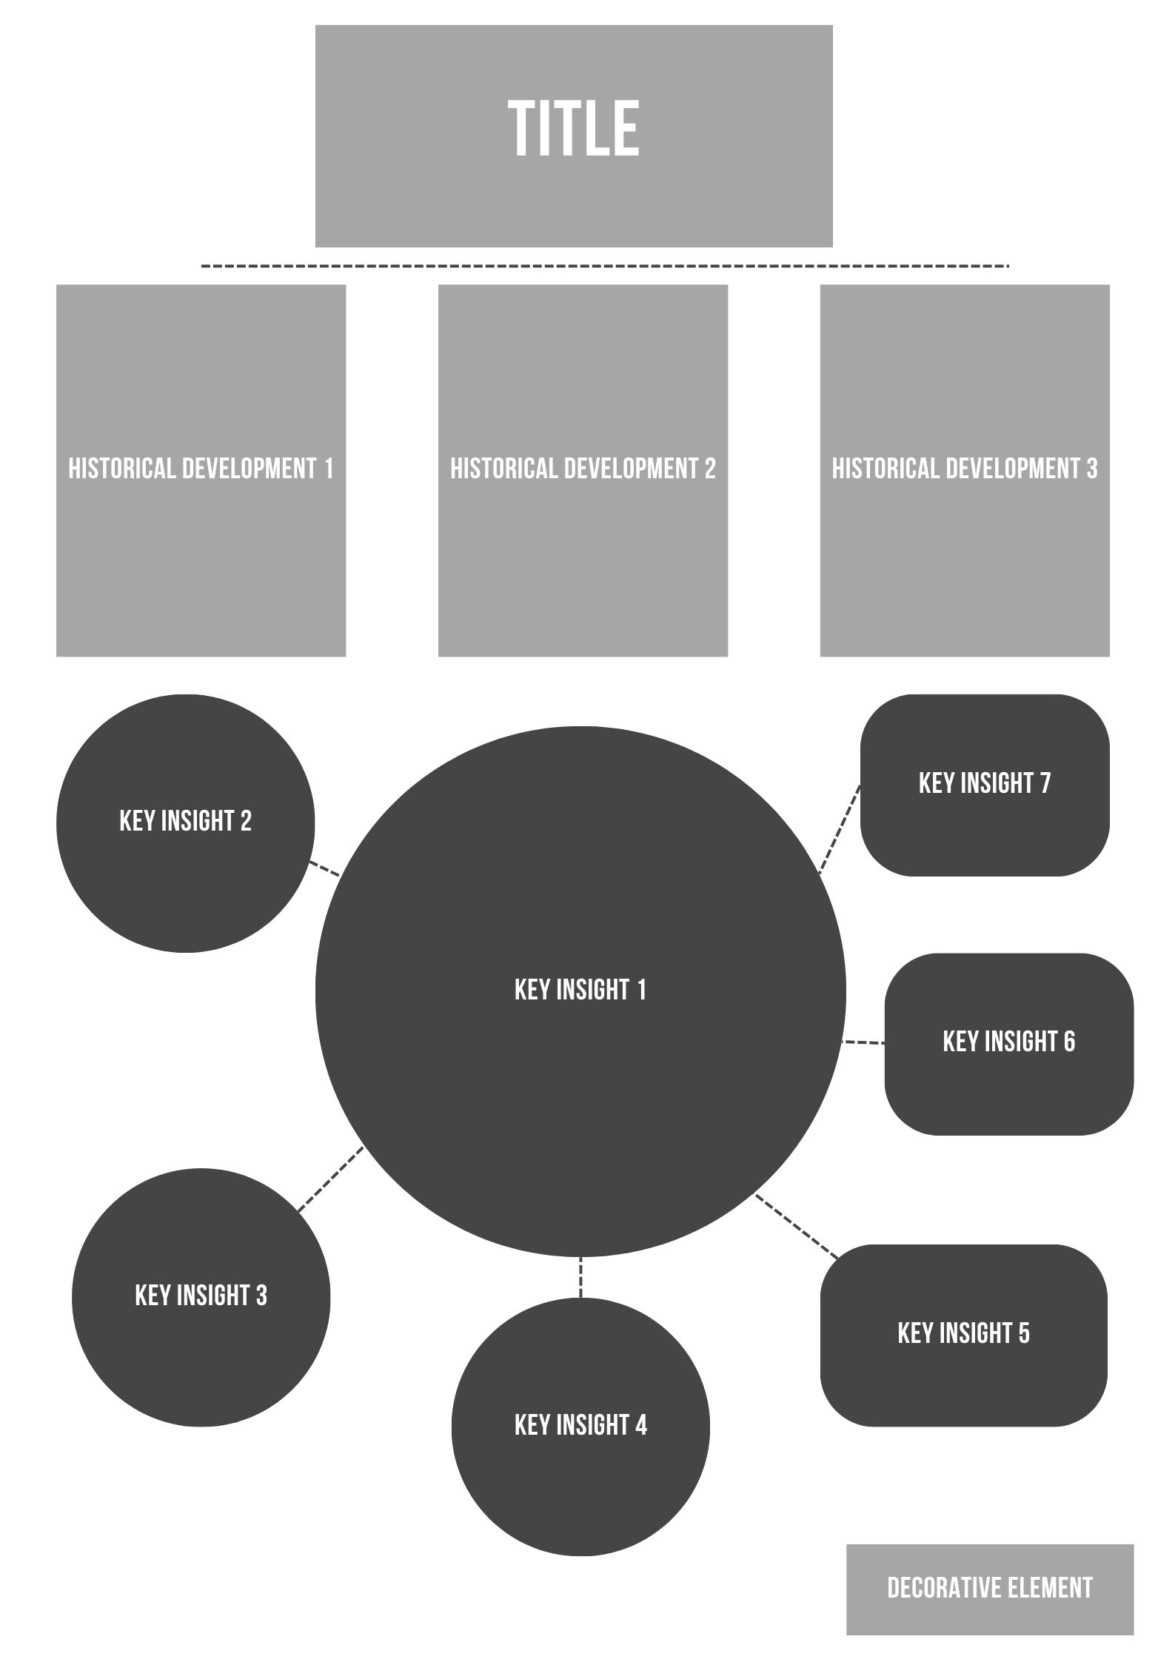
Graphic design basics
As a class engage with the following videos to enhance your knowledge and understanding of colour theory and principles of design:
- What's Colour Theory | Graphic Design Basic (5:03)
- How to use Colour Theory | Graphic Design Basic (2:57)
- Understanding the Principles of Design | Graphic Design Basic (9:55)
- How to use Principles of Design | Graphic Design Basic (7:06)
Teacher note: refer to Canva Education’s teacher resources for more materials.
Add the following terms to the glossary:
- colour palette
- contrast
- font pairing
- layout
- visual hierarchy
- white/negative space.
As a class engage with the following Canva tutorials:
- Canva for Beginners: Opening Canva (1/10) (3:57)
- Canva for Beginners: Using Templates (2/10) (4:55)
- Canva for Beginners: Using Search (3/10) (2:56)

Digital portfolio – key insights
Select 8–10 key insights from your digital portfolio research and organise content into a logical, visual narrative.
1. | 6.
2. | 7.
3. | 8.
4. | 9.
5. | 10.

Digital portfolio – drafting infographic layout
Draft an infographic layout on Canva or Adobe Express considering the qualities of an effective infographic.

Digital tools
As a class, discuss:
What choices did you make about layout, colours and icons? Why?
How will these help your audience understand your message?
As a class engage with the following Canva tutorials:
- How to upload and edit photos in Canva (4/10) (2:35)
- How to use lines, shapes, graphics, charts and more in Canva (5/10) (4:12)
- How to find fonts and format text in Canva (6/10) (1:59)

Checklist for using Canva as a digital tool
Step | Checklist
I can set up canvas size and orientation.
I can select colour schemes and fonts.
I can upload and arrange content.
I can use icons, charts and visual hierarchy.
I can add basic interactive elements such as hyperlinks and buttons.
I can export and save files in the appropriate format.

Checklist for digital safety and ethical image use
Ensure you are: | Yes/No
sourcing icons and images with appropriate permissions, for example using Creative Commons
saving or exporting work in appropriate file types and versions such as JPG, PNG, PDF
checking accessibility, for example contrast and readability.

Writing a script
As a class, discuss:
How is a motion graphics video different from an infographic?
How does movement, sound and voice change the way we communicate a message?
Think about tone, length, and clarity:
- ‘Is this sentence too long for a 5-second scene?’
- ‘Does this line in the script match what’s being communicated in my infographic?’
Once draft scripts are written, students participate in a peer review session using effective feedback approaches:
- Students read their script aloud to a partner.
- Partners offer feedback using the structure: ‘What worked well was …’, ‘You could improve …’, ‘Have you considered …?’
Students revise their script based on peer suggestions.

Digital portfolio – script
Below is a sample script for the Netflix motion graphics video.
In 1997, two guys mailed out DVDs …
and unknowingly sparked a global revolution.
By 2007, the disc was dead, streaming had begun.
Instant. Limitless. Addictive.
Then in 2015, Australia hit play.
And the binge was on.
10 years on, Netflix isn't just a platform,
it's part of the planet's daily rhythm,
with over 300 million people pressing play.
Age doesn’t matter.
Borders don’t matter.
The algorithm knows you better than you know yourself.
Two hours a day.
One more episode.
And another.
And another.
The stories. The obsession. The global takeover.
This … is Netflix.
So … are you still watching?
Below is a sample scaffold you can refer to while developing your script.
Title: [create a catchy title for your video]
1. Introduction (1–2 sentences)
Start with a hook to grab attention.
Example: ‘In [year], a new idea changed how we connect and share content.’

2. The beginning (2–3 sentences)
Describe the early days of the digital platform or your chosen topic.
Example: “It all started when [describe the event or person involved]. This marked the beginning of something big.”

3. The rise (2–3 sentences)
Explain how the platform gained popularity over the years.
Example: “By [year], [describe what happened next]. It quickly became [describe the impact of this change].”

4. The current situation (2–3 sentences)
Talk about the present state of the digital platform.
Example: “Today, [name of the platform] has millions of users worldwide. It’s more than just a service; it’s part of our everyday lives.”

5. The audience (1–2 sentences)
Mention who is using this platform.
Example: “People of all ages and backgrounds are using it. It appeals to everyone!”

6. The impact (2–3 sentences)
Discuss how this platform has changed habits or behaviours.
Example: “With just a click, we can [describe the variety of content or services offered]. We’re engaging with more content than ever before!”

7. Conclusion (1–2 sentences)
End with a thought-provoking question or statement.
Example: “So, what will you explore next?”

Place your final script in the space below.
Write a short note explaining how you used AI and include citation (if applicable)

Digital portfolio – storyboard
Below is a sample storyboard using the Netflix infographic as a reference point.
Script | Visual reference from infographic
In 1997, two guys mailed out DVDs…  and unknowingly sparked a global revolution. | Figure 7 – Netflix – historical development 1 example  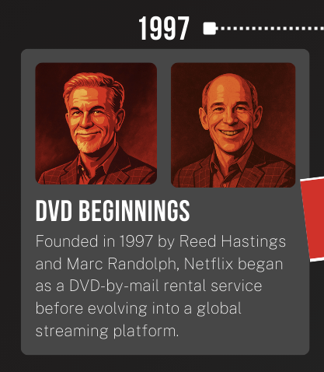
By 2007, the disc was dead, streaming had begun.  Instant. Limitless. Addictive. | Figure 8 – Netflix – historical development 2 example  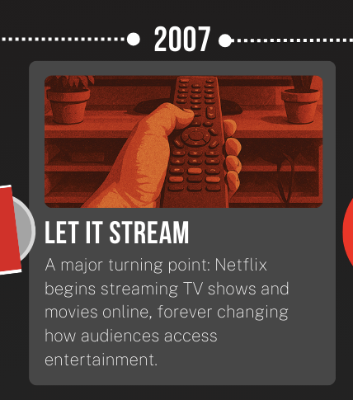
Then in 2015, Australia hit play.  And the binge was on. | Figure 9 – Netflix – historical development 3 example  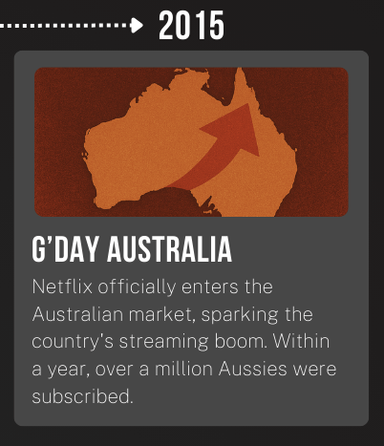
10 years on, Netflix isn't just a platform,  it's part of the planet's daily rhythm,  with over 300 million people pressing play. | Figure 10 – Netflix – key insight 1 example  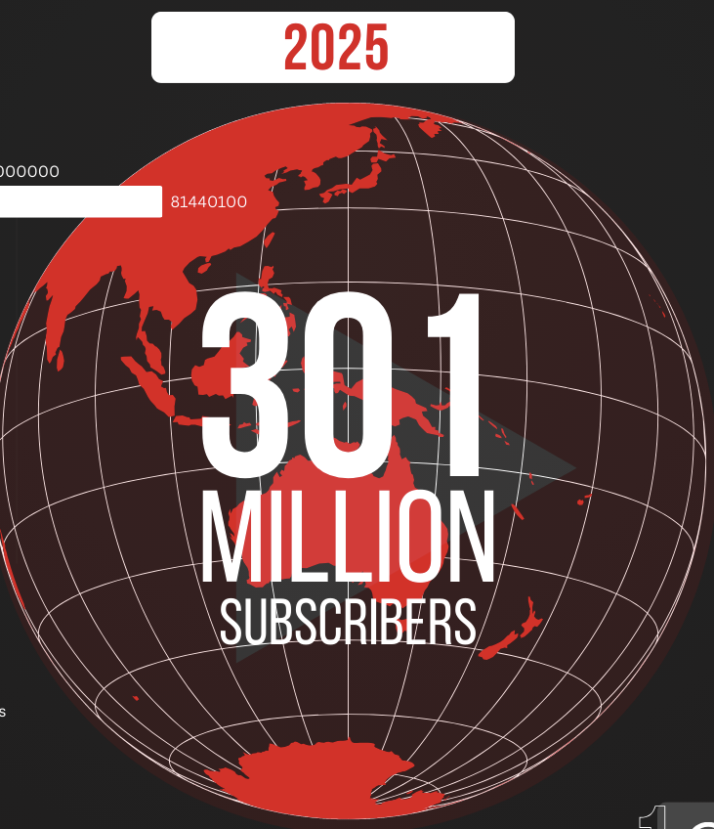
Age doesn’t matter. | Figure 11 – Netflix – key insight 2 example  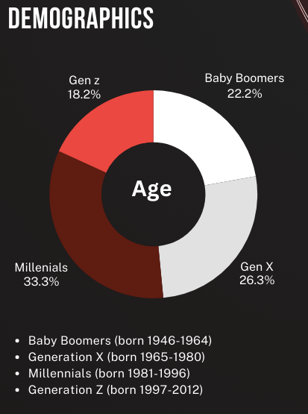
Borders don’t matter. | Figure 12 – Netflix – key insight 3 example  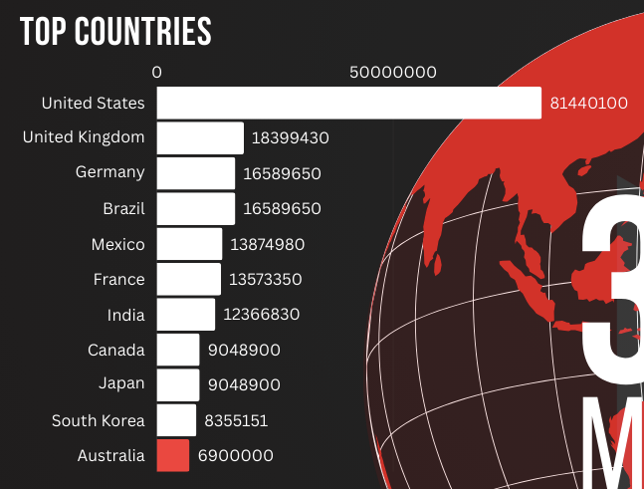  Figure 13 – Netflix – key insight 4 example  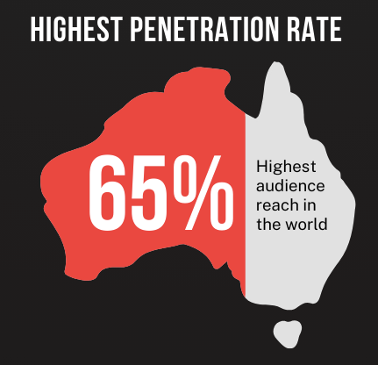
The algorithm knows you better than you know yourself. | Figure 14 – Netflix – key insight 5 example  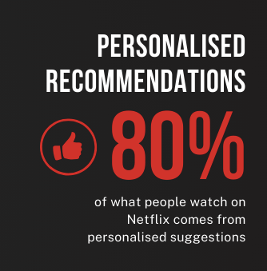
Two hours a day. | Figure 15 – Netflix – key insight 6 example  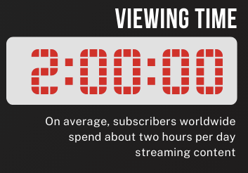
One more episode.  And another.  And another. | Figure 16 – Netflix – key insight 7 example  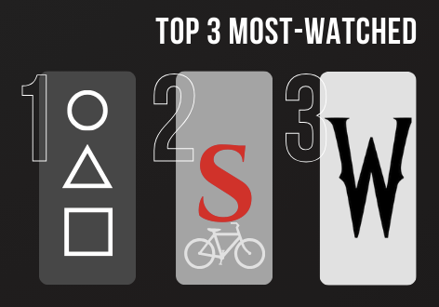
The stories. The obsession. The global takeover.  This … is Netflix.  So … are you still watching? | Figure 17 – Netflix – title example    Figure 18 – Netflix – decorative element example  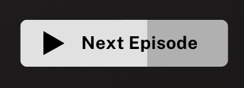

Create a storyboard using the infographic you drafted and match it to the relevant sections of your script.
Script | Visual reference from infographic

Voiceover
As a class, discuss:
Your voiceover is what brings your story to life. But how do you sound persuasive, serious or excited using just your voice?
To demonstrate, play the following short video clips while your eyes are shut. What do you think is being shown on screen:
- Every product carbon neutral by 2030 | Apple (1:15)
- Just Ask Google (1:00)
- The Story of Roblox (1:57)
Identify how the voiceover uses:
- melody (combination of pitches)
- pace (rate of speech, slow, fast)
- pauses (to create rhythm and tension)
- pitch (low, high)
- tonality (the emotion)
- volume (soft, loud, ascending, descending).
Add these terms to the glossary.
As students record or review their voiceover, students apply vocal communication skills such as:
- appropriate volume and pacing
- strategic use of pause
- matching tone and pitch to their message.
Once complete, students:
- upload and name their files correctly
- test that they work on their device and in Canva
- document their process and choices in their digital portfolio.

Digital portfolio – voiceover (extension activity)
Describe the tool or method used.
Explain how you used elements such as pace, volume, pitch, melody, tonality and pauses.
Write a short reflection on what worked well and what you would change next time.

Combining visuals, audio and motion
As a class, discuss:
Have you ever watched a product video from a company that made a message feel clear and compelling all in under a minute? What made it work?
Teacher presents examples of motion graphics videos with a focus on the animation elements:
- ChatGPT | The Intelligence Age (1:00)
- Google – Welcome to the Gemini era (1:00)
- Introducing Canva’s Brand Refresh (1:15)
As a class engage with the following Canva tutorials:
- How to upload and edit video and audio in Canva (7/10) (4:06)
- 2. How to Animate your Designs with Canva | Skill (3:55)
- Make it move with animation | Canva (4:23)
Students use their infographic as a storyboard. The teacher models how to break the infographic into video scenes or frames, with one key idea per screen.
Key tip: keep each scene under 5–7 seconds to maintain pacing and viewer attention.
- Upload and place the voiceover track.
- Use scene timing controls to match visuals to narration.
- Add movement with transitions and simple animations.
- Layer on-screen text and icons carefully to avoid distraction.
Industry insight: keep animations subtle and purposeful. Professionals avoid ‘over-animation’ and ensure every movement draws attention to a key idea.
- Maintain consistent font styles, colours and layouts.
- Use contrast and alignment to guide the viewer’s eye.
- Emphasise key statistics or insights.
- Use the rule of thirds or centre focus to frame content visually.
- Export at 1080p resolution as an MP4 file with audio settings checked.
Students build their motion graphics video by:
- importing voiceover
- recreating infographic scenes as timed slides or frames
- animating entry/exit of elements
- synchronising voice and visuals
- previewing and refining visual flow.
Reflection questions include:
- Is your animation helping your audience understand the message, or does it distract from the message?
- What do you want your viewer to remember in the final 5 seconds?

Digital portfolio – production (extension activity)
Which frames worked best and why?
What timing or visuals did you adjust after seeing/hearing it in action?
How does the design support the tone and purpose of your message?

Refine and enhance
As a class, discuss:
What is left to complete?
How will you know your video communicates your message clearly?
What technical issues might still need solving?
As a class engage with the following Canva tutorial:
- Audio essentials | Canva (4:25)
Best practice guidelines:
- Keep music instrumental and mood-appropriate.
- Avoid lyrics or overused sound effects.
- Ensure all audio is royalty-free and acknowledge if required.
- Balance voice and music ensuring that the voiceover is clear throughout the entire video.

Students continue building or refining their motion graphics video.
Focus tasks include:
- syncing visuals with narration
- adjusting slide timing
- refining layout and transitions
- reviewing overall flow and message clarity
- adding suitable video effects and transitions.

Digital portfolio – post-production (extension activity)
Describe your audio decisions (for example, selection of background music and sound effects).
Describe the visual refinements made.
Describe challenges encountered and how you resolved them.
Explain how sound changes improved tone or audience engagement.
Export a draft version for final peer feedback.

Present and evaluate motion graphics video
If someone watched your video with no explanation, would they understand the message, the purpose and how it was made?
As a class, discuss the key features of an effective motion graphics video.
- Clear and consistent visuals
- Well-synced and appropriate voiceover
- Purposeful motion and timing
- Balanced and engaging audio
- Logical sequence and flow of ideas
Structured peer presentation
Students share their completed motion graphics videos in small groups or through a class screening rotation. Each student presenter explains:
- the purpose of their project
- key design choices they made
- any challenges they faced and how they resolved them.
Effective questioning is used to guide peer review.
Students respond to questions such as:
- ‘How does the video communicate its message visually?’
- ‘What did you notice about the pacing and voiceover tone?’
- ‘Was there a scene or technique that stood out? Why?’

Digital portfolio – self-reflection and evaluation
What are you most proud of?
How well did your motion graphics video meet the criteria?
What part of the project you find most challenging?
How did you use feedback or iteration to improve your work?
What would you do differently if you had more time?

Reflection
As a class, discuss:
What kind of stories have we told through our motion graphics video?
What values or messages have we shared?
What are the long-term effects of the platforms we use every day?
One thing I learned about the impact of digital technologies is ...
I think designers have a responsibility to ...
Next time I create digital content, I will ...

References
This resource contains NSW Curriculum and syllabus content. The NSW Curriculum is developed by the NSW Education Standards Authority. This content is prepared by NESA for and on behalf of the Crown in right of the State of New South Wales. The material is protected by Crown copyright.
Please refer to the NESA Copyright Disclaimer for more information https://educationstandards.nsw.edu.au/wps/portal/nesa/mini-footer/copyright.
NESA holds the only official and up-to-date versions of the NSW Curriculum and syllabus documents. Please visit the NSW Education Standards Authority (NESA) website https://educationstandards.nsw.edu.au/ and the NSW Curriculum website https://curriculum.nsw.edu.au/home.
Technology 7–8 Syllabus © NSW Education Standards Authority (NESA) for and on behalf of the Crown in right of the State of New South Wales, 2023.
ABC Australia (12 August 2020) ‘The ancient Aboriginal art and culture of NSW's Sandstone Caves | Explore Aus | ABC Australia’, ABC Australia, YouTube, accessed 30 July 2025.
Apple (23 April 2021) ‘Every product carbon neutral by 2030 | Apple’, Apple, YouTube, accessed 30 July 2025.
Artist Bookings (7 July 2022) ‘LOWELL – Indigenous Sand Artist – Hire from Artist Bookings’, Artist Bookings, YouTube, accessed 30 July 2025.
Australian Rail Track Corporation (26 March 2022) ‘Elenore Binge teaches us the symbols in her artwork Journey: the heart of Reconciliation at ARTC’, Australian Rail Track Corporation, YouTube, accessed 30 July 2025.
Canva (2 August 2021) ‘Canva for Beginners: Opening Canva’, Canva, YouTube, accessed 30 July 2025.
——(2 August 2021) ‘Canva for Beginners: Using Search’, Canva, YouTube, accessed 30 July 2025.
——(2 August 2021) ‘Canva for Beginners: Using Templates’, Canva, YouTube, accessed 30 July 2025.
——(2 August 2021) ‘How to find fonts and format text in Canva’, Canva, YouTube, accessed 30 July 2025.
——(2 August 2021) ‘How to upload and edit photos in Canva’, Canva, YouTube, accessed 30 July 2025.
——(2 August 2021) ‘How to upload and edit video and audio in Canva’, Canva, YouTube, accessed 30 July 2025.
——(2 August 2021) ‘How to use lines, shapes, graphics, charts and more in Canva’, Canva, YouTube, accessed 30 July 2025.
——(6 October 2021) ‘How to use Colour Theory | Graphic Design Basic’, Canva, YouTube, accessed 30 July 2025.
——(6 October 2021) ‘How to use Principles of Design | Graphic Design Basic’, Canva, YouTube, accessed 30 July 2025.
——(6 October 2021) ‘Understanding the Principles of Design | Graphic Design Basic’, Canva, YouTube, accessed 30 July 2025.
——(6 October 2021) ‘What's Colour Theory | Graphic Design Basic’, Canva, YouTube, accessed 30 July 2025.
——(25 November 2021) ‘How to Animate your Designs with Canva | Skill’, Canva, YouTube, accessed 30 July 2025.
Canva (9 February 2023) ‘Audio essentials | Canva’, Canva, YouTube, accessed 30 July 2025.
——(9 February 2023) ‘Make it move with animation | Canva’, Canva, YouTube, accessed 30 July 2025.
——(8 August 2024) ‘Introducing Canva’s Brand Refresh’, Canva, YouTube, accessed 30 July 2025.
——(September 2025) ‘Canva Education: First Nations Content’, Canva for Education, Canva website, accessed 3 September 2025.
——(September 2025) ‘Canva Education: Teacher-tested tutorials, resources, and guides for your classroom’, Canva for Education, Canva website, accessed 3 September 2025.
Creator Insider (24 January 2025) ‘The YouTube Algorithms in 2025 — Explained!’, Creator Insider, YouTube, accessed 30 July 2025.
Google (15 May 2024) ‘Google – Welcome to the Gemini era’, Google, YouTube, accessed 30 July 2025.
——(14 June 2025) ‘Just Ask Google’, Google, YouTube, accessed 30 July 2025.
OpenAI (10 February 2025) ‘ChatGPT | The Intelligence Age’, OpenAI, YouTube, accessed 30 July 2025.
Roblox (16 October 2019) ‘The Story of Roblox’, Roblox, YouTube, accessed 30 July 2025.
Rural Medical Education Australia (18 October 2013) ‘What are song lines?’, Rural Medical Education Australia, YouTube, accessed 30 July 2025.
Sacred Australia (17 May 2017) ‘The Story of the Message Stick’, Sacred Australia, YouTube, accessed 30 July 2025.
TED (April 2023) 'TikTok's CEO on its future — and what makes its algorithm different’ [video], TED website, accessed 30 July 2025.
WeAreNetflix (23 March 2024) ‘Netflix Research: Recommendations’, WeAreNetflix, YouTube, accessed 30 July 2025.

© State of New South Wales (Department of Education), 2025
The copyright material published in this resource is subject to the Copyright Act 1968 (Cth) and is owned by the NSW Department of Education or, where indicated, by a party other than the NSW Department of Education (third-party material).
Copyright material available in this resource and owned by the NSW Department of Education is licensed under a Creative Commons Attribution 4.0 International (CC BY 4.0) license.

This license allows you to share and adapt the material for any purpose, even commercially.
Attribution should be given to © State of New South Wales (Department of Education), 2023.
Material in this resource not available under a Creative Commons license:
- the NSW Department of Education logo, other logos and trademark-protected material
- material owned by a third party that has been reproduced with permission. You will need to obtain permission from the third party to reuse its material.
Links to third-party material and websites
Please note that the provided (reading/viewing material/list/links/texts) are a suggestion only and implies no endorsement, by the New South Wales Department of Education, of any author, publisher, or book title. School principals and teachers are best placed to assess the suitability of resources that would complement the curriculum and reflect the needs and interests of their students.
If you use the links provided in this document to access a third-party's website, you acknowledge that the terms of use, including licence terms set out on the third-party's website apply to the use which may be made of the materials on that third-party website or where permitted by the Copyright Act 1968 (Cth). The department accepts no responsibility for content on third-party websites.

