Technology 7–8 – Food and agricultural practices – teacher support resource
Grow up! – vertical garden adventure

Contents
Unit overview 3
Glossary 4
Introduction to agricultural production 5
Agriculture in NSW 9
Horticulture – fresh herbs 13
Observe 14
Grow up! Designing a vertical garden 18
Identifying and designing 18
Design situation 18
Design brief 18
Analysis of the brief 21
Constraints 21
Criteria for success 21
Growing crops in Australia 23
Practical skills safety 28
Using potting mixes 28
Personal Protective Equipment (PPE) 29
Types of PPE 29
When do we use PPE? 29
End of section student skills formative assessment checklist 32
Building a working model 34
Vertical garden designs and models 34
Vertical garden structure 34
Planters’ selection 34
Adjustable mechanism 35
Planting grid 35
Watering system 35
Research and planning 35
Producing and implementing 40
End of section student skills formative assessment checklist 40
Looking at the markets 41
Investigation 41
Emerging technologies in horticulture 46
Current technologies tackling sustainability issues 46
Emerging technologies reducing labour and resource costs 49
Record keeping 51
Comparing Aboriginal and Torres Strait Islander Peoples’ management practices with emerging agricultural practices 52
Evaluation and feedback 56
Harvest record 56
Market specifications 57
Criteria for success 60
Real-world application 61
End of section student skills formative assessment checklist 61
References 62

Unit overview
The ‘Grow up! – vertical garden adventure’ unit, is an engaging and comprehensive 10-week program designed for technology 7–8 students. This unit offers a unique blend of theoretical knowledge and practical experience, focusing on the design and construction of a working model of a vertical garden. Throughout the unit, students will gain insights into the agricultural industry, learn about the origins of their food, and explore innovative practices in horticulture.
The central task in this unit is for students to work in small groups to design and build a vertical garden model that will be used to grow basil plants. This activity provides an opportunity for students to collaborate, think critically and apply design and technology principles to a real-world context. The unit encourages creativity and problem-solving, culminating in the presentation of their vertical gardens, complete with thriving basil plants.
Students will achieve a number of outcomes during this unit, including a broad understanding of agricultural industries in New South Wales (NSW), focusing on key sectors and gaining insights into the origins of our food. They will safely explore various plant products, emerging technologies and engage in practical skills, such as planting seeds for germination and transplanting seedlings into the vertical garden model.
The unit also explores the agricultural supply chain through the included assessment task, with a focus on sustainability, allowing students to assess sustainable methods and practices used within this context.
Note: this resource has been designed to facilitate the ready conversion into a student booklet by removing the answers within the response windows. Teacher notes (in blue) can be deleted before distributing to students.
The resource is intended for you to adapt to suit to your school and your resources. Alternative ideas are included for the project design brief. The resource can be introduced and delivered earlier in the term or used as an assessment.
School leaders and teachers should refer to Equipment Safety in Schools, Animals in Schools, and Chemical Safety in Schools for current information on safety and safe working practices.

Glossary
Note: provide the table with the definition column blank for students to complete the activity throughout the term.
Each time you see a new word throughout the workbook you can add its definition in the table below in case you need to refer back later.
Table 1 – glossary
Word | Definition
Enterprise | A business involved in agricultural activities, such as horticulture.
Hydroponics | Growing plants with roots suspended in a nutrient-rich water solution.
Market specifications | The specific requirements or standards that products must meet to be sold in a market, such as size, quality or colour.
Monoculture | Growing only one type of crop in an area, often used in large-scale farming.
Polyculture | Growing multiple types of crops in the same area, often to promote biodiversity and reduce risks of pests and diseases.
Supply chain | The network of processes, people and organisations involved in producing, processing and delivering agricultural products to consumers.
Sustainable agriculture | Farming methods that meet today's needs while ensuring future generations can meet theirs. Includes reducing environmental harm and saving resources.
Primary industries | Industries that involve the extraction and production of raw materials, such as agriculture, mining, fishing and forestry.
Vertical garden | A method of growing plants in a vertical structure, such as a wall or a tower, often used in urban environments to save space and increase plant diversity.

Introduction to agricultural production
Note: Connecting learning
Class discussion (using preferred methods of communication):
- What is agriculture?
- What words do you associate with agriculture?
Use these words to create a digital word cloud to display in the classroom or add to student workbooks.
Draw links between agriculture and its importance to their everyday lives, for example, food they eat or clothing they have worn.
Use images as inspiration for students.
Figure 1 – different aspects of agriculture
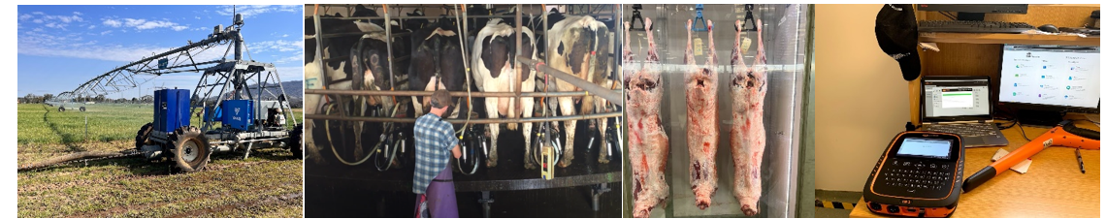
What words do you think about when you hear or see the word ‘agriculture’?
Sample answers:
Farming, food, fibre, cattle, sheep, poultry, crops, milk, plants, animals, country, tractors.
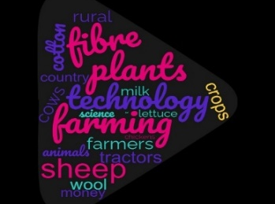
Note: demonstrate how to use a simple image search for relevant pictures students could include in their collage. Use these pictures to either print and add to workbooks or use Canva to create a simple collage.
If computers are not available, use past editions of newspapers (for example The Land) or magazines.
Create your own picture collage using internet research to show what agriculture means to you.
Sample answer:
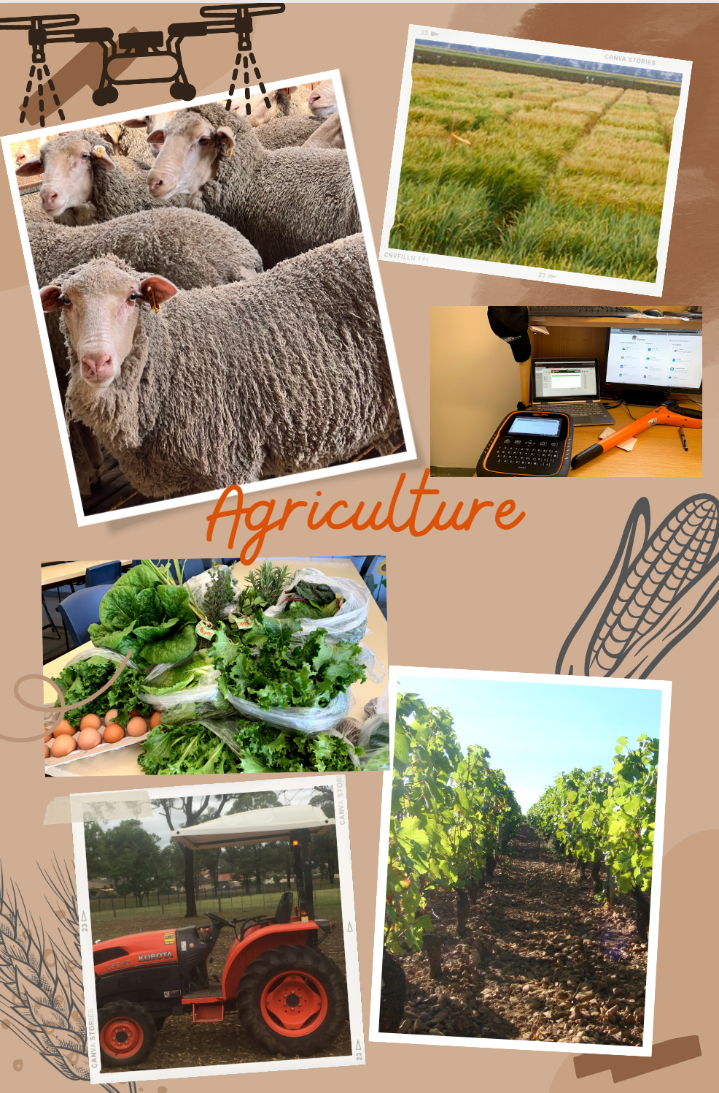

Think, Pair, Share activity
Note: write this definition on the image collage or in student workbooks for later reference.
Create a simple definition for the following question: What is agriculture and why is it important for everyday life?
Sample answer:
Any activity connected with the growing of food, fibre, timber and foliage. Including, but not limited to, cropping, raising livestock, growing flowers or fruits and vegetables.
Note: Gradual release of responsibility
- I do: use dairy farming example as a modelled answer, explaining how the three products link directly to a dairy farm, with raw milk being the product produced on the farm.
- We do: ask students to provide another type of agricultural farm they are familiar with and work with students to determine the raw product produced. Link this to food or fibre used in their everyday lives. Continue this step until students can demonstrate clear understanding.
- You do: students work in pairs to complete at least 2 more with different farms. Share examples from different groups.
Brainstorm different types of agriculture in Australia and include a short list of products obtained from each (what the farmer grows for people to eat or use, or what it can be made into).
Sample answers:
- Dairy farm – milk, butter, ice cream
- Broadacre wheat cropping – wheat for bread and pasta
- Cotton crops – cotton for clothes like socks and t-shirts
- Viticulture – grapes, wine, sultanas

You and agriculture
Note: Check for understanding
Students use a real-life scenario to show where their food comes from, building on the previous activity. This serves as a formative assessment. If understanding is unclear, use a photo of a familiar meal and a Think, Pair, Share strategy to help students work in pairs to improve their understanding.
A sample solution is provided in the table below.
Think about a meal you had for breakfast or dinner recently. Can you identify 3 food products from that meal that have come from an agricultural farm?
List the 3 food products and what type of farm they would have come from.
Table 2 – origin of breakfast
Food product | Type of farm it came from
Strawberries in the strawberry jam | A strawberry growing farm, horticulture.
Wheat in bread for toast | Cropping farm.
Milk in cereal | Dairy farm, if it is cow’s milk.
Butter on toast | Dairy farm if it is regular cow’s milk butter.

Agriculture in NSW
Note: Gradual release of responsibility
- I do: use the think-aloud technique and other modelling to show students where to find the required data on the website. Complete the first row of the table with the data found.
- We do: have students guide you through the next data collection steps while you fill in the second row on the board, correcting or clarifying as needed.
- You do: students work in pairs or individually to complete the final 3 rows of data.
You can also download data as an Excel file for the whole state or individual regions. As an alternative activity, use the Excel files to teach students simple sorting and filtering to find the relevant data. For additional support, watch Excel sorting and filtering data (13:28).
Extend students by using Excel file data to create graphs representing the collated information.
Using the map of NSW showing Regional Output, find your local region and list the top 5 primary industries (types of farms or things grown on farms), including their value in dollars. Present this data in a simple table in ascending order based on dollar value.
Note: a sample solution is provided below. The answer is based on if a student’s local region is the Hunter region.
Table 3 – regional output
Industry | Value (Million $)
Cattle | 238
Milk | 128
Poultry | 107
Eggs | 102
Fisheries | 51
For the top 5 producing regions within NSW (according to dollar value), identify their top producing primary industry and its value.
Table 4 – top 5 producing regions in NSW
Region | Top producing industry | Value of industry
Riverina | Wheat | $3.92 billion
Northwest | Wheat | $3.05 billion
Central West | Wheat | $2.92 billion
Murray | Wheat | $2.14 billion
Western | Wheat | $1.28 billion
Note: discuss the key aspects of successful farming by using leading questions to help students form answers as a class. Alternatively, you can use a map of NSW to help students identify important agricultural features, such as river systems, flat and open spaces and transportation access.
To extend research and group work skills, assign small groups one of the top 5 agricultural regions. Have them research features like average rainfall, irrigation water sources and transport access. Each group then reports their findings to the class.
Looking at the locations of the top 5 producing regions of NSW on the map, describe what you think they have in common, or why they might be a top producer compared to some of the other regions.
Sample answers:
All 5 regions are not along the coastal areas where populations are usually higher and therefore have less space available. All have wheat as their top producing product, which requires lots of space to grow in large paddocks. These areas also have large river systems running through them, providing access to irrigation waters for some industries.

Create
For ONE commodity (product) grown in your local region, create a postcard to be displayed at the Sydney Royal Easter show, teaching people about the contributions of agriculture from where you live. Include the following:
- the name of the raw product produced, for example milk, cotton
- pictures and words showing products that are made from this industry
- how much value it has in your region
- what percentage of the state’s total production they produce
- a list of the range of inputs required for the enterprise to be grown, for example dairy farms producing milk require water for cattle to drink and hay for feed.
Note: if you live in an agriculturally-diverse region, allocate different commodities to students, these will make excellent classroom displays. If you used an internet image search and Canva for the agriculture collages created earlier in the program, this activity can formatively assess students’ progress to mastering these digital skills.

Sample answer:
Northwest region
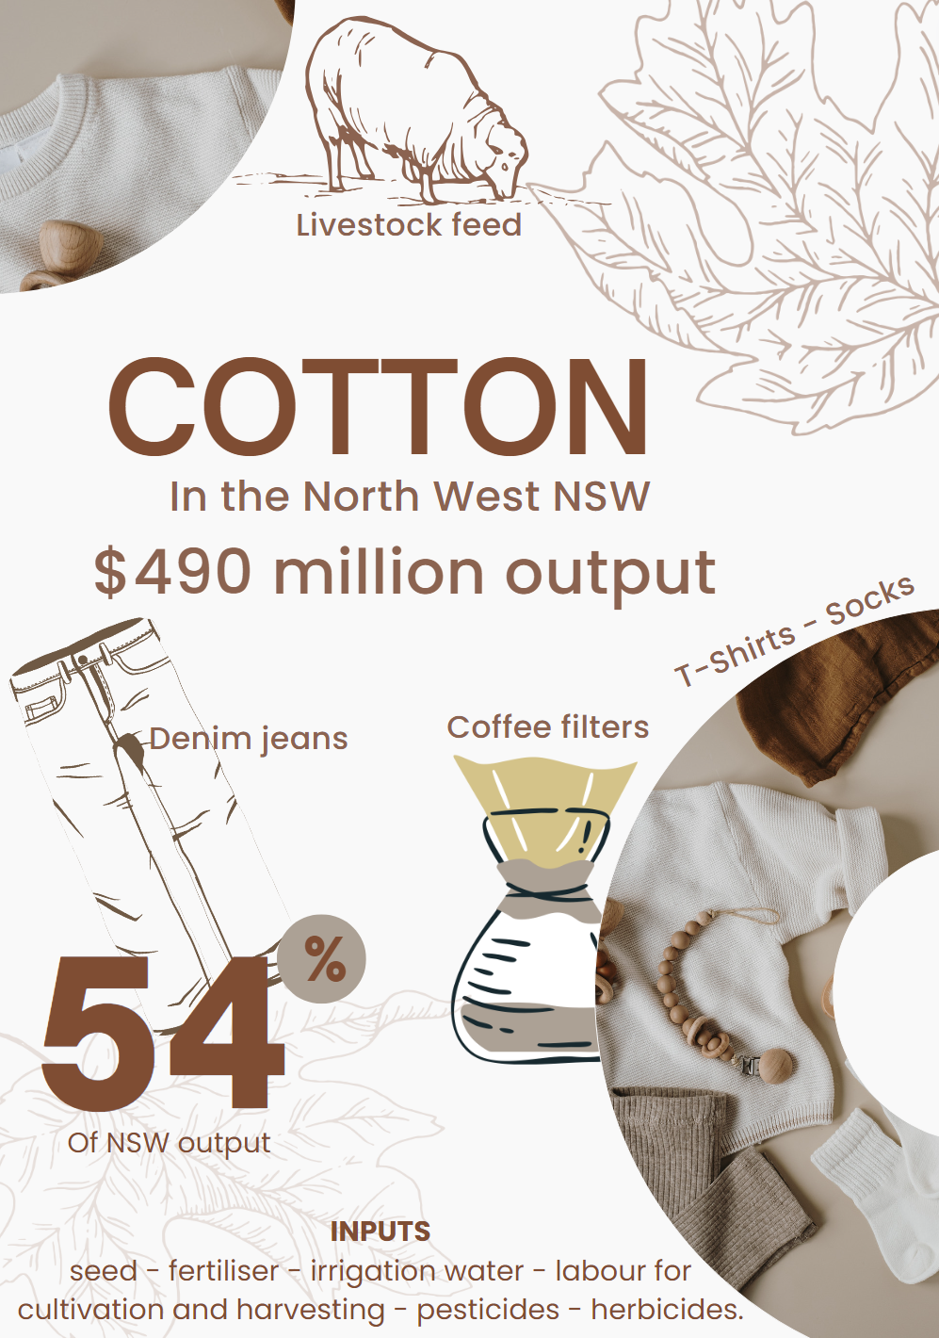

End of section student skills formative assessment checklist
Table 5 – skills assessment checklist
Student skills checklist | Checkbox
Students can use simple internet searches to find suitable images.
Students can use Canva (or other relevant software) to create a document that displays data and images in an appealing way.
Students can link everyday food and fibre products to their point of origin in agriculture.
Students can access accurate information from the map of NSW showing Regional Output to collect relevant data on one identified commodity.

Horticulture – fresh herbs
Note: ensure students understand horticulture and can give examples of its products. Use local business examples, short videos of horticulture farms or build on students' prior knowledge from family and holidays.
Hinge question: the following questions are hinge questions. These are used to check for clear understanding, prior to moving forward with the lesson.
Circle the picture that best represents the agricultural industry ‘horticulture’.
Figure 2 – three types of agriculture
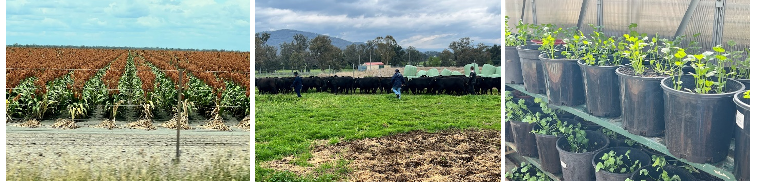
Sample answer:
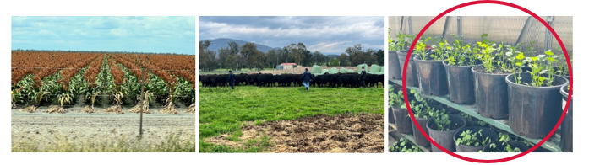
What is horticulture?
Sample answers:
Growing plants for food and fibre, this could include fruits, vegetables and fresh herbs.
What types of produce are grown on a horticulture farm?
Sample answers:
Berries, fresh herbs, leafy green vegetables like lettuce and Bok choy.
Herbs are plants grown in horticulture production. List as many types of herbs as you can think of.
Sample answers:
Basil, thyme, oregano, rosemary, sage, chives, mint, coriander, parsley and dill.
Note: arrange labelled fresh and dried herbs around the classroom for students to observe, look, touch, smell and taste. Consider including local native herbs or bushfoods to create local connections in this learning activity. Read the questions together and clarify expectations. Students will work together to complete the questions and activities. Circulate to answer questions, prompt discussion and encourage the sampling of the displays.

Observe
Observe the appearance, smell and taste of different herb samples provided by your teacher. Describe the similarities in properties of these plants.
Sample answers:
Strong smell and taste, green and leafy.
What are herbs used for in food preparation and how does this link with the properties observed in the previous question?
Sample answers:
Flavour, this comes back to the strong smell and taste in a small sample.
What part of the herb plant is typically used in food preparation?
Sample answers:
Leaves and the stems.
Practical activity
Sketch one of the samples of herbs to scale. Label its main structures, including leaves, stem, roots, flowers, fruits.
Note: using the fresh herb samples from the previous activity, use students prior knowledge to draw and label the typical parts of a plant. Note that some samples may not have all parts present.
Alternative options to this task: draw diagrams to scale, measuring the samples and using adequate scale conversions. Or use software to digitally draw to scale.
Sample answers:
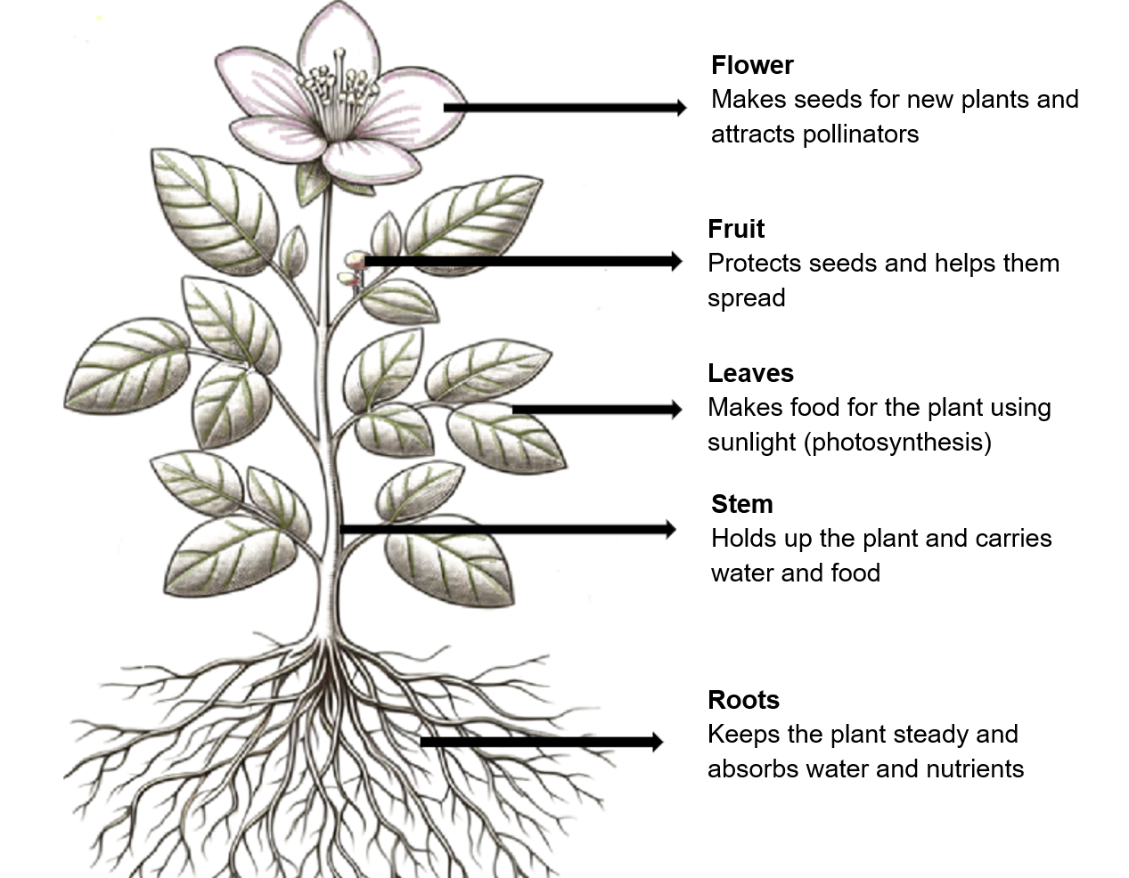
Image partially generated using Copilot and used in accordance with Copilot copyright commitment.
On the diagram above outline its function of each of the structure (How does it keep the plant alive and growing?). If any are missing from the diagram or herb sample, add them to the side of the page.
Note: students complete annotations using prior knowledge, research or the table below.
Table 6 – function of plant parts
Plant part | Function
Leaves | Site of photosynthesis where plant uses carbon dioxide and water with the help of sunlight to create glucose used for growth and development.
Stem | Provide support to hold up leaves, flowers and fruits. Transport food, water and minerals to all parts of the plant and store excess food in the form of starch.
Roots | Absorb water and minerals for the plant, anchor the plant to the ground and store excess food in the form of starch.
Flowers | Site of sexual reproduction in plants to produce seeds.
Fruits | Protect the growing seeds and assist in seed dispersal.
Note: Gradual release of responsibility
- I do: show images of complete strawberry and lettuce plants to illustrate parts not consumed, linking to previous labelling activity.
- We do: students choose a different fruit or vegetable, find a picture and identify eaten parts with guidance.
- You do: students complete the table, share and discuss examples in class.
A sample solution is provided in the table below.
Make a list of other horticultural products grown in NSW and identify the part of the plant eaten for each. An example is given for you.
Table 7 – parts of horticultural plants eaten as food
Plant grown in horticulture | Part of the plant eaten
Strawberries | Fruit
Lettuce | Leaf
Corn | Seed
Potatoes | Tuber
Celery | Stalk
Broccoli | Flower
Figure 3 – snow pea plant in flower
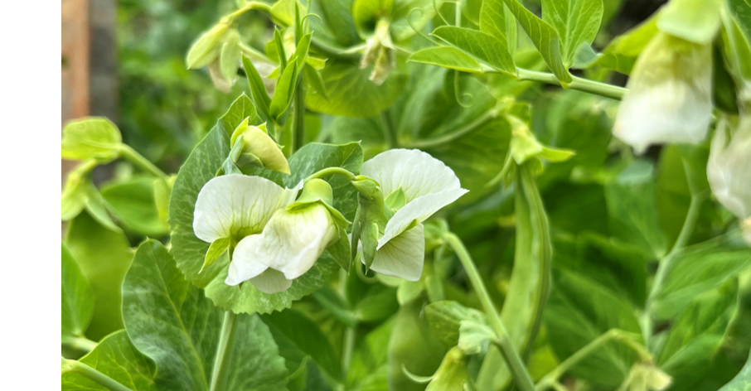

Grow up! – designing a vertical garden

Identifying and designing

Design situation
As Australia’s population continues to expand, cities face the pressing need to produce more food locally. Traditional agricultural practices often require vast land areas, which are scarce in densely-populated urban environments. To tackle this challenge, your team has been tasked with designing an accessible vertical garden system that can be easily lowered for planting, watering and harvesting while being capable of growing crops within the city limits.

Design brief
Your team is to design, produce and evaluate a working model of a vertical garden system that is space efficient, accessible and fully functional to grow a crop from seedling through to harvest.
The vertical system designed should address the following key aspects:
- Space efficiency: using a vertical space such as using the walls of a building.
- Accessibility: including a design mechanism that allows the plants to be lowered for easy access during planting, maintenance (watering) ad harvest.
- Planter types: explore different types of planters used for growing the crop (for example, pots, pipes and bags).
- Aesthetics: the garden should enhance the visual appeal of the urban environment.
Germination of seeds and growing them into seedlings will be done during lessons. These seedlings will be transplanted into your working model when the design is built and mounted.
Note: present the design situation and design brief given, and link to real-world scenarios. Use the design and production process’ diagram below to support students through the steps in project design. This workbook also uses guided questions and activities to support students moving through the design process.
Figure 4 – design and production process
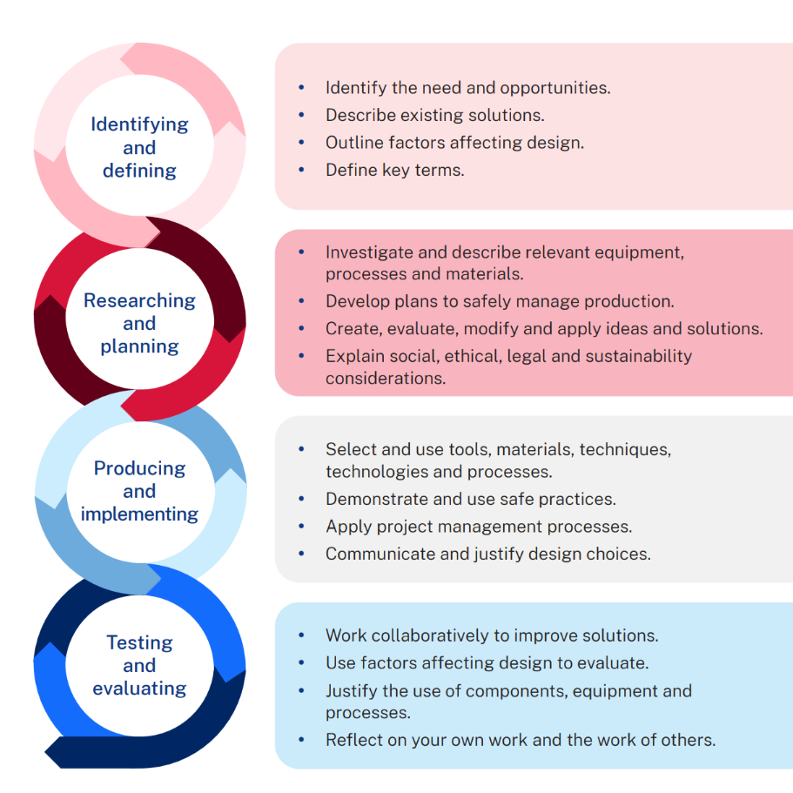
Alternative task ideas
- Food focus: design a dish featuring fresh herbs, integrating gardening and culinary skills.
- Digital focus: create an Internet of Things (IoT) system for monitoring the crop, such as soil moisture sensors, a simple irrigation system, or a weather monitoring system.
- Agriculture focus: develop a system optimising seed germination, integrating technology and agricultural concepts, possibly 3D printing for custom models.

Analysis of the brief
Use the space below to answer the following questions:
- What information do you need to meet the brief (research)?
- What do you need to learn to meet the brief?
- What do you need to produce?
- How will you know you have met the brief?
Sample answers:
- What plant we are growing, for how long and what does it need to grow successfully?
- How to make the planter move up and down for access.

Constraints
Constraints are the rules for the project. Outline the constraints for the project below.

Criteria for success
Note: Checking for understanding
Hinge question: ask students what they believe will indicate success for their project, use leading questions if required. Clear articulation of success criteria shows understanding of the brief. Students struggling to identify success criteria may require additional support in analysing the brief before proceeding with the project.
A sample solution is provided in the table below.
Criteria for success is a list of requirements that your project must meet to satisfy the brief.
In the table below, create your own personal criteria for success and identify the effects if each standard is not met.
Table 8 – criteria for success
Criteria | Effect if not met?
Lifts up and down easily | Cannot be planted or harvested easily
Holds a planter that can grow a plant | Plant will not grow or will be stunted
Plant grows through to harvest | No product produced

Growing crops in Australia
Access the video A Day on a lettuce farm in Western Australia (3:33) to answer the following questions.
Note: the video resource supplied looks at field-grown lettuce. It demonstrates a standard field growing operation in horticulture. The type of plant and its specific growth requirements are not the critical learning for this activity. Students will look at stages in the supply chain (paddock to plate).
The resource will also juxtapose standard field grown horticulture with new and emerging technologies in the industry in later lessons.
Identify the different jobs or activities that take place on the field grown lettuce farm, placing them in order of where the lettuce growing begins through to the end of its life on the farm.
Sample answers:
Cultivating the soil ready for planting. Planting seeds into straight rows, watering or irrigating, pest, and disease control, harvesting with a tractor and specialised harvester. Washed, weighed, and packaged into different sized plastic bags for sale.
Describe how the lettuce on this farm is harvested.
Sample answers:
The farm has a special harvester that follows along behind the tractor and cuts the tops of the lettuce plants at the height set by the tractor driver. Once cut, the lettuce moves up the conveyor belt of the harvester and into a plastic tub.
Suggest a reason why lettuce on this farm is not harvested by hand?
Sample answers:
It would take too long for such a big crop, and this would mean they need more people to work on the farm that would cost more money to the business and customer.
Predict the next step for the packaged lettuce in the supply chain (steps from farm to your plate).
Sample answers:
Packaged lettuce bags are placed into boxes or containers and sent to wholesale markets or directly to supermarkets on a refrigerated truck.
Note: model how to draw a flow chart, including the directional arrows. Simple responses look like the sample answer included. Extending students may include adding an outline of what happens at each step, including an image or identify which steps are automated.
Class discussion: predict which steps could be automated in the future. How would they envisage this happening?
Draw a flow chart showing the steps in the supply chain, from planting on the farm, through to your plate at home.
Sample answer:
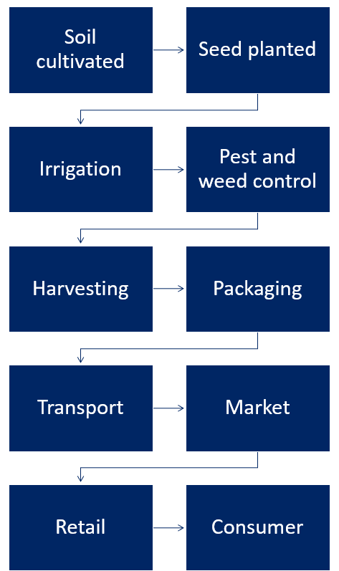

Grow your own
Observe the video resource Growing the best basil (15:28) and use the information about growing conditions to fill in the information guide below.
Note: Why use basil?
Basil is featured in the video and samples, but any plant can be used.
Basil was chosen because it germinates in 7 to10 days and is ready for harvest in 3 to 4 weeks, aligning with a 10-week unit of work. This timeframe allows students to germinate seeds, transplant seedlings, and care for them through harvest, spanning 5 weeks.
Considerations for plant choice include time to harvest, seasonal growth and suitability for pots.
Other plants that may be suitable: dwarf beans (harvest within 5 to 8 weeks); baby spinach (harvest within 4 to 8 weeks); non-hearting lettuce (harvest 4 to 8 weeks); rocket (harvesting 4 to 8 weeks); warrigal greens (harvest 8 to 10 weeks from seed, or from cuttings, less).
Alternative to video: use seed packets or websites for research.
Extension: students choose plants based on given criteria, similar to previous bullet points.
A sample solution is provided in the table below.
Table 9 – plant species information
Criteria | Plant-specific information
Name | Basil
Picture | 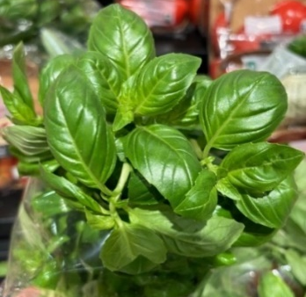
Temperature preferences | Above 21°C optimal, not below 10°C
Watering requirements (How, How much and when?) | Sensitive to both drought and waterlogging, making well-drained soil crucial for their growth and health.  Watering from below, not allowing the water to remain for longer than a few hours if not all absorbed.
Soil requirements | Basil plants require well-drained, moisture-retaining soil with high organic content and a slightly acidic pH.
Sunlight | Not in direct sunlight with prolonged heat, windowsill sunlight is enough.
How to germinate seeds | Sprinkle 8 to 10 seeds 1 cm deep and add potting mix over top. Add wet paper towel over the top. At 21–27°C temperatures they will germinate in 3 to 5 days. Remove paper towel when germinated.
Pot requirements for grown plants | Pots (10) – 15 cm deep; 1.8L volume, drainage holes.
Ideal method used for harvesting | Start harvesting when the plant has 2 to 3 leaf nodes. Cut above the node, leaving one remaining. Harvest before flowering.
Optional numeracy activity
The video uses Fahrenheit for temperature instead of Celsius. Use a simple formula to convert the temperatures into Celsius with students.
Step 1: Subtract 32 from the temperature given in Fahrenheit.
Step 2: Multiply the difference value by 5.
Step 3: Divide the product by 9.
Worked example:
Fahrenheit temperature 212°F
Step 1: 212 - 32 = 180
Step 2: 180 × 5 = 900
Step 3: 900 ÷ 9 = 100
212°F = 100°C

Practical skills safety
Note: provide bags of seed-raising and vegetable-specific potting mix for reading and discussing safety requirements and warning labels. Alternatively, use a picture of a potting mix bag. These instructions will be applied during the seed germination practical activity.

Using potting mixes
Potting mix, commonly used for gardening and planting, can pose health risks due to its composition. Key hazards include:
- Microbial contaminants: potting mix may harbour harmful bacteria, fungi and parasites.
- Dust and particles: inhaling fine dust particles from potting mix can lead to respiratory issues.
- Chemical components: some mixes contain fertilizers, pesticides or additives that can be toxic if ingested or absorbed through the skin.
- Precautions: proper hygiene, wearing gloves and avoiding inhalation are essential when handling potting mix.
Read the warning label on a bag of potting mix, copy it below.
Sample answers:
Health warning. This product contains microorganisms. Avoid breathing dust. Wear particulate mask if dusty. Wear gloves and keep product moist when handling. Wash hands after use.
Using the warning from the potting mix bag and the information above, recommend ways that the hazards could be reduced while working with potting mix for your project.
Sample answers:
Wearing correct protective equipment, opening it up outside or in good ventilation and always washing your hands. Make sure to wet the potting mix down before using so it is less dusty.

Personal Protective Equipment (PPE)
PPE is equipment you wear to protect yourself from hazards or things that can harm you in the workplace or during certain activities.

Types of PPE
- Gloves: these shield your hands from chemicals, germs, or sharp objects.
- Protective eyewear: think of them as safety glasses – they guard your eyes.
- Aprons: these cover your clothes to keep them clean or safe.
- Masks: they help filter out harmful particles from the air.

When do we use PPE?
Whenever there’s a risk. Such as handling chemicals, gardening or working with tools.
- Name each of the types of PPE in the table below.
- Tick the boxes of the PPE you would recommend when working with potting mix.
 |  | 
1. | 2. | 3.
 |  | 
4. | 5. | 6.
Sample answers:
1. Gloves (required); 2. Safety glasses; 3. Sunscreen; 4. Enclosed footwear; 5. Earmuffs; 6. Dust mask (required).
Practical activity – teacher instructions
Provide a variety of personal protective equipment (PPE) for students to explore.
Demonstrate how to wear each piece correctly and explain its purpose in different situations.
Discuss scenarios such as agricultural work and everyday activities like going to the beach.
Allow students to try on the equipment and discuss proper storage and maintenance, including cleaning, storing away from sunlight, and replacing when damaged.
Use the sample scenarios on the following page for extended activities and formative assessment.

Sample scenarios
Scenario 1
You are a farm hand on a small lettuce farm. Today your manager has asked you to drive the tractor to cultivate (dig up) the soil for the next crop of lettuce to be sown. What PPE would you select to complete this task safely?
Scenario 2
You are working on a small cattle farm and today your manager asks you to load up the back of the trailer with 20 bales of hay for the cattle in the paddock. What type of PPE would you select to complete this task safely.
Hint: hay is dried grasses tied up with bailing twine. It is heavy and dusty. You may be working outside to complete this task.
Scenario 3
You are working in a processing factory that receives fresh herbs from local farms, dries them and packages for sale. This job involves lots of loud machinery, dust from drying herbs in large ovens and moving oversized crates around with fresh herbs ready to be processed. What PPE would you select to complete your daily tasks safely?
Scenario 4
You are a farm assistant working on a sheep farm in rural NSW. Today’s first job is to check the fences to ensure no predators can get in and harm the sheep. You will need to ride the farm motorbike to make the task faster as you ride along each fence in the paddocks checking for holes.
What PPE would you select to make this task safer?
Scenario 5
You are an agricultural scientist who works in a science lab testing new chemicals to make sure farmers can grow crops without diseases. What PPE would you expect to wear on a regular day in the lab testing chemical samples on plants?
Note: Gradual release of responsibility
- I do: demonstrate the use of basic horticultural tools to plant basil seeds in a tray, explaining each step safety instructions.
- We do: students work in groups, selecting tools at their workstation and completing the task with prompts.
- You do: students independently complete a second tray of seeds without direct teacher guidance.
Seedlings are needed for the design task, ensure that there are enough for each group. Allow time for germination and growth before the project setup. Allocate time in each lesson for students to check and water seeds.
Practical activity – teacher instructions
Equipment required for germinating seeds
- Seed raising potting mix
- Seed raising pots or containers (can use seed raising trays or repurpose items like egg cartons or plastic food containers). Read 10 DIY seed starter pot ideas for more examples.
- Seeds (for example, basil seeds from supermarket or garden store)
- Water spray bottle (from supermarket, for even watering)
Planting hints to improve safety and success
- Open potting mix outdoors or in a well-ventilated area before use with students to reduce risks. Use a face mask and open away from your face.
- Always work with potting mix in open or well-ventilated areas with students and have students wash their hands afterward.
- Use seed raising mix for better germination, as it provides the right balance of air and moisture.
- Do not compact potting mix tightly in seedling trays to avoid hindering root growth.
- Moisten potting mix before adding seeds. It should be moist but not soaked.
- Plant seeds shallowly in the mix, then lightly cover with more mix for good soil-seed contact.
- Seeds need warmth and moisture to germinate, not necessarily sunlight. Use a clear lid or dome or a sunny windowsill for warmth.
- Keep soil damp but not waterlogged and add water as needed.
- Seedlings do not require outdoor space. Use artificial lights, shelves near windows or slim containers along windowsills.
- Keep the seed raising mix bag for a lesson on reading labels later.

End of section student skills formative assessment checklist
Table 10 – skills assessment checklist
Student skills checklist | Checkbox
Students can select and safely use small horticultural tools for propagation.
Students can identify and select simple PPE equipment suitable for a range of scenarios.
Students can safely follow instructions to plant seeds for germination.
Students can read and follow warning labels on agricultural labels and equipment.

Building a working model
Note: this part of the program requires significant time as students will be creating and testing their project designs.
Simplify the task by providing or removing one or more sections from the design, for example, not having a watering system required, or specific pots being included.
Challenge students to design a system that attaches to a building wall, like a demountable building, and include a watering system.

Vertical garden designs and models
At the beginning of this unit, your team was given a design brief to build a working model for growing a crop in a vertical space.
The following design elements need to be considered.

Vertical garden structure
- Create a sturdy frame that can be securely attached to a wall or will free-stand safely.
- Consider materials like wood, metal or recycled materials.
- Ensure the structure can support the weight of planters and soil.

Planters’ selection
Explore different planter types:
- Pots: traditional clay or plastic pots.
- Pipes: repurposed PVC pipes with holes for planting.
- Bags: fabric grow bags or hanging pouches.
- Choose planters based on crop requirements and aesthetics.

Adjustable mechanism
- Develop a system to raise and lower the entire garden or sections at a time to a height suitable for the average-sized adult.
- Use pulleys, ropes, a simple winch mechanism or other creative idea to move the planters easily without ergonomic strain or use of ladders.
- Ensure all planters can be easy accessed for planting, watering and harvest.

Planting grid
- Arrange planters in a suitable formation to allow easy access when the structure is lowered.
- Optimise spacing to allow plants to thrive without overcrowding.

Watering system
- Install a watering system that ensures each plant is watered sufficiently, but not over watered. This can be passive (under pot soaking) or active (irrigation).
Note: plant selection is already decided as seeds were sown previously.

Research and planning

Types of planters
Research 3 types of planters that could be used for growing plants in a vertical garden structure after they have been germinated and are ready for potting on.
Include a picture and advantages and disadvantages of use.
Note: have a range of suitable options available for observation in class to generate ideas for the design project. Planters can be bought from the local nursery and other recycled items can be collected. Students can also research the planter properties further online.
Examples for display:
- different sized and shaped plastic pots
- small pots made of different materials (terracotta, ceramic)
- material planter bags
- coir fibre
- biodegradable wood pots
- PVC pipe
- plastic bottles, plastic bags, old material (socks, T-shirts), jars and kitchenware.
Note: a sample solution has been provided in table below.
Table 11 – planter research information
Planter types (including picture) | Advantages and disadvantages
Plastic pots  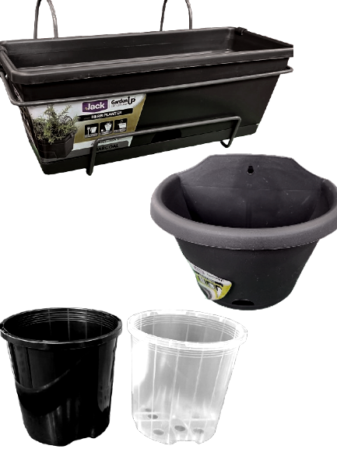 | Ready-made and specifically designed for planting seedlings.  Easy to clean after use and reuse.  Cost money to buy.  Must build the system around the shape.
Material bag style planters  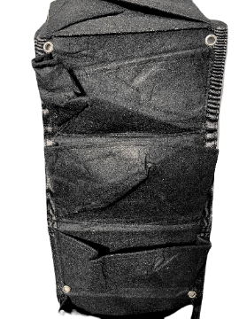 | Can be purchased already made for this purpose or can make my own for free from old material.  Lightweight.  Good drainage.  Might not be great for sun exposure.
Plastic bottles  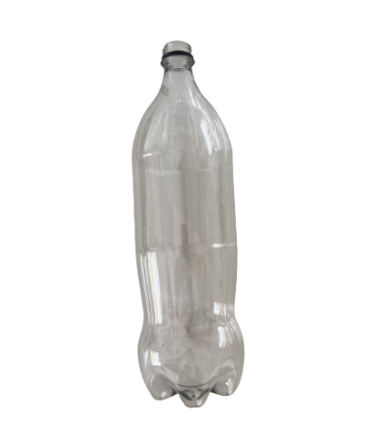 | Free.  Easy to cut out the top and can be sideways or standing upright for the system.  Easy to clean after use and reuse.  Getting enough for the whole system could be difficult.  How to attach them could be tricky.

Identify possible raising and lowering mechanisms
Identify up to 3 ways you could raise and lower the support structure and planters effectively. In the table below, place a picture or diagram of the system and its pros and cons for use.

Support links:
- How to make a simple pulley system (2:10)
- The Drawbridge (0:25)
- How to make a murphy bed with stow away table (18:51)
- 10 Tallest Ferris Wheels in the World (3:24)
- Inclined bucket conveyor (0:10)
Note: sample solution provided.
Table 12 – simple mechanisms and their advantages and disadvantages
Raising – lowering system (including picture) | Advantages and disadvantages
Pulley  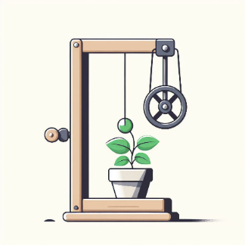 | Can be easy to set up and will not need many parts.  Can be lightweight if rope is used.  Reduces the weight of the pots if they are heavy.  Could be tricky to work out how to set it up so all the pots move down and up the wall.
Ferris wheel style  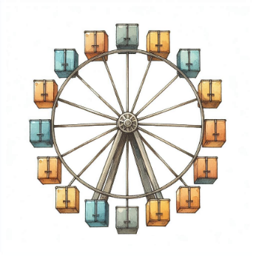 | One pot on each spoke could be easily attached.  Simple design that might not need much construction.  Fixing the centre piece to the wall would need some thought.  Easily moved in a circle to raise and lower pots.
Drawbridge style with roller  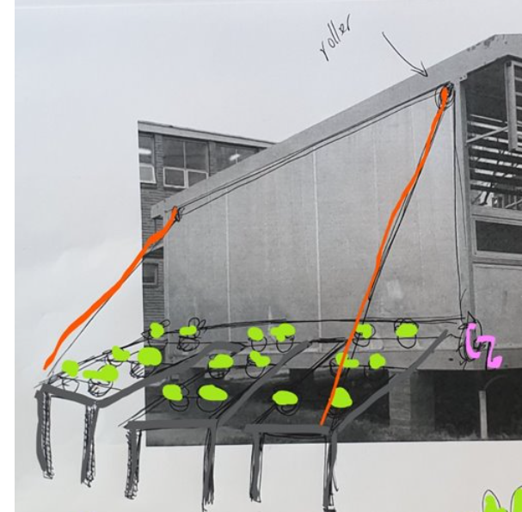 | Would be better for larger systems.  Easy to set up a roller with crank handle to raise and lower lines of pots with little strain.  Pots or rows of pots will need to be able to swing with the change in angle.  Making a crank handle and attaching it to the wall might be difficult.
Sketch your vertical garden structure below, including the types of materials you plan to use.
Consider:
- the types of planters you will use; how big they need to be to accommodate a fully grown plant and how they will be secured within the structure
- how will you raise and lower the system and what materials will you need to do it
- if your working model of the garden will have one planter, or more?
Note: use the research on material types and planter styles from the tables above to design your sketch.
Sample answers:
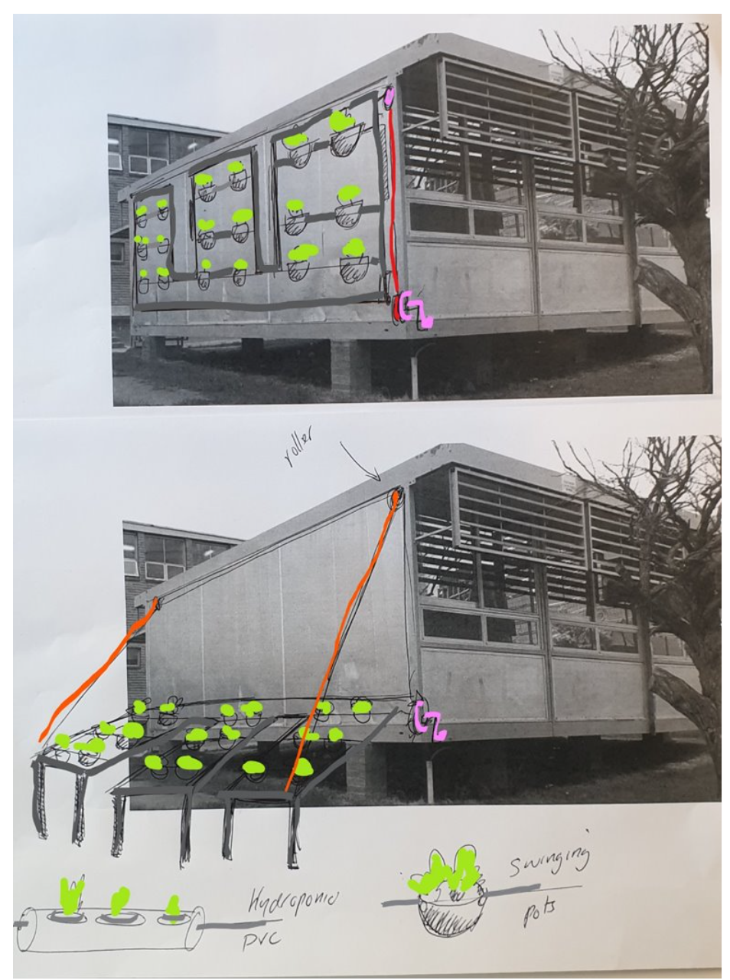

Producing and implementing
Practical activity – teacher instructions
Students collaborate to construct their designs. If the structure is part of the project, they'll build it first, then attach the planters and raising mechanisms. Once construction is complete, transplant seedlings into the vertical garden.
Teachers demonstrate proper seedling transplantation from germination trays to selected pots. This can be done as a whole class or in small groups. For extra support on how to successfully transplant seedlings into small pots, watch Transplanting Basil Seedlings (8:03).
Equipment required for transplanting seedlings
- Vegetable growing potting mix
- Marker or dibble stick
- Pots for projects
- Water sprayer or small watering can
Note: this can be a messy activity and is best done outside over grass. If this is not possible, lay a plastic sheet down under the table used to transplant seedlings so excess dirt can be picked up easily. Do not wash the potting mix down the sink when cleaning off benches.

End of section student skills formative assessment checklist
Table 13 – skills assessment checklist
Student skills checklist | Checkbox
Students can work collaboratively and safely to build a working model, designed to solve an identified problem.

Looking at the markets
The main wholesale markets in Australia are where bulk quantities of fresh foods (fruit, vegetables, seeds and nuts) are sold from company to company, not to the end consumer (you). If you want to buy a one tonne truck of lettuce, you need to go to one of the wholesale markets.
There are 5 main wholesale markets in Australia for fresh vegetables:
- Sydney – Freshmark, Homebush NSW
- Melbourne – Fresh State, Epping VIC
- Brisbane – Brismark, Rocklea QLD
- Adelaide – South Australian Produce Market, Pooraka SA
- Perth – Market West, Canning Vale WA
Almost all vegetables (over 90%) sold in Australia go through these 5 markets.
Note: utilise local farms meeting criteria to ensure locally relevance. For areas with fewer farms, teachers can assist in researching suitable examples. Prompt students by asking if they recall any herb labels from previous lessons or supermarkets.
Encourage students to use the same three examples for streamlined activity, or challenge students by including at least one different farm. This aids in formative assessment and skill development.

Investigation
Identify 3 fresh herb or produce farms that operate in NSW (for example Green Leaf Farm or Clybucca). You could select a local farmer, a family connection or use the internet to search farms in other regions.
Sample answers:
Green Leaf Farm, Clybucca. Harvest Farms, Kurrajong Heights. Ruberto Vegetable Farm, Hay.
Note: Gradual release of responsibility
- I do: use Google Maps to demonstrate how to calculate the distance and fill in the first row.
- We do: guide students through the process step by step, answering questions and correcting mistakes as they complete the second row.
- You do: have students independently complete the task using their last farm to fill in the table.
A sample solution is provided in the tables below.
For each of the farms you have listed, identify the closest wholesale market and calculate an approximate distance between the farm and market. (Hint: use Google maps to help).
Table 14 – distance between wholesale markets and farms in NSW
Farm | Closest wholesale market | Distance between farm and market (km) – Calculation A
Green Leaf Farm, Clybucca. | Freshmark, Sydney | 437
Calculate the distance from the wholesale markets above, to your local supermarket where your family purchases fresh fruits and vegetables from.
Table 15 – distance between wholesale markets and retail stores in NSW
Wholesale market | Closest local supermarket | Distance between market and supermarket (km) – Calculation B
Freshmark, Sydney | Coles Narrabri, NSW | 525
Note: Gradual release of responsibility
- I do: demonstrate how to derive numbers for A and B and substitute them into a number sentence.
- We do: work through the first calculation, prompting each step with students as they complete them. Answer questions directly to formatively assess understanding.
- You do: ask students to complete the final rows individually, supporting where required.
Extend students: add data to Excel and demonstrate how to insert formulas to calculate the final distance. Use How to create formulas in Microsoft Excel (1:37) for extra support.
A sample solution is provided in the table below.
Combine calculation A with calculation B to determine the total distance for products from each farm to reach your local store. This is the distance it takes for some fresh produce to go from paddock to consumer.
Table 16 – food mile calculations
Farm | A + B = (km)
Green Leaf Farm, Clybucca. | 437 = 525 = 962
Note: simple differentiation and students’ choice with 3 options. Complete this task in small groups or pairs as a discussion allowing time to deep dive into the topic before reporting back. Groups become experts in their field and teach their peers about the issues raised.
Select one of the 3 questions below and discuss the possible answers with your partner. Share your ideas with the class.
- Considering fresh produce grown in Australia is transported mainly by truck, what environmental issues might this cause?
- Think about food that is imported to Australia (grown overseas and bought into our country)? How does it get to the consumers in your local area?
- Apart from environmental issues, what issues could rural communities face with access to fresh fruit and vegetables when there are natural disasters such as floods and fire?
Sample answers: ideas for discussion points could include the following.
- Use of trucks for transport causing increased carbon emissions and poor air quality. Trucks require fuel to run, made from crude oil.
- Foods from overseas require extensive transportation compared to Australian grown products, increasing the amount of emissions into the atmosphere.
- Roads and transport accesses can be restricted or cut off completely meaning that some communities can be cut off from food supplies that are not grown locally.

End of section student skills formative assessment checklist
Table 17 – skills assessment checklist
Student skills checklist | Checkbox
Students can collate and present agricultural data from secondary sources.
Extension: students can collate, sort and filter data using Excel spreadsheets.

Emerging technologies in horticulture

Current technologies tackling sustainability issues
As cities across Australia expand and our population grows, the demand for food has never been greater. But how do we ensure that our plates remain full while safeguarding our environment and resources? We must find ways to produce more food with less space, but how?
a. Precision farming:  Farmers now use technology to tailor their efforts. Drones monitor crops, soil sensors optimise irrigation and GPS-guided tractors sow seeds with pinpoint accuracy. This precision minimises waste and maximises yield (how much is grown). | b. Vertical farming:  Imagine skyscrapers filled not with offices, but with lettuce, tomatoes and herbs. Vertical farms stack crops in layers, using LED lights and hydroponics. They’re popping up in city centres, reducing food miles and providing fresh produce year-round.
Food mileage refers to the distance food travels from farm to fork. The farther it goes, the more energy it consumes and the greater its environmental impact.
Buying locally-grown food reduces food mileage. When you enjoy strawberries from a nearby farm, you’re supporting your community and minimising transportation emissions. But how do you do this when you live in a city and there are no big farms down the road?
Note: this resource is an example of a new technology in an urban landscape. Substitute with any new technology in horticulture, especially local examples if available.
Alternatively, consider an excursion or guest speaker session, exploring new technologies. Universities, CSIRO and startup companies are good places to seek ideas.
Watch the video A small farm making big waves from an underground car park in Sydney | ABC News (8:07).
- Urban Greens farm grows fresh produce in a basement of a high-rise building in Sydney. Describe the growing system they use and the type of technologies they rely on.
Sample answers:
They grow produce using hydroponics indoors in a basement of a Sydney high-rise building, with shelves with trays of plants under hydroponic lights, all hand watered.
- How are the growing systems that Urban Green use different from a farm in rural NSW growing fresh greens in a field?
Sample answers:
Field farming is outside in paddocks using machinery, soil and relying on sunlight and rain for watering crops. Transporting the vegetables is usually by truck into the wholesale markets.
- Create a Venn diagram to show the similarities and differences between the 2 systems.
Sample answers:
Similarities: plants are grown with soil, light, water and correct temperatures.
Differences: artificial lights used at Urban farms and irrigation, harvesting and packaging is by hand. Larger scale farms rely on rainfall or irrigators and machinery as the quantity is larger.
- Identify 3 concerns of agricultural production that are being tackled by the business showcased in the video.
Sample answers:
Food mileage, freshness of product and lack of farm space by using the basement of a building.
- Describe how the business showcased in the video resource is tackling one of the concerns listed above. What are they doing that is different from the typical agricultural production that you think of in NSW?
Sample answers:
It is in a Sydney suburb and delivers fresh produce locally as opposed to wholesale markets. Their goal is to have 50% of their deliveries within a 2 km radius and deliver them by bicycle. This will reduce food milage and carbon footprint.

Emerging technologies reducing labour and resource costs
Note: choose one video resource from the options below. The showcased technology is 'emerging', meaning it's in testing but not yet available commercially. Discuss differences between field farming, underground hydroponics and this technology. Consider resources like human effort, water, energy, costs and space.
Watch the video Farms of the Future: the way we grow food is changing | Way Out Ag Ep2 | ABC Australia (15:02), or Virtual tour of CubicFarms’ fresh produce system (8:50).
- Describe the types of technology used in these farming systems.
Sample answers:
A shipping container containing the full growing system from start to finish, including rotation of shelves for accessing the plants, automatic watering and lights for growth. Then harvesting is completed by machine as well.
- In what ways can using one of these systems reduce wastage of water, chemicals and other important resources?
Sample answers:
Included monitors track when and how much water or fertiliser is required, adding it only when necessary, reducing run off.
- How can using one of these systems improve the quality of the crop produced? For example, pest and disease control and climate control.
Sample answers:
Being fully contained, the system gives optimum water and sunlight ratio to increase production or improve quality. Pests and diseases are kept out, so they don’t need chemical application.
- What ideas from this emerging technology could be utilised in your project design? What will you need to investigate further to support your design?
Note: the current and emerging technologies showcased in the videos might seem difficult to replicate, but what aspects of their design could be modified or utilised to work with your design? Consider the way the crops are planted or containers they are grown in. How are they irrigated or watered? How are they accessed for harvest or to receive light?
Sample answers:
Types of pots used; how many are placed together. How plants and pots are watered with the plant being placed in the water bath to absorb the water instead of spraying it over the top. How to move the pots off the wall for easy access to water them and harvest them.
Simple plastic soda bottles cut open for planting, with a few drainage holes in the bottom, but also used for soaking up water when the plants are watered.
A system of moving so that each plant can be accessed easily for watering and plants or harvesting. Maybe on a pulley system with rope instead of conveyor belts or being automatic.

End of section student skills formative assessment checklist
Table 18 – skills assessment checklist
Student skills checklist | Checkbox
Students can recognise aspects of technology that can improve agricultural production and environmental sustainability.

Record keeping
Brainstorm the types of data that can be collected on an ongoing basis throughout the life of the project.
Sample answers:
- Design portfolio creation and completion.
- Weekly progress recording: plant height, number of leaves, surviving plants.
- Data from sensors and monitors: water moisture, temperature.
- Harvest records: product yield in grams or number of plants.
Note: this section allows for a digital technology exploration, incorporating outcomes from other syllabus sections if desired. Students can build a soil moisture probe, temperature sensor or motion detector to detect unwanted pests for their vertical gardens.
A sample solution is provided in the table below.
Student activity
For one type of data collected during the growth phase of the project, create a suitable table, or other appropriate representation method, for collation of data.
Table 19 – temperature record keeping
Date | Minimum temperature (°C) | Maximum temperature (°C)
8 April | 15 | 31
9 April | 16 | 30
10 April | 15 | 32
11 April | 15 | 31

Comparing Aboriginal and Torres Strait Islander Peoples’ management practices with emerging agricultural practices
Note: this section is text heavy. Explore alternative ways to implement this lesson. If available, involve local AECG and/or community groups with Aboriginal knowledge of land management, including traditional and contemporary practices. Consider guest speakers or a site visit.
Consulting with Aboriginal and/or Torres strait Islander communities is essential to the development of meaningful Aboriginal and/or Torres strait Islander Histories and Culture embedded across the curriculum. Aboriginal and/or Torres Strait Islander people are the owners and custodians of their knowledge and cultures and should be consulted when aspects of Aboriginal and/or Torres strait Islander histories and cultures are being incorporated into the school curriculum. If you want to establish an authentic relationship with Aboriginal communities you should understand local community protocols and engage with the community respectfully and authentically. Remember that any information shared by Aboriginal and/or Torres Strait Islander people remains their intellectual property.
The learning activities that follow have been sourced from public-facing materials available online.
Comparing Aboriginal and Torres Strait Islander Peoples’ agricultural and land management practices to emerging techniques gives us a good look at the evolution of food and fibre production and the challenges and opportunities faced with both traditional and contemporary approaches.
Aboriginal and Torres Strait Islander Peoples’ land management practices are deeply connected to the land and understanding of local ecosystems and natural cycles. Instead of just growing one type of plant in a big area like many of today’s farms (monoculture), traditional agricultural practices emphasised polyculture and where multiple plant species are grown together. Soils were tilled and aerated using digging sticks where highly nutritious root vegetables like Murnong were grown. This way of farming maintained healthier soils, helped plants and animals thrive and made the crops grown resilient to problems like pests and diseases.
Controlled burning is practised as a key part of land management as it controls vegetation growth, helps biodiversity, and reduces the risks of wildfires. This method also regenerates the land, allowing the growth of new plants, including native grasses, which increases the carrying capacity in certain areas for grass eating animals such as kangaroos. The ash caused by burning also improves soil condition similar to fertilisers used today.
These traditional land management practices are based on generations of knowledge and innovation, adapted to local environmental conditions and cultural traditions. They demonstrate resourcefulness and resilience in adapting to the landscapes and climatic variations in Australia.
Some contemporary farming methods focus on producing lots of food and fibre quickly, even if it's not so good for the environment. Farms may choose to only grow one type of crop and use lots of chemicals. This can harm the soil, nearby waterways and the animals living around them.
But there are also new farming technologies and techniques that are trying to make agriculture better for the environment. For example, precision farming uses technology to carefully manage things like water, fertilisers and pesticides to make sure they're used only when needed. Genetic engineering is another technology that helps make crops more resistant to pests and diseases, so farmers can use fewer chemicals.
Sample answers
- Briefly describe 2 traditional land management practices used by Aboriginal and Torres Strait Islander peoples.
Sample answers:
Two traditional land management practices used by Aboriginal and Torres Strait Islander peoples were:
- Polyculture farming, where multiple plant species were grown together, promoting biodiversity and soil health.
- Controlled burning, which controls vegetation growth, reduced the risks of wildfires and encouraged the growth of new plants while providing habitat for various animal species.
- How did these practices contribute to the sustainability of communities and the local environment?
Sample answers:
These practices contributed to the sustainability of communities and the local environment by promoting biodiversity, maintaining soil health, and reducing the risks of wildfires. Polyculture farming ensured healthier soil, supported diverse plant and animal life, and made crops more resilient to pests and diseases. Controlled burning helped control vegetation growth, encouraged the growth of new plants, and provided habitat for various animal species.
- Identify a contemporary or emerging agricultural or land management practice that is similar for each of the practices described above. Outline the similarities and differences between the 2 paired practices.
Note: a sample solution is provided in the table below.
Table 20 – comparison of agricultural practices
Agricultural practices | Similarities and differences
Aboriginal and Torres Strait Islander people’s management practice 1  Polyculture  Contemporary or emerging agricultural practice for comparison 1  Sustainable agriculture, for example crop rotations. | Similarities  Both practices emphasise diversity in plant species grown together.  They promote healthier soil and ecosystem resilience.  They aim to reduce reliance on chemicals and promote natural pest and disease control.  Differences  Contemporary sustainable agriculture may incorporate modern scientific principles and techniques alongside traditional knowledge.  Contemporary sustainable agriculture may be practiced on larger scales and integrated into mainstream agricultural systems.
Aboriginal and Torres Strait Islander people’s management practice 2  Controlled burning  Contemporary/emerging agricultural practice for comparison 2  Prescribed burning | Similarities  Both practices involve controlled burning to manage vegetation growth and reduce wildfire risks.  They aim to promote biodiversity and regenerate the land.  Differences  Prescribed burning may be regulated and implemented by government agencies or landowners rather than Indigenous communities.  Prescribed burning may have different objectives and management strategies compared to traditional Indigenous burning practices.

Evaluation and feedback

Harvest record
Note: growing the plants through to harvest allows students to collect first-hand data for harvest records, developing skills using weighing equipment. Demonstrate setting up kitchen scales, use the tare function and read accurately, prior to students completing this activity.
A sample solution is provided in the table below.
This activity may be completed over several weeks as plants are ‘cut and come again’, which means parts can be harvested while the plant continues to grow more leaves for future harvests.
Table 21 – harvest records
Date harvested | Weight of product harvested (g) | Notes or further comments
21 February 2025 | 53 | First harvest, not many leaves or branches to select from.
28 February 2025 | 81 | More branches resprouting for extra harvest.
7 March 2025 | 120 | Lots of leaves, no signs of pest or diseases.
14 March 2025 | 321
Total product harvested from the duration of the project:

Market specifications
Market specifications are rules or guidelines for how fruits and vegetables should look, taste and even how they should be packaged before they get to the supermarket. Farmers use these guidelines to make sure their produce meets the standards that buyers are looking for.
In horticulture, market specifications are important for consistency and will impact the price a farmer receives for their produce. Farmers need to know exactly what size, shape, colour and quality their fruits and vegetables should be to sell them for the fresh produce market. For example, a supermarket might want apples that are a certain size and shape and have a shiny red colour. When you go to the supermarket, you may notice that all the apples look very similar on the stand.
The following table has some of the market specifications for basil that supermarkets expect farmers to meet.
Practical activity – teacher instructions
Market specifications and the specific language used may not be familiar to students in this age group. To help improve understanding, a simple practical activity can help.
- Ask students to describe what they look for when buying common fruits like apples or bananas, noting factors like bruises or size. Link this these to the ‘criteria type’ in Table 22 below. Green bananas are not ripe enough and may be rejected, this is a colour criterion.
- Set up 3 samples of a range of different fruits or vegetables, each with slight differences.
- In small groups, have students rank the samples from best to worst and explain their choices.
- Explain that their judgments reflect consumer preferences and influence supermarket purchases. Produce that does not meet market specifications is typically not sold to the fresh food market but will go into processing or landfill.
Table 22 – market specifications for basil
Criteria type | Specification for basil
Colour | Bright green leaves and stems.
Visual appearance | Finely ridged, square stems covered with fine hairs, smooth, glossy leaves with distinct veins, no foreign matter.
Sensory | Crisp, juicy stems, firm leaves, strong sweet but spicy flavour. Free from forging odours or tastes.
Size | Bunch length 200-300mm, bunch weight > 70g.
Maturity | Young, tender stems and leaves, flower buds may be present but not fully open.
Practical activity
Students evaluate their harvested products using market specifications from Table 23. They read each set of criteria and decide where their sample fits best, considering both quantitative and qualitative aspects. Students circle their assessment for each criterion and make a final judgement of high, medium or low-quality produce.
To differentiate, students assess a sample from each group to determine the best harvested produce from the class.
Assess your basil grown in the working model using the checklist.
Table 23 – market specifications for basil student assessment criteria
Specification | High | Medium | Low
Colour | All leaves and stems present are bright green | Most leaves or stems are bright green, a few darker, yellow or brown ones. | Less than half the leaves and stems are bright green, some brown, yellow or dark green
Visual appearance | No foreign matter (weeds).  Glossy leaves with distinct veins.  Firm stems with fine hairs. | Some foreign matter that could be easily removed.  Mostly glossy leaves, only a few dull ones.  Stems mostly firm. | Obvious foreign matter (weeds, dirt).  More dull leaves than glossy ones.  Stems are floppy.
Sensory | Smell: strong basil smell.  Touch: stems firm to touch, crispy when snapped and have visible sap. | Smell: basil smell noticeable, but not strong.  Touch: some stems bend, others are firm and crispy when snapped. | Smell: other, non-basil smelling odours present.  Touch: all stems feel wilted, bend more than snap under pressure.
Size | Bunch length 200–300 mm  Bunch weight > 70 g | Bunch length between 150–200 mm or 300–350 mm.  Bunch weight 50–70 g | Bunch length <150 mm or >350 mm.  Bunch weight <50 g
Maturity | Young, tender stems and leaves, flower buds present, not fully open. | Some flowers present and starting to open.  Older, larger leaves. | Lots of flowers all open, old large leaves.

Criteria for success
Note: a sample solution is provided in the table below.
The criteria for success were determined in a previous lesson. Copy the 3 main criteria in the table below and evaluate your project based on these criteria.
Table 24 – evaluation of criteria
Criteria | Evaluation
Plant grows through to harvest. | Mostly, some plants died from the heat of being up against the wall. Needed a bit of shade.
After completing the project, were there other criteria you should have considered to evaluate your project design against? Why?

Real-world application
This design project was about building a working model of a vertical garden for growing basil from planting to harvest. Where would you see the skills you have developed during this project used in other ways?
Sample answers:
In urban gardening and peoples’ homes. In architecture when people want to make tall buildings look better on the outside.

End of section student skills formative assessment checklist
Table 25 – skills assessment checklist
Student skills checklist | Checkbox
Students can accurately collect and present first-hand data.
Students can follow the design process to provide a solution to an agricultural problem.
Students can evaluate a design based on given success criteria.
Students can link classroom lessons to real-world applications.

References
This resource contains NSW Curriculum and syllabus content. The NSW Curriculum is developed by the NSW Education Standards Authority. This content is prepared by NESA for and on behalf of the Crown in right of the State of New South Wales. The material is protected by Crown copyright.
Please refer to the NESA Copyright Disclaimer for more information https://educationstandards.nsw.edu.au/wps/portal/nesa/mini-footer/copyright.
NESA holds the only official and up-to-date versions of the NSW Curriculum and syllabus documents. Please visit the NSW Education Standards Authority (NESA) website https://educationstandards.nsw.edu.au and the NSW Curriculum website https://curriculum.nsw.edu.au.
Technology 7–8 Syllabus © NSW Education Standards Authority (NESA) for and on behalf of the Crown in right of the State of New South Wales, 2023.
ABC Australia (4 March 2022) 'Farms of the Future: the way we grow food is changing 🍆🍅 | Way Out Ag Ep2 | ABC Australia' [video], ABC Australia, YouTube, accessed 9 April 2024.
ABC News (Australia) (7 July 2022) 'A small farm making big waves from an underground car park in Sydney | ABC News' [video], ABC News (Australia), YouTube, accessed 9 April 2024.
CubicFarm Systems (26 June 2020) ‘Virtual tour of CubicFarms’ fresh produce system’ [video], CubicFarm Systems, YouTube, accessed 9 April 2024.
Department of Primary Industries & Regional Development (29 October 2020) 'A Day on a Lettuce Farm in Western Australia' [video], Department of Primary Industries & Regional Development, YouTube, accessed 26 March 2024.
Engineering8 (13 October 2017) '10 Tallest Ferris Wheels in the World' [video], Engineering8, YouTube, accessed 2 May 2024.
Fresh Markets Australia (2024) Brismark, Fresh Markets Australia website, accessed 5 March 2024.
—— (2024) Fresh State, Fresh Markets Australia website, accessed 5 March 2024.
—— (2024) Freshmark, Fresh Markets Australia website, accessed 5 March 2024.
—— (2024) Market West, Fresh Markets Australia website, accessed 5 March 2024.
—— (2024) South Australia, Fresh Markets Australia website, accessed 5 March 2024.
Griffiths M (7 January 2024) ‘10 DIY Seed Starter Pot Ideas: Repurpose, Reuse and Recycle Household Items’, Gardening Know How, accessed 20 February 2024.
INVENTORINDO FURNITURE (29 April 2023) 'HOW TO MAKE A MURPHY BED WITH FOLDING TABLE STEP BY STEP' [video], INVENTIRINDO FURNITURE, YouTube, accessed 2 May 2024.
Korff J (2000–2018) Aboriginal land management & care, Creative Spirits website, accessed 18 March 2024.
Microsoft 365 (18 February 2018) 'How to create formulas in Microsoft Excel' [video], Microsoft 365, YouTube, accessed 14 March 2024.
NSW Department of Primary Industries and Regional Development (2022) Foreword: Regional Output, NSW Department of Primary Industries website, accessed 1 March 2024.
Specific Love Creations (27 March 2015) 'How to make a Simple Pulley System - Pulleys Simple Machines' [video], Specific Love Creations, YouTube, accessed 2 May 2024.
Star Mountain, Inc. (7 March 2019) 'Transplanting Basil Seedlings' [video], Star Mountain, Inc., YouTube, accessed 20 February 2024.
State of New South Wales (Department of Education) (2024) ‘Gradual release of responsibility’, Explicit teaching, NSW Department of Education website, accessed 9 May 2024.
State of New South Wales (Department of Education) (n.d.) ‘Think Pair Share’, Digital Learning Selector, NSW Department of Education website, accessed 12 March 2024.
The Organic Chemistry Tutor (8 June 2018) 'Excel Sorting and Filtering Data' [video], The Organic Chrmistry Tutor, YouTube, accessed 14 March 2024.
The Ripe Tomato Farms (21 August 2023) 'Growing The Best Basil - The Definitive Guide' [video], The Ripe Tomato Farms, YouTube, accessed 12 March 2024.
Thiel O (29 January 2019) 'The drawbridge' [video], Oliver Thiel, YouTube, accessed 2 May 2024.

© State of New South Wales (Department of Education), 2024
The copyright material published in this resource is subject to the Copyright Act 1968 (Cth) and is owned by the NSW Department of Education or, where indicated, by a party other than the NSW Department of Education (third-party material).
Copyright material available in this resource and owned by the NSW Department of Education is licensed under a Creative Commons Attribution 4.0 International (CC BY 4.0) license.

This license allows you to share and adapt the material for any purpose, even commercially.
Attribution should be given to © State of New South Wales (Department of Education), 2024.
Material in this resource not available under a Creative Commons license:
- the NSW Department of Education logo, other logos and trademark-protected material
- material owned by a third party that has been reproduced with permission. You will need to obtain permission from the third party to reuse its material.
Links to third-party material and websites
Please note that the provided (reading/viewing material/list/links/texts) are a suggestion only and implies no endorsement, by the New South Wales Department of Education, of any author, publisher, or book title. School principals and teachers are best placed to assess the suitability of resources that would complement the curriculum and reflect the needs and interests of their students.
If you use the links provided in this document to access a third-party's website, you acknowledge that the terms of use, including licence terms set out on the third-party's website apply to the use which may be made of the materials on that third-party website or where permitted by the Copyright Act 1968 (Cth). The department accepts no responsibility for content on third-party websites.

