STEM Stage 4 – Olympiad

Challenge 9 – mini greenhouse
In this challenge, you will construct a greenhouse using the resources listed below that increases internal temperature over a short period of time and maximises transparent surface area.
Figure 1 – illustration of mini greenhouse activity
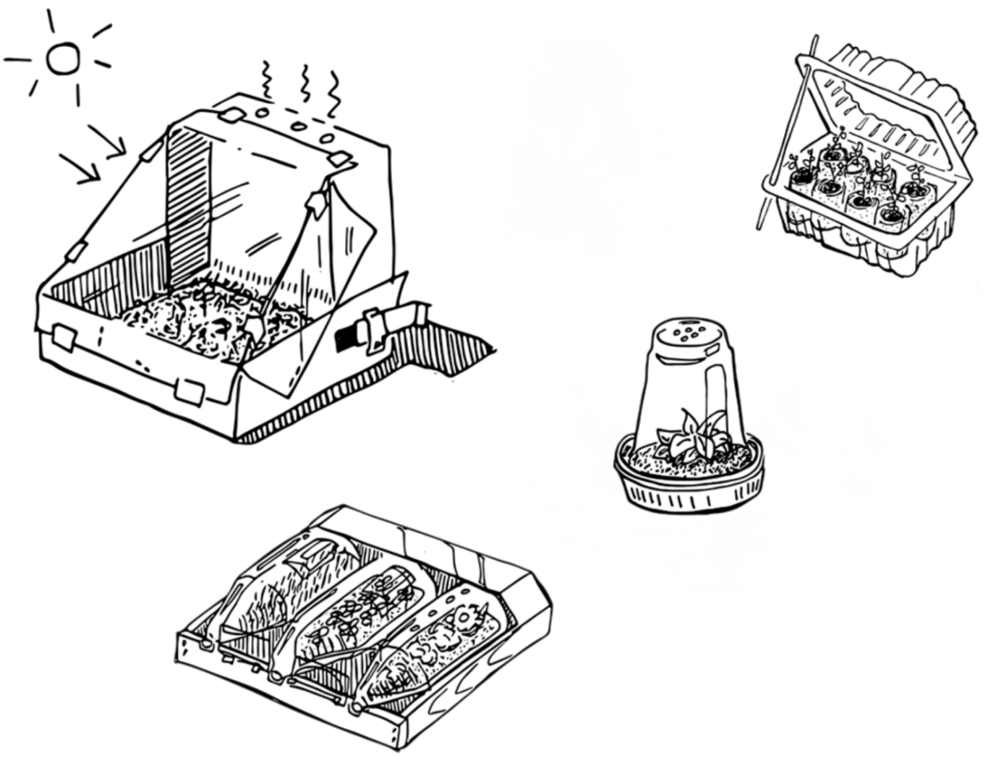

Resources required
- Empty plastic bottles, plastic containers or egg cartons
- Other materials, such as cardboard tubes, straws, craft sticks, cardboard
- Soil and a thermometer
- Video: Gardening Australia: How to create a mini greenhouse (4:44)

Learning intentions and success criteria
In this challenge you will design, build and test a recycled mini greenhouse.
Table 1 – syllabus outcomes, learning intentions success criteria
Syllabus outcomes | Learning intentions and success criteria
SC4-LIV-01  describes the role, structure and function of a range of living systems and their components  SC4-WS-04  follows a planned procedure to undertake safe and valid investigations  TE4-MSC-01  explains how materials, systems and components contribute to solutions  MA4-ARE-C-01  applies knowledge of area and composite area involving triangles, quadrilaterals and circles to solve problems | We are learning to:  - describe how a greenhouse supports life by trapping heat and allowing light into the structure  - apply practical skills to test and construct an effective greenhouse  - measure and apply area formulas of basic shapes.  We can:  - describe how each part of the greenhouse helps to trap heat and allows light through to support plant life  - accurately measure and compare temperatures to draw conclusions about the effectiveness of a greenhouse  - calculate the whole surface area of the greenhouse that receives light.

Mini greenhouse terms
To assist with your understanding of the task, read through the following terms in the table below and complete the reflection to check for understanding of the key terms.
Table 2 – key terms
Term | Definition
microclimate | The climate conditions in a small, specific area which may be different from the surrounding area.
greenhouse effect | The process where gases in the atmosphere trap heat and warm the Earth.
humidity | The amount of water vapour in the air.
radiation | Energy that travels as waves, such as heat or light from the Sun.
solar energy | Energy from the Sun that can be used for heat, light or electricity.
surface area | The total area of the outside surfaces of an object.
Write ‘T’ for true or ‘F’ for false.
- ‘Humidity’ is the amount of water vapour in the air. (__.)
- ‘Radiation’ is energy that travels as waves, like heat or light from the Sun. (__.)
- ‘Surface area’ is the total area of the outside of an object. (__.)

Criteria for success
Your greenhouse must meet the following requirements:
- increase the inside temperature compared to the outside temperature
- maximise the surface area of transparent materials.

Directions to students
Step 1: research (10 minutes)
- Watch the video Gardening Australia: How to create a mini greenhouse (4:44) by ABC Education.
- Consolidate this research with your build team before moving on.
Step 2: design and construct (20 minutes)
- Assess what materials you have available and consider their shape and properties. Items like plastic bottles or containers might be useful in your design if they are cut in half.
- Use items like half plastic bottles or an egg carton as the base of your greenhouse and fill with soil.
- Water the soil with a small amount of water as if you were growing seedlings.
- Create a three-dimensional shape to cover your soil and trap heat from the sun’s rays. Use the transparent plastic to allow light to reach the soil.
Step 3: investigation and recording data (15 minutes)
- Place your mini greenhouse in a sunny spot and measure the temperature. Record the measurements in the table.
- Record the temperatures inside and outside of the green house (see Table 3).
- Measure and calculate the maximum surface area of all transparent surfaces of your greenhouse (see Table 4). You may need to divide complex shapes into familiar shapes.
Table 3 – example of calculation
Section of greenhouse | Dimension 1 | Dimension 2 | Dimension 3 (if needed) | Area formula | Area
Roof – rectangle | 30 cm | 15 cm |  | length × width | 450 cm²
End wall, square section | 30 cm | 30 cm |  | S² | 900 cm²
Table 4 – data collection for greenhouse temperature
Elapsed time (minutes) | Inside greenhouse (temperature °C) | Outside greenhouse (temperature °C)
0 minutes
3 minutes
5 minutes
8 minutes
10 minutes
Table 5 – calculating greenhouse surface area
Section of greenhouse | Dimension 1 | Dimension 2 | Dimension 3 (if needed) | Area formula | Area
Total transparent surface area: __ cm²

Reflection
Compare the inside and outside temperatures and describe how well your mini greenhouse trapped heat. Think about what the data shows, what worked in your design and what you would change to make it better. Use the following sentence starters to help you write your reflection.
From my temperature readings, I can see that my greenhouse …
The inside temperature changed because …
If I redesigned my greenhouse, I would improve it by …
By comparing the surface areas of different sides, I found that …

References
This resource contains NSW Curriculum and syllabus content. The NSW Curriculum is developed by the NSW Education Standards Authority (NESA). This content is prepared by NESA for and on behalf of the Crown in right of the State of New South Wales. The material is protected by Crown copyright.
Please refer to the NESA Copyright Disclaimer for more information https://www.nsw.gov.au/education-and-training/nesa/copyright.
NESA holds the only official and up-to-date versions of the NSW Curriculum and syllabus documents. Please visit NESA https://www.nsw.gov.au/education-and-training/nesa and NSW Curriculum https://curriculum.nsw.edu.au.
Science 7–10 Syllabus © NSW Education Standards Authority (NESA) for and on behalf of the Crown in right of the State of New South Wales, 2023.
Technology 7–8 Syllabus © NSW Education Standards Authority (NESA) for and on behalf of the Crown in right of the State of New South Wales, 2023.
Mathematics K–10 Syllabus © NSW Education Standards Authority (NESA) for and on behalf of the Crown in right of the State of New South Wales, 2022.
ABC (Australian Broadcasting Corporation) (4 July 2022) ‘Gardening Australia: How to create a mini greenhouse’ [video], ABC Education, ABC website, accessed 17 November 2025.

© State of New South Wales (Department of Education), 2026
The copyright material published in this resource is subject to the Copyright Act 1968 (Cth) and is owned by the NSW Department of Education or, where indicated, by a party other than the NSW Department of Education (third-party material).
Copyright material available in this resource and owned by the NSW Department of Education is licensed under a Creative Commons Attribution 4.0 International (CC BY 4.0) license.

This license allows you to share and adapt the material for any purpose, even commercially.
Attribution should be given to © State of New South Wales (Department of Education), 2026.
Material in this resource not available under a Creative Commons license:
- the NSW Department of Education logo, other logos and trademark-protected material
- material owned by a third party that has been reproduced with permission. You will need to obtain permission from the third party to reuse its material.
Links to third-party material and websites
Please note that the provided (reading/viewing material/list/links/texts) are a suggestion only and implies no endorsement, by the New South Wales Department of Education, of any author, publisher, or book title. School principals and teachers are best placed to assess the suitability of resources that would complement the curriculum and reflect the needs and interests of their students.
If you use the links provided in this document to access a third-party's website, you acknowledge that the terms of use, including licence terms set out on the third-party's website apply to the use which may be made of the materials on that third-party website or where permitted by the Copyright Act 1968 (Cth). The department accepts no responsibility for content on third-party websites.

