STEM Stage 4 – Olympiad

Challenge 8 – rubber band-powered vehicle
In this challenge, you will construct a wheeled vehicle using the resources listed below that uses rubber band energy to propel it forward.
Figure 1 – illustration of rubber band-powered vehicle activity
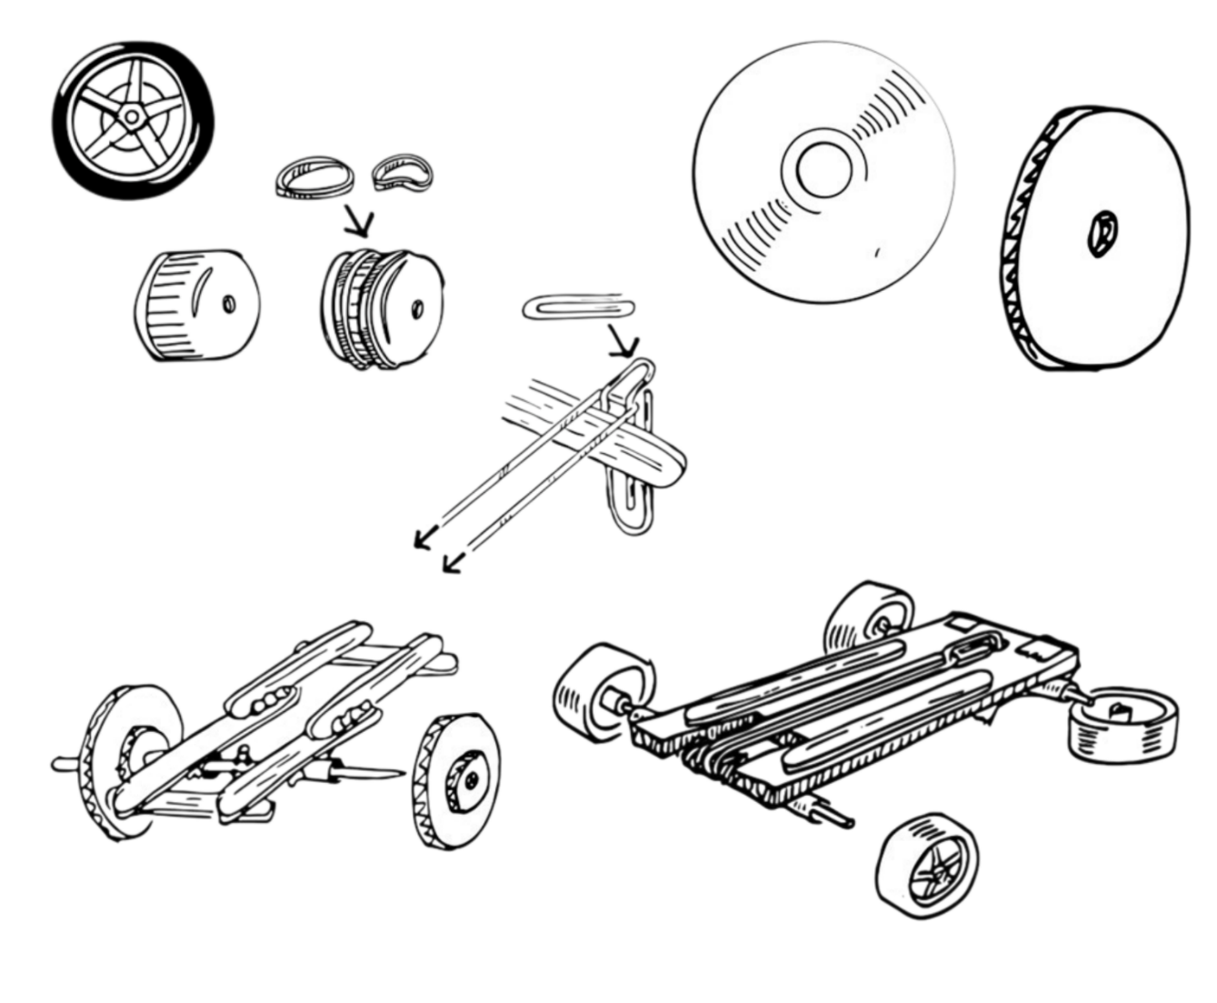

Resources required
- Corrugated cardboard or craft sticks
- 2 straws and 2 wooden skewers (used for sleeves and axles)
- 4 wheels (these can be cardboard, CDs, bottle caps or purpose-made wheels)
- An assortment of rubber bands and paper clips
- Masking tape
- Scissors
- Hot glue gun (optional)
- Video STEMonstrations: Kinetic and Potential Energy | NASA + (2:38)

Learning intentions and success criteria
In this challenge you will design, build and test a vehicle powered by a rubber band. You will then conduct a controlled investigation to see how far it will travel.
Table 1 – syllabus outcomes, learning intentions and success criteria
Syllabus outcomes | Learning intentions and success criteria
SC4-FOR-01  describes the effects of forces in everyday contexts  TE4-MSC-01  explains how materials, systems and components contribute to solutions | We are learning to:  - describe forces within different systems using appropriate scientific language  - improve design solutions from observed results.  We can:  - describe how forces affect the distance travelled  - independently conduct a valid investigation  - use observed results to provide predictions for future testing.

Rubber band-powered vehicle terms
To assist with your understanding of the task, read through the following terms in the table below and complete the reflection to check for understanding of the terms.
Table 2 – key terms
Term | Definition
parallel | Two lines that run alongside each other without touching.
chassis | The frame or base of a vehicle that supports all other parts.
axle | A rod or shaft that connects wheels and allows them to turn.
kinetic energy | The energy an object has because it is moving.
potential energy | The stored energy an object has due to its position or condition.
work | The energy transferred when a force moves an object.
Write ‘T’ for true or ‘F’ for false.
A ‘chassis’ is the main frame of a vehicle that supports all other parts. (__.)
‘Kinetic energy’ is the energy an object has because it is moving. (__.)
‘Potential energy’ is the energy an object has due to its movement. (__.)
‘Work’ is the energy transferred when a force moves an object. (__.)

Criteria for success
Your vehicle must meet the following requirements:
- be constructed using the materials provided
- move forwards using the rubber band
- be reliably tested for the 3 trials.

Directions to students
Step 1: research (5 minutes)
- Watch the NASA video on STEMonstrations: Kinetic and Potential Energy | NASA + (2:38) to learn about the energy that will propel your vehicle.
- In construction teams, identify and share the most important takeaway from the video.
Step 2: construction and testing (30 minutes)
- Follow suggested instructions on the following page to construct your vehicle.
- Select an area for testing that is long, flat and clear of obstacles (for example, a corridor, quad or hall can work well).
- Wind the rubber band to provide potential energy to the vehicle and gently place it at start line.
- Release the rubber band. This will propel the vehicle forward, converting the stored potential energy in the rubber band into kinetic energy.
- Use a tape measure to record the distance that your vehicle travelled from the start line to where it stopped.
- Repeat this process for the remaining trials, recording your results after each attempt of the 3 attempts in the table below (see Table 3).
Table 3 – data collection for distance travelled
Attempts | Distance travelled (metres)
Trial 1
Trial 2
Trial 3
Total distance
Average distance

Build instructions
- Create a rectangular chassis for the vehicle. This can be modified later, but the important thing to have is 2 places for the axles to be attached parallel to each other.
- Cut a straw into 4 equal pieces, each about 3 centimetres long. Two pieces at each end of the chassis will house each axle. Positioning the straws near the edge of the chassis may help ensure the 2 axles will be parallel to each other. Attach them with masking tape to the underside of the chassis.
- Thread a skewer through them to create axles. Attach the axles to the body of the vehicle by taping the straw (not the skewer) to the underside of the chassis.
- Attach wheels to the end of the skewers. Make sure they are secure and not wobbly. (Note: if using CDs for wheels, you may need to use a piece of sponge or cardboard to secure the axles to the middle of the CD. You may also need to add a rubber band around the drive wheels if testing on a smooth surface.)
- Attach a paper clip to be an anchor point for the rubber band. If the chassis is made from cardboard, cut a small hole in the middle of the cardboard and bend a paper clip through the hole and secure. Or, if the chassis is made from craft sticks, glue or tape a paper clip firmly to some point on the chassis. The important thing here is to attach the paper clip equally at a distance from the drive axle.
- Attach the rubber band using a loop from the axle to the paper clip.
- Wind and rotate the wheels (and the axle) that the rubber band is attached to until the rubber band is taut and is wrapped around the axle a number of times.
- Put the vehicle on the ground and make sure the area is clear before releasing the vehicle. Release the vehicle.
- If the vehicle moved forward, wind the axle up again and get ready to take measurements. If not, re-check the whole vehicle and check that the rubber band is connected correctly to the drive axle.

Reflection
The investigation suggests that vehicles with straight axles, well-attached wheels and a tightly wound rubber band usually travel the furthest. When the rubber band is wound the same number of turns each time, the vehicle tends to move in a more predictable way and the distances for each trial are often similar. This means that careful building and consistent testing help the vehicle work well and travel further.
Based on your results, explain whether you agree, partly agree or disagree with the statement above.
Use your evidence to explain any similarities or differences in the distances travelled:

References
This resource contains NSW Curriculum and syllabus content. The NSW Curriculum is developed by the NSW Education Standards Authority (NESA). This content is prepared by NESA for and on behalf of the Crown in right of the State of New South Wales. The material is protected by Crown copyright.
Please refer to the NESA Copyright Disclaimer for more information https://www.nsw.gov.au/education-and-training/nesa/copyright.
NESA holds the only official and up-to-date versions of the NSW Curriculum and syllabus documents. Please visit NESA https://www.nsw.gov.au/education-and-training/nesa and NSW Curriculum https://curriculum.nsw.edu.au.
Science Years 7–10 Syllabus © NSW Education Standards Authority (NESA) for and on behalf of the Crown in right of the State of New South Wales, 2023.
Technology Years 7–8 Syllabus © NSW Education Standards Authority (NESA) for and on behalf of the Crown in right of the State of New South Wales, 2023.
NASA (National Aeronautics and Space Administration) (3 April 2018) ‘STEMonstrations: Kinetic and potential energy’ [video], NASA+, NASA website, accessed November 2025.
© State of New South Wales (Department of Education), 2026
The copyright material published in this resource is subject to the Copyright Act 1968 (Cth) and is owned by the NSW Department of Education or, where indicated, by a party other than the NSW Department of Education (third-party material).
Copyright material available in this resource and owned by the NSW Department of Education is licensed under a Creative Commons Attribution 4.0 International (CC BY 4.0) license.

This license allows you to share and adapt the material for any purpose, even commercially.
Attribution should be given to © State of New South Wales (Department of Education), 2026.
Material in this resource not available under a Creative Commons license:
- the NSW Department of Education logo, other logos and trademark-protected material
- material owned by a third party that has been reproduced with permission. You will need to obtain permission from the third party to reuse its material.
Links to third-party material and websites
Please note that the provided (reading/viewing material/list/links/texts) are a suggestion only and implies no endorsement, by the New South Wales Department of Education, of any author, publisher, or book title. School principals and teachers are best placed to assess the suitability of resources that would complement the curriculum and reflect the needs and interests of their students.
If you use the links provided in this document to access a third-party's website, you acknowledge that the terms of use, including licence terms set out on the third-party's website apply to the use which may be made of the materials on that third-party website or where permitted by the Copyright Act 1968 (Cth). The department accepts no responsibility for content on third-party websites.

