STEM Stage 4 – Olympiad

Challenge 7 – spoon catapult
In this challenge, you will construct a catapult using the resources listed below that can throw a small projectile with precision and accuracy.
Figure 1 – illustration of spoon catapult activity
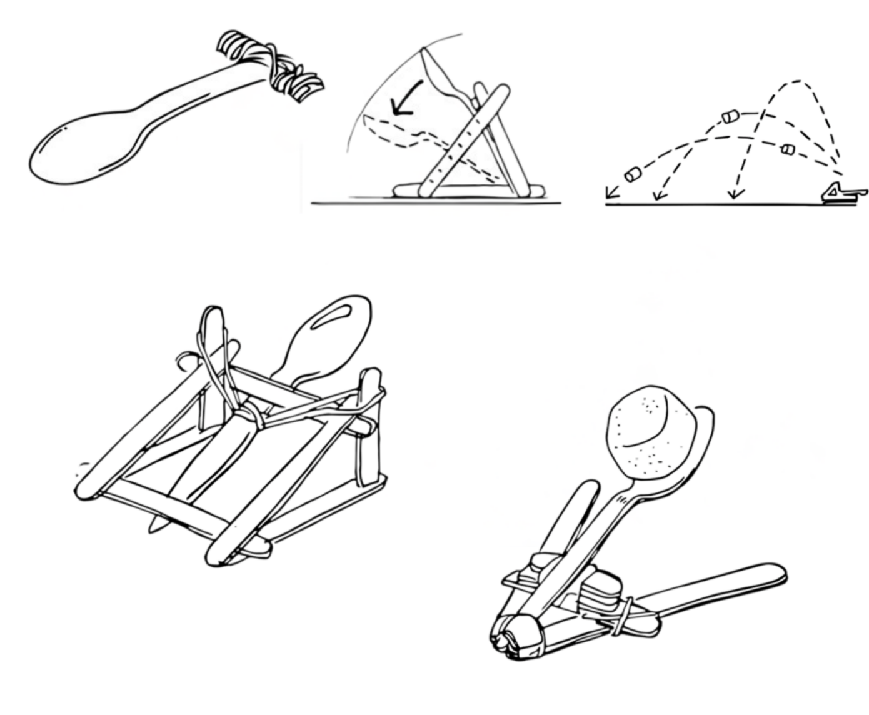

Resources required
- Plastic spoon
- Craft sticks
- Rubber bands
- Masking tape
- Scissors
- Marshmallow, cotton balls or some suitable projectiles
- Materials for a target, for example, card, markers, string, tape
- Video: Right On Target (1:31)

Learning intentions and success criteria
In this challenge, you will construct a catapult and carry out a valid investigation. You will identify variables, conduct fair tests and collect data to analyse the results.
Table 1 – syllabus outcomes, learning intentions and success criteria
Syllabus outcomes | Learning intentions and success criteria
SC4-WS-07  identifies problem-solving strategies and proposes solutions  SC4-WS-03  plans safe and valid investigations  MA4-PRO-C-01  solves problems involving the probabilities of simple chance experiments | We are learning to:  - design and improve a spoon catapult to achieve repeatable outcomes  - plan and conduct a valid investigation using a spoon catapult and a target  - use probability data to evaluate how successful a design is.  We can:  - test the catapult design, analyse the results and make changes to improve accuracy  - conduct a valid investigation by controlling variables  - calculate and interpret basic probabilities using data.

Spoon catapult terms
To assist with your understanding of the task, read through the following terms in the table below and complete the reflection to check for understanding of the terms.
Table 2 – key terms
Term | Definition
catapult | A device used to launch objects a distance by storing and releasing energy.
fulcrum | The pivot point around which a lever turns.
projectile | An object that is thrown, launched or fired through the air.
accuracy | How close a result or measurement is to the true or intended value.
precision | How consistently a result or measurement can be repeated.
variable | Something that can change or be changed in an experiment or design.
Write ‘T’ for true or ‘F’ for false.
- A ‘catapult’ stores and releases energy to launch a projectile. (__.)
- A ‘fulcrum’ is the pivot point around which a lever turns. (__.)
- A ‘projectile’ is any object that stays completely still when thrown. (__.)
- A ‘variable’ is something that cannot change in an experiment. (__.)
- ‘Accuracy’ is how close a result is to the true or intended value. (__.)
- ‘Precision’ means results can never be repeated. (__.)

Criteria for success
Your catapult must meet the following requirements:
- launch the projectile
- reliably hit the target.

Directions to students
Step 1: construction of catapult and target (20 minutes)
- Complete the reflection to check for understanding of the key terms.
- Watch the video Right On Target (1:31).
- Build a catapult using the instructions and the pictures on page 1 (students can change the design following the first launch).
- Wrap a rubber band around one end of 2 craft sticks that are stacked on top of each other, approximately 1 cm from the end.
- Wrap 2 rubber bands around 5 stacked craft sticks.
- Open the 2 joined craft sticks and wedge the stack in between to form a ‘T’ shape. The stack of craft sticks will be the pivot point, also known as the ‘fulcrum’ (the catapult can also be made using the can as a base).
- Secure the spoon to the upper craft stick with a rubber band. The combined upper craft stick and spoon will be the arm (or lever) of the catapult that can flex over the fulcrum when a force is applied.
- To test your catapult, place the projectile (marshmallow, cotton ball or some similar small object) onto the spoon. Hold the T-shape frame in place and push down on the upper craft stick and spoon. Caution: pushing only on the tip of the spoon may cause it to break.
- Release the upper craft stick (and spoon) and let it fling the projectile forward.
- Design a target that has 6 concentric circles with Points 1 to 6 assigned to each circle.
Step 2: conduct experiment (15 minutes)
- Aim the catapult at the target and launch the projectile.
- Refine your design to improve accuracy.
- Launch the catapult 10 times and record each result in the table below (see Table 3).

Data collection
Use the table below to record how many times your catapult hits the target and the total points you scored.
Table 3 – data collection for spoon catapult
Attempts | Hit target (Yes or No) | Points hit on target
1
2
3
4
5
6
7
8
9
10
Total times the target was hit: __ out of 10
Total points scored: __

Reflection
Identify 3 variables that you kept the same while conducting the 10 projectile launches experiment: __________________, ___________________ and ________________.
Identify one variable you changed during the launches:
Describe what effect changing this variable had on your ability to hit the target with the projectile:
How accurate was your spoon catapult? Use the data you collected to support your response:
Describe how could you plan the 10 attempts to make a fairer accuracy test:

References
This resource contains NSW Curriculum and syllabus content. The NSW Curriculum is developed by the NSW Education Standards Authority (NESA). This content is prepared by NESA for and on behalf of the Crown in right of the State of New South Wales. The material is protected by Crown copyright.
Please refer to the NESA Copyright Disclaimer for more information https://www.nsw.gov.au/education-and-training/nesa/copyright.
NESA holds the only official and up-to-date versions of the NSW Curriculum and syllabus documents. Please visit NESA https://www.nsw.gov.au/education-and-training/nesa and NSW Curriculum https://curriculum.nsw.edu.au.
Science 7–10 Syllabus © NSW Education Standards Authority (NESA) for and on behalf of the Crown in right of the State of New South Wales, 2023.
Mathematics K–10 Syllabus © NSW Education Standards Authority (NESA) for and on behalf of the Crown in right of the State of New South Wales, 2022.
Teach Engineering (19 July 2017) ‘Right on target’ [video], Teach Engineering, YouTube, accessed 2December 2025.

© State of New South Wales (Department of Education), 2026
The copyright material published in this resource is subject to the Copyright Act 1968 (Cth) and is owned by the NSW Department of Education or, where indicated, by a party other than the NSW Department of Education (third-party material).
Copyright material available in this resource and owned by the NSW Department of Education is licensed under a Creative Commons Attribution 4.0 International (CC BY 4.0) license.

This license allows you to share and adapt the material for any purpose, even commercially.
Attribution should be given to © State of New South Wales (Department of Education), 2026.
Material in this resource not available under a Creative Commons license:
- the NSW Department of Education logo, other logos and trademark-protected material
- material owned by a third party that has been reproduced with permission. You will need to obtain permission from the third party to reuse its material.
Links to third-party material and websites
Please note that the provided (reading/viewing material/list/links/texts) are a suggestion only and implies no endorsement, by the New South Wales Department of Education, of any author, publisher, or book title. School principals and teachers are best placed to assess the suitability of resources that would complement the curriculum and reflect the needs and interests of their students.
If you use the links provided in this document to access a third-party's website, you acknowledge that the terms of use, including licence terms set out on the third-party's website apply to the use which may be made of the materials on that third-party website or where permitted by the Copyright Act 1968 (Cth). The department accepts no responsibility for content on third-party websites.

