STEM Stage 4 – Olympiad

Challenge 6 – build a boat
In this challenge, you will construct a boat using the resources listed below that can support the largest mass before it breaks or sinks.
Figure 1 – illustration of build a boat activity
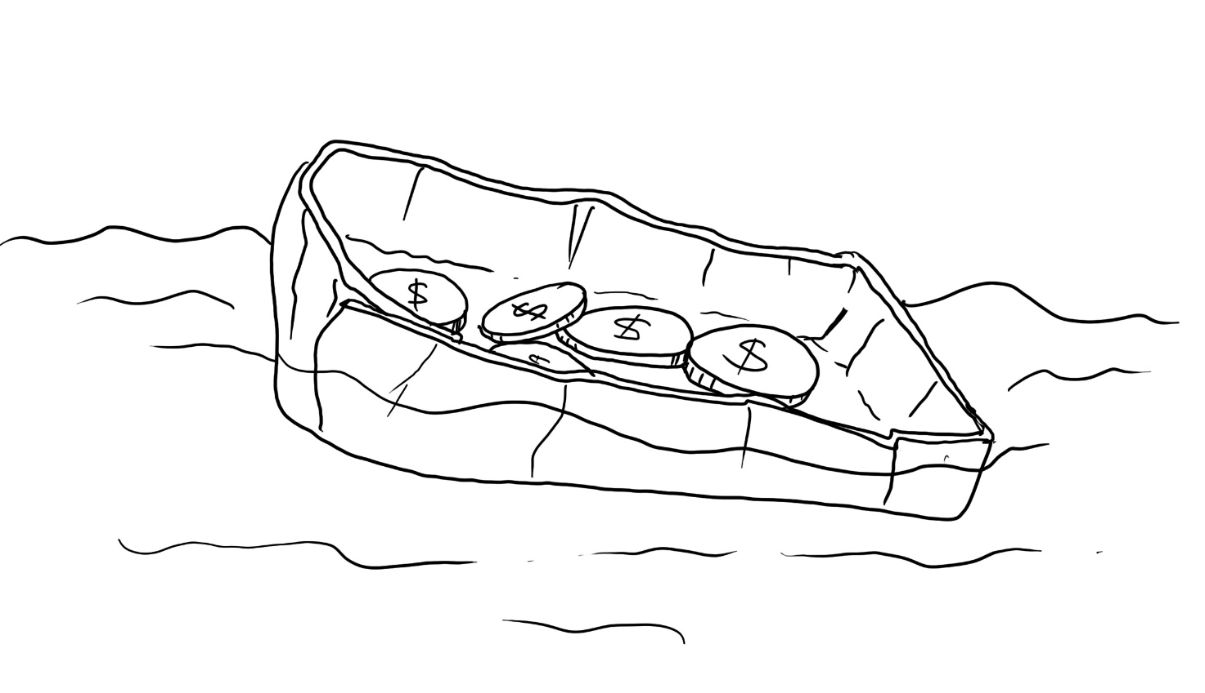

Resources required
- 2 sheets of aluminium foil (30 cm × 30 cm)
- Scissors
- Measuring devices, for example, rules, rulers or tape measures
- Tub or sink to fill with water
- Video: How Do Ships Float? | Things Explained: Buoyancy (2:17)
- Coins, washers, nuts or small weights.

Learning intentions and success criteria
In this challenge, you will design, build, and test an aluminium foil boat to investigate how the volume affects the amount of weight it can hold.
Table 1 – syllabus outcomes, Learning intentions and success criteria
Syllabus outcomes | Learning intentions and success criteria
SC4-WS-06  uses data to identify trends, patterns and relationships, and draw conclusions  MA4-ARE-C-01  applies knowledge of area and composite area involving triangles, quadrilaterals and circles to solve problems  MA4-VOL-C-01  applies knowledge of volume and capacity to solve problems involving right prisms and cylinders | We are learning to:  - understand how the shape of an object can affect its buoyancy  - accurately take measurements using appropriate tools  - conduct a scientific investigation.  We can:  - describe why certain shapes hold more mass  - calculate the volume of the boat  - evaluate and refine designs to improve carrying capacity.

Build a boat terms
To assist with your understanding of the task, read through the following terms in the table below and complete the reflection to check for understanding of the terms.
Table 2 – key terms
Term | Definition
area | The amount of surface a shape or object covers.
volume | The amount of space an object occupies.
mass | The measure of the amount of matter (or ‘stuff’) contained in an object.
displacement | The amount of fluid that gets pushed aside when an object is placed in it.
buoyancy | The tendency of an object to rise upward or float in a fluid.
Write ‘T’ for true or ‘F’ for false.
- ‘Area’ is the amount of surface a shape or object covers. (__.)
- ‘Volume’ is how heavy an object is. (__.)
- ‘Buoyancy’ is the upward force that makes objects float in a fluid. (__.)

Criteria for success
Your boat must meet the following requirements:
- be constructed out of a 30 cm × 30 cm piece of aluminium foil
- float on water
- be able to support at least one weight
- be able to calculate its volume.

Directions to students
Step 1: research and construction (15 minutes)
- Access the video How Do Ships Float? | Things Explained: Buoyancy (2:17) by GPB Education.
- Complete the reflection to check for understanding of the key terms.
- Construct a boat using a 30 cm × 30 cm piece of aluminium foil. You may fold, shape or mould it to create your vessel. No additional materials can be used for the structure.
- Ensure your vessel is open at the top and can float in water. You may pinch or fold the edges to strengthen it.
Step 2: conducting experiment (15 minutes)
- Measure the length, width and height of your boat.
- Calculate its volume by multiplying the length, width and height together.
- Test your boat by gently placing it in a container of water and observing if it floats.
- Add masses (coins, washers or small objects) gradually until the boat sinks.
- Record the total weight the boat supported before it sank.
Table 3 – calculating volume of boat
Attempt | Length (cm) | Width (cm) | Height (cm) | Volume (cm3) | Weight the boat holds (grams)
1
2
Step 3: changing boat volume (10 minutes)
- Create a new boat with a different volume.
- Test the new boat design using previous steps.
- Record the information in table above.

Evidence of completion
In the space provided below, draw a pencil sketch or insert a digital image, if required.
First boat design
Second boat design

Reflection
Write your own reflection of how your aluminium foil boat performed. Use your recorded measurements and results to support your response.
Use the following questions to assist in collecting your thoughts:
- What did you notice from the data?
- What is the relationship between a boat’s volume and the amount it can hold?
- If you were to repeat the test, what would you change to improve the next design?
In the first design I observed that the boat failed when:
In Design 2, I reduced the chances of this occurring by:
This change was (successful or unsuccessful) because:
From my observations and the data gathered in the experiment, I also noticed that:
If I repeated the experiment, I would ensure that ________________________________________
_____________________________, as this would allow me to ____________________________
______________________________________________________________________________.

References
This resource contains NSW Curriculum and syllabus content. The NSW Curriculum is developed by the NSW Education Standards Authority (NESA). This content is prepared by NESA for and on behalf of the Crown in right of the State of New South Wales. The material is protected by Crown copyright.
Please refer to the NESA Copyright Disclaimer for more information https://www.nsw.gov.au/education-and-training/nesa/copyright.
NESA holds the only official and up-to-date versions of the NSW Curriculum and syllabus documents. Please visit NESA https://www.nsw.gov.au/education-and-training/nesa and NSW Curriculum https://curriculum.nsw.edu.au.
Mathematics K–10 Syllabus © NSW Education Standards Authority (NESA) for and on behalf of the Crown in right of the State of New South Wales, 2022.
GPB Education (7 December 2017) ‘How Do Ships Float? | Things Explained Buoyancy’ [video], GPB Education, YouTube, accessed 17 November 2025.

© State of New South Wales (Department of Education), 2026
The copyright material published in this resource is subject to the Copyright Act 1968 (Cth) and is owned by the NSW Department of Education or, where indicated, by a party other than the NSW Department of Education (third-party material).
Copyright material available in this resource and owned by the NSW Department of Education is licensed under a Creative Commons Attribution 4.0 International (CC BY 4.0) license.

This license allows you to share and adapt the material for any purpose, even commercially.
Attribution should be given to © State of New South Wales (Department of Education), 2026.
Material in this resource not available under a Creative Commons license:
- the NSW Department of Education logo, other logos and trademark-protected material
- material owned by a third party that has been reproduced with permission. You will need to obtain permission from the third party to reuse its material.
Links to third-party material and websites
Please note that the provided (reading/viewing material/list/links/texts) are a suggestion only and implies no endorsement, by the New South Wales Department of Education, of any author, publisher, or book title. School principals and teachers are best placed to assess the suitability of resources that would complement the curriculum and reflect the needs and interests of their students.
If you use the links provided in this document to access a third-party's website, you acknowledge that the terms of use, including licence terms set out on the third-party's website apply to the use which may be made of the materials on that third-party website or where permitted by the Copyright Act 1968 (Cth). The department accepts no responsibility for content on third-party websites.

