STEM Stage 4 – Olympiad

Challenge 5 – paper gyrocopter
In this challenge, you will construct a gyrocopter with the slowest glide rate using the resources listed below. This challenge is inspired by how gyrocopters use a free spinning rotor as a wing during flight.
Figure 1 – constructing a paper gyrocopter
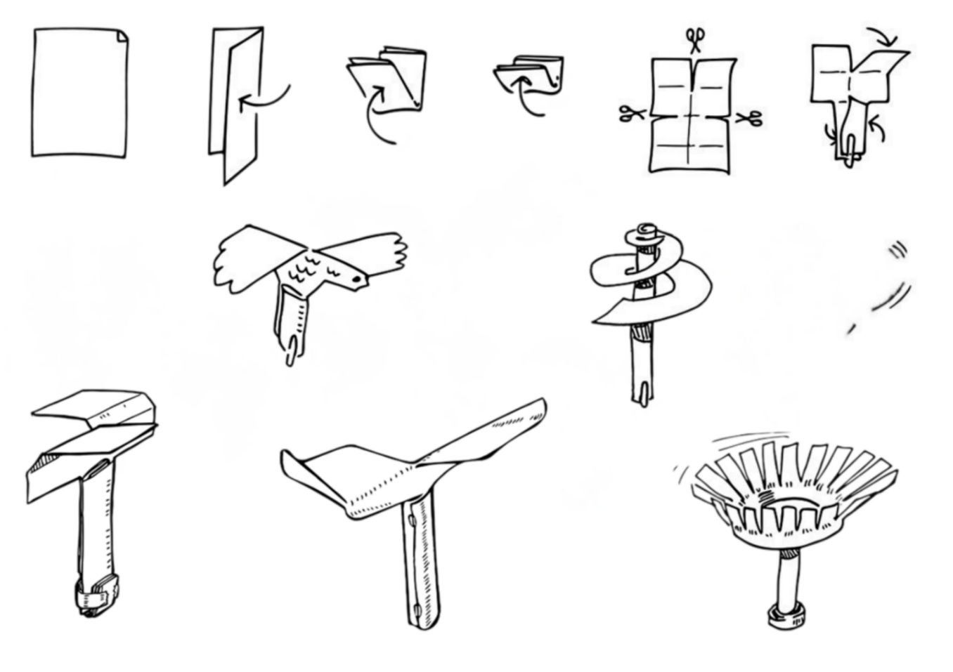

Resources required
- A4 paper
- Scissors
- Stopwatch
- Measuring devices, for example, rules, rulers or tape measures
- Sticky tape
- Paper clip

Learning intentions and success criteria
In this challenge, you will design, build and test a paper gyrocopter.
Table 1 – syllabus outcomes learning intentions and success criteria
Syllabus outcomes | Learning intentions and success criteria
SCLS-FOR-01  recognises forces in everyday contexts  TE4-DES-01  communicates and evaluates design ideas and solutions  MA4-DAT-C-02  analyses simple datasets using measures of centre, range and shape of the data | We are learning to:  - conduct a consistent and valid investigation  - distinguish different forces related to bodies in motion  - accurately record results.  We can:  - follow a scientific procedure to conduct an investigation  - identify the forces acting on bodies in motion  - calculate the average fall time of the paper gyrocopter.

Paper gyrocopter terms
To assist with your understanding of the task, read through the following terms in the table below and complete the reflection to check for understanding of the key terms.
Table 2 – key terms
Term | Definition
gyrocopter | A small aircraft that uses a freely spinning rotor to lift off and fly.
rotor | The spinning part of an aircraft or helicopter that creates lift.
glide rate | How fast or far an aircraft moves forward while descending without engine power.
rotate | To turn or spin around an axis.
arrest | To stop or slow down something quickly.
fuselage | The main body of an aircraft that holds the passengers and cargo.
Write ‘T’ for true or ‘F’ for false.
- The ‘fuselage’ is the main body of an aircraft that holds passengers and cargo. (__.)
- A ‘rotor’ is a stationary part of an aircraft that does not create lift. (__.)
- A ‘gyrocopter’ is a small aircraft that uses a freely spinning rotor to lift off and fly. (__.)
- ‘Glide rate’ is how fast an aircraft moves upward while climbing. (__.)

Criteria for success
Your gyrocopter must meet the following requirements:
- survive 10 drops, showing consistent rotation and gliding
- use the correct method to calculate the average fall time.

Directions to students
Step 1: creating a gyrocopter (15 minutes)
- Complete the reflection to check for understanding of the key terms.
- Construct a paper gyrocopter. Refer to the images on first page for inspiration.
- Fold the A4 paper in half lengthways, then fold it in half, widthways, twice.
- Unfold the paper.
- Use the scissors to cut halfway down along the centre lengthways fold.
- Cut along the widthways fold, one-quarter from each side.
- Create the gyrocopter fuselage by folding each of the bottom panels towards the horizontal centre fold line, each on an opposite side.
- Create the rotors by folding the 2 top-quarter panels down at the vertical centre fold line, in opposite directions.
Step 2: testing (10 minutes)
- Test your gyrocopter’s ability to glide by dropping it from your outstretched arm as high as you can reach. It is unlikely to rotate, as the fuselage is not heavy enough.
- Add weight by experimenting with additional small folds in the bottom of the fuselage.
- Adjust the design until the gyrocopter spins to arrest the fall as much as possible. This can be done by:
- changing the length of the rotor arms
- slightly bending the rotor arms
- changing the weight or length of the fuselage.
Step 3: conducting experiment (15 minutes)
- Use a tape measure to measure 1.5 metres from the ground.
- Practise dropping your paper gyrocopter from 1.5 metres high and timing how long it takes to reach the ground.
- Record the time it took in the data collection table (see Table 3).
- Repeat the drop test 10 times.

Data collection
Use this table to record your test times and calculate the average time taken for the paper gyrocopter to fall.
Table 3 – paper gyrocopter data collection
Test Number | Time (seconds)
Test 1
Test 2
Test 3
Test 4
Test 5
Test 6
Test 7
Test 8
Test 9
Test 10
Table 4 – paper gyrocopter data summary
Sum of all tests
Sum of tests ÷ 10
Average time

Reflection
Complete the reflection activity by filling in the blanks.
Average fall time: __ seconds
Fastest drop: __ seconds
Slowest drop: __ seconds
Did your gyrocopter behave the same way each time? (tick one)
☐ Yes, it was very consistent.
☐ Mostly consistent.
☐ No, it varied a lot.
Describe how changing these design features affected performance:
The rotor:
The fuselage:
The shape of the gyrocopter helped it glide or rotate because:
Using the information you have entered, complete the scaffolded evaluation of the challenge.
Using my results from the gyrocopter experiment, I noticed that:
The performance of my gyrocopter was mostly affected by:
If I were to complete the challenge again, I would:
This would allow:

References
This resource contains NSW Curriculum and syllabus content. The NSW Curriculum is developed by the NSW Education Standards Authority (NESA). This content is prepared by NESA for and on behalf of the Crown in right of the State of New South Wales. The material is protected by Crown copyright.
Please refer to the NESA Copyright Disclaimer for more information https://www.nsw.gov.au/education-and-training/nesa/copyright.
NESA holds the only official and up-to-date versions of the NSW Curriculum and syllabus documents. Please visit NESA https://www.nsw.gov.au/education-and-training/nesa and NSW Curriculum https://curriculum.nsw.edu.au.
Science Years 7–10 Syllabus © NSW Education Standards Authority (NESA) for and on behalf of the Crown in right of the State of New South Wales, 2023.
Technology Years 7–8 Syllabus © NSW Education Standards Authority (NESA) for and on behalf of the Crown in right of the State of New South Wales, 2023.

© State of New South Wales (Department of Education), 2026
The copyright material published in this resource is subject to the Copyright Act 1968 (Cth) and is owned by the NSW Department of Education or, where indicated, by a party other than the NSW Department of Education (third-party material).
Copyright material available in this resource and owned by the NSW Department of Education is licensed under a Creative Commons Attribution 4.0 International (CC BY 4.0) license.

This license allows you to share and adapt the material for any purpose, even commercially.
Attribution should be given to © State of New South Wales (Department of Education), 2026.
Material in this resource not available under a Creative Commons license:
- the NSW Department of Education logo, other logos and trademark-protected material
- material owned by a third party that has been reproduced with permission. You will need to obtain permission from the third party to reuse its material.
Links to third-party material and websites
Please note that the provided (reading/viewing material/list/links/texts) are a suggestion only and implies no endorsement, by the New South Wales Department of Education, of any author, publisher, or book title. School principals and teachers are best placed to assess the suitability of resources that would complement the curriculum and reflect the needs and interests of their students.
If you use the links provided in this document to access a third-party's website, you acknowledge that the terms of use, including licence terms set out on the third-party's website apply to the use which may be made of the materials on that third-party website or where permitted by the Copyright Act 1968 (Cth). The department accepts no responsibility for content on third-party websites.

