STEM Stage 4 – Olympiad

Challenge 3 – straw water tower
In this challenge, you will design and build the most cost-effective tower. Your tower must support the load at least 200 mm above the ground. You may only use the resources provided and you will have to calculate a budget for the project.
Figure 1 – illustration of straw water tower activity
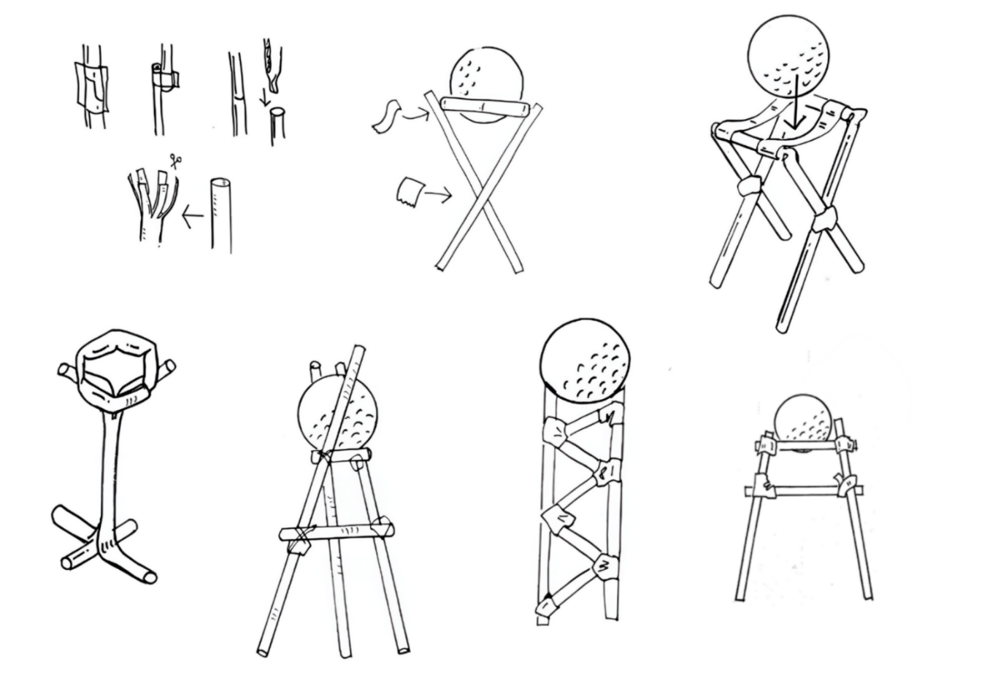

Resources required
- Drinking straws
- Craft sticks
- Pipe-cleaners
- A4 paper
- Sticky notes
- Sticky tape or masking tape
- Rulers
- Elastic bands
- A golf ball or similar

Learning intentions and success criteria
In this challenge, you will learn how to manage resources and budgets when designing.
Table 1 – syllabus outcomes, learning intentions and success criteria
Syllabus outcomes | Learning intentions and success criteria
SC4-WS-07  identifies problem-solving strategies and proposes solutions  TE4-DES-01  communicates and evaluates design ideas and solutions  TE4-PPM-01  applies processes in the planning, management and production of projects | We are learning to:  - produce a prototype to meet specific criteria  - plan and manage resources  - complete a project budget.  We can:  - construct a tower using limited resources  - use a table to calculate material cost  - calculate a running total in a budget.

Straw water tower terms
To assist with your understanding of the task, read through the following terms in the table below and complete the reflection to check for understanding of the terms.
Table 2 – key terms
Term | Definition
tower | A tall structure designed to stand upright and often carry weight or equipment.
truss | A framework of triangles used to make structures strong and stable.
vertical | A direction that goes straight up and down at a right angle to the ground.
member | An individual part of a structure, like a beam, brace or column.
budget | The amount of money available to design, build or complete a project.
load | The weight or force that a structure must carry or support.
compression | A force that squeezes or pushes materials together.
Write ‘T’ for true or ‘F’ for false.
- ‘Vertical’ is a direction straight up and down at a right angle to the ground. (__.)
- A ‘member’ is an individual part of a structure like a beam, brace, or column. (__.)
- A ‘truss’ is a framework of triangles that makes a structure strong and stable. (__.)
- A ‘tower’ is a tall structure that stands upright and can carry weight or equipment. (__.)
- A ‘load’ is the weight or force a structure must carry or support. (__.)
- A ‘budget’ is the amount of money available to design or build a project. (__.)
- ‘Compression’ is a force that squeezes or pushes materials together. (__.)

Criteria for success
Your tower must meet the following requirements:
- be freestanding
- support the load at least 200 mm from the table’s surface
- not be secured to the table’s surface
- use only the materials provided in the costing table.

Directions to students
Step 1: research and planning (15 minutes)
- Complete the reflection to check for understanding of the key terms.
- Design a tower that holds a golf ball 200 mm above the surface of the table.
- Capture evidence of design as a digital photo or pencil sketch.
- Annotate your design by clearly identifying each material used in the tower.
Step 2: construction and testing (15 minutes)
- Using your annotated drawing as a guide, construct your tower.
- Test that the tower can support a golf ball that is 200 mm above the table’s surface.

Material costing
Step 3: costing calculations (10 minutes)
- Use the prices for each material to assist in calculating your tower design.
- Write how many of each material you used in the quantity column.
- Multiply the quantity by the price to calculate the total cost for that material.
- Add all the individual total costs together to work out the overall cost of your tower.
Table 3 – material costing table
Material | Quantity |  | Individual cost ($) |  | Total cost ($)
drinking straws |  | × | $2.00 each | =
pipe-cleaners |  | × | $3.00 each | =
craft sticks |  | × | $5.00 each | =
sticky notes |  | × | $0.50 each | =
A4 paper |  | × | $5.00 each | =
sticky tape |  | × | $6.00 per 100 mm | =
masking tape |  | × | $8.00 per 100 mm | =
elastic bands |  | × | $7.00 each | =
 |  |  | Overall cost

Reflection
Complete the reflection by filling in the blanks and selecting the options that apply to your experience.
Using the costing table helped me to calculate my budget because it showed me the cost of each material. I decided to use ____________________ and ____________________ because they were (tick one):
☐ the cheapest options.
☐ strong for their price.
☐ easy to work with.
When I evaluated my choices, I realised that I could have improved my design by changing ____________________ because it was (tick one):
☐ too expensive.
☐ not strong enough.
☐ difficult to attach.
☐ not the best value for what it added.
The costing table also helped me to avoid going over my budget, as I could see that ____________________ was too costly for what it offered. Overall, the costing table made it easier to plan because it helped me (tick all that apply):
☐ compare materials.
☐ make choices that fitted my design idea.
☐ keep track of what I used.
☐ adjust my design before building.
This resulted in my final tower costing ____________________.

References
This resource contains NSW Curriculum and syllabus content. The NSW Curriculum is developed by the NSW Education Standards Authority (NESA). This content is prepared by NESA for and on behalf of the Crown in right of the State of New South Wales. The material is protected by Crown copyright.
Please refer to the NESA Copyright Disclaimer for more information https://www.nsw.gov.au/education-and-training/nesa/copyright.
NESA holds the only official and up-to-date versions of the NSW Curriculum and syllabus documents. Please visit NESA https://www.nsw.gov.au/education-and-training/nesa and NSW Curriculum https://curriculum.nsw.edu.au.
Science Years 7–10 Syllabus © NSW Education Standards Authority (NESA) for and on behalf of the Crown in right of the State of New South Wales, 2023.
Technology Years 7–8 Syllabus © NSW Education Standards Authority (NESA) for and on behalf of the Crown in right of the State of New South Wales, 2023.

© State of New South Wales (Department of Education), 2026
The copyright material published in this resource is subject to the Copyright Act 1968 (Cth) and is owned by the NSW Department of Education or, where indicated, by a party other than the NSW Department of Education (third-party material).
Copyright material available in this resource and owned by the NSW Department of Education is licensed under a Creative Commons Attribution 4.0 International (CC BY 4.0) license.

This license allows you to share and adapt the material for any purpose, even commercially.
Attribution should be given to © State of New South Wales (Department of Education), 2026.
Material in this resource not available under a Creative Commons license:
- the NSW Department of Education logo, other logos and trademark-protected material
- material owned by a third party that has been reproduced with permission. You will need to obtain permission from the third party to reuse its material.
Links to third-party material and websites
Please note that the provided (reading/viewing material/list/links/texts) are a suggestion only and implies no endorsement, by the New South Wales Department of Education, of any author, publisher, or book title. School principals and teachers are best placed to assess the suitability of resources that would complement the curriculum and reflect the needs and interests of their students.
If you use the links provided in this document to access a third-party's website, you acknowledge that the terms of use, including licence terms set out on the third-party's website apply to the use which may be made of the materials on that third-party website or where permitted by the Copyright Act 1968 (Cth). The department accepts no responsibility for content on third-party websites.

