STEM Stage 4 – Olympiad

Challenge 2 – paper bridge
In this challenge, you will construct a bridge that supports the largest load possible using only the resources listed below.
Figure 1 – illustration of paper bridge activity
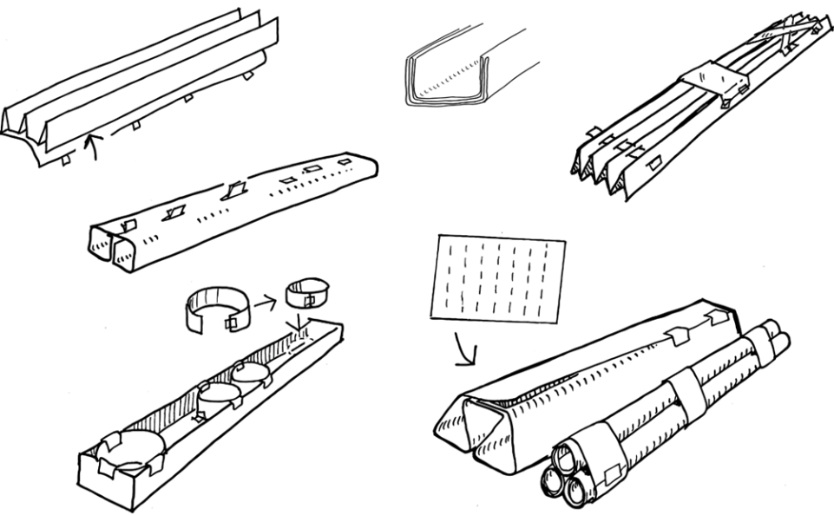

Resources required
- 1 sheet of A4 paper
- Measuring devices, for example, rules, rulers or tape measures
- Scissors
- Masses, for example, baking beads, metal washers or coins of the same size
- Plastic cup to hold masses
- Video: Design a bridge (1:42)
- 100 mm of masking tape
- Measuring scales

Learning intentions and success criteria
In this challenge, you will learn to understand the design brief, experiment with materials and improve your solutions.
Table 1 – syllabus outcomes, learning intentions and success criteria
Syllabus outcomes | Learning intentions and success criteria
SC4-WS-07  identifies problem-solving strategies and proposes solutions  TE4-DES-01 communicates and evaluates design ideas and solutions  TE4-MSC-01  explains how materials, systems and components contribute to solutions | We are learning to:  - evaluate designed solutions  - understand a design brief  - experiment with material properties and structures.  We can:  - distinguish what criteria makes a design successful  - identify constraints within a design brief  - describe ways to use materials to improve structures.

Paper bridge terms
To assist with your understanding of the task, read through the following terms in the table below and complete the reflection to check for understanding of the terms.
Table 2 – key terms
Term | Definition
beam | A long, strong piece of material (like wood, steel or concrete) that supports weight across a span.
load | The weight or force that a structure must hold or carry.
pier | A vertical support or column that holds up a structure, such as a bridge or building.
brace | A support added to a structure to make it stronger and prevent it from bending or collapsing.
span | The distance between 2 supports of a structure, like the gap a bridge covers.
deflection | The amount a structure bends or moves when a load is applied.
Write ‘T’ for true or ‘F’ for false.
- A ‘pier’ is a vertical support that holds up a structure. (__.)
- A ‘beam’ is a long piece of material that supports weight across a space. (__.)
- A ‘brace’ is a support added to make a structure stronger and prevent bending. (__.)
- A ‘span’ is the distance between 2 supports of a structure. (__.)
- A ‘load’ is the weight or force that a structure must carry. (__.)
- ‘Deflection’ is the amount a structure bends or moves when a load is applied. (__.)

Criteria for success
Your bridge must meet the following requirements:
- be able to support the plastic cup and masses
- should not be secured to the piers
- should be constructed only from the provided paper and tape.

Directions to students
Step 1: research (15 minutes)
- Access the video Design a bridge (1:42) by ABC Education to discover what civil engineers must consider when building bridges.
- Complete the reflection to check for understanding of the key terms.
- Use the space provided below to sketch your paper bridge design to help guide your construction.

Step 2: construction and testing (15 minutes)
- Arrange desks 200 mm apart to function as bridge piers.
- Use the materials to construct a bridge beam that spans the 200 mm gap between the desks.
- Paper can be folded, twisted or rolled but must be able to support a plastic cup that holds the masses.
- The bridge must not be secured to the piers.
- Once constructed, balance the plastic cup on the bridge to hold the masses.
- Slowly load the bridge with masses.
- Load the bridge until it collapses or the structure is deemed a failure.
- Count the number of masses the bridge supported before it failed.
Step 3: record and reflect (10 minutes)
- Using a set of scales, record the weight of the masses that the bridge was able to hold.
- Record evidence of the design with a digital photo or pencil sketch.
- Complete the reflection activity.

Evidence of completion
Record the item used to test the bridge, the number of items used and the total weight the bridge supported in the results table below.
Table 3 – results table
Results
Item name
Number of items
Total weight supported

Reflection
Complete the reflection by filling in the blanks using the word bank below.
Table 4 – word bank
Word bank
stability | piers
beam | compression
tension | brace
span | load
deflection | truss
In this task, I designed a paper bridge that crossed a __________ of 200 mm between 2 desks which were acting as __________.
You constructed your __________ using the available paper, choosing to fold, roll or twist the material to improve __________.
While building the bridge, you observed areas of __________, where the paper stretched, and areas of __________, where the paper squashed.
When you added the plastic cup and began placing masses inside it, the __________ increased until the structure failed.
Before it collapsed, you noticed some __________ which showed how much the bridge bent under the load.
To make the design stronger next time, you could add a __________ or a small __________ to provide extra support and better manage forces on the structure.

References
This resource contains NSW Curriculum and syllabus content. The NSW Curriculum is developed by the NSW Education Standards Authority (NESA). This content is prepared by NESA for and on behalf of the Crown in right of the State of New South Wales. The material is protected by Crown copyright.
Please refer to the NESA Copyright Disclaimer for more information https://www.nsw.gov.au/education-and-training/nesa/copyright.
NESA holds the only official and up-to-date versions of the NSW Curriculum and syllabus documents. Please visit NESA https://www.nsw.gov.au/education-and-training/nesa and NSW Curriculum https://curriculum.nsw.edu.au.
Science Years 7–10 Syllabus © NSW Education Standards Authority (NESA) for and on behalf of the Crown in right of the State of New South Wales, 2023.
Technology Years 7–8 Syllabus © NSW Education Standards Authority (NESA) for and on behalf of the Crown in right of the State of New South Wales, 2023.
ABC (Australian Broadcasting Corporation) (13 July 2022) ‘Design a bridge’ [video], ABC Education, ABC website, accessed 20 November 2025.

© State of New South Wales (Department of Education), 2026
The copyright material published in this resource is subject to the Copyright Act 1968 (Cth) and is owned by the NSW Department of Education or, where indicated, by a party other than the NSW Department of Education (third-party material).
Copyright material available in this resource and owned by the NSW Department of Education is licensed under a Creative Commons Attribution 4.0 International (CC BY 4.0) license.

This license allows you to share and adapt the material for any purpose, even commercially.
Attribution should be given to © State of New South Wales (Department of Education), 2026.
Material in this resource not available under a Creative Commons license:
- the NSW Department of Education logo, other logos and trademark-protected material
- material owned by a third party that has been reproduced with permission. You will need to obtain permission from the third party to reuse its material.
Links to third-party material and websites
Please note that the provided (reading/viewing material/list/links/texts) are a suggestion only and implies no endorsement, by the New South Wales Department of Education, of any author, publisher, or book title. School principals and teachers are best placed to assess the suitability of resources that would complement the curriculum and reflect the needs and interests of their students.
If you use the links provided in this document to access a third-party's website, you acknowledge that the terms of use, including licence terms set out on the third-party's website apply to the use which may be made of the materials on that third-party website or where permitted by the Copyright Act 1968 (Cth). The department accepts no responsibility for content on third-party websites.

