STEM Stage 4 – Olympiad

Challenge 10 – marble maze
In this challenge, you will construct a marble maze, which has at least 5 obstacles, using the resources listed below that allows players to complete the maze in the fastest time.
Figure 1 – illustration of marble maze challenge
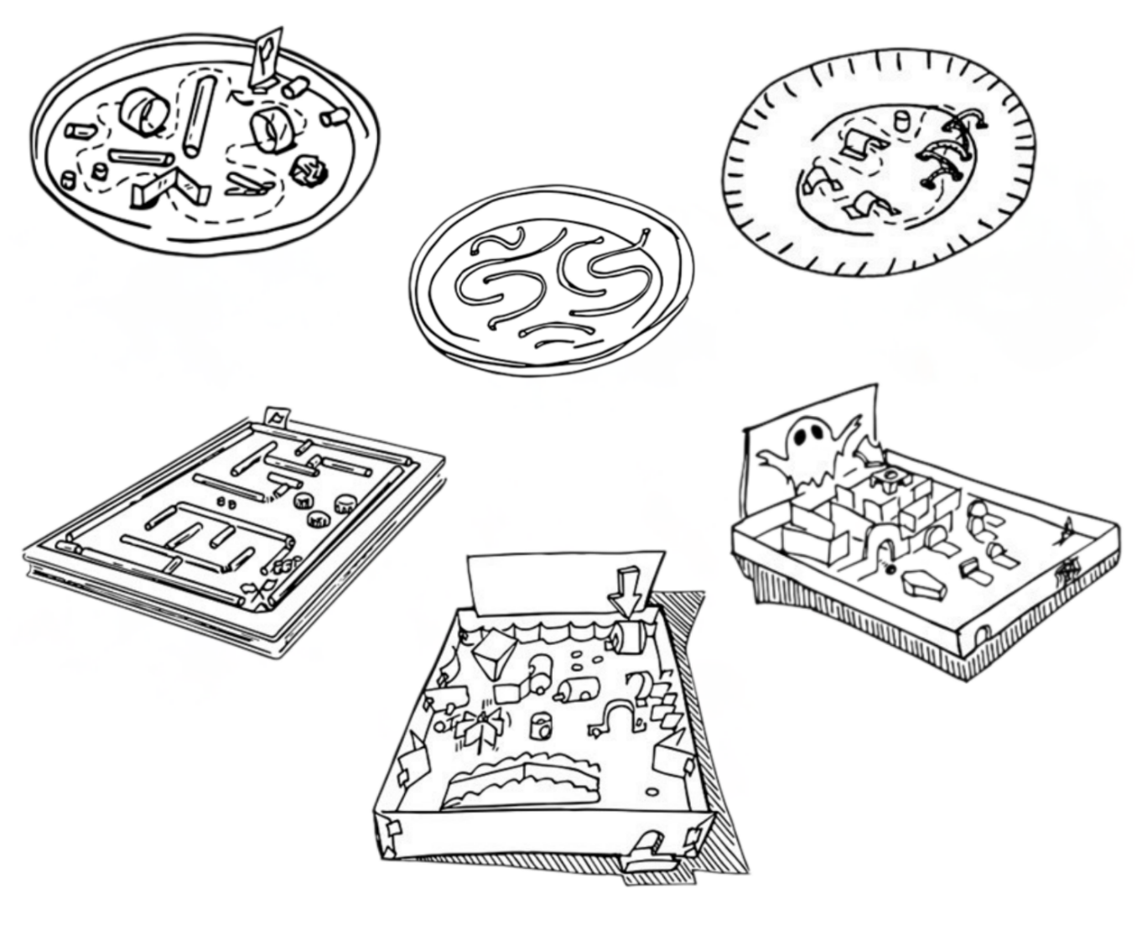

Resources required
- Cardboard
- Masking tape
- Scissors
- A marble

Optional resources
- Cardboard box or lid
- Straws, paper plates, craft sticks, PVC pipe or paper rolls

Learning intentions and success criteria
In this challenge, you will design, build and test a cardboard marble maze.
Table 1 – syllabus outcomes, learning intentions and success criteria
Syllabus outcomes | Learning intentions and success criteria
SC4-FOR-01  describes the effects of forces in everyday contexts  TE4-DES-01  communicates and evaluates design ideas and solutions | We are learning to:  - identify the effects of forces within different systems  - investigate different ways to reduce the kinetic energy of an object in motion  - communicate design ideas through sketching and annotation.  We can:  - describe how angle of incline and motion affect the speed of the marble  - describe how friction, angle of incline and collisions affect kinetic energy  - apply basic sketching skills to communicate our design.

Marble maze terms
To assist with your understanding of the task, read through the following terms in the table below and complete the reflection to check for understanding of the key terms.
Table 2 – key terms
Term | Definition
kinetic energy | The energy an object has because it is moving.
friction | The force that slows down or resists the movement of objects when they rub together.
acceleration | The rate at which an object’s speed or direction changes.
mass | How much matter is in an object.
force | A push or pull that can make an object move, stop or change direction.
collision | When 2 objects hit each other.
Write ‘T’ for true or ‘F’ for false.
- ‘Kinetic energy’ is the energy an object has because it is moving. (__.)
- ‘Acceleration’ is the rate at which an object’s speed or direction changes. (__.)
- ‘Force’ is a push or pull that can make an object move, stop or change direction. (__.)
- ‘Collision’ is when objects pass by each other without touching. (__.)

Criteria for success
The marble maze must meet the following requirements:
- include at least 5 challenging obstacles
- have a start and finish location

Directions to students
Step 1: designing the maze (10 minutes)
- Create the marble maze from a piece of rectangular cardboard or a shallow box, so the marble does not run off the sides.
- Sketch the maze layout directly onto the cardboard. Mark the starting point at the top and the finishing point at the bottom.
- Draw a pathway for the marble to follow and consider where the 5 obstacles will be positioned within the maze.
Step 2: construction (20 minutes)
- If using a flat piece of cardboard, add sides so that the marble will stay in the maze.
- Using your sketched layout, construct the maze by adding your 5 obstacles.
- Materials such as cardboard, paper rolls, straws, paper plates, craft sticks or PVC pipes can be useful at this stage.
Step 3: testing (10 minutes)
- Hold the cardboard maze with both hands. Have a peer drop the marble at the top of the maze. Make the marble travel from start to finish by tilting the maze in different directions.
- Record the time taken for the marble to travel through the maze in the table below (see Table 3).
Table 3 – data recording table for marble maze
Trial | Time (seconds)
Trial 1
Trial 2
Trial 3
Average time for completion: __

Challenge reflection
Complete the following reflection questions after you have used the marble maze.
- Explain how tilting the maze at different angles affected the speed of the marble.
When tilting the maze, the angle:
Describe 2 features of your maze that slowed the marble down.
The marble slowed down when:
Using the data from the recording table, evaluate how well the maze worked. Suggest one change that would improve the flow of the marble.

References
This resource contains NSW Curriculum and syllabus content. The NSW Curriculum is developed by the NSW Education Standards Authority (NESA). This content is prepared by NESA for and on behalf of the Crown in right of the State of New South Wales. The material is protected by Crown copyright.
Please refer to the NESA Copyright Disclaimer for more information https://www.nsw.gov.au/education-and-training/nesa/copyright.
NESA holds the only official and up-to-date versions of the NSW Curriculum and syllabus documents. Please visit NESA https://www.nsw.gov.au/education-and-training/nesa and NSW Curriculum https://curriculum.nsw.edu.au.
Science 7–10 Syllabus © NSW Education Standards Authority (NESA) for and on behalf of the Crown in right of the State of New South Wales, 2023.
Technology 7–8 Syllabus © NSW Education Standards Authority (NESA) for and on behalf of the Crown in right of the State of New South Wales, 2023.

© State of New South Wales (Department of Education), 2026
The copyright material published in this resource is subject to the Copyright Act 1968 (Cth) and is owned by the NSW Department of Education or, where indicated, by a party other than the NSW Department of Education (third-party material).
Copyright material available in this resource and owned by the NSW Department of Education is licensed under a Creative Commons Attribution 4.0 International (CC BY 4.0) license.

This license allows you to share and adapt the material for any purpose, even commercially.
Attribution should be given to © State of New South Wales (Department of Education), 2026.
Material in this resource not available under a Creative Commons license:
- the NSW Department of Education logo, other logos and trademark-protected material
- material owned by a third party that has been reproduced with permission. You will need to obtain permission from the third party to reuse its material.
Links to third-party material and websites
Please note that the provided (reading/viewing material/list/links/texts) are a suggestion only and implies no endorsement, by the New South Wales Department of Education, of any author, publisher, or book title. School principals and teachers are best placed to assess the suitability of resources that would complement the curriculum and reflect the needs and interests of their students.
If you use the links provided in this document to access a third-party's website, you acknowledge that the terms of use, including licence terms set out on the third-party's website apply to the use which may be made of the materials on that third-party website or where permitted by the Copyright Act 1968 (Cth). The department accepts no responsibility for content on third-party websites.

