STEM Stage 4 – Olympiad

Challenge 1 – slender tower
In this challenge, you will use iteration to build the tallest stable paper tower possible using the resources listed below.
Figure 1 – illustration of slender tower activity
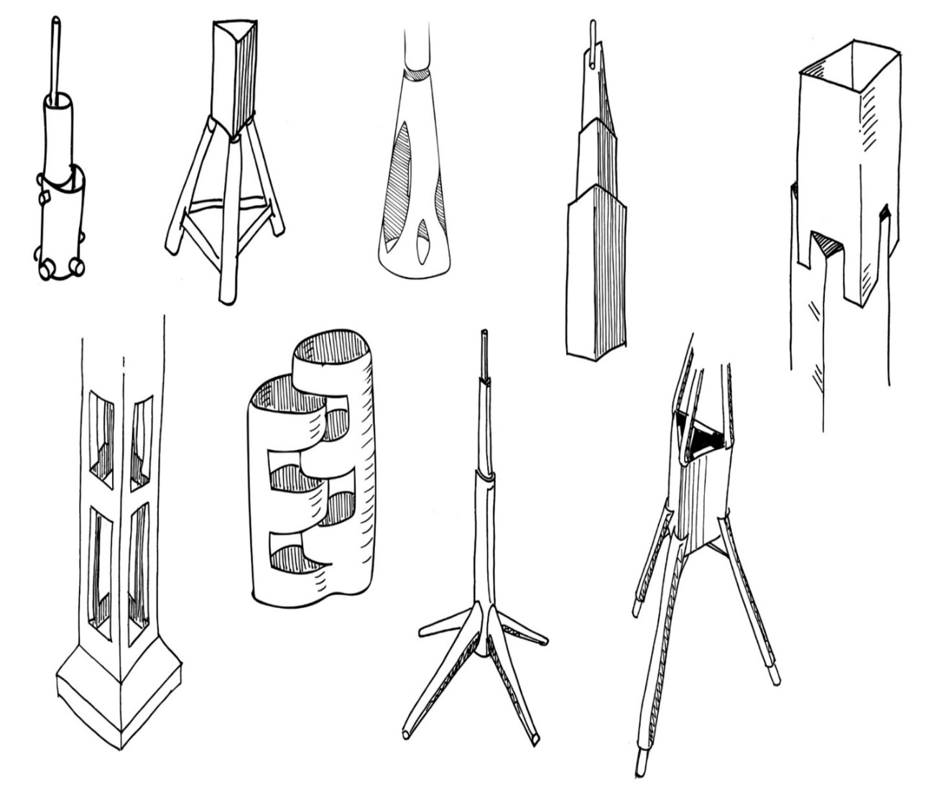

Resources required
- 10 sheets of A4 paper
- 300 mm of sticky tape
- Measuring devices, for example rules, rulers, tape measures
- Scissors
- Glue sticks

Learning intentions and success criteria
In this challenge, you learn to design, build, evaluate and improve a paper tower.
Table 1 – syllabus outcomes, learning intentions and success criteria
Syllabus outcomes | Learning intentions and success criteria
SC4-WS-07  identifies problem-solving strategies and proposes solutions  TE4-DES-01 communicates and evaluates design ideas and solutions | We are learning to:  - use a range of communication forms to express ideas  - build and test design solutions  - evaluate design solutions  - apply evaluations to improve design solutions.  We can:  - describe what makes a tower tall and stable  - share and explain design ideas  - use constrained resources to develop and test a slender tower  - describe what worked well and what could be done differently next time.

Slender tower terms
To assist with your understanding of the task, read through the following terms in the table below and complete the reflection to check for understanding of the terms.
Table 2 – key terms
Term | Definition
construct | To build or put together a structure, machine or system according to a plan or design.
tower | A tall, vertical structure designed to support loads, carry equipment or reach a height safely
footprint | The area on the ground that a structure or object covers.
evaluate | Make a judgement based on criteria or determine the value of.
freestanding | A structure that can stand on its own without being attached to anything else for support.
Write ‘T’ for true or ‘F’ for false.
- A ‘freestanding’ structure can stand on its own without attachments. (__.)
- The ‘footprint’ of a structure is the base area it takes up on the ground. (__.)
- To ‘evaluate’ a design means to check how well it works or meets requirements. (__.)

Criteria for success
Your tower must meet the following requirements:
- the tower is only to be constructed from the paper and tape provided
- the tower is freestanding (not secured to any surfaces)
- the tower is at least 300 mm in height.

Directions to students
Step 1: individually build your first tower (20 minutes)
- Within 10-minutes, construct the tallest tower possible from the supplied materials. Paper can be cut and folded.
- Ensure that the tower can stand for 30 seconds without falling over.
- Capture evidence of the design, either a digital photo or a pencil sketch in the space provided below.
- Record the standing height of the tower in millimetres.
Record the height of your tower (millimetres): __.
Step 2: reflect, evaluate and improve (5 minutes)
- Partner with the person beside you and spend 5 minutes evaluating both towers. Discuss the following questions
- How tall was your tower?
- How wide was the base and footprint?
- Where did it fail or wobble?
- How could you make the biggest improvements?
Step 3: iteration (15 minutes)
- With your partner, complete the task again, within a 10-minute time frame. In your second attempt, aim to achieve a greater height and address previous weaknesses.
- In the space provided below, draw a pencil sketch in the space below or insert a digital image if required.
Record the height of your second tower (millimetres): __.

Reflection
Complete the reflection by filling in the blanks using the word bank below.
Table 3 – word bank
Word bank
teamwork | taping carefully | straws
weight distribution | balancing the base | compression
tension | buckling | bending
triangular shapes | folding and rolling | cardboard
When building the tallest paper tower, it is important to work effectively with others. This is called __________.
To strengthen your building structure, you can reinforce paper by __________ or __________.
Ensuring the bottom of the tower is stable is called __________. This prevents the structure from falling over.
Proper __________ helps your tower stay upright even when more levels are added.
Triangular supports are strong because they resist __________ and __________ forces.
When a part of the tower bends under pressure, it may __________ or fail due to __________.
To connect parts of the tower, it is important to reinforce joints by __________.
Alternative materials that could be used in the future are ___________________ and ______________________. These provide a lightweight and rigid option for your tower.

References
This resource contains NSW Curriculum and syllabus content. The NSW Curriculum is developed by the NSW Education Standards Authority (NESA). This content is prepared by NESA for and on behalf of the Crown in right of the State of New South Wales. The material is protected by Crown copyright.
Please refer to the NESA Copyright Disclaimer for more information https://www.nsw.gov.au/education-and-training/nesa/copyright.
NESA holds the only official and up-to-date versions of the NSW Curriculum and syllabus documents. Please visit NESA https://www.nsw.gov.au/education-and-training/nesa and NSW Curriculum https://curriculum.nsw.edu.au.
Science Years 7–10 Syllabus © NSW Education Standards Authority (NESA) for and on behalf of the Crown in right of the State of New South Wales, 2023.
Technology Years 7–8 Syllabus © NSW Education Standards Authority (NESA) for and on behalf of the Crown in right of the State of New South Wales, 2023.

© State of New South Wales (Department of Education), 2026
The copyright material published in this resource is subject to the Copyright Act 1968 (Cth) and is owned by the NSW Department of Education or, where indicated, by a party other than the NSW Department of Education (third-party material).
Copyright material available in this resource and owned by the NSW Department of Education is licensed under a Creative Commons Attribution 4.0 International (CC BY 4.0) license.

This license allows you to share and adapt the material for any purpose, even commercially.
Attribution should be given to © State of New South Wales (Department of Education), 2026.
Material in this resource not available under a Creative Commons license:
- the NSW Department of Education logo, other logos and trademark-protected material
- material owned by a third party that has been reproduced with permission. You will need to obtain permission from the third party to reuse its material.
Links to third-party material and websites
Please note that the provided (reading/viewing material/list/links/texts) are a suggestion only and implies no endorsement, by the New South Wales Department of Education, of any author, publisher, or book title. School principals and teachers are best placed to assess the suitability of resources that would complement the curriculum and reflect the needs and interests of their students.
If you use the links provided in this document to access a third-party's website, you acknowledge that the terms of use, including licence terms set out on the third-party's website apply to the use which may be made of the materials on that third-party website or where permitted by the Copyright Act 1968 (Cth). The department accepts no responsibility for content on third-party websites.

