Clinical trials
Human clinical trials are primary investigations that test the efficacy of a treatment, procedure, drug, therapy or intervention in humans. The analysis of data collected in primary investigations is sometimes referred to as ‘primary data analysis’ or simply, ‘primary analysis’. Some trials focus on how people respond to a new intervention and what side effects might occur. They help to determine if the intervention works, is safe and is better than existing options. Researchers also use clinical trials to compare and improve interventions, explore new delivery methods, and observe responses to other factors.
Some clinical trials include a control arm, where participants with the same condition or similar characteristics receive a placebo or standard treatment instead of the experimental intervention, so their outcomes can be compared with those who received the experimental intervention.
To prevent bias, one or more groups in a clinical trial may be blinded, or not made aware of the treatment intervention being delivered.
Watch Investigative approaches: clinical trials (3:28) for more information.

Single-blinded clinical trials
A clinical trial where only the recipient or patient is blinded, or is not aware of the intervention, is called a ‘single-blinded clinical trial’.
Figure 1 – single-blinded clinical trial
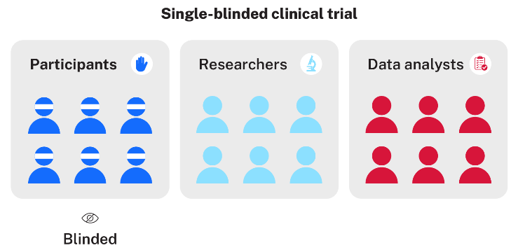

Double-blinded clinical trials
A clinical trial where both the recipient or patient and the investigator or researcher are blinded, is called a ‘double-blinded clinical trial’.
Figure 2 – double-blinded clinical trial
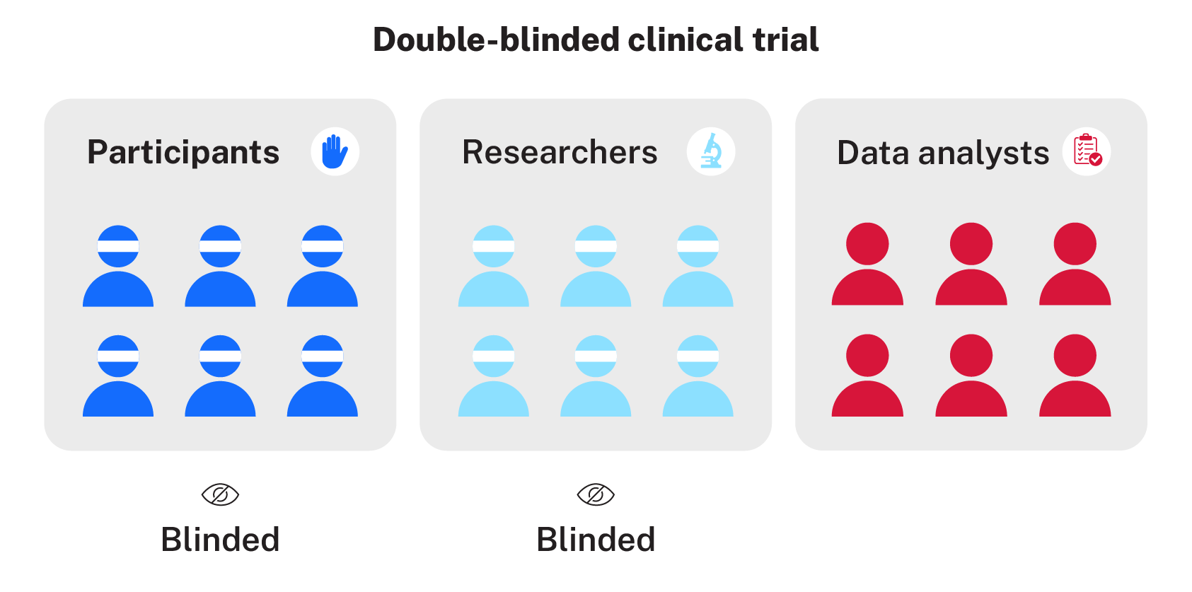

Triple-blinded clinical trials
A clinical trial where the recipient or patient, the investigator or researcher, and the data analysts are all blinded, is called a ‘triple-blinded clinical trial’.
Figure 3 – triple-blinded clinical trial
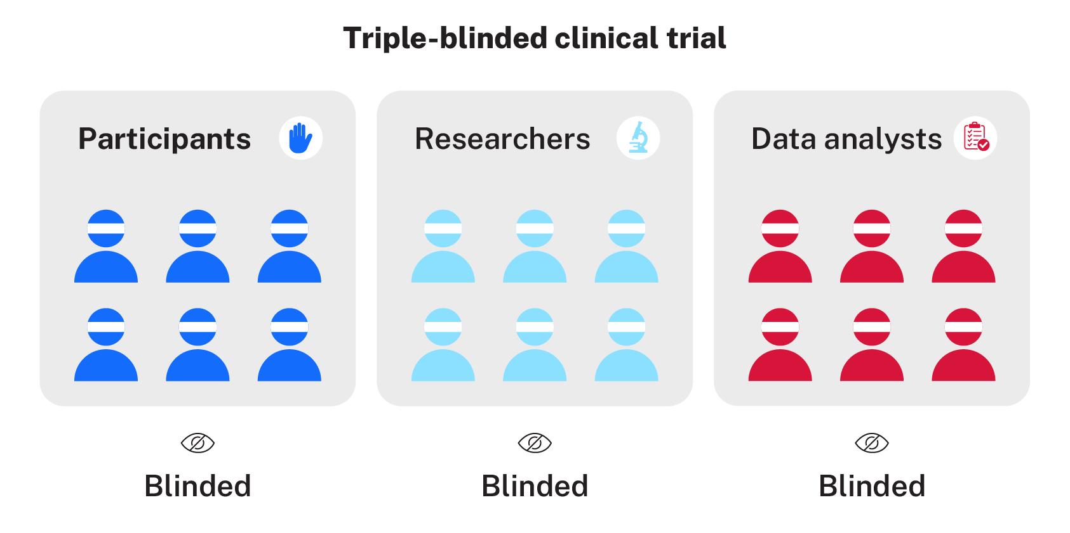

References
Australian Clinical Trials (2023) ‘What is a clinical trial?’, About clinical trials, Australian Clinical Trials website, accessed 29 January 2026.

© State of New South Wales (Department of Education), 2026
The copyright material published in this resource is subject to the Copyright Act 1968 (Cth) and is owned by the NSW Department of Education or, where indicated, by a party other than the NSW Department of Education (third-party material).
Copyright material available in this resource and owned by the NSW Department of Education is licensed under a Creative Commons Attribution 4.0 International (CC BY 4.0) license.

This license allows you to share and adapt the material for any purpose, even commercially.
Attribution should be given to © State of New South Wales (Department of Education), 2026.
Material in this resource not available under a Creative Commons license:
- the NSW Department of Education logo, other logos and trademark-protected material
- material owned by a third party that has been reproduced with permission. You will need to obtain permission from the third party to reuse its material.
Links to third-party material and websites
Please note that the provided (reading/viewing material/list/links/texts) are a suggestion only and implies no endorsement, by the New South Wales Department of Education, of any author, publisher, or book title. School principals and teachers are best placed to assess the suitability of resources that would complement the curriculum and reflect the needs and interests of their students.
If you use the links provided in this document to access a third-party's website, you acknowledge that the terms of use, including licence terms set out on the third-party's website apply to the use which may be made of the materials on that third-party website or where permitted by the Copyright Act 1968 (Cth). The department accepts no responsibility for content on third-party websites.

