Phases of clinical trials
Clinical trials are conducted in stages to test whether a new treatment is safe and effective before and after it is approved for public use.
Figure 1 – phases of clinical trials
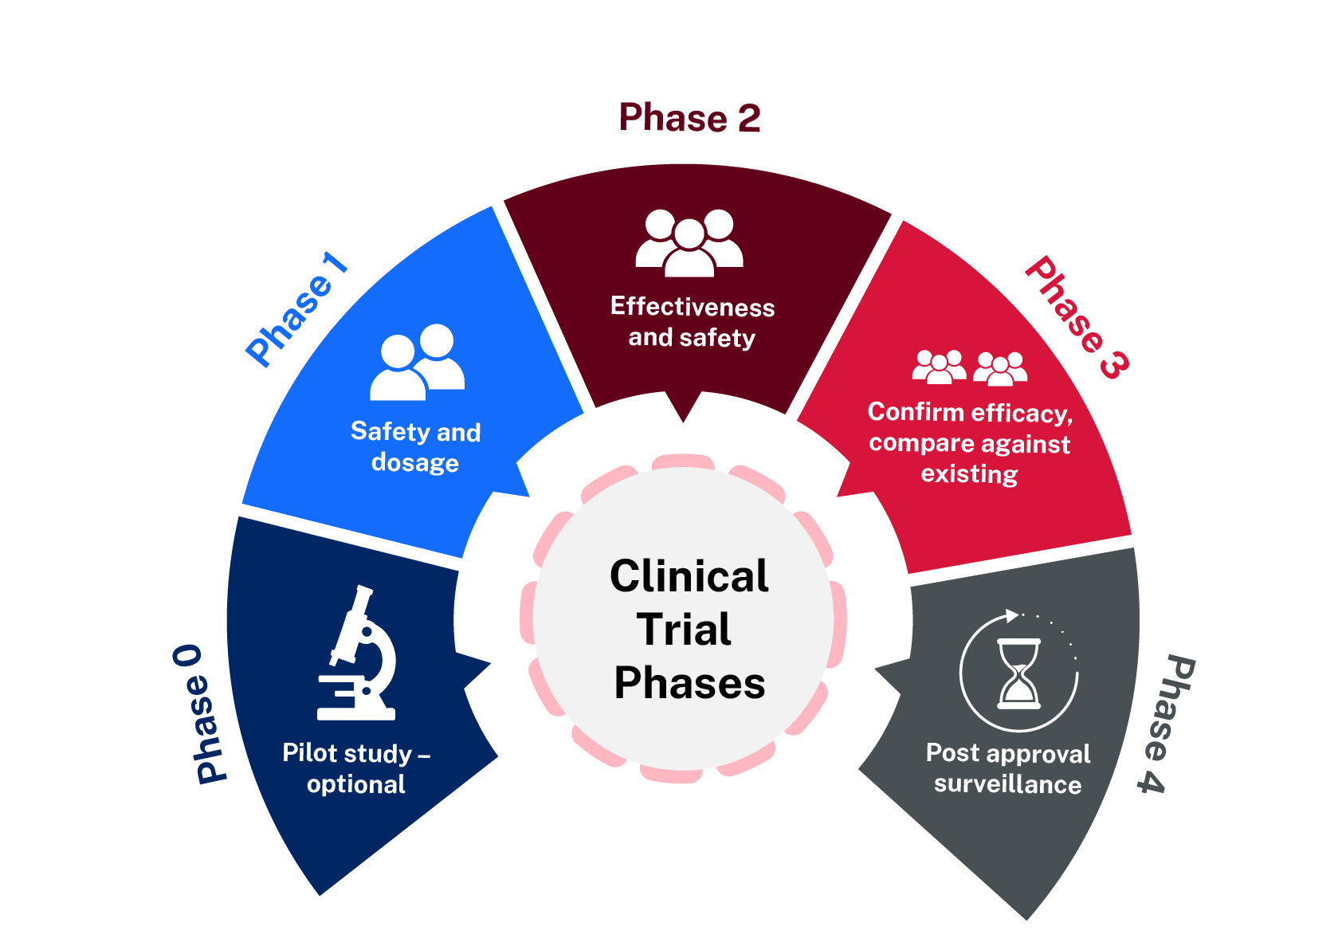

Figure 2 – features of each phase of a clinical trial
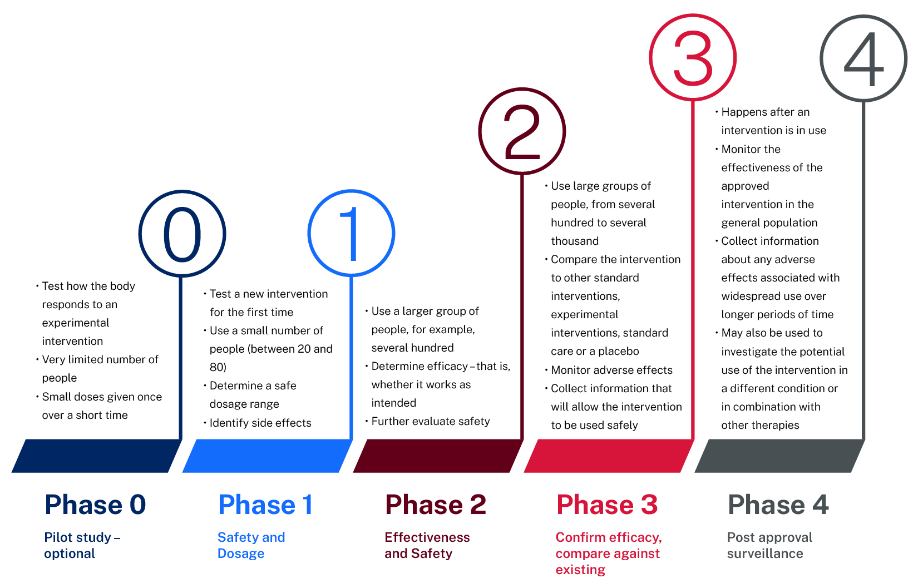

Clinical trial phases
Complete the table below using the information provided and after viewing Investigative approaches: clinical trials (3:28).
Table 1 – clinical trial phases
Phase | Purpose | Participants
0 – Pilot study – optional
1 – Safety and dosage
2 – Effectiveness and safety
3 – Confirm efficacy, compare against existing
4 – Post approval surveillance

Clinical trial phases – suggested answers
Complete the table below using the information provided and after viewing Investigative approaches: clinical trials (3:28).
Table 2 – suggested answers for the clinical trial phases
Phase | Purpose | Participants
0 – Pilot study – optional | - Test how the body responds to an experimental intervention  - Small doses given once or over a short time | Very limited numbers
1 – Safety and dosage | - Test a new intervention for the first time  - Determine a safe dosage range and identify side effects | Between 20 to 80
2 – Effectiveness and safety | - Determine whether the intervention works as intended  - Further evaluate safety | Approximately 200 to 300
3 – Confirm efficacy, compare against existing | - Compare the intervention to other standard interventions  - Monitor adverse effects and collect information for safe use | Between 300 to 3000
4 – Post approval surveillance | - Monitor the effectiveness of the approved use in the general population  - Collect information about adverse effects in widespread use, long term | Monitor post use in the general population

References
Australian Clinical Trials (2023) ‘What is a clinical trial?’, About clinical trials, Australian Clinical Trials website, accessed 29 January 2026.

© State of New South Wales (Department of Education), 2026
The copyright material published in this resource is subject to the Copyright Act 1968 (Cth) and is owned by the NSW Department of Education or, where indicated, by a party other than the NSW Department of Education (third-party material).
Copyright material available in this resource and owned by the NSW Department of Education is licensed under a Creative Commons Attribution 4.0 International (CC BY 4.0) license.

This license allows you to share and adapt the material for any purpose, even commercially.
Attribution should be given to © State of New South Wales (Department of Education), 2026.
Material in this resource not available under a Creative Commons license:
- the NSW Department of Education logo, other logos and trademark-protected material
- material owned by a third party that has been reproduced with permission. You will need to obtain permission from the third party to reuse its material.
Links to third-party material and websites
Please note that the provided (reading/viewing material/list/links/texts) are a suggestion only and implies no endorsement, by the New South Wales Department of Education, of any author, publisher, or book title. School principals and teachers are best placed to assess the suitability of resources that would complement the curriculum and reflect the needs and interests of their students.
If you use the links provided in this document to access a third-party's website, you acknowledge that the terms of use, including licence terms set out on the third-party's website apply to the use which may be made of the materials on that third-party website or where permitted by the Copyright Act 1968 (Cth). The department accepts no responsibility for content on third-party websites.

