Science Stage 5 – Reactions
Teacher resource book 2 of 3 (TRB 2)
2. How can you manipulate the rate of reaction?
Creation date: 6 February 2026.

Contents
Overview 3
Glossary 3
An approach to teaching chemistry 4
Common misconceptions about the rate of reaction 5
2.1 Rate of reaction 6
What is the rate of reaction? 7
Student resource – What is the rate of reaction? 9
What is happening at the particle level? 10
Factors affecting the rate of reaction 11
Student resource – factors affecting the rate of reaction 15
2.2 Investigating the rate of reaction 16
How can we measure the rate of reaction? 17
Student resource – calculating rate of reaction 21
Planning and conducting an investigation to measure the reaction rate 23
Analysing the reaction rate data 27
Student resource – investigating the rate of reaction (practical investigation) 37
2.3 Reaction rate: surface area and catalysts 46
The effect of surface area on the rate of reaction 46
Student resource – the effect of surface area on the rate of reaction 53
The effect of catalysts on the rate of reaction 58
Student resource – the effect of a catalyst on the rate of reaction 63
2.4 Reaction rate: temperature and concentration 67
Planning and conducting an investigation 68
Student resource – planning template 80
Scientific report 83
Student resource – scientific investigation report 89
Evidence base 92

Overview
Stage and learning area: Stage 5 Science
Description: this resource complements the Reactions program of learning. It aims to serve as a teacher reference, offering practical strategies and ideas to enrich teaching practices and create engaging learning environments. The activities should be adapted to suit students' needs.
Duration: while timing will vary based on the mode of delivery, differentiation strategies employed and class or school context, this series of activities should take approximately 8 hours.
Risk management: teachers are advised to undertake a risk assessment before conducting any classroom investigation or experiment. For more information on developing risk assessments, see Risk Assessment – a pre-requisite for risk control.
This resource book elaborates on many of the activities in the Reactions sample program of learning. Some activities also reference the Reactions slide deck (identified as RXN PPT throughout this document).

Glossary
Tier 3 words are those that are relevant for learning subject-specific content. More information is provided in the ‘Vocabulary in context’ document found on the Stage 5 reading – Vocabulary in context page. A glossary containing Tier 3 vocabulary related to the essential question ‘How can you manipulate the rate of reaction’ has been provided below. The Guide for planning and implementing explicit vocabulary instruction can be used by teachers across all curriculum areas.
Table 1 – glossary of key terms for Reactions TRB2
Term | Definition
Catalyst | A substance that changes the speed of a chemical reaction but is itself unchanged at the end of the reaction (NESA 2025).
Concentration | A quantitative measure of the number of particles in a unit volume. The units for concentration vary. For solutions, concentration can be expressed in grams per litre, which refers to the mass of solute per litre of solution.
Hypothesis | A supposition or proposed explanation made based on limited evidence as a starting point for further investigation (NESA 2025).
Rate of reaction | A measure of change in the quantity of reactants or products per unit time.
Surface area | In chemistry, surface area is defined as the total area of the exposed surface of a solid material reactant. In reactions involving solid reactants, a larger surface area exposes more reactant particles, increasing the likelihood of successful collisions and thus accelerating the reaction rate.
Temperature | The degree of hotness or coldness of a substance relative to its surroundings. It is a measure of the average kinetic energy of particles in a substance.

An approach to teaching chemistry
In Stage 5, students progress from simple concepts to more complex ones about the properties and structures of substances. Many chemistry concepts involve interactions among particles, such as atoms and molecules that are too small to see. To understand these concepts, students must learn to think more abstractly. Generally, students find these concepts quite challenging because it is difficult to imagine them without seeing the actual processes or objects.
Alex Johnstone developed a model called Johnstone's triangle (Figure 1) that helps explain the different levels of thinking in chemistry and how to link these levels. It shows how teachers can explain the complex chemical concepts at 3 levels:
- macroscopic level (what we see)
- the sub-microscopic level (particles and atoms)
- the symbolic level (formulas and equations).
This framework helps students connect ideas and make sense of abstract concepts in chemistry.
Figure 1 – Johnstone’s triangle showing 3 levels of thinking and linking these levels
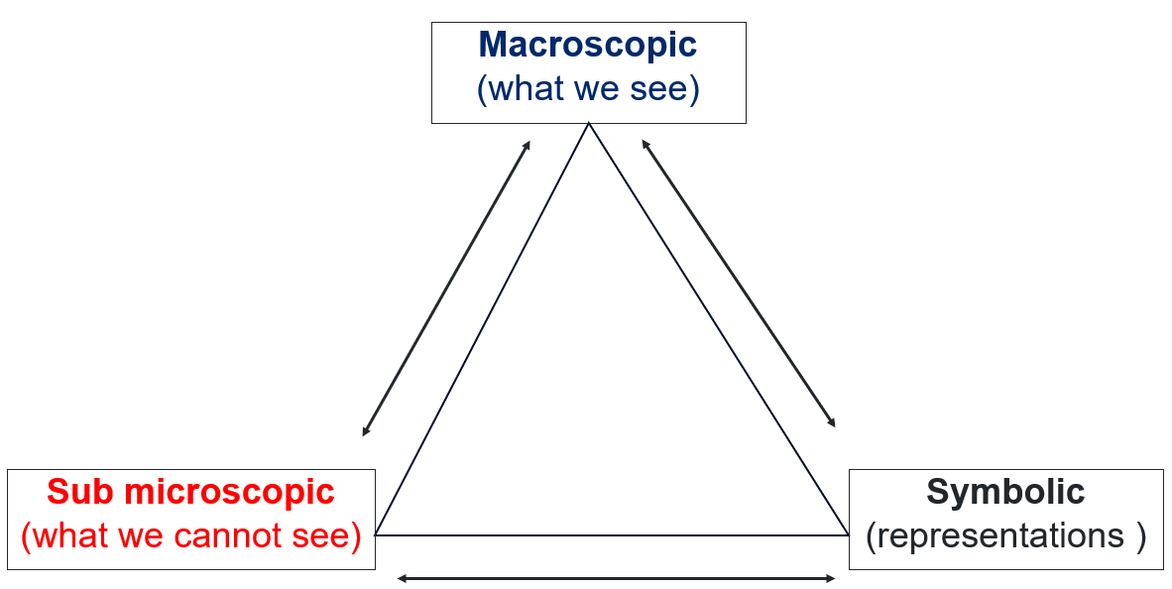

Common misconceptions about the rate of reaction
Table 2 – misconceptions about the rate of reaction
Misconception | Correct conception
All collisions between the reactant particles result in the formation of the product. | Only successful collisions result in the formation of product(s). Not all collisions are successful.
If the reaction rate is high, more product is formed. | An increased reaction rate does not produce more product. Instead, the products form more quickly, provided the amounts of the reactants remain constant.
A catalyst increases the amount of product. | A catalyst speeds up the reaction by increasing the rate at which the product forms, not by increasing the amount of product.

2.1 Rate of reaction
Table 3 – learning intention and success criteria for ‘2.1 Rate of reaction’
We are learning: | I can:
- to describe the factors that affect the rate of chemical reactions. | - define the rate of reaction  - identify the factors that affect the rate of reaction  - describe how each factor affects the rate of a reaction  - define collision theory  - use collision theory to explain how each factor affects the rate of a reaction.
Checkpoint 1: use slide RXN PPT ‘2.1 Checkpoint 1’ to check for prior understanding of chemical reactions and clarify any misconceptions before introducing the rate of reactions. Students can answer questions on a mini whiteboard or verbally.
Which statement best describes what happens during a chemical reaction at the particle level?
- New atoms are created to form products, but the total number of atoms remains the same.
- Atoms in the reactants are rearranged to form products, but the total number of atoms remains the same.
- Some atoms in the reactant are destroyed, and some new atoms are created to form products, but the total mass remains the same.
Table 4 – the explanation for correct and incorrect responses for the RXN PPT 2.1 Checkpoint 1’
Response | Explanation
A | Incorrect. No new atoms are created in a chemical reaction.
B | Correct. This description is consistent with the law of conservation of mass.
C | Incorrect. As no new atoms are created in a chemical reaction, both the number of atoms and the mass are conserved in a chemical reaction.

What is the rate of reaction?
- Review the definition of a chemical reaction from the Stage 4 Change focus area: 2.2 – ‘Changes in chemical reactions’. Remind students that a chemical reaction is ‘a process in which substance(s) (reactants) transform into new substance(s) (products) by rearranging their atoms and breaking and forming chemical bonds’.
- Introduce the topic by showing slide RXN PPT ‘2.1 Introduction to rate of reaction’ to discuss an everyday example where a chemical reaction can be observed happening at different rates. Use the example of bread dough rising in a warm or cold place.
- Show the slide RXN PPT ‘2.1 Frayer diagram – rate of reaction’ to define the term ‘rate of reaction’.
- Students complete the Frayer diagram on the rate of reactions provided in the Student resource – What is rate of reaction? Unpack the term with students to describe the features of the reaction rate. The quantitative and qualitative measures of reaction rate will be covered in more detail in later activities.
Sample response: Student resource – What is the rate of reaction?
Note: additional stimulus information has been removed from the sample response.
Figure 2 – sample response showing Frayer diagram on the rate of reaction
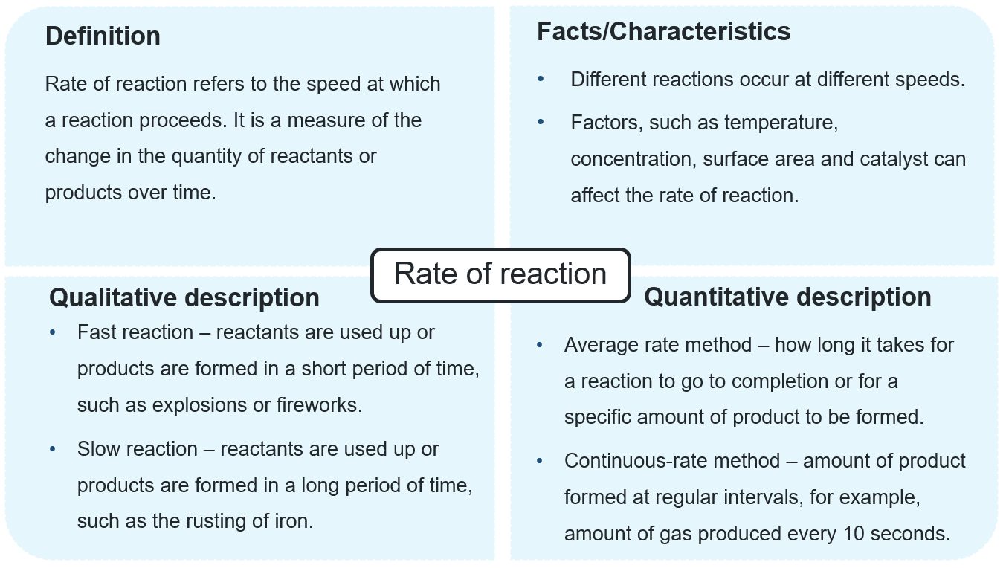

Student resource – What is the rate of reaction?
Complete the Frayer diagram on the rate of reaction.
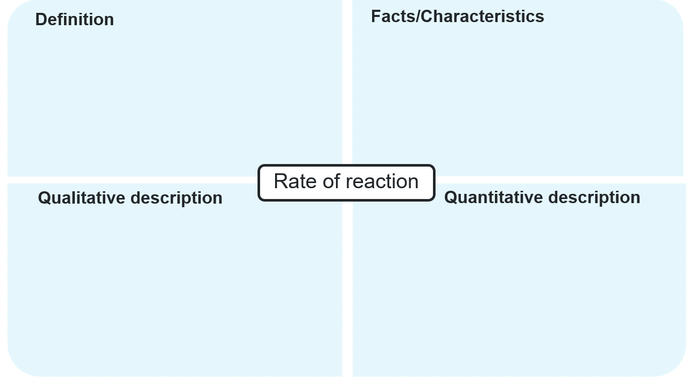

What is happening at the particle level?
- Use slide RXN PPT ‘2.1 Johnstone’s triangle’ to explain that the chemical reactions can be represented at 3 levels:
- macroscopic (what we see during experiments): observations we make, such as a change in colour, the formation of bubbles, fizzing and a temperature change
- sub-microscopic (what we cannot see): we try to understand what is happening at the particle level by using models such as pictures or 2D and 3D models, including ball-and-stick models
- symbolic (representations): such as graphs to show trends and patterns and chemical equations.
- Watch the video Collision Theory & Reactions Part 1 | Reactions | Chemistry | FuseSchool (2:28) to introduce ‘collision theory’. This video is included in RXN PPT ‘2.1 Collision theory and reactions video’.
- Show slides RXN PPT ‘2.1 Collision theory’ (3 slides) to explain the collision theory, referring to the particle models and the role of the kinetic energy of reactant molecules in successful collisions that form products. Refer to the ball-and-stick model pictures in the slides to explain that if the colliding reactant particles do not have sufficient energy, the collisions will be unsuccessful.
- Use slide RXN PPT ‘2.1 Collision theory and rate of reaction’ to explain that energy is required to break the bonds in the reactants. If there is not enough energy to break the bonds, the number of successful collisions per unit time (collision frequency) will be low, resulting in a low reaction rate. Expand on this by explaining that ‘activation energy’ is the minimum amount of energy required for particles to react. Emphasise that this energy requirement differs among various chemical substances.
Differentiation: to extend students, use slides RXN PPT ‘2.1 Collision theory – extension’ (3 slides) to explain a slightly more advanced version of the collision theory and link it to the rate of reactions, including the role of the correct orientation of reactant particles in successful collisions.
Note: a simplified version of collision theory is included in the RXN PPT to help students visualise what happens at the particle level and how it affects the reaction rate. Although not explicitly stated in the syllabus, its inclusion allows students to explore reaction rates in greater depth.
Including collision theory to explain chemical reactions and linking it to reaction rates helps students consider what is happening at the particle level (sub-microscopic) during chemical reactions.

Factors affecting the rate of reaction
Teacher background information
The rate of reaction refers to how fast a chemical reaction proceeds. Understanding reaction rates helps students connect chemical theory to everyday experiences and large-scale industrial processes.
A familiar example of the concept of reaction rate is the rusting of iron. Iron reacts with oxygen and moisture in the air, forming rust, iron(III) oxide. This process occurs gradually, often over days, weeks or even months, before it becomes visible. The slow pace lets students observe how different factors influence the reaction rate. For example:
- increased temperature can speed up rusting
- greater exposure to oxygen and moisture increases the frequency of collisions between the reactant particles.
Thus, reactions can occur at very different rates, and reaction rates are influenced by factors that can speed them up or slow them down.
In industrial chemistry, controlling reaction rates is essential for efficiency, safety and economic viability. A key example is the Haber process, used to manufacture ammonia, a raw material for synthesising fertilisers. In this reaction, nitrogen gas reacts with hydrogen gas to produce ammonia. Under normal conditions, this reaction is extremely slow. However, chemists manipulate reaction conditions, such as temperature, reactant gas concentrations and catalyst addition, to achieve commercially useful reaction rates.
In this lesson sequence, students will investigate how the following factors affect the rate of reaction:
- temperature
- concentration
- surface area
- catalysts.
Pressure is also an important factor, particularly when reactants and/or products are gases. However, the concept is beyond the scope of Science Stage 5 and is not covered in this focus area.
It is also important to note that the effects of these factors are general trends. There are exceptions to how each factor influences the reaction rate, and these will be explored in Chemistry 11–12, alongside a more detailed study of equilibrium reactions and competing reaction pathways.
- Provide students with a copy of the Student resource – factors affecting the rate of reaction. Students complete the table to summarise the impact of each factor on reaction rate and what is happening at the particle level as the slides are delivered.
- Display RXN PPT ‘2.1 Factors that affect the rate of reaction video’ and play the video Factors that affect Rate of Reaction (3:06) to introduce the factors that affect the rate of reaction. Skip the part of the video on inhibitors (from 2:12–2:40), as this is beyond the scope of the Science Stage 5 Syllabus.
- Use slide RXN PPT ‘2.1 Factors affecting the rate of reaction’ (5 slides) to identify the factors that affect the rate of reaction. Explain how each factor (temperature, concentration, surface area and catalyst) affects the rate of reaction by relating them to the collision theory. Expand on how these factors affect the frequency of collisions or the activation energy, thereby changing the rate of reaction.
- Use the relevant slide RXN PPT ‘2.1 Factors affecting the rate of reaction (sample answer)’ to discuss the sample answers and support students in refining their summaries.
Checkpoint 2: show slide RXN PPT ‘2.1 Checkpoint 2’ to check for understanding of the rate of reaction and discuss the incorrect options to clear any alternative conceptions students may have. Students answer this question on a mini whiteboard or in their workbooks.
Which of the following explanations about reaction rates is correct?
  - Adding a catalyst provides more energy to the reactant particles, making them move faster.
- Increasing the concentration means more reactant particles, leading to more energetic collisions.
- Increasing the temperature makes particles move faster and collide with more energy, increasing the number of successful collisions.
- Using smaller pieces of solid reactants decreases the surface area so that particles can collide more easily.
Table 5 – the explanation for correct and incorrect responses for the RXN PPT ‘2.1 Checkpoint 2’
Option | Explanation
A | Incorrect. Catalysts do not supply energy. Rather, they lower the activation energy for the reaction, increasing the number of successful collisions.
B | Incorrect. Concentration does not increase the kinetic energy of particles. Rather, increasing the number of reactant particles leads to more frequent collisions.
C | Correct. An increase in temperature results in an increase in kinetic energy of the reactant particles, leading to a higher collision frequency and more successful collisions.
D | Incorrect. Using smaller pieces increases, not decreases, the surface area, allowing more collisions between reactant particles.
Sample response: Student resource – factors affecting the rate of reaction
- Complete the following table on the factors affecting the rate of reaction.
Table 6 – sample response for factors affecting the rate of reaction
Factor | Impact on the rate of reaction | Describe what is happening at the particle level
Temperature | The reaction rate increases with temperature and decreases with lower temperatures. | At higher temperatures, particles have more kinetic energy, so they move faster and collide more often.
Concentration | A higher concentration of reactant(s) increases the rate of reaction. | A higher reactant concentration results in more particles per unit volume, increasing the collision frequency and, in turn, the number of successful collisions per second.
Surface area | The higher the surface area of a reactant exposed, the greater the reaction rate. | A larger exposed surface allows more reactant particles to collide with the solid's surface, increasing the frequency of successful collisions.
Catalyst | A catalyst speeds up the reaction by lowering the activation energy, so a greater fraction of reactant particles can form products. | More collisions succeed without increasing temperature or concentration when a catalyst is present.

Student resource – factors affecting the rate of reaction
- Complete the following table on the factors affecting the rate of reaction.
Table 1 – factors affecting the rate of reaction
Factor | Impact on the rate of reaction | Describe what is happening at the particle level

2.2 Investigating the rate of reaction
Table 7 – learning intentions and success criteria for ‘2.2 Investigating the rate of reaction’
We are learning: | I can:
- to explain the factors that affect the rate of chemical reactions | - identify ways to calculate the rate of reaction  - qualitatively and quantitatively describe the rate of reaction
- plan a valid and reliable investigation | - identify the types of data that can be collected to measure the products of a chemical reaction  - identify features in a method that help to ensure the collected data is reliable  - identify risks that need to be controlled in an investigation  - identify ways to modify an investigation to improve the reliability or validity
- to follow a planned procedure to conduct a safe and valid investigation | - assemble and manipulate equipment to conduct the experiment  - follow a procedure to conduct an experiment  - implement safe work practices to manage risks
- to process and represent data | - tabulate collected data  - graph experiment data using an appropriate graph
- to analyse data from investigations to identify trends and draw conclusions. | - assess the validity of an investigation  - assess the reliability of an investigation  - describe the rate of reaction from the graphed data  - determine the rate of reaction from the graphed data.
Note: the current lesson sequence is designed to ensure that students develop the requisite skills in preparing risk assessments, systematically collecting and recording data, graphing collected data, and assessing the validity and reliability of investigations. These skills are explicitly addressed in this section, with the expectation that students will apply them in subsequent lessons.
Students will use the same Student resource – investigating the rate of reaction (practical investigation) in each of the 3 activities outlined in this sequence:
- How can we measure the rate of reaction?
- Planning and conducting an investigation to measure reaction rate
- Analysing the reaction rate data.

How can we measure the rate of reaction?
- Recap the definition of the rate of reaction: ‘The rate of a chemical reaction refers to how quickly reactants are converted into products. It can be measured by monitoring the change in concentration or quantity of a reactant or product over time. Common methods include measuring changes in mass, volume of gas produced in a chemical reaction or other macroscopic properties such as colour intensity.’
- Recall that a metal and an acid react to form a salt and hydrogen gas. Demonstrate this using magnesium and hydrochloric acid, including the pop test for hydrogen, if required.
- Use slide RXN PPT ‘2.2 Investigating the rate of reaction’ to unpack the reaction between magnesium and hydrochloric acid.
- Students are to complete the word equation in the Student resource – investigating the rate of reaction (practical investigation).
- Discuss the ways (both qualitative and quantitative) to collect data on the rate of reaction. Use prompts in the slides to engage students. Expand on the viable options that could be used in a high school laboratory to measure the rate of reaction.
- Display RXN PPT ‘2.2 Determining the rate of reaction’ (slides 1 and 2 of 3). Unpack the different methods to measure the rate of reaction when the amount of reactant or product can be measured, including the mean rate method and the instantaneous rate method.
$$rate of reaction \text{= }\frac{∆ in amount of reactant or product}{∆time}$$
- Display RXN PPT ‘2.2 Determining the rate of reaction’ (slide 3 of 3) and unpack how the relative rate of reaction can be calculated when the change in the amount of reactant or product cannot be measured.
$$\text{relative rate of reaction} α \frac{1}{time}$$
Relative rate of reaction
The rate of a chemical reaction is usually calculated as the amount of reactants consumed or products formed per unit time. If the amounts of reactants consumed or products formed cannot be easily measured, the reciprocal of the time taken for the reaction to complete ($\frac{1}{time}$) can be used to determine reaction rates.
In this activity, a modified version of this approach is used to determine the reaction rate between calcium carbonate and hydrochloric acid by measuring the time required for a fixed amount of product (5 mL of CO₂) to form. This approach provides a relative reaction rate because, in each case, the same amount of product is formed. Thus, the observed rate depends only on how quickly that amount is produced.
This method is applicable to many reactions but is especially convenient for those with a visible change, such as:
- the reaction between sodium thiosulfate and hydrochloric acid: the clear solution becomes cloudy as pale-yellow sulphur precipitates form. Placing a white paper with a black cross under the beaker and measuring the time it takes for the cross to disappear (due to opacity) corresponds to a specific amount of sulphur formed.
- the reaction between magnesium and hydrochloric acid: observing the time it takes for a fixed mass or length of magnesium ribbon to react and disappear in hydrochloric acid fully.
The key principle behind using the relative rate of reaction is that, at the measured time, a consistent amount of product has formed or a consistent amount of reactant has been consumed.
- Provide students with the Student resource – calculating rate of reaction and use gradual release of responsibility to work through the problems.
Sample response: Student resource – calculating the rate of reaction
Note: additional stimulus information has been removed from the sample response.
- A reaction produced 24 mL of carbon dioxide in 48 seconds. Calculate the rate of reaction.
$$rate of reaction \text{= }\frac{∆ in amount of product}{∆time}$$
$$rate of reaction \text{= }\frac{24}{48}$$
$$rate of reaction \text{= }\text{0.5 mL/s}$$
- A student investigates how concentration affects the rate of reaction using an iodine clock reaction. The reaction mixture suddenly changes from colourless to dark blue when the reaction reaches the endpoint. In one trial, the colour change occurs after 6 seconds.
$$rate of reaction \text{= }\frac{1}{time}$$
$$rate of reaction \text{= }\frac{1}{6 sec}$$
$rate of reaction \text{= }$0.17 $s^{-1}$
- A student investigates how temperature affects the reaction between magnesium ribbon and hydrochloric acid. At 30 °C, the reaction produces 18 mL of hydrogen gas in 37 seconds.
$$rate of reaction \text{= }\frac{∆ in amount of product}{∆time}$$
$$rate of reaction \text{= }\frac{18}{37}$$
$$rate of reaction \text{= }\text{0.49} \text{mL/s}$$
- A reaction is timed to see how long it takes for a cross to disappear when sodium thiosulfate reacts with hydrochloric acid. The same concentrations and volumes are used each time. The trial conducted at 20 °C took 45 seconds, and the trial at 40 °C took 20 seconds. Calculate the rate of reaction for each trial.
$$rate of reaction at 20 °C \text{= }\frac{1}{time}$$  $$rate of reaction \text{= }\frac{1}{45 sec}$$  $rate of reaction at 20 °C \text{= }\text{0.022}$ $s^{-1}$ | $$rate of reaction at 40 °C\text{= }\frac{1}{time}$$  $$rate of reaction \text{= }\frac{1}{20 sec}$$  $rate of reaction at 40 °C \text{=}$ 0.05 $s^{-1}$
- A reaction between hydrochloric acid and magnesium produces 28 mL of gas after 20 seconds and 42 mL of gas after 40 seconds. Calculate the mean rate of reaction between 20 and 40 seconds.
$$rate of reaction \text{= }\frac{∆ in amount of product}{∆time}$$
$$rate of reaction \text{= }\frac{42-28}{40-20}$$
$$rate of reaction \text{=} \text{0.7 mL/s}$$

Student resource – calculating rate of reaction
Which equation should I use?
The rate of reaction describes how fast reactants are used up or products are formed.
There are 2 common ways you may be asked to calculate reaction rate, depending on what data you have measured:
- $rate of reaction \text{= }\frac{∆ in amount of reactant or product}{∆time}$
Use this equation when you have measured how much product forms (or reactant is used) over a period of time. Examples of ‘amount’ include volume of gas (mL), mass (g) or concentration (mol/L).
- $rate of reaction \text{= }α \frac{1}{time}$
Use this equation when the amount of product formed is kept constant each time and you only measure the time taken. This method is useful when comparing conditions (for example, different temperatures, surface areas or catalysts) and you only record how long it takes to reach a fixed endpoint (such as producing 5 mL of gas or a colour change).
Complete the following questions using this structure:
- Write the formula you will use.
- Substitute the values into the formula.
- Calculate the rate of reaction.
- State the units in your answer.
- A reaction produced 24 mL of carbon dioxide in 48 seconds. Calculate the rate of reaction.
- A student investigates how concentration affects the rate of reaction using an iodine clock reaction. The reaction mixture suddenly changes from colourless to dark blue when the reaction reaches the endpoint. In one trial, the colour change occurs after 6 seconds.
- A student investigates how temperature affects the reaction between magnesium ribbon and hydrochloric acid. At 30 °C, the reaction produces 18 mL of hydrogen gas in 37 seconds.
- A reaction is timed to see how long it takes for a cross to disappear when sodium thiosulfate reacts with hydrochloric acid. The same concentrations and volumes are used each time. The trial conducted at 20 °C took 45 seconds and the trial at 40 °C took 20 seconds. Calculate the rate of reaction for each trial.
- A reaction between hydrochloric acid and magnesium produces 28 mL of gas after 20 seconds and 42 mL of gas after 40 seconds. Calculate the mean rate of reaction between 20 and 40 seconds.

Planning and conducting an investigation to measure the reaction rate
Note: it may be useful to demonstrate the investigation described in the Student resource – investigating the rate of reaction (practical investigation) before allowing students to engage in the experiment to collect data. Inverting the measuring cylinder without introducing air bubbles can be difficult and should be practised.
- Read through the method (equipment, procedure, diagram of equipment set-up) in the Student resource – investigating the rate of reaction (practical investigation).
Note: a full risk assessment should be conducted before completing practical investigations with students. This should follow any procedures set by your school.
- Use slide RXN PPT ‘2.2 Risk assessment’ to revise the scaffold for developing a risk assessment for a practical investigation. Define the meaning of the following terms:
- ‘hazard’ is a situation or thing that has the potential to harm a person, such as equipment or chemicals
- ‘risk’ is the possibility that harm (death, injury or illness) might occur when exposed to a hazard
- ‘controls or precautions’ are actions to eliminate health and safety risks, so far as is reasonably practicable, and if that is not possible, minimising the risks so far as is reasonably practicable.
- Display RXN PPT ‘2.2 Chemical safety’ to model how to use the information in the Safety Data Sheet (SDS) to develop a risk assessment for hazardous chemicals. Illustrate this by taking students step by step through the hazard pictogram and the hazard and precautionary statements provided in the SDS for magnesium and hydrochloric acid. Instruct students to complete the first 2 rows of the risk assessment table in the Student resource – investigating the rate of reaction (practical investigation).
Note: the screenshots of information in the slide RXN PPT ‘2.2 Chemical safety’ are from the Gold SDS available in Chemwatch. Similar information can be accessed from the vendor-supplied SDS.
- Use slide RXN PPT ‘2.2 How to develop a risk assessment?’ to model how to identify the potential hazards and the relevant control measures for the equipment used in the investigation. Explicitly unpack the potential hazards related to the equipment used in this experiment and how they will be controlled. Instruct students to complete the remaining rows of the risk assessment table in the Student resource – investigating the rate of reaction (practical investigation).
- Display slide RXN PPT ‘2.2 Sample risk assessment’ to review the risk assessment and give students time to add any information they may have missed. Additional hazards, risks and controls may be included.
- Use slides RXN PPT ‘2.2 Equipment set-up’ and RXN PPT ‘2.2 Practical tips for setting up the equipment’ to demonstrate how to set up the equipment correctly and how to conduct the experiment to collect the gas produced in the reaction.
Figure 3 – equipment set-up for collecting gas produced in the reaction between magnesium and hydrochloric acid
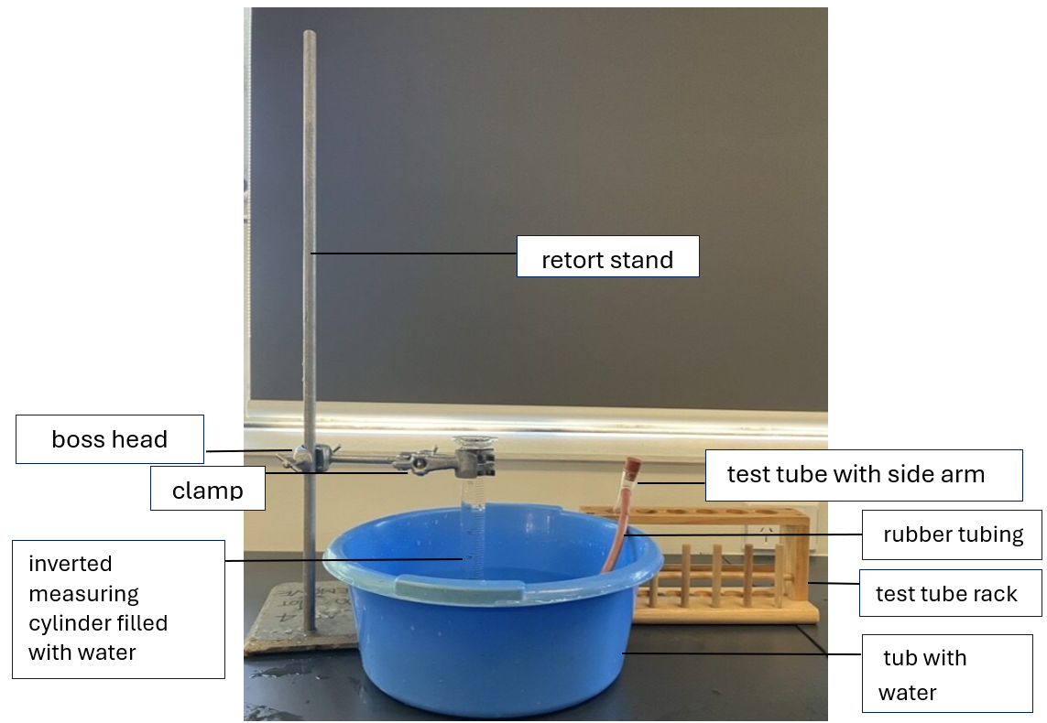
Differentiation: to further support students, copy the picture of the integrated instruction equipment from RXN PPT ‘2.2 Equipment set-up – integrated instruction’ in the student resource. This reduces cognitive load by minimising split attention among the equipment set-up, labels and following the procedure, enabling students to refer to a condensed version that integrates both the set-up and the steps into a single diagram.
- Use slide RXN PPT ‘2.2 Measuring the gas volume’ to show students how to read the scale on an inverted measuring cylinder to measure the volume of hydrogen gas produced in the reaction. Remind them to remove any air bubbles, as they can give a false, higher reading, leading to measurement errors.
Checkpoint 1: show slide RXN PPT ‘2.2 Checkpoint 1’. Students read the scale on an inverted measuring cylinder to measure the volume of gas produced in the chemical reaction and record their answers in their workbooks. Show slide RXN PPT ‘2.2 Checkpoint 1 sample answer’ to discuss the sample answers.
Figure 4 – Checkpoint 1 answers to inverted measuring cylinders with different amounts of gas collected
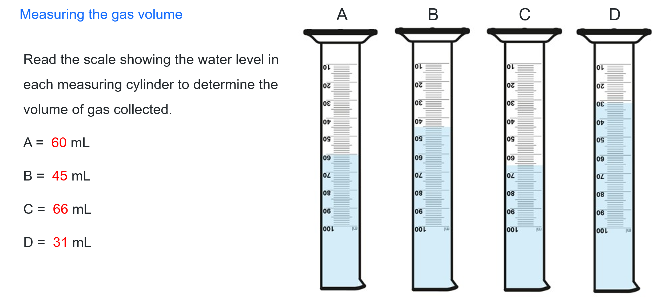
Note: reading the scale on a measuring cylinder provides a quick way to assess students’ ability to correctly read the volume formatively. It may be necessary to explicitly teach some students how to read the scale on a measuring cylinder.
To reduce waste, it is recommended that the specified volumes of acid and magnesium metal be dispensed to each group. There will inevitably be errors in the set-up or data collection that lead to null results in some trials. You may wish to have some additional acid and magnesium on hand, if required.
Optional: collect the class results in a Microsoft Excel spreadsheet to facilitate a discussion on reliability.
- Tell students that before collecting experimental data, a table should be developed to record the results. Show slide RXN PPT ‘2.2 Results table’ and instruct students to identify the independent and dependent variables in the investigation and use them to construct a table for their investigation.
- Display RXN PPT ‘2.2 Results table model’ to show students what a good table looks like. Students can modify their tables in preparation for the investigation.
Differentiation: some students may have a sound understanding of table construction. You could delete the table scaffold included in the Student resource – investigating the rate of reaction (practical investigation) and have students design their own table to record the results. Feedback on their table design should be provided.
- Students conduct the experiment on the reaction between magnesium and hydrochloric acid in groups of 3 or 4 and complete 3 trials of the experiment. Students could use a marker to mark the gas level at each 10-second interval and record the readings once the reaction is complete if it is too difficult to take readings quickly while the reaction proceeds.
- Discuss why some data may be invalid (for example, having air bubbles in the measuring cylinder) and why this data should not be included in the calculations. This data should be identified (for example, with an asterisk and a note below the table).
- Students can be introduced to identifying unexpected data at this stage. For example, if a group gets an unusual result due to an equipment set-up or measurement error. Also, groups may discuss how any inaccuracies in their method implementation could influence their results. This has been modelled in the sample results.
- Discuss with students why a line graph is the most appropriate graph for this data (for example, the data is continuous). A column graph is used for discrete or categorical data.
- Students graph the volume of gas produced in the reaction over time for 120 seconds, either using Microsoft Excel or by hand on graph paper. Tell students that, by convention, the independent variable is generally on the x-axis (time) and the dependent variable on the y-axis (gas volume). Display RXN PPT ‘Quality criteria for a graph’ to support students in refining their tables.
Differentiation: use RXN PPT ‘2.2 Graph scaffold’ (3 slides) to support students by providing them with the appropriate scaffold for plotting a graph. There are 3 different levels of scaffolds available in these slides.

Analysing the reaction rate data
- Use slide RXN PPT ‘2.2 Analysing graph – qualitative analysis’ to guide students in analysing the rate graph by referring to the shape of the curve at different time intervals. Explain how a steeper slope on the graph indicates that the reaction is occurring at a faster rate, meaning more reactants are being used up in a given time. As the reaction proceeds, the slope becomes less steep, indicating that the reaction is slowing because fewer reactant particles remain to collide and react.
- Assessing the validity and reliability of the method is a good way for students to identify weaknesses in the experimental design or the way the procedure was carried out and then propose improvements. Use slides RXN PPT ‘2.2 Validity checklist’ and RXN PPT ‘2.2 Reliability checklist’ to discuss the validity and reliability criteria for this investigation
- Show slide RXN PPT ‘2.2 CER Scaffold’ to unpack the claim–evidence–reasoning (CER) scaffold for structuring their responses to assess the validity and reliability of the investigation.
Differentiation: To extend students, use slides RXN PPT ‘2.2 Analysing graph – quantitative analysis’ (2 slides) to explain 2 different methods for calculating the rate of reaction using the average rate method or continuous rate method.
Sample response: Student resource – investigating the rate of reaction
Note: additional stimulus information has been removed from the sample response.
Introduction
Complete the word equation:
magnesium + hydrochloric acid → magnesium chloride + hydrogen gas
Risk assessment
Refer to the hazard, precautionary and disposal statement provided by your teacher to complete the risk assessment table below:
Table 8 – sample response of risk assessment for the investigation of the rate of reaction between a metal and an acid
Hazard | Risk | Controls or precautions
Magnesium ribbon (flammable solid) | Sharp edges may cause cuts.  Damage to the retina can occur if the bright light from burning magnesium is viewed with the naked eye.  Magnesium combusts at high temperatures and can cause burns on the skin. | - Handle carefully.  - Keep away from heat, hot surfaces and sparks so that the magnesium cannot be ignited.
Hydrochloric acid (corrosive) | Splashing chemicals in the eyes or on the skin will cause irritation. | - Wear safety glasses throughout the experiment.  - Wear enclosed leather footwear.  - Wash off the splashes from the skin immediately with cool water.
Broken glassware | Cuts from chipped glassware. | - Inspect and discard broken glassware.  - Sweep up broken glass with a dustpan and a brush – do not use fingers to clean it up.
Water spills, chairs | Slips, trips and falls. | - Spills are to be cleaned immediately. No running in the lab.
Results
Table 9 – sample response of the volume of gas produced by a reaction of magnesium ribbon with hydrochloric acid over time
Time (seconds) | Volume of gas generated (mL) |  |  |  | Range
Time (seconds) | Trial 1 | Trial 2 | Trial 3 | Mean | Range
0 | 0 | 0 | 0 | 0 | 0
10 | 7 | 8 | 6 | 7 | 2
20 | 14 | 13 | 14 | 14 | 1
30 | 20 | 21 | 22 | 21 | 2
40 | 28 | 28 | 29 | 28 | 1
50 | 35 | 34 | 33 | 34 | 2
60 | 38 | 38 | 39 | 38 | 1
70 | 42 | 42 | 43 | 42 | 1
80 | 44 | 46 | 48 | 46 | 4
90 | 46 | 48 | 50 | 48 | 4
100 | 49 | 49 | 64* | 49 | 15
110 | 50 | 50 | 65* | 50 | 15
120 | 50 | 50 | 65* | 50 | 15
*data was removed when calculating the mean because an air bubble distorted the results.
Note: please note that the data presented here is sample data only. When students perform their own experiments, their recorded values may vary due to differences in conditions, measurement methods and individual variation. Encourage students to carefully record their results and understand that some variation is normal in experimental work.
Plot a graph of the average volume of hydrogen gas collected versus time for a reaction between magnesium and hydrochloric acid.

Analyse the trend shown in the graph to discuss how the rate of reaction for magnesium and hydrochloric acid varies with time.
Qualitative analysis
The slope is steeper at the beginning (zero to 40 seconds), indicating a higher reaction rate.
As the reactants are used up, the slope becomes less steep (40 to 80 seconds), indicating that the reaction rate slows.
Towards the final 40 seconds (110 to 120 seconds), the graph plateaus as the magnesium is used up and the volume of hydrogen gas produced becomes constant.
Analyse the collected data to calculate the mean reaction rate for the reaction between magnesium and hydrochloric acid.
Quantitative analysis
$Mean rate of reaction$=$\frac{volume of gas produced}{time in seconds}$
= $\frac{50}{110}$ = 0.45 mL/second
Note: the graph shows the data recorded to 120 seconds. However, no additional product was produced after 110 seconds indicating that the reaction had completed.
Calculate the reaction rate at 2 intervals and compare them.
$Mean rate of reaction$=$\frac{V2-V1}{T2-T1}$
Mean rate of reaction = $\frac{28-14}{40 - 20}$ = 0.7 mL/s (between 20 and 40 seconds)
Mean rate of reaction = $\frac{46 - 38}{80 - 60}$ = 0.4 mL/ s (between 60 and 80 seconds).
The first time interval, which is earlier in the reaction, was the fastest, producing hydrogen at a rate of 0.7 mL/s. As the reaction proceeded, it slowed down. Between 60 and 80 seconds, only 0.4 mL of hydrogen was being produced each second.
Answer the following questions to assess the validity of your investigation. Refer to the procedure and how it was implemented to answer these questions. The first question is completed as an example.
Table 10 – sample response to assessing the validity of the investigation
Question | Response
Were all factors (such as temperature, acid concentration, amounts of acid and Mg) the same for all trials? | Yes. The reaction was carried out at room temperature (25°C). 10 mL of 1 Mol L⁻¹ hydrochloric acid and 3.0 cm of Mg ribbon were used for each trial.
Were the time intervals consistent for recording gas volume? | Yes, the gas volume was measured every 10 seconds.
Did you measure the length of the magnesium ribbon accurately? | Yes, the length of the magnesium ribbon was measured using a centimetre ruler.
Was the equipment set-up suitable for gas collection? | Yes, the graduated measuring with 1 mL increments was suitable for gas collection.
Was the gas volume measured accurately, using appropriate equipment? | Yes. The inverted measuring cylinder was filled to the edge with water, all air bubbles were removed and plasticine was used to seal the mouth of the cylinder in the water to prevent gas leakage.
Were there any unusual results (outliers)? Explain possible reasons. | The answers may vary.
Do you have any suggestions for improving the method? | The method could be improved by:  - Instead of measuring the length of the magnesium ribbon, weigh the magnesium pieces to ensure they have the same mass.  - Use a gas syringe to avoid errors caused by gas leakage or dissolution in water which may affect the volume of the collected gas.
Refer to the questions above to assess the validity of your investigation. Use the CER scaffold to structure your response.
Claim – state an answer to the question: Is the investigation valid?
The experiment was valid.
Evidence – provide information such as facts and data from the experiment that supports the claim.
The data was collected at regular intervals every 10 seconds (independent variable).
The other variables were controlled:
- same amount of reactants for each trial (10 mL of HCl and 3.0 cm piece of Mg ribbon from the same batch
- constant temperature (both water and HCl were at room temperature)
- same concentration of hydrochloric acid for each trial
- same equipment used for each trial.
The method (collecting gas by water displacement) accurately measures the volume of hydrogen produced as:
- all air bubbles were removed before gas collection
- all readings were taken at eye level to minimise parallax error.
A centimetre ruler was used to measure the Mg ribbon's length to 3.0 cm for precision.
Reasoning – explain how the evidence supports the claim
The results of the magnesium and hydrochloric acid reaction rate experiment are reliable because repeated trials produced consistent results. The variables that affect the reaction rate were controlled, so the observed changes are attributable to the reaction between Mg and HCl at room temperature.
Measurements were taken with appropriate equipment and are quantitative (time and gas volume) and repeatable, supporting the validity of the conclusion. Any deviations, such as timing errors or differences in the mass of magnesium, can affect precision but do not invalidate the overall trend in the reaction rate, as multiple controlled trials and the calculation of the mean gas volume collected during the reaction help mitigate random error.
Answer the following questions to assess the reliability of your investigation. Refer to the procedure and the results table to answer these questions. The first question is completed as an example.
Table 11 – sample response to assessing the reliability of the investigation
Question | Response
Was the experiment repeated under the same conditions? | Yes, the experiment was repeated 3 times and all factors, such as temperature, hydrochloric acid concentration and magnesium piece size, were kept constant across trials.
Were the results consistent across the repeated trials (small spread or standard deviation)? | The answers may vary depending on the data students collect.
Were your results within the same range as the rest of the class? | The answers may vary depending on the data students collect.
Note: the response given below is only a sample based on the data in the results table. However, the student data may vary based on the experimental values. The student responses would vary based on the data collected in their investigations.
Refer to the questions above to assess the reliability of your investigation. Use the CER scaffold to structure your response.
Claim – the experiment is reliable.
Evidence
The experiment was repeated multiple times (3 trials) under the same conditions.
Each trial produced a consistent volume of hydrogen gas over the same time period. The mean volume of hydrogen gas collected across repeated trials was within a range of ± 2 mL. Furthermore, the results were within a small range of ± 4 mL compared to the whole class.
Reasoning
Reliability refers to how consistent and repeatable results are. The experiment is reliable because it produces consistent, reproducible results within a small range.
To improve reliability, we could do more trials and include the standard deviation to show the spread of data. A smaller spread and a smaller range would indicate consistent results.

Student resource – investigating the rate of reaction (practical investigation)
Introduction
In chemical reactions, the rate describes how quickly reactants are converted into products. One way to measure the rate of a reaction is to collect and measure the product over time. In this experiment, magnesium reacts with hydrochloric acid.
Complete the word equation:
magnesium + hydrochloric acid → ______________+ ______________ ____________
By measuring the volume of hydrogen gas at regular intervals, we can determine how fast the reaction occurs using the equation:
$Mean rate of reaction$=$\frac{∆ volume of gas (amount of product)}{∆ time}$
Equipment list
- 50 mL × 1 Mol L⁻¹ hydrochloric acid  - 1 × 10 cm magnesium ribbon  - 1 × retort stand  - 1 × boss head and clamp  - 1 × 100 mL measuring cylinder  - 1 × 10 mL measuring cylinder  - 1 × stopwatch | - 1 × side-arm test tube with approximately 25 to 30 cm of rubber tubing attached  - 1 × rubber stopper (which fits the top of the test tube)  - 1 × 150 mL beaker (labelled, to hold the HCl)  - 1 × pneumatic trough (or similar)  - 1 × scissors  - 1 × ruler
Risk assessment
Table 1 – risk assessment for the investigation of the rate of reaction between a metal and an acid
Hazard | Risk | Controls or precautions
Figure 1 – equipment set-up for collecting gas produced in the reaction between magnesium and hydrochloric acid
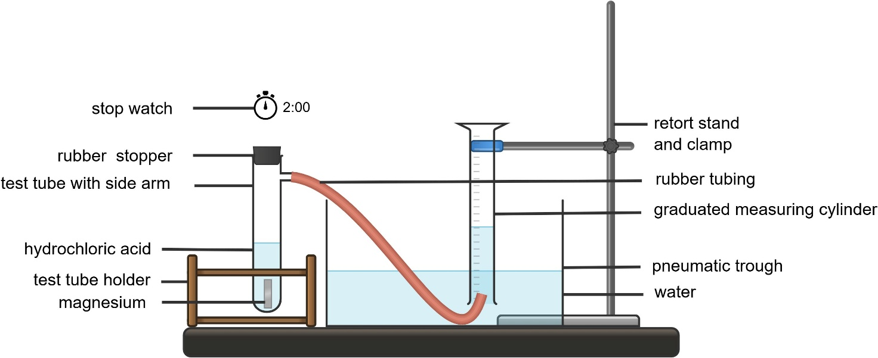Procedure
- Half fill a trough with water.
- Fill the measuring cylinder to the brim with water and invert (turn upside down) it in the trough (as shown in the diagram). Make sure no air bubbles get in and secure it with the clamp on the retort stand.
- Position the rubber tubing from the side-arm test tube so that it directs the gas into the measuring cylinder, as shown in the diagram above. Secure the mouth of the measuring cylinder with plasticine to prevent gas leakage.
- Add 10 mL of 1 Mol L⁻¹ hydrochloric acid to a large side-arm test tube and place the test tube in a test tube holder.
- Measure and cut the magnesium ribbon into three 3 cm pieces.
- Drop a 3 cm piece of magnesium in the test tube and immediately place the stopper over the opening (the gas will travel through the tubing and displace the water in the upturned measuring cylinder).
- Start the stopwatch as soon as you drop the magnesium piece.
- Measure and record the volume of gas produced every 10 seconds for 120 seconds. Record the volume of gas in Table 2.
Differentiation: the results table is missing most of the column headings. This can be adjusted to support or extend student understanding of constructing results tables.
- Repeat steps 2 to 8 with the remaining 2 pieces of magnesium.
- Calculate the mean volume produced in each 10-second interval and record it in Table 2.
- Plot a graph of the mean volume of hydrogen gas produced versus time and draw a curve of best fit.
Results
Table 2 – the volume of gas produced by a reaction of magnesium ribbon with hydrochloric acid over time
 |  |  |  |  | Range
 |  |  |  | Mean | Range
Plot a graph of the average volume of hydrogen gas collected versus time for a reaction between magnesium and hydrochloric acid.
Title:

Analyse the trend shown in the graph to discuss how the rate of reaction for magnesium and hydrochloric acid varies with time.
Qualitative analysis
Analyse the collected data to calculate the mean reaction rate for the reaction between magnesium and hydrochloric acid.
Quantitative analysis
Calculate the reaction rate at 2 intervals and compare them.
‘Validity’ refers to ‘the extent to which the processes and resultant data measure what was intended’ (NESA 2025). An experiment is valid if all variables other than the independent variable are suitably controlled and the measurements collected are accurate.
Answer the following questions to assess the validity of your investigation. Refer to the procedure and how it was implemented to answer these questions. The first question is completed as an example.
Table 3 – assessing the validity of the investigation
Question | Response
Were all factors (such as temperature, acid concentration, amounts of acid and Mg) the same for all trials? | Yes. The reaction was carried out at room temperature (25°C). 10 mL of 1 Mol L⁻¹ hydrochloric acid and 3.0 cm of Mg ribbon were used for each trial.
Were the time intervals consistent for recording gas volume?
Did you measure the length of the magnesium ribbon accurately?
Was the equipment set-up suitable for gas collection?
Was the gas volume measured accurately, using appropriate equipment?
Were there any unusual results (outliers)? Explain possible reasons.
Do you have any suggestions for improving the method?
Refer to the questions above to assess the validity of your investigation. Use the CER scaffold to structure your response.
Claim – state an answer to the question: Is the investigation valid?
Evidence – provide information such as facts and data from the experiment that supports the claim.
Reasoning – explain how the evidence supports the claim
‘Reliability’ refers to the degree to which repeated observations and/or measurements taken under identical circumstances will yield the same results (NESA 2025).
Reliability can be improved by using more accurate and precise measuring devices, such as a graduated syringe, and by repeating the experiment to reduce random error.
Answer the following questions to assess the reliability of your investigation. Refer to the procedure and the results table to answer these questions. The first question is completed as an example.
Table 4 – assessing the reliability of the investigation
Question | Response
Was the experiment under the same conditions? | Yes, the experiment was repeated 3 times and all factors, such as temperature, hydrochloric acid concentration and magnesium piece size, were kept constant across trials.
Were the results consistent across the repeated trials (small spread or standard deviation)?
Were your results within the same range as the rest of the class?
Refer to the questions above to assess the reliability of your investigation. Use the CER scaffold to structure your response.
Claim – state an answer to the question: Is the investigation valid?
Evidence – provide information such as facts and data from the experiment that supports the claim.
Reasoning – explain how the evidence supports the claim.

2.3 Reaction rate: surface area and catalysts
Table 12 – learning intentions and success criteria for ‘2.3 Reaction rate: surface area and catalysts’
We are learning: | I can:
- to explain the factors that affect the rate of chemical reactions | - explain how the surface area of reactants affects the rate of reaction  - explain how the presence of a catalyst affects the rate of reaction
- to use scientific tools for accurate observations | - use equipment correctly  - make precise observations
- to plan a valid and reliable investigation | - identify the purpose of an investigation  - identify the independent, dependent and controlled variables used in an investigation
- to follow a planned procedure to undertake a valid and reliable investigation | - assemble equipment to conduct an investigation  - collect and record precise measurements
- to use data to draw conclusions in a scientific investigation. | - describe relationships between variables and draw conclusions.

The effect of surface area on the rate of reaction
Background information
The surface area of a solid affects the rate of reaction. When a solid is broken into smaller pieces or is powdered, its total surface area increases. This exposes more particles to the other reactant, leading to more frequent collisions per second. As a result, reactions occur faster when the surface area of a solid reactant is greater, provided other factors, such as temperature and concentration, are kept constant.
Calcium carbonate comes in many forms, including powder, pellets and also as ‘marble chips’. The reaction between calcium carbonate and hydrochloric acid is a neutralisation reaction that produces a salt, calcium chloride and carbon dioxide.
- Recall the factors affecting the rate of reaction covered in the prior lessons. Read through the background information in the Student resource – the effect of surface area on the rate of reaction with the class.
- Tell students that acid + carbonate reactions are a special type of neutralisation reaction. They may recall that ‘acid + base → salt + water. However, when an acid reacts with a carbonate, carbon dioxide gas is also produced.
$$acid+carbonate→salt+carbon dioxide+water$$
- Read through the hypothesis, equipment and procedure with students. Students record the purpose of the investigation.
- Demonstrate how to set up the equipment shown in Figure 5. The image shows a plastic syringe in use, which is a suitable replacement for a gas syringe, provided it has a good seal and the plunger can move easily. Display the scientific diagram of the equipment set-up to support students on RXN PPT ‘2.3 The effect of surface area on the rate of reaction’.
Figure 5 – equipment set-up for collecting gas to determine the rate of reaction
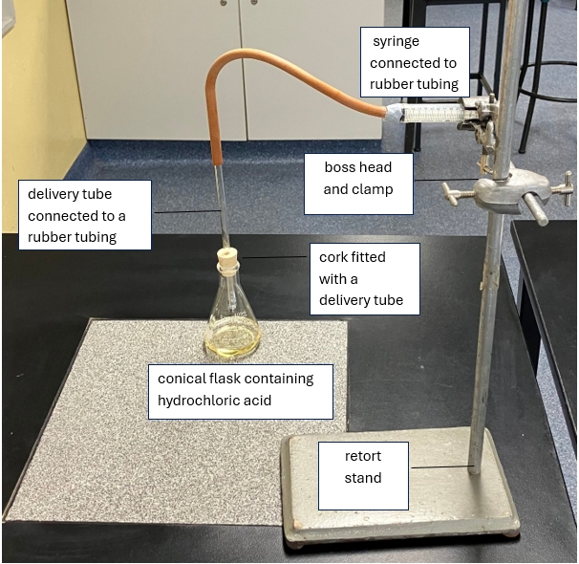
- Discuss the risk assessment with students and ensure all controls are implemented during the investigation. Students note down key hazards, risks and controls in Table 1 of the student resource.
- Instruct students to conduct their investigation by following the steps provided in the procedure in the Student resource – the effect of surface area on the rate of reaction.
- Collect class results and share them either by displaying them on the screen or entering class data in a Microsoft Excel spreadsheet. Refer to the Reactions Microsoft Excel workbook (The effect of surface area workbook) to record class results. Share the class results with students so they can complete the results table.
- Discuss the results by:
- identifying any outliers (the value is significantly higher or lower than the rest of the class)
- identifying the reasons for those outliers, such as random errors caused by human reaction time, gas leaking from the syringe if the rubber tubing is not securely attached or gas escaping from the conical flask if the stopper is not tightly sealed.
- Guide students to compare the mean volume of gas produced in 2 cases (calcium carbonate pellets versus powder) and link it to the rate of reaction using collision theory.
- Guide students to calculate the rate of reaction:
- Recall the equation for the rate of reaction
$$Rate of reaction=\frac{∆volume of gas produced}{∆time}$$
- To compare the rate of reaction under 2 different conditions, we can substitute in the mean time for each condition and then compare the rate of reaction. A higher number indicates a faster reaction rate and a lower number indicates a slower reaction rate.
- Instruct students to summarise their findings by analysing the calculated reaction time and comparing the effect of surface area on the rate of reaction using the Johnstone’s triangle framework in the Student resource – the effect of surface area on the rate of reaction.
- Use slides RXN PPT ‘2.3 Johnstone’s triangle – surface area’ (3 slides) to discuss the sample answer.
- Support students to construct a conclusion for the investigation.
Sample answer: Student resource – the effect of surface area on the rate of reaction
What is the purpose of this investigation?
To investigate the effect of the surface area of a solid on reaction rate.
Variables
Independent | The surface area of the calcium carbonate.
Dependent | Reaction rate.
Controlled | Temperature – all conducted at room temperature.  The amount of reactants is kept the same.  The same concentration of acid is used.
Risk assessment
Table 13 – risk assessment for the investigation into the effect of surface area on reaction rate
Hazard | Risk | Controls or precautions
Hydrochloric acid (corrosive) | Splashing chemicals in the eyes or on the skin will cause irritation. | - Wear safety glasses throughout the experiment.  - Wear enclosed leather footwear.  - Wash off the splashes from the skin immediately with cool water.
Broken glassware | Cuts from chipped glassware. | - Inspect and discard broken glassware.  - Sweep up broken glass with a dustpan and a brush – do not use fingers to clean it up.
Water spills, chairs | Slips, trips and falls. | - Spills are to be cleaned immediately. No running in the lab.
Note: the amount of gas produced (5 mL), the mass of calcium carbonate (1 g), and the volume and concentration of hydrochloric acid (20 mL of 1 Mol L⁻¹ HCl) are the same in all trials. The only factor that is varied is the form (surface area) of calcium carbonate.
For smaller classes with fewer than 10 groups, remove the extra columns from the table and update the table in the Student resource – the effect of surface area on the rate of reaction. The sample data shows only 2 trials.
Table 14 – sample results for the effect of surface area on time taken to produce 5 mL of gas
Chemical substance | Time taken to produce 5 mL of gas(seconds)
Chemical substance | G1 | G2 | G3 | G4 | G5 | G6 | G7 | G8 | G9 | G10 | Mean
Calcium carbonate pellets + HCl | 165 | 168 | 168 | 169 | 172 | 160 | 165 | 167 | 164 | 167 | 166.5
Calcium carbonate powder + HCl | 5 | 7 | 6 | 7 | 8 | 5 | 7 | 8 | 9 | 5 | 6.7
Determine the mean rate of reaction for the calcium carbonate powder and the calcium carbonate pellets using the equation $reaction rate α \frac{1}{time}$.
Powder  $$mean reaction rate= \frac{∆amount of product}{∆time}$$  $$reaction rate= \frac{5 mL}{6.7 s}$$  $$reaction rate= 0.75 mL/s$$ | Pellets  $$mean reaction rate=\frac{∆amount of product}{∆time}$$  $$reaction rate= \frac{5 mL}{166.5 s}$$  $$reaction rate= 0.03 mL/s$$
Table 15 – sample response for Johnstone’s triangle framework for the effect of surface area on the rate of reaction
What we see  (macroscopic) | What we cannot see  (sub-microscopic) | Representation  (symbolic)
Record what you observed in the experiment.  Fizzing (gas bubbles in both cases, calcium carbonate pellets and powder).  Powdered calcium carbonate produces more fizzing than pellets.  The amount of time required to produce 5 mL of gas with calcium carbonate powder was much smaller than that of the calcium carbonate pellets. | What is happening at the particle level to cause these observations?  Pellets have a smaller surface area, so there are fewer frequent collisions between reactant particles.  Powdered calcium carbonate has more surface area, so it has a higher frequency of successful collisions between reactant particles. | Word equation  calcium carbonate + hydrochloric acid → calcium chloride + carbon dioxide + water  Balanced chemical equation  CaCO₃(s) + 2HCl(aq) → CaCl₂(aq) + CO₂(g) + H₂O(l)
Write a conclusion for the investigation.
The aim of this investigation was to compare the rate of reaction between hydrochloric acid and calcium carbonate when the calcium carbonate was in pellet form and when it was powdered. The results showed that the powdered calcium carbonate produced 5 mL of carbon dioxide gas in a shorter time than the pellets. This indicates that the reaction occurred faster when powdered calcium carbonate was used. The powder reaction rate was 0.75 mL/s, whereas the pellet reaction rate was slower at 0.03 mL/s$.$
The faster reaction rate with powdered calcium carbonate can be attributed to its greater surface area. Powdered calcium carbonate has a much larger surface area than the pellets, meaning that more calcium carbonate particles were in contact with the hydrochloric acid at any given time. This increased the frequency of successful collisions between reactant particles, leading to a faster production of carbon dioxide gas.
Therefore, the investigation supports the conclusion that increasing the surface area of a solid reactant increases the reaction rate.

Student resource – the effect of surface area on the rate of reaction
Background information
In many chemical reactions, the reactants need to collide for a reaction to occur. The rate of reaction describes how fast reactants are converted into products. One factor that affects the rate of reaction is the surface area of a solid reactant. When a solid is broken into smaller pieces or is powdered, its total surface area increases. This exposes more particles to the other reactant, leading to more frequent collisions per second. As a result, reactions occur faster when the surface area of a solid reactant is greater, provided other factors, such as temperature and concentration, are kept constant.
Calcium carbonate comes in many forms, including powder, pellets and ‘marble chips’. The reaction between calcium carbonate and hydrochloric acid is a neutralisation reaction that produces the salt calcium chloride, carbon dioxide and water.
$$acid+carbonate→salt+carbon dioxide+water$$
Calcium carbonate is a base with carbonate ions, unlike other bases, which have hydroxide ions. When it reacts with water, it produces carbonic acid (H₂CO₃), which is unstable and decomposes into carbon dioxide and water.
$$carbonic acid→carbon dioxide+water$$
What is the purpose of this investigation?
Hypothesis: the powdered calcium carbonate (larger surface area) will have a faster reaction rate compared to the calcium carbonate pellets (smaller surface area).
Equipment list
- 1 × electronic balance  - 1 × 100 mL conical flask  - 1 × delivery tube and stopper  - 1 × stopwatch  - 1 g calcium carbonate pellets  - 1 g calcium carbonate powder | - 1 × 50 mL measuring cylinder  - 1 × 50 mL 1 M HCl  - 1 × 10 mL gas syringe  - 1 × retort stand and clamp  - 1 × rubber tube
Variables
Independent
Dependent
Controlled
Risk assessment
Table 1 – risk assessment for the investigation into the effect of surface area on reaction rate
Hazard | Risk | Controls or precautions
Figure 1 – equipment set-up for investigating the effect of surface area on the rate of reaction
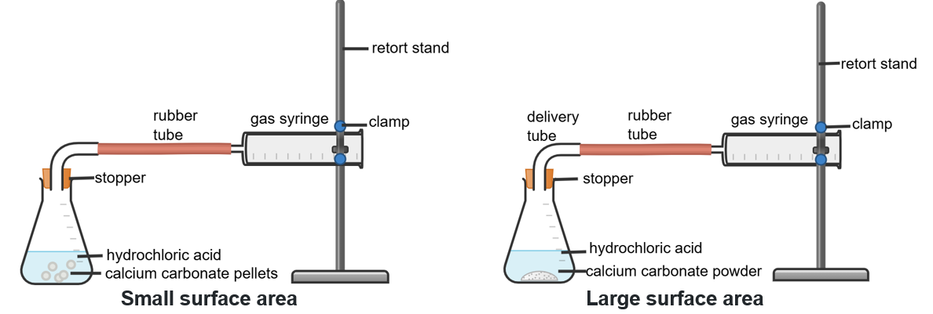
Image created using Chemix and is licensed under the Chemix Terms of Service.
Procedure
- Set up the equipment as shown in Figure 1.
- Clamp the gas syringe and connect it to a delivery tube inserted in a stopper. Ensure the plunger is fully depressed to remove any air and that the rubber tube is fitted tightly to the gas syringe to prevent gas leaks.
- Measure 20 mL of hydrochloric acid and add it to the conical flask.
- Weigh 1 g of calcium carbonate pellets and add to the conical flask, stopper and start the stopwatch.
- Measure and record the time taken to produce 5 mL of the gas.
- Repeat the experiment by replacing calcium carbonate pellets with powdered calcium carbonate.
- Record your results in Table 2 below.
- Complete Table 2 below by adding the results from other groups and calculating the mean time. Columns G1 to G10 represent Groups 1 to 10.
Table 2 – the effect of surface area on time taken to produce 5 mL of gas
Chemical substance | Time taken to produce 5 mL of gas(seconds)
Chemical substance | G1 | G2 | G3 | G4 | G5 | G6 | G7 | G8 | G9 | G10 | Mean
calcium carbonate pellets + HCl
calcium carbonate powder + HCl
Determine the mean rate of reaction for the calcium carbonate powder and the calcium carbonate pellets using the equation $reaction rate α \frac{1}{time}$.
Table 3 – Johnstone’s triangle framework for the effect of surface area on the rate of reaction
What we see  (macroscopic) | What we cannot see  (sub-microscopic) | Representation (symbolic)
Record what you observed in the experiment. | What is happening at the particle level to cause these observations? | Word equation  Balanced chemical equation
Write a conclusion for the investigation.

The effect of catalysts on the rate of reaction
Hydrogen peroxide decomposes into water and oxygen gas very slowly at room temperature, but the rate of reaction can be increased by adding a ‘catalyst’. The enzyme, peroxidase, in yeast catalyses the decomposition of hydrogen peroxide.
Note: enzymes are biological catalysts and are found in or produced by cells.
- Display RXN PPT ‘2.3 The effect of a catalyst on the rate of reaction’ and refer to the procedure in the Student resource – the effect of a catalyst on the rate of reaction and explain the steps in the procedure. Students should record the purpose of the investigation and identify the variables involved.
Figure 6 – equipment needed for the investigation of the effect of the catalyst on the rate of reaction
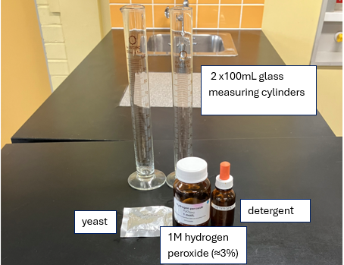
Note: hydrogen peroxide has a short shelf life, so ensure the sample is not very old. Lukewarm water (37°C to 40°C) is required to activate yeast. If the water is not warm enough, it will not activate the yeast. If it is too hot, it may kill the yeast.
- Co-construct the risk assessment with students and ensure all control measures are implemented during the experiment.
Figure 7 – an image representing the expected results of the investigation
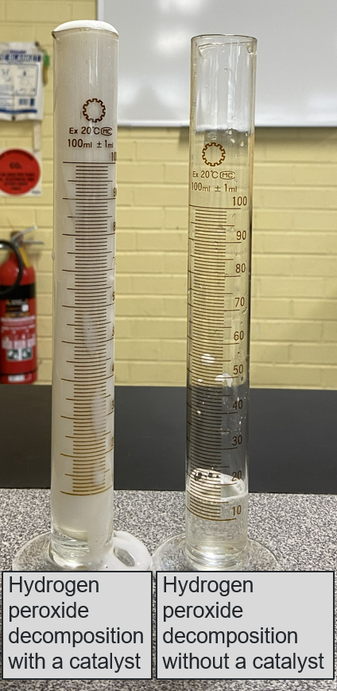
- Tell students that it is the enzyme in the yeast that acts as a catalyst. The purpose of the detergent is to trap oxygen released during the decomposition reaction and produce foam.
- Instruct students to compare their observations of the decomposition of hydrogen peroxide with and without the catalyst and complete the table in the Student resource – the effect of a catalyst on the rate of reaction.
- Instruct students to summarise their findings using Johnstone’s triangle framework in the Student resource – the effect of a catalyst on the rate of reaction. Use slides RXN PPT ‘2.3 Johnstone’s triangle – catalyst (3 slides) to discuss the sample answer. Students should then draw a conclusion for the investigation.
Sample answer: Student resource – the effect of a catalyst on the rate of reaction
What is the purpose of this investigation?
To investigate the impact of a catalyst on the rate of a reaction.
Variables
Independent | The presence or absence of a catalyst.
Dependent | The height of the bubbles of oxygen.
Controlled | The temperature of the hydrogen peroxide.  The concentration of the hydrogen peroxide.
Risk assessment
Table 16 – risk assessment for the investigation into the effect of a catalyst on reaction rate
Hazard | Risk | Controls or precautions
Broken glassware | Cuts from chipped glassware. | - Inspect and discard broken glassware.  - Sweep up broken glass with a dustpan and a brush – do not use fingers to clean it up.
Water spills, chairs | Slips, trips and falls. | - Spills are to be cleaned immediately. No running in the lab.
Hydrogen peroxide | Irritation of the skin or eyes. | - Wear safety glasses.  - Rinse skin immediately if it comes into contact with the solution.  - Use H₂O₂ of a low concentration.
Observations
Table 17 – sample response for decomposition of hydrogen peroxide with and without yeast
Hydrogen peroxide and detergent solution | Hydrogen peroxide and a detergent solution with the catalyst
A minimal number of tiny bubbles.  The level of hydrogen peroxide does not change. | A lot of fizzing is observed as soon as the yeast is added.  The foam rises to the top and overflows.
Complete the following table.
Table 18 – sample response for comparing the effect of the catalyst on the rate of reaction
What we see  (macroscopic) | What we cannot see  (sub-microscopic) | Representation  (symbolic)
Record what you observed in the 2 measuring cylinders.  Measuring cylinder without catalyst no observable change.  Measuring cylinder with catalyst: gas production was observed because it was trapped as bubbles in the detergent. The foam rose to the top and overflowed onto the bench. | What is happening at the particle level to cause these observations?  The enzyme peroxidase in yeast accelerates the reaction by lowering the activation energy, so a greater fraction of reactant molecules (hydrogen peroxide) can form products (oxygen and water) at room temperature. | Word equation  hydrogen peroxide → water + oxygen  Balanced chemical equation  $$2H_{2}O_{2}(l)→ O_{2}(g)+2H_{2}O(l)$$
Write a conclusion for the investigation.
In the reaction investigated, hydrogen peroxide decomposes to form water and oxygen. The detergent added to the reaction forms foam as oxygen is produced. This reaction occurs slowly at room temperature because the activation energy required for the decomposition of hydrogen peroxide is high. This explains the observation that there was no visible change in the cylinder without the catalyst (yeast enzyme). However, the cylinder containing the catalyst (yeast enzyme) showed a vigorous reaction, with a large amount of foam forming. This occurred because the enzyme lowered the activation energy for the decomposition of hydrogen peroxide, enabling the reaction to proceed at room temperature.

Student resource – the effect of a catalyst on the rate of reaction
Background information
A ‘catalyst’ is a substance that speeds up a chemical reaction without being consumed in the process. It works by making it easier for the reactant particles to react when they collide. This means more successful collisions happen each second, so the reaction rate increases. A catalyst does not change the reactants or the products – it only changes how fast the reaction happens. Catalysts are important in everyday life and industry, such as in car catalytic converters, and in living things, where enzymes act as catalysts to speed up reactions in cells.
Hydrogen peroxide decomposes into water and oxygen gas very slowly at room temperature, but the reaction rate can be increased by adding a catalyst. An enzyme (biological catalyst) in yeast, peroxidase, catalyses the decomposition of hydrogen peroxide.
What is the purpose of this investigation?
Hypothesis
If a catalyst is added to hydrogen peroxide, it will decompose at a faster rate because the catalyst increases the rate of successful collisions.
Equipment list
- 2 × 100 mL measuring cylinders  - Yeast  - 1 × stopwatch | - 3% hydrogen peroxide  - 1 × spatula  - Dishwashing detergent
- Lukewarm water | - 1 × 100 mL beaker
Figure 1 – equipment set-up for investigating the effect of yeast on the decomposition of hydrogen peroxide
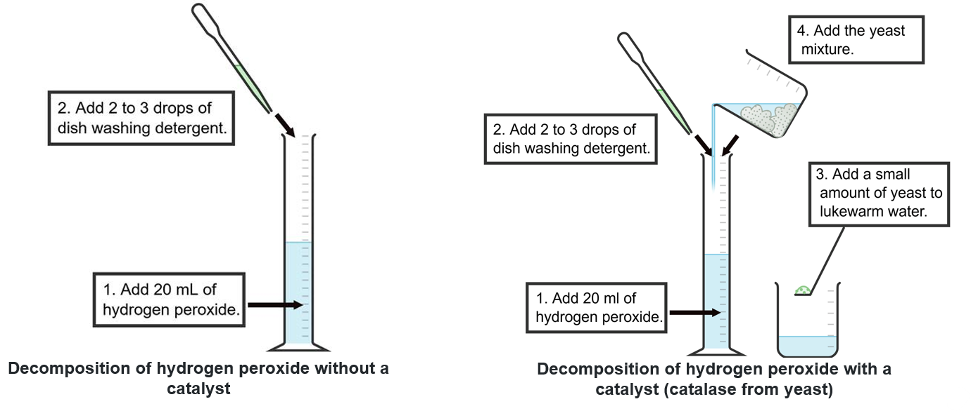
Image created using Chemix and is licensed under the Chemix Terms of Service.
Variables
Independent
Dependent
Controlled
Risk assessment
Table 1 – risk assessment for the investigation into the effect of a catalyst on reaction rate
Hazard | Risk | Controls or precautions
Procedure
- Collect 2 100 mL measuring cylinders.
- Add 20 mL of 3% hydrogen peroxide solution to each measuring cylinder.
- Add 3 to 4 drops of dishwashing detergent to each measuring cylinder.
- Add 10 mL of lukewarm water to a 100 mL beaker. Add a spatula full of yeast to the water and mix gently.
- Add the yeast mixture to one of the measuring cylinders.
- Start the stopwatch and record observations for 2 minutes.
- Record your observations in the table below.
Observations
Table 2 – decomposition of hydrogen peroxide with and without yeast.
Hydrogen peroxide and detergent solution | Hydrogen peroxide and a detergent solution with the catalyst
Complete the following table.
Table 3 – Johnstone’s triangle framework for comparing the effect of a catalyst on the rate of reaction
What we see  (macroscopic) | What we cannot see  (sub-microscopic) | Representation  (symbolic)
Record what you observed in the 2 measuring cylinders. | What is happening at the particle level to cause these observations? | Word equation
 |  | Balanced chemical equation
Write a conclusion for the investigation.

2.4 Reaction rate: temperature and concentration
Table 19 – learning intentions and success criteria for ‘2.4 Reaction rate: temperature and concentration’
We are learning: | I can:
- to explain the factors that affect the rate of a chemical reaction | - describe the effect of temperature on the rate of reaction  - describe the effect of concentration on the rate of reaction
- to develop hypotheses based on observations and scientific knowledge | - develop a measurable hypothesis
- to design a valid scientific investigation | - identify the purpose of an investigation  - identify the variables in the investigation  - explain how the investigation method is valid
- to follow a planned procedure | - undertake a safe, valid and reliable investigation  - accurately collect data and record it in a table
- to process and represent data | - plot experimental data on an appropriate graph  - plot multiple sets of data on the same graph
- to analyse data from investigations to identify trends, patterns and relationships, and draw conclusions. | - analyse data from investigations to identify trends  - analyse data from investigations to identify relationships between variables and draw conclusions  - assess the validity and reliability of the collected data.

Planning and conducting an investigation
In this activity, students will plan and conduct an investigation on how one factor (concentration or temperature) affects the reaction rate. It will be reported on in the next activity, Scientific report. Students will use magnesium metal and hydrochloric acid in their investigation, using the method they learned in 2.2 Investigating the rate of reaction.
Note: to maximise available lesson time, it is suggested that the class be divided into small groups, with several groups investigating the effect of temperature on reaction rate and the others investigating the effect of concentration. This approach allows both investigations to be conducted concurrently, with findings shared with the whole class. However, if preferred, teachers may have all students complete both investigations, individually or as a whole class, for a more comprehensive experience. The decision can be adapted to suit classroom needs, time constraints and learning goals.
Note that the effect of concentration on reaction rate is assessed in the Science Stage 5 – sample assessment task – Reactions.
- Assign groups to investigate the effect of temperature on the rate of reaction, or the effect of concentration on reaction rate. Provide students with a copy of the Student resource – planning template. If students can work on the plans digitally, it will save them time transferring information into their report for the next activity.
Note: the Student resource – planning template is in a digital format. If you intend to print the planning template, adjust the text box sizes to accommodate handwritten responses.
- Show slide RXN PPT ‘2.4 Frayer diagram – hypothesis’ to revise the term ‘hypothesis’ and unpack it by exploring the features, examples and non-examples.
- Use slide RXN PPT ‘2.4 Developing hypothesis’ to guide students in writing a clear, testable hypothesis that links the independent and dependent variables and includes a logically predicted outcome. Provide a checklist in the slide RXN PPT ‘2.4 Checkpoint – framing hypothesis’ to guide students with framing a hypothesis.
Checkpoint: display slide RXN PPT ‘2.4 Checkpoint’ showing a table with hypothesis statements. Students identify the hypothesis statement from the list that best describes the hypothesis and provide reasons for their choice. Sample reasoning is animated to pop up on the slide.
Table 20 – checkpoint sample response for identifying the correct hypotheses
Number | Hypothesis statement | Reason why the hypothesis is suitable or unsuitable
1 | If a catalyst is added to hydrogen peroxide, the reaction rate will increase. | It does not include the scientific reasoning.
2 | If a catalyst is added to hydrogen peroxide, the reaction rate will increase because the catalyst lowers the activation energy required for the reaction to occur. | It is testable. It links the independent variable (catalyst) to the dependent variable (reaction rate). It includes the expected outcome (an increase in the reaction rate) and provides the scientific reasoning.
3 | If a catalyst is added to hydrogen peroxide, it will affect the rate because it changes the reaction's activation energy. | It does not specify how the addition of a catalyst affects the rate of reaction (increase or decrease) and the scientific reasoning is unclear.
- Support students to work in their groups to outline the purpose of the investigation, construct a hypothesis and identify the variables.
- Discuss the importance of only changing one variable in a valid scientific investigation and the need to control all other variables. Guide students as they explain the importance of keeping the controlled variables constant.
- Discuss the need to consider validity and reliability when planning investigations. Read through the stimulus material provided in the Student resource – planning template. Students then outline the steps they will take to ensure their investigation is valid and reliable.
- Guide students in constructing an equipment list for their investigation.
- Students construct a procedure for the investigation. Opportunities for feedback should be provided to ensure that students can conduct the investigation. Sample procedures that students can be guided towards are provided in the sample responses:
- Remind students of the correct gas collection procedure. They should measure the time and accurately read the gas volume from the measuring cylinder.
- Emphasise consistency, for example, start timing when the acid is added and stop when gas production reaches the target.
- Remind students that they need to calculate the rate of reaction using their collected data and this should be accounted for in the procedure.
- Provide students with the relevant risk assessment information (such as hazard, precautionary and disposal statements from your risk assessment document or the relevant Safety Data Sheets (SDS) to construct the risk assessment for their investigation.
- Students construct a suitable table to record their results and determine how they will calculate the rate of reaction so that they can test their hypothesis.
- Review the procedure for each half before students start conducting their investigations to check they have:
- identified the independent variable (temperature or concentration)
- controlled other variables appropriately
- planned to measure the rate using gas volume or time for the reaction to finish.
- Use the students' planning information to order equipment and materials required for the investigations and have them ready for the next lesson.
- In the next lesson, ensure students have access to their planning documents so that they can conduct the investigation to collect data for their scientific report.
Sample response: Student resource – planning template (temperature)
Note: additional stimulus information has been removed from the sample response.
- What independent variable is your group investigating?
Temperature.
- Outline the purpose of the investigation.
To investigate the effect of temperature on the rate of reaction between magnesium and hydrochloric acid.
- Construct a hypothesis for your investigation, using ‘if’, ‘then’ and ‘because’.
If the temperature of the hydrochloric acid is increased, then the rate of reaction between magnesium and hydrochloric acid will increase. This is because the particles have more kinetic energy at higher temperatures, leading to more frequent and more energetic collisions between reactant particles.
- Identify the variables in the investigation. Include a description of how they will be changed, measured or kept constant.
Independent variable | The temperature of the hydrochloric acid.
Dependent variable | The rate of reaction.
Controlled variables | The concentration of the hydrochloric acid (1 Mol L⁻¹).  The batch of hydrochloric acid.  The amount of magnesium used in the reaction (3 cm).  The surface area of the magnesium (one uniform strip).
- Explain the importance of keeping the controlled variables constant.
If factors such as the amount of magnesium, the concentration of acid or the surface area of the magnesium change between trials, they could also affect the rate of reaction. This would make it unclear whether any change in reaction rate was due to temperature or to these other factors. By controlling all other variables, we can be confident that any difference in the reaction rate is due solely to temperature, making the conclusion fair and reliable.
- Outline the steps you will take to ensure your investigation is reliable and valid.
To ensure the investigation is valid and reliable, only the temperature should be changed. At the same time, all other variables are kept constant, including the mass and surface area of the magnesium, the volume and concentration of hydrochloric acid, and the apparatus and method used to collect gas.
The reaction mixture should be brought to the target temperature using a water bath and checked with a thermometer before starting. The rate should be measured in the same way each time, such as by timing how long it takes to produce a fixed volume of hydrogen gas.
The experiment should be repeated several times at each temperature and the mean calculated to improve reliability, with care taken to minimise measurement errors by using airtight connections, consistent timing and accurate volume readings.
- Identify the equipment you will need for the investigation.
- 120 mL × 1 Mol L⁻¹ hydrochloric acid  - 1 × 24 cm magnesium ribbon  - 1 × retort stand  - 1 × boss head and clamp  - 1 × 100 mL measuring cylinder  - 1 × 10 mL measuring cylinder  - 1 × stopwatch  - 1 × side-arm test tube with approximately 25 to 30 cm of rubber tubing attached | - 1 × rubber stopper (which fits the top of the test tube)  - 1 × 150 mL beaker (labelled, to hold the HCl)  - 1 × pneumatic trough (or similar)  - 1 × thermometer  - Scissors  - 1 × ruler  - Hot water  - Ice cold water
- Conduct a risk assessment for the investigation.
Table 21 – risk assessment for the investigation into the effect of temperature on reaction rate
Hazard | Risk | Controls or precautions
Hydrochloric acid (corrosive) | Splashes on the eyes or skin will cause irritation and burns. | - Wear safety glasses throughout the experiment.  - Wear enclosed leather footwear. Wash splashes off the skin with cool water.
Hot water | Burns. | - Handle carefully with tongs or heatproof gloves
Glassware (beakers, measuring cylinders) | Breakage of glass equipment, cuts from chipped glassware. | - Use standard handling procedures.  - Inspect and discard broken glassware.  - Sweep up broken glass with a dustpan and a broom – do not use fingers to clean it up.
Water spills, chairs | Slips, trips and falls. | - Spills are to be cleaned immediately.  - No running in the lab.
- Construct a stepped procedure for the investigation.
- Half fill a trough with water.
- Fill the measuring cylinder to the brim with water and invert (turn upside down) it, making sure no air bubbles get in, and secure it with the clamp on the retort stand.
- Position the rubber tubing from the side-arm test tube so that it directs the gas into the measuring cylinder.
- Add 10 mL of 1 Mol L⁻¹ hydrochloric acid to a large side-arm test tube and place the test tube in a beaker with about 50 mL of iced water.
- Use a thermometer to measure the temperature of the hydrochloric acid. When it reaches the target temperature, go to the next step (10°C for the first temperature).
- Drop a 2 cm piece of magnesium in the test tube and immediately place the stopper over the opening and start the stopwatch (the gas will travel through the tubing and displace the water in the upturned measuring cylinder).
- Measure and record the time taken to produce 40 mL of gas.
- Repeat steps 2 to 9 two more times for the same temperature.
- Repeat steps 2 to 9 by changing the temperature of the hydrochloric acid solution using different temperature water baths.
- Construct a suitable table to document the results of the investigation.
Table 22 – sample results table and data for the investigation into the effect of temperature on reaction rate
Temperature (°C) | Time to produce 40 mL of gas (seconds) |  |  |  | Mean rate of reaction (mL/s)
Temperature (°C) | Trial 1 | Trial 2 | Trial 3 | Mean | Mean rate of reaction (mL/s)
10 | 71 | 75 | 73 | 73 | 0.55
20 | 72 | 70 | 68 | 70 | 0.57
40 | 63 | 61 | 63 | 61 | 0.66
60 | 48 | 49 | 47 | 48 | 0.83
- Outline the method you will use to calculate the rate of reaction so you can test your hypothesis.
$$rate of reaction \text{= }\frac{∆ in amount of product}{∆time}$$

Sample response: Student resource – planning template (concentration)
Note: additional stimulus information has been removed from the sample response.
- What independent variable is your group investigating?
Concentration.
- Outline the purpose of the investigation.
To investigate the effect of the concentration of a reactant on the rate of a chemical reaction.
- Construct a hypothesis for your investigation using ‘if’, ‘then’ and ‘because’.
If the concentration of the hydrochloric acid is increased, then the rate of reaction between magnesium and hydrochloric acid will increase. This is because there are more hydrochloric acid particles in a higher concentrated solution, leading to more frequent collisions between reactant particles.
- Identify the variables in the investigation. Include a description of how they will be changed, measured or kept constant.
Independent variable | The concentration of the hydrochloric acid.
Dependent variable | The rate of reaction.
Controlled variables | The temperature at which the reaction is conducted.  The batch of hydrochloric acid.  The amount of magnesium used in the reaction (3 cm).  The surface area of the magnesium (one uniform strip).
- Explain the importance of keeping the controlled variables constant.
If factors such as the amount of magnesium or its surface area change between trials, they could also affect the reaction rate. This would make it unclear whether any change in reaction rate was due to temperature or to these other factors. By controlling all other variables, you can be confident that any difference in the reaction rate is due solely to concentration, making the conclusion fair and reliable.
- Outline the steps you will take to ensure your investigation is reliable and valid.
To ensure the investigation is valid and reliable, only the HCl concentration should be varied. At the same time, all other variables are kept constant, including the mass and surface area of the magnesium, the volume of hydrochloric acid, and the apparatus and method used to collect the gas.
The experiment should be repeated several times at each concentration and the mean calculated to improve reliability, with care taken to minimise measurement errors by using airtight connections, consistent timing and accurate volume readings.
- Identify the equipment you will need for the investigation.
- 40 mL × 0.5 Mol L⁻¹ hydrochloric acid  - 40 mL × 1 Mol L⁻¹ hydrochloric acid  - 40 mL × 2 Mol L⁻¹ hydrochloric acid  - 1 × 20 cm magnesium ribbon  - 1 × retort stand  - 1 × boss head and clamp  - 1 × 100 mL measuring cylinder  - 1 × 10 mL measuring cylinder | - 1 × side-arm test tube with approximately 25 to 30 cm of rubber tubing attached  - 1 × rubber stopper (which fits the top of the test tube)  - 1 × pneumatic trough (or similar)  - Scissors  - 1 × ruler  - 1 × stopwatch
- Conduct a risk assessment for the investigation.
Table 23 – risk assessment for the investigation into the effect of concentration on reaction rate
Hazard | Risk | Controls or precautions
Hydrochloric acid | The acid is corrosive – splashes on the eyes or skin will cause irritation and burns. | - Wear safety glasses throughout the experiment.  - Wear enclosed leather footwear. Wash splashes off the skin with cool water.
Glassware (beakers, measuring cylinders) | Breakage of glass equipment, cuts from chipped glassware. | - Use standard handling procedures.  - Inspect and discard broken glassware.  - Sweep up broken glass with a dustpan and a broom – do not use fingers to clean it up.
Water spills, chairs | Slips, trips and falls. | - Spills are to be cleaned immediately. No running in the lab.
- Construct a stepped procedure for the investigation.
- Half fill a trough with water.
- Fill the measuring cylinder to the brim with water and invert (turn upside down) it, making sure no air bubbles get in, and secure it with the clamp on the retort stand.
- Position the rubber tubing from the side-arm test tube so that it directs the gas into the measuring cylinder.
- Add 10 mL of 0.5 Mol L⁻¹ hydrochloric acid to a large side-arm test tube.
- Drop a 2 cm piece of magnesium in the test tube and immediately place the stopper over the opening and start the stopwatch (the gas will travel through the tubing and displace the water in the upturned measuring cylinder).
- Measure and record the time taken to produce 20 mL of gas.
- Repeat steps 2 to 9 two more times for the same concentration of acid.
- Repeat steps 2 to 7 by changing the concentration of the hydrochloric acid solution using different concentrations of hydrochloric acid (1 Mol L⁻¹ and 2 Mol L⁻¹).
- Construct a suitable table to document the results of the investigation.
Table 24 – sample results table and data for the investigation into the effect of concentration on reaction rate
Concentration (Mol L⁻¹) | Time to produce 20 mL of gas (seconds) |  |  |  | Mean rate of reaction (mL/s)
Concentration (Mol L⁻¹) | Trial 1 | Trial 2 | Trial 3 | Mean | Mean rate of reaction (mL/s)
0.5 | 130 | 122 | 133 | 128.3 | 0.16
1 | 30 | 29 | 31 | 30.0 | 0.67
2 | 17 | 20 | 19 | 18.0 | 1.11
- Outline the method you will use to calculate the rate of reaction so you can answer your hypothesis.
$$rate of reaction \text{= }\frac{∆ in amount of product}{∆time}$$

Student resource – planning template
Name: |  | Group member names:
- What independent variable is your group investigating?
You will use the method of measuring the volume of hydrogen gas produced in a reaction between magnesium and hydrochloric acid to test the effect of your variable. You will need to design an investigation to change the variable you have been allocated.
Figure 1 – equipment set-up for measuring the volume of gas production in a chemical reaction
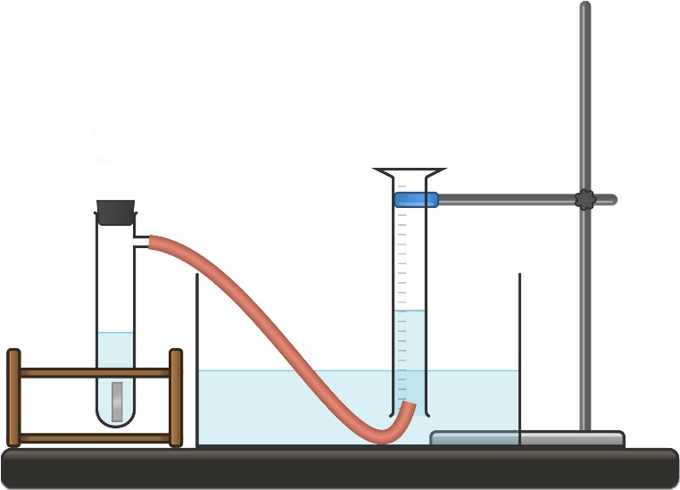
- Outline the purpose of the investigation.
- Construct a hypothesis for your investigation, using ‘if’, ‘then’ and ‘because’.
- Identify the variables in the investigation. Include a description of how they will be changed, measured or kept constant.
Independent variable
Dependent variable
Controlled variables
- Explain the importance of keeping the controlled variables constant.
When planning your investigation into a factor that affects the rate of a chemical reaction, you need to consider how to make your results valid and reliable. A ‘valid investigation’ is a fair test in which only one factor (the independent variable) is deliberately changed and all other variables are kept constant. This ensures that any change in reaction rate can be confidently linked to the factor you are investigating, rather than to other influences in the experiment.
A reliable investigation produces consistent results when repeated. This means planning to repeat trials under the same conditions and taking measurements in the same way each time. Repeating trials and averaging results help reduce the effects of random error and increase confidence in any observed patterns. As you plan, consider whether another student could follow your method and obtain similar results and whether your design allows you to clearly link changes in reaction rate to the factor being tested.
- Outline the steps you will take to ensure your investigation is reliable and valid.
- Identify the equipment you will need for the investigation.
- Conduct a risk assessment for the investigation.
Table 1 – risk assessment for the investigation into the effect of _________________ on reaction rate
Hazard | Risk | Controls or precautions
- Construct a stepped procedure for the investigation.
- Construct a suitable table in the space below to document the results of the investigation.
- Outline the method you will use to calculate the rate of reaction so you can test your hypothesis.

Scientific report
Note: students will require access to the Student resource – planning template and their collected data from the Planning and conducting an investigation activity to complete their scientific report.
- Outline the components of a scientific investigation report. A scientific report often includes an aim, introduction, hypothesis, method, results, discussion and a conclusion.
- Students should draw from their planning documents to complete some parts of the report, such as the aim, hypothesis, variables, procedure and raw data.
- Support students to present their results in an appropriate graph.
- Unpack how to construct a discussion:
- Restate the aim or claim.
- Outline what the data shows.
- Use relevant scientific concepts to explain the trend that was observed.
- Evaluate the validity of the investigation.
- Evaluate the reliability of the investigation.
- Identify any sources of error and limitations.
- Suggest improvements and what could be further investigated.
- Use question prompts to guide students to assess the validity of their investigation:
- Were all factors the same for all trials except the one (independent variable)?
- Did you measure the length of the magnesium ribbon accurately?
- Was the equipment used suitable for measuring gas collection (if relevant)?
- Was the apparatus checked for leaks or air bubbles before each trial?
- Use question prompts to guide students to assess the reliability of their investigations:
- How similar were the times for the repeat trials?
- Was the mean time for each temperature calculated to reduce the effect of random error?
- If another group repeated the investigation with this method using the same equipment and conditions, would they be likely to get similar results? Why or why not?
- Remind students that claim–evidence–reasoning (CER) provides a framework for constructing a conclusion. Remind them to address the hypothesis in the conclusion.
- Provide feedback on students' scientific reports. Student groups should share their findings so that all students gain an understanding of how concentration and temperature affect reaction rate.
Sample response: Student resource – scientific investigation report (temperature)
Note: some sections of the report are outlined in the sample response for the planning template in the previous activity.
Results

Discussion
The results show that increasing the temperature of hydrochloric acid increased the rate of reaction between magnesium and hydrochloric acid. As the temperature increased from 10°C to 60°C, the mean time taken to produce 40 mL of hydrogen gas decreased from 73 s to 48 s. When converted to reaction rates, this corresponds to an increase from 0.55 mL/s at 10°C to 0.83 mL/s at 60°C. This data supports the hypothesis that higher temperatures lead to faster reaction rates.
This relationship can be explained using collision theory. At higher temperatures, reactant particles have greater kinetic energy and move faster. This increases both the frequency of collisions between hydrochloric acid particles and magnesium atoms and the proportion of collisions that have sufficient energy to overcome the reaction's activation energy. As a result, more successful collisions occur per second, leading to faster hydrogen gas production.
The investigation was valid because temperature was the only variable deliberately changed. Other factors known to affect the reaction rate, such as the concentration and volume of hydrochloric acid and the length and surface area of the magnesium ribbon, were kept constant. This means that differences in reaction rate can be attributed to temperature rather than to changes in these other variables. Using a water bath and thermometer to bring the acid to a target temperature before starting the reaction also improved control over the independent variable.
At each temperature, the volume of gas produced was measured 3 times and the mean reaction rate was calculated. The results for each temperature were reasonably consistent across trials, indicating good repeatability and, thus, reliability. Reliability and accuracy could be improved by using a temperature-controlled water bath, a data logger or a gas syringe to measure gas volume continuously and by automated timing to reduce human reaction-time errors.
Some sources of error may have affected the precision of the results. The temperature of the hydrochloric acid may have changed slightly once the magnesium was added and as the water bath cooled. Small leaks in the stopper or tubing could also have caused gas loss, leading to an underestimation of the reaction rate. Despite these limitations, the overall trend in the data is consistent with scientific theory and supports the expected effect of temperature on reaction rate.

Conclusion
The results support the hypothesis that increasing the temperature of hydrochloric acid increases the rate of reaction with magnesium. Higher temperatures resulted in a shorter time to produce the same volume of hydrogen gas and, therefore, indicate a higher calculated reaction rate.
This occurs because particles at higher temperatures have more kinetic energy, leading to more frequent and more energetic collisions that result in successful reactions. Overall, the investigation was valid and reasonably reliable and the data provided clear evidence that temperature is an important factor affecting the rate of chemical reactions.
Sample response: Student resource – scientific investigation report (concentration)
Note: some sections of the report are outlined in the sample response for the planning template in the previous activity.
Results

Discussion
The results show a clear relationship between the concentration of hydrochloric acid and the reaction rate with magnesium. As the concentration of hydrochloric acid increased from 0.5 Mol L⁻¹ to 2.0 M, the time taken to produce 20 mL of hydrogen gas decreased substantially (from a mean of 128.3 s at 0.5 Mol L⁻¹ to 18.0 s at 2.0 Mol L⁻¹). When converted to reaction rates (mL/s), the calculated values indicate an increase in reaction rate from 0.16 mL/s to 1.11 mL/s as the HCl concentration increased. This trend supports the hypothesis that increasing the concentration of hydrochloric acid increases the rate of reaction.
This pattern can be explained using collision theory. A higher concentration of hydrochloric acid contains more acid particles per unit volume. This increases the frequency of collisions between hydrochloric acid particles and magnesium atoms at the surface of the magnesium ribbon. With more frequent collisions, there are more successful collisions per second, leading to a faster formation of hydrogen gas and, therefore, a higher reaction rate.
The investigation was valid because only the concentration of hydrochloric acid was changed, while other variables that affect reaction rate were controlled. The same length and surface area of magnesium ribbon were used for each trial, the temperature was kept constant, and the same volume of hydrochloric acid and the same gas collection method were used. This means the observed changes in reaction rate can be attributed to changes in concentration rather than other factors.
At each concentration, the volume of hydrogen gas produced was measured 3 times, and the mean time and rate were calculated. The trial results for each concentration were reasonably consistent, indicating good repeatability and, thus, reliability. For example, the 3 trials at 1.0 Mol L⁻¹ were 29 s, 30 s and 31 s, showing minimal variation. This consistency increases confidence in the results. Reliability could be further improved by increasing the number of trials and by using digital gas-collection equipment to reduce human reaction time when starting and stopping the stopwatch.
Some sources of uncertainty and error may have affected the accuracy of the results. Small gas leaks from the rubber stopper or tubing could have reduced the measured gas volume. Delays in starting the stopwatch after adding the magnesium may have slightly underestimated the reaction rate, particularly for the faster reactions at higher concentrations. In addition, slight variations in the exact length or thickness of the magnesium ribbon could have caused minor differences in surface area between trials. Despite these limitations, the overall trend in the data is clear and consistent with theoretical expectations.
Conclusion
The results support the hypothesis that increasing the concentration of hydrochloric acid increases the rate of reaction with magnesium. Higher concentrations produced hydrogen gas more quickly, resulting in a higher calculated reaction rate.
This occurs because a higher concentration provides more reactant particles, leading to more frequent collisions and, therefore, more successful reactions per second. Overall, the investigation was valid and reliable, and the data provided strong evidence that concentration is a key factor affecting the rate of chemical reactions.

Student resource – scientific investigation report
Aim
Hypothesis
Variables
Independent
Dependent
Controlled
Procedure
Results
Title:

Discussion
- Describe how the reaction rate changed as (concentration or temperature) increased, using evidence from your data and graph.
- Assess the validity and reliability of the investigation.
Conclusion

Evidence base
This resource contains NSW Curriculum and syllabus content. The NSW Curriculum is developed by the NSW Education Standards Authority (NESA). This content is prepared by NESA for and on behalf of the Crown in right of the State of New South Wales. The material is protected by Crown copyright.
Please refer to the NESA Copyright Disclaimer for more information https://www.nsw.gov.au/education-and-training/nesa/copyright.
NESA holds the only official and up-to-date versions of the NSW Curriculum and syllabus documents. Please visit NESA https://www.nsw.gov.au/education-and-training/nesa and NSW Curriculum https://curriculum.nsw.edu.au.
Science 7–10 Syllabus © NSW Education Standards Authority (NESA) for and on behalf of the Crown in right of the State of New South Wales, 2023.
01 Data Book: Science 7–10 © NSW Education Standards Authority (NESA) for and on behalf of the Crown in right of the State of New South Wales, 2023.
AITSL (Australian Institute for Teaching and School Leadership Limited) (n.d.) Learning intentions and success criteria [PDF 251 KB], AITSL, accessed 18 July 2024.
Brookhart SM (2018) ‘Appropriate Criteria: Key to Effective Rubrics’, Frontiers in Education, volume 3(22):1–12, doi:10.3389/feduc.2018.00022, accessed 6 February 2025.
CESE (Centre for Education Statistics and Evaluation) (2021) Growth goal setting – what works best in practice, NSW Department of Education, accessed 6 February 2025.
——(2025) What Works Best 2025, NSW Department of Education, accessed 26 March 2026.
Fisher D and Frey N (1 November 2009) ‘Feed Up, Back, Forward’, ASCD (Association for Supervision and Curriculum Development): Educational Leadership magazine, 67(3), accessed 18 July 2024.
Flowers P, Theopold K, Langley R and Robinson WR (2019) ‘21.3 Radioactive decay’, Chemistry 2e (OpenStax), Libre Texts – Chemistry, accessed 14 April 2025.
FuseSchool – Global Education (31 May 2013) ‘Collision Theory & Reactions Part 1’ | Reactions | Chemistry | FuseSchool [video], FuseSchool – Global Education, YouTube, accessed 16 October 2025.
Griffin P (2017) Assessment for Teaching, Cambridge University Press, Port Melbourne, Victoria.
Hattie J and Timperley H (2007) ‘The Power of Feedback’, Review of Educational Research, 77(1): 81–112, doi:10.3102/003465430298487.
MooMooMath and Science (12 Nov 2021) ‘Factors that affect Rate of Reaction' [video], MooMooMath and Science, YouTube, accessed 16 October 2025.
Neils T (n.d.) ‘2.4 Nuclear Reactions’, Grand Rapids Community College: CHM 120 Survey of General Chemistry, LibreTexts – Chemistry, accessed 14 April 2025.
NESA (NSW Education Standards Authority) (2025) ‘Glossary’, Science 7–10 Syllabus, NSW Curriculum website, accessed 7 May 2026.
Panadero E and Jonsson A (2013) ‘The use of scoring rubrics for formative assessment purposes revisited: A review’, Educational Research Review, 9:129–144, doi:10.1016/j.edurev.2013.01.002, accessed 18 July 2024.
Sherrington T (2019) Rosenshine’s Principles in Action, John Catt Educational Limited, Melton, Woodbridge.
Wiliam D (2017) Embedded Formative Assessment, 2nd edn, Solution Tree Press, Bloomington, IN.
© State of New South Wales (Department of Education), 2026
The copyright material published in this resource is subject to the Copyright Act 1968 (Cth) and is owned by the NSW Department of Education or, where indicated, by a party other than the NSW Department of Education (third-party material).
Copyright material available in this resource and owned by the NSW Department of Education is licensed under a Creative Commons Attribution 4.0 International (CC BY 4.0) license.

This license allows you to share and adapt the material for any purpose, even commercially.
Attribution should be given to © State of New South Wales (Department of Education), 2026.
Material in this resource not available under a Creative Commons license:
- the NSW Department of Education logo, other logos and trademark-protected material
- material owned by a third party that has been reproduced with permission. You will need to obtain permission from the third party to reuse its material.
Links to third-party material and websites
Please note that the provided (reading/viewing material/list/links/texts) are a suggestion only and implies no endorsement, by the New South Wales Department of Education, of any author, publisher, or book title. School principals and teachers are best placed to assess the suitability of resources that would complement the curriculum and reflect the needs and interests of their students.
If you use the links provided in this document to access a third-party's website, you acknowledge that the terms of use, including licence terms set out on the third-party's website apply to the use which may be made of the materials on that third-party website or where permitted by the Copyright Act 1968 (Cth). The department accepts no responsibility for content on third-party websites.

